

|  |  |  |  |
| --- | --- | --- | --- |
|  | | ONE CLICK SHOPPING HUB |  |
|  |  |
|  | |



***Department of Computer Science M.Sc.***

***Major: E-Commerce***

E-COMMERCE REPORT

**Presented by:**

**Mohammed Sardar Patel**

**Mahesh Patil**

**A Project Report**

Project Report submitted in partial fulfillment of the requirements for the award of the degree of M.Sc. Computer Science in Shrikrishna Shikshan Mahavidyalaya

College in Gunjoti, Maharashtra.

**by**

Mohammed Patel

Seat. No.: CXD401717 & PRN No.: 2015015200569024

Mahesh Patil

Seat. No.: CXD401718 & PRN No.: 2017015200178415

**Under the Guidance of**

**Swapna Kulkarni.**

**Ibrahim Inamdar**

**Suryakant Kode.**

**Signature of the Student**

**Name : Mahesh Patil**

**Seat. No :** **CXD401718**

**Semester : M.Sc. 2nd IV Sem**

**Branch : Comp. Science**

**Date : 11 July 2022**

**Signature of the Student**

**Name : Mohammed Patel**

**Seat. No :** **CXD401717**

**Semester : M.Sc. 2nd IV Sem**

**Branch : Comp. Science**

**Date : 11 July 2022**

**CERTIFICATE**

This is to certify that the Project entitled E-Commerce Project presented by **Mohammed Patel** and **Mahesh Patil** bearing **Seat No. CXD401717 and CXD401718** of **Shrikrishna Shikshan Sanstha Mahavidyalaya** has been completed successfully.

This is in partial fulfillment of the requirements of Master Degree in **Shrikrishna Shikshan Sanstha Mahavidyalaya** under **Dr. Babasaheb Ambedkar Marathwada University. Aurangabad-431004, Maharashtra, India**.

I wish her/ him success in all future endeavors.

**Prof. Swapna Kulkarni**

(Department of Computer Science)

**Acknowledgements**

I would like to express my deep and sincere gratitude to my guide(s), **Prof. Swapna Kulkarni** of **Shrikrishna Shikshan Sanstha Mahavidyalaya** for his/her/their unflagging support and continuous encouragement throughout the seminar/project work. Without his/her/their guidance and persistent help this report would not have been possible.

I must acknowledge the faculties and staffs of **Shrikrishna Shikshan Sanstha Mahavidyalaya Gunjoti.**

It’s my great pleasure to acknowledge my colleagues for providing their opinions about project and came together to complete it. I am especially grateful to **Shrikrishna Shikshan Sanstha Mahavidyalaya Gunjoti.**

**Prof. Swapna Kulkarni.**

**Department of Computer Science.**

Table of Contents

INTRODUCTION:...................................................................................................................................... 3

PROBLEM STATEMENT:........................................................................................................................... 4

Value propositions................................................................................................................................... 5

A-Platform objectives:......................................................................................................................... 5

B-Funtions ........................................................................................................................................... 5

Project detail: .......................................................................................................................................... 5

Platform main goals: *to provide ease*................................................................................................... 5

The target addressed by the site:............................................................................................................ 6

Project scope:.......................................................................................................................................... 6

Revenue Model: ...................................................................................................................................... 7

Market Opportunity:............................................................................................................................... 8

Competitive environment....................................................................................................................... 8

Competitive Advantage:.......................................................................................................................... 8

Requirements.......................................................................................................................................... 9

Software Requirements....................................................................................................................... 9

Hardware Requirements..................................................................................................................... 9

Technical constraints:.............................................................................................................................. 9

Expected benefits:................................................................................................................................. 10

ANALYSIS: .............................................................................................................................................. 10

Payment mode:..................................................................................................................................... 10

Conclusion & Perspectives: ................................................................................................................... 11

INTRODUCTION:

In 1995, in the garage of a small house in Seattle in the United States, Jeff Bezos, former trader,

ships the first order of the e-commerce store he just created: Amazon.com. In less than twenty

years, and after being openly criticized repeatedly about its strategy, its site will become yet a giant of e-commerce, realizingmorethan 100 billion dollarsof annual turnover and thus bearing the personal fortune of his founder to nearly 80 billion dollars.

For many people, this event will mark the birth of e-commerce. The exceptional course of Jeff Bezos will inspire a lot contractors in the United States and elsewhere, and particularly in France, where Patrice Magnard replies in 1996, creating the European competitor: Alapage.com. Quickly follow Cdiscount.com, Voyage-sncf.com or Vente-privée.com, whose success is well established.

These pioneers laid the first stones and paved the wayfor what was going become e-commerce. They paved the way for more than 2 million entrepreneurs desperate to succeed in their turn. And yet, the beginnings were difficult. From the 2000s, the aspirants e-merchants face many pitfalls:

• technical difficulties first of all, with complex technologies to implement and few providers to support them effectively;

• financial difficulties then, with a cost of deployment and management important.

To create an online store then becomes part of the obstacle course, or even a balancing act, during which some people burn their wings. Only positive point, e-commerce is at this time a virgin territory, in kind of a digital gold rush in which the pioneers will be widely rewarded. Some e-commerce sites benefit so favors Google and manage to position themselves easily in first page of the results on consumer products, thus becoming unavoidable.

Farmer can buy/exchange online equipment and earn cash. E-commerce is the buying and selling of goods and services, or the transmitting of funds or data, over an electronic network, primarily the Internet.

The agricultural sector is becoming familiar with e-commerce. The market offer is growing and the online sales platforms are multiplying. Vital Concept, Agriculture, Beiser, Prodealcenter, Allaince, Agram, etc. Today there are lot of serious actors on the universal market.

PROBLEM STATEMENT:

Internet is a key for globalization and a tool for communication around the world. E-commerce

has been introduced as a global phenomenon recently. The main goal of this idea is to investigate the challenges and solutions of e-commerce in across the world.

Nowadays as a consequence of the spread of e-commerce, anyone can be easily informed about the latest market prices, buyers, and major producing centers. With the help of information technology and the internet , e-commerce sector has a high potential to expand and grow. According to the Statistical Center of both countries database, there are approximately 61% of the economically active population is engaged in e-commerce and electronics and around 18% in world. In countries the internet is used generally, also the users use the internet mostly as remote telephone and electronic instrument. It is known in e-commerce domain that farming is a difficult job,so farmer suffers from lack of time and energy to buy his needs from the market.

This existing system of buying goods has several disadvantages. It requires lots of time to travel

to the particular shop to buy the goods. Since every electronics is leading busy life now a days, time means a lot to everyone. Also there are expenses for travelling from electronics to shop. More over the electronics shop from where we would like to buy some things may not be open. Hence we have to adjust our time with the shopkeeper’s time or vendor’s time.

In order to overcome these, we have e-commerce solution, i.e. one place where we can get all required tools/equipments online. The proposed system helps in building an online platform to buy, sell products or goods online using internet connection. Purchasing of goods online, user can choose different tools/equipments based on categories, online payments and delivery services.

We propose our platform to help farmers to online buying, exchanging or lending e-commerce needs such as electronics, laptop, camera…etc.

Value propositions A-Platform objectives:

- The "E-commerce" site will be the first and only platform for the sale or exchange of

electronics products and tools, and must be able to offer a quality experience to visitors of the

site. The back office of the site must also allow daily management of e-commerce activities (order tracking, updating the product catalog) without the need for agency intervention.

B-Funtions

• Enable electronics to buy or exchange online.

• Enable electronics to easily browse through.

• Enable electronics to search products.

• Allowing electronics to post queries and discuss products and sell through •Allow the companies to manage the shop inventory.

Project detail:

Our platform is like an online store with at least the following elements at the front office:

• An onlineelectroniccatalog, presentingallthe products available forsale or to exchange, their price and sometimes their availability (product in stock or number of days before delivery);

• A search engine to easily find a product using search criteria (brand, price range, keyword, ...);

• A virtual shopping cart system (sometimes called a virtual shopping cart): this is the heart of the e-commerce system. The virtual shopping cart makes it possible to keep track of the customer's purchases along the way and to modify the quantities for each reference;

• Secure online payment (accounting) is often provided by a trusted third party (a bank) via a secure transaction;

• An order tracking system, to follow the process of order processing and sometimes to obtain information on the handling of the package by the carrier.

Platform main goals: *to provide ease*

• Maximize search options: by category's name or by Product’s title

• Help user by providing specification of products. • Full Security System.

• *Sell and Buy online any e-commerce supplies.*

• A borderless market, by opening an online store, products will be visible worldwide. A great way to develop your customer (Farmer)!

• Sales possible at all times, E-commerce enables the execution of commercial transactions 24/7. Including holidays and weekends. Which will logically have the consequences of significantly increasing the number of sales ... and therefore farmer’s profits.

The target addressed by the site:

"E-commerce" targets electronics, sellers of electrnoiccs equipment, the quantitative objectives at

the beginning:

- Rate of electronics using the platform is estimated about: 2% in the first year - In two years 2% of the electronics market

- Around 70% of the market in 5 years.

Project scope:

- The activity targets across the world

- The site will be available in across the world only.

- The site will be fully "Responsive Design".

- All the features detailed in this document will be accessible from a mobile.

**Link Of Website:**

[**https://mohammed5002.github.io/techbay.github.in/**](https://mohammed5002.github.io/techbay.github.in/)

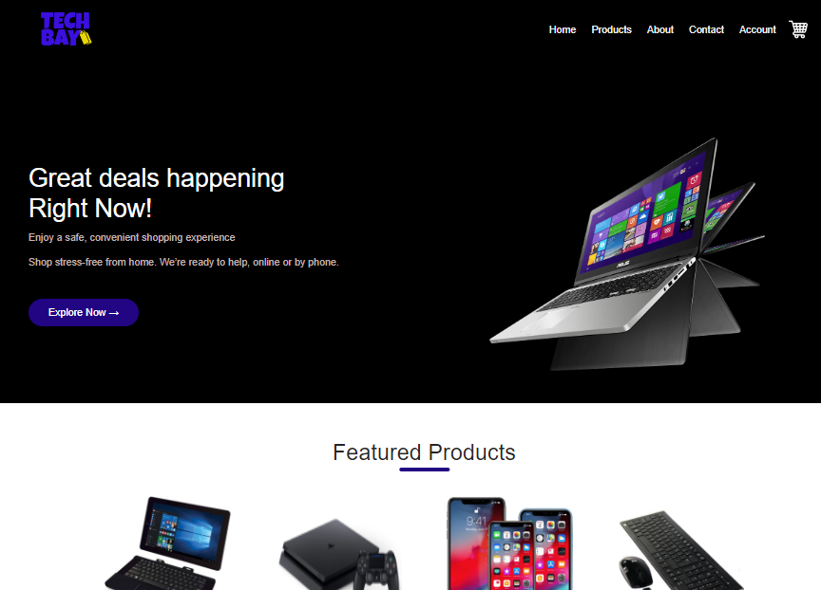

**Main portal**

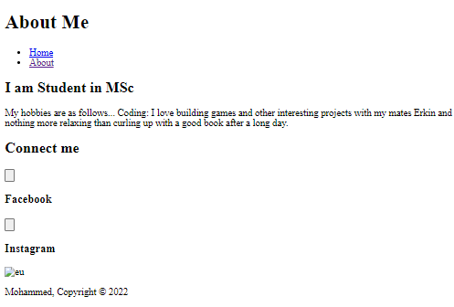

**About page**

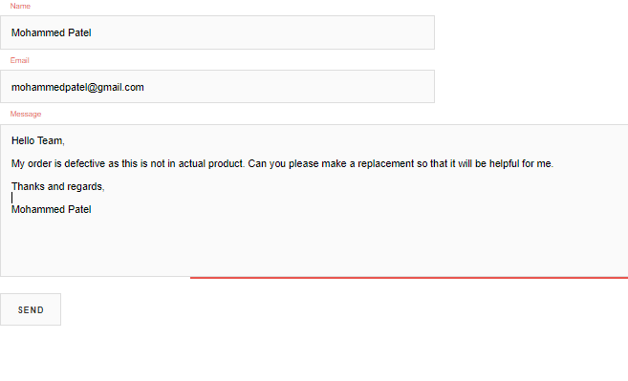

**Contact Page for the customers.**

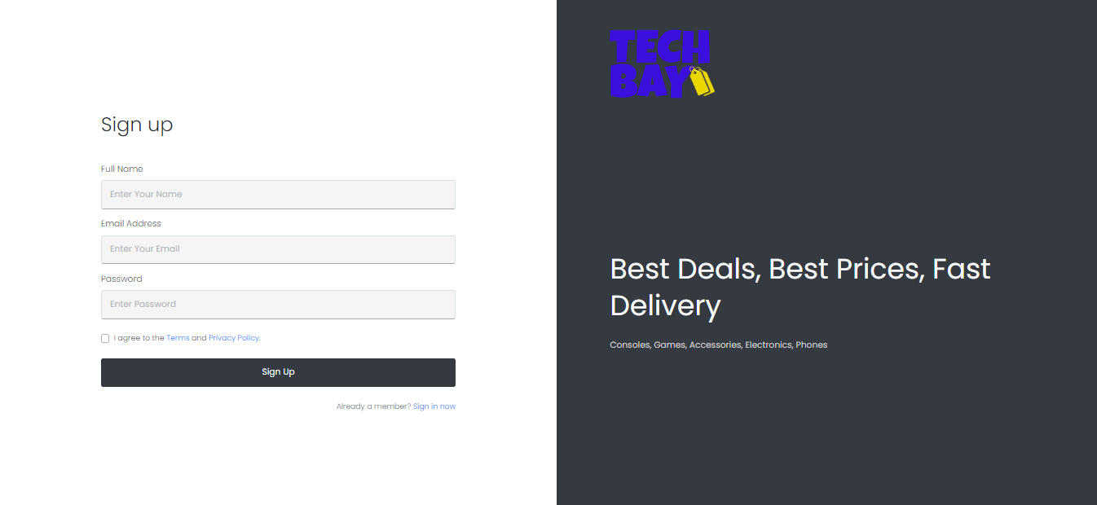

**Login Page**

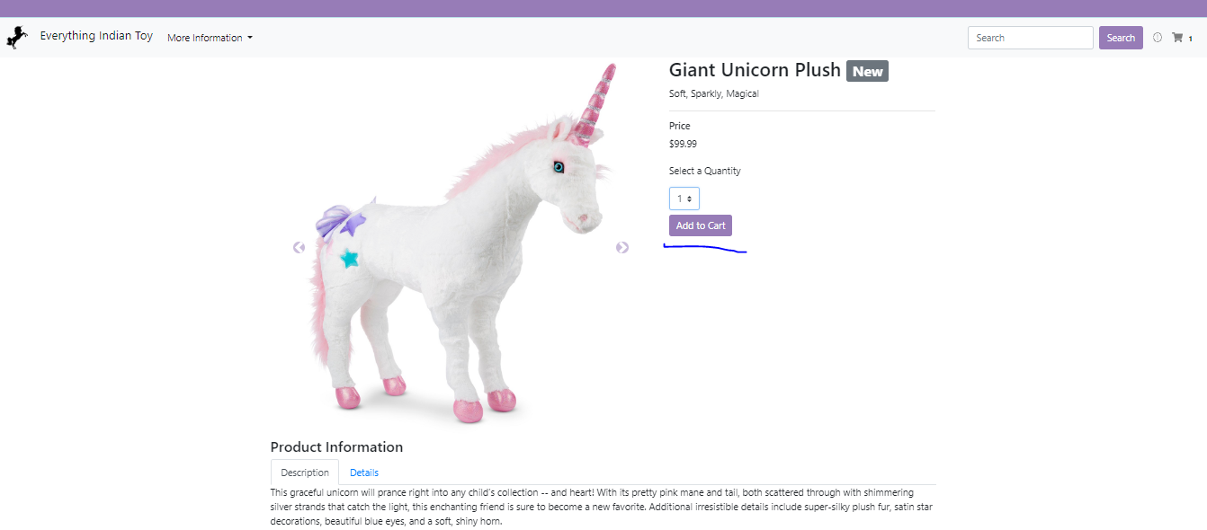

**Adding to cart**

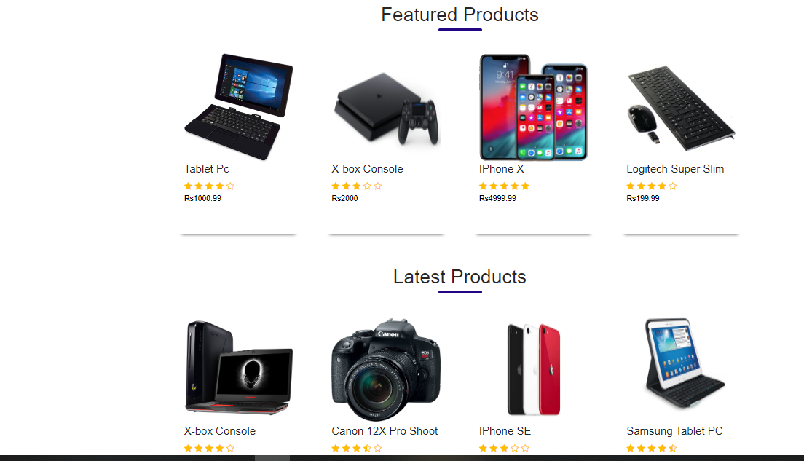

**Products available on the website for sale.**

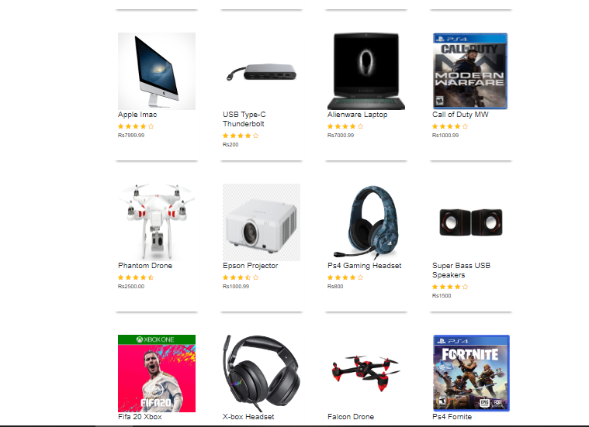**Products available on the website for sale.**

Revenue Model:

The platform is free and we offer many services free of charge to get customers.

For Farmers:

• Subscribe is free

• Advertising is free

For Companies

• Subscribe (in first year) is free.

• Advertising for any good less than 5000$ is free

• For good more than 5000$ will get only 5% on transaction

We will get our revenue from tow operations:

1. Transaction: we take 5% from any transaction between farmers and company.

2. Information: we offer contacts’ information from farmer to farmer(F2F). when farmer can browse the products of others and compare between them free, and when he decides to buy or exchange with one he have to make contact with him then he ask about the contacts. In that case he has to pay to get the contact

Market Opportunity: We are:

• The first online platform to exchange between farmers (F2F), and companies(F2C). • Good infrastructure in communications

• The size of the agriculture market (Great revenue)

• The size of irrigation farming (Unseasonal Revenue)

Competitive environment

In resent time there is no competitive on online agricultural marketing in both countries. May

be in near future we will face some competitive.

The other competitor work in the traditional commerce.

Competitive Advantage:

• First and Free: been the first is a big advantage if we manage it will. We looking to get

a big and various partners to get financial position and market name (trust).

• Advertising Plan: Reaching at least 20% of the farmers in irrigated sector and 7% in the rain sector.

• Partners: we can reach government (Ministry of agriculture), Commercial bank, big Companies and Organization.

• **Market Strategy**

|  |  |
| --- | --- |
| **Category** | **Strategy** |
| Target Market | Small to medium companies, small to medium electronics |
| Positioning Statement | The best online agricultural App for exchanges and Buy |
| Offering to customers | Free Advertise, subscribe, and platform |
| Price Strategy | From 10% to 2% lower than the market |
| Distribution | Internet gift stores |
| Sales Strategy | Expand by 10%, hire a national account manager |
| Service Strategy | Available online, and offline |
| Promotion Strategy | Develop a new campaign that focuses on the positioning, emphasize higher price and customer look |

|  |  |
| --- | --- |
| Marketing Research | Conduct customer audit and identify new market opportunities |
| Any other component of your marketing plan | Using social media and social network marketing |

Requirements Software Requirements

• Operating System : Windows 10/8/7 or Linux

• User Interface : HTML, CSS

• Client-side Scripting : JavaScript, Ajax • Programming Language : Php

• Database : MYSQL

• Server Deployment: Apache, Web services

Hardware Requirements

Linux Server with a complete LAMP installed.

Android and IPhone for customers (Additional)

• Allow the businessman to change the look and feel of the site with ease.

• Allow the shopkeeper to view different configuration options and update them.

Technical constraints:

- Technologies and software to use: No particular constraints. The service provider can offer

external services and software if it reduces the cost of creating and managing the site.

- The site must be compatible with all standard browsers: Google Chrome, Android, Mozilla FireFox, Internet Explorer, Safari & Opera. Compatible versions must be explicitly defined by the provider).

- The host will be selected and the accommodation set by the provider, but directly billed to "E-agriculture".

- Third-party systems will potentially be integrated later in the activity: social networks, accounting, billing, emailing, marketing automation, CRM, webanalysis. The development of the site must take this into account and make these future integrations easily feasible.

Expected benefits:

- Design: Realization of models for each of the main pages listed in the site tree.

- Integration: Integration of these models after validation - Website and back office development

- Creation and configuration of the database of the site

- Domain Name: The domain name will be purchased by us once the company is created.

- The host must be selected and the hosting set by the provider, but directly billed to "E-commerce".

- Maintenance: The service provider must include in the estimate a commercial proposal for all maintenance activities following the start of production of the site.

- Training in the management of the site: The service provider will have to organize a training for the team of "E-commerce" as well as a document of help describing the actions to be carried out for the good management of the current activities.

- Marketing support: The provider can be force of proposal. All elements related to marketing support (Social Media).

ANALYSIS:

Farmers need to buy lots of tools or products from an commerce shop. It may be pesticides,

seeds, or need experience from another electronics. Now a days, it is really hard to get some time to go out and get them by ourselves due to busy life style or lots of works. In order to solve this, B2B E-Commerce websites have been started. Using these platform, electrnoics companies can buygoods or products online justbyvisitingthe websiteand orderingthe item onlinebymaking payments online.

Payment mode:

Among the various means of payment, several parameters determine the choice which is the

most appropriate for the consumer. This choice will induce some legal issues, we need third party to make any trust transaction.

None of the many transaction tools have yet emerged as standard. Several types of payment methods can be distinguished:

- The Postal card (used frequently): is the most used way on the internet the user communicates its number with its expiry date. The risks interception of the postal card number are low.

- A systematically authorized debit card is a payment card that systematically requests

authorization (online transaction) and checking of the bearer's account for each transaction, in order to verify that it is sufficiently stocked. If the provision is sufficient, the transaction is accepted and the amount of the authorization is taken into account for future authorizations issuance (like a transaction made by a conventional card that has been the subject of a request for authorization); otherwise, it is refused.

- Off-line intermediation: means of payment also use an off-line intermediation. The electronics, while connected, gets, third party to communicate his postal or bank card number, a secret number through which it performs the transaction with the server of the seller. Recourse to this third party would help build confidence between the seller and the buyer while ensuring the security of the payment and authentication of the exchange.

Conclusion & Perspectives:

Our platform is the first and real E-commerce site in electronics sector, even we tried to resolve so many problems related to people life, and electronics environment, the system need some many revisions and may be extended to be not only B2B model but also B2C model, we can sell and buy so many electronics products, also can be C2C model when we make transactions between farmers. The system is difficult to deploy and getting trust from people in the two countries, need supplyfrom third partysuch government. A lot of people are literate and didn’t have internet culture so we may develop search pattern focus on speech.