DEWATERING TRIAL REPORT
Portable Pump Trial – AGL Manholes, Taxiway G and Taxiway M

Airport | Zayed International Airport (OMAA), Abu Dhabi
Trial dates | 06 and 07 July 2026, 15:30 – 18:00 (approved closure windows)
Locations | Taxiway G (K – L2 and L3 – C centreline) and Taxiway M (L – H centreline)
Carried out by | AGL Team – ADB SAFEGATE, with FM Civil support
Reference | Condition Survey AUH-CS-DW-001 Rev A / PTW-ZIA-0818 / NOC-21-37/EXT-10
Prepared by | Mohammed Faheem – AGL Team Leader

1. Background
After the recent adverse weather, a large number of AGL manholes on the airfield are holding water. FM proposed using portable pumps instead of the dewatering tanker to clear them. A two-day trial was arranged on Taxiway G and Taxiway M to check on the ground whether portable pumps can actually leave the manholes dry. This report gives the result of that trial, the photos taken on site, and the difficulties we faced.
2. Trial Locations and Summary
Day | Date | Location | Manholes planned | Result
1 | 06/07/2026 | Taxiway G, between K and L2 | 15 | Bulk water pumped out. About 50 mm of water left in every pit.
2 | 07/07/2026 | Taxiway G between L3 and C, and Taxiway M between L and H | 18 | Bulk water pumped out. About 50 mm of water left in every pit.

The target for dewatering is a dry chamber, because the whole point of the activity is to protect the primary cable joints and allow IR testing and cable connection works. On that basis, none of the manholes attempted over the two days were completed. The pump removed the bulk of the water in each pit, but a layer of roughly 50 mm always remained on the floor, sitting directly on the cable loops and joints.
3. Photographs from Site
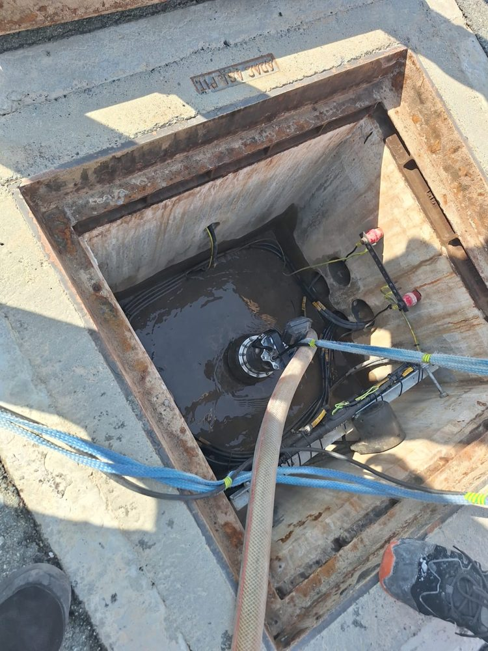
Photo 1 – Submersible pump rigged in an AGL pit on Taxiway G during bulk pumping.
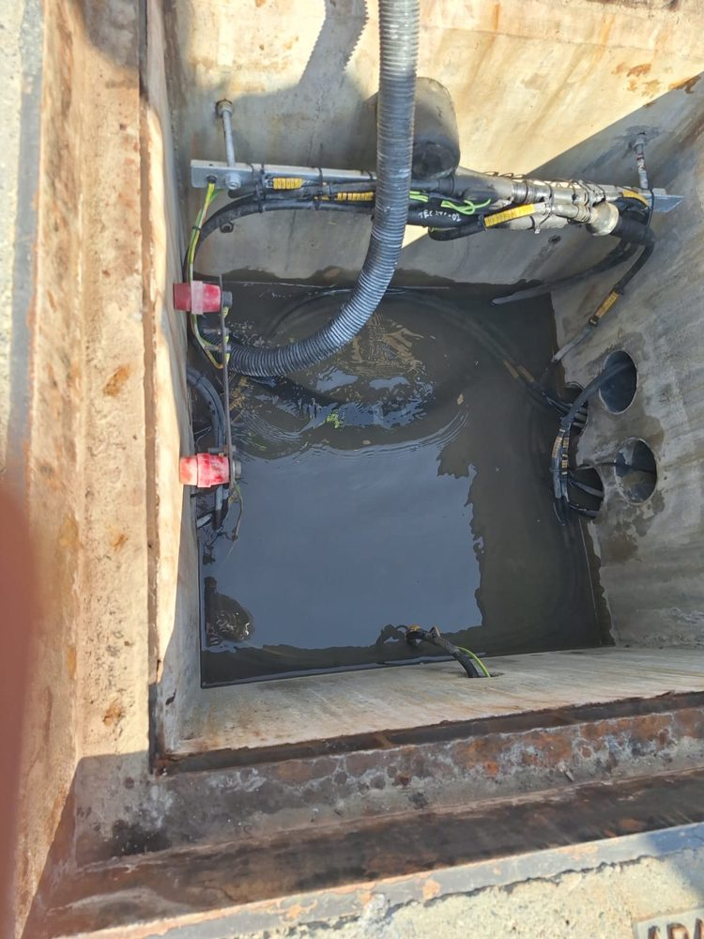
Photo 2 – Deep pit after bulk pumping. The pump has reached its limit and the remaining water still covers the whole chamber base. Duct entries are visible in the wall on the right.
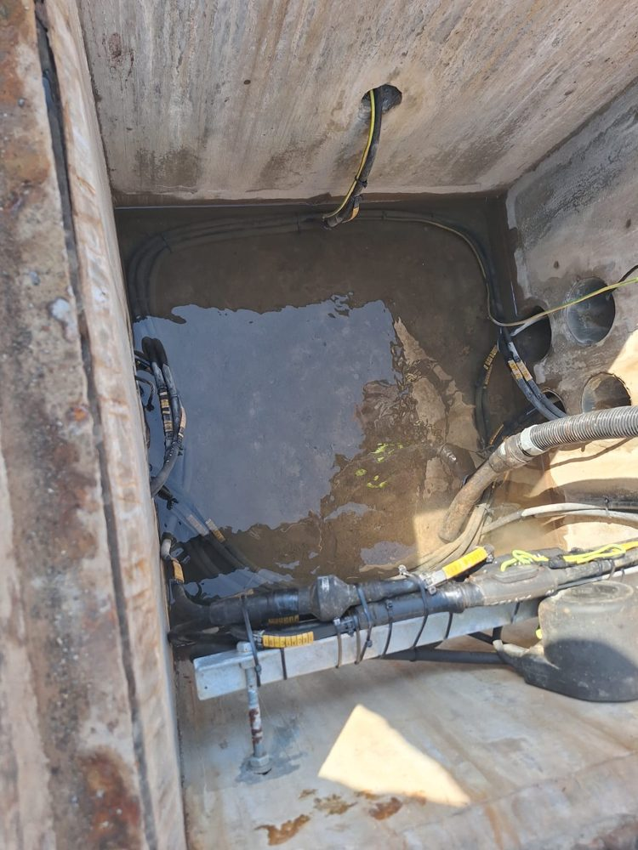
Photo 3 – Residual water layer on the chamber floor. The primary cable loops and joints are lying in this water, with the earth conductor also entering it.
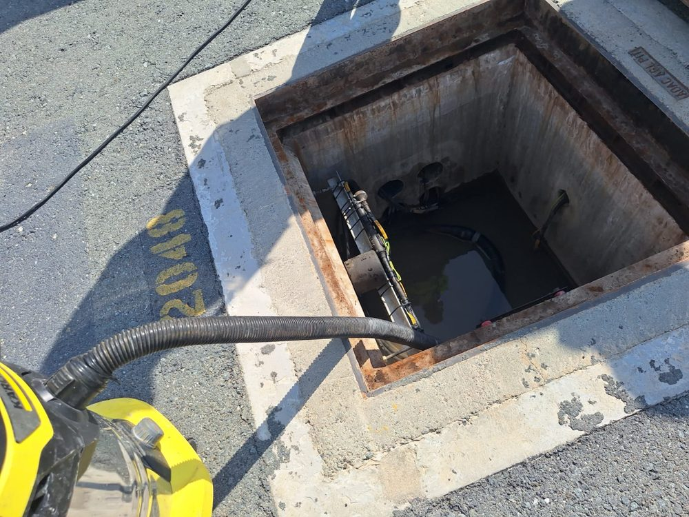
Photo 4 – Small wet-vacuum used to try to pick up the leftover layer from the surface. The drum is around 20 litres against roughly 70 litres of water per pit.
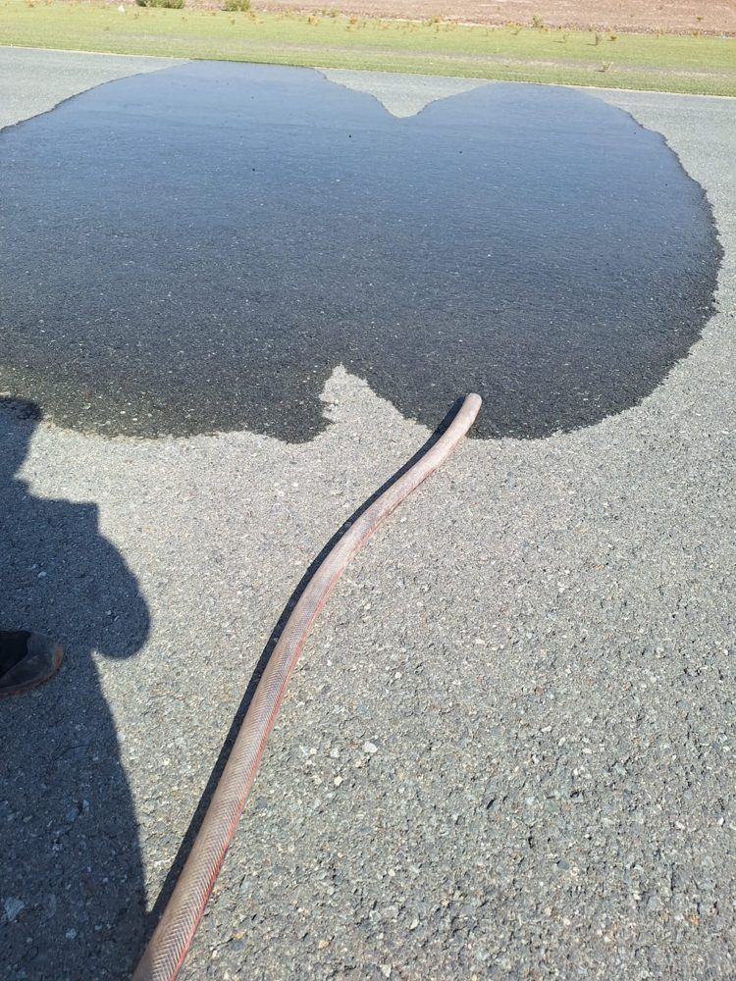
Photo 5 – Pumped water pooling on the surface next to the work area. There is no drainage trench within hose reach at these locations.
4. Difficulties Faced
The main problems during the trial were the following:
- Residual water the pump cannot lift. The portable pump is a centrifugal submersible type. Once the water level drops to about 50 mm above the pit floor it starts drawing air and loses suction, so it cannot go lower. This is a limitation of the pump type itself, not a fault of the operators or the setup. The 50 mm left behind is exactly the layer that keeps the cable joints wet (Photos 2 and 3).
- Wet-vacuum too slow for the job. We tried finishing each pit with a small wet-vacuum (Photo 4). With a 20-litre drum against about 70 litres of leftover water per pit, each pit needs 3 to 4 fill-and-empty rounds, roughly 15 to 20 minutes of vacuuming alone. Across a group of 13 to 18 manholes, that alone is more time than the 2.5-hour closure window allows. The silt in the water also clogs the vacuum filter, so it gets slower pit after pit, and from the surface it cannot reach the low spots and duct mouths around the cables.
- Nowhere to discharge the water. There is no serviceable drainage trench within hose reach of these locations, so the pumped water ended up pooling on the adjacent surface (Photo 5). This softens the graded ground, creates standing water airside (a bird and FOD hazard next to active taxiways), and part of it soaks back into the duct network, refilling the same pits we just pumped.
- Time per pit and circuit downtime. With setup, bulk pumping, the vacuum attempts and putting covers back, the rate achieved is well below one location group per closure window. That means the AGL circuits stay isolated (LOTO) for longer than the work justifies.
All four of these problems were already flagged as constraints in the condition survey AUH-CS-DW-001 Rev A before the trial. The trial confirmed each one in practice.
5. Why the Leftover Water Matters
The AGL series circuits run at several kilovolts, and their health is checked by insulation resistance (IR) testing. The leftover water is silty rainwater sitting directly on the primary cable joints, and every wet joint leaks current to earth. Since one bad point pulls down the reading for the whole circuit, a single wet manhole is enough to keep an entire circuit below its maintenance limit. Long immersion also pushes moisture into the connector interfaces, and that damage does not fully recover once the water is removed. This is why “bulk water removed” is not good enough – the chamber has to be dry. While the pits stay wet, IR rectification and cable connection works in these areas remain blocked. Post-event IR testing of the circuits through the affected areas is in progress and readings below the limit will be raised as defects.
6. Conclusion and Way Forward
The portable pump method, as tried on 06 and 07 July, cannot deliver dry manholes. It is suitable for removing bulk water only. To make dewatering workable, the following is needed before any further mobilization:
- Bring back the FM dewatering tanker (vacuum extraction) for adverse-weather dewatering, as per the SLA – this is the only method demonstrated to leave the chambers dry; or
- If portable pumps are to be used again, add a residue/puddle pump that can suck down to about 5 mm, plus a proper industrial wet-vacuum and longer hose sets (30 – 60 m).
- Arrange an approved discharge route at each location group. No discharging onto unpaved graded ground.
- AGL to complete the post-event IR testing and record the readings.
- FM and Operations to acknowledge this report before the dewatering program resumes.
Until these points are closed, the dewatering forecast (around 315 manholes) stays on hold.

7. Sign-off
Prepared by – AGL Team Leader | Mohammed Faheem | Date:
Reviewed by – AGL Manager | Ragesh Menon | Date:
Approved – ADA AGL |  | Date:
Acknowledged – FM |  | Date:

