Postmortem

500 Internal Server Error:

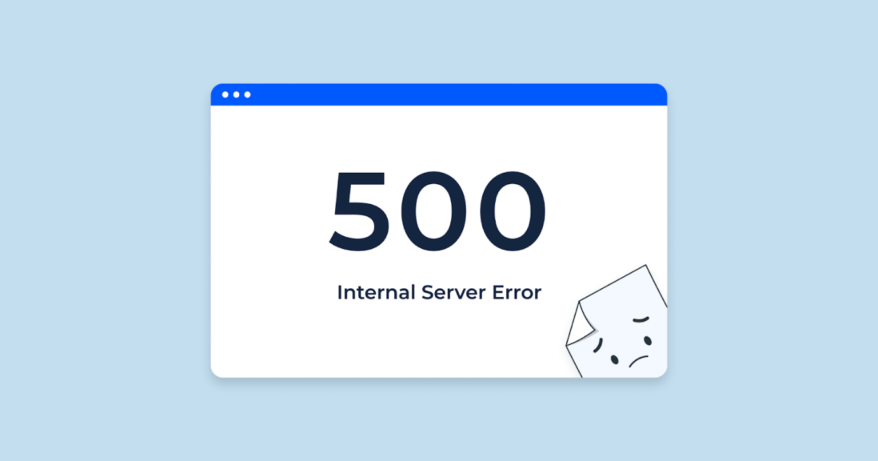

     During my work with ALX server, I always find a problem to deal with this error as I did not understand what it mean, so I start to learn about that error,

The Hypertext Transfer Protocol (HTTP) **500 Internal Server Error** server error response code indicates that the server encountered an unexpected condition that prevented it from fulfilling the request.

So after I understand the meaning of the error I fix it, and It was an error due to code written wrong so the server run this error