Use Case Diagram



Sequence Diagram



Class Diagram

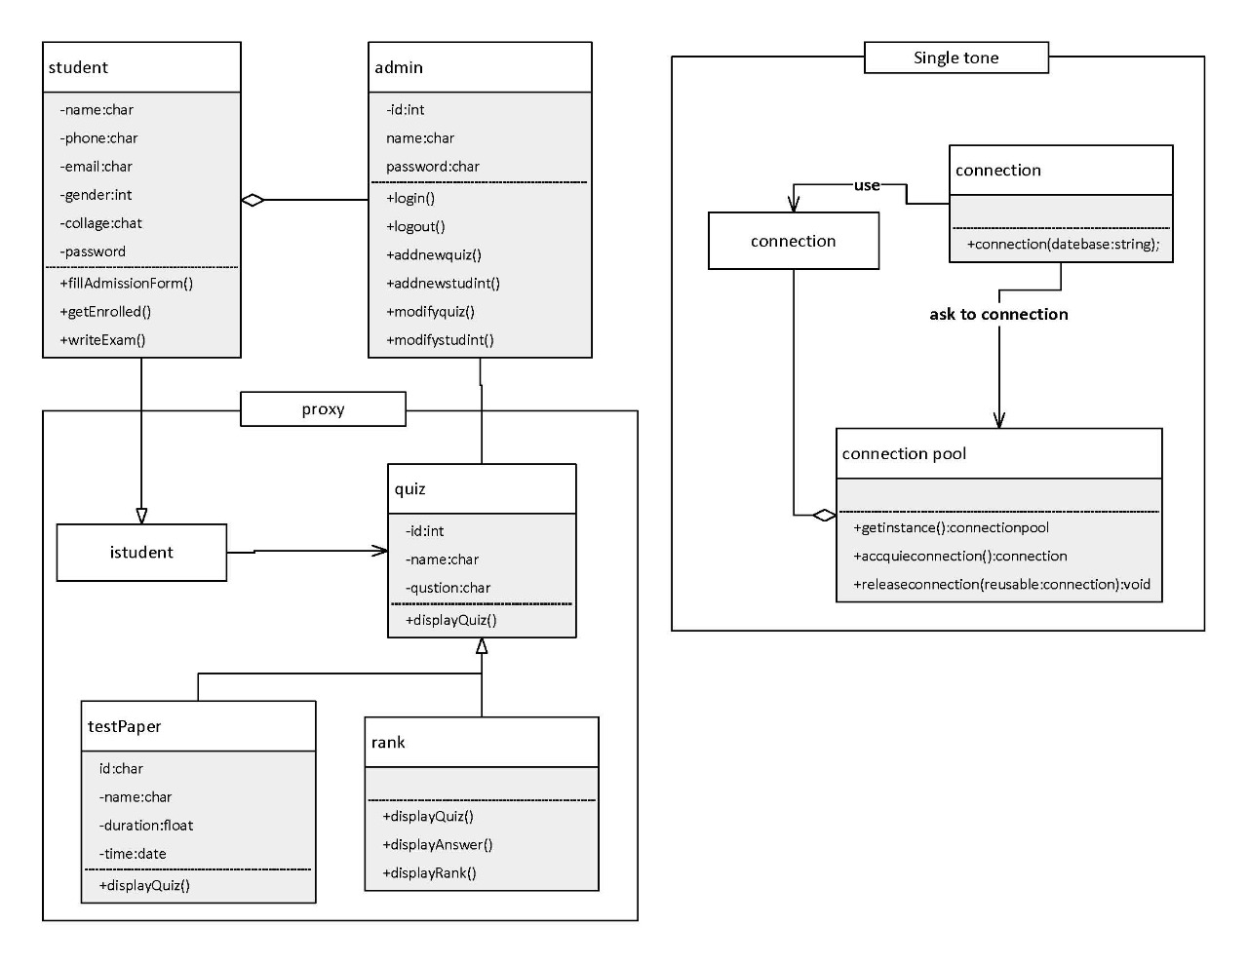

ERD

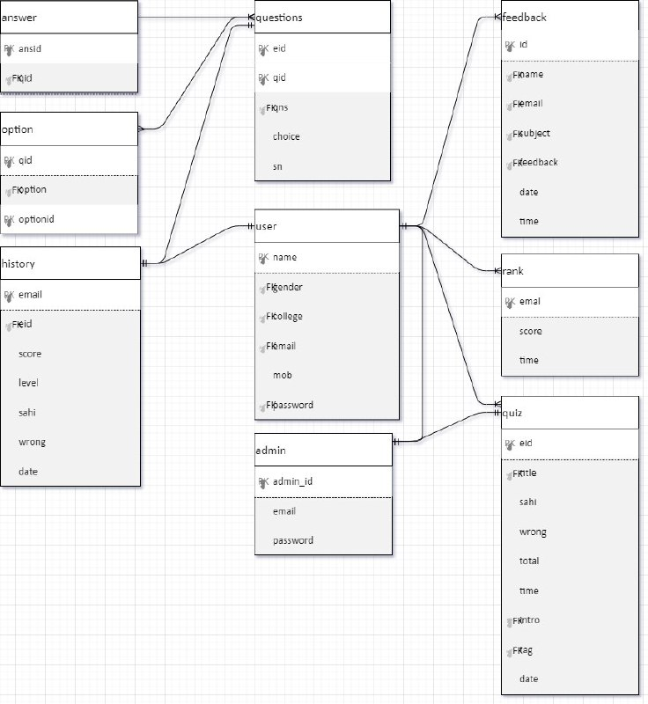

ERD

