Colleges of Excellence (COE)
eCAPS Module 0.3
Business Logic

Document Information
Document Description
Title: | eCAPS Module
Document Issue: | 0.3
Date: | 01-Oct-22
Document Status: | Proposed

Document Versions
Versions
Version No. | Date | Cause of Change
0.1 | 10-Aug-22 | First Version
0.2 | 1-Sep-22 | Trainee Functionality
0.3 | 10-Sep-22 | CRs added

Document Approvals
Approvals
Version No | Date | Name | Position

Table of Contents

1 Document Information 2
2 Document Versions 2
3 Document Approvals 2
4 eCAPS Module 7
4.1 Purpose 7
4.2 Project Overview 7
4.3 Functional Requirements 7
4.4 Business To-Be Process 9
4.4.1 eCAPS Level 0 DFD diagram 10
4.4.2 eCAPS Business Process diagram 10
4.5 Actors 11
4.5.1 Actors diagram 12
4.6 Use Cases 12
4.6.1 Use Cases diagram 12
4.6.2 Login 13
4.6.2.1 Login Use Cases diagram 13
4.6.2.2 UC-01 Login 13
4.6.3 User Management 14
4.6.3.1 User Management Use Cases diagram 15
4.6.3.2 UC-02 List Users 15
4.6.3.3 UC-03 View User Details 17
4.6.3.4 UC-04 Add Qualification to Trainer 20
4.6.3.5 UC-05 Delete Qualification from Trainer 22
4.6.3.6 UC-06 Add Trainee to Trainer 23
4.6.3.7 UC-07 Delete Trainee from Trainer 25
4.6.4 Qualification Management 26
4.6.4.1 Qualification Management Business Process diagram 26
4.6.4.2 Qualification Management Use Cases diagram 27
4.6.4.3 UC-08 Maintain Grade Scheme 27
4.6.4.4 UC-09 List Qualifications 30
4.6.4.5 UC-10 Qualification Builder 31
4.6.4.6 UC-11 Set Qualification Grade Schema 34
4.6.4.7 UC-12 Maintain Unit Skill Scope 35
4.6.4.8 UC-13 Maintain Skill/Learning Outcome 38
4.6.4.9 UC-14 Maintain Performance Criteria 41
4.6.4.10 UC-15 View Capstone 43
4.6.4.11 UC-16 Maintain Capstone 45
4.6.4.12 UC-17 Maintain Capstone Resources 47
4.6.4.13 UC-18 Maintain Capstone Task 49
4.6.4.14 UC-19 Maintain Capstone Task Grading 51
4.6.4.15 UC-20 Maintain Capstones Final Scoring 55
4.6.4.16 UC-21 Activate Capstone 56
4.6.5 Trainee Management 57
4.6.5.1 View Trainee Portfolio diagram 58
4.6.5.2 UC-22 Search Trainee 59
4.6.5.3 UC-23 View Trainee Portfolio 62
4.6.5.4 UC-24 View Trainee Information 64
4.6.5.5 UC-25 View Qualification Folder 66
4.6.5.6 UC-26 View Skill/Learning Outcome 70
4.6.5.7 UC-27 View Evidence 71
4.6.5.8 UC-28 View Evidence Folder 73
4.6.5.9 UC-29 View Unit Summary 76
4.6.5.10 UC-30 View Capstone Unit 78
4.6.5.11 UC-31 View Capstone Summary 79
4.6.5.12 UC-32 View Capstone Grade 81
4.6.5.13 UC-33 View Feedback/Appointments 82
4.6.6 Evidence Management 85
4.6.6.1 Evidence Management Business Process diagram 85
4.6.6.2 Evidence Management State Machine diagram 85
4.6.6.3 Evidence Management Use Cases diagram 86
4.6.6.4 UC-34 Accept Trainee Declaration 87
4.6.6.5 UC-35 Add Evidence 89
4.6.6.6 UC-36 Cross Reference Evidence 91
4.6.6.7 UC-37 Edit Evidence 93
4.6.6.8 UC-38 Delete Evidence 94
4.6.6.9 UC-39 Add Capstone Evidence 95
4.6.6.10 UC-40 Update Progress 97
4.6.7 Grading Management 98
4.6.7.1 Grading Management diagram 98
4.6.7.2 Grading Management Use Cases diagram 99
4.6.7.3 UC-41 Accept Assessor Declaration 99
4.6.7.4 UC-42 Grade Unit 101
4.6.7.5 UC-43 Edit Grade Unit 103
4.6.7.6 UC-44 Refer Unit 105
4.6.7.7 UC-45 Grade Skill/Learning Outcome Evidence 107
4.6.7.8 UC-46 Refer Skill/Learning Outcome Evidence 109
4.6.7.9 UC-47 Grade Capstone Unit 111
4.6.7.10 UC-48 Reset Graded Unit 113
4.6.8 Verification Management 114
4.6.8.1 Verification Management Use Cases diagram 114
4.6.8.2 UC-49 Verify Graded Unit 114
4.6.8.3 UC-50 Refer Graded Unit 116
4.6.8.4 UC-51 Verify Unit/Skill Outcome 117
4.6.8.5 UC-52 Refer Graded Skill/Learning Outcome 119
4.6.8.6 UC-53 Verify Graded Capstone 121
4.6.9 Feedback Management 122
4.6.9.1 Feedback Management Business Process diagram 122
4.6.9.2 Feedback Management diagram 122
4.6.9.3 UC-54 Send Feedback by System 123
4.6.9.4 UC-55 Send Feedback 124
4.6.9.5 UC-56 Schedule Appointment 126
4.6.9.6 UC-57 Print Feedback 128
4.6.9.7 UC-58 Acknowledge Appointments 129
4.6.10 Reports 130
4.6.10.1 Reports diagram 130
4.6.10.2 Trainees Reports 131
4.6.10.2.1 UC-59 Overall Qualification Progress Report 131
4.6.10.2.2 UC-60 Portfolio Progress Report 132
4.6.10.2.3 UC-61 Capstone Progress Report 133
4.6.10.2.4 UC-62 Graph Report 134
4.6.10.3 Common Reports 135
4.6.10.3.1 UC-63 Overall Qualification Progress Report 135
4.6.10.3.2 UC-64 Trainee Wise – ePortfolio Report 137
4.6.10.3.3 UC-65 Unit Wise – ePortfolio Report 138
4.6.10.3.4 UC-66 Grade Report Graph 140
4.6.10.3.5 UC-67 Unit Report Graph 141
4.6.10.3.6 UC-68 Capstone Report Graph 142
5 Glossary 143

eCAPS Module

- electronic Capstone and Portfolio system (eCAPS) is module to provide portfolio and Capstone functionality

Purpose

- The purpose of this document is to present a detailed description of the eCAPS Module as a part of ePortal.
- It will explain the purpose and features of the module, the interfaces of the module, what the module will do, the constraints under which it must operate and how the module will react to different users.
- This document is intended for both the stakeholders and the developers of the system and will be proposed approval.

Project Overview

- eCAPS is a module used to track a trainee's or learner's progress toward a qualification using the ePortfolio feature, the evidence the trainee or learner has provided, and their advancement over the course of their academic career.
- eCAPS will make it easier for COE to control the trainee/user learner's journey through an admin account.
- Each training provider will have an administrator who can view the electronic portfolio.
- The learner's progress through the qualification would be monitored collaboratively by COE admin and the college/training provider.
- Qualification is broken down into different units (Topics).
- Each unit includes specific learning objectives that are used to gauge the trainees' competency.
- Each skill learning outcome is accompanied by a set of performance standards.
- For each unit, skill, or learning outcome, the learner should provide relevant evidence.
- Assessor would evaluate the data and assign a grade for the unit.
- Internal Verifier would examine and confirm

Functional Requirements

REQUIREMENTS
- Admin user to generate predefined reports.

System should allow admin user to generate predefined reports.
- Assessor feedback should have upload or create file.

Assessor should be able to give overall feedback for a capstone. Either upload the feedback of provide a box for the feedback.
- Assessor to give overall feedback for a capstone.

Assessor should be able to give overall feedback for a capstone. Either upload the feedback of provide a box for the feedback.
- Assessor to grade submissions based on defined rules

System should support grading of learners and submissions based on defined rules
- Assessors to view, track and monitor Learner’s submissions.

System should allow assessors to view, track and monitor Learner’s submissions.
- COE admin to define grade boundaries for qualification

System should allow COE admin to define grade boundaries for a qualification and modify those when required.
- COE admin to manage qualifications.

The system should allow COE admin to manage qualifications.
- COE admin to manage Training Providers/Colleges.

System should allow COE admin to manage Training Providers/Colleges.
- COE/College admin to assign role to their staff

System should allow COE / College admin to assign role to their staff (Assessor/IV/ EV) and assign Learners to Assessor.
- eCAPS to use ePortal metadata

System should use ePortal system for learners’ enrolment, Qualification metadata and Training provider information.
- Learner enrollment status from ePortal

System should reflect the updates in learner enrollment status from ePortal for a qualification and their progression.
- Learners and assessors to submit outcome evidence

System should allow learners and assessors to upload evidence for the tasks assigned to a learner
- Milestones for every trainee 25% completion

- We want some gamification for trainees and other users. e.g., there are milestones for every trainee i.e., 25% completion, 50% completion, 75% completion and then 100% completion.
- These milestones are for college as well for each qualification and for each entire college.
- let us say on trainee page and on other pages (like reports) we will have 4 stars. * * * *.
- Every star means 25% or overall completion. These stars are also milestones.
- As soon as trainee finishes first 25%, he/she will get one start and will be visible to every user against that trainee.
- System will calculate trainee percentage and will assign these stars.
- Portfolio will have yellow star and capstone might have blue star. only one star for capstone.
- Semester in Reports

More filters for semesters/batches are required. At present there is no way to know if trainee is in semester 1 or not
- Semester in Search Trainee

For Search functionality we need to identify Semester 1 and Semester 2 trainees.
- System should provide progress of Grading in Reports

Admin Assessor would like to see trainees progress of upload and a progress of grading (Graded vs Uploaded) in reports and screens.
- Trainee Qualification History

System should provide Trainee Qualification History even in another college.
- Trainee, Assessor, IV or any user to see the previous history of a trainee.

- A trainee, Assessor, IV or any user should be able to see the previous history of a trainee.
- Example once a trainee moves to next level, he/she should be able to see the progress of last level. but just the summary. In stage one we do not want to allow downloading of the evidence for any user other than COE Admin
- Every diploma qualification has a pre-requisite qualification mapped in the system. you need to pick that qualification and check the status whether it is graduated or not. if it is graduated. it does not matter which college was it.
- if the question is about how to show the history from previous college. we cannot until the entire history will be moved manually. so, it is ok to not show. or just display a message that trainee belonged to a different college.

Business To-Be Process

- This section describes the high-level business process for eCAPS module

eCAPS Level 0 DFD diagram
Data Flow diagram in 'Business To-Be Process'

Context Diagram showing high level data flow from and to eCAPS

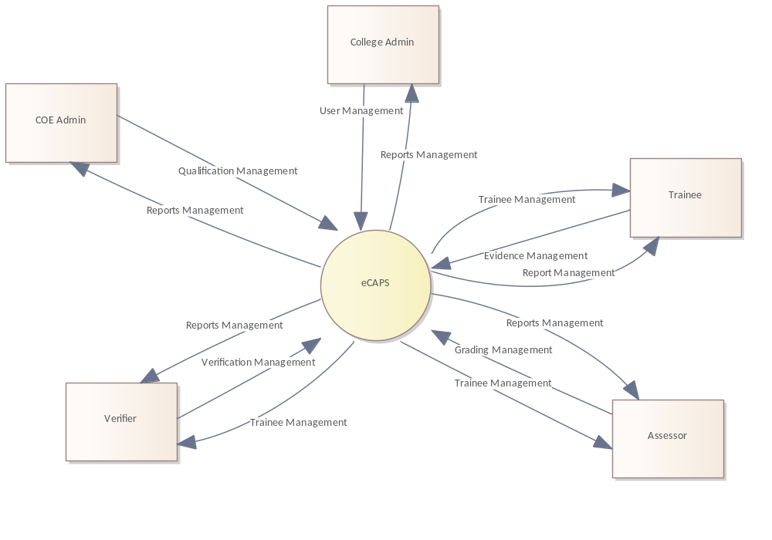

eCAPS Level 0 DFD

eCAPS Business Process diagram
Business Process diagram in 'Business To-Be Process'

- eCAPS Business Process begins with COE Admin
- The COE Admin defines Skill/Learning Scope, Outcomes and Performance criteria for Qualification Units.
- COE admin defines Qualification Capstone, Tasks and Grading Schema.
- College Admin assigns one or more Qualification(s) to Trainer
- College Admin assigns one or more Trainee(s) to be graded by Assessor
- Trainee starts to add evidence to his Qualification Units
- Assessor reviews the provided evidence and grade the Unit
- Verifier reviews and verifies graded Unit

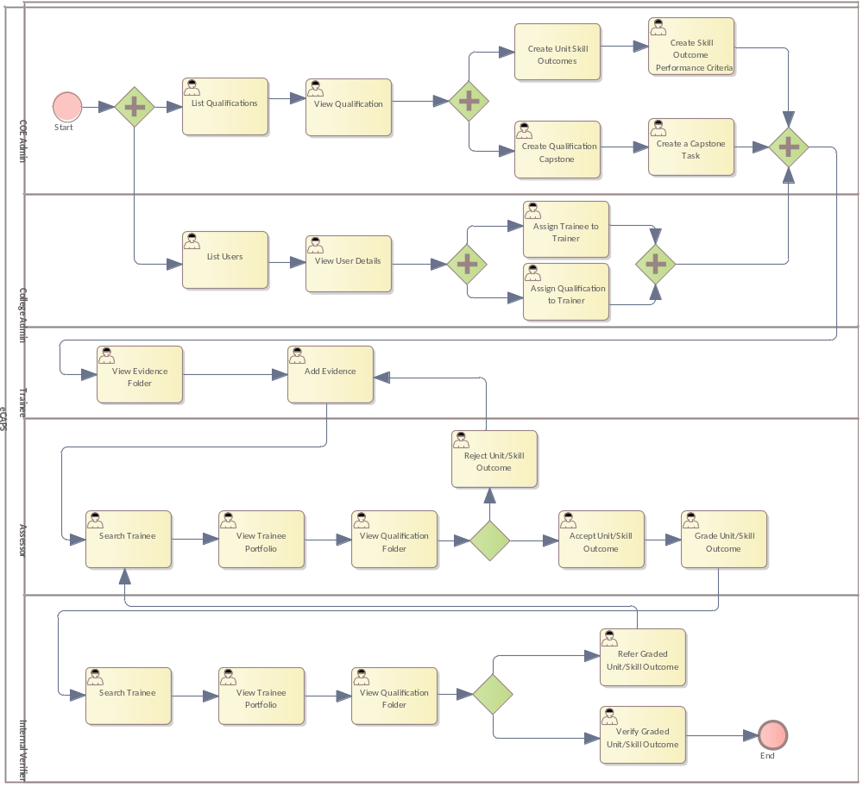

eCAPS Business Process

Actors

- Actors are the users of the system being modeled. Each Actor will have a well-defined role, and in the context of that role have useful interactions with the system.
- A person may perform the role of more than one Actor, although they will only assume one role during one use case interaction.
- An Actor role may be performed by a non-human system, such as another computer program.
- There will be the following major actors who will be using eCAPS system.
- Each actor will have specific set of privileges in the system and will be able to perform specific transaction in the system.
- COE Admin: Is an actor from COE who will administer and manage the system.
- College Admin: Is an actor from the college who can manage operations of the college.
- Assessor: Is an actor from a college who evaluate and grades Trainee/Learner’s performance.
- Internal Verifier (IV): Is an actor from a college who verifies the grades awarded by assessor to Trainees/Learners by sampling.
- External Verifier (EV): Responsible for performing quality check of the grades awarded to Trainees/learners by the training providers.
- Trainee/Learner.

Actors diagram
Use Case diagram in 'Actors'

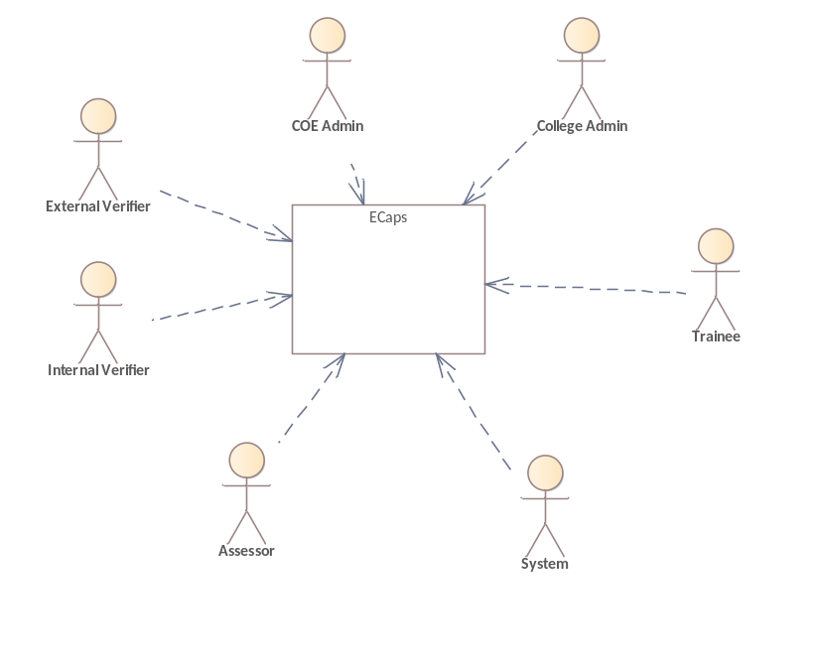

Actors

Use Cases

- Use Cases specify a goal that an Actor wishes to achieve. They describe the interaction between actors and the system and may be left at a high level with just a description of the user goal in this case they are similar to their cousin the user story.
- They can also be detailed where the steps carried by both the Actor and the System are defined in sequence including entities used during the Interaction, possible results and the change of state.

Use Cases diagram
Use Case diagram in 'Use Cases'

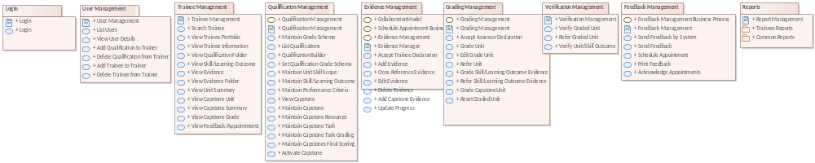

Use Cases

Login

Login Use Cases diagram
Use Case diagram in 'Login'

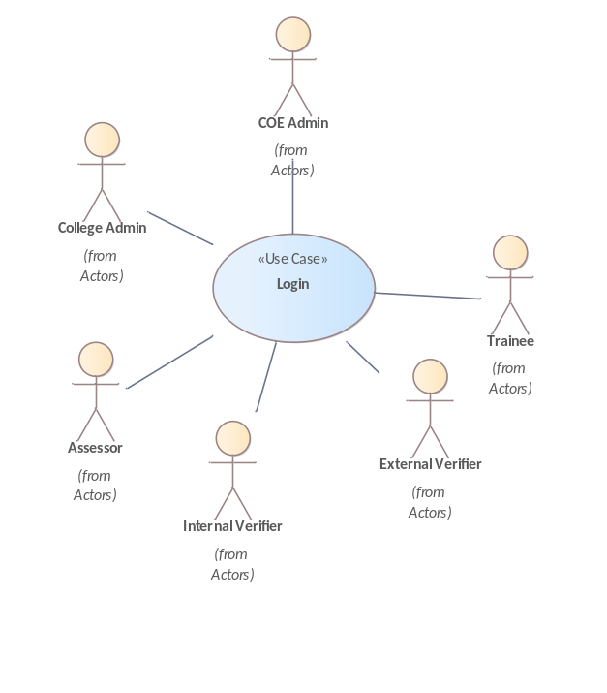

Login Use Cases

UC-01 Login
Use Case in 'Login'

The User's goal is to log into the eCAPS system.

ACTORS
Actor: Assessor
Actor: Trainee
Actor: External Verifier
Actor: COE Admin
Actor: College Admin
Actor: Internal Verifier

PRE-CONDITIONS
A valid user defined in ePortal

SCENARIOS
Main Flow. Main Flow

Re-use the ePortal standard login screen.

POST CONDITIONS
System redirects to user landing page

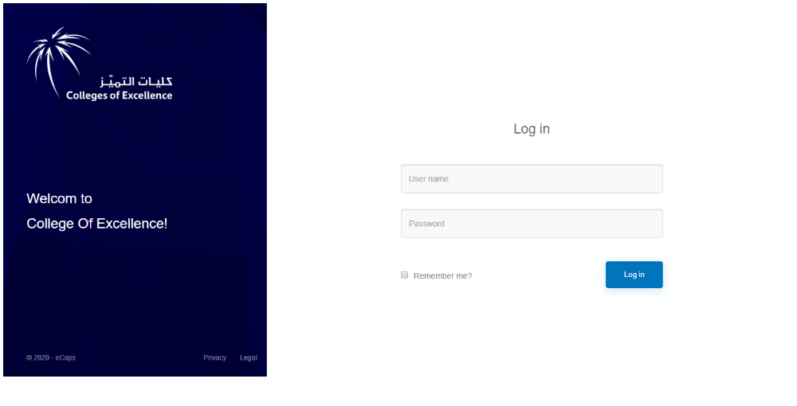

Login wireframe

User Management

- With the help of this collection of use cases, the administrator can grant Assessor/Verifier User access to certain Trainees and Qualifications.
- Only qualifications in the assigned qualification list and only trainees in the assigned trainee list will be accessible to the assessor/verifier.
- Initially, the trainer's list of assigned learners and qualifications is empty.

BUSINESS RULES
Business Rule. College admin can assign only qualifications in his college

Business Rule. College admin can assign only trainees in his college

Business Rule. Assessor can be associated with one college only

User Management Use Cases diagram
Use Case diagram in 'User Management'

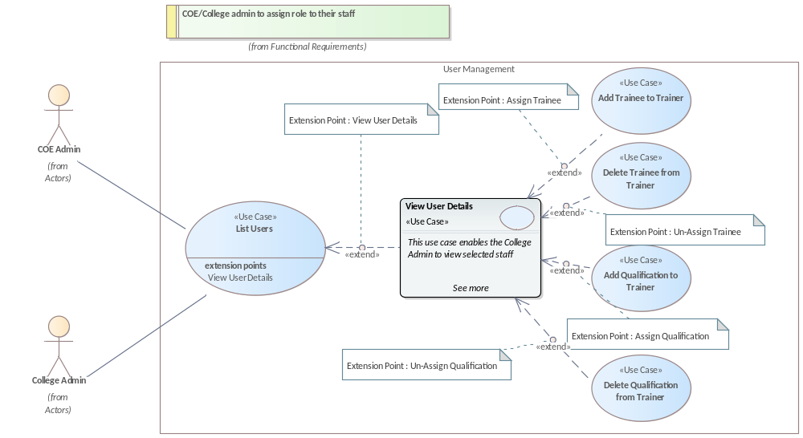

User Management Use Cases

UC-02 List Users
Use Case in 'User Management'

This use case enables the college Admin to search for staff (user)
Search Criteria:
- Staff Code or Name
- Role
Search result records include:
- Staff Name
- Role
- Actions (View) View User Details

It also enables the user to:
- View User Details

ACTORS
Actor: COE Admin
Actor: College Admin

PRE-CONDITIONS
Logged in user with College Admin Privileges
User(s) with Assessor/Verifier role is defined in ePortal

SCENARIOS
Main Flow. Main Flow

1. Use case begins when the User selects User Management
2. System displays User Management Screen
3. User may enter search criteria (Staff Code or Name)
4. User may select Role (Default All)
5. User clicks Search
6. System displays list of users matching the search criteria
Exception: 7a. No Matching Records Found
7. User may view staff details by performing View User Details
8. Use case ends

Exception. No Matching Records Found

1. System displays message

EXTENSION POINTS
View User Details

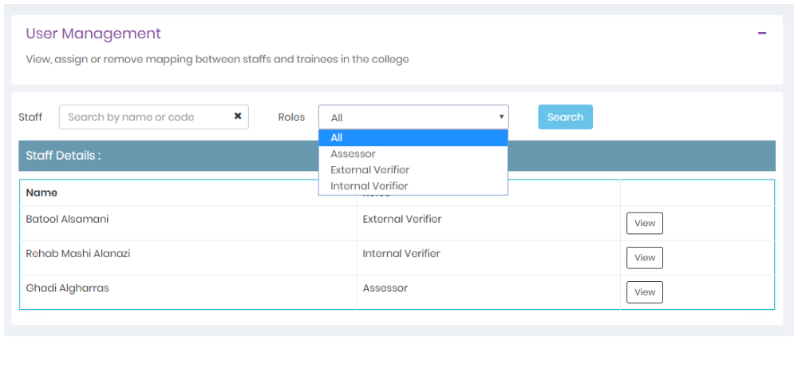

User Management wireframe

UC-03 View User Details
Use Case in 'User Management'

This use case enables the College Admin to view selected staff (User) details, assigned qualifications and assigned trainees.
Staff details include:
- Staff Information
- Qualifications Tab (List of Qualifications assigned to the staff)
- Trainees Tab (List of trainees assigned to the staff)
It also enables the College Admin to:
- Add Qualification to User
- Delete Qualification from User
- Add Trainee to User
- Delete Trainee from User

ACTORS
Actor: College Admin
Actor: COE Admin

PRE-CONDITIONS
Logged in user with College Admin Privileges
User(s) with Trainer role is defined in ePortal

SCENARIOS
Main Flow. View User Details

1. The use case starts when User selects to View User Details
2. System displays Staff Information (Staff Name, Role, National ID)
3. System displays list of Qualifications assigned to the Staff
Alternate: 6a. Search Qualification
4. System displays list of Trainees assigned to the Staff
Alternate: 6a. Search Trainee

Alternate. Search Qualifications

- User enters Qualification Code or Name
- User clicks Search
- System displays list of Assigned Qualifications matching search criteria

Alternate. Add Qualification

- User chooses Add Qualification button
- System performs Add Qualification to Trainer

Alternate. Delete Qualifications

- User chooses to Delete Qualification from Staff Assigned Qualification list
- System performs Delete Qualification from Trainer

Alternate. Search Trainees

- User enters Trainee Code or Name
- User clicks Search
- System displays list of Assigned Trainees matching search criteria

Alternate. Add Trainee

- User clicks Add Trainee button
- System performs Add Trainee to Trainer

Alternate. Delete Trainees

- User chooses to Delete Trainee from Staff Assigned Trainee list
- System performs Delete Trainee from Trainer

EXTENSION POINTS
Assign Trainee

Un-Assign Trainee

Assign Qualification

Un-Assign Qualification

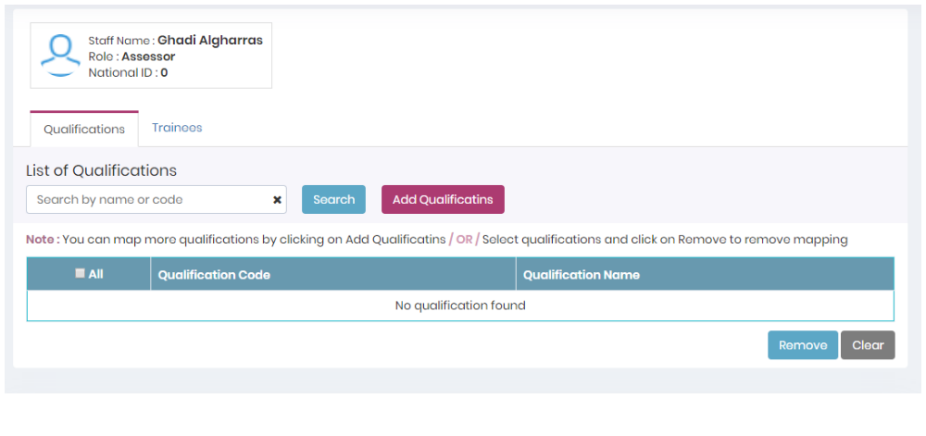

Assigned Qualifications Wireframe

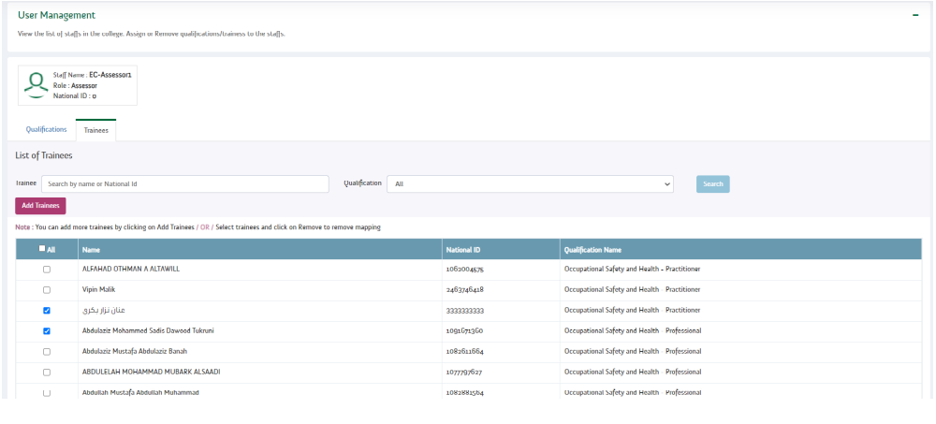

Assigned Trainees Wireframe

UC-04 Add Qualification to Trainer
Use Case in 'User Management'

This use case enables the user to add Qualification to trainer (Assessor/Verifier) Assigned Qualifications List
Assigned Qualifications list is list of Qualifications Trainer can access.

ACTORS
Actor: College Admin
Actor: COE Admin

PRE-CONDITIONS
Logged in user with College Admin Privileges
User(s) with Assessor/Verifier role is defined in ePortal
Qualification(s) already defined in ePortal

SCENARIOS
Main Flow. Main Flow

1. Use case starts when User performs View User Details
2. User selects Qualification Tab
3. System displays list of Qualifications assigned to the Staff in Trainees Tab
4. User clicks Add Qualifications button
5. System displays Add Qualification screen
6. User may search for a trainee by Qualification Code or Name
Alternate: 6a. No Qualification Found
7. System displays list of unassigned Qualifications
8. User selects Qualifications to be added
Alternate: 8a. Select All
9. User clicks Add button
10. System adds selected Qualifications to the assigned trainees list

Alternate. No Qualification Found

1. System displays message

Alternate. Select All

- If User chooses to select all
- System checks all records
- If User chooses to unselect all
- System unchecks all records

POST CONDITIONS
Assessor/Verifier can access the added qualification(s)

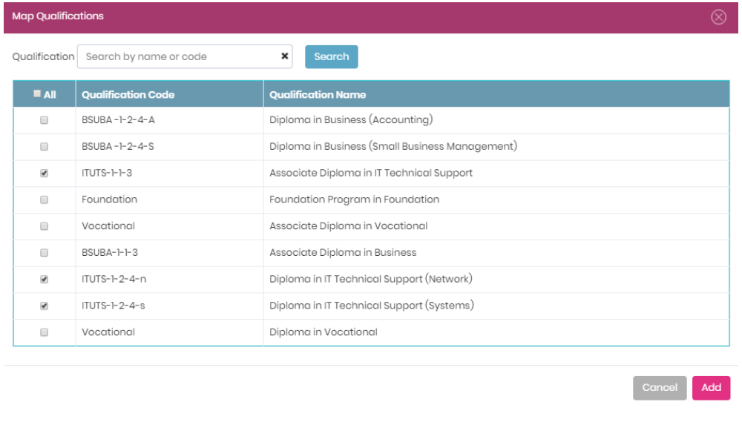

Add Qualification Wireframe

UC-05 Delete Qualification from Trainer
Use Case in 'User Management'

- This use case enables the user to remove Qualification from Assigned Qualification list.
- Assigned Qualification list is list of qualifications staff can access.

ACTORS
Actor: College Admin
Actor: COE Admin

PRE-CONDITIONS
Logged in user with College Admin Privileges
User(s) with Assessor/Verifier role is defined in ePortal
Assessor cannot access the qualification delete from the assigned list

SCENARIOS
Main Flow. Main Flow

1. Use case starts when User performs View User Details
2. System displays list of Qualifications assigned to the selected user
3. User checks Qualifications to be unassigned
Alternate: 3a. Select All
4. User clicks Remove Button
Alternate: 4a. Clear Checked Qualifications
5. System removes the selected qualifications from assigned qualifications list

Alternate. Select All

- If User chooses to select all
- System checks all records
- If User chooses to unselect all
- System unchecks all records

Alternate. Clear Checked Qualifications

- User clicks Clear Button
- System unchecks all Checked records

POST CONDITIONS
Assessor/Verifier cannot access the deleted qualification(s)

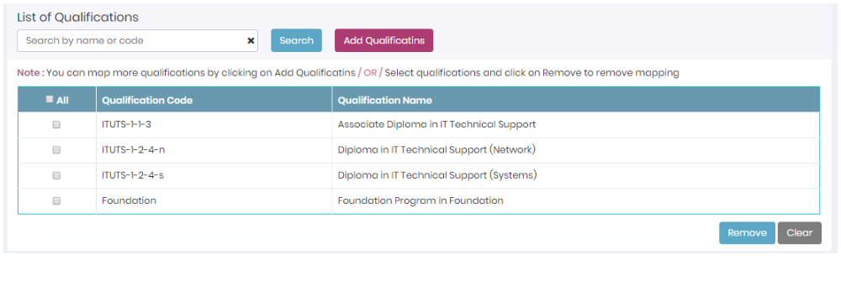

Delete Qualification from Trainer wireframe

UC-06 Add Trainee to Trainer
Use Case in 'User Management'

- This use case enables the user to add Trainee to trainer (Assessor/Verifier) Assigned Trainee List
- Assigned Trainee list is list of Trainees Trainer can access.

ACTORS
Actor: College Admin
Actor: COE Admin

PRE-CONDITIONS
Logged in user with College Admin Privileges
User(s) with Assessor/Verifier role is defined in ePortal
Trainee(s) already defined in ePortal
Qualification(s) already added to the Assigned List

SCENARIOS
Main Flow. Main Flow

1. Use case starts when User performs View User Details
2. User selects Trainees Tab
3. System displays list of Trainees assigned to the Staff in Trainees Tab
4. User clicks Add Trainees button
5. System displays Add Trainee screen
6. User may search for a trainee by National ID or Name
Alternate: 6a. No Trainee Found
7. System displays list of unassigned Trainees
8. User selects Trainees to be added
Alternate: 8a. Select All
9. User clicks Add button
10. System adds selected trainees to the assigned trainees list

Alternate. No Trainee Found

1. System displays Message

Alternate. Select All

- If User chooses to select all
- System checks all records
- If User chooses to unselect all
- System unchecks all records

BUSINESS RULES
Business Rule. User can add trainees enrolled in qualifications in Assigned Qualification List

POST CONDITIONS
Assessor/Verifier can access added Trainee(s)

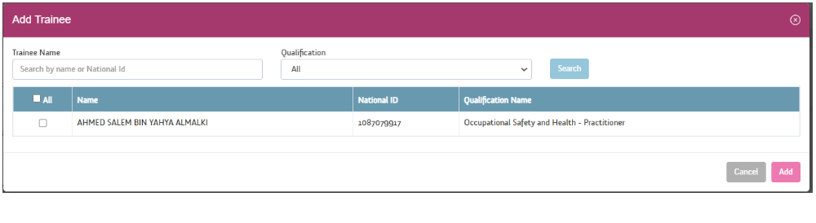

Add Trainee Wireframe

UC-07 Delete Trainee from Trainer
Use Case in 'User Management'

- This use case enables the user to remove Trainee from Assigned Trainee list.
- Assigned Trainee list is list of Trainees staff can access.

ACTORS
Actor: COE Admin
Actor: College Admin

PRE-CONDITIONS
Logged in user with College Admin Privileges
User(s) with Assessor/Verifier role is defined in ePortal
Trainee(s) already defined in ePortal

SCENARIOS
Main Flow. Main Flow

1. Use case starts when User performs View User Details
2. System displays list of Trainees assigned to the selected user
3. User checks Trainees to be unassigned
Alternate: 3a. Select All
4. User clicks Remove Button
Alternate: 4a. Clear Checked Trainees
5. System displays list of assigned Trainees

Alternate. Select All

- If User chooses to select all
- System checks all records
- If User chooses to unselect all
- System unchecks all records

Alternate. Clear Checked Trainees

1. User clicks Clear Button
2. System uncheck all Checked records

POST CONDITIONS
Assessor/Verifier cannot access deleted Trainee(s)

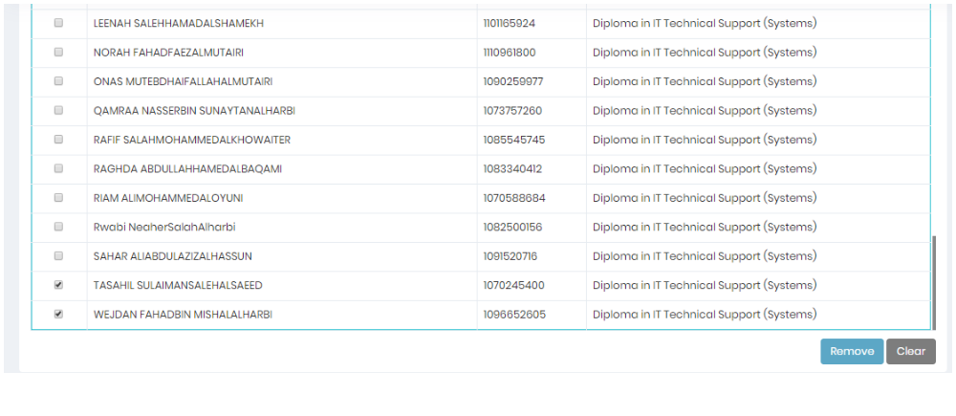

Delete Trainee from Trainer Wireframe

Qualification Management

This set of use cases enables the user with COE Admin role to maintain qualification data, needed for eCAPS:
- Unit Skill/Learning Scope.
- Unit Skill/Learning Outcomes.
- Performance Criteria for the Skill/Learning Outcome.
- Capstone.
- Capstone Resources.
- Capstone Tasks.
- Capstone Grading.

Qualification Management Business Process diagram
Business Process diagram in 'Qualification Management'

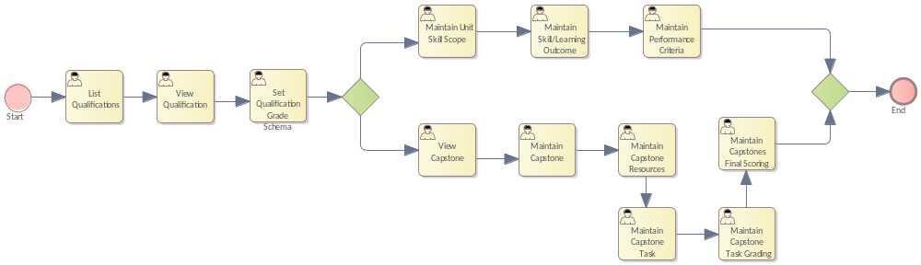

Qualification Management Business Process

Qualification Management Use Cases diagram
Use Case diagram in 'Qualification Management'

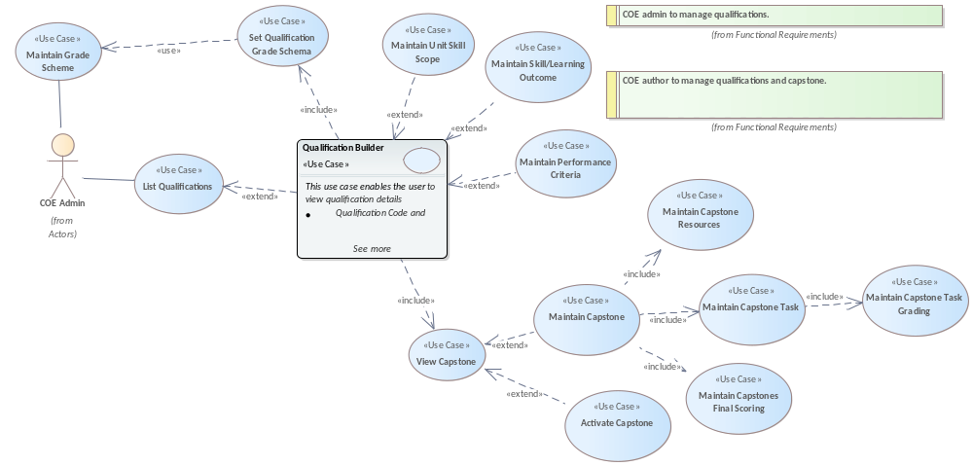

Qualification Management Use Cases

UC-08 Maintain Grade Scheme
Use Case in 'Qualification Management'

- This use case enables the user to define Grade Scheme.
- User will be able to define different schemes and assign to qualification.

ACTORS
Actor: COE Admin

PRE-CONDITIONS
Logged in user with COE Admin privileges

SCENARIOS
Main Flow. Main Flow

- Use case starts when User selects to view Grading Schema
- System displays Grading Schema screen
- System displays list of Grading schema

Alternate. Add Grade Schema

- User clicks Add New button
- System displays Add New Grade screen
- User enters the Grade schema name
- User enters Grade "A" Average score
- System generates Grade "B" To score (Grade "A" Average score - 0.01)
- User enters Grade "A" To Score
- User enters Grade "B" Average score
- System generates Grade "C" To score (Grade "B" Average score - 0.01)
- User enters Grade C Average score
- System generates Grade "D" To score (Grade "C" Average score - 0.01)
- User enters Grade "D" Average score
- System generates Grade "F" To score (Grade "D" Average score - 0.01)
- User clicks Save and Finish

Alternate. View Grade Schema

- User clicks View button
- System displays Grade Schema screen with the selected Grade Schema values (Read Only)

Alternate. Edit Grade Schema

- User clicks Edit button
- System displays Grade Schema screen with the selected Grade Schema values for Editing
- User edits the needed values
- User clicks Save and Finish

Alternate. Delete Grade Schema

- User clicks Delete button
- System displays Delete Confirmation Dialog
- User selects to confirm
- System deletes the selected Grade Schema

BUSINESS RULES
Business Rule. Qualification Schema cannot be edited or deleted once assigned to Qualification

POST CONDITIONS
Grade Schema can be assigned to Qualification

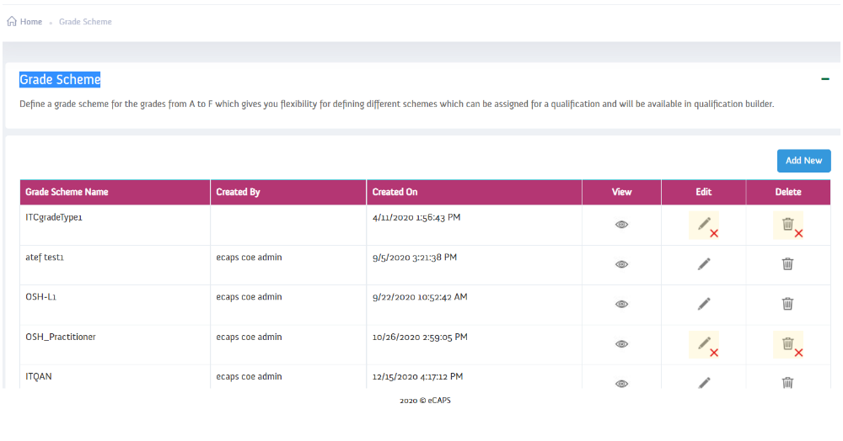

Define Grade Scheme wireframe

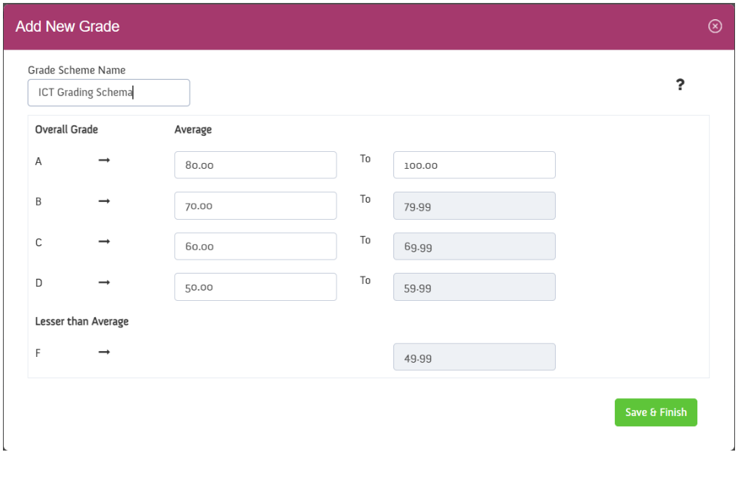

Add Grade Scheme wireframe

UC-09 List Qualifications
Use Case in 'Qualification Management'

This use case illustrates how to search for qualifications and View Qualification Details.
Search Criteria includes
- Qualification Code and Name
Search Result Includes:
- Qualification Code
- Qualification Name
- Action (View)
User will be able to:
- View Qualification

ACTORS
Actor: COE Admin
Actor: College Admin

PRE-CONDITIONS
Logged in user with COE/College Admin/Assessor/Verifier Privileges
Qualification(s) already defined in ePortal

SCENARIOS
Main Flow. Main Flow

1. Use case starts when User navigates to Qualification Builder
2. System displays List Qualifications screen
3. User may search for qualification using Qualification Code or Name
4. System displays List of available qualifications
Alternate: 4a. No Matching Records Found
5. Use may click View button to View Qualification

Exception. No Matching Records Found

1. System displays Message

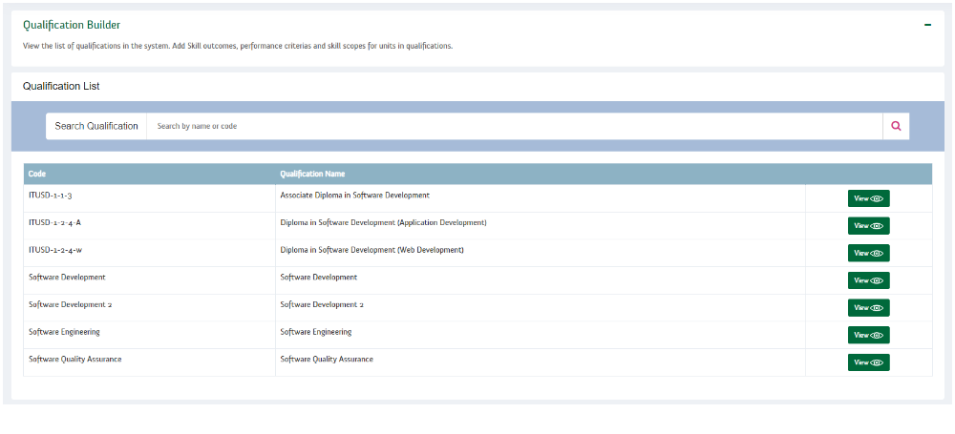

List Qualifications wireframe

UC-10 Qualification Builder
Use Case in 'Qualification Management'

This use case enables the user to view qualification details
- Qualification Code and Name
- Grading Schema
- Qualification Units details (Unit Code, Name, Skill scope, skill learning outcome, Performance criteria
- Capstones, Capstones Tasks
It also enables the user to:
- Set Qualification Grade Schema
- Maintain Unit Skill Scope
- Maintain Skill/Learning Outcome
- Maintain Performance Criteria
- View Capstone
- Maintain Qualification Capstone
- Maintain Capstone Task
- Maintain Capstone Task Grading

ACTORS
Actor: College Admin
Actor: Trainee
Actor: Assessor
Actor: COE Admin
Actor: External Verifier
Actor: Internal Verifier

PRE-CONDITIONS
Logged in user with COE/College Admin/Assessor/Verifier Privileges
Qualification(s) already defined in ePortal

SCENARIOS
Main Flow. Main Flow

- Use case starts when User selects to view Qualification Details
- System displays Qualification Details screen
- Use sets Grade Schema by performing Set Qualification Grade Schema
- System displays Qualification Units (Code, Name)
- System displays Actions (Expand)
- User chooses to Expand Unit
- System Displays Unit Details (Actions Edit/Add Skill/Learning Outcomes)
- System Displays Skill/Learning Outcomes
- System displays Actions (Edit, Delete, Add Performance Criteria, Expand)
- User chooses Expand Skill/Learning Outcome
- System displays Performance Criteria
- System displays Actions (Edit, Delete)

Alternate. Add Skill Scope

- User selects to Add Skill Scope
- System performs Maintain Unit Skill Scope (Add Skill Scope)

Alternate. Add Skill/Knowledge Outcome

- User selects to Add Skill Learning Outcome
- System performs Maintain Skill/Learning Outcome (Add Skill/Knowledge Outcome)

Alternate. Edit Skill Scope

- User selects to Edit Skill Scope
- System performs Maintain Unit Skill Scope (Edit Skill Scope)

Alternate. Edit Skill/Knowledge Outcome

- User selects to Edit Skill/Knowledge Outcome
- System performs Maintain Skill/Learning Outcome (Edit Skill/Knowledge Outcome)

Alternate. Delete Skill/Knowledge Outcome

- User selects to Delete Skill/Knowledge Outcome
- System performs Maintain Skill/Learning Outcome (Delete Skill/Knowledge Outcome)

Alternate. Add Performance Criteria

- User selects to Add Performance Criteria
- System performs Maintain Performance Criteria (Add Performance Criteria)

Alternate. Edit Performance Criteria

- User selects to Edit Performance Criteria
- System performs Maintain Performance Criteria (Edit Performance Criteria)

Alternate. Delete Performance Criteria

- User selects to Delete Performance Criteria
- System performs Maintain Performance Criteria (Delete Performance Criteria)

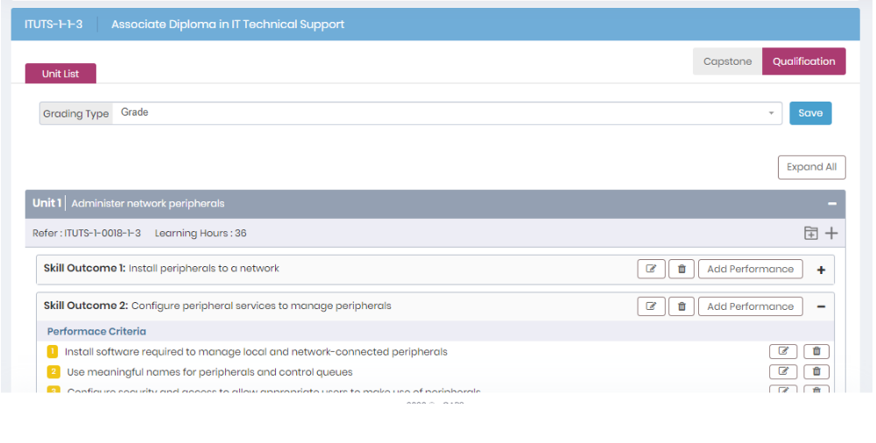

Qualification Builder wireframe

UC-11 Set Qualification Grade Schema
Use Case in 'Qualification Management'

- This use case is to set grade schema for the qualification

ACTORS
Actor: COE Admin

PRE-CONDITIONS
Logged in user with COE Admin Privileges
Grading Schema already defined

SCENARIOS
Main Flow. Main Flow

- User selects Grade Schema from list of Grading schema defined in Define Grade Scheme

POST CONDITIONS
Grade Schema setup cannot be Deleted

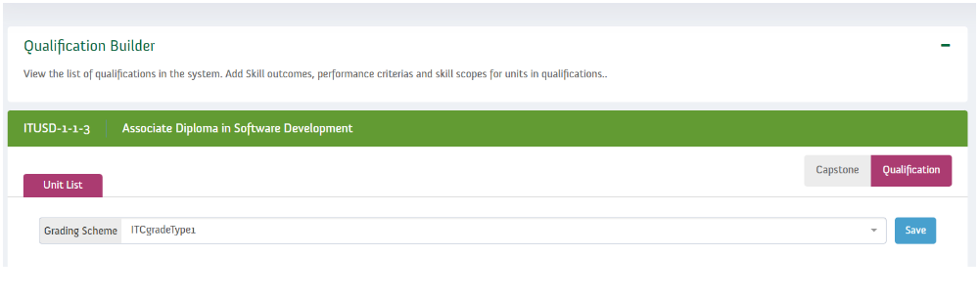

Set Qualification Grade Schema wireframe

UC-12 Maintain Unit Skill Scope
Use Case in 'Qualification Management'

- This use case enables the user to create/Edit Scope for Qualification Units.

ACTORS
Actor: COE Admin

PRE-CONDITIONS
Logged in user with COE Admin Privileges
Qualification(s) already defined in ePortal
Qualification Unit(s) already defined in ePortal

SCENARIOS
Main Flow. Add skill scope

1. Use case starts when User selects to Add Skill Scope for Unit
2. System displays Add Skill Scope screen
3. User enters Skill Scope Title (Mandatory)
4. User selects to Save
5. System validates mandatory fields
Exception: 5a. Missing Fields
6. System saves Skill Scope record
7. Use case ends

Main Flow. Edit Skill Scope

1. Use case starts when User selects to Edit Skill Scope for Unit
2. System displays Edit Skill Scope screen
3. User enters Skill Scope Title (Mandatory)
4. User selects to Save
5. System validates mandatory fields
Exception: 5a. Missing Fields
6. System saves Skill Scope record
7. Use case ends

Main Flow. Delete Skill Scope

1. Use case starts when User selects to Edit Skill Scope for Unit
2. System displays confirmation dialog
3. User selects to delete
Alternate: 3a. Cancel Delete
4. System deletes Skill Scope
5. Use case ends

Exception. Missing Fields

- System highlights missing Fields
- System prompts the user to enter missing fields

Alternate. Cancel Delete

- User selects to Cancel
- The use case ends.

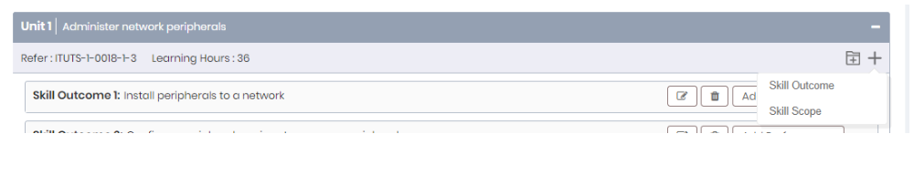

Create Unit Skill wireframe

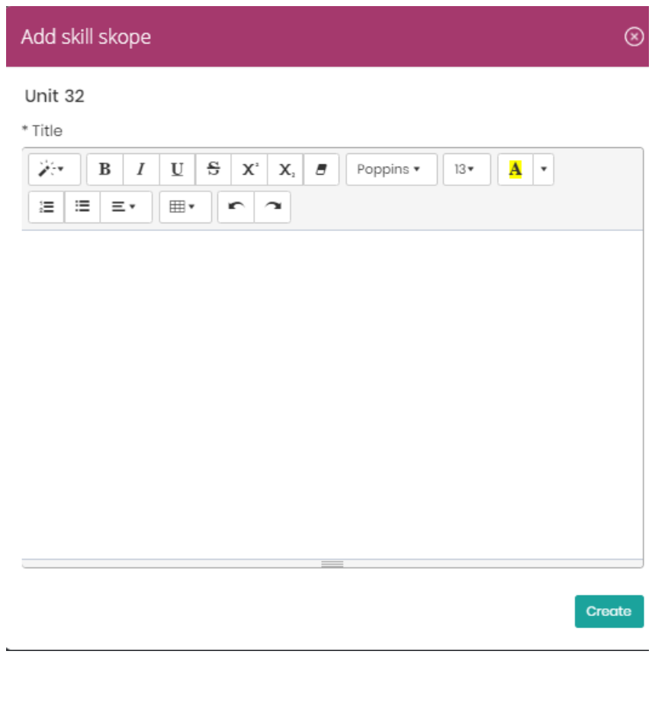

Add Skill Scope wireframe

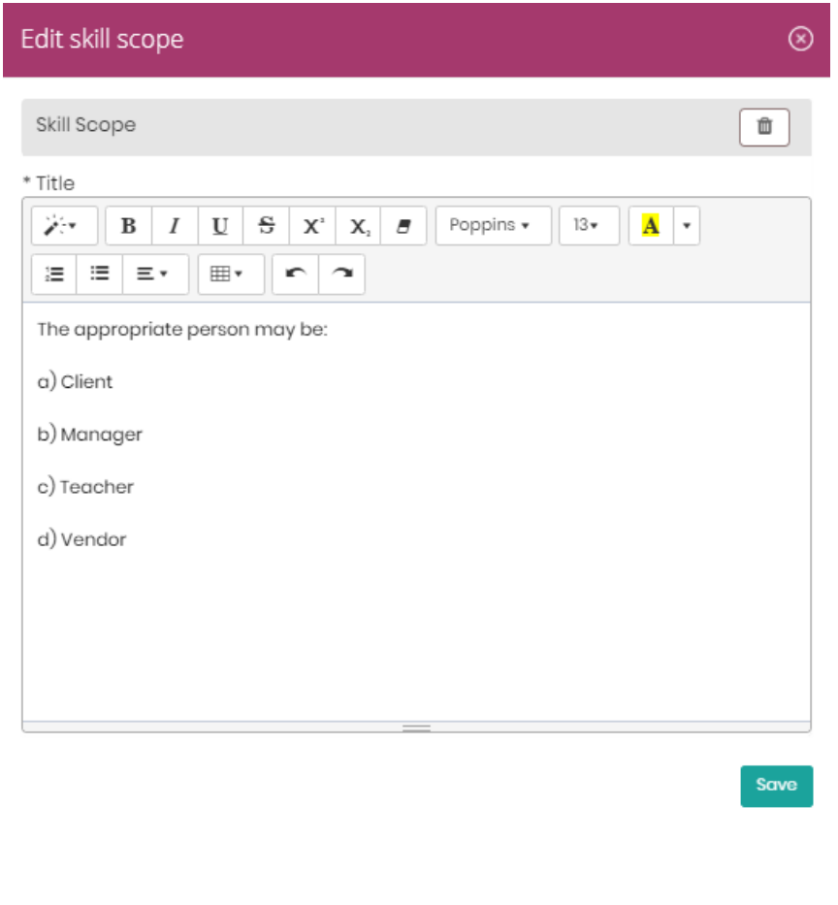

Edit Skill Scope wireframe

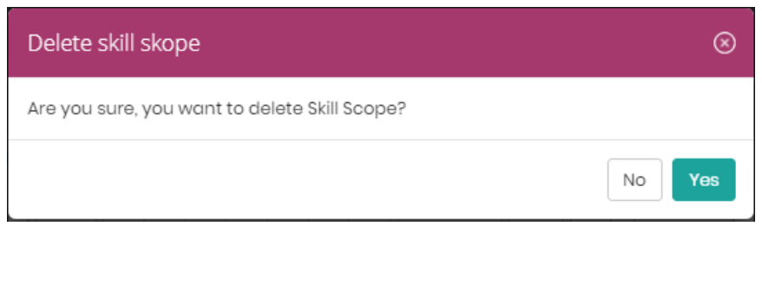

Delete Skill Scope wireframe

UC-13 Maintain Skill/Learning Outcome
Use Case in 'Qualification Management'

- This use case enables the user to create/Edit/Delete Skill/ Learning Outcomes for Qualification Unit.

ACTORS
Actor: COE Admin

PRE-CONDITIONS
Logged in user with COE Admin Privileges
Qualification(s) already defined in ePortal
Qualification Unit(s) already defined in ePortal

SCENARIOS
Main Flow. Add Skill/Learning Outcome

1. Use case starts when User selects to add Skill/Learning outcome
2. System displays Add Skill/Learning Outcome screen
3. System generated sequence number
4. User selects Skill/Learning Outcome
5. User enters Skill learning outcome Description (Mandatory)
6. User selects to save
7. System validates mandatory fields
Exception: 7a. Missing Fields
8. System saves Skill learning outcome record
9. Use case ends

Alternate. Edit Skill Outcome

1. Use case starts when User selects to modify Skill learning outcome
2. System displays edit Skill Learning Outcome screen
3. User enters Skill learning outcome Description (Mandatory)
4. User selects to save
5. System validates mandatory fields
Exception: 5a. Missing Fields
6. System saves Skill learning outcome record
7. Use case ends

Alternate. Delete Skill Outcome

1. Use case starts when User selects to Delete Skill/Learning Outcome
2. System displays confirmation dialog
3. User selects to delete
Alternate: 3a. Cancel Delete
4. System deletes Skill/Learning Outcome record
5. Use case ends

Exception. Missing Fields

- System highlights missing Fields
- System prompts the user to enter missing fields

Alternate. Cancel Delete

- User selects to Cancel
- The use case ends.

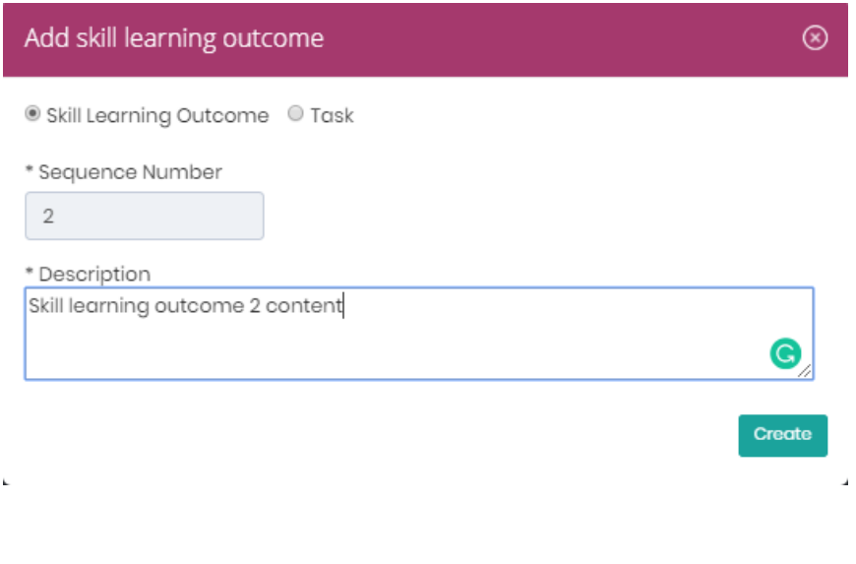

Add Skill Learning Outcome wireframe

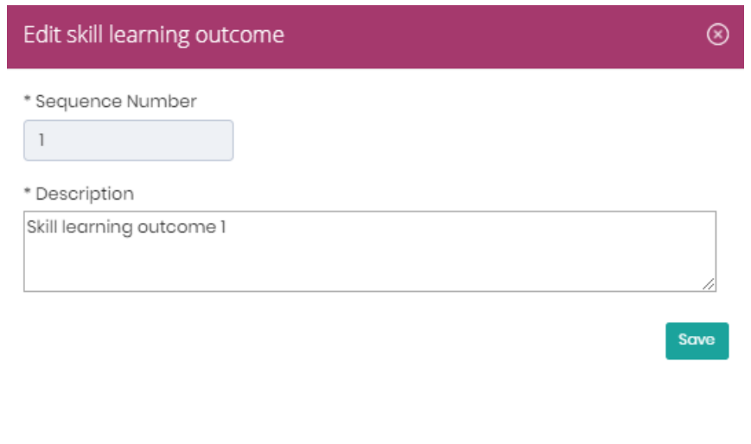

Edit Skill Learning Outcome wireframe

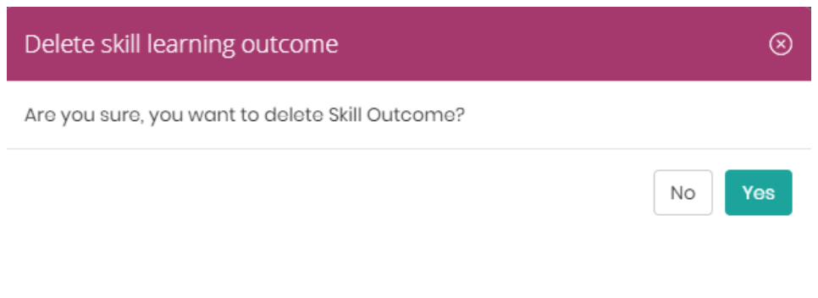

Delete Skill Learning Outcome wireframe

UC-14 Maintain Performance Criteria
Use Case in 'Qualification Management'

- This use case enables the user to Create/Edit/Delete Performance criteria for Skill/Learning Outcomes.

ACTORS
Actor: COE Admin

PRE-CONDITIONS
Logged in user with COE Admin Privileges
Qualification(s) already defined in ePortal
Qualification Unit(s) already defined in ePortal

SCENARIOS
Main Flow. Add Performance Criteria

1. Use case starts when User selects to add Performance Criteria for Skill/Learning outcome
2. System displays Add Performance Criteria screen
3. System generated sequence number
4. User enters Performance Criteria Description (Mandatory)
5. User selects to save
6. System validates mandatory fields
Exception: 6a. Missing Fields
7. System saves Performance Criteria record
8. Use case ends

Alternate. Edit Performance Criteria

1. Use case starts when User selects to Edit Performance Criteria for Skill/Learning outcome
2. System displays Edit Performance Criteria screen
3. User enters Performance Criteria Description (Mandatory)
4. User selects to save
5. System validates mandatory fields
Exception: 5a. Missing Fields
6. System saves Performance Criteria record
7. Use case ends

Alternate. Delete Performance Criteria

1. Use case starts when User selects to Delete Performance Criteria for Skill/Learning Outcome
2. System displays confirmation dialog
3. User selects to delete
Alternate: 3a. Cancel Delete
4. System deletes Skill/Learning Outcome record
5. Use case ends

Exception. Missing Fields

- System highlights missing Fields
- System prompts the user to enter missing fields

Alternate. Cancel Delete

- User selects to Cancel
- The use case ends.

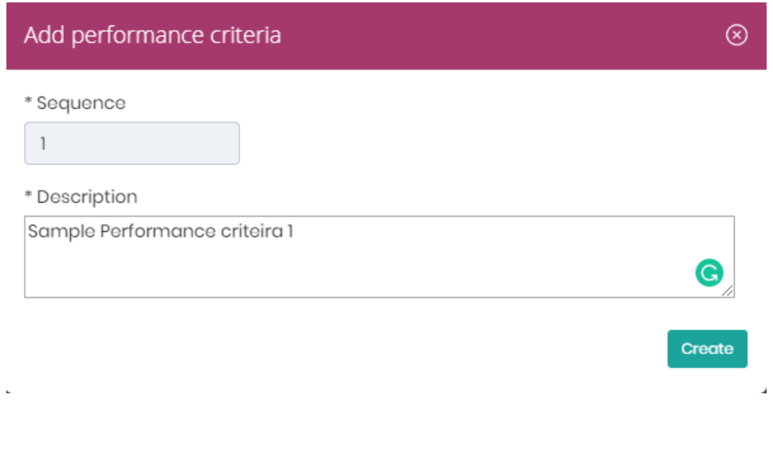

Add Performance Criteria wireframe

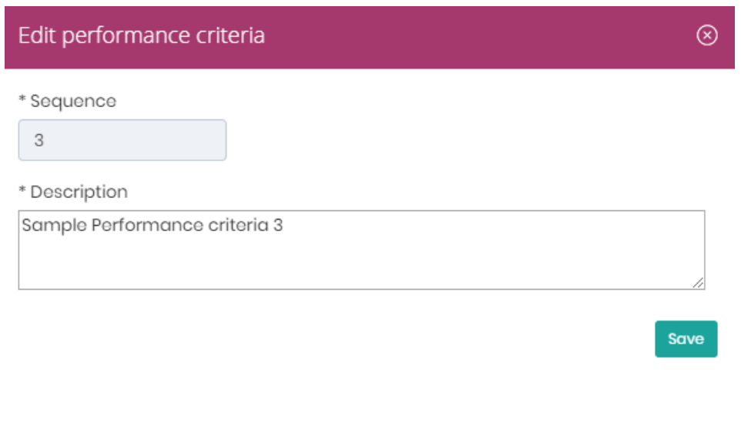

Edit Performance Criteria wireframe

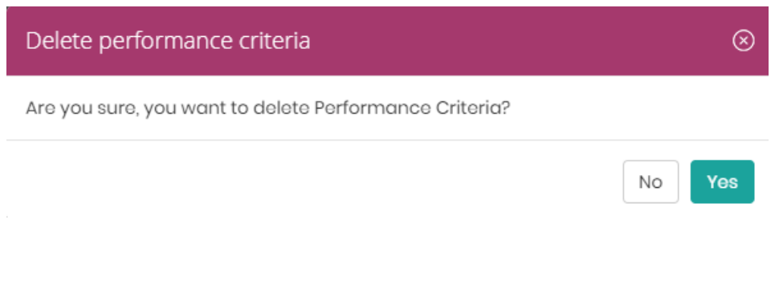

Delete Performance Criteria wireframe

UC-15 View Capstone
Use Case in 'Qualification Management'

This use case enables the user to view Qualification Capstones list
Capstone List includes
- Capstone Name
- Version
- Created by
- Status (Active, Inactive)
- Actions (Edit, Delete)
User will be able to:
Maintain Qualification Capstone

ACTORS
Actor: COE Admin
Actor: Assessor
Actor: College Admin
Actor: Internal Verifier
Actor: External Verifier

PRE-CONDITIONS
Logged in user with sufficient privileges
- COE Admin
- College Admin with access to college
- Assessor/Verifier with access to Qualification and Trainee

SCENARIOS
Main Flow. Main Flow

- User selects Capstones Tab
- System displays Capstones list

Alternate. Add Capstone

- User clicks on Add Capstone
- System performs Maintain Qualification Capstone

Alternate. Edit Capstone

- User clicks on Add Capstone
- System performs Maintain Qualification Capstone with the selected Capstone

Alternate. Delete Capstone

- User clicks Delete Capstone
- System displays confirmation message
- User confirms
- System displays success message

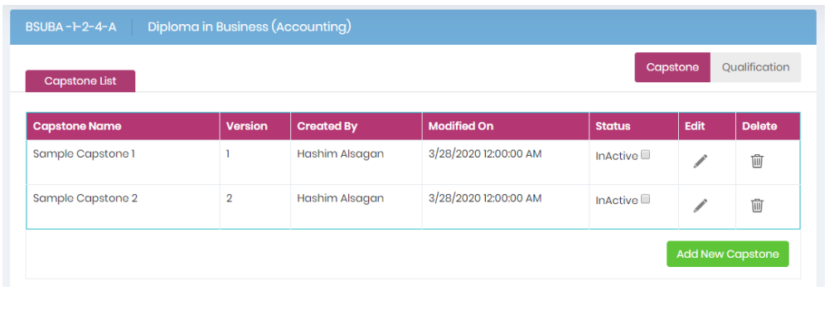

Capstone Tab wireframe

UC-16 Maintain Capstone
Use Case in 'Qualification Management'

- This use case enables the user to Add/Edit/Delete Qualification Capstone.

ACTORS
Actor: COE Admin

PRE-CONDITIONS
Logged in user with COE Admin Privileges
Qualification(s) already defined in ePortal

SCENARIOS
Main Flow. Add Capstone

1. Use case starts when User selects to Add New Capstone
2. System displays Add New Capstone - General section
3. User enters Capstone name (Mandatory)
4. User enters Author (Mandatory)
5. User selects to save and continue
Alternate: 7a. Cancel
6. System validates mandatory fields
Exception: 8a. Missing Fields
7. System performs Maintain Capstone Resources

Alternate. Edit Capstone

1. Use case starts when User selects to Edit Capstone
2. System displays Edit Capstone - General section
3. User enters Capstone name (Mandatory)
4. User enters Author (Mandatory)
5. User selects to save and continue
Alternate: 7a. Cancel
6. System validates mandatory fields
Exception: 8a. Missing Fields
7. System performs Maintain Capstone Resources

Alternate. Cancel

- User selects to Cancel
- The use case ends.

Exception. Missing Fields

- System highlights missing Fields
- System prompts the user to enter missing fields

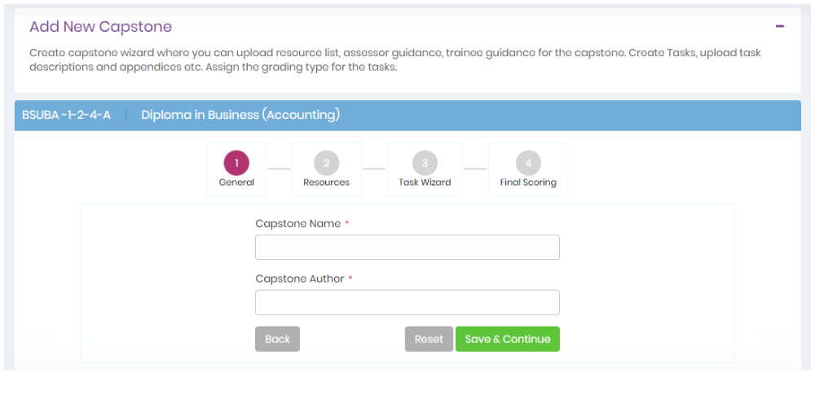

Add New Capstone wireframe

UC-17 Maintain Capstone Resources
Use Case in 'Qualification Management'

This use case enables the user to create/upload
- Resource list
- Assessor guidance
- Trainee guidance
for the Capstone.

ACTORS
Actor: COE Admin

PRE-CONDITIONS
Logged in user with COE Admin Privileges
Qualification(s) already defined in ePortal

SCENARIOS
Main Flow. Main Flow

1. Use case starts when Maintain Capstone ends
2. System displays Add New Capstone - Resources
3. user selected to upload Assessor Guidance file
Alternate: 3a. Create New Assessor Guidance File
4. System displays upload file dialog
5. User selects the file
6. user selected to upload Trainee Guidance file
Alternate: 6a. Create New Trainee Guidance File
7. System displays upload file dialog
8. User selects the file
9. user selected to upload Resource List file
Alternate: 9a. Create New Resource List File
10. System displays upload file dialog
11. User selects the file
12. User selects to Save and Continue
Alternate: 12a. Back to Capstone
13. System performs Maintain Capstone Task

Alternate. Create New Assessor Guidance File

1. User selects to Create File
2. System displays File Editor
3. User enters the contents of the file

1.

Alternate. Create New Trainee Guidance File

1. User selects to Create File
2. System displays File Editor
3. User enters the contents of the file

Alternate. Create New Resource List File

1. User selects to Create File
2. System displays File Editor
3. User enters the contents of the file

Alternate. Back to Capstone

- User selects to Go Back
- System performs Maintain Capstone
- The use case ends.

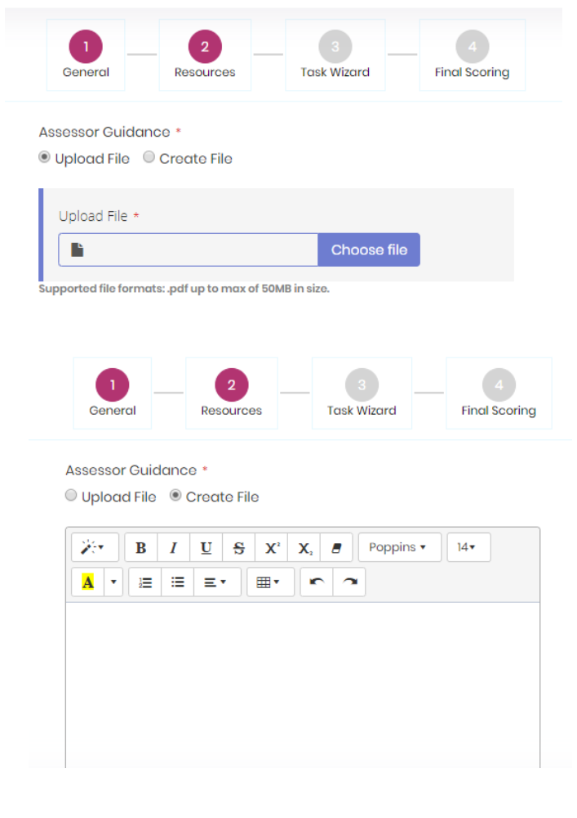

Capstone Resources wireframe

UC-18 Maintain Capstone Task
Use Case in 'Qualification Management'

- This use case enables the user to Add/Edit/Delete a Capstone Tasks.

ACTORS
Actor: COE Admin

PRE-CONDITIONS
Logged in user with COE Admin privileges
Qualification(s) already defined in ePortal

SCENARIOS
Main Flow. Add Task

1. User selects to Add Task
2. System displays New Task Screen
3. User enters Task Number, Task Name, Assessment criteria, Evidence required
4. User selects to create or upload Assessor task description file
5. User selects to create or upload Trainee Task description file
6. User selects to create or upload Appendix file
7. User selects to save and continue
8. System performs Maintain Capstone Task Grading

Alternate. Edit Task

1. User selects to Edit Task
2. System displays New Task Screen with Task Data
3. User may enter Task Number, Task Name, Assessment criteria, Evidence required
4. User may select to create or upload Assessor task description file
5. User may select to create or upload Trainee Task description file
6. User may select to create or upload Appendix file
7. User may select to save and continue
8. System performs Maintain Capstone Task Grading

Main Flow. Delete Task

- User selects to Delete Task
- System displays Confirmation
- User confirms
- System deletes the selected task

Alternate. Pass/Fail

1. User selects Pass/Fail

Alternate. Scoring

1. User selects Score
2. User enters Maximum Score

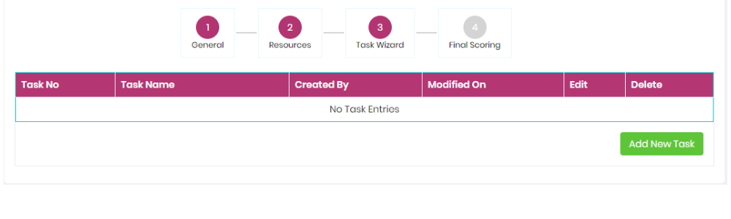

Task Wizard wireframe

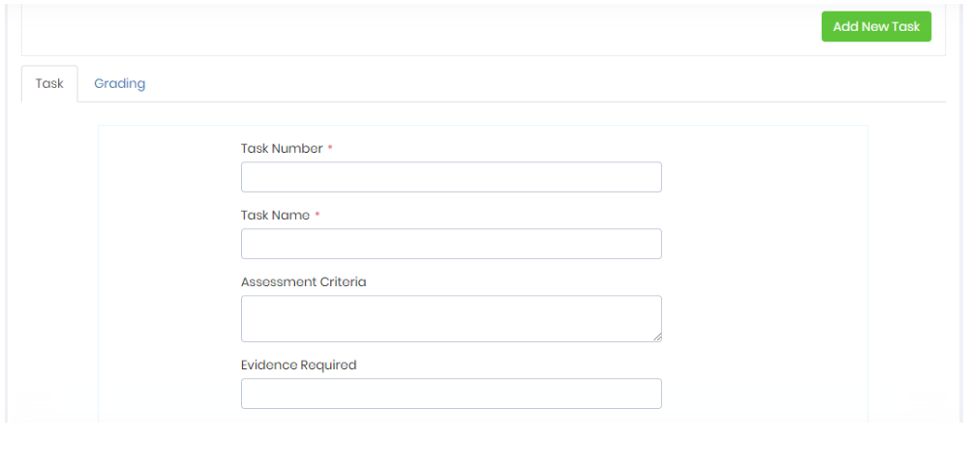

New Task wireframe

UC-19 Maintain Capstone Task Grading
Use Case in 'Qualification Management'

This use case enables the user to Define Capstone Task Grading Criteria.

ACTORS
Actor: COE Admin

PRE-CONDITIONS
Logged in user with COE Admin privileges
Qualification(s) already defined in ePortal

SCENARIOS
Main Flow. Add Capstone Task Grades

1. User navigates to Task wizard
2. System displays Task Details screen
3. User selects to Save and Continue
4. System displays Grading section
5. User selects Grade
6. System displays Grading Criteria
7. User selects to Add Info
Main Flow: 7a. Edit Capstone Tasks Grade Info
Alternate: 7b. Delete Capstone Task Grade Info
Alternate: 7c. Edit Capstone Tasks Grade Criteria
Alternate: 7d. Delete Capstone Task Grade Criteria
8. System displays Info screen
9. User enters Grade Info
10. User selects to add info
11. System adds the grade info to the grade record.
12. User selects to Add Criteria
13. System displays Criteria screen
14. User enters Grade Criteria
15. User selects to add
16. System adds the grade criteria to the grade record.
17. User selects to Go Next
Alternate: 17a. Add New Task
18. System Performs Maintain Capstones Final Scoring

Main Flow. Edit Capstone Tasks Grade Info

1. User selects to modify grade Info
2. System displays Info screen
3. User enters the new info
4. User selects to Save
5. System updates info record to the selected grade
6. User selects to Go Next
Alternate: 6a. Add New Task
7. System Performs Maintain Capstones Final Scoring

Alternate. Delete Capstone Task Grade Info

1. User selects to delete grade Info
2. System displays confirmation message
3. User selects to confirm
Alternate: 3a. Cancel Delete
4. System deletes the selected record

Alternate. Edit Capstone Tasks Grade Criteria

1. User selects to modify grade Criteria
2. System displays Criteria screen
3. User enters the new Criteria
4. User selects to Save
5. System updates Criteria record to the selected grade
6. User selects to Go Next

Alternate. Delete Capstone Task Grade Criteria

1. User selects to delete grade Criteria
2. System displays confirmation message
3. User selects to confirm
Alternate: 3a. Cancel Delete
4. System deletes the selected record

Alternate. Add New Task

1. User selects to Add New Task
2. System Performs Maintain Capstone Task

Alternate. Cancel Delete

- User selects to Cancel
- Use case ends

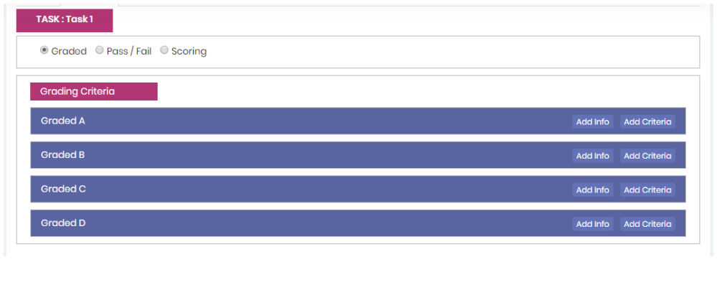

Grading Criteria wireframe

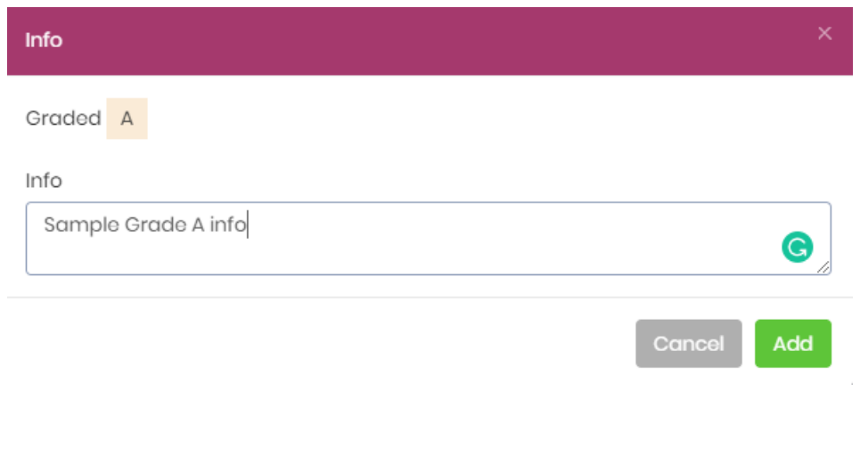

Add Grade Info wireframe

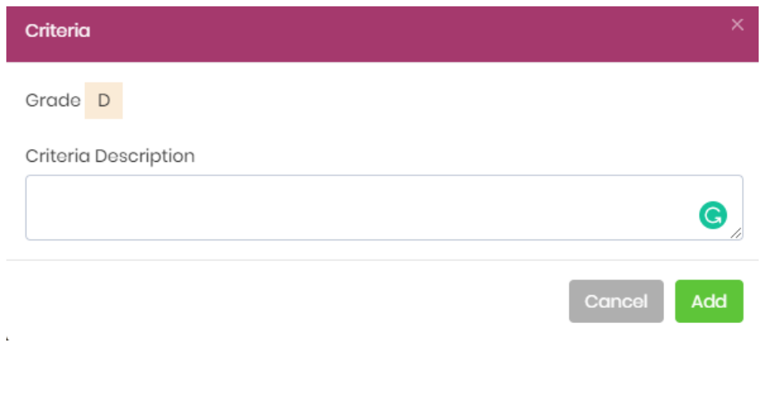

Add Grade Criteria wireframe

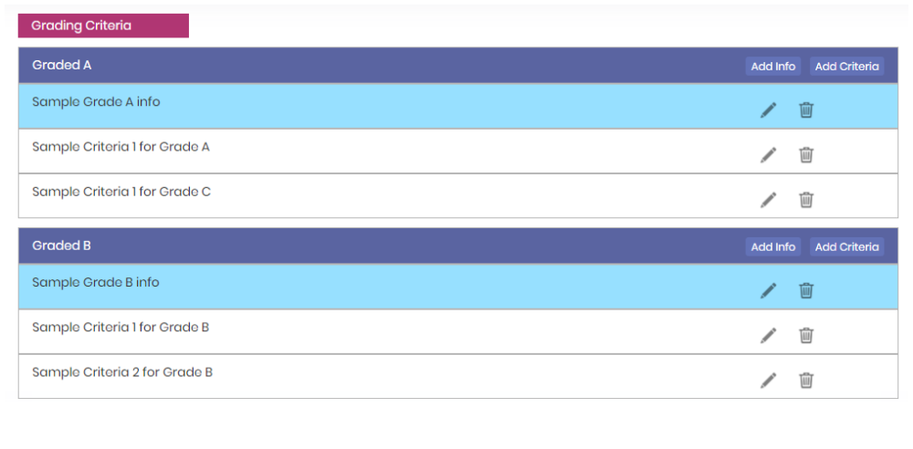

Grading Criteria wireframe

UC-20 Maintain Capstones Final Scoring
Use Case in 'Qualification Management'

This use case enables the user to define Capstone Grading scores.

ACTORS
Actor: COE Admin

PRE-CONDITIONS
Logged in user with COE Admin privileges
Qualification(s) already defined in ePortal

SCENARIOS
Main Flow. Main Flow

- System displays Capstone Final Scoring
- User clicks Finish

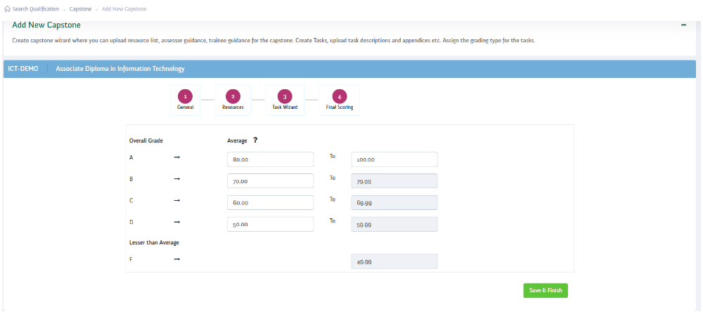

Final Scoring wireframe

UC-21 Activate Capstone
Use Case in 'Qualification Management'

- This use case enables the user to Activate/Deactivate Capstone.
- Qualification has only one active Capstone.

ACTORS
Actor: COE Admin

PRE-CONDITIONS
Logged in user with COE Admin privileges

SCENARIOS
Main Flow. Main Flow

1. User selects to displays Capstone List
2. System displays Capstone List
3. User clicks Status
4. System displays confirmation dialog
5. User selects to confirm
Alternate: 5a. Cancel Activation
6. System sets capstone to be Active

Alternate. Cancel Activation

- User selects to Cancel
- System exits screen

POST CONDITIONS
System deactivates other capstone records if any

System disables Edit/Delete in Active Capstone

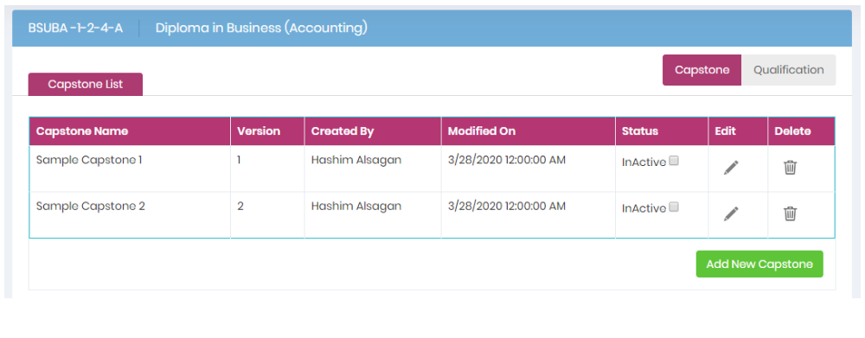

List Capstone wireframe

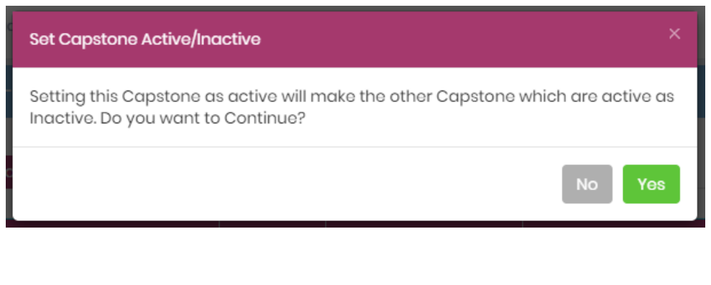

Activate Capstone wireframe

Trainee Management

This set of use cases to enable the user to view complete trainee ePortfolio.
User can review
- Trainee general Information (ID, Name, Qualification, Academic Year, Semester)
- Portfolio Progress
- Capstone Progress
- The Assessors and Verifiers for the trainee
- Qualification Units.
- Unit Skill/Learning Scope
- Unit Skill/Learning Outcomes
- Evidence uploaded by Trainee for Unit, Skill Learning Outcomes.
- Capstone resources and tasks
- Evidence uploaded by Trainee for Capstone Tasks.
- Unit Completion %
- Unit Grading %
- Unit Verifying %

BUSINESS RULES
Business Rule. Assessor can upload evidence only after accepting declaration

Business Rule. Assessor can grade evidence only after accepting declaration

Business Rule. Assessor can grade only units with Completion % is 100% (All Outcomes are "Started")

Business Rule. Assessor can Grade whole Unit (All Outcomes evidence submitted)

Business Rule. Graded Unit Status is "Graded", Status of Skill/Learning Outcomes within the Unit is also "Graded"

Business Rule. Grading %: Number of Graded Units/Number of Units with evidence

View Trainee Portfolio diagram
Use Case diagram in 'Trainee Management'

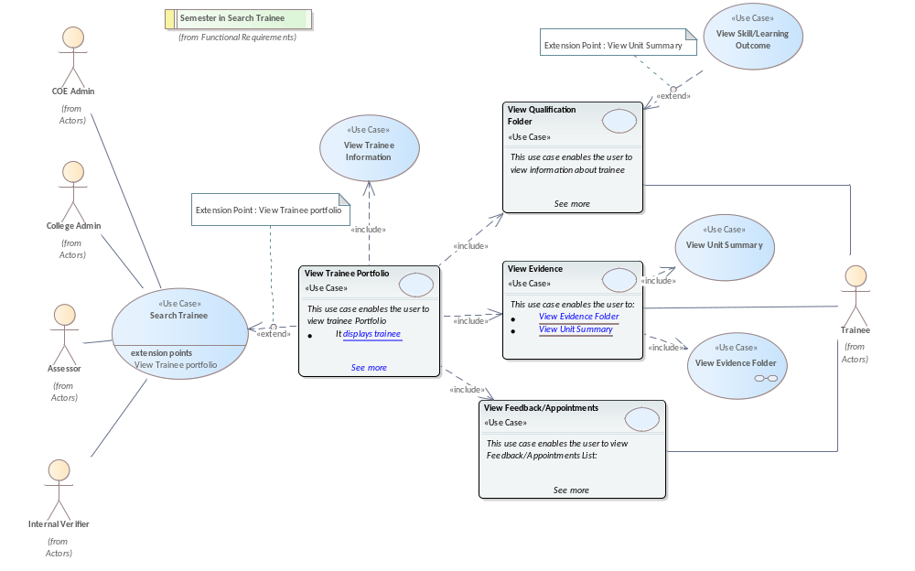

View Trainee Portfolio

UC-22 Search Trainee
Use Case in 'Trainee Management'

This use case enables different uses to Search for the Trainees/learners available in the system according to the user privileges.
- Admin can search for all trainees in the system
- College Admin can search for trainees within his assigned colleges
- Assessor can search for trainees assigned to him and in qualifications assigned to him
- Verifier can search for trainees assigned to him and in qualifications assigned to him

Search Criteria includes:
- College
- Qualification
- Academic Year (Default Current Academic Year)
- Semester
- Assessor
- Trainee National ID
- Trainee Name
- Trainee Status
System will display search result trainee records includes:
- Trainee Name
- National ID
- Qualification Code
- Qualification Name
- Capstone % (If qualification has capstone)
- Progress %
- Milestone (* for every 25% of the progress)
- Grading %
- Trainee Status
- Action (View) View Trainee portfolio

ACTORS
Actor: Internal Verifier
Actor: Assessor
Actor: COE Admin
Actor: External Verifier
Actor: College Admin

PRE-CONDITIONS
Logged in user with sufficient privileges
- COE Admin
- College Admin with access to college
- Assessor/Verifier with access to Qualification and Trainee

SCENARIOS
Main Flow. Search Trainee by Admin

- Use case starts when Admin initiates Search Trainee
- System displays Search Trainee screen
- User selects College
- System populates and enables Qualification, Academic Year, Semester, Trainee Status
- User selects Qualification
- User may select Academic Year (Default Current Academic Year)
- User may select Semester (Default All)
- User may select Trainee Status (Default All)
- User may select Assessor (Default All)
- User may select Verifier (Default All)
- User may enter Trainee National ID or Trainee Name
- User clicks Search; Exception: No Matching Records Found
- System returns list of trainees matching the search criteria
- Use case ends

Main Flow. Search Trainee by College Admin

- Use case starts when user initiates Search Trainee
- System displays Search Trainee screen
- User selects College (Colleges assigned to user)
- System populates and enables Qualification (Qualification assigned to user)
- User selects Qualification
- System populates Academic Year, Semester, Trainee Status
- User may select Academic Year (Default Current Academic Year)
- User may select Semester (Default All)
- User may select Trainee Status (Default All)
- User may select Assessor (Default All)
- User may select Verifier (Default All)
- User may enter Trainee National ID or Trainee Name
- User clicks Search; Exception: No Matching Records Found
- System returns list of trainees matching the search criteria
- Use case ends

Main Flow. Search Trainee by Assessor

- Use case starts when user initiates Search Trainee
- System displays Search Trainee screen
- System sets College (Colleges assigned to user)
- System populates and enables Qualification, Academic Year, Semester, Trainee Status
- User selects Qualification
- User may select Academic Year (Default Current Academic Year)
- User may select Semester (Default All)
- User may select Trainee Status (Default All)
- User may select Verifier (Default All)
- User may enter Trainee National ID or Trainee Name
- User clicks Search; Exception: No Matching Records Found
- System returns list of trainees matching the search criteria
- Use case ends

Main Flow. Search Trainee by Verifier

- Use case starts when user initiates Search Trainee
- System displays Search Trainee screen
- System sets College (Colleges assigned to user)
- System populates and enables Qualification, Academic Year, Semester, Trainee Status
- User selects Qualification
- User may select Academic Year (Default Current Academic Year)
- User may select Semester (Default All)
- User may select Trainee Status (Default All)
- User may select Assessor (Default All)
- User may enter Trainee National ID or Trainee Name
- User clicks Search; Exception: No Matching Records Found
- System returns list of trainees matching the search criteria
- Use case ends

Exception. No Matching Records Found

- System displays message

EXTENSION POINTS
View Trainee portfolio

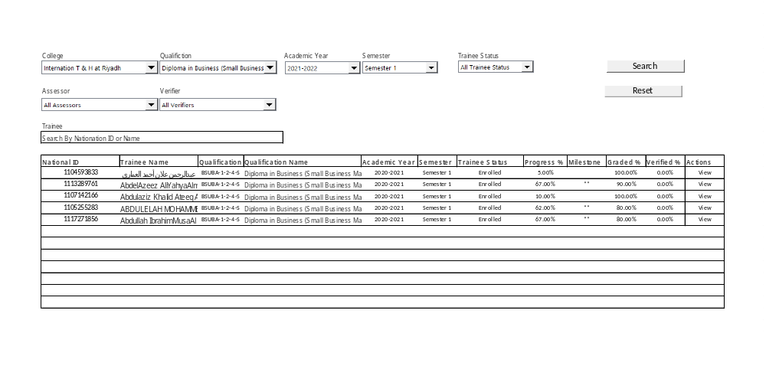

Search Trainee Wireframe

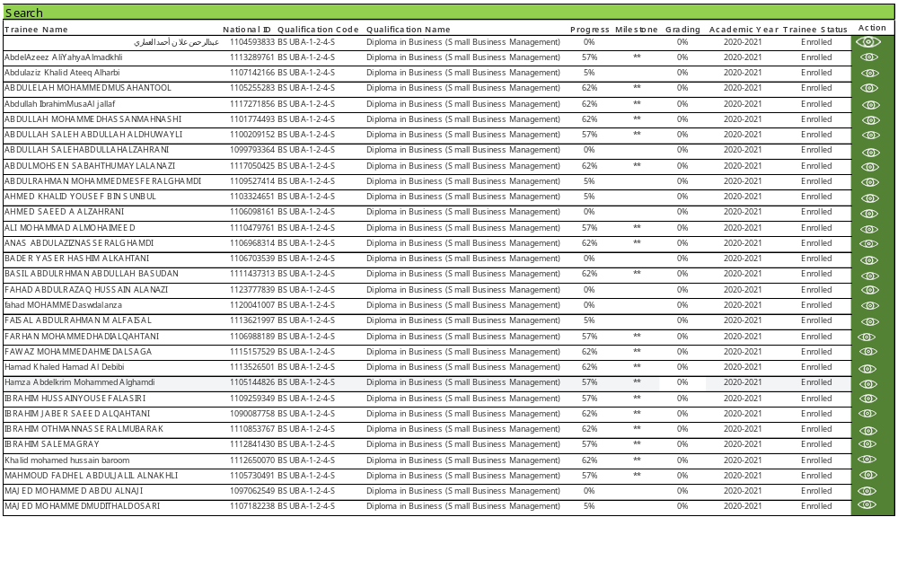

Search Result wireframe

UC-23 View Trainee Portfolio
Use Case in 'Trainee Management'

This use case enables the user to view trainee Portfolio
- It displays trainee information.
- It displays Qualification, Qualification Units, Unit Skill/Learning Outcomes and Skill/Learning Outcome Performance Criteria with the status.
- It displays capstone, resources, tasks
- It displays all evidence uploaded by Trainee
- It displays all feedback and appointments done between Assessor and Trainee

ACTORS
Actor: Assessor
Actor: External Verifier
Actor: Trainee
Actor: Internal Verifier
Actor: COE Admin
Actor: College Admin

PRE-CONDITIONS
Logged in user with sufficient privileges
- COE Admin
- College Admin with access to college
- Assessor with access to Qualification and Trainee
- Verifier with access to Qualification and Trainee
- Trainee can view his own portfolio

SCENARIOS
Main Flow. Main Flow

- This use case begins when a user requests to view trainee portfolio.
- System displays Trainee Information
- System displays Qualification Folder

Alternate. View Evidence

- User selects to view Evidence
- System displays View Evidence

Alternate. View Feedback/Appointments

- User selects to View Feedback/Appointments
- System displays View Feedback/Appointments

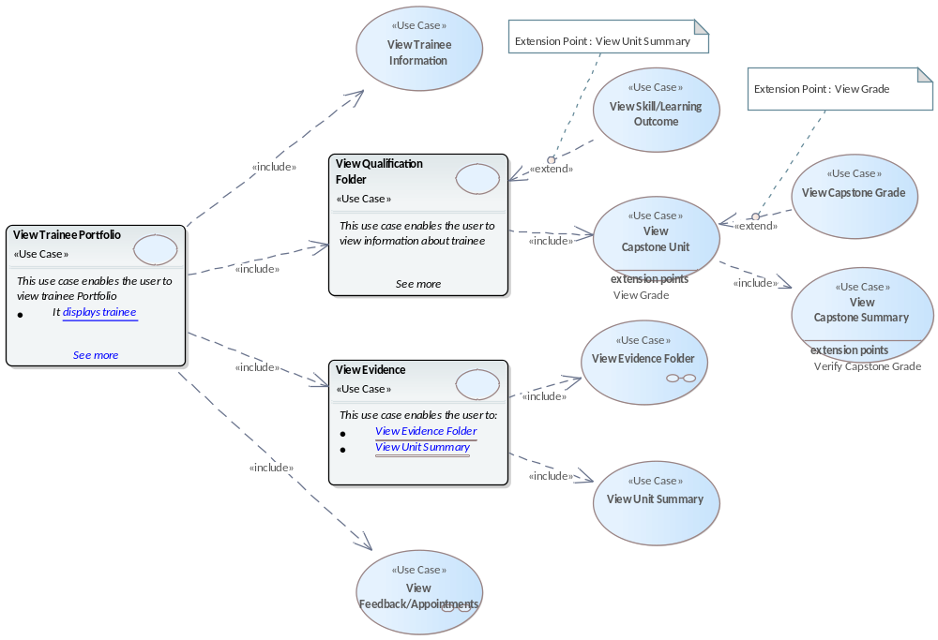

View Trainee Portfolio

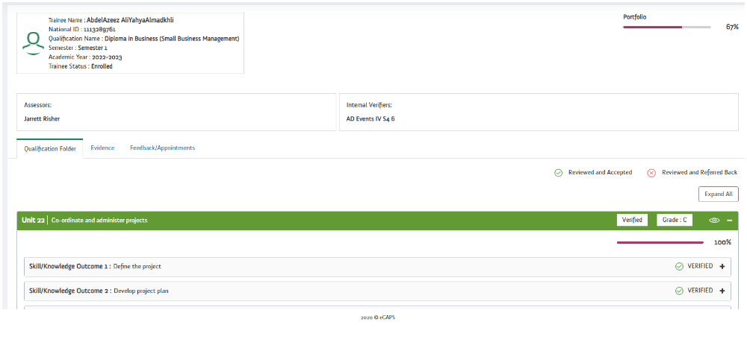

View Trainee Portfolio wireframe

UC-24 View Trainee Information
Use Case in 'Trainee Management'

The goal of the use case is to displays trainee general information
- Trainee Name
- Nation ID
- Qualification Name
- Semester
- Academic Year
- Trainee Status
- Portfolio Progress %
- Grading %
- Capstone %
- Assessors
- Verifiers

ACTORS
Actor: Assessor
Actor: COE Admin
Actor: External Verifier
Actor: Trainee
Actor: Internal Verifier
Actor: College Admin

PRE-CONDITIONS
Logged in user with sufficient privileges
- COE Admin
- College Admin with access to college
- Assessor with access to Qualification and Trainee
- Verifier with access to Qualification and Trainee
Trainee can view his own portfolio

SCENARIOS
Main Flow. Main Flow

The use case starts when the user selects to View Trainee portfolio
System displays Trainee Information as show

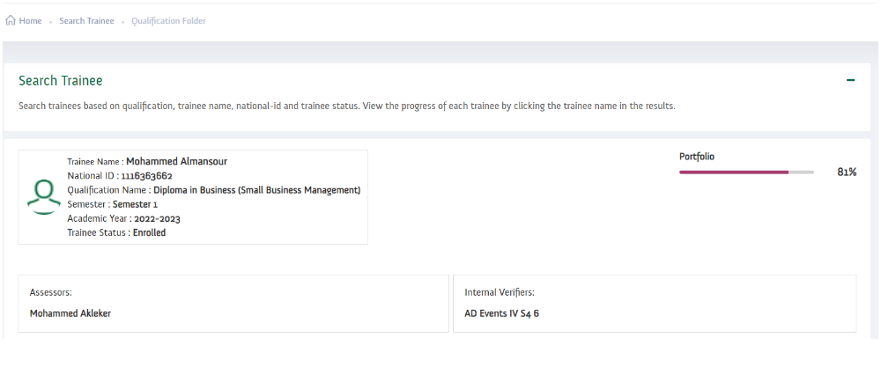

Trainee Information wireframe

UC-25 View Qualification Folder
Use Case in 'Trainee Management'

This use case enables the user to view information about trainee qualification.
- Unit Code and Name.
- Unit Status and progress.
- Actions on the Unit level (Accept/Grade/Refer/Verify/Reset/View Summary)
- List of Skill learning outcome of each Unit.
- Skill scope.
- List of performance criteria for each Skill/Learning outcome.

ACTORS
Actor: COE Admin
Actor: College Admin
Actor: Trainee
Actor: External Verifier
Actor: Internal Verifier
Actor: Assessor

PRE-CONDITIONS
Logged in user with sufficient privileges
- COE Admin
- College Admin with access to college
- Assessor with access to Qualification and Trainee
- Verifier with access to Qualification and Trainee
Trainee can view his own portfolio

SCENARIOS
Main Flow. Main Flow

- This use case begins when a user requests to view trainee portfolio.
- System displays Trainee Information
- System displays Qualification Folder

Alternate. Expand All

- User clicks Expand All
- System expands all units to view Unit kill/Knowledge Outcomes
- System changes the button label to "Collapse All"

Alternate. Collapse All

- User clicks Collapse All
- System collapses all units.
- System changes the button label to "Expand All"

Alternate. Expand Unit

- User clicks + of a certain collapsed unit.
- System expands the unit to view Unit kill/Knowledge Outcomes
- System changes the button label to "-"

Alternate. Collapse Unit

- User clicks - of a certain expanded unit.
- System collapses the unit
- System changes the button label to "+"

Alternate. View Unit Summary

- User clicks View Unit Summary button
- System displays View Unit Summary

Alternate. Accept Unit

- For Assessor user, User clicks on Accept Unit Button
- System performs Accept and Grade Unit

Alternate. Refer Unit

- For Assessor user, User clicks on Refer Button
- System performs Refer unit

Alternate. Verify Graded Unit

- For Verifier user, User clicks on Verify Unit Button
- System performs Verify Graded Unit

Alternate. Refer Graded Unit

- For Verifier user, User clicks on Refer Unit Button
- System performs Refer Graded Unit

EXTENSION POINTS
View Unit Summary

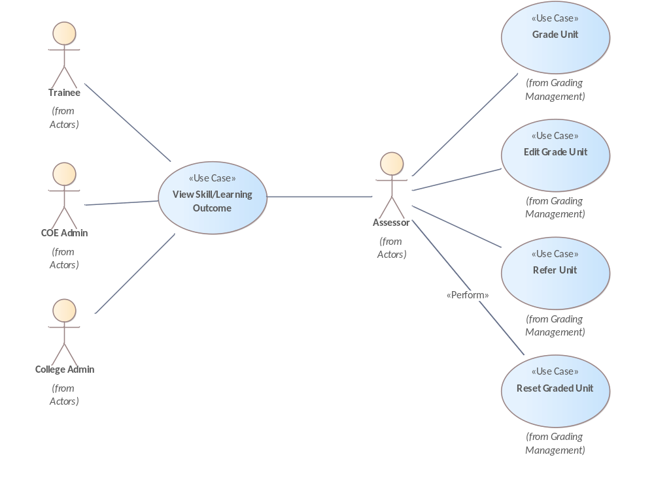

Qualification Folder

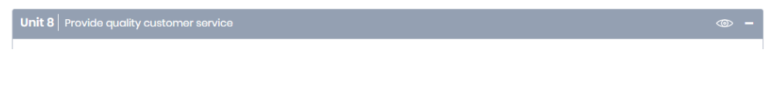

Admin Unit Bar wireframe

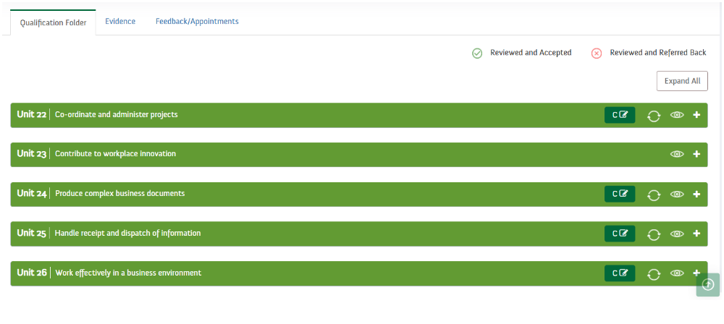

Qualification Folder wireframe

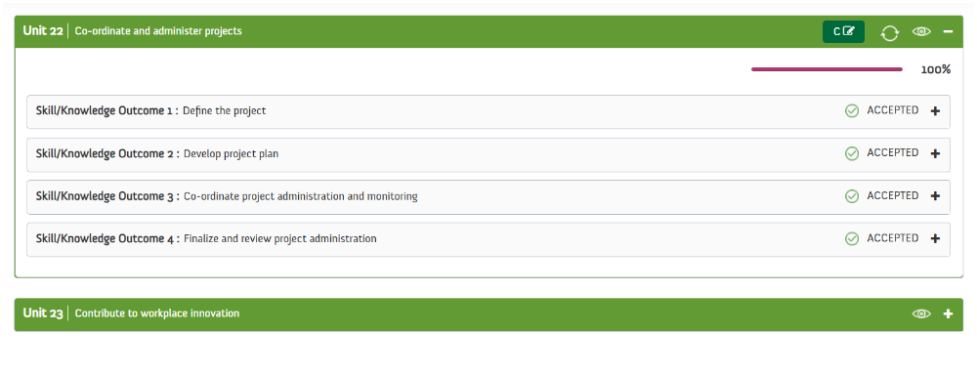

Skill/Learning Outcomes wireframe

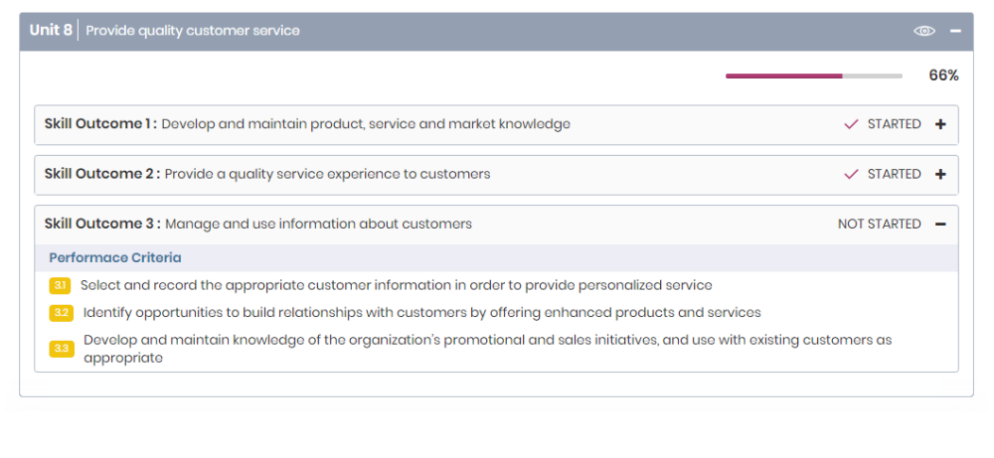

Skill/Learning Outcome Performance Criteria wireframe

UC-26 View Skill/Learning Outcome
Use Case in 'Trainee Management'

This use case enables the user to view Skill/Learning Outcomes of a unit
    - Skill/Learning Outcome
    - Evidence Title
    - Evidence Type
    - Documents
    - Uploaded on
    - Graded
    - Accepted
    - Verified

ACTORS
Actor: College Admin
Actor: Internal Verifier
Actor: External Verifier
Actor: COE Admin
Actor: Trainee
Actor: Assessor

PRE-CONDITIONS
Logged in user with sufficient privileges
- COE Admin
- College Admin with access to college
- Assessor with access to Qualification and Trainee
- Verifier with access to Qualification and Trainee
- Trainee can view his own portfolio

SCENARIOS
Main Flow. Main Flow

- This use case starts when the clicks view button on a certain Unit
- System displays list of Unit skill/Learning Outcomes and evidence attached with status

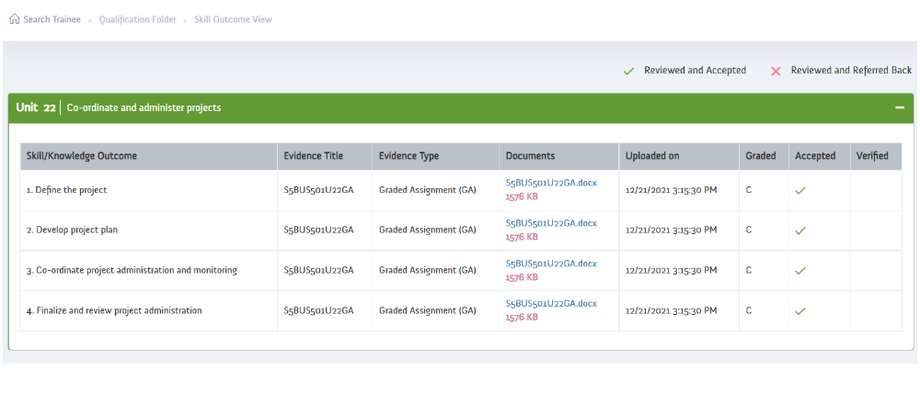

Skill/Learning Outcome View wireframe

UC-27 View Evidence
Use Case in 'Trainee Management'

This use case enables the user to:
- View Evidence Folder
- View Unit Summary

ACTORS
Actor: COE Admin
Actor: College Admin
Actor: Internal Verifier
Actor: Assessor
Actor: External Verifier
Actor: Trainee

PRE-CONDITIONS
Logged in user with sufficient privileges
- COE Admin
- College Admin with access to college
- Assessor with access to Qualification and Trainee
- Verifier with access to Qualification and Trainee
Trainee can view his own portfolio

SCENARIOS
Main Flow. Main Flow

- This use cases starts when the user selects to View Evidence
- System displays View Evidence Folder

Alternate. View Unit Summary

- User selects to View Unit Summary
- System performs View Unit Summary

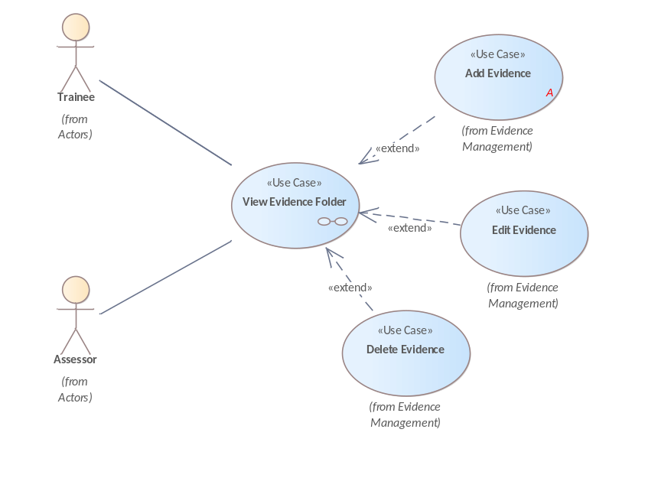

View Evidence

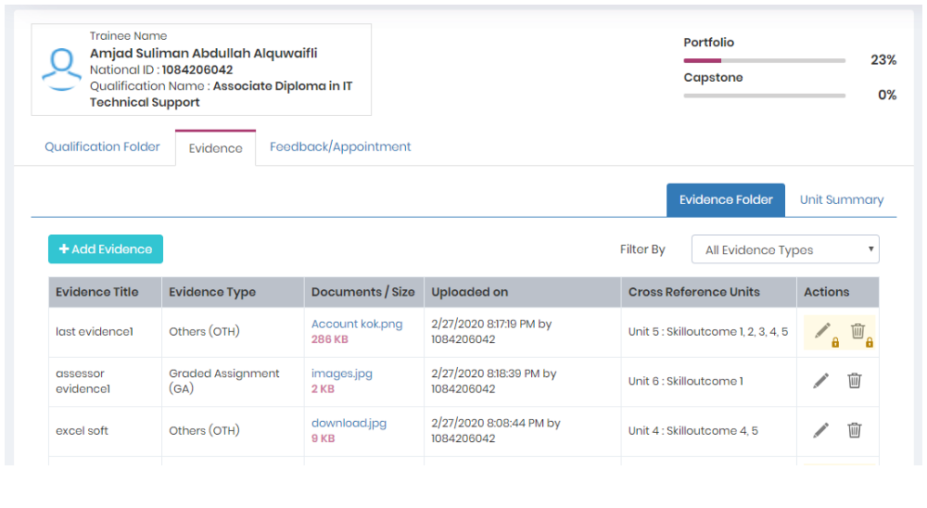

View Evidence wireframe

UC-28 View Evidence Folder
Use Case in 'Trainee Management'

This use case enables the user to manage Unit evidence on the qualification level
User can view list of evidence submitted to the qualification Units with Cross Referenced Units
- Evidence Title
- Evidence Type
- Documents / Size
- Uploaded on
- Cross Referenced Units
- Actions (Edit, Delete)
It also enables the user to:
- Add Evidence
- Edit Evidence
- Delete Evidence

ACTORS
Actor: External Verifier
Actor: College Admin
Actor: Trainee
Actor: COE Admin
Actor: Trainee
Actor: Assessor
Actor: Internal Verifier

PRE-CONDITIONS
Logged in user with sufficient privileges
- COE Admin
- College Admin with access to college
- Assessor with access to Qualification and Trainee
- Verifier with access to Qualification and Trainee
- Trainee can view his own portfolio

SCENARIOS
Main Flow. Main Flow

- This use case starts when trainee selects to View Evident Folder or when Trainer selects to view trainee portfolio and selects to view Evidence folder
- System displays list of evidence assigned to the Skill/Learning Outcomes

Alternate. Filter by Evidence Type

- User selects Evidence Type
- User clicks Search
- System displays evidence matching the Evidence Type

Main Flow. Add Evidence

- User clicks Add Evidence
- System performs Add Evidence

Alternate. Edit Evidence

- User clicks Edit Evidence
- System performs Edit Evidence

Alternate. Delete Evidence

- User clicks Delete Evidence
System performs Delete Evidence

BUSINESS RULES
Business Rule. Evidence Type(s)

- Graded Assignment (GA)
- Product Evidence (PE)
- Evidence Diary (ED)
- Exam Result (ER)
- Written Questioning (EQ)
- Observation (O)
- Written Testimony (WT)
- Capstone (CAP)
- Others (OTH)

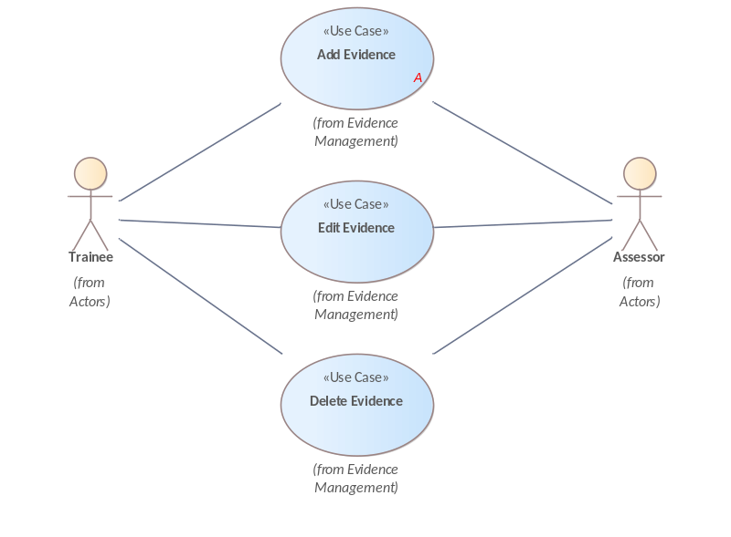

View Evidence Folder

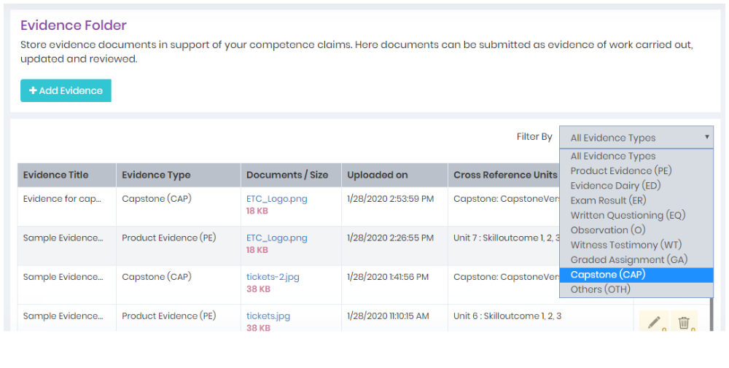

Evidence Filter wireframe

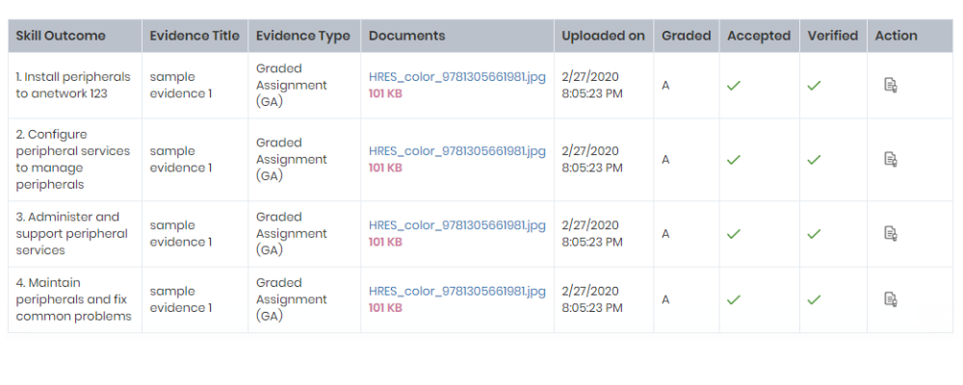

View Trainee portfolio Evidence Folder wireframe

UC-29 View Unit Summary
Use Case in 'Trainee Management'

This use case enables the user to view the evidence grouped under units.
User can view list of Units and Unit Skill/Learning Outcomes and the evidence assigned to each
- Skill learning outcome
- Evidence title
- Evidence type
- Documents
- Uploaded on date and time
- Grade
- Acceptance status
- Actions (Edit, Delete, Grade)

ACTORS
Actor: External Verifier
Actor: COE Admin
Actor: Internal Verifier
Actor: Assessor
Actor: College Admin
Actor: Trainee
Actor: Assessor

PRE-CONDITIONS
Logged in user with sufficient privileges
- COE Admin
- College Admin with access to college
- Assessor with access to Qualification and Trainee
- Verifier with access to Qualification and Trainee
- Trainee can view his own portfolio

SCENARIOS
Main Flow. Main Flow

- This use case starts when user selects to view Trainee Portfolio, Evidence, Unit Summary tab
- System displays Expandable list of Units
- User clicks expand a Unit
- System displays Skill/Learning Outcomes Evidence with Accepted flag/Grade/Verified flag.

Main Flow. Edit Evidence

- User clicks Edit Evidence button
- System performs Edit Evidence

Main Flow. Delete Evidence

- User clicks Delete Evidence button
- System performs Delete Evidence

Main Flow. Grade Unit

- User clicks Grade button
- System performs Accept and Grade Unit

Alternate. Download Evidence

- User clicks on the evidence file name
- System downloads the file
- User opens the file with a suitable file viewer to view the file.

Skill/Learning Outcome View wireframe

UC-30 View Capstone Unit
Use Case in 'Trainee Management'

- This use case enables the user to view Trainee Capstone details
- Capstone Tasks
- Assessor Guide
- Resource List
- Uploaded evidence(s)

ACTORS
Actor: Internal Verifier
Actor: College Admin
Actor: External Verifier
Actor: COE Admin
Actor: Assessor
Actor: Trainee

PRE-CONDITIONS
Logged in user with sufficient privileges
- COE Admin
- College Admin with access to college
- Assessor with access to Qualification and Trainee
- Verifier with access to Qualification and Trainee
- Trainee can view his own portfolio

SCENARIOS
Main Flow. Main Flow

This use case starts when user chooses to view capstone unit

EXTENSION POINTS
View Grade

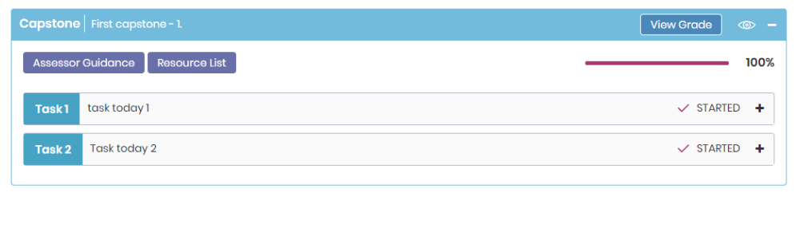

View Capstone Unit wireframe

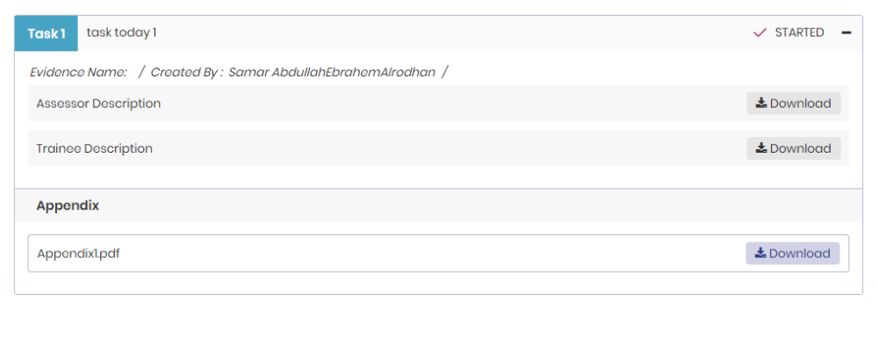

View Capstone Task wireframe

UC-31 View Capstone Summary
Use Case in 'Trainee Management'

This use case enables the user to manage evidence on the Capstone Task level
User can view list of Capstone Tasks and the evidence assigned to each
- Task
- Evidence title
- Evidence type
- Documents
- Uploaded on date and time
- Grade
- Acceptance status
- Actions (Edit, Delete, Grade)

ACTORS
Actor: College Admin
Actor: Assessor
Actor: Internal Verifier
Actor: Trainee
Actor: COE Admin
Actor: External Verifier

PRE-CONDITIONS
Logged in user with sufficient privileges
- COE Admin
- College Admin with access to college
- Assessor with access to Qualification and Trainee
- Verifier with access to Qualification and Trainee
- Trainee can view his own portfolio

SCENARIOS
Main Flow. Main Flow

- This use case starts when user selects to view Trainee Portfolio, Evidence, Capstone Summary tab
- System displays Expandable list of Tasks
- User clicks expand a Capstones
- System displays Tasks Evidence with Accepted flag/Grade/Verified flag.

Main Flow. Edit Evidence

- User clicks Edit Evidence button
- System performs Edit Evidence

Main Flow. Delete Evidence

- User clicks Delete Evidence button
- System performs Delete Evidence

Main Flow. Grade Task

- User clicks Grade button
- System performs Grade Capstone Unit

Alternate. Download Evidence

- User clicks on the evidence file name
- System downloads the file
- User opens the file with a suitable file viewer to view the file.

EXTENSION POINTS
Verify Capstone Grade

UC-32 View Capstone Grade
Use Case in 'Trainee Management'

This use case enables the user to view the grades and the calculation

ACTORS
Actor: Trainee
Actor: External Verifier
Actor: Internal Verifier
Actor: COE Admin
Actor: Assessor
Actor: College Admin

PRE-CONDITIONS
Logged in user with sufficient privileges
- COE Admin
- College Admin with access to college
- Assessor with access to Qualification and Trainee
- Verifier with access to Qualification and Trainee
- Trainee can view his own portfolio

SCENARIOS
Main Flow. Main Flow

- This use case starts when user clicks View Grade on Capstone Bar
- System displays Assessment Screen

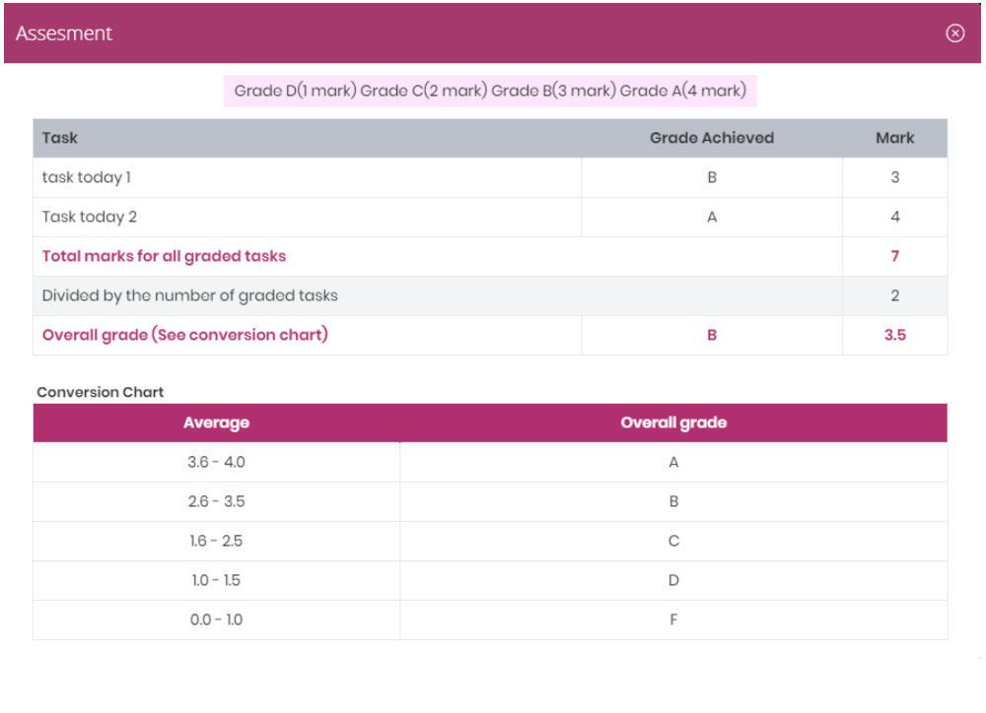

View Capstone Grade wireframe

UC-33 View Feedback/Appointments
Use Case in 'Trainee Management'

This use case enables the user to view Feedback/Appointments List:
  - Date
  - Posted By
  - Description
  - Action
  - Skill/Knowledge Outcome
  - Next Meeting
  - Acknowledged
  - Action (Print)

It also enables the user to:
- Schedule Appointment
- Send Feedback

ACTORS
Actor: Trainee
Actor: College Admin
Actor: Trainee
Actor: Assessor
Actor: External Verifier
Actor: COE Admin
Actor: Internal Verifier

PRE-CONDITIONS
Logged in user with sufficient privileges
- COE Admin
- College Admin with access to college
- Assessor with access to Qualification and Trainee
- Verifier with access to Qualification and Trainee
- Trainee can view his own portfolio

SCENARIOS
Main Flow. Main Flow

1. This use case begins when user selects to View Feedback/Appointment
Alternate: 1a. Filter by Category
2. System displays Feedback/Appointment List

Alternate. Schedule Appointment

- This use case starts when user clicks Schedule Appointment
- System performs Schedule Appointment

Alternate. Send Feedback

- User clicks Send Feedback button
- System performs Send Feedback

Alternate. Filter by Category

- User selects Feedback Category
- User selects to Search

BUSINESS RULES
Business Rule. If the Assessor has requested for Acknowledgement for the feedback or appointment a checkbox will be in enabled state for the Trainee to click and acknowledge.

Business Rule. If the Assessor has not requested for Acknowledgement for the feedback or appointment checkbox will be in disabled state for the trainee.

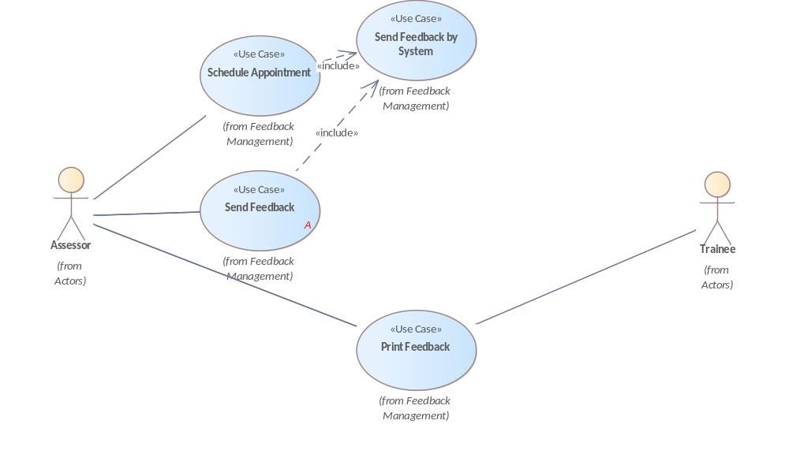

View Feedback/Appointments

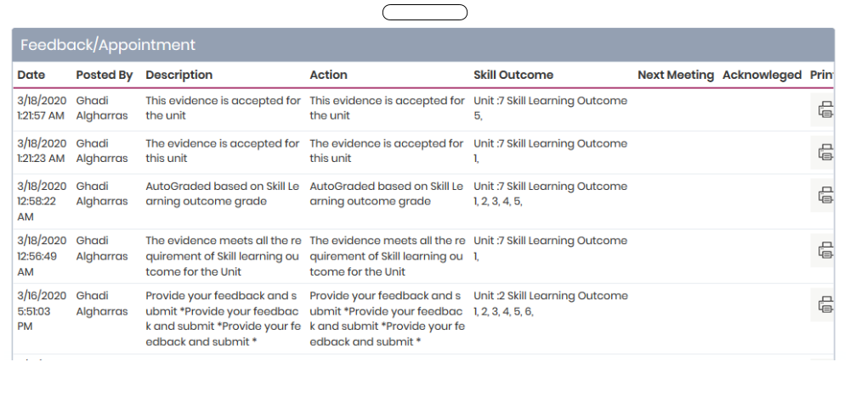

View Trainee portfolio - Feedback wireframe

Evidence Management

- This set of use cases to enables Trainees to manage evidence.
- User can upload/create evidence for the Unit Skill/Learning outcomes or Capstone Tasks assigned to the Trainee.
- Assessor can do the same for trainee.

BUSINESS RULES
Business Rule. Trainee can upload evidence only after accepting declaration

Business Rule. Initial Status of Skill Learning Outcome is "Not Started"

Business Rule. Trainee can submit evidence for Unit (All Outcomes in the Unit) or for outcome(s) within Unit

Business Rule. Status of Skill Learning Outcome with evidence uploaded is "Started"

Business Rule. Unit Completion: Number of Started skill learning outcome/number of Unit skill learning outcome

Business Rule. Portfolio %: Number of Started Skill/Learning Outcomes/Number of Qualification Units Skill/Learning Outcomes

Business Rule. Capstone %: Number of Started Tasks/Number of Capstone Tasks

Evidence Management Business Process diagram
Business Process diagram in 'Evidence Management'

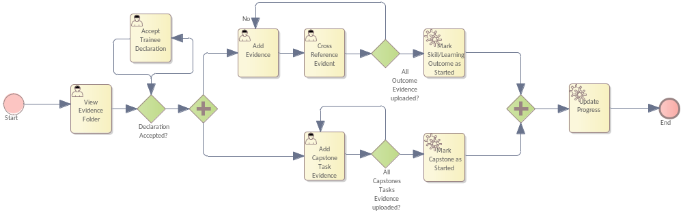

Evidence Management Business Process

Evidence Management State Machine diagram
StateMachine diagram in 'Evidence Management'

A state machine diagram models the behavior of a single object, specifying the sequence of events that an object goes through during its lifetime in response to events.

The following state machine diagram shows the states that a Qualification Unit goes through during its lifetime.

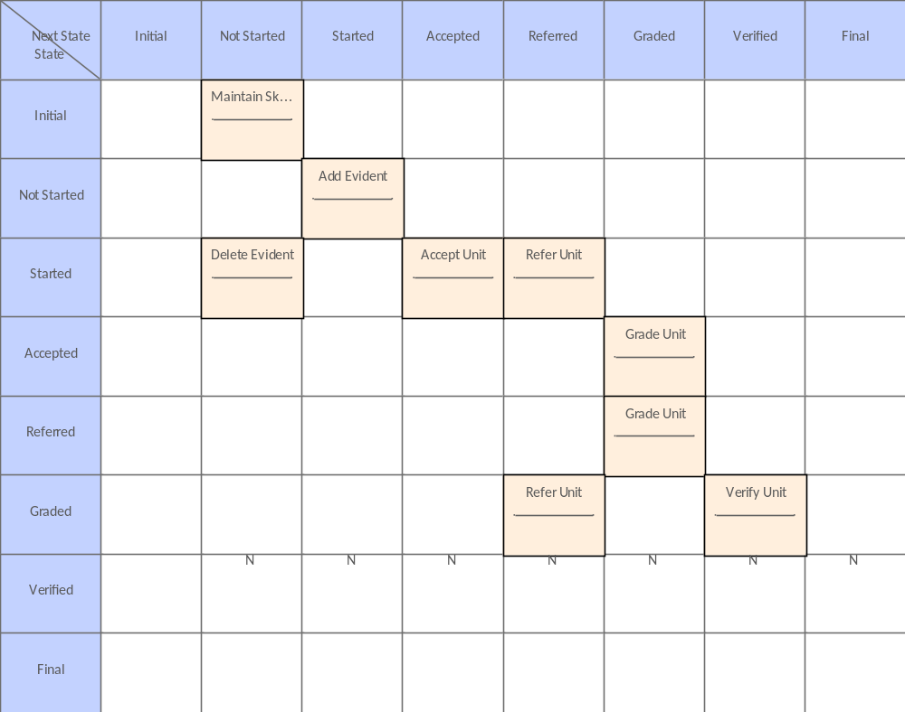

Evidence Management State Machine

Evidence Management Use Cases diagram
Use Case diagram in 'Evidence Management'

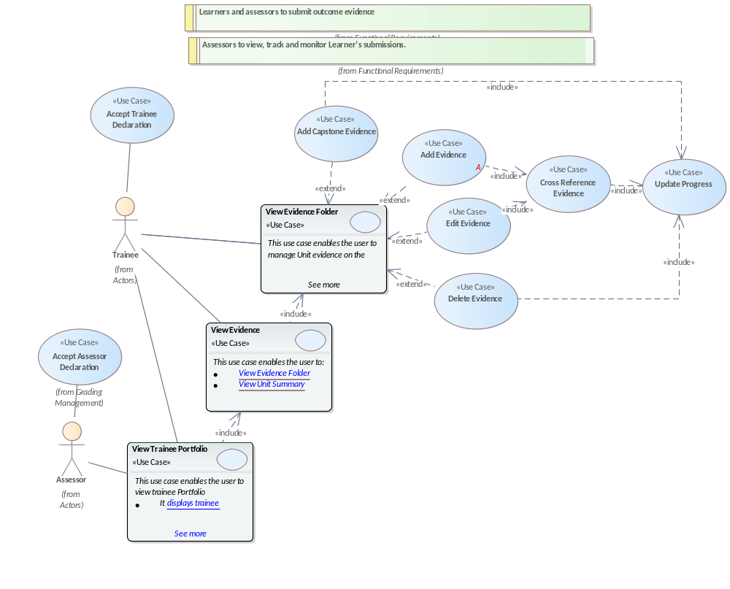

Evidence Management Use Cases

UC-34 Accept Trainee Declaration
Use Case in 'Evidence Management'

- This use case illustrates how to accept Declaration.
- User will be allowed to start creating/uploading evidence only if declaration is accepted.

ACTORS
Actor: Trainee

PRE-CONDITIONS
Logged in user with Trainee Privileges

SCENARIOS
Main Flow. Accept Trainee Declaration

1. This use case begins when user selects to Accept Trainee Declaration
2. System displays Trainee Declaration screen
3. User selects to Accept Declaration
Alternate: 3a. Decline Trainee Declaration
4. System performs Send Feedback by System
5. System marks Trainee Declaration as Done
6. The use case ends.

Alternate. Decline Trainee Declaration

1. User selects to Decline Declaration
2. System marks Trainee Declaration as Not Accepted

POST CONDITIONS
User can add evidence(s)

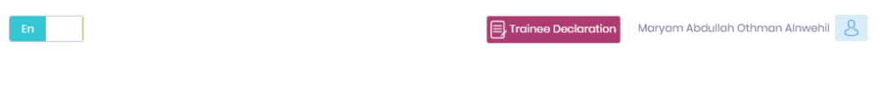

Trainee Declaration wireframe

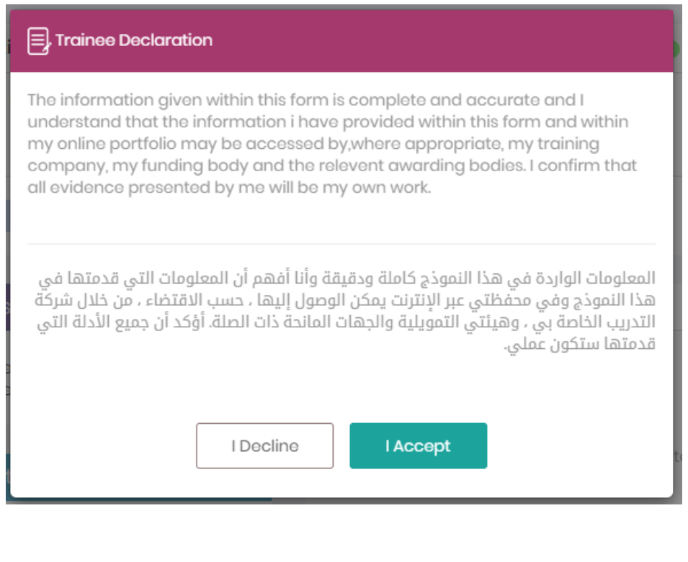

Submit Trainee Declaration wireframe

UC-35 Add Evidence
Use Case in 'Evidence Management'

This use case illustrates how to add evidence for Unit, Skill/Learning Outcome as defined in qualification assigned to the user

ACTORS
Actor: Trainee
Actor: Assessor

PRE-CONDITIONS
Logged in user with Trainee or Assessor Privileges

SCENARIOS
Main Flow. Main Flow

1. Use case starts when User selects to add New Evidence
2. System displays New Evidence screen
3. User enters Evidence Title (Mandatory)
4. User enters Evidence Description (Mandatory)
5. User selects Evidence Type(s) (Mandatory)
6. User selects to Upload or create file for the evidence
7. User selects to Save and Cross Reference Evidence
Alternate: 7a. Cancel
8. System validates mandatory fields
Exception: 8a. Missing Fields
9. System performs Cross Reference Evidence
10. The use case ends.

Alternate. Cancel

- User selects to Cancel
- The use case ends.

Exception. Missing Fields

- System highlights missing Fields
- System prompts the user to enter missing fields

BUSINESS RULES
Business Rule. Evidence Type(s)

- Graded Assignment (GA)
- Product Evidence (PE)
- Evidence Diary (ED)
- Exam Result (ER)
- Written Questioning (EQ)
- Observation (O)
- Written Testimony (WT)
- Capstone (CAP)
- Others (OTH)
Business Rule. Evidence File Format

- Document Formats (PDF, DOC, Docx, XLS, XLSX, TXT, Zip)
- Image Formats (JPEG, JPG, PNG, BMP)
- Audio and Video Formats (MP3, MP4, FLV)

POST CONDITIONS
System sends feedback

Send Feedback by System

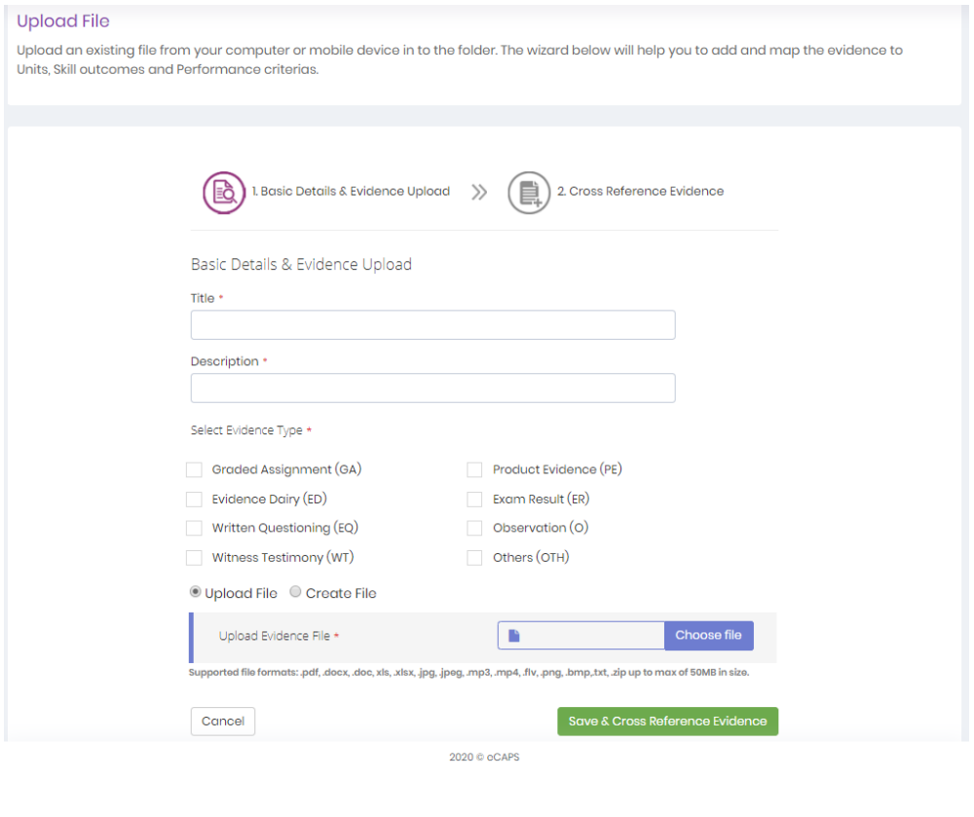

Add Evidence wireframe

UC-36 Cross Reference Evidence
Use Case in 'Evidence Management'

This use case illustrates how use can select assign evidence to one or more Units as a whole or assign to one or more Skill/Learning Outcome

ACTORS
Actor: Trainee
Actor: Assessor

PRE-CONDITIONS
Logged in user with sufficient privileges

SCENARIOS
Main Flow. Main Flow

1. Use case starts when user selects Save and Cross Reference Evidence in Add Evidence
2. System displays list of units with Expand option
3. User clicks Expand Unit
4. System displays Skill/Learning Outcomes with Expand option
5. User clicks Expand Skill/Learning Outcome
6. System displays Performance Criteria
7. User may select Unit
8. System will check all Skill/Learning Outcomes in the Unit
9. User may check/Uncheck Skill/Learning Outcome
10. User selects to Save and Finish
Alternate: 10a. Cancel Cross Reference Evidence
Alternate: 10b. Back to Add Evidence
11. System performs Update Progress

1.

Alternate. Back to Add Evidence

- User clicks Back
- System goes to Add Evidence

Alternate. Cancel Cross Reference Evidence

- User clicks Cancel
- System goes back to List Evidence

BUSINESS RULES
Business Rule. When evidence submitted to All Outcomes, Unit has completed 100%

POST CONDITIONS
Status of Skill Learning Outcome with evidence uploaded is "Started"

Assessor can grade unit with all skill/learning outcome evidence submitted

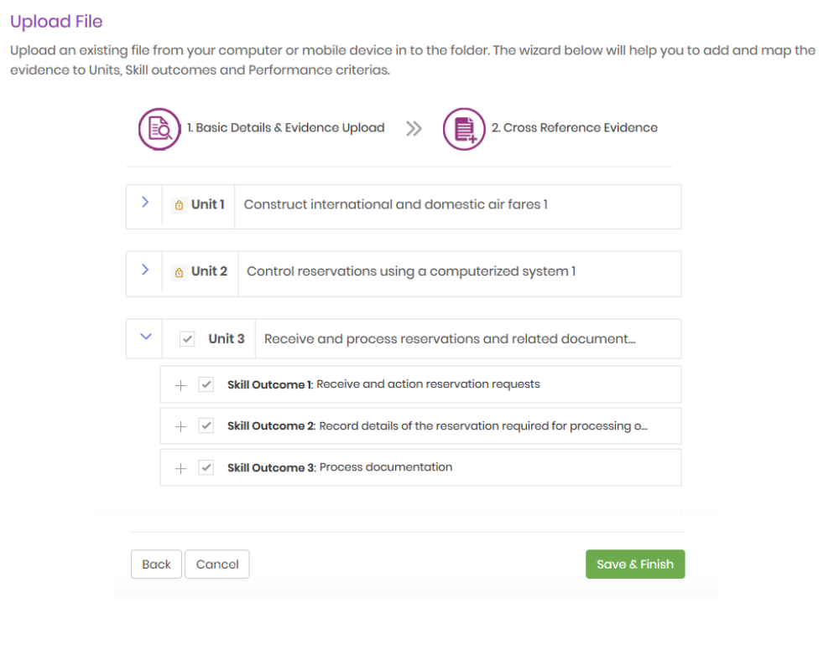

Cross Reference Evidence wireframe

UC-37 Edit Evidence
Use Case in 'Evidence Management'

This use case illustrates how to edit submitted evidence for Unit, Skill/Learning Outcome as defined in qualification assigned to the user

ACTORS
Actor: Assessor
Actor: Trainee

PRE-CONDITIONS
Logged in user with sufficient privileges

SCENARIOS
Main Flow. Main Flow

1. User selects to Edit an evidence record
2. System displays the selected evidence in Add Evidence screen
3. User may modify Evidence Title (Mandatory)
4. User may modify Evidence Description (Mandatory)
5. User selects Evidence Type(s) (Mandatory)
6. User selects to Upload or create file for the evidence
7. User selects to Save and Cross Reference Evidence
Alternate: 7a. Cancel
8. System performs Cross Reference Evidence

Alternate. Cancel

- User selects to Cancel
- The use case ends.

BUSINESS RULES
Business Rule. An evidence record is added for every unit selected in Cross Reference Evidence

POST CONDITIONS
System sends feedback
Send Feedback by System

UC-38 Delete Evidence
Use Case in 'Evidence Management'

This use case illustrates how to delete evidence of Unit, Skill/Learning Outcome, Performance Criteria defined in qualification assigned to the user

ACTORS
Actor: Assessor
Actor: Trainee

PRE-CONDITIONS
Logged in user with sufficient privileges

SCENARIOS
Main Flow. Main Flow

1. User selects to Delete an Evidence
2. System displays confirmation message
3. User selects to confirm
Alternate: 3a. Cancel Delete
4. System deletes the selected evidence
5. System performs Update Progress
6. System closes the confirmation message

Alternate. Cancel Delete

1. User selects to Cancel

POST CONDITIONS
System sends feedback
Send Feedback by System

UC-39 Add Capstone Evidence
Use Case in 'Evidence Management'

This use case illustrates how to add evidence for capstone task as defined in qualification assigned to the user

Create a new capstone evidence (This will be displayed only when the capstone unit is activated in the qualification

ACTORS
Actor: Assessor
Actor: Trainee

PRE-CONDITIONS
Logged in user with Trainee or Assessor Privileges

SCENARIOS
Main Flow. Main Flow

1. This use case begins when user chooses to add capstone evidence
2. System displays Create Capstone Evidence
3. User selects Capstone Task (Mandatory)
4. User enters Title (Mandatory)
5. User selects to Upload or Create File
6. User Clicks Save and Finish
Alternative: 6a. Cancel
7. System validates mandatory fields
Exception: 7a. Missing Fields
8. Use case ends

Alternate. Cancel

- User clicks Cancel
- use cases ends

Exception. Missing Fields

- System highlights missing Fields
- System prompts the user to enter missing fields

POST CONDITIONS
Status of Capstone Task with evidence submitted is "Started"

Assessor can Grade capstone Task with all tasks evidence submitted

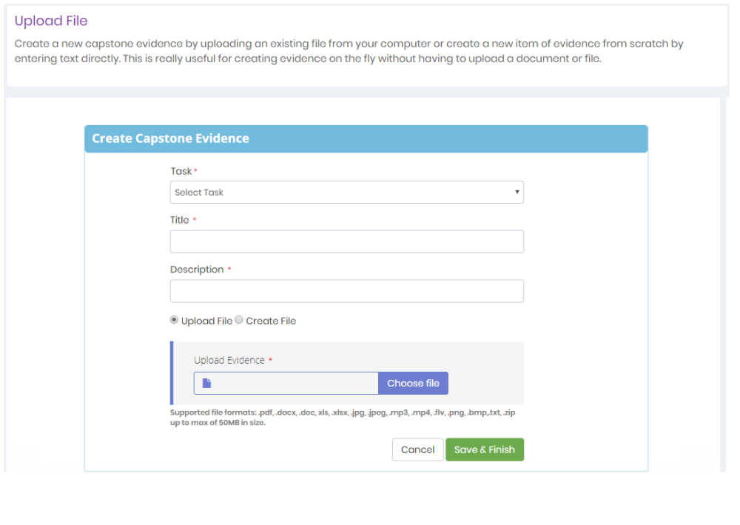

Add Capstone Evidence wireframe

UC-40 Update Progress
Use Case in 'Evidence Management'

This use case is performed by the system to:
- Update Evidence Status.
- Update Progress of e-Portfolio Progress, Grading
- This use case is also for updating Milestones (Star 25% completion)
- It should update progress when
- Evidence for Units/Skill Learning Outcomes is added/Deleted
- Evidence for Capstone Task is added/Delete
- Evidence is Accepted/Rejected/Graded
- Evidence is Verified/Referred.

ACTORS
Actor: System

SCENARIOS
Main Flow. Main Flow

This use case begins when user completes Add/Delete/Accept/Refer/Verify Grade/Refer Grade
It should update
- Unit Completion %
- Portfolio Completion %
- Grading Completion %
- Verifying Complete %

POST CONDITIONS
ePortfolio progress updated
- Unit Completion % updated
- Grading % updated
- Verifying % updated
- ePortfolio progress updated

Grading Management

- This set of use cases enables user with Assessor Role to Accept and Grade Trainee submitted evidence.
- Assessor will be able to review progress of assigned trainees at Unit levels as well as Outcome levels.
- Assessor will be able to accept/refer Unit/Skill Learning outcomes of a trainee qualification based upon the evidence.

BUSINESS RULES
Business Rule. Assessor can upload evidence only after accepting declaration

Business Rule. Assessor can grade evidence only after accepting declaration

Business Rule. Assessor can grade only units with Completion % is 100% (All Outcomes are "Started")

Business Rule. Grading evidence will grade all the skill outcomes which are tagged.
If evidence tagged to more than one skill outcome. Accepting/grading this will grade all the skill outcomes which are tagged.
Business Rule. When Grading Unit Status is "Graded", All Outcomes within the Unit status is also "Graded"

Business Rule. Grading %: Number of Graded Units/Number of Units with evidence submitted

Business Rule. Graded Unit evidence cannot be Edited or Deleted by Trainee

Business Rule. Graded Skill/Learning Outcomes evidence cannot be Edited or Deleted by Trainee

Grading Management diagram
Business Process diagram in 'Grading Management'

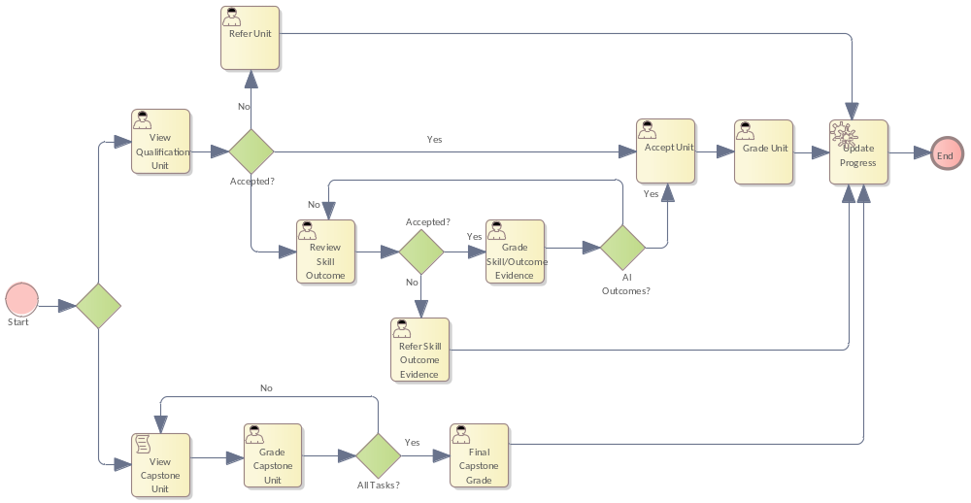

Grading Management

Grading Management Use Cases diagram
Use Case diagram in 'Grading Management'

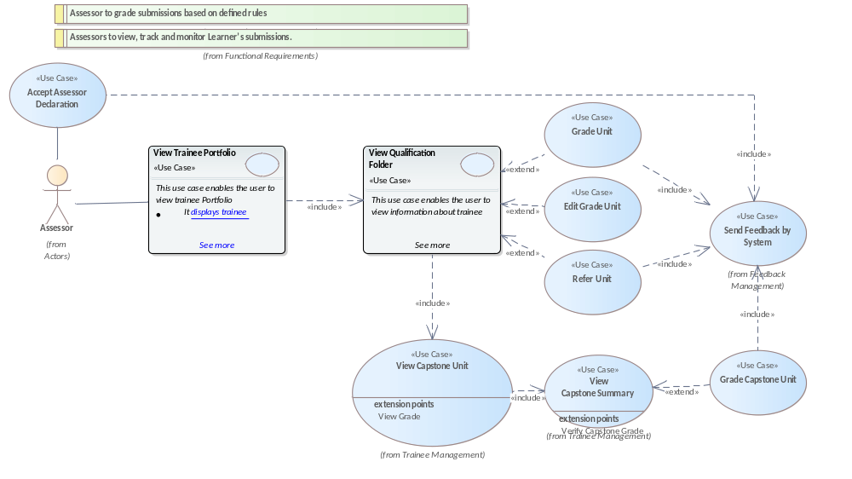

Grading Management Use Cases

UC-41 Accept Assessor Declaration
Use Case in 'Grading Management'

- This use case enables the user to accept declaration.
- User will be allowed to start grading only if declaration is accepted.

ACTORS
Actor: Assessor

PRE-CONDITIONS
Logged in user with Assessor Privileges

SCENARIOS
Main Flow. Accept Assessor Declaration

1. This use case begins when user selects to Accept Assessor Declaration
2. System displays Assessor Declaration screen
3. User selects to Accept Declaration
Alternate: 3a. Decline Assessor Declaration
4. System performs Send Feedback by System
5. System marks Assessor Declaration as Done
6. The use case ends.

Alternate. Decline Assessor Declaration

- User selects to Decline Declaration
- The use case ends.

POST CONDITIONS
User can add evidence(s)

User can grade evidence(s)

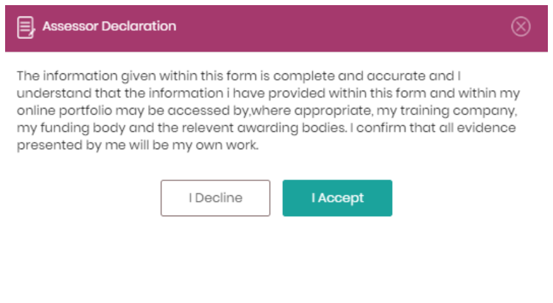

Submit Assessor Declaration wireframe

UC-42 Grade Unit
Use Case in 'Grading Management'

This use case enables the user to grade unit based on Trainee submission for Unit Skill/Learning Outcomes

ACTORS
Actor: Assessor

PRE-CONDITIONS
Logged in user with Assessor privileges

SCENARIOS
Main Flow. Main Flow

1. This use case begins when user selects to Grade Unit
2. System displays Accept Unit and Assign Grade screen
3. User selects to Accept the Unit
4. System displays Grade section
5. User selects Grade
6. User enters Feedback (Mandatory)
7. User selects to Submit
Alternate: 7a. Cancel
8. System validates mandatory fields
9. System performs Send Feedback by System
Alternate: 9a. Missing Fields
10. The use case ends.

Exception. Missing Fields

- System highlights missing Fields
- System prompts the user to enter missing fields

Alternate. Cancel

- User selects to Cancel
- The use case ends.

BUSINESS RULES
Business Rule. Unit can be assessed only if all Skill/Learning outcomes evidence are added.

POST CONDITIONS
System sends feedback
Send Feedback by System
Trainee cannot Edit/Delete evidence record

Verifier can Review Graded Units

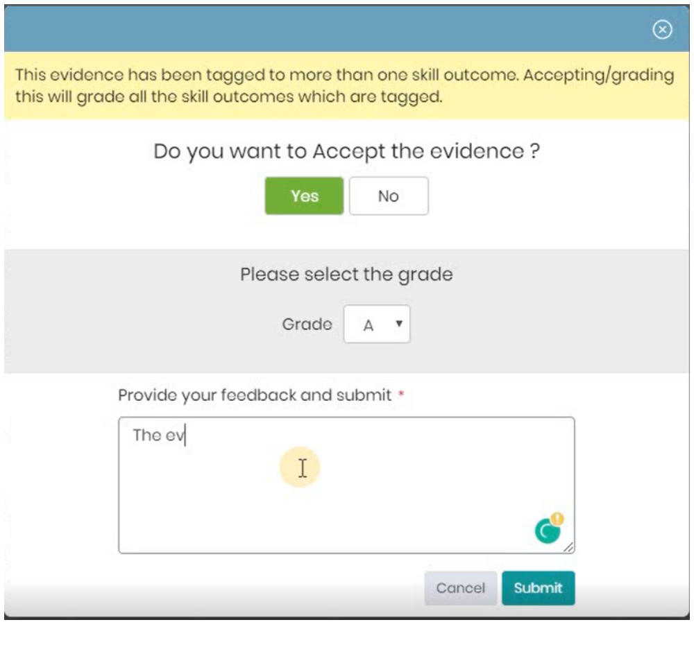

Assign Grade wireframe

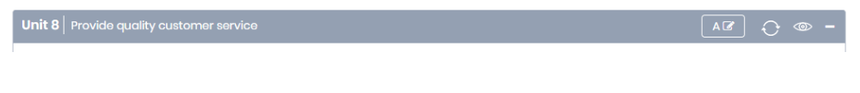

Unit Grade wireframe

UC-43 Edit Grade Unit
Use Case in 'Grading Management'

This use case enables the user to edit the grade assigned to Unit

ACTORS
Actor: Assessor

PRE-CONDITIONS
Logged in user with Assessor privileges

SCENARIOS
Main Flow. Main Flow

1. This use case begins when user selects to Edit Unit Grade
2. System displays Grade screen with Grade and Feedback
5. User selects Grade
6. User enters Feedback (Mandatory)
7. User selects to Submit
Alternate: 7a. Cancel
8. System validates mandatory fields
9. System performs Send Feedback by System
Alternate: 9a. Missing Fields
10. The use case ends.

Alternate. Cancel

- User selects to Cancel
- The use case ends.

Exception. Missing Fields

- System highlights missing Fields
- System prompts the user to enter missing fields

BUSINESS RULES
Business Rule. Unit can be assessed only if all Skill/Learning outcomes evidence are added.

POST CONDITIONS
Trainee receives Feedback

Trainee cannot Edit/Delete evidence record

Verifier can Review Graded Units

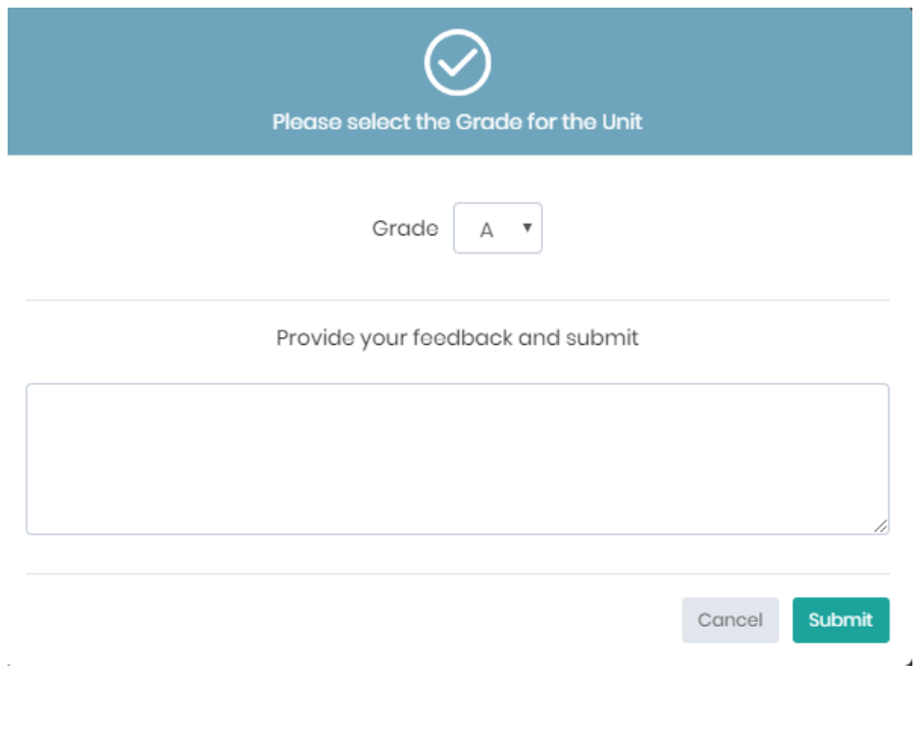

Edit Grade wireframe

UC-44 Refer Unit
Use Case in 'Grading Management'

This use case enables the user to Refer Qualification Unit to Trainee to take an action.

ACTORS
Actor: Assessor

PRE-CONDITIONS
Logged in user with Assessor privileges

SCENARIOS
Main Flow. Main Flow

1. This use case begins when user selects to Refer Unit
2. System displays Refer Unit screen
3. User selects to Refer the Unit
4. User enters Feedback (Mandatory)
5. User selects to Submit
Alternate: 5a. Cancel
6. System validates mandatory fields
7. System performs Send Feedback by System
Alternate: 7a. Missing Fields
8. The use case ends.

Exception. Missing Fields

- System highlights missing Fields
- System prompts the user to enter missing fields

Alternate. Cancel

- User selects to Cancel
- The use case ends.

BUSINESS RULES
Business Rule. Unit can be assessed only if all Skill/Learning outcomes evidence are added.

POST CONDITIONS
System sends feedback
Send Feedback by System
Trainee can Add/Edit/Delete evidence record

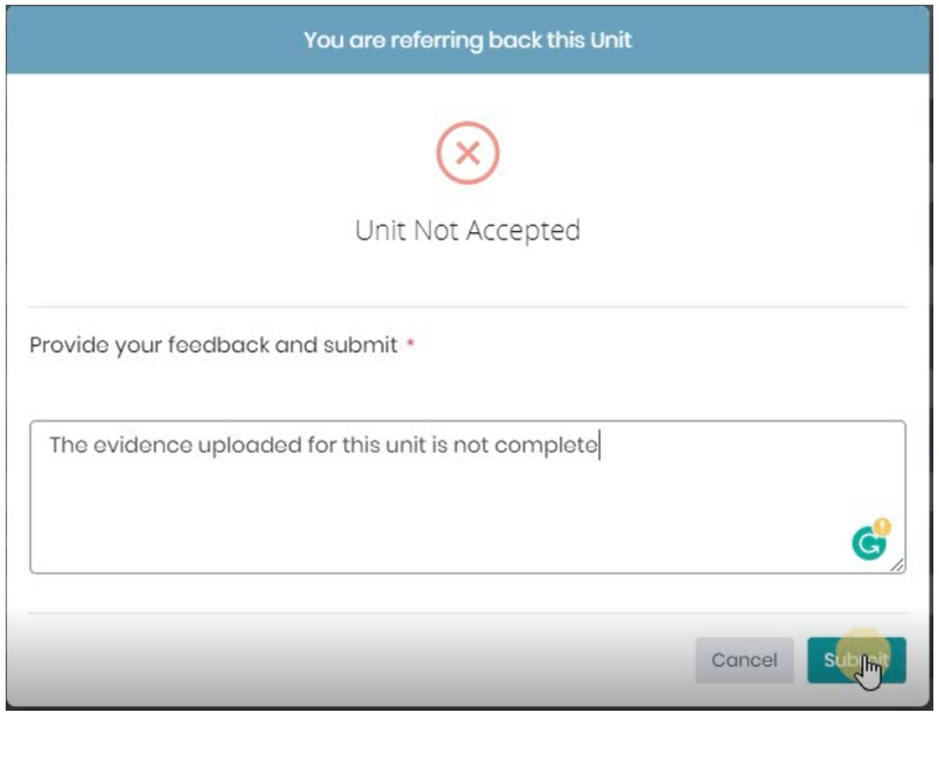

Refer Unit wireframe

UC-45 Grade Skill/Learning Outcome Evidence
Use Case in 'Grading Management'

This use case enables the user to Grade Unit Skill/Learning Outcome.

ACTORS
Actor: Assessor

PRE-CONDITIONS
Logged in user with Assessor privileges

SCENARIOS
Main Flow. Main Flow

1. This use case begins when user selects Grade Skill/Learning Outcomes
2. System displays Accept Unit and Assign Grade screen
3. User selects to Accept the Unit
4. System displays Grade section
5. User selects Grade
6. User enters Feedback (Mandatory)
7. User selects to Submit
Alternate: 7a. Cancel
8. System validates mandatory fields
Alternate: 8a. Missing Fields
9. System updates all Skill/Learning Outcomes in the Unit to "Graded"
10. System updates all Skill/Learning Outcomes Grade with the selected grade
11. System updates Unit Status to "Graded"
12. System updates Unit Grade with the selected Grade
13. System performs Send Feedback by System
14. The use case ends.

Exception. Missing Fields

- System highlights missing Fields
- System prompts the user to enter missing fields

Alternate. Cancel

- User selects to Cancel
- The use case ends.

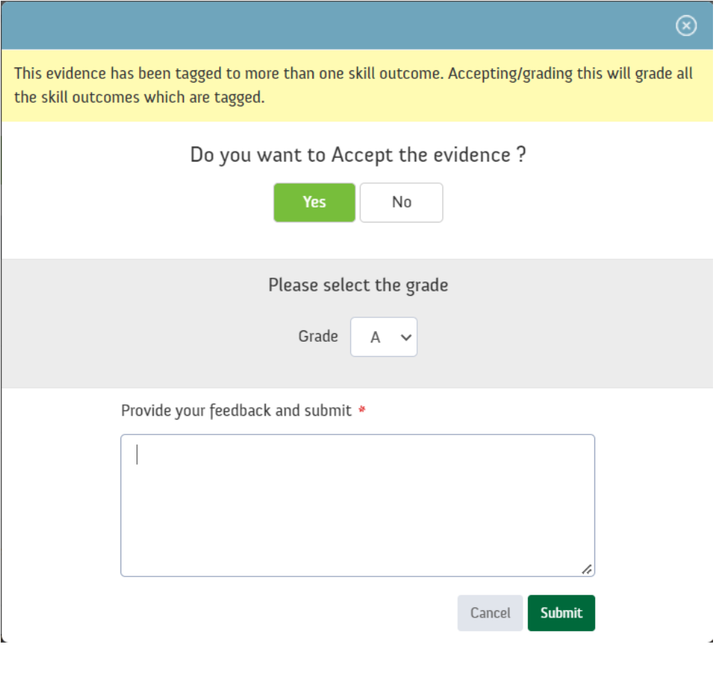

Grade Skill/Learning Outcome Evidence

UC-46 Refer Skill/Learning Outcome Evidence
Use Case in 'Grading Management'

This use case enables the Assessor to refer Unit Skill/Learning Outcome evidence uploaded by trainee.

ACTORS
Actor: Assessor

PRE-CONDITIONS
Logged in user with Assessor privileges

SCENARIOS
Main Flow. Main Flow

1. This use case begins when user selects Refer Skill/Learning Outcomes
2. System displays Refer Unit screen
3. User selects to Refer the Unit
4. User enters Feedback (Mandatory)
5. User selects to Submit
Alternate: 5a. Cancel
6. System validates mandatory fields
Alternate: 6a. Missing Fields
7. System updates all Skill/Learning Outcomes in the Unit to "Graded"
8. System updates all Skill/Learning Outcomes Grade with the selected grade
9. System updates Unit Status to "Graded"
10. System updates Unit Grade with the selected Grade
11. System performs Send Feedback by System
12. The use case ends.

Alternate. Cancel

- User selects to Cancel
- The use case ends.

Exception. Missing Fields

- System highlights missing Fields
- System prompts the user to enter missing fields

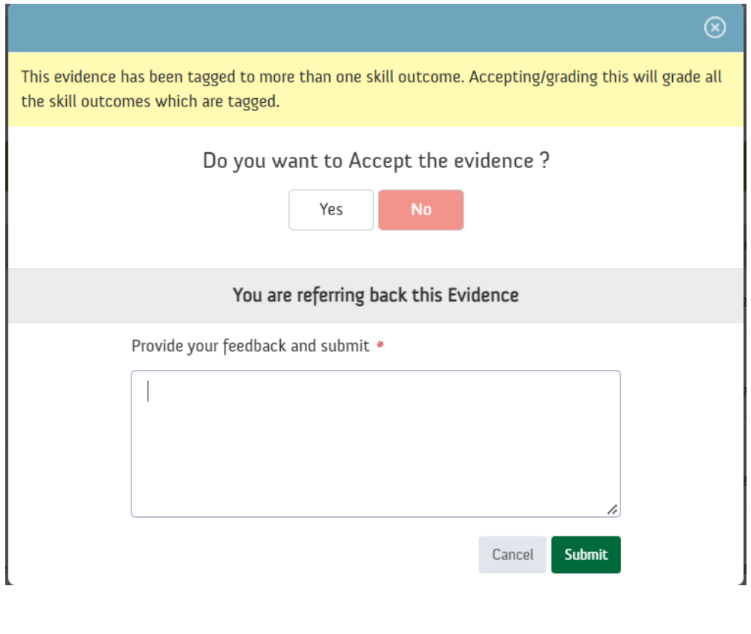

Refer Skill/Learning Outcome Evidence

UC-47 Grade Capstone Unit
Use Case in 'Grading Management'

This use case enables the Assessor to Grade Trainee Capstone

ACTORS
Actor: Assessor

PRE-CONDITIONS
Logged in user with Assessor privileges

SCENARIOS
Main Flow. Main Flow

- This use case starts when use clicks Capstone Task Grade button
- System displays Capstone Grading screen
- If user wants the evidence to be graded as A you have to check all the check boxes from Grade D to Grade A
- User selects to Save; Alternate: 4a. Cancel
- System performs Send Feedback by System

Alternate. Cancel

- User selects to Cancel
- The use case ends.

POST CONDITIONS
Trainee receives Feedback

Trainee cannot Edit/Delete evidence record

Verifier can Review Graded Capstone Tasks

Grade Capstone Unit wireframe

UC-48 Reset Graded Unit
Use Case in 'Grading Management'

This use case enables the user to Reset Unit and Skill/Learning Outcomes grades

ACTORS
Actor: Assessor

PRE-CONDITIONS
Logged in user with Assessor privileges

SCENARIOS
Main Flow. Main Flow

1. This use case begins when user selects to Reset Unit
2. System displays Reset Unit screen
3. User selects to Reset Unit
Alternate: 3a. Cancel
4. System resets Unit and Skill/Learning Outcomes Grades
5. The use case ends.

Alternate. Cancel

- User selects to Cancel
- The use case ends.

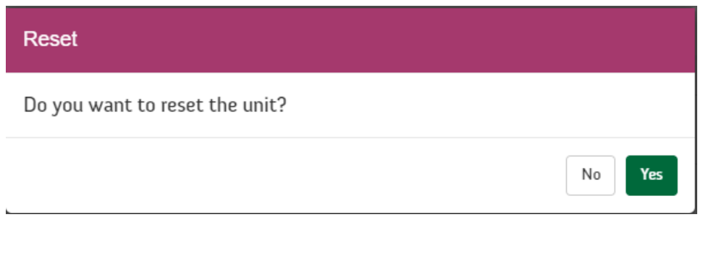

Reset Graded Unit wireframe

Verification Management

This set of use cases enables the user with Verifier Role to verify grades provided by the Assessor.
Where Verifier can verify the given grade or refer the grading to the assessor for review and re-grade.

BUSINESS RULES
Business Rule. Verifier can upload evidence only after accepting declaration

Business Rule. Verifier can review only Graded Units

Business Rule. Assessor cannot edit verified grade.

Verification Management Use Cases diagram
Use Case diagram in 'Verification Management'

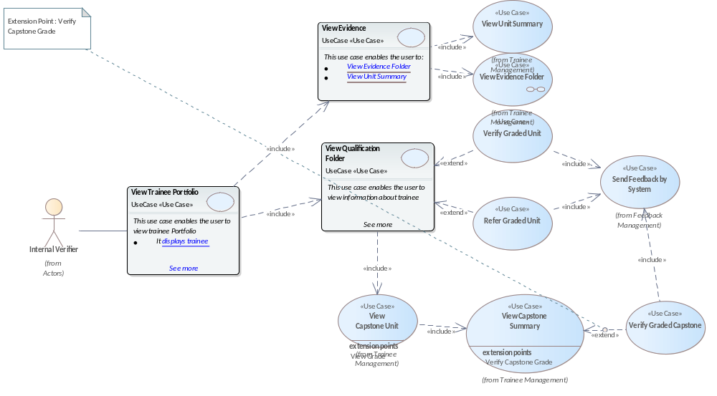

Verification Management Use Cases

UC-49 Verify Graded Unit
Use Case in 'Verification Management'

This use case enables the user to Verify Unit graded by Assessor.

ACTORS
Actor: External Verifier
Actor: Internal Verifier

PRE-CONDITIONS
Logged in user with Verifier Privileges

SCENARIOS
Main Flow. Main Flow

1. This use case begins when user selects to Verify Unit Graded by Assessor
2. System displays Verify Unit screen
3. User selects to Verify the Unit
4. User enters Feedback (Mandatory)
5. User selects to Submit
Alternate: 5a. Cancel
6. System validates mandatory fields
7. System performs Send Feedback by System
Exception: 7a. Missing Fields
8. The use case ends.

Alternate. Cancel

- User selects to Cancel
- The use case ends.

Exception. Missing Fields

- System highlights missing Fields
- System prompts the user to enter missing fields

BUSINESS RULES
Business Rule. Unit graded by Assessor

POST CONDITIONS
System sends feedback
Send Feedback by System
Assessor cannot Edit Graded record

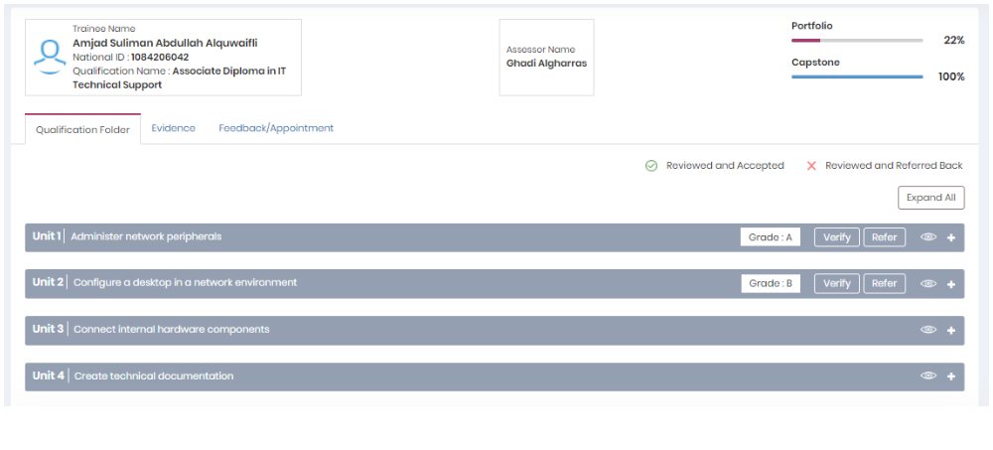

Qualification Folder Tab wireframe

UC-50 Refer Graded Unit
Use Case in 'Verification Management'

This use case enables the user to Refer Unit graded by Assessor.

ACTORS
Actor: External Verifier
Actor: Internal Verifier

PRE-CONDITIONS
Logged in user with verifier privileges
Unit graded by Assessor

SCENARIOS
Main Flow. Main Flow

1. This use case begins when user selects to Refer Unit Graded by Assessor
2. System displays Refer Unit screen
3. User selects to Refer the Unit
4. User enters Feedback (Mandatory)
5. User selects to Submit
Alternate: 5a. Cancel
6. System validates mandatory fields
7. System performs Send Feedback by System
Alternate: 7a. Missing Fields
8. The use case ends.

Alternate. Cancel

- User selects to Cancel
- The use case ends.

Exception. Missing Fields

- System highlights missing Fields
- System prompts the user to enter missing fields

POST CONDITIONS
System sends feedback

Refer Unit wireframe

UC-51 Verify Unit/Skill Outcome
Use Case in 'Verification Management'

User will be able to verify Accepted Unit

ACTORS
Actor: Internal Verifier
Actor: External Verifier
Actor: Internal Verifier

PRE-CONDITIONS
Logged in user with Verifier Privileges
Unit graded by Assessor

SCENARIOS
Main Flow. Grade Unit

1. User navigates to Trainee Portfolio
2. System displays Trainee Portfolio - Qualification Folder
3. User selects to Grade Unit
Alternate: 3a. Grade Skill Outcome
4. System displays verification grade screen
5. User confirms verification
6. System displays Feedback
7. User enters feedback
8. User selects to Submit
9. System Marked Verified Records
10. User navigates to Qualification Folder
11. System displays Qualification Folder with the Unit Marked as Verified (Verify and Refer buttons disappeared)

Alternate. Grade Skill Outcome

1. User selects to view Graded Unit
2. System displays Unit Summary (Skill Outcome View)
3. User selects to Verify the Grade
4. System displays verification grade screen
5. User confirms verification
6. System displays Feedback
7. User enters feedback
8. User selects to Submit
9. System Marked Verified Records
10. User navigates to Qualification Folder
11. System displays Qualification Folder with the Unit Marked as Verified (Verify and Refer buttons disappeared)

POST CONDITIONS
Assessor receives Feedback

Assessor cannot Edit Graded record

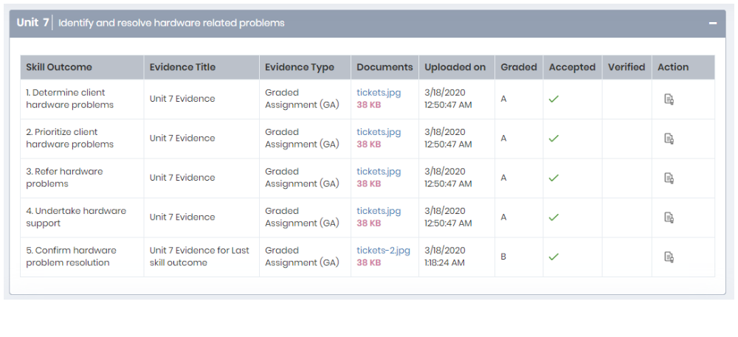

Unit summary wireframe

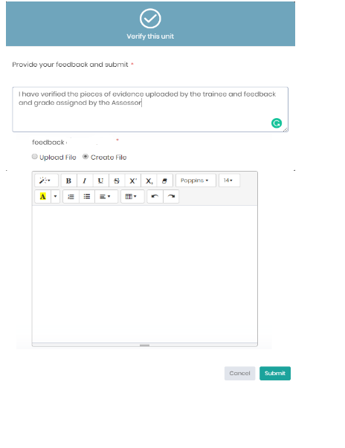

Verify Unit wireframe

UC-52 Refer Graded Skill/Learning Outcome
Use Case in 'Verification Management'

User will be able to refer any Accepted Unit Skill/Learning Outcome

ACTORS
Actor: Internal Verifier
Actor: External Verifier
Actor: Internal Verifier

PRE-CONDITIONS
Logged in user with Verifier Privileges
Unit graded by Assessor

SCENARIOS
Main Flow. Main Flow

1. Use case starts when user navigates to Qualification Folder
2. System displays Qualification Folder
3. User selects to Refer Graded Unit
4. User selects to Refer the Unit
5. System displays Refer this Unit screen
6. User confirms Refer
7. System displays Feedback (Mandatory)
8. User enters feedback
9. User selects to Submit
System validates mandatory fields
10. System unmarked Verified Unit
11. User navigates to Qualification Folder
12. System displays Qualification Folder with the Unit Marked as Referred (Grade, Verify and Refer buttons disappeared)
13. Use case ends

POST CONDITIONS
Assessor receives Feedback

Assessor can Add/Edit/Delete evidence record

Feedback wireframe

UC-53 Verify Graded Capstone
Use Case in 'Verification Management'

This use case enables the Verifier to Verify Graded Trainee Capstone

ACTORS
Actor: Internal Verifier
Actor: External Verifier

SCENARIOS
Main Flow. Main Flow

- This use case starts when user selects to Verify Graded Capstone
- System displays Capstone Verifying screen
- User enters feedback (Mandatory)
- User selects to Save; Alternate: 4a. Cancel
- System validates mandatory fields; Exception: 5a. Missing Fields
- System performs Send Feedback by System

Alternate. Cancel

- User selects to Cancel
- The use case ends.

Exception. Missing Fields

- System highlights missing Fields
- System prompts the user to enter missing fields

Feedback Management

This section has a set of use cases to enable user with Assessor Role to submit feedback on the Skill/Learning Outcome evidence or Capstone task evidence.
Trainee would check the feedback from Assessor and have to do actions
Assessor can also ask Trainer for meeting.
Verifier can view feedback history between Assessor and Trainee.
Verifier may also send feedback on verifying or referring a grade.

Feedback Management Business Process diagram
Business Process diagram in 'Feedback Management'

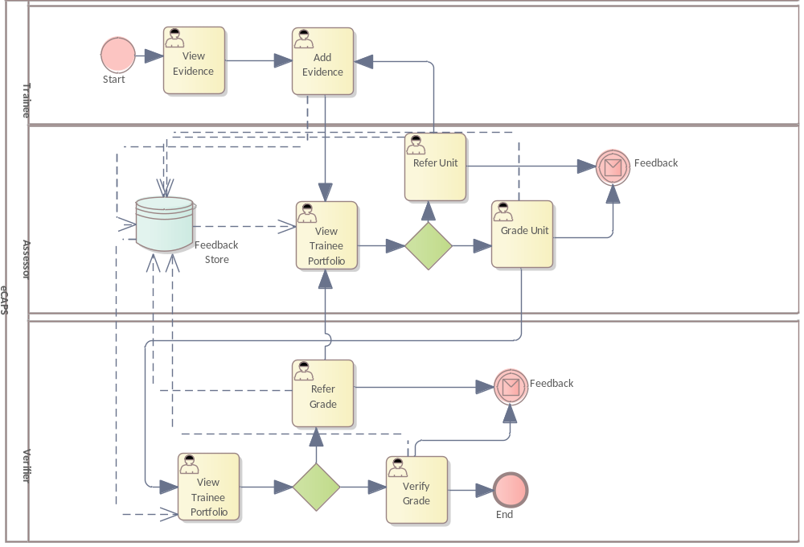

Feedback Management Business Process

Feedback Management diagram
Use Case diagram in 'Feedback Management'

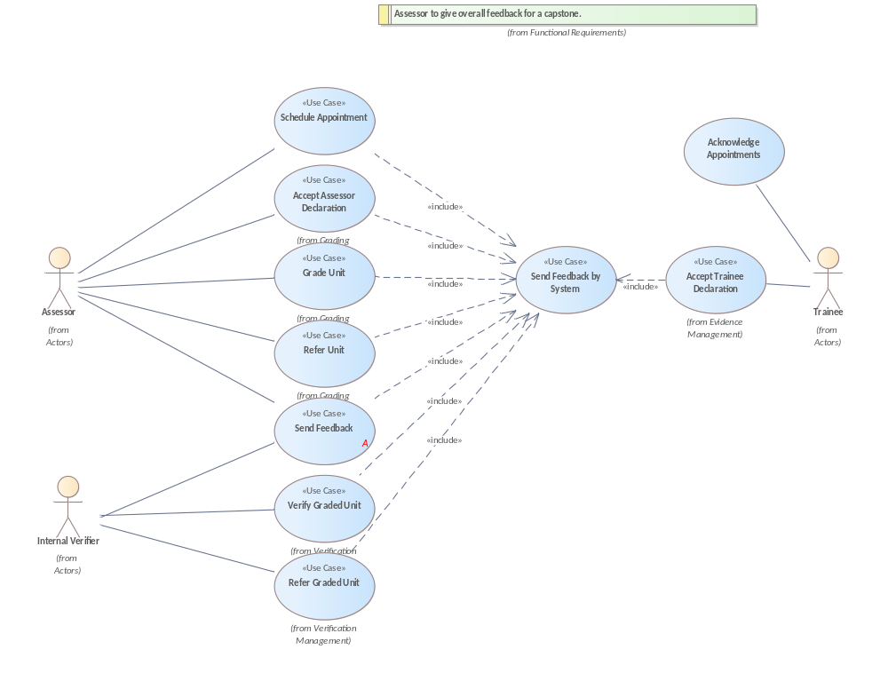

Feedback Management

UC-54 Send Feedback by System
Use Case in 'Feedback Management'

This use case is performed automatically by the system
It creates feedback record.
It is called when
- Trainee/Assessor Accepts Declaration.
- Assessor Grade Unit
- Assessor Refer Unit
- Verifier Verifies Unit Grade
- Verifier Refer Unit Grade

It takes the following parameters:
- Posted by
- Post Date
- Action
- Skill/Learning Outcome
- Next Meeting
- Acknowledged

ACTORS
Actor: System

PRE-CONDITIONS
Logged in user with Assessor Privileges

POST CONDITIONS
Trainee can flag Feedback as Acknowledged

UC-55 Send Feedback
Use Case in 'Feedback Management'

This use case is to enable Assessor to send feedback about Skill/Learning Outcome.

ACTORS
Actor: Assessor
Actor: Internal Verifier
Actor: Assessor
Actor: External Verifier

PRE-CONDITIONS
Logged in user with Assessor privileges

SCENARIOS
Main Flow. Main Flow

1. This use case begins when user selects to send feedback
2. System displays feedback screen
3. User selects Skill/Learning Outcome (Mandatory)
4. User selects Category (Mandatory)
5. User enters Description (Mandatory)
6. User may add Create/Upload Feedback files
7. User chooses to Submit
Alternate: 7a. Cancel
8. System validates mandatory fields
Alternate: 8a. Missing Fields
9. System performs Send Feedback by System
10. The use case ends.

Exception. Missing Fields

- System highlights missing Fields
- System prompts the user to enter missing fields

Alternate. Cancel

- User selects to Cancel
- The use case ends.

BUSINESS RULES
Business Rule. Feedback Categories

- General
- Planning
- Assessment Feedback
- Verification Feedback
- One to one Review
- Evidence Deletion
- Message Copy
- Interim Verification
- Candidate Declaration
- Training

Send Feedback wireframe

UC-56 Schedule Appointment
Use Case in 'Feedback Management'

create a new appointment with the Trainee. The following page will be displayed
The following fields are mandatory to create an appointment
1. Brief Description – about the appointment
2. Actions – You can mention action items for the trainee to take in this section
3. Require Trainee Acknowledgement - This bit is to set if you wish trainee to acknowledge your message
4. Schedule a meeting - Select the date and time from the calendar

ACTORS
Actor: Assessor

PRE-CONDITIONS
Logged in user with Assessor Privileges

SCENARIOS
Main Flow. Main Flow

1. This use case begins when user selects to Schedule Appointment
2. System displays Schedule Appointment screen
3. User enters Description (Mandatory)
4. User enters Action (Mandatory)
5. User checks Require Trainee Acknowledgement (Default No)
6. User picks meeting date/Time
7. User selects to Save
Alternate: 7a. Cancel
8. System validates mandatory fields
9. System performs Send Feedback by System
Alternate: 9a. Missing Fields
10. The use case ends.

Alternate. Cancel

- User selects to Cancel
- The use case ends.

Exception. Missing Fields

- System highlights missing Fields
- System prompts the user to enter missing fields

POST CONDITIONS
Trainee can see the request in Upcoming Appointments

Schedule Appointment wireframe

UC-57 Print Feedback
Use Case in 'Feedback Management'

This use case enables the user to print the feedback / Appointment entries.

ACTORS
Actor: Trainee
Actor: Assessor
Actor: Internal Verifier
Actor: Assessor
Actor: COE Admin
Actor: External Verifier
Actor: College Admin

PRE-CONDITIONS
Logged in user with sufficient privileges
- COE Admin
- College Admin with access to college
- Assessor with access to Qualification and Trainee
- Verifier with access to Qualification and Trainee
- Trainee can view his own portfolio

SCENARIOS
Main Flow. Main Flow

1. This use case begins when user selects to Print Feedback
2. System displays a preview screen for printing.
3. User selects to Save
Alternate: 3a. Cancel
4. System generates file for download

Alternate. Cancel

- User selects to Cancel
- The use case ends

UC-58 Acknowledge Appointments
Use Case in 'Feedback Management'

This use case enables the user to be informed when he has an appointment.

ACTORS
Actor: Trainee

SCENARIOS
Main Flow. Main Flow

- Use case starts after Assessor schedules for an appointment with Trainee
- System displays Upcoming Appointments in the User dashboard
- User views Appointment Subject, Date/Time and Appointment with
- User can navigate between Appointments
- User can confirm Acknowledge
- Use case ends

Acknowledge Appointments wireframe

Reports

Reports diagram
Use Case diagram in 'Reports'

Reports

Trainees Reports

UC-59 Overall Qualification Progress Report
Use Case in 'Trainees Reports'

- This use case enables the user to view his overall progress, Portfolio %
- Milestone
- Capstone %
- Capstone Milestone
- Overall Grade

ACTORS
Actor: COE Admin
Actor: Internal Verifier
Actor: College Admin
Actor: External Verifier
Actor: Assessor
Actor: Trainee

PRE-CONDITIONS
Logged in user with Trainee privileges

SCENARIOS
Main Flow. Main Flow

- User selects to view reports
- System displays Reports screen
- system displays the report

Overall progress of the qualification

UC-60 Portfolio Progress Report
Use Case in 'Trainees Reports'

This use case enables the user to view the ePortfolio progress reports table.
- Unit No.
- Unit Code
- Unit Name
- Completion %
- Milestone
- Status (Not Started, Started, Completed, Graded, Verified, Referred)
- Score/Grade of the unit
- Assessed by
- Verified by

ACTORS
Actor: COE Admin
Actor: Trainee
Actor: External Verifier
Actor: College Admin
Actor: Assessor
Actor: Internal Verifier

PRE-CONDITIONS
Logged in user with Trainee privileges

SCENARIOS
Main Flow. Main Flow

- User selects to view reports
- System displays Reports screen
- system displays the report

Portfolio progress table

UC-61 Capstone Progress Report
Use Case in 'Trainees Reports'

This use case enables the user to view capstone progress.
- Capstone Name
- Completion %
- Milestone
- Status
- Score/Grade
- Assessed by
- Verified by
The data in this table will be available only when the capstone is activated and started. By default, the table will display a message “No Capstone Activated”

ACTORS
Actor: COE Admin
Actor: Internal Verifier
Actor: Trainee
Actor: External Verifier
Actor: Assessor
Actor: College Admin

PRE-CONDITIONS
Logged in user with Trainee privileges

SCENARIOS
Main Flow. Main Flow

- User selects to view reports
- System displays Reports screen
- system displays the report

Capstone Progress table

UC-62 Graph Report
Use Case in 'Trainees Reports'

- This use case enables the user to view the tabular data of Portfolio and capstone is also represented in a graph.
- The graph displays the unit numbers and the unit completion percentage.

ACTORS
Actor: COE Admin
Actor: Internal Verifier
Actor: Trainee
Actor: Assessor
Actor: College Admin
Actor: External Verifier

PRE-CONDITIONS
Logged in user with Trainee privileges

SCENARIOS
Main Flow. Main Flow

- User selects to view reports
- System displays Reports screen
- system displays the report

Graph Report

Common Reports

This set of use cases is to View the progress of the trainees, like the completion status, Grade etc.
The Grade report graphs depicts the overall grades and unit wise grades for the qualification.

UC-63 Overall Qualification Progress Report
Use Case in 'Common Reports'

This use case enables the user to view:
- Qualification Code
- Qualification Name
- Number of trainees
- e-Portfolio Completion %
- Milestone
- Grading Completion %
- Verification Completion %
per qualification in a selected college.

ACTORS
Actor: College Admin
Actor: Trainee
Actor: Assessor
Actor: COE Admin
Actor: External Verifier
Actor: Internal Verifier

PRE-CONDITIONS
Logged in user with sufficient privileges
- COE Admin
- College Admin with access to college
- Assessor with access to Qualification and Trainee
- Verifier with access to Qualification and Trainee
- Trainee can view his own portfolio

SCENARIOS
Main Flow. Main Flow

- User selects to view reports
- System displays Reports screen
- System prompts the user to select College, Academic Year, Semester and Trainee Status
- User selects college
- User selects academic year
- User may select Semester
- User may select Trainee Status
- user clicks search
- system displays qualification progress reports of all the trainees in a college.

Overall progress of the qualification

UC-64 Trainee Wise – ePortfolio Report
Use Case in 'Common Reports'

This use case enables the user to view:
- The overall qualification progress of the selected qualification
- The ePortfolio progress table will list the unit progress of all the trainees for the selected qualification.
- The table will list the Grade for each unit for each student.

ACTORS
Actor: Trainee
Actor: COE Admin
Actor: Assessor
Actor: Internal Verifier
Actor: College Admin
Actor: External Verifier

PRE-CONDITIONS
Logged in user with sufficient privileges
- COE Admin
- College Admin with access to college
- Assessor with access to Qualification and Trainee
- Verifier with access to Qualification and Trainee
- Trainee can view his own portfolio

SCENARIOS
Main Flow. Main Flow

- User selects to view reports
- System displays Reports screen
- System prompts the user to select College, Qualification, Academic Year, Semester and Trainee Status
- User selects college
- User selects qualification
- User selects academic year
- User may select Semester
- User may select trainee status
- user clicks search
- system displays the report

Trainee Wise – ePortfolio Report Table

UC-65 Unit Wise – ePortfolio Report
Use Case in 'Common Reports'

This use case enables the user to view Unit Wise – ePortfolio report table
It lists the details of the selected qualification unit wise. The table lists
- Unit No.
- No. of Trainees completed each unit
- Graph of the same data

ACTORS
Actor: Internal Verifier
Actor: Trainee
Actor: College Admin
Actor: External Verifier
Actor: COE Admin
Actor: Assessor

PRE-CONDITIONS
Logged in user with sufficient privileges
- COE Admin
- College Admin with access to college
- Assessor with access to Qualification and Trainee
- Verifier with access to Qualification and Trainee
- Trainee can view his own portfolio

SCENARIOS
Main Flow. Main Flow

- User selects to view reports
- System displays Reports screen
- System prompts the user to select College, Qualification, Academic Year, Semester and Trainee Status
- User selects college
- User selects qualification
- User selects academic year
- User may select Semester
- User may select trainee status
- user clicks search
- system displays the report

individual trainee report

UC-66 Grade Report Graph
Use Case in 'Common Reports'

- This use case enables the user to view Grade Report Graph
- This graph shows no. of trainees who have secured A, B, C, D or F grade.
- By default, all the trainees will be marked as F grade

ACTORS
Actor: COE Admin
Actor: Trainee
Actor: Internal Verifier
Actor: External Verifier
Actor: Assessor
Actor: College Admin

PRE-CONDITIONS
Logged in user with sufficient privileges
- COE Admin
- College Admin with access to college
- Assessor with access to Qualification and Trainee
- Verifier with access to Qualification and Trainee
- Trainee can view his own portfolio

SCENARIOS
Main Flow. Main Flow

- This use case starts when the user navigates to Reports section
- User goes to Graph Report
- User selects Grade Report

Grade Report Graph

UC-67 Unit Report Graph
Use Case in 'Common Reports'

- This use case enables the user to view Unit Report Graph
- This graph shows no. of Trainees who have secured grades A, B, C, D or F in each unit for the selected qualification

ACTORS
Actor: Internal Verifier
Actor: External Verifier
Actor: Assessor
Actor: Trainee
Actor: College Admin
Actor: COE Admin

PRE-CONDITIONS
Logged in user with sufficient privileges
- COE Admin
- College Admin with access to college
- Assessor with access to Qualification and Trainee
- Verifier with access to Qualification and Trainee
- Trainee can view his own portfolio

SCENARIOS
Main Flow. Main Flow

- This use case starts when the user navigates to Reports section
- User goes to Graph Report
- User selects Unit Report

Unit Report Graph

UC-68 Capstone Report Graph
Use Case in 'Common Reports'

- This use case enables the user to view Capstone Report Graph
- This graph shows the Capstone grades secured by each trainee in the qualification

ACTORS
Actor: Trainee
Actor: Assessor
Actor: External Verifier
Actor: Internal Verifier
Actor: College Admin
Actor: COE Admin

PRE-CONDITIONS
Logged in user with sufficient privileges
- COE Admin
- College Admin with access to college
- Assessor with access to Qualification and Trainee
- Verifier with access to Qualification and Trainee
- Trainee can view his own portfolio

SCENARIOS
Main Flow. Main Flow

- This use case starts when the user navigates to Reports section
- User goes to Graph Report
- User selects Capstone

Capstone Report Graph

Glossary
Term | Type | Meaning
Assessor | Definitions | Assessor is a trainer or a teacher in a Training provider who grades learner’s performance
BRD | Abbreviations | Business Requirements Document
CBT | Abbreviations | Computer Based Training
COE | Abbreviations | Collage of Excellence
Digital certificate | Definitions | Softcopy certificate usually in PDF format
eCAPS | Definitions | Electronic Capstone and Portfolio System
eCAPS Module | Definitions | Module to support ePortfolio and Capstone functionality
ePortal | Definitions | The system at COE that has all the master data and is the launch point for eCAPS.
EV | Abbreviations | External Verifier
External Verifier | Definitions | A person appointed by COE to keep a check on quality of assessments at Training providers.
Internal Verifier | Definitions | is a person who verifies the grades awarded by assessor to learners
IV | Abbreviations | Internal Verifier
Learner | Definitions | Learners are the Trainees or students who are associated with Training providers and COE
Qualification | Definitions | A qualification is a set of units that is defined by COE and conducted by Training provider
SAQF | Abbreviations | Saudi Arabian Qualification Framework
Saudi Arabian Qualification Framework | Definitions | A document aiming to integrate education, training and employment in a unified system. It has replaced the old National Qualification Framework (NQF) document.
Stationary Certificate | Definitions | Hardcopy certificate printed in official secured papers
Training provider | Definitions | Training providers are the training institutes or colleges that provide the courses and conduct qualification
TVTC | Abbreviations | Technical and Vocational Training Corporation
Unit | Definitions | A unit is a part of qualification represents knowledge, understanding and skills for the qualification.

