Training Platform
User Guide: From Administrator to Trainee
A step-by-step walkthrough of one complete training journey, from setting up a course to issuing a verified certificate.
Version 1.0, November 2026
Screens show sample data. All names and records are made up.

Contents
1. Getting started 4
1.1 Who does what 4
1.2 The journey at a glance 4
1.3 Signing in 4
1.4 Finding your way around 5
2. Administrator: prepare the platform 6
2.1 Review the dashboard 6
2.2 Add users 6
2.3 Assign roles 7
3. Coordinator: build the course 9
3.1 Create a category (optional) 9
3.2 Create the course 9
3.3 Add the content 9
3.4 Set the completion rules 10
3.5 Fill the question bank (optional) 11
3.6 Publish the course 11
3.7 Open a cohort 12
3.8 Approve enrollments 13
3.9 Add a badge (optional) 14
3.10 Set up competencies and learning plans (optional) 14
4. Trainee: enroll and start 15
4.1 Create an account 15
4.2 Enroll in a cohort 15
5. Instructor: run the cohort 16
5.1 Create a quiz 16
5.2 Create an assignment 16
5.3 Record attendance 17
5.4 Hold a live class 17
5.5 Use groups, forums, wikis and workshops 18
6. Trainee: learn and complete 19
6.1 Study the course 19
6.2 Take a quiz 19
6.3 Submit an assignment 20
6.4 Join discussions and live classes 20
6.5 Keep track of what to do 21
7. Instructor: grade and publish 22
7.1 Mark and publish grades 22
7.2 What completes the course 22
8. Trainee: certificate and results 23
8.1 Download your certificate 23
8.2 See your badges and plans 23
8.3 Your files and privacy 24
9. Administrator: oversee and report 25
9.1 Verify a certificate 25
9.2 Manage certificates 25
9.3 Read and export reports 26
9.4 Handle privacy requests 26
9.5 Check the audit log 27
10. Quick help 28

1. Getting started
The Training Platform runs a course from planning to certificate. This guide follows one example, Project Management Basics, through every role in the order the work happens. Read your own part, or read it all to see how the roles connect.

1.1 Who does what
Role | Main responsibilities
Administrator | Manages users, roles and privacy requests. Revokes and reissues certificates. Can also do everything a coordinator does.
Coordinator | Builds and publishes courses, opens cohorts, approves enrollments, and manages badges, competencies and learning plans.
Instructor | Runs the cohorts they teach: content, quizzes, assignments, attendance, grades, groups, forums and live classes.
Trainee | Enrolls, learns, completes assessments and earns certificates and badges.
Auditor | Reads reports, users, certificates and the audit log. Cannot change anything.

1.2 The journey at a glance
Step | Who | What happens
1 | Administrator | Creates accounts for staff and trainees.
2 | Coordinator | Creates the course, adds its content and publishes it.
3 | Coordinator | Opens a cohort, which is one group running the course on set dates with one instructor.
4 | Trainee | Enrolls in the cohort.
5 | Instructor | Sets quizzes and assignments, and records attendance.
6 | Trainee | Studies the content and completes the assessments.
7 | Instructor | Grades work and publishes grades.
8 | System | Marks the course complete, then issues the certificate and any badge automatically.
9 | Administrator | Reviews reports. Anyone can verify the certificate.

1.3 Signing in
- Open the platform address in your browser.
- Enter your National ID and Password, then select Sign in.
- If you were given a temporary password, you must choose a new one before continuing.
- Staff are asked to set up two-step sign-in with an authenticator app. After that, each sign-in also asks for a code from the app.
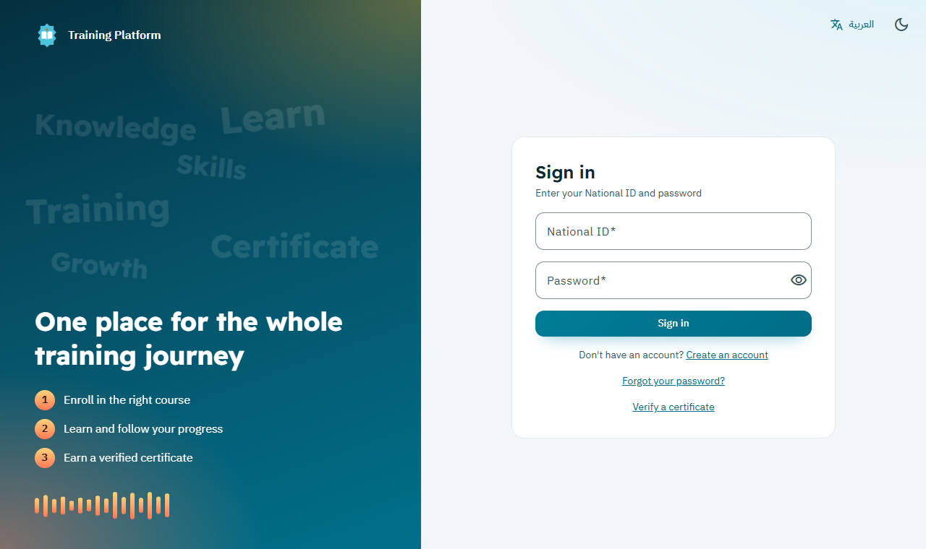
The sign-in page

Good to know: Forgot your password? Select Forgot your password? on the sign-in page and follow the link sent to your email. Use the language button at the top to switch between Arabic and English, and the moon icon for dark mode.

1.4 Finding your way around
- Side menu: shows only what your role can use. Select a section heading to open or close it.
- Search box: type to narrow the menu. Press Enter to search courses, cohorts and people across the platform.
- Top bar: language, dark mode, messages, notifications and your account menu.
- Your account: open your account menu and select Sign-in security to change your password or manage two-step sign-in.

2. Administrator: prepare the platform
The administrator makes sure everyone has an account with the right role.

2.1 Review the dashboard
- Sign in. The Dashboard opens first.
- Read the headline numbers: enrolled trainees, cohorts running, completion rate, certificates, average grade and users.
- Scroll down for charts of enrollments, cohorts, popular courses, completion and users.
- Hover over a monthly chart to see its figures, or select Show as a table.
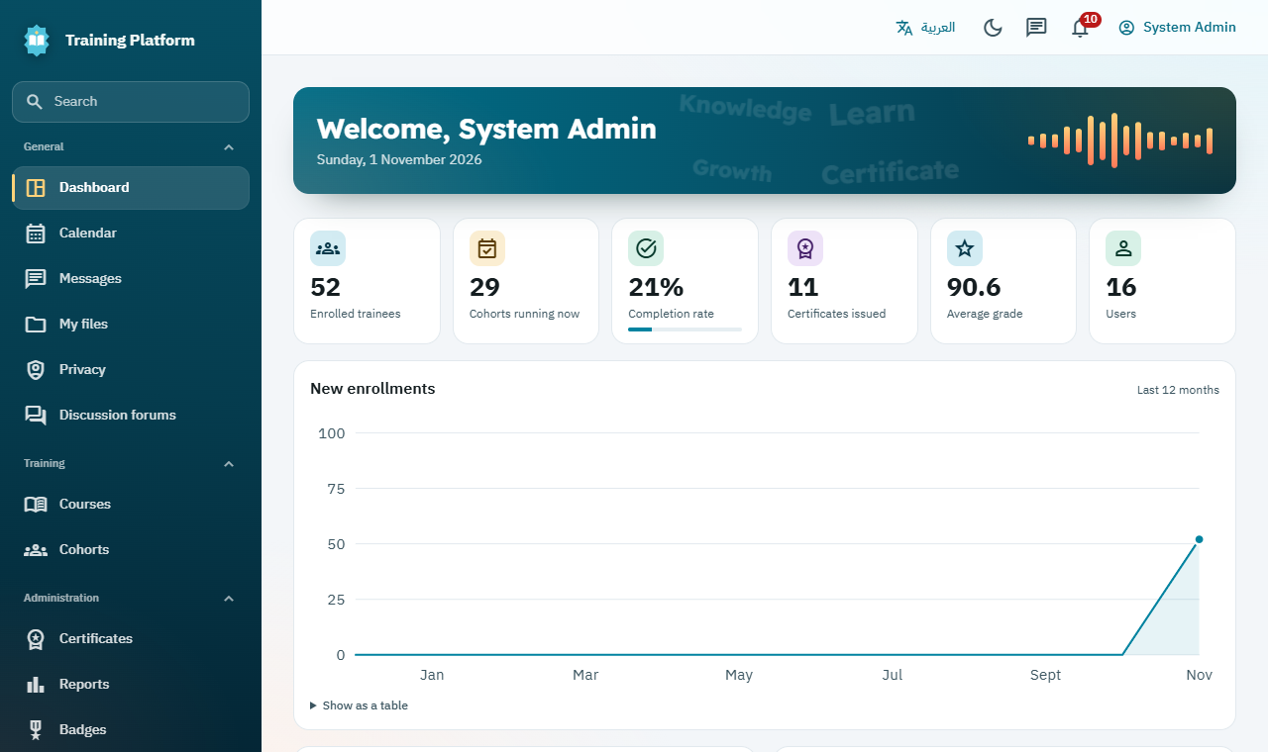
The dashboard shows live figures and charts for staff

2.2 Add users
Trainees can register themselves. To add many people at once, including staff:
- Open Users, then select Upload users.
- Save your spreadsheet as a CSV file in UTF-8, using the columns shown on the page.
- Select Choose a file and review the results. Each row shows Ready or what needs fixing.
- Select Create accounts, then Download passwords and share each one privately.
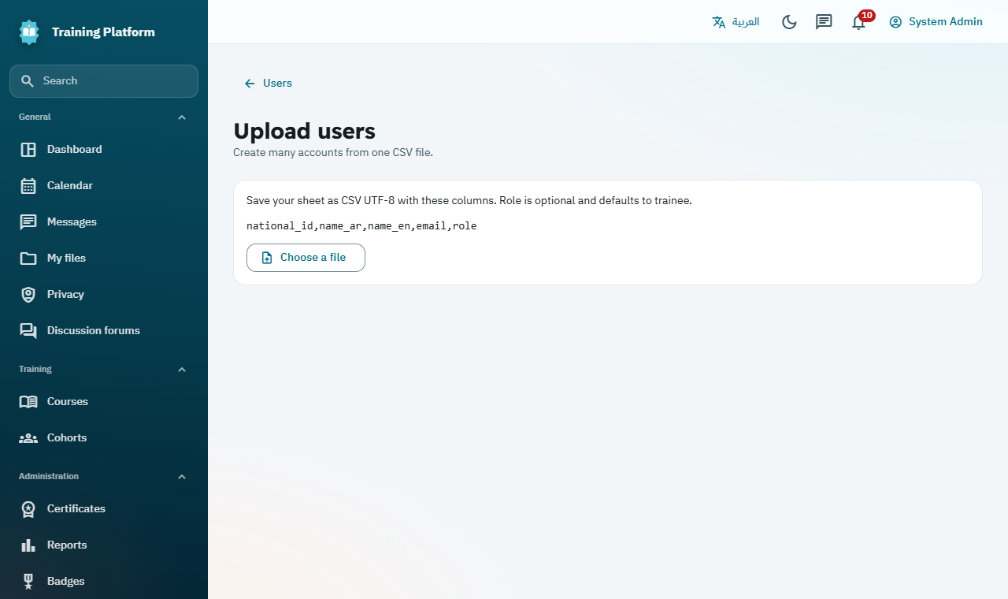
Upload many users from one CSV file

Good to know: Uploaded accounts must change their password at first sign-in. Administrators cannot be created by upload, which protects the most powerful role.

2.3 Assign roles
- Open Users and find the person by name or email.
- Choose the new role from the Role list in their row.
- National IDs stay masked. To see a full one, select the eye icon and give a reason, which is recorded in the audit log.
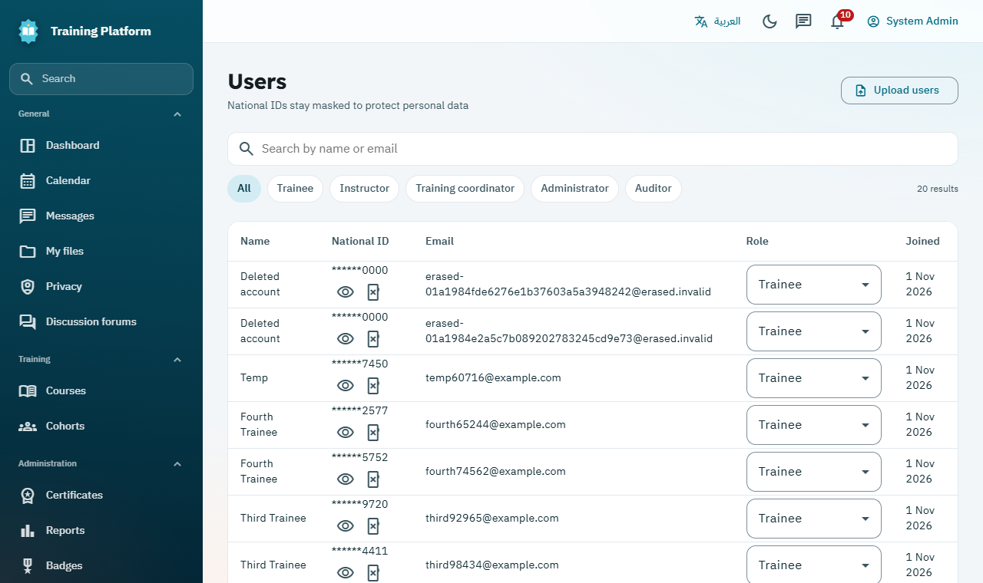
Users, with National IDs masked

3. Coordinator: build the course
The coordinator turns a training need into a published course and opens it for enrollment. Administrators can do all of this too.

3.1 Create a category (optional)
- Open Course categories and select New category.
- Enter the name in both languages. Choose Inside to place it under another category.
- Save.

3.2 Create the course
- Open Courses and select New course.
- Enter the Course code, Duration in hours, and the title and description in Arabic and English.
- Select Save. The course starts as a draft, which trainees cannot see.
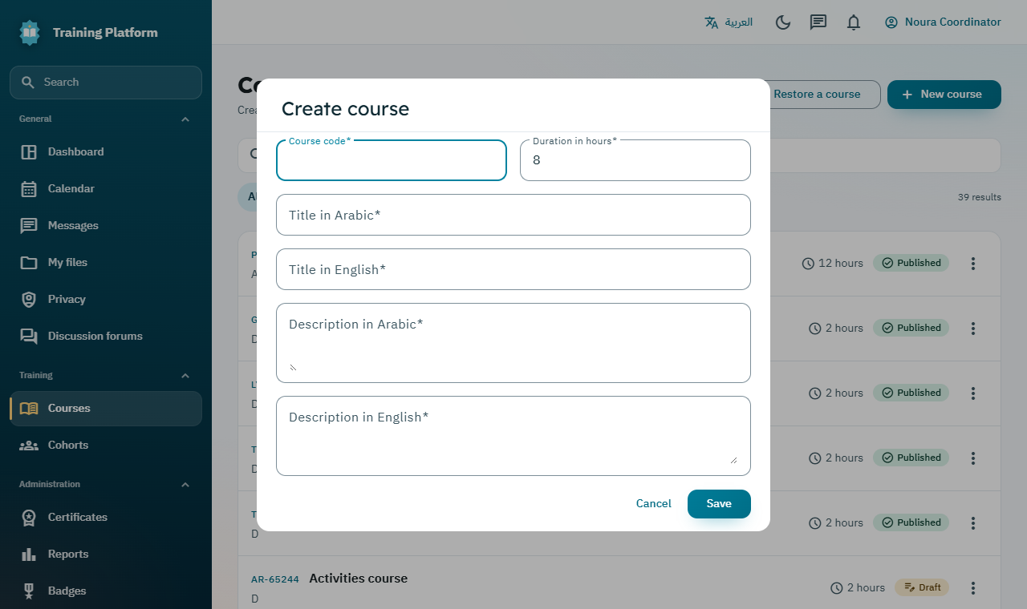
Creating a course

Good to know: Every title and description needs both Arabic and English, because users can switch language at any time.

3.3 Add the content
- In Courses, open the menu (three dots) on the course and select Manage content.
- Select Add unit and name it, for example "Unit 1: Starting a project".
- Under the unit, select Add activity and choose the Activity type.
- Fill in the details. Turn on Required for completion if trainees must finish it.
- Use the arrows to reorder items, the pencil to edit and the bin to remove.
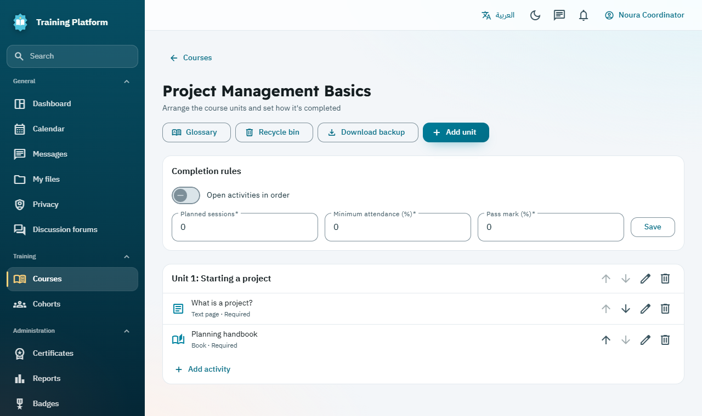
Managing a course: units, activities and completion rules
Activity type | Use it for
Text page | Text to read.
File | A PDF, Word, Excel, PowerPoint, image or video file.
Video link | A link to a video.
SCORM package, H5P interactive content | Interactive packages made in other tools.
Form or survey | Choices, feedback and surveys, named or anonymous.
Book | A longer text split into chapters.
Branching lesson | Pages with choices that lead to different pages.

3.4 Set the completion rules
These rules decide when a trainee has finished the course and earns the certificate. They are at the top of the Manage content page.
- Turn on Open activities in order if trainees must work through them in sequence.
- Enter the Planned sessions and the Minimum attendance (%), if attendance counts.
- Enter the Pass mark (%).
- Select Save.

3.5 Fill the question bank (optional)
- From the course menu, select Question bank.
- Select New question, or Import from Moodle to bring in a Moodle XML file.
- Instructors can then add these questions to their quizzes.
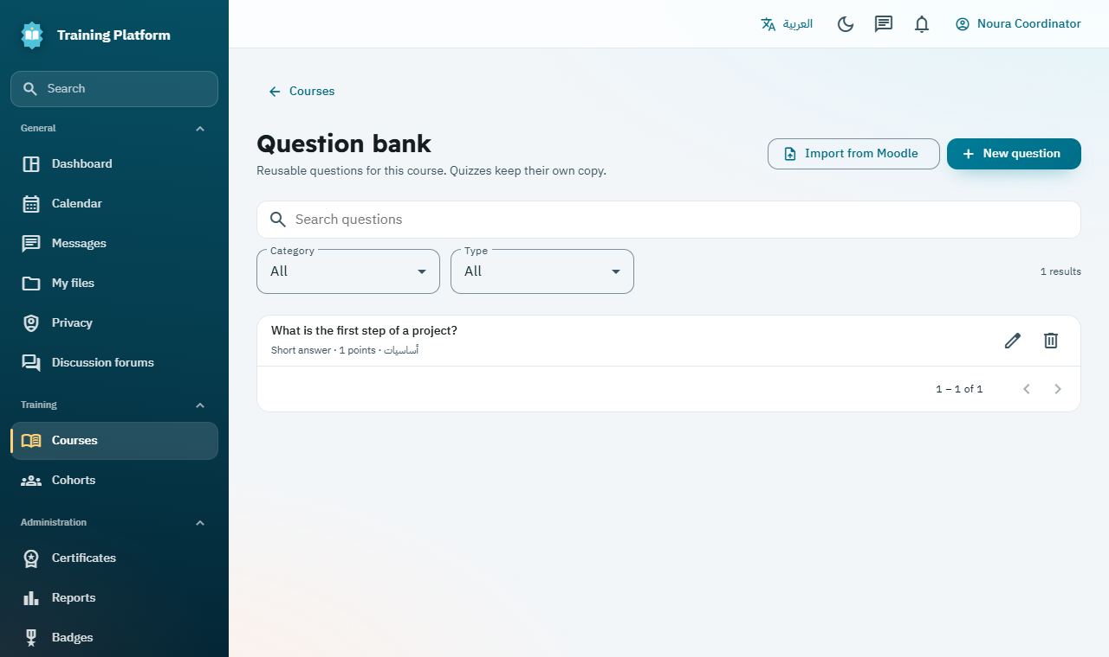
The question bank holds reusable questions for a course

3.6 Publish the course
- Check the content one last time.
- From the course menu, select Publish and confirm.
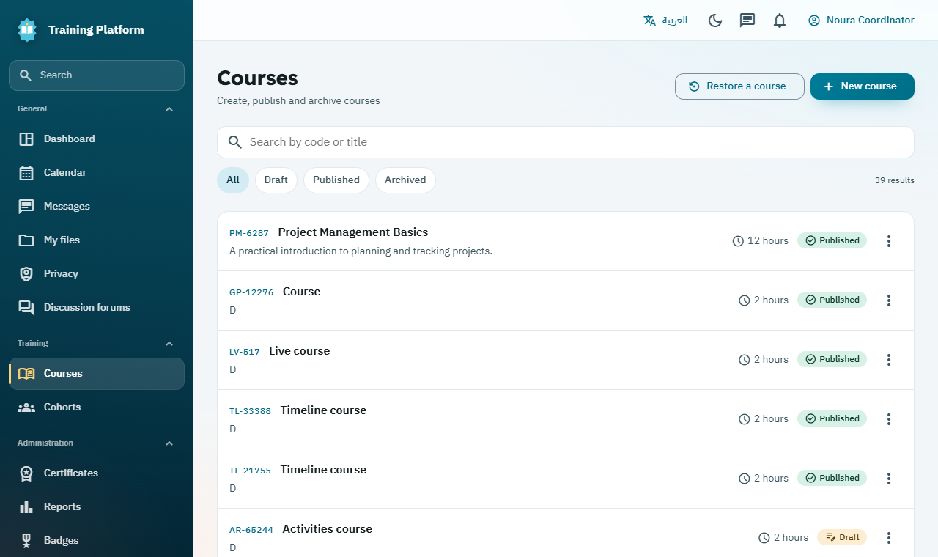
The published course in the course list

Good to know: Course details lock once published. To reuse a course, select Download backup on its Manage content page, then Restore a course on the Courses page to make a new draft.

3.7 Open a cohort
A cohort is one running of a course. It has its own dates, instructor and trainees.
- Open Cohorts and select New cohort.
- Choose the Course and Instructor.
- Enter the cohort name in both languages, the Branch, Start date, End date and Seats.
- Turn on Requires coordinator approval if you want to approve each trainee.
- Save. Trainees can now see the cohort.
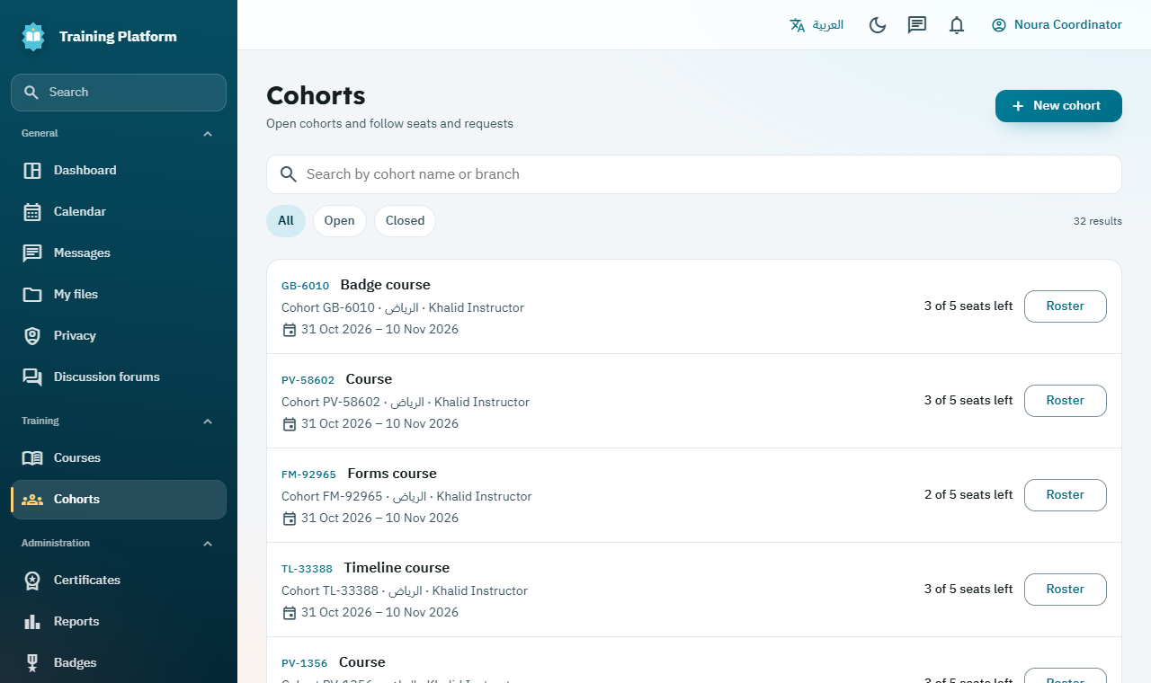
Cohorts show their dates, instructor and remaining seats

3.8 Approve enrollments
- Open Cohorts and select Roster on the cohort.
- Select Approve or Reject on each waiting request. A rejection needs a reason, which the trainee sees.
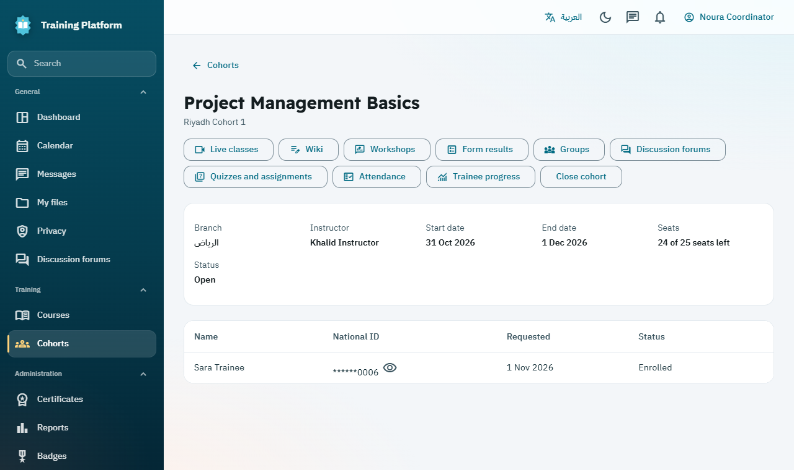
The roster page links to everything about a cohort

3.9 Add a badge (optional)
- Open Badges and choose the Course and an icon.
- Enter the name and description in both languages, then select Create badge.
- Trainees earn it automatically when they complete the course.

3.10 Set up competencies and learning plans (optional)
- Open Competencies, enter a code and names, link the courses that prove the skill, then select Add competency.
- Open Learning plans, name the plan, choose its competencies, then select Add plan.
- Open the plan, choose a Cohort, set a due date if needed, then select Assign to cohort.
- The grid shows each trainee's progress. A valid certificate in a linked course meets a competency automatically, and staff can also sign one off by hand.
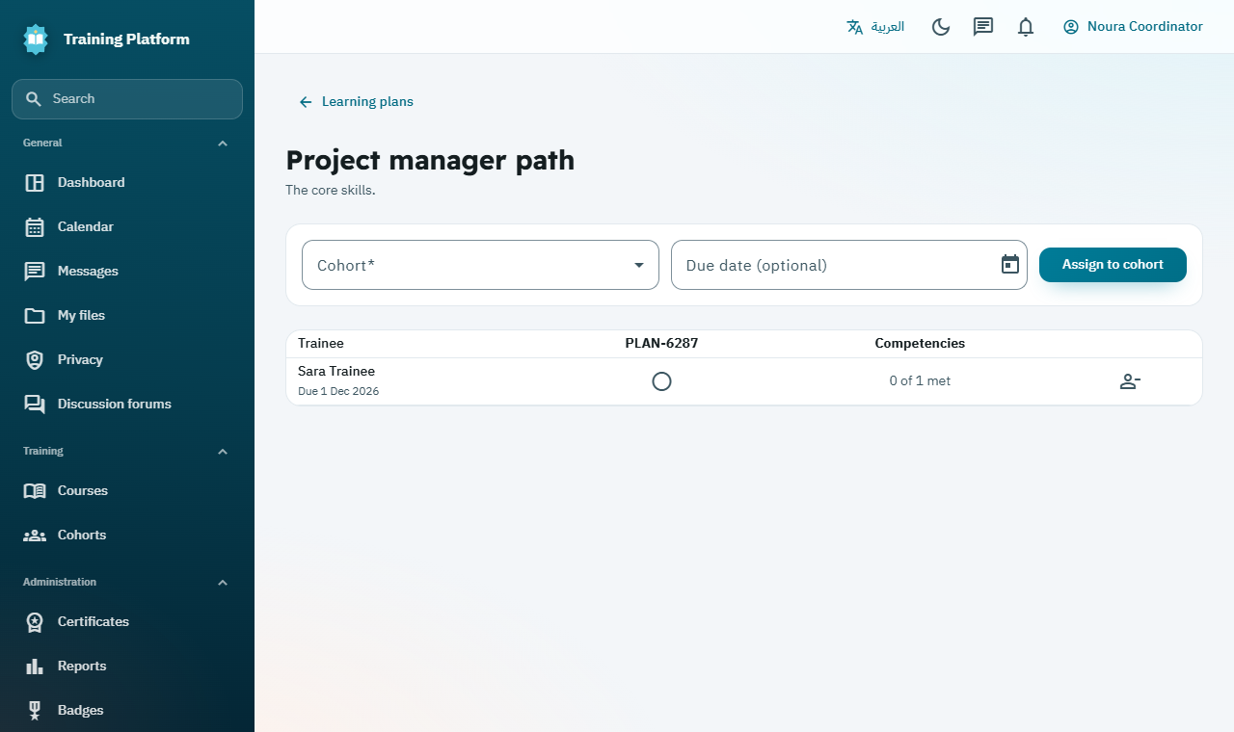
Tracking a learning plan for a cohort

4. Trainee: enroll and start
Trainees can register themselves, then choose a cohort.

4.1 Create an account
- On the sign-in page, select Create an account and enter your National ID, names, email and password.
- Sign in. You land on your dashboard.

Good to know: Each National ID can hold one account. If your institute uploaded your details, use the temporary password you were given instead.

4.2 Enroll in a cohort
- Open Cohorts to see what is available. Use the search box to find one.
- Select Enroll now. If the cohort needs approval, the button reads Request a place, and you are notified of the decision.
- Follow your requests under My enrollments. You can withdraw from there.
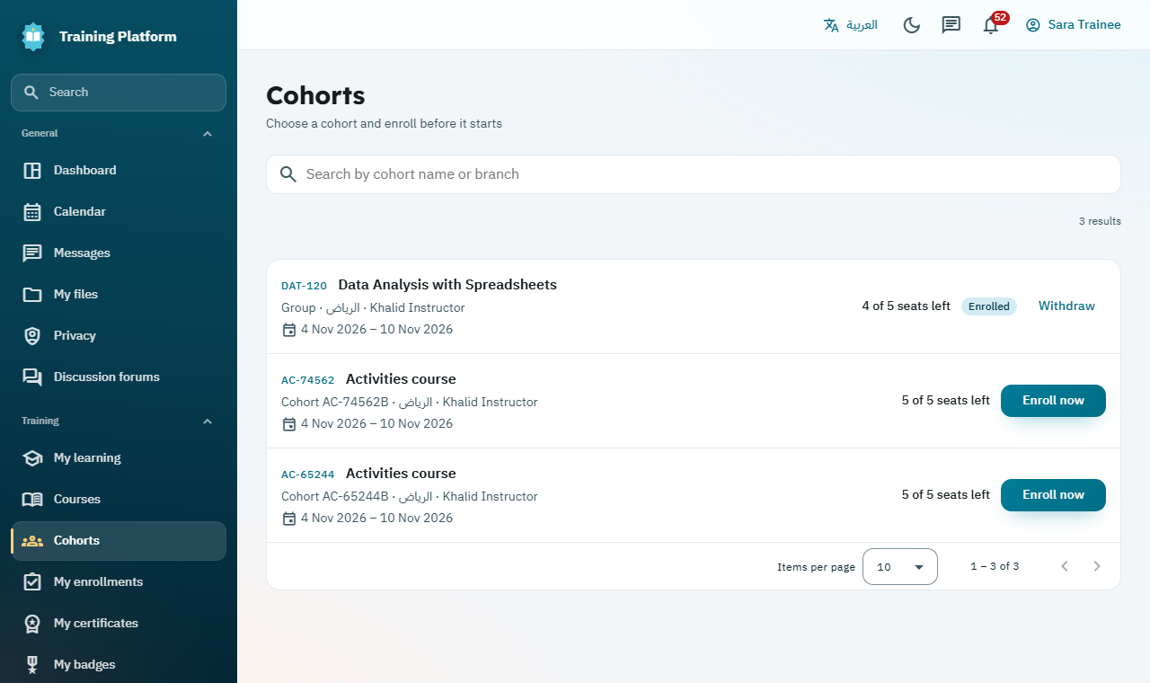
Choosing a cohort and enrolling

Good to know: Course content opens on the cohort start date. The notifications bell tells you when things change.

5. Instructor: run the cohort
Instructors see only the cohorts they teach. Open Cohorts, then Roster, to reach the buttons used below.

5.1 Create a quiz
- Open Quizzes and assignments and select New quiz.
- Enter the title, Time limit (minutes), Attempts allowed, Weight, and optional opening and closing times.
- Add questions by hand or select From question bank.
- Optionally set Questions per attempt to draw a random set, and turn on Shuffle questions and options.
- Save, then Publish.
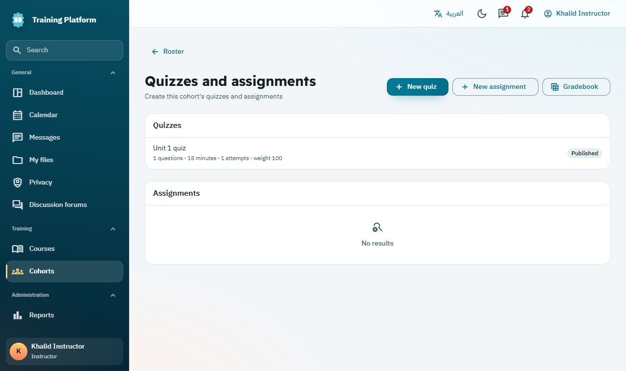
Quizzes and assignments for a cohort

Good to know: For high-stakes exams, paste a Safe Exam Browser Config Key into the quiz. It then opens only in that locked-down browser. Test it on your devices first.

5.2 Create an assignment
- Select New assignment.
- Enter the title, instructions, Due date and Weight, then save.
- Later, open the assignment to see Submissions, download each file, enter a Grade and add Feedback.

5.3 Record attendance
- From the roster page, select Attendance.
- Choose the Session date.
- Mark each trainee Present, Absent or Excused, then select Save.
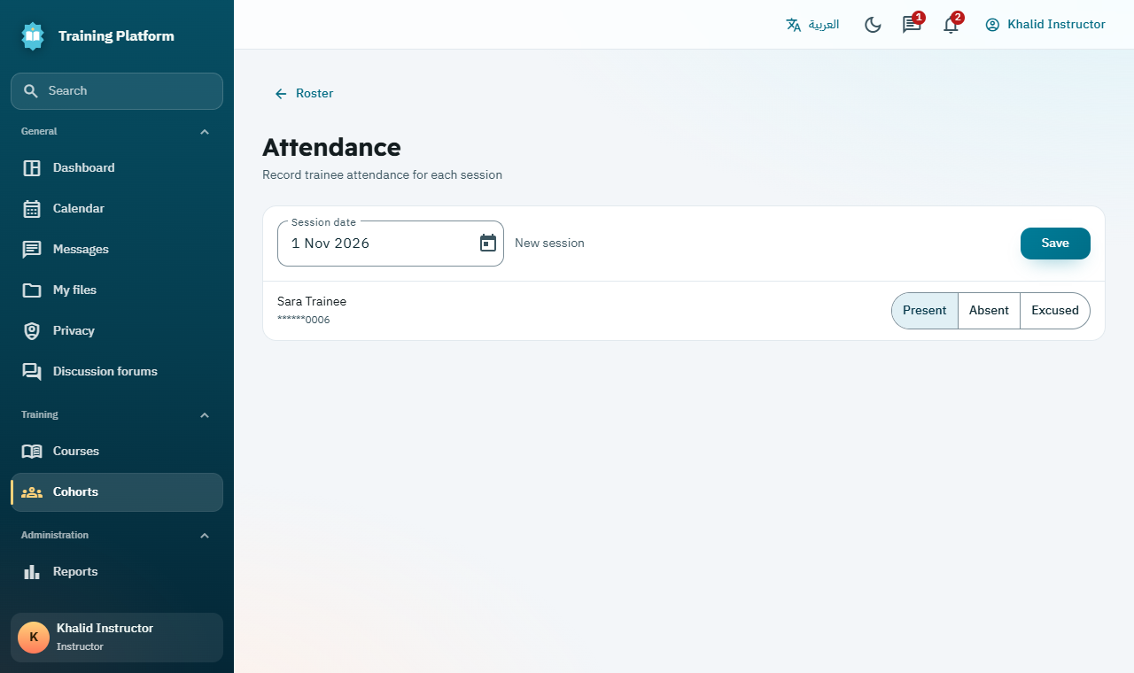
Recording attendance for a session

5.4 Hold a live class

Before you start: Live classes need a BigBlueButton server. Until your administrator connects one, the page says so and classes can be scheduled but not started.

- From the roster page, select Live classes.
- Enter the title, start time and length, then select Schedule class. Trainees are notified.
- From 15 minutes before the time, select Start class. Trainees can join once you start.
- Select End class when you finish. The page lists who joined.
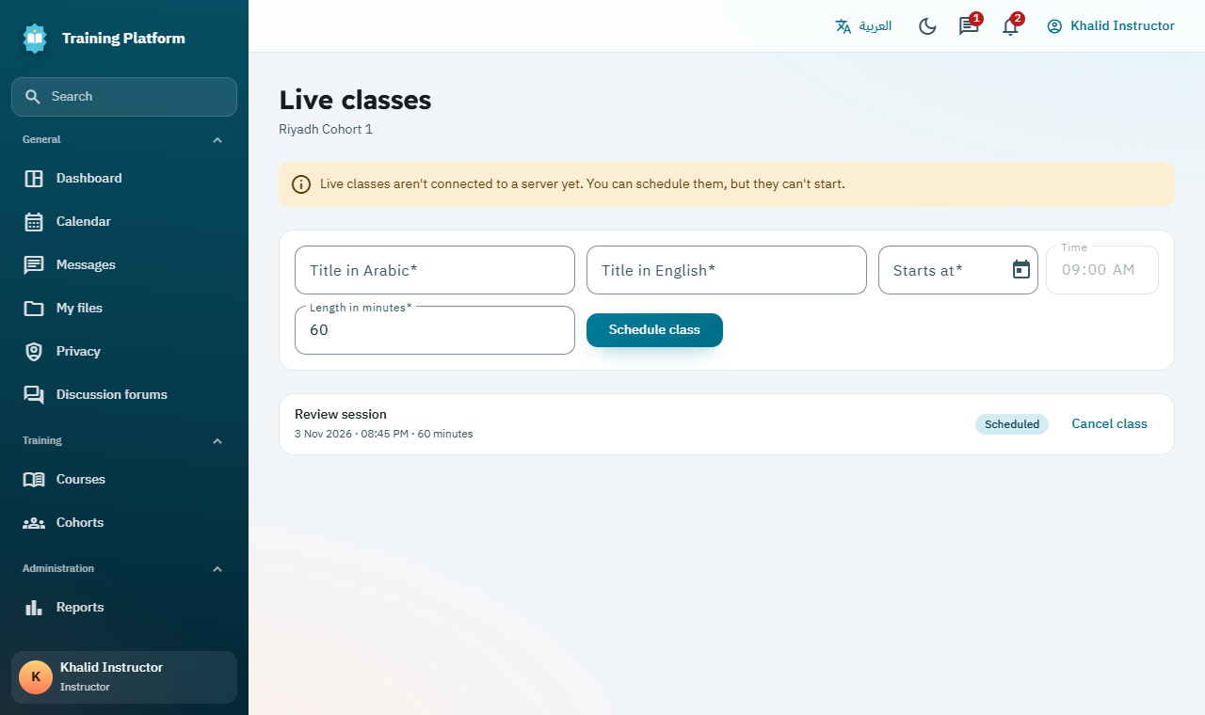
Scheduling a live class

5.5 Use groups, forums, wikis and workshops
Tool | How to use it
Groups | Add groups, or use Split at random. Forum topics can then be private to one group.
Discussion forums | Everyone in the cohort can post. Instructors can pin, lock or remove topics and replies.
Wiki | Pages the cohort writes together. Every change is kept, and instructors can restore an older version.
Workshops | Trainees submit written work and review each other anonymously. Close and set grades turns the average into a grade.
Form results | Shows answers to course forms. Anonymous results appear after 3 people answer.
Trainee progress | Shows how far each trainee has got.

6. Trainee: learn and complete

6.1 Study the course
- Open My learning and select Continue on the course.
- Choose an activity from the course outline.
- Read or watch it, then select Done, go to next.
- The progress bar shows how much is left. The buttons at the top open the Glossary, Live classes, Wiki, Workshops and your assessments.
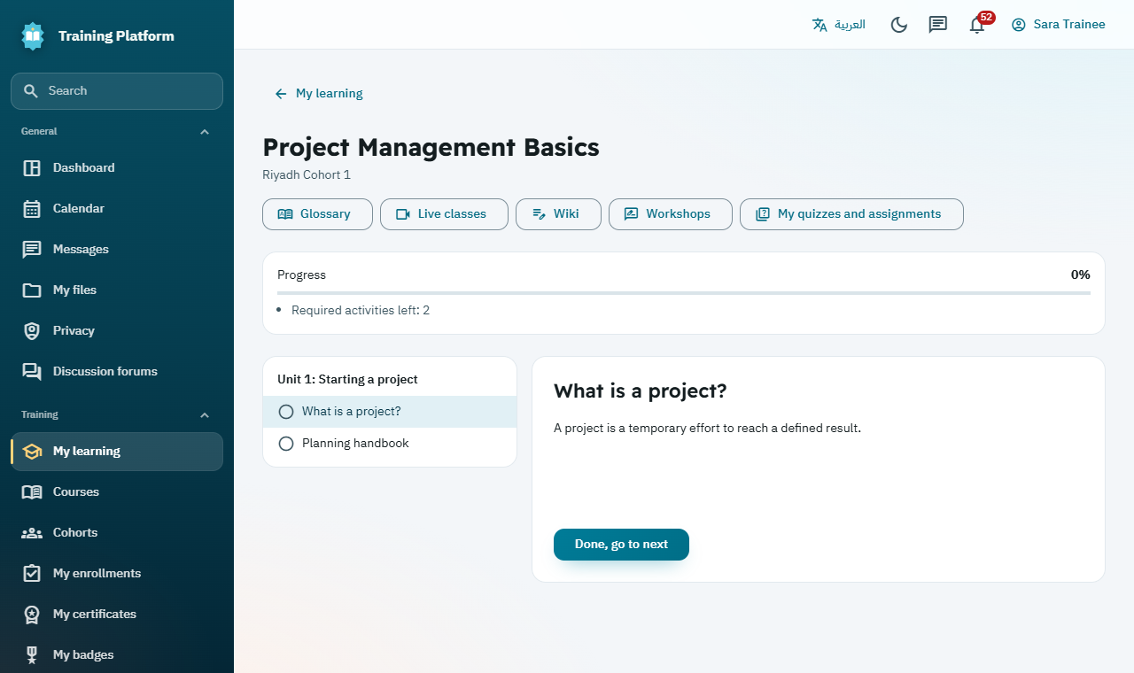
The course player, with progress and the course outline

6.2 Take a quiz
- Select My quizzes and assignments, then Start quiz.
- Answer the questions. Answers save automatically and the timer stays on screen.
- Select Submit quiz when finished. If time runs out, your saved answers are submitted for you.
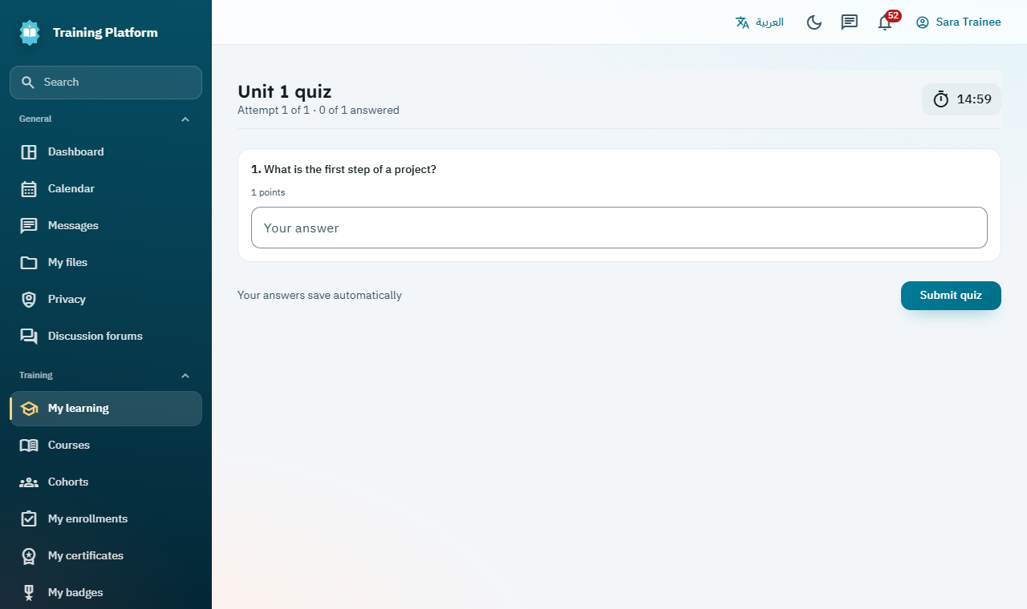
A quiz in progress, with the timer at the top

6.3 Submit an assignment
- On My quizzes and assignments, find the assignment.
- Select Submit file and choose your file. Use Replace file if you need to change it.
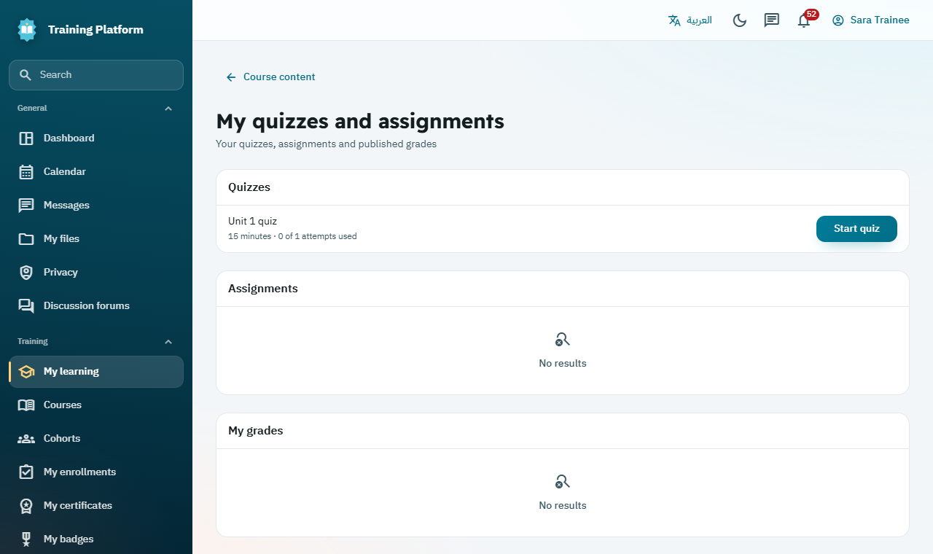
Your quizzes, assignments and published grades in one place

6.4 Join discussions and live classes
- Open Discussion forums, choose your cohort, and select New topic or reply to one.
- Open Live classes from the course page and select Join class once the instructor has started it.
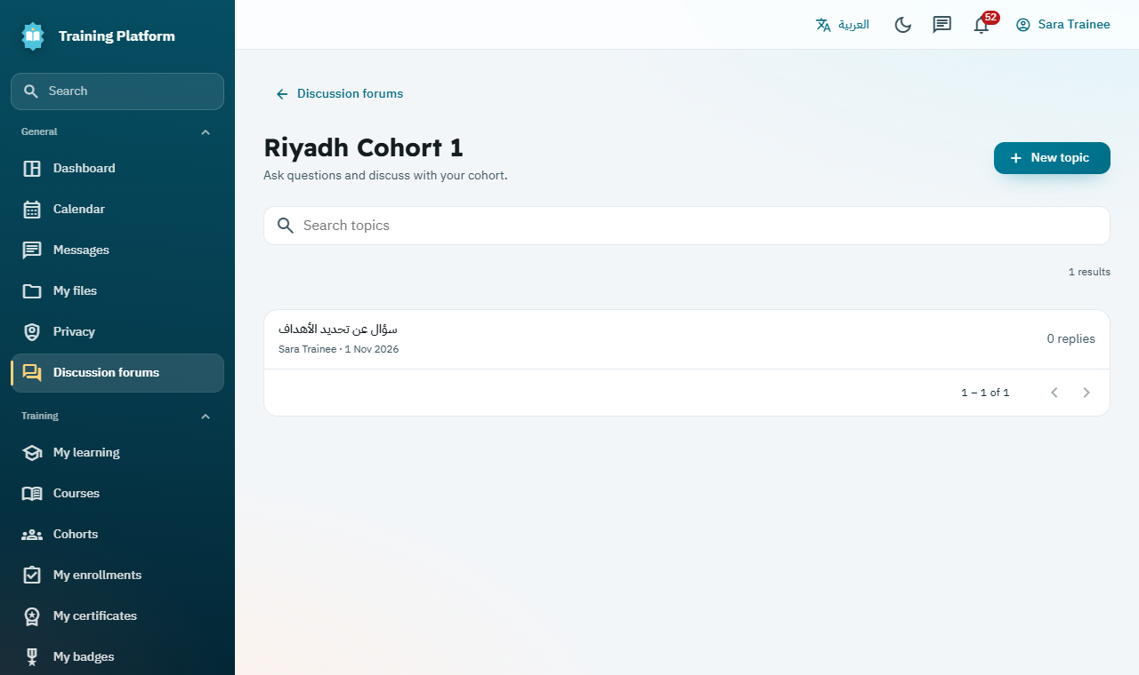
A cohort discussion forum

6.5 Keep track of what to do
The To do list on your dashboard shows open quizzes, assignments and workshop tasks, with overdue work first. The Calendar shows all your dates.
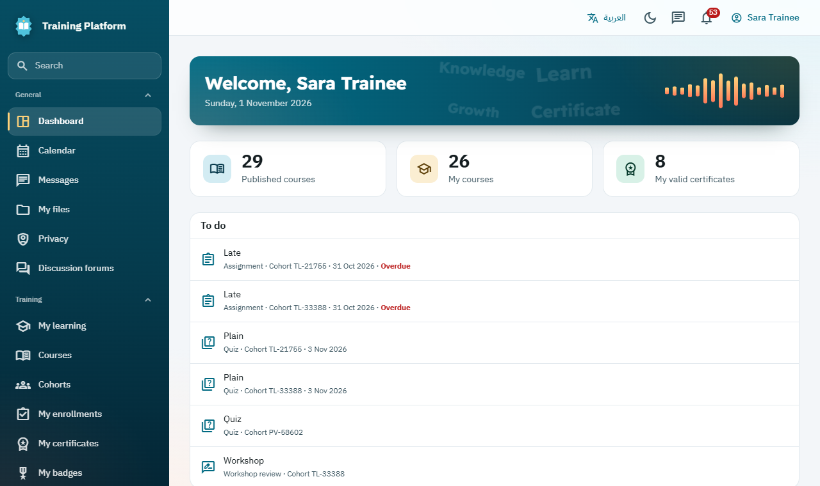
The trainee dashboard with the To do list

7. Instructor: grade and publish
Trainees cannot see any grade until you publish it.

7.1 Mark and publish grades
- Open Quizzes and assignments, then Gradebook.
- Quizzes mark themselves, except essays. For those, use Mark essays on the quiz.
- Enter any missing grades.
- When a column is ready, select Publish under its name and confirm.
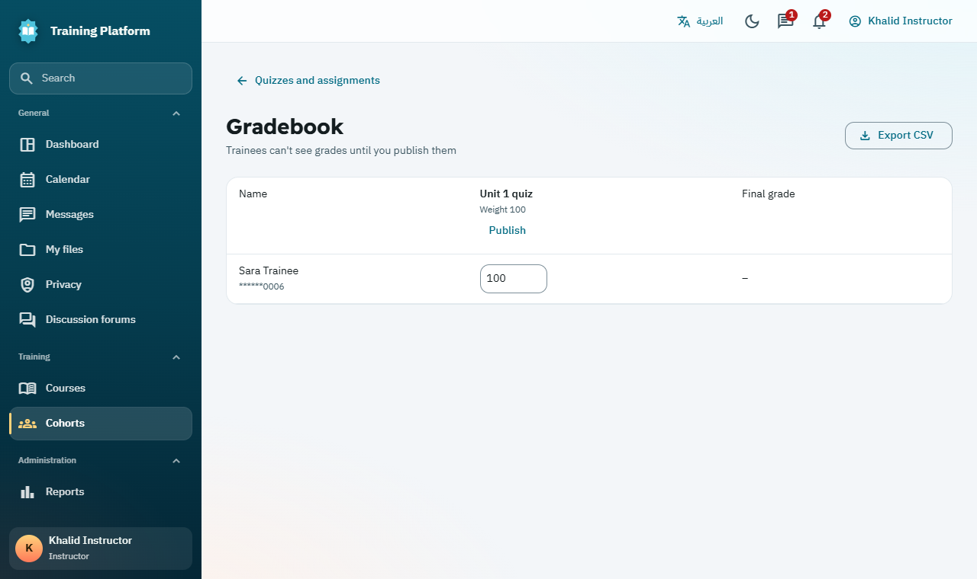
The gradebook before publishing

Before you start: Check grades carefully. Once published, a grade changes only through Request grade correction, which a second person must approve.

7.2 What completes the course
The platform completes a course automatically when a trainee meets all the rules set in section 3.4:
- Every required activity is done.
- Attendance reaches the minimum, if one is set.
- The final grade reaches the pass mark, if one is set.
The final grade exists only when every graded item is published and graded for that trainee. Nobody needs to issue the certificate by hand.

8. Trainee: certificate and results

8.1 Download your certificate
- Open My certificates. You are also notified when one is ready.
- Select Download certificate to save the PDF. It includes a QR code and a unique code.
- Select Verification page to see the public proof that it is genuine.
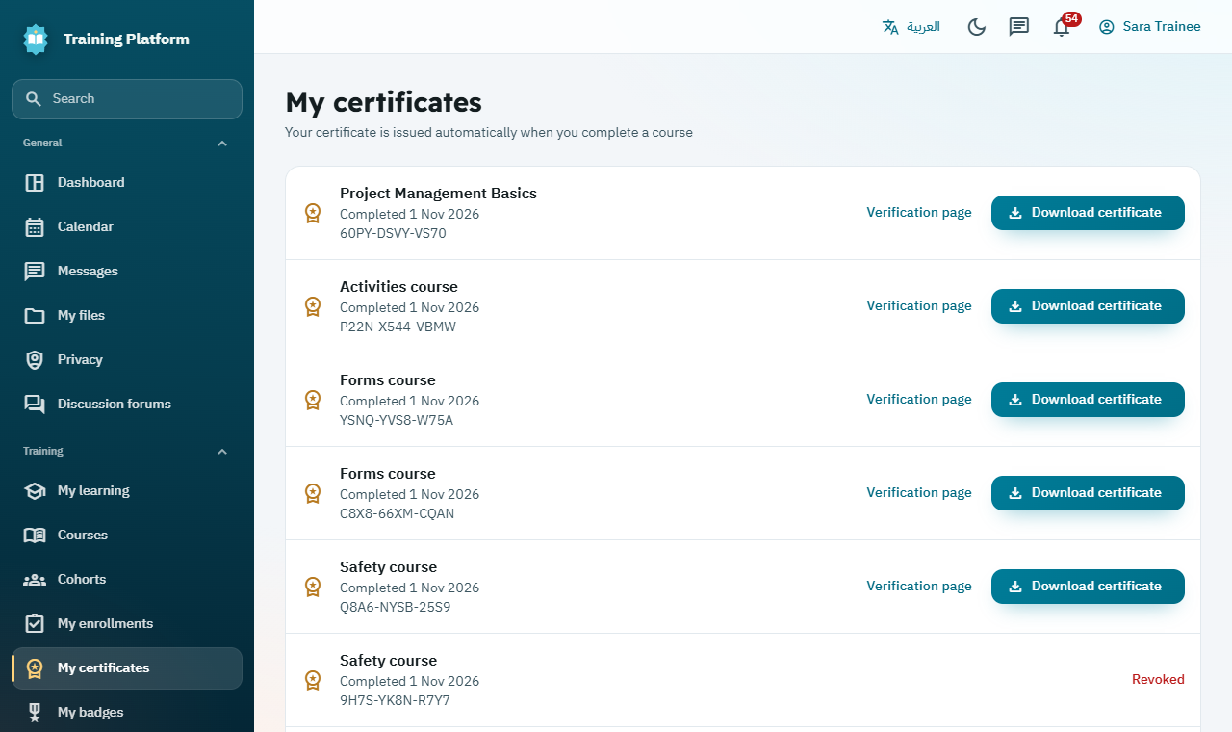
Certificates ready to download

8.2 See your badges and plans
- Open My badges to see what you have earned.
- Open My plans to see the skills asked of you and which you have met.
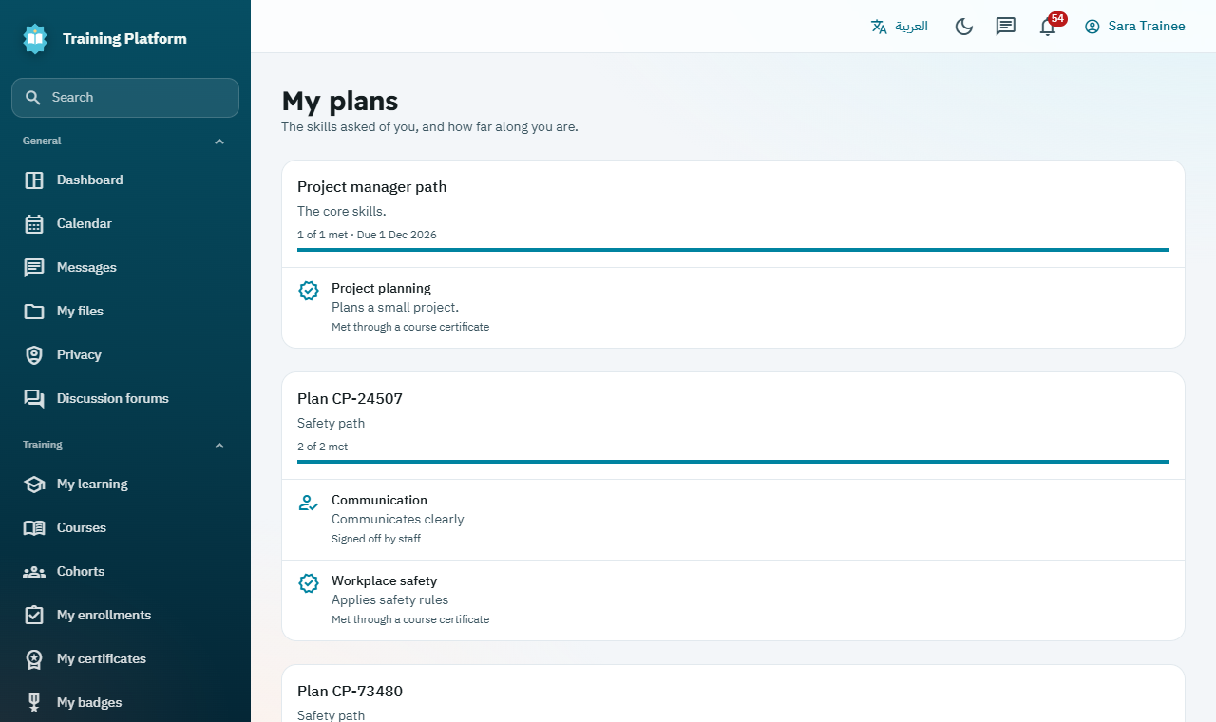
Your learning plans and the skills you have met

8.3 Your files and privacy
- My files: private storage of up to 200 MB that only you can open.
- Privacy: ask for a copy of your data, or for your account to be deleted. An administrator reviews each request.
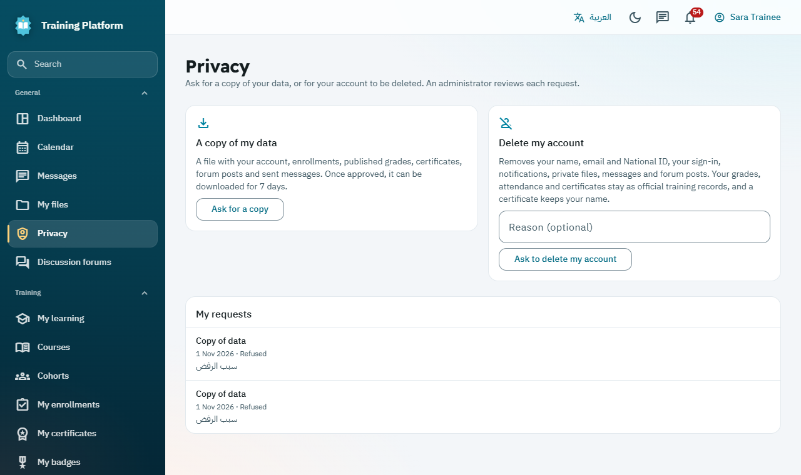
Asking for a copy of your data or account deletion

9. Administrator: oversee and report

9.1 Verify a certificate
Anyone can check a certificate without an account, such as an employer.
- Scan the QR code, or select Verify a certificate on the sign-in page.
- Enter the Certificate code and select Verify.
- The page shows whether it is valid or revoked. It shows no National ID.
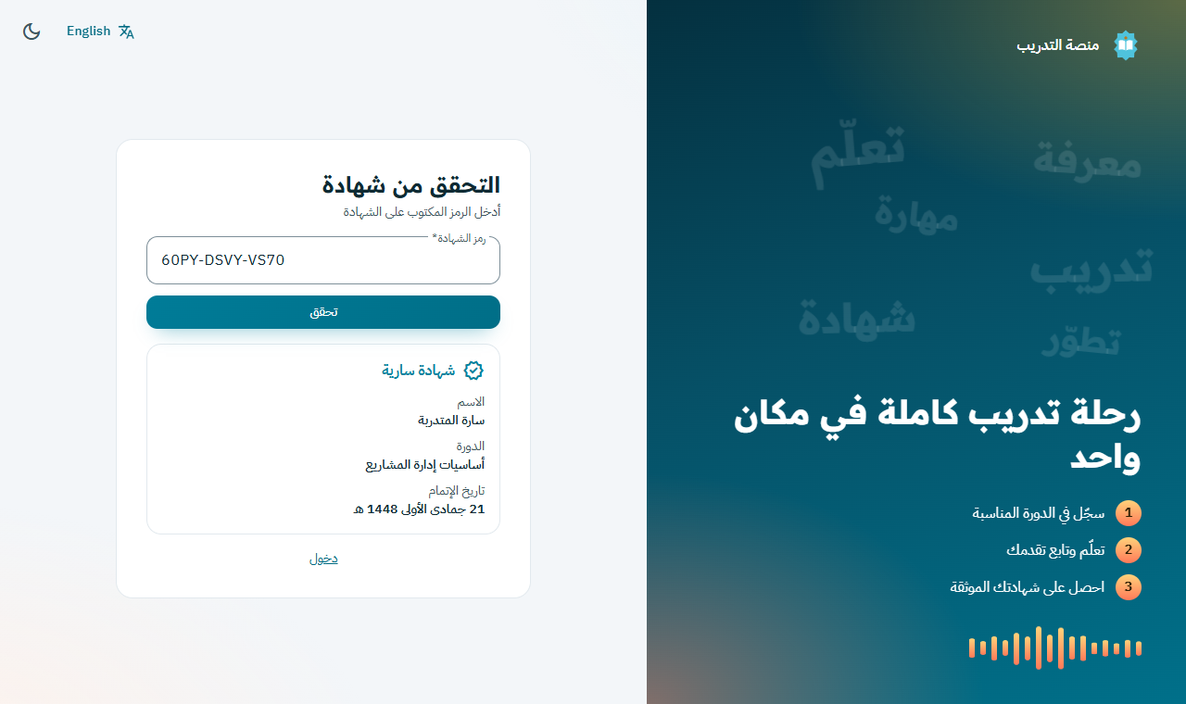
The public verification page, shown here in Arabic

9.2 Manage certificates
- Open Certificates and search by code or trainee name.
- To cancel one, select Revoke and give a reason. The trainee is told, and any badge from that course is removed.
- To correct one, revoke it first, then select Reissue. This creates a new certificate with a new code.
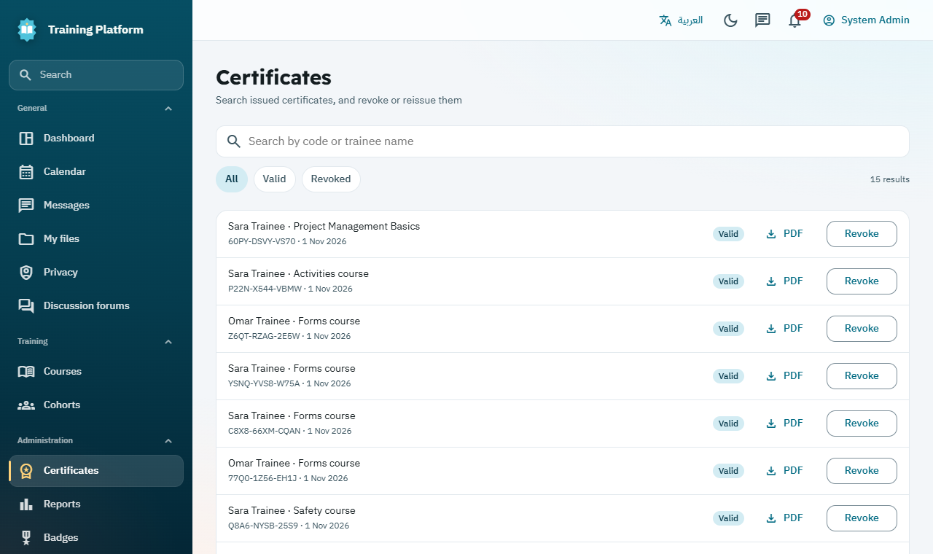
Managing certificates

9.3 Read and export reports
- Open Reports for enrollment, completion, grades and certificates by cohort.
- Select Export to Excel (CSV) to download the data.
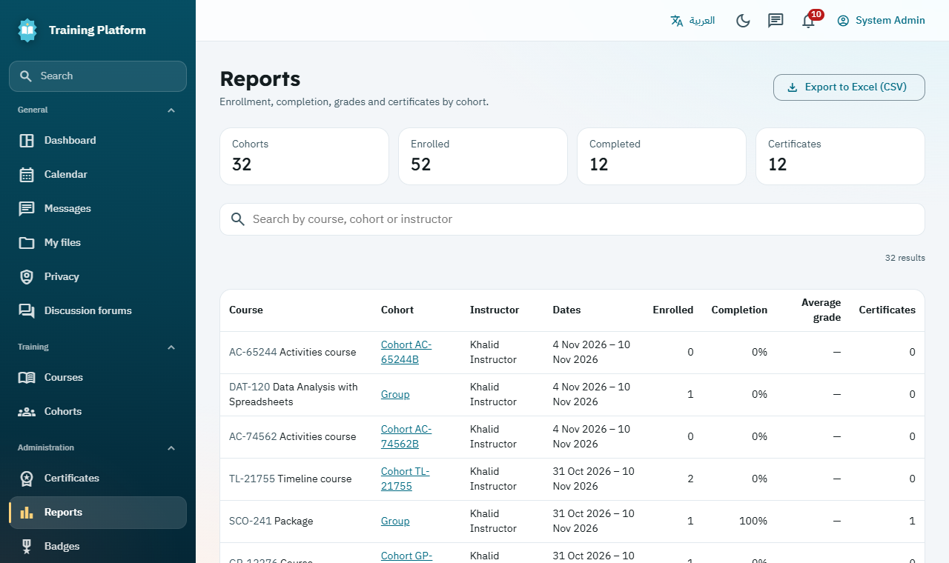
Reports by cohort

9.4 Handle privacy requests
- Open Privacy requests. Waiting requests appear first.
- Select Approve, or enter a reason and select Refuse. You cannot decide your own request.

Before you start: Approving an account deletion cannot be undone. The name, email, National ID, sign-in, messages and forum posts are removed at once. Official records such as grades and certificates stay.

9.5 Check the audit log
Audit log records who did what and when. Administrators and auditors can search it and export it, and nobody can edit it.
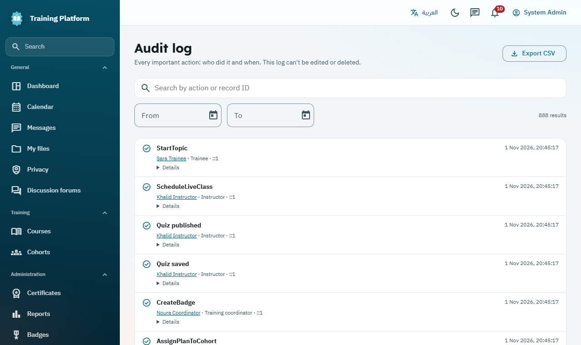
The audit log

10. Quick help
If this happens | Try this
I cannot sign in. | Check your National ID and password. After 5 failed tries, wait 15 minutes. Then use Forgot your password?
I do not see a course. | Trainees see only published courses. Ask your coordinator whether it is published and has an open cohort.
I cannot open the content. | Content opens on the cohort start date. With ordered activities, finish the earlier ones first.
I cannot see my grade. | Grades appear only after the instructor publishes them.
I finished but have no certificate. | Check that all required activities, attendance and grades are complete. A grade still unpublished can hold it up, so ask your instructor.
A quiz says to use Safe Exam Browser. | Open it in Safe Exam Browser with the setup file from your instructor.
A live class will not start. | Your administrator needs to connect the class server, or it may be too early. Classes can start 15 minutes before their time.
I deleted something by mistake. | Staff can open Recycle bin on the Manage content page. Removed units and activities stay for 30 days.

