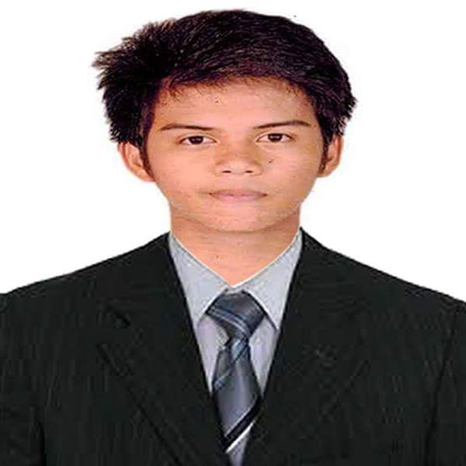**FRANCIS LODOVICA AVILA**  
#81 Midway Street, Forest Hills Subd.,  
Novaliches, Quezon City  
09554562584  
[avilafrncs19@gmail.com](mailto:avilafrncs19@gmail.com)

**CAREER OBJECTIVES:**

To seek a position in a progressive company that could offer good opportunities for growth and development in the field of information technology and be part of the company’s success.  
**PERSONAL INFORMATION:**

DATE OF BIRTH : November 8, 1997  
BIRTH PLACE : Urdaneta, Pangasinan  
GENDER : Male  
STATUS : Single  
RELIGION : Catholic  
CITIZENSHIP : Filipino  
NAME OF MOTHER : Josephine L. Avila OCCUPATION: Statistical Researcher  
NAME OF FATHER : Ferdinand B. Avila OCCUPATION: Deceased

**EDUCATIONAL BACKGROUND:**

TERTIARY : Quezon City Polytechnic University 673 Quirino Highway, San Bartolome, Novaliches,  
 Quezon City  
 Bachelor of Science in Information Technology  
 June 2014 – April 2018

SECONDARY : St. Patrick School Of Novaliches  
 Forest Hills Subd., Novaliches, Quezon City June 2010 – March 2014  
  
PRIMARY : Legaspi Elementary School  
 Legaspi, Tayug, Pangasinan  
 June 2004 - March 2010

**TECHNICAL SKILLS:**  
   
 Oriented in Microsoft Office ( Microsoft Office Word, Microsoft Office Excel, Microsoft  
 Office Powerpoint)

Basic knowledge in programming language ( PHP, Visual Basic.Net, C#.Net)

**PERSONAL SKILLS:**

Good skills in written and verbal communication

Ability to work independently

Hardworking

Flexibility

**TRAINING AND SEMINAR UNDERTAKEN:**

On-The-Job Training  
National Printing Office  
NPO Road, EDSA Diliman Quezon City  
July 2017 – March 2018

Xamarin Forms Kindergarten  
EPH Office, 9th Flr 500 Shaw Zentrum, 500 Shaw Blvd.,  
Pleasant Hills, Mandaluyong City  
August 3, 2017

14th Youth Congress On Information Technology  
SMX Convention Center Manila, Mall of Asia Complex, Pasay City  
September 27, 2016

MMDA Summer Internship Program (SPES)  
Metropolitan Manila Development Authority  
EDSA corner Orense Street, Guadalupe Nuevo, Makati City  
April 2015 – May 2015

**CHARACTER REFERENCE:**

Jonathan Natividad  
 Traffic and Disaster Office  
 09151766471

Robert Laigo  
 Caloocan City  
 09495671675

Manuel Abiera  
Quezon City Polytechnic University  
09184905517

**FRANCIS L. AVILA**

**_______________**

Applicant