**CPRG 211 ASSIGNMENT** 

**STUDENT NAME: Asma Akbar, Abeel Ahmed Mohiuddin Mohammed**

**STUDENT ID: 000934375, 000934374**

**PROJECT:** Group 5-Gym Management System

**1. Introduction**

**Brief Introduction:**

The Gym Management System will be used for the management of gym operation effectively. It helps in recording its members, be able to manage the employees within the gym and enable the gym to address issues to do with memberships and fitness schedules. The system is supposed to help manage the operations of a gym and offer an intuitive design on the user side for both – the gym staff and the members.

**Technologies Used:**

Classes and Objects: For modeling actual concepts like the members, the staff, and equipment that are involved in payment transaction processing.

Interfaces and Abstract Classes: To declare some common functions and constraints on the classes’ behaviors.

GUI: To come up with an interface through which a user can directly represent the system. Exceptions: To deal and control exceptions that may arise due to the running of the program.

**Overview of Goals and Functionality:**

1. Member Management:

Track Member Information: It is necessary to save and organize customers’ different information such as their address, phone number, and their type of membership of the gym.

Manage Membership Accounts: Check whether its members’ accounts are up-to date by monitoring balances as well as the status of payment.

Identify Unique Members: It is recommended to use distinct numbers (MemberID) to track changes in user accounts of the particular member.

1. Staff Management:

Store Staff Details: Record each staff member and their position, phone number, and number or any other identification number.

Assign Roles: There must be specified duties which should be performed by the concerned staff like the instructors of the school or the receptionists of the firm.

1. Equipment Management:

Track Equipment Inventory: Record signs of the gym equipment’s and ensure you associate them with name, description and serial numbers.

Manage Equipment Usage: Possibly, control and oversee the use and preservation of the tools.

1. Payment Processing:

Record Payments: Record the mirror amounts of the subscriptions collected from the members as well as the date on which the amounts were received.

Monitor Financial Transactions: Guarantee the validity of financial operations and make it easy for the financial department to refer to the records of members’ accounts.

1. Fitness Class Scheduling:

Organize Classes: Oversee all the events of fitness classes such as the classification of the course and timing, and trainers.

Schedule Management: It will assist in checking that classes are equitably scheduled and quality instructors are assigned to the courses.

1. Reporting and Analysis:

Generate Reports: Prepare reports of membership position, payment received, performance of employees, and utilization of the equipment.

Analyze Data: Probably, other things equal, using the collected data to analyze issues to do with the operations of the gym and its members and staff.

1. User Interface and Experience:

Provide Navigation: Provide the targets for an easy-to-navigate for the staff and members interface that allows simple navigation through the offered tools and display of members’ information.

Facilitate Interaction: How the Transition of Control between Manual Forms and Technology can be made Smooth for Activities Related to the System Such as, Payment of Fees, Course Registration and Modification of Personal Data.

**UI mock-up**

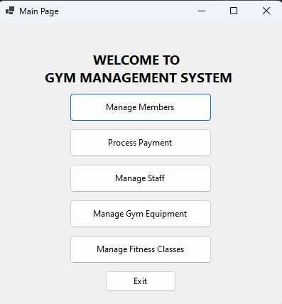

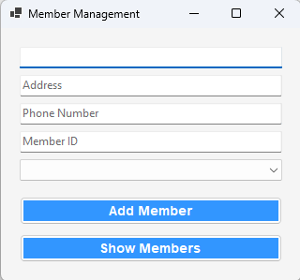

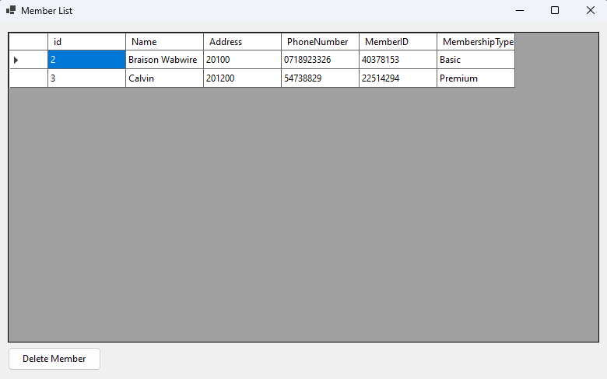



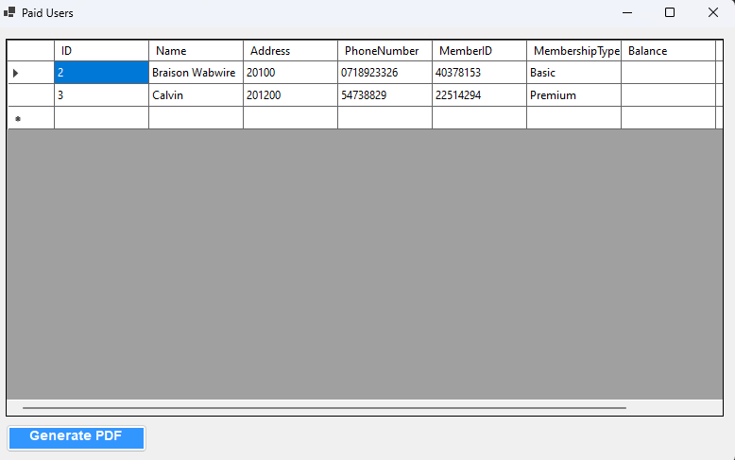

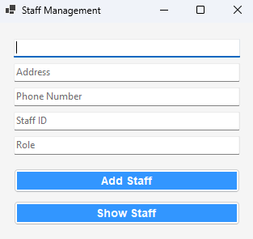

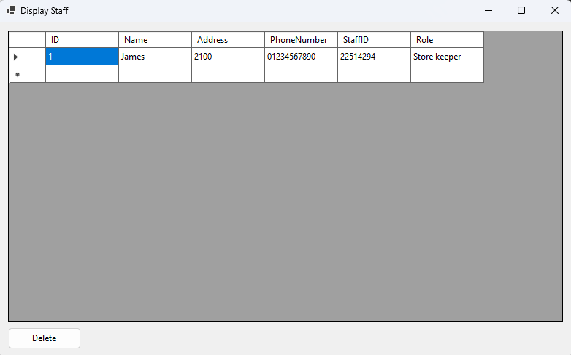

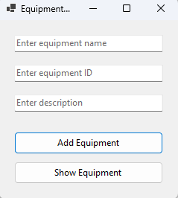

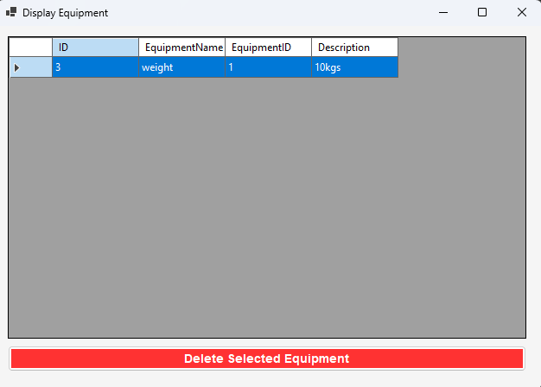

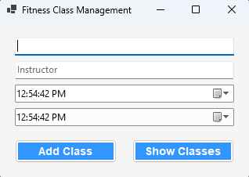

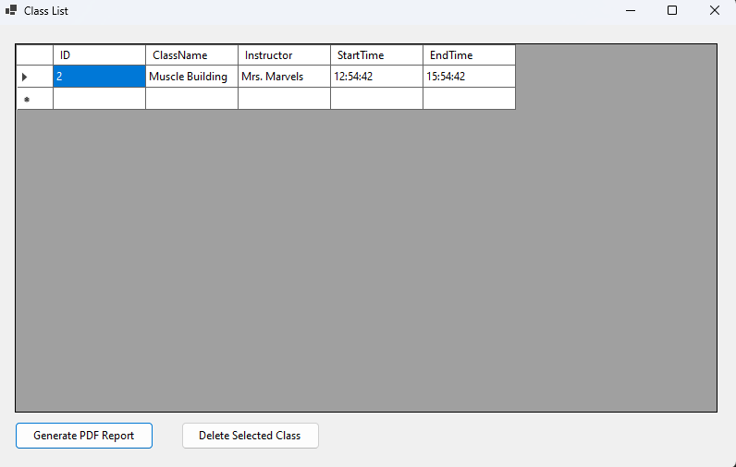

**2. Functionality**

**Core Functionality:**

Member Management: Adding, updating, and deleting member records.

Membership Management: Tracking active memberships, renewals, and payments.

Fitness Classes Management: Scheduling classes, tracking attendance, and managing instructors.

Staff Management: Handling staff records, roles, and schedules.

Use of Classes, Interfaces, and Abstract Classes:

Classes: Represent specific entities like Member, Staff, Class, Equipment, etc.

Interfaces: Define common behaviors. For example, IPayable for entities that handle payments.

Abstract Classes: Provide a base for specific types of entities. For instance, an abstract class Person might be used for Member and Staff with common properties and methods.

**ERD DIAGRAM**

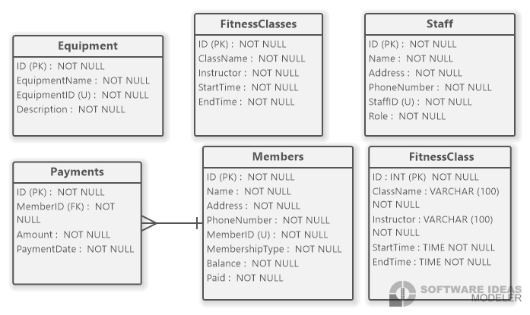

**3. Classes and Inheritance**

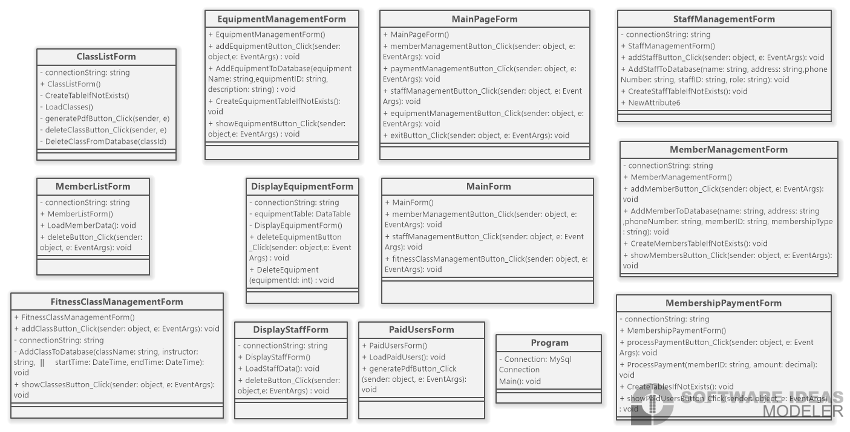

**Classes:**

Member: Presents one of the gym members. They may include MemberID, Name, MembershipType etc and functions to update infor-mation on these attributes.

Staff: It depicts a gym employee, a gym instructor, or a trainer and so the features must show that too. It is consists of StaffID, Name, Role and some of ways to handle the staff tasks.

FitnessClass: Some examples of the name tags include; It represents a fitness class. Other attributes include ClassID, ClassName, Instructor, and methods for schedule.

Equipment: Represents gym equipment. The characteristics consist of three fields: EquipmentID, Name, and Type as well as several methods in the management of equipments.

Inheritance:

Base Class: Person could be an abstract class which consists of its common reference-states such as the Name, Address, PhoneNumber etc.

Derived Classes: Both Member and Staff classes are derived classes of Person. Incorporating specific attributes and methods that correlate to their ranks in the organization or business.

Interfaces/Abstract Classes Implementation:

Interface Example: Interface called IPayable with the functions such as ProcessPayment(). Implemented by classes like Membership and PersonalTrainingSession.

Abstract Class Example: Person as an abstract class of an object with the common attributes and functions. Member and Staff utilize individually detailed Person and add more functionality to it.

**4. GUI**

**GUI Library:**

**Technology: Windows Forms**

**Implementation:**

In the application, it is necessary to use Windows Forms to create the basic interface of the application as well as forms for member registration, staff listing, and classes schedule.

To attend to the user, incorporate items such as text boxes, buttons and data grids to manipulate the system.

Example: An example of a form that can be created is that of adding a new member; this form would consist of blocks of text for inputting data, a save button that would record the member’s information.

**5. Exceptions**

**Exception Handling:**

Purpose: For cases when an error must be worked with in the same application, for example, invalid input or failed operation.

**Examples:**

Validation Errors: Nonce: Check actual membership types for members and ensure that no invalid membership types are given and that the fields cannot be empty. Employ exceptions to provide messages to the user and stop consideration of incorrect data.

Database Errors: Handle exceptions with respect to the connection or any kind of activity with the database. For instance, if adding a new member does not take place since there is a problem with the database, omit the exception and let the user know about it.

