***RESTAURANT TASKS***

***SYSTEM***

***TEAM :***

***Description:***

* This project is a restaurant system that manages the task between manager and admin where admin can enter tasks or delete it and the manager have to complete it a see it.

***UML DIAGRAMS:***

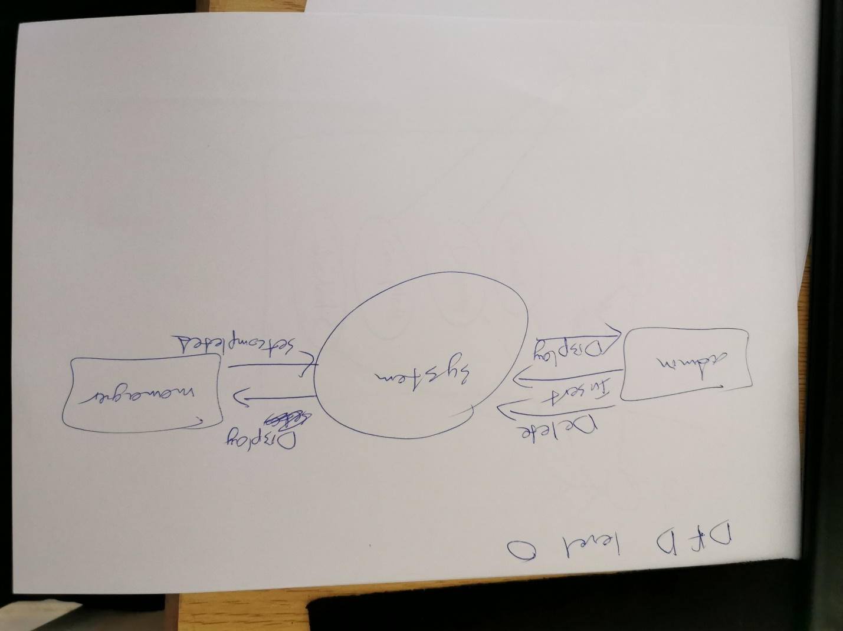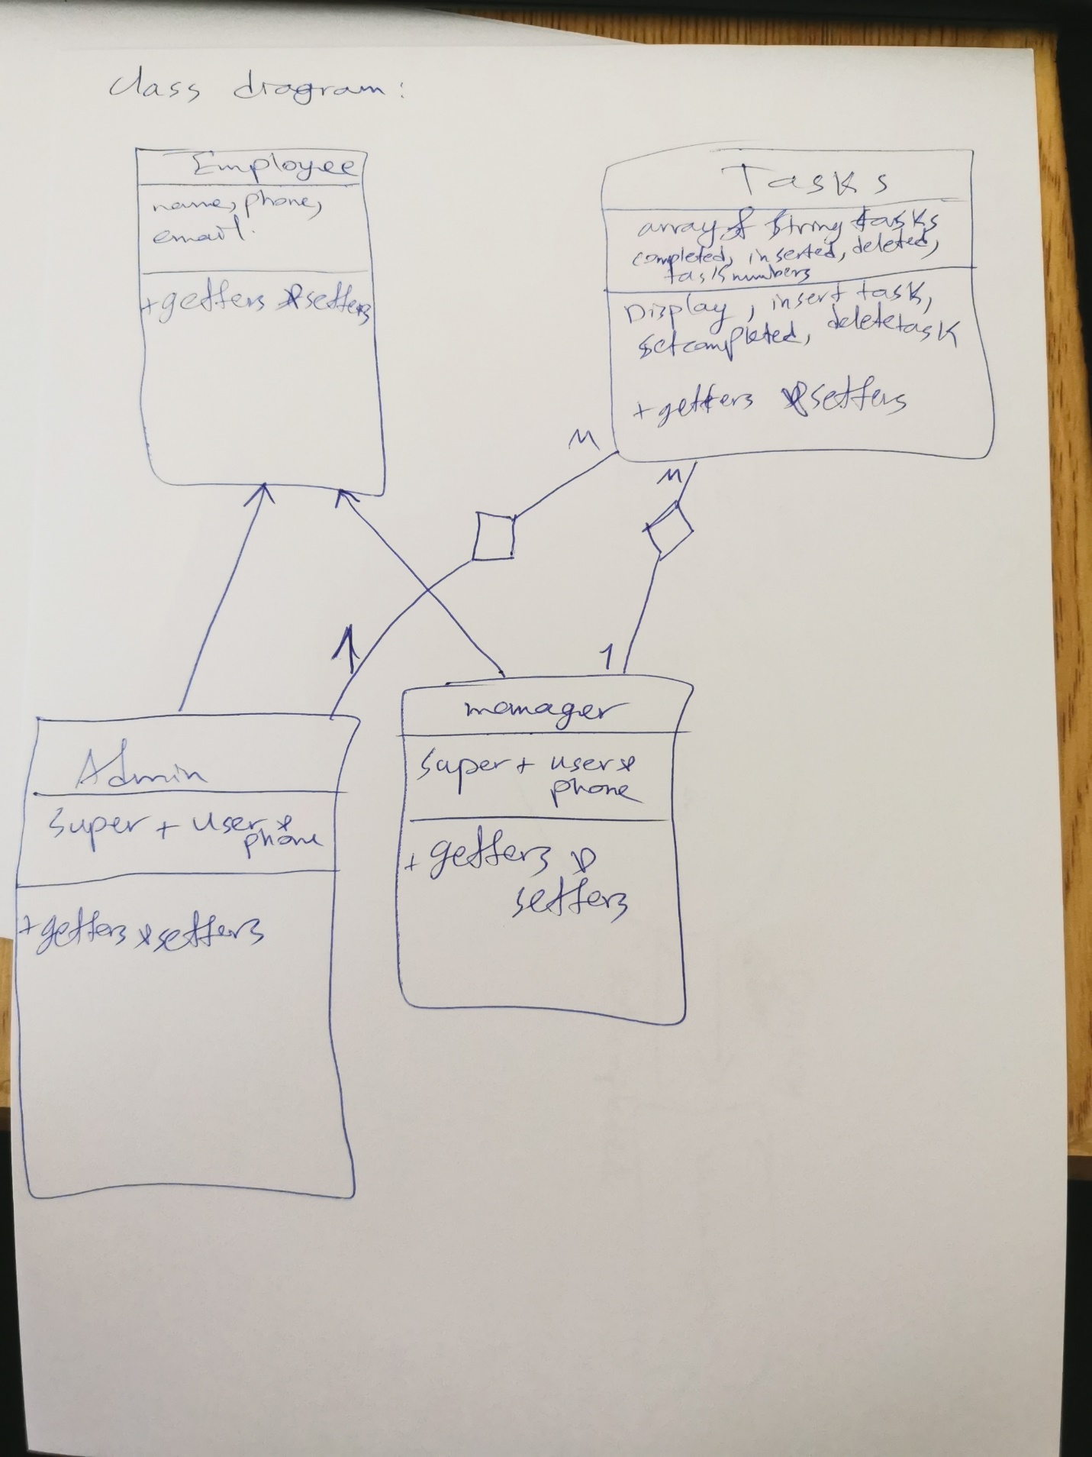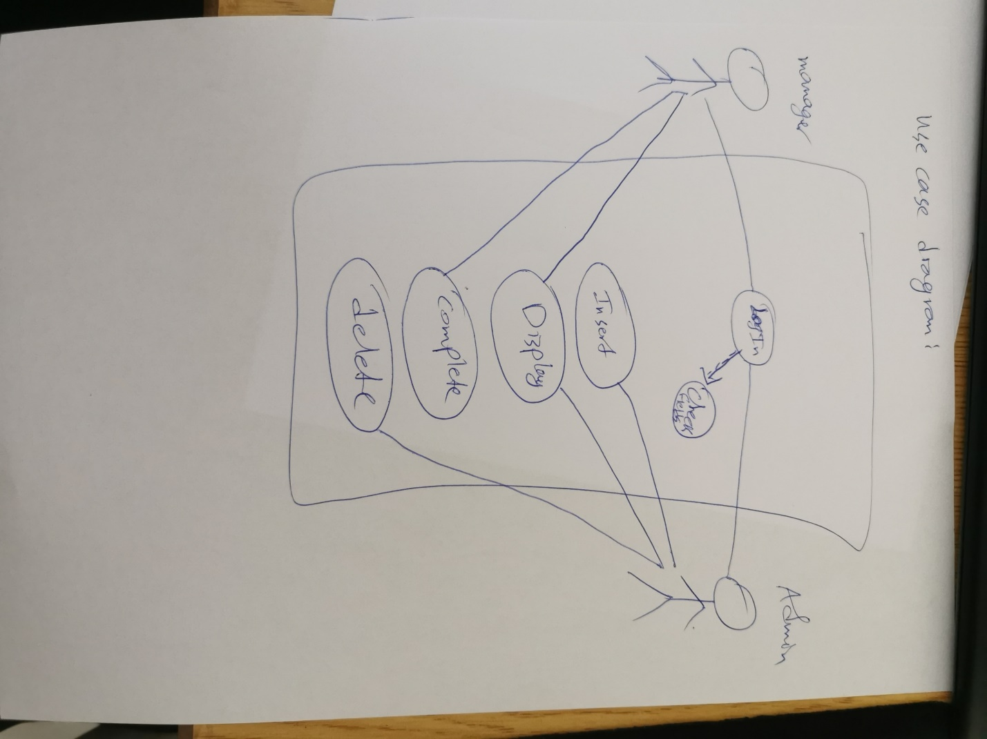

***CODE:***

**package** farouq_oop_project;

**public** **class** admin **extends** employee {

String user ,pass;

**public** admin() {

**super**();

}

**public** admin(String fname, String lname, String email, String phone) {

**super**(fname, lname, email, phone);

}

**public** String getUser() {

**return** user;

}

**public** **void** setUser(String user) {

**this**.user = user;

}

**public** String getPass() {

**return** pass;

}

**public** **void** setPass(String pass) {

**this**.pass = pass;

}

}

**package** farouq_oop_project;

**public** **class** employee {

String fname;

String lname;

String email;

String phone;

**public** employee() {

}

**public** employee(String fname, String lname, String email, String phone) {

**this**.fname = fname;

**this**.lname = lname;

**this**.email = email;

**this**.phone = phone;

}

**public** String getFname() {

**return** fname;

}

**public** **void** setFname(String fname) {

**this**.fname = fname;

}

**public** String getLname() {

**return** lname;

}

**public** **void** setLname(String lname) {

**this**.lname = lname;

}

**public** String getEmail() {

**return** email;

}

**public** **void** setEmail(String email) {

**this**.email = email;

}

**public** String getPhone() {

**return** phone;

}

**public** **void** setPhone(String phone) {

**this**.phone = phone;

}

@Override

**public** String toString() {

**return** "employee [fname=" + fname + ", lname=" + lname + ", email=" + email + ", phone=" + phone + "]";

}

}

**package** farouq_oop_project;

**public** **class** manager **extends** employee {

String user;

String pass;

**public** manager() {

**super**();

}

**public** manager(String fname, String lname, String email, String phone , String user ,String pass) {

**super**(fname, lname, email, phone);

}

**public** String getUser() {

**return** user;

}

**public** **void** setUser(String user) {

**this**.user = user;

}

**public** String getPass() {

**return** pass;

}

**public** **void** setPass(String pass) {

**this**.pass = pass;

}

@Override

**public** String toString() {

**return** "manager [user=" + user + ", pass=" + pass + ", fname=" + fname + ", lname=" + lname + ", email=" + email

+ ", phone=" + phone + "]";

}

}

**package** farouq_oop_project;

**import** java.util.Arrays;

**public** **class** tasks {

String[] task = **new** String[100];

**int** completed = 0 , inserted = 0 , deleted = 0 , tasknumbers = 0 ;

**public** tasks() {

}

**public** **void** Display() {

**for**(**int** i = 0 ; i < tasknumbers ; i++){

System.***out***.println("Task "+(i+1)+" :\n"+task[i]);

}

}

**public** **void** insertTask(String a) {

task[inserted]=a;

inserted++;

tasknumbers++;

}

**public** **void** setToCompleted(**int** k) {

**for**(**int** i = k ; i < tasknumbers ; i++) {

task[k]=task[k+1];

}

completed++;

tasknumbers--;

}

**public** **void** Delete(**int** a) {

**for**(**int** i = a ; i < tasknumbers ; i++) {

task[a]=task[a+1];

}

completed++;

tasknumbers--;

}

@Override

**public** String toString() {

**return** "tasks [task=" + Arrays.*toString*(task) + ", completed=" + completed + ", inserted=" + inserted

+ ", deleted=" + deleted + "]";

}

}

**package** farouq_oop_project;

**import** java.util.*;

**public** **class** main {

**public** **static** **void** main(String[] args) {

Scanner s = **new** Scanner(System.***in***);

tasks t = **new** tasks();

admin e = **new** admin();

e.setUser("admin");

e.setPass("admin");

manager m = **new** manager();

m.setUser("manager");

m.setPass("manager");

**int** choice;

**do** {

**int** choice2;

System.***out***.println("1.admin.");

System.***out***.println("2.manager.");

System.***out***.println("3.exit.");

System.***out***.println("---------------------------------");

choice = s.nextInt();

**if**(choice==1) {

System.***out***.println("Enter user:");

String user = s.next();

System.***out***.println("Enter pass:");

String pass = s.next();

System.***out***.println("---------------------------------");

**if**(user.equals(e.getUser()) && pass.equals(e.getPass())) {

**do** {

System.***out***.println("---------------------------------");

System.***out***.println("1.add task.");

System.***out***.println("2.delete task.");

System.***out***.println("3.Display.");

System.***out***.println("4.Exit.");

choice2 = s.nextInt();

**switch**(choice2) {

**case** 1:

System.***out***.println("Enter task:");

t.insertTask(s.next());

**break**;

**case** 2:

System.***out***.println("task number:");

t.Delete(s.nextInt());

**break**;

**case** 3:

t.Display();

**break**;

}

System.***out***.println("---------------------------------");

}**while**(choice2!=4);

}**else** {

System.***out***.println("wrong informations!");

}

}**else** **if**(choice==2) {

System.***out***.println("Enter user:");

String user = s.next();

System.***out***.println("Enter pass:");

String pass = s.next();

System.***out***.println("---------------------------------");

**if**(user.equals(m.getUser()) && pass.equals(m.getPass())) {

**do** {

System.***out***.println("---------------------------------");

System.***out***.println("1.Display tasks.");

System.***out***.println("2.set as completed.");

System.***out***.println("3.Exit.");

choice2 = s.nextInt();

**switch**(choice2) {

**case** 1:

t.Display();

**break**;

**case** 2:

System.***out***.println("enter task number:");

t.setToCompleted(s.nextInt());

**break**;

}

System.***out***.println("---------------------------------");

}**while**(choice2!=3);

}**else** {

System.***out***.println("wrong informations!");

}

}

}**while**(choice!=3);

}

}

***OUTPUT:***

1.admin.

2.manager.

3.exit.

---------------------------------

1

Enter user:

admin

Enter pass:

admin

---------------------------------

---------------------------------

1.add task.

2.delete task.

3.Display.

4.Exit.

1

Enter task:

cooking

---------------------------------

---------------------------------

1.add task.

2.delete task.

3.Display.

4.Exit.

1

Enter task:

cleaning

---------------------------------

---------------------------------

1.add task.

2.delete task.

3.Display.

4.Exit.

3

Task 1 :

cooking

Task 2 :

cleaning

---------------------------------

---------------------------------

1.add task.

2.delete task.

3.Display.

4.Exit.

4

---------------------------------

1.admin.

2.manager.

3.exit.

---------------------------------

2

Enter user:

manager

Enter pass:

manager

---------------------------------

---------------------------------

1.Display tasks.

2.set as completed.

3.Exit.

1

Task 1 :

cooking

Task 2 :

cleaning

---------------------------------

---------------------------------

1.Display tasks.

2.set as completed.

3.Exit.

2

enter task number:

2

---------------------------------

---------------------------------

1.Display tasks.

2.set as completed.

3.Exit.

1

Task 1 :

cooking

---------------------------------

---------------------------------

1.Display tasks.

2.set as completed.

3.Exit.