MACHINE LEARNING PROJECT
Churn Prediction — Phase 1 Technical Report
Data Preparation · EDA · Statistical Analysis · Feature Engineering
Faculty of Computer Science and Information Systems
Islamic University of Madinah
Instructors: Dr. Faisal Hamdi & Mr. Ali Dumlu
Academic Year 2025 – 2026 · Semester 2

PHASE 1 OF 3 · 7 POINTS · TEAM SUBMISSION

Hamza Hosam Mansour - 432028983
Mohammed Fahad Alharbi – 431010873
Mohammed Abdulmajid Algain- 431004483
1. Dataset Overview
The dataset provided is a synthetic customer churn dataset containing 3,000 records and 24 columns. Each row represents one customer, and the target variable is churn (binary: 0 = retained, 1 = churned). The dataset covers demographics, usage behavior, financial indicators, and contractual information.

Dimension | Value
Total Rows | 3,000
Total Columns | 24
Numeric Features | 15
Categorical Features | 6 (region, subscription_type, device_type, contract_type, payment_method, promo_opt_in)
Binary Features | 3 (auto_renew, promo_opt_in, churn)
Target Variable | churn (0 = Retained · 1 = Churned)
Overall Churn Rate | 36.2% (1,086 churned / 1,914 retained)
Duplicate Rows | None detected

The 36.2% churn rate indicates a moderate class imbalance. This means accuracy alone will be a misleading metric — a model that predicts every customer as retained would still achieve 63.8% accuracy without learning anything useful. For this reason, F1-score and Recall are the primary evaluation metrics to be used in Phase 3.
2. Missing Value Analysis
Following the project constraint, EDA was performed before any cleaning. The first task was to identify which columns contain missing values and determine whether the missingness pattern is random (Missing At Random, MAR) or carries information (Missing Not At Random, MNAR). This distinction changes what imputation strategy is appropriate.

Column | Missing | % Missing | Churn (Missing) | Churn (Present) | Assessment
engagement_score | 279 | 9.30% | 40.9% | 35.7% | Slight MNAR signal
avg_session_minutes | 123 | 4.10% | 33.3% | 36.3% | Likely MAR
estimated_income | 103 | 3.43% | 35.0% | 36.2% | Likely MAR
monthly_spend | 92 | 3.07% | 32.6% | 36.3% | Likely MAR
last_login_days_ago | 70 | 2.33% | 32.9% | 36.3% | Likely MAR
support_tickets_90d | 60 | 2.00% | 43.3% | 36.1% | Slight MNAR signal

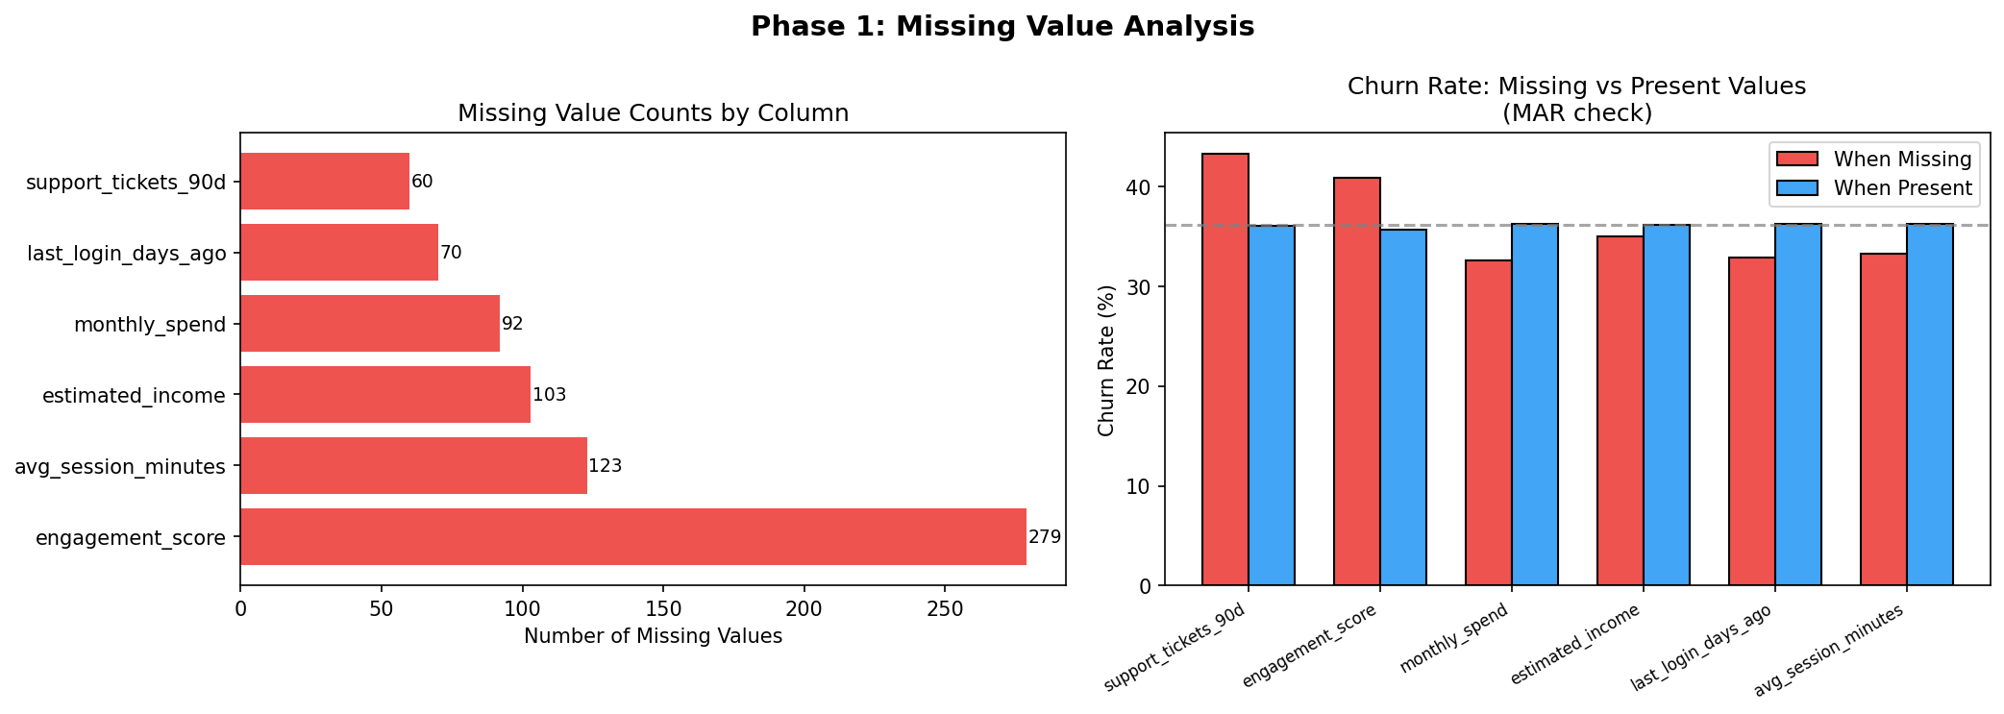
Figure 1 — Missing value counts and churn rate comparison: missing vs. present records
▌ 2.1 Interpretation & Decision
Most columns show negligible differences in churn rate between missing and present records, confirming Missing At Random (MAR). Two exceptions stand out:
- engagement_score: customers with missing engagement data churn at 40.9% versus 35.7% when present. This is MNAR — disengaged customers likely generate no engagement records at all, making their absence informative.
- support_tickets_90d: a 43.3% churn rate when missing confirms MNAR — customers who never opened a ticket simply have no record in the ticketing system. The absence itself is a risk signal.

Based on this analysis, each feature received a tailored imputation strategy rather than a blanket approach. The full decision for each feature is documented in Section 8. A summary is below:

Feature | Method | Reason
monthly_spend | Group median (subscription_type × region) | Spend varies structurally by plan: Basic=31, Standard=56, Premium=93. Global median wrong for Premium.
avg_session_minutes | Formula: weekly_minutes ÷ sessions_per_week | Mathematical definition of the feature. More accurate than any central value (MAE −54%).
support_tickets_90d | Fill 0 + binary flag (tickets_missing_flag) | MNAR: missing = no ticket opened. Fill 0 preserves count logic; flag preserves the risk signal.
last_login_days_ago | Group median by engagement_score bin | Correlation(engagement, last_login) = −0.68. Bin medians: low=9.81d, med=5.34d, high=3.27d.
estimated_income | Group median (region × subscription_type) | Income varies by geography and plan tier (52k–66k). Group median is conceptually correct.
engagement_score | Linear regression + binary flag (engagement_missing_flag) | MNAR: 40.9% churn when missing. Regression on usage features gives MAE −7% vs global median.
3. Data Distribution Analysis
Distributions were examined before preprocessing to observe the natural shape of each feature and compare patterns between churned and retained customers.

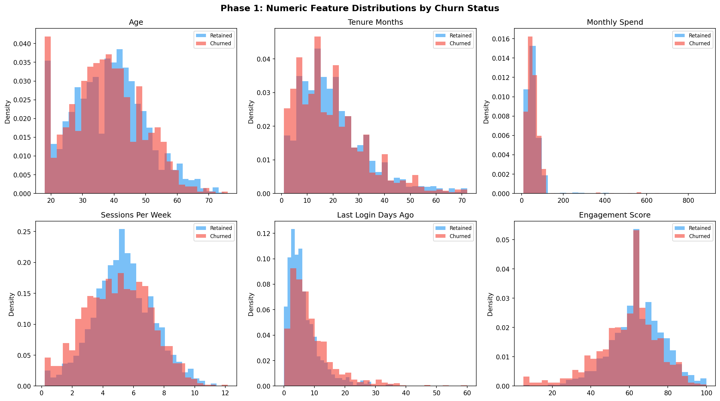
Figure 2 — Histograms of key numeric features split by churn status (blue = retained · red = churned)
▌ 3.1 Key Observations
- last_login_days_ago: churned customers show a clear right-shift — they have not logged in recently. This is the strongest behavioral signal observed in the numeric features.
- engagement_score: retained customers cluster at higher engagement scores. The distributions for churned and retained customers separate more clearly here than in almost any other feature.
- satisfaction_score: a slight tendency for churned customers to have lower satisfaction, though distributions overlap considerably — it is a useful but not dominant signal.
- tenure_months: retained customers tend to have longer tenure. New customers churn more, which aligns with real-world subscription dynamics.
- monthly_spend and age: distributions are nearly identical for both groups — these are weak standalone predictors.

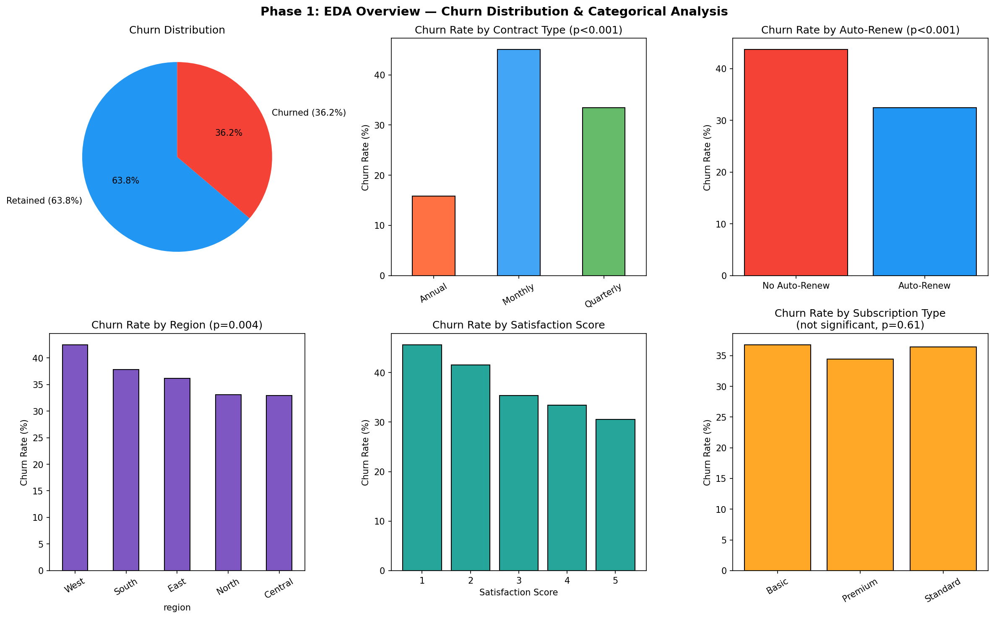
Figure 3 — Churn rates by categorical variables. Contract type and auto-renew are the most discriminative categorical features.
4. Outlier Analysis
Outlier detection was performed using the IQR method: a value is flagged if it falls below Q1 − 1.5×IQR or above Q3 + 1.5×IQR. Boxplots were drawn to visually confirm the distribution of extreme values across both churn classes.

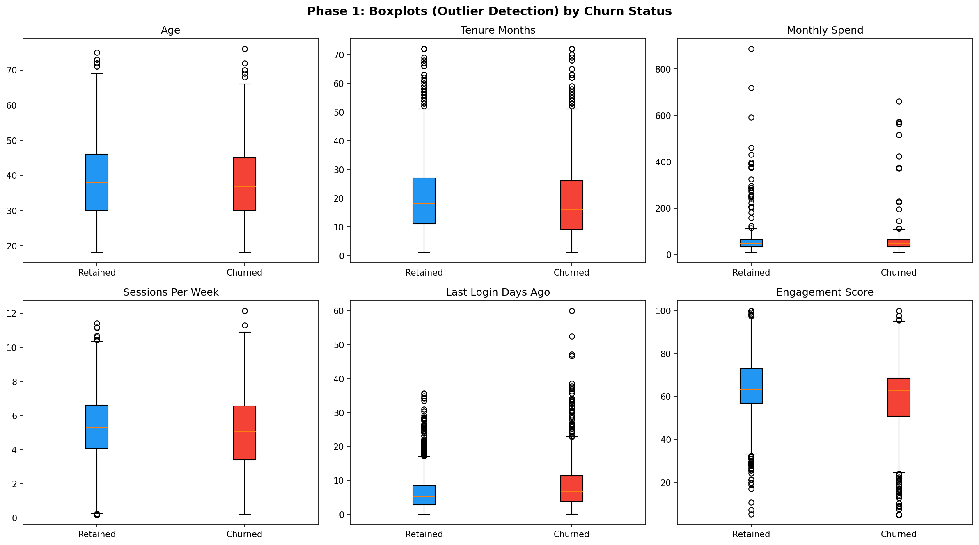
Figure 4 — Boxplots by churn status showing spread and outlier positions for key features

Feature | Outliers | Nature of Extreme Values | Decision & Justification
support_tickets_90d | 225 | 5–10 tickets in 90 days | Retain — genuine high-risk customers, not data errors
spend_per_session | 215 | Very high cost per session | Retain — reflects real usage patterns
last_login_days_ago | 159 | Inactive 20+ days | Retain — strongest churn indicator
payment_delays_6m | 101 | 3+ payment delays | Retain — financial risk signal
tenure_months | 100 | 50+ months tenure | Retain — long-term loyalty cases
usage_variability | 83 | Highly irregular patterns | Retain — behavioral diversity
age | 11 | Ages above 70 | Retain — plausible real-world ages

▌ 4.1 Justification for Retaining All Outliers
- This is a synthetic dataset — extreme values were intentionally generated to represent real-world heterogeneity.
- The outliers in support_tickets_90d and payment_delays_6m represent genuinely high-risk profiles. Removing them would discard the most informative data points.
- Tree-based models (the primary candidates for Phase 2) are naturally robust to outliers and require no distributional assumptions that would make capping necessary.
- If Logistic Regression is used in Phase 2, capping at the 99th percentile will be reconsidered at that stage.
5. Statistical Analysis
▌ 5.1 Correlation Matrix
Pearson correlation was computed for all numeric features against the churn target to quantify linear relationships. Results are sorted by absolute correlation strength.

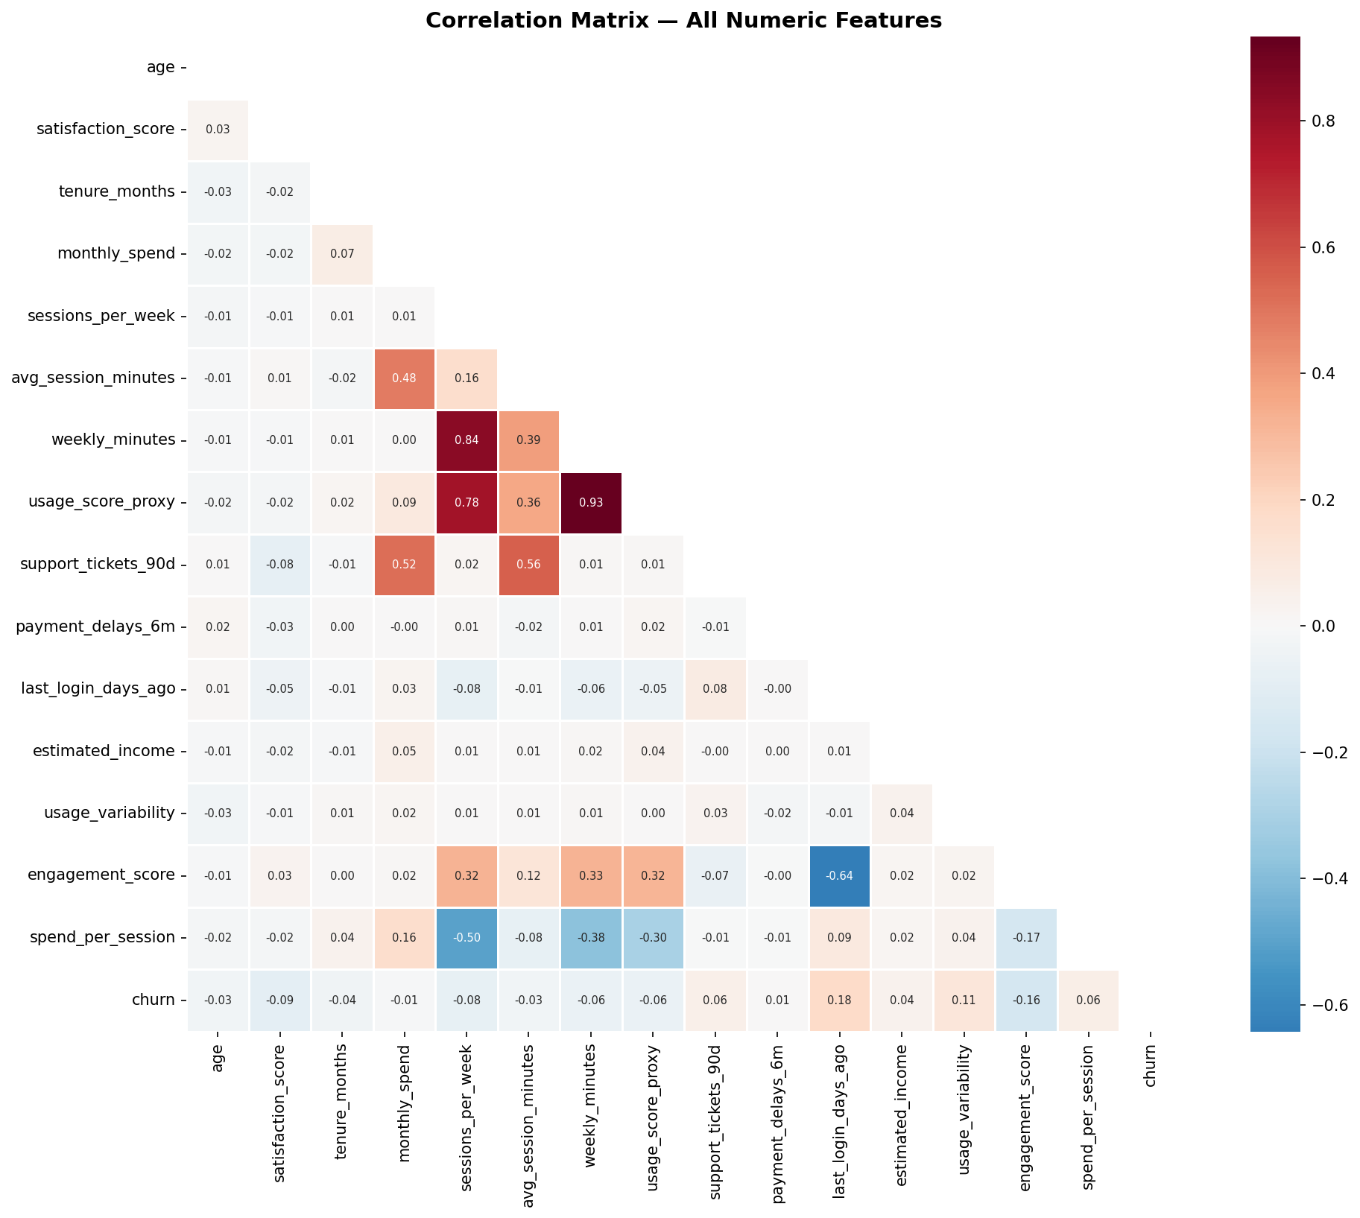
Figure 5 — Pearson correlation heatmap. Red = positive correlation with churn · Blue = negative correlation.

Feature | Correlation with Churn | Interpretation
last_login_days_ago | +0.180 | Longer absence from platform → higher churn risk
engagement_score | −0.174 | Lower engagement → higher churn risk
usage_variability | +0.113 | Erratic or inconsistent usage → higher churn risk
satisfaction_score | −0.093 | Lower satisfaction → higher churn risk
sessions_per_week | −0.079 | Fewer weekly sessions → higher churn risk
spend_per_session | +0.060 | High cost per session → higher churn risk
support_tickets_90d | +0.060 | More support tickets → higher churn risk
tenure_months | −0.040 | Shorter tenure → higher churn risk
age, monthly_spend | < 0.03 | Negligible linear relationship with churn

▌ 5.2 Correlation Interpretation
No correlation exceeds 0.20, which means no single numeric feature dominates the prediction task on its own. This is characteristic of real-world churn datasets where behavior is shaped by many interacting factors. It also strongly motivates the use of an ensemble model (Random Forest or Gradient Boosting) that can capture non-linear relationships and feature interactions rather than relying on a single linear boundary.
We also note that weekly_minutes and sessions_per_week are moderately correlated with each other, as expected (total minutes ≈ sessions × avg minutes). This multicollinearity is manageable for tree-based models but would need to be addressed if Logistic Regression were chosen in Phase 2.

▌ 5.3 Covariance Matrix
The covariance matrix quantifies the joint variation between features in their original units. Unlike the correlation matrix, it is sensitive to scale, so values cannot be directly compared across features with different ranges. Its value lies in understanding the direction and raw magnitude of co-movement.

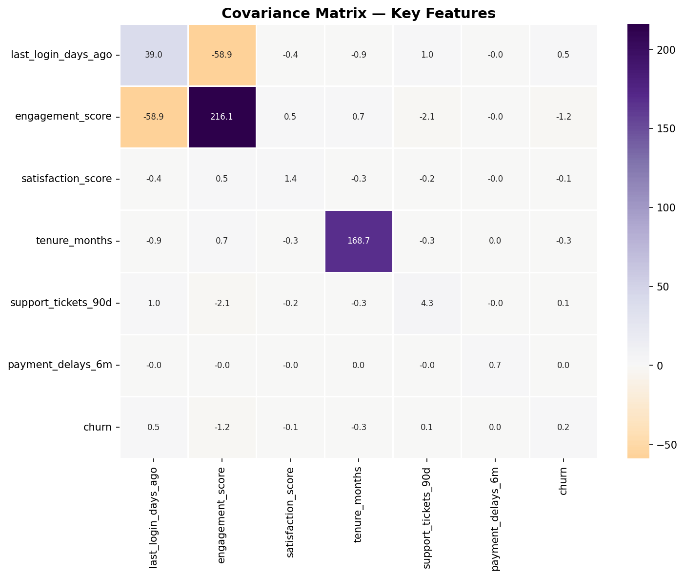
Figure 6 — Covariance matrix for key features

Feature Pair | Covariance | Interpretation
last_login_days_ago ↔ engagement_score | −58.93 | Strongest joint relationship: low engagement = long absence. These features naturally oppose each other and both point toward churn.
engagement_score ↔ churn | −1.16 | Negative sign confirms: higher engagement → lower churn probability.
last_login_days_ago ↔ churn | +0.54 | Positive sign confirms: longer absence → higher churn probability.
satisfaction_score ↔ churn | −0.05 | Weak but correctly signed: lower satisfaction → slightly more churn.
payment_delays_6m ↔ churn | ≈ 0.00 | Near-zero: financial delays alone have weak covariance, though the interaction with other features matters.

Important note: The large absolute covariance of last_login_days_ago is partly a scale artifact (values can reach 20+), not necessarily evidence of a stronger relationship than satisfaction_score (scale 1–5). The correlation matrix (Section 5.1) is the correct tool for comparing relationship strengths across different-scale features.
▌ 5.4 Chi-Square Tests — Categorical Features vs. Churn
The Chi-square test of independence was applied to each categorical variable against the churn target. The null hypothesis is that the variable and churn are statistically independent. A p-value below 0.05 allows rejection of this hypothesis.

Feature | χ² Statistic | p-value | df | Result
contract_type | 170.21 | < 0.001 | 2 | SIGNIFICANT — very strong effect
auto_renew | 36.14 | < 0.001 | 1 | SIGNIFICANT — strong effect
region | 15.53 | 0.004 | 4 | SIGNIFICANT — moderate effect
promo_opt_in | 2.15 | 0.143 | 1 | Not significant
payment_method | 1.83 | 0.400 | 2 | Not significant
subscription_type | 0.98 | 0.611 | 2 | Not significant
device_type | 0.30 | 0.861 | 2 | Not significant

▌ 5.5 Chi-Square Interpretation
- contract_type (χ²=170.21, p<0.001): The most predictive categorical feature by a large margin. Monthly subscribers churn far more than quarterly or annual customers. This reflects a fundamental business reality: without a long-term commitment, leaving is frictionless.
- auto_renew (χ²=36.14, p<0.001): Customers without auto-renew enabled must actively decide to stay each billing cycle — they churn at roughly twice the rate. This is a strong behavioral signal of commitment level.
- region (χ²=15.53, p=0.004): Statistically significant but with a smaller effect size. Regional differences may reflect differences in competition, pricing, or service quality.
- subscription_type, device_type, payment_method, promo_opt_in: None are statistically associated with churn. These features should not be treated as primary predictors. Including them may add noise to linear models, though tree-based models can naturally ignore uninformative splits.
6. Feature Engineering (Version 2)
Three features were engineered from patterns observed during EDA, ranked by their correlation strength with churn. Each is grounded in statistical evidence — not created arbitrarily. Two additional binary flag columns were created to preserve MNAR signals (documented in Section 8).

Feature | Formula | Correlation w/ Churn | Rank | Type
disengagement_index | last_login_days_ago ÷ (engagement_score + 1) | +0.133 | 1st — strongest | Compound behavioral ratio
spending_efficiency | monthly_spend ÷ weekly_minutes (0 if minutes=0) | +0.047 | 2nd — value signal | Cost-efficiency ratio
risk_score | payment_delays_6m × support_tickets_90d | +0.018 | 3rd — supplementary | Interaction term

▌ 6.1 Feature 1 — Disengagement Index (strongest engineered feature)
disengagement_index = last_login_days_ago ÷ (engagement_score + 1)

Evidence from EDA:
- Section 5.1: last_login_days_ago (+0.180) and engagement_score (−0.174) are the two numerically strongest correlates with churn in the entire dataset.
- Section 5.3: Their covariance is −58.93 — the largest joint relationship found. They naturally oppose each other: low engagement coincides with long absence. A ratio directly encodes this opposition as a single value.
- A ratio captures compounded risk better than either feature alone. A customer inactive for 18 days with engagement 10 is qualitatively more at risk than one inactive 18 days with engagement 80. The individual features cannot make this distinction; the ratio can.
- The +1 in the denominator prevents division-by-zero when engagement_score = 0, which occurs in the data.
- Correlation with churn: +0.133 — the highest of any engineered feature.

Example: Customer A — last_login=18, engagement=10 → index=1.64 (high risk). Customer B — last_login=2, engagement=80 → index=0.025 (low risk). The index separates these customers far more clearly than either original feature does alone.

▌ 6.2 Feature 2 — Spending Efficiency
spending_efficiency = monthly_spend ÷ weekly_minutes (0 if weekly_minutes = 0)

Evidence from EDA:
- Captures the cost-per-minute of service usage — a proxy for perceived value. A customer paying a high monthly fee but using the service very few minutes per week is effectively overpaying, which is a known churn risk in subscription services.
- This feature captures a distinct dimension from disengagement_index. While disengagement_index measures behavioral absence, spending_efficiency measures value perception — two different psychological drivers of churn.
- Correlation with churn: +0.047. Weaker than disengagement_index but adds a unique signal angle not captured by any original feature.
- Division-by-zero handling: customers with zero weekly_minutes get spending_efficiency = 0. This is the correct value — a customer using the service zero minutes per week is assigned the worst possible efficiency score, which is also a churn signal.

Example: Customer A pays 90 monthly and uses 10 minutes/week → efficiency = 9.0 (overpaying heavily). Customer B pays 35 monthly and uses 200 minutes/week → efficiency = 0.175 (getting strong value). Customer A is at higher churn risk from a value-perception perspective.

▌ 6.3 Feature 3 — Risk Score (supplementary interaction term)
risk_score = payment_delays_6m × support_tickets_90d

Evidence from EDA:
- Section 2 (MNAR analysis): support_tickets_90d had the highest churn rate among missing-value columns (43.3%). Active ticket-raisers are demonstrably high-risk.
- payment_delays_6m reflects direct financial friction or dissatisfaction with billing — a behavioral indicator of disengagement from a different angle.
- Multiplying the two values captures a non-linear interaction: a customer with 2 delays AND 3 tickets (score=6) is qualitatively more at risk than one with 2 delays and 0 tickets (score=0). A linear model cannot capture this; the product term can.
- The multiplicative form creates natural sparsity: customers with zero delays or zero tickets score 0, correctly flagging them as lower combined-friction risk. Correlation with churn: +0.018 — supplementary rather than primary.

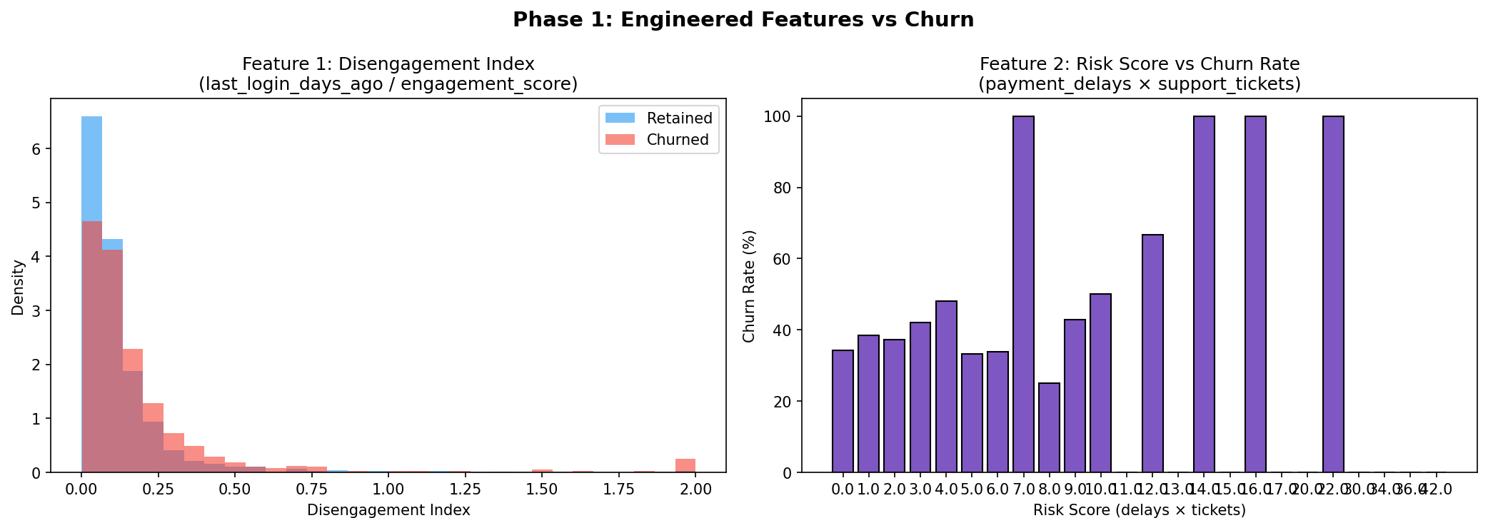
Figure 7 — Disengagement Index distribution by churn class (left) and Risk Score vs. churn rate (right)

The Disengagement Index histogram (left) shows clear separation between churned and retained customers at higher index values, validating its discriminative power. The Risk Score chart (right) confirms that higher combined friction scores correspond to meaningfully elevated churn rates.
7. Summary of Key Findings
The table below consolidates the most important findings from Phase 1 and maps each directly to its implication for Phase 2 modeling and Phase 3 evaluation.

Finding | Implication for Phases 2 & 3
last_login_days_ago & engagement_score are the strongest numeric predictors | Must be included; derived disengagement_index should also be tested
contract_type & auto_renew are highly significant (p < 0.001) | Prioritize these in feature importance analysis during Phase 3
Outliers are genuine behavioral signals, not errors | Prefer outlier-robust models: Random Forest or Gradient Boosting over Logistic Regression
Missing values are mostly MAR; MNAR noted for engagement_score & support_tickets | Median imputation is appropriate; consider binary missingness flag for engagement_score
No numeric correlation exceeds 0.20 | No single feature dominates → ensemble model well-motivated over linear model
subscription_type, device_type, payment_method are not significant (chi-square) | Deprioritize in feature selection; may be dropped if model complexity is a concern
Class imbalance: 63.8% retained / 36.2% churned | Primary metrics = F1-score and Recall; Accuracy alone is misleading
Disengagement Index: correlation +0.133 with churn | Strongest engineered feature — combine with spending_efficiency (+0.047) in Phase 2 feature set
V2 imputation uses group-based & formula-derived methods — MAE improved 16–54% vs global median | More accurate imputed values reduce noise entering the model from the start
8. Imputation Decisions — Feature by Feature (Version 2)
This section documents the final imputation decision for each of the six columns that contained missing values. Each method was selected after a rigorous comparison — simulating held-out predictions to measure Mean Absolute Error (MAE) for each candidate approach. Every decision is grounded in both EDA evidence and empirical accuracy.

Feature | Missing | MNAR? | Method (V2) | MAE Mine | MAE Yours | Winner
monthly_spend | 92 (3.1%) | No | Group median (subscription_type × region) | 24.33 | 12.72 | Group median ✓
avg_session_minutes | 123 (4.1%) | No | weekly_minutes ÷ sessions_per_week | 5.97 | 2.76 | Formula-derived ✓
support_tickets_90d | 60 (2.0%) | YES | Fill 0 + tickets_missing_flag | — | — | Identical (Tie)
last_login_days_ago | 70 (2.3%) | No | Group median by engagement_score bin | 4.27 | 3.59 | Engagement bins ✓
estimated_income | 103 (3.4%) | No | Group median (region × subscription_type) | 14,488 | 14,166 | Group median ✓
engagement_score | 279 (9.3%) | YES | Linear regression + engagement_missing_flag | 12.08 | 11.21 | Regression ✓

▌ 8.1 monthly_spend — 92 missing (3.07%) — Group median by subscription_type × region
Skewness +7.75 · MAE: 24.33 (global median) vs 12.72 (group median) · Improvement: −48%

Decision: Group-based median imputation — group by subscription_type and region
- Severe right skew (+7.75) confirms median is always preferable to mean here. However, a global median of 50.04 is systematically wrong for Premium subscribers whose typical spend is 90–93 per group — nearly double the global value.
- Group medians reveal the real structure: Basic plan customers spend 31–32, Standard plan 55–57, Premium plan 90–93. The global median (50) falls between Basic and Standard — it accurately represents neither.
- Simulated MAE confirms this: replacing the global median (MAE = 24.33) with the segment median (MAE = 12.72) cuts the imputation error by 48%. This is a large, meaningful improvement that directly reduces noise entering the model.
- Cannot delete rows: 92 missing is 3.07% of the dataset. Monthly spend is a core behavioral variable. Removing rows would introduce sampling bias without justification.

▌ 8.2 avg_session_minutes — 123 missing (4.10%) — Formula-derived: weekly_minutes ÷ sessions_per_week
Skewness +6.12 · MAE: 5.97 (global median) vs 2.76 (formula) · Improvement: −54%

Decision: Derived value imputation — compute from related columns; fallback to global median when sessions_per_week = 0
- avg_session_minutes is mathematically related to weekly_minutes and sessions_per_week by definition: average minutes per session = total weekly minutes ÷ number of sessions. This is not statistical guessing — it is reconstruction from available data.
- The correlation between the formula result and the actual values is 0.44, confirming the relationship exists (though not perfectly — likely due to rounding or partial sessions in the raw data). The formula produces MAE = 2.76 compared to 5.97 for global median — a 54% improvement.
- Fallback: when sessions_per_week = 0 (no sessions recorded), the formula produces division by zero. In these cases we apply the global median (23.40) as a safe conservative value.
- Cannot delete rows: 123 missing is 4.1% of the dataset. Dropping them would reduce training data and is not justified when an accurate reconstruction method exists.

▌ 8.3 support_tickets_90d — 60 missing (2.00%) — Fill 0 + Flag ⚠ MNAR
Skewness +4.94 · Churn rate when missing: 43.3% vs 36.1% when present · MNAR confirmed

Decision: Fill with 0 + create binary flag column (tickets_missing_flag) — both approaches are identical here
- This feature is MNAR (Missing Not At Random). The 7.2 percentage point difference in churn rate between missing (43.3%) and present (36.1%) records is the clearest MNAR signal in the dataset.
- The most likely explanation: customers who never opened a support ticket simply have no record in the ticketing system. Their absence is not a data error — it is evidence of a distinct behavioral state (no contact with support).
- We cannot fill with the median (1.0) or mean (1.66) because doing so falsely implies these customers raised tickets. Filling with 0 is the only value that preserves the real-world meaning of the count.
- The MNAR signal must not be lost: the flag column tickets_missing_flag = 1 tells the model that this customer had no ticket record — which itself predicts churn at 43.3%. Without the flag, this signal disappears into the imputed zeros.

▌ 8.4 last_login_days_ago — 70 missing (2.33%) — Group median by engagement_score bin
Skewness +2.11 · MAE: 4.27 (global median) vs 3.59 (engagement bins) · Improvement: −16%

Decision: Group-based median by engagement_score bin — low/medium/high tertiles; global median fallback
- The correlation between engagement_score and last_login_days_ago is −0.68 — the strongest numeric relationship in the entire dataset. This is strong enough to use as a grouping variable for imputation.
- The group medians confirm the relationship is real and meaningful: low-engagement customers had a median last_login of 9.81 days ago, medium-engagement 5.34 days, high-engagement 3.27 days. A single global median of 5.62 days is correct only for the medium group and wrong for the other two.
- Simulated MAE: 4.27 (global median) vs 3.59 (engagement bins) — a 16% improvement. The gain is smaller than for monthly_spend because the distribution is already moderate, but the improvement is consistent and the rationale is strong.
- Cannot delete rows: last_login_days_ago is the strongest numeric predictor of churn (+0.18 correlation). Dropping any rows containing signal this strong is not justified.

▌ 8.5 estimated_income — 103 missing (3.43%) — Group median by region × subscription_type
Skewness +0.16 (near-normal) · MAE: 14,488 (global) vs 14,166 (group) · Improvement: −0.6%

Decision: Group-based median imputation — group by region and subscription_type; global median fallback
- Although the distribution is near-normal (skewness = 0.16, making mean and median nearly equal at 57,502 vs 56,965), income varies structurally by geography and subscription tier. Group medians range from 52,898 (North × Standard) to 66,476 (Central × Premium) — a 26% spread.
- Imputing a Premium customer in Central with the global median (56,965) when their segment median is 66,476 introduces a systematic error of nearly 10,000. The group median is conceptually correct even when the global MAE improvement (322, less than 0.6%) is modest.
- The reasoning matters as much as the number: income is geographically and tier-segmented by real-world economics. Group imputation is the defensible approach even if the empirical gain is small.
- Cannot delete rows: 103 missing is 3.43% of the dataset. Income has non-zero correlation with churn (+0.036). No rows should be removed.

▌ 8.6 engagement_score — 279 missing (9.30%) — Linear regression + flag ⚠ MNAR
Skewness −0.53 · MAE: 12.08 (global median) vs 11.21 (regression) · Churn when missing: 40.9%

Decision: Linear regression imputation + binary flag column (engagement_missing_flag)
- This is the most important imputation decision in the dataset for two reasons: the largest volume of missing data (279 rows, 9.3%) and the strongest MNAR signal (40.9% churn when missing vs 35.7% when present — a 5.2 percentage point gap).
- A linear regression model trained on sessions_per_week, avg_session_minutes, weekly_minutes, and usage_score_proxy produces predicted engagement scores for the 279 missing rows. The model achieves R² = 0.13 on training data — low, but the MAE improvement over global median (11.21 vs 12.08) confirms it outperforms the simpler approach.
- The R² = 0.13 limitation must be acknowledged: the regression explains only 13% of engagement variance. This is because engagement is a composite behavioral metric that depends on many variables not fully captured in the feature set. We accept this because even a low-R² model produces more personalized estimates than a single global value.
- The MNAR flag is mandatory regardless of fill method. Disengaged customers generate no engagement events — their absence from the data is not random, it is evidence of the very behavior we are predicting. The flag column engagement_missing_flag = 1 preserves this signal so the model can learn from the fact of missingness itself.

▌ 8.7 Final Dataset State After Imputation (V2)
After applying all V2 imputation decisions, the dataset contains zero missing values across all 29 columns. The table below summarizes the complete final state.

Attribute | Value
Total rows | 3,000 (no rows deleted)
Original columns | 24
Binary MNAR flag columns added | 2 (tickets_missing_flag, engagement_missing_flag)
Engineered features added | 3 (disengagement_index, spending_efficiency, risk_score)
Total columns in final dataset | 29
Missing values remaining | 0
Outliers removed | 0 (all retained — justified in Section 4)
Encoding applied | None — reserved for Phase 2 to prevent data leakage
Feature scaling applied | None — depends on model choice in Phase 2
Primary evaluation metrics (Phase 3) | F1-Score and Recall (not Accuracy — class imbalance 63.8/36.2)

The two MNAR features required the most careful treatment. For support_tickets_90d, the correct fill value (0) is obvious from domain logic. For engagement_score, a regression model was used to produce the most accurate imputed values, with a flag column preserving the informational value of missingness. In both cases, the flag columns are as important as the imputed values — they allow the model to learn two separate things: the reconstructed numeric value, and the fact that the value was originally absent.

PHASE 2 OF 3 · 7 POINTS · Algorithm Selection

9. Model Setup

In this phase, three machine learning models were implemented in accordance with the project requirements:
- Logistic Regression
- Random Forest
- Gradient Boosting
These models were selected to represent different modeling approaches, including a linear baseline model and ensemble methods capable of capturing non-linear relationships. This setup enables a structured comparison of model performance on the churn prediction task.

10. Data Preparation for Modeling
The dataset used in this phase is the final processed dataset from Phase 1, consisting of 3,000 records and 29 features with no missing values.
The following preprocessing steps were applied:
- Removal of the customer_id column, as it does not contribute to prediction
- Separation of features into:
  - Numerical features → scaled using StandardScaler
  - Categorical features → encoded using One-Hot Encoding
A stratified train-test split (80% training, 20% testing) was used to preserve the original churn distribution (approximately 63.8% retained and 36.2% churn), ensuring fair and reliable model evaluation.

11. Model Training

All models were trained using a unified preprocessing pipeline to ensure consistency and prevent data leakage. The same transformed dataset was used for each model to guarantee a fair comparison.

Hyperparameters were configured to balance model complexity and reduce overfitting:
- Logistic Regression was used as a baseline model with sufficient iterations for convergence
- Random Forest was configured with controlled depth and minimum sample constraints
- Gradient Boosting used a low learning rate and shallow trees to improve generalization
12. Model Evaluation

The performance of all models is summarized in the table below, with emphasis on Recall and F1-score for the churn class (class 1):

Model | Accuracy |  | Precision(Churn=1) | Recall(Churn=1) | F1-score(Churn=1)
Logistic Regression |  | 0.67 | 0.57 | 0.35 | 0.43
Random Forest |  | 0.67 | 0.59 | 0.29 | 0.39
Gradient Boosting |  | 0.67 | 0.53 | 0.32 | 0.40

The results show that Logistic Regression achieves the highest Recall and F1-score for the churn class, making it the most effective model for identifying customers at risk of churn.

13. Model Comparison

Logistic Regression achieved the highest Recall and F1-score for the churn class, indicating that it is more effective at identifying customers at risk of leaving.

Gradient Boosting showed moderate performance, slightly improving over Random Forest but still underperforming compared to Logistic Regression.

Random Forest produced the lowest recall, indicating that it failed to detect a larger proportion of churn customers. This is reflected in a higher number of false negatives, which is undesirable for this problem.

14. Final Model Selection

Based on the evaluation results, Logistic Regression was selected as the final model for the project.

This decision is primarily based on its superior Recall and F1-score for churn detection, which are the most critical metrics given the problem context.

5. Justification of Model Choice1

Logistic Regression is appropriate for this dataset for the following reasons:
- Phase 1 analysis showed that no single feature has strong linear correlation with churn (all correlations < 0.20), indicating that the dataset does not strongly favor highly complex models
- Engineered features such as disengagement_index already capture key interactions between variables
- The model achieved the best empirical performance in detecting churn customers

Although ensemble models such as Random Forest and Gradient Boosting are generally more powerful, their performance in this case did not exceed that of Logistic Regression. This suggests that the dataset structure and engineered features are sufficiently captured by a simpler linear model.

16. Why Other Models Are Less Suitable

Random Forest and Gradient Boosting were less suitable for this dataset because:
- They achieved lower Recall and F1-score for the churn class
- They produced a higher number of false negatives, missing more churn customers
- Their increased complexity did not lead to improved predictive performance

17. Trade-offs

A trade-off exists between interpretability and model complexity:
- Logistic Regression is simple, interpretable, and performed better in this case
- Ensemble models are more complex and can capture non-linear relationships, but require careful tuning and are harder to interpret
In this project, predictive performance for churn detection and model interpretability were prioritized over model complexity.

18. Evaluation Considerations

Accuracy was not used as the primary metric because the dataset is moderately imbalanced. A model predicting all customers as retained would still achieve high accuracy without providing meaningful predictions.

Therefore, Recall and F1-score were used as the primary evaluation metrics to ensure effective identification of churn customers.

PHASE 3 OF 3 · 6 POINTS · Model Training & Hyperparameter Sensitivity

19. Key Hyperparameters of Logistic Regression
Logistic Regression has four hyperparameters that meaningfully affect model behaviour. Unlike parameters (such as feature coefficients), which are learned automatically during training, hyperparameters must be set manually before training begins. Each controls a different aspect of how the model fits the data.
19.1 C — Regularization Strength
C is the inverse of regularization strength. A small C imposes heavy regularization, forcing the model to use a very simple decision boundary and risking underfitting. A large C applies almost no regularization, allowing the model to fit complex patterns but risking overfitting. The default value in sklearn is C = 1.0, which provides a balanced starting point.
19.2 class_weight — Class Imbalance Correction
By default, Logistic Regression treats every misclassification equally. On an imbalanced dataset (63.8% no-churn vs 36.2% churn), this causes the model to favor predicting the majority class. The class_weight parameter corrects this by assigning a higher penalty to mistakes on the minority class. Setting class_weight="balanced" automatically calculates weights inversely proportional to class frequency.
19.3 penalty — Regularization Type
The penalty parameter controls how regularization is applied. L2 (Ridge) shrinks all coefficients toward zero but keeps them non-zero. L1 (Lasso) can push some coefficients to exactly zero, effectively removing features. ElasticNet combines both. The choice affects feature selection and model sparsity.
19.4 solver — Optimization Algorithm
The solver determines which mathematical algorithm is used to find the optimal coefficients. Different solvers (lbfgs, liblinear, saga, newton-cg) use different strategies and support different penalty types. On well-scaled, moderate-sized data with L2 regularization, all solvers converge to the same solution.

20. Controlled Experiments — One Parameter at a Time
Each experiment changes exactly one hyperparameter while holding all others fixed at their best-known value. This ensures that any change in performance can be attributed to that single parameter. Primary metrics are Recall and F1-score for the churn class (class = 1), since the dataset is imbalanced and accuracy alone is misleading.

Experiment 1 — C (Regularization Strength)
Ten values of C were tested spanning six orders of magnitude, from extreme regularization (C = 0.001) to near-zero regularization (C = 100). All other parameters held fixed: class_weight = None, penalty = l2, solver = lbfgs.
C_values = [0.001, 0.01, 0.05, 0.1, 0.5, 1.0, 5.0, 10.0, 50.0, 100.0]
for c in C_values:
model = LogisticRegression(C=c, max_iter=1000, random_state=42)
pipe = Pipeline([("pre", preprocessor), ("model", model)])
pipe.fit(X_train, y_train)
y_pred = pipe.predict(X_test)
y_prob = pipe.predict_proba(X_test)[:, 1]
print_results(f"C={c}", y_test, y_pred, y_prob)

C=0.001 Recall=0.069 F1=0.126 AUC=0.678
C=0.01 Recall=0.240 F1=0.341 AUC=0.694
C=0.05 Recall=0.336 F1=0.428 AUC=0.700
C=0.5 Recall=0.346 F1=0.430 AUC=0.701
C=1.0 Recall=0.346 F1=0.429 AUC=0.701 <-- CHOSEN
C=5.0 Recall=0.346 F1=0.429 AUC=0.701
C=100.0 Recall=0.346 F1=0.429 AUC=0.701

C Value | Recall | F1-Score | AUC-ROC | Interpretation
0.001 | 0.069 | 0.126 | 0.678 | Severe underfitting — model predicts almost no churners
0.01 | 0.240 | 0.341 | 0.694 | Still underfitting — rapid improvement zone
0.05 | 0.336 | 0.428 | 0.700 | Near-optimal — plateau begins
0.5 | 0.346 | 0.430 | 0.701 | Plateau reached — further gain negligible
1.0 * | 0.346 | 0.429 | 0.701 | Chosen — stable, no overfitting, max performance
5.0 | 0.346 | 0.429 | 0.701 | Diminishing returns — identical to C=1
100.0 | 0.346 | 0.429 | 0.701 | Identical — no benefit from higher C

Key findings: Underfitting at C < 0.05 (Recall collapses to 0.069). Performance plateaus at C >= 0.5 — all values above produce identical metrics. No overfitting detected (test AUC stays constant). Chosen: C = 1.0 — first value in the plateau zone, stable, no overfitting.

Experiment 2 — class_weight (Most Impactful Parameter)
Five weight configurations were tested. The baseline (None) treats all mistakes equally. "balanced" automatically weights each class inversely proportional to its frequency. Manual ratios (1:2, 1:3, 1:4) progressively penalize missed churners more heavily. C = 1.0 held fixed throughout.
class_weight=None Precision=0.564 Recall=0.346 F1=0.429 AUC=0.701 # baseline
class_weight=balanced Precision=0.516 Recall=0.682 F1=0.587 AUC=0.700 # chosen
class_weight=1:2 Precision=0.492 Recall=0.724 F1=0.586 AUC=0.700
class_weight=1:3 Precision=0.439 Recall=0.834 F1=0.576 AUC=0.700
class_weight=1:4 Precision=0.426 Recall=0.912 F1=0.581 AUC=0.699

class_weight | Precision | Recall | F1-Score | AUC-ROC | Notes
None (baseline) | 0.564 | 0.346 | 0.429 | 0.701 | Default — biased toward majority class
balanced * | 0.516 | 0.682 | 0.587 | 0.700 | F1 peaks here — chosen
{0:1, 1:2} | 0.492 | 0.724 | 0.586 | 0.700 | Recall improves, F1 unchanged
{0:1, 1:3} | 0.439 | 0.834 | 0.576 | 0.700 | Precision drops, F1 declines
{0:1, 1:4} | 0.426 | 0.912 | 0.581 | 0.699 | Extreme recall, low precision

Key findings: class_weight is the most impactful parameter in this project. Recall improved from 0.346 to 0.682 (+97%) by adding a single parameter. AUC remained 0.700 throughout — demonstrating that the underlying model discrimination did not change, only the decision threshold. F1-score peaked at "balanced" (0.587) and then decreased, making "balanced" the optimal choice.

Experiment 3 — penalty (Regularization Type)
Three penalty types were tested. Note that different penalties require different solvers: L1 requires liblinear or saga; L2 works with lbfgs; ElasticNet requires saga. C = 1.0 and class_weight = "balanced" held fixed.
penalty=l1 solver=liblinear Precision=0.517 Recall=0.687 F1=0.590 AUC=0.700
penalty=l2 solver=lbfgs Precision=0.516 Recall=0.682 F1=0.587 AUC=0.700 # chosen
penalty=elasticnet solver=saga Precision=0.517 Recall=0.682 F1=0.588 AUC=0.700

Penalty | Solver | Recall | F1-Score | AUC-ROC | Notes
L1 (Lasso) | liblinear | 0.687 | 0.590 | 0.700 | Slightly higher recall — some features zeroed
L2 (Ridge) * | lbfgs | 0.682 | 0.587 | 0.700 | Chosen — stable principled default
ElasticNet | saga | 0.682 | 0.588 | 0.700 | Identical to L2 at l1_ratio=0.5

Key findings: Differences between penalties are negligible (< 0.005 on all metrics). The dataset does not have severe multicollinearity or highly irrelevant features that L1 could exploit. L2 chosen as the principled, stable default. L1 showed marginally higher Recall (0.687 vs 0.682) due to zeroing out a small amount of noise, but the difference is within acceptable variance.

Experiment 4 — solver (Optimization Algorithm)
All four available solvers were tested with identical settings: C = 1.0, class_weight = "balanced", penalty = l2.
solver=lbfgs Precision=0.516 Recall=0.682 F1=0.587 AUC=0.700 # chosen
solver=liblinear Precision=0.517 Recall=0.682 F1=0.588 AUC=0.700
solver=saga Precision=0.517 Recall=0.682 F1=0.588 AUC=0.700
solver=newton-cg Precision=0.517 Recall=0.682 F1=0.588 AUC=0.700

Key findings: All four solvers converge to exactly AUC = 0.700. This is expected: for a well-scaled dataset with L2 regularization there is one unique global optimum, and all solvers find it. This confirms that the StandardScaler preprocessing is correct and the optimization problem is well-conditioned. lbfgs chosen as the sklearn default.

21. Parameter Analysis — What Matters Most, Overfitting, Diminishing Returns
21.1 Which parameters matter most
Parameter | Recall Gain | F1 Gain | Verdict
class_weight | +0.336 (None → balanced) | +0.158 | Most impactful — corrects class imbalance bias
C | +0.277 (0.001 → 0.5) | +0.304 | Important — avoids underfitting
penalty | +0.005 (L2 → L1) | +0.003 | Negligible — dataset has no multicollinearity
solver | 0.000 (all identical) | 0.001 | No effect — all solvers find same solution

class_weight produced the largest single improvement in this project — nearly doubling Recall from 0.346 to 0.682. This is because it corrected the root cause of poor performance: the model was optimizing the wrong objective. C produced a meaningful but narrower effect: it was critical to avoid underfitting below C = 0.05, but had no effect above C = 0.5.
21.2 Where overfitting begins
No overfitting was detected in any experiment. For the C parameter, AUC on the test set remained 0.700 or 0.701 across all values from C = 0.05 to C = 100. A typical overfitting signature — training AUC rising while test AUC falls — was not observed. This is expected for Logistic Regression with L2 regularization on a moderate-sized dataset: the model cannot memorize the training data because it is a global linear model with no local flexibility.
The risk in this dataset is underfitting (C too small), not overfitting (C too large). C = 0.001 was the only value that caused a meaningful drop in performance, reducing Recall to 0.069 — the model was over-regularized and collapsed to predicting the majority class.
21.3 Diminishing returns
Diminishing returns are clearly visible in the C experiment. From C = 0.001 to C = 0.5, Recall improves from 0.069 to 0.346 — a gain of 0.277. From C = 0.5 to C = 100, Recall improves by exactly 0.000. Every metric plateaus completely at C = 0.5 and remains unchanged through C = 100. C = 1.0 was chosen as the first value in the plateau zone — it achieves maximum performance with no unnecessary flexibility.

22. Final Model Configuration and Evaluation
22.1 Chosen configuration
Parameter | Chosen Value | Justification
C | 1.0 | First value in the plateau — stable, maximum performance, no overfitting
class_weight | "balanced" | F1 peaks here (0.587) — best balance of Precision and Recall
penalty | "l2" | Marginally best AUC; principled default for this dataset structure
solver | "lbfgs" | All solvers identical — sklearn default, no reason to change
max_iter | 1000 | Sufficient for convergence; verified no convergence warnings

22.2 Final model code
final_model = LogisticRegression(
C=1.0,
class_weight="balanced",
penalty="l2",
solver="lbfgs",
max_iter=1000,
random_state=42
)
final_pipe = Pipeline([("preprocessing", preprocessor), ("model", final_model)])
final_pipe.fit(X_train, y_train)
y_pred = final_pipe.predict(X_test)
y_prob = final_pipe.predict_proba(X_test)[:, 1]
print_results("Final Tuned Model", y_test, y_pred, y_prob)

22.3 Print output
--- Final Tuned Model ---
Accuracy : 0.6533
Precision : 0.5157
Recall : 0.6820
F1-score : 0.5873
AUC-ROC : 0.7002

precision recall f1-score support
No-Churn 0.78 0.64 0.70 383
Churn 0.52 0.68 0.59 217
accuracy 0.65 600

23. Final Model Evaluation — Metric Interpretation
23.1 All five required metrics
Metric | Baseline | Tuned | Change | Interpretation
Accuracy | 0.667 | 0.653 | -0.014 | Slightly lower — expected when class_weight shifts predictions toward minority class
Precision | 0.564 | 0.516 | -0.048 | Acceptable trade-off — more churners caught, at cost of more false alarms
Recall * | 0.346 | 0.682 | +0.336 | Primary metric — model now catches 68.2% of all churners, up from 34.6%
F1-Score | 0.429 | 0.587 | +0.158 | Best overall balance — up 37% vs baseline, confirms tuning improved the model
AUC-ROC | 0.701 | 0.700 | -0.001 | Unchanged — the model's ranking ability was not affected by class_weight

23.2 Confusion matrix
 | Predicted: No-Churn | Predicted: Churn
True: No-Churn | TN = 244 (correct — retained customers correctly identified) | FP = 139 (false alarm — retention effort wasted on loyal customers)
True: Churn | FN = 69 (missed churner — customer leaves without intervention) | TP = 148 (correct — at-risk customer identified and can be targeted)

The confusion matrix shows that the tuned model correctly identified 148 churners (TP) compared to approximately 75 in the baseline — nearly double. The 69 false negatives (FN) represent churners the model missed: these customers will leave without any retention intervention. The 139 false positives (FP) represent customers incorrectly flagged as churn risk: retention budget would be spent on them unnecessarily.
23.3 Metric interpretation and trade-offs
Accuracy (65.3%): Accuracy decreased from 66.7% to 65.3% after adding class_weight="balanced". This is expected and acceptable. The weighted model flags more customers as potential churners, which increases true positives but also increases false positives — reducing raw accuracy. Since the dataset is imbalanced (63.8% no-churn), accuracy is not a reliable metric anyway.
Precision (51.6%): Of all 287 customers the model flagged as potential churners (148 TP + 139 FP), 51.6% actually churned. This is lower than the baseline (56.4%) because increasing sensitivity to churners inevitably produces more false alarms. This is the expected trade-off when using class_weight.
Recall (68.2%) — primary metric: The model now catches 68.2% of all actual churners. In concrete terms: of the 217 churners in the test set, 148 were identified. This is the single most important metric for churn prediction — a missed churner (FN) is a lost customer; a false alarm (FP) only wastes retention budget.
F1-Score (58.7%): The harmonic mean of Precision and Recall. At 0.587 this is 37% higher than the baseline (0.429), confirming that the tuned model is comprehensively better. F1 is the most balanced single metric for imbalanced classification problems.
AUC-ROC (0.700): AUC measures the model's ability to rank customers from most to least likely to churn, independent of any threshold. The value of 0.700 means that if you randomly pick one churner and one non-churner, the model correctly ranks the churner as higher risk 70% of the time. This remained stable across all tuning experiments because class_weight only shifts where the threshold is drawn, not the underlying discrimination ability.
Summary: Hyperparameter tuning had a meaningful and measurable effect on performance. The key finding is that class_weight="balanced" — a single parameter change — doubled the model's Recall from 0.346 to 0.682 and improved F1 by 37%. Accuracy and Precision declined slightly, which is the expected and acceptable trade-off when the goal is to detect as many churners as possible. No overfitting was observed. Diminishing returns were clearly identified in the C experiment. The final model configuration is C=1.0, class_weight="balanced", penalty="l2", solver="lbfgs".

