عال 3070/ CCS 3034
Mobile Applications Developments/ Mobile Device Technology and Applications
Second semester 2024-25

grocery app
Project for Mobile Application Development

supervisor: Dr. Tariq

Hamza Mansour
Mohammed Algain
Mohammed Alharbi

Table of Contents
Introduction 2
Problem Statement 2
Project Objectives 2
Technologies Used 3
Summary of The Project 3
System Design 4
Implementation (Coding) 6
Overall Coding Structure Breakdown 6
Important Code Snippet 9
Testing 10
Challenges and Solutions 11
Future Work 11
References 11

Introduction
We as a team selected the buying and selling app from the table of projects, and what is better than a grocery store application! The concepts is very simple yet highly effective and on high demand. The projects allows the admin (store owners) to manage their inventory by adding new grocery items, setting their prices and limiting the quantity. The admin have the authority to see the list of users using the app, he can delete them or change their role from admin to user and vice versa. The user can place their order with a few clicks, and after they are done, they can simply go see their cart and check out. The user has the option of paying online or cash!

Problem Statement
Our project addresses the inconvenience and inefficiency often faced in traditional grocery shopping. Customers may have to wait in long lines, deal with out-of-stock items, or physically visit multiple stores to find what they need. The app sees these problems and eliminates them entirely.

Project Objectives
- To simplify grocery shopping
- To build a functional android application
- To improve user experience
- To promote digital presence

Technologies Used
- Front End: XML, Java, Android Studio
- Backend: SQLite library
- Hardware Requirements: Personal computer 32gb ram

Summary of The Project
Our grocery store application offers a simple yet powerful set of features aimed at improving the buying and selling experience. Admins (store owners) can manage their inventory by adding grocery items, setting prices, and limiting quantities. They also have control over user management, including viewing all registered users, deleting accounts, or changing user roles between Admin and User. On the other hand, regular users can browse available items, add them to their cart, and place orders with just a few clicks. Once done, they can review their cart and proceed to check out with the option to pay either online or with cash, offering flexibility and convenience.

System Design
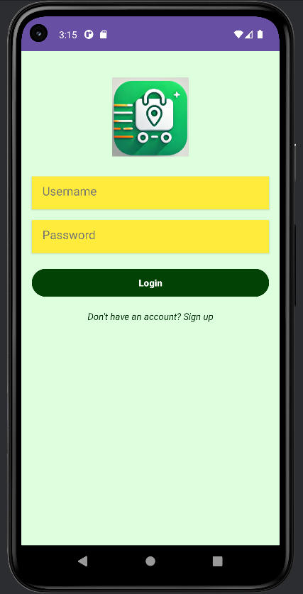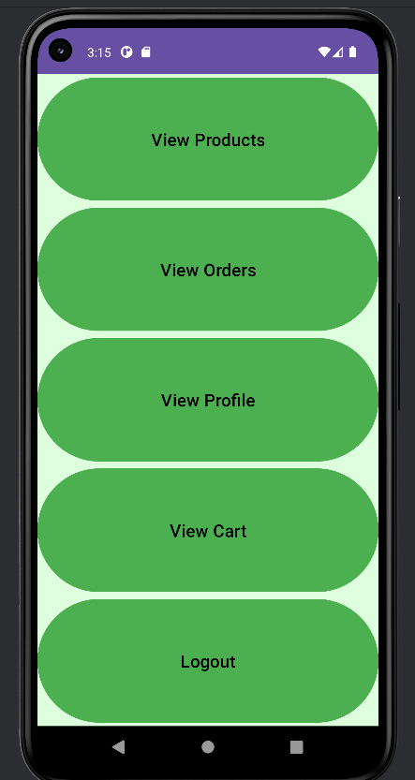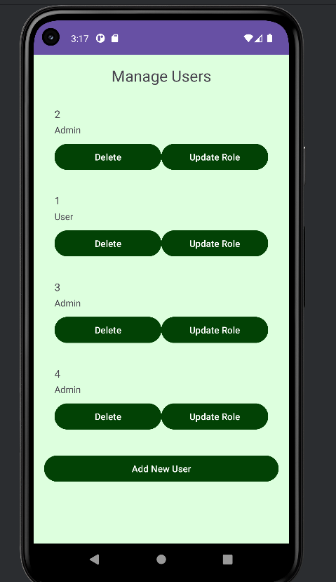

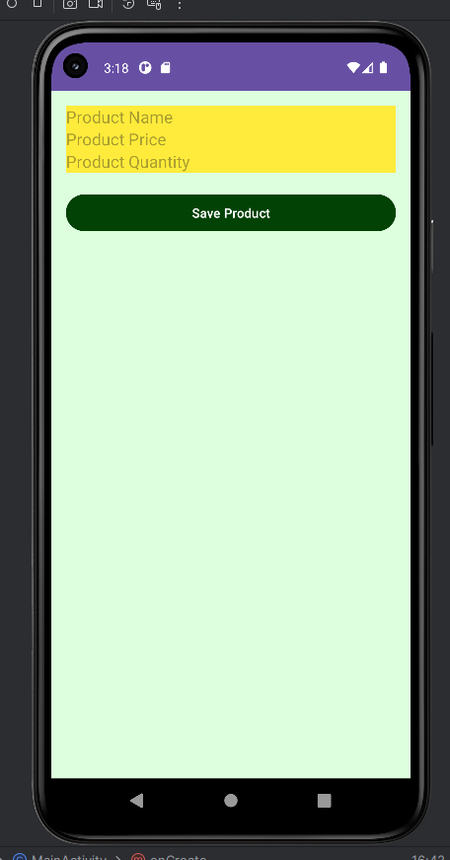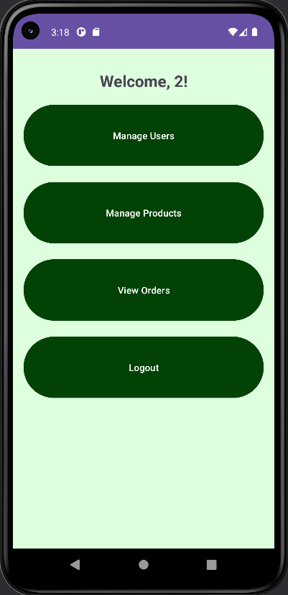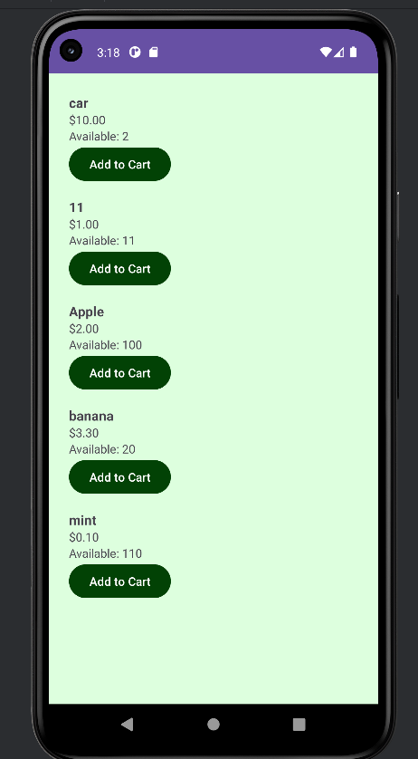

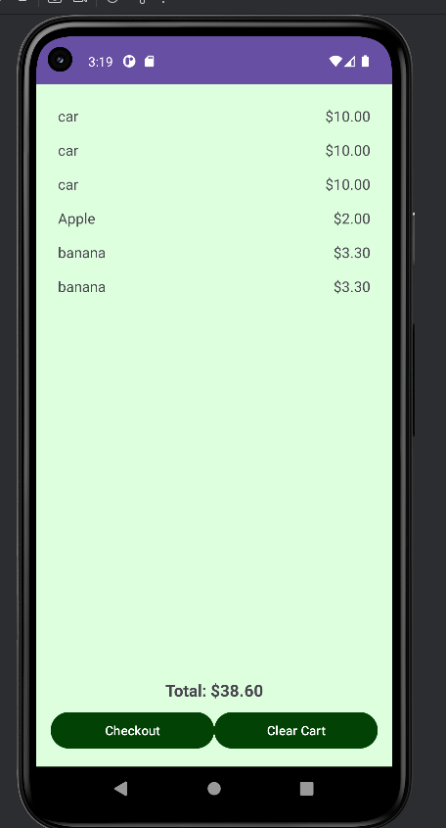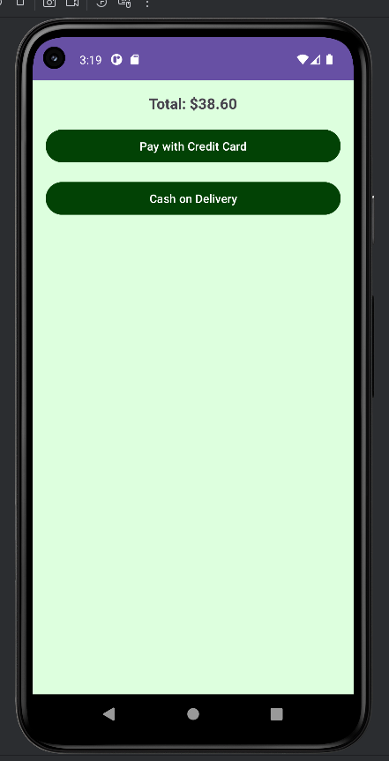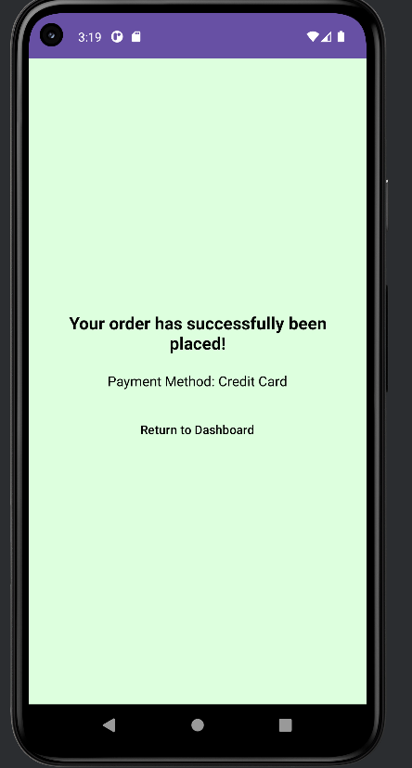

Implementation (Coding)
The code is lengthy and a bit complicated. We mainly focused on making every button work, and every important method we implemented it on a class of its own. For example, Login has a class called LoginActivity, Signup has a class called SignUpActivity, Admin dashboard is in a class called AdminDashboardActivity, and so on. Yet everything is in DBHelper class for the SQL part.

Overall Coding Structure Breakdown
1. Packages & Class Organization
The app is organized in the com.example.grocerydeliveryapp package and includes the following types of classes:

* Activities (UI Controllers)
Each screen has its own Activity:

LoginActivity, SignUpActivity, MainActivity: Authentication and entry points

AdminDashboardActivity, UserDashboardActivity: Dashboard screens based on role

ManageUsersActivity, ManageProductsActivity: Admin tools

ProductListActivity, CartActivity, OrderActivity, OrdersActivity: User interaction

EditProfileActivity, ProfileActivity: Profile management

PaymentMethodActivity, SuccessActivity: Checkout flow

MapsActivity: Map integration for future delivery tracking

* Data Models
These are plain Java objects (POJOs):

Product

Order

User

Feedback

Address

CartItem

Each has getters/setters and sometimes implements Parcelable or Serializable for passing between activities.

* Adapters
For populating lists in RecyclerViews:

ProductAdapter

OrdersAdapter

CartAdapter

UserAdapter

Each adapter binds data to UI components dynamically.

*Database
DBHelper: Central class that extends SQLiteOpenHelper for managing local SQLite DB. It handles:

CRUD operations for users, products, orders

User authentication and role management

Inserting initial admin user

* Utility/Singleton
CartManager: A singleton class managing the user's cart globally (add/remove, calculate total).

OnProductActionListener, OnCartActionListener, etc.: Interfaces for callbacks between components.

* Navigation & Flow
Authentication

LoginActivity or SignUpActivity → Redirects to dashboard based on role (admin/user)

Admin Flow

AdminDashboardActivity → ManageUsersActivity / ManageProductsActivity

Can edit/add products or manage user roles.

User Flow

UserDashboardActivity → ProductListActivity → OrderActivity or CartActivity

Cart → PaymentMethodActivity → SuccessActivity

Supportive Features

ProfileActivity → EditProfileActivity

MapsActivity (not yet fully implemented) for delivery location

OrdersActivity for order history

*Key Design Concepts
Role-Based Access Control via SharedPreferences

SQLite DB Layer encapsulated in DBHelper

RecyclerView + Adapters for scalable lists

Intent + Parcelable for passing data between screens

Error Handling & Validation through Toasts and AlertDialogs

SharedPreferences for storing session/user info

Important Code Snippet
Most Important Part (Admin and Cart Logic)

1. Product Add/Update Logic (Admin)
if (productId == -1) {
// Add a new product
result = dbHelper.addOrUpdateProduct(product);
showToast(result, "added");
} else {
// Update existing product
result = dbHelper.addOrUpdateProduct(product);
showToast(result, "updated");
}
2. Cart Checkout Logic

btnCheckout.setOnClickListener(v -> {
List<Product> cartItems = CartManager.getInstance().getCartItems();
if (cartItems.isEmpty()) {
Toast.makeText(this, "Cannot checkout, your cart is empty!", Toast.LENGTH_SHORT).show();
return;
}
double totalAmount = CartManager.getInstance().calculateTotal();
Intent intent = new Intent(this, PaymentMethodActivity.class);
intent.putExtra("totalAmount", totalAmount);
startActivity(intent);
});
3. Database Initialization

db.execSQL("CREATE TABLE products (...)");
db.execSQL("CREATE TABLE orders (...)");
insertAdminUser(db);

Testing
Testing was implemented after every addition to the application, after buttons, pages, popups, and all. All of the testing was done manually. As for the results, everything works!

Challenges and Solutions
The most difficult thing in the project was the database link, thanks to sources that will be named in references, it was tolerable, but still very difficult

Future Work
We hope in the future that we will add a delivery system, with the user being able to track his orders, and get estimated delivery time.
References
- Dr. Tanweer’s Moblie Application Development slides/courses
- https://www.youtube.com/watch?v=fis26HvvDII&t=1s
- https://stackoverflow.com/questions/tagged/android-studio

