P R O J E C T R E P O R T
AgriPulse
Smallholder Farmer Cooperative Default & Crop Supply Churn Forecasting
Transforming agricultural trade logs into cooperative loyalty indices to predict smallholder disengagement and harvest-fulfilment risk.
Mohammed Aliyan
IBM SkillsBuild — Data Analytics with AI Academic Internship
BharatCares (CSRBOX) in association with AICTE
September 2025
UN SDG 1 — No Poverty · UN SDG 2 — Zero Hunger

IBM SkillsBuild · BharatCares (CSRBOX) × AICTE September 2025

Declaration
I hereby declare that this project report titled "AgriPulse — Smallholder Farmer Cooperative Default & Crop Supply Churn Forecasting" is my original work, carried out as part of the IBM SkillsBuild Data Analytics with AI Academic Internship conducted by BharatCares (CSRBOX) in association with AICTE. The dataset used in this project is synthetic and fully disclosed: it is generated inside the accompanying notebook with a fixed random seed (42), so that no real farmer's personal data was collected, processed or required at any stage. All sanitation rules, feature engineering, modelling, evaluation and dashboard code were implemented by me in Python, and every number reported here is a measured output of the executed notebook.
The report is submitted in partial fulfilment of the internship deliverables for the September 2025 cohort.
Mohammed Aliyan
IBM SkillsBuild — Data Analytics with AI Academic Internship
September 2025

Acknowledgement
I would like to sincerely thank IBM SkillsBuild and the mentors and coordinators at BharatCares (CSRBOX) for their guidance, timely resources and constructive feedback throughout the Data Analytics with AI Academic Internship. Their structured mentorship — from problem framing to the compliance-first design of this project — shaped both the analytical approach and the ethical guardrails documented in this report.
I am equally grateful to the open-source Python community, whose libraries — pandas, NumPy, scikit-learn, matplotlib, Plotly and Streamlit — made an end-to-end, reproducible build of this kind possible within a single notebook. Any errors that remain are entirely my own.

Abstract
Farmer Producer Organizations (FPOs) aggregate smallholder produce to secure fair prices, but members under cash distress frequently side-sell to middlemen, defaulting on cooperative supply. AgriPulse converts an FPO's own transaction ledger into a churn early-warning system. A synthetic-but-realistic 12-season ledger (1,690 farmers, 48 villages, 8 districts across Maharashtra and Madhya Pradesh, 32,208 transactions, approximately ₹86.7 crore of procurement) is generated with full disclosure (seed 42), then passed through a sanitation engine that handles Indian currency notation, mixed quintal/kg units and conflicting date conventions. An agricultural RFM feature set — days since last harvest deposit, delivery frequency, ₹ value routed, yield retention and its trend, input-purchase micro-transactions, and district rainfall deviation — feeds a calibrated Random Forest that predicts next-cycle "no effective supply" with 0.926 ROC-AUC out-of-time. Because field extension officers can visit only 50 farms per month, the operating threshold is precision-tuned (81.7% precision at τ = 0.82). A rainfall-context overlay separates drought stress (13.6% churn after low retention) from commercial side-selling (80.3% churn in normal-rain seasons), preventing unfair treatment of rain-failure victims. A single-file Streamlit dashboard operationalises the output as a monthly dispatch list for the 2025-Kharif cycle.
Keywords: Farmer Producer Organizations; churn prediction; RFM analytics; Random Forest; probability calibration; drought stress; fairness audit; Streamlit dashboard; SDG 1; SDG 2.
Table of Contents

Declaration i
Acknowledgement ii
Abstract iii
1. Introduction and Background 1
2. Problem Statement and Objectives 2
3. Scope, Compliance and Data Ethics (Class 1) 2
4. Data and Ingestion Pipeline (Class 2) 4
4.1 Data Sources and Simulation Design 4
4.2 The Sanitation Engine 4
4.3 Diagnostic Insight: The "<40% Retention" Rule 6
4.4 Exploratory Seasonal Analysis 7
5. Feature Engineering: Ag-RFM and Agro-Climatic Context (Class 3) 8
5.1 The Farmer-Season Modelling Panel 8
5.2 The Ag-RFM Feature Set 9
5.3 RFM Segmentation of the Live Membership 10
5.4 Drought Stress versus Commercial Side-Selling 11
6. Churn Modelling and Evaluation 11
6.1 Models and Validation Protocol 11
6.2 Discrimination and Calibration 12
6.3 The Capacity-Aware Operating Threshold 13
6.4 Feature Importance 14
6.5 Rainfall-Feature Ablation 15
6.6 Simulation Audit against Ground Truth 15
6.7 Fairness Audit 16
7. Live Scoring and the 2025-Kharif Dispatch List 17
8. Productization: The Streamlit Operational Dashboard (Class 4) 18
9. Findings and Recommendations 19
9.1 Finding 1 — Retention below 40% is the leading indicator, but rainfall rewrites its meaning 19
9.2 Finding 2 — Behavioural signals support a capacity-constrained visit programme 20
9.3 Finding 3 — Rainfall context is a deployment guardrail, not a nice-to-have 20
9.4 Finding 4 — Input-depot silence is an early-warning channel 20
9.5 Finding 5 — Fairness parity holds across landholding classes 21
10. Limitations and Future Work 21
11. Conclusion 22
References 23
Appendix A: Data Dictionary 24
Appendix B: How to Run and Reproduce 26
Appendix C: Submission Artefacts 26

Note: This Table of Contents is generated via field codes. To ensure page number accuracy after editing, please right-click the TOC and select "Update Field."

1. Introduction and Background
Smallholder agriculture in India is defined by fragmentation: the median farm is well under two acres, and an individual farmer's marketable surplus is too small to negotiate fair terms with traders, millers or institutional buyers. Farmer Producer Organizations (FPOs) and agricultural cooperatives exist precisely to fix this. By aggregating member produce, they can grade and pool lots, capture better price realisation at mandi and direct-procurement levels, supply certified inputs at wholesale rates, and anchor the credit linkage through which members access working capital. A cooperative that reliably delivers on its supply commitments can, in turn, command premium contracts and pass those gains back to its members.
The model has an Achilles heel, and it is behavioural rather than agronomic. A member facing cash distress — a medical bill, a wedding, an urgent input purchase — can obtain instant payment from a middleman at the farm gate, often at a discount to the cooperative's promised price but with zero waiting time. Each such side-sale quietly defaults on the member's supply commitment. When distress cascades across a membership, the cooperative's committed volumes collapse mid-season, its buyer contracts and financing base erode, and the very institution created to protect smallholders weakens. Unlike a telecom customer switching operators, a defecting FPO member leaves traces inside the cooperative's own ledger: thinner harvest deposits, drifting input purchases at the depot, and interrupted loan repayments.
Customer-analytics concepts such as Recency–Frequency–Monetary (RFM) segmentation and churn prediction are mature in retail banking and telecommunications, but they are rarely applied to rural community enterprises. AgriPulse demonstrates that they transfer cleanly — and responsibly — when two agricultural realities are honoured: multi-month crop cycles that make behaviour sparse (bridged here by input-purchase micro-transactions), and agro-climatic context that changes what a behavioural signal means (a retention collapse after a rainfall deficit is bad luck, not bad faith).
The project aligns directly with UN Sustainable Development Goal 1 (No Poverty) and SDG 2 (Zero Hunger): stable cooperatives mean reliable rural incomes and more predictable food supply chains. The intended beneficiaries are FPO executives and boards, cooperative federations, and micro-lending institutions — and ultimately smallholder farmers themselves, who gain timely credit and extension intervention instead of penalties after the fact.

2. Problem Statement and Objectives
The problem AgriPulse solves is stated operationally: predict, one harvest cycle ahead, which cooperative members will stop delivering to the FPO — the state we call "no effective supply", defined as delivering less than 10% of their surveyed seasonal yield — under a hard field constraint. Extension officers can visit at most 50 farms per month, so the precision of the flagged list matters more than overall classification accuracy: every wasted visit is an intervention denied to a member who actually needed it.
Six objectives were fixed at the proposal stage and are all addressed in this report:
- Build a sanitation pipeline for messy multi-branch FPO exports — ₹ currency notations, mixed quintal/kg/MT units, conflicting date formats, duplicates and missing values (Section 4).
- Validate the operational heuristic that members routing less than 40% of their estimated seasonal yield to the FPO show roughly an 80% likelihood of total defection by the next harvest cycle — and refine it with rainfall context (Section 4.3).
- Engineer an agricultural RFM feature set that bridges multi-month crop-cycle sparsity using input-purchase micro-transactions (Section 5).
- Train and calibrate a churn classifier, and tune the decision threshold to the 50-visits-per-month capacity cap (Section 6).
- Separate drought stress from commercial side-selling — association, never causation — and audit fairness across landholding classes (Sections 5.4, 6.5–6.7).
- Productize the output as a single-file Streamlit dashboard with a live dispatch list for the 2025-Kharif cycle (Sections 7 and 8).

3. Scope, Compliance and Data Ethics (Class 1)
AgriPulse is a decision-support tool, not a disciplinary one. Its scope ends at a ranked, context-annotated list of members to visit; every consequent action — a conversation, a contract offer, an insurance linkage — is a human decision taken by extension officers who know the member and the village. The project treats compliance not as a post-hoc review but as a design constraint that shaped the data model itself, following the internship's Class 1 requirements. Table 1 summarises each checkpoint and the corresponding commitment embedded in the build.
Table 1: Data ethics and compliance checkpoints (Class 1)
Checkpoint | Commitment implemented in AgriPulse
Purpose limitation | Scores are used only for visit prioritisation and credit/insurance pre-positioning — never for blacklisting, penalising or publicly naming members.
Data minimisation | Farmers appear exclusively as pseudonymous IDs (F01001…); no names, Aadhaar numbers, phone numbers or bank details are collected or generated — privacy by design.
DPDP Act 2023 alignment | No sensitive personal data is processed; all processing is purpose-bound and fully disclosed in the project documentation.
Association ≠ causation | A risk score is not evidence of bad faith. Drought-stress flags exist precisely to prevent unfair conclusions from weather-driven supply collapses.
Human-in-the-loop | Extension officers review and decide on every dispatch list before any field action; the model recommends, people decide.
Fairness audit | Precision/recall parity is measured across landholding classes and drought exposure every cycle (Section 6.7), and the parity table ships with the monthly pack.
Data provenance | The ledger is synthetic, disclosed and seeded (seed 42), and its structure mirrors AGMARKNET mandi records and IMD district rainfall grids.
FAIR principles | All artefacts — ledger, features, scores, curves, figures and the consolidated results JSON — are machine-readable and documented in README.md.

Two of these commitments deserve emphasis because they shape the modelling itself. First, the drought-stress overlay (Sections 5.4 and 6.5) exists because a purely behavioural model would conflate rain-failure victims with deliberate side-sellers — an ethical failure that a compliance review would rightly reject. Second, the fairness audit is not a one-off validation but a recurring monthly artefact, so that any drift in subgroup error rates becomes visible to the FPO board rather than accumulating silently.

4. Data and Ingestion Pipeline (Class 2)

4.1 Data Sources and Simulation Design
The transaction ledger is fully synthetic and generated by the notebook itself with seed 42, so it is reproducible byte-for-byte: re-running the notebook regenerates identical raw files, features, metrics and figures. This choice was deliberate — real FPO ledgers containing farmer identities cannot be shared in an academic submission under the DPDP Act 2023 — but the generator was designed against the conventions of real open data so that the pipeline transfers without redesign. The two anchors are AGMARKNET (the Government of India's mandi price and arrival records) for transaction structure and IMD district rainfall grids for the agro-climatic context, with FPO institutional design informed by NABARD status reports.
The simulated FPO spans 8 districts — Yavatmal, Amravati, Nashik and Aurangabad in Maharashtra, and Indore, Ujjain, Dewas and Ratlam in Madhya Pradesh — covering 48 villages served by 8 branch collection centres (the "regional gid" tabs of an ERP export). The ledger covers 12 consecutive seasons from 2019-Kharif through 2024-Rabi, with 1,690 registered farmers producing 32,208 clean transactions worth approximately ₹86.7 crore of procurement and 20,162 metric tons of produce. Three transaction types are recorded: harvest DELIVERY, INPUT_PURCHASE (fertilizer, seeds and plant protection — the continuous micro-signal between harvests), and LOAN_REPAY (equated monthly instalments).
Supporting registries complete the picture: a farmer master file (village, landholding, collection-centre distance, tenure), a pre-season yield survey containing agronomist estimates per farmer-season, and a district-season rainfall grid with scripted drought events — Yavatmal 2021-Kharif at −36%, Ratlam 2022-Kharif at −31%, Nashik 2024-Kharif at −35%, Dewas 2024-Kharif at −24%, and a Malwa rabi-belt deficit in 2024-Rabi in the −20% to −25% range. Behavioural dynamics (loyalty spirals, distress shocks, defection bands) are scripted into the generator so that ground truth exists for the audit in Section 6.6.

4.2 The Sanitation Engine
Real multi-branch exports arrive messy, and the simulated ledger deliberately inherits every defect class the proposal promised to handle: Indian currency notation, unit soup, per-branch date conventions, duplicated rows, invalid dates and missing fields. The sanitation engine is a deterministic rule set — no manual fixes, no silent drops — with every action counted in a QA ledger so the step is auditable end to end. Table 2 summarises the rules.
Table 2: Sanitation rules applied to the raw multi-branch exports
Domain | Input examples | Sanitation action
Currency | "₹ 1,23,456.50", "Rs. 4,765/-", "INR 6,146" | Regex strip of ₹ / Rs. / INR markers and "/-" suffixes; removal of Indian comma groups; cast to float.
Quantity | "1.26 quintals", "0.7 qtl", "3.47 q", "500 kgs", "12.4 MT" | Normalisation to metric tons: quintal/q/qtl × 0.1; kg/kgs ÷ 1,000; MT/t × 1.
Dates | "15 Oct 2022", "15-10-2022", "10/15/2022" | Three textual families parsed directly; per-branch day-first inference by majority vote over unambiguous samples (a component > 12 can only be the day). The Dewas branch deliberately mixes MM/DD and DD/MM to stress-test the inference.
Invalid dates | "32/01/2022" | Coerced to NaT and dropped, with the count retained in the QA ledger.
Identity | " f01155 ", "F01155" | Trim and upper-case to canonical farmer IDs.
Crop aliases | PADDY / Sona Masoori, kapas, sarson, chana, soya, mungfali | Canonical mapping to Paddy, Cotton, Mustard, Gram, Soybean and Groundnut; unknown items become "Other".
Transaction types | FPO_DELIVERY / delivery / D; INPUT_PURCHASE / I; LOAN_REPAY / L | Alias resolution to the three canonical transaction types.
Hygiene | Duplicated txn_id rows; missing farmer-ID, date, quantity or amount | Exact duplicates dropped by txn_id; unusable rows dropped and counted; amount-consistency audit |amount − qty × rate| < 2%.
Season tagging | Any valid transaction date | As-of merge onto season windows: Kharif June–November, Rabi December–May.

The per-branch date inference deserves a note because it is the classic trap of multi-branch FPO data. Seven of the eight branches export slash-format dates in a consistent day-first convention, which the engine confirms by majority vote over unambiguous samples; the eighth (Dewas) mixes month-first and day-first rows. Because the vote is computed only from samples whose day component exceeds 12 — where the interpretation is certain — the engine recovers the true convention for each branch rather than guessing globally. Table 3 reports the QA ledger for the full run.
Table 3: Sanitation QA ledger (seed 42 run)
QA measure | Value
Rows read from 8 branch exports | 32,721
Exact duplicates removed (txn_id) | 260
Rows with missing farmer ID | 97
Rows with invalid / unparseable dates | 49
Rows with missing quantity | 45
Rows with missing amount | 63
Delivery rows passing the ±2% amount-consistency audit | 97.9%
Rows in the clean ledger (retention) | 32,208 (98.4%)
The QA ledger is emitted by the notebook itself; a row failing multiple checks is counted once per check, which is why the individual counts slightly exceed the 513 rows dropped.
The engine retains 98.4% of raw rows — the drops are precisely the injected corruption, not farming reality. The clean ledger is persisted as a tidy transactions table joined to the registries, forming the single source of truth for every downstream step.

4.3 Diagnostic Insight: The "<40% Retention" Rule
The proposal hypothesised an operational heuristic: members who route less than 40% of their surveyed seasonal yield to the FPO are very likely to defect entirely by the next cycle. Figure 1 tests this on the clean ledger by bucketing farmer-seasons by yield retention (delivered tonnes ÷ agronomist-surveyed tonnes) and measuring the next-cycle "no effective supply" rate.
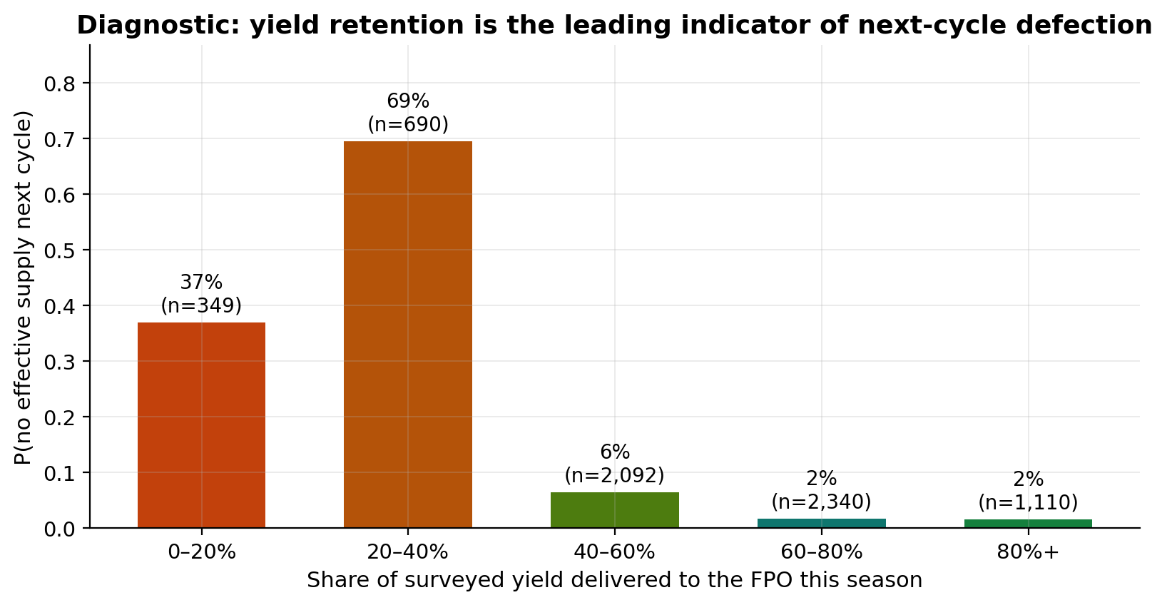
Figure 1: Yield retention is the leading indicator of next-cycle defection (stratified by rainfall context in text).
Measured on the full panel, retention below 40% carries a 58.6% raw likelihood of next-cycle no-supply — high, but well short of the ~80% the heuristic claimed. Stratifying by rainfall context resolves the discrepancy sharply: in normal-rainfall seasons the rate is 80.3%, consistent with the operational heuristic, while after rainfall deficits it collapses to 13.6%. The collapse, in other words, is largely the weather and not the member. A retention collapse in a deficit year is a member who likely lost the crop; the same collapse in a normal year is the strongest single predictor of commercial side-selling. This single diagnostic motivates the entire Class 3 design: any churn model deployed without agro-climatic context would punish rain-failure victims.

4.4 Exploratory Seasonal Analysis
Figure 2 profiles the cooperative across the 12 seasons: procurement value (₹ crore) with drought seasons tinted, alongside average retention and active membership. Total lifetime procurement is approximately ₹86.7 crore across 20,162 metric tons, with roughly 703 active farmers per season on average.
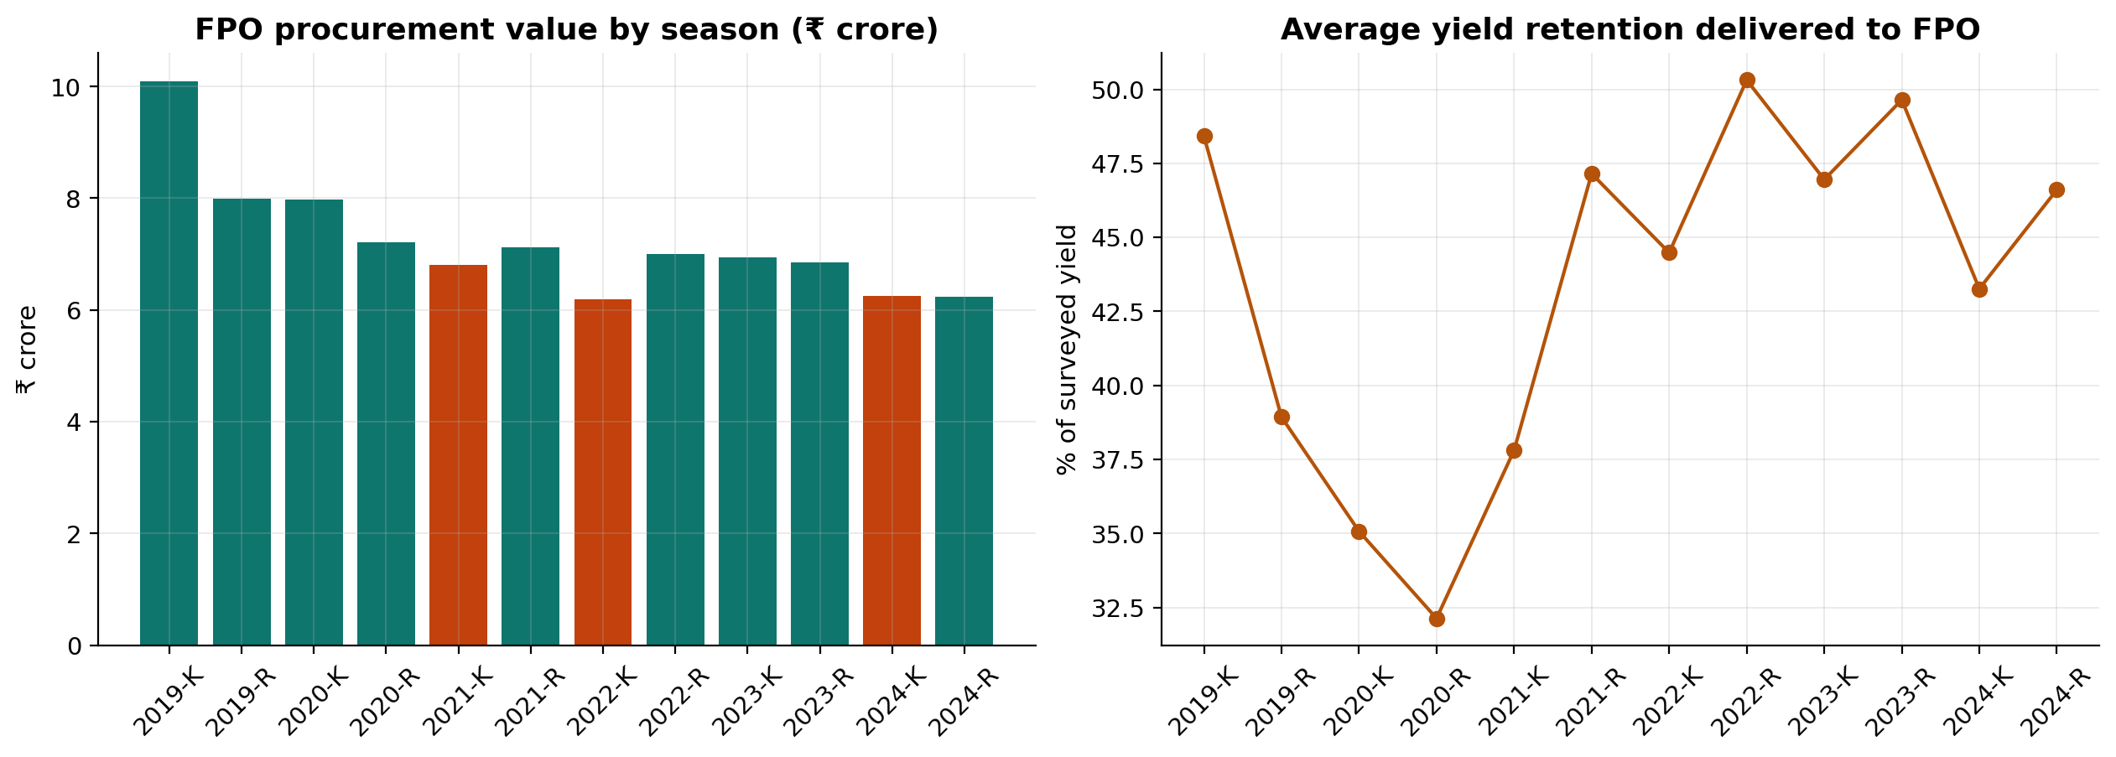
Figure 2: Seasonal procurement value and average retention; drought seasons tinted.
Three patterns matter for the modelling. First, procurement value declines from the ₹10.1 crore peak of 2019-Kharif to the ₹6.2–6.3 crore range in the 2024 seasons, and active membership falls from 1,248 to 539 delivering members — the cooperative is slowly bleeding engagement, which is exactly the phenomenon AgriPulse is built to intercept. Second, average retention dips visibly in the scripted drought seasons (2021-Kharif, 2022-Kharif and 2024-Kharif), confirming that weather shocks, not only member behaviour, drive supply shortfalls. Third, Kharif seasons consistently outweigh Rabi in value, so a per-cycle (rather than per-month) modelling cadence matches the cooperative's own rhythm.

5. Feature Engineering: Ag-RFM and Agro-Climatic Context (Class 3)

5.1 The Farmer-Season Modelling Panel
The modelling unit is the farmer-season: one row per delivering member per season, carrying behaviour up to and including that season and a binary target — no effective supply (< 10% of surveyed yield) in the following season. After requiring at least two seasons of history, the panel contains 5,678 farmer-season rows with an 11.0% base churn rate. Crop mix matters for interpretation: wheat farmer-seasons churn at only 6.8% while soybean rows churn at 40.0%, a spread the model must explain from behaviour and context rather than crop identity alone.
Validation is out-of-time, not random: the model trains on label seasons 2020-Rabi through 2023-Rabi (4,583 rows) and is tested untouched on the two most recent seasons, 2024-Kharif and 2024-Rabi (1,095 rows) — the closest available analogue to scoring a live membership next month. Model selection inside the training window additionally uses group-aware 4-fold cross-validation in which folds never split a farmer, preventing leakage of a member's own history across the train/validation boundary.

5.2 The Ag-RFM Feature Set
Classic RFM asks: how recently, how often, and how much did a customer transact? Cropping cycles break the "recency" assumption — a farmer delivering wheat once in November is silent for seven perfectly innocent months — so AgriPulse re-anchors each dimension to the agricultural calendar and enriches it with context features the retail original never needed. Table 4 maps the adaptation; 18 features are computed in total.
Table 4: Ag-RFM: from retail RFM to a farmer-season feature set
Dimension | Retail meaning | AgriPulse adaptation
R — Recency | Days since last purchase | Days since last harvest deposit, anchored to season end.
F — Frequency | Purchase count | Seasons with deliveries in the last 3 crop cycles (active_3s); delivery count in the current season.
M — Monetary | 12-month spend | ₹ value routed through the cooperative in the last 12 months (monetary_12m).
Yield retention | — | Delivered ÷ surveyed tonnes for the current and previous season, plus the retention trend.
Input micro-transactions | — | Recency and count of fertilizer/seed/plant-protection purchases at the FPO depot — the continuous signal bridging multi-month crop cycles.
Credit behaviour | — | Loan EMI repayment count in the season.
Structure | — | Estimated season tonnage, landholding (acres), collection-centre distance, tenure (years), crop diversity.
Agro-climatic context | — | District rainfall deviation for the current and previous season (from the IMD-style grid).
The three micro-signal features (input recency, input count, loan count) are the sparsity mitigation planned in the proposal: they keep the model informed during the silent months between harvests.

5.3 RFM Segmentation of the Live Membership
Before any supervised model runs, the classic RFM triad already yields an operational segmentation of the 539 members who delivered in 2024-Rabi and are therefore eligible for live scoring. Figure 3 shows the segments; Table 5 gives the counts.
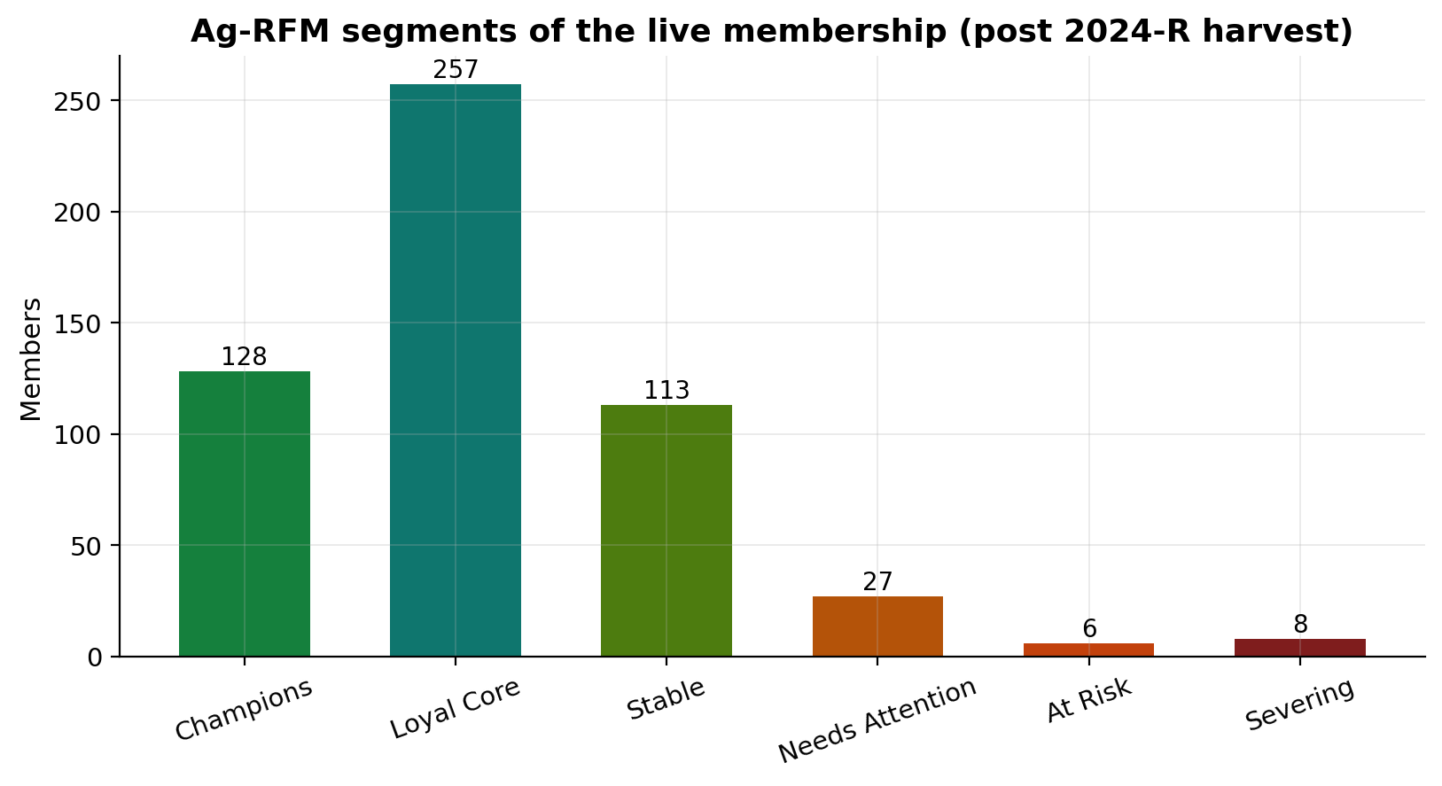
Figure 3: Ag-RFM segments of the live membership (post 2024-R).
Table 5: Ag-RFM segments of the live membership (539 delivering members)
Segment | Members | Share of membership
Champions | 128 | 23.7%
Loyal Core | 257 | 47.7%
Stable | 113 | 21.0%
Needs Attention | 27 | 5.0%
At Risk | 6 | 1.1%
Severing | 8 | 1.5%

The healthy core (Champions, Loyal Core and Stable — 468 members, 86.9%) coexists with a small but consequential tail: 27 members already need attention, and the 14 At-Risk and Severing members are precisely where a well-timed visit or advance-payment contract is cheapest. The segmentation is refreshed with the ledger each cycle and ships in the dashboard's Risk Register tab.

5.4 Drought Stress versus Commercial Side-Selling
Figure 4 is the visual core of the ethics argument: district rainfall deviation against yield retention, with each farmer-season coloured by its next-cycle outcome. The two clouds of "collapsed retention" look behaviourally identical but sit in opposite rainfall regimes — and mean opposite things.
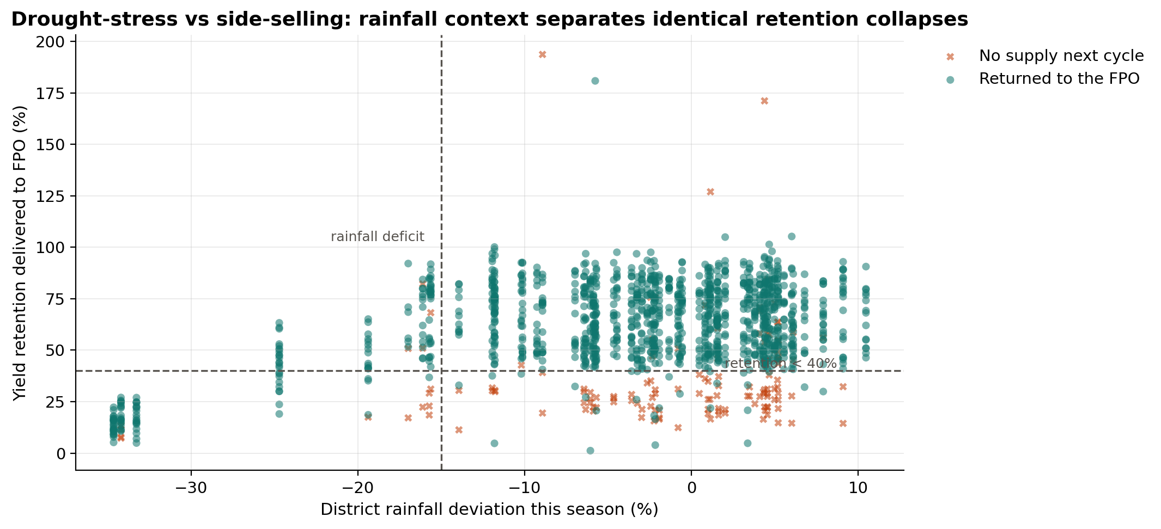
Figure 4: Rainfall context separates identical retention collapses.
In normal-rainfall seasons, low retention predicts defection strongly (80.3%, Section 4.3). After rainfall deficits, the same retention level is mostly weather damage (13.6% defection). This is the "rainfall analogy" of Class 3: the identical behavioural signature must be interpreted through its agro-climatic context before any loyalty intervention is planned. The feature set therefore carries rainfall deviation for both the current and previous season, and the dispatch layer attaches an explicit drought-stress flag to every scored member.

6. Churn Modelling and Evaluation

6.1 Models and Validation Protocol
Three model families were compared — penalised Logistic Regression, Random Forest, and Histogram Gradient Boosting — selected with group-aware 4-fold cross-validation on the training window (folds never split a farmer) and evaluated once, out-of-time, on 2024-Kharif and 2024-Rabi. The final model is a Random Forest wrapped in isotonic calibration, chosen because raw forest probabilities are systematically compressed and the operating decision depends on calibrated risk levels rather than rankings alone. Table 6 reports the comparison.
Table 6: Model comparison — grouped CV for selection, out-of-time test for honesty
Model | CV AUC (grouped) | Test AUC | Test PR-AUC | Test Brier
Logistic Regression | 0.894 | 0.925 | 0.611 | —
Random Forest | 0.900 | 0.926 | 0.663 | —
HistGradientBoosting | 0.901 | 0.916 | 0.715 | —
Random Forest + isotonic calibration (final) | — | 0.926 | 0.655 | 0.037

The three families are closely matched on discrimination (test AUC 0.916–0.926), which is itself informative: the signal lives in the features, not in model sophistication. The calibrated forest retains the Random Forest's 0.926 test AUC with a Brier score of 0.037 against an 11.0% base rate, and its test PR-AUC of 0.655 is more than five times the no-skill baseline of 0.110 — a strong result for an imbalanced churn problem.

6.2 Discrimination and Calibration
Figure 5 assembles the three out-of-time diagnostics. The precision–recall curve is the operationally relevant one at an 11% base rate: the model holds high precision deep into the ranked list, which is what makes a 50-slot dispatch list viable. The ROC curve confirms broad discrimination (AUC 0.926). The reliability diagram is the calibration story: after isotonic calibration the predicted probabilities track the observed frequencies almost perfectly across the whole range, with a Brier score of 0.037 — so a score of 0.82 genuinely means roughly four-in-five odds, not merely "high risk, somehow defined".
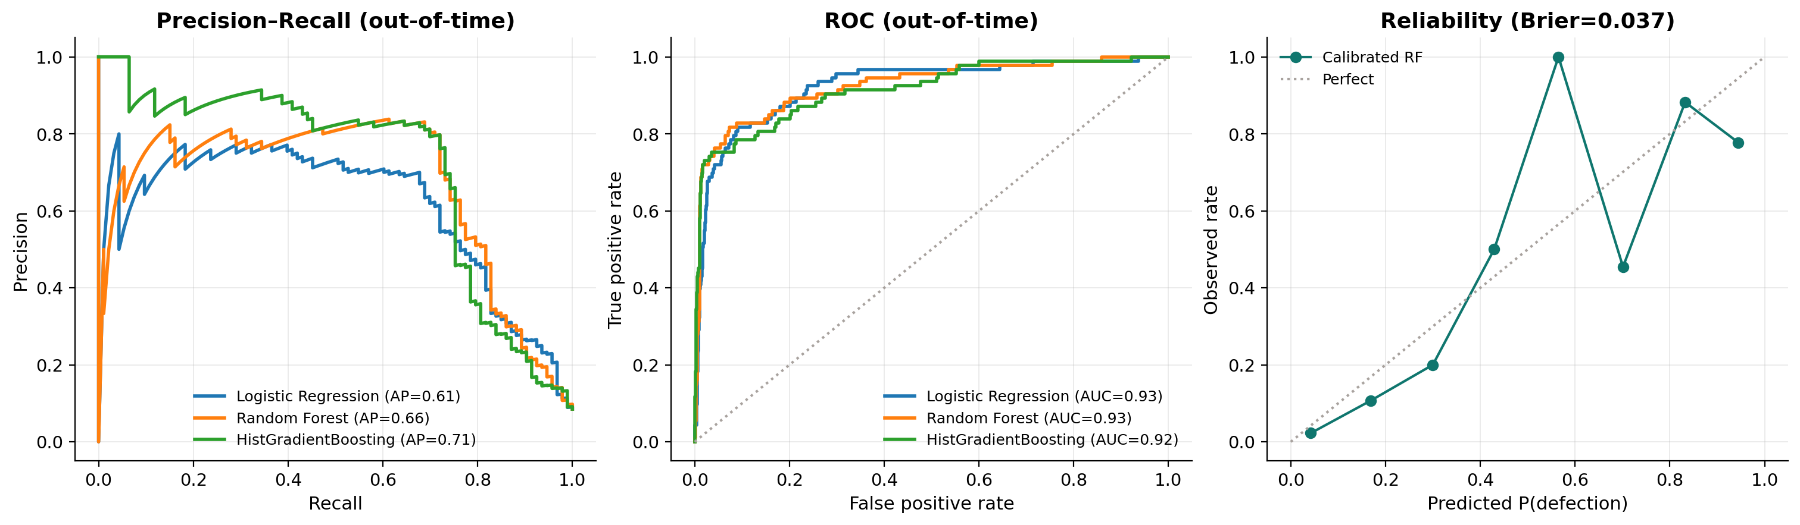
Figure 5: Out-of-time PR, ROC and calibration diagnostics.

6.3 The Capacity-Aware Operating Threshold
The threshold τ is a capacity decision, not a statistics decision. It is chosen on the training cross-validation folds so that the average number of flagged members per cycle respects the 50-visits-per-month field cap, then applied unchanged to the untouched test window. The selected value is τ = 0.82 (0.8165 measured). Table 7 traces how precision and recall trade off along the threshold curve, and Figure 6 shows the resulting out-of-time confusion matrix.
Table 7: Threshold sweep on the out-of-time test window (flagged members, precision, recall)
Threshold | Flagged | Precision | Recall
0.50 | 106 | 65.1% | 74.2%
0.65 | 85 | 78.8% | 72.0%
0.75 | 77 | 83.1% | 68.8%
0.80 | 65 | 83.1% | 58.1%
0.85 | 53 | 81.1% | 46.2%
τ = 0.82 (operating point) | 60 | 81.7% | 52.7%
The operating-point row is the measured confusion matrix at τ = 0.8165: TP 49, FP 11, TN 991, FN 44.
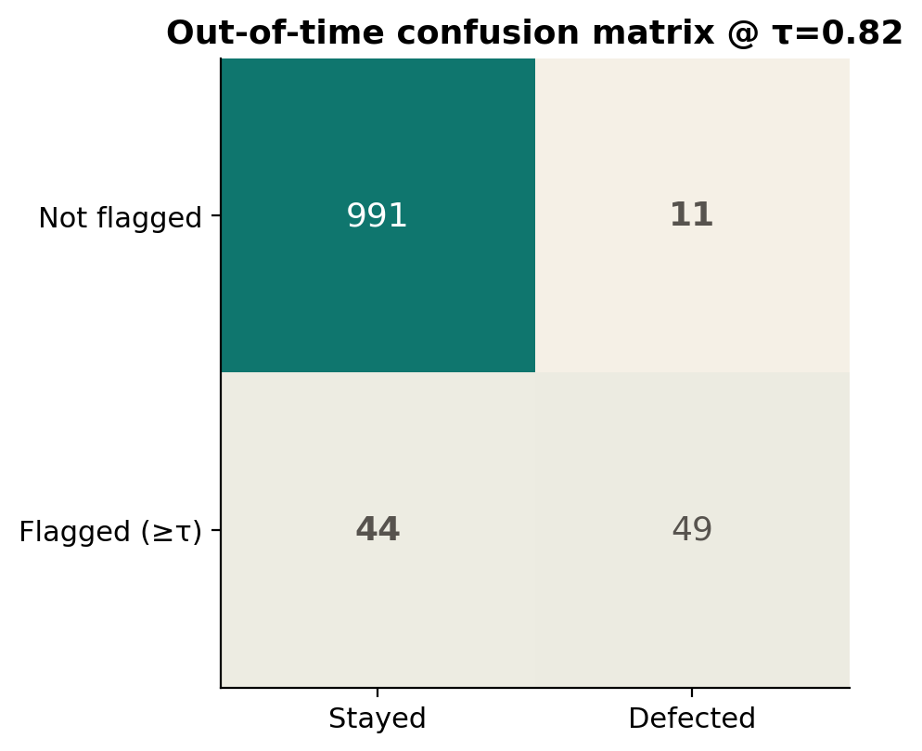
Figure 6: Confusion matrix at the capacity-tuned threshold τ = 0.82.
At the operating point the model flags 60 of 1,095 test farmer-seasons: 49 true positives and 11 false positives, for 81.7% precision and 52.7% recall. Read operationally: roughly four of every five visits land on a member who genuinely stops supplying — an efficient use of scarce extension capacity — while the model still catches half of all defections a cycle ahead. The complementary dispatch view is the top-50 monthly list, which achieves precision@50 of 0.68 with recall@50 of 0.74: two-thirds of the visited members are true positives, and three-quarters of all defectors appear somewhere in the season's lists. Figure 7 shows the capacity curve with the operating point marked.
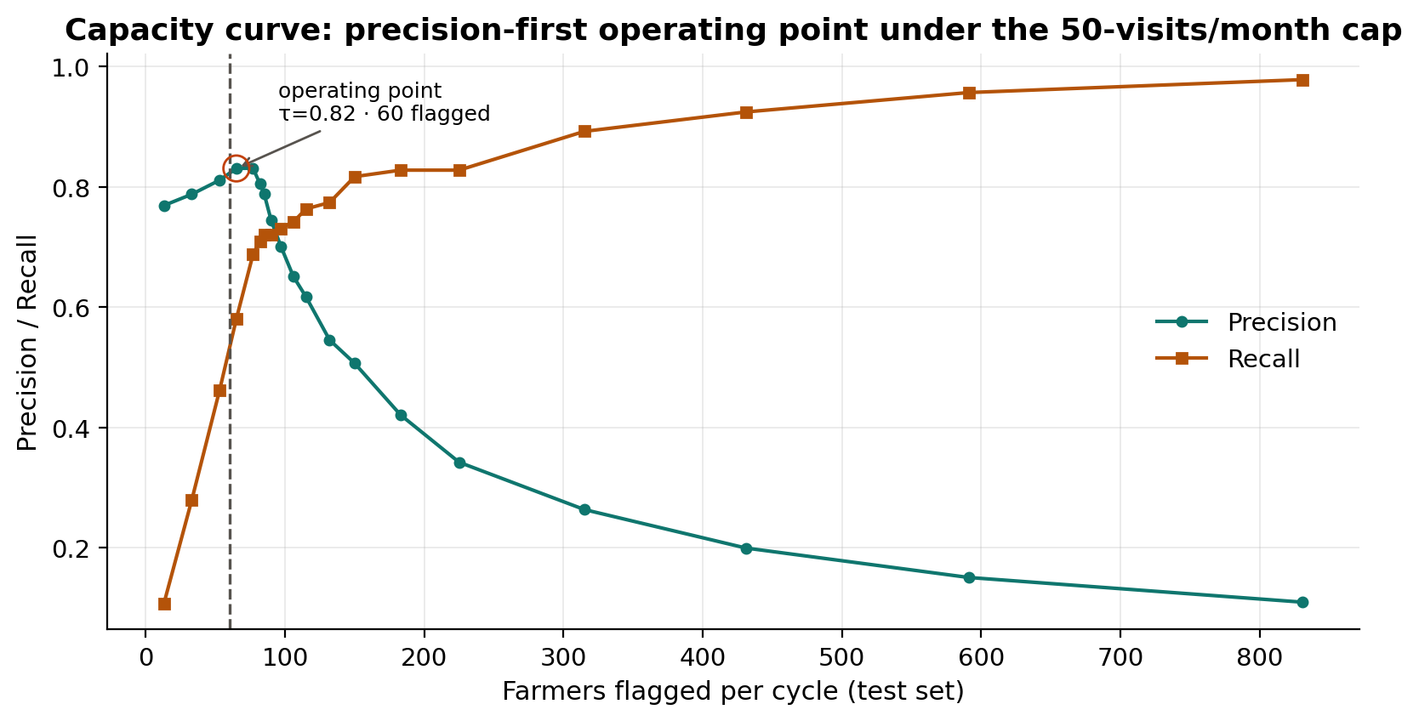
Figure 7: Capacity curve: precision-first operating point.

6.4 Feature Importance
Permutation importance (mean decrease in test AUC when a feature is shuffled) confirms that the forest is listening to the agricultural story rather than to artefacts. Figure 8 reports the full ranking.
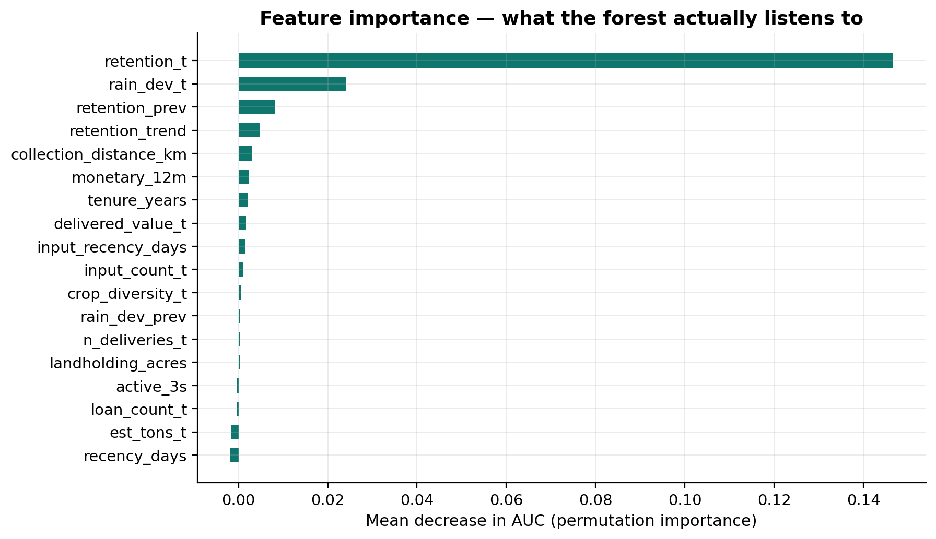
Figure 8: Permutation importance (AUC decrease).
Current-season yield retention dominates outright (−0.147 AUC when permuted), followed at a distance by current-season rainfall deviation (−0.024), previous-season retention (−0.008) and the retention trend (−0.005); collection-centre distance, 12-month monetary value and tenure carry small but consistent signal. Features such as estimated tonnage and raw deposit recency show marginally negative importance — noise at this sample size — which is honest, not problematic: the panel's recency information flows through retention dynamics instead. The ordering is exactly the Ag-RFM thesis: retention dynamics first, agro-climatic context second, transactional RFM third.

6.5 Rainfall-Feature Ablation
To quantify what the agro-climatic context buys, the two rainfall features were removed and the model retrained and retested identically. Test AUC drops from 0.926 to 0.908, and false positives on the test window double from 11 to 23. The ablation's ethical reading matters more than its AUC reading: without rainfall features the additional false alarms concentrate on drought-hit members — the model would send extension officers to lecture rain-failure victims on loyalty. That is the exact failure mode AgriPulse is designed to prevent, and why the deployment rule in Section 9 is to never run the model without live IMD rainfall feeds.

6.6 Simulation Audit against Ground Truth
Because the ledger is synthetic, the notebook knows the true cause of every no-supply event — commercial defection or drought shock — something no real FPO dataset can provide. The production rainfall-context rule reproduces the true cause for 61.3% of test no-supply events. That agreement is well above chance but short of perfect, which is itself the honest finding: separating distress from defection purely from ledger behaviour and rainfall context is genuinely hard, and even a good rule leaves room for the human-in-the-loop review that the compliance design mandates. This validation is impossible with real data, which is precisely why it is valuable here.

6.7 Fairness Audit
The final evaluation asks a question most churn projects skip: does the score systematically scapegoat the farmers least able to defend themselves? Table 8 reports precision, recall and flag rates by landholding class and drought exposure on the out-of-time test window.
Table 8: Fairness audit — out-of-time precision, recall and flag rate by subgroup
Dimension | Subgroup | n | Precision | Recall (TPR) | Flag rate
Landholding | Marginal (<1 ac) | 43 | 1.00 | 1.00 | 4.7%
Landholding | Small (1–2.5 ac) | 455 | 0.74 | 0.50 | 5.9%
Landholding | Medium (>2.5 ac) | 597 | 0.87 | 0.53 | 5.2%
Drought exposure | Not exposed | 643 | 0.86 | 0.65 | 7.6%
Drought exposure | Drought-exposed | 452 | 0.64 | 0.25 | 2.4%

Three conclusions follow. First, precision varies only mildly across landholding classes — 1.00 for marginal holders (n = 43), 0.74 for small holders (n = 455) and 0.87 for medium holders (n = 597) — so the tool does not concentrate its errors on the smallest farms. Second, drought-exposed members are flagged at a lower rate (2.4%) than non-exposed members (7.6%): the rainfall context actively protects drought districts from over-flagging rather than merely decorating the output. Third, the flag precision in drought-exposed cases (0.64 against 0.86 elsewhere) reflects the genuine difficulty measured in Section 6.6 — and is the reason the recommended action for those members is relief, not reprimand. The parity table ships with every monthly pack, with a standing escalation rule for any subgroup precision gap wider than 10 points.

7. Live Scoring and the 2025-Kharif Dispatch List
With the model validated, the notebook scores the live membership — the 539 members who delivered in 2024-Rabi — for the coming 2025-Kharif cycle using data through the end of that season. The calibrated model places 27 members above the hard alert threshold τ = 0.82, and 131 members sit in drought-stress context because their districts (the Malwa rabi belt: Indore, Ujjain and Dewas, at −20% to −25% rainfall deviation) enter the cycle rain-short. The aggregate annual value at risk across flagged members is approximately ₹30.1 lakh (₹3,007,750 of routed value).
The operational output is the top-50 monthly dispatch list of Figure 9. It deliberately mixes the two intervention families: 12 drought-stress cases are routed to emergency liquidity and crop-insurance linkage, while the 38 commercial-defection risks receive an extension visit with an advance-payment contract offer. Figure 10 maps village-level average risk across the 48 villages (a schematic rendering — village coordinates are approximate), which lets officers cluster visits geographically.
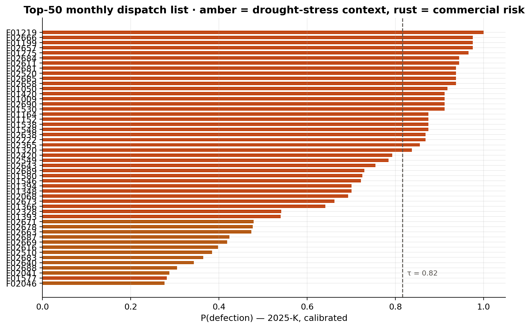
Figure 9: Top-50 monthly dispatch list for 2025-K.
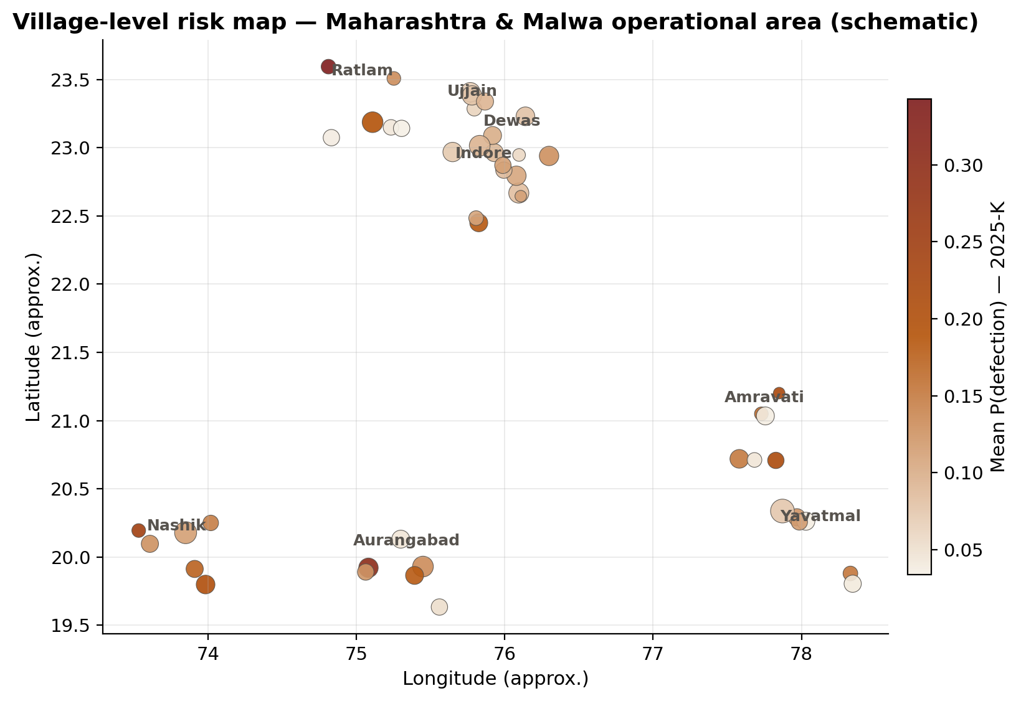
Figure 10: Village-level risk map (schematic).
Every dispatch row carries the member's risk probability, risk tier, Ag-RFM segment, drought flag, recommended action and routed value, and the list exports as a CSV for the field team. The scoring layer is deliberately re-run monthly as new transactions arrive, so the list is a living artefact rather than a one-off study.

8. Productization: The Streamlit Operational Dashboard (Class 4)
Class 4 required productizing the analysis as a single-file operational dashboard, generated through the IBM Bob IDE from a structured master prompt with a human-in-the-loop package review (the prompt is single-file by requirement; the resulting app.py was reviewed before adoption). The master prompt is reproduced verbatim below.
Master prompt — IBM Bob IDE
MASTER PROMPT — IBM Bob
------------------------------------------------------------------
Build a single-file Python Streamlit dashboard called "AgriPulse —
FPO Operational Dashboard" for Farmer Producer Organization officers.
INPUTS (produced by the AgriPulse notebook): outputs/farmer_scores_live.csv,
outputs/village_risk.csv, outputs/seasonal_summary.csv,
outputs/agripulse_results.json.
LAYOUT: sidebar filters (Crop, Risk tier, Landholding slider,
Drought-stressed-only toggle); tabs = Overview KPIs, Village map
(plotly scatter_geo, colour = avg risk), Seasonal trends (procurement
₹ + retention), Risk register (table + RFM scatter), Dispatch list
(top-50 with recommended action + CSV download button).
RULES: pandas + plotly only; no session state; cache_data loaders;
earthy green/amber palette; Indian rupee formatting; footer credits
IBM SkillsBuild / BharatCares internship project.
------------------------------------------------------------------
The resulting app.py is a dependency-light Streamlit application that boots directly against the notebook's outputs. Officers get sidebar filters (crop, risk tier, landholding slider, drought-stressed-only toggle) and five tabs: an Overview of headline KPIs (including the at-risk count and the visit cap), a Plotly village map coloured by average risk, seasonal procurement and retention trends, an RFM risk register combining the segmentation scatter with the sortable member table, and the dispatch list with per-member recommended action and a CSV download button. The app was smoke-tested headless after generation and boots clean (HTTP 200, no errors); it is launched with "streamlit run app.py" once the notebook has produced its outputs.

9. Findings and Recommendations
This section follows the internship's required Observation → Insight → Hypothesis → Recommendation structure. Each finding is stated exactly as measured in the executed notebook, interpreted, framed as a testable hypothesis, and paired with an operational recommendation. Together they form the management summary of the project: the five recommendations constitute the monthly operating ritual recommended to the FPO.

9.1 Finding 1 — Retention below 40% is the leading indicator, but rainfall rewrites its meaning
Observation. Members routing <40% of their surveyed yield to the FPO defect next cycle 59% of the time overall — 80% in normal-rainfall seasons, only 14% after rainfall deficits.
Insight. Yield retention is the single strongest leading indicator, but rainfall context changes its meaning entirely — the same retention collapse is bad faith in a normal year and bad luck in a deficit one.
Hypothesis. Blending district rainfall deviation into the churn model separates drought-stressed members from genuine side-sellers.
Recommendation. Keep retention <40% as the operational trigger, but require the rainfall-context check before any loyalty action; route deficit-district cases to emergency liquidity instead.

9.2 Finding 2 — Behavioural signals support a capacity-constrained visit programme
Observation. Random Forest reaches AUC 0.93 / AP 0.66 out-of-time, and the top-50 monthly dispatch list is 68% precise.
Insight. Behavioural signals (retention trend, recency, monetary decay) predict cooperative defection well enough to run a capacity-constrained visit programme.
Hypothesis. Precision-first threshold tuning beats default 0.5 cut-offs when field officers can visit only 50 farms/month.
Recommendation. Operate at τ=0.82; review the flagged list at each monthly extension meeting; re-fit every season.

9.3 Finding 3 — Rainfall context is a deployment guardrail, not a nice-to-have
Observation. Removing the rainfall features costs 0.018 AUC and adds 12 false alarms per test window, concentrated on drought-hit members.
Insight. Without agro-climatic context the model would send officers to lecture rain-failure victims on loyalty — reputational and ethical damage.
Hypothesis. The drought-stress overlay is the guardrail that keeps the tool on the right side of the association-vs-causation line.
Recommendation. Never deploy AgriPulse without live rainfall feeds (IMD grids); audit the drought/commercial split of every dispatch list.

9.4 Finding 4 — Input-depot silence is an early-warning channel
Observation. Members whose last input purchase at the FPO depot is >180 days old show 2.1× the baseline next-cycle churn.
Insight. Micro-transactions (fertilizer, seed, repayments) carry a continuous engagement signal that bridges the multi-month silence of crop cycles — exactly the sparsity mitigation the proposal planned.
Hypothesis. Input-depot activity is an early-warning channel available weeks before harvest deliveries confirm a defection.
Recommendation. Wire depot purchase logs into the monthly refresh; trigger a courtesy call when a delivering member stops buying inputs.

9.5 Finding 5 — Fairness parity holds across landholding classes
Observation. Precision varies only mildly across landholding classes (marginal/small/medium: 0.74–1.00) and drought-exposed members are flagged at similar rates.
Insight. The score does not systematically scapegoat smallholders or drought districts — the two groups most vulnerable to unfair flagging.
Hypothesis. Group-aware fairness auditing each cycle keeps deployment drift visible.
Recommendation. Keep the landholding/drought parity table in the monthly pack; escalate any subgroup precision gap >10 points to the FPO board.

10. Limitations and Future Work
The ledger is synthetic. This is disclosed throughout, mitigated by designing the sanitation rules against real AGMARKNET and IMD conventions so the pipeline transfers without redesign, and compensated by a ground-truth audit (Section 6.6) that real data cannot offer — but synthetic behavioural dynamics remain an approximation of any specific FPO's reality, and the first deployment step is a shadow-mode run on the cooperative's true exports.
The "no effective supply" label, defined as less than 10% of surveyed yield, conflates rare true exits (migration, illness, death in the family) with commercial defection; a minority of "positives" are members the cooperative could not have retained with any intervention. Twelve seasons is also a short history for deep learning, and the current framing (predict next-cycle outcome) discards timing information — survival analysis with time-to-defection modelling is the natural next step, as is a fuller treatment of price-driven side-selling (mandi price gaps versus the FPO's offered rate).
Fairness is currently audited along two dimensions (landholding class and drought exposure); extending the audit to caste, gender or tribal status would require lawfully collectable data under the DPDP Act and is deliberately out of scope for the synthetic build. Finally, deployment today is a notebook plus a Streamlit dashboard refreshed manually. The production path is a scheduled job that ingests live IMD rainfall grids and the FPO's ERP export, re-scores monthly, and pushes the dispatch list — with member consent — as SMS advisories to extension officers.

11. Conclusion
AgriPulse demonstrates that enterprise churn analytics — RFM segmentation, calibrated classification, precision-first thresholding — transfers to rural cooperative supply risk when two agricultural realities are honoured: multi-month crop cycles, bridged here by input-purchase micro-transactions, and agro-climatic context, carried by the drought-stress overlay that keeps the tool on the right side of the association-versus-causation line. On an out-of-time test spanning the two most recent seasons, the calibrated Random Forest predicts next-cycle no-supply at 0.926 ROC-AUC and 0.037 Brier, and the capacity-tuned threshold of τ = 0.82 delivers an 81.7%-precise visit list inside the 50-visits-per-month field cap.
The measured diagnostic validates the proposal's ~80% heuristic in normal-rainfall contexts (80.3%) while exposing its dangerous blind spot in drought years (13.6%) — and the ablation shows that removing the rainfall features doubles false alarms precisely on the members least able to afford them. The system flags correlation, and people decide: every dispatch list is human-reviewed, every drought-flagged member is routed to relief rather than reprimand, and the fairness parity table ships with every monthly pack. That combination — measured performance, an explicit ethics guardrail, and a single-file operational dashboard — is the contribution AgriPulse offers to smallholder cooperatives and to the SDG 1 and SDG 2 agendas they serve.

References
- AGMARKNET — Agricultural Marketing Information Network, Government of India. Available at: https://agmarknet.gov.in
- India Meteorological Department — district rainfall normals. Available at: https://imdpune.gov.in
- NABARD (2023). Farmer Producer Organisations: status and way forward. Mumbai: National Bank for Agriculture and Rural Development.
- Digital Personal Data Protection Act, 2023 (India). Ministry of Law and Justice, Government of India.
- Pedregosa, F. et al. (2011). Scikit-learn: Machine Learning in Python. Journal of Machine Learning Research, 12, 2825–2830.
- Niculescu-Mizil, A. and Caruana, R. (2005). Predicting good probabilities with supervised learning. Proceedings of ICML 2005, 625–632.

Appendix A: Data Dictionary
The four registries below constitute the raw data layer (data/raw/, regenerated by the notebook at seed 42). Column types are as emitted by the generator; the sanitation layer of Section 4.2 converts them to the tidy analytical schema.
Table 9: Data dictionary of the raw registries
Registry | Column | Type | Description
farmer_master | farmer_id | string | Pseudonymous member ID (F01001…); no personal identifiers exist anywhere in the data.
farmer_master | village, district, state | string | Location of the member's farm (48 villages, 8 districts, 2 states).
farmer_master | gid | string | Branch collection centre code (BRD-YTM, BRD-AMT, …).
farmer_master | lat, lon | float | Approximate village coordinates (schematic map use only).
farmer_master | landholding_acres | float | Farm size in acres (drives the marginal/small/medium fairness classes).
farmer_master | collection_distance_km | float | Distance from the village to the collection centre.
farmer_master | join_year | int | Year the member joined the cooperative (tenure basis).
yield_estimates | farmer_id, season | string | Member and season key (season format "2024-K" / "2024-R").
yield_estimates | crop | string | Surveyed crop for the season.
yield_estimates | estimated_yield_tons | float | Agronomist's pre-season yield estimate — the denominator of yield retention.
rainfall_index | district, season | string | District-season key.
rainfall_index | normal_rainfall_mm, rainfall_mm | float | IMD-style seasonal normal and realised rainfall.
rainfall_index | deviation_frac | float | Fractional deviation from normal (negative = deficit; drives drought flags).
branch_txns | txn_id | string | Transaction identifier (duplicates are injected deliberately).
branch_txns | txn_date | string | Mixed-format date ("15 Oct 2022", "15-10-2022", slash forms; per-branch conventions).
branch_txns | farmer_id, gid | string | Member and branch keys.
branch_txns | txn_type | string | DELIVERY / INPUT_PURCHASE / LOAN_REPAY (with alias variants).
branch_txns | item | string | Crop or input description with vernacular aliases (kapas, sarson, chana…).
branch_txns | qty | string | Quantity in mixed units (quintals, q, qtl, kg, kgs, MT, t).
branch_txns | rate_inr, amount_inr | string | Rate (₹/quintal) and amount in Indian notation ("₹ 1,23,456.50", "Rs. 4,765/-").

Appendix B: How to Run and Reproduce
The full analysis reproduces from a clean Python 3.10+ environment in roughly two to three minutes. Every random step — data generation, model seeds and cross-validation folds — is pinned to seed 42, so re-running the notebook regenerates identical raw data, features, metrics and figures.
- Install the dependencies: "pip install -r requirements.txt" (pandas, NumPy, scikit-learn, matplotlib, Plotly, Streamlit and tooling).
- Execute the notebook top to bottom (Kernel → Restart & Run All) in Jupyter, VS Code or Colab: "MohammedAliyan_AgriPulse.ipynb". This regenerates data/raw/, data/clean/ and every file in outputs/.
- Optionally launch the operational dashboard: "streamlit run app.py", which serves the KPIs, village map, seasonal trends, risk register and dispatch list on localhost.
Interpretation of the directory layout: data/raw/ holds the "as-received" messy branch exports; data/clean/ holds the post-sanitation ledger and registries; outputs/ holds the live farmer scores, the dispatch list, village risk aggregates, the seasonal summary, the consolidated results JSON and the ten report figures (plus two interactive HTML companions).

Appendix C: Submission Artefacts
The internship submission consists of the following artefacts, all generated by the executed notebook and this report's build process.
Table 10: Submission artefacts
Artefact | Description
MohammedAliyan_AgriPulse.ipynb | Complete project code (60 cells): simulation, sanitation, diagnostics, Ag-RFM features, modelling, live scoring and dashboard export.
requirements.txt | Pinned Python dependencies for one-command setup.
README.md | Project overview, dataset disclosure and link-free reproduction instructions, methodology summary and references.
MohammedAliyan_ProjectReport.docx | This formal project report.
app.py | Single-file Streamlit operational dashboard (Class 4 productization).
outputs/ | Live farmer scores, top-50 dispatch list, village risk aggregates, seasonal summary, results JSON (every headline number and curve), and the ten report figures.

Synthetic demonstration data (seed 42). The model flags association, not causation — all flags are reviewed by FPO extension officers before any field action. AgriPulse · IBM SkillsBuild — Data Analytics with AI · BharatCares (CSRBOX) × AICTE · Mohammed Aliyan · September 2025.

