

A Framework for Adaptive Data Encryption

Prepared By
Mohammed Al-abbas &
Mohammed Al-masry
Academic Supervisor Dr. Khaled Al-Najjar Eng. Abdulrahman Arar
Academic year 2026/2027
List of Tables 4
List of Figures 5
List of Abbreviations 6
List of Symbols 8
Abstract 9
1.Introduction 10
1.1 Importance of the Specialization 10
1.2 Problem Statement 10
1.3 Proposed Framework & Solution 11
1.4 Objective 12
1.5 Practical Applications 12
1.6 Scientific Challenges 12
2.Chapter 1: Theoretical Foundations 14
2.1 Cloud, Fog, and Edge computing architecture 14
2.2 Security Challenges in Fog-IoT 15
2.3 Cryptographic Foundations 17
2.3.1 Symmetric Encryption — AES 17
2.3.2 Asymmetric Encryption — ECC 18
2.3.3 Hash Functions and KDFs 20
2.3.4 AEAD — GCM Mode 20
2.4 Adaptive Encryption 20
2.5 Machine Learning for Data Classification 21
2.5.1 KNN (baseline in primary paper) 21
2.5.2 SVM 22
2.5.3 Random Forest 22
2.6 Hybrid Cryptography — AES + ECC 23
2.7 Energy Considerations 23
2.8 Research Gap and Motivation 24
3.Chapter 2: Related Work and Literature Review 26
3.1 Comparative Table of Studies 26
3.2 Discussion of the Literature 29
8.References 30

List of Tables
Table | Description | Source
Table (1) | Cloud vs Fog vs Edge comparison | [3]
Table (2) | Comparable security levels RSA vs ECDSA | [6]
Table (3) | Adaptive encryption policies (4 levels) | [2]
Table (4) | Comparison of the 10 reviewed studies | (This project)

List of Figures
Figure | Description | Source
Fig. (1) | Proposed Framework Flowchart | (This project)
Fig. (2) | Cloud–Fog–Edge computing architecture | [3]
Fig. (3) | Adaptive encryption system overview | [1]
Fig. (4) | AES encryption and decryption flow | [13]
Fig. (5) | Elliptic Curve graph | [5]
Fig. (6) | Hybrid encryption workflow | [5]
Fig. (7) | KNN-based data classification | [1]

List of Abbreviations
Abbreviation | Meaning
AES | Advanced Encryption Standard
AEAD | Authenticated Encryption with Associated Data
CBC | Cipher Block Chaining
CCM | Counter with CBC-MAC
DDoS | Distributed Denial of Service
ECC | Elliptic Curve Cryptography
ECDH | Elliptic Curve Diffie-Hellman
ECDSA | Elliptic Curve Digital Signature Algorithm
ECDLP | Elliptic Curve Discrete Logarithm Problem
ECIES | Elliptic Curve Integrated Encryption Scheme
GCM | Galois/Counter Mode
HKDF | HMAC-based Key Derivation Function
IoT | Internet of Things
KNN | K-Nearest Neighbors
LWC | Lightweight Cryptography
MAC | Message Authentication Code
ML | Machine Learning
QoS | Quality of Service
RF | Random Forest
SHA | Secure Hash Algorithm
SVM | Support Vector Machine
TLS/DTLS | (Datagram) Transport Layer Security

List of Symbols
Symbol | Meaning
$K$ | Symmetric encryption key
$d$ | ECC private key
Q=d⋅P | ECC public key (with base point P
$EK​(⋅)$ | Encryption under key K
$DK​(⋅)$ | Decryption under key K
H(⋅) | Cryptographic hash function
S | Sensitivity score (0 = non-sensitive, 1 = sensitive)
$Fp$  ​ | Prime finite field
$αi$  ​ | Weight coefficient in trust/fitness functions

Abstract

1.Introduction

1.1 Importance of the Specialization
The convergence of IoT, fog computing, and cloud computing has created unprecedented opportunities for real-time healthcare delivery.
However, this convergence exposes critical data — ranging from heart-rate readings to full medical records — to a broad attack surface across distributed nodes. The specialization of cybersecurity in fog-enabled IoT therefore sits at the intersection of cryptography, distributed systems, and machine learning, addressing the fundamental tension between security strength, computational efficiency, and energy sustainability — a tension especially acute on resource-constrained gateways.

1.2 Problem Statement
Traditional encryption frameworks apply a uniform policy to all data, regardless of context. In a hospital environment where a single gateway aggregates both ambient temperature logs and electrocardiogram (ECG) streams, a uniform policy either:
Over-protects non-critical data, wasting CPU, energy, and bandwidth on gateway and fog nodes; or Under-protects sensitive data, exposing confidential health information to eavesdropping and man-in-the-middle attacks.
Rajan Kumar and Goel (2025) demonstrated that adaptively selecting the cryptographic scheme based on the data's sensitivity resolves this tension. However, their primary paper used a K-Nearest Neighbors (KNN) classifier — a model that stores the entire training dataset and computes distances at inference time, causing elevated memory footprint and latency on gateways.

1.3 Proposed Framework & Solution
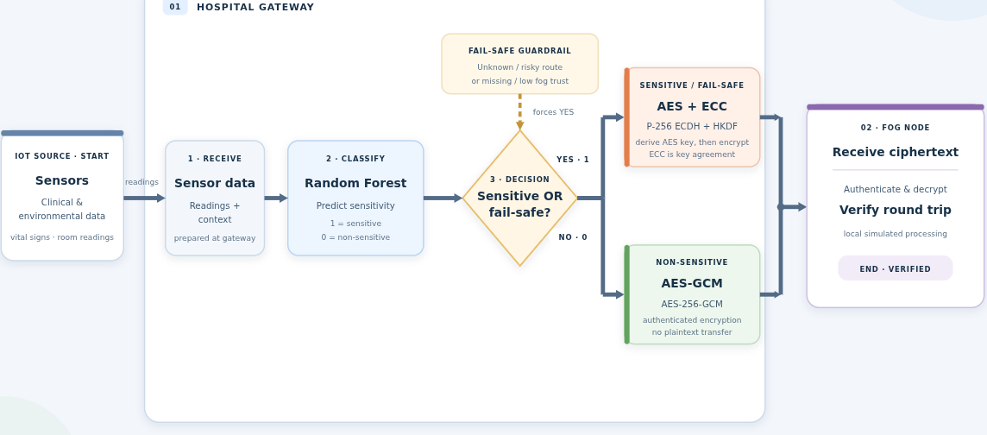
Figure (1). Proposed Framework Flowchart

The proposed framework processes clinical and environmental IoT records at a hospital gateway. It uses a Random Forest classifier to predict privacy sensitivity from policy and transfer-context features, including data type, patient linkability, identifier presence, data granularity, transfer context, payload size, latency budget, and fog-node trust. Raw sensor measurements are not used as classifier inputs.

Sensitive records use an enhanced encryption route in which ephemeral P-256 Elliptic Curve Diffie–Hellman (ECDH) and HKDF-SHA256 derive key material for AES-256-GCM. Non-sensitive records use AES-256-GCM without the additional ECDH key-agreement step. Both routes encrypt and authenticate the payload; the non-sensitive route does not send plaintext.

Fail-safe policy rules select the enhanced route when privacy metadata is unknown or the transfer context is unsafe, unknown, or insufficiently trusted. The prototype performs a local simulated fog-side decryption and round-trip verification.

1.4 Objective
This project aims to:
Develop a prototype hospital-IoT gateway workflow that classifies records as sensitive or non-sensitive under the project’s declared scenario policy. Compare Random Forest, K-Nearest Neighbors, and Support Vector Machine classifiers using the same project-generated training dataset; Random Forest is used by the gateway demonstration. Apply AES-256-GCM to payloads in both encryption routes, with ephemeral P-256 ECDH and HKDF-SHA256 added to the enhanced route. Apply conservative policy guardrails so that unknown or risky metadata and transfer contexts receive the enhanced encryption route. Report classifier metrics and host-measured inference and cryptographic timings. Report energy values only as literature-based estimates, not physical measurements of this implementation.

1.5 Practical Applications
Hospitals and clinics: secure real-time patient monitoring. Smart homes and elderly care: differentiated protection for medical vs environmental sensors. Industrial IoT: adaptive protection for plant telemetry vs intellectual property. Cloud-backed applications: dynamic policy selection across multi-tenant databases.

1.6 Scientific Challenges
Classification accuracy vs inference cost on constrained gateways. Model deployment — packaging RF into a lightweight binary (ONNX, micromlgen, emlearn). Key management for hybrid AES-ECC without central infrastructure. Energy measurement — the project relies on literature-based estimates rather than physical hardware tests. Non-IID data across departments and hospitals.

Chapter 1

2.Chapter 1: Theoretical Foundations

2.1 Cloud, Fog, and Edge computing architecture
Cloud computing's centralized model is fundamentally unsuitable for latency-sensitive healthcare applications because of the physical distance between edge devices and distant data centers. Fog computing (Bonomi et al., 2012) introduces an intermediate tier that brings storage, computation, and networking closer to the source. The three-layer architecture comprises:
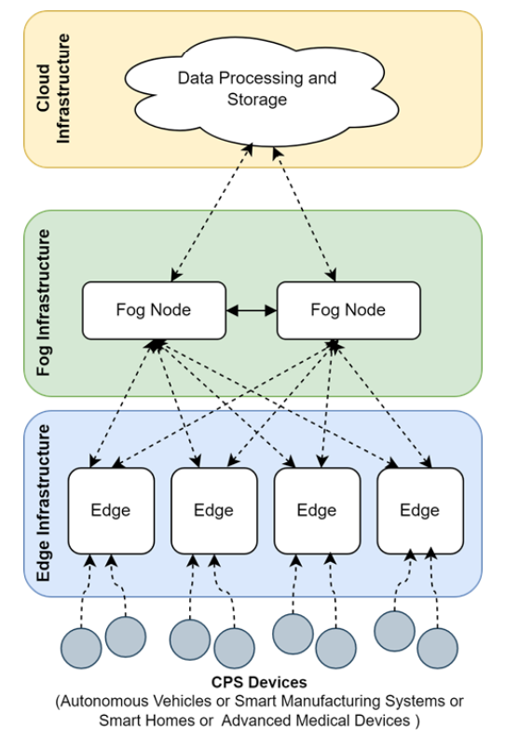
Figure (2). Cloud, Fog, and Edge computing architecture.
Edge layer: sensors, wearables, actuators. Fog layer: gateways, edge servers, localized storage and analytics. Cloud layer: long-term storage and global analytics.
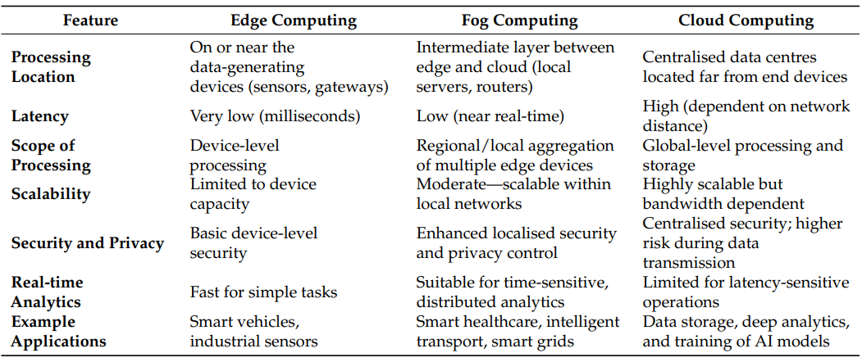
Table (1). Comparison among Cloud, Fog, and Edge Computing.
compares the three paradigms across latency, scalability, security, and analytics capability — confirming fog as the appropriate tier for our adaptive encryption engine, since it is close enough to the data source to reduce latency yet powerful enough to perform ML-based classification and hybrid cryptographic operations.

2.2 Security Challenges in Fog-IoT
Fog environments inherit classic IoT threats (DDoS, eavesdropping, replay, MITM, Sybil, node tampering) while introducing new ones (malicious fog nodes, cross-tenant interference, physical exposure of gateways). The distributed and heterogeneous nature of fog (Suárez-Albela et al., 2018) makes uniform security policies untenable: a gateway that must handle thousands of streams per second cannot apply AES-256-GCM + ECC to every ambient temperature reading without exhausting battery and bandwidth.

Key insight from the primary paper (Rajan Kumar & Goel, 2025):
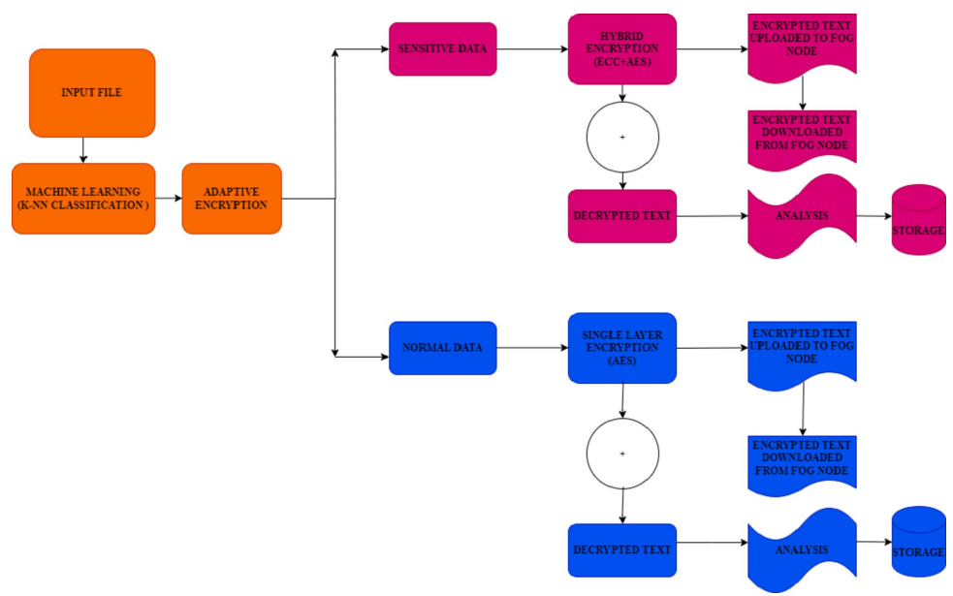
Figure (3). Adaptive encryption system overview.
security policy must adapt to data sensitivity, context (sender, recipient, purpose), and risk level.

2.3 Cryptographic Foundations

2.3.1 Symmetric Encryption — AES
AES (NIST FIPS-197, 2001) is a 128-bit block cipher with key sizes of 128, 192, or 256 bits, performing 10, 12, or 14 rounds respectively.
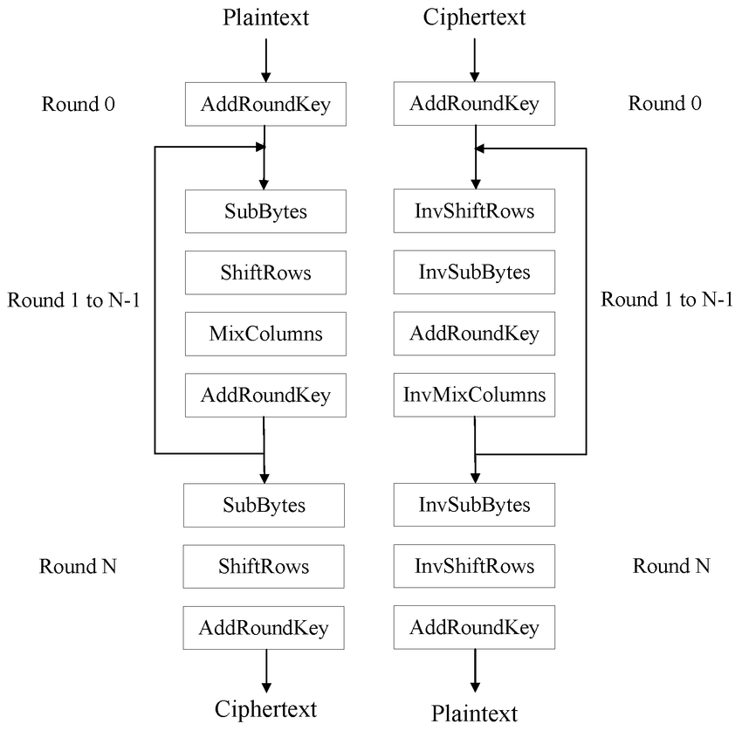
Figure (4). AES encryption and decryption flow.
Each round applies SubBytes, ShiftRows, MixColumns, and AddRoundKey. In fog-IoT deployments, AES is the dominant symmetric primitive because of:
Hardware acceleration availability on most SoCs (ESP32, STM32, etc.). Well-understood security margins. Rich mode library: GCM (AEAD), CCM, CBC.
AES-256 in GCM mode provides confidentiality + integrity + authenticity simultaneously — critical for healthcare compliance (HIPAA, GDPR, SDAIA).
Energy notes: Thaenkaw et al. (2023) demonstrated that AES-256 adds only ~750 µs and ~236 µJ over AES-128 for a 222-byte payload — negligible (~0.13%) relative to the LoRa time-on-air. Wu (2024) showed AES-256 processes 512 MB data faster than PRESENT while remaining energy-efficient for larger workloads. Therefore, selecting AES-256 in our framework is energy-justified.

2.3.2 Asymmetric Encryption — ECC
Elliptic Curve Cryptography (Koblitz, Miller, 1985) relies on the intractability of the Elliptic Curve Discrete Logarithm Problem (ECDLP). Over a prime field $Fp,$a curve is defined by $y2=x3+ax+b(modp)$ .
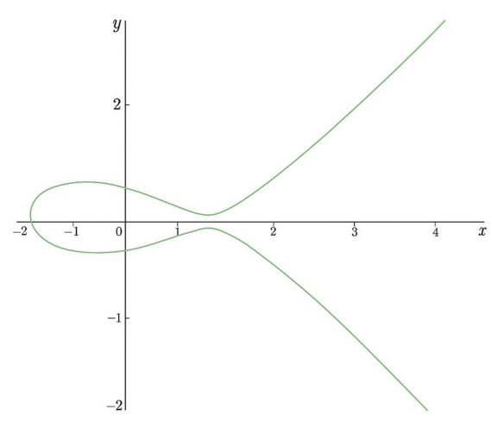
Figure (5). Elliptic Curve graph.
Scalar multiplication $Q=d⋅P is easy;$recovering $d$ from $Q$ is computationally infeasible for well-chosen curves.

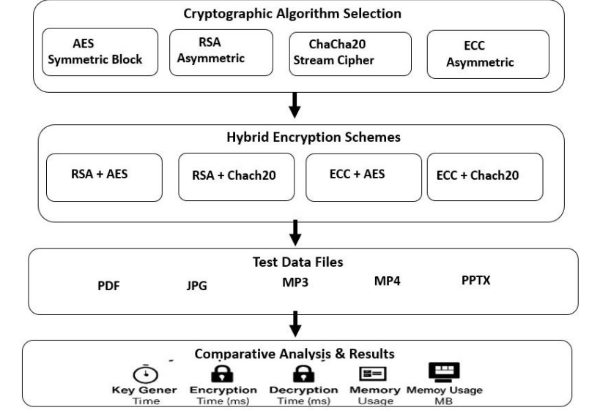
Figure (6). Hybrid encryption workflow.
Why ECC over RSA:
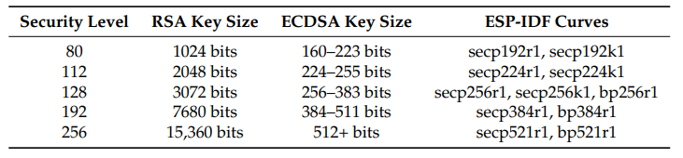
Table (2). Comparable security levels RSA vs ECDSA.
256-bit ECC ≈ 3072-bit RSA in security ( Suárez-Albela et al., 2018). ECC key generation and sign/verify are dramatically cheaper — ECDSA key generation ~5 ms vs DH_EC ~130 ms for 2048-bit (Jawad et al., 2025). Suárez-Albela et al. (2018) measured ECC reducing energy consumption by up to 75% vs RSA for equivalent security levels on constrained devices.
Recommended curve for our framework: secp256r1 (NIST P-256) — supported by virtually all TLS stacks and ESP32 hardware, and provides 128-bit security — or Curve25519 for superior side-channel resistance.

2.3.3 Hash Functions and KDFs
SHA-256 is used for integrity; HKDF (RFC 5869) derives session keys from ECDH shared secrets. In our pipeline, ECDH + HKDF + AES-GCM key wrapping effectively implements ECIES (Elliptic Curve Integrated Encryption Scheme) — the standard way to combine ECC key agreement with symmetric payload encryption.

2.3.4 AEAD — GCM Mode
Galois/Counter Mode combines CTR-mode encryption with a GHASH authenticator. It is the recommended AEAD in TLS 1.3 and provides:
Confidentiality of payload. Integrity + authenticity of ciphertext + AAD. No padding oracle issues (unlike CBC).
Albert (2025) measured AES-128-GCM at ~110 µJ per 128-byte packet — nearly 3× cheaper than AES-256-CBC + HMAC-SHA256 (~320 µJ).

2.4 Adaptive Encryption
Adaptive encryption (Rajan Kumar & Goel, 2025) dynamically selects cryptographic primitives based on:
Data sensitivity (Low, Medium, High, Critical — Jad et al., 2026).
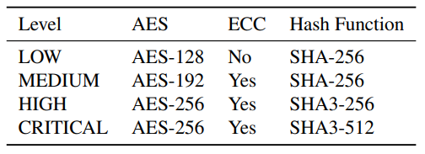
Table (3). Comparison among Cloud, Fog, and Edge Computing.
Context — sender role, recipient, purpose, location. Device state — battery, CPU load, memory. Threat level — detected anomalies, reputation.
Advantages (Rajan Kumar & Goel, 2025):
Reduces CPU and battery on the gateway. Preserves strong protection for critical streams. Enables policy customization for compliance.
Comparison of static vs adaptive overhead (Fig. 4–5, Rajan Kumar & Goel, 2025):
Sensitive data via hybrid ECC+AES: ~9.7 ms encrypt, ~5.0 ms decrypt for 1 KB. Normal data via AES alone: ~62.5 ms for 1 KB — note the baseline in the primary paper, but at larger sizes the lightweight AES-only path remains substantially cheaper per byte than ECC+AES, validating the two-tier policy.

2.5 Machine Learning for Data Classification

2.5.1 KNN (baseline in primary paper)
KNN classifies a test sample by majority vote among its $k$ nearest training points:
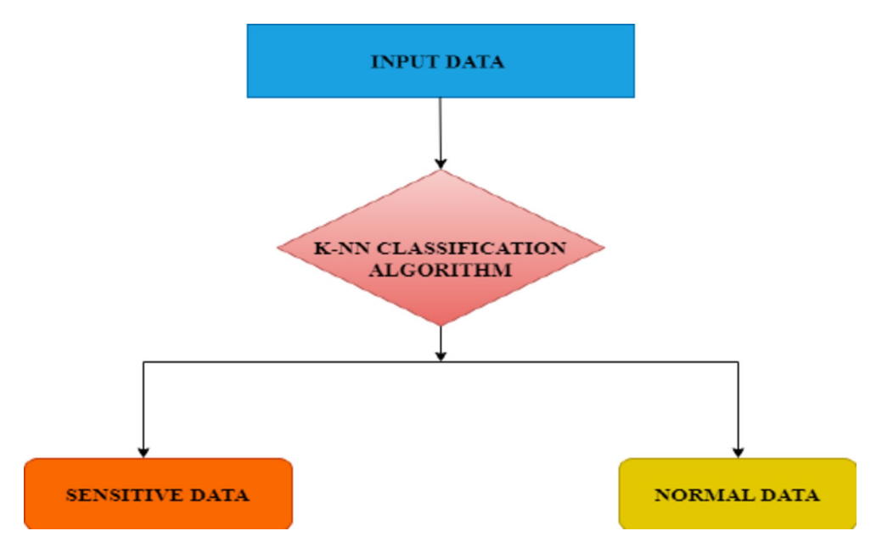
Figure (7). KNN-based data classification.
Strengths: simple, no training phase. Weaknesses: Must store the entire training set (RAM cost). Distance computation at inference is O(n⋅d) O(n⋅d). Sensitive to feature scaling and to K k choice. Suffers from the curse of dimensionality.
On gateways, KNN's storage and inference cost are barriers — a gap the primary paper acknowledges but does not eliminate.

2.5.2 SVM
SVMs construct an optimal separating hyperplane in a high-dimensional feature space (kernel trick). Strengths: strong generalization, robust in moderate dimensions. Weaknesses: $O(n^{2}) to O(n^{3})$training Large model size when many support vectors remain. Inference latency higher than RF for similar accuracy. Less interpretable.

2.5.3 Random Forest
RF builds an ensemble of decorrelated decision trees via:
Bagging (bootstrap sampling). Random feature subsetting at each split. Majority vote (classification) or averaging (regression).
Strengths for gateway deployment:
O(tree depth) O(tree depth) inference — typically < 100 µs for a single sample on ARM Cortex-M. Handles non-linear interactions, missing values, and heterogeneous features naturally. No feature scaling required. Can be compiled to C via micromlgen/emlearn and flashed to ESP32.
Pandey et al. (2025) reported RF achieving 99.99% accuracy on SensorNetGuard, and Fahd et al. (2025) reported 93.5% accuracy, 90.8% precision, 88.7% recall, and 89.7% F1 on healthcare anomaly data using an enhanced RF.

2.6 Hybrid Cryptography — AES + ECC
Hybrid schemes combine the speed of symmetric encryption with the secure key distribution of asymmetric cryptography. The primary paper applies:
Generate ECC key pair
(d,Q)
(d,Q).
Perform ECDH with the peer's public key.
Derive symmetric session key via HKDF.
Encrypt payload with AES.
ECIES-style flow (Saydahd et al., 2025) is the industrial standard. Recent measurements (Saydahd et al., 2025) show ECC+AES achieving:
Key generation: ~739 ms.
Encryption: ~733 ms for 367 KB–79 MB.
Memory: ~14 MB.
While this is heavier than AES alone, it is applied only to sensitive data, amortizing the cost across a minority of high-value streams.

2.7 Energy Considerations
Energy is the operative constraint in fog and edge deployments. Two published data points anchor our energy reasoning:
Thaenkaw et al. (2023): AES-256 incurs only ~236 µJ extra over AES-128 for a 222-byte payload — ≈0.13% of the LoRa time-on-air energy (~183.7 mJ). Conclusion: using AES-256 is practically free from an energy standpoint on the symmetric path.
Albert (2025): Ascon-128 consumes ~45 µJ per 128-byte authenticated encryption vs ~320 µJ for AES-256-CBC+HMAC and ~110 µJ for AES-128-GCM. Projected lifetime extension using Ascon+ECDH vs traditional crypto is >2.5 years.
Combined with Suárez-Albela et al. (2018) — which showed ECC curves consuming 40–75% less energy than RSA — our framework, which prefers AES-256-GCM + ECC-P256 for sensitive data and AES-256-GCM for the rest, is energy-justified.

2.8 Research Gap and Motivation

Gap in the primary paper (Rajan Kumar & Goel, 2025) | This project's response
Uses KNN — high memory + inference cost | Replaces with RF for gateway-feasibility
No head-to-head comparison of ML models | Benchmarks RF / KNN / SVM on the same dataset
Evaluated on unrelated text/image datasets | Evaluated on a hospital-specific dataset (Multi-Sensor Medical IoT)
Energy not measured against a well-defined baseline | Energy projected from peer-reviewed benchmarks (Albert, 2025; Thaenkaw et al., 2023; Suárez-Albela et al., 2018)
Simple decision, no policy engine | Introduces explicit adaptive policy engine with AES-256-GCM and AES+ECC tiers

Chapter 2

3.Chapter 2: Related Work and Literature Review

3.1 Comparative Table of Studies
Study and Year |  | Context and objective | Encryption / security method | Dataset or experimental data | Energy Evaluated | Relation to this project
1. Rajan Kumar and Goel (2025) — (Primary study) |  | Adaptive ML-based encryption for fog computing; classifies files as sensitive or normal before transmission to fog. | KNN classification; sensitive files use ECC-derived key material with AES, while normal files use AES. Evaluates encryption/decryption time and throughput, plus image-security metrics (histogram, NPCR, UACI). | File inputs of varying sizes; image files are used for image-security analysis. The paper does not identify a named, publicly available classification dataset. | reports timing and throughput, not calibrated power or energy in joules. | adaptive sensitivity classification followed by stronger hybrid protection for sensitive data and AES for normal data. The project adapts the concept to hospital IoT, uses Random Forest rather than KNN, adds healthcare-specific policy/context features and fail-safe transport rules, and uses AES-256-GCM in both paths with ephemeral P-256 ECDH/HKDF on the enhanced path. The primary study does not validate these project-specific labels, model results, or energy estimates; its reported timing/throughput cannot be transferred as project measurements
2.Explainable Sensitivity-Aware Encryption Policy Framework for Adaptive Enterprise Email Security Using Hybrid AES–ECC Cryptography.(2026) |  | Explainable, sensitivity-aware adaptive encryption for enterprise email. | Random-Forest regression estimates a sensitivity score; SHAP provides explanations; a tiered policy selects hybrid AES–ECC parameters. | Enron Email Dataset; rule-generated sensitivity labels and a 10,000-email holdout are described in the supplied copy. The authors identify expert-annotated labels and broader enterprise datasets as future work. | The paper tracks computational/encryption overhead, but that is not a calibrated energy measurement in joules. | adaptive sensitivity-to-crypto selection is a shared design principle, adapted here to hospital records and fog. **Not covered:** email features, continuous sensitivity scoring, SHAP explanations, and validated expert annotation.
3.Secure Fog Computing for Remote Health Monitoring with Data Prioritisation and AI-Based Anomaly Detection |  | Fog-based remote health monitoring; intelligent data prioritisation (IDP) and Random-Forest-based anomaly/threat detection for timely clinical streams. | Secure edge-to-fog communication and lightweight cryptographic mechanisms are described, but a specific, fully benchmarked AES/ECC suite is not the paper's main contribution. | Simulated wearable health streams, including hourly data modelled for five Fitbit devices over one month; the paper also discusses testing against a clinical dataset. | It motivates reduced transmission and efficiency; it does not provide a directly comparable measured AES/ECC energy per record for this project. | the current project also places RF-based processing and protection at the hospital gateway before a simulated fog receiver. **Not covered:** IDP, anomaly detection, clinical urgency ranking, and real-time deployment. The paper supports the relevance of fog-based health monitoring, not the current sensitivity-label performance.
A Comparative Performance Evaluation of Hybrid Encryption Techniques Using ECC, RSA, AES, and ChaCha20 for Secure Data Transmission(2025) |  | Comparative evaluation of hybrid encryption for secure file/data transmission across cloud, application, and IoT contexts. | Compares RSA+AES, RSA+ChaCha20, ECC+AES, and ECC+ChaCha20; reports ECC+ChaCha20 as strongest on execution-time and memory measures, with ECC+AES also considered. | Text files / digital files of varying formats and sizes in a Java implementation; not a healthcare sensitivity dataset. The supplied paper recommends future validation on embedded hardware and dynamic networks. | Timing and memory are evaluated; these cannot substitute for measured energy. | AES with ECC is also used in the sensitive route.
A Practical Evaluation on RSA and ECC-Based Cipher Suites for IoT High-Security Energy-Efficient Fog and Mist Computing Devices.(2018) |  | Experimental evaluation of TLS RSA- and ECC-based cipher suites for fog/mist IoT devices, including throughput and energy. | TLS 1.2 suites using RSA versus ECC (including ECDHE/ECDSA and AES-GCM suites); evaluates the impact of ECC curve choice. | Physical testbed with ESP32 mist devices and Orange Pi PC fog gateway, with controlled communications and current/energy sensing; not a labeled ML dataset. | Reports energy consumption and throughput; ECC generally outperforms RSA in the tested configurations, while curve and communication scenario matter. | Scientifically supports the general rationale for evaluating ECC-based security on fog/mist hardware.** The current project uses P-256 ECDH, but has no physical power instrumentation and does not reproduce the TLS testbed.
Leveraging Larger AES Keys in LoRaWAN: A Practical Evaluation of Energy and Time Costs.(2023) |  | Real-world LoRaWAN study of the processing-time and energy impact of AES-128, AES-192, and AES-256. | AES key-size variants within the LoRaWAN implementation; examines payload encryption and MIC-related operations. | Modified LoRaWAN end-device and open-source server stack; controlled payload-size experiments in a real LoRaWAN environment, not a clinical classification dataset. For the maximum tested payload, AES-256 versus AES-128 adds 750 ms and 236 μJ in their setup. | Both processing time and energy are measured on the LoRaWAN implementation. | Scientifically supports the narrow statement that AES key-length overhead should be measured in its workload and compared against radio airtime
A Lightweight Encryption Scheme for IoT Devices in the Fog  (2024) |  | Lightweight hash-based encryption proposal for resource-constrained IoT devices communicating with fog nodes; evaluates runtime and memory. | Pre-deployed shared secret and counter feed a hash-derived keystream; XOR encrypts message data. The paper discusses authentication/integrity limitations and suggests HMAC as future work. It is not AES-GCM. | Implementations and timing/memory tests on ESP32-S2-Kaluga-1, Arduino Zero, and Arduino Nano; no labeled external dataset. | Reports execution and memory, not joules or power. | supports the architectural relevance of lightweight IoT-to-fog cryptographic evaluation and reporting runtime/memory.
An Efficient and Robust Framework for IoT Security Using Machine Learning Techniques  (2025) |  | IoT network intrusion detection: classify malicious versus legitimate sensor nodes using ML. | No adaptive payload-encryption scheme is proposed; security contribution is ML-based malicious-node detection. | IEEE SensorNetGuard dataset with 21 features, as reported in the paper. RF, SVM, KNN and other classifiers are evaluated; the paper reports very high classification results for RF. | No cryptographic energy evaluation identified. | the current project also evaluates RF, SVM, and KNN on an IoT-related classification task.
10.Energy-Efficient Cryptographic Protocols for Securing Low-Power IoT Networks  (2025) |  | Comparative discussion and simulated evaluation of energy-aware cryptographic choices for low-power IoT; proposes context-adaptive selection. The supplied PDF does not provide verifiable publication venue/DOI metadata; its year is cited as 2025 elsewhere in the project materials, but should be confirmed before formal citation. | Compares AES-based schemes, Ascon-128, TinyJAMBU, ECC-based key establishment, and other modes; proposes selecting primitives by device/context. | ARM Cortex-M0+ simulation/model-based evaluation; no external labeled application dataset. Energy is calculated from voltage, current assumptions, and execution time. | as model/simulation-based estimates—not a physical deployment measurement.** Reports energy per packet and modeled lifetime; the supplied copy's abstract and detailed energy comparisons use different baseline figures, so numerical claims require checking against a verifiable publication. | supports context-aware crypto selection and energy accounting as research directions.
Towards Secure IoT Authentication System Based on Fog Computing and Blockchain Technologies to Resist 51% and Hijacking Cyber-Attacks  (2025) |  | IoHT authentication and resistance to attacks using fog computing and blockchain. The work focuses on identity/authentication, not sensitivity classification. | Blockchain-assisted authentication, chaotic-based key/public-key mechanisms, LED with a 3-D Lorenz chaotic map, and hash-based operations; the supplied paper describes Ethereum/Solidity simulation and Scyther security analysis. | Ethereum/Smart Contract simulation and JMeter performance tests; no clinical labeled dataset is identified for a sensitivity classifier. | Reports authentication/registration latency and computational/communication overhead, not physical joules. | the current prototype includes a fog destination and transport-trust guardrail.
Table (4). Comparison of the 10 reviewed studies.

3.2 Discussion of the Literature
On classification: Pandey et al. (2025) and Fahd et al. (2025) both demonstrate the superiority of RF among classical ML models for IoT and healthcare classification tasks. Jad et al. (2026) use RF as the sensitivity estimator for an adaptive encryption framework — a direct precursor to this project, though applied to email rather than fog-IoT. The present project aligns with this direction and further narrows the domain to hospital sensors using the IoT Healthcare Security Dataset.
On cryptography: Saydahd et al. (2025), Suárez-Albela et al. (2018), and Thaenkaw et al. (2023) converge on ECC + AES as the preferred hybrid for resource-constrained environments, with AES-256 being energetically justifiable over AES-128. Chun et al. (2024) offer a highly optimized hash-based alternative but sacrifice IND-CCA2 security — acceptable only in low-risk contexts.
On fog architecture: Fahd et al. (2025) and Rajan Kumar & Goel (2025) both place the intelligence at the fog layer. This project follows that convention: classification and adaptive encryption are performed at the gateway, before forwarding to fog nodes for storage and cloud aggregation.
On energy: Albert (2025) provides the most granular energy accounting for AEAD primitives, and Thaenkaw et al. (2023) quantifies AES key-size overhead precisely. Together they allow our project to project realistic energy benefits without needing physical instrumentation — a recognized limitation.

8.References
- Rajan Kumar, P., & Goel, S. (2025). A secure and efficient encryption system based on adaptive and machine learning for securing data in fog computing. Scientific Reports, 15.
- Jad, H. A., Shaheen, N. A., Allam, M. H., & Shehata, M. A. (2026). Explainable Sensitivity-Aware Encryption Policy Framework for Adaptive Enterprise Email Security Using Hybrid AES-ECC Cryptography. (Preprint, Research Square).
- Fahd, K., Parvin, S., Di Serio, A., & Venkatraman, S. (2025). Secure Fog Computing for Remote Health Monitoring with Data Prioritisation and AI-Based Anomaly Detection. Sensors, 25(23), 7329.
- Saydahd, S. J., Muhammed, R. K., Hassan, S. A., & Aladdin, A. M. (2025). Performance evaluation of hybrid encryption schemes (AES/RSA/ECC/ChaCha20). Iraqi Journal of Industrial Research, 12(2).
- Suárez-Albela, M., Fraga-Lamas, P., & Fernández-Caramés, T. M. (2018). A Practical Evaluation on RSA and ECC-Based Cipher Suites for IoT High-Security Energy-Efficient Fog and Mist Computing Devices. Sensors, 18(11), 3868.
- Thaenkaw, P., Quoitin, B., & Meddahi, A. (2023). Leveraging Larger AES Keys in LoRaWAN: A Practical Evaluation of Energy and Time Costs. Sensors, 23(22), 9172.
- Chun, M., Weber, S., & Tewari, H. (2024). A Lightweight Encryption Scheme for IoT Devices in the Fog. Springer LNCS (WISTP proceedings).
- Pandey, V. K., Prakash, S., Jha, S. K., Yang, T., & Rathore, R. S. (2025). An Efficient and Robust Framework for IoT Security using Machine Learning Techniques. Procedia Computer Science, 258, 118–124.
- Albert, B. (2025). Energy-Efficient Cryptographic Protocols for Securing Low-Power IoT Networks. SSRN Preprint 6117826.
- Jawad, M., Yassin, A. A., Al-Asadi, H. A. A., Abduljabbar, Z. A., Nyangaresi, V. O., Hussien, Z. A., & Neamah, H. A. (2025). Towards Secure IoT Authentication System Based on Fog Computing and Blockchain Technologies to Resist 51% and Hijacking Cyber-Attacks. JJCIT, 11(2).
- Wang, F., & Wang, K. (2026). Federated learning-based trust and energy-aware routing in Fog-Cloud computing environments for the Internet of Things. Scientific Reports, 16, 2244.
- ECDSA-based authentication for Fog-IoT (2023). A signature scheme based on ECDSA for improving the security of the private key and key-pair generation time in IoT-Fog environments. IJCNC, 15(4).
- NIST FIPS-197 (2001). Advanced Encryption Standard (AES).
- NIST SP 800-38D (2007). Galois/Counter Mode (GCM) and GMAC.
- Barker, E. (2020). Recommendation for Key Management, Part 1. NIST SP 800-57.
- Kaggle Dataset: IoT Healthcare Security Dataset — https://www.kaggle.com/datasets/faisalmalik/iot-healthcare-security-dataset
- Bonomi, F., Milito, R., Zhu, J., & Addepalli, S. (2012). Fog computing and its role in the Internet of Things. MCC Workshop.
- Koblitz, N. (1987). Elliptic curve cryptosystems. Mathematics of Computation, 48, 203–209.
- Miller, V. (1985). Use of elliptic curves in cryptography. CRYPTO '85.
- Ujjwal Sinha01 and collaborator, “Multi-Sensor Medical IoT,” Kaggle dataset, MIT License. Available: https://www.kaggle.com/datasets/ujjwalsinha01/multi-sensor-medical-iot (accessed 26 October 2026).

