**Project marks** - 90/100

**MCQ marks**- 10/100

**Deadline**- 23rd 11:59PM AST

**Submission link** - <https://docs.google.com/forms/d/e/1FAIpQLSfPfq_XQ6999fAqzyCQ0Lf8sZQXqg4GihuPqFauv18t_fMpCQ/viewform?usp=sf_link>

**Explanation video-**

**Question Explanation -**

Linux system administration is a fundamental task for any DevOps engineer. Linux administration skills are most commonly applied in configuring OS architecture and will be the focus of this belt exam.

Some other common areas where these skills are applicable are as given below:

**Part 1: Question 1-3.**

You are working as a system administrator for a large corporation. The company would like to use the best industry standard for management of environment variables, users and groups. You have been asked to perform those actions with the instructions given below.

**Part 2: Question 4-6.**

Most of the analytical work and system administration in linux requires giving a batch of instructions to the operating system for automation, time and cost saving and error free execution. You are required to use linux commands to create the required file. Then you have to write scripts to perform logical operations using loops, conditionals and function call to meet the requirements.

1. You have to write a script for the following operations in user management.   
     
   Create a user, name it "user1", switch to user1, check the environment variable DB_URL and shell variables. - 10

Write the script for doing these operations back to back.

|  |
| --- |
| CREAT USER : useradd user1  Switch to user1 : su user1  Check the enviroment DB_URL : env $DB-URL |

1. You have to write a script for the following operations in environment variable management.   
     
   Change the environment variable value from USERNAME=user1 to user2. - 5  
     
   Write the script for doing these operations.

|  |
| --- |
| USERNAME=user1  Echo “$USERNAME”  The value in USERNAME WILL BE “ user1”  To change  USERNAME=user2  Echo “$USERNAME”  Now new value in USERNAME it will be “ user2” |

1. Write script for following actions in user management- 20
   1. Create users user1, user2, user3
   2. Assign them password pass1, pass2, pass3 respectively
   3. Create groups ec2, rds, lambda
   4. Add one user to one group in sequence
   5. Delete user3 in lambda group.
   6. Delete user2

Write the script for doing these operations.

|  |
| --- |
| Useradd user1  Passwd user1 “ then wil ask to set password I enter pass1”  Useradd user2  Passwd user2 “then wil ask to set password I enter pass2”  Useradd user3  Passwd user3 “ then wil ask to set password I enter pass3”  Groupadd ec2  Groupadd rds  Groupadd lambda  Sudo usermod -a -G ec2 user1  Sudo usermod -a -G rds user2  Sudo usermod -a -G lambda user3  When wright “ groups user3 it show group lambda also as user2 ..etc”  Userdel user3  Userdel user2 |

1. File operations using command line - 15
   1. Create directories “DevOps1” and “DevOps2”
   2. Create a file named “aws.txt” that contains “Welcome to AWS” to “DevOps” folder.
   3. Copy “aws.txt” to DevOps2 folder
   4. Delete the directory “DevOps2”

Write the script for doing these operations.

|  |
| --- |
| Mkdir DevOps1  Mkdir DevOps2    Cd DevOps1  Touch aws.txt  Vi aws.txt  “ now I wrigt insiad aws.txt file in DevOps1 directories  Welcom to aws by insert then esc :wq to save and get out file”  To show inside file aws.txt I type , cat aws.txt  “ now to copy aws.txt from DvoOps1 to DevOps2 :”  Cp DevOps1/aws.txt DevOps2/  “ then I moved to dir DevOps2 to show list of file I copyed from DevOps1”  Cd DevOps2  Ls  To show the file I take copy from devops1 in devops2  “ now to delete the directory DevOps2 I used the command : “  “ rm -rf DevOps2 |

1. Write a script to compare input number and print if bigger, lesser or equal to number 10. - 10

Example:

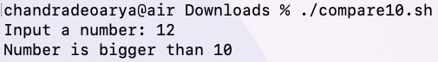

Write the script for that.

|  |
| --- |
| First make fil name it comp.sh  Touch comp.sh  Then by comman ,, vi comp.sh  Insid file wrigt a script  echo -n " input number : "  read input  if [ $input -gt 10 ]  then  echo " number is bigger than 10 "  elif [ $input = 10 ]  then  echo " number is equal 10 "  else  echo " number less than 10"  Fi |

1. Make a Calculator using bash scripting which meet the following checkpoint - 15
   1. Write a script to make a calculator.
   2. Take two input numbers and perform basic operations.
   3. Input 1- add, input 2 - subtract, input 3- multiplication, input 4 - division , 5 exit
   4. Maintain the loop until 5 is not pressed on keyboard.

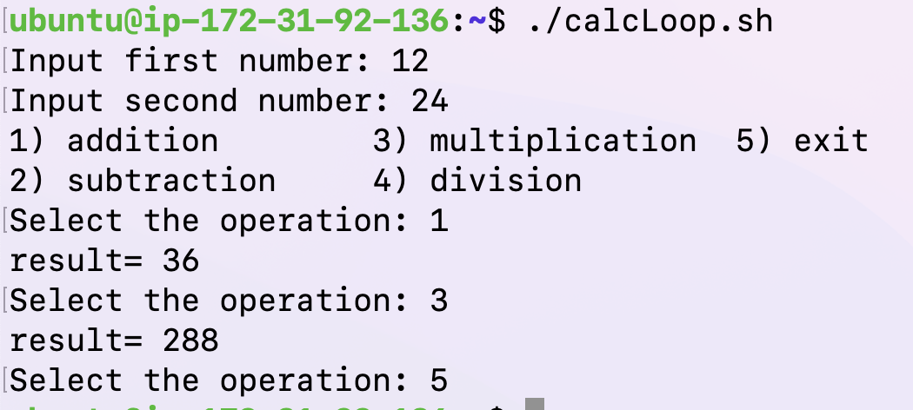

Write the script for that.

|  |
| --- |
|  |

1. Linux scripting allows calling of a function from inside another function. This helps to reuse the code and makes the script much easier to maintain and read. In this questions you are going to create two functions and call one from another.  
     
   Call function1 and then call function2 from inside the function1. Do the required printing inside the function to express the output and show the function call sequences - 15  
     
   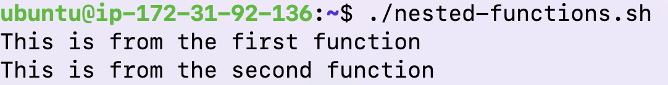

Write the script for doing this operation.

|  |
| --- |
|  |