Software Requirements Specification
For
HireHub
AI-Powered local Employment Marketplace

Version 1.0
Prepared by:Biswajith P N,Vibin Aravind R,Mohammed Ameen A
July 2026
Table of Contents
Table of Contents ii
Revision History ii
1. Introduction 1
1.1 Purpose 1
1.2 Document Conventions 1
1.3 Intended Audience and Reading Suggestions 1
1.4 Product Scope 2
1.5 References 2
2. Overall Description 2
2.1 Product Perspective 2
2.2 Product Functions 3
2.3 User Classes and Characteristics 3
2.4 Operating Environment 3
2.5 Design and Implementation Constraints 4
2.6 User Documentation 4
2.7 Assumptions and Dependencies 4
3. External Interface Requirements 4
3.1 User Interfaces 4
3.2 Software Interfaces 5
3.3 Communications Interfaces 6
4. System Features 6
4.1 AI Resume Analyzer and Resume-Job Match Score 6
4.2 AI Job Recommendation System…………………………………………………………6
4.3 AI Candidate Recommendation and shortlisting………………………………………..6
5. Other Nonfunctional Requirements 8
5.1 Performance Requirements 8
5.2 Safety Requirements 8
5.3 Security Requirements 8
5.4 Business Rules 9
6. Other Requirements 9
Appendix A: Glossary 9
Appendix B: Analysis Models 9

Introduction

Purpose
The HireHub is a web-based recruitment platform designed to connect local employers with nearby job seekers through an intelligent and secure hiring ecosystem. The primary objective of the system is to simplify the recruitment process by reducing the time and effort required for employers to find suitable candidates while helping job seekers discover relevant employment opportunities within their preferred locations.

This platform targets local businesses such as retail stores, restaurants, hospitals, startups, workshops, and service providers that often rely on offline recruitment methods. By integrating Artificial Intelligence into the recruitment workflow, the platform provides personalized job recommendations, candidate ranking, resume analysis, making the hiring process faster, smarter, and more reliable.

This Software Requirements Specification (SRS) defines the functional and non-functional requirements of the proposed system, serving as a reference for developers, testers, project supervisors, and future maintenance teams throughout the software development lifecycle.

Document Conventions
This Software Requirements Specification follows the IEEE standard format to ensure consistency, clarity, and completeness throughout the document. Functional requirements are represented using unique identifiers making each requirement easy to reference during development and testing. Requirements are also categorized according to their implementation priority as High, Medium, or Low, enabling effective planning and sprint management.

Technical terms, abbreviations, and acronyms used throughout the document are explained in the glossary section to ensure that all stakeholders have a common understanding of the terminology. The document follows a structured hierarchy of chapters and sub-sections, allowing readers to easily locate information related to system functionality, design, interfaces, constraints, and quality requirements.

Intended Audience and Reading Suggestions
This document is intended for all stakeholders involved in the development and maintenance of the project. Software developers will use it as a reference while implementing system modules and APIs. Project supervisors and evaluators will use it to understand the project's objectives, architecture, and overall functionality. Testers will use the documented requirements to prepare test cases and validate system behavior. Future maintenance teams can also refer to this document to understand the existing system architecture and extend the platform with additional features.

Although this document contains technical information, it is organized in a structured manner so that readers with different levels of technical expertise can understand the overall system requirements and functionality.

Product Scope
The HireHub aims to create an intelligent recruitment platform that enables employers and job seekers to connect efficiently within their local communities. Employers can create company profiles, publish job vacancies, manage applications, and schedule interviews, while job seekers can build professional profiles, upload resumes, search for jobs, apply online, and monitor their application status.The system analyzes candidate skills, experience, job requirements, relationship data and automate candidate ranking.

References
[1] "ISO/IEC/IEEE International Standard - Systems and software engineering -- Life cycle processes -- Requirements engineering," ISO/IEC/IEEE 29148:2018(E), 2018. Available: https://standards.ieee.org/standard/29148-2018.html
[2] "IEEE Recommended Practice for Software Requirements Specifications," IEEE Std 830-1998, 1998. Available: https://ieee.org
[3] International Institute of Business Analysis, A Guide to the Business Analysis Body of Knowledge (BABOK Guide), ver. 3.0, 2015. Available: https://iiba.org
[4] K. Wiegers and J. Beatty, Software Requirements, 3rd ed. Redmond, WA: Microsoft Press, 2013. Available: https://amazon.in

Overall Description

Product Perspective
This is a full-stack web-based recruitment platform designed to connect local employers with nearby job seekers through an intelligent and secure hiring ecosystem. The frontend is developed using React.js, while the backend is implemented using Java, exposing FAST APIs to handle communication between the client and server. MongoDB serves as the primary database for storing user accounts, employer information, job postings, applications, resumes, notifications, and other operational data. AI modules developed using Python libraries such as spaCy and scikit-learn are integrated with the backend to automate recruitment tasks including job recommendations, resume analysis, candidate ranking, and skill gap analysis. The platform provides a secure, scalable, and efficient environment for connecting employers with local job seekers.

Product Functions
This comprehensive platform operates as a modern, end-to-end career ecosystem by integrating standard management tools with advanced automation. It begins with Secure Authentication to keep user data safe and Job Seeker & Employer Profile Management to let users showcase their company details. Employers can easily control their listings through Job Posting and Management, while candidates explore openings using Job Search and Applications.To make hiring faster, the system uses AI-powered Recommendations to match the best candidates to the right roles and Resume Analysis to instantly scan and grade CVs. Finally, the platform maintains high quality and trust through upvoting and gives full system control to operators through Admin Management.

User Classes and Characteristics
Employee
The Employee is an individual seeking employment opportunities through the platform. Employees can a personal profiles, upload resumes, search and apply for jobs, and track the status of their applications. They can also benefit from intelligent features such as Resume–Job Match Score, AI-based Job Recommendations, Candidate Profile Analysis. Employees are expected to possess basic computer and internet navigation skills and should be familiar with common web applications.
Employer
The Employer represents organizations or businesses that recruit candidates through the platform. Employers can create and manage company profiles, post job vacancies, review applications, and identify suitable candidates using the AI Candidate Recommendation and Shortlisting feature. They can also monitor recruitment activities and manage job postings through their dashboard. Employers are expected to have basic technical knowledge for operating web-based applications and should be capable of providing accurate job descriptions and recruitment information.
System Administrators
This class represents the internal technical team responsible for maintaining the platform’s health, safety, and operational standards. They use the platform continuously and daily to monitor system health and resolve issues. Their technical expertise is very high, consisting of IT professionals, system managers, or software developers. They possess maximum security privileges, giving them full read, write, and delete permissions across the entire database. They focus on user management, platform analytics, moderation of reported profiles. Their workspace requires a highly functional backend portal focused on security logs, data tables, and system control overrides.

Operating Environment
The system is designed as an online web application that runs on a single computer during development and testing.
The frontend is developed using React.js, while the backend is implemented using java,FAST API,MongoDB serves as the primary database for storing user accounts, employer information, job postings, applications, and other operational data.
The system is intended to run on Windows, Linux, or macOS and can be accessed using modern browsers such as Google Chrome, Microsoft Edge, Firefox, or Safari.

Design and Implementation Constraints
The application is developed as an online system .Constant internet connectivity is required for the app . User authentication is implemented using JWT-based authorization, and communication between the frontend and backend is performed through FAST APIs . AI modules are implemented using Python libraries and executed online.

User Documentation
The system will provide user documentation to assist all user groups in effectively using the application. A User Manual will explain the procedures for user registration, login, profile management, resume upload, job search, job application, company profile management, and job posting. A Quick Start Guide will help new users understand the basic workflow of the platform. Context-sensitive help messages and form validations will be provided throughout the application to guide users and reduce input errors.

Assumptions and Dependencies
It is assumed that all users provide accurate and authentic information during registration and profile creation. Employers are expected to publish genuine job opportunities, while job seekers are expected to upload valid resumes and educational information.
The application assumes that the development environment has all the required software installed, including java,React.js, FAST API, MongoDB, and the necessary Python libraries used for AI functionalities.
The AI-powered features depend on sufficient user profiles, resumes, job postings, and relationship data being available in the databases. Recommendation accuracy and candidate ranking improve as the amount of stored data increases.

External Interface Requirements

User Interfaces
The HireHub will provide a clean, responsive, and intuitive user interface developed using React.js. The interface will be designed to ensure ease of navigation for users with different levels of technical knowledge while maintaining a consistent layout across all pages. Role-based dashboards will be provided for Job Seekers, Employers, and Administrators, ensuring that each user only accesses features relevant to their responsibilities.

The Job Seeker Dashboard will allow users to manage their profiles, upload resumes, search and filter job listings, apply for jobs, track application status,receive AI-generated job recommendations, monitor resume match scores.

The Employer Dashboard will provide tools for managing company profiles, creating and editing job postings, viewing applications, accessing AI-ranked candidate lists, scheduling interviews, monitoring recruitment progress, and reviewing hiring analytics. Employers will also receive AI-generated recommendations for suitable candidates based on job requirements.

The Administrator Dashboard will serve as the control center of the platform. It will enable administrators to verify employer accounts, review AI-flagged job postings, monitor platform analytics, manage users, oversee recruitment activities.

The user interface will be fully responsive and optimized for desktops, laptops, tablets, and mobile browsers to ensure a consistent user experience across different screen sizes.

Software Interfaces
The application integrates React.js for the frontend user interface , Java as backend ,FAST API for backend API development , MongoDB for document-oriented data storage ,JWT for secure authentication and authorization , Python AI libraries such as spaCy, Scikit-learn, Pandas, NumPy, and Sentence Transformers for implementing intelligent recruitment features.

Communications Interfaces
Communication between different components of the system is performed through FAST APIs over the environment. The React.js frontend sends HTTP requests to the FAST API backend whenever users perform actions such as logging in, creating profiles, searching for jobs, applying for jobs, uploading resumes, or managing job postings.
The backend processes these requests, performs business logic, interacts with MongoDB and executes AI modules when required, and returns structured JSON responses to the frontend. JWT-based authentication tokens are used to verify user identity and enforce role-based authorization for different user types.
AI modules interact internally with the backend to analyze resumes, calculate job compatibility scores, recommend jobs, rank candidates. This communication architecture ensures efficient data exchange while maintaining modularity and security throughout the application.

System Features
4.1 AI Resume Analyzer and Resume–Job Match Score

4.1.1 Description and Priority

The AI Resume Analyzer and Resume–Job Match Score feature automatically analyzes resumes uploaded by employees to extract relevant information such as technical skills, educational qualifications, work experience, certifications, and projects. The extracted information is compared with the requirements of a selected job posting to calculate a Resume–Job Match Score, indicating the candidate's compatibility with the position. The system also highlights matched and missing skills to help employees understand their strengths and areas for improvement before submitting an application.
4.1.2 Stimulus/Response Sequences

The feature is initiated when an employee uploads a resume and selects a job posting for analysis. Upon receiving the request, the system extracts the textual content from the uploaded resume, identifies relevant skills, qualifications, work experience, certifications, and projects, and compares the extracted information with the selected job requirements. Based on this comparison, the system calculates a Resume–Job Match Score and displays the compatibility percentage along with the matched skills, missing skills, and recommendations that can help improve the candidate's suitability for the selected position.

4.1.3 Functional Requirements

The system shall allow employees to upload resumes in PDF format and extract the relevant textual information for analysis. It shall identify important candidate attributes, including technical skills, educational qualifications, work experience, certifications, and projects, and compare them with the selected job requirements. The system shall calculate and display a Resume–Job Match Score as a percentage while presenting matched and missing skills separately. The extracted resume information shall be stored in the database for future use and updated whenever a new resume is uploaded. If the uploaded resume is corrupted, unsupported, or cannot be processed successfully, the system shall notify the employee with an appropriate error message.
4.2 AI Job Recommendation System
4.2.1 Description and Priority
The AI Job Recommendation System provides personalized job recommendations by analyzing an employee's skills, educational qualifications, work experience, preferred job location, and career interests. Using relationship analysis and similarity scoring, the system identifies relevant job opportunities that closely match the employee's profile and displays them according to their recommendation scores. This feature significantly improves job discovery and reduces the time required for employees to search for suitable employment opportunities.

4.2.2 Stimulus/Response Sequences
The recommendation process begins when an employee logs into the application and accesses the dashboard. The system retrieves the employee's profile information, analyzes the available skills, educational background, work experience, preferred location, and career interests, and then searches the databases for suitable job opportunities. Based on the calculated recommendation scores, the system ranks the available jobs and displays the most relevant opportunities in descending order, allowing the employee to explore detailed job information before submitting an application.
4.2.3 Functional Requirements
The system shall retrieve and analyze employee profile information, including skills, education, experience, preferred location, and career interests, before generating job recommendations. It shall utilize relationship-based analysis and similarity scoring to identify relevant job opportunities and assign a recommendation score to each job. The recommended jobs shall be displayed in descending order of relevance, and the recommendations shall be automatically updated whenever the employee modifies the profile or uploads a new resume. If no suitable jobs are available, the system shall notify the employee appropriately.
4.3 AI Candidate Recommendation and Shortlisting
4.3.1 Description and Priority
The AI Candidate Recommendation and Shortlisting feature assists employers in identifying the most suitable applicants by automatically evaluating and ranking candidates based on predefined recruitment criteria. The ranking process considers resume compatibility, technical skills, educational qualifications, work experience, projects, certifications, and preferred location to generate an overall recommendation score for every applicant. This feature reduces manual resume screening effort and enables employers to make more efficient and informed hiring decisions.

4.3.2 Stimulus/Response Sequences
The feature is activated when an employer opens a specific job posting and requests the list of applicants. The system retrieves the information of all candidates who have applied for the selected job, evaluates each applicant using the predefined scoring criteria, calculates an overall recommendation score, and ranks the candidates accordingly. The ranked list, along with the recommendation scores and candidate details, is then displayed on the employer dashboard to support the recruitment process.

4.3.3 Functional Requirements
The system shall retrieve all applications submitted for a selected job posting and evaluate each applicant based on resume compatibility, skills, education, work experience, projects, certifications, and location. It shall calculate an overall recommendation score and display the candidates in descending order according to their suitability. The rankings shall be updated automatically whenever new applications are received or applicant information changes. Employers shall be able to view detailed candidate profiles and resumes before making recruitment decisions. If no applications exist for a particular job posting, the system shall display an appropriate notification.

Other Nonfunctional Requirements

Performance Requirements
The system shall provide efficient and reliable performance during normal operation in the local development environment. User authentication and login operations shall be completed within 2 seconds, while job searches shall return relevant results within 2 seconds. Profile creation, profile updates, job posting creation, job modifications, and job application submissions shall be processed within 3 seconds under normal system load. Uploaded resumes shall be successfully stored within 5 seconds, after which the AI Resume Analyzer and Resume–Job Match Score module shall complete its analysis within 8 seconds. The AI Job Recommendation System shall generate personalized job recommendations within 5 seconds, while the AI Candidate Recommendation and Shortlisting module shall process and rank applicants within 10 seconds.
The system shall ensure that user information and recruitment data are protected against accidental loss or corruption. Uploaded resumes, profile information, and job postings shall be stored safely in the local storage and database. The system shall validate user inputs before processing them to prevent invalid or incomplete data from entering the system.
The administrator shall have the authority to review AI-generated decisions before permanently removing job postings or blocking user accounts. Regular database backups are recommended to prevent data loss due to unexpected software failures or hardware issues.

Security Requirements
The system shall implement secure user authentication using JWT (JSON Web Token) to ensure that only authorized users can access protected resources. User passwords shall be encrypted using secure hashing algorithms before being stored in MongoDB.
Role-based access control shall restrict system functionalities according to user roles, including Job Seeker, Employer, and Administrator. All communication between the React frontend and FastAPI backend shall use authenticated requests. The system shall validate all uploaded files and user inputs to reduce the risk of malicious data entering the application.

Business Rules
The system shall operate according to predefined business rules to ensure a secure, transparent, and efficient recruitment process. Only registered users shall be permitted to access the platform, and every user shall be assigned one of three roles: Job Seeker, Employer, or Administrator, each with role-specific permissions. Employers shall be required to complete profile verification before publishing job vacancies, while job seekers shall be allowed to apply only for active job postings. Each job application shall be associated with a single job seeker and a single job posting, and employers shall have access only to applications submitted for their own vacancies. AI-powered features, including Resume Analysis, Resume–Job Match Score, Job Recommendations, Candidate Recommendation . shall function as decision-support tools rather than replacing human judgment. Final hiring decisions shall remain the responsibility of employers, while AI-flagged job postings shall require administrator review before publication or removal. The system shall accept only supported file formats for resume uploads, and all user information, job postings, and recruitment activities shall be stored and managed according to the platform's operational policies to maintain data integrity and ensure a fair recruitment process.
ER Diagram
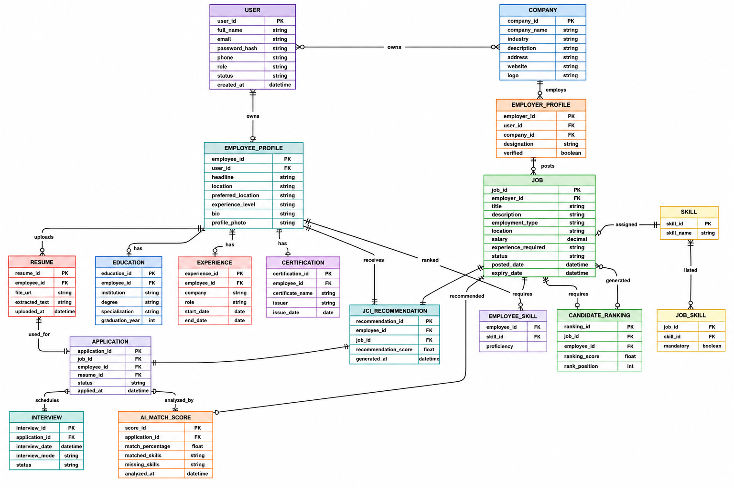
Appendix A: Glossary
- AI – Artificial Intelligence
- API – Application Programming Interface
- JWT – JSON Web Token used for user authentication.
- REST API – Communication interface between the frontend and backend.
- CRUD – Create, Read, Update, Delete operations.
- NLP – Natural Language Processing used for resume analysis.
- MongoDB – NoSQL database for storing application data.
- FastAPI – Python framework used to develop the backend APIs.
- React.js – JavaScript library used to build the frontend user interface.
- Resume Parser – AI module that extracts information from uploaded resumes.
- Job Recommendation Engine – AI module that recommends suitable jobs to candidates.
- Candidate Recommendation Engine – AI module that ranks applicants for employers.
- Resume–Job Match Score – AI-generated compatibility score between a resume and a job.
- JSON – Lightweight data format used for API communication.
Appendix B: Analysis Models
The following diagrams and models will be developed during the design phase:
- System Architecture Diagram
- Use Case Diagram
- Activity Diagram
- Sequence Diagram
- Class Diagram
- Entity Relationship (ER) Diagram
- Data Flow Diagram.
- Database Schema Diagram
- Component Diagram
- Deployment Diagram
- UI Wireframes / Mockups
- Flowchart of AI Recommendation Process
- Flowchart of Fake Job Detection Process

