Plant Disease Detection And Remedy Suggestion
A PROJECT WORK

Plant Disease Detection And Remedy Suggestion
A PROJECT WORK

DECLARATION

DECLARATION

Signature of the candidate

Place:
Date:

CERTIFICATE

CERTIFICATE

Place: Signature of the Guide

HEAD OF THE DEPARTMENT PRINCIPAL

ACKNOWLEDGEMENT

ACKNOWLEDGEMENT

SYNOPSIS

SYNOPSIS
Plant health is crucial for agriculture and food security, as diseases can significantly reduce crop yields. Early detection and accurate identification of plant diseases are essential for effective management and mitigation. A Plant Health Monitoring System utilizing Convolutional Neural Networks (ResNet50) is proposed to automate the process of detecting plant diseases from leaf images. ResNet50, a deep learning technique, excels in image classification tasks and is specifically designed to handle complex visual data, making it an ideal tool for this application.
Traditional methods of detecting plant diseases require manual inspection of plant leaves by experts. This process is time-consuming, requires continuous monitoring, and can be very expensive, especially on large farms.
The main purpose of this proposed system is to take a leaf image as input and classify the disease using an effective deep learning ResNet50 model. The proposed application uses a dataset for training sourced from the Plant Leaf Disease Dataset, available on the Kaggle repository. The dataset used for training and testing in the proposed application consists of two main folders: one for training and the other for testing. The training folder contains a large set of labeled leaf images, which are used to train the ResNet50 model. Once the model is trained, users can upload test input images to evaluate the model's performance on the testing set.
After the test image is uploaded, it undergoes image segmentation, followed by conversion from RGB to grayscale. The segmentation is applied to the pre-processed image, and the ResNet50 model processes each segment, predicting and classifying whether the uploaded plant leaf image has a disease or not. Upon successful plant leaf disease detection, the application identifies the cause of the plant disease and provides fertilizer suggestions using a pattern-matching approach.

CONTENTS

CONTENTS
Sn No | CONTENT | PAGE. NO
1 | INTRODUCTION | 14
 | 1.1. OVERVIEW OF THE PROJECT | 15
2 | SYSTEM STUDY | 16
 | 2.1. EXISTING SYSTEM | 17
 | 2.1.1. LIMITATIONS OF EXISTING SYSTEM | 17
 | 2.2. PROPOSED SYSTEM | 18
 | 2.2.1. ADVANTAGES OF PROPOSED SYSTEM | 18
3 | SYSTEM SPECIFICATIONS | 20
 | 3.1. HARDWARE CONFIGURATION | 21
 | 3.2. SOFTWARE CONFIGURATION | 21
 | 3.3. SOFTWARE DESCRIPTION | 22
4 | SYSTEM DESIGN | 29
 | 4.1. INPUT DESIGN | 30
 | 4.2. OUTPUT DESIGN | 30
 | 4.3. DATA STORAGE DESIGN | 31
 | 4.4 FILE DESIGN | 32
5 | CONCLUSION
6 | FUTURE ENHANCEMENT
7 | BIBLIOGRAPHY
8 | APPENDICES
 | 8.1 DATA FLOW DIAGRAM
 | 8.2 SYSTEM ARCHITECTURE
 | 8.3 CODING
 | 8.4 SAMPLE OUTPUT

INTRODUCTION

1. INTRODUCTION

1.1 OVERVIEW OF THE PROJECT
Plant Disease Identification this project introduces a new classification of rain days and dry days incorporating plant disease status which is particularly appropriate for agriculture. The vegetation indices from hyper spectral data have been shown for indirect monitoring of plant diseases. But they cannot distinguish different diseases on crop. Enhanced images have high quality and clarity than the original image. Colour images have primary colors red, green and blue. It is difficult to implement the applications using RGB because of their range i.e. 0 to 255. Hence they convert the RGB images into the grey images. Then the histogram equalization which distributes the intensities of the images is applied on the image to enhance the plant disease images. They have used artificial neural network for detection of disease. To remove noise in image or other object removal, different pre-processing techniques is considered. The mage clipping i.e. cropping of the leaf image to get the interested image region. Image smoothing is done using the smoothing filter. Image enhancement is carried out for increasing the contrast. Segmentation means partitioning of image into various parts of same features or having some similarity. The segmentation can be done using various methods like otsu’ method, k-means clustering, converting RGB image into HIS model etc. Segmentation using Boundary and spot detection algorithm: The RGB image is converted into the HIS model for segmenting. Boundary detection and spot detection helps to find the infected part of the leaf.

SYSTEM STUDY

2. SYSTEM STUDY
2.1 Existing System
- Leaf disease identification has become a widely researched area due to the increasing number of agricultural fields and the need for efficient disease management. Several works have been done in the area of leaf disease identification, and many researchers are still striving to improve models for better disease detection accuracy.

2.1.1 LIMITATIONS OF THE EXISTING SYSTEM
- To detect plant diseases in images that contain multiple conditions or variations, more training data is required, leading to increased computational time and effort.

- The existing system lacks sufficient accuracy and demands extensive training to improve detection performance, which is inefficient for real-time applications.

- Random Forest may not produce good results for low-dimensional data, as it struggles to extract meaningful features from such data.

- Reliance on Expert Input: In the existing system, experts often provide remedies based on their knowledge, but this process is time-consuming and often inaccurate. Since experts must manually evaluate the disease and suggest remedies, there is room for human error, leading to delayed and potentially incorrect treatment recommendations.
2.2 PROPOSED SYSTEM
The main objective of the proposed system is to provide a user-friendly interface for plant health monitoring using a deep learning model. The system is implemented using Convolutional Neural Networks, a family of deep learning models widely used in computer vision and image processing. Specifically designed for disease detection, ResNet50 is a model optimized to process arrays of data, such as images.
Our proposed application first captures an input image from the user. The image is then processed using image segmentation techniques, and the segmented image is provided as input to the ResNet50 model. The model extracts feature vectors from the image, which are subsequently used for the leaf disease classification task. In addition to disease detection, this application identifies the cause of the plant disease and provides fertilizer recommendations, leveraging a pattern-matching approach to enhance agricultural practices.

2.2.1 ADVANTAGES OF THE PROPOSED SYSTEM
- The system enables early detection of plant leaf diseases.

- By leveraging advanced deep learning models like ResNet50, the system can achieve high accuracy in detecting diseases from leaf images, minimizing the chances of misdiagnosis.

- The entire detection process is automated, reducing the need for manual intervention and allowing for quicker results.
- Deep learning models, such as ResNet50, can process images quickly, providing real-time feedback to users.

- ResNet50 significantly improves accuracy with low noise, ensuring reliable and precise disease classification.

SYSTEM SPECIFICATION

3. SYSTEM SPECIFICATION

3.1 HARDWARE CONFIGURATION
- Processor : Intel Dual Core
- Ram : 4 Gb Ram
- Monitor : 15” Color
- Hard Disk : 512 Gb
- Keyboard : Standard 102 Keys
- Mouse : 3 Buttons

3.2 SOFTWARE CONFIGURATION
- Operating System : Windows Platform
- IDE (Software ) : Visual Studio Code
- Front End : Python using Streamlit

3.3 SOFTWARE DESCRIPTION

Python Programming Characteristics
- It provides rich data types and easier-to-read syntax than many other programming languages.

- It is a platform-independent scripted language with full access to operating system APIs.

- Compared to other programming languages, it allows more run-time flexibility.

- It includes the basic text manipulation facilities of Perl and Awk.

- A module in Python may have one or more classes and free functions.

- Libraries in Python are cross-platform compatible with Linux, Macintosh, and Windows.

- For building large applications, Python can be compiled to byte-code.

- Python supports functional and structured programming as well as OOP.

- It supports an interactive mode that allows interactive testing and debugging of snippets of code.

- In Python, since there is no compilation step, editing, debugging, and testing are fast.

- Applications of Python Programming Language.

- Develop web-based applications.

- Build Artificial Intelligence and Machine Learning models.

- Implement various scientific programs such as image processing and medical diagnostics.

Streamlit
- Streamlit is an open-source Python library that makes it easy to create and deploy interactive web applications for machine learning and data visualization. It enables developers to quickly turn Python scripts into shareable web apps without requiring extensive front-end knowledge.

Key Features of Streamlit
- Rapid Development: Allows developers to build and deploy interactive applications quickly.

- User-Friendly Interface: Uses a simple and intuitive API, making it easy to create interactive dashboards.

- Seamless Integration: Works well with popular Python libraries such as NumPy, Pandas, Matplotlib, and TensorFlow.

- Automatic Updates: Any changes made to the script reflect instantly in the application without needing a manual refresh.

- Deployment Friendly: Apps can be deployed easily using platforms like Streamlit Sharing, Heroku, or AWS.

Streamlit Development Process

- To build an interactive application, we need three key components: data processing, user interface, and interactions. Streamlit provides functionalities to handle each part efficiently:

- Data Processing: Uses Pandas and NumPy to handle and manipulate datasets.

- User Interface: Uses widgets like sliders, buttons, and input fields to create an interactive interface.

- Interactions: Captures user inputs and dynamically updates visualizations and results.

RESNET50 (Residual Network-50)

- ResNet-50 (Residual Network-50) is a deep convolutional neural network (CNN) architecture with 50 layers, designed for image recognition and classification tasks. It is a variant of the ResNet (Residual Network) family, which was introduced by Microsoft Research in 2015 to solve the problem of vanishing gradients in deep networks.

Key Features:

- Residual Connections: Instead of learning a direct mapping, it learns residual functions (F(x) = H(x) x), which help in training very deep networks by allowing gradients to flow easily during backpropagation.

- 50 Layers Deep: Composed of convolutional layers, batch normalization, ReLU activations, and skip connections.

- Bottleneck Blocks: Uses a 3-layer bottleneck design (1x1, 3x3, 1x1 convolutions) instead of simple 3x3 convolution lay computation..

RESNET50 in Disease Detection

- In this project, ResNet50 was employed to analyze medical images and classify diseases. The process involves:

- Preprocessing: Images are resized, normalized, and augmented to improve model performance and robustness during training.
- Feature Extraction: The ResNet50 architecture, with its deep residual learning framework, allows for the detection of intricate patterns, such as edges, textures, and shapes, through its convolutional layers. The use of residual connections helps the model learn more complex features without suffering from vanishing gradients.

- Classification: The fully connected layers of ResNet50 classify the images into different disease categories based on the features extracted by the convolutional layers.

- Prediction: The trained ResNet50 model predicts the disease by analyzing the input medical image, leveraging its learned features for accurate classification.

List-Based Data Storage

- Instead of using a relational database like MySQL, this project stores remedial suggestions inside Python lists. This approach simplifies data retrieval and avoids the need for complex database management.

- Advantages of List-Based Storage

- Lightweight: No need for additional database management systems.

- Fast Retrieval: Data can be accessed instantly without query execution overhead.

- Flexible: Easy to update and modify the stored remedies.

Implementation in the Project

- The list stores disease names along with corresponding remedies.

- When a disease is detected, the application retrieves the corresponding remedy from the list.

- The remedies are displayed in an interactive format using Streamlit widgets.

By integrating Streamlit for the interface, RESNET50 for disease detection, and lists for data storage, this project provides a lightweight yet efficient solution for medical diagnostics.

SYSTEM DESIGN

4. SYSTEM DESIGN

4.1 INPUT DESIGN

- Input design converts user-oriented inputs into computer-based formats. Inaccurate input data is a common cause of errors in data processing, so proper input handling ensures accuracy. The goal of input design is to make data entry simple, logical, and as error-free as possible.

- The proposed system provides an intuitive user interface where users can upload an image, which is then processed for classification. The design ensures ease of use, guiding users through the process smoothly without unnecessary complexity.

4.2 OUTPUT DESIGN

- Outputs are crucial as they provide direct information to users. Well-structured output enhances user experience and assists in decision-making. The system displays the classification results in a clear format, allowing users to understand the detected category.

- Once an image is processed through the Convolutional Neural Network (RESNET50) model, the result is shown instantly. The system ensures that the output is easily interpretable and provides useful insights to the user.
4.3 DATA STORAGE DESIGN

- A structured data storage approach ensures efficient information management and retrieval. Unlike traditional databases, the proposed system processes and stores data dynamically without using MySQL. Instead, it maintains necessary data within structured lists and variables in Python.

Data Storage Structure

- Uploaded Image Information: Stores details such as image ID, name, and image path.

- Classification Results: Stores the image ID along with the predicted category.

- Since the system is built using Streamlit, data is handled dynamically, with no persistent database storage.

4.4 FILE DESIGN

- The file system manages how data is stored and retrieved. In this project, file handling is implemented using Python's built-in capabilities. The classification process involves handling image files uploaded by users and processing them through a RESNET50 model for classification.

- System Workflow

- Image Upload Process – Users upload images for classification.

- Image Preprocessing – Uploaded images are prepared for model input.

- RESNET50 Model Execution – The trained deep learning model classifies the image.

- Classification Output Page – The predicted category is displayed.

The front-end design of the application is built using Streamlit, ensuring an interactive and user-friendly interface.

5. TESTING AND IMPLEMENTATION
4.5 SYSTEM TESTING
Software testing is a critical element of software quality assurance and represents the ultimate reviews of specification, design and coding. Testing presents an interesting anomaly of the software. During earlier definition and development phases, it was attempted to build software form abstract concept to a tangible implementation.
The testing phase involves the testing of the developed system using various set data. Presentation of test data plays a vital role in system testing. After preparing the test data the system under study was tested using test data. While testing the system by using test data errors were found and corrected. A series of tests were performed for the proposed system before the system was ready for implementation. The various types of testing done on the system are: Testing methodology
- Unit Testing
- Integration Testing
- Validation Testing
- White box testing
- Black box testing
UNIT TESTING
Unit testing focuses verification effort on the smallest unit of software design, the module. It comprises the set of test performed by the programmer prior to integration of the unit into larger system. The testing was carried out during the coding stage itself. In this step each module is found to be working satisfactorily as regards to the expected output from the module.

INTEGRATION TESTING
Integration testing is a systematic technique for constructing the program structure while at the same time conducting tests to uncover error associated within the interface. The objective is to take unit tested modules and build a program structure that has been dictated by design. All modules are combined in this step. The entire program is tested as whole. And chaos in interfaces may usually result. A set of errors is encountered in such A case.
VALIDATION TESTING
Here in the validation testing we want to check whether the given conditions to the text box are working correctly. Because in the name place we want to enter the characters and the special symbols only we should not enter the numbers in the name field. Here while on runtime we entered numeric values in the string specified columns of product inwards. It raises error. In this phase each module has been tested by wrong inputs, for example Employee Name should be a character as well as their age should be in numbers.
WHITEBOX TESTING
White box testing, sometimes called glass-box testing is a test case design method that uses the control structure of the procedural design to derive test cases. Using white box testing methods, the software engineer can derive test cases.
- Guarantee that all independent paths within a module have exercised at least once.
- Exercise all logical decisions on their true and false sides.
- Execute all loops at their boundaries and within their operational bounds.
- Exercise internal data structures to ensure their validity.

BLACK BOX TESTING

- Black box testing, also called behavioural testing, focuses on the functional requirements of the software. That is, black box testing enables the software engineer to derive sets of input conditions that will fully exercise all functional requirements for a program. Black box testing is not an alternative to white box techniques. Rather it is a complementary approach that is likely to uncover a different class of errors than white box methods. Black box testing attempts to find errors in the following categories. After preparing the test data the system under study was tested using test data. While testing the system by using test data errors were found and corrected. A series of tests were performed for the proposed system before the system was ready for implementation.

4.6 SYSTEM IMPLEMENTATION
Implementation is the stage in the project where the theoretical design is turned into a working system. The most crucial stage is achieving a successful new system and giving a user confidence in that the new systern will work efficiently and effectively in the implementation stage. The stage consist of ϖ Testing a developed program with sample data Detection and correction of error ϖ Making necessary changes as desired by users. ϖ Training user personal Spring Boot is a multi-paradigm, object-oriented Java framework built on the Spring Framework. It was introduced by Pivotal Software in 2014 to simplify Java-based enterprise application development. By eliminating boilerplate configurations and integrating embedded servers, Spring Boot enables developers to build scalable, high-performance web applications with minimal effort. Spring Boot is one of the most widely used frameworks for developing microservices and cloud-based applications, providing features such as auto-configuration, embedded Tomcat, Spring Security, and Spring Data JPA integration. It remains a key component of modern Java development, offering a lightweight, modular, and flexible approach to application building while ensuring security, efficiency, and maintainability.

CONCLUSION

5. CONCLUSION

In conclusion, the proposed system effectively harnesses deep learning techniques, specifically the ResNet50 architecture, to classify and detect plant leaf diseases from images. By training the model on a robust dataset sourced from Kaggle, the system can process input leaf images and accurately determine whether the plant is healthy or diseased. The workflow includes image preprocessing, such as resizing and normalization, followed by feature extraction using the ResNet50 model's deep convolutional layers. The fully connected layers then classify the images into disease or health categories. Additionally, the system provides valuable information regarding the detected disease and offers fertilizer recommendations, utilizing a pattern-matching approach to enhance agricultural practices. This solution is designed to support farmers by enabling early disease detection and offering actionable insights to improve plant health.

FUTURE ENHANCEMENT

6. FUTURE ENHANCEMENT

The future scope of this plant leaf disease detection system includes expanding the dataset to cover a broader range of plant species and diseases, enabling real-time detection through mobile apps or drones, and integrating with IoT sensors for more comprehensive monitoring. Additionally, predicting disease severity, offering AI-powered treatment recommendations, and making the system accessible across platforms will enhance its usability and effectiveness. These advancements would further support farmers in making proactive and informed decisions for healthier crops and improved agricultural practices.

BIBLIOGRAPHY

7. BIBLIOGRAPHY

REFERENCES BOOK
1. The Python Language Reference Manual For Python Version 3.2 By Guido Van Rossum, Fred L. Drake · 2021
2."Hands-On Machine Learning with Scikit-Learn, Keras, and Tensor Flow" Author: Aurelian Géron 2022
3. "Hands-On Machine Learning with Scikit-Learn, Keras, and TensorFlow" by Aurélien Géron 2020.
4."Deep Learning" by Ian Goodfellow, Yoshua Bengio, and Aaron Courville 2018 .
5."Python for Data Analysis" by Wes McKinney."Building Machine Learning Powered Applications: Going from Idea to Product" by Emmanuel Ameisen 2017.
REFERENCES WEBSITE
https://realpython.com/tutorials/machine-learning/
https://machinelearningmastery.com/machine-learning-in-python-step-by-step/
https://www.datacamp.com/tutorial/machine-learning-python
https://www.tutorialspoint.com/python_deep_learning/index.htm
vhttps://www.tutorialspoint.com/python_deep_learning/index.htm
https://www.javatpoint.com/machine-learning
https://realpython.com/python-ai-neural-network/

APPENDICES

8. APPENDICS

8.1 DATA FLOW DIAGRAM

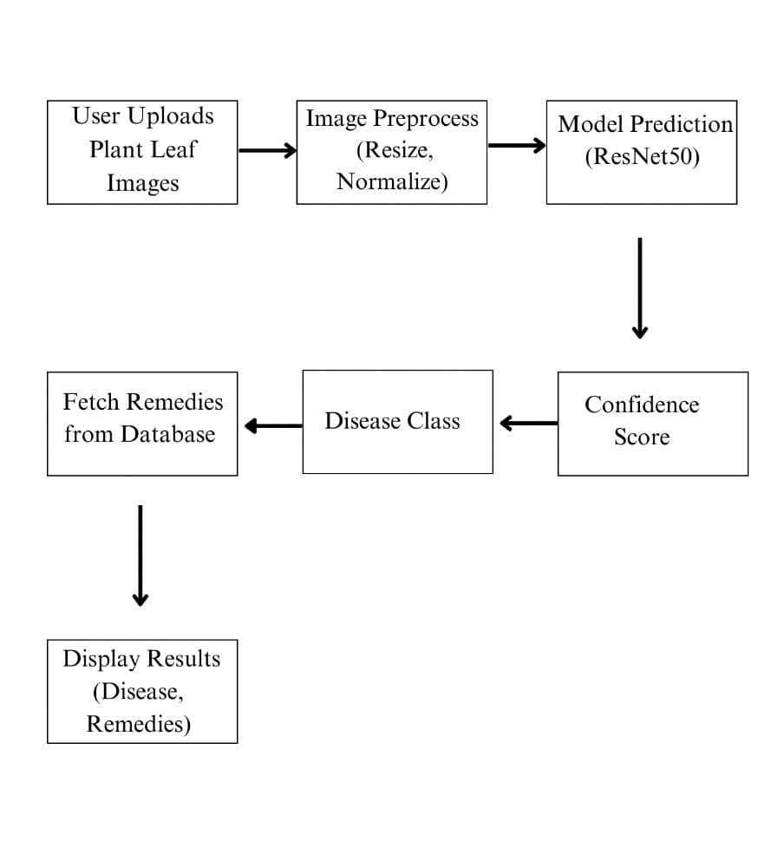

8.2 SYSTEM ARCHITECTURE:

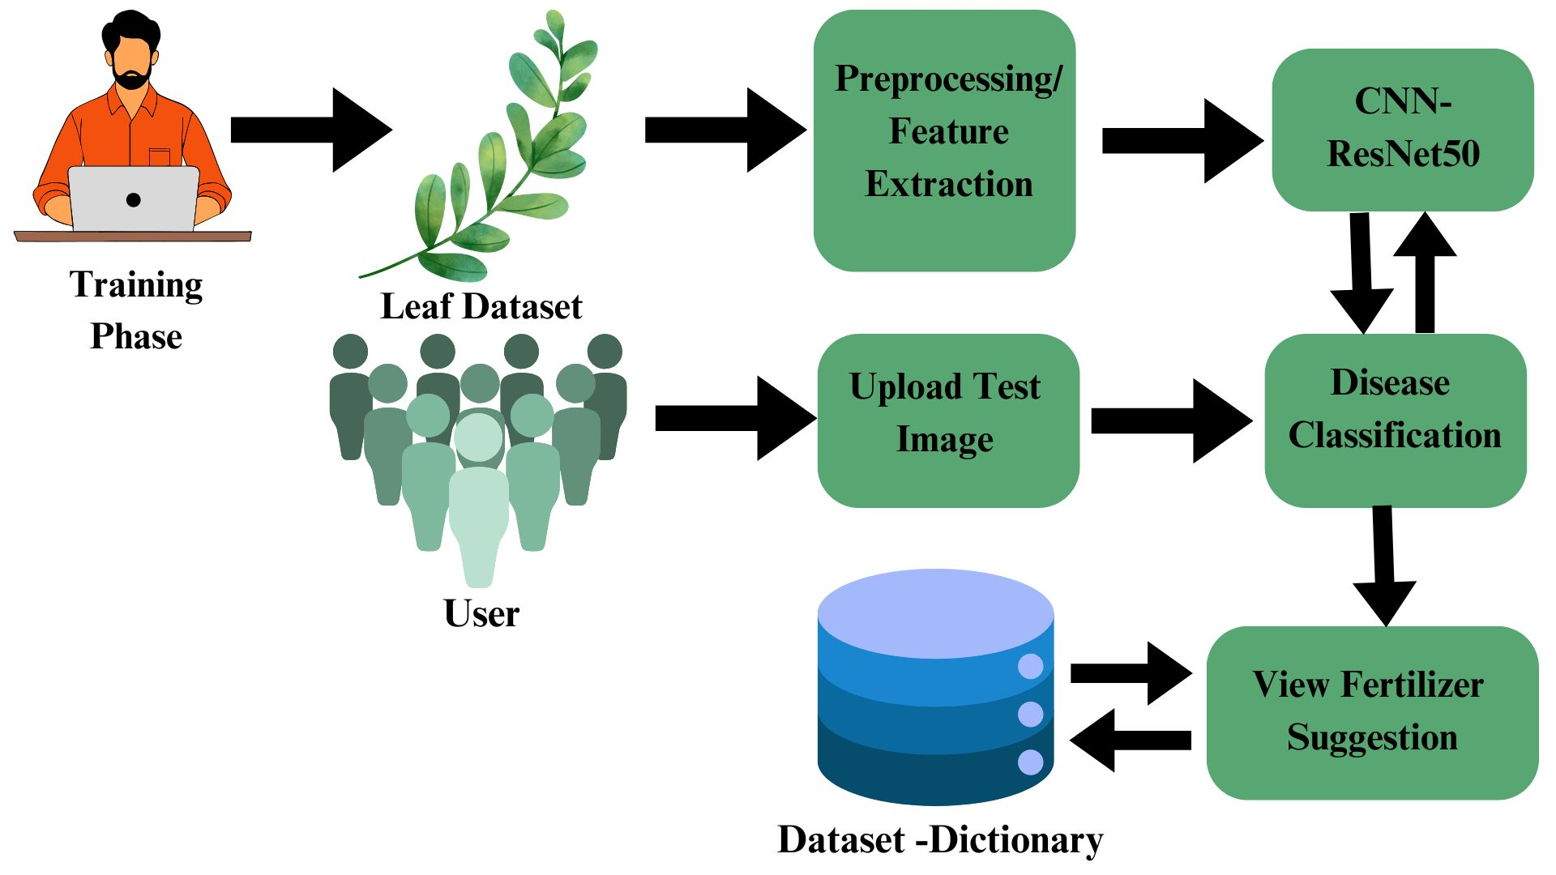

8.3 CODING:
import os
os.environ['TF_ENABLE_ONEDNN_OPTS'] = '0'
os.environ['TF_CPP_MIN_LOG_LEVEL'] = '3'

import streamlit as st
import tensorflow as tf
import numpy as np
from PIL import Image

# Suppress TensorFlow warnings
tf.get_logger().setLevel('ERROR')

# Set page config
st.set_page_config(
page_title="Plant Disease Detection",
page_icon="🌱",
layout="centered"
)

# Load model and class indices
@st.cache_resource
def load_model():
model_path = os.path.join(os.path.dirname(__file__), 'best_model (3).h5')
class_indices_path = os.path.join(os.path.dirname(__file__), 'class_indices.npy')

model = tf.keras.models.load_model(model_path)
model.compile() # Fix metric warnings
class_indices = np.load(class_indices_path, allow_pickle=True).item()
return model, class_indices

model, class_indices = load_model()

# Remedies database
REMEDIES = {
'Potato___healthy': {
'description': 'Healthy potato plant',
'remedies': [
'No action needed',
'Maintain good growing conditions'
]
},
'Potato___Early_blight': {
'description': 'Fungal disease causing dark spots on leaves',
'remedies': [
'Remove and destroy infected leaves',
'Apply copper-based fungicides',
'Practice crop rotation'
]
},
'Tomato_Septoria_leaf_spot': {
'description': 'Fungal disease causing small dark spots with light centers on leaves',
'remedies': [
'Remove affected leaves',
'Use fungicides like chlorothalonil',
'Avoid overhead watering'
]
},
'Tomato__Tomato_mosaic_virus': {
'description': 'Viral disease causing mottled, mosaic-like leaf patterns',
'remedies': [
'Remove and destroy infected plants',
'Control aphids and other insect vectors',
'Use resistant tomato varieties'
]
},
'Pepper__bell___healthy': {
'description': 'Healthy bell pepper plant',
'remedies': [
'No action needed',
'Ensure proper watering and nutrition'
]
},
'Tomato_Spider_mites_Two_spotted_spider_mite': {
'description': 'Tiny pests causing yellowing and webbing on leaves',
'remedies': [
'Spray plants with neem oil or insecticidal soap',
'Introduce predatory mites',
'Increase humidity to deter mites'
]
},
'Tomato__Target_Spot': {
'description': 'Fungal disease causing brown spots with yellow halos on leaves',
'remedies': [
'Apply copper-based fungicides',
'Remove infected leaves',
'Improve air circulation around plants'
]
},
'Tomato_healthy': {
'description': 'Healthy tomato plant',
'remedies': [
'No action needed',
'Maintain good growing conditions'
]
},
'Pepper__bell___Bacterial_spot': {
'description': 'Bacterial disease causing water-soaked spots on leaves and fruit',
'remedies': [
'Remove infected plants',
'Apply copper sprays',
'Use disease-resistant varieties'
]
},
'Tomato_Late_blight': {
'description': 'Serious fungal disease causing brown, water-soaked lesions',
'remedies': [
'Remove and destroy affected plants',
'Apply fungicides containing chlorothalonil',
'Ensure proper air circulation'
]
},
'Potato___Late_blight': {
'description': 'Severe fungal disease causing dark lesions on leaves and tubers',
'remedies': [
'Use resistant potato varieties',
'Apply fungicides like chlorothalonil or copper-based sprays',
'Avoid excessive moisture'
]
},
'Tomato_Early_blight': {
'description': 'Fungal disease causing dark, concentric rings on leaves',
'remedies': [
'Apply fungicides such as copper-based sprays',
'Remove affected leaves',
'Use mulch to prevent soil splash'
]
},
'Tomato__Tomato_YellowLeaf__Curl_Virus': {
'description': 'Viral disease causing leaf curling and yellowing',
'remedies': [
'Remove and destroy infected plants',
'Control whiteflies, the main vector',
'Use virus-resistant tomato varieties'
]
},
'Tomato_Bacterial_spot': {
'description': 'Bacterial disease causing small, water-soaked spots on leaves and fruit',
'remedies': [
'Remove affected plants',
'Apply copper-based sprays',
'Use disease-free seeds'
]
},
'Tomato_Leaf_Mold': {
'description': 'Fungal disease causing yellowing and mold growth on leaves',
'remedies': [
'Improve air circulation',
'Apply fungicides like copper-based sprays',
'Avoid overhead watering'
]
}
}

def predict_image(img):
"""Process image and return prediction results"""
img = img.resize((224, 224))
img_array = tf.keras.preprocessing.image.img_to_array(img) / 255.0
img_array = np.expand_dims(img_array, axis=0)

pred = model.predict(img_array, verbose=0)
class_idx = np.argmax(pred[0])
class_name = list(class_indices.keys())[class_idx]
confidence = np.max(pred[0])

return class_name, confidence, REMEDIES.get(class_name, {
'description': 'No information available',
'remedies': ['Consult with an agricultural expert']
})

def main():
"""Main application interface"""
st.title("🌱 Plant Disease Detection & Remedies")
st.markdown("---")

with st.container():
uploaded_file = st.file_uploader(
"Upload a plant leaf image",
type=["jpg", "jpeg", "png"],
help="Supported formats: JPG, JPEG, PNG"
)

if uploaded_file is not None:
try:
image = Image.open(uploaded_file)
st.image(image, caption='Uploaded Image', use_column_width=True)

class_name, confidence, remedy = predict_image(image)

# Display results
st.subheader("🔍 Analysis Results")
st.markdown(f"""
**Predicted Disease:**
{class_name.replace('___', ' ').title()}
""")

# Display remedies
st.subheader("🩺 Recommended Remedies")
st.markdown(f"**Description:** {remedy['description']}")
st.markdown("**Treatment Recommendations:**")
for i, treatment in enumerate(remedy['remedies'], 1):
st.markdown(f"{i}. {treatment}")

except Exception as e:
st.error(f"Error processing image: {str(e)}")

if __name__ == "__main__":
main()

8.4 SAMPLE OUTPUT

