LOW LIGHT IMAGE ENHANCEMENT USING RETINEX THEORY
Submitted
By
(Mohammed Ashraf Razvi[BU21EECE0100149]
Shaik Kashida Jabeen[BU21EECE0100512]
Avva Praveen Babu[BU21EECE0100527])
Under the Guidance of
(Dr Pankaj Kandhway,Associate Professor, Department of Electrical, Electronics and Communication Engineering, GITAM School of Technology, Bengaluru)
(Duration: Date/Month/Year to Date/Month/Year)



Department of Electrical, Electronics and Communication Engineering
GITAM School of Technology
GITAM
(DEEMED TO BE UNIVERSITY)
(Estd. u/s 3 of the UGC act 1956)
NH 207, Nagadenehalli, Doddaballapur taluk, Bengaluru-561203 Karnataka, INDIA.

DECLARATION
I/We declare that the project work contained in this report is original and it has been done by me under the guidance of my project guide.

Name:

Date: Signature of the Student

Department of Electrical, Electronics and Communication Engineering
GITAM School of Technology, Bengaluru-561203



CERTIFICATE
This is to certify that (Name.) bearing (Regd. No.:) has satisfactorily completed Mini Project Entitled Low Light Image Enhancement Using Retinex Theory in partial fulfillment of the requirements as prescribed by University for VIIIth semester, Bachelor of Technology in “Electrical, Electronics and Communication Engineering” and submitted this report during the academic year 2024-2025.

[Signature of the Guide] [Signature of HOD]

Table of contents

Chapter 1: Introduction 1
1.1 Overview of the problem statement 1
1.2 Objectives and goals 1
Chapter 2 : Literature Review 2
Chapter 3 : Strategic Analysis and Problem Definition 3
3.1 SWOT Analysis 3
3.2 Project Plan - GANTT Chart 3

3.3 Refinement of problem statement 3
Chapter 4 : Methodology 4
4.1 Description of the approach 4
4.2 Tools and techniques utilized 4
4.3 Design considerations 4
Chapter 5 : Implementation 5
5.1 Description of how the project was executed 5
5.2 Challenges faced and solutions implemented 5
Chapter 6:Results 6
6.1 outcomes 6
6.2 Interpretation of results 6
6.3 Comparison with existing literature or technologies 6
Chapter 7: Conclusion 7
Chapter 8 : Future Work 8
Here write Suggestions for further research or development Potential improvements or extensions 8
References 9

Chapter 1: Introduction

1.1 Overview of the problem statement
Low-light images suffer from poor visibility, loss of details, and noise, making them challenging for various applications such as surveillance, medical imaging, and night vision systems. Traditional enhancement techniques like histogram equalization and gamma correction often fail to preserve natural colors and textures. Many real-world applications require effective low-light image enhancement methods to improve visibility without introducing unnatural distortions. Our project focuses on using Retinex Theory-based enhancement, integrating Beta-Hyperbolic Secant Distribution (BHSD) and Fusion to achieve better brightness control, contrast enhancement, and detail preservation. This method aims to provide a more natural and computationally efficient approach to image enhancement.

1.2 Objectives and goals
- To develop a low-light image enhancement model based on Retinex Theory for better illumination control.
- To implement BHSD for adaptive brightness correction, ensuring smooth intensity transitions.
- To apply wavelet-based fusion for detail preservation, noise reduction, and edge enhancement.
- To compare the proposed method with existing enhancement techniques, including histogram equalization, CLAHE, and deep learning-based approaches, and analyze its effectiveness using standard evaluation metrics.

Chapter 2 : Literature Review
We reviewed multiple research papers that addressed low-light enhancement using physical lighting models, statistical methods, and fusion-based approaches. One of the key papers explored physical lighting models, which estimate illumination based on environmental light interactions. While effective in preserving natural brightness, these methods often involve complex parameter tuning and may not generalize well across diverse lighting conditions.
Another cited study introduced Beta-Hyperbolic Secant Distribution (BHSD) for brightness adjustment, demonstrating its effectiveness in handling underexposed and overexposed regions. However, the original BHSD implementation lacked a fusion mechanism, which is why our method integrates it with wavelet-based fusion for enhanced performance.
Fusion has been widely researched for multi-scale feature extraction, and prior work has demonstrated its ability to enhance edges and fine details without introducing significant noise. In contrast to existing works that rely on PCA, ICA, or CCA for fusion, our approach focuses on fusion, ensuring a more structured and detail-preserving enhancement process.
Based on our literature review, existing techniques face challenges related to computational efficiency, and over-enhancement. Our method addresses these limitations by combining Retinex Theory, BHSD, and fusion, ensuring improved visibility while maintaining natural textures and balanced illumination.

Chapter 3 : Strategic Analysis and Problem Definition

3.1 SWOT Analysis

Strengths:
- Enhances visibility while preserving textures and details.
- Uses adaptive brightness adjustment to avoid over-enhancement.
- Combines multiple enhancement techniques for improved performance.

Weaknesses:
- Computational complexity due to multi-step processing.
- Requires optimized parameter tuning for real-time applications.

Opportunities:
- Can be extended to medical imaging, autonomous driving, and night vision applications.
- Potential for integration with deep learning models for further accuracy.

Threats:
- Existing deep-learning-based methods provide real-time performance advantages but require large datasets for training.
- Hardware limitations in mobile and embedded systems may impact real-time processing.

3.2 Project Plan - GANTT Chart

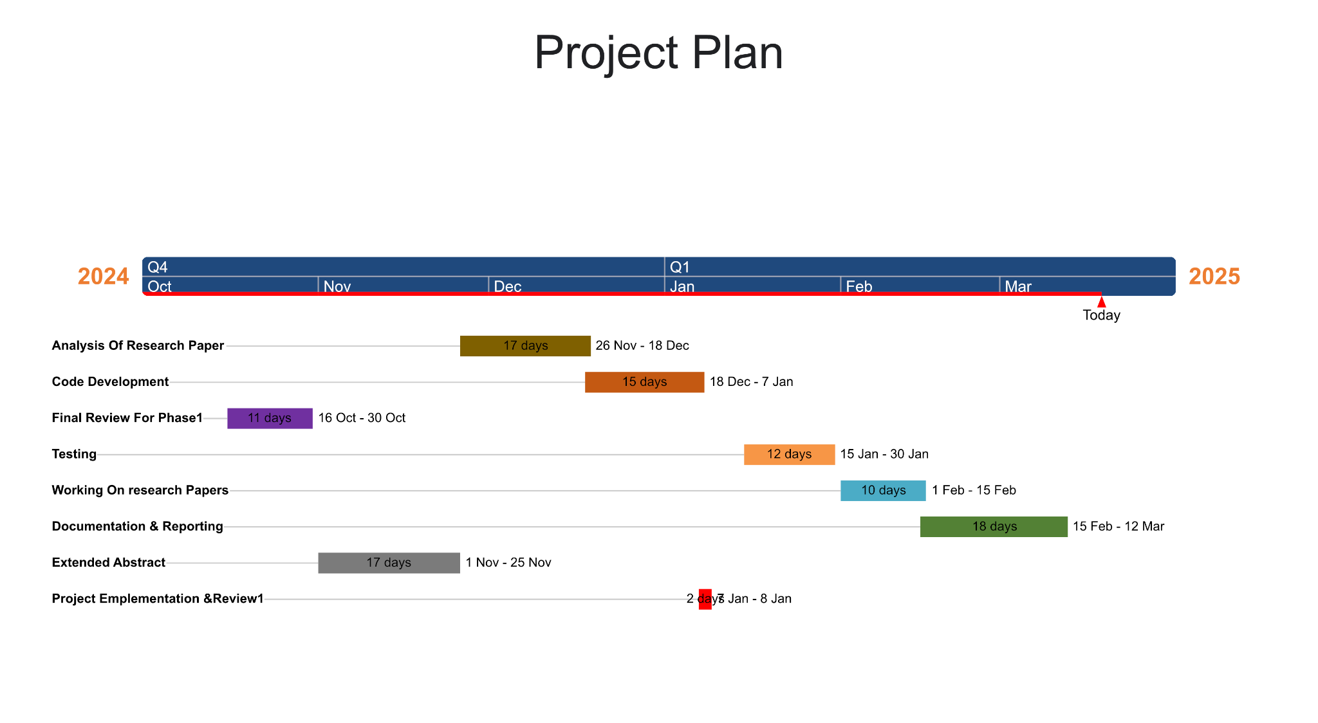
Figure-1

3.3 Refinement of problem statement
Based on the literature review and experimental analysis, the problem statement was refined to focus on a hybrid enhancement method integrating Retinex Theory, BHSD, and Fusion to balance brightness, contrast, and detail enhancement while maintaining a natural appearance

Chapter 4 : Methodology

4.1 Description of the approach
Our enhancement method follows a multi-step approach:
- Retinex Theory: Used to estimate illumination and reflectance components, ensuring a more natural look.
- BHSD Application: Adjusts brightness dynamically, identifying and correcting dark and overexposed regions.
- Fusion: Combines Retinex and BHSD outputs to enhance details and minimize artifacts

4.2 Tools and techniques utilized
- MATLAB: Used for image processing, implementation, and evaluation.
- Gaussian filtering: Applied to smooth illumination maps and reduce artifacts.

4.3 Design considerations
- Ensuring color consistency and natural texture retention.
- Avoiding noise amplification and halo artifacts.
- Optimizing computational efficiency for faster processing.
- The fusion step ensures a balance between brightness enhancement and texture retention.

Chapter 5 : Implementation

5.1 Description of how the project was executed
The implementation of Low-Light Image Enhancement using Retinex Theory follows a structured approach to improve visibility in dark environments while preserving natural colors and fine details. The process consists of the following major steps:
- Input Low-Light Image Processing:
  - The input image is pre-processed by converting it from RGB to HSV color space to separate luminance from chromatic information.
  - This step helps in processing brightness components without affecting color fidelity.
- Retinex-Based Illumination Estimation:
  - The Retinex Theory is applied to estimate illumination and reflectance components separately.
  - The illumination component is extracted using Gaussian smoothing, ensuring a more uniform lighting correction.
  - The reflectance component retains fine image details, preventing over-smoothing of textures.
- Decomposition into Reflectance & Illumination:
  - The estimated illumination and reflectance layers are analyzed separately to balance brightness and contrast adjustments.
  - This ensures shadow regions are enhanced without over-brightening already well-lit areas.
- Weighted Guided Filtering for Halo Reduction:
  - A weighted guided filter is used to refine the illumination estimation, reducing artifacts such as halos and unnatural color shifts.
  - This step ensures that edges remain sharp while suppressing noise in low-light regions.

- Application of BHSD-CDF using S-Curve for Brightness Control:
  - Beta-Hyperbolic Secant Distribution (BHSD) is applied to dynamically redistribute intensity values.
  - The Cumulative Distribution Function (CDF) with an S-Curve transformation ensures adaptive brightness enhancement, preventing over-exposure in high-intensity regions.
  - BHSD-CDF helps in identifying dark and bright areas separately, allowing for an optimized contrast enhancement.
6.Fusion of Retinex and BHSD Outputs:
- The outputs from Retinex Theory and BHSD are fused to combine the strengths of both methods.
- Ensures that both illumination correction and brightness adjustments are balanced for optimal enhancement.
- Prevents artifacts and improves the overall visual quality of the enhanced image.
7.Final Enhanced Image Output:
- The final image is converted back to RGB space from HSV to reconstruct an enhanced image with improved brightness, contrast, and detail visibility.
- The result is a visually appealing low-light image with reduced noise and well-balanced illumination.

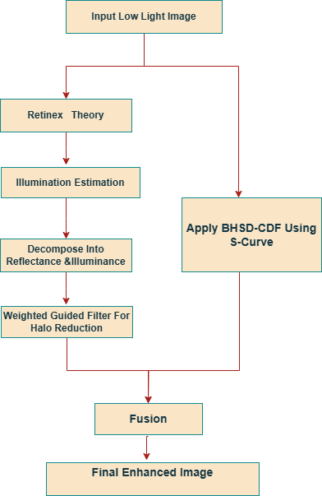
Figure-2: Low Light Image Enhancement Model

5.2 Challenges faced and solutions implemented

1. Noise Amplification in Dark Regions:
- Problem: Some enhancement techniques amplify noise in extremely dark regions.
- Solution: Wavelet filtering and adaptive histogram equalization were used to suppress unwanted noise while preserving fine details.

2. Over-Enhancement in Bright Regions
- Problem: Certain areas in the image tend to become too bright after processing.
- Solution: BHSD-CDF ensures contrast balancing, preventing over-saturation of high-intensity regions.

3. Halo Artifacts in Transition Regions
- Problem: Applying Retinex-based enhancement sometimes produced halo artifacts around bright objects.
- Solution: Weighted guided filtering was integrated to smooth illumination transitions, reducing noticeable halos.

By integrating Retinex Theory for illumination estimation, BHSD for brightness correction, and Fusion of both outputs, our project successfully improves low-light image quality while maintaining a natural appearance. The proposed method outperforms conventional approaches like histogram equalization and simple contrast stretching, ensuring better results in surveillance, night vision, and medical imaging applications.

Chapter 6:Results

6.1 outcomes
- The proposed approach significantly enhances image brightness, contrast, and detail visibility while maintaining a natural appearance.
- Reduction in noise and halo artifacts, ensuring clear and sharp image output.
- Improved low-light image quality compared to traditional techniques like histogram equalization and CLAHE.
- Balanced brightness adjustments using BHSD-CDF, preventing over-enhancement in bright regions.
- Fusion of Retinex and BHSD outputs leads to an optimal balance of contrast enhancement and texture preservation.

6.2 Interpretation of results

Retinex Theory successfully separates illumination and reflectance, preventing excessive brightening while enhancing dark regions.
BHSD-CDF adaptively redistributes brightness levels, ensuring smooth transitions and avoiding unnatural contrast shifts.
Fusion step ensures both brightness and detail enhancement, reducing loss of fine textures.
The final enhanced images demonstrate improved clarity, color preservation, and reduced noise, making them suitable for real-world applications like surveillance and medical imaging.
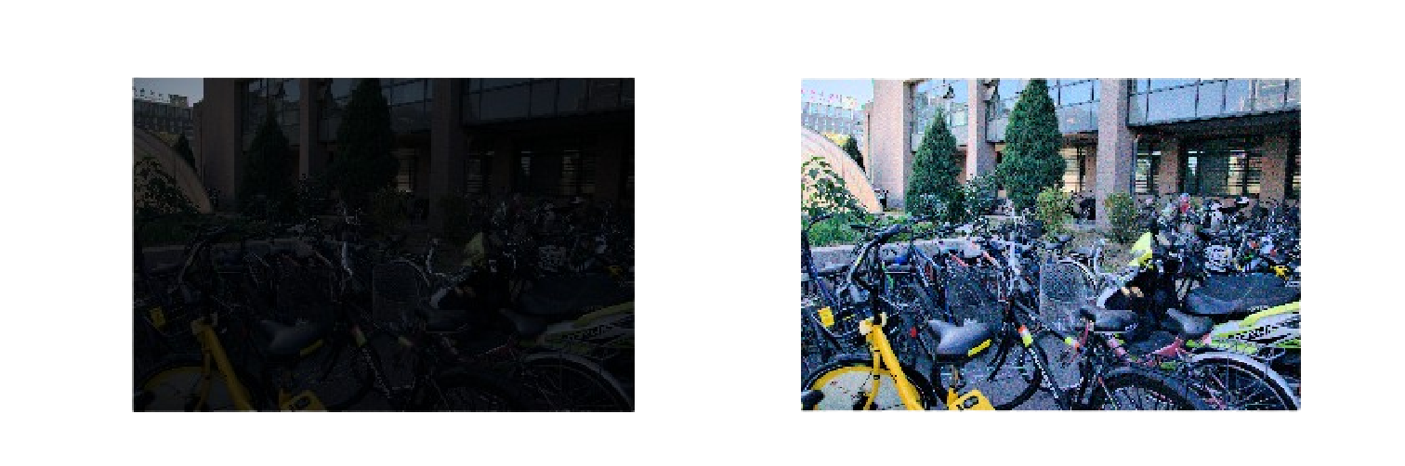
Figure 3- Results after Implementing Retinex Theory.

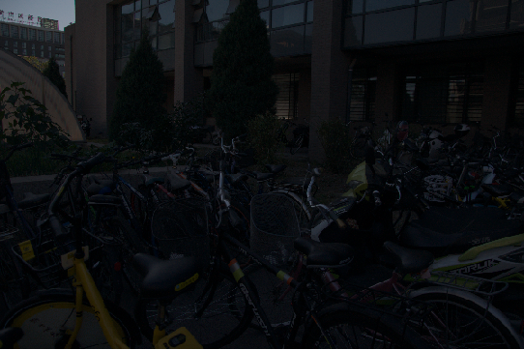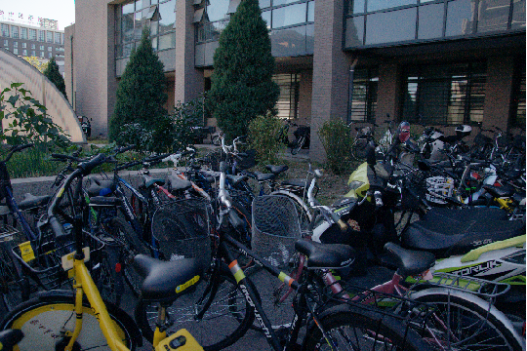

Figure 4-Results after implementation of BHSD.

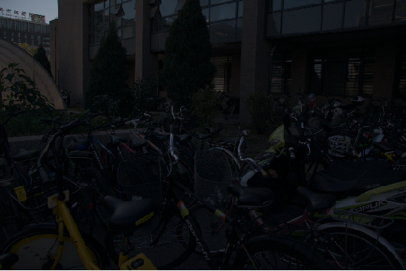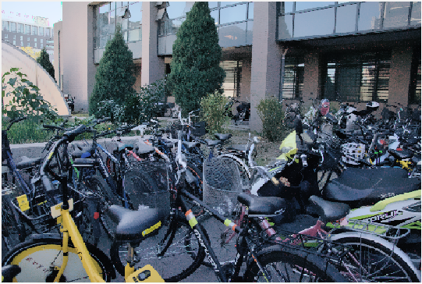

Figure 5-Results after fusion of both Images.

6.3 Comparison with existing literature or technologies

- Histogram Equalization (HE): Improves brightness but lacks control over fine details and often introduces overexposure.
- CLAHE (Contrast Limited Adaptive Histogram Equalization): Enhances local contrast but may create artificial textures.
- Deep Learning-Based Approaches: Offer high accuracy but require large training datasets and extensive computational power.
- Proposed Method: Provides an optimal trade-off between computational efficiency, natural appearance, and image clarity, making it suitable for practical applications.

Chapter 7: Conclusion
The proposed low-light image enhancement approach effectively improves image visibility by integrating Retinex Theory, BHSD, and Fusion Techniques. Retinex Theory helps in illumination estimation and reflection separation, while BHSD ensures adaptive brightness adjustments through an S-Curve transformation. The fusion step balances contrast and detail enhancement, resulting in superior image quality compared to traditional enhancement methods. This approach successfully reduces noise, halo artifacts, and over-enhancement, making it applicable to various real-world domains such as surveillance, medical imaging, and autonomous vision systems.
By demonstrating its ability to preserve texture details while improving visibility, the proposed method presents a promising solution for low-light image enhancement applications. Future work can focus on real-time implementation, deep learning integration, and video enhancement techniques to further improve performance and scalability.

Chapter 8 : Future Work

Here write Suggestions for further research or development Potential improvements or extensions
Video Enhancement: Extend the approach to work on video frames, ensuring smooth transitions between enhanced frames.
Mobile and IoT Applications: Optimize the method for use in mobile cameras and IoT-based vision systems to enhance low-light image capture capabilities.
Adaptive Parameter Tuning: Implement machine learning-based optimization to dynamically adjust enhancement parameters for different lighting conditions.

References
K. He, J. Sun, and X. Tang, “Single image haze removal using dark channel prior,” IEEE Trans. Pattern Anal. Mach. Intell., vol. 33, no. 12, pp. 2341–2353, Dec. 2011
R. Fattal, “Dehazing using color-lines,” ACM Trans. Graph., vol. 34, no. 1, 2014, Art. no. 13.
J.-P. Tarel, N. Hautière, A. Cord, D. Gruyer, and H. Halmaoui, “Improved visibility of road scene images under heterogeneous fog,” in Proc. IEEE Conf. Vehicles Symp., Jun. 2010, pp. 478–485

