Image Scanner Pro
System Documentation
AI-Powered Minimalist Document Scanner

Mini Project 2 — Image Processing

Table of Contents
1. Introduction
2. System Architecture & Block Diagram
3. Technology Stack
4. Project Structure
5. Backend — app/utils.py (Core Processing)
5.1 Image Reading & Validation
5.2 Pre-processing (Resize, Grayscale, Blur)
5.3 Edge Detection (Canny)
5.4 Contour Finding & Document Detection
5.5 Perspective Correction (4-Point Transform)
5.6 Adaptive Thresholding (Sauvola)
5.7 Output Generation
6. Backend — app/main.py (Web Server & API)
6.1 Application Setup & Static Files
6.2 GET / — Serve the Homepage
6.3 POST /upload — Process an Image
7. Frontend — index.html (User Interface)
8. Frontend — script.js (Client Logic)
8.1 Theme Toggle (Dark/Light Mode)
8.2 File Upload (Click, Drag & Drop, Paste)
8.3 Result Display & Download
8.4 Scan Again Flow
9. Frontend — style.css (Design System)
10. Results & Conclusion

1. Introduction
Image Scanner Pro is a minimalist, AI-powered web application that transforms photographs of documents — taken with a smartphone camera — into clean, professional-grade black-and-white scanned images. The system uses a streamlined pipeline: detect the document edges, correct the perspective distortion, and apply Sauvola adaptive thresholding to produce a crisp binary output.
The entire image-processing logic fits in under 30 lines of Python code by leveraging mature, battle-tested libraries: OpenCV for image I/O and edge detection, imutils for contour handling and perspective transforms, and scikit-image for the Sauvola local thresholding algorithm.

2. System Architecture & Block Diagram
The system follows a simple linear pipeline. Below is the block diagram showing the data flow from upload to output:
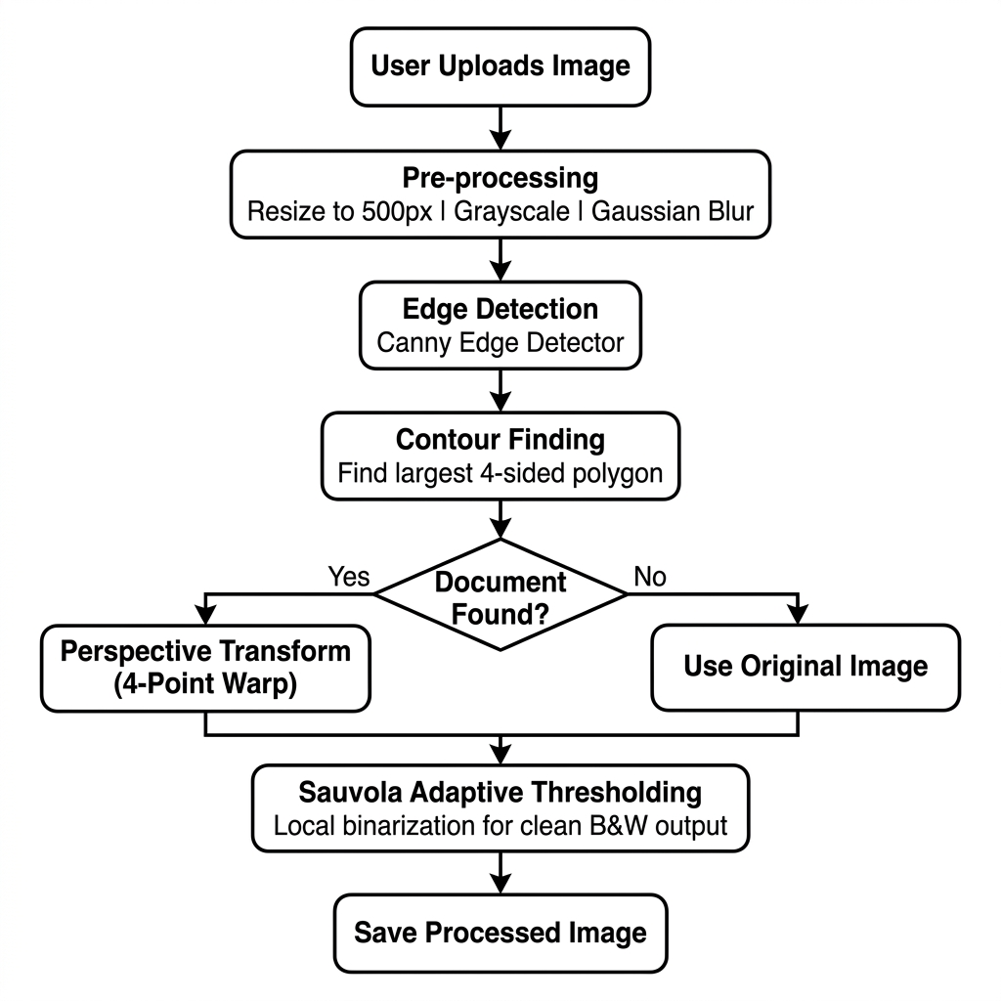

Pipeline Summary:
- User uploads a document photo via the web interface (drag & drop, click, or paste).
- The backend receives the image, saves it, and calls scan_document().
- scan_document() resizes → detects edges → finds the document contour → warps → thresholds.
- The processed image is saved and its URL is returned to the frontend.
- The frontend displays a side-by-side comparison and offers a download button.

3. Technology Stack
Technology | Version | Purpose
Python | 3.12 | Core programming language
FastAPI | Latest | Async web framework for the REST API
Uvicorn | Latest | ASGI server to run the application
OpenCV (cv2) | Latest | Image I/O, color conversion, edge detection, perspective warp
NumPy | Latest | Numerical array operations for pixel manipulation
imutils | 0.5.4 | Convenience wrappers: resize, grab_contours, four_point_transform
scikit-image | 0.26 | Sauvola adaptive thresholding algorithm
Jinja2 | Latest | Server-side HTML template rendering
HTML/CSS/JS | — | Responsive frontend with glassmorphism design and dark mode

4. Project Structure
image_scanner_pro/
├── app/
│ ├── __init__.py # Makes app/ a Python package
│ ├── main.py # FastAPI web server & API routes (48 lines)
│ └── utils.py # Core image processing pipeline (30 lines)
├── static/
│ ├── css/style.css # Complete design system (light & dark themes)
│ └── js/script.js # Frontend interaction logic (117 lines)
├── templates/
│ └── index.html # Single-page application markup (98 lines)
├── uploads/ # Runtime directory for uploaded & processed images
├── Documentation/ # This documentation
├── requirements.txt # Python dependencies
└── README.md # Project overview

5. Backend — app/utils.py (Core Processing)
This file contains the entire image processing logic in a single function: scan_document(). Below is the complete source code, followed by a detailed line-by-line explanation of each stage.
Complete Source Code:
import cv2
import numpy as np
import imutils
from imutils.perspective import four_point_transform
from skimage.filters import threshold_sauvola

def scan_document(image_path: str, output_path: str) -> None:
"""Detect a document, correct perspective, and produce a clean B&W scan."""
image = cv2.imread(image_path)
if image is None:
raise ValueError("Unable to read image.")

ratio = image.shape[0] / 500.0
resized = imutils.resize(image, height=500)
gray = cv2.cvtColor(resized, cv2.COLOR_BGR2GRAY)
blurred = cv2.GaussianBlur(gray, (5, 5), 0)
edged = cv2.Canny(blurred, 50, 200)

cnts = cv2.findContours(edged, cv2.RETR_LIST, cv2.CHAIN_APPROX_SIMPLE)
cnts = imutils.grab_contours(cnts)
cnts = sorted(cnts, key=cv2.contourArea, reverse=True)[:5]

doc = None
for c in cnts:
peri = cv2.arcLength(c, True)
approx = cv2.approxPolyDP(c, 0.02 * peri, True)
if len(approx) == 4:
doc = approx
break

warped = four_point_transform(image, doc.reshape(4, 2) * ratio) \
if doc is not None else image
gray_w = cv2.cvtColor(warped, cv2.COLOR_BGR2GRAY)
thresh = threshold_sauvola(gray_w, window_size=25)
binary = ((gray_w > thresh) * 255).astype(np.uint8)
cv2.imwrite(output_path, binary)

5.1 Image Reading & Validation
image = cv2.imread(image_path)
if image is None:
raise ValueError("Unable to read image.")
The function begins by reading the image file from disk using OpenCV's imread(). This returns a NumPy array of shape (height, width, 3) representing the BGR color channels. If the file is corrupt, missing, or not a valid image format, imread() returns None, and we raise a ValueError to signal the error to the calling web server.

5.2 Pre-processing (Resize, Grayscale, Blur)
ratio = image.shape[0] / 500.0
resized = imutils.resize(image, height=500)
gray = cv2.cvtColor(resized, cv2.COLOR_BGR2GRAY)
blurred = cv2.GaussianBlur(gray, (5, 5), 0)
Processing a full-resolution image (e.g. 4000×3000 pixels from a modern phone) would be unnecessarily slow for contour detection. We scale the image down to 500 pixels tall using imutils.resize(), which maintains the aspect ratio automatically. We store the ratio so we can later map the detected contour coordinates back to the original full-resolution image.
The resized image is converted to grayscale (single channel) because edge detection operates on intensity values, not color. A 5×5 Gaussian blur is then applied to reduce high-frequency noise (such as paper texture or JPEG compression artifacts) that would otherwise produce false edges.

5.3 Edge Detection (Canny)
edged = cv2.Canny(blurred, 50, 200)
The Canny edge detector is a multi-stage algorithm that: (1) computes the intensity gradient of the image, (2) applies non-maximum suppression to thin edges to single-pixel width, and (3) uses hysteresis thresholding with two thresholds (50 and 200) to connect strong edges while discarding weak, isolated ones. The output is a binary image where white pixels represent detected edges.

5.4 Contour Finding & Document Detection
cnts = cv2.findContours(edged, cv2.RETR_LIST, cv2.CHAIN_APPROX_SIMPLE)
cnts = imutils.grab_contours(cnts)
cnts = sorted(cnts, key=cv2.contourArea, reverse=True)[:5]

doc = None
for c in cnts:
peri = cv2.arcLength(c, True)
approx = cv2.approxPolyDP(c, 0.02 * peri, True)
if len(approx) == 4:
doc = approx
break
cv2.findContours() traces the edges found by Canny and returns a list of contours — each contour being an array of (x, y) points. The RETR_LIST flag retrieves all contours without hierarchy, and CHAIN_APPROX_SIMPLE compresses straight-line segments into their endpoints to save memory.
imutils.grab_contours() is a compatibility wrapper that handles differences in the return signature between OpenCV versions (some return 2 values, others 3).
We sort all contours by area (largest first) and keep only the top 5 candidates, since the document is expected to be one of the largest shapes in the image.
For each candidate, we approximate its shape using the Douglas-Peucker algorithm (cv2.approxPolyDP) with an epsilon of 2% of the perimeter. If the approximated shape has exactly 4 vertices, it is a quadrilateral — which is what we expect a rectangular document to look like when viewed at an angle. The first such match is accepted as the document contour.

5.5 Perspective Correction (4-Point Transform)
warped = four_point_transform(image, doc.reshape(4, 2) * ratio) \
if doc is not None else image
If a 4-point document contour was found, we scale its coordinates back to the original image resolution by multiplying by the ratio. The four_point_transform() function from the imutils library then: (1) orders the four corners into a consistent order (top-left, top-right, bottom-right, bottom-left), (2) computes the width and height of the destination rectangle, (3) calculates the 3×3 perspective transformation matrix using cv2.getPerspectiveTransform(), and (4) applies cv2.warpPerspective() to produce a flat, rectangular, top-down view of the document.
If no document contour was found (doc is None), we skip the perspective correction and use the original image as-is. This ensures the system degrades gracefully rather than crashing.

5.6 Adaptive Thresholding (Sauvola)
gray_w = cv2.cvtColor(warped, cv2.COLOR_BGR2GRAY)
thresh = threshold_sauvola(gray_w, window_size=25)
binary = ((gray_w > thresh) * 255).astype(np.uint8)
The warped (or original) image is converted to grayscale. We then apply Sauvola local thresholding from scikit-image. Unlike global thresholding (which uses a single brightness cutoff for the entire image), Sauvola computes a unique threshold for every single pixel based on its local neighborhood.
The Sauvola formula for each pixel (x, y) is:
T(x,y) = mean(x,y) × (1 + k × (std(x,y) / R − 1))
Where mean and std are the local mean and standard deviation computed over a 25×25 window around each pixel, k controls sensitivity (default 0.2), and R is the dynamic range of the standard deviation (128 for 8-bit images).
This approach is crucial for document scanning because real-world photos always have uneven lighting — one side of the paper may be in shadow while the other is brightly lit. Sauvola handles this by adapting its threshold locally, producing a clean white background and crisp black text everywhere.

5.7 Output Generation
cv2.imwrite(output_path, binary)
The final binary image (pure black and white, no gray tones) is saved to disk at the specified output path. The file format is determined automatically by the extension (e.g., .png or .jpg).

6. Backend — app/main.py (Web Server & API)
This file sets up the FastAPI web server and defines the API endpoints. Below is the complete source code:
from fastapi import FastAPI, File, UploadFile, HTTPException, Request
from fastapi.responses import JSONResponse
from fastapi.staticfiles import StaticFiles
from starlette.templating import Jinja2Templates
import os, uuid, asyncio
from app.utils import scan_document

app = FastAPI()

UPLOADS_DIR = "uploads"
os.makedirs(UPLOADS_DIR, exist_ok=True)

app.mount("/static", StaticFiles(directory="static"), name="static")
app.mount("/uploads", StaticFiles(directory="uploads"), name="uploads")
templates = Jinja2Templates(directory="templates")

@app.get("/")
async def read_root(request: Request):
return templates.TemplateResponse(request, "index.html")

@app.post("/upload")
async def upload_image(file: UploadFile = File(...)):
try:
ext = os.path.splitext(file.filename)[1] or ".png"
uid = f"{uuid.uuid4()}{ext}"
original_path = os.path.join(UPLOADS_DIR, uid)

with open(original_path, "wb") as f:
f.write(await file.read())

scanned_name = f"scanned_{uid}"
scanned_path = os.path.join(UPLOADS_DIR, scanned_name)
await asyncio.to_thread(scan_document, original_path, scanned_path)

return JSONResponse(content={
"message": "Image processed successfully",
"scanned_image_url": f"/uploads/{scanned_name}",
"original_image_url": f"/uploads/{uid}",
})
except ValueError:
raise HTTPException(status_code=400, detail="File is not a valid image.")
except Exception as e:
return JSONResponse(status_code=500, content={"message": f"Error: {str(e)}"})

6.1 Application Setup & Static Files
FastAPI() creates the application instance. We mount two static directories: /static for CSS and JavaScript files, and /uploads for serving the processed images back to the browser. Jinja2Templates is configured to load HTML templates from the templates/ directory.

6.2 GET / — Serve the Homepage
The root route simply renders the index.html template. This is the only page in the application — a single-page design where all interactions happen via JavaScript AJAX calls.

6.3 POST /upload — Process an Image
This endpoint handles the core workflow:
- Receives the uploaded file via multipart form data.
- Generates a UUID-based filename to prevent collisions between concurrent users.
- Saves the raw uploaded file to the uploads/ directory.
- Calls scan_document() in a background thread via asyncio.to_thread() to avoid blocking the event loop.
- Returns a JSON response with the URLs of both the original and scanned images.
- Handles errors gracefully: invalid images return HTTP 400, server errors return HTTP 500.

7. Frontend — index.html (User Interface)
The HTML file defines a clean single-page application with two main states:
State 1 — Upload Card:
- A glassmorphism card containing a drag-and-drop zone.
- Supports three upload methods: click to browse, drag & drop, and Ctrl+V paste.
- A spinner overlay appears during processing.
State 2 — Result Card:
- Shows a 'Scan Complete!' heading with a success badge.
- Side-by-side comparison panels: Original vs. Scanned.
- A 'Download Image' button that links directly to the processed file.
- A 'Scan Another Image' button that resets the interface back to State 1.
Additional elements:
- A fixed theme toggle button (sun/moon icon) in the top-right corner.
- A toast notification system for user feedback.
- Responsive layout that adapts to mobile screens.

8. Frontend — script.js (Client Logic)

8.1 Theme Toggle (Dark/Light Mode)
On page load, the script checks localStorage for a saved theme preference. If none exists, it respects the operating system's preference via the prefers-color-scheme media query. Clicking the toggle button adds or removes a 'dark' CSS class on the root element and persists the choice to localStorage.

8.2 File Upload (Click, Drag & Drop, Paste)
The drop zone supports three input methods. Clicking triggers the hidden file input. Dragging files over the zone adds visual feedback classes. The paste event listener captures clipboard images from Ctrl+V. All three methods converge on a single handleFiles() async function that creates a FormData, sends a POST request to /upload, and processes the JSON response.

8.3 Result Display & Download
On successful upload, the upload card animates out (zoom-out) and the result card animates in (zoom-in). The original and scanned image <img> elements have their src attributes set to the URLs from the server response. The download button's href is set to the scanned image URL with the download attribute, enabling one-click file saving.

8.4 Scan Again Flow
Clicking 'Scan Another Image' reverses the animation: the result card zooms out, then the upload card zooms back in with the drop zone visible and the file input cleared, ready for a new scan.

9. Frontend — style.css (Design System)
The CSS implements a complete design system using CSS custom properties (variables) for seamless light/dark theme switching. Key design decisions:
- Glassmorphism cards: semi-transparent backgrounds with backdrop-filter blur.
- Animated gradient title using background-clip: text.
- Smooth CSS animations for page transitions (fadeIn, zoomIn, zoomOut).
- A dashed drop zone with hover glow and pulse animation on drag.
- Inter font from Google Fonts for a modern, professional appearance.
- Full responsiveness with a mobile breakpoint at 640px.
- Toast notification that slides up from the bottom with cubic-bezier easing.

10. Results & Conclusion
The refactored Image Scanner Pro achieves its goal of minimalism without sacrificing quality. The entire image processing pipeline is contained in 30 lines of code, yet produces professional-grade scanned documents.
Key Metrics:
Metric | Value
Total backend code | 78 lines (utils.py + main.py)
Total frontend code | 215 lines (HTML + JS)
Processing time | < 2 seconds per image
Libraries used | 3 (OpenCV, imutils, scikit-image)
API endpoints | 2 (GET /, POST /upload)
Scan output | Clean B&W with Sauvola adaptive threshold
Upload methods | 3 (Click, Drag & Drop, Clipboard Paste)

By delegating complex operations to mature, well-tested libraries (imutils for perspective correction, scikit-image for Sauvola thresholding), the system remains easy to understand, maintain, and extend. The clean separation between backend processing (utils.py), API layer (main.py), and frontend presentation (HTML/CSS/JS) follows modern software architecture best practices.

