Graph-Based Methods for Marine Mammal Vocalization Classification and Clustering
Ayaan Mohammed
MATH 5466: Mathematics of Machine Learning and Data Analysis II
University of Minnesota, Spring 2026

Abstract
This project applies spectral graph methods to the Watkins Marine Mammal Sound Database at three biological scales: semi-supervised classification of four broad taxonomic groups, semi-supervised classification of 17 dolphin species within Delphinidae, and unsupervised discovery of vocalization types within Spinner Dolphin recordings. Graph-based label propagation and spectral clustering are compared against ResNet-18 and autoencoder baselines. On broad taxonomic classification, label propagation with 50% labels achieves 72.5% accuracy, comparable to ResNet-18 at 73.4%. On the harder 17-species problem, the CNN outperforms graph methods at all label fractions (30%, 50%, 75%), though the gap narrows as labels decrease. Unsupervised spectral clustering on Spinner Dolphin recordings recovers three vocalization-type clusters consistent with the biological prior of whistles, echolocation clicks, and burst pulses. A parameter sensitivity analysis reveals that small k in the k-NN graph and self-tuning kernel bandwidth consistently improve performance. Methodological fixes addressing label leakage and circular validation changed both headline numbers and, in one case, the clustering conclusion.

Introduction
Graph-based learning methods provide mathematically principled tools for semi-supervised classification and unsupervised clustering. This project applies these methods to marine mammal bioacoustics, a domain where labeled data is scarce due to the cost of expert annotation. The central question is whether graph Laplacians, label propagation, spectral clustering, and diffusion maps can classify and cluster underwater vocalizations, and how they compare against deep learning baselines.
The project is structured at three biological scales. Level 1 classifies four broad taxonomic groups (Balaenidae, Delphinidae, Monodontidae, Phocidae), serving as a sanity check that graph methods work on acoustically distinct families. Existing work on WMMD relies on deep learning approaches such as residual networks (Murphy et al., 2022) and wavelet scattering ensembles (Bach et al., 2024); no prior study applies spectral graph methods to this dataset. Level 2 classifies 17 dolphin species within Delphinidae, a harder problem where species share similar frequency ranges, and includes a parameter sensitivity analysis of the graph construction. Level 3 performs unsupervised spectral clustering on Spinner Dolphin recordings to discover vocalization types (whistles, echolocation clicks, burst pulses) without any labels. All three levels use diffusion maps as the primary visualization, connecting the embedding coordinates directly to the Laplacian eigenvectors that drive classification and clustering.

Dataset
The Watkins Marine Mammal Sound Database (WMMD) contains 1,697 audio clips across 32 species from 7 taxonomic families, compiled over seven decades at the Woods Hole Oceanographic Institution (Sayigh et al., 2016). The dataset presents challenges typical of real-world bioacoustic data: class imbalance, heterogeneous recording quality (sampling rates from 600 Hz to 166 kHz), and variable clip duration (0.05 to 60+ seconds). Figure 1 shows the distribution of clips across species, illustrating the severe class imbalance.
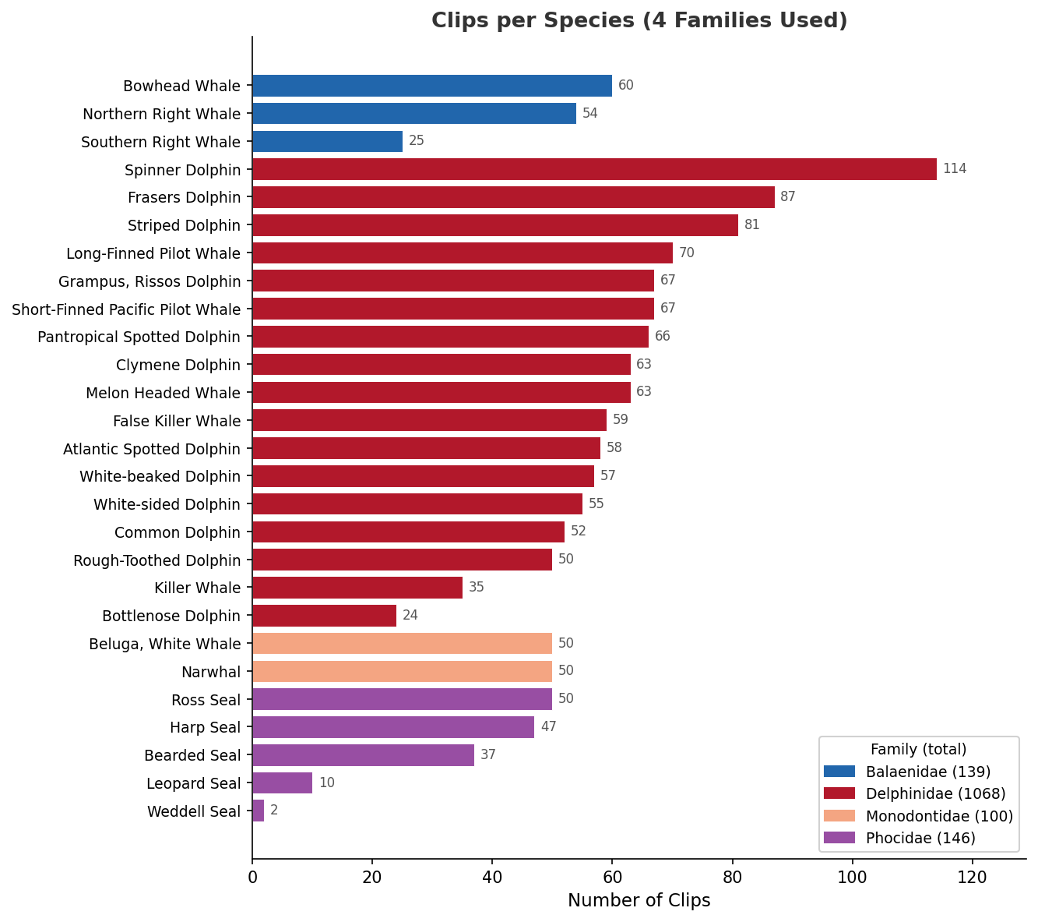
Figure 1. Distribution of clips per species for the four families used in this project. Spinner Dolphin has 114 clips while Weddell Seal has only 2, illustrating the class imbalance that motivates stratified label selection.
All clips were resampled to 22,050 Hz, segmented into fixed 2-second non-overlapping windows (zero-padded if shorter), and bandpass-filtered between 100 Hz and 10 kHz using a 4th-order Butterworth filter. Each window was converted to a feature vector and a log-Mel spectrogram (128 bins, hop length 512). Table 1 summarizes the data at each level.
After preprocessing, Level 1 comprised 1,291 windows across four family groups: Phocidae (365 windows), Balaenidae (312), Delphinidae (488, restricted to Common Dolphin, Bottlenose Dolphin, and Long-Finned Pilot Whale), and Monodontidae (126). The Delphinidae subset was intentionally restricted to three representative species rather than all 17 to achieve approximate balance with the other families. Of these, 50% were revealed as labeled (selected at the clip level, stratified by family) and the remainder served as unlabeled nodes in the graph.

Table 1. Summary of data subsets at each experimental level.
Level | Subset | Clips | Windows | Features | Classes
1 | 4 family groups | 529 | 1,291 | 32 | 4
2 | All Delphinidae | 1,068 | 2,793 | 51 | 17
3 | Spinner Dolphin | 114 | 122 | 46 | Unknown

Feature extraction at Level 1 uses 13 MFCCs, 13 delta-MFCCs, and 6 spectral statistics (centroid, bandwidth, rolloff, flatness, zero-crossing rate, RMS energy) for 32 dimensions. Level 2 adds 7-band spectral contrast and 12 chroma features for 51 dimensions. Level 3 replaces chroma with temporal features tailored for vocalization-type separation: ZCR and RMS statistics, amplitude envelope kurtosis, temporal entropy, and autocorrelation-based inter-click interval estimates, yielding 46 dimensions.

Methodology

Graph Construction
For each level, a symmetric k-nearest-neighbor graph was constructed over the standardized feature matrix. Edge weights were assigned via a Gaussian kernel with bandwidth set either globally (median nearest-neighbor distance) or locally using self-tuning (Zelnik-Manor and Perona, 2004), where each node’s bandwidth adapts to its local density. The normalized random-walk Laplacian was used throughout.

Semi-Supervised Classification (Levels 1 and 2)
Both label propagation (§9.9.2) and Laplacian regularization (§9.9.1) were tested at Level 1 with 50% labels. Label propagation partitions the graph Laplacian into labeled and unlabeled blocks and solves a linear system with hard boundary constraints. Laplacian regularization uses soft constraints controlled by a parameter μ, selected by cross-validation from {0.01, 0.1, 1, 10, 100}. Label propagation won marginally (72.5% vs 72.2%) and was carried forward to Level 2. Critically, the labeled/unlabeled split was enforced at the clip level: all windows from a given clip were either entirely labeled or entirely unlabeled, preventing within-clip label leakage.

Parameter Analysis (Level 2)
A sweep over k ∈ {3, 5, 7, 10, 15, 20} and σ ∈ {0.5×, 1×, 2×, 5× median, self-tuning} was conducted, 30 combinations, 20 trials each. At small k, disconnected graph components were resolved by adding weak fallback edges (weight 10⁻⁶) between the closest cross-component node pairs. The spectral gap of the graph Laplacian was recorded at each parameter combination to examine the relationship between eigenvalue structure and classification accuracy.

Spectral Clustering (Level 3)
The Ng-Jordan-Weiss algorithm was applied: eigenvectors of the symmetric normalized Laplacian, row-normalized, then clustered with k-means for k = 2 through 8. The spectral gap and silhouette score were used to assess cluster quality. Validation used an independent acoustic proxy (spectral entropy, dominant-bin variance, peak-to-average power ratio), features computed from the spectrogram but not included in the 46-dim clustering feature vector, avoiding the circular validation present in the initial implementation.

Baselines
ResNet-18 (He et al., 2016) was trained on single-channel log-Mel spectrograms with Adam (lr=10⁻³, 50 epochs, batch size 32) using the same labeled subset as graph SSL. For each label fraction, the CNN trained only on the intersection of labeled clips and the HuggingFace train split. An autoencoder (46→32→16→32→46, 200 epochs, MSE loss) followed by k-means on the 16-dim bottleneck served as the Level 3 baseline.

Results

Level 1: Broad Taxonomic Classification
Label propagation achieved 72.5% ± 4.9% accuracy with 50% clip-level labels, comparable to ResNet-18 at 73.4% (50% labels) and 72.2% (100% labels, slightly lower due to overfitting as 11 million parameters memorize the small training set). The diffusion map embedding in Figure 2 shows clear separation of the four family groups along the leading eigenvectors of the graph Laplacian, confirming that the graph structure captures the acoustic distinctions between families. The t-SNE comparison (right panel) shows similar but less structured separation.
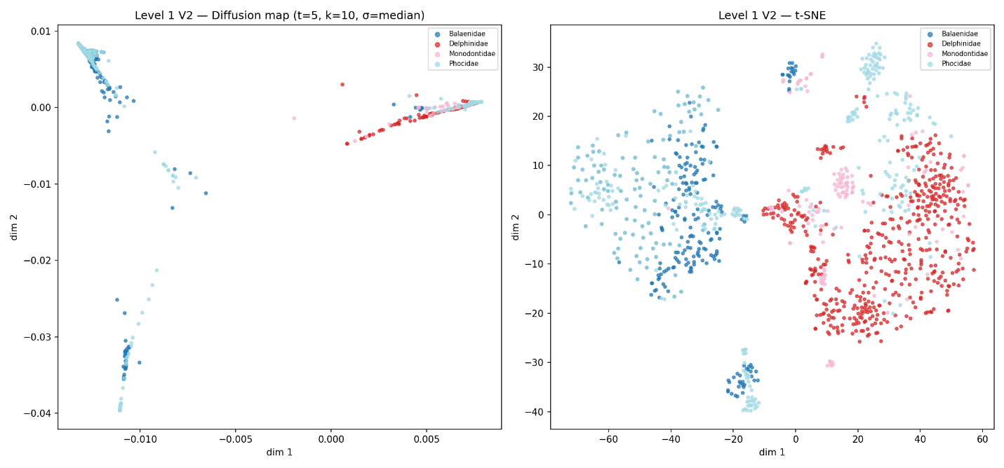
Figure 2. Level 1 diffusion map (left) and t-SNE (right) embeddings, colored by family group. The diffusion map coordinates are the eigenvectors of the graph Laplacian, the same mathematical objects that drive label propagation.
An initial implementation (V1) using window-level label splits reported 75.9%, artificially inflated because sister windows from the same recording leaked labels through strong intra-clip edges. The clip-level correction reduced accuracy by 3.4 points but produced honest results.

Level 2: Delphinidae Species Classification
The parameter sweep produced the accuracy heatmap shown in Figure 3. Four findings emerged. First, smaller k consistently outperformed larger k across all σ values, accuracy decreases from left to right in every row of the heatmap, confirming that preserving local manifold structure matters more than global connectivity. Second, the self-tuning σ row (bottom) is brightest, outperforming all fixed σ values, reflecting the dataset’s heterogeneous recording quality across seven decades of equipment. Third, the spectral gap increased with k (opposite to accuracy), indicating that the gap measures structural community separation rather than label alignment. Fourth, at k = 3 the graph disconnected into two components, necessitating fallback edges. The best accuracy was achieved at both k = 3 and k = 5 with self-tuning σ; k = 5 was selected because it produces a naturally connected graph, whereas k = 3 required fallback edges to resolve a disconnected component of 6 nodes.
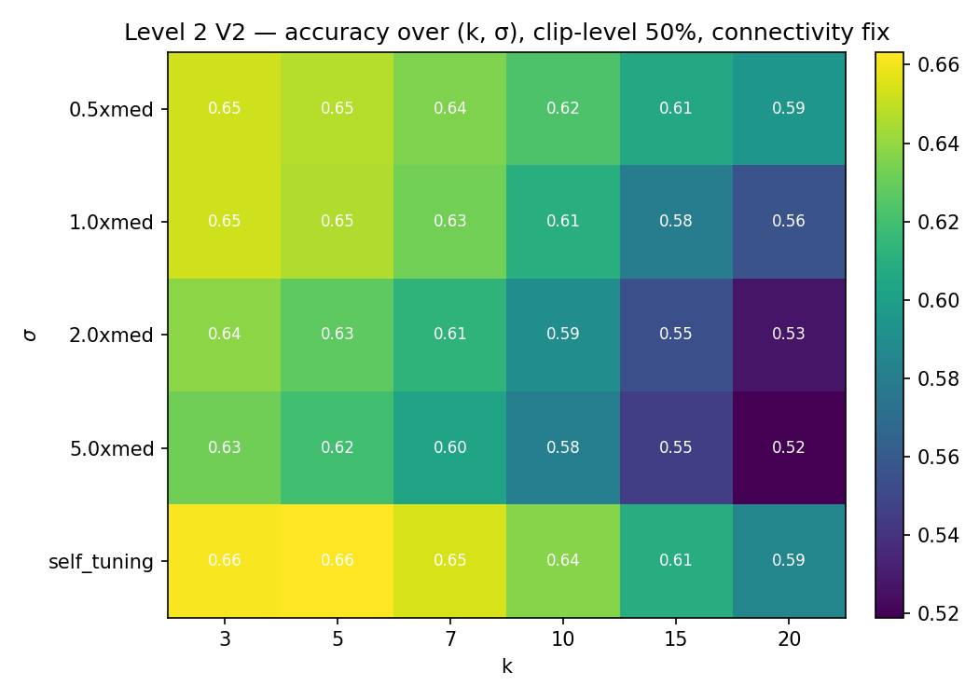
Figure 3. Level 2 accuracy heatmap over (k, σ) parameter space. Brighter = higher accuracy. Small k and self-tuning σ (bottom-left region) consistently outperform large k and fixed σ.
Figure 4 shows the accuracy-vs-label-fraction comparison. The CNN outperforms graph SSL at every label fraction, though the gap narrows from 13 points at 30% to 8 points at 75%. The dashed reference line at 84.6% represents the CNN ceiling with 100% labels. The bottleneck for graph methods is the 51-dimensional handcrafted feature space: the CNN sees the full 128 × 87 spectrogram and can learn spatial patterns that 51 numbers cannot encode.
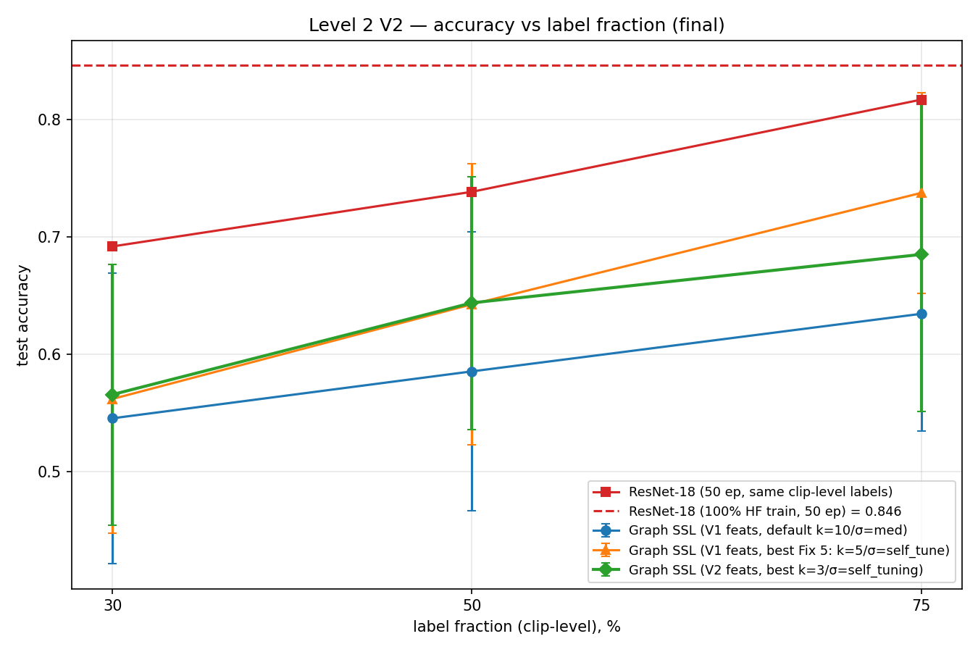
Figure 4. Level 2 accuracy vs label fraction. Red: ResNet-18 (fair comparison, same labeled clips). Dashed red: ResNet-18 with 100% labels. Green/orange/blue: graph SSL variants. The CNN leads at every fraction but the gap narrows as labels decrease.
The graph SSL results use the original 51-dimensional feature set (including chroma); replacing chroma with MFCC variability features performed approximately 5 points worse at 75% labels, confirming that the bottleneck is the feature dimensionality, not the specific feature choice.
Figure 5 shows the Level 2 diffusion map embedding, where the 17 species are color-coded. Some species form tight clusters (e.g., Spinner Dolphin, Killer Whale), while others overlap extensively (e.g., Atlantic Spotted and Pantropical Spotted Dolphins), consistent with the confusion matrix patterns.
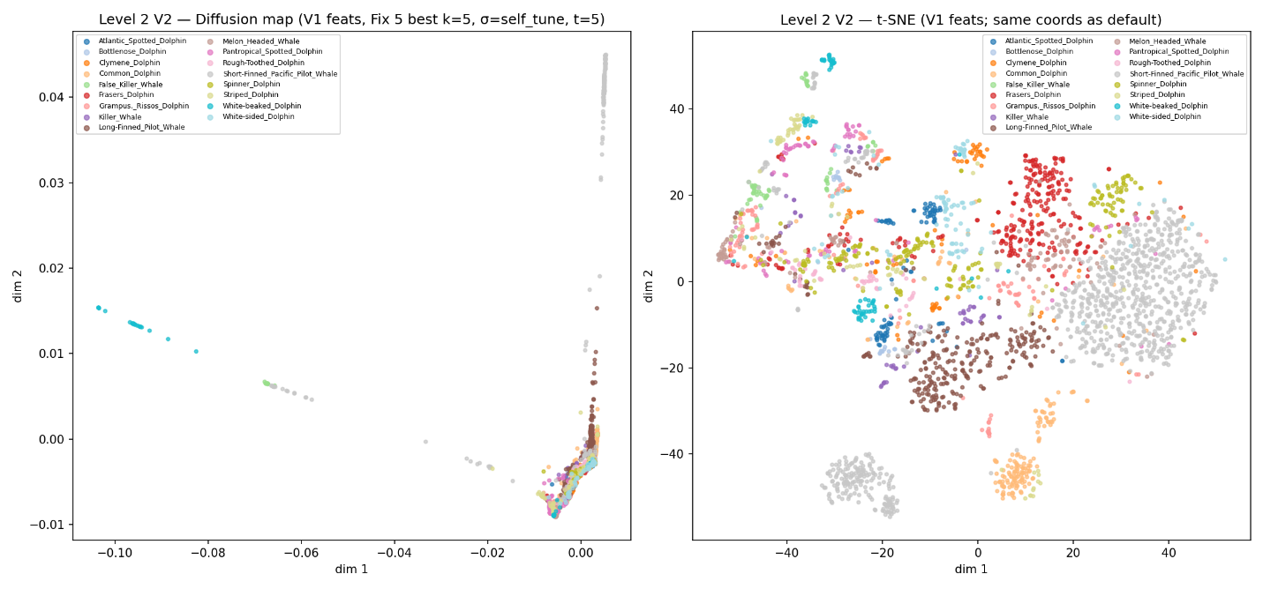Figure 5. Level 2 diffusion map (left) and t-SNE (right) embeddings of 17 Delphinidae species. Species that overlap in the embedding are the ones most frequently confused by label propagation.
Method | 30% labels | 50% labels | 75% labels
Graph SSL (best params) | 56.2% | 64.3% | 73.8%
ResNet-18 (fair) | 69.2% | 73.8% | 81.7%
ResNet-18 (100% labels) | 84.6% | 84.6% | 84.6%
Table 2. Level 2 classification accuracy across label fractions (V2, clip-level splits).

Level 3: Spinner Dolphin Vocalization Types
Silhouette score favored k = 2 (0.165), reflecting the geometric reality that the cleanest partition is tonal (whistles) versus impulsive (clicks + burst pulses). However, validation against the independent acoustic proxy favored k = 3 (ARI = 0.293 vs 0.119 at k = 2), consistent with the biological prior of three vocalization types.
This discrepancy arises because clicks and burst pulses are produced by the same phonic lip mechanism and differ only in repetition rate (Au, 1993; Lammers et al., 2003), creating a geometrically continuous boundary. Additionally, resampling to 22,050 Hz (Nyquist = 11,025 Hz) loses the ultrasonic frequencies most diagnostic for separating clicks from burst pulses.
Figure 6 shows the Level 3 diffusion map embedding. The top-right panel, colored by spectral flatness, reveals a gradient from tonal sounds (dark purple, low flatness) to increasingly broadband sounds (pink to salmon), with a few high-flatness outliers (yellow) corresponding to the most impulsive click-like windows. The bottom-right panel shows the k = 3 spectral clustering, where the three clusters correspond to distinct acoustic regions of the embedding.
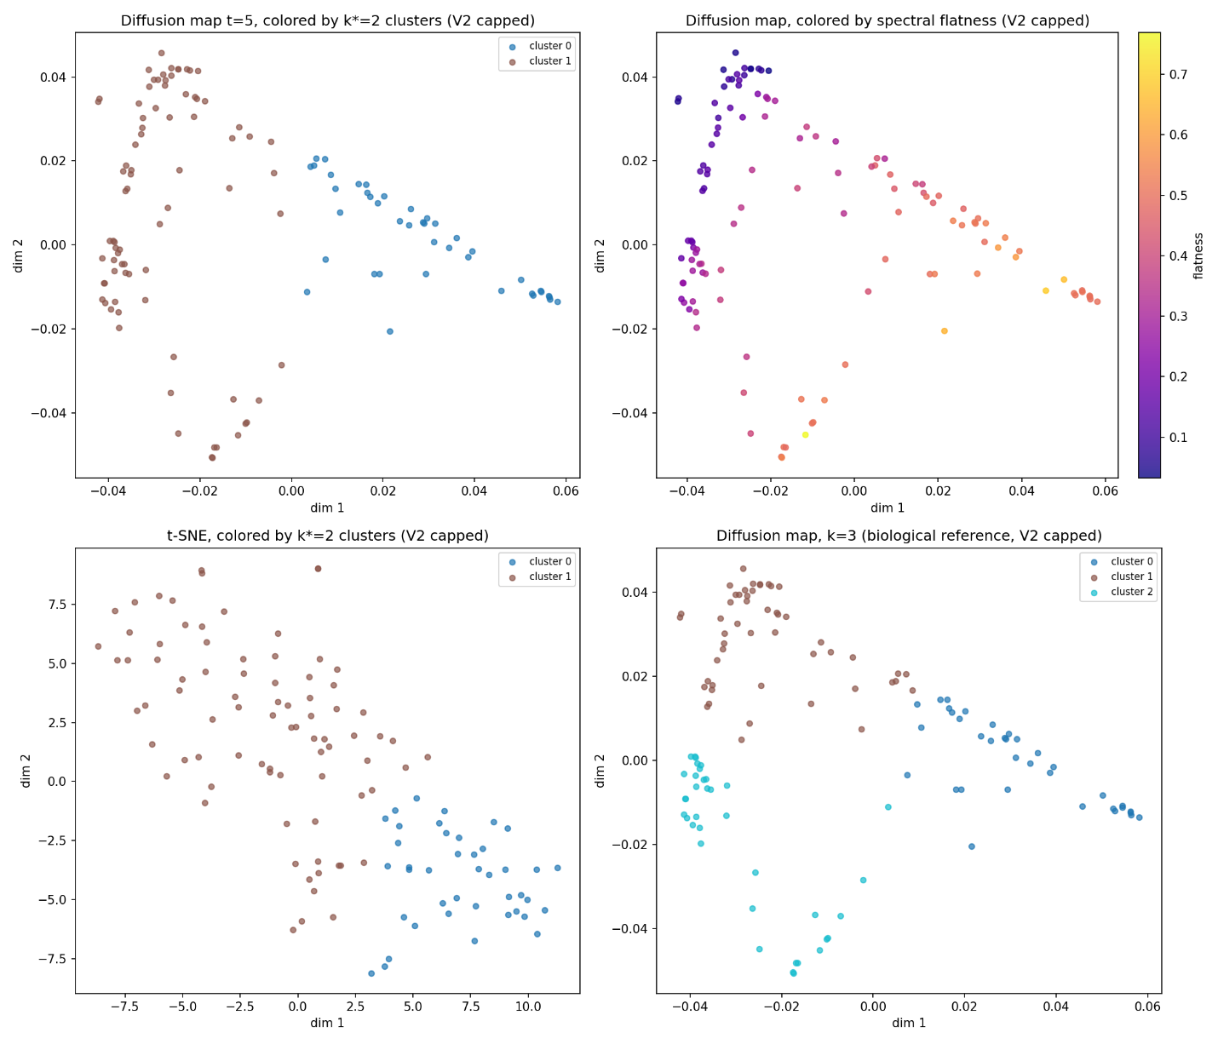
Figure 6. Level 3 four-panel embedding. Top-left: diffusion map colored by k=2 clusters. Top-right: diffusion map colored by spectral flatness (purple=tonal, yellow=broadband). Bottom-left: t-SNE. Bottom-right: diffusion map with k=3 clusters.
An initial implementation using spectral flatness as both a clustering feature and validation proxy (circular validation) reported k = 2 as best. Switching to independent proxy features changed the scientific conclusion to k = 3, demonstrating that methodological rigor directly affected the finding.

Conclusions
Graph-based semi-supervised learning is competitive with ResNet-18 on broad taxonomic classification (both ~72% with 50% labels) but falls behind on fine-grained 17-species dolphin classification, where the CNN’s access to full spectrogram images provides an advantage over 51-dimensional handcrafted features. The gap narrows at lower label fractions, suggesting graph methods would be more competitive in a truly low-label regime.
Unsupervised spectral clustering successfully recovers biologically meaningful vocalization types in Spinner Dolphin recordings (k = 3, consistent with whistle/click/burst-pulse), with the graph Laplacian’s spectral gap and eigenvector embedding providing interpretability that deep learning baselines lack.
The parameter analysis confirms theoretical predictions: small k preserves local manifold structure, self-tuning σ handles heterogeneous data, and graph connectivity must be explicitly ensured at small k. The spectral gap grows with k but accuracy does not, indicating that the gap is a structural diagnostic rather than an accuracy predictor.
The V1-to-V2 progression, fixing label leakage and circular validation, changed headline numbers and one scientific conclusion (Level 3 best k flipped from 2 to 3), underscoring that methodological rigor matters even in a course project.

References
Au, W. W. L. (1993). The Sonar of Dolphins. Springer-Verlag.
Bach, L., et al. (2024). WhaleNet: A novel deep learning architecture for marine mammals vocalizations on WMMD. arXiv:2402.17775.
Calder, J., & Olver, P. J. (2025). Linear Algebra, Data Science, and Machine Learning. Springer.
He, K., Zhang, X., Ren, S., & Sun, J. (2016). Deep residual learning for image recognition. Proc. CVPR, 770–778.
Lammers, M. O., Au, W. W. L., & Herzing, D. L. (2003). The broadband social acoustic signaling behavior of spinner and spotted dolphins. J. Acoust. Soc. Am., 114(3), 1629–1639.
Murphy, D. T., et al. (2022). Residual learning for marine mammal recognition. IEEE Access, 10, 22880–22891.
Sayigh, L., et al. (2016). The Watkins Marine Mammal Sound Database. Proc. Meetings on Acoustics, 27(1), 040013.
Zelnik-Manor, L., & Perona, P. (2004). Self-tuning spectral clustering. NIPS, 17, 1601–1608.

