1.How are inline and block elements different from each other?

Ans.

An inline element does not start on a new line and only takes up as much width as necessary.

eg.<span>,<strong>,<select>.

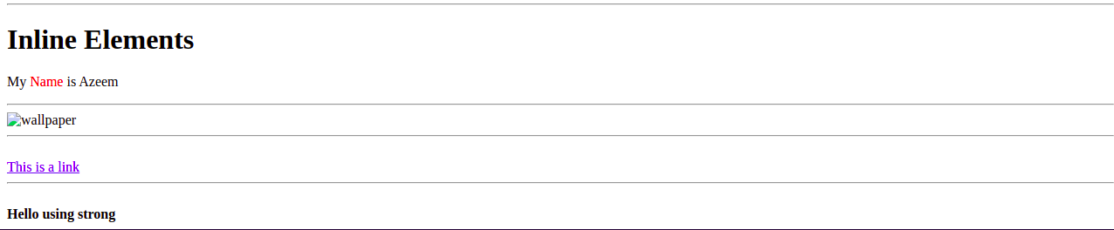

A block-level element always starts on a new line and takes up the full width available (stretches out to the left and right as far as it can).

Eg. <div>, <header>, <footer>, <form>.

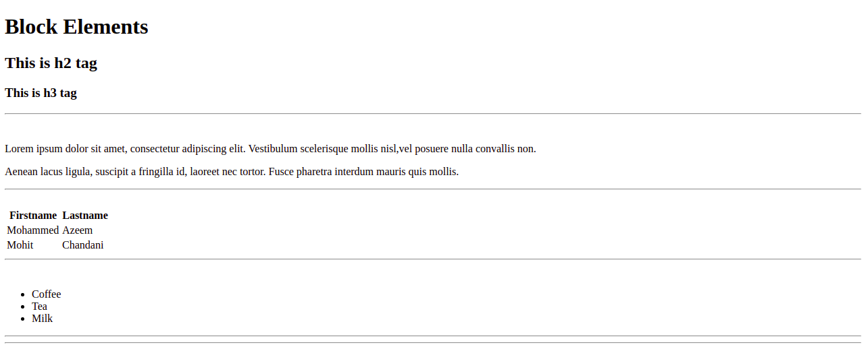

2.Explain the difference between visibility:hidden and display:none

Ans.

display:none means that the tag in question will not appear on the page at all (although you can still interact with it through the dom). There will be no space allocated for it between the other tags.

visibility:hidden means that unlike display:none, the tag is not visible, but space is allocated for it on the page. The tag is rendered, it just isn't seen on the page.

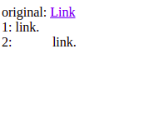

3. Explain the clear and float properties.

Ans. The clear property specifies what elements can float beside the cleared element and on which side.

The clear property can have one of the following values:

* none - Allows floating elements on both sides. This is default
* left - No floating elements allowed on the left side
* right- No floating elements allowed on the right side
* both - No floating elements allowed on either the left or the right side
* inherit - The element inherits the clear value of its parent

The float property is used for positioning and formatting content e.g. let a section float left to the text in a div.

The float property can have one of the following values:

* left - The element floats to the left of its container
* right - The element floats to the right of its container
* none - The element does not float (will be displayed just where it occurs in the text). This is default
* inherit - The element inherits the float value of its parent

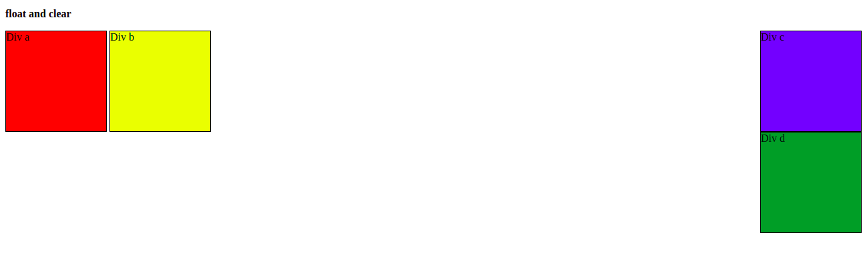

4. Explain difference between absolute, relative,fixed and static.

Ans. The position property specifies the type of positioning method used for an element.

There are five different position values:

* Static:Static positioned elements are not affected by the top, bottom, left, and right properties.
* Relative:This element is positioned relative to its normal position.
* Fixed:This element is positioned relative to the viewport, which means it always stays in the same place even if the page is scrolled.
* Absolute:This element is positioned relative to the nearest positioned ancestor (instead of positioned relative to the viewport, like fixed).
* Sticky:This element is positioned based on the user's scroll position.

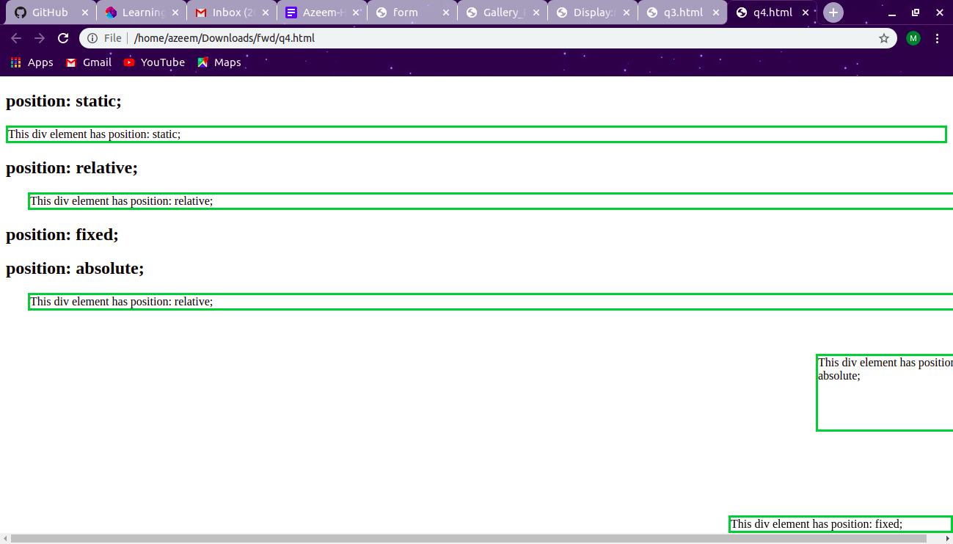

5. Write the HTML code to create a table in which there are 4 columns( ID , Employee Name, Designation, Department) and at least 6 rows. Also do some styling to it.

Ans.

**<SOURCE CODE>**

<!DOCTYPE html>

<html>

<head>

<style>

table {

font-family: arial, sans-serif;

border-collapse: collapse;

width: 100%;

}

td, th {

border: 1px solid #a9a9a9;

text-align: left;

padding: 8px;

}

tr:nth-child(even) {

background-color: cyan;

}

tr:nth-child(odd) {

background-color: grey;

}

</style>

</head>

<body>

<h2>Employee Details</h2>

<table>

<tr>

<th>ID</th>

<th>Employee Name</th>

<th>Designation</th>

<th>Department</th>

</tr>

<tr>

<td>4001</td>

<td>Mohammed Azeem</td>

<td>Trainee</td>

<td>.Net</td>

</tr>

<tr>

<td>4002</td>

<td>Pinki Bhati</td>

<td>Trainee</td>

<td>JVM</td>

</tr>

<tr>

<td>4003</td>

<td>Himanshu Bhansali</td>

<td>Trainee</td>

<td>FEEN</td>

</tr>

<tr>

<td>4004</td>

<td>Vishesh</td>

<td>Trainee</td>

<td>.Net</td>

</tr>

<tr>

<td>4005</td>

<td>Shivam Sharma</td>

<td>Trainee</td>

<td>JVM</td>

</tr>

<tr>

<td>4006</td>

<td>Latika</td>

<td>Trainee</td>

<td>.Net</td>

</tr>

</table>

</body>

</html>

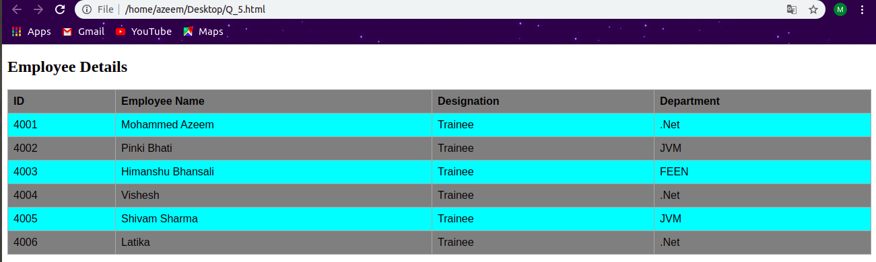

6. Why do we use meta tags?

Ans. The <meta> tag provides metadata about the HTML document. Metadata will not be displayed on the page, but will be machine parsable.

* + Meta elements are typically used to specify page description, keywords, author of the document, last modified, and other metadata. Also, it helps to improve the SEO( Search Engine Optimization) of a web page by using certain keywords related to the web page.
  + <meta> tags always go inside the < head > element.

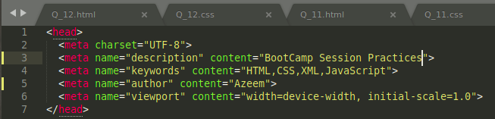

7. Explain box model.

Ans. All HTML elements can be considered as boxes. In CSS, the term "box model" is used when talking about design and layout.

The CSS box model is essentially a box that wraps around every HTML element. It consists of: margins, borders, padding, and the actual content.

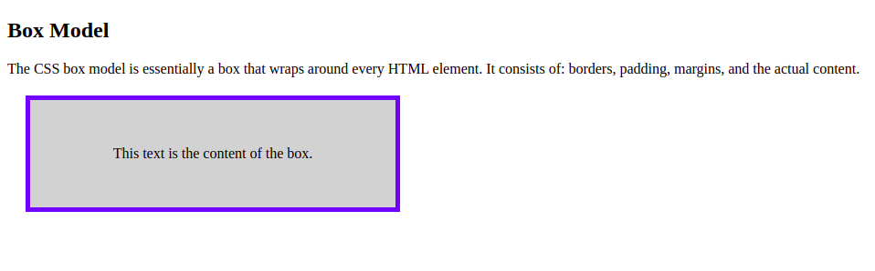

8. What are the different types of CSS Selectors?

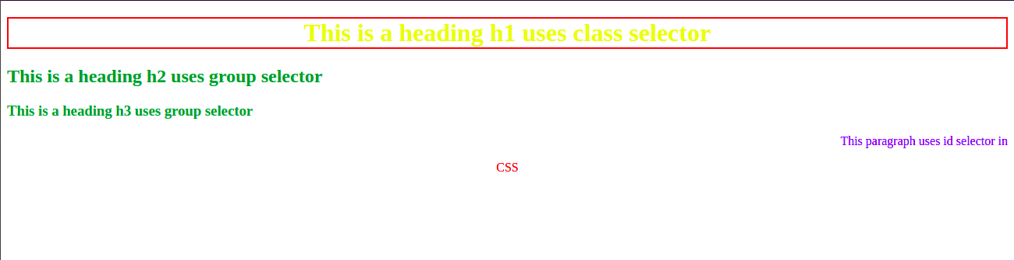

9. Define Doctype.

Ans. The <!DOCTYPE> declaration must be the very first thing in your HTML document, before the <html> tag.

The <!DOCTYPE> declaration is not an HTML tag; it is an instruction to the web browser about what version of HTML the page is written in.

In HTML 4.01, the <!DOCTYPE> declaration refers to a DTD, because HTML 4.01 was based on SGML. The DTD specifies the rules for the markup language, so that the browsers render the content correctly.

10. Explain 5 HTML5 semantic tags.

Ans.

<html>

<body>

<nav>

<a href="#">Nav</a> |

<a href="#">Section</a> |

<a href="#">Article</a> |

<a href="#">Footer</a>

</nav>

<section>

<h1>This is h1 in section tag element</h1>

<p>section tag paragragh tag.</p>

</section>

<article>

<h1>What Does article Do?</h1>

<p>this is a paragrapgh tag in article element.</p>

</article>

</body>

<footer>

<p>Posted by: Azeem</p>

<p>Contact information: <a href="example@example.com">

example@example.com</a>.</p>

</footer>

</html>

