Compilers Project
PyJinjaCompiler
A Lexer / Parser / AST / Semantic Analyzer / Code Generator for Python + Jinja2, with a demo Flask-style web application
Final Project Report — Fall/Spring 2025/2026
Team members: [Name 1], [Name 2], [Name 3]
Group number: [___]
Supervisors: Eng. Aya Shhadeh, Eng. Sarah Al-Muqbaa

1. Introduction
PyJinjaCompiler is a Java/ANTLR-based compiler front end and lightweight interpreter for a subset of Python and a subset of the Jinja2 templating language, built to satisfy the course's compilers project brief: implement the lexing, parsing, AST-construction, semantic-analysis, and code-generation phases for both languages, then demonstrate the whole pipeline inside a small integrated web application.
The two languages are treated as two separate ASTs that share a common expression layer, mirroring how a real templating engine (Flask + Jinja2) separates “the program that computes the data” from “the template that displays it”, while still needing one consistent notion of what an expression, an identifier, or a literal is.

2. Requirement 1 — Lexers and Parsers
Both languages are defined as ANTLR4 grammars and compiled to Java lexers/parsers:
- grammar/python/PythonLexer.g4, PythonParser.g4 — statements (assignment, if/elif/else, for, while, function definitions with decorators, return), expressions with full operator precedence, list and dict literals.
- grammar/jinja/JinjaLexer.g4, JinjaParser.g4 — HTML_TEXT passthrough plus {{ expression }} output tags, {% if/elif/else %} and {% for %} block tags, with the same expression precedence chain as Python (or → and → comparison → additive → multiplicative → unary → primary → trailers).
HTML is handled as the literal text between Jinja tags (HTML_TEXT tokens) rather than a separate grammar, since in this project HTML only ever appears as template markup, never as a language being compiled in its own right.

Scope note — CSS
A CSS grammar was scoped out of this delivery by team decision; every other item in requirement 1 (Python, Jinja2, HTML) is implemented. If CSS support is later required, the same ANTLR4 + AstBuilder + AstVisitor pattern used for Jinja would extend cleanly to it.

3. Requirement 2 — Two AST Trees and the Generator
Two separate ASTs are built from the two parse trees:
- compiler.ast.python — Program (root) plus statement nodes: Assign, ExprStmt, IfStmt/ElifClause/ElseClause, ForStmt, WhileStmt, FunctionDef/FunctionParameter/Decorator, ReturnStmt.
- compiler.ast.jinja — Template (root) plus template-element nodes: HtmlText, ExpressionOutput, JinjaIfStmt/JinjaElifClause/JinjaElseClause, JinjaForStmt.
Both trees are built by a compiler.frontend.{python,jinja}.AstBuilder — an ANTLR visitor that converts the raw parse tree into these typed AST nodes.

The Generator (compiler.generator.Generator)
The Generator is the function the brief specifically asks for: it walks the Python AST looking for a render_template("template.jinja", key=value, ...) call — the same call a real Flask route would make — and, for every keyword argument, resolves the referenced Python variable back to a real value using compiler.generator.ExpressionEvaluator. The result is a RenderCall carrying:
- getContextValues() — real Java values (String/Long/Double/Boolean/List/Map) extracted from the Python data, e.g. the products list built inside a route function.
- getContextSymbolTable() — the same names, typed, packaged as a SymbolTable ready to hand straight to the Jinja semantic analyzer.
This is what “passes data from the array in the Python code to the second (Jinja) tree” concretely means in this implementation: the Generator is the bridge between the two trees, and everything downstream (semantic checking, rendering) consumes what it produces.

4. Requirement 3 — OOP Node Structure
Every AST node implements a common compiler.ast.common.AstNode interface (node name + source line) and one of two role interfaces, Expression or Statement/TemplateElement. Concrete classes extend AbstractAstNode / AbstractExpression / AbstractStatement / AbstractTemplateElement, giving:
- Inheritance — shared fields (name, line) and shared prettyPrint() behaviour live once, in the abstract base classes.
- Polymorphism — every node implements accept(AstVisitor<T> visitor), dispatching to a type-specific visitXxx(...) method. Semantic analysis, printing, and (for Jinja) rendering are all implemented as visitors over the same node hierarchy, rather than as instanceof chains scattered through the codebase.
- Per-node metadata — node name and source line number are stored on every node (via AbstractAstNode's constructor), and used directly in every semantic error message and print method.
The most important structural decision is that the expression layer (Identifier, the literal types, BinaryExpr, UnaryExpr, CallExpr, AttributeAccess, IndexAccess, and the Argument types) lives in compiler.ast.common and is shared, unmodified, by both trees. A BinaryExpr node built while parsing Python arithmetic and a BinaryExpr node built while parsing a Jinja {% if %} condition are literally the same class. The diagram below shows the full hierarchy.
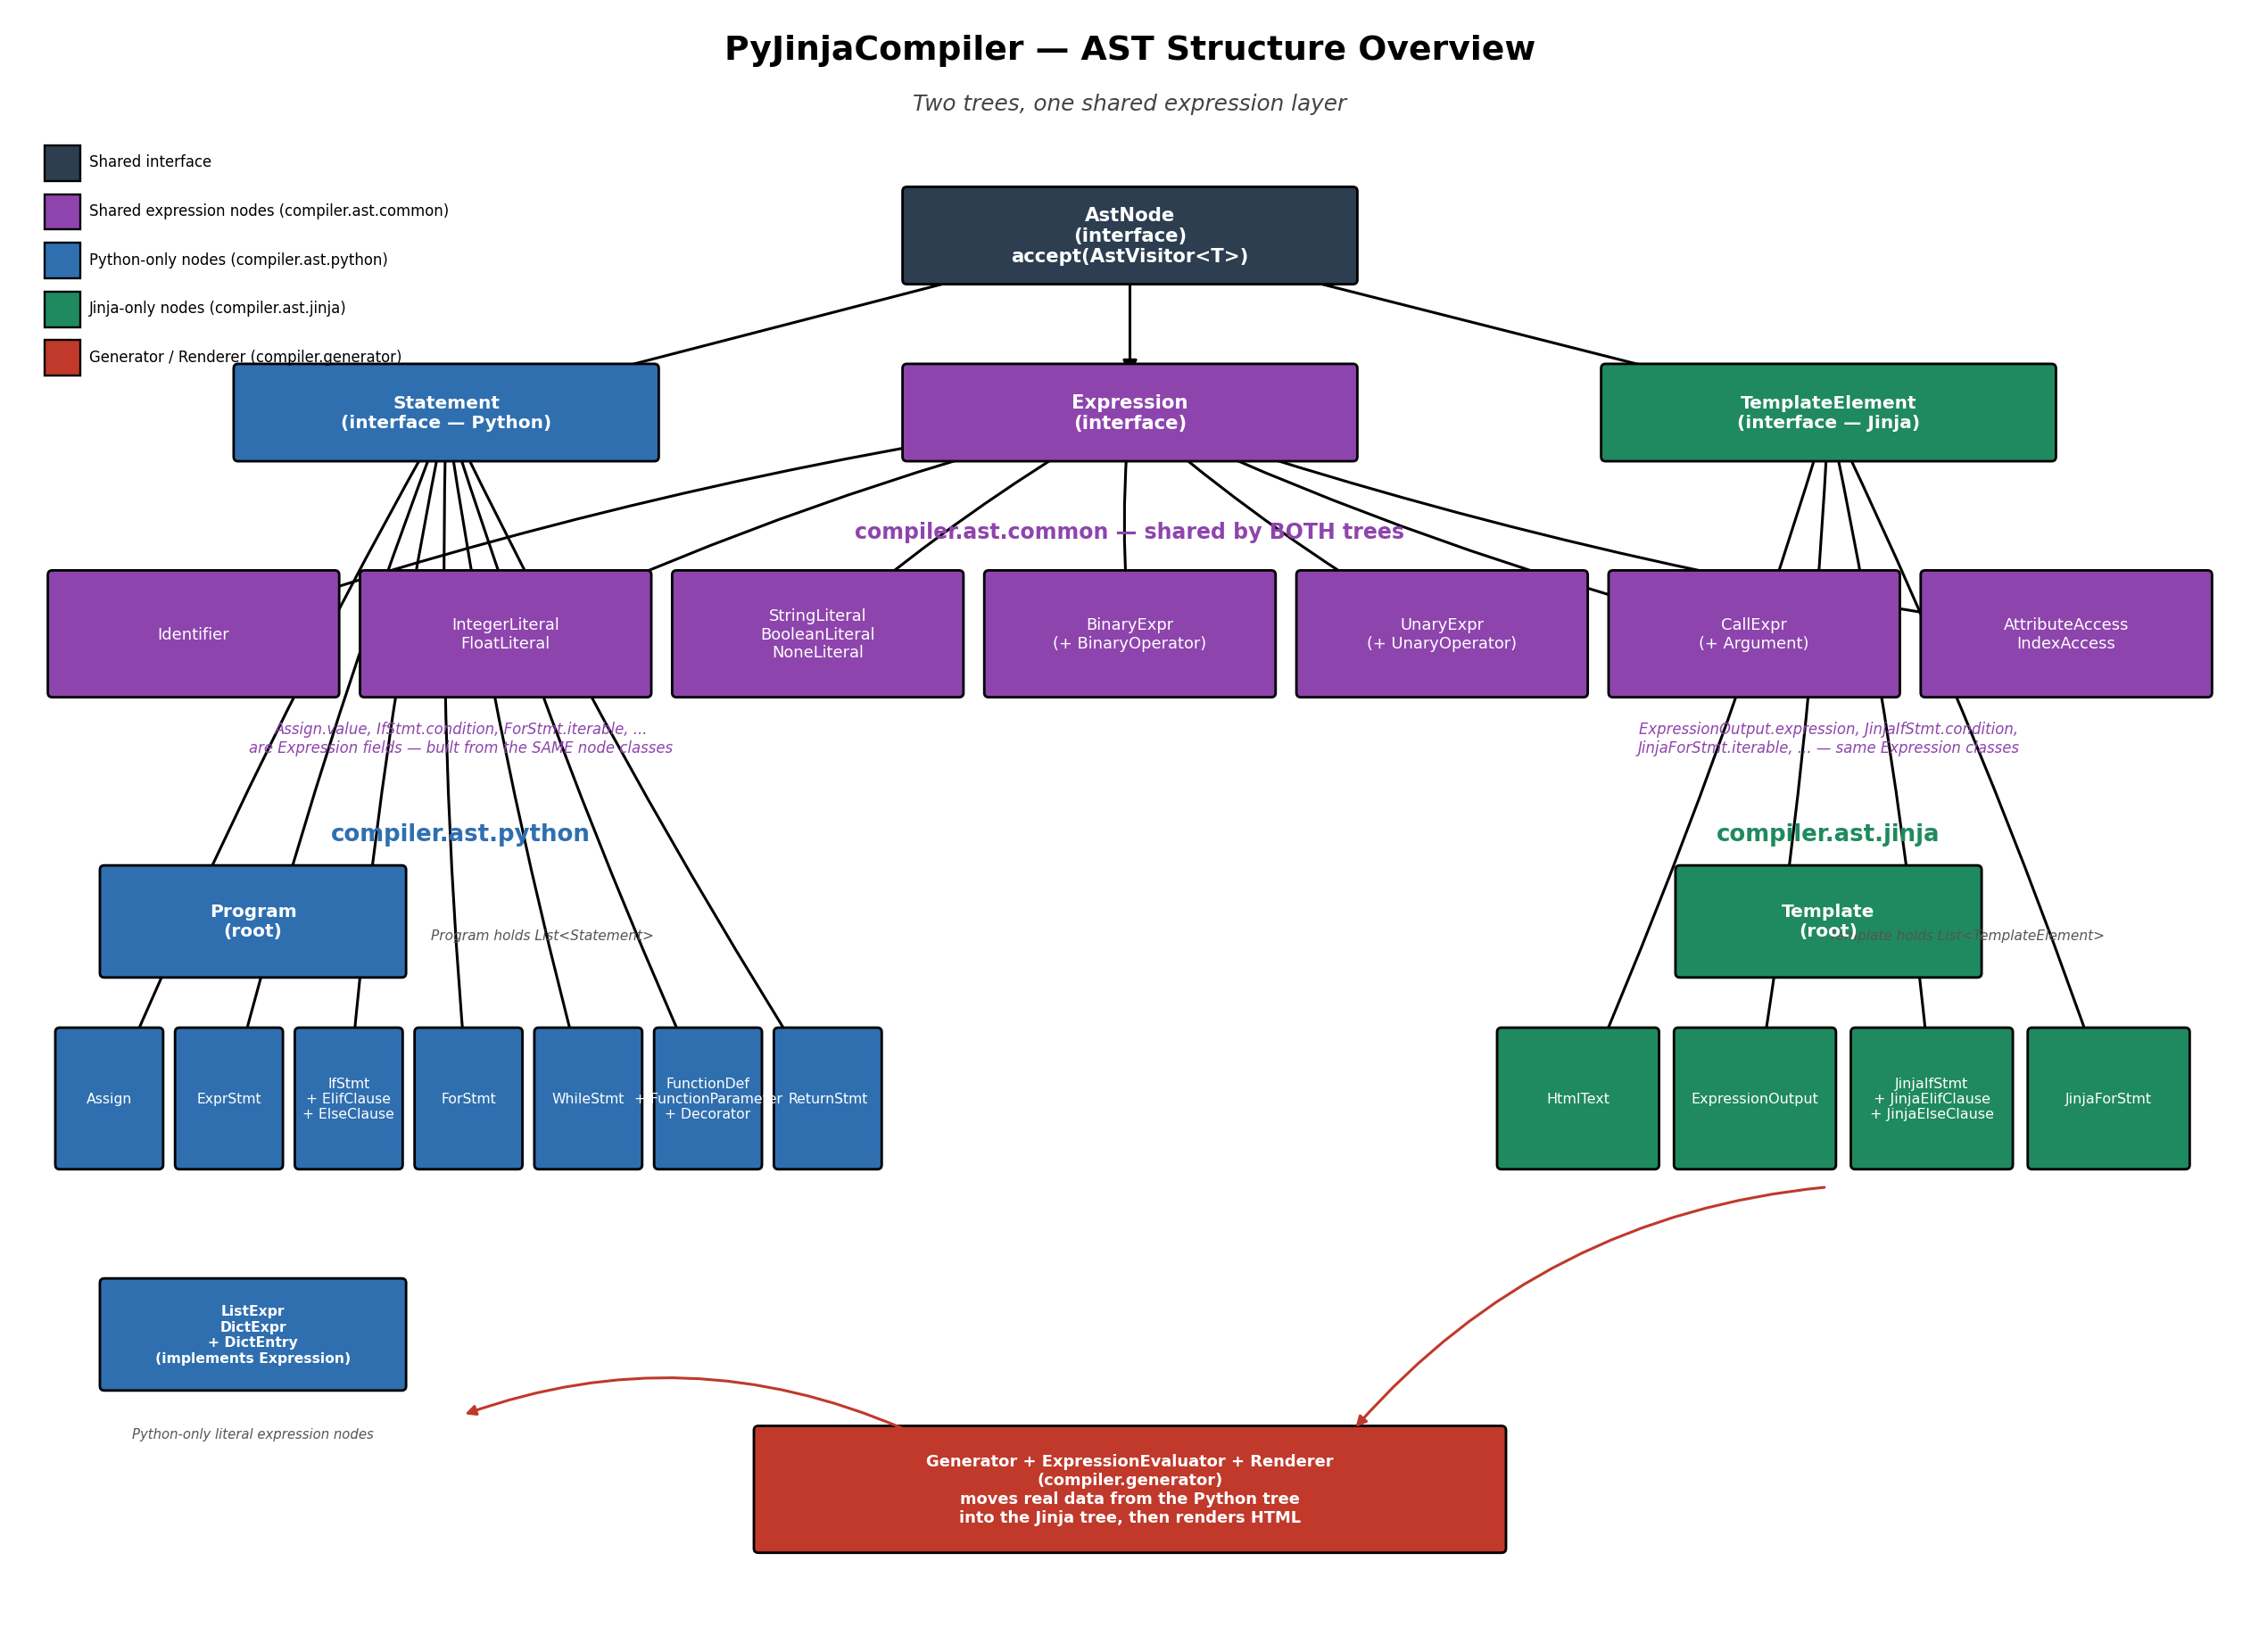

5. Requirement 4 — Semantic Analysis

Python side — compiler.semantic.python.SemanticAnalyzer
Builds a SymbolTable of nested Scopes (GLOBAL / FUNCTION / BLOCK) while walking the Program, and reports 8 distinct semantic error types (comfortably above the 5-error minimum):
- DUPLICATE_FUNCTION_DEFINITION, DUPLICATE_PARAMETER, WRONG_ARGUMENT_COUNT
- UNDEFINED_VARIABLE, UNDEFINED_FUNCTION, NOT_CALLABLE
- NON_ITERABLE_IN_FOR, TYPE_MISMATCH

Jinja side — compiler.semantic.jinja.JinjaSemanticAnalyzer
Reuses the same compiler.semantic.common.{SymbolTable, Scope, Symbol, Type, SemanticError} classes rather than duplicating them, and is constructed directly from a SymbolTable — normally the one Generator.RenderCall.getContextSymbolTable() produces, so a template is only ever type-checked against the data it will actually be rendered with. It reuses 5 of the Python analyzer's error types where they apply to templates: UNDEFINED_VARIABLE, UNDEFINED_FUNCTION, NOT_CALLABLE, NON_ITERABLE_IN_FOR, TYPE_MISMATCH, plus six built-in functions registered in its global scope (len, range, str, int, float, bool).
Each {% if %}/{% elif %}/{% else %} body and {% for %} body gets its own BLOCK scope, and a for-loop's variable is declared only inside that loop's own body scope — the same scoping discipline as the Python analyzer's IfStmt/ForStmt handling.

6. Requirement 5 — Code Generation
compiler.generator.Renderer is the code-generation stage: given a Template AST and a context map (real values), it walks the tree and produces the final rendered HTML string. HtmlText nodes pass through verbatim; ExpressionOutput nodes are evaluated and stringified (Python-style — True/False/None); JinjaIfStmt picks the first true branch; JinjaForStmt iterates a List (items), a Map (keys, matching Python dict iteration) or a String (characters), re-rendering its body once per item with the loop variable bound in a child scope.
Both Generator and Renderer share one compiler.generator.ExpressionEvaluator, since the expression nodes being evaluated are the same shared classes described in section 4 — this is the concrete proof that “the generated parts are able to work together”: the same evaluator that extracts products out of Python code is the one that computes p.price > 350 while rendering the template.

7. Requirement 6 — Web Interfaces
compiler.webapp is a small, dependency-free demo application (JDK's built-in com.sun.net.httpserver — no Flask, since the whole project is Java) that exercises the full pipeline against real HTTP requests:
- GET /products — product list, via templates/list.html
- GET /products/new and POST /products — add product, via templates/form.html
- GET /products/{id} — product detail, via templates/detail.html
- GET /products/{id}/edit and POST /products/{id} — edit product (form.html shared with add, switching on a mode variable)
- POST /products/{id}/delete — delete, then redirect back to the list
Every page is produced by TemplateEngine, which parses the .html files through the project's own JinjaLexer → JinjaParser → AstBuilder → Renderer chain — the web app is a live demonstration of the compiler, not a separate reimplementation. Navigation between all five views is via ordinary <a href> links and HTTP redirects after POST, giving the smooth list ↔ detail ↔ edit ↔ delete flow the brief asks for.

8. Requirement 7 — Printing
Every AST node overrides prettyPrint(String indent), producing an indented, human-readable rendering of itself and its children (this is also how the AST diagram's structure was verified during development). compiler.ast... ASTPrinter walks a full tree from the root and prints it in one pass, and SymbolTable.prettyPrint() renders every scope and its declared symbols, so a full compile can be inspected as: parse tree → AST (prettyPrint) → symbol table (prettyPrint) → semantic errors (if any) → rendered output.

9. Requirement Coverage Summary
# | Requirement | Status | Implemented in
1 | Lexer/Parser grammars: Python, Jinja2, HTML | Done (CSS out of scope — see Scope Notes) | grammar/python/*.g4, grammar/jinja/*.g4
2 | Two AST trees + Generator passing Python data into the Jinja tree | Done | compiler.ast.python, compiler.ast.jinja, compiler.generator.Generator
3 | OOP node structure (inheritance, polymorphism, per-node metadata) | Done | compiler.ast.common (AstNode, AbstractAstNode, AstVisitor)
4 | Semantic analysis, both trees, ≥5 error types each | Done | compiler.semantic.python, compiler.semantic.jinja
5 | Code generation — generated parts work together | Done | compiler.generator.ExpressionEvaluator, Renderer
6 | Integrated web interfaces with smooth navigation | Done | compiler.webapp (ProductStore, TemplateEngine, WebServer)
7 | Per-node printing + full tree + symbol table printing | Done | prettyPrint() on every node, ASTPrinter, SymbolTable.prettyPrint()

10. Package Layout
compiler
|-- ast
| |-- common (AstNode, AstVisitor, Expression, literals, BinaryExpr, UnaryExpr,
| | CallExpr, AttributeAccess, IndexAccess, Argument types)
| |-- python (Program, Statement, Assign, IfStmt, ForStmt, WhileStmt,
| | FunctionDef, ListExpr, DictExpr, ...)
| `-- jinja (Template, TemplateElement, HtmlText, ExpressionOutput,
| JinjaIfStmt, JinjaForStmt, ...)
|-- frontend
| |-- python (AstBuilder: ANTLR parse tree -> Python AST)
| `-- jinja (AstBuilder: ANTLR parse tree -> Jinja AST)
|-- generated
| |-- python (ANTLR-generated PythonLexer / PythonParser)
| `-- jinja (ANTLR-generated JinjaLexer / JinjaParser)
|-- semantic
| |-- common (SymbolTable, Scope, Symbol, Type, SemanticError)
| |-- python (PythonSemanticAnalyzer)
| `-- jinja (JinjaSemanticAnalyzer)
|-- generator (Generator, ExpressionEvaluator, Renderer)
`-- webapp (ProductStore, TemplateEngine, WebServer)

11. How to Run

Compiler pipeline (Python -> Generator -> Jinja check -> render)
See PIPELINE_USAGE.md in the submitted source for the exact call sequence; in short: parse + analyze the Python file, run Generator.generate(...) to get a RenderCall, parse the target .jinja/.html file, run JinjaSemanticAnalyzer against the RenderCall's SymbolTable, then Renderer.render(...) the RenderCall's values against the Template.

Web application
java -cp "out;antlr-4.13.2-complete.jar" compiler.webapp.WebServer templates
Open http://localhost:8080/products

12. Known Limitations / Future Work
- CSS grammar not implemented (see section 2's scope note).
- Jinja filters (e.g. {{ value|upper }}) and {% set %} are not part of the grammar, so templates can't declare new template-local variables — only read what the Generator provides.
- Renderer does not HTML-escape output; acceptable for this trusted, hand-written template set, but would need addressing before accepting arbitrary user input in a template context.
- No automated test run has been performed inside this report-generation environment (no JDK compiler available here) — all code has been manually cross-checked against the generated ANTLR sources' exact field/method names, but a full javac + test-suite run should be done before final submission.

