**Suicide rate Worldwide**

G07

Nikhil Desai

Mohammad Bharmal

CPCS 6030, Fall 2021

**Project Report**

**Introduction**

Suicide is a serious global public health issue. It is generally done to escape from pain and suffering. Death by suicide is an extremely complex issue that causes pain to thousands of people every year around the world. People generally think suicide might not be that common cause of death among people and generally tend to ignore it. When we try to put light on the statistics, suicide numbers around the world are immense. It is among the top twenty leading causes of death worldwide. Close to 8,00,000 people die by suicide every year, with more deaths due to suicide than natural disasters, breast cancer, and homicides. Suicide is a condition that can be prevented by taking necessary actions. National Suicide Prevention Lifeline is a body that works towards the goal of reducing suicides. Effective and evidence-based interventions can be implemented at age, county, and individual levels to prevent suicide and suicide attempts. Once we have this discrete information, It will be easy for the National Suicide Prevention community to help such people. This is our sincere effort to put down our work in data visualization, contribute to our community, and address a social issue.

**Dataset**

The World Health Organization is a specialized agency of the United Nations responsible for international public health. WHO surveyed suicide data worldwide in 2016. The suicide data is readily available on Kaggle and WHO for educational purposes. The dataset consists of suicide data for most of the developed countries around the world. In a few countries, it is not easy to gather data like China, North Korea, which might not be readily available in some countries. This a small overview and some shortcomings of the dataset. The dataset attributes include country, year, age groups, population, suicides, and sex. While visualizing this data as per suicide numbers might not be a good idea, each country's population may vary, and thus the number might be higher for densely populated countries. To overcome this issue, we created a new attribute suicide rate. The suicide rate is calculated by the number of suicides per one thousand people living in that country.

Source: https://www.who.int/teams/mental-health-and-substance-use/suicide-data

**Design solution**

As discussed in the previous section, Suicides is a major global issue. To tackle it, we need to get to a microscopic level and identify the specific people, their geographic location, Age group, gender that are at high risk of suicide. Now in this section, we will present the design solution we proposed for exploring suicide worldwide. To explore suicides worldwide, we consider the suicide rate, as the population for different countries will vary, which might mislead the user.

Initially, the user is expected to select a year for visualizing the data. The year can be selected from a drop-down menu from 1987 to 2015. By default, it is all years, i.e., the user gets the cumulative data from 1987-2015. The drop-down year selection will help the user visualize each country's performance for a specific year and its overall performance in the last 28 years.



Figure 1: Dropdown menu for year selection.

**World map**

Once the user has selected a specific year from the drop-down menu or chose to use all years data, the user can see each country's suicide rate on the world map. This will help the user understand how each country is performing compared to other countries worldwide.

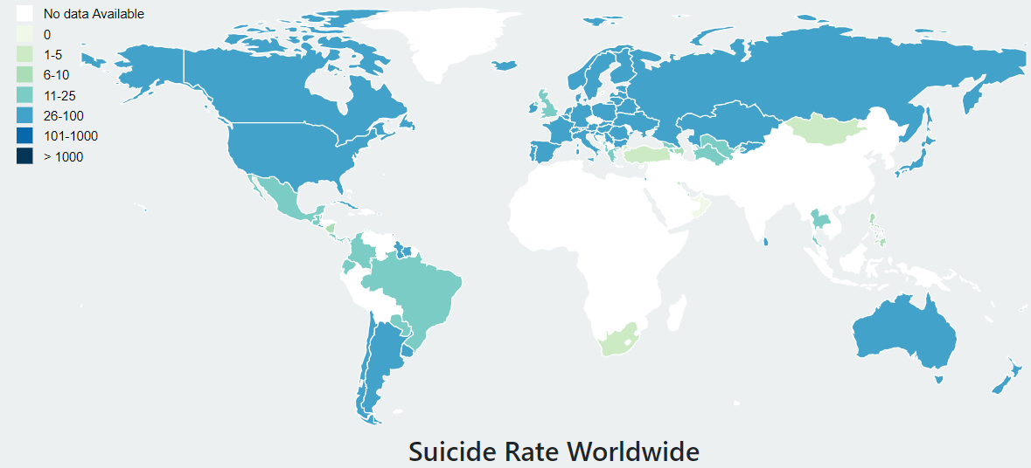

Figure 2: Suicide rate worldwide.

World map provides the user with a more remarkable ability to visualize the distribution of suicide rates more easily across the globe. Another way to choose a country could be by selecting a drop-down menu, search bar, or a radio box. Since the data to be selected is a country, we do have some basic idea about each country's geographical locations on the world map. This gives some clarity and confidence to the user. Ex. If the user wants to select Russia, the user will look at the topmost part of the Asian continent. The world map shows the suicide rate worldwide using a geo-Patterson projection. In the countries that are in white, we have no data available for it. Rest all the countries choose color depending upon their suicide rate.

As the world map displays the suicide rate, the attribute type is quantitative. Displaying the suicide rate on the world map first and then choosing a specific country can help the user make a more intuitive decision by just looking at the figures. If the user is unsure which country it needs to explore first, it can just look at the world map and then choose the country. Ex In the world map, we can see that Brazil is on the lower side of the suicide rate even though brazil is a bigger country by size and population when compared to other big countries. This might generate some curiosity for the user and help the user select a specific country from the world map. If the user chooses not to select any country, the entire world map gets selected. The central design behind the world map is that it helps the user to compare the suicide rate across several countries at a glance.

**Horizontal bar chart**

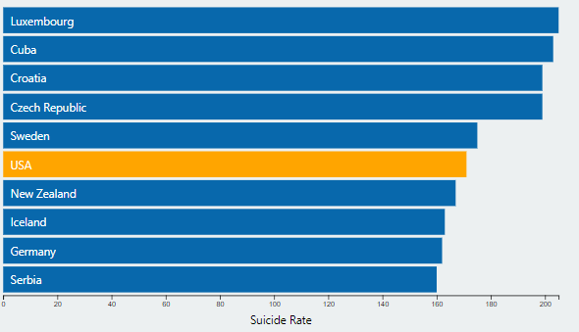

Figure 3: Horizontal bar chart suicide rate by country.

Once the user selects a specific country, the user can see the horizontal bar chart that displays the suicide rate. The Horizontal bar chart also helps compare countries that lie immediately above and below the selected country. To compare several countries, using a horizontal bar chart is an excellent way to present the data as it would be hard for long labels to be displayed below a vertical bar. This is the prime intention behind using a horizontal bar chart.

The attribute type here is quantitative. As we know, the world map displays the suicide rate worldwide but goes in further depth; we need to understand each country's performance compared to countries immediately above and below it. In figure 3, we can see that when the country USA is selected, the suicide rate is around 170. We also have information about the countries above and below it. The intuition from this can be that the countries having a suicide rate close to the USA are a majority of European countries.

**Stacked bar chart**

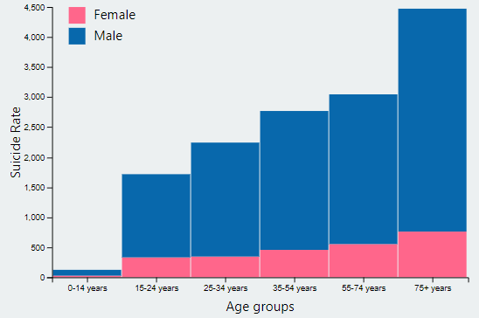

Figure 4: Suicide rate by age group.

As the user selects a specific country or chooses the world map's entire data, we have the country's suicide rate. However, this information can be a bit vague as we need to know the specific people inside a geographical region that are highly prone to suicidal attempts. The stacked bar chart gives us the suicide rate distributed over different age groups concerning gender. Stacked bar charts here help save time by interpreting the data quickly, and much information can be shown concisely. The main reason behind choosing a stacked bar chart is that it helps us compare gender and compare the performance between the different age groups.

From figure 4, we can conclude that the suicide rate increase as the age group increases. For the age group 75+ years, the suicide rate is the highest. Out of which the male occupies the majority of the portion. Thus, we can say that if we want to control the suicide rate. In figure 4, We need to focus majorly on people of 75+ years and gender males.

**Pie chart**

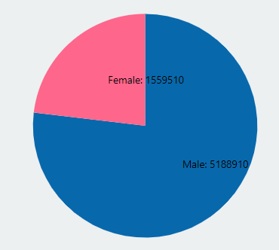

Figure 5: Suicide number by gender.

Figure 5 displays the pie chart to compare the suicide numbers between the two age groups. Sometimes the user may need the suicide numbers for a specific country and the share occupied by each gender group. The pie chart's preliminary design helps the user see gender comparison at a glance to make an immediate analysis and to understand information quickly.

As the pie chart displays the suicide number for different age groups, the attribute type is quantitative. The pie chart's effectiveness is due to its simplicity, considering we have only two groups in the pie chart. Also, it can be a useful communication tool for an uninformed audience. Ex. The graph in figure 5 for a specific country shows that males occupy 3/4th of the total suicides.

**Dashboard**

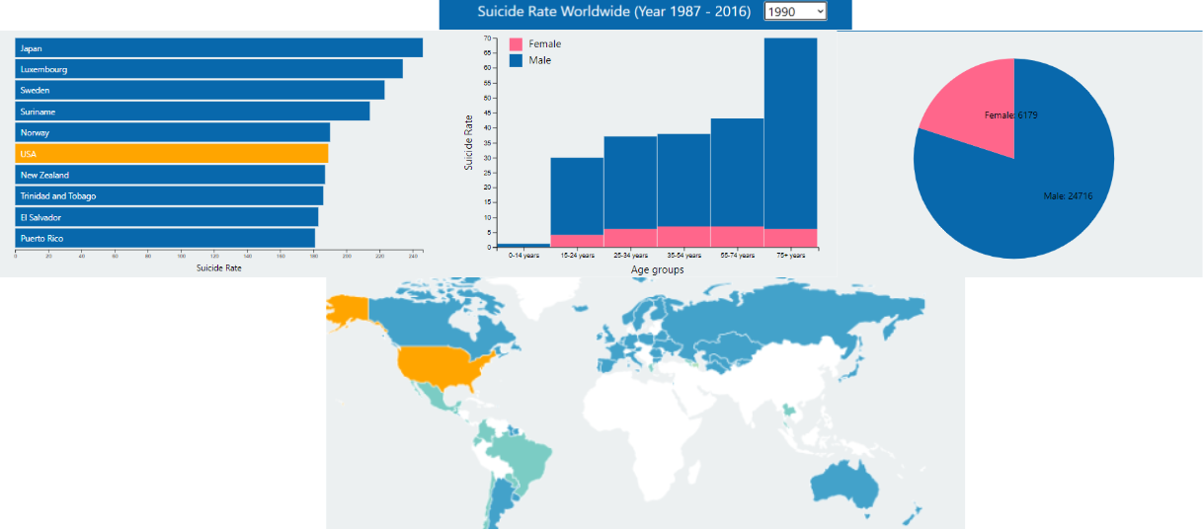

Figure 6: Dashboard.

Ideal design flowchart (story telling). Refer figure 5.

1. Select year: 1990.
2. Select country: USA.
3. Horizontal bar chart: Interpret the suicide rate and immediate top and bottom countries.
4. Stacked bar chart: Interpret high risk prone suicide age groups and gender.
5. Pie chart: Share of suicide numbers between male vs females.

**Literature review**

[1] "Suicide". Published online at OurWorldInData.org. Hannah Ritchie, Max Roser and Esteban Ortiz-Ospina (2015)

[2] A Survey of Scholarly Data Visualization JIAYING LIU1 , TAO TANG2 ,WEI WANG1 , BO XU1 , XIANGJIE KONG 1, (Senior Member, IEEE), AND FENG XIA 1, (Senior Member, IEEE)

[3] COVID-19 mortality and Jews: A global overview of the first wave of the coronavirus pandemic, March to May 2020 L. Daniel Staetsky and Ari Paltiel

[4] Mapping the Global South: Equal-Area Projections for Choropleth Maps by Gabriela Molina Leon, Michael Lischka, Andreas Breiter University of Bremen.

[5]Population reference bureau, [Family Planning, and Reproductive Health](https://www.prb.org/family-planning-and-reproductive-health/) [Population Change](https://www.prb.org/population-change/).

[6] Nowcasting and forecasting the potential domestic and international spread of the 2019-nCoV outbreak originating in Wuhan, China: a modeling study by Wu, Joseph T, Leung Kathy, Leung Gabriel M

In [1], the focus is on significant types of death issues. The author has drawn a horizontal bar chart that shows different death issues and their death numbers. The horizontal bar chart is in sorted order from highest to lowest but not dynamic. This graph inspired us to create a horizontal bar chart. The improvisation we have is the horizontal bar chart in figure 2 shows us the suicide rate for a specific country and its immediate top and bottom countries.

In paper [2], data visualization is done on the number of advisees and their advisors between 63 countries on the world map. When hovered in a specific country, the world map gets highlighted, and then the data changes accordingly. This paper has inspired the world map in figure 2. As the user hovers over a country in the world map, the graphs related to that country get displayed. In the research paper, the countries that are not interested are shown in the white background; the same concept is used on our world map.

[3] is a recent paper on covid-19 and has good visualization on Jews and their community's effect over the pandemic period. In section 2.2, there is a visualization of Jews communities outside Europe. The paper uses a horizontal grouped bar chart. Figure 4 in our website has been inspired by this visualization. The improvisation we have is to use limited colors whenever required, and the background is kept clear in most cases. Also, as our labels are not significant, the stacked bar chart is positioned vertically.

[4] The research here is on the different projections for the world map. The paper focuses on different types of projections and how the map's choice can influence the user. This paper inspires the world map projection in figure 2 and the color scheme.

[5] Focuses birth rate for women of different racial backgrounds. Since the population of these women are not the same, the data is visualized per 1000 females. This same inference can be used for our website, where the countries' population is not the same. Instead of using the suicide number, we are using the suicide rate.

[6] It shows how the covid-19 pandemic spread from Wuhan over some time. This inspired us to map the bar chart according to the geographical locations. On our website, the stacked bar chart gets updated as we hover over the world map.