1.
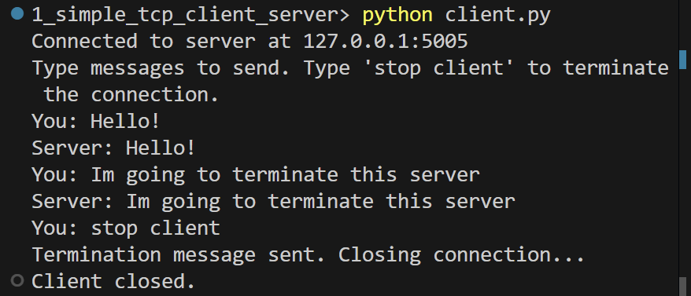
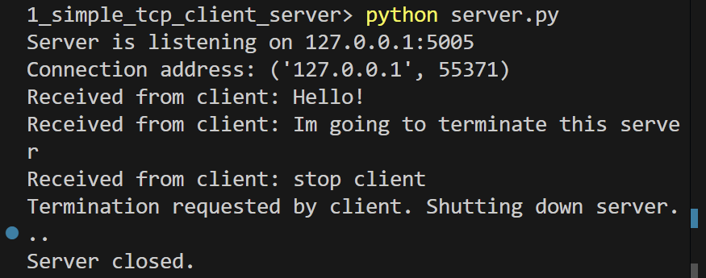
2.
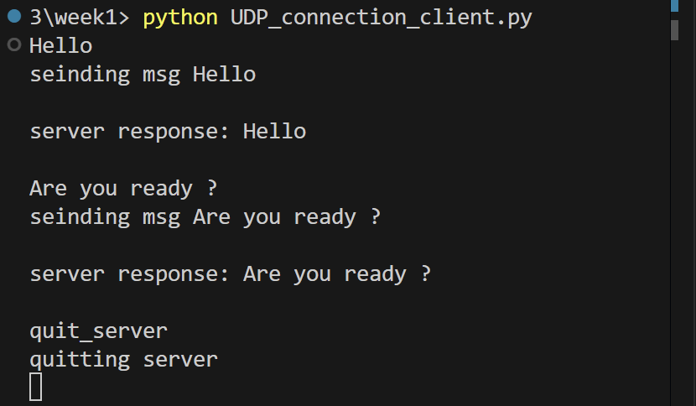
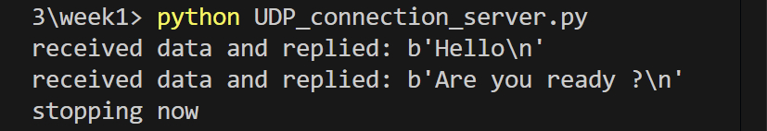
3.
The TCP server has to be started first before implementing the MQTT protocol.
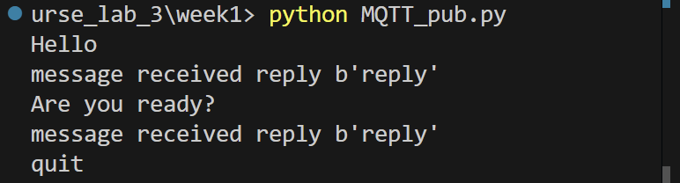
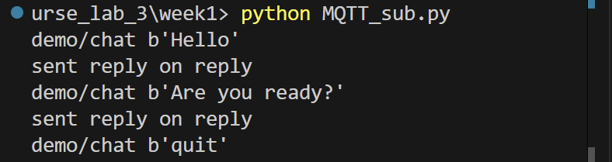
4. Observe the behaviors of all three protocols and relate them to the OSI layers. Discuss the following:
a. From a functionality perspective, what is the role of a client and a server in a communication network?
Client: Initiates communication and sends requests or data.
Server: Listens for incoming connections or messages and responds or processes data.
For TCP / UDP, client knows the server’s IP address and port, the server listens on a specific port. In MQTT, the publisher and subscriber are both clients. The broker acts as the server and manages all message routing.
b. What is the difference between TCP, UDP and MQTT configurations? What constructions have to be defined and why?
TCP (Transmission Control Protocol)
Reliable, connection-oriented transport protocol.
Connection established via a three-way handshake (SYN, SYN-ACK, ACK).
Guarantees reliable, ordered, and error-free data delivery.
Uses acknowledgments and retransmissions.
Implements congestion and flow control.
Client cannot send data if the server is not running.

UDP (User Datagram Protocol)
No connection setup or handshake.
No guarantee of delivery, order, or duplication.
No acknowledgments or retransmissions.
Client can send packets even if the server is offline.

MQTT (Message Queuing Telemetry Transport)
Uses publish/subscribe instead of direct client-server communication.
Requires a broker (e.g., Mosquitto).
Runs on top of TCP and inherits its reliability.
Messages are exchanged using topics.

TCP needs connection parameters for reliability.
UDP minimizes configuration for speed.
MQTT needs topics and a broker to enable decoupled communication.

c. What happens in the protocols when a connection is established and before transmitting the first message? Does it matter if the server or the client is started first?
TCP
- Uses a three-way handshake before sending any data : SYN → SYN-ACK → ACK
- If the server is not running, the client cannot establish a connection, therefore the server has to be started first.
- Data transmission starts only after the handshake completes.

UDP
- No connection establishment.
- Client can send packets immediately.
- If the server is not running, packets are sent but discarded, therefore startup order doesn’t matter.

MQTT
- Client first establishes a TCP connection to the broker.
- MQTT “connect” control packet is exchanged.
- Only after successful connection can “publish” or “subscribe” occur. The broker has to start first, publisher/subscriber order does not matter.

d. How do the protocols react when the client-server connection is closed and reestablished?
TCP
Safe termination:
- Proper socket closure.
- FIN/ACK exchange visible in Wireshark.
Abrupt termination:
- Connection reset (RST).
Reconnection requires a new handshake.
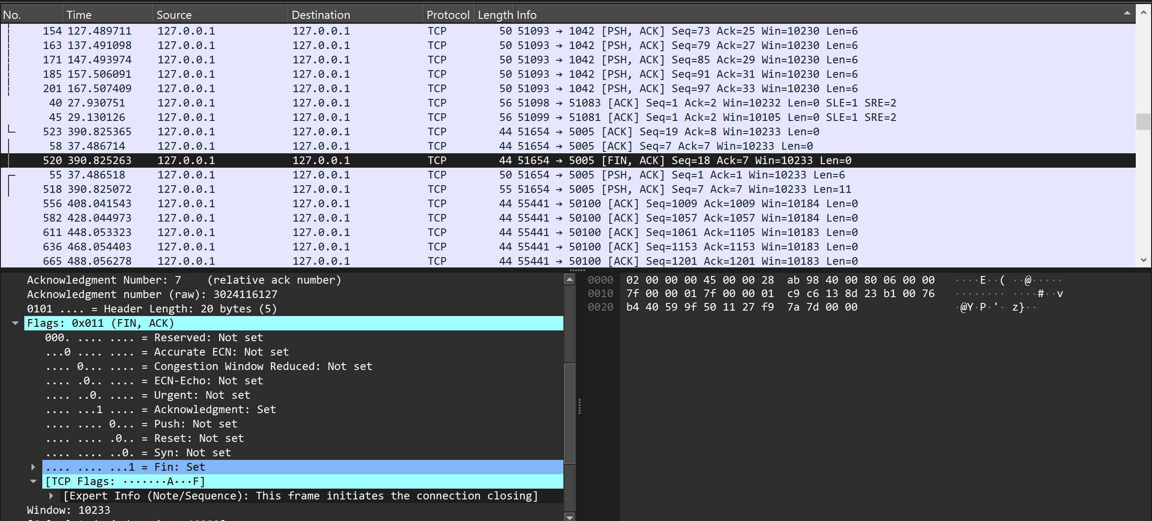
UDP
- No termination signaling.
- Stopping client or server has no protocol-level indication.
- Restarting either side works immediately.
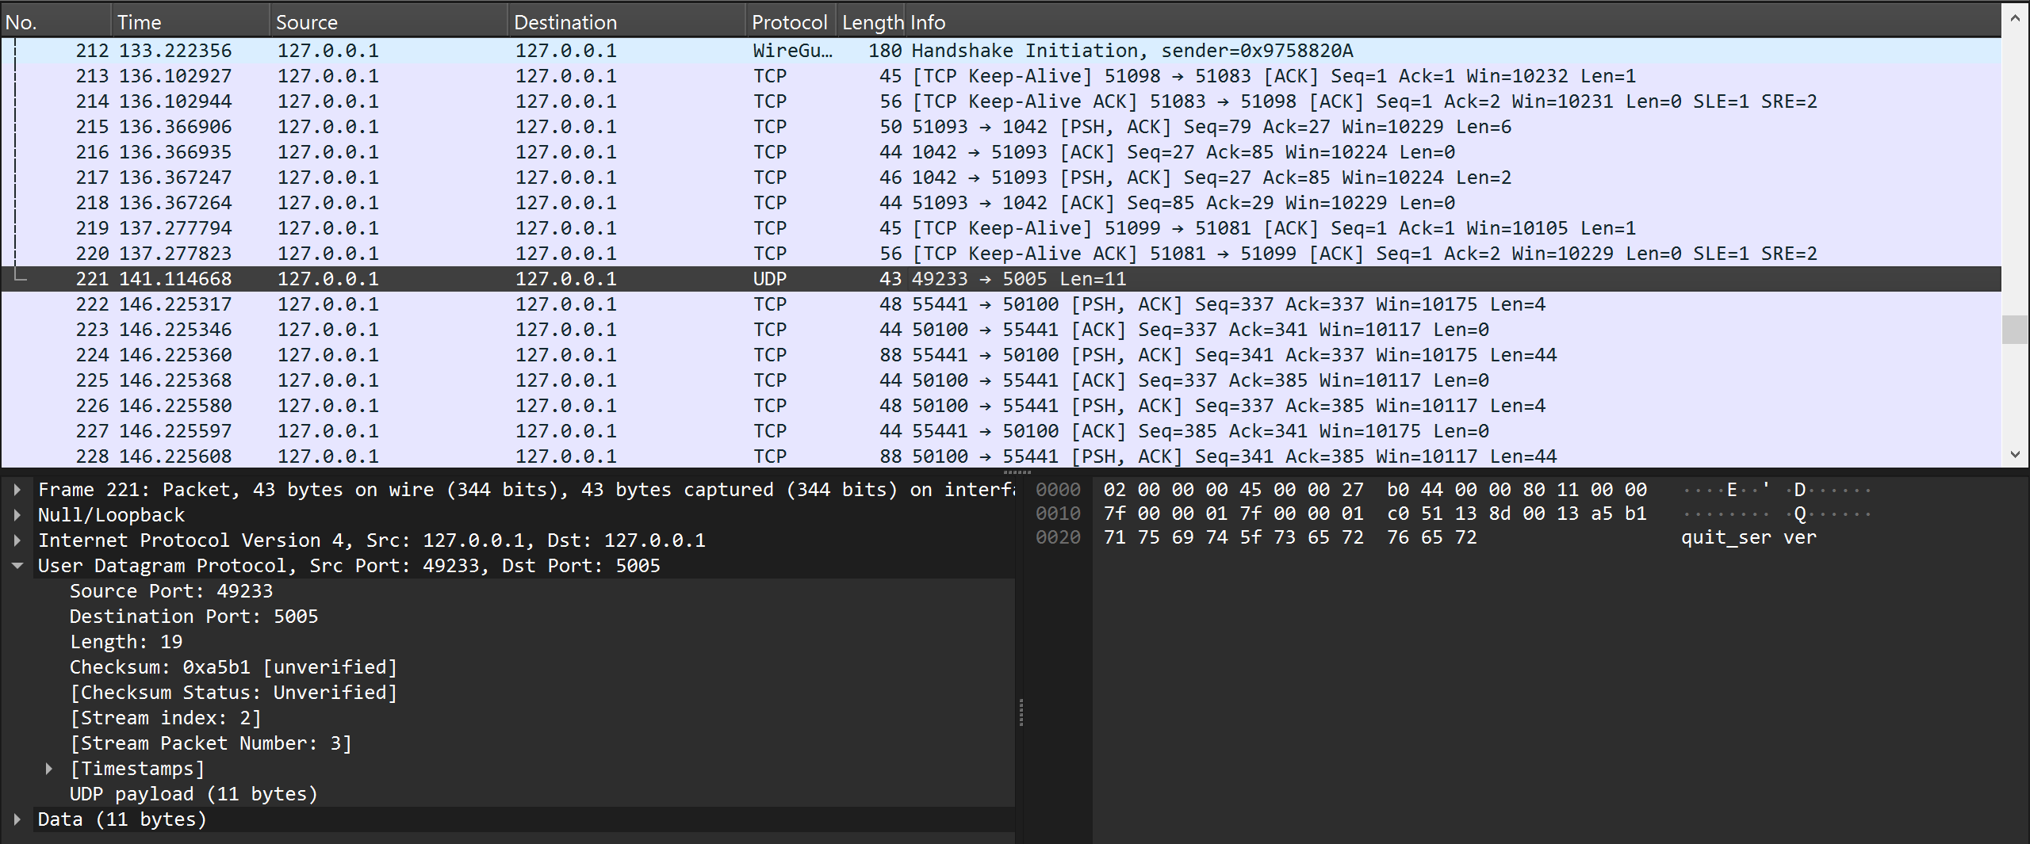
MQTT
Safe termination:
- MQTT DISCONNECT packet.
Abrupt termination:
- TCP connection reset.
Client must reconnect to broker before resuming communication.
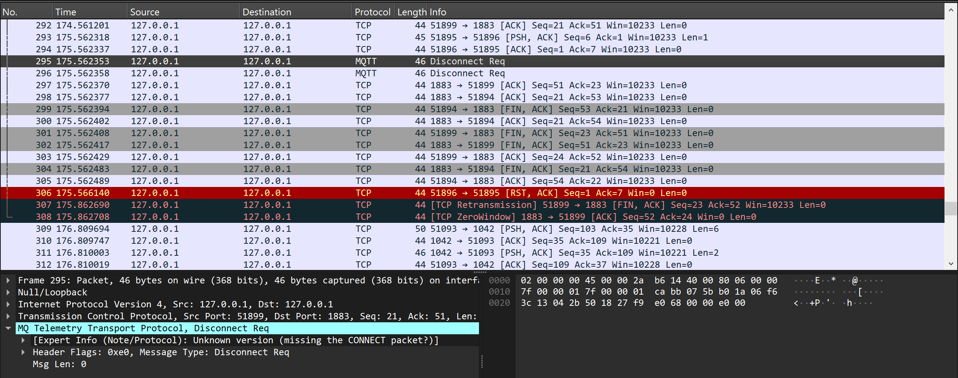

e. What was the size of the sent message? And what is the receiving buffer size?

TCP
Message sent: Hello! – 50 bytes on wire
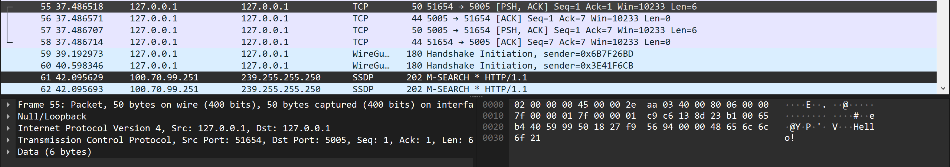

UDP
Message sent: Are you ready ? – 48 bytes on wire 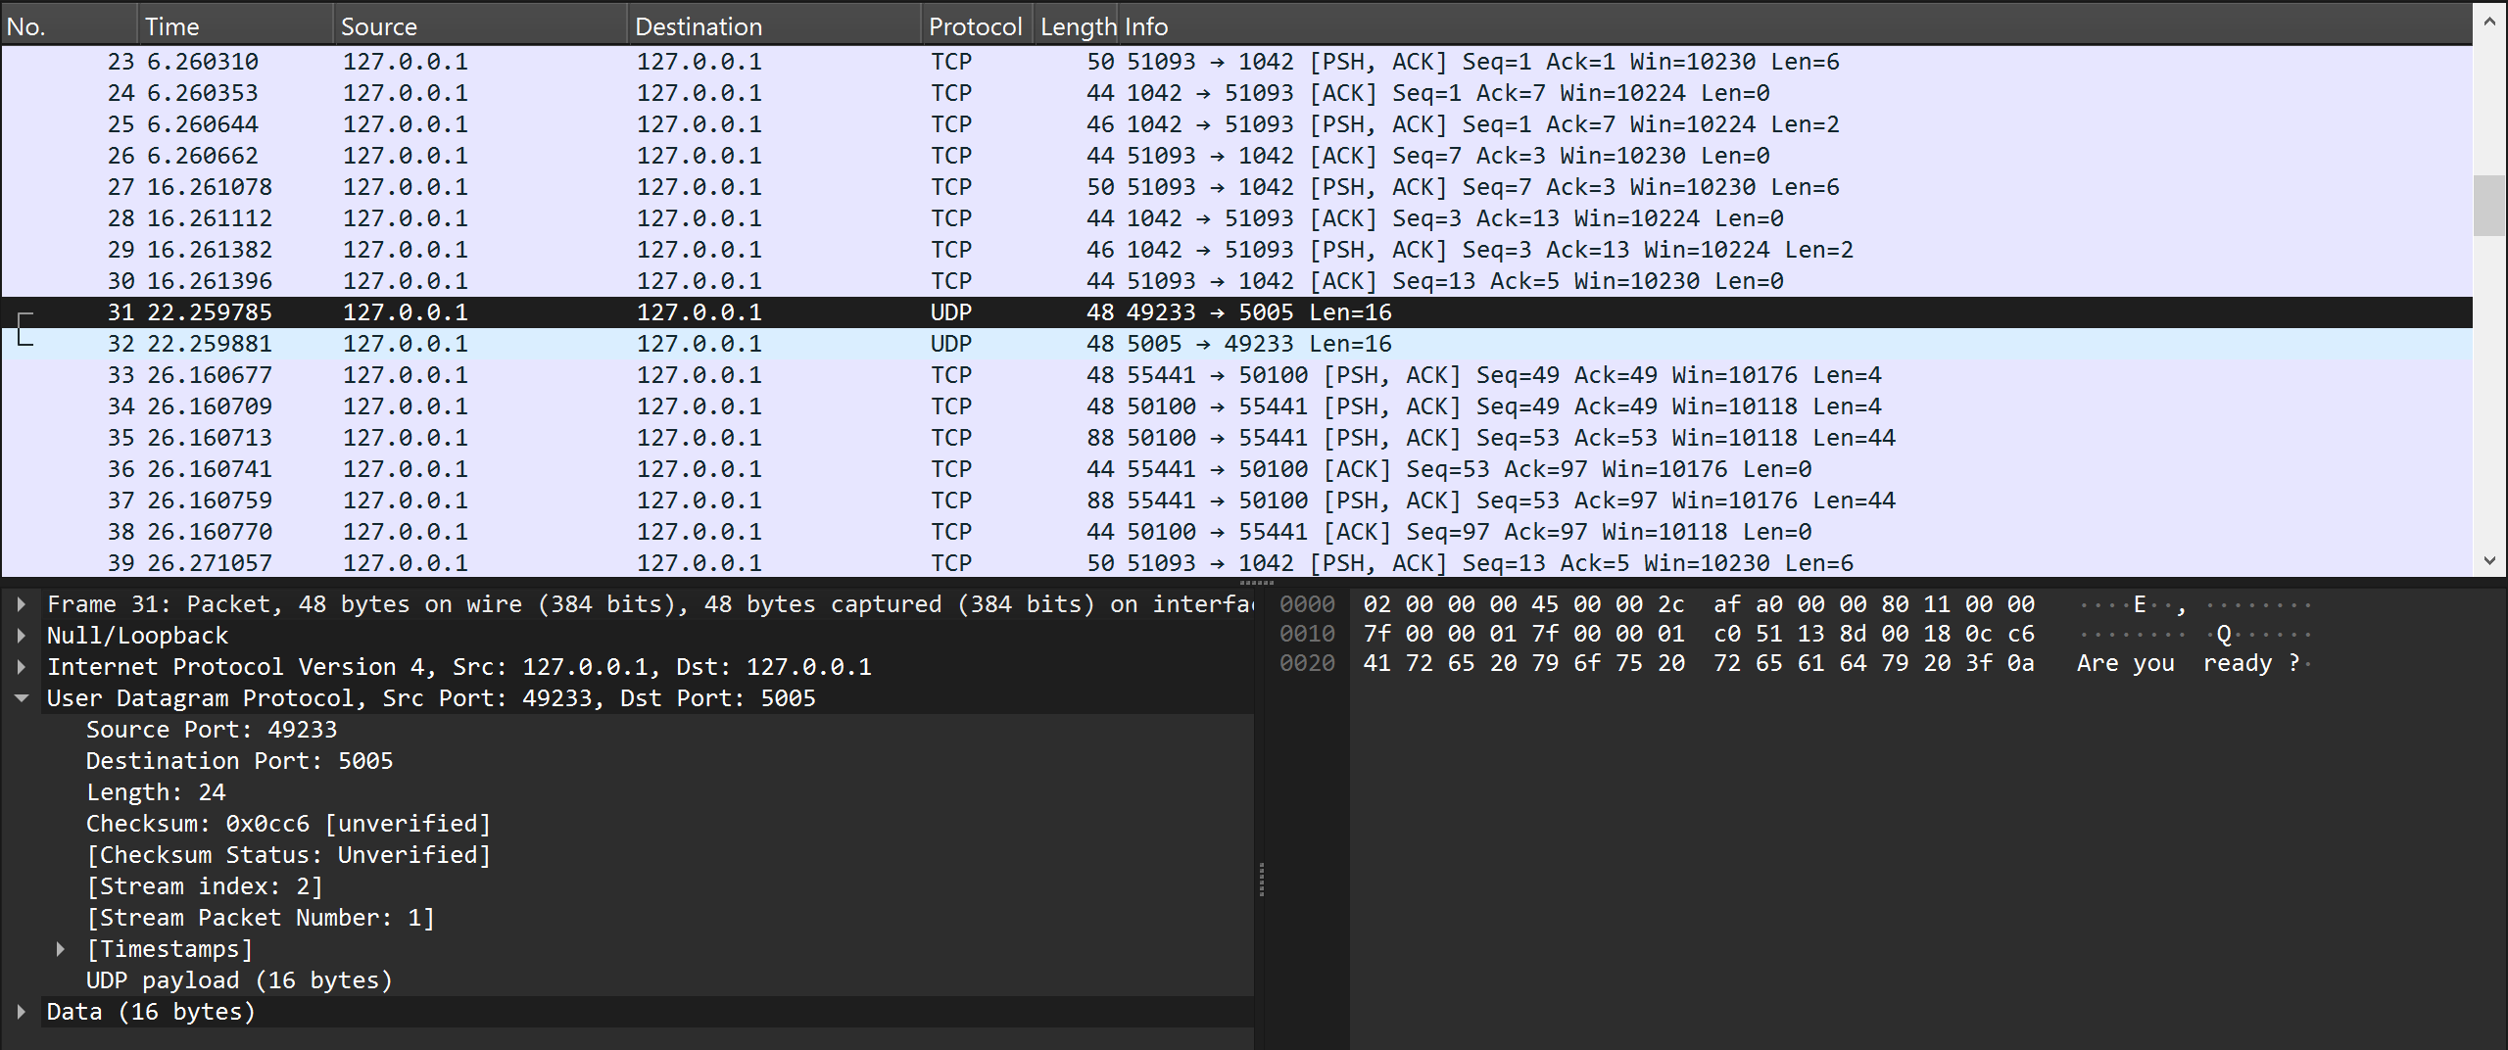

MQTT
Message sent: Are you ready? – 71 bytes on wire
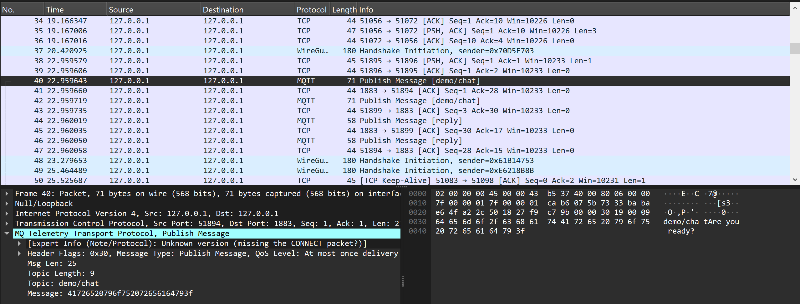

Receiving buffer size
From the code:

BUFFER_SIZE = 500
data, addr = conn.recvfrom(BUFFER_SIZE)

-The receiving buffer size is defined at the application layer by the recv() or recvfrom() call and determines how much data is read per receive operation.
The receiving buffer size is defined by us in the code and it controls how much data can be read per call.
If the message is larger than the buffer, in:
TCP - data arrives in chunks
UDP - packet may be truncated

