# Caption This!

Note:- To run this project we require linux based operating system, as the project is docker dependent.

Place the code folder i.e image_caption folder at your home directory location

# Docker

Install Docker using the platform-specific installation instructions for Docker [here](https://docs.docker.com/engine/installation/#platform-support-matrix).

Use the pre-built Docker image from Docker Hub

3. After installing Docker, pull a prebuilt image from Docker Hub by entering:

sudo docker pull mlatberkeley/showandtell

You will need a Docker Hub account in order to pull the image (get one [here](https://hub.docker.com/)).

If it's your first time pulling a Docker image from Docker Hub you will need to login to your Docker Hub account from your terminal with `docker login`, and follow the username and password prompt.

4. To run the pulled image (after cloning and downloading the repository) enter

sudo docker run -it -p 8888:8888 -v </pathtoimage_captionfolder>:/root mlatberkeley/showandtell

where __pathtoimage_captionfolder__ should be the __absolute path__ to image_caption.

5. After building, starting, and attaching to the appropriate Docker container, run the provided Jupyter notebooks by entering

jupyter notebook --ip 0.0.0.0

Click on the link obtained…see the below image

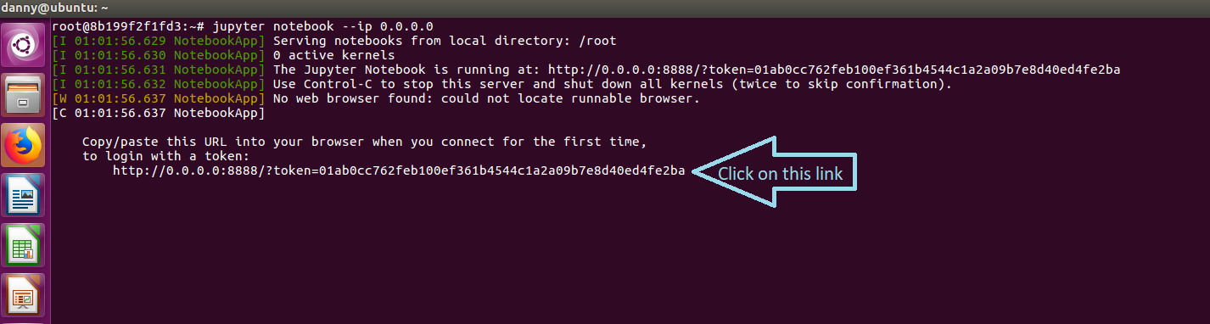

# The Notebooks

There are three notebooks:

* `image_caption_train.ipynb` - Contains code to train a TensorFlow caption generator from a VGG16 word embedding as described in our article.

* `image_caption_generator.ipynb` - Contains the same code as `1.ipynb` except it introduces functionality to generate captions from an image embedding (as opposed to just being able to train on captions). Functions as a sanity check for the quality of captions we are generating.

* `image_caption_test.ipynb` - Builds on the previous notebook, except instead of feeding an image embedding to our caption generation model, it first feeds an image to the VGG-16 Convolutional Neural Network to generate an image feature embedding. This gives us an end-to-end pipeline for going from an image to a caption.

* In order to run the test notebook edit the image path in the ipynb (more details in the `.ipynb` itself).

# Additional Downloads:

Visit the link and download and extract the folder imag_caption.

https://drive.google.com/file/d/11T4qocrd8E_V-NOpCyVtSj5BKS4MKEdJ/view?usp=sharing

Copy all the three folders inside imag_caption i.e. data, dockerfiles, models and paste them inside the home directory directory image_caption of your linux system.