Deploying MiroTalk C2C
Course Project Report

Prepared by:
Mohammed Daraghmeh
Date:4/8/2026

Table of Contents
- Introduction
- Project Objectives
- Technologies Used
- System Requirements
- Installing Ubuntu on Windows (WSL)
- Installing Docker
- Installing Containerlab
- Installing Proxmox VE
- Creating the Ubuntu Server Virtual Machine
- Installing Ubuntu Server
- Configuring the Network
- Downloading the MiroTalk C2C Project
- Running MiroTalk C2C
- Creating the Containerlab Topology
- Docker Containers
- Publishing the Application Using Ngrok
- Testing the System
- Challenges and Solutions
- Results
- Conclusion

Introduction
Video conferencing systems have become an essential part of modern communication. This project demonstrates how to deploy the open-source MiroTalk C2C video conferencing application using modern virtualization and container technologies.
The project combines several technologies including:
- Ubuntu
- Docker
- Containerlab
- Proxmox Virtual Environment
- Ubuntu Server
- Ngrok
The objective was to create a working video conferencing platform that can be accessed both locally and remotely through a secure public URL.

Project Objectives
The objectives of this project are:
- Install Ubuntu on Windows.
- Install Docker.
- Install Containerlab.
- Install Proxmox Virtual Environment.
- Create an Ubuntu Server virtual machine.
- Deploy MiroTalk C2C.
- Create a virtual network using Containerlab.
- Publish the application using Ngrok.
- Verify that users can access the application remotely.

Technologies Used
Technology | Purpose
Ubuntu | Linux operating system
Ubuntu Server | Server operating system
Docker | Container platform
Containerlab | Virtual networking environment
Proxmox VE | Virtualization platform
VirtualBox | Running Proxmox as a VM
Git | Download project source code
Node.js | Runtime required by MiroTalk
Docker Image | Running MiroTalk C2C
Ngrok | Public HTTPS tunnel
GitHub | Project repository

System Requirements
The development environment included:
- Ubuntu (WSL)
- Docker Desktop
- Containerlab
- VirtualBox
- Proxmox VE
- Ubuntu Server Virtual Machine
Installing Ubuntu on Windows (WSL)
Ubuntu was installed using Windows Subsystem for Linux (WSL).
The installation provided a Linux environment inside Windows for development purposes.
Typical verification commands included:
wsl --status
lsb_release -a

Installing Docker
Docker was installed to run MiroTalk inside containers.
Docker was verified using:
docker version
docker ps
Docker allowed the project to run without manually installing all dependencies.

Installing Containerlab
Containerlab was installed to simulate a small virtual network.
It was used to create Linux nodes representing:
- Router
- Server
The topology file:
name: mirotalk-project

topology:
nodes:

router:
kind: linux
image: ubuntu:24.04

server:
kind: linux
image: ubuntu:24.04
links:
- endpoints:[ router:eth1,server:eth1]
Containerlab was started using:
containerlab deploy

Installing Proxmox VE
Proxmox Virtual Environment was installed inside VirtualBox.
Proxmox was used as the virtualization platform for hosting Ubuntu Server.
The installation process included:
- Downloading the Proxmox ISO.
- Creating a Virtual Machine.
- Booting from the ISO.
- Completing the Proxmox installation wizard.

Creating the Ubuntu Server Virtual Machine
Inside Proxmox, a new virtual machine was created.
The VM was configured with:
- CPU
- Memory
- Disk
- Network Adapter
The Ubuntu Server ISO was uploaded to Proxmox and attached to the VM.

Installing Ubuntu Server
Ubuntu Server was installed inside the virtual machine.
The installation included:
- Language selection
- Keyboard layout
- Network configuration
- Storage configuration
- User creation
- SSH installation
After installation, the VM booted successfully.

Configuring the Network
Networking was configured so the virtual machine could communicate with other systems.
The assigned IP address was verified using:
ip a
Connectivity was tested using:
ping google.com

Downloading the MiroTalk C2C Project
The project source code was downloaded from GitHub.
Repository:
https://github.com/miroslavpejic85/mirotalkc2c
Commands:
git clone https://github.com/miroslavpejic85/mirotalkc2c.git
cd mirotalkc2c
Running MiroTalk C2C
The project was executed using Docker.
The running container was verified with:
docker ps
Example output:
mirotalk/c2c:latest
The application was available locally at:
http://localhost:8080

Creating the Containerlab Topology
The project network consisted of:
Router
|
|
Server
The Router and Server communicated through a virtual Ethernet link.
This topology was sufficient because MiroTalk itself served as the application endpoint, and a separate client node was unnecessary.

Docker Containers
Running containers included:
- MiroTalk C2C
- Router
- Server
Example:
docker ps
showed:
- mirotalkc2c
- clab-mirotalk-project-router
- clab-mirotalk-project-server

Publishing the Application Using Ngrok
Ngrok was used to expose the local application to the Internet.
Command:
ngrok http 8080
Ngrok generated a secure HTTPS public URL.
Example:
https://xxxxxxxx.ngrok-free.app
All requests were forwarded to:
http://localhost:8080
This enabled remote users to access the video conferencing application.

Testing the System
The following tests were performed:
✅ Docker container started successfully.
✅ Ubuntu Server booted successfully.
✅ Containerlab topology deployed successfully.
✅ MiroTalk web interface opened correctly.
✅ Public URL generated by Ngrok.
✅ Remote access through the public URL.

Challenges and Solutions
Challenge | Solution
Docker installation | Installed Docker Desktop
DNS resolution issues | Verified network configuration
GitHub connectivity | Checked Internet connection
Ubuntu Server networking | Configured IP correctly
Public access | Used Ngrok tunnel
Container networking | Used Containerlab

Results
The project achieved all intended objectives.
The deployed system successfully demonstrated:
- Linux virtualization
- Container deployment
- Virtual networking
- Public Internet access
- Video conferencing using MiroTalk C2C

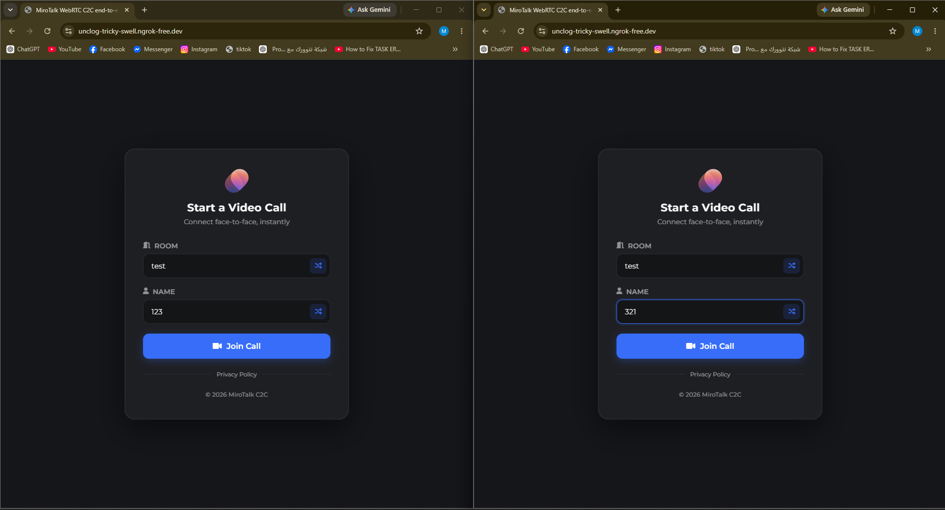

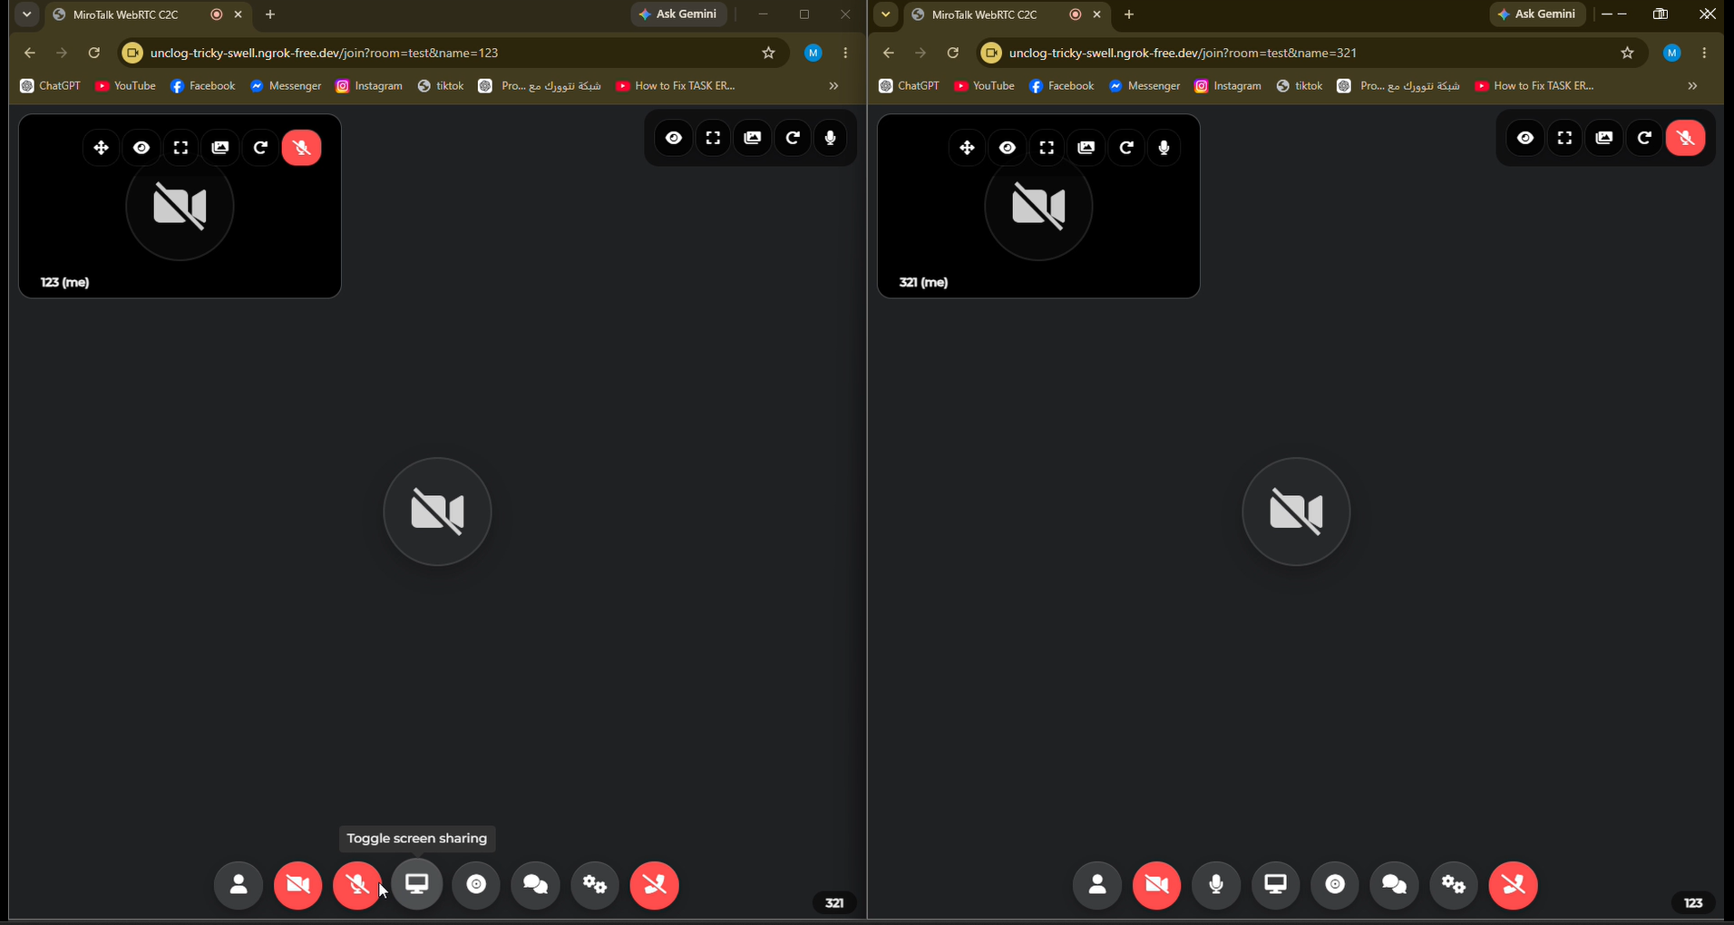

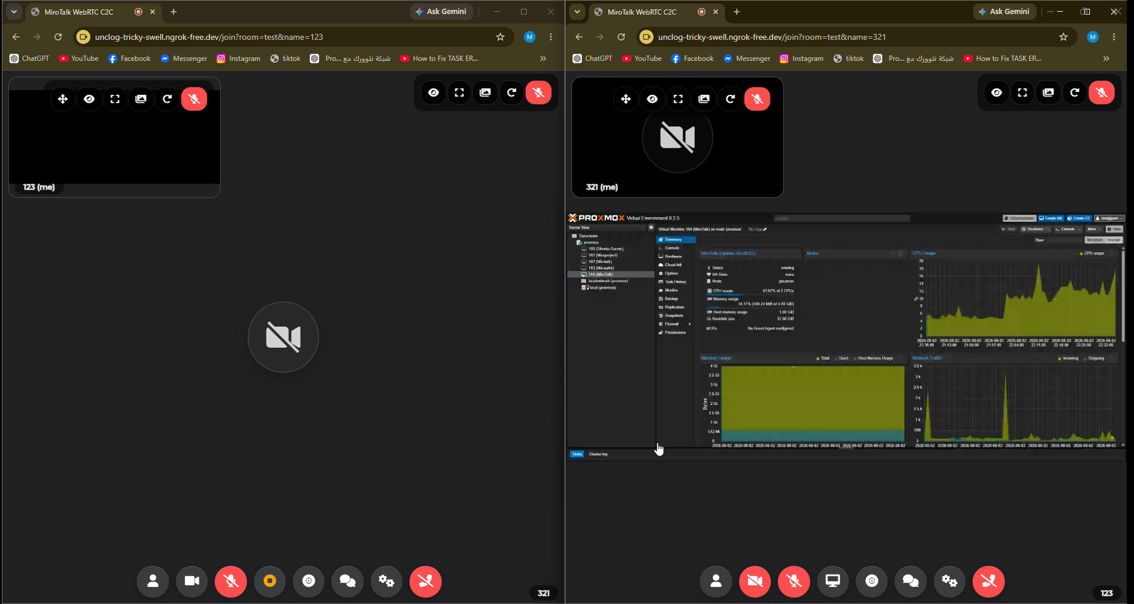
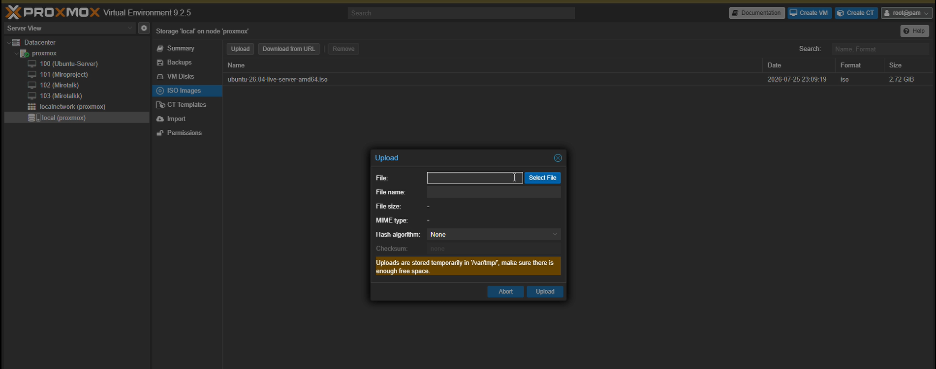

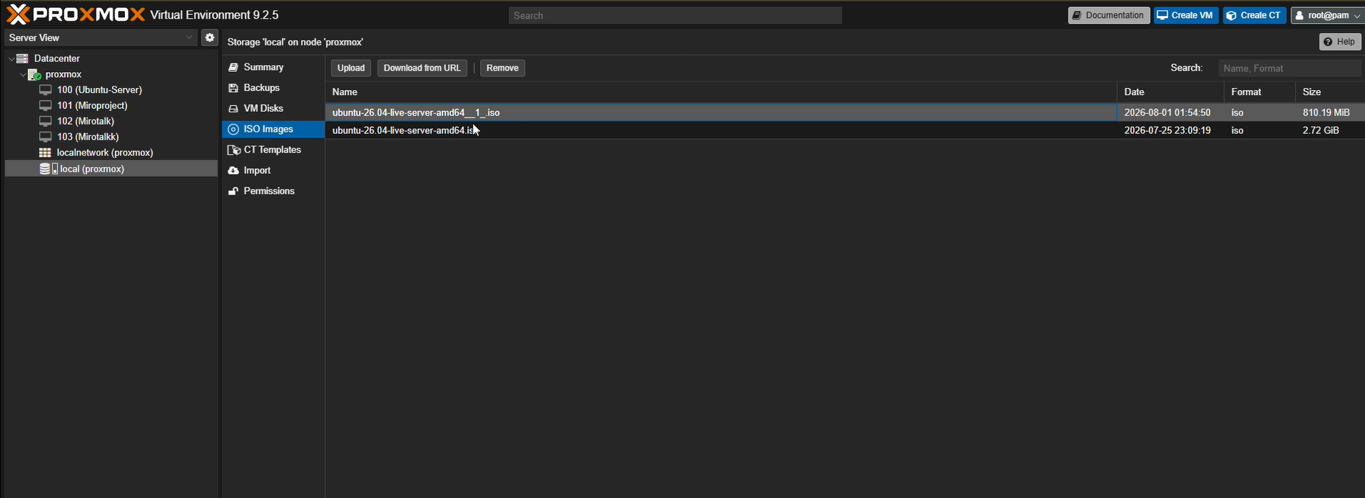

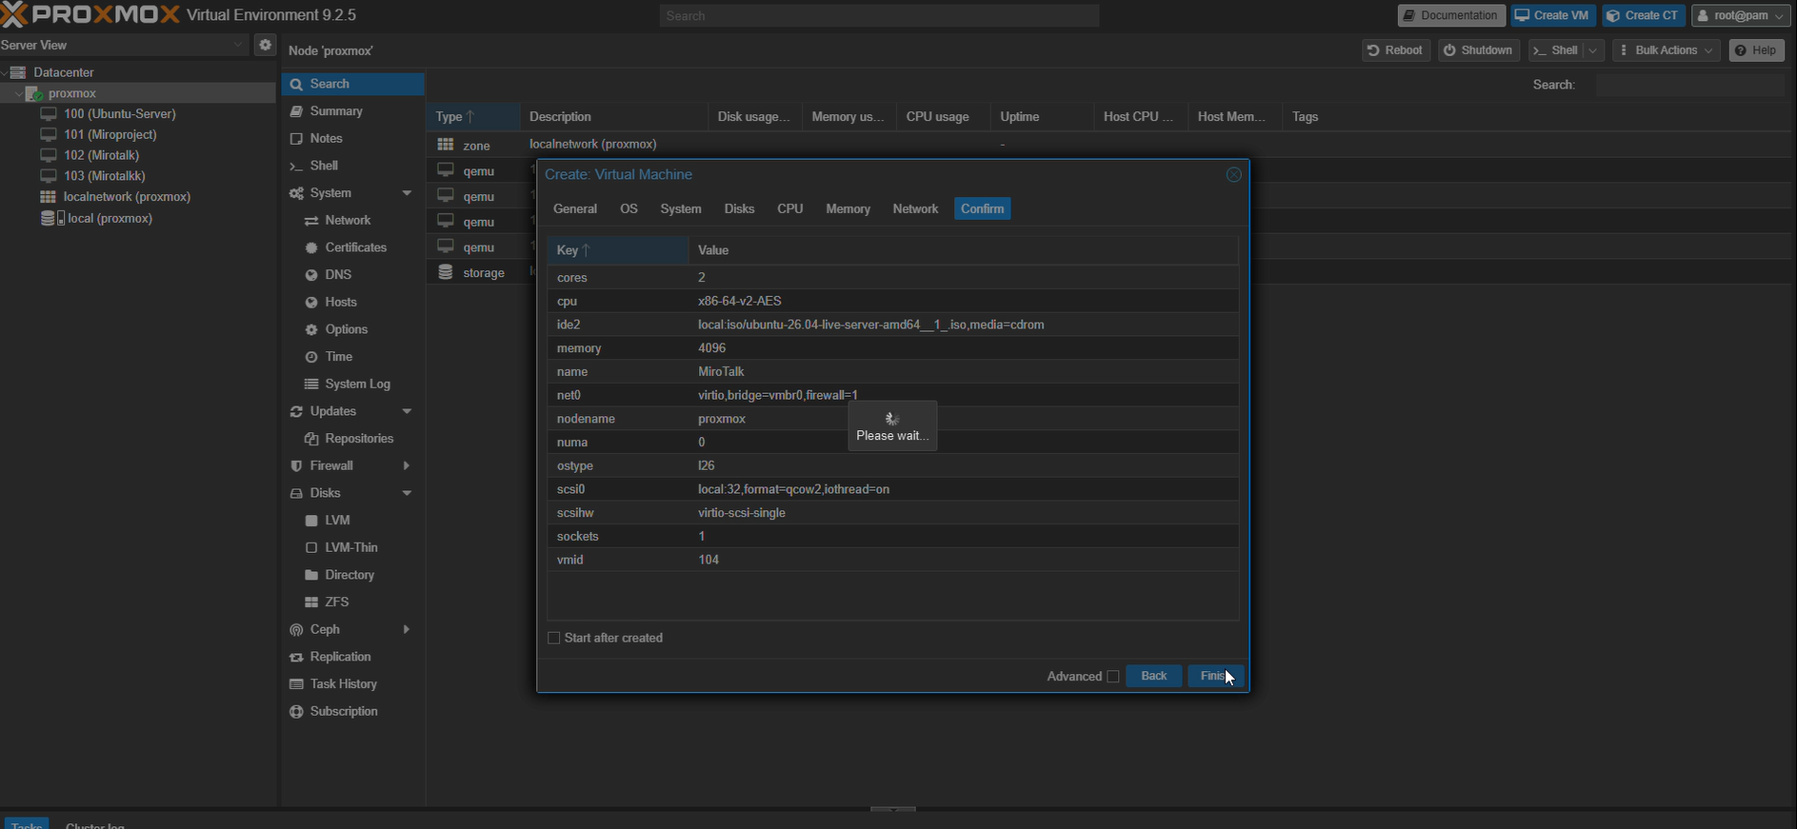

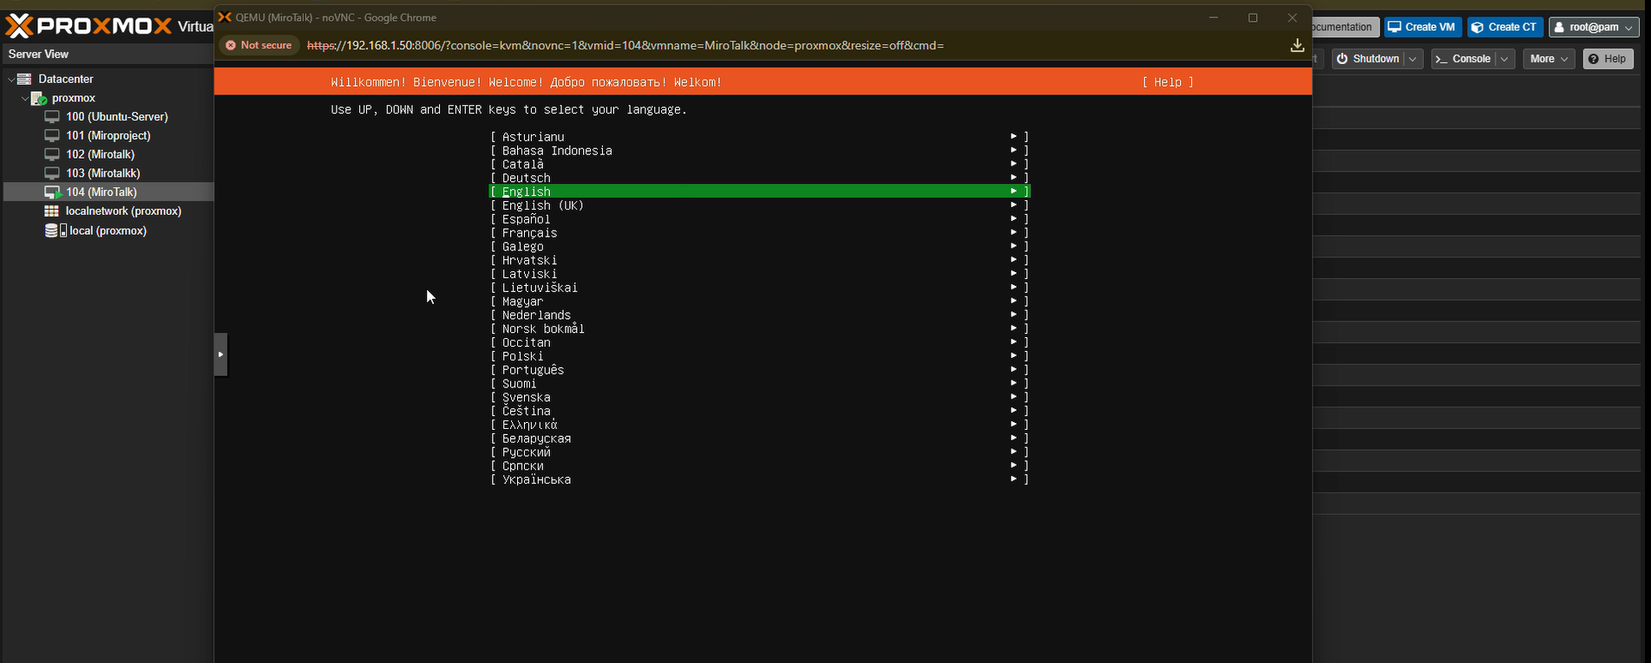
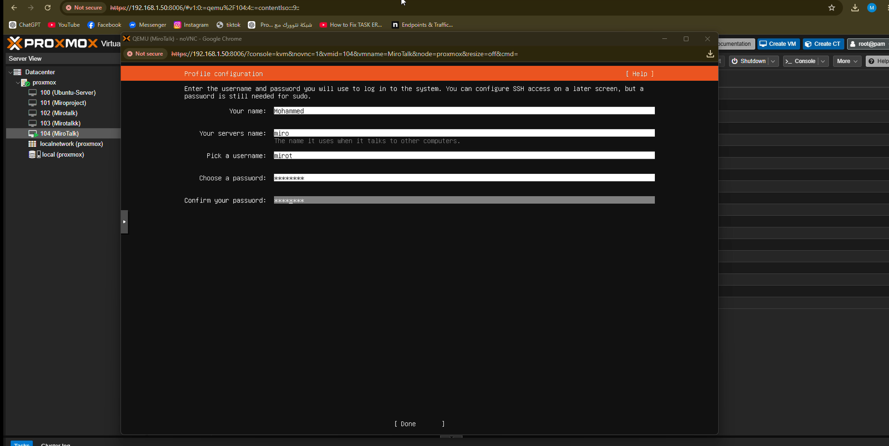

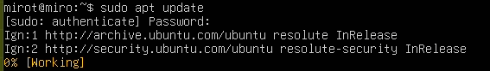
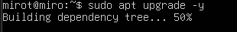
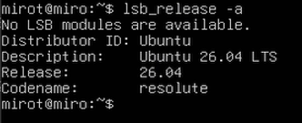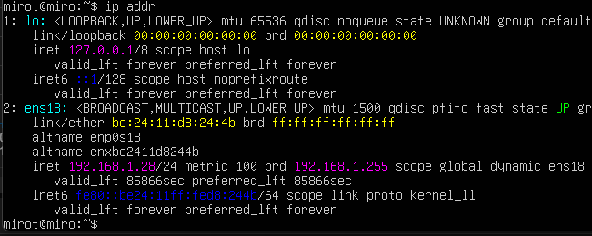
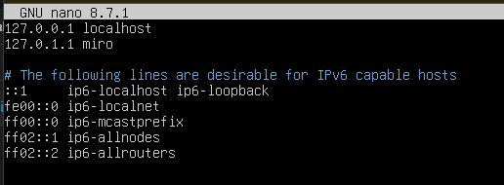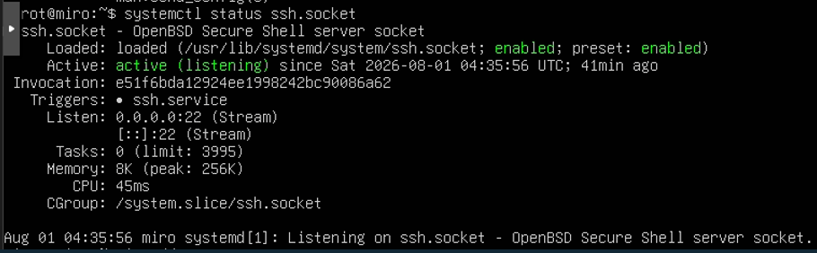

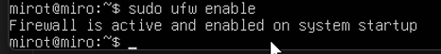
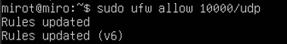
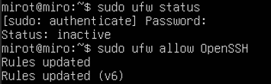
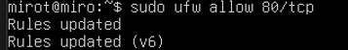
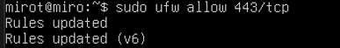

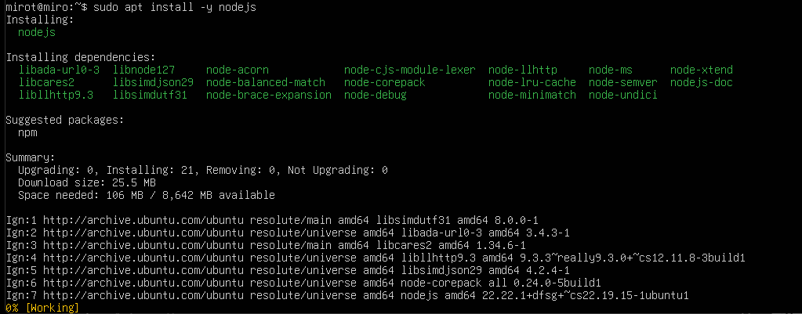

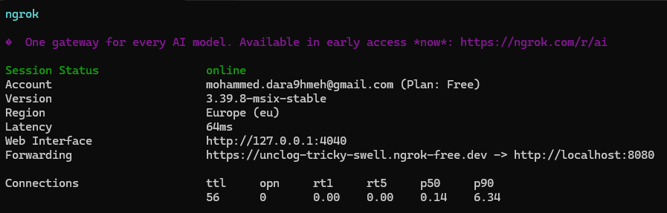
Conclusion
This project demonstrated how multiple modern technologies can be integrated to deploy a real-time communication platform.
Using Ubuntu, Docker, Containerlab, Proxmox, Ubuntu Server, and Ngrok, a complete deployment environment was successfully created.
The project provided practical experience in virtualization, containerization, networking, and cloud-style application deployment.

