ENHANCING THE SUSTAINABILITY OF LISTED PLACES OF WORSHIP
Synthesis of Past Scheme Evaluations:
A Report for the Department for Digital, Culture, Media and Sport
November 2019

The Frontier Economics network consists of two separate groups, Frontier Economics Limited (incorporated in the UK) and Frontier Economics Pty Limited (incorporated in Australia). The two groups are independently owned, and legal commitments entered into by one group does not impose any obligations on the other group in the network.

Contents
Executive Summary 4
Lessons from past schemes 4
Insights for future policy 9
1 Objectives of this study 11
2 Overview of the study 12
2.1 Methodology of the review 12
2.2 The schemes selected for review 13
2.3 Data on selected past schemes 18
2.4 Additional schemes 20
3 Thematic findings 21
3.1 Scheme design, set-up and implementation 21
3.2 Scheme outcomes 29
4 Observations on the quality of evidence on past schemes 41
5 References 44
Annex: Findings from the First World War Centenary Cathedral Repairs Fund Evaluation 46

Executive Summary
The Department for Digital, Culture, Media and Sport (DCMS) asked Frontier Economics to provide an independent evaluation of the impact and effectiveness of the Taylor Review Pilot. To complement the evidence base being developed for the evaluation, Frontier was also asked to review existing evaluation evidence relating to similar past schemes. This report provides this review and is intended to compile the learning about the effectiveness and impact of past initiatives.
This review focuses on publicly funded schemes for which evaluation evidence is available and is complemented by available data on other relevant schemes that have not formally been evaluated.
The selection criteria used to identify the documents for inclusion in this review are:
- The availability of evaluation documents and/or data within the last 10 years (some older schemes were also included where they were especially relevant to future policy considerations). This was the overriding criterion, as relatively few evaluations of support schemes for places of worship are available; and
- Schemes that are relevant to inform future national policy considerations relating to the sustainability of listed places of worship, with a focus on publicly funded fabric maintenance and community support schemes.
The availability of evaluation documents has been the main constraint of selection for this review. In most cases it is only the larger support schemes that have evaluation reports available to review. Fifteen evaluation documents were identified in scope, from 10 different schemes.
Documents were identified through discussions with DCMS, Historic England, the National Lottery Heritage Fund, selected charities in the sector and sector experts.
The evaluations reviewed relate to various forms of support that have aimed to enhance the sustainability of listed places of worship. This review has allowed us to synthesise the evidence on the factors that improve or impede the effectiveness of these support schemes. The lessons drawn from the evidence, the main limitations in the available evidence, and insights for future policy are set out below.

Lessons from past schemes
This review of evidence has revealed a number of lessons to enhance the effectiveness of different forms of support for places of worship. These are summarised below.

Eligibility criteria need to balance a tension between inclusivity and managing the demand for available funds

16%
The grant value awarded by the Listed Places of Worship Roof Repair Fund as a percentage of the total value of applications.
(ERS Research & Consultancy, 2017)
In the past, most schemes adopted eligibility criteria to define who could bid for support (mainly grants). The scope of eligible organisations varied markedly across the past schemes included in this review. For example, English Heritage (now Historic England) primarily restricted applications for its grants to Grade I and Grade II* listed buildings, whereas the Heritage Lottery Fund (now National Lottery Heritage Fund) typically sought wider eligibility based on societal goals.
For financial support, typical eligibility criteria related to the type of work to be funded, the size of grants that would be awarded and the urgency of the problem the grant would solve. For non-financial support, the views and motivations of communities and volunteers were an important factor to determine the fit and the chances of success of specific projects.
There is a high demand for grants overall. Ensuring grants are well targeted is therefore important for reaching the intended objectives of a scheme, while avoiding excessive numbers of unsuccessful applications. Some schemes for which the criteria were less tightly defined led to the scale of applications far exceeding the available grants. For example, the Listed Places of Worship Roof Repair Fund could only award grants totalling 16% of the total value of applications, despite funding only roof repair works. This could be discouraging for places of worship who have applications rejected, especially given the high reliance on volunteers in preparing applications.

Listed places of worship see grants as essential to complement other sources of funding

50%
While grants represent only 9% of Church of England parish churches’ income, they are equivalent to almost 50% of all capital expenditures. (Church of England, 2018)

Survey data from several past schemes suggest that the funding of maintenance and repair works is a major issue for many places of worship.
Grants are heavily relied on; they currently represent almost 50% of Church of England parish churches’ annual capital expenditures.

The evidence shows that:
- Places of worship often do not generate sufficient revenues internally to fund major maintenance and repair works. This makes community fundraising and grants especially important. The majority of places of worship use fundraising activities to help finance capital-intensive projects.

79%
The percentage of recipients of the Listed Places of Worship Grant who stated that without it, the work could not have been completed to the same extent or time frames.
(BDRC Continental, 2010a)
- Effective fundraising and innovative funding models may still not be sufficient to cover all costs. This can be seen in the high demand for grants, as well as in survey evidence from grant recipients on the impact of grants on the capacity of communities to undertake maintenance and repairs.
- Survey evidence from past schemes shows that some communities experience difficulties in finding out about funding opportunities and applying to them. This is particularly true in rural areas where communities are typically small. To help remedy this, Historic England introduced the Support Officers scheme in 2008. The scheme part-funded 34 Support Officers who provide help to communities in identifying suitable schemes. The scheme is ongoing. The Support Officers work with communities to establish their needs and the scope of works. In many cases, they also advise on how to apply for additional resources and grants. Since 2008, Support Officers have worked with congregations that have successfully applied for grants with a total value of over £13 million.

Volunteers play a central role in driving forward maintenance programmes, but they often need support and guidance to help navigate the challenges of maintaining complex historic buildings
Volunteers are central to the sustainability of places of worship because they make themselves available to care for the fabric of the building. However, volunteers may have limited amounts of time to devote to their places of worship and often will not have specialist expertise.

83%
The percentage of participants in courses from the Faith in Maintenance programme who felt more confident identifying and taking action on maintenance issues at their place of worship.
(Oakmere Solutions Ltd, 2012)
Courses and workshops have proven to be an effective way to improve volunteers’ motivation, confidence and skills. The provision of courses, such as those provided by the Society for the Protection of Ancient Buildings (SPAB) through the Faith in Maintenance programme, has also been found to attract people from outside faith groups and increase the number of volunteers who care for places of worship.
It can be harder to attract volunteers to roles that may be very time-consuming or involve substantial responsibilities. Application processes can be seen as daunting for volunteers (Payne and Cooper, 2016). The SPAB, for instance, intended to elect a Volunteer Co-ordinator for each of the maintenance co-operatives it developed but had to revise this plan. The scheme’s evaluation found that more decentralised forms of leadership are better for engaging volunteers with projects at places of worship (Oakmere Solutions Ltd, 2016). Additionally, projects for which leadership does not rest on the shoulders of a single volunteer may benefit from a greater continuity of leadership. For example, the interim evaluation of Grants for Places of Worship found that in many cases volunteers would not want to continue after their project was completed, but few had active succession plans in place (Payne and Cooper, 2016). Indeed, the evaluation of the Rural Churches in Community Service Programme identified that discontinuity in activities held at places of worship was often linked to the departure of a volunteer who assumed leadership on his/her own (Rowe, 2009).
Lastly, collaboration between groups of volunteers who care for different places of worship, such as through maintenance co-operatives, are suggested by the evidence to be an effective way to widen the pool of skills available to each place of worship (Oakmere Solutions Ltd, 2016). In certain circumstances this can also encourage volunteers to manage building maintenance actively through maintenance planning. Achieving these outcomes depends on local circumstances; for example, a number of different models emerged as approaches to maintenance co-operatives rather than a single successful model that would suit all locations and circumstances (Oakmere Solutions Ltd, 2016).

Wider community engagement can increase the sustainability of listed places of worship under appropriate circumstances
Community engagement and utilisation of places of worship beyond the worshipping community have been found to be key drivers of sustainability in appropriate contexts. This is for several reasons:
- A wider pool of people who engage with the place of worship can potentially contribute to the funding of repair and maintenance projects;
- More revenues can be generated from activities taking place at the place of worship; and
- Places of worship with higher community engagement may be able to call on a wider pool of potential volunteers.
Past schemes have highlighted that the appropriate approach to community engagement (e.g. new facilities, social enterprise, co-operatives) is location specific because it must fit the needs, resources and motivations of each community. Additionally, faith communities have varying degrees of openness to wider community use of their place of worship, so alternative approaches may be needed for different locations, faiths or denominations (Withers and Payne, 2012).
While maintaining a building to avoid it falling into a state of disrepair is clearly a pre-condition for use by communities in the long run, in most cases it is very difficult to attribute specific community use to a given maintenance activity. There are, however, cases where grants have allowed the repairs or installation of facilities that are essential to wider community activities (e.g. kitchen or toilets) (Derrick, 2005). Derrick (2005) recommends that grants to fund new facilities are considered where it can be shown that the new facilities would be likely to lead to increased income generation through higher utilisation of the facilities, or where the new facilities are essential to secure continued use of the place of worship.

There are limitations in the evidence base on past schemes
There are several complex factors affecting the maintenance and sustainability of places of worship which make evaluating the impact of individual schemes challenging. The following limitations are identified in the available evidence:
- The majority of the evaluations reviewed for this report rely almost exclusively on qualitative data: telephone interviews, online surveys, mailing lists and occasionally interviews in person. This type of data is important for understanding the views of the parties involved in projects. However, it leaves important gaps in the evidence base, such as evidence on changes in the physical condition of the buildings over time. The Taylor Review Pilot will play an important role in filling this evidence gap by ensuring that data on the state of the fabric are collected consistently throughout the pilot.
- The survey questions have a relatively low level of consistency. While questions generally aim to generate quantitative information relevant for the evaluation, the phrasing or structure of questions is generally different. This is to be expected given that various organisations are involved in the schemes and the different evaluations, but greater conformity would allow deeper understanding of the relative effectiveness of schemes, comparability in performance and learning from one another. If scheme providers were to adopt a joint framework of monitoring and evaluation, they and others could draw on insights into the relative effectiveness of different support approaches in the future.
- The qualitative evaluation approaches typically ask respondents about their appreciation of certain aspects of the scheme at one point in time and do not consider what might have happened without the scheme. A few studies ask respondents to compare their appreciation of certain aspects of the maintenance and sustainability of the places of worship today with pre-scheme observations, but only two studies use control groups for comparison. This means it is difficult to understand the extent to which any impacts observed are attributable to the scheme, or some other factor.
- There is limited evidence in the evaluations to verify changes in the physical condition of buildings as a result of past support. Physical inspections of the buildings before and after (and potentially during) maintenance and repair projects would allow evaluators to collect more data in this regard. However, evaluations rarely include such observations, or at least do not consistently report them in the evaluations reviewed. This may in large part be due to the cost and time investment necessary to conduct such inspections. It could be valuable to draw on existing inspection plans after a project, sample a proportion of sites to visit following the completion of works or interview architects working with places of worship. The cost of this follow-up means this is more likely to be proportionate for larger grant schemes.
- Community support is very context specific. While evaluations of past schemes provide useful insights on the effectiveness of individual interventions, it is difficult to assess how generalisable the findings are. Broader research would be valuable to understand the conditions under which certain approaches are more likely to be successful. The Taylor Review Pilot intends to play an important role in building this understanding by monitoring the community support included in the pilot.

Insights for future policy
The evidence provides us with a number of valuable insights that are relevant for future policy considerations:
- Prioritising support: the evidence from past schemes demonstrates a high demand for both financial and wider support to facilitate the sustainability of places of worship. This suggests a prioritisation process is likely to be important when offering support. Clear eligibility criteria can help to manage demand for grants, provide clarity on aims and objectives, and encourage suitable applications while redirecting less suitable projects to alternative funding routes. The application process should be proportionate, ensuring funds are well targeted while also limiting the burden on volunteers applying for funding. Similarly, it is important to clearly communicate the nature of the support provided, working with stakeholders to disseminate this information.
- Support needs are context specific: different places of worship require different types of support. This can be driven by factors such as the nature of the building, the characteristics of the local area (e.g. rural or urban, socio-demographics), the availability of other types of support, and the motivations and skills of local volunteers. This is especially true for community engagement, which by its nature needs to be tailored to the communities involved. This highlights the importance of flexibility in the support available to places of worship.
- Building the evidence base: evaluations of past schemes provide valuable insights, but the evidence base also has limitations. The evaluation of the Taylor Review Pilot intends to add new insights by broadening the evidence base available and help to understand the additional value of the scheme relative to what could otherwise have been achieved. This includes:
  - identifying and testing the causal links between inputs of the Taylor Review Pilot and outcomes;
  - testing the outcomes of the package of support with both qualitative insights and data collected throughout the pilot;
  - generating evidence on the extent to which the components of the support package interact, complement or hamper each other;
  - building understanding of what has and has not worked, how, why, and under what conditions; and
  - disseminating these findings to inform future policy making.

Objectives of this study
There are approximately 14,800 listed places of worship in England. These buildings provide spaces for worship as well as social and community events, allowing people to gather for a wide range of social and spiritual reasons.
Over the last few decades, a number of schemes have been run by the government, its arm’s-length bodies, charities and trusts to provide support to listed places of worship across the country. The purpose of this support is to ensure that listed places of worship remain open and cared for as important pieces of heritage by offering funding and support for maintenance and repair works and community use.
In 2016, the Secretary of State for Digital, Culture, Media and Sport (DCMS) and the Chancellor of the Exchequer commissioned the ‘Taylor Review: Sustainability of English Churches and Cathedrals’ to examine how Church of England buildings could become more financially sustainable.
The Taylor Review highlighted the scale of the challenge and emphasised the paucity of evidence for what will work (and what will not) to secure the future of these buildings. The review referred to the effectiveness of some schemes but could not provide a comprehensive overview of what had been effective and what had not.
Following the recommendations of the Taylor Review Panel published in December 2017, the government is now implementing a pilot scheme to test and develop the panel’s findings in relation to the funding of minor repairs. The Taylor Review Pilot will last 18 months in two areas – Manchester and Suffolk – and will apply the recommendations of the Taylor Review across all faiths and denominations.
Frontier Economics has been commissioned by DCMS to evaluate the impact and effectiveness of the Taylor Review Pilot. To complement this evidence, Frontier was also asked to review the evaluation evidence on past schemes. This report provides the findings from that review with a particular focus on understanding the effectiveness and impacts of past initiatives and the lessons that can be learned for future policy. This review assessed evidence from past schemes over the last 10 years, focussing on those for which evaluation evidence is available. Available data on other key schemes that have not been evaluated is also included.

Overview of the study
This review of evidence on past schemes focuses on those that offer the most relevant lessons for future policy considerations related to the sustainability of places of worship, with a focus on fabric maintenance and community support. The selection of schemes to review was also in large part driven by the availability of evaluation documents. Data for key national schemes where evaluation documents were not available has also been reviewed. This section outlines the method used to identify the schemes within the scope of this review and the nature of the schemes included.

Methodology of the review
The first stage of the review process involved selecting the evaluation documents to be reviewed. Using desk research, a number of available evaluation documents relating to relevant schemes were identified.
Engagement with stakeholders was also carried out to ask for any evaluation reports they were aware of or that they had access to but that had not been published. Stakeholders included DCMS, Historic England, the National Lottery Heritage Fund and charities such as the National Churches Trust, the All Churches Trust and the Churches Conservation Trust.
The process for selecting the documents to include in the review was based on two main criteria:
- The availability of evaluation documents and/or data. While there has been an array of relevant schemes over the past few decades, most have not been subject to an evaluation. The focus was therefore on those schemes for which evaluation evidence, or other key data on scope, operation years and grants value, was available to review; and
- The relevance of the schemes to inform future national policy considerations with respect to the sustainability of places of worship, with a focus on publicly funded fabric maintenance and community support schemes.
The availability of evaluation documents was the main constraint of the review selection. In most cases it is only the larger support schemes that have evaluation reports available to review.
The evidence available provides insights into various forms of support available to places of worship over the past 10 years. A small number of older schemes where they were especially relevant to future policy considerations were also included.
The following sections present the schemes for which an evaluation or data were available, and which have therefore been included in this review, followed by the findings and observations from this review.

The schemes selected for review
The criteria set out above led us to review 15 evaluations of 10 different schemes. Additionally, some key national schemes did not have a formal evaluation but data on their scope and size were available.
From each evaluation document, this review aimed to collect the following information, if it was available:
- Descriptive information about the scheme such as the provider, the nature of support, the years of operation, the size and scope of the support;
- Descriptive information about the evaluation such as the type of evaluation, the data sources, methodology and Maryland Scientific Methods Scale of the evaluation;
- The eligibility criteria used by the scheme providers to select beneficiaries;
- The context in which funding was applied for or provided by the schemes;
- Evidence of the impact of the schemes on knowledge and practice of regular maintenance, on the fabric of the buildings and on long-term repair costs;
- Evidence of generating income for places of worship and building a sustainable model beyond the life of the scheme;
- Evidence of impacts on volunteers’ motivation, confidence and capabilities; and
- Evidence of the impact of the schemes on community engagement and utilisation of facilities, and whether this helped improve their sustainability.
This review pays particular attention to what has proven to be effective or less effective and under what conditions. The collected evidence on impacts includes both intended and unintended impacts of the schemes.

Past grant schemes with evaluation documents
This review of evaluation documents incorporates a variety of schemes providing different forms of support to places of worship across the UK. The majority of the schemes reviewed (six out of 10) provide financial support predominantly to places of worship.
The documents reviewed evaluated six grant schemes, which are listed in Figure 1 below.
Throughout this report the bodies responsible for funding schemes are referred to under the names used at the time each funding scheme was reviewed. However, it should be noted that some bodies have subsequently changed their names. In particular, English Heritage changed to Historic England in 2015 and the Heritage Lottery Fund changed to the National Lottery Heritage Fund in 2019.

Figure 1 List of grant schemes included in the review
Scheme name | Funding body | Administrator | Type of works funded | Years operational | Total grants’ value estimation | Geography of funding figure
Joint Scheme for Churches and other Places of Worship | English Heritage and the Heritage Lottery Fund | English Heritage | Repairs only | 1996-2002 | £111 million | England
Repair Grants for Places of Worship | English Heritage and the Heritage Lottery Fund | English Heritage | Repairs only | 2002-2013 | £254 million | England
Grants for Places of Worship | Heritage Lottery Fund | Heritage Lottery Fund | Major repairs and new facilities | 2012-2017 | £133.5 million | UK
Listed Places of Worship Grant | Government | Topmark | Maintenance and repairs costing over £1k | 2001-present | £275 million | UK
Listed Places of Worship Roof Repair Fund | Government | National Heritage Memorial Fund | Roof repairs under £100k only | 2015-2017 | £55 million | UK
Rural Churches in Community Service Programme | Millennium Commission | Rural Churches in Community Service Ltd | Developments to benefit the wider community, no repairs or maintenance | 1998-2001 | £2.5 million | UK
Source: Frontier Economics, see footnotes and References for individual sources
Evaluation documents were identified to review for the following six schemes:
- Joint Scheme for Churches and other Places of Worship (1996-2002) was the first scheme to be co-administered by English Heritage and the Heritage Lottery Fund. The criteria for eligibility were wider compared to English Heritage’s previous restrictions (where only Grade I and Grade II* essential works were considered). Over its five to six years of operation, the scheme distributed about £111 million in grants. Two evaluations of this scheme were reviewed. The first was conducted by Architectural History Practice (which evaluated all schemes run jointly by the Heritage Lottery Fund and Historic England). The second report evaluated the relative impact of grants provided through this scheme to fund new facilities for wider community use (Derrick, 2005).
- The Repair Grants for Places of Worship scheme provided about £249 million in repair and maintenance grants, funding 2,600 projects in listed places of worship from 2002 to 2012. The scheme was administered by English Heritage and the Heritage Lottery Fund and was designed to help congregations to care for historic churches, synagogues and other places of worship. The scheme effectively took over the role played by the earlier Joint Scheme for Churches and Other Places of Worship (1996-2002). Of the £249 million in grants, the scheme awarded £171 million to Grade I and II* listed buildings, and £78 million to Grade II listed buildings. Two evaluations of this scheme were reviewed, produced by BDRC Continental and by the Architectural History Practice.
- The Grants for Places of Worship scheme was the successor of the Repair Grants for Places of Worship scheme above. It was launched by the Heritage Lottery Fund in December 2012, alongside a number of wider programmes, as part of the Heritage Lottery Fund’s 4th strategic framework. Grants for Places of Worship was the first major programme for places of worship to include community engagement as a core element. The scheme closed in September 2017 after distributing over £130 million in total. The evaluation of this scheme is ongoing as it involves interviews with a sample of places of worship repeated over several years. The first three interim evaluation reports for this scheme were reviewed.
- The Listed Places of Worship Grant Scheme is an ongoing scheme which gives grants that cover the VAT incurred in making repairs to listed buildings in use as places of worship. The scheme is funded by HM Treasury with a value of up to £42 million per annum. The scheme covers repairs to the fabric of the building and associated professional fees, plus repairs to turret clocks, pews, bells and pipe organs. This scheme has generated about 4,000 claims every year. For the financial year 2015/2016, it is estimated that a total of £18 million in grants were awarded to approximatively 4,300 projects. The scheme already reached this amount of funding by the end of September for the financial year 2018/2019.
- The Listed Places of Worship Roof Repair Fund was managed by the Heritage Lottery Fund and the National Heritage Memorial Fund. In 2015/2016, it granted a total of £30 million to over 900 projects to make the UK’s listed places of worship weathertight. The value of grants ranged from £10k to £100k. The scheme awarded another £25 million in 2017/18.
- The Rural Churches in Community Service Programme delivered grants between 1998 and 2001. It was administered by the Rural Churches in Community Service Limited, which the Millennium Commission established to distribute and manage £2.5 million of UK National Lottery funds. The grants were awarded to 99 projects that could demonstrate they would support high levels of use of the buildings by the community. The projects needed to spend the grant on adaptations of the buildings for the wider community and not on renovation, restoration and repairs.
In addition to these schemes, the evaluation of the First World War Centenary Cathedral Repairs Fund Evaluation was also reviewed. This scheme is not directly relevant to most places of worship as it provided one-time funding in the form of large grants only to selected cathedrals. The main findings from this evaluation can be found in the annex of this report.

Past non-grant schemes with evaluation documents
The documents reviewed also evaluated four wider support schemes, which are listed in Figure 2.
Figure 2 List of wider schemes reviewed
Scheme name | Funding body | Administrator | Years operational | Nature of support
Faith in Maintenance programme | The Heritage Lottery Fund and Historic England (as well as the Society for the Protection of Ancient Buildings (SPAB) and other charities) | SPAB | 2007-2010 | Training courses
Maintenance Co-operatives | The Heritage Lottery Fund (and small grants from Historic England) | SPAB | 2014-2017 | Project support and training courses
Empowering Design Practices | Arts and Humanities Research Council | Open University | 2014-2019 | Project support and training courses
Support Officers | Historic England | Historic England | 2009-present | Project support and training courses
Source: Frontier Economics, various evaluations (see References for individual sources)
Note: Two further studies were also reviewed – ‘Social Enterprise and Rural Places of Worship in England’ and ‘Funding Gap for Church of England Parish Churches’ – that do not evaluate specific schemes.
The documents reviewed show these wider support programmes can take various forms: courses, workshops, community development and support, and social enterprise development. The four schemes for which the evaluation documents were reviewed are presented briefly below, along with the two studies which do not evaluate any specific schemes:
- Between 2007 and 2010, the Society for the Protection of Ancient Buildings (SPAB) administered the Faith in Maintenance programme, funded mainly by the Heritage Lottery Fund and Historic England. It delivered a maintenance training course appropriate to the needs of volunteers who cared for historic buildings used as places of worship. It also provided a support system to assist volunteers in the care of the fabric of places of worship and their contents.
- The SPAB administered another scheme between 2014 and 2017 aimed at forming and supporting maintenance co-operatives to bring together groups of people caring for places of worship. The scheme was granted an award of £907,400 by the Heritage Lottery Fund as well as smaller grants from Historic England. By October 2016, 24 co-operatives involving 144 places of worship had been formed and supported. The aim of these co-operatives was to support co-ordination between communities to improve management and maintenance practices at places of worship. In addition, training courses were again provided to volunteers. While the scheme is now closed, the SPAB still provides open-source documentation to help places of worship create their own maintenance co-operative.
- Two of the documents reviewed relate to the Empowering Design Practices scheme, a five-year long (2014-2019) collaborative project between the Arts and Humanities Research Council, Historic England, the Heritage Lottery Fund and the Historic Religious Buildings Alliance. It offers funding of £1.5 million and aims to explore how community-led design can help empower those who look after historic places of worship to create more open, vibrant and sustainable places that respect and enhance their heritage. The scheme is multi-dimensional and involves an ongoing research project, community support for their projects, training programmes and specialist workshops.
- Since 2009, Historic England has been part-funding Support Officers whose aims are to help communities understand, manage and maintain their places of worship. The Support Officers’ precise roles vary in different areas, but all generally aim to help communities to develop maintenance planning, identify community engagement opportunities, and identify and apply for grants. Historic England has invested a total of £2.5 million and in most cases has provided 50% funding to support the costs of the Support Officer post for three years. The rest of the cost is generally met by the diocese (Church of England or Roman Catholic) or other employers (which have included third sector bodies and a local authority). Some posts have been extended to longer periods, with and without ongoing funding from Historic England. So far, a total of 34 posts have been created. While this scheme does not benefit from a formal evaluation, data and documentation to draw lessons for future policy considerations were assessed.
- Inspired Futures is a project run by Inspired North East and funded at £222k by the Heritage Lottery Fund which aims at improving the sustainability of church buildings in the North East. A team of volunteers and professionals work with 18 listed places of worship in the Durham and Newcastle Dioceses to develop opportunities for heritage conservation, improvements to facilities and access, and enhance potential for wider community use. Support is provided in several forms including training, targeted consultancy, development of feasibility assessments, heritage activity plans and overall business plans. This project has been running since 2016.
- During this review of past schemes, account was also taken of a study that is not linked to any specific scheme but nonetheless provides useful insight on an innovative approach to sustainability. The Social Enterprise and Rural Places of Worship in England study evaluates the impact of the introduction of social enterprise on the sustainability of rural places of worship.

Data on selected past schemes
In addition to the schemes for which there is an evaluation report, there are a few schemes for which scope and size data is available. This data was considered for key nationally significant schemes. These are listed in Figure 3, followed by a description.
Figure 3 List of schemes for which size and scope data were reviewed
Scheme/  organisation name | Funding body | Types of work funded | Grants value estimate*** | Years covered by grants value estimate* | Geography
Heritage Grants** | National Lottery Heritage Fund | Large/very large maintenance and repairs | £107.9 million | 2013/14-2017/18* | UK
Our Heritage** | National Lottery Heritage Fund | Medium/large maintenance and repairs | £7.8 million | 2013/14-2017/18* | UK
Sharing Heritage** | National Lottery Heritage Fund | Small maintenance and repairs | £0.6 million | 2013/14-2017/18* | UK
First World War: Then and Now** | National Lottery Heritage Fund | Conservation of war heritage | £0.6 million | 2013/14-2017/18* | UK
National Churches Trust | National Churches Trust | Small repair, maintenance and community support grants | £16 million | 2007-2018 | UK
Allchurches Trust | Ecclesiastical Insurance Group | Wide scope, not limited to the fabric of the building | £171 million**** | 1972-2018 | UK
Source: Frontier Economics, see footnotes and References for individual sources.
Note: *The data analysed for these schemes relate to the years 2013/14 to 2017/18. In some cases, the schemes were in operation for longer and/or are ongoing. **These grants are not exclusively for places of worship, but the data analysed concern grants to places of worship only. ***A total across schemes is not provided because the data reviewed are not over comparable time periods. ****These grants are not exclusively for places of worship.
- The National Lottery Heritage Fund awards grants to places of worship through its wider heritage grants. For these grants, places of worship are in competition with secular heritage projects. Data was analysed for the four most important programmes in terms of total grants value awarded to places of worship between 2013/14 and 2017/18:
  - The main programme from which places of worship have benefited in the last few years is the Heritage Grants programme. The programme awarded a total of 66 large grants, ranging from £100k to several millions with an average value of £1.6 million, to places of worship between 2013/14 and 2017/18. This programme was closed in 2018.
  - The Our Heritage programme awarded a total of 154 grants ranging from £10k to £100k with an average value of £50.5k to places of worship between 2013/14 and 2017/18.
  - The Sharing Heritage programme awarded a total of 74 grants ranging from £3k to £10k with an average value of £7.7k to places of worship between 2013/14 and 2017/18.
  - The First World War: Then and Now programme awarded a total of 77 grants ranging from £3k to £10k with an average value of £8.1k to places of worship between 2013/14 and 2017/18.
- The National Churches Trust provides grants to listed and non-listed places of worship of any Christian denomination across the UK. It aims to preserve heritage, promote churches’ sustainability and inspire support. The organisation publishes data on the grants it has awarded since 2016. The data show that £1.4 million and £1.5 million were awarded in 2016 and 2017 respectively (National Churches Trust, 2018a). The grants range from £411 to £40,000 and average at £7,500. They are awarded to help communities fund maintenance projects, but also to fund the installation of essential facilities and improve access for everyone. The National Churches Trust is expected to launch three new grants programmes for 2019-2023 (National Churches Trust, 2018b):
  - The Foundation Grant Programme will offer grants of £500 to £3,000 to fund urgent maintenance works and small repairs.
  - The Gateway Grant Programme will offer grants of £3,000 to £10,000 towards project development and investigative work. The latter will support churches to prepare for a major project to the point where they can approach a major grant funder.
  - The Cornerstone Grant Programme will offer grants of £10,000 to £50,000 towards the cost of urgent structural repair projects costed at more than £100,000 including VAT. Projects that introduce kitchens and accessible toilets to enable increased community use will also be considered. Grants will never exceed 50% of the project cost.
In addition to grants, the National Churches Trust provides non-financial tools and support to communities who care for places of worship. For instance, in 2017, it launched the MaintenanceBooker website, an online ‘one stop shop’ where churches and chapels can book accredited contractors for services including gutter clearance, tree maintenance and lightning protection systems inspections.
- Allchurches Trust provides grants aimed at promoting the Christian faith and other charitable causes mainly in the UK and Ireland. The funded projects are varied and include grant support to churches and cathedrals of all Christian denominations and to charities with Christian links as well as schools, colleges, hostels, care homes and other communities. The funded projects are not restricted to maintenance and repairs but include projects benefiting the wider community such as the adaptation of churches to the needs of community activities. Their latest annual report shows that about £100 million have been distributed by the organisation within the last 10 years: £11.7 million, £13.2 million and £15.6 million were distributed in 2015, 2016 and 2017 respectively (Allchurches Trust, 2018). Over 80% of these funds are directed to cathedrals, churches and dioceses. The remainder of the funds go to registered charities.

Additional schemes
Published documents on a number of additional schemes and organisations were also reviewed. These schemes did not have evaluations available or did not provide the scale of support of those listed above, for which size and scope data was analysed. However, they did provide useful further insights. For example, in the Taylor Review Pilot areas the websites of the Suffolk Historic Churches Trust and the Greater Manchester Churches Preservation Society were reviewed as notable local funding schemes.
In some cases, relevant funders could not be included in this review because they did not have sufficient information in the scope of this review. For example, the Big Lottery Fund provides funding to places of worship, but published evaluation documents focussing on this aspect of its funding were not available. Although the Church Urban Fund includes a degree of support for community engagement, its principle aim is to achieve wider social outreach.
Lastly, the websites of different organisations active in the sector and additional documents from these organisations were used to add contextual elements to this review. This includes for example:
- ‘Crossing the Threshold Toolkit’: a guide to developing a place of worship for wider community use and managing successful building projects (Historic Religious Buildings Alliance, 2017);
- ‘From Anecdote to Evidence’: a document reporting on the findings from the Church Growth Research Programme 2011-2013 (Church of England, 2014); and
- ‘Assets not Burden – Using Church Property to Accelerate Mission’: a study from the Centre for Theology & Community on church buildings utilisation, untapped potential and innovative management structures (The Centre for Theology & Community, 2017).
A list of documents that were considered for review or provided useful contextual information but were not formally reviewed is included in the annex.

Thematic findings
The review of past scheme evaluations provides valuable insights on the achievements of past schemes, the methods that have worked in the past and the challenges that were encountered. This section summarises the relevant findings of the past schemes’ evaluations by theme. Each theme outlines relevant lessons for future policy considerations about the sustainability of places of worship by synthesising and comparing the available evidence from the different evaluations. The themes identified are:
- Scheme design, set-up and implementation:
  - eligibility criteria used by the schemes to select beneficiaries; and
  - the importance of grants as a funding source for maintenance and repair projects.
- Scheme outcomes:
  - improvements in the fabric of the buildings;
  - improvements in volunteers’ motivation, confidence and capabilities; and
  - increased community engagement and facilities utilisation.
It should be noted that making generalised conclusions from the evidence on past schemes is challenging because of limitations in the evaluation evidence and differences between individual support schemes (these issues are discussed further in section 4). However, taken together, the body of evidence provides useful insights for future policy considerations, which are outlined below.

Scheme design, set-up and implementation

Eligibility criteria used by the schemes to select beneficiaries
Schemes differ in their approach to prioritisation. This section synthesises the evidence on the approaches used to prioritise how the various schemes target their support.

Repair and maintenance grants
For repair and maintenance grants, urgency of repairs is a common criterion used for the selection of projects. For example, the main condition for applying for the Listed Places of Worship Roof Repair Fund was that the repairs were identified via a condition survey as needed within a certain period of time. This was within the next five years for Round 1 of the fund and within the next two years for Round 1 and Round 2 (ERS Research & Consultancy, 2017).
While there was no explicit reference to urgency in the criteria to benefit from the Repair Grant for Places of Worship in the documents reviewed, survey data from an evaluation claimed that the scheme was reaching those most in need of assistance. The survey evidence showed that 98% of respondents stated that they agreed that ‘the repairs and maintenance work has prevented irreversible damage to the building’ (BDRC Continental, 2010b).
Despite its tight urgency eligibility criterion, the Listed Places of Worship Roof Repair Fund proved to be highly popular because it met a growing need for roof repairs across the country. This also led to excess demand for the grants with applications far exceeding funding available. Many applications therefore had to be rejected. In its first round of application, the scheme could only accept 500 of the 1,900 applications (26%). In its second round, 400 of the 1,500 applications (about 800 were re-applications from the first round) were accepted (27%). Over the two rounds, applications were received for a combined value of £193 million, yet the fund could only award £55 million in grants (28%) (ERS Research & Consultancy, 2017).
The criteria for the Listed Places of Worship Grant do not require the projects to be urgently needed and applicants saw the ease of the application process as a positive feature (BDRC Continental, 2010a). Between 300 and 500 applications per month were accepted for a sustained period and the clear majority of survey respondents (84%) stated that the application process was very easy or fairly easy. The ‘funding gap’ study estimates that almost 100% of legitimate applications were accepted (Cooper, 2016).
The necessity of sufficiently restrictive eligibility criteria in order to manage demand and avoid widespread disappointment of unsuccessful applicants was highlighted as important by Architectural History Practice in a review of older joint schemes of the Heritage Lottery Fund and Historic England. According to this study, the first round of the Joint Scheme for Churches and Other Places of Worship (1996-1999) attempted to be more inclusive than previous schemes, by loosening criteria on the type of work to be funded and the type of churches that could apply (Architectural History Practice, 2005). Unfortunately, in seeking to be more inclusive, the scheme created excessive demand and administrative difficulties within the Heritage Lottery Fund and Historic England. This led the two organisations to suspend the scheme’s application process for almost a year in 1998-1999, in order to deal with the overflow of applications. In its second round (1999-2002), the scheme then attempted to tighten its eligibility criteria, partly by adding an urgency criterion. This was, however, not sufficient to curtail demand, and less than 20% of the requested funding was awarded (Architectural History Practice, 2005).
By contrast, the subsequent Repair Grants for Places of Worship in England, Scotland, Wales and Northern Ireland (2002-2005) managed to more closely match demand and expectations. This scheme required applicants to submit a 10-year maintenance plan and subsequently to report on maintenance efforts on a yearly basis. Its criteria also included a requirement for the works to enable the place of worship to be widely accessible during the daytime (Architectural History Practice, 2005).

Wider fabric and community support
Schemes that provide non-financial support tend to select projects mostly based on their willingness to participate and the fit of their project to the aims of the scheme. This is because the involvement and motivation of volunteers is of prime importance to the success of these schemes. For example, the maintenance training courses provided by the SPAB were attended on a voluntary basis and the documents reviewed do not mention any criteria restricting participation (Goddard, 2012; Oakmere Solutions Ltd., 2016). The scheme also made a support system readily and freely available to assist volunteers with the care and maintenance of their place of worship.
The need to align schemes for non-financial support with communities’ views and motivations also means that some faith groups may be underrepresented. For example, seeking wider community use of places of worship can be challenging for those faiths and denominations where it is not seen as appropriate to use these spaces for non-worshipping activities. This was highlighted as a challenge by one of the stakeholders interviewed as part of this review.
In addition to the criteria presented above, the Rural Churches in Community Service Programme explicitly adopted eligibility criteria related to the nature of targeted places of worship: they assisted churches of Christian denominations located only in rural areas.
Lessons for Future Policy Considerations:
Project Selection CRiteria
There is a tension between how inclusive the eligibility criteria for a scheme are and how restrictive those criteria need to be to avoid excess demand and hence disappointment of unsuccessful applicants. It is important that the criteria reflect the objectives of the scheme and are well communicated to potential applicants. In the past, schemes curtailed demand by specifying:
  - the type of work that could be funded (maintenance or new facilities, roof only, etc.);
  - the type of places of worship that could apply (for example, grade of listed building, those in rural areas etc.);
  - the size of grants to be awarded;
  - the urgency of the problem the grant would solve;
  - financial needs; and
  - whether the funded works represented value for money.
For non-financial support, the views and motivations of communities and volunteers are an important factor to determine the fit and the chances of success of specific projects. This is especially relevant when considering how to target community support, especially for larger projects.

The role of grants as a funding source for maintenance and repair projects
Evaluations of schemes providing financial support to places of worship often highlight the importance of grants to fund maintenance and repair projects (see examples below).
For Church of England parish churches, this is confirmed by finance statistics. While grants represented only 9% of parish churches’ overall income in 2016 (Figure 4), they were equivalent to almost 50% of capital expenditures (Figure 5). This suggests that in most years, a single place of worship will not have major capital expenditures for maintenance or repairs and will also not receive grants. However, inevitably a place of worship will have to spend large sums on major repair works from time to time, even at well-maintained places of worship (APEC Architects, 2019). When this happens, most places of worship will rely heavily on the funding provided by grants.
Figure 4 Grants as a proportion of overall parish income in the Church of England
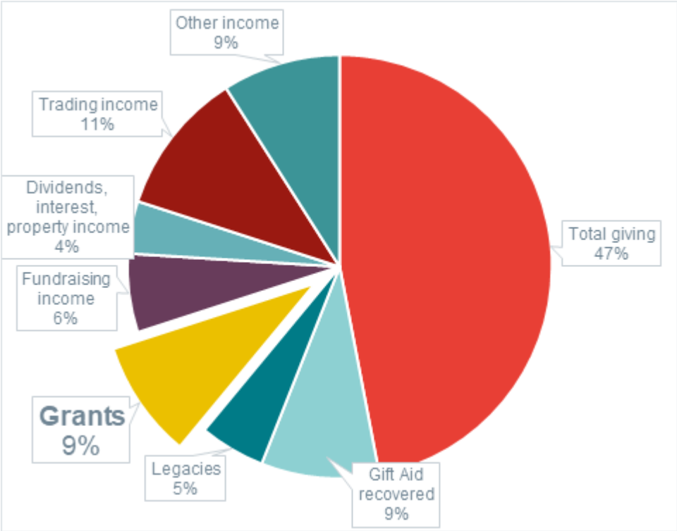
Source: Church of England (2018), Parish Finance Statistics 2016
Note: These figures may not be representative of the funding structure of all places of worship.

Figure 5 Capital expenditure as a proportion of total expenditure, and grants as a proportion of funding for capital expenditures
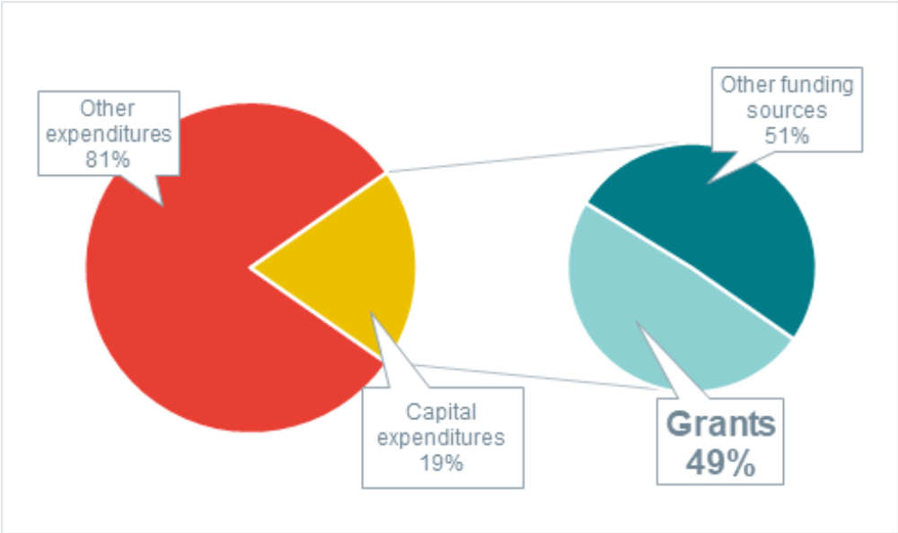
Source: Church of England (2018), Parish Finance Statistics 2016
Note: These figures may not be representative of the funding structure of all places of worship.
There is great variation in the size of available grants as well as the percentage of project costs that grants typically cover. For instance:
- The value of the Repair Grant for Places of Worship was below £47k for 19% of grantees, between £47k and £78k for 23%, between £78k and £127k for 28%, and above £127k for 31%. 73% of respondents to the evaluation’s survey stated that the grant (and other grants) represented more than 50% of the funding of the project cost (BDRC Continental, 2010b).
- The value of the Listed Place of Worship Grants is fixed at the amount of VAT (on eligible works), which means that grantees recoup at most 20% of the project cost through this grant (BDRC Continental, 2010a).
- The value of the grants awarded by the Listed Places of Worship Roof Repair Fund was below £25k for 22% of grantees, between £25k and £50k for 26%, between £50k and £75k for 22%, and between £75k and £100k for 30%. The average value of grants awarded was £54.7k. Applicants were not required to provide match funding, and so the grant was likely to constitute a large share of the works’ funding (ERS Research & Consultancy, 2017).
It is important to note that this review has covered evaluation evidence from mostly large schemes because they are more likely to undertake evaluations of the impact of their funding. A number of smaller grant funds are also available, particularly for the conservation of fixtures and fittings, as well as for new facilities (e.g. installation of toilets).
Evidence of the added impact of grants above what could have otherwise been achieved (that is, their additionality) is mostly generated through qualitative surveys in the evaluations. Questions generally explore the counterfactual of ‘what would have happened without the grant’. Other surveys try to establish the need for grants by asking direct questions about the difficulty of finding other funding sources or how concerned respondents are with maintenance. Unfortunately, the lack of survey question consistency across schemes means it is difficult to establish meaningful comparisons.
The following bullets describe examples of survey evidence on the additionality of grants to fund maintenance:
- As Figure 6 shows, maintenance and repairs are a major concern for many places of worship. Strikingly, all of the respondents to the Repair Grants for Place of Worship and Listed Places of Worship Grant survey believed repairs and maintenance were of some level of concern to them. The same survey reports on the difficulty of raising funds for repairs and maintenance projects with 74% of respondents finding it ‘very difficult’ or ‘fairly difficult’ to raise funds (BDRC Continental, 2010a).
- The Listed Places of Worship scheme evaluation also reports survey evidence on the hypothetical impact of not receiving the grant (see Figure 7). It shows that despite the relatively small share of work that the grant covers (at most 20%, the VAT on eligible works), only 21% of respondents would have been able to complete the works in the same time period without the grant.
- Many respondents to the survey for the Listed Places of Worship Roof Repair Fund described a lack of alternative options for funding repairs despite continued fundraising efforts. Congregations for rural parishes tend to be small and some communities have little disposable income to donate (ERS Research & Consultancy, 2017).
Figure 6 Recipients’ beliefs about maintenance: Listed Places of Worship Grant and Repair Grants for Place of Worship
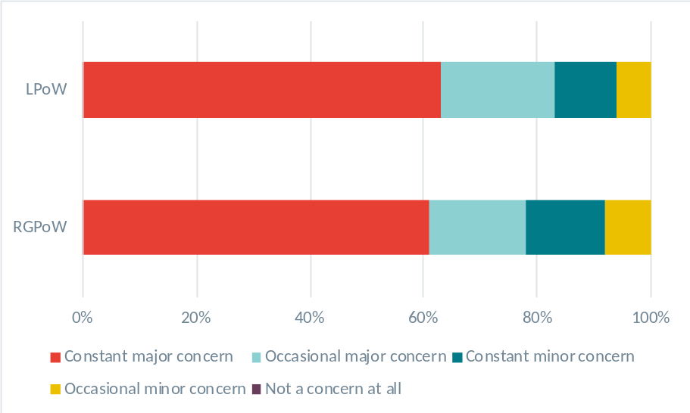
Source: BDRC Continental (2010a)

Figure 7 The impact of the Listed Places of Worship Grant on the completion of maintenance and repair projects
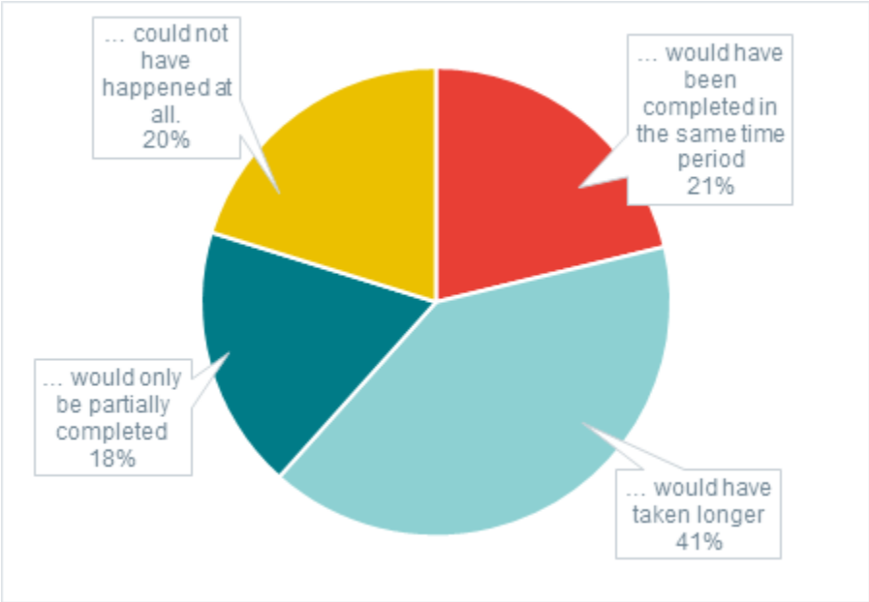
Source: BDRC Continental (2010a)

The interim evaluation of the Grants for Places of Worship fund undertakes a series of interviews over time with 60 grant recipients and with a control group of 10 places of worship which had funding applications rejected. The interim findings provide information on grant applications from which some inferences of additionality can be made:
- A significant number of the 60 grant recipients interviewed had applied to the fund more than once (in some cases several times). This may suggest these places of worship were not able to identify viable alternative funding options after their initial applications were rejected, or at least that they still considered Grants for Places of Worship to be the best option for them despite an initial rejection. This experience also reflects that the National Lottery Heritage Fund more broadly receives many more applications than it is able to fund, and it is standard practice to provide feedback and encourage strong applications that miss out at the first attempt to re-apply.
- Of the 10 control places of worship, only two had managed to proceed with projects without re-applying for funding. One of these had been able to proceed after reducing the scope of the work, while the other was a relatively small project and had used a fundraising professional and small grant funds to secure the required funds. Two of the 10 were ‘in limbo’ and had not decided how to proceed. The remaining six had re-applied to the Grants for Places of Worship fund, the Heritage Grant or the Listed Places of Worship Roof Repair Fund. This suggests that it is difficult for larger projects to proceed without some form of funding available (Payne and Cooper, 2018).
Many grant recipients also reported on difficulties and challenges in finding out about relevant grants and completing applications. This is a problem that the Historic England Support Officers scheme actively seeks to resolve. To date the Support Officers have helped:
- 2,682 congregations with ongoing support and advice;
- 4,608 individuals to build confidence in developing maintenance programmes and to build maintenance and fundraising skills through study days; and
- Congregations to successfully apply for over £13 million in grants to deal with urgent repairs (Historic England, 2017).
It is estimated that every £1 invested in Support Officers generates £12 in access to grant funding (Historic England, 2017). However, no evidence is available on the extent to which national funding could be displaced from one area to another, which is a possibility as not all areas have Support Officers.
Grants are generally not the only source of funding used by places of worship to fund maintenance and repair projects. Indeed, many survey respondents stated that they also used fundraising among attendees or the local community along with existing funds (see Figure 8). Moreover, grants are combined for many projects. This is particularly true for the Listed Places of Worship Grant.
Figure 8 Proportion of Listed Places of Worship Grant recipients who have used other sources of funding for their project
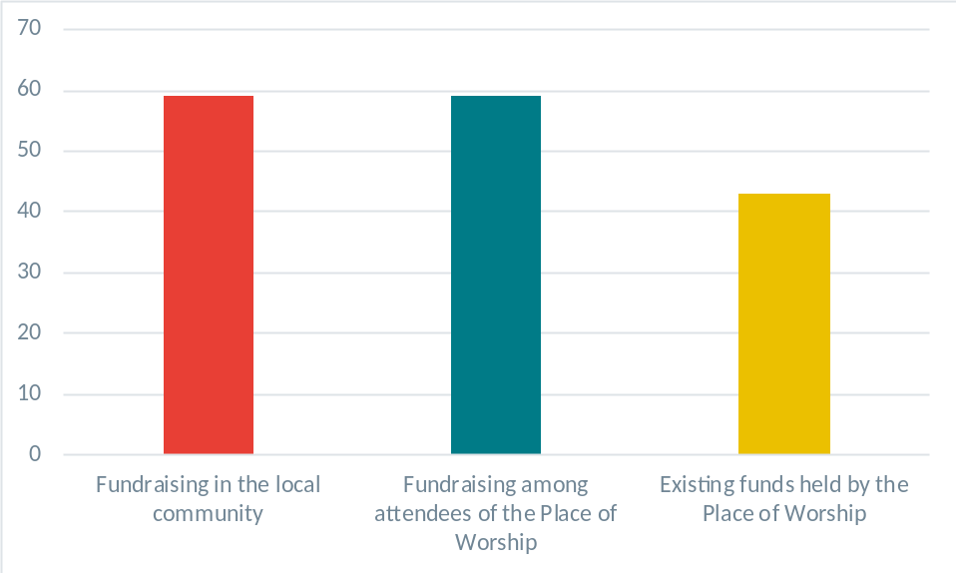
Source: BDRC Continental (2010a)

Social Enterprise as an alternative funding model
The study ‘Social Enterprise and Rural Places of Worship in England’ examines the impact of the introduction of social enterprises in rural places of worship on their sustainability. Social enterprises are defined as trading organisations with social and community objectives with any surplus used to fulfil social purposes (Withers and Payne, 2012). The study concludes from its seven case studies that this alternative funding source can positively impact the long-term sustainability of the buildings through:
- Increased use of the building (sharing the space can lead to cost sharing too);
- Additional regular income from enterprise profits; and
- A higher number of involved people.
While social enterprise has the potential to make a place of worship more independent of external funding, it is stressed that the project must necessarily involve consultation with the wider community to ensure that it will get involved with the project. Additionally, it is important to recognise that using a spiritual place for secular purposes may give rise to tensions. Empowering Design Practices found through their survey that 85% of respondents agreed or strongly agreed with the use of places of worship for local services, community events or art activities, but only 50% agreed or strongly agreed with the use of places of worship for business (Brockwell, 2018).
Lessons for Future Policy Considerations:
The role of Grant funding
Survey data show that funding of maintenance and repair works is a major issue for many places of worship. This stems from multiple constraints which future schemes should aim to address:
- Places of worship do not usually generate sufficient revenues internally to fund major maintenance and repair works. This makes community fundraising especially important, but expertise to organise effective fundraising is an area where places of worship often need support. Even with expert support, fundraising activities may still not be sufficient to cover maintenance and repair costs on their own in many cases. There is likely to be an ongoing demand for major repairs funding, whether through existing routes or a new fund.
- By providing grants, funding bodies can help places of worship fund projects which communities cannot source funding for themselves. As mentioned in the previous section, establishing clear eligibility criteria will be necessary to ensure grant funds are allocated to where they add most value.
- Some communities have difficulty finding out about funding opportunities and completing application processes. This also highlights a support role that scheme providers can play in redirecting communities towards appropriate grants where they exist and providing assistance to places of worship in navigating the application processes. The experience of Support Officer roles funded by Historic England is particularly relevant to this type of support.

Scheme outcomes

Improvements in the fabric of the buildings
As described in section 2.2, most of the schemes for which evaluations were available for this review provide places of worship with funding to ensure the maintenance of the fabric of the buildings. Evaluations of these schemes provide useful insights of the impact of this support.
Most of the conclusions drawn in the evaluations reviewed are based in large part on opinions collected though surveys and not on observed and measured tangible outcomes. For example, none of the evaluations provide comprehensive comparisons of the state of the buildings before and after the completion of funded project work. The evidence reviewed suggests field visits of the sites may be conducted in some cases, but they do not seem to form a basis to consistently evaluate the impact of the grants in the evaluations reviewed. Apart from the status of buildings in Historic England’s Heritage Asset Management database or the Heritage at Risk Register, there also does not seem to be a common metric reported in the evaluations reviewed which can be used to compare the physical state of places of worship across the country. Better use of information collected through the Quinquennial Inspection Reports could also provide supporting evidence for the impact of grant schemes on the physical aspects of the buildings.
The survey evidence that can be found in the evaluations reviewed includes:
- There was widespread agreement among recipients of the Repair Grant for Places of Worship and the Listed Places of Worship schemes that the repair and maintenance work had had a positive impact on preserving the fabric of the buildings. Indeed, over 85% of the respondents agreed (strongly or slightly) that the repairs and maintenance work had:
  - prevented irreversible damage to the building;
  - improved the fabric of the building;
  - halted the decline in the fabric of the building;
  - helped prevent major problems developing; and
  - encouraged better planning of further repairs and maintenance in the future (BDRC Continental, 2010a).
- 70% of survey respondents who had received training as part of the Maintenance Co-operatives scheme reported that the training had led to improved condition of their place of worship (Oakmere Solutions Ltd., 2016).
- The Listed Places of Worship Roof Repair Fund survey suggests that the majority of grantees reported their building to be both watertight and weatherproof following completion of the repairs. In addition, respondents believed that the works had prevented further deterioration of the fabric and that repairs had been dealt with for the foreseeable future (ERS Research & Consultancy, 2017). However, it is worth noting that this may not be true for the large number of unsuccessful applicants to the fund (about 73% of all applicants).
LESSONS FOR FUTURE POLICY CONSIDERATIONS:
Improvements in the physical aspects of the buildings
There is a lack of firm evidence beyond the qualitative surveys on the physical impact of past grants schemes.
It might be possible to ascertain some evidence on the impact of past grant schemes on places of worship that have received grants. For example, Quinquennial Inspection Reports before and after the funder works were undertaken could be compared. This could, however, be a very costly exercise to perform.
Ensuring this information is captured through the Taylor Review Pilot evaluation will be important. This will provide a stronger evidence base to understand the impact of the pilot on the fabric of the places of worship that receive support.
It would also be valuable to draw on existing inspection plans after a project, sample a proportion of sites to visit after works are complete or interview architects working with places of worship. The cost of this follow-up means this is more likely to be proportionate for larger grant schemes.

Improvements in volunteers’ motivation, confidence and capabilities

Volunteers play an important role in the maintenance and sustainability of churches
Volunteers are central to sustaining places of worship. They represent the majority of the workforce available to care for the fabric of the building, to help with the use of the building for worship and for engagement with the wider community. The evaluation report of the Listed Places of Worship Roof Repair Fund, for instance, reveals that for 97% and 98% of the projects in Round 1 and Round 2 respectively, the lead contact was a non-professional volunteer (ERS Research & Consultancy, 2017). Architectural History Practice (2005) insists on this point, stating that ”those responsible for the upkeep of places of worship are invariably unpaid volunteers”.
Because of the essential role volunteers play in the sustainability of places of worship, a number of schemes have in the past years focussed on:
- Increasing their number by increasing community engagement with places of worship (social enterprise and rural places of worship, Rural Churches in Community Service Programme);
- Improving their confidence, motivation and skills by providing training courses (e.g. Empowering Design Practice, Faith in Maintenance); and
- Encouraging them to actively manage buildings’ maintenance through maintenance planning (e.g. Maintenance Co-operatives, Faith in Maintenance).
Schemes providing financial support towards maintenance insist on the last point because they recognise the role of volunteers in the physical sustainability of places of worship. Evaluation surveys of these schemes often include questions about the volunteers’ methods and confidence in their ability to maintain their place of worship.
As Figure 9 shows, the evaluation of the Listed Places of Worship Grant, for instance, reports on whether volunteers had plans for future maintenance and development works. Moreover, they report that 75% agreed (strongly or slightly) that the repairs and maintenance works had encouraged them to plan development to improve their facilities (BDRC Continental, 2010a).
Figure 9 Plans for future maintenance: Listed Places of Worship Grant and Repair Grants for Place of Worship
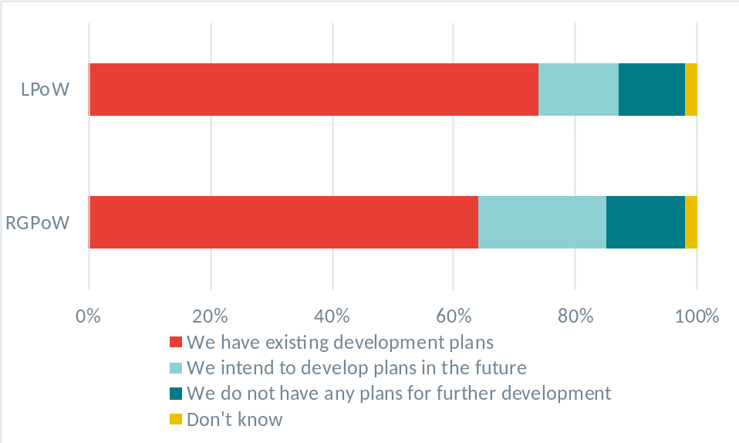
Source: BDRC Continental (2010a)
Where maintenance plans have been developed, ‘buy-in’ to carry out the plan can also be a challenge. The interim findings of the evaluation of the Grants for Places of Worship scheme found a number of cases where experts had prepared maintenance plans, but the congregation representatives interviewed had little knowledge of the plans or what was required of the congregation (Payne and Cooper, 2017). This may suggest a challenge around expertise and ongoing support even in cases where maintenance plans are prepared.

Courses can improve the motivation, confidence and skills of volunteers
Some of the schemes in this review explicitly focus on enhancing the motivation, confidence and capabilities of volunteers. The Faith in Maintenance programme, for example, delivered maintenance training courses as well as a support system targeted at volunteers who took care of their place of worship. There is evidence that the scheme improved the confidence of volunteers in certain aspects of maintenance, as shown in Figure 10. The reported improvements in confidence are greatest for ‘knowing what to do about maintenance problems’ and ‘identifying maintenance issues or problems at your place of worship’. The study responses also point to increased involvement, motivation, understanding and enjoyment of their volunteer role, and sense of usefulness from participating volunteers. For example, 54% of participating volunteers reported spending more time inspecting the facilities and 85% of respondents reported that they had shared what they had learned with other volunteers at their place of worship (Goddard, 2012).
Figure 10 Improvement in confidence in maintenance skills of volunteers who participated in courses through Faith in Maintenance
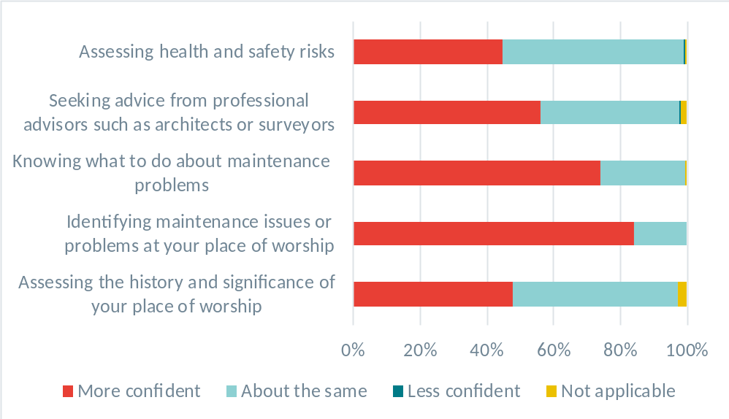
Source: Armitage and Taylor (2010)
A second scheme from the SPAB, the Maintenance Co-operatives project, also supported volunteers with maintenance training courses. The survey evidence in the evaluation again suggests that the project provided high-quality training that supported participants to develop greater skills, knowledge and confidence to tackle preventive maintenance in places of worship (Oakmere Solutions Ltd., 2016).
The Empowering Design Practices programme provided courses and workshops that helped communities design new facilities to transform their place of worship to accommodate wider community activities. This scheme’s impact evaluation also included survey evidence of improved skills related to the management of their place of worship (see Figure 11) (Brockwell, 2018).
The project identified three main challenges that volunteers commonly face:
- Difficulty in engaging in design processes: understanding the potential of the building, identifying the wants and needs of its users, creating a clear vision and design brief, testing and prototyping ideas;
- Lack of confidence in commissioning and communicating with design professionals; and
- Weak engagement with others: for example, the organisation of effective fundraising.

Figure 11 Improvement in confidence and skills of volunteers who participated in the Empowering Design Practice programme
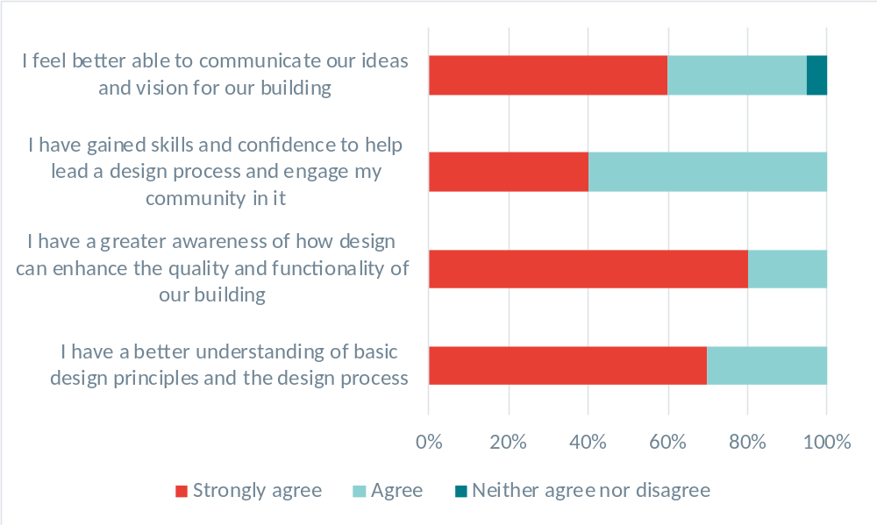
Source: Brockwell, 2018
Note: Based on a sample of 20 respondents.
The Historic England Support Officers’ role also involves the provision of a number of day-long courses and seminars for volunteers about the importance of effective maintenance for the sustainability of places of worship. This has helped 6,542 individuals to learn confidence-building skills through study days led by Support Officers (Historic England, 2017).
The Grants for Places of Worship programme also included workshops provided by the Heritage Lottery Fund to help places of worship with the application process (similar workshops are used across all Heritage Lottery Fund programmes). Most interviewees in the interim evaluation of this fund were positive about the workshops being extremely helpful and valuable. However, there was still a perception among volunteers that the application process and guidance were daunting and that processes should be streamlined (Payne and Cooper, 2016).
Lastly, it should be noted that experience with maintenance projects is probably the most relevant form of training. The Listed Places of Worship Roof Repair Fund reports survey evidence on improved skills and confidence of volunteers. Many grantees reported that after the funded project, they were looking to undertake other improvement projects and they felt more confident seeking additional grants for future projects. Eighty-four percent of surveyed respondents also strongly agreed that the workshop they attended helped them with project planning.

Reliance on volunteer workforces poses some challenges
While volunteers are essential to places of worship, the nature of their involvement comes with certain challenges. In comparison with paid employees, volunteers are less likely to be willing to bear important responsibilities and to work on projects for many hours for a sustained period of time. Several of the evaluations reviewed pointed towards challenges in the implementation of projects linked to the characteristics of volunteers.
The evaluation of the Rural Churches in Community Service Programme identifies overstretched volunteers as one of the two most likely reasons why some of its social enterprise projects were not sustainable in the long-term. The second reason is a high turnover in leadership (Rowe, 2009). Volunteers often become ‘project champions’ and their departure often leads to the discontinuity of the project when no suitable replacement can be found. The vision some volunteers provide is often the key determinant in the sustainability and success of the projects that communities undertake.
The interim evaluation of Grants for Places of Worship finds that the role of one key volunteer can be critical for the success of applications and project delivery. While churches with larger congregations sometimes had teams of volunteers, those with smaller congregations, especially in rural areas, were often reliant on one key individual. This raises a risk if that individual is unwilling or unable to continue in their role. Many of those interviewed in the interim evaluation of this scheme expressed that they had ‘had enough’ of their project and would not want to continue after it was completed, but few had active succession plans in place. The interim evaluation also highlighted that many places of worship are very reliant on professional advisers, such as architects or diocesan (or equivalent) support officers, when preparing grant applications (Payne and Cooper, 2016, 2017).
The Maintenance Co-operatives project from the SPAB faced an unexpected challenge with volunteers. The project team initially intended to give to a volunteer in each newly formed maintenance co-operative the role of Volunteer Co-ordinator. However, evidence collected from volunteers and the project team suggests a reluctance amongst most volunteers to take on a role that could be seen as, and often was, time-consuming (Oakmere Solutions Ltd., 2016). While there may be a number of volunteers that are keen to help with the maintenance of their place of worship, they may not want to commit to very time-consuming responsibilities. Alternative arrangements can be made to seek more decentralised leadership, such as:
- The establishment of a steering group with relevant stakeholders’ representation;
- The formation of working groups and designation of leaders within these groups, thereby spreading the workload and co-ordination responsibility;
- The emergence of one or more volunteers as organisers, without their self-identification as official leaders or coordinators; and
- The shift of leadership to a member of the (paid) clergy.
In some cases, community members can be hard to engage in planning maintenance, or underestimate the maintenance costs, and so engaging with these volunteers can be an important part of the Support Officer role (Mottram, 2018).
Lessons for Future Policy Considerations:
Volunteers’ Motivation, confidence and Skills
Volunteers are essential to the sustainability of places of worship. Their motivation, confidence and skills are key determinants in sustaining places of worship.
Volunteers have limited amounts of time and often will not have specialist expertise when they start. Courses and workshops have proven to be an effective way to improve volunteers’ motivation, confidence and skills.
Continuity of volunteers is important. If project leadership rests on the shoulders of a single volunteer, then this risks losing momentum if they leave. Rather, alternative arrangements should be sought to decentralise leadership responsibilities and ensure succession planning. This could be an important area for community support officers to consider in their community engagement work with places of worship.
Lastly, maintenance co-operatives, and more generally collaboration between groups of volunteers who care for different places of worship, can be an effective way to widen the pool of skills available to each place of worship.

Increased community engagement and facilities utilisation
Many places of worship, especially in rural areas, have limited opening hours and have small numbers of regular attendees. Even in urban areas, most churches are not in active use at most times and there is therefore scope for wider community use (Thorlby, 2017). It is very difficult to preserve the physical state of these buildings because they often lack volunteers and funding to successfully conduct maintenance and repairs projects. For this reason, several of the schemes which have been evaluated and considered in this review have the objective to increase community engagement and utilisation of the facilities.
There are a limited number of schemes providing community engagement support that have benefited from an impact evaluation. The evidence base is therefore limited, and the extent to which findings can be generalised beyond the specific schemes evaluated should be treated with caution. The Taylor Review Pilot will play an important role in testing which forms of support are most effective and under which conditions they will increase the sustainability of listed places of worship.

Wider community engagement can increase the sustainability of listed places of worship under appropriate circumstances
Places of worship with stronger community engagement and higher utilisation are likely to be more sustainable due to the increased number of potential volunteers, potential financers and generally people who are actively involved in caring for and using the place of worship.
Two of the studies reviewed provide direct examples of this approach to sustainability:
- The Social Enterprise and Rural Places of Worship in England: in addition to the source of funding it provides, as explained in section 3.1.2, social enterprise can improve the sustainability of places of worship through increased community engagement, as shown by the case studies from the report. It can also help increase utilisation and ultimately lead to more sustainable places of worship. Social enterprises in rural places most often take the form of a community-managed shop, run by volunteers. It is most common for those shops to offer local food (97%), to run the post office (67%) and to have a café/seating area (52%) (Withers and Payne, 2012). These shops often emerge as the result of shop closures in the town or village and play an important role in stimulating community and social activity. By providing services for the local community, places of worship play a more central role in the community and more people care for them.
- The Rural Churches in Community Service Programme: this scheme funded projects in rural locations to adapt places of worship to enable them to be used for community activities. The funds could not be used for renovation, restoration or repair works and were explicitly targeted at new facilities. In 2003, shortly after the end of the project, a first evaluation found that the funding of new facilities had been successful in allowing community activities to be run at all the supported places of worship. In 2009, a second study found that community activities were still taking place in most of the churches that were reviewed, but generally to a lesser extent than at the time of the first evaluation in 2003. This shows that improvements can be sustained, but maintaining momentum is important. In cases where community activities decreased over time, overstretched volunteers and considerable turnover of leadership are mentioned as probable causes. However, faith communities and their places of worship are found to generally benefit from wider community use when a social enterprise is set up. This is mainly through the improved financial stability from the regular income generated by the use of the facilities by the wider community and improved participation in fundraising (Rowe, 2009).
Increasing engagement with the wider community is also one of the objectives of the Empowering Design Practices project. However, the evaluation here mentions that sufficient data have not yet been collected on this matter to conclude whether the project has had any impact (the project and evaluation are ongoing). As noted in section 3.1.1, this scheme has found that seeking broader uses of places of worship can be challenging for those faiths and denominations where non-worship use of a sacred space is not seen as appropriate (Brockwell, 2018). Tension over the use of a spiritual place for secular purposes was also mentioned as a common challenge in the Social Enterprise and Rural Places of Worship in England study (Withers and Payne, 2012).

Maintenance co-operatives can increase wider community engagement
The SPAB adopted another approach to improve the sustainability of places of worship. With the Maintenance Co-operatives project, it formed 24 maintenance co-operatives engaging 144 places of worship. The aim of the scheme was to increase collaboration between communities to better manage and maintain places of worship.
The evaluation evidence suggests that participants felt the scheme had been successful in increasing the engagement of volunteers and also the engagement of the local community in the maintenance of places of worship. As Figure 12 shows, over 75% of respondents in each training year reported feeling a greater sense of ownership and responsibility for the place of worship and about 50% reported devoting more time to volunteering activity as a result of the training (Oakmere Solutions Ltd., 2016). According to the evaluation document, there is also some evidence that the training courses attracted people from outside of faith communities and this had a positive impact on general awareness of the importance of building maintenance. Additionally, the courses are reported to have increased the number of volunteers who actively engaged with maintenance-related tasks (Oakmere Solutions Ltd., 2016).
Figure 12 Impact of the Maintenance Co-operative training on volunteers’ engagement with their place of worship
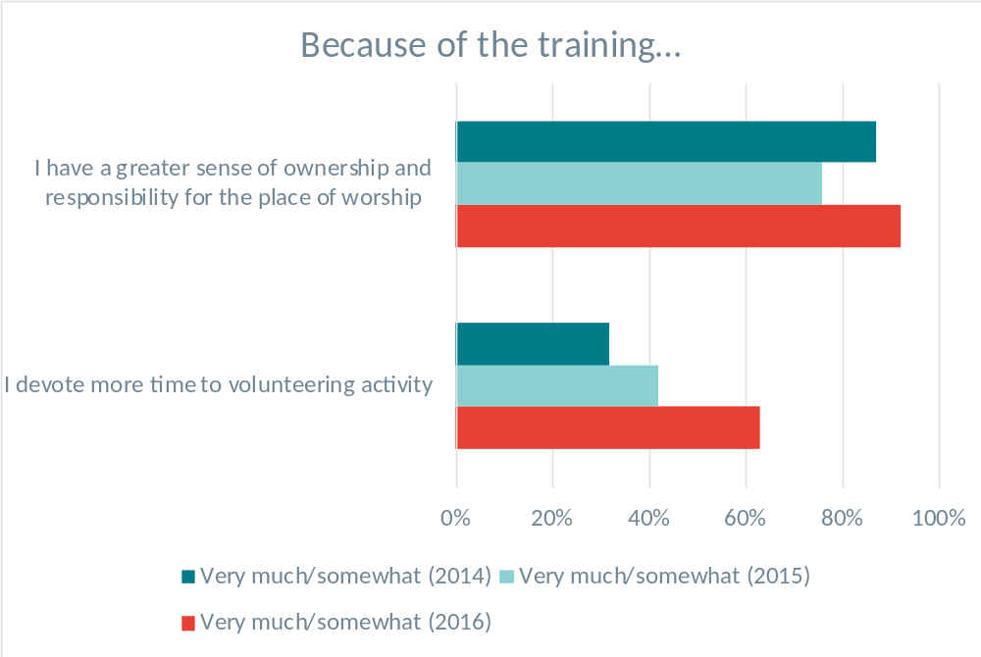
Source: Oakmere Solutions Ltd (2016)

It is challenging to evidence the direct links between maintenance/repairs grants and community use
The evidence on the impact of maintenance grants on community engagement is mixed. Maintaining a building is clearly a pre-condition for its use with communities in the long run, but it is often difficult to directly attribute a specific community use to a given piece of maintenance that unlocked the community activity. There are, however, cases where the direct link to community use is more obvious.
The evaluation of the Listed Places of Worship Roof Repair Fund mentions that grant funding of maintenance and repair projects often increases or safeguards the available space in the buildings. This space can therefore be made available for community activities. Moreover, when repairs and maintenance works are funded through grants, this often safeguards the disposable income of places of worship, which means that more funds can be allocated to community activities instead of maintenance and repairs. Some respondents to the survey also reported new uses, or plans for new uses, for their place of worship as a result of the support (ERS Research & Consultancy, 2017).
There is limited evidence of repair and maintenance works having a direct impact on community use. For example, data from the Repair Grant for Places of Worship and the Listed Places of Worship schemes are shown below. This shows that around 20% of places of worship responding to the evaluation survey believed that the maintenance project ‘definitely’ or ‘probably’ increased the number of visitors.
Figure 13 Opinion of Listed Places of Worship Grant recipients on change in attendance
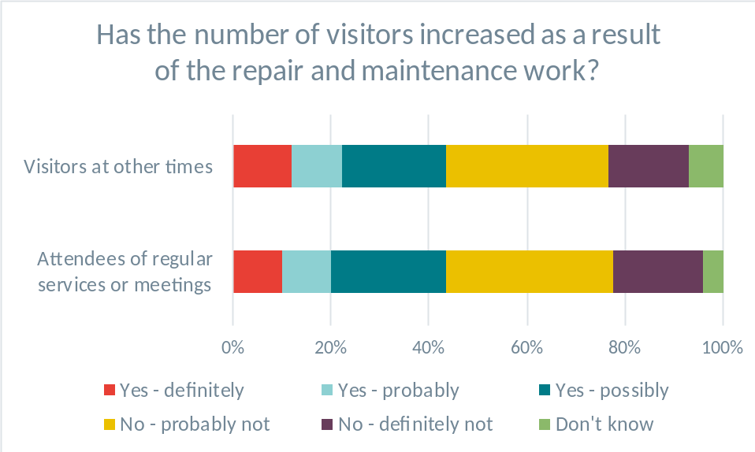
Source: BDRC Continental (2010a)
Some schemes have offered grants for wider facility projects alongside maintenance and repairs, with the intention of more directly facilitating community use. These could include projects such as new toilets, kitchens, heating systems or meeting rooms. For example, the Grants for Places of Worship fund had up to 15% of grant funds available for these types of ‘new capital’ projects and required community engagement from recipients. The interim evaluation of this scheme finds a mixed response to this community engagement requirement, but most places of worship interviewed felt it had made them reflect on how to increase their sustainability. Some places of worship had undertaken more community engagement than planned as interest had ‘taken off’, while others found the requirement a genuine burden (Payne and Cooper, 2016).

Lessons for Future Policy Considerations:
Community engagement and facilities utilisation
In preventing a building from falling into a state of disrepair, maintenance is a pre-condition for use with communities in the long run. However, it is often very difficult to directly attribute a specific community use to a given piece of maintenance or repairs. There are, however, cases such as the installation or repair of facilities essential to wider community use (e.g. kitchens, toilets) where the direct link to community use is more obvious.
Community engagement and utilisation of places of worship may also support the maintenance of places of worship in the long run under certain circumstances. Places of worship with a wider community engagement and usage may benefit in several ways:
  - they can rely on a wider pool of people to fund maintenance and repair projects;
  - they can generate more revenues from activities taking place at the place of worship; and
  - more people may care about the place of worship and can potentially volunteer.
For this reason, schemes in the past have promoted community engagement using different approaches (e.g. new facilities, social enterprise, co-operatives) and have reported some success in improving sustainability.
Importantly, the appropriate community approach is location and context specific. The needs, resources and motivations of communities determine the most appropriate approach. This highlights the potential value of support officers to help identify the most appropriate approach for a given community.

Observations on the quality of evidence on past schemes
This section provides some observations regarding the quality of evidence available from past schemes. The past evaluations and data provide useful evidence, particularly in terms of perceptions among beneficiaries of grants. However, there are also limitations in the evidence base, especially in terms of the physical condition of buildings after support and the longer-term impacts of schemes. These issues are explored further below.

Assessment of evaluation evidence against the Maryland Scale
This review found several evaluations of large schemes as well as some smaller schemes. The evaluations rely principally on qualitative evidence rather than quantitative methods, reflecting challenges in data collection and availability.
Collecting evidence on the impact of schemes is also made difficult by a lack of common measures for comparison. This is because different schemes provide support for different types of projects in different circumstances, and individual evaluations focus on the specific schemes they are assessing.
Where qualitative evaluation work is undertaken, evaluations typically ask respondents about their appreciation of certain aspects of the scheme at one point in time and do not compare it to pre-project levels. A few studies do ask respondents to compare their appreciation of certain aspects today to its pre-project level. Two studies use control groups. ‘Assessment of the Impact of HLF [Heritage Lottery Fund]/English Heritage Places of Worship Funding’ uses a control group to isolate the effect of grants for new facilities from the effect of standard maintenance grants (Derrick, 2005). The ongoing evaluation of Grants for Places of Worship uses 10 places of worship that had funding applications rejected as a control group (Payne and Cooper, 2017). However, most of the evaluations do not include these types of comparisons.
For these reasons, the majority of the evaluations would be considered level 1 on the Maryland scale. This means that while past evaluations offer very useful insights, they should be interpreted with a degree of caution, especially when seeking to generalise the findings to different contexts.

Strengths in the available evidence on past schemes
The available evaluations of past schemes provide useful evidence in a number of ways:
- Most of the larger grant scheme evaluations reviewed provide evidence of their areas of impact, including perceived state of the fabrics, attendance at regular services and meetings, wider community engagement, and volunteers’ engagement with maintenance.
- Evaluations of several schemes providing non-financial support to places of worship provide evidence on their successes and challenges. Qualitative information is especially valuable for these schemes, where the impact is very context specific.
- Most evaluations rely on survey information about the perceptions of recipients. This provides first-hand insights from those closely involved in working with places of worship. The ongoing Grants for Places of Worship evaluation uses interviews with a sample of grant recipients and a control group, which are repeated in several rounds after funding was awarded (Payne and Cooper, 2017).
- There is also some limited additional data available on a few key national schemes. Although evaluations of the impact of the schemes in more detail are not available, the data provide useful insights on the level of support given and the type of supported projects.

Limitations in the available evidence on past schemes
Limitations in the available evidence were identified in the following areas:
- The majority of the evaluations reviewed rely almost exclusively on survey data of some form: telephone interviews, online surveys and mailing lists. While this type of data is important to get an understanding of the views of the parties involved in projects, there is a lack of independent data, such as changes in the physical condition of the buildings over time, to complement this evidence.
- There is a relatively low level of consistency in the questions that are asked in surveys. While questions generally aim to quantify similar aspects of the projects, the phrasing or structure of questions is generally different. This is not surprising given that various organisations run schemes, but striving for more conformity would allow more understanding of the relative effectiveness of schemes and accumulated learning. Insights on the relative effectiveness of different support approaches could be drawn in the future if scheme providers were to adopt a joint framework of assessment.
- The qualitative evaluation approaches typically ask respondents about their appreciation of certain aspects of the scheme at one point in time and do not compare it to pre-project levels. A few studies do ask respondents to compare their appreciation of certain aspects today to its pre-project level, but only two studies use control groups for comparison. This means it is difficult to isolate the impacts of the schemes from other factors influencing places of worship.
- There is limited evidence in the evaluations to verify changes in the physical condition of buildings as a result of past support. Physical inspections of the buildings before and after (and potentially during) maintenance and repair projects would allow evaluators to collect more data in this regard. It could be valuable to draw on existing inspection plans after a project, sample a proportion of sites to visit after works are complete or interview architects working with places of worship. However, such observations are rarely made, or are at least not reported consistently in evaluations. This may in large part be due to the cost and time investment necessary to conduct such inspections. The cost of this follow-up means this is more likely to be proportionate for larger grant schemes.
- Community support is very context specific. While evaluations of past schemes provide useful insights on the effectiveness of individual interventions, it is difficult to assess how generalisable findings could be to different circumstances. A broader consideration of the conditions under which certain approaches are more likely to be successful would be valuable.

References
Allchurches Trust Limited (2018), 2017 Strategic Report with Supplementary Material.
APEC Architects (2019), The Value of Maintenance?
Architectural History Practice (2005), A Review of Heritage Lottery Fund/English Heritage Funding to Places of Worship 1996-2005.
Armitage, M. and Taylor, M. (2010), The Impact of Faith in Maintenance.
BDRC Continental (2010a), Listed Places of Worship Grant Impact Assessment.
BDRC Continental (2010b), Repair Grants for Places of Worship Impact Assessment.
Brockwell, A.J. (2018), Mid-term Impact Review for Empowering Design Practices, A Five-Year Research Project Funded by the Arts and Humanities Research Council. Green Spiral Consulting.
Church of England (2014), From Anecdote to Evidence – Findings from the Church Growth Research Programme 2011-2013.
Church of England (2018), Parish Churches Finance Statistics 2016.
Cooper, T. (2016), English Churches and Cathedrals Sustainability Review – The ‘Funding Gap’ for Church of England Parish Churches.
Derrick, A. (2005), Assessment of the Impact of HLF/English Heritage Places of Worship Funding.
ERS Research & Consultancy (2017), National Heritage Memorial Fund: Listed Places of Worship Roof Repair Fund Evaluation.
ERS Research & Consultancy (2018), First World War Centenary Cathedral Repairs Fund Evaluation – Final Report.
Goddard, S. (2012), Faith in Maintenance – Final Project Evaluation Report March 2007-January 2012. Oakmere Solutions Ltd.
Greater Manchester Churches Preservation Society, http://www.manchesterchurches.btck.co.uk/Grants (accessed December 2018).
Historic England (2017), Support Officer Evaluation.
Historic Religious Buildings Alliance (2017), Crossing the Threshold – A Step-by-Step Guide to Developing your Place of Worship for Wider Community Use and Managing a Successful Building Project.
Mottram, A. (2018), Place of Worship Support Officer – Worchester Diocese – Overview Report on the 9 year PoWSO Post (1st September 2009 – 31st August 2018) in the Diocese of Worchester.
The National Churches Trust (2018a), Open grant data – 360 Giving, https://www.nationalchurchestrust.org/our-grants/open-grant-data-360-giving.
The National Churches Trust (2018b), Grants Programmes 2019-2023, https://www.nationalchurchestrust.org/grant-programmes-2019-2023.
Oakmere Solutions Ltd. (2016), Maintenance Co-operatives Project: Final Summative Evaluation.
Payne, B. and Cooper, T. (2016, 2017, 2018), Evaluating Heritage Lottery Fund’s Grants for Places of Worship (GPOW) Programme, Interim report - YEAR 1 (2016), YEAR 2 (2017), YEAR 3 (2018).
Rowe, S. (2009), Ten Years On – A Review of the Millennium Commission Funded Rural Churches in Community Service Programme
Suffolk Historic Church Trust, https://shct.org.uk/grants/grants-awarded/.
Thorlby, T. (2017), Assets not Burden – Using Church Property to Accelerate Mission. The Centre for Theology & Community.
Withers, G. and Payne, R. (2012), Social Enterprise and Rural Places of Worship in England.

Annex: Findings from the First World War Centenary Cathedral Repairs Fund Evaluation
The First World War Cathedral Repairs Fund is a grant scheme to which the government contributed £40 million and funded 130 projects at 57 cathedrals in England between 2016 and 2018. The fund was administered by the Cathedrals and Church Division of the Archbishops’ Council of the Church of England on behalf of the DCMS but also benefited 16 Roman Catholic cathedrals. The scheme awarded large grants of up to £870,000 with an average grant value estimated at £277k to carry out necessary repair works to the fabric or to prevent further deterioration of the fabric in order to ensure listed buildings were in a good and safe state of repair to host events commemorating the First World War. Many cathedrals benefited from multiple grants so that the 57 cathedrals that were granted awards received an average of just under £700k (ERS Research & Consultancy, 2018).
The scheme funded roof repairs in 33% of cases, towers or spires in 10% of cases, other high-level repairs in 30% of cases, windows in 6%, ground level repairs and drainage in 9%, and the funding contributions to electric, heating, lighting and sound systems in 12% of cases (ERS Research & Consultancy, 2018).
As its name indicates, the scheme was targeted at cathedrals only and grants were restricted to buildings of Christian denominations (Church of England and Roman Catholic Church).
Like many other major grant schemes, The First World War Centenary Cathedral Repairs Fund used the urgency of the work as eligibility criterion. The evaluation for instance states that the grants allowed the majority of recipients to complete work that ‘would not have gone ahead without the grant’. Over 80% of respondents described the status of the grant-assisted area as ‘urgent, requiring immediate attention’ before the project and as ‘routine maintenance’ after the project (ERS Research & Consultancy, 2018).
In addition, the selection criteria included:
- The contribution of the project to keeping the cathedral safe and open;
- The financial need of the cathedral; and,
- The future impact of the funding on the building’s repair and maintenance programme (ERS Research & Consultancy, 2018).
The award process of the First World War Centenary Cathedral Repairs Fund is well documented in its evaluation report. All applications were assessed against the objectives and criteria of the fund by an Expert Panel of 14 volunteer members from a range of sectors. The use of an external panel of volunteer experts to make award decisions for large grants allowed the First World War Centenary Cathedral Repairs Fund to award grants in a transparent manner while also limiting administrative costs (ERS Research & Consulting, 2018). This approach appears more likely to be proportionate for larger grants, and it may not be feasible to award a large number of grants and to select projects among many applicants.


www.frontier-economics.com

The Taylor Review Pilot is a project funded by DCMS and run by Historic England. The aim of the pilot is to test some of the recommendations of the 2017 ‘Taylor Review: Sustainability of English Churches and Cathedrals’ and to provide free support and advice for listed places of worship of all faiths and denominations.
Published sources do not provide any detailed information about the basis on which eligibility criteria were developed. The nature and stringency of those criteria, along with the criteria used to evaluate any applications, would be expected to influence the number of applications; resources needed to submit each application; and the likelihood of success, among other factors. Absence of this information in the literature therefore hinders consideration of these issues in this report.
Throughout this report, different types of work such as maintenance, minor repairs and major repairs are referred to as they are labelled in the evaluation documents reviewed. The precise definitions of these concepts may differ between schemes and may not align with the definitions used as part of the Taylor Review Pilot.
Without the Listed Places of Worship Grant, 20% of recipients surveyed stated that the work could not have happened at all, 18% stated the work would only have been partially completed, 41% stated it would have taken longer, and 21% stated the work would have been completed in the same time period.
The SPAB provided similar courses as part of their Maintenance Co-operatives project and reported similar course satisfaction levels. Empowering Design Practices also provided courses to participants and presents supporting evidence for the impact of the courses. This evidence is, however, not directly comparable since the survey questions are different.
The Maryland Scale is a 5-point scale for evaluation methodologies, where 1 is the lowest and 5 is the highest. Level 1 represents cross-sectional or before-and-after comparisons but without use of a control group or control variables.
The Taylor Review: Sustainability of English Churches and Cathedrals, page 25.
The Taylor Review: Sustainability of English Churches and Cathedrals, page 25.
National Lottery Heritage Fund data.
This is a VAT refund scheme rather than a grant scheme. The scheme provides a refund for VAT on eligible maintenance and repairs and has at present refunded about £300 million in VAT.
Topmark.
The Taylor Review: Sustainability of English Churches and Cathedrals, page 25.
TEN YEARS ON – A Review of the Rural Churches in Community Service Programme, page 4.
http://www.lpwscheme.org.uk/
National Lottery Heritage Fund data.
National Lottery Heritage Fund data.
National Lottery Heritage Fund data.
National Lottery Heritage Fund data.
https://www.nationalchurchestrust.org/how-we-help/map-churches-chapels-and-meeting-houses-we-have-helped
Allchurches Trust Limited (2017) https://www.allchurches.co.uk/about
Percentages may not sum to 100% due to rounding.
The ongoing evaluation of the Grants for Places of Worship fund provides the most detail on the condition of buildings after projects are undertaken of the evaluations reviewed. This evaluation includes a series of follow-up interviews after projects are complete, including site visits in some cases.
The Maryland Scale is a 5-point scale for evaluation methodologies, where 1 is the lowest and 5 is the highest. Level 1 represents cross-sectional or before-and-after comparisons but without use of a control group or control variables. The two evaluations that use control groups could be higher on the Maryland Scale depending on the precise approach used, but the documents reviewed did not provide sufficient detail to make an exact assessment.

