

National Citizen Service 2017
Evaluation
Main report

Kantar Public: David Andersson, Sinan Fahliogullari, Alice Fitzpatrick, Rebecca Hamlyn, Katie Hamilton, Peter Matthews, Valeriya Titkova
London Economics: Gavan Conlon, Viktoriya Peycheva
July 2020

Contents
Table of Contents
1. Executive Summary 3
2. Introduction and background 12
3. Participant experience 25
4. Social mobility 31
5. Social cohesion 38
6. Social responsibility 53
7. Value-for-money 59
8. Appendices 75

- Executive Summary
Overview
The National Citizen Service (NCS) is a Government-backed initiative that brings together young people aged 15 to 17 from different backgrounds, giving them the chance to undertake a programme of personal and social development and community action. The overarching aims of NCS are to enable and build social cohesion, social responsibility and social mobility. Since the full launch of NCS in 2013, more than 480,000 young people have taken part. In 2017, 98,733 young people took part in the programme.
The programme is funded by the Department for Digital, Culture, Media & Sport (DCMS) and has been managed by the NCS Trust, a Royal Charter Body established by the government to shape, champion and support NCS.
National independent evaluations, commissioned annually by DCMS and previously the Cabinet Office since 2012¹, have consistently shown the positive impact the programme has on young people. Value-for-money assessments have also demonstrated that the monetised benefits of the programme are consistently greater than the costs. However, as in previous evaluations, it has not been possible to assess and monetise all of the possible benefits of the programme, including longer-term benefits to young people who took part in the programme and any benefits to parents/guardians and the workforce that deliver the programme. In fully accounting for all the costs of the programme while only accounting for some of its potential benefits, this value-for-money assessment is likely to undervalue the full benefit of the NCS programme.
In 2017 NCS programmes were delivered in the spring, summer and autumn. Summer delivery included both a 3 and 4 week programme (with the 4 week programme providing an additional week of social action activity). Autumn delivery encompassed October half-term provision (the ‘Standard model’), as well as programmes run by colleges during term time (the ‘College model’). In 2017, the majority of summer participants attended a 4-week programme, while in autumn just over half of participants attended the Standard model.
This report includes findings from an evaluation of the 2017 summer 4-week programme only, and for both the Standard and College autumn model programmes, hereafter referred to as ‘summer’ and ‘autumn’. Autumn College model participants were included in the 2017 survey, unlike previous years because of the timings of the fieldwork, and have therefore been included in both the impact and VfM analysis.
While the main elements of the programme are consistent, there are differences between the summer and autumn NCS programmes, as well as in demographic profile of participants. It is therefore not possible to meaningfully compare findings between programme variations.
The 2017 programmes have been assessed against the initial objective of enabling and encouraging social cohesion, social mobility and social responsibility.
Kantar Public in conjunction with London Economics have evaluated the summer and autumn 2017 NCS programmes on behalf of the Office for Civil Society, within DCMS. Kantar Public and London Economics also evaluated the 2016 NCS programmes.
The evaluation followed the approach taken in previous years: NCS participants and a comparison group of young people who had not taken part in NCS were invited to take part in a baseline survey and, if they agreed, later invited to complete a follow-up survey. The comparison group was mainly composed of young people who had previously expressed interest in NCS but did not take part. This was complemented with a boost sample of young people from online panels.
Baseline data for the two groups was collected simultaneously. NCS participants were invited to fill out a self-completion paper questionnaire, which was distributed by providers before NCS activities began on the first day of their residential programme. The comparison group was invited to complete a web survey with the same questions. All participants and comparison group respondents who agreed to re-contact in the baseline survey were then invited to complete an online follow-up survey approximately three months after the end of the NCS residential programme.
This evaluation focuses on short-term outcomes, those that are detectable in the three-months post participation in the programme. Kantar Public have analysed self-reported experience measures for participants and estimated the impact of NCS participation on a range of the intended outcomes of the programme. London Economics have conducted a value-for-money assessment of the programme. Additional work, separate from this evaluation activity, has been undertaken to examine longer term impacts of participation in NCS.
This report details findings from the core elements of the 2017 evaluation:
- Young people’s reported experience of the programme referred to as ‘participant experience’.
- A formal impact estimation of outcomes referred to as ‘NCS impact’. Impact estimates are based on a combination of propensity score matching (PSM), which attempts to control for any systematic differences between participants and comparison groups, and difference in difference (DiD) analysis, which compares the levels of changes observed in participant and comparison groups.

Where outcome measures have been asked on a 0-10 point scale, distribution analysis is also presented. This shows the proportion of respondents selecting each point on the scale. This is intended to provide context for interpreting the results of the difference-in-difference analysis presented in the social cohesion chapter.
- A value-for-money assessment of the programme, conducted by London Economics. Two complementary approaches were used:
  - Approach 1 focuses primarily on calculating the monetary value of increased lifetime earnings among NCS participants due to enhanced leadership skills as well as the value of additional hours spent volunteering by NCS participants
  - Approach 2 estimates the monetary value associated with the impact of NCS on wellbeing based on self-reported life satisfaction scores
A detailed explanation of the methodology can be found in the accompanying technical report.
Throughout this report, the term ‘participants’ refers to young people who took part in NCS. The term ‘respondents’ is used when talking about both the young people who participated in NCS and the young people who make up the comparison group.

Findings
Participant experience
The survey findings show that NCS has a positive impact on the young people that take part, as measured in a short-term post-participation time window. The results are in line with the positive programme impacts reported in previous evaluation years.
Overall, NCS participants were positive about their NCS experience and the staff who delivered their programme:
On a scale of 0-10 for how worthwhile and enjoyable they found their NCS experience, almost all participants (at least 90% in both summer and autumn) gave a score of at least 6, indicating that the large majority rated their experience as both ‘worthwhile’ and ‘enjoyable’. Participants were particularly likely to find the programme enjoyable, with around six in ten (in both summer and autumn) giving the maximum score of 10 on this measure.
In turn, they were also likely to recommend participating in NCS to their peers. Almost all summer and autumn participants would recommend NCS, with the majority (around eight in ten) saying they would ‘definitely’ recommend it.
Participants held positive attitudes about the staff who delivered the NCS programme. Among NCS summer participants, 79% said the staff were supportive and 77% encouraged them to fully take part. Two thirds (65%) of NCS autumn participants felt the staff were supportive and encouraged them to fully take part. Around seven in ten summer participants, and six in ten autumn participants, also felt that the staff challenged them, and ran the programme well.
Participants were also asked to reflect on the benefits NCS had had on them personally. Again, responses were very positive across both programmes; 9 in 10 agreed they felt ‘proud of what I achieved’, and 8 in 10 agreed the programme had given them a ‘better understanding of my abilities’. Most participants (8 in 10) also reported feeling ‘more positive towards people from different backgrounds to myself’, after completing the programme.
NCS Impact
In keeping with the findings of previous evaluations of NCS, the current evaluation identified positive impacts on NCS participants compared with the matched comparison group, across a range of programme outcome measures.
The greatest impacts can be found on the social mobility and social responsibility outcome measures. NCS has a positive impact on participants’ self-confidence, leadership and communication skills and their attitudes towards community involvement. In comparison, fewer statistically significant positive impacts were seen across the social cohesion outcomes.

Social mobility
“…build essential skills for life and work, investing in our country’s future talent”
Since 2013, evaluations of NCS programmes have consistently shown positive impact on the outcomes used to assess social mobility. This pattern holds true for 2017, with positive outcomes recorded for many of the social mobility measures.
The 2017 evaluation found that both NCS summer and NCS autumn helped to build young people’s confidence in their leadership and communication skills. In particular NCS had a positive impact on participants’ confidence in their ability to lead a team, explain their ideas clearly and meet new people.
NCS also helps young people to develop problem solving and decision-making capabilities. Both NCS summer and NCS autumn had a positive impact on young people’s ability to ‘think about both long-term and short-term consequences when working through problems’ and to ‘usually make good decisions, even in difficult situations’.
In addition, NCS had a positive impact on measures relating to working as part of a team and building social networks. Participants of both NCS summer and NCS autumn were more likely than the comparison group to feel that they ‘get along with people easily’ after completion of their programme. NCS summer also had a positive impact on a number of other measures in this category.
Participating in NCS was also found to have helped young people develop important life skills that will help them in their transition to adulthood. NCS helps enhance positivity about the future and has a positive impact on the outcomes used to measure emotional resilience. The summer programme in particular was found to have had a positive impact on participants’ confidence that they ‘usually handle whatever comes my way’ and their ‘ability to stay calm when faced with a stressful situation’.
More detail on the measures used to assess impact on social mobility can be found in Chapter 4 and Appendix 1.

Social cohesion
“…bring our country together by building stronger, more integrated communities and fostering understanding between young people from different backgrounds”

NCS encourages social mixing amongst participants. The evaluation includes outcome measures of trust, and attitudes towards mixing with people from different ethnic, social and religious backgrounds.
A statistically significant impact was recorded for some outcomes.
NCS was found to have had a positive impact on how comfortable participants indicated they felt about ‘a friend/relative going out with someone from a richer or poorer background’ and from a ‘different race or ethnicity’. NCS autumn was also found to have had a positive impact on whether participants said they often have positive or good experiences with people from a different race or ethnicity.
The distribution analysis presented in chapter 5 shows that the responses to the questions on social cohesion using a 0-10 rating scale tend to be clustered at the top of the scale, revealing that many young people start from a high base in terms of stated levels of comfort with people from different backgrounds. This in part may explain why this, and previous evaluations, have struggled to detect impact on these measures of social cohesion. More detail on the measures used to assess impact on social cohesion can be found in Chapter 5 and Appendix 1.
Wellbeing
Young people’s perception of their wellbeing was measured in the surveys. In 2017, the evaluation followed the same approach as previous years of using the four ONS wellbeing measures to assess the programme’s impact on young people’s wellbeing. Across the different NCS evaluations, NCS has consistently shown a positive impact on participants’ life satisfaction.
In both summer and autumn 2017, NCS showed a positive impact on reported life satisfaction, happiness and participants’ sense that the things they do in life are worthwhile. The autumn programme also had a positive impact on self-reported levels of anxiety.
“…to engage young people in social action in their communities and the democratic process, building their understanding of their responsibilities as citizens”
Social responsibility
NCS aims to encourage young people to be involved in their communities both during the programme and beyond. There has been a range of positive impacts on this area in previous NCS evaluations.
This continued in 2017. NCS was found to have had a positive impact on all four attitudinal measures related to social responsibility. NCS had a positive impact on: participants’ sense of responsibility to their local community; their confidence that they would know how to deal with a problem in their local area; and it made them more likely to feel able to have an impact on the world around them. As previous evaluations have found, NCS had a positive impact on political engagement, with participants also more likely to say they would vote at the next general election.
NCS also had a positive impact on many of the community involvement measures. Excluding the activities undertaken as part of the programme, NCS participants had still spent significantly more hours volunteering (formally and informally) than the comparison group.
More detail on the measures used to assess impact on social responsibility can be found in Chapter 6 and Appendix 1.

Value-for-money
Methodology, caveats and interpretation
The value-for-money analysis was conducted in line with the principles of the HM Treasury Green Book, and sought to monetise as far as possible the resource costs and benefits associated with NCS. It is important to note that for the 2017 analysis, both ‘full costs’ as well as core programme delivery costs were considered in the analysis. This approach is congruent with the 2016 evaluation of the NCS.
Reflecting the positive impact of NCS on a range of participant outcomes, the value-for-money analysis consistently demonstrated monetised benefits that were greater than costs and remained even when an alternative analytical approach was tested, and when the two approaches were subjected to a number of sensitivity analyses.
As in previous annual evaluations, it has not been possible to assess and monetise all of the possible benefits of the programme. Consequently, this value-for-money assessment focusing on the central elements of the programme is likely to undervalue the full benefit of the programme.

Alternative approaches
Two approaches to understanding the value-for-money associated with NCS were adopted. Firstly, London Economics estimated the monetised impact associated with leadership and volunteering outcomes (only). NCS had a strong positive impact on these. In the second approach, London Economics estimated the monetary impact associated with changes in the self-reported wellbeing of participants, which was also positively impacted following NCS participation. The findings associated with both approaches are presented below, and full details of both analyses are included in Chapter 7.

Value-for-money findings
Approach 1 – valuing leadership and volunteering
A number of different scenarios were modelled to generate a range of estimates for the monetised benefit associated with the summer 4-week programme and autumn programme resulting from improvements in volunteering and leadership. In addition to the ‘central’ estimates that reflected the identified impact in respect of volunteering and leadership, ‘high’ and ‘low’ estimates were also generated to illustrate a plausible range of monetised benefits and net Benefit Cost Ratios. The central estimate reflects the most likely estimate of monetised benefits.
The analysis demonstrates that:
- the central estimate of the net economic benefit associated with enhanced leadership skills was £187.0 million in summer 2017 (4-week programme) and £30.0 million in autumn 2017. This estimated benefit equates to approximately £2,650 per participant in summer 2017 and £2,180 per participant in autumn 2017;
- the central estimate of the economic benefit associated with improved volunteering outcomes was £57.7 million in summer 2017 (4-week programme) and £12.6 million in autumn 2017. This estimated benefit equates to approximately £820 per participant in summer 2017 (4-week programme) and £920 per participant in autumn 2017; and combining these,
- the value-for-money analysis estimated that the net economic benefits associated with the 2017 NCS, in terms of its impact on leadership and volunteering only, was £244.2 million in summer 2017 (4-week programme) and £42.6 million in autumn 2017. This estimated benefit equates to approximately £3,460 per participant in summer 2017 (4-week programme) and £3,100 per participant in autumn 2017.

As part of the evaluation, a detailed analysis of the total costs associated with the 2017 cohort of NCS participants was undertaken, including the costs incurred in the previous financial year. Having removed the costs associated with both NCS spring and NCS three-week summer participants, the total costs associated with NCS were estimated to be £128.6 million in summer and £21.4 million in autumn. This estimate of costs included: the payments made to providers for the delivery of the programme; the central costs incurred by the NCS Trust in delivering the programme; and the component of costs relating to NCS Trust overheads.
Combining these total costs and benefits, the value-for-money analysis suggests that from a public purse perspective:
- the central estimate of the net Benefit Cost Ratio associated with 2017 NCS summer (4-week) participants was 1.90, while the comparable estimate for autumn participants was 1.99. In other words, for every £1 spent on the 2017 NCS summer and autumn programmes, we estimated that an economic benefit of £1.90 and £1.99 was generated (respectively).
London Economics estimated a range of net Benefit Cost Ratios around these central estimates based on alternative assumptions relating to the size of the estimated impact and the persistence of effects:
- for the summer 2017 programme (4-week programme), the net Benefit Cost Ratios ranged from 1.20 in the ‘low impact’ scenario to 2.58 in the ‘high impact’ scenario
- the corresponding range of estimates associated with autumn 2017 were 1.27 and 2.67 in the low impact and high impact scenarios respectively
Approach 2 – valuing wellbeing
London Economics also conducted an analysis using a ‘wellbeing approach’ to valuing the economic impact associated with the NCS. Although analyses of the impact of policy interventions and programmes on wellbeing have become more mainstream and robust, the approach to placing a monetised value on possible wellbeing impacts is still somewhat exploratory.
It is important to note that this is an alternative approach and the results presented here cannot be combined with those estimated under the first approach presented. In particular, the estimated impact of NCS on wellbeing might incorporate the fact that there are identifiable impacts on leadership outcomes and volunteering (as well as a number of other outcomes of interest, such as learning progression). Therefore, combining the estimated economic benefit of wellbeing and the estimated economic benefits associated with leadership and volunteering might result in double counting. As such, the results of the different approaches should be considered separately.
Under the wellbeing approach, the analysis suggests that:
- the central estimate of the economic benefit associated with enhanced wellbeing was £430.9 million in summer 2017 (4-week programme) and £62.3 million in autumn 2017. This estimated benefit equates to approximately £6,100 per participant in summer 2017 and £4,530 per participant in autumn 2017.
- Under this wellbeing approach, the central estimate of the net Benefit Cost Ratios associated with the summer 2017 programme (4-week programme) was 3.35. The corresponding estimate associated with the autumn 2017 programme was estimated to be 2.91.
- Introduction and background

Introduction
Kantar Public was commissioned by the Department for Digital, Culture, Media and Sport to conduct an impact evaluation of the 2017 summer and autumn National Citizen Service (NCS) programmes. This evaluation also includes a value-for-money analysis, conducted and delivered by London Economics.
The main aims of the 2017 evaluation were consistent with the 2016 evaluation, to:
- assess the impact of the programme on three outcome areas
  - social cohesion
  - social mobility
  - social responsibility
- understand whether NCS represents good value-for-money to the public purse
This report presents findings from the 2017 summer and autumn NCS programmes. The findings of the evaluation are of interest to government, service providers and voluntary, community and social enterprise organisations.
Background to NCS
NCS is a government backed and funded initiative which is managed by the NCS Trust, a Royal Charter body established by the government to develop, promote and support NCS. NCS brings together young people aged 16 and 17 from various backgrounds and gives them an opportunity to participate in a programme designed for personal and social development and community action. NCS programmes are run in spring, summer and autumn. NCS aims to enable and encourage social cohesion, social mobility, and social responsibility. NCS Trust, with support from service design specialists Shift, have developed a theory of change for the programme outlining how and why the programme can benefit participants. The theory of change can be found in Appendix 3.
The programme was piloted successfully in 2011 and 2012 and NCS was subsequently launched in 2013, with just under 40,000 young people taking part across England that year. Every year the number of young people participating has increased, and in 2017 98,733 young people took part across England: 82,517 young people took part in NCS in the summer, 13,762 took part in autumn (7,727 in the ‘Standard’ model and 6,035 in the ‘College’ model), while 2,454 took part in spring.
The passing of the NCS Act in April 2017 secured the future of the NCS Trust and granted the organisation a Royal Charter. The Act and Charter work together to establish a relationship between the NCS Trust and Parliament and ensure that the programme is delivered efficiently, effectively, and transparently for the future.
National independent evaluations, commissioned annually by DCMS and previously Cabinet Office since 2012, have consistently shown the positive impact the programme has on young people. Value-for-money assessments have also demonstrated that the monetised benefits of the programme are greater than the costs. This is despite only a fraction of NCS programme benefits entering the value-for-money analysis. A follow-up study of the 2013 summer programme reported that some of the positive impacts of NCS had been sustained long-term. For example, two years after attending the programme, a sub-set of participants who chose to participate in a follow-up survey still said they benefited from NCS and would recommend the programme to others.
NCS has been scrutinised by the National Audit Office and Public Accounts Committee. The resulting reports published in early 2017 highlighted a series of recommendations including the need to consider the longer-term impact of NCS and to ensure the value-for-money of the programme as it expands. DCMS responded to these recommendations via a Treasury Minute Response, which details how these areas will be addressed. To construct a plan to measure longer-term impact, DCMS appointed London Economics in partnership with Kantar Public to conduct a feasibility study to establish the best approach to measuring the long-term impact and value-for-money of the programme. The Department’s plan for measuring the long-term impact of the programme was published in April 2018.
Structure and delivery of the programme
All 16 and 17 year-olds across England and Northern Ireland are eligible to participate in NCS. The programme involves groups of 12 to 15 young people completing a series of activities lasting up to four weeks. This includes an outdoor residential phase aimed at building teamwork, a phase for participants to learn life skills, and a community-based social action project in which young people build their understanding of issues in their local community and work together to find ways to have a positive social impact.
Since 2011, the structure of NCS has undergone several refinements based on evidence from pilot and test programmes. The main structure of NCS in 2017 is outlined in Figure 2.1 below.
Figure 2.1 NCS programme structure

Outward-bound activities
Project in the local community
Skills development
Graduation ceremony
Both the summer and autumn programmes included all phases, although the exact timings of delivery varied across regions and seasons. Summer programmes largely took place during the school summer holidays, while the autumn programmes took place over a few weeks during and after the autumn half-term holidays in October and November.
NCS has been delivered over three seasons since 2012: spring, summer, and autumn. This seasonal model recognises that not all young people will find it easy - for a variety of reasons - to attend the programme in the summer. Seasonal delivery is therefore one way of maximising the accessibility of the programme.
Table 2.1 summarises the differences between the programmes in summer and autumn.
Table 2.1 Programme overview
Phase | Summer | Autumn
Phase 1 - Adventure  Outdoor team-building activities | 4 nights/5 days residential, >1 hour from participants’ homes | 3 nights/4 days residential, >1 hour from participants’ homes
Phase 2 - Discovery  Skills development and community exploration | 4 nights/5 days residential, <1 hour from participants’ homes | 3 days non-residential
Phase 3 - Action  Designing and delivering social action projects | (a) 30 hours over 4/5 days, planning projects (non-residential) | 30 hours, full-time or part-time, planning and delivering social action projects (non-residential)
 | (b) 30 hours, either full-time or part-time, delivering social action projects (non-residential)
Celebration Event
Participants receive certificates and celebrate achievements/development
Recruitment and profile of NCS participants
To recruit participants to the programme, NCS is advertised via national and local marketing, for example, via television and social media, and in schools through assemblies and tutor groups. Young people register their interest on the Trust’s website or at school assemblies and are then given further programme information from their regional delivery provider. Although not a primary aim of the programme, NCS aims for an over-representation of minority groups to help encourage greater social mobility.
Table 2.2 shows the profile of young people who took part in the summer and autumn 2017 NCS programmes, based on information collected by the NCS Trust. Kantar Public used this information to weight the participant experience data collected in the survey (discussed in chapter 3) to be representative of the young people who took part in the programme.
As Table 2.2 demonstrates, in comparison with summer 2017, there was a greater proportion of young people aged 17 years and over in the autumn programme. Many summer participants are young people who have just completed Year 11. In autumn, NCS is conducted both during half term and during term-time via a college delivery model, which helps to create an older age profile of participants.

Table 2.2 Profile of NCS participants
 |  | Summer 17 | Autumn 17
Age | 16 years and under | 93% | 68%
Age | 17 years and over | 7% | 32%
Gender | Male | 42% | 55%
Gender | Female | 58% | 45%
Ethnicity | White | 64% | 56%
Ethnicity | Asian | 15% | 9%
Ethnicity | Black | 8% | 3%
Ethnicity | Mixed | 5% | 3%
Ethnicity | Other | 2% | 1%
Free School Meals (FSM) | Yes | 15% | 15%
Free School Meals (FSM) | No | 77% | 56%
Special Educational Needs (SEN) | Yes | 4% | 6%
Special Educational Needs (SEN) | No | 87% | 79%
Religion | No religion | 41% | 37%
Religion | Christian | 32% | 23%
Religion | Muslim | 10% | 7%
Religion | Hindu | 3% | 1%
Religion | Sikh | 1% | 1%
Religion | Buddhist | ^ | ^
Religion | Jewish | ^ | ^
Religion | Other | 2% | 1%
Source: NCS Trust participant data
Base: all summer participants on the 4-week programme (70,510), all standard and college model autumn participants excluding participants on pilot programmes (13,075)
^ Indicates a figure of less than 1%
Scope
The 2017 evaluation, similar to the 2016 evaluation, was commissioned to assess the overall impact of the summer and autumn programmes on participants when the majority take part. The spring programme is much smaller and as such was not evaluated as sample sizes would not be sufficiently large to allow robust impact estimates to be calculated. There is regional variability in the specific content of the NCS programme, although all programmes adhere to the 3-phase structure. However, for the purposes of this evaluation, NCS is treated as a single programme; the impact of individual programme components falls outside of the scope of this evaluation.
Summer NCS delivery included both a 3 and 4 week programme (with the 4 week programme providing an additional week of social action activity). Autumn delivery encompassed October half-term provision (the ‘Standard model’), as well as programmes run by colleges during term time (the ‘College model’). In 2017, the majority of summer participants attended a 4-week programme, while in autumn just over half of participants attended the Standard model.
This report includes findings from an evaluation of the 2017 summer 4-week programme only, and for both the Standard and College autumn model programmes, hereafter referred to as ‘summer’ and ‘autumn’. Autumn College model participants were included in the 2017 survey, unlike previous years because of the timings of the fieldwork, and have therefore been included in both the impact and VfM analysis.
Evaluation methodology
The methodology for the 2017 evaluation was generally consistent with the 2016 evaluation, with the exception of the inclusion of autumn College model programmes for this year.
In 2017, all young people taking part in NCS residential programmes in the weeks commencing July 31 and August 7 and October 13 and November 17 were eligible for inclusion within the evaluation.
NCS participants completed paper questionnaires on-site as they started Phase 1 of their programme. Kantar Public invited those who gave their permission to be re-contacted to complete an online follow-up survey around three months later.
At a similar time-point to when the participant group completed the baseline questionnaires, a comparison group of non-participants completed the same questionnaire online. As with the participant group, those who gave their permission to be re-contacted were invited to complete an online follow-up survey around three months later. The follow-up survey was identical to the participant group, but excluded the section on participants’ experience of NCS.
The comparison group comprised young people who expressed an interest in NCS (by completing an expression of interest on the NCS Trust website) but did not go on to take part. This was supplemented with online panellists of a similar age, and purchased ‘lifestyle’ sample of parents of 16- and 17-year olds to achieve an adequate sample size. Table 3 shows the number of completed surveys achieved at each stage.
Table 2.3 Evaluation survey interviews achieved
Season | Type | Group | Respondents (n)
Summer | Baseline | Participant | 12,499
Summer | Baseline | Comparison (EOI) | 3,764
Summer | Baseline | Comparison (lifestyle sample) | 33
Summer | Baseline | Comparison (online panel) | 301
Summer | Follow up | Participant | 1,870
Summer | Follow up | Comparison (EOI) | 645
Summer | Follow up | Comparison (lifestyle sample) | 8
Summer | Follow up | Comparison (online panel) | 211
Autumn | Baseline | Participant | 7,115
Autumn | Baseline | Comparison (EOI) | 2,163
Autumn | Baseline | Comparison (lifestyle sample) | 38
Autumn | Baseline | Comparison (online panel) | 980
Autumn | Follow up | Participant | 1,202
Autumn | Follow up | Comparison (EOI) | 529
Autumn | Follow up | Comparison (lifestyle sample) | 13
Autumn | Follow up | Comparison (online panel) | 584
Table 2.4 shows the profile of survey respondents.
Table 2.4 Profile of survey respondents
 |  | Participant |  | Comparison
 |  | Summer | Autumn | Summer | Autumn
Age | 16 years and under | 90% | 74% | 62% | 47%
Age | 17 years and over | 7% | 21% | 28% | 42%
Age | Missing | 4% | 5% | 9% | 11%
Gender | Male | 27% | 36% | 29% | 35%
Gender | Female | 69% | 62% | 71% | 64%
Gender | Missing | 3% | 2% | ^ | ^
Ethnicity | White | 73% | 57% | 73% | 77%
Ethnicity | Asian | 12% | 23% | 14% | 14%
Ethnicity | Black | 6% | 8% | 6% | 4%
Ethnicity | Mixed | 4% | 6% | 5% | 4%
Ethnicity | Other | 1% | 3% | 2% | 2%
Ethnicity | Missing | 3% | 4% | ^ | ^
Free School Meals | Yes | 12% | 18% | 13% | 13%
Free School Meals | No | 77% | 71% | 76% | 78%
Free School Meals | Missing | 11% | 11% | 11% | 9%
Religion | No religion | 56% | 42% | 49% | 52%
Religion | Christian | 31% | 32% | 35% | 32%
Religion | Muslim | 6% | 17% | 10% | 10%
Religion | Hindu | 3% | 4% | 2% | 1%
Religion | Sikh | 1% | 1% | 1% | 1%
Religion | Jewish | ^ | ^ | ^ | 1%
Religion | Buddhist | ^ | 1% | 1% | 1%
Religion | Other | 1% | 1% | 2% | 2%
Religion | Missing | 1% | 2% | ^ | ^
Base: summer participants (1,870), autumn participants (1,202), summer comparison group (864), autumn comparison group (1,125)
^ Indicates a figure of less than 1%
Note that the purpose of the comparison group was to construct a comparison group for the difference in difference analysis via propensity score matching. Therefore, the profile of this group is not representative of any population.
Kantar Public conducted propensity score matching (PSM) to attempt to control for systematic differences between the participant and comparison groups. The PSM controls for a range of variables to account for differences in the profiles of the groups as well as differences in attitudes or behaviours prior to the course:
- Demographic characteristics, such as age, religion, eligibility for free school meals, disability status
- Geodemographic variables (where possible) such as the ACORN category and quintile of Indices of Multiple Deprivation (IMD), based on respondents’ home postcodes
- Reported behaviour and activities prior to the programme, such as taking part in youth groups and volunteering
- Reported attitudes prior to the programme, such as trust in others, and how comfortable the respondent was with a friend/relative going out with someone from a range of different backgrounds
Kantar Public fit PSM models separately for (i) females with geodemographic information, (ii) males with geodemographic information, and (iii) all respondents without geodemographic information. Eligibility for free school meals, religion and, where available, geodemographic variables (ACORN category and IMD quintiles) were included in all the models. Other variables were included only where they represented a significant difference between the NCS participant group and the comparison group. Further details of this modelling can be found in the technical report.
Figure 5 Difference in difference (DiD) analysis
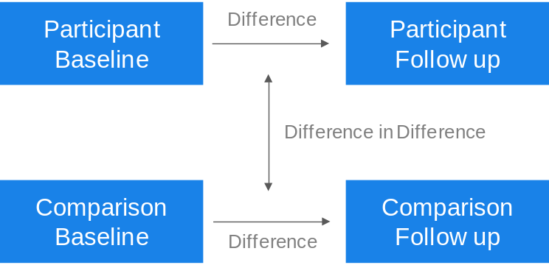
Kantar Public then conducted difference in difference (DiD) analysis to assess the impact NCS participation had on measured outcomes. This analysis measures the change in outcome measures for NCS participants pre-programme to post-programme, compared with the change in outcome measures experienced by non-participants over the same time period. The difference between these two levels of change is the impact attributed to participation in NCS.

Worked example 1: All participants and non-participants were asked the following question in the baseline survey and again in the follow-up survey:
“The next question is about how confident you feel about different areas of your life. How do you feel about the following things, even if you have never done them before...?
 | Very confident | Confident | Neither confident  nor not confident | Not very confident | Not at all confident
Being the leader of a team | ⬜ | ⬜ | ⬜ | ⬜ | ⬜

In the DiD analysis, Kantar Public compared the proportion of respondents who say very confident or confident in the baseline survey and in the follow-up survey
- There was a 22 positive percentage point difference for NCS participants
- There was a 3 positive percentage point difference for non-participants
- There is a positive, 19 percentage point difference in this outcome measure between NCS participants and non-participants
This is shown in the outcome tables included in Appendix 1 as:
Outcome: social mobility  Self-confidence: leadership and communication | Impact Summer
% who feel confident in being the leader of a team | +19pp*

Worked example 2 All participants and non-participants were asked the following question in the baseline survey and again in the follow-up survey:
“Have you given your time to help in any of the following ways outside of school or college hours in the last three months/since your summer NCS (i.e. after summer 2017)/since the summer holidays this year?”
Helping-out other organisations | ⬜

In the DiD analysis, Kantar Public compared the proportion of respondents that choose this statement in the baseline survey and in the follow-up survey
- There was a 4 positive percentage point difference for NCS participants
- There was a 3 negative percentage point difference for non-participants
- There is a positive 7 percentage point difference in this outcome measure between NCS participants and non-participants
This is shown in the outcome tables included in Appendix 1 as:
Outcome: Teamwork, communication and leadership | Impact Summer
% who helped out other organisations | +7pp*

Impacts were estimated using OLS regression and tested with a two-tailed t-test. The standard errors account for the weights used (non-response weights for participants and propensity score matched weights for the comparison group).
Only statistically significantly different results (p<0.05) are shown throughout the main body of this report, although all impact estimates can be found in Appendix 1. Measures where there is no statistically significant difference between the participant and non-participant comparison group are left blank in the graphics. All statistically significant impacts are shown as percentage points (pp) except for the time spent volunteering, which is described in hours and the mean scores for numeric scales which are described as point changes to the mean.
The evaluation was conducted in accordance with the Government Social Research (GSR) ethics guidance.
Limitations
In every research or evaluation there are unavoidable design limitations. These are noted below for purposes of appraising the results in the appropriate context.
Firstly, it is likely that those respondents who (i) agreed to be re-contacted and (ii) completed the follow up survey will have been different in various respects to those respondents who did not agree to be re-contacted and/or did not complete the follow up survey. For instance, it is possible that those participants with a less positive experience of NCS were less likely to complete the follow up survey. This therefore could have introduced a degree of bias in the follow-up survey estimates. Although the participant data is weighted to ensure it is in line with the profile of all NCS participants in terms of age, gender and geographic region, this is unlikely to eliminate all non-response bias.
Secondly, while the baseline and follow-up surveys were both self-completion questionnaires and were, as far as possible, identically worded, it is possible that responses were influenced by differences between the two surveys, including the mode; participants completed paper questionnaires while the comparison group completed online. The fact that the participant baseline survey was completed on paper while the follow-up survey was completed online, could also have introduced differences due to the mode. Furthermore, the fact that the baseline participant paper questionnaire was completed in a room alongside other participants while the follow-up questionnaire was completed online in a more individual setting, could have influenced the responses.
Thirdly, the difference in difference analysis assumes that the average level of change observed for the participant group would have been equal to the average level of change observed for the comparison group, had they not taken part in NCS. We think this assumption is reasonable, especially considering this relatively short time-frame. Moreover, it is not possible to collect data for participants and a comparison group over a longer period of time prior to their participation in NCS. It is unavoidable that there will be systematic differences between the two groups and it is possible that a different trend than the one we are assuming would have been observed for the participant group. Moreover, although the propensity score weights are designed to control for these differences between the two groups, some unobserved differences that cannot be controlled for are likely to remain. The propensity score weights reduce any bias in this perspective, however these are unlikely to eliminate the bias altogether.
Finally, since the impacts are estimated over a relatively short time-frame, there is a possibility that these differences will not persist over the longer term. Additional work has been undertaken to examine longer term impacts of participation in NCS.
As with all surveys, respondents’ answers may be influenced by other factors, for instance they may be prone to giving answers they feel are socially desirable.
Explanation of graphics
In Chapters 4 to 6 graphics are used to highlight measures where the evaluation identified impact. The measures are primarily based on the summer programme, as it is the largest programme. In some cases, an impact was statistically significant for either summer or autumn, but not the other. Where no statistically significant impact was detected, the graphic has been left blank. Note that while the main elements of the programme are consistent, there are some key differences between the summer and autumn NCS programmes, which means that while the results are presented together, they should be considered as separate sets of results.
All figures in the graphics are percentage points (pp).
Structure of this report
This report opens with an exploration of participants’ self-reported experiences and views on NCS in Chapter 3. These questions were asked to the participant group in the follow-up questionnaire and were the only difference between the follow-up questionnaire for the participant and comparison groups. This chapter uses simple descriptive analysis.
Chapters 4 (social mobility), 5 (social cohesion) and 6 (social responsibility) are based on the matched comparison between the participants and non-participants groups and difference in difference analysis. These chapters demonstrate the impact of participation in NCS.
Chapter 7 presents the value-for-money analysis, conducted by London Economics.

- Participant experience
This chapter explores the self-reported experiences of NCS participants who took part in the 2017 summer and autumn programmes. As noted above, while the main elements of the programme are consistent, there are differences between the summer and autumn NCS programmes, as well as in demographic profile of participants. This means that while for the purposes of this report results are presented side by side, comparison of the results for summer and autumn does not form part of this evaluation.
Overall experience of programme
Summer and autumn participants were asked to rate how enjoyable and worthwhile they felt their NCS experience was using a scale of 0 to 10. As shown in Figure 3.1, almost all participants (at least 90% in both summer and autumn) gave a score of at least 6, indicating that the large majority rated their experience as both ‘worthwhile’ and ‘enjoyable’. Participants were particularly likely to find the programme enjoyable, with around six in ten of both participant groups giving the maximum score of 10 on this measure. In line with this, eight in ten respondents (83% summer, 77% autumn) said they would recommend NCS to their peers.

Figure 3.1 How worthwhile and enjoyable participants found NCS 2017
% giving scores 6 to 10
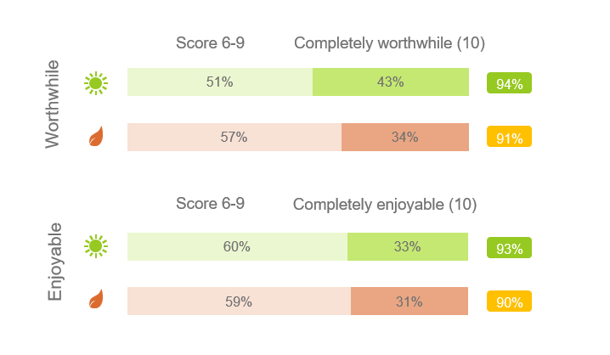

Base: Summer participants (1,870) Autumn participants (1,202)
On a scale of 0-10, where 0 is not at all worthwhile and 10 is completely worthwhile, how worthwhile did you find your National Citizen Service experience overall?
On a scale from 0-10, where 0 is not at all enjoyable and 10 is completely enjoyable, how enjoyable did you find your National Citizen Service experience overall?

Views on staff
Participants were asked how they would describe the NCS staff member they spent the most amount of time with, using the list of attributes outlined in figure 3.2.
Across both the summer and autumn programmes staff were most likely to be described as ‘supportive’ (79% in summer, 65% in autumn) and ‘that they encouraged me to fully take part in the programme’ (77% in summer, 65% in autumn).
Attributes used less often to describe staff, although still selected by approximately half of participants, were ‘they were interested in me and my development’ (63% in summer, 46% in autumn) and ‘they were knowledgeable about the programme’ (59% in summer, 49% in autumn)’. It should be noted that participants were asked to select any applicable statements, rather than respond ‘yes’ or ‘no’ to each statement. It is possible that respondents view statements as ‘not applicable’ for multiple reasons, including viewing the statements as less relevant than others in the list, or if they felt ill-equipped to make a judgement about staff’s knowledge of the programme.

Figure 3.2 Participants’ views on NCS staff
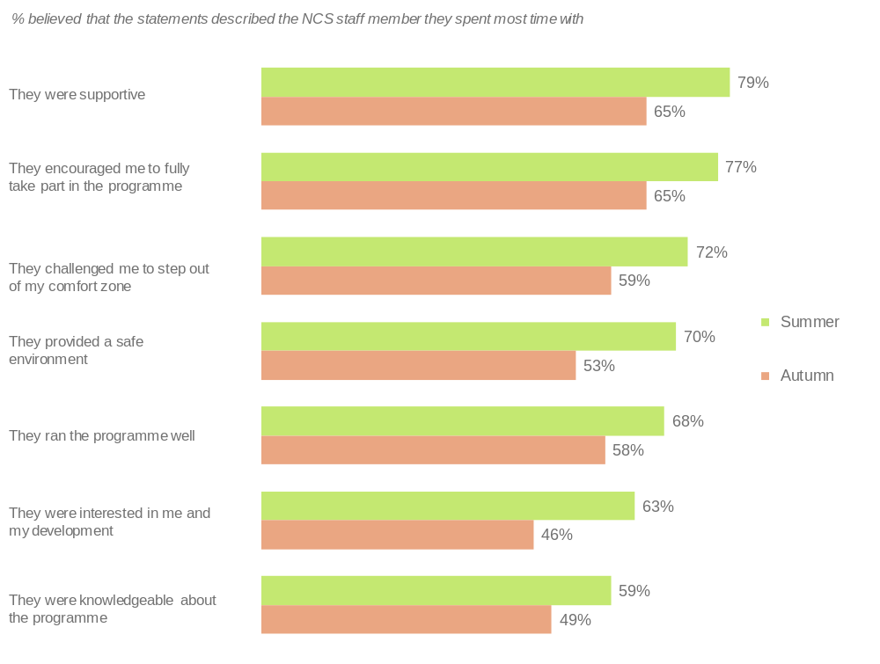
Base: Summer participants (1,870) Autumn participants (1,202)
Which, if any, of the following statements describes the member of staff who spent the most time with you and your team during your National Citizen Service experience?

NCS in the future
Participants were asked about their planned involvement in and recommendation of NCS in the future. As shown in Figure 3.3, the majority of both summer and autumn participants said they either definitely or potentially wanted to stay involved with NCS in the future. In line with the fact that nine in ten participants felt their NCS experience was enjoyable and worthwhile, participants were also highly likely to recommend NCS to other young people. Almost all summer and autumn participants would recommend NCS, with the majority (around eight in ten) saying they would ‘definitely’ recommend it.

Figure 3.3 Whether participants want to stay involved with NCS and would recommend NCS
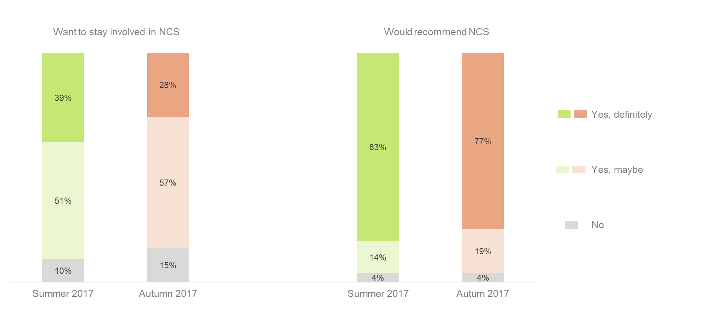

Base: Summer participants (1,870) Autumn participants (1,202)
Would you like to stay involved in National Citizen Service in the future?
Would you recommend National Citizen Service to other young people?

Self-reported benefits of NCS
Participants were asked the extent to which they agreed or disagreed with a number of statements (shown in Figure 3.4) that measure self-reported benefits of NCS. Responses were very positive across both programmes, particularly in terms of participants being ‘proud of what I achieved’; having ‘a chance to develop skills which will be more useful to me in the future’; having ‘a better understanding of my abilities’; and feeling ‘more positive towards people from different backgrounds to myself’.

Figure 3.4 Agreement with benefits of NCS - % strongly agree / agree
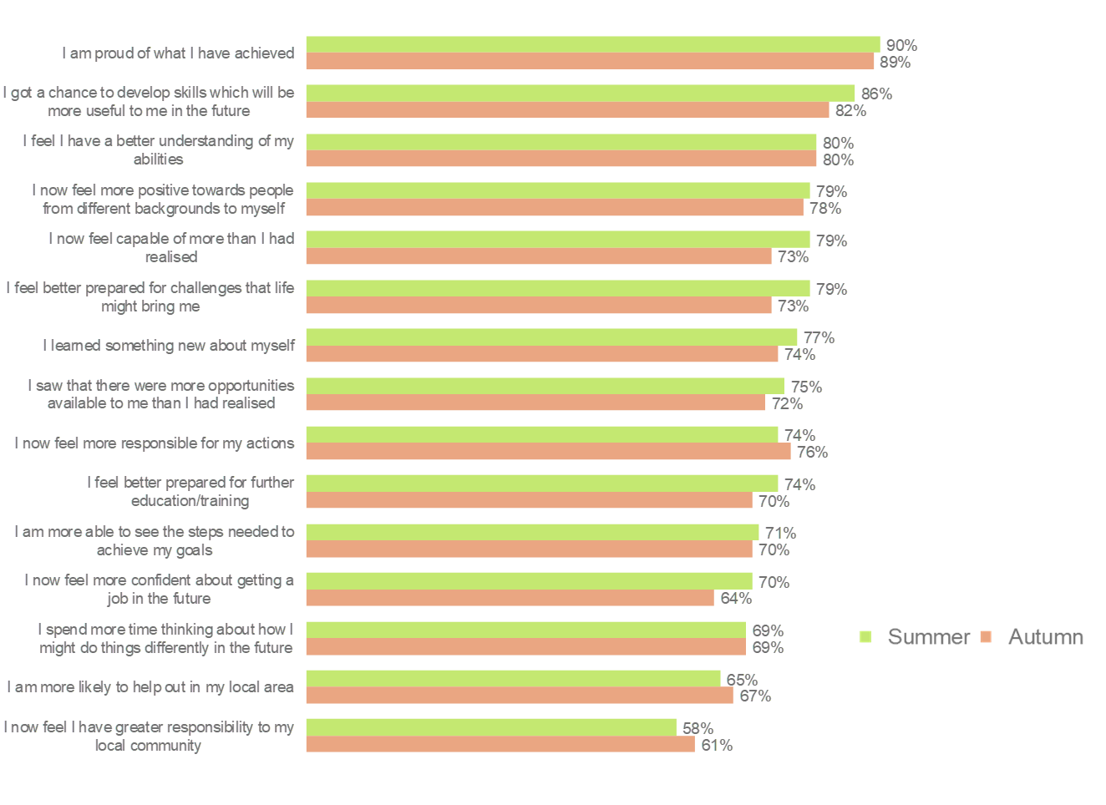
Base: Summer participants (1,870) Autumn participants (1,202)
To what extent do you agree or disagree with the following statements about your National Citizen Service experience? [Strongly agree. Agree, Neither agree nor disagree, Disagree, Strongly disagree]

National Citizen Service

Impact

- Social mobility
The NCS programme and theory of change has three core aims. In relation to social mobility, the NCS overarching goal is to:
“…build essential skills for life and work, investing in our country’s future talent.”

NCS aims to improve young people’s teamwork, communication and leadership skills and support young people in their transition to adulthood. The evaluation measured outcomes about young people’s confidence in these areas, and their attitudes to working with other people. Other outcome measures in this category included problem-solving and decision-making skills, positivity about the future, resilience and emotional regulation.

Self-reported impact
As outlined in chapter 3 above, NCS participants are very positive about their experiences of the programme; the majority reported feeling that NCS improved their self-confidence and helped them to feel more positive about their future.
9 in 10 NCS participants (90% summer, 89% autumn) felt proud of what they had achieved
8 in 10 participants said…
- NCS had given them a chance to develop skills which will be useful to them in the future (86% summer, 82% autumn)
- that as a result of NCS they feel they have a better understanding of their abilities (80% summer and autumn)
7 in 10 NCS participants said...
- they learnt something new about themselves (77% summer, 74% autumn)
- they saw that there were more opportunities open to them than they realised (75% summer, 72% autumn)
- they felt better prepared for further education/training (74% summer, 70% autumn)
- they felt more able to see the steps needed to achieve their goals (71% summer, 70% autumn)
- they now feel more confident about getting a job (70% summer, 64% autumn)
- they spend more time thinking about how they might do things differently in the future (69% summer and autumn)

Impact measures
As detailed in chapter 2, impact is measured using difference in difference analysis. This analysis measures the change in outcome measures for NCS participants pre-programme to post-programme, compared with the change in outcome measures experienced by non-participants over the same time period. The difference between these two levels of change is the impact attributed to participation in NCS.
The outcome measures that are used to assess the impact of NCS on social mobility can be divided into five, related sub-categories:
- Self-confidence: leadership and communication
- Problem solving and decision-making skills
- Teamwork and social network building
- Positivity about the future
- Resilience and emotional regulation
The results of the difference in difference analysis for these outcome measures is outlined below. All social mobility impact measures are shown in tables 1-5 in Appendix 1.

Self-confidence: leadership and communication
Across both programmes, NCS had a positive impact on all seven measures relating to leadership and communication.
The greatest positive impact was seen on how confident participants feel ‘being the leader of a team’, ‘explaining ideas clearly’, and ‘meeting new people’. The data for all measures are shown in figure 4.1.
Note, due to rounding the difference between the results for the participant and comparison groups may differ very slightly from the impact result shown.

Figure 4.1 Teamwork, communication and leadership impact measures
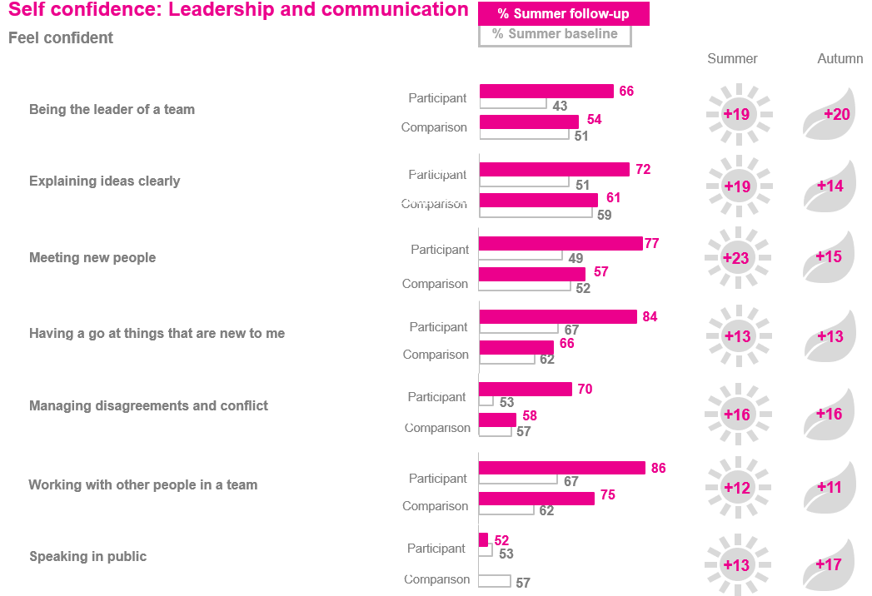
Base: Summer participants (1,870) Autumn participants (1,202) Summer comparison group (864) Autumn comparison group (1,125)
The next question is about how confident you feel about different areas of your life. How do you feel about the following things, even if you have never done them before...? [Very confident, Confident, Neither confident nor not confident, not very confident, not at all confident]
Charts show the percentage of young people selecting ‘very confident’ or ‘confident’

Problem solving and decision-making skills
NCS summer had a positive impact across three of the four measures in this category (outlined in Figure 4.2 below), while NCS autumn had a positive impact on two out of the four measures. Figure 4.2 shows that both NCS programmes had a positive impact on whether participants feel that they ‘think about both long-term and short-term consequences when I work through problems’ and ‘usually make good decisions, even in difficult situations’. NCS summer also had a positive impact on feeling that ‘when solving a problem, I try to think of as many solutions as possible’.

Figure 4.2 Problem-solving and decision-making skills
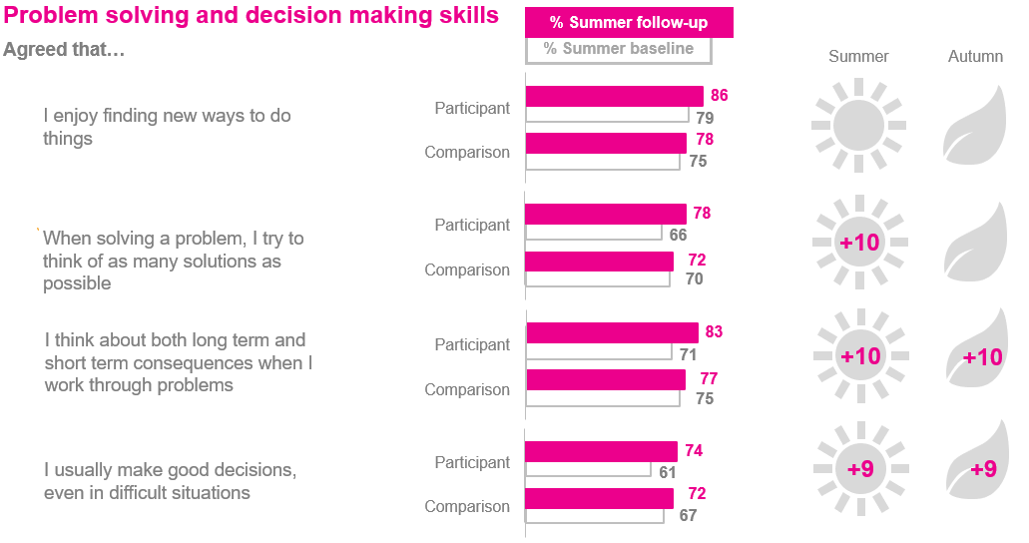
Base: Summer participants (1,870) Autumn participants (1,202) Summer comparison group (864) Autumn comparison group (1,125)
How much do you agree or disagree with the following statements? [Strongly agree. Agree, Neither agree nor disagree, Disagree, Strongly disagree]
Charts show the percentage of young people selecting ‘strongly agree’ or ‘agree’

- No significant impact was detected on participants’ level of agreement that they ‘enjoy finding new ways to do things’

Teamwork and social network building
NCS summer had a positive impact across nearly all (five out of six) measures in this category, while the impact of the autumn programme was more limited (two out of six).
As shown in Figure 4.3, in both programmes there was a positive impact on participants’ feeling that they ‘get along with people easily’ and ‘can easily tell when someone says one thing but means another’. For NCS summer, further positive impacts were observed for participants feeling that they can both access support ‘If I needed help, there are people who would be there for me’ and provide it ‘I notice quickly if someone in a group is feeling awkward’; also, that they feel ‘able to see things from the other person’s viewpoint’. There was no significant impact on participants’ feeling able to ‘say no to friends’.

Figure 4.3 Teamwork and social network building
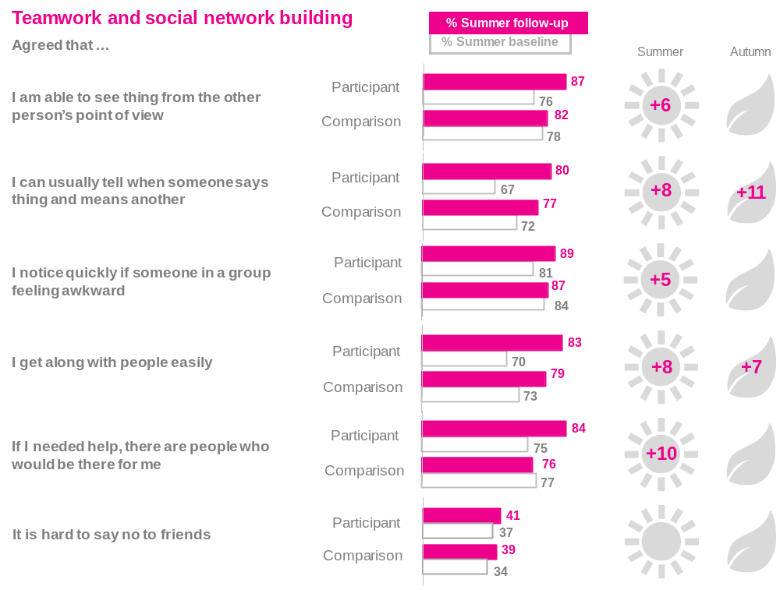

Base: Summer participants (1,870) Autumn participants (1,202) Summer comparison group (864) Autumn comparison group (1,125)
How much do you agree or disagree with the following statements? [Strongly agree. Agree, Neither agree nor disagree, Disagree, Strongly disagree]
Charts show the percentage of young people selecting ‘strongly agree’ or ‘agree’
N.B on the ‘saying not to friends’ outcome the desired impact is negative (i.e. a reduction in the proportion agreeing that it is hard to say no to friends)

Positivity about the future
For NCS summer positive impacts were observed across all three measures in this category, as shown in Figure 4.4. NCS autumn, had a positive impact on participants feeling confident about ‘having the skills and experience to get a job in the future’.

Figure 4.4 Positivity about the future
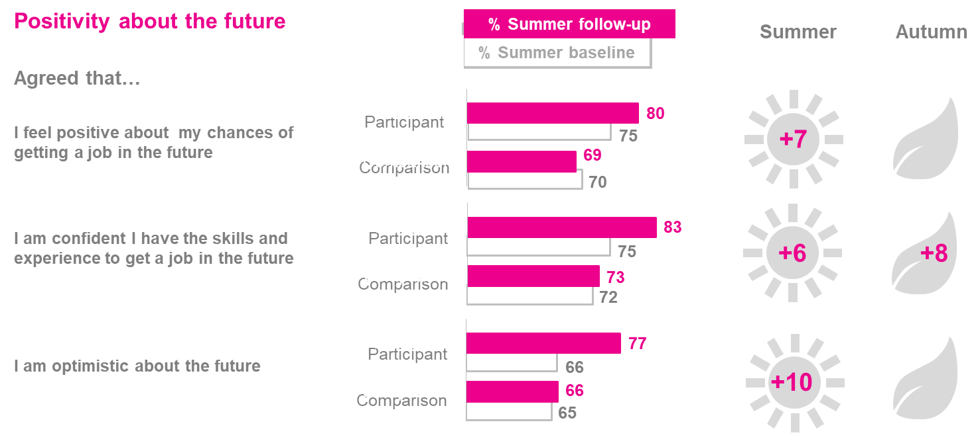
Base: Summer participants (1,870) Autumn participants (1,202) Summer comparison group (864) Autumn comparison group (1,125)
How much do you agree or disagree with the following statements? [Strongly agree. Agree, Neither agree nor disagree, Disagree, Strongly disagree]
Charts show the percentage of young people selecting ‘strongly agree’ or ‘agree’

Resilience and emotional regulation
NCS summer was also found to have a positive impact on nearly all (four out of five) measures in this category. NCS autumn was found to have had a positive impact on one of the five measures in this category.
In both NCS summer and NCS autumn, there was a positive impact on participants feeling that they can ‘usually handle whatever comes my way’. NCS summer had a further positive impact on participants feeling that ‘when faced with stressful situations I am able to stay calm’, ‘setbacks don’t normally discourage me’ and their ability to ‘stay in control when I’m angry’.
No significant impact was detected, for summer or autumn, on participants’ feeling able to get over it quickly ‘when things go wrong’.

Figure 4.5 Resilience and emotional regulation
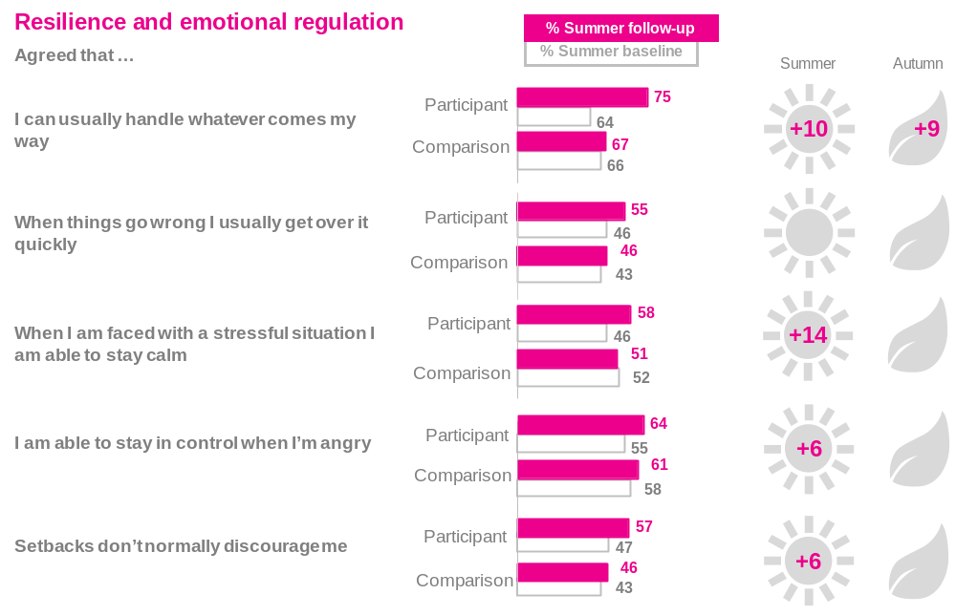
Base: Summer participants (1,870) Autumn participants (1,202) Summer comparison group (864) Autumn comparison group (1,125)
How much do you agree or disagree with the following statements? [Strongly agree. Agree, Neither agree nor disagree, Disagree, Strongly disagree]
Charts show the percentage of young people selecting ‘strongly agree’ or ‘agree’

- Social cohesion
The NCS programme and theory of change outlines three aims which the programme seeks to achieve. In relation to social cohesion, the NCS overarching goal is to
“…bring our country together by building stronger, more integrated communities and fostering understanding between young people from different backgrounds.”

NCS encourages social mixing amongst participants, and the evaluation measures outcomes around trust and attitudes towards mixing with people from different ethnic, social and religious backgrounds.

Self-reported impact
More than three quarters of summer and autumn participants agreed (strongly agree + agree) that following their NCS experience ‘I now feel more positive towards people from different backgrounds to myself’.
79% of NCS summer participants and 78% of NCS autumn participants said that after their NCS experience they felt more positive towards from different backgrounds to themselves

Impact measures
The outcome measures captured under social cohesion can be split into three subcategories:
- trust and community cohesion
- experiences with others
- attitudes towards people from different backgrounds
This chapter also includes more general measures of wellbeing. See Appendix 1 for the full breakdown of the measures included.
As detailed in chapter 2, impact is measured using difference in difference analysis. This analysis measures the change in outcome measures for NCS participants pre-programme to post-programme, compared with the change in outcome measures experienced by non-participants over the same time period. The difference between these two levels of change is the impact attributed to participation in NCS.
Most outcomes in this chapter, are measured using 0-10 scale questions. To measure attitudes towards people from different backgrounds, respondents were asked to rate how comfortable, on a scale of 0-10, they feel with a friend or relative going out with someone different from themselves, including from a different race or ethnicity or someone that is from a different religious background. To assess the impact of NCS on young peoples’ wellbeing the four Office for National Statistics (ONS) measures were used. Respondents were asked to rate their life satisfaction, happiness and whether they feel that the things they do in life are ‘completely worthwhile’, and the extent to which they feel anxious on a scale of 0-10.
Historically, these have been recoded into binary variables using the extreme point of the scale e.g. ’10 –completely satisfied with life’ vs. all other answers, or ‘0 – not at all anxious’ vs. all other answers. This is referred to as ‘top box’ analysis within the report. This approach does not reveal if any movement has taken place lower down the scale (between 0 and 9 or between 1 and 10). Nor does it reveal anything about the size of the change, a 1-point change from 9-10 on the scale has the same weight as a 10-point change from 0-10.
To overcome this limitation for this year’s evaluation, impact estimates for these questions were also calculated using mean scores. Difference in difference analysis was conducted on the change in mean scores for the participant and comparison groups.
Both sets of analysis are provided in the relevant sections below.
For context, this chapter also includes charts showing the distribution of responses across the scale, i.e. the proportion of respondents selecting each point on the scale, for all outcomes measures using a 0-10 scale. These distributions show that responses to the questions on social cohesion tend to be clustered around the top of the scale, revealing that many young people start from a high base in terms of stated levels of comfort with people from different backgrounds. This in part explains why this, and previous evaluations, have struggled to detect impact on measures of social cohesion.

Social cohesion
The measures on trust and community cohesion, and ‘experiences with others’ are asked using a five point agree to disagree scale (rather than a numeric 0-10 scale). For these measures, difference in difference analysis has been conducted on the proportions that agree with the statement, mean score analysis has not been undertaken.
Trust and community cohesion
Neither NCS summer nor NCS autumn had a statistically significant impact on whether participants felt that:
- most people can be trusted
- their local area is a place where people from different backgrounds get on well together
Experiences with Others
Participants were asked how frequently they had negative or positive experiences with people from the same race or ethnicity as themselves, as well as people from a different race or ethnicity. NCS autumn had a positive impact on whether participants said they:
- often have positive or good experiences with people from a different race or ethnicity (+9pp)
For other measures related to experiences with others, there was also a positive shift from the baseline to the follow-up survey among NCS participants. However, the difference in the change between the participant and the comparison group was not statistically significant. Full results are provided in appendix 1 (table 9).
Attitudes towards people from different backgrounds
As outlined above, to measure attitudes towards people from different backgrounds, respondents were asked to rate how comfortable, on a scale of 0-10, they feel with a friend or relative going out with someone from a different background, someone who is disabled or someone who is gay or lesbian. The results of the difference in difference analysis on the mean scores, and the proportion of respondents selecting the top box of the scale are provided below.
Mean score analysis
The difference in difference analysis of the means scores found that both NCS summer and NCS autumn had a positive impact on two of the social cohesion measures: levels of comfort with a friend or relative going out with someone from a different race or ethnicity and with someone from a richer or poorer background.
The statistically significant impacts detected are shown in figure 5.1 below: a change of between 0.2 and 0.5 of a point to the mean score (0-10). The mean scores for all social cohesion measures are provided in appendix 1 (table 8).
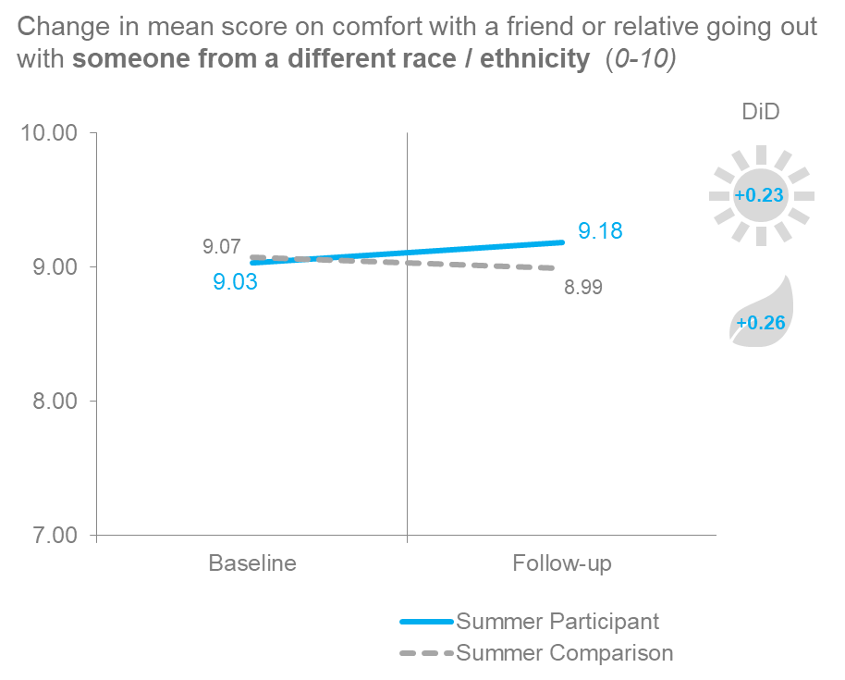
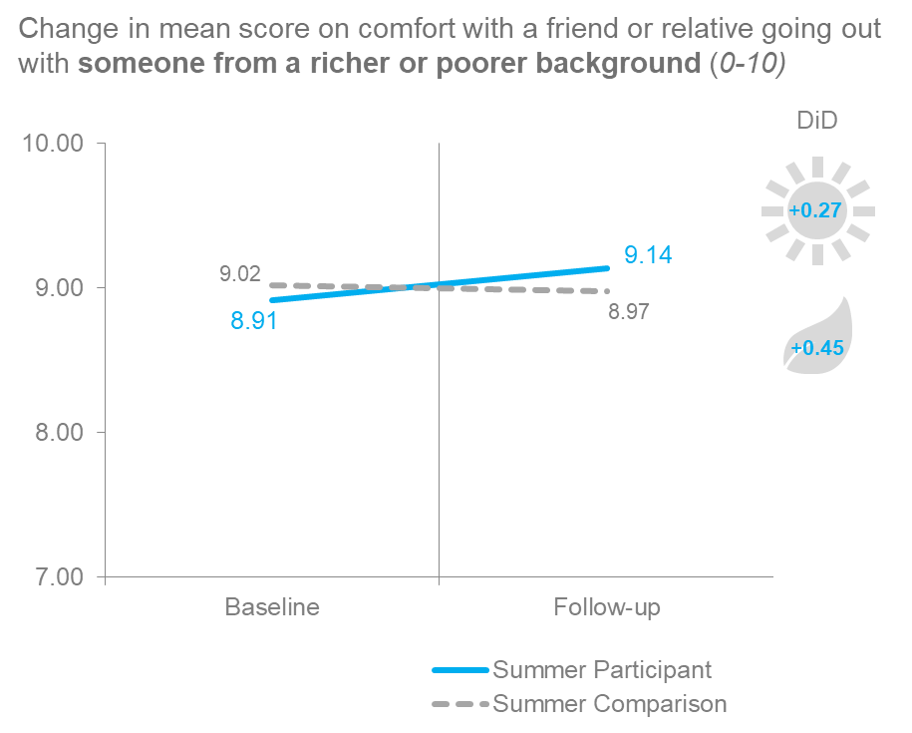
Figure 5.1 Social cohesion measures – mean scores

Top box analysis
Using this approach of looking only at the young people who gave a score of ten on a ten-point scale, a positive impact was detected for NCS autumn on the same two outcomes: how comfortable participants indicated they felt about ‘a friend/relative going out with someone from a richer or poorer background’ and of a ‘different race or ethnicity’.
For the remaining three outcome measures and for NCS summer, the differences between the participant and comparison groups are not statistically significant and so this ‘10/10’ analysis does not allow us to conclude the 2017 programme had an impact on these outcomes. As mentioned earlier, the very high baseline scores on these measures makes it very challenging for any programme to detect significant pre-post impact.
Figure 5.2 Social cohesion measures
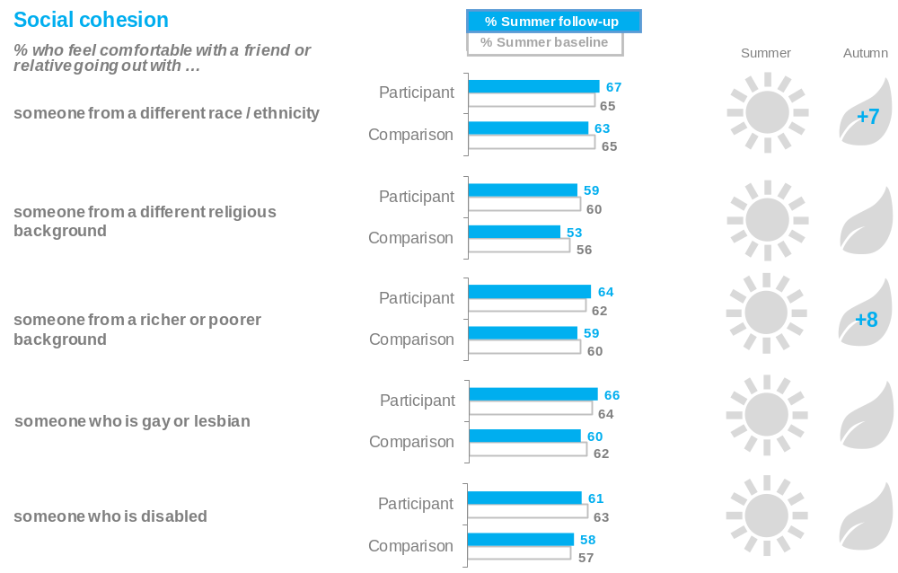
Base: Summer participants (1,870) Autumn participants (1,202) Summer comparison group (864) Autumn comparison group (1,125)
Please use this scale to show how you would personally feel about a close relative or friend going out with someone from the following backgrounds. On this scale, 0 means that you would be very uncomfortable and 10 means that you would be very comfortable
Chart shows % selecting 10 on 0-10 scale
No positive impact was detected on how comfortable participants indicated they felt about ‘a friend/relative going out with someone from a different school or college’.
Wellbeing
The evaluation surveys included the four Office for National Statistics (ONS) wellbeing measures.
Mean score analysis
As with the social cohesion outcomes that are measured using numeric scales, the wellbeing impact estimates have previously been calculated using the extremes of the scales only (0/10 for anxiety and 10/10 for the satisfaction, happiness and worthwhile measures). As outlined above, this approach means that change is only detected at the top end of the scale and it is not possible to detect if NCS had an impact across the scale. Mean score impact estimates (the difference in the change in the mean score from baseline to follow up) have also therefore been produced for the wellbeing measures.
This analysis found that both NCS summer and NCS autumn had a positive impact on reported levels of life satisfaction and whether participants felt that the ‘things they do in life are worthwhile’. For the summer programme, the impact on the mean score for both measures was approximately half a point (0.53 for life satisfaction, 0.54 for feeling things in life are worthwhile). For the autumn programme, the impact on the mean score was slightly smaller: 0.38 for life satisfaction and 0.51 for feeling things in life are worthwhile.
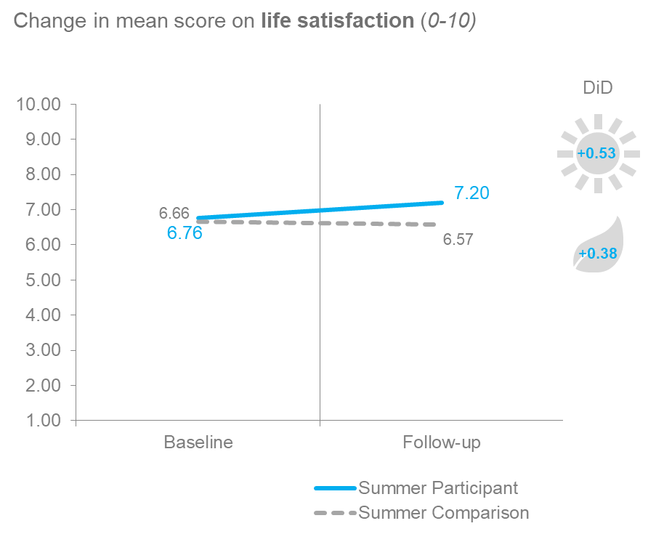
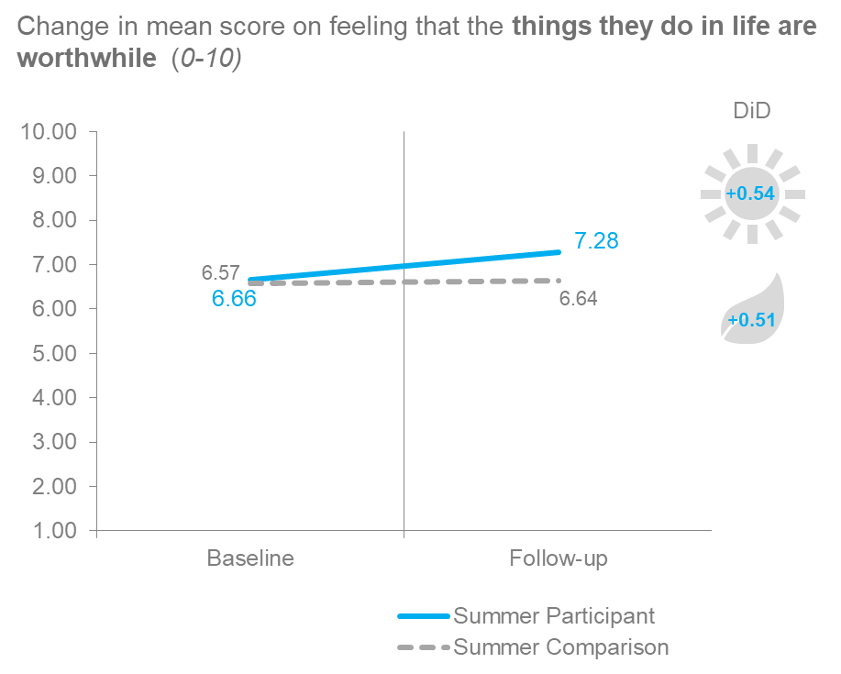
Figure 5.4 Wellbeing measures – mean scores

Top box analysis
As shown in Figure 5.5, using the top box approach, NCS summer and NCS autumn were found to have had a positive impact on reported levels of life satisfaction, happiness and whether participants feel that the things they do in life are ‘completely worthwhile’. The autumn programme was also found to have had a beneficial impact on anxiety, with the number of participants saying they had felt ‘not at all anxious’ yesterday increasing.
Figure 5.5 Wellbeing measures
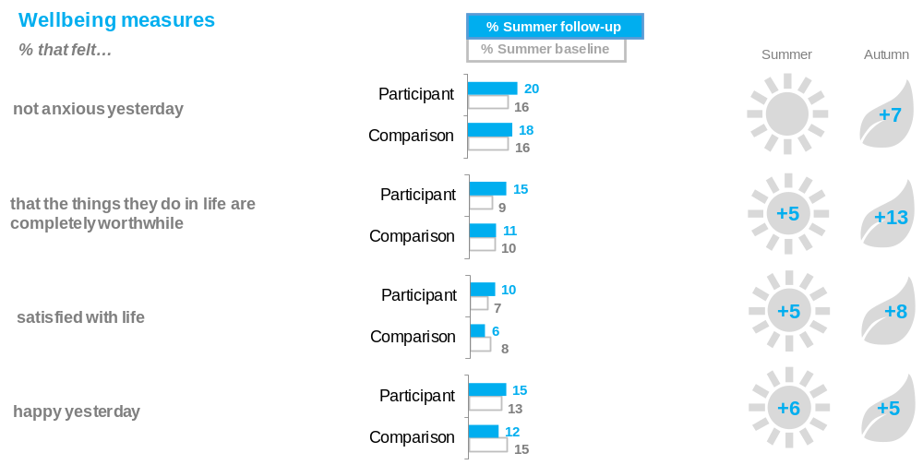
Base: Summer participants (1,870) Autumn participants (1,202) Summer comparison group (864) Autumn comparison group (1,125)
On a scale of 0-10, where 0 is not at all anxious / worthwhile / satisfied / happy and 10 is completely anxious / worthwhile / satisfied / happy, overall ….
…how anxious did you feel yesterday
…how satisfied are you with your life nowadays
…to what extent do you feel the things you do in your life are worthwhile
…how happy did you feel yesterday

‘Not anxious yesterday’ = % selecting ‘0 - not at all anxious’ on 0-10 scale
‘That the things they do in life are completely worthwhile’ = % selecting ’10 – completely worthwhile’ on 0-10 scale
‘Satisfied with life’ = % selecting ’10 completely satisfied’ on 0-10 scale
‘Happy yesterday’ = % selecting ’10 completely happy’ on 0-10 scale

Distribution Analysis
In February 2018, James Laurence published a report examining how participation in NCS affects social integration for different groups of young people. This report used data collected to evaluate the 2015 summer NCS programme and aimed to answer the following questions:
1. Does NCS have stronger impacts for young people who join the programme less socially integrated to begin with?
2. Does NCS help overcome barriers to social integration faced by young people, such as less frequent positive contact with people from different ethnic groups, or more frequent negative encounters?
3. Can NCS help build social integration in communities where it is much weaker, such as in more socio-economically disadvantaged areas or more ethnically segregated communities?
The analysis included in the report explores the difference in distance travelled by different groups of NCS participants.
This type of analysis is best suited to questions asked on a scale, such as the measures included in this chapter. Further analysis, using a similar approach is planned using combined data from the 2016-2018 NCS evaluations. This report does not include distance travelled analysis, which was not within the scope of this evaluation.
As outlined above, this chapter includes charts showing the distribution of responses across the scale, i.e. the proportion of respondents selecting each point on the scale, for the attitude measures and the ONS wellbeing measures. As the charts show, many young people start from a high base in terms of stated levels of comfort with people from different backgrounds, with responses clustered around the top of the scale. In comparison, responses to the questions on wellbeing tend to be more evenly spread throughout the scale.

Social cohesion measures
The charts that form figure 5.3 show the distribution of responses across the 11-point scales (0-10). The results for NCS summer participants and the control group are shown here, the results for NCS autumn are very similar and are provided in the appendix.
As the charts show, responses tended to be clustered at the top end of the scale at both the baseline and the follow up. For all six measures, between 70% and 86% of respondents selected 8,9 or 10 at the baseline with between 50% and 60% of young people (NCS participants and the comparison group) reporting feeling very (10/10) comfortable at the baseline. The only exception is the comparison group’s levels of comfort with a friend going out with someone from a different school, where 48% said they were very comfortable (10/10) at the baseline.
These high levels of reported comfort mean there is limited potential for positive movement within the scale: for most respondents, who start at 10/10, it is not possible to give a more positive response. It also means that there are very few respondents who would feel ‘uncomfortable’ with a friend or relative going out with someone from a different background at the baseline. Less than 3% of NCS participants gave a response between 0 and 4 when asked how comfortable they would be with a friend or relative going out with someone from a different race or ethnicity.
Consequently, it is difficult to detect meaningful movement within the scale pre to post NCS programme. As the charts show, while there are some small positive shifts from baseline to follow up, the responses for both NCS participants remain largely consistent.

Figure 5.3 Social Cohesion measures – distributions (Summer)
Comfort with a close relative or friend going out with someone from a different race / ethnicity

NCS Participants (Summer) | Comparison Group (Summer)
Q. Please use this scale to show how you would personally feel about a close relative or friend going out with someone from the following backgrounds. On this scale, 0 means that you would be very uncomfortable and 10 means that you would be very comfortable

Comfort with a close relative or friend going out with someone from a different religious background

NCS Participants (Summer) | Comparison Group (Summer)
Q. Please use this scale to show how you would personally feel about a close relative or friend going out with someone from the following backgrounds. On this scale, 0 means that you would be very uncomfortable and 10 means that you would be very comfortable

Comfort with a close relative or friend going out with someone from a richer or poorer background

NCS Participants (Summer) | Comparison Group (Summer)
Q. Please use this scale to show how you would personally feel about a close relative or friend going out with someone from the following backgrounds. On this scale, 0 means that you would be very uncomfortable and 10 means that you would be very comfortable

Comfort with a close relative or friend going out with someone who is gay or lesbian

NCS Participants (Summer) | Comparison Group (Summer)
Q. Please use this scale to show how you would personally feel about a close relative or friend going out with someone from the following backgrounds. On this scale, 0 means that you would be very uncomfortable and 10 means that you would be very comfortable

Comfort with a close relative or friend going out with someone who is disabled

NCS Participants (Summer) | Comparison Group (Summer)
Q. Please use this scale to show how you would personally feel about a close relative or friend going out with someone from the following backgrounds. On this scale, 0 means that you would be very uncomfortable and 10 means that you would be very comfortable

Comfort with a close relative or friend going out with someone who is from a different school or college

NCS Participants (Summer) | Comparison Group (Summer)
Q. Please use this scale to show how you would personally feel about a close relative or friend going out with someone from the following backgrounds. On this scale, 0 means that you would be very uncomfortable and 10 means that you would be very comfortable

Wellbeing measures
Figure 5.6 below shows the distribution of responses across the scale for NCS summer participants and the control group for the wellbeing measures. The results for NCS autumn are provided in the appendix. As the charts show there was a greater distribution of responses across the scale compared with the social cohesion measures. On the measures where NCS was found to have a positive impact both using the mean scores and the top box – life satisfaction and feeling that things in life are worthwhile - it is clear that the difference between the proportion of respondents at the top of the scale increases to a greater extent among the NCS participants than among the control group

Figure 5.6 Wellbeing measures – distributions (Summer)

Anxiety

NCS Participants (Summer) | Comparison Group (Summer)
Q. On a scale of 0-10, where 0 is not at all anxious and 10 is completely anxious overall …. how anxious did you feel yesterday?

Worthwhile

NCS Participants (Summer) | Comparison Group (Summer)
Q. On a scale of 0-10, where 0 is not at all worthwhile and 10 is completely worthwhile overall …. to what extent do you feel the things you do in your life are worthwhile?

Satisfied with life

NCS Participants (Summer) | Comparison Group (Summer)
Q. On a scale of 0-10, where 0 is not at all satisfied and 10 is completely satisfied overall …. how satisfied are you with your life nowadays?

Happiness

NCS Participants (Summer) | Comparison Group (Summer)
Q. On a scale of 0-10, where 0 is not at all happy and 10 is completely happy overall …. how happy did you feel yesterday?

- Social responsibility
The NCS programme and theory of change outlines three aims which the programme seeks to achieve. In relation to social responsibility, the NCS overarching goal is:
“…to engage young people in social action in their communities and the democratic process, building their understanding of their responsibilities as citizens.”
NCS aims to encourage young people to be involved in their communities, both during the programme and beyond. This chapter includes measures on young people’s attitudes towards their community, as well as activities they have taken part in and help they have provided to those outside their immediate family. These measures focus on activities undertaken outside of the NCS programme itself.

Self-reported impact
More than three quarters of both NCS summer and NCS autumn participants agreed that that following their NCS experience they feel more responsible for their own actions, while two-thirds said they were more likely to help out in their local area.
- 74% of NCS summer participants and 76% of NCS autumn participants said that after their NCS experience they felt more responsible for their actions
- 65% of NCs summer participants and 67% of NCS autumn participants said that after their NCS experience they are more likely to help-out in their local area
- 58% of NCs summer participants and 61% of NCS autumn participants said that after their NCS experience they feel they have a greater responsibility to their local community

Impact measures
As detailed in chapter 2, impact is measured using difference in difference analysis. This analysis measures the change in outcome measures for NCS participants pre-programme to post-programme, compared with the change in outcome measures experienced by non-participants over the same time period. The difference between these two levels of change is the impact attributed to participation in NCS.
Attitudes towards community involvement
NCS was found to have had a positive impact on all four community involvement measures (shown in Figure 6.1). Participants of both NCS programmes were more likely than their counterparts in the comparison group to say they ‘know how to deal with a problem in my local area’, ‘feel able to have an impact on the world’ and ‘feel a sense of responsibility to my local community’.

Figure 6.1 Attitudes towards community involvement
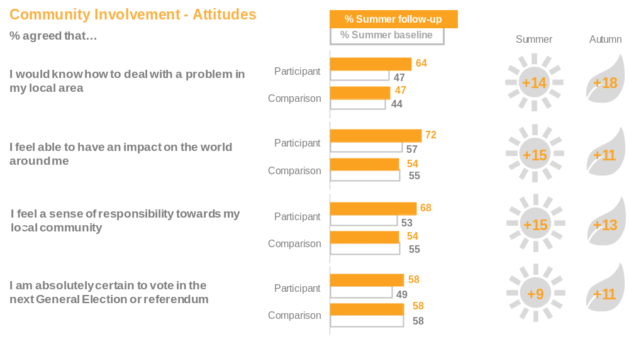
Base: Summer participants (1,870) Autumn participants (1,202) Summer comparison group (864) Autumn comparison group (1,125)
How much do you agree or disagree with the following statements [Strongly agree, Agree, Neither agree or disagree, Disagree, Strongly disagree]?
Charts show the percentage of young people selecting ‘strongly agree’ or ‘agree’
At the next election or referendum where you are legally old enough to vote, how likely are you to vote? Use a scale of 1 to 10, where 10 means you would be absolutely certain to vote, and 1 means that you would be absolutely certain not to vote. [showing 10/10 likely to vote]
NCS was also found to impact positively on participants’ propensity to vote at the next general election. The likelihood to vote question was asked on a scale of 1-10 so mean score analysis was also possible (as detailed in chapter 5 above). For summer the impact of NCS on the mean score (the difference in the change between baseline and follow up for participants vs the comparison group) was 0.39. The impact for autumn was 0.67.

Distribution analysis
In line with the mean score analysis and top box analysis, the distribution analysis shows a positive impact on propensity to vote. The proportion of NCS participants selecting 10/10, absolutely certain to vote, increased from the baseline to the follow up survey, whereas the proportion of the control group selecting 10/10 remained stable.
Figure 6.1.1 – Likelihood to vote – distribution

NCS Participants (Summer) | Comparison Group (Summer)
Q. At the next election or referendum where you are legally old enough to vote, how likely are you to vote? Use a scale of 1 to 10, where 10 means you would be absolutely certain to vote, and 1 means that you would be absolutely certain not to vote.

Community involvement actions
NCS also had a positive impact on many of the community involvement measures.
Measures in this category can be divided into two groups: ‘community activities’ and ‘volunteering to help others’ outside of the young person’s direct family. There are seven ‘community activities’ these include ‘helping out at local club or organisation’, ‘raising money for charity and organising a petition or even to support a local or national issue’. There are nine ‘volunteering to help others’ activities these include ‘doing shopping, collecting pension or paying bills, ‘baby-sitting for caring for children’ (for someone outside of your direct family) as well as ‘helping out in some other way’. The full list of outcome measures is shown in Table 13 in Appendix 1.
For each group an ‘overall’ measure is also calculated, this examines the difference between the proportion of participants that have selected one or more of the activities listed compared with the comparison group.
Community activities
NCS autumn had a positive impact on the overall measure of spending time undertaking any of the community activities listed in the questionnaire (+15pp). While a statistically significant positive impact was not detected for NCS summer at this overall level, the programme had a positive impact on 4 of the 7 specific measures related to community activities (NCS autumn had a positive impact on 6 of 7).
Figure 6.2 Community activities
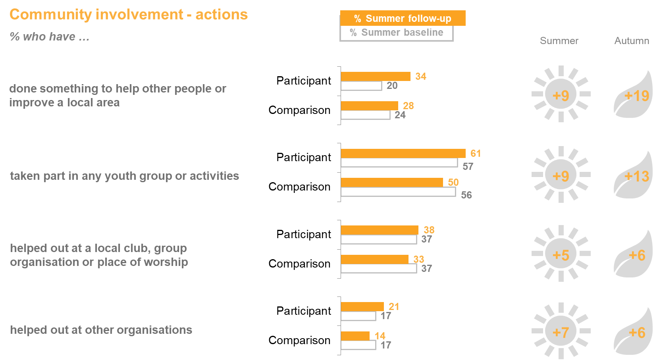

Base: Summer participants (1,870) Autumn participants (1,202) Summer comparison group (864) Autumn comparison group (1,125)
Participants: Have you given your time to help in any of the following ways outside of school or college hours since your autumn / summer NCS?
Comparison: Have you given your time to help in any of the following ways outside of school or college hours since the end of autumn half term / the summer holidays this year
NCS autumn also had a positive impact on whether participants said they had:
- Raised money for charity (+9pp)
- Organised a petition or event to support a local or national issue (+3pp)
No positive impact was detected, for either programme, on whether NCS participants were more likely than their counterparts to have ‘contacted someone (e.g. council, medial, school) about something affecting their local area’.
Volunteering to help others
Again, for NCS autumn a positive impact was recorded for the overall measure of volunteering to help others in one or more of the ways listed in the questionnaire (+9pp). For NCS summer a positive impact was detected for three of the nine specific measures and for NCS autumn a positive impact was detected for one of the specific measures, as shown in Figure 6.3.
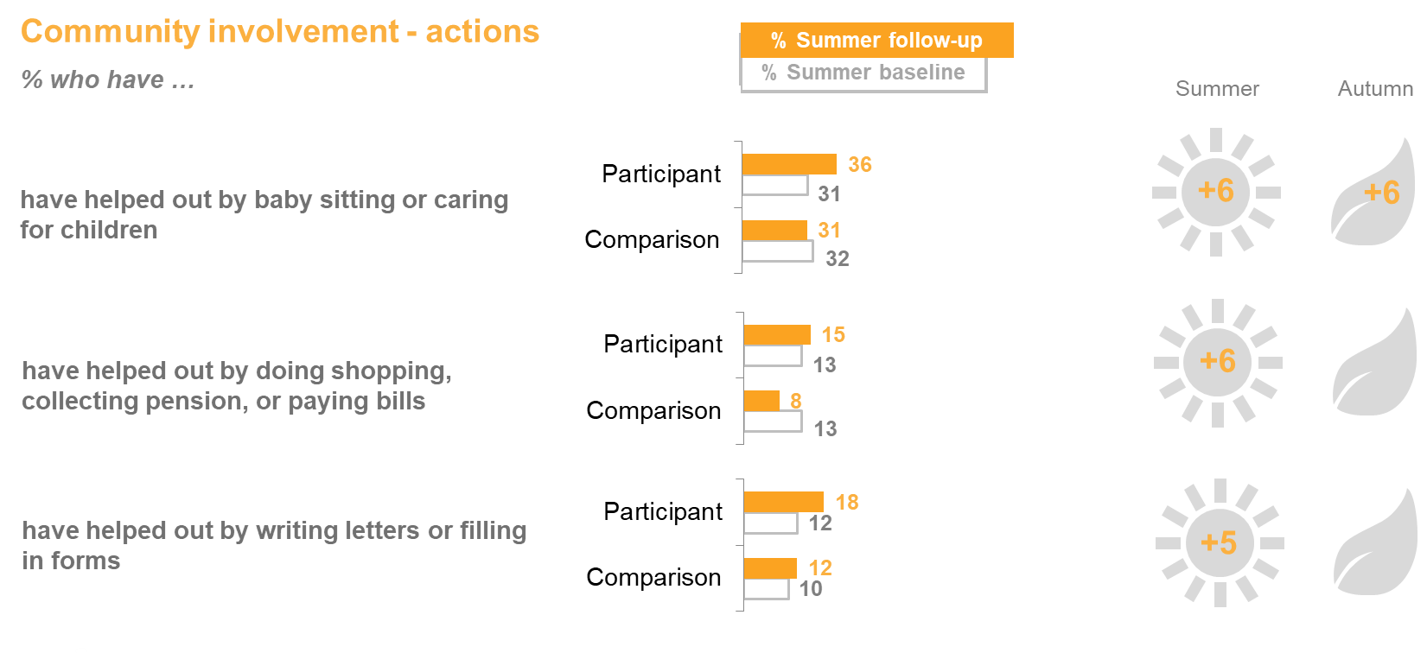
Figure 6.3 Volunteering to help others
Base: Summer participants (1,870) Autumn participants (1,202) Summer comparison group (864) Autumn comparison group (1,125)
Participants: Have you helped out anyone not in your family in any of these ways since your autumn / summer NCS? Do not include anything you were paid to do or anything you have done as part of NCS
Comparison: Have you helped out anyone not in your family in any of these ways since the end of autumn half term / the summer holidays this year?

However, both programmes had an impact on whether participants said they had helped in a way other than listed in the questionnaire (+19 for NCS summer, +23 for NCS autumn).
Young people were also asked how many hours they had spent in formal (community activities) and informal (to help others) volunteering, outside of activities undertaken during the NCS programme. Both NCS summer and NCS autumn had a positive impact on the number of volunteering hours (+6 additional hours for NCS summer and +7 additional hours for NCS autumn).
National Citizen Service

Value-for-money

- Value-for-money
Introduction
The final part of the evaluation is to gain some understanding of the extent to which NCS represents good value-for-money. London Economics, working with Kantar Public, conducted a value-for-money assessment and generated estimates of the benefit-cost ratios associated with the 2017 NCS summer and autumn programmes.
The value-for-money analysis in this section has been conducted in line with the principles of the HM Treasury Green Book, and seeks to monetise (as far as possible) the resource costs and benefits associated with the programme.
It is important to note that for this report, full costs were included in the analysis, in line with the 2016 NCS evaluation. However, as in previous evaluations, it has not been possible to assess and monetise all of the possible benefits of the programme. In fully accounting for all the costs of the programme while only accounting for some of its potential benefits, this value-for-money assessment is likely to undervalue the full benefit of the NCS programme.
The methodology for assessing the value-for-money of the 2017 NCS programme closely follows the methodology adopted for the 2016 NCS evaluation. As such, we do not repeat the full methodological approach here.
Approaches used to monetise benefits of NCS participation
The first approach (Approach 1) used in the value-for-money assessments of both the 2016 and 2017 NCS programmes focuses primarily on calculating the monetary value of increased lifetime earnings among NCS participants due to enhanced leadership skills as well as the monetary value of additional hours spent volunteering by NCS participants.
A complementary but separate approach (Approach 2) estimates the monetary value associated with the impact of NCS on wellbeing (based on self-reported life satisfaction scores). This is based on a separate approach which has previously been used to monetise the economic value associated with the 2015 NCS programmes.
Both Approach 1 and 2 are used to assess value-for-money associated with the 2017 NCS programmes. However, the results from these two approaches should not be combined because enhanced leadership skills and time spent volunteering could both conceivably drive increases in self-reported wellbeing. As such, summing the benefits of NCS from the two approaches is highly likely to lead to double counting. This report presents separately the benefit-cost ratios achieved using each approach.
Under each approach, a number of different scenarios were modelled to generate the monetised benefit. Therefore, in addition to the ‘central’ estimates that reflected the identified impact, ‘high’ and ‘low’ estimates were also generated to illustrate a plausible range of monetised benefits and net Benefit Cost Ratios. The central estimate reflects the most likely estimate of monetised benefits.
Key findings
Volunteering and leadership approach.
Modelling a number of different scenarios to generate a range of estimates for the monetised benefit associated with volunteering and leadership, the analysis demonstrates that:
- Combining the total costs and benefits (Approach 1), the value-for-money analysis suggests that the central estimate of the net Benefit Cost Ratio associated with the 4-week 2017 NCS summer programme was 1.90, while the corresponding estimate for autumn participants was 1.99. In other words, for every £1 spent on the 2017 NCS summer and autumn programmes, we estimated that an economic benefit of £1.90 and £1.99 was generated (respectively).
- We also estimated a range of net Benefit Cost Ratios around these estimates based on alternative assumptions relating to the size and persistence of effects. For the 4-week 2017 NCS summer programme, the net Benefit Cost Ratios ranged from 1.20 in the ‘low impact’ scenario to 2.58 in the ‘high impact’ scenario. The corresponding range of estimates associated with autumn 2017 were 1.27 and 2.67 in the low impact and high impact scenarios respectively.

Wellbeing approach
- Using the wellbeing approach (Approach 2), the analysis demonstrated that the central estimate of the Benefit Cost Ratio associated with the 4-week summer 2017 programme was 3.35, and that for the autumn programme was 2.91.
- The net Benefit Cost Ratio for the 4-week summer programme under this wellbeing approach ranged between 2.25 under the low impact scenario and 4.40 under the high impact scenario. The Benefit Cost ratio for the autumn programme under this wellbeing approach ranged between 1.37 under the low impact scenario and 4.37 under the high impact scenario.

Table 7.1: Value-for-money assessment: summer and autumn 2017 NCS programmes
 | Summer 2017 |  |  |  | Autumn 2017
 | Low scenario | Central scenario | High scenario | Low scenario |  | Central scenario | High scenario
Approach 1 (Leadership and Volunteering approach)
Leadership (£m) | £133.1m | £187.0m | £240.9m | £21.4m |  | £30.0m | £38.7m
Volunteering (£m) | £22.4m | £57.7m | £91.1m | £5.9m |  | £12.6m | £18.5m
Total net benefits (£m) | £155.0m | £244.2m | £331.5m | £27.1m |  | £42.6m | £57.1m
Total costs (£m) | £128.6m |  |  | £21.4m
Net benefit to Total Cost Ratio 2017 | 1.20 | 1.90 | 2.58 | 1.27 |  | 1.99 | 2.67
Delivery costs (£m) | £104.8m |  |  | £16.7m
Net benefit to Delivery Cost Ratio | 1.48 | 2.33 | 3.16 | 1.62 |  | 2.54 | 3.41
Approach 2 (Wellbeing approach)
Net wellbeing (£m) | £289.1m | £430.9m | £566.3m | £29.4m |  | £62.4m | £93.6m
Total costs (£m) | £128.6m |  |  | £21.4m
Net benefit to Total Cost Ratio | 2.25 | 3.35 | 4.40 | 1.37 |  | 2.91 | 4.37

Approach 1: Valuing the impacts on leadership skills and volunteering

Key findings
Table 7.2 outlines the estimates of the monetary value of leadership skills attained during 2017 NCS summer (4-week programme) and autumn programmes. The central scenario analysis suggests that the value of enhanced leadership skills was £187.0 million in summer and £30.0 million in autumn. This equates to approximately £2,650 per participant in summer 2017 and £2,180 per participant in autumn 2017.
Table 7.2 Total value of attained leadership skills
Scenario | Summer 2017 | Autumn 2017
Low scenario (£m) | 133.1 | 21.4
Central scenario (£m) | 187.0 | 30.0
High scenario (£m) | 240.9 | 38.7

Assessing the monetised impact of Leadership skills
A core goal of NCS is to support young people in their transition to adulthood. Developing leadership skills is a key component of this support and is therefore central to the value-for-money assessment. The leadership skills indicator used in this assessment is a composite variable, calculated as an average of the impact across four outcome measures. Each of the outcome measures is based on a question asking participants to rate their confidence at a certain activity (listed below) on a 5-point scale.

How do you feel about the following things, even if you have never done them before...?
- Being the leader of a team
- Working with other people in a team
- Explaining my ideas clearly
- Meeting new people

Questions used to assess leadership skills
- Taking an average of these four outcomes, in summer 2017, we estimate the increase in the proportion of young people who indicated that there was an improvement in leadership skills was 18.2 percentage points between the baseline and a three-month follow up survey, relative to the comparison group.
- In autumn 2017, the corresponding estimate was 15.0 percentage points. One particular paper suggests that leadership skills can improve the present value of lifetime earnings by between 2.1% and 3.8%, holding other factors constant. We apply this to an estimate of the present value of lifetime earnings (£616,200 (in 2017 prices)) to generate the gross value of increased leadership skills .
However, this figure must be deflated to account for the dual impact that enhanced leadership skills can have on both wages and education. An individual who attains leadership skills is likely to earn more because of those skills directly, but also because those skills will typically help him or her gain a higher level of education, which is also associated with higher earnings.
To ensure these two effects are not double-counted, and following the approach adopted in previous evaluations for comparability, a 20% discount rate is applied. This effectively nullifies the additional value of leadership skills generated through education, allowing the direct impact of leadership on lifetime earnings to be represented in the value-for-money assessment.

Table 7.3: Summary of value-for-money assessment for leadership skills (Approach 1)
Factors | Description | Values
A | Proportion of programme participants who gained leadership skills | 18.2 percentage points for summer, 15.0 percentage points for autumn
B | Lower/central/upper bound effect | Lower bound: 2.1%  Central estimate: 2.95%  Upper bound: 3.8%
C | Present value of lifetime earnings | £616,200
D | Number of programme participants | 70,654 (4-week Summer programme)  13,762 (Autumn programme)
E | Discount to avoid double counting | Reduction of 20%
A*B*C*D*E | Total value of leadership | Product of all the above
Note: A sensitivity analysis presented in a later section explores the impact of disaggregating the present value of lifetime earnings by gender.
Total value of attained leadership skills
The following table outlines the estimates of monetary value of leadership skills attained during 2017 NCS summer and autumn programmes. The central scenario analysis suggests that the value of enhanced leadership skills in summer 2017 was £187.0 million and £30.0 million in autumn 2017. This estimated benefit equates to approximately £2,650 per participant in summer 2017 and £2,180 per participant in autumn 2017
Table 7.4 Total value of attained leadership skills
Scenario | Summer 2017 | Autumn 2017
Low scenario (£m) | 133.1 | 21.4
Central scenario (£m) | 187.0 | 30.0
High scenario (£m) | 240.9 | 38.7

Volunteering
Key findings
Table 7.7 outlines the estimates of the monetary value of enhanced volunteering activity resulting from 2017 NCS summer and autumn programmes. The central scenario analysis suggests that the value of additional volunteering was £57.7 million in summer and £12.6 million in autumn. This estimated benefit equates to approximately £820 per participant in summer 2017 and £920 per participant in autumn 2017.
Assessing the monetised impact of Volunteering
Similar to leadership, volunteering is a core theme of National Citizen Service. Phase 3 of the programme consists of a social action project in which participants contribute 30 hours of volunteer work in their local communities. However, volunteering may not end after the programme ends, and indeed the aspiration is for young people to continue volunteering post-programme. A follow-up survey conducted three months after NCS graduation showed that after both summer and autumn programmes, participants continued to volunteer at a higher rate than non-participants.
Further, a two-year follow up evaluation of NCS 2013 found that the impact of the programme lasted well beyond its lifetime, with significantly higher rates of volunteering observed up to 28 months after NCS programme graduation. Calculations of the monetary value of additional volunteering hours in this evaluation are based on these findings.
In describing these calculations, we distinguish between the volunteering hours supplied as part of the NCS programme and those that occurred following graduation from the programme.
Within programme benefits
To calculate the value of the 30 hours of volunteering work undertaken as part of the NCS programme, the average baseline number of hours that participants volunteered prior to the programme was subtracted from the 30 required hours, resulting in the number of additional hours supplied as part of the NCS programme. This was then multiplied by the median hourly wage rate earned by 16-17 year-olds (as reported in the Annual Survey of Hours and Earnings (ASHE) administered in April 2017), and the number of programme participants.
Table 7.5: Summary of value-for-money assessment for volunteering hours supplied within the programme (Approach 1)
Factors | Description | Summer 2017 | Autumn 2017
A | Number of participants | 70,654 | 13,762
B | Additional volunteering hours supplied (30 hours minus baseline hours) | 18.1 | 19.1
C | Median hourly wage rate for 16-17 year olds | £5.60
A*B*C | Total | Product of all the above
After programme benefits
The 3-month follow-up survey is used to estimate the impact on volunteering following completion of NCS. The analysis considers three different scenarios to produce a range of value-for-money estimates (‘lower’, ‘central’ and ‘higher’). The scenarios are differentiated by two features:
- the assumptions governing the number of additional volunteering hours being supplied 3 months following NCS (with the upper and lower bounds based on a 95% confidence interval around the central estimate), and
- the length of time that impacts are assumed to last beyond this point.
The following table (7.6) shows the factors underpinning the calculation of the estimated monetary value of additional volunteering hours in the 3 months following NCS and in the time up to 28 months following NCS. Further explanation of each factor follows the table. Tables showing full calculations are presented in the Appendix.
Table 7.6: Summary of value-for-money assessment for volunteering hours supplied following the programme (Approach 1)
Factors | Description | Summer 2017 | Autumn 2017
A | Number of participants | 70,654 | 13,762
B | Additional volunteering hours supplied (3 month follow up survey) | Lower bound: 2.5 per month  Central estimate: 5.9 per month  Upper bound: 9.3 per month | Lower bound: 3.7 per month  Central estimate: 6.7 per month  Upper bound: 9.7 per month
C | (Linear) Rate of decline in hours volunteered | Additional hours supplied assumed to fall to zero at a constant rate after the first year.
D | Wage rate | £5.60 per hour in first 12 months, £6.55 in months 13 to 25, £7.50 in subsequent months.
E | Discount factor | Following HM Treasury Green book guidelines (using a discount rate of 3.5%): 0.9662 after 1 year and 0.9335 after 2 years.
A*B*C*D*E | Total | Product of all the above

A: Number of participants: There were 70,654 participants in the 2017 summer NCS programme (4-week programme only) and 13,762 participants of the autumn programme (accounting for both Standard and College models).
B: Additional hours of volunteering: According to the 3-month follow-up survey for summer NCS participants, the average additional amount of volunteering hours supplied by participants, relative to the comparison group, was 5.9 hours per month. The 95% confidence interval around this estimate gives the lower and upper bounds of 2.5 and 9.3 hours per week, used in the ‘low’ and ‘high’ scenarios respectively. For the autumn programme, the central estimate was 6.7 hours per month with a lower and upper bound of 3.7 and 9.7 hours, used in the ‘low’ and ‘high’ scenarios respectively.
C: Rate of decline in hours volunteered: In the first 15 months post completion, the level of volunteering activity remains constant. This is based on the assumption that the number of hours reported in the 3-month follow up survey remains constant over the subsequent 12 months.
However, evidence from the previous two-year follow-up evaluation suggests that, by the third year of the post-completion period, even the most optimistic scenario sees additional volunteering hours falling to zero. Taking these findings into account, the three scenarios in this analysis assume different rates of decline beyond the 15-month point:
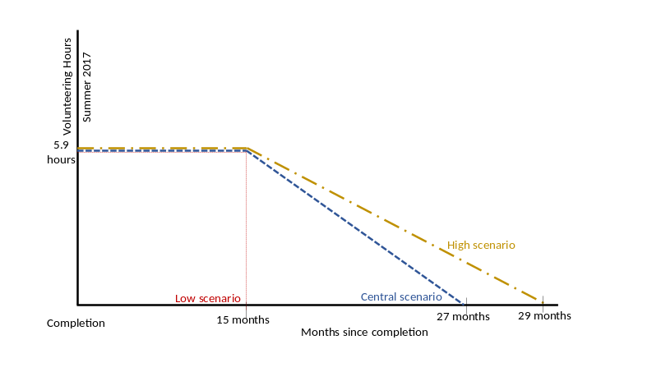
- In the ‘low’ scenario, the effects are assumed to end at this point.
- In the ‘central’ scenario, the effects are assumed to diminish at a constant rate (i.e. linearly), starting from month 16 of the post completion period, and falling to zero by the 27th month.
- In the ‘high’ scenario, the number of additional hours supplied also begins to decline in month 16; however, it is assumed that the rate of linear decline is slower - falling to zero only in the 29th month of the post-programme period.

D: Wage rate: In order to monetise the value of volunteering associated with the programme, each hour must be translated into a monetary value. This is calculated by considering the opportunity cost of the individual’s volunteer work (i.e. the wage the young person would have otherwise earned in employment). The research team consider the median wage rate for a young person’s age category to be the most accurate measure of this opportunity cost. The median pay reported in ASHE (undertaken in April 2017) was £5.60 for 16-17 year-olds and £7.50 for 18-20 yearolds.
The value of additional volunteering hours beyond the 3-month period is calculated as follows:
- Over the first year after graduation, the impact calculations used the median wage rate for 16-17 yearolds of £5.60 per hour.
- The calculations for the impact during months 25-28 used the median wage rate for 18-20 year-olds of £7.50 per hour (only applicable to the ‘high’ scenario).
- To take account of some participants turning 18 in the second and third years following graduation from the NCS, an average of the two rates (£6.55 per hour) was applied to additional volunteering hours between month 13 and month 25 (applicable to the ‘central’ and ‘high’ scenarios).
E: Discount factor: Economic analysis of streams of future benefits or costs requires discounting in order to make them comparable to benefits and costs accruing in the present. Following recommendations in HM Treasury’s Green Book, the benefits in the first 12 months are not discounted. Thereafter, the social rate of time preference of 3.5% gives a discount factor of 0.9662 from month 12 to month 23 and 0.9335 from month 24 onward.
Findings
Table 7.7 outlines the estimates of the monetary value of enhanced volunteering activity resulting from the 2017 NCS summer (4-week) and autumn programmes. The central scenario analysis suggests that the value of enhanced volunteering was £57.7 million in summer (4-week programme) and £12.6 million in autumn. This estimated benefit equates to approximately £820 per participant in summer 2017 (4-week programme) and £920 per participant in autumn 2017.
Table 7.7 Total value of additional volunteering hours
Scenario | Summer 2017 |  |  | Autumn 2017
 | Within programme | Post-graduation | Total | Within programme | Post-graduation | Total
Low scenario (£m) | £7.2m | £15.2m | £22.4m | £1.5m | £4.4m | £5.9m
Central scenario (£m) | £7.2m | £50.5m | £57.7m | £1.5m | £11.2m | £12.6m
High scenario (£m) | £7.2m | £84.0m | £91.1m | £1.5m | £17.1m | £18.5m

Total monetary impact (Approach 1)
Combining the monetary estimates of the impact of the NCS on volunteering and leadership outcomes, the analysis indicates that the total economic impact (associated with the ‘central’ estimates) was £244.2 million (summer 2017 4-week programme) and £42.6 million (autumn 2017 programme). This estimated benefit equates to approximately £3,460 per participant in summer 2017 (4-week programme) and £3,100 per participant in autumn 2017.
Table 7.8: Value-for-money assessment: Summer and Autumn 2017 NCS programmes (Approach 1)
 | Summer 2017 |  |  |  | Autumn 2017
 | Low scenario | Central scenario | High scenario | Low scenario |  | Central scenario | High scenario
Leadership (£m) | £133.1m | £187.0m | £240.9m | £21.4m |  | £30.0m | £38.7m
Volunteering (£m) | £22.4m | £57.7m | £91.1m | £5.9m |  | £12.6m | £18.5m
Total net benefits (£m) | £155.0m | £244.2m | £331.5m | £27.1m |  | £42.6m | £57.1m

Value-for-money assessment: Approach 1
From information provided by the NCS Trust, the total delivery cost associated with providing the National Citizen Service programme to the 2017 cohort of participants was £104.8 million in summer 2017 (4-week) and £16.7 million in autumn 2017.
In addition to these delivery costs, NCS Trust also provided information on the central costs associated with the operation and facilitation of the programme. However, there is a mismatch between the financial year in which these costs are accounted for against the calendar year in which the bulk of programme activity took place. Therefore, these costs from an accounting perspective have been re-allocated to align with the timing of NCS participant activity. The costs associated with the operation of the NCS Trust associated with programme participants were estimated to be £33.3 million in 2017. Note that this estimate relates to all programme participants – including those undertaking the spring programme and the 3-week summer programme. Given the spring programme participants and summer 3-week participants are not the focus of the evaluation, the central costs and overheads associated with these individuals were removed from the overall estimate of costs.
Therefore, in addition to the £104.8 million in delivery costs associated with the 4-week summer 2017 programme, an additional £23.9 million in NCS Trust central and overheads costs were incurred (bringing the total cost of delivery to £128.6 million). Similarly, in addition to the £16.7 million in delivery costs associated, an additional £4.6 million in NCS Trust central and overheads costs were incurred (bringing the total cost of delivery to £21.4 million).
Table 7.9 Cost information
Factors | Description | Summer 2017 | Autumn 2017
A | Number of participants | 70,654 | 13,762
B | Delivery Costs | £104.8m | £16.7m
C | NCST Central cost and overheads | £23.9m | £4.6m
D | Total costs | £128.6m | £21.4m

Given this information, the 2017 NCS programme costs used are as follows:
- Summer 2017: £128.6 million in total costs associated with 70,654 participants, equating to:
- a total cost of £1,821 on average per participant
- a delivery cost of £1,483 on average per participant
- Autumn 2017: £21.4 million in total costs associated with 13,762 participants equating to:
- a total cost of £1,555 on average per participant
- a delivery cost of £1,217 on average per participant
Given this information on costs, the following Table (7.10) presents the net Benefit Cost Ratios associated with the summer (4-week programme) and autumn 2017 NCS programmes.

Table 7.10: Value-for-money assessment: Summer and Autumn 2017 NCS programmes (Approach 1)
 | Summer 2017 |  |  | Autumn 2017
 | Low scenario | Central scenario | High scenario | Low scenario | Central scenario | High scenario
Leadership (£m) | £133.1m | £187.0m | £240.9m | £21.4m | £30.0m | £38.7m
Volunteering (£m) | £22.4m | £57.7m | £91.1m | £5.9m | £12.6m | £18.5m
Total net benefits (£m) | £155.0m | £244.2m | £331.5m | £27.1m | £42.6m | £57.1m
Total costs (£m) | £128.6m |  |  | £21.4m
Net benefit total Cost Ratio | 1.20 | 1.90 | 2.58 | 1.27 | 1.99 | 2.67
Delivery costs (£m) | £104.8m |  |  | £16.7m
Net benefit Delivery Cost Ratio | 1.48 | 2.33 | 3.16 | 1.62 | 2.54 | 3.41

As shown in the table above, the volunteering and leadership benefits associated with the 2017 NCS summer (4-week programme) and autumn programmes exceed the costs of the programme, with the central estimates of the net Benefit Cost Ratio standing at 1.90 and 1.99 for 4-week summer programme and autumn programme, respectively. In other words, for every £1 spent on implementing the 2017 summer NCS, in terms of its impact on leadership skills and volunteering alone, a return of £1.90 was achieved.
Even in the ‘low’ persistence scenarios, which make conservative assumptions about the value of leadership skills on lifetime earnings and the degree and persistence of the impact in terms of additional volunteering hours, the NCS programmes still represent a positive return on investment (1.20 (summer) and 1.27 (autumn) net Benefit Cost Ratios).
Assessing the identified benefits to delivery costs only (i.e. excluding overheads and the central costs incurred), the central estimates indicate that the net Benefit Delivery Cost Ratio associated with the summer 2017 (4-week) programme was 2.33, with the corresponding estimate for autumn 2017 participants was 2.54.
Approach 2: Valuing the impact of wellbeing
Key findings
Using the wellbeing approach to monetise the economic benefits associated with NCS participation (as well as the same total costs as adopted under Approach 1), the central estimate indicates that the economic benefits associated with summer 2017 (4-week) NCS participation were £430.9 million, which corresponds to a net Benefit Cost Ratio of 3.35. The estimated benefit associated with the autumn 2017 NCS was £62.3 million, resulting in a Benefit Cost Ratio of 2.91.
Table 7.11: Value-for-money assessment: 2017 NCS programme (Approach 2)
 | Summer 2017 |  |  | Autumn 2017
 | Low scenario | Central scenario | High scenario | Low scenario | Central scenario | High scenario
Total wellbeing (£m)  Approach 2 | £289.1m | £430.9m | £566.3m | £29.3m | £62.3m | £93.5m
Costs (£m) | £128.6m |  |  | £21.4m
Net benefit Total Cost Ratio (Approach 2) | 2.25 | 3.35 | 4.40 | 1.37 | 2.91 | 4.37
Net benefit Total Cost Ratio (Approach 1) | 1.20 | 1.90 | 2.58 | 1.27 | 1.99 | 2.67
Assessing economic benefits using the wellbeing approach
With the wider adoption of using subjective wellbeing as a means of assessing the economic and social impact of policies and programmes (HM Treasury Green Book (2018)), a 2016 report by Jump outlines an approach for monetising the impact of 2016 NCS on wellbeing based on self-reported life satisfaction scores. This approach is distinct from Approach 1 described above, and the two sets of results should not be combined, as this would lead to benefits being double-counted. This approach evaluates the entire wellbeing impact, which includes the benefits already estimated above. For instance, impacts in terms of enhanced leadership skills and time spent volunteering are considered potential “constituent drivers” of life satisfaction monetised in the analysis.
A number of wellbeing measures are tracked within the survey of NCS participants, but the Jump report identified life satisfaction as the most robust and broad measure of wellbeing. By using respondents’ information on self-reported life satisfaction, the value-for-money analysis estimates the wellbeing effect associated with NCS participation.
The following monetisation is based on the estimate of the measured (difference in difference) impact on mean life satisfaction between the 2017 (4-week) summer NCS participant group and the control group using the response to Question 13 of the survey. Based on the confidence intervals around this central estimate, we replicated the analysis for ‘low’ and ‘high’ scenarios.
Description of Calculation
The following equation is used to calculate the value of a change in wellbeing for the 2017 summer NCS programme:
$$CS=M^{0} -e^{\left[\ln\left(M^{0}\right) - \frac{β_{NCS}}{α_{1}}\right]}$$
Table 7.12: Description of the elements of the wellbeing analysis
Element | Description | Summer 2017 | Autumn 2017
$$M^{0}$$ | Median household income (British Household Panel Survey) | £26,394 | £26,394
β_{NCS} | NCS impact on life satisfaction: lower bound estimate | 0.34 | 0.17
β_{NCS} | NCS impact on life satisfaction: central estimate | 0.53 | 0.38
β_{NCS} | NCS impact on life satisfaction: upper bound estimate | 0.73 | 0.6k
α₁ | The causal effect of a log-point change in household income on life satisfaction for a representative individual.  This is calculated using lottery wins as an ‘instrumental variable’ for an increase in income. | 2.015 | 2.015
CS | Compensating Surplus per participant: lower bound estimate | £4,099 | £2,136
CS | Compensating Surplus per participant: central estimate | £6,105 | £4,537
CS | Compensating Surplus per participant: upper bound estimate | £8,023 | £6,798
Using Approach 2 (but with the same costs as in Approach 1), the following table presents Benefit Cost Ratios associated with the summer (4-week) and autumn 2017 NCS programmes. Tables showing full calculations are presented in the Appendix.
By assessing wellbeing directly, all effects the programme had on individuals (both positive and negative) are essentially pooled together. This means that, in addition to volunteering and leadership skills, many more positive impacts associated with the NCS programme have been included. As such. it should not be surprising therefore that these estimates are larger than those found using Approach 1.
Table 7.13: Value-for-money assessment: 2017 NCS programme (Approach 2)
 | Summer 2017 |  |  | Autumn 2017
 | Low scenario | Central scenario | Low scenario | Low scenario | Central scenario | Low scenario
Total net wellbeing (£m) Approach 2 | £289.1m | £430.9m | £566.3m | £29.3m | £62.3m | £93.5m
Costs (£m) | £128.6m |  |  | £21.4m
Net benefit Total Cost Ratio (Approach 2) | 2.25 | 3.35 | 4.40 | 1.37 | 2.91 | 4.37
Net benefit Total Cost Ratio (Approach 1) | 1.20 | 1.90 | 2.58 | 1.27 | 1.99 | 2.67

- Appendices

Appendix 1 Full impact results 2017
Below are the full results for the summer and autumn 2017 evaluations. Only results denoted with * are statistically significant.

- Social mobility – Self-confidence: leadership and communication
Outcome: Self-confidence - leadership and communication | Summer Participant |  | Summer Comparison |  | Impact Summer | Autumn Participant |  | Autumn Comparison |  | Impact Autumn
Outcome: Self-confidence - leadership and communication | Baseline | Follow-up | Baseline | Follow-up | Impact Summer | Baseline | Follow-up | Baseline | Follow-up | Impact Autumn
% who feel confident in being the leader of a team | 43% | 66% | 51% | 54% | +19pp* | 42% | 60% | 47% | 46% | +20pp*
% who feel confident in explaining ideas clearly | 51% | 72% | 59% | 61% | +19pp* | 52% | 68% | 53% | 55% | +14pp*
% who feel confident in meeting new people | 49% | 77% | 52% | 57% | +23pp* | 60% | 71% | 59% | 55% | +15pp*
% who feel confident in working with other people in a team | 70% | 86% | 71% | 75% | +12pp* | 75% | 82% | 73% | 69% | +11pp*
% who feel confident speaking in public | 35% | 52% | 34% | 38% | +13pp* | 35% | 48% | 30% | 27% | +17pp*
% who feel confident having a go at things that are new to them | 67% | 84% | 62% | 66% | +13pp* | 71% | 78% | 69% | 64% | +13pp*
% who feel confident managing disagreements and conflict | 53% | 70% | 57% | 58% | +16pp* | 49% | 67% | 52% | 54% | +16pp*

- Social mobility: Problem solving and decision-making skills
Outcome: Problem solving and decision-making skills | Summer Participant |  | Summer Comparison |  | Impact Summer | Autumn Participant |  | Autumn Comparison |  | Impact Autumn
Outcome: Problem solving and decision-making skills | Baseline | Follow-up | Baseline | Follow-up | Impact Summer | Baseline | Follow-up | Baseline | Follow-up | Impact Autumn
% who agree that they enjoy finding new ways to do things | 79% | 86% | 75% | 78% | +5pp | 83% | 85% | 80% | 81% | +2pp
% who agree that when solving a problem, they try to think of as many solutions as possible | 66% | 78% | 70% | 72% | +10pp* | 71% | 77% | 71% | 72% | +5pp
% who agree that they think about both long term and short-term consequences when they work through problems | 71% | 83% | 75% | 77% | +10pp* | 71% | 81% | 76% | 76% | +10pp*
% who agree that they usually make good decisions, even in difficult situations | 61% | 74% | 67% | 72% | +9pp* | 58% | 73% | 61% | 67% | +9pp*

- Social mobility – team work and social network building
Outcome: team work and social network building | Summer Participant |  | Summer Comparison |  | Impact Summer | Autumn Participant |  | Autumn Comparison |  |  | Impact Autumn
Outcome: team work and social network building | Baseline | Follow-up | Baseline | Follow-up | Impact Summer | Baseline | Follow-up |  | Baseline | Follow-up | Impact Autumn
% who agree that they are able to see things from the other person’s point of view | 76% | 87% | 78% | 82% | +6pp* | 78% | 84% |  | 79% | 81% | +5pp
% who agree that they can usually tell when someone says one thing but means another | 67% | 80% | 72% | 77% | +8pp* | 70% | 78% |  | 75% | 72% | +11pp*
% who agree that they notice quickly if someone in a group is feeling awkward | 81% | 89% | 84% | 87% | +5pp* | 81% | 87% |  | 83% | 85% | +3pp
% who agree that they get along with people easily | 70% | 83% | 73% | 79% | +8pp* | 75% | 81% |  | 77% | 76% | 7pp*
% who agree that if they needed help there are people who would be there for them | 75% | 84% | 77% | 76% | +10pp* | 80% | 81% |  | 80% | 79% | +3pp
% who agree that it is hard to say no to friends* | 37% | 41% | 34% | 39% | -1pp | 43% | `40% |  | 43% | 39% | +1pp
*note that on this outcome the desired impact is negative (i.e. a reduction in the proportion agreeing that it is hard to say no to friends)
- Social mobility – Positivity about the future
Outcome: Positivity about the future | Summer Participant |  | Summer Comparison |  | Impact Summer | Autumn Participant |  | Autumn Comparison |  | Impact Autumn
Outcome: Positivity about the future | Baseline | Follow-up | Baseline | Follow-up | Impact Summer | Baseline | Follow-up | Baseline | Follow-up | Impact Autumn
% who agree that they feel positive about their chances of getting a job in the future | 75% | 80% | 70% | 69% | +7pp* | 77% | 76% | 74% | 69% | +4pp
% who agree that they are confident they have the skills and experience to get a job in the future | 75% | 83% | 72% | 73% | +6pp* | 76% | 81% | 76% | 73% | +8pp*
% who agree that they are optimistic about the future | 66% | 77% | 65% | 66% | +10pp* | 74% | 74% | 74% | 70% | +5pp

- Social mobility – Resilience and emotional regulation
Outcome: Resilience and emotional regulation | Summer Participant |  | Summer Comparison |  | Impact Summer | Autumn Participant |  | Autumn Comparison |  | Impact Autumn
Outcome: Resilience and emotional regulation | Baseline | Follow-up | Baseline | Follow-up | Impact Summer | Baseline | Follow-up | Baseline | Follow-up | Impact Autumn
% who agree that they can usually handle whatever comes their way | 64% | 75% | 66% | 67% | +10pp* | 66% | 71% | 69% | 66% | +9pp*
% who agree that when things go wrong they usually get over it quickly | 46% | 55% | 43% | 46% | +6pp | 52% | 54% | 50% | 51% | +1pp
% who agree that when they are faced with a stressful situation they are able to stay calm | 46% | 58% | 52% | 51% | +14pp* | 51% | 59% | 52% | 57% | +3pp
% who agree that they are able to stay in control when they’re angry | 55% | 64% | 58% | 61% | +6pp* | 60% | 65% | 61% | 63% | +3pp
% who agree that setbacks don’t normally discourage them | 47% | 57% | 43% | 46% | +6pp* | 50% | 54% | 49% | 50% | +4pp

- Social Cohesion - Social mixing
Outcome: Social mixing | Summer Participant |  | Summer Comparison |  | Impact Summer | Autumn Participant |  | Autumn Comparison |  | Impact Autumn
Outcome: Social mixing | Baseline | Follow-up | Baseline | Follow-up | Impact Summer | Baseline | Follow-up | Baseline | Follow-up | Impact Autumn
% who say that most people can be trusted | 18% | 20% | 14% | 17% | -1pp | 18% | 18% | 17% | 18% | -1pp
% who agree that their local area is a place where people from different backgrounds get on well together | 58% | 67% | 59% | 64% | +3pp | 57% | 64% | 57% | 58% | +6pp

- Social Cohesion - Attitudes towards protected characteristics – top box scores
Outcome: Attitudes towards protected characteristics | Summer Participant |  | Summer Comparison |  | Impact Summer | Autumn Participant |  | Autumn Comparison |  | Impact Autumn
Outcome: Attitudes towards protected characteristics | Baseline | Follow-up | Baseline | Follow-up | Impact Summer | Baseline | Follow-up | Baseline | Follow-up | Impact Autumn
% who feel comfortable with friend/relative going out with someone from a different school or college | 56% | 58% | 47% | 56% | -7pp* | 47% | 55% | 41% | 52% | -2pp
% who feel comfortable with friend/relative going out with someone from a different race or ethnicity | 65% | 67% | 65% | 63% | +4pp | 58% | 64% | 59% | 58% | +7pp*
% who feel comfortable with friend/relative going out with someone from a different religious background | 60% | 59% | 56% | 53% | +2pp | 51% | 54% | 47% | 47% | +3pp
% who feel comfortable with friend/relative going out with someone from a richer or poorer background | 62% | 64% | 60% | 59% | +3pp | 56% | 63% | 54% | 53% | +8pp*
% who feel comfortable with friend/relative going out with someone who is gay or lesbian | 64% | 66% | 62% | 60% | +4pp | 53% | 58% | 51% | 53% | +3pp
% who feel comfortable with friend/relative going out with someone is disabled | 63% | 61% | 57% | 58% | -4pp | 55% | 60% | 50% | 52% | +4pp

- Social Cohesion - Attitudes towards protected characteristics – mean scores
Outcome: Attitudes towards protected characteristics | Summer Participant |  | Summer Comparison |  | Impact Summer | Autumn Participant |  | Autumn Comparison |  | Impact Autumn
Outcome: Attitudes towards protected characteristics | Baseline | Follow-up | Baseline | Follow-up | Impact Summer | Baseline | Follow-up | Baseline | Follow-up | Impact Autumn
Feel comfortable with friend/relative going out with someone from a different school or college | 8.63 | 8.83 | 8.50 | 8.69 | 0.02 | 8.26 | 8.73 | 8.20 | 8.45 | 0.22
Feel comfortable with friend/relative going out with someone from a different race or ethnicity | 9.03 | 9.18 | 9.07 | 8.99 | 0.23* | 8.73 | 8.97 | 8.68 | 8.66 | 0.26*
Feel comfortable with friend/relative going out with someone from a different religious background | 8.74 | 8.86 | 8.71 | 8.62 | 0.20 | 8.40 | 8.53 | 8.15 | 8.18 | 0.09
Feel comfortable with friend/relative going out with someone from a richer or poorer background | 8.91 | 9.14 | 9.02 | 8.97 | 0.27* | 8.67 | 8.99 | 8.73 | 8.61 | 0.45*
Feel comfortable with friend/relative going out with someone who is gay or lesbian | 8.80 | 8.92 | 8.68 | 8.72 | 0.09 | 8.18 | 8.32 | 8.01 | 8.10 | 0.04
Feel comfortable with friend/relative going out with someone is disabled | 8.99 | 9.04 | 8.94 | 8.83 | 0.16 | 8.55 | 8.80 | 8.53 | 8.55 | 0.23
- Social Cohesion - Race/Ethnicity
Outcome: Race/Ethnicity | Summer Participant |  | Summer Comparison |  | Impact Summer | Autumn Participant |  | Autumn Comparison |  | Impact Autumn
Outcome: Race/Ethnicity | Baseline | Follow-up | Baseline | Follow-up | Impact Summer | Baseline | Follow-up | Baseline | Follow-up | Impact Autumn
% who often have positive experiences with people from a different race or ethnicity | 76% | 77% | 73% | 73% | +1pp | 74% | 72% | 75% | 64% | +9pp*
% who rarely or never have negative or bad experiences with people from a different race or ethnicity | 65% | 66% | 60% | 64% | -3pp | 63% | 60% | 66% | 60% | +4pp
% who often have positive or good experiences with people from the same race or ethnicity | 76% | 76% | 76% | 72% | +4pp | 75% | 70% | 75% | 68% | +2pp
% who rarely or never have negative or bad experiences with people from the same race or ethnicity | 50% | 53% | 45% | 42% | +5pp | 50% | 50% | 50% | 48% | +1pp

- Social Cohesion – Wellbeing – top box scores
Outcome: Wellbeing | Summer Participant |  | Summer Comparison |  | Impact Summer | Autumn Participant |  | Autumn Comparison |  | Impact Autumn
Outcome: Wellbeing | Baseline | Follow-up | Baseline | Follow-up | Impact Summer | Baseline | Follow-up | Baseline | Follow-up | Impact Autumn
% who feel that things they do in their life are completely worthwhile | 9% | 15% | 10% | 11% | +5pp* | 10% | 19% | 12% | 8% | +13pp*
% who did not feel at all anxious yesterday | 16% | 20% | 16% | 18% | +2pp | 17% | 23% | 19% | 18% | +7pp*
% who feel completely satisfied with life nowadays | 7% | 10% | 8% | 6% | +5pp* | 9% | 16% | 5% | 4% | +8pp*
% who felt completely happy yesterday | 13% | 15% | 15% | 12% | +6pp* | 16% | 20% | 13% | 12% | +5pp*

- Social Cohesion – Wellbeing – mean scores
Outcome: Wellbeing | Summer Participant |  | Summer Comparison |  | Impact Summer | Autumn Participant |  | Autumn Comparison |  | Impact Autumn
Outcome: Wellbeing | Baseline | Follow-up | Baseline | Follow-up | Impact Summer | Baseline | Follow-up | Baseline | Follow-up | Impact Autumn
Feel that things they do in their life are completely worthwhile | 6.66 | 7.28 | 6.57 | 6.64 | 0.54* | 7.08 | 7.34 | 7.00 | 6.74 | 0.51*
Did not feel at all anxious yesterday | 4.18 | 3.59 | 3.98 | 4.06 | -0.68* | 3.93 | 3.78 | 3.86 | 4.00 | -0.29
Feel completely satisfied with life nowadays | 6.76 | 7.20 | 6.66 | 6.57 | 0.53* | 6.97 | 7.18 | 6.76 | 6.59 | 0.38*
Felt completely happy yesterday | 6.85 | 7.02 | 6.73 | 6.62 | 0.28 | 6.99 | 6.98 | 6.79 | 6.64 | 0.14

- Social Responsibility – Community Involvement - Attitudes
Outcome: Community Involvement - Attitudes | Summer Participant |  | Summer Comparison |  | Impact Summer | Autumn Participant |  | Autumn Comparison |  | Impact Autumn
Outcome: Community Involvement - Attitudes | Baseline | Follow-up | Baseline | Follow-up | Impact Summer | Baseline | Follow-up | Baseline | Follow-up | Impact Autumn
% who agree that they would know how to deal with a problem in their local areas if they wanted to | 47% | 64% | 44% | 47% | +14pp* | 47% | 63% | 47% | 46% | +18pp*
% agree that they feel able to have an impact on the world around them | 57% | 72% | 55% | 54% | +15pp* | 62% | 71% | 59% | 57% | +11pp*
% who agree that they feel a sense of responsibility towards their local community | 53% | 68% | 55% | 54% | +15pp* | 55% | 66% | 52% | 51% | +13pp*
% that say they are absolutely certain (10/10 on 1 – 10 scale) to vote at the next general election or referendum | 49% | 58% | 58% | 58% | +9pp* | 44% | 54% | 49% | 48% | +11pp*
Mean score likelihood to vote at the next general election or referendum | 8.31 | 8.69 | 8.59 | 8.58 | 0.39* | 7.98 | 8.47 | 8.31 | 8.13 | 0.67*

- Social Responsibility – Community Involvement - Actions
Outcome: Community Involvement - Actions | Summer Participant |  | Summer Comparison |  | Impact Summer | Autumn Participant |  | Autumn Comparison |  | Impact Autumn
Outcome: Community Involvement - Actions | Baseline | Follow-up | Baseline | Follow-up | Impact Summer | Baseline | Follow-up | Baseline | Follow-up | Impact Autumn
% who agree that they often help out their family and around the home | 86% | 87% | 88% | 88% | +2pp | 89% | 87% | 88% | 83% | +3pp
% who have taken part in any youth group or activities in the last three months | 57% | 61% | 56% | 50% | +9pp* | 53% | 59% | 57% | 50% | +13pp*
% who have helped out at a local club, organisation or place of worship outside of school or college hours in the last three months | 37% | 38% | 37% | 33% | +5pp* | 30% | 30% | 35% | 28% | +6pp*
% who helped out at other organisations outside of school or college hours in the last three months | 17% | 21% | 17% | 14% | +7pp* | 15% | 19% | 17% | 14% | +6pp*
% who have raised money for charity (including taking part in a sponsored event) outside of school or college in the last three months | 27% | 31% | 25% | 28% | +1pp | 24% | 24% | 26% | 17% | +9pp*
% who have contacted someone (e.g. council, media, school) about something affecting their local area outside of school or college hours in the last three months | 8% | 11% | 5% | 7% | +1pp | 6% | 7% | 5% | 6% | 0pp
% who have organised a petition or event to support a local or national issue outside of school or college hours in the last three months | 4% | 6% | 4% | 4% | +1pp | 3% | 4% | 5% | 2% | +3pp*
% who have done something to help other people or improve a local area outside of school or college hours in the last three months | 20% | 34% | 24% | 28% | +9pp* | 16% | 28% | 27% | 20% | +19pp*
% who have helped out by doing shopping, collecting pension, or paying bills for someone not in their family in the last three months | 13% | 15% | 13% | 8% | +6pp* | 13% | 14% | 13% | 12% | +3pp
% who have helped out by cooking, cleaning, laundry, gardening or other household jobs for someone not in their family in the last three months | 28% | 31% | 27% | 27% | +4pp | 23% | 24% | 22% | 17% | +6pp
% who have helped out by decorating, or doing any kind of home or car repairs for someone not in the family in the last three months | 15% | 18% | 11% | 10% | +3pp | 12% | 11% | 9% | 7% | 0pp
% who have helped out by taking care of someone who is sick or frail not in the family in the last three months | 13% | 14% | 9% | 9% | 0pp | 11% | 13% | 7% | 6% | +3pp
% who have helped out by looking after a pet for someone not in their family who is away in the last three months | 18% | 19% | 20% | 17% | +4pp | 14% | 14% | 13% | 11% | +2pp
% who have helped out by helping someone not in their family with a university or job application in the last three months | 11% | 21% | 10% | 18% | +2pp | 13% | 19% | 12% | 18% | 0pp
% who have helped out by writing letters or filling in forms for someone not in their family in the last three months | 12% | 18% | 10% | 12% | +5pp* | 12% | 16% | 11% | 11% | +4pp
% who have helped out by baby sitting or caring for children | 31% | 36% | 32% | 31% | +6pp* | 24% | 29% | 24% | 23% | +6pp*
% who have helped out by helping out in some other way | 25% | 46% | 28% | 30% | +19pp* | 27% | 46% | 33% | 29% | +23pp*

Appendix 2 Distribution Analysis
The charts below show the distributions of responses for summer and autumn, for all questions asked on a numeric scale.

Social Cohesion measures
Comfort with a close relative or friend going out with someone from a different race / ethnicity

NCS Participants (Summer) | Comparison Group (Summer)

NCS Participants (Autumn) | Comparison Group (Autumn)
Q. Please use this scale to show how you would personally feel about a close relative or friend going out with someone from the following backgrounds. On this scale, 0 means that you would be very uncomfortable and 10 means that you would be very comfortable
Comfort with a close relative or friend going out with someone from a different religious background

NCS Participants (Summer) | Comparison Group (Summer)

NCS Participants (Autumn) | Comparison Group (Autumn)
Q. Please use this scale to show how you would personally feel about a close relative or friend going out with someone from the following backgrounds. On this scale, 0 means that you would be very uncomfortable and 10 means that you would be very comfortable

Comfort with a close relative or friend going out with someone from a richer or poorer background

NCS Participants (Summer) | Comparison Group (Summer)

NCS Participants (Autumn) | Comparison Group (Autumn)
Q. Please use this scale to show how you would personally feel about a close relative or friend going out with someone from the following backgrounds. On this scale, 0 means that you would be very uncomfortable and 10 means that you would be very comfortable

Comfort with a close relative or friend going out with someone who is gay or lesbian

NCS Participants (Summer) | Comparison Group (Summer)

NCS Participants (Autumn) | Comparison Group (Autumn)
Q. Please use this scale to show how you would personally feel about a close relative or friend going out with someone from the following backgrounds. On this scale, 0 means that you would be very uncomfortable and 10 means that you would be very comfortable

Comfort with a close relative or friend going out with someone who is disabled

NCS Participants (Summer) | Comparison Group (Summer)

NCS Participants (Autumn) | Comparison Group (Autumn)
Q. Please use this scale to show how you would personally feel about a close relative or friend going out with someone from the following backgrounds. On this scale, 0 means that you would be very uncomfortable and 10 means that you would be very comfortable

Comfort with a close relative or friend going out with someone who is from a different school or college

NCS Participants (Summer) | Comparison Group (Summer)

NCS Participants (Autumn) | Comparison Group (Autumn)
Q. Please use this scale to show how you would personally feel about a close relative or friend going out with someone from the following backgrounds. On this scale, 0 means that you would be very uncomfortable and 10 means that you would be very comfortable

Wellbeing measures
Anxiety

NCS Participants (Summer) | Comparison Group (Summer)

NCS Participants (Autumn) | Comparison Group (Autumn)
Q. On a scale of 0-10, where 0 is not at all anxious and 10 is completely anxious overall …. how anxious did you feel yesterday?

Worthwhile

NCS Participants (Summer) | Comparison Group (Summer)

NCS Participants (Autumn) | Comparison Group (Autumn)
Q. On a scale of 0-10, where 0 is not at all worthwhile and 10 is completely worthwhile overall …. to what extent do you feel the things you do in your life are worthwhile?

Life satisfaction

NCS Participants (Summer) | Comparison Group (Summer)

NCS Participants (Autumn) | Comparison Group (Autumn)
Q. On a scale of 0-10, where 0 is not at all satisfied and 10 is completely satisfied overall …. how satisfied are you with your life nowadays?

Happiness

NCS Participants (Summer) | Comparison Group (Summer)

NCS Participants (Autumn) | Comparison Group (Autumn)
Q. On a scale of 0-10, where 0 is not at all happy and 10 is completely happy overall …. how happy did you feel yesterday?

Likelihood to vote
Likelihood to vote

NCS Participants (Summer) | Comparison Group (Summer)

NCS Participants (Autumn) | Comparison Group (Autumn)
Q. At the next election or referendum where you are legally old enough to vote, how likely are you to vote? Use a scale of 1 to 10, where 10 means you would be absolutely certain to vote, and 1 means that you would be absolutely certain not to vote.

Appendix 3 NCS theory of change
The first stage NCS theory of change was developed with support from service design specialists Shift and drew on three main data sources. First, a review of existing NCS literature, including mission documentation and evaluation material, with a focus on highlighting the programme’s desired outcomes. Second, a review of external literature, including theoretical papers, systematic reviews, evaluation reports and grey literature. Third, consultation with NCS stakeholders, including NCS Trust senior leadership and staff from a range of departments, regional delivery partners and local delivery partners, and group discussions with a sample of NCS graduates.
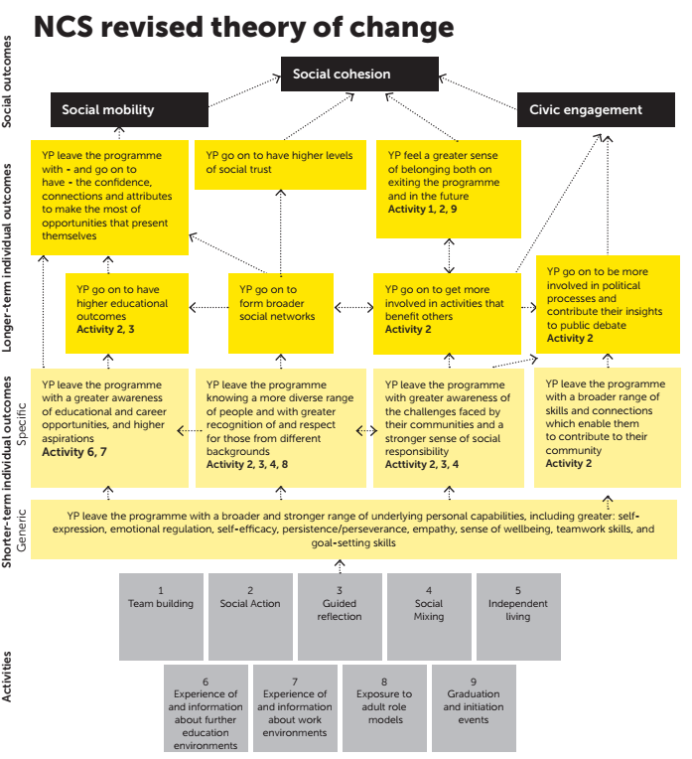

Appendix 4 Impact results 2016
Below are the impact results for both the 2016 summer and autumn evaluations. Results denoted with * are significant impacts.
Given the differences in evaluation methodology, and the structure and timing of the programmes, any comparison between these results and the 2017 results should be treated as indicative only.
Outcome: Social mobility: Self-confidence: leadership and communication | Impact Summer 16 | Impact Autumn 16
% who feel confident in being the leader of a team | +20pp* | +24pp*
% who feel confident in explaining ideas clearly | +25pp* | +20pp*
% who feel confident in meeting new people | +20pp* | +23pp*
% who feel confident in working with other people in a team | +14pp* | +13pp*
% who feel confident speaking in public | N/A | N/A
% who feel confident having a go at things that are new to them | +18pp* | +16pp*
% who feel confident managing disagreements and conflict | N/A | N/A

Outcome: Social mobility - Problem solving and decision-making skills | Impact Summer 16 | Impact Autumn 16
% who agree that they enjoy finding new ways to do things | N/A | N/A
% who agree that when solving a problem, they try to think of as many solutions as possible | N/A | N/A
% who agree that they think about both long term and short-term consequences when they work through problems | N/A | N/A
% who agree that they usually make good decisions, even in difficult situations | N/A | N/A

Outcome: Social mobility – team work and social network building | Impact Summer 16 | Impact Autumn 16
% who agree that they are able to see things from the other person’s point of view | N/A | N/A
% who agree that they can usually tell when someone says one thing but means another | N/A | N/A
% who agree that they notice quickly if someone in a group is feeling awkward | N/A | N/A
% who agree that they get along with people easily | +9pp* | +8pp*
% who agree that if they needed help there are people who would be there for them | +9pp* | +1pp
% who agree that it is hard to say no to friends | N/A | N/A

Outcome: Social Mobility – Positivity about the future | Impact Summer 16 | Impact Autumn 16
% who agree that they feel positive about their chances of getting a job in the future | +7pp* | +6pp*
% who agree that they are confident they have the skills and experience to get a job in the future | +13pp* | +6pp
% who agree that they are optimistic about the future | N/A | N/A

Outcome: Social Mobility - Resilience and emotional regulation | Impact Summer 16 | Impact Autumn 16
% who agree that they can usually handle whatever comes their way | +13pp* | +5pp
% who agree that when things go wrong they usually get over it quickly | +10pp* | +12pp*
% who agree that when they are faced with a stressful situation they are able to stay calm | N/A | N/A
% who agree that they are able to stay in control when they’re angry | N/A | N/A
% who agree that setbacks don’t normally discourage them | N/A | N/A

Outcome: Social Cohesion - Social mixing | Impact Summer16 | Impact Autumn 16
% who say that most people can be trusted | +2pp | +3pp
% who agree that their local area is a place where people from different backgrounds get on well together | +8pp* | +7pp*

Outcome: Social Cohesion – Attitudes towards protected characteristics | Impact Summer 16 | Impact Autumn 16
% who feel comfortable with friend/relative going out with someone from a different school or college | -1pp | +5pp
% who feel comfortable with friend/relative going out with someone from a different race or ethnicity | +5pp* | +6pp*
% who feel comfortable with friend/relative going out with someone from a different religious background | +3pp | +5pp
% who feel comfortable with friend/relative going out with someone from a richer or poorer background | +5pp | +10pp*
% who feel comfortable with friend/relative going out with someone who is gay or lesbian | +6pp* | +4pp
% who feel comfortable with friend/relative going out with someone is disabled | +4pp | +6pp*

Outcome: Social Cohesion – Race/Ethnicity | Impact Summer 16 | Impact Autumn 16
% who often have positive experiences with people from a different race or ethnicity | +3pp | +1pp
% who rarely or never have negative or bad experiences with people from a different race or ethnicity | +6pp* | -1pp
% who often have positive or good experiences with people from the same race or ethnicity | +5pp* | +1pp
% who rarely or never have negative or bad experiences with people from the same race or ethnicity | +3pp | -3pp

Outcome: Social Cohesion – Wellbeing | Impact Summer 16 | Impact Autumn 16
% who feel that things they do in their life are completely worthwhile | +12pp* | +4pp
% who did not feel at all anxious yesterday | +11pp* | +7pp*
% who feel completely satisfied with life nowadays | +7pp* | +4pp*
% who felt completely happy yesterday | +3pp | +5pp*

Outcome: Social Responsibility – Community Involvement - Attitudes | Impact Summer 16 | Impact Autumn 16
Hours in total spent in formal and informal volunteering in the last month (excl. time spent on social action project as part of NCS) | +6hours* | +6hours*
% who agree that they would know how to deal with a problem in their local areas if they wanted to | +20pp* | +17pp*
% agree that they feel able to have an impact on the world around them | +17pp* | +13pp*
% who agree that they feel a sense of responsibility towards their local community | N/A | N/A

Outcome: Social Responsibility – Community Involvement - Actions | Impact Summer 16 | Impact Autumn 16
% who agree that they often help out their family and around the home | N/A | N/A
% who have taken part in any youth group or activities in the last three months | +4pp* | +5pp*
% who have helped out at a local club, organisation or place of worship outside of school or college hours in the last three months | +5pp* | +4pp
% who helped out at other organisations outside of school or college hours in the last three months | +8pp* | +6pp*
% who have raised money for charity (including taking part in a sponsored event) outside of school or college in the last three months | -2pp | +2pp
% who have contacted someone (e.g. council, media, school) about something affecting their local area outside of school or college hours in the last three months | +2pp | +5pp*
% who have organised a petition or event to support a local or national issue outside of school or college hours in the last three months | +1pp | +2pp
% who have done something to help other people or improve a local area outside of school or college hours in the last three months | +15pp* | +13pp*
% who have helped out by doing shopping, collecting pension, or paying bills for someone not in their family in the last three months | -1pp | +3pp
% who have helped out by cooking, cleaning, laundry, gardening or other household jobs for someone not in their family in the last three months | +4pp | +4pp
% who have helped out by decorating, or doing any kind of home or car repairs for someone not in the family in the last three months | -1pp | +3pp
% who have helped out by taking care of someone who is sick or frail not in the family in the last three months | +2pp | +3pp
% who have helped out by looking after a pet for someone not in their family who is away in the last three months | +3pp | +3pp
% who have helped out by helping someone not in their family with a university or job application in the last three months | +2pp | +5pp*
% who have helped out by writing letters or filling in forms for someone not in their family in the last three months | +8pp* | +6pp
% who have helped out by baby sitting or caring for children | 0pp | +5pp
% who have helped out by helping out in some other way | +9pp* | +8pp*

Appendix 5 Value-for-money sensitivity testing
London Economics conducted a number of sensitivity tests to examine the reliance of the final benefit-cost ratios on the specific assumptions made.
1. Accounting for the gender differential in lifetime earnings
In considering the impact of enhanced leadership skills on lifetime earnings, the analysis described previously uses an average estimated present value of lifetime earnings of £600,000 for all participants. This however masks the continued persistence of a pay gap between genders. Previous research by London Economics found a substantial difference in the expected lifetime earnings between males and females. The present value of lifetime earnings for females with a Level 3 qualification (equivalent to GCE ‘A’ Levels) was estimated to be approximately £408,000, while the equivalent for males is approximately £791,000. Furthermore, impact estimates suggest that the attainment of enhanced leadership skills through 2017 summer NCS is higher for female participants (18.9% of whom attain enhanced leadership skills) compared to male participants (17.0%).
Given these gender differences, it is possible that the value-for-money assessment overestimates the value associated with enhanced leadership skills. This sensitivity test explores how the benefit-cost ratio for 2017 summer NCS would change with differential impacts and lifetime earnings for each gender (holding other estimates of monetary impacts constant).
Using the updated measures of lifetime benefits (by gender) and the differential boost to leadership skills (by gender), the table below (12) compares leadership and benefit cost ratios from the core analysis and the sensitivity analysis, described above.

- Sensitivity testing: Comparison of alternative leadership estimates and the overall Benefit Cost Ratios with baseline analysis
Summer 2017
 | Core analysis (Approach 1) |  |  | Sensitivity analysis
 | Low scenario | Central scenario | High scenario | Low scenario | Central scenario | High scenario
Leadership (£m) | £133.1m | £187.0m | £240.9m | £119.8m | £168.3m | £216.8m
Net benefit Total Cost Ratio | 1.20 | 1.90 | 2.58 | 1.10 | 1.75 | 2.39

Autumn 2017
 | Core analysis (Approach 1) |  |  | Sensitivity analysis
 | Low scenario | Central scenario | High scenario | Low scenario | Central scenario | High scenario
Leadership (£m) | £21.4m | £30.0m | £38.7m | £21.7m | £30.5m | £39.3m
Net benefit Total Cost Ratio | 1.27 | 1.99 | 2.67 | 1.28 | 2.01 | 2.70

As expected, the estimate of the Benefit Cost Ratio slightly declines, with the central estimate falling from 1.90 in (4-week) summer 2017 to 1.75 under the revised assumptions relating to the gender specific impact on leadership skills and associated lifetime benefits. In relation to autumn 2017 participants, the net Benefit to cost ratio increases because of the relatively high proportion of males taking part in the autumn programme compared to the summer programme (from 1.99 to 2.01).
2. Using National Minimum Wage rates
An important methodological difference between this analysis and analyses undertaken in previous years is the wage rate used. Previous analyses used National Minimum Wage (NMW) rates to price the opportunity cost of an extra hour of voluntary work. However, as discussed in the main report, this is likely to be lower than the actual wage rate young people can command in the labour market, thus underestimating the value-for-money associated with NCS.
Instead, the value-for-money assessment described in this report uses median wage rates. However, in order to facilitate a similar comparison between years, we test how the results would change if National Minimum Wage rates were used.
- Sensitivity testing: Comparison of alternative volunteering estimates and the overall Benefit Cost ratios with baseline analysis
Summer 2017
 | Core analysis (Approach 1) |  |  | Sensitivity analysis
 | Low scenario | Central scenario | High scenario | Low scenario | Central scenario | High scenario
Volunteering (£m) | £22.4m | £57.7m | £91.1m | £16.2m | £42.0m | £66.5m
Net benefit Total Cost Ratio | 1.20 | 1.90 | 2.58 | 1.16 | 1.78 | 2.39

Autumn 2017
 | Core analysis (Approach 1) |  |  | Sensitivity analysis
 | Low scenario | Central scenario | High scenario | Low scenario | Central scenario | High scenario
Volunteering (£m) | £5.9m | £12.6m | £18.5m | £4.3m | £9.2m | £13.5m
Net benefit Total Cost Ratio | 1.27 | 1.99 | 2.67 | 1.19 | 1.83 | 2.43
Note: The benefit-cost figures in this table are the most directly comparable to those in previous years’ evaluations and should be used if comparing results across time.

3-week summer programmes were largely excluded from the survey and have therefore been excluded from both the impact and VfM analysis
For example, the autumn programmes include shorter residential stays than the summer programmes, and have an older age profile of participants (see table 2.2 in chapter 2).
These can be accessed at https://wearencs.com/our-objectives-and-impact
https://wearencs.com/sites/default/files/2018-10/NCS%202013%202YO%20Evaluation%20Report.pdf
This approach is based on a separate analysis of the value associated with the 2015 NCS programmes undertaken by Jump x Simetrica (2017) on behalf of the NCS Trust, “If you could bottle it…A wellbeing and human capital value-for-money analysis of the NCS 2015 programme”. Available at: https://wearencs.com/sites/default/files/2018-10/NCS%20Wellbeing%20and%20Human%20Capital%20Valuation%20-%20Jump_0.pdf The approach adopted here replicates the same methodology as implemented for the 2016 evaluation of the NCS.
Specifically, these are young people defined as ‘Turn ups’ – i.e. those who have started the programme but did not necessarily complete the full four weeks.
These can be accessed at https://wearencs.com/our-objectives-and-impact
The quotations used in this section are from: https://wearencs.com/about-ncs
https://www.ons.gov.uk/peoplepopulationandcommunity/wellbeing/bulletins/measuringnationalwellbeing/januarytodecember2017
HM Treasury (2018), The Green Book: Central Government Guidance on appraisal and evaluation (link here) [Last accessed 11-10-2018]
Note that there has been one important methodological adjustment between the 2016 and 2017 evaluation. Because of the timing of the fieldwork in 2017, both Standard and College model autumn participants were surveyed (unlike in 2016, when College model participants were mostly excluded). In relation to the value for money analysis, the effect of this change is to increase both the associated benefits and costs associated with the 2017 NCS programme (compared to the 2016 Autumn programme); however, as the change in both costs and benefits are in the same proportions, the estimates of the various benefit to cost ratios are unchanged.
Net of parental contributions.
Note that totals may not sum as a result of rounding
Net of income received from providers for paid services delivered by the NCST.
This evaluation has focused on the main NCS delivery models; that is the summer 4-week programme (it excludes 3-week programme), and both Standard and College model autumn programmes, as outlined in the Executive Summary, p3. .
This includes 70,654 who took part in the 4-week summer programmes, and 11,863 young people who took part in the 3-week version.
These figures exclude Northern Ireland. In Northern Ireland 451 young people took part in 4-week summer programmes.
These can be accessed at https://wearencs.com/our-objectives-and-impact
https://wearencs.com/sites/default/files/2018-10/NCS%202013%202YO%20Evaluation%20Report.pdf
https://www.gov.uk/government/uploads/system/uploads/attachment_data/file/651448/Treasury_minute_12_October_Cm_9505_Web.pdf
https://assets.publishing.service.gov.uk/government/uploads/system/uploads/attachment_data/file/734751/Options_for_evaluation_of_long-term_outcomes_of_the_NCS_-_Final_Report_06-04-2018.pdf
https://www.parliament.uk/documents/commons-committees/public-accounts/Correspondence/2017-19/dcms-ncs-long-term-evaluation-plan.pdf
https://www.nao.org.uk/wp-content/uploads/2017/02/National-Citizen-Service.pdf
Where figures do not sum to 100% this is due to missing data
FSM entitlement refers to pupils that are eligible for free school meals. These pupils come from families that are entitled to one or more of a range of benefits, which aim to support those on low incomes. As such, FSM entitlement is used as a proxy measure for disadvantage.
A child or young person has special educational needs (SEN) if he or she has a learning difficulty that calls for special educational provision to be made for him or her. A child of compulsory school age or a young person has a learning difficulty if he or she has a significantly greater difficulty in learning than the majority of others of the same age.
These population figures are based on the figures available at the time the impact analysis was undertaken. They are slightly lower the final figures which have been used for the VfM analysis, and which are cited above on page 10. College model participants were included in the autumn population figures used for weighting the survey data which underpins the impact scores.
3-week summer programmes were largely excluded from the survey and have therefore been excluded from both the impact and VfM analysis
Because of the timing of the fieldwork in 2017, both Standard and College model autumn participants were surveyed (unlike in 2016, where College model participants were largely excluded). In relation to the value for money analysis, the effect of this change is to increase both the associated benefits and costs associated with the 2017 NCS programme (compared to the 2016 Autumn programme); however, as the change in both costs and benefits are in the same proportions, the estimates of the various benefit to cost ratios are unchanged.
Prior to 2015 evaluations all NCS participants were eligible for inclusion at the baseline however once the programme expanded this was no longer feasible.
For the first time in 2017, the use of supplementary purchased sample was trialled, the aim was to find out if this was a feasible means of boosting the comparison group for future NCS evaluations. 8,000 parents of 16 and 17 year-olds was purchased. In these cases parents were emailed a link to the survey, or sent a letter with login details, and asked to pass on the link or the details for the survey to their 16 or 17 year-old. Given the very low response rate achieved using this method, this will not be repeated for the 2018 evaluation. This is discussed in greater detail in the technical report.
In most cases, this was where respondents had refused to give their postcode and so geodemographic information could not be appended.
https://www.gov.uk/government/publications/ethical-assurance-guidance-for-social-research-in-government
https://wearencs.com/sites/default/files/2018-10/NCS%202013%202YO%20Evaluation%20Report.pdf
For example, the autumn programmes include shorter residential stays than the summer programmes, and have an older age profile of participants (see table 2 earlier in this chapter).
For example, the autumn programmes include shorter residential stays than the summer programmes, and have an older age profile of participants (see table 2 in chapter 2).
Of the 7 statements listed in this question, the mean number of statements selected by summer participants was 4.88, the mean number of statements selected by autumn participants was 3.96.
https://wearencs.com/about-ncs
https://wearencs.com/about-ncs
The only outcomes that are not are the trust and community cohesion outcomes which are asked using a five point agree to disagree scale
These are asked as five separate questions; full responses can be found in table 9 of Appendix 1. The questionnaire is provided in the appendix of technical report.
Respondents were also asked how comfortable they would feel with a friend or relative going out with someone from a different school or college to them as a warm up question. This statement has been excluded from the analysis in the report, but responses can be found in table 9 of appendix 1.
https://www.ons.gov.uk/peoplepopulationandcommunity/wellbeing/bulletins/measuringnationalwellbeing/januarytodecember2017
https://wearencs.com/sites/default/files/2018-10/Social%20Integration%20Report.pdf
https://wearencs.com/about-ncs
This overall measure does not include whether or not a young person has taken part in any youth groups or activities, as this is not categorised as ‘helping’.
HM Treasury (2018), The Green Book: Central Government Guidance on appraisal and evaluation https://assets.publishing.service.gov.uk/government/uploads/system/uploads/attachment_data/file/685903/The_Green_Book.pdf
The full methodological approach is available in the 2016 report detailing the evaluation of the National Citizens Service – which can be found at https://wearencs.com/our-objectives-and-impact
Jump x Simetrica (2017), “If you could bottle it…A wellbeing and human capital value-for-money analysis of the NCS 2015 programme” https://wearencs.com/sites/default/files/2018-10/NCS%20Wellbeing%20and%20Human%20Capital%20Valuation%20-%20Jump_0.pdf
Note that we have not undertaken any statistical comparison of the impact estimates between years. We simply present the differences in the estimates between the two evaluations.
Note that there was a small means-tested contribution towards the costs associated with the NCS from parents of participants. The parental contribution expended by the Trust was deducted from the estimate of gross benefits (as this was a cost incurred to achieve the economic benefits associated with volunteering and leadership). This accounts for any totals in tables 7.1 to 7.13 that do not add up.
Kuhn and Weinberger (2005), “Leadership Skills and Wages”, Journal of Labor Economics, Vol 23 No 3 (July 2005).
Department for Business Innovation & Skills (2013), “The impact of university degrees on the lifecycle of earnings; some further analysis”. BIS Research Paper No, 112; original £600,000 estimate used in 2016 analysis uprated by 2.7% to account for inflation between 2016 and 2017.
In terms of the underlying academic analysis on which our monetised estimate of leadership is based, the Kuhn and Weisberger (2005) analysis uses a generated continuous measure of leadership (standardised) based on the survey responses to a number of questions (both binary measures as well as responses along scales). The authors identify a 2.9% impact on wages associated with a 1 standard deviation leadership effect. However, in the impact analysis presented here, the outcome measure identified for each of the leadership measures is a binary measure (‘very confident’ or ‘confident’ or otherwise), and we take the average difference in differences between the treatment and counterfactual groups before and after the NCS intervention across the four leadership measures. As such, the application of the Kuhn and Weisberger (2005) econometric estimates is not perfectly compatible with the nature of the data collected as part of this evaluation. However, in the absence of other information or evidence, we believe this to be a reasonable approach.
In relation to the impact of the NCS on leadership skills, the estimated effect of NCS participation on leadership measures is large. In particular, the analysis suggests that the relative increase in the proportion of participants indicating a gain in leadership skills was between 17 and 19 percentage points depending on gender. This finding has been identified consistently in previous evaluations (for instance, between 16 and 21 percentage points in 2016). To monetise this impact, we rely on external econometric analysis linking perceived changes in leadership skills and earnings outcomes later in life and the assumption that the leadership impact persists over the working life. While the persistency of the leadership effect is a relatively strong assumption, there are also a number of issues in respect the academic findings on which the analysis is based (in particular, whether the current cohort of NCS participants are really comparable to the individuals in the original analysis). However, in the absence of additional information, and in part to ensure consistency with earlier evaluations, we have adopted the same estimates of leadership effects on lifetime earnings. The size of the effect is 3%, which is in part reduced to account for potential double counting. The monetised impact per participant was estimated to be approximately £2,650 per summer participant in 2017.
Ipsos MORI (2017), “National Citizen Service 2013 Evaluation – Two Years On: Main Report”
Low Pay Commission (2017), “National Minimum Wage – Low Pay Commission Report Autumn 2017”
HM Treasury, 2011, “The Green Book, Appraisal and Evaluation in Central Government”.
Note that totals may not sum as a result of rounding. See also footnote 60, for additional information on the treatment of parental contributions as a ‘dis-benefit’ and the associated reduction in estimated economic benefits.
Note that there was a small means-tested contribution towards the costs associated with the NCS from parents of participants. This parental contribution expended by the Trust was deducted from the estimate of gross benefits (as this was a cost incurred to achieve the economic benefits associated with volunteering and leadership), and accounts for any totals that do not add up.
Summer 4-week programme (excludes 3-week programme) and autumn Standard and College models
The costs presented here may not align with those presented by the NCS Trust in their statement of annual accounts. This statement reports the Trust’s income and expenditure in a 12-month period (financial year), irrespective of the cohorts of NCS participants it relates to. In contrast, this value for money analysis apportions expenditure associated with the 2017 cohort of NCS participants, though this may have occurred over different (and multiple) financial reporting periods.
Jump (2016), “If you could bottle it…A wellbeing and human capital value-for-money”.
Note that the original analysis undertaken by Jump (2016) uses a lottery win as a means of monetising wellbeing improvements – for a representative household. Median household income is greater than the median individual income – but also it is probable that the median income for a representative household is greater than the median income for a young person (potentially impacted by the NCS). Therefore, it is possible that the estimates presented here are indeed overestimates to the true wellbeing impact.
The figure uses the 2016 estimate updated by a 2.7% inflation rate.
The value of α₁ reported by Jump (2016) is 1.282. However, this is adjusted to account for different scales used in the British Household Panel Survey and the NCS questionnaire. The BHPS asks about life satisfaction on a 7-point scale, whereas NCS uses an 11-point scale. To account for this we apply the following adjustment: (α₁/7)*11 to get 2.0146.
As with the analysis of the monetary value of leadership skills, in the case of wellbeing impacts, there is a need to undertake a longer-term evaluation to identify the extent to which the early impacts dissipate or persist into the longer term.
London Economics (2019). ‘Assessing the economic returns to Level 4 and 5 STEM-based qualifications’. A report on behalf of the Gatsby Foundation (link).
Aggregate gross estimate, i.e. values are not average annual figures but rather a before-tax accumulated figure over individuals’ lifetimes.
Note that the original Kuhn and Weinberger (2005) paper only considers the impact of leadership for men. However, despite the lack of gender specific information, we have applied the same estimated impact to the enhanced lifetime earnings posted by women as that applied to men.
Gender-differentiated estimates for enhanced leadership were not available for the autumn 2017 NCS due to a smaller sample. Given the similar average effect of the NCS on leadership between Summer 2017 and Autumn 2017 (18.9% and 17.0% respectively), the gender-differentiated estimates in autumn 2017 were assumed to be the same as those for the summer 2017 programme.

