

Tech City UK Impact Evaluation
  - Final Report to the Department for Digital, Culture, Media & Sport
October 2017

Contact: | Osman Anwar | Tel: | 0131 243 0729 |  | email: | oanwar@sqw.co.uk
Approved by: | Jonathan Cook | Date: |  | 31/10/17
Approved by: | Director
Contents
Executive Summary i
1. Introduction 1
2. Evaluation approach and issues 7
3. Assessment of delivery 14
4. Assessment of outcomes, impacts and value for money 38
5. Assessment of monitoring and evaluation data 67
6. Review of progress against recommendations from interim evaluation 70
7. Conclusions and recommendations 78

Annex A: List of consultees A-1
Annex B: Logic models B-1
Annex C: Case studies C-1
Annex D: Online survey results D-1
Annex E: Future Fifty events E-1

Executive Summary

Background to the study
- Tech City UK (TCUK) was established as an independent, private sector organisation in 2010 to accelerate the development of digital businesses and entrepreneurs across the UK. It has been supported with core funding of around £2m per annum by UK government, originally through the Department for Business, Energy and Industrial Strategy (BEIS) and now from the Department for Digital, Culture, Media and Sport (DCMS). TCUK seeks to address the barriers and challenges to starting and growing digital tech businesses and the digital tech sector in the UK, and to put on the agenda issues that affect the sector and its ecosystem more widely. The initial focus was around London, reflecting the cluster of activity around Shoreditch in East London, though it had a remit for the UK as a whole. In 2015 Tech North was established, as part of TCUK, to provide further focus on delivering its mission in the North of England with supplementary funding of just under £2m per annum.
- SQW was commissioned in December 2016 to undertake an evaluation of TCUK. The study’s objectives were principally to:
- assess the impact of TCUK (and Tech North) activities on beneficiary firms and, to the extent possible, on the wider ecosystem, including the effects of TCUK activities as an overall package
- estimate the extent to which the funding of TCUK (and Tech North) were justified by the benefits achieved
- review how interim recommendations had been taken forward, and draw lessons on:
- how TCUK complements other organisations in the digital economy space
- how the effectiveness of the TCUK initiative could be improved
- outline monitoring and evaluation data limitations and propose areas to strengthen or amend data being collected to improve impact assessment possibilities.
- The scope of the study was to consider the three key sets of activities delivered by TCUK, covering its: business lifecycle programmes that support businesses at various stages of their development; digital skills programmes that address labour market and skills deficits and issues; and its thought leadership and advocacy role on behalf of the digital tech sector.
- The approach to the work has drawn on feedback from various groups of beneficiaries, stakeholders and documented data (e.g. from monitoring). This evidence has been used to test the underlying logic and theory for how TCUK and its different activities were expected to bring about effects, and to estimate, where possible, the quantitative and monetary impacts.

Impact of TCUK
- The evaluation of outcomes and impacts of the business lifecycle programmes focussed on three schemes, Future Fifty, Upscale and Northern Stars. These programmes target companies at different stages of development, respectively as follows: the most pioneering late-stage tech companies in the UK that have global growth ambitions; earlier stage companies with growth potential that have had Series A or equivalent funding or have £500k revenues (if ‘bootstrapped’); and leading tech start-ups in the North of England.
- Across all three of these programmes, the evidence was strong in relation to the ‘intermediate’ effects on companies, such as the effects on the capabilities, practices and behaviours of companies, with the following notable:
- Beneficiary companies in all three programmes commonly reported networking and new connections, the increased promotion and recognition of their business, improved peer to peer learning, and gaining access to government to communicate the issues facing the digital tech sector.
- In addition, beneficiaries of Upscale reported the access to expertise and improved management capabilities, and those beneficiaries of Northern Stars commonly reported the improvement in credibility of their business and improved ability to pitch the business. These additional benefits are likely to reflect the increased emphasis on coaching in Upscale and the nature of Northern Stars as a business pitching competition.
- On average, companies engaged in the three programmes have grown significantly during and since their participation. However, the effect on ‘hard’ performance measures, such as employment and sales turnover, that could be attributed to the programmes was limited – especially for Future Fifty. Future Fifty companies reported that this was not their expectation as the focus was on the networking and profile-raising. That said, even though effects on hard performance measures were limited in terms of the number of companies affected, due to the scale of growth of Future Fifty companies and one of the Upscale companies where turnover and employment growth was attributed to the programmes, the overall value attributed to TCUK was substantive (see below). Beneficiaries of Northern Stars were most likely (four out of eight) to report benefits to their turnover and employment, which may reflect their earlier development stage.
- Through both the Digital Business Academy (DBA) and the Tech Nation Visa Scheme, there is evidence that the digital skills programmes are helping address key challenges:
- The interest, understanding and confidence on a range of digital tech issues have been improved amongst DBA survey respondents. For just over three-fifths of DBA survey respondents have progressed with a business or business idea, progressed in their digital career or started their digital career – with some of these respondents attributing their or their business’s progress partly to what they have learnt.
- Case study evidence on the Tech Nation Visa Scheme highlights the ways in which this has helped to bring new talent and connections to the UK, thereby addressing shortages or bringing in new ideas.
- There have been a number of outcomes relating to the thought leadership and advocacy role of TCUK and Tech North. Three notable areas relate to the raised profile and promotion of the UK internationally as one of the top places for digital tech companies, which is particularly related to London; the increased awareness and understanding of regional clusters, particularly through the highly regarded Tech Nation reports, especially within the UK but also to an extent internationally; and the voice provided to the digital tech sector, especially in policy circles.
- In bringing about these benefits, there have been some important links between activities, as evidenced by the different sources of data from the evaluation. These suggest that TCUK has drawn across the package of support to deliver synergies, rather than simply having an effect through the sum of individual parts. Several examples from the evidence illustrate this:
- The advocacy and thought leadership has depended on the effective networking and connections of TCUK leadership, on its ability to engage effectively with digital tech companies, and to get these companies to present their views to government.
- The business lifecycle programmes have been used to support promotional activities. Future Fifty, for instance, has attracted high potential companies that reflect the strongest on the UK digital tech scene. The potential of these companies have helped to raise the international profile of the UK digital tech sector.
- Within the business lifecycle programmes, there have been some individual points of feedback that the flagship Future Fifty programme acts as an aspiration for programme participants on other programmes (such as Upscale and Northern Stars). It is early days, though there are some examples starting to occur of Upscale graduates applying for Future Fifty.

Economic evaluation
- As noted above, the extent of attribution of monetised benefits to the programmes has been limited to a degree. This has partly reflected the promotional, networking and advocacy focus of certain programmes. This is not to denigrate such activities and benefits – they are likely to be hugely valuable in developing the digital tech ecosystem. However, it is important to note this caveat in presenting the economic evaluation. A second caveat is that the economic evaluation is very sensitive to relatively small changes in certain assumptions – e.g. with high growth companies, if the value attributed to the programme is lower or higher this can have a significant bearing on the results. Sensitivity analysis is presented in the main report to better illustrate these effects.
- With these points in mind, the economic evaluation has focussed on the three business lifecycle programmes. The core estimate of the economic benefits associated with cohorts of companies joining programmes between 2014/15 and 2016/17 represents £11m of gross value added (GVA) to the UK economy to date.
- Dividing the aggregate GVA impact by the total costs of £1.91m associated with these business lifecycle programmes gives a benefit cost ratio of 5.8:1 for the period 2014/15-2016-17. This evidence indicates that the estimated benefits of the programmes justify their costs, and the BCR is in a similar ballpark to other innovation support and sector/cluster support schemes.
- There is a strong ‘health warning’ associated with these estimates. They are based on a small number of companies who were able to attribute changes in their performance, and do not take account of the wider non-quantifiable benefits that the programmes have brought about, such as enhanced networks and knowledge. They also only reflect impacts to date, and for some programmes in particular, the current stage of the businesses engaged is likely to mean that there may be some substantial effects in the future. It is not possible to estimate these from the evaluation evidence.
- The estimated economic benefits are generated through the three business lifecycle programmes, which account for around one-quarter of the total costs for the period 2014/15-2016/17. More widely, the evidence indicates there is value through TCUK contributing to the development of a digital tech community that is now less fragmented and is better networked and connected (within the UK and internationally).
- In addition, it is also worth highlighting the assessment that TCUK was seen by stakeholders as a ‘lean operation’. It was noted by stakeholders that both TCUK and Tech North have modest budgets, with some comparisons made to similar initiatives overseas. Given the scale of operations, they were seen to be delivering a range of activities – suggesting that the initiatives were efficient in their delivery. The evidence on the activities delivered justified this view.

Enhancing monitoring
- Overall, TCUK’s systems and processes for collecting (and reporting) monitoring data appear to be extensive and adopt industry leading tools to track and report activity data. Going forward, there is a need to ensure consistency and accuracy of data over time and between different sources. The current monitoring indicators are currently mainly focussed on activities rather than TCUK’s intended outcomes, and a slight shift in balance would be desirable. In doing this, and as shown by the challenges in quantifying and monetising economic effects through this evaluation, monitoring and evaluation of TCUK should reflect on both economic and non-economic indicators (e.g. relating to profile and networks). It is important that this ‘balanced’ set of indicators is communicated to funders and partners.

Lessons and recommendations
- The evidence on outcomes, impacts and value for money presented above is favourable. There have been some important achievements and some good feedback from the range of beneficiaries, partners and wider organisations interviewed as part of this evaluation. That said, a number of areas were identified where improvements could be made, relating to strategic direction, the currently perceived London focus, and operational issues.
- TCUK and Tech North need to reach greater clarity on their strategic intent going forward. This needs to take account of a number of issues:
- There is currently a plethora of brands, e.g. TCUK, Tech North, Tech Nation and others, and some simplification and/or clarity is required. As part of this, the unclear distinction between TCUK and Tech North should be addressed.
- There is evidence that TCUK has made a contribution to the development of London as a key global digital tech cluster, and could now do more to support the digital tech ecosystems outside of London. The Tech Nation reports have assisted with raising awareness and understanding of ‘clusters’ outside of London, and the cluster alliance had previously assisted in sharing practice and expertise. Going forward, there should be a greater balance of activity outside of London, building on the activities of Tech North and the extending reach of Future Fifty and Upscale programmes.
- To assist with strategic development and planning, longer-term certainty over funding is required. This will be important in setting realistic expectations for what can be delivered in terms of activities and intended outcomes.
- In relation to operational lessons, there are a number of recommendations:
- There is a need to ensure a continuity of approach, avoiding the adverse effects of changes in personnel. This will help to overcome issues that were reported by business beneficiaries and stakeholders with respect to some inconsistencies in the delivery of activities.
- TCUK should take greater advantage of the existing landscape for business development, by linking businesses in the sector to other existing initiatives such as those relating to export advice or access to finance.
- A range of other operational suggestions should be considered for specific programmes:
- greater consistency of engagement for beneficiaries of the business lifecycle programmes
- events and other activities could be better pitched at the right level to reflect first time versus more experienced entrepreneurs, and could also take account of the different needs of health tech, Fintech etc.
- greater international focus should be incorporated for ambitious Upscale beneficiaries
- for Tech North activities, such as Northern Stars, the pan-northern nature of companies and the sector had been built in, though there were some perceptions that this had not been as strong in recent months – it is therefore a risk that needs to be carefully managed.

Introduction

Background

Context
  - The digital transformation of the UK economy is affecting every sector and changing many aspects of work and home life. New digital businesses are disrupting markets, breaking new ground and bringing value and expediency to the UK consumer. Internationally, the UK is currently a frontrunner in the digital technology revolution, with the highest percentage of GDP involved in the digital economy of all European nations. According to the most recent Tech Nation report, the digital industries represent around £100bn of the UK’s gross value added (GVA), employ over 1.5million people and are growing twice as fast (in terms of job creation) than the rest of the economy.
  - Within the UK, whilst London has comfortably the largest presence of digital companies, with around one-third of digital business turnover coming from the capital, there are digital tech ‘clusters’ in other parts of the UK, from Bristol and Dundee and Brighton to Sunderland – and some of these clusters outside of London are growing rapidly.
  - In the UK, plans for the digital economy and related infrastructure, support for digital skills and the removal of ‘red tape’ have been high on the policy agenda. The Industrial Strategy Green Paper highlights the UK as a world leading digital nation, and the imperatives to develop digital skills, improve digital infrastructure and support digital technologies as part of science and innovation investment. DCMS’s own recently-published digital strategy also puts an emphasis on digital skills, digital connectivity (including infrastructure) and key digital sectors as part of its priorities, and points to the role of Tech City UK in a number of areas, including developing digital tech ecosystems in London and the north of England, attracting talent, and in emerging areas such as the FinTech delivery panel.
  - These recent developments represent a continuation of previous policy commitments, such as the Productivity Plan, which included a commitment to put in place “regulatory frameworks that support disruptive business models, innovation, emerging technologies and the digital economy”, and support for bodies such as the Digital Catapult, which includes a focus on supporting SMEs across the digital landscape.
  - Notwithstanding the encouraging growth of the digital tech sector, there have been some recognised barriers and challenges, including in relation to shortages of skills and people, and obtaining finance. There are also potential benefits from enhancing the density and connectivity of networks between people and companies. The density, connectivity and diversity represent key drivers of successful digital tech clusters. In the context of uncertainty around key issues affecting the economy, such as in relation to movement of labour (associated with Brexit), some of these issues are critical, and it is important that the voice of the digital economy is heard and understood.

Tech City UK
  - Tech City UK (TCUK) was established as an independent, private sector organisation in 2010 to accelerate the development of digital businesses and entrepreneurs across the UK. Originally with core funding (c. £2m per annum) from the Department for Business, Innovation and Skills (BIS) and now from the Department for Digital, Culture, Media and Sport (DCMS), it seeks to address the barriers and challenges to starting and growing digital tech businesses and the digital tech sector in the UK, and to put on the agenda issues that affect the sector and its ecosystem more widely. In 2015, Tech North was established to provide further focus on delivering this mission in the North of England – with additional funding of just under £2m per annum in 2015/16 and 2016/17. The programmes/activities of TCUK/Tech North align with these issues, broadly under three stands (with summary details in Table 1-1):
- Business lifecycle programmes support businesses at various stages of their development.
- Digital skills programmes address labour market and skills deficits and issues.
- Thought leadership and advocacy provide a voice for the digital tech sector.
Table 1-1: Summary details of programmes and activities
Programme/activity | Brief summary
Business lifecycle programmes
Future Fifty (TCUK) | Started in 2014  Supports the UK’s top growth-stage digital companies – cohorts of up to 50  Provides access to government and the private sector (experts etc.)  Builds links to the UK and overseas investors  Establish the foundation for IPO readiness, M&A and global expansion  Delivers through networking, events, and some tailored support to help companies grow
Upscale (TCUK) | Started in 2015  Aimed at early stage companies who have received Series A funding and ready for that next step in their growth cycle – cohorts of up to 30  Connects companies with founders and leaders to help tackle challenges of scaling  Provides support on specific topics (e.g. strategy, marketing, recruitment)
Northern Stars (Tech North) | Started in 2015  A pitching competition that identifies and showcases the best tech start-ups in the North of England  Online application process, supported by a series of Regional Pitch events, culminating in a Grand Final  10 winning companies are chosen by a high-profile panel of judges
Founders Network (Tech North) | Started in 2016  Connects start-up founders from across the North of England and brings together individuals within their local communities to share networks and opportunities
Digital skills programmes
Digital Business Academy (TCUK) | Started in 2014  Massive Open Online Course (MOOC) that brings together resources from industry experts and educational institutions such as University of Cambridge, University College London, Founder Centric and Valuable Content  11 online courses free to users to develop skills to start, grow or join a digital business  Upon completion, access to rewards including free co-working, internships and bespoke mentoring support  Over 17,600 users
Tech Nation Visa Scheme (TCUK) | Started in 2015  TCUK acts as endorsement body for scheme (Tier 1 exceptional talent), offering a dedicated route for businesses to attract world class talent outside the EU  An endorsement from Tech City UK allows an individual to submit their Visa application to the UK Home Office  This visa can be granted for up to 5 years after which an individual is eligible to apply for settlement in the UK
Tech Immersion (TCUK) | Started in 2016  Half-day workshop for organisations to understand and engage with start-up culture in UK, making the start-up world more accessible and providing industry insights to senior leaders from corporate backgrounds
Thought leadership and advocacy
Tech Nation report (TCUK) | Presents the current state of UK digital economy. Raises awareness and improves public understanding of the strengths and values of digital sector.
Marketing and partnerships (TCUK) | Activities to promote and raise the profile of the UK digital tech sector, and to develop partnerships and highlight issues facing the sector to relevant organisations and policy-makers
Hackney Report - Challenge of growth series (TCUK) | New initiative (in development stage) that gives insights into challenges facing entrepreneurs at different stages in lifecycle.
Regional access to investment (Tech North) | Proposed new co-investment fund that will improve access to investment in North of England by bringing together private investors, increase funding available.
Source: SQW, drawing on TCUK

Objectives and scope of assessment
  - An interim evaluation of TCUK in 2015 concluded that TCUK has made a substantial contribution to raising the profile of UK digital tech, both in the UK and abroad. In addition, a number of other conclusions were drawn, including:
- TCUK was found to have good links with senior policy makers, which were seen as important and beneficial to the digital tech sector – though there was some uncertainty about the long-term support for TCUK.
- Future Fifty was seen as valuable to firms, with the level of benefit determined by the ‘maturity’ of the company at joining.
- The Tech Nation/Cluster Alliance was useful, and the Tech Nation report was seen as a seminal publication.
- The DBA was attractive, with significant numbers of people signing up – though some potential issues around completions that needed to be watched.
  - As part of the conclusions, a series of recommendations were made to TCUK and wider partners. As a follow up to this interim evaluation, SQW was commissioned in December 2016 to undertake a further evaluation of TCUK. The study’s objectives were as follows:
- Impact evaluation: robustly establish the causal effects of TCUK (and Tech North) programmes and activities on beneficiary firms and, to the extent possible, on the wider ecosystem (i.e. the “digital economy” and wider societal benefits). This was to consider the effects of TCUK programmes and activities as an overall package.
- Economic evaluation: An economic evaluation to establish how far the funding of TCUK (and Tech North) were justified by the benefits achieved.
- Review how recommendations put forward in the interim evaluation had been taken forward by TCUK, and draw conclusions and lessons in light of experience with regards to:
- how TCUK complements and works well with other advocacy and industry organisations in the digital economy space
- how the effectiveness of the TCUK initiative could be improved; in particular, how TCUK's setup/status enables them to do their job and/or if there are other models that might deliver better value for money.
- Outline monitoring and evaluation data limitations and propose areas to strengthen or amend data being collected to improve impact assessment possibilities.

Scope
  - Reflecting the varying stages of maturity of the activities, and also their nature (and so applicability for quantitative impact and economic evaluation), different aspects of TCUK/Tech North were agreed to be within and out of scope for the evaluation. In Table 1-2, we summarise the scope of the assessment, which was, in some parts subject to time elapsed and the ability to quantify/monetise certain benefits (in the case of DBA – where this was reliant on an online survey and the extent to influence of the programme).
  - The time period considered within scope of the evaluation is 2014/15 to 2016/17. This is when the key programmes within scope were operational or became operational – as described in more detail in section 3. Inevitably there has been some feedback on TCUK’s wider work that reflect activities such as promotion and advocacy from before 2014. However, for the purpose of reporting expenditure and outputs, and for the economic evaluation the study has used 2014/15 to 2016/17 as its period of interest.
Table 1-2: Scope of the evaluation
 | Impact & economic evaluation | Interim or qualitative evaluation | Outside of scope
Business lifecycle programmes | Future Fifty  Northern Stars  Upscale | Founders’ Network
Digital skills programmes | Digital Business Academy | Tech Nation Visa Scheme | Tech Immersion
Thought leadership and advocacy |  | Tech Nation reports  Marketing | Hackney Report (Challenge of growth series)  Regional access to investment  Inward investment
Source: SQW

Structure of this report
  - The remainder of this report is structured as follows:
- Section 2 summarises the approach taken to the evaluation, covering the methods, a discussion of the logic models that underpin the study. It also notes some of the key challenges to the work ahead of the analysis that follows.
- Section 3 reviews the delivery of TCUK and Tech North, assessing the expenditure that has been made, the progress of activities of different programmes that have been assessed, and the resulting outputs.
- Section 4 sets out the evidence on the outcomes and impacts of the different programmes to date, including the extent to which these may not have occurred without TCUK or Tech North.
- Section 5 provides a view on the monitoring and evaluative data that TCUK collects and how these could be strengthened to facilitate evaluation and performance assessment in the future.
- Section 6 assesses TCUK against the other objectives of the evaluation, covering the ways in which interim recommendations have been addressed, and how effectiveness could be improved going forward.
- Finally, section 7 sets out the conclusions and recommendations from the study.
  - In addition to these principal sections, there are four annexes:
- Annex A provides a list of all the consultees.
- Annex B provides logic models for the Business Lifecycle Programmes, Digital Skills, and Thought Leadership.
- Annex C provides case studies for Future Fifty, DBA and Tech Nation Visa Scheme.
- Annex D presents results from the online surveys for DBA and Founders’ Network.

Evaluation approach and issues
  - This section summarises the approach taken, and sets out some of the key issues and challenges for the evaluation, thereby providing context for the analysis that follows. In particular, the section reflects on the logic models for TCUK and its programmes, the nature of TCUK, and issues associated with quantifying the benefits of TCUK’s activities.

Approach
  - An evaluation strategy was produced in 2014, and the approach taken to the study broadly follows that which was recommended in the strategy. Therefore, we do not go into detail on the justification of the approach as this is more thoroughly reported in the aforementioned strategy. The overarching approach to the work has been to adopt a theory-based assessment, drawing on feedback from various groups of beneficiaries, stakeholders and documented data (e.g. from monitoring). The evidence has been used to test the underlying logic models for TCUK and the different programmes, to establish causal links, and, where applicable, to estimate the quantitative and monetary impacts. The evaluation has involved a number of stages and tasks:
- desk-based review of programme documentation, monitoring information and wider data/evidence;
- refinement of the logic models that were developed as part of the original evaluation strategy;
- 29 stakeholder consultations capturing a range of perspectives, including TCUK, Tech North, DCMS, devolved administrations and local partners across the UK, other national government representatives (e.g. Department for International Trade and HM Treasury), private sector perspectives (e.g. investors and entrepreneurs) and other relevant organisations;
- beneficiary interviews/surveys of various types:
- 21 in-depth telephone interviews with Future Fifty beneficiaries
- 13 in-depth telephone interviews with Upscale beneficiaries
- 8 in-depth telephone interviews with Northern Stars beneficiaries
- 4 in-depth interviews with Tech Nation Visa scheme beneficiaries
- an online survey of DBA beneficiaries (with 121 responses), followed up with 15 in-depth interviews
- an online survey of Founders’ Network beneficiaries (with 11 responses);
- data collected has informed the modelling of impacts (for those where impact and economic evaluation was within scope)
- more widely, evidence has informed an assessment of qualitative effects, areas of strength and issues, which has also been supported by a series of case studies for the different programmes.
  - It is worth recognising that the interviews/surveys identified above, by their nature, rely on self-reporting by beneficiaries. This inevitably leads to subjective statements of progress which might not always be comparable across companies. In addition, supported firms may describe support as helpful, regardless of actual impact. To address some of these potential limitations, we were careful in our design and use of research tools, ‘checked and challenged’ the feedback from beneficiaries; and interpreted the findings on outcomes and impacts with our wider knowledge and experience of evaluating other business development, technology and innovation related interventions.

Use of logic models to underpin the evaluation
  - In appraising or evaluating a publicly-funded policies and programmes, it is considered good practice, and recommended in government guidance on policy evaluation, to develop a ‘logic model’ which explicitly articulates the context and rationale for the initiative, and describes the relationship between the inputs, activities, outputs, outcomes and impacts. The Tech City UK Evaluation Strategy established logic models for TCUK overall, as well as individual activities such as Future Fifty, the Digital Business Academy and policy development.
  - The logic models have been important underpinnings for the evaluation, in particular to the approach taken and the types of evidence that have been collected. Put simply, the evaluation has sought to collect evidence that would support (or otherwise) the underlying logic as set out in the individual logic models, including testing the outputs, outcomes and impacts that have been achieved and the causal links between these and the activities.
  - Some modest refinements were made to the logic models at the outset of the study, and additional logic models were developed for programmes for which logic models had not previously been developed (e.g. Upscale). These drew on initial conversations with programme leads, and the logic models were agreed with the study steering group. By way of example, the logic model for TCUK overall is summarised in Figure 2-1, and logic models for individual programmes are set out in Annex B. As shown in Figure 2-1, the underlying logic for TCUK overall indicates the following:
- Contextually, there were a number of drivers, including technological advances that were providing opportunities for growth in the digital tech sector, but some barriers in the UK prevented from maximising these, including a shortage of digital tech entrepreneurs a support landscape that was fragmented. There was strategic commitment and early activities of TCUK were promoting a cluster around East London, reflecting the importance of proximity and density of networks; and there were emerging clusters elsewhere in the UK, including in part of the north of England with Tech North established to help develop an ecosystem in the north.
- In terms of the rationale for intervention, two key market failures were identified, namely externalities associated with clusters, and various information issues in relation to knowledge, accessibility of support and policy-makers’ understanding of the digital tech sector. The first market failure was associated with clusters, with economic and innovation literature indicating that clusters can result in positive externalities. Clusters can increase knowledge spillovers and skills amongst their actors and pool labour market capabilities (often regionally), which can potentially contribute to higher productivity, innovation and competitiveness. Three defining characteristics of clusters are often highlighted in the literature: technology specialisation; networking platforms; and an international profile or links (helping to attract FDI). The second market failure was related to various information issues relating to knowledge, accessibility of support and policy-makers’ understanding of the digital tech sector. These are supported in the literature on innovation, with actors making decisions under asymmetric or incomplete information.
- It is worth noting that an assessment of market failures was not within the formal scope of this evaluation. To the extent possible, in chapter 3 and 4 we draw on the evidence gathered on motivations and effects to comment on their existence and how they may have been addressed.
- The delivery of the programme is varied, reflecting the direct delivery of programmes to support firms and individuals, e.g. through the business lifecycle and digital skills programmes, but also more widely the thought leadership, policy influence and profile-raising work. The activities were funded by around £2m per annum, originally supported by what was then the Department for Business, Innovation and Skills (BIS) and now DCMS, and delivered through a lean staff that started with less than a dozen people in 2014 and grew to c. 40 across both Tech City UK and Tech North by March 2016.
- The intended outputs and outcomes, and the associated routes to intended effects, again vary to reflect the different types of activities. Three examples illustrate this:
- Outputs include firms provided with intensive one-to-one support and mentoring through business lifecycle programmes, which was designed to help operational and strategic developments of these companies leading to growth, and additional employment and GVA.
- The DBA included a range of outputs associated with courses and registrations, which was expected to help improve skills, help improve perceptions of digital entrepreneurship and so lead to more digital tech entrepreneurship in the UK.
- More widely, the delivery of communications outputs as well as events and networking was expected to develop strong ecosystems across the UK, thereby contributing to the digital tech sector’s growth.

Figure 2-1: Overall TCUK logic model
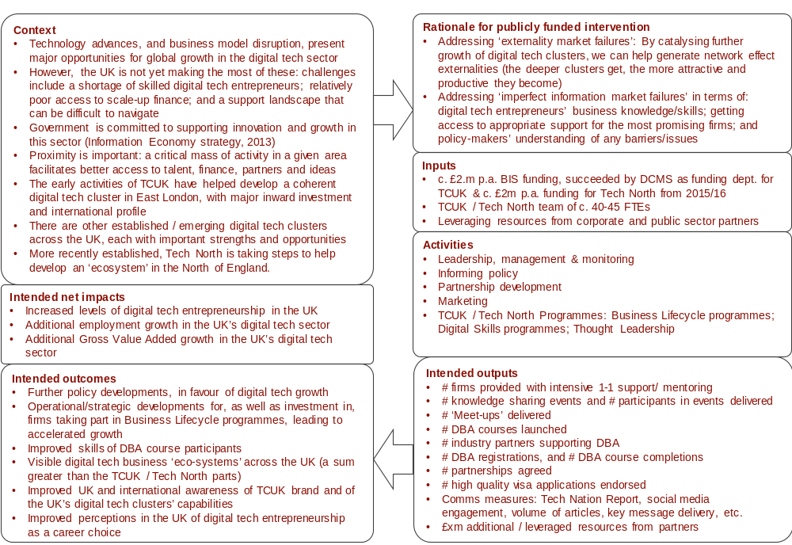
Source: SQW
  - The points raised on the logic model with respect to the nature of TCUK activities and the varying routes to, and types of, outcomes are important to note. It is normally the case that some of these can be more readily quantified and monetised, such as the creation and development of new businesses – and such quantitative effects and the attribution of these to TCUK were tested as part of the evaluation. However, for others it can be more difficult to quantify the outcomes and/or establish the links between activities and outcomes, such as with respect to policy developments and awareness of brands and the UK’s digital tech clusters more widely. In these cases, qualitative evidence was sought. The extent to which we have been able to attribute benefits to TCUK directly was a key evaluation issue and it is to this that we now turn.
  - As noted above, the study was not explicitly tasked with assessing the rationale associated with Tech City UK. Nevertheless, in chapters 3 and 4 the evidence that has been collected and assessed is related back to the underpinning rationale. In addition, in the box below we provide a brief introduction to the role of clusters in the economy and the evidence relating to key digital tech clusters in the UK.

Tech clusters in the UK
Alfred Marshall, in Principles of Economics (1890), originally noted the positive spillover effects from clustering of economic activity. It was much later that Michael Porter, in The Competitive Advantage of Nations (1990), popularised the concept of clusters in the context of business strategy and economic development.
Porter (1998) referred to clusters as “geographic concentrations of interconnected companies and institutions in a particular field.” He indicated that clusters affect competition in three ways: (i) increasing the productivity of companies based in a cluster area; (ii) driving the direction and pace of innovation, which underpins future productivity growth; and (iii) expanding and strengthening the cluster itself by stimulating the formation of new businesses.
He further pointed out that “a cluster allows each member to benefit as if it had greater scale or as if it had joined with others formally – without requiring it to sacrifice its flexibility. Being part of a cluster allows companies to operate more productively in sourcing inputs; accessing information, technology, and needed institutions; coordinating with related companies; and measuring and motivating improvement.”
The UK Digital Strategy (2017) reported that the digital sectors contributed, in 2015, £118 billion to the economy (over 7% of the UK’s gross value added). The Strategy also pointed out that the UK has several digital clusters across the country, including Reading and Bracknell, Bristol and Bath, Manchester, and Birmingham, as well as emerging clusters in Southampton, Cornwall and Dundee. The UK’s digital tech clusters are also reported to vary in terms of their sectors across the economy, e.g. EdTech, FinTech and HealthTech.
Clusters have developed in the digital tech sectors globally including, for example, in Berlin, Paris and Amsterdam. The Tech Nation Report (2017) identified London as a key global digital tech cluster, as well as emerging digital tech clusters outside of London. The Report profiled 30 digital tech clusters across the UK. Indicators of cluster performance used in the report, and the associated places in the UK, included:
- Digital business concentration: Reading, Bristol and Bath, Cambridge, Southampton, and Oxford.
- Total digital turnover: London, Reading, Bristol and Bath, Manchester, and Cambridge.
- Digital turnover growth:Dundee, London, Sunderland, Bristol and Bath, and Edinburgh.
- High growth digital businesses: Bournmouth and Poole, Newcastle, London, Glasgow, and Brighton.
- Six clusters attracted nearly £700 million of investment between them in 2016: Edinburgh, Cambridge, Bristol and Bath, Oxford, Manchester, and Sheffield.

Testing the logic and estimating impacts

Evidence in relation to the underpinning logic
  - A key theme that emerges in the ensuing sections 3 and 4 of this report is the challenge in being able to attribute effects to the TCUK activities. This was especially found with respect to some of the activities, where more direct links between activities, outputs and outcomes were anticipated as part of the underlying logic. Two key points are noteworthy in advance of the detail provided in sections 3 and 4:
- The way in which TCUK activities have engaged with businesses and individuals taking part in the programmes, such as Future Fifty, have focussed on the more indirect routes to affecting performance, e.g. networks and knowledge sharing, rather than aspects such as intensive one-to-one engagement.
- There have been a minority of cases where businesses and individuals have reported direct attribution of performance benefits to engagement with TCUK activities. Extrapolating the evidence from these cases to the wider population of businesses engaged has been subject to some uncertainty. This is especially the case for Future Fifty and the DBA where the proportion for which there is evidence of quantifiable and monetised benefits is limited. In the case of the DBA this was partly a reflection of the need to use an online survey. Online surveys can suffer from high drop-out rates if respondents get frustrated with questions and so intrusive questions (e.g. on salaries and business turnover) are normally minimised; and they can also have lower reliability of data (compared to telephone interviews). The specific approach and results are summarised in section 4.

Primary research
  - As introduced in section 1, the approach to the evaluation involved a significant amount of primary research, notably interviews and surveys with those individuals and businesses that have been engaged by TCUK activities, and consultations with partners and stakeholders. A key challenge was securing an adequate level of participation in the primary research:
- There were difficulties in persuading a sufficient number of participants to meet the target for some of the programmes. For example, out of 71 companies that had participated in Future Fifty up to and including the 2016 cohort, we intended to interview at least 35. Against this target, 21 interviews were completed (from 58 company contacts that were available). This represented a 36% response rate, which, for relatively time-intensive interviews (lasting around 45 minutes) with CEOs, was quite high. In hindsight, the initial target was too ambitious.
- For Northern Stars, as an example, the response rate was much higher, with eight interviews completed from the 10 participants in the most recent cohort that were within the scope of the evaluation. The response rate here was exceptional.
- The online survey received 121 respondents from over 12,800 users that were sent the link to the survey. This would indicate a low engagement rate, but it is important to note that just under 1,700 have completed one or more of the DBA courses, and so would be deemed to be ‘warm’ contacts. Of those respondents where we have data on whether or not they had completed any course, 68% had completed at least one course and a further 27% expect to complete at least one course. Therefore, in this context the response rate to the online survey was closer to what one may expect from such an approach.

Challenge in estimating impacts
  - Therefore, bringing some of these issues together, a key challenge for the study has been in providing quantitative and monetary values for the impacts of TCUK. Section 4 sets out the core estimates, drawing on the evidence provided by those that have been interviewed and surveyed as part of the study. There are some uncertainties around the specific numbers on impact, because certain assumptions in the impact model are subject to a degree of error. We have sought to take account of the principal differences in magnitude that may be possible with these assumptions through sensitivity testing (see the detail in Section 4). This provides a range for the quantifiable and monetisable effects of TCUK.
  - It is important to note that this quantitative assessment provides a partial picture of the impact of TCUK, because it does not incorporate the range of wider non-quantifiable effects that have been assessed as part of the evidence informing this evaluation. These are presented in section 4 of this report, alongside the quantitative evidence.

Assessment of delivery
  - This section reviews the delivery of TCUK and Tech North, assessing the actual expenditure, the progress of activities relating to the Business Lifecycle Programmes, Digital Skills and Thought Leadership, and the resulting outputs.

Inputs
  - TCUK has been supported with core funding through UK government grant of around, or just over, £2m per annum plus a small proportion from commercial revenue. The total budget over three years from 2014/15 to 2016/17 was c. £7.5m (or £2.5m annually). For the latest year, 2016/17, income was £2.55m comprising a DCMS grant of £2.22m and commercial revenue of £327k.
  - The spend figures for TCUK are shown in Table 3-1. TCUK’s actual expenditure from 2014/15 to 2016/17 was just over £7m. For the latest year, 2016/17, actual spend was £2.25m, which was just below the income reported above. The figures in the table below indicate that the largest spend by TCUK was on DBA and Future Fifty, along with supporting costs covering marketing, TCUK Executive Team and overheads.
Table 3-1: Tech City UK expenditure (£)
 | 2014/15 | 2015/16 | 2016/17 | Total | % of total spend
Future Fifty | 343,344 | 205,576 | 154,977 | 703,897 | 10%
Upscale |  | 87,498 | 146,358 | 233,856 | 3%
DBA | 492,177 | 428,860 | 221,797 | 1,142,834 | 16%
Tech Nation Visa Scheme |  | 24,449 | 98,426 | 122,875 | 2%
Tech Immersion |  |  | 57,004 | 57,004 | 1%
Tech Nation |  | 199,984 | 174,905 | 374,889 | 5%
Fintech |  |  | 48,965 | 48,965 | 1%
Discontinued projects | 212,956 | 73,600 |  | 286,556 | 4%
Other* | 744,549 |  |  | 744,549 | 11%
Executive Team | 79,923 | 356,306 | 355,772 | 792,001 | 11%
Marketing | 344,261 | 320,214 | 305,284 | 969,759 | 14%
Operations** | 263,384 |  | 157,882 | 421,266 | 6%
Events & Partnerships | 27,414 | 229,212 | 177,532 | 434,158 | 6%
Overheads** |  | 356,306 | 346,589 | 702,895 | 10%
Total | 2,508,008 | 2,282,005 | 2,245,493 | 7,035,506 | 100%
Source: TCUK’; *Other includes ‘Cluster Alliance’; **There are no figures reported for overheads in 2014/15 and for operations in 2015/16 as these cost classifications were used interchangeably by TCUK or reported within other central cost items
  - Tech North was established in 2015/16, and in its first two years its annual spend has been just under £2m, with a total of £3.73m across the two years. This has been primarily on the Northern Stars programme along with central costs: marketing, Executive Team and overheads.
Table 3-2: Tech North expenditure (£)
 | 2015/16 | 2016/17 | Total | % of total spend
Northern Stars | 171,130 | 238,209 | 409,339 | 11%
Founders’ Network |  | 160,927 | 160,927 | 4%
Investment Strategy | 59,969 | 111,839 | 171,808 | 5%
Talent & Skills | 188,691 | 131,704 | 320,395 | 9%
FDI | 248,591 | 109,734 | 358,325 | 10%
Research | 66,500 | 86,062 | 152,562 | 4%
Community Engagement | 300,621 | 71,629 | 372,250 | 10%
Executive Team | 193,227 | 243,668 | 436,895 | 12%
Marketing | 281,379 | 346,040 | 627,419 | 17%
Operations | 49,217 | 106,505 | 155,722 | 4%
Events & Partnerships | 37,416 | 69,798 | 107,214 | 3%
Overheads | 229,951 | 228,826 | 458,777 | 12%
Total | 1,826,692 | 1,904,942 | 3,731,634 | 100%
Source: TCUK
  - It is worth pointing out that the total costs in the tables above include some activities which are not within the scope of the economic evaluation (see Table 1-2). In addition, we understand from TCUK that five cost items (Executive Team, Marketing, Operations, Events & Partnerships, and Overheads) have contributed to Future Fifty, Upscale, Northern Stars, and DBA. Table 3-3 provides estimates from TCUK for programme costs as a proportion of non-core activities. These proportions are multiplied by the total five cost items (as identified above) to arrive at more accurate estimates of the programme costs that are within the scope for the economic evaluation (see Table 3-4). These figures are used in the assessment of value for money in section 4. We wish to stress that these should be treated as indicative estimates only.

Table 3-3: Programme costs as a proportion of other activities*
 | 2014/15 | 2015/16 | 2016/17 | Total
Future Fifty | 19% | 20% | 17% | 19%
Upscale | - | 9% | 16% | 6%
Northern Stars |  | 17% | 26% | 21%
DBA | 27% | 42% | 25% | 31%
Tech Nation Visa Scheme |  | 2% | 11% | 3%
Tech Immersion |  |  | 6% | 2%
Tech Nation |  | 20% | 19% | 10%
Other Research |  |  |  | 0%
Fintech |  |  | 5% | 1%
Discontinued projects | 12% | 7% |  | 8%
Other | 42% |  |  | 20%
Founders’ Network |  |  | 18% | 8%
Investment Strategy |  | 6% | 12% | 9%
Talent & Skills |  | 18% | 14% | 16%
FDI |  | 24% | 12% | 18%
Research |  | 6% | 9% | 8%
Community Engagement |  | 29% | 8% | 19%
TCUK % | 100% | 100% | 100% | 100%
TN % | 0% | 100% | 100% | 100%
Source: TCUK; * ‘other activities’ includes: Future Fifty, Upscale, DBA, Tech Nation Visa Scheme, Tech Immersion, Tech Nation, Other research, Fintech, Discontinued Projects, and Other. For Northern Stars ‘other activities’ includes: Northern Stars, Founders’ Network, Investment Strategy, Talent & Skills, FDI, Research, Community Engagement
  - Table 3-4 presents expenditure including other core costs.
Table 3-4: Expenditure including other core costs (£)*
 | 2014/15 | 2015/16 | 2016/17 | Total
Future Fifty | 480,255 | 459,942 | 385,624 | 1,325,821
Upscale |  | 97,881 | 182,089 | 279,970
Northern Stars |  | 301,884 | 498,597 | 800,481
DBA | 688,436 | 959,502 | 551,890 | 2,199,828
Source: SQW estimates based on TCUK data; *Note 1: ‘other core costs’ include Executive Team, Marketing, Operations, Events & Partnerships, and Overheads. Note 2: According to TCUK: Upscale programme straddled half of 2015 and half of 2016; Note 3: Northern Stars first cohort ran in 2015/16 (call outs for applications in mid-2015 and programme closing in March 2016) –this means for Northern Stars, only the 2015/16 cohort costs are included in the GVA estimates reported in section 4
  - In terms of personnel, TCUK and Tech North directly employed 26 and 19 full-time equivalent (FTE) staff respectively in 2016/17 (we understand from TCUK this is higher than in previous years). From a review of TCUK data, these look to be allocated across the main programmes and activities of TCUK and Tech North in a suitable manner.
  - In our assessment, the costs appear to be well managed over time by TCUK and Tech North, and spent on activities appropriate to their objectives. Stakeholders interviewed shared this assessment, noting that TCUK is a lean operation given the breadth of activities that it supports. Benchmarking against other international schemes was not within the remit of this study, though a brief review of La French Tech’s activities would seem to support the view that TCUK and Tech North are relatively lean operations. Indeed, although its core team is smaller (with around 10 core staff) La French Tech has recently increased its resources, e.g. through regional presence (Métropoles French Tech and the French Tech Hubs), and a relatively high budget of €15m towards enhancing its international attractiveness.

Progress of delivery

Future Fifty
  - Future Fifty is a programme designed for the fastest growing, late stage digital tech companies. Applicants must be headquartered in the UK, demonstrate £5m+ net revenue in the previous 12 months and 30% revenue growth over the two years prior to applying. The programme aims to “build” expertise through workshops led by global experts; “boost” company brand through promotional opportunities with TCUK; “broaden” network in the UK Government, and key business support services; “brainstorm” and learn from a network of high growth companies. Through the combination of these services, the programme assists, over a two-year period for each cohort, founders and senior leadership to navigate growth challenges and expand globally.
  - Future Fifty has 50 companies enrolled in the programme at any one time. Each year, at least 25 companies who have served their two years or exited and became graduate alumni. Those vacancies are replaced by 25 (or more) new companies who begin their first year on the programme. A total of 77 companies joined the programme between 2014 and 2016. These companies are profiled as follows:
- represent diverse sectors as shown in Table 3-5, with a mix of business to consumer (B2C) and business to business (B2B)
- an average age of eight years when joining the programme (ranging from three to 24)
- just over half founded by first-time entrepreneurs
- the vast majority (90%) based in Greater London and the South East
- c. $4.6 billion investment raised collectively to date - five have undergone an Initial Public Offerings (IPO), and 15 mergers and acquisitions (M&A) have taken place.

Table 3-5: Future Fifty companies by sector, 2014-2016
Sector | Number of companies
eCommerce & Marketplace | 25
FinTec | 17
Data, Analytics & Cybersecurity | 9
Digital Advertising & Marketing | 6
Enterprise Software & Cloud Computing | 6
Digital Entertainment | 4
SAAS | 3
HealthTech & Biology | 3
App & Software Development | 3
EdTech | 1
Total | 77
Source: TCUK
  - The programme is supported by a team of eminent advisors and partners e.g. investors, lawyers, accountants, business advisors, recruitment consultants and global companies (including graduates of Future Fifty). It is worth pointing out that these advisors and partners are from top-level management (e.g. Managing Directors, Heads of Departments, CEOs, founding partners of firms) as opposed to mid-level representatives.
  - In our view, this list of advisors and partners is in itself a major achievement that points to the extensive connections of TCUK from across the tech, finance, legal and wider business communities.
Table 3-6: Future Fifty advisors and partners
Role | Organisations
Advisors | Invoke Capital; White Star Capital; Scaleup Institute; KPMG; Deloitte; Cass Business School; Summit Partners; Temasek; Lepe Partners; Reed Smith; Balderton Capital; ASOS; Accel; Silicon Valley Bank; CBPE Capital; Numis Securities; Local Globe; Just Eat; Photbox
Partners | Wilson Sonsini Goodrich & Rosati; FTI Consulting; JCDecaux; Barclays; JLL
Source: TCUK; some organisations in the list engaged with the programme from 2017
  - A review of TCUK’s monitoring data (see Annex E) show 42 events held between 2014 and 2016 with over 1,240 attendees. These events are classified by TCUK into three types, as follows: ‘networking/speaker dinner’ (nine held), ‘partner-led workshops’ (14 held), and ‘peer-networking roundtables’ (19 held).
  - We interviewed 21 companies from seven of the 11 sectors covered by the programme as identified in Table 3-7. From these companies:
- around half came from two sectors: eCommerce & Marketplace, and Fintech
- 11 were B2B, eight B2C and two were both
- the average age was six years when joining the programme
- 17 were located in London, and one each from the North East, North West, South East, and Yorkshire and the Humber
- nine were alumni of the programme (five had undergone an IPO or and M&A).
Table 3-7: Future Fifty companies interviewed
Sectors | Number of companies
eCommerce & Marketplace | 6
Fintech | 6
Data Analytics and Cybersecurity | 4
Digital Advertising & Marketing | 2
HealthTech & Biology | 1
App & Software Development, | 1
SAAS | 1
Total | 21
Source: SQW
  - The vast majority of the consulted companies considered the range of events, dinners, conferences and informal mixers to be the programme’s key set of activities. Events themed around topics as diverse as “how to raise funding”, “international expansions”, “leadership development” and “HR” were highlighted as particularly notable. In addition, the launch events for each new cohort were important and well-attended. The ability for companies to “pick and choose” events relevant to them was seen as important. Within, and complementary to, the events programme were networking activities that allowed Future Fifty companies to “mingle and rub shoulders”. The thematic content of the events provided the focal point for extended discussions between fellow peers as well as with the experts and “trailblazing” company executives brought in to deliver talks and presentations.
  - Further to the events programme, access to government was highlighted as a significant component of the programme. This included direct connections made with Downing Street and cabinet ministers, but also included ad-hoc support on issues such as visa support to those companies seeking to hire international staff as well as meetings connecting the UK government with the UK’s leading tech entrepreneurs to ensure that the policymakers are fully in touch with the needs of the sector.
  - Independent of the activities available as part of the programme, many of the consultees were motivated to join the programme for the PR value, recognition and kudos associated with becoming a Future Fifty company alone, or in conjunction with the activities described above. The Future Fifty brand is viewed very positively and most of the companies wanted to be part of the programme to support the formation of “a cohort of the best, brightest, and most promising digital tech companies in the UK”.
  - Of the companies able to provide an estimate of their time invested in the programme, most had invested at least a few person-days, ranging from four hours to 10 days. Companies with lower amounts of time invested tended to be located outside of London – where the majority of events were hosted – and were consequently less able to attend as many events as they would have liked.
  - In terms of suggested improvements, there was mixed feedback on the responsiveness of the programme to requests made by the participant companies. While some suggested that feedback was acted upon both quickly and to the satisfaction of the company, a few particular cases highlighted instances where responsiveness to requests did not meet their expectations, sometimes linked to changes in their contact at TCUK. This links to feedback gathered from stakeholders, who indicated that levels of communication and responsiveness to requests have tended to decline over time. We return to this in section 6 in relation to lessons around communication and ensuring greater continuity and consistency.
  - In terms of overall satisfaction, all but two companies suggested that the programme met or exceeded their expectations, providing a score of 7 out of 10 (where 10 is “high likely”), for recommending the programme to other companies.

Upscale
  - The Upscale programme connects high potential technology companies with expert coaches to learn how to accelerate their growth. To be eligible, these firms must have completed Series A or equivalent funding or have £500k revenues (if ‘bootstrapped’); and be able to demonstrate high growth potential. The programme is delivered through a series of workshops and mentoring sessions on specific topics addressing growth barriers (e.g. on strategy, finance and recruitment).
  - The programme uses an impressive list of coaches, advisors/judges and partners drawing from experts in, for example, the tech, investment and legal communities (see Table 3-8). This includes founders and managers from global companies that have gone through the scale-up journey (including some participants in Future Fifty, thus demonstrating linkages between programmes). The Upscale programme completed its first cohort of 30 companies in 2016. These were relatively young companies established between 2008 and 2014, and most had 10 to 60 employees. They operated mainly in Data & Analytics, eCommerce and marketplace, EdTech and Fintech, and the majority had gone through multiple funding rounds at time of application to Upscale.

Table 3-8: Upscale coaches, advisors/judges and partners
Role | Organisations
Scale Coaches/Founders | Hassle.com; Just Giving; Lastminute.com; Mind Candy; Price Intelligently; Just Eat; One Fine Stay; Blippar; King; Lovefilm; Space Ape Games; Buffer; FanDuel; Moon Fruit
Scale Coaches/Leadership | Skyscanner; Million Peacemakers; Graze; MediaMath; Threat Quotient; Lyst
Scale Coaches/Investors | Google Ventures; Balderton Capital; Kindred Spirit; Atomico; Moo
Upscale Advisors & Judges | F65; Forward Partners; Kindred; Passion Capital; Balderton Capital; Codebase; Eight Roads; Index Ventures; Local Globe; Seedcamp; Connect Ventures; Multiple; 500
Upscale Partners | Amazon Web Services; Cooley; Silicon Valley Bank.
Source: TCUK; some organisations in the list engaged with the programme from 2017
  - We interviewed 13 Upscale companies from the 2016 cohort (from a list of 30 firms). In summary, the profile of the interviewed firms was aligned to the profile of the wider 30, as follows:
- in terms of sectors, four were from eCommerce & marketplace, three from EdTech, two from FinTech, two from HealthTech, and one each from Internet of Things/Connected Devices and Social Networks
- the turnover of the firms ranged from approximately £100k to £2m, employing 15 to 50 staff (at the time of application to the programme i.e. 2015/16)
- 10 firms were located in London, two in North of England and one in Scotland (of the 30 Upscale companies in 2015/16, six are based outside of London).
  - The overall feedback from companies was very positive about the programme. Almost all consultees reported high levels of satisfaction with the activities delivered.
  - The motivations for applying to the programme were mainly for the three broad reasons:
- To access quality expertise to help address barriers to growth – thereby helping to address imperfect information failures identified in chapter 2. As a core part of the rationale for the programme, participants reported the motivation to receive coaching and mentoring on scaling-up their business. Part of this was the opportunity to work with experts and mentors who have been successful in building global tech companies (e.g. founders of Skype and Zoopla). Specifically, they were keen to get advice on addressing challenges to growth such as on how to recruit staff at scale, expand globally, raise private investment and develop strategy.
- To be part of start-up ecosystem and network: participants also wanted to be part of a wider network of tech businesses (to exchange experiences, ideas etc.) and in doing so access peer network support and make connections with other businesses at a similar stage of development. In addition, for those firms based outside of London, the opportunity to meet London VCs and become more familiar with the tech scene in London was also seen as valuable. These network-based motivations align with the rationale associated with clustering externalities identified in chapter 2.
- To enhance profile, reputation, and validation: Upscale was seen as a way of enhancing PR/profile especially for early stage start-ups. Acceptance on the programme was an “accolade” and a “seal of approval” as it meant that they were recognised as one of a select number of tech businesses in the UK capable of successfully growing and scaling up. In turn, this validation helps foster confidence in potential partners and other third parties.
  - In terms of the process for applying to the programme, this primarily involved a written application along with a telephone interview. The process was generally considered straightforward and not onerous. The main programme activities identified by company consultees were seminars, workshops, events and meetings/discussion groups (often breakfast-series). These were led by scale-up coaches (experts from industry), and covered a range of topics (e.g. finance, commercial, strategy and recruitment).
  - The following topics were considered of particular value, as cited by consultees:
- “building management structures/teams”
- “how to choose a chairman”
- “managing the Board”
- “dealing with redundancy”
- “developing company culture”
- “how to grow internationally”
- “communication and understanding”
- “connecting vision to activities and individuals”.
  - In the view of one consultee, the events and mentoring “looked at the whole person, rather than just the business side”. In the view of another consultee, the content of events/sessions was “fantastic, very high value”. There was also consensus on the high quality of the scale-up coaches. In the majority of cases, it was thought to be an appropriate number of events, and pitched at the right level.
  - In terms of the amount of time companies invested engaging with the programme, four provided the following responses: eight person-days; 10-12 person-days; 30 person-days; and 10 hours a month for three months. Based on these specific responses, it appears the time input by companies is significant, arguably demonstrating their perceived value of the scheme.
  - There were some suggestions on improving activities in specific areas, for example: making the programme more internationally focused (two companies suggested this, albeit not providing specifics on exactly how); need for “written agenda” for sessions to make it easier to assess whether they would be worthwhile attending; covering “legal” topics for growing tech businesses; continuing with discussion-type events including Q&As; and further tailoring of activities which reflect the different needs of the diverse sectors represented on the programme (e.g. Fintech, HealthTech).
  - Notwithstanding the above, the majority of companies reported that the programme met their expectations (albeit in a few cases, expectations were low) and that they would recommend the programme to others – based on six company responses provided, the likelihood of recommending the programme to others was just under nine out of 10 (where 10 is “high likely”).

Northern Stars
  - The Northern Stars programme is a pitch competition to identify and then showcase leading tech start-ups in the North of England. Each year, following regional pitches and a Grand Final, 10 firms are selected as that year’s Northern Stars. Once selected, the Northern Stars have six months of events and networking opportunities. The programme is delivered by Tech North, with the first cohort of Northern Stars on the programme in 2016, and a second cohort currently enrolled.
  - For this aspect of the study, we consulted eight of the 10 firms in the 2016 cohort who have graduated from Northern Stars. The firms consulted had the following characteristics:
- Businesses came from across the north of England. Three were from Manchester, four were from the North East, and one was from Sheffield.
- The firms operate across a variety of sectors, including two in Data analytics, two in Enterprise Software & Cloud Computing, and one each in HealthTech, App & Software Development, Digital Entertainment and Professional Services (e.g. Advertising, R&D).
- Six businesses were B2B, one was B2C, and one was a hybrid of B2B and B2C.
- The firms were young. All were one to two years old at the start of the programme.
- Seven of the eight firms had achieved sales prior to joining Northern Stars.
- All firms were micro or small firms, with two to 15 members of staff.
  - Overall, firms typically contributed between 14 and 30 person days to the programme over the year. In return for this investment of time, the firms were involved initially in the regional heats and grand final to win a place on Northern Stars, followed by the opportunity to take part in several high profile events. This included attendance at South by South West in the US, at Tech Crunch in the UK, a pitch to Bloomberg, attendance at Business Rocks, and a Game of Thrones-themed photoshoot.
  - All firms noted that one of the attractions of Northern Stars was the potential to increase the profile of their business. Three firms reported potential networking benefits as being another attraction of the programme – again aligning with clustering externality arguments.
  - Satisfaction with the programme was very high, with most firms stating that Northern Stars had exceeded their expectations; many would recommend the programme to others. Feedback on which events were most important was mixed; South by South West and Tech Crunch were both cited. However, there was wide agreement on what the programme had been most valuable for, namely the opportunity to raise the profile of the business and meet other businesses and other organisations.
  - Overall, company consultees thought that Tech North operated the programme effectively. Importantly, the programme was considered to be truly pan-Northern, rather than being focused on Manchester, as the largest tech cluster in the North. However, two of the eight companies perceived staff changes at Tech North to have been disruptive towards the end of the programme, with the programme losing momentum. Three of the eight companies reported that the various personnel changes in recent months also meant that there were now fewer connections into Tech North for the 2016 Northern Stars cohort. We understand from TCUK that the Northern Stars lead did not change, nor did other key personnel. However, the director of Tech North changed, as did some community engagement staff.
  - Notably, awareness of TCUK and its programmes more widely was low amongst the Northern Stars. This was attributed to the programme being delivered by Tech North, with TCUK seen as having more of a London focus.

Founders’ Network
  - The Tech North Founders’ Network (FN) is an educational six-month programme comprised of workshops and events for tech start-up founders in the North of England that allows them to connect with each other, share experiences and learn from experts.
  - We developed a short online survey that was sent by Tech North to the beneficiaries of FN. The survey went live in March 2017. The purpose of the survey was to gather feedback on their experiences from participating in FN. The survey received 11 completed responses out of 208 companies. This is a low response rate, despite sending out several reminders. It is, therefore, appropriate to treat the results below as illustrative at this stage, aligning with the interim nature of the evaluation of FN (as per the scope noted in Table 1-2). Full survey results can be found in Annex D.
  - The respondents were based in North West England (five responses), North East England (three responses) or Yorkshire and Humber (three responses). Most (eight responses) had launched a business by the time of taking the survey, while the remainder were in the process of developing ideas or making concrete plans to start a business. Respondents became aware of the Network from various sources: TCUK or Tech North staff, TCUK/Tech North websites and newsletters, or from peers, colleagues and friends. They chose to apply to become members of FN in order to:
- meet like-minded digital tech founders in their region and feel part of a community (10 responses)
- get help with setting up and growing their business generally (nine responses)
- build a professional network with a view to future collaborations (eight responses)
- learn about specific aspects of starting up and scaling a digital tech business (six responses)
- engage with Tech North and/or Tech City UK (five responses).
  - All but two of the respondents were either “satisfied” or “very satisfied” with the application process to become an FN member.
  - In terms of the activities that respondents took part in, 10 were involved in workshops/masterclasses on specific topics, seven attended evening networking, and four participated in the Slack Digital Communications Platform; and one FN: The Summit - a regional event held on 2nd March 2017.
  - All workshops and masterclasses were considered very useful or useful, apart from the Slack Digital Communication Platform where there were mixed opinions; two found it “very useful” and two considered it “not very useful”.
  - Of the 10 respondents involved in workshops or masterclasses, eight found the subjects covered, the quality of the speakers and the organisation of the event “excellent”.
  - Several respondents put forward recommendations for how FN could be improved. These included continuous engagement after events, increased communication between FN staff and start-ups, greater support for young people starting up a business, increased transparency, more workshops, a Manchester Technology Week (referencing the London technology Week), virtual events, and a mentor/entrepreneurship programme.

Digital Business Academy
  - The DBA is a set of free Massive Open Online Courses (MOOC) for users to develop skills to start, grow or join a digital business. It brings together resources from industry experts and educational institutions such as University of Cambridge, University College London, Founder Centric and Valuable Content.
  - An online survey was sent to 12,859 users (of which 1,699 had completed at least one of the 11 courses offered through DBA). The purpose of the survey was to collate feedback from these users. The survey was ‘live’ for 13 weeks (February to May 2017) and received 121 responses. Full survey results can be found in Annex D.
  - The profile of the respondents to the survey is as follows:
- In terms of demographics nearly two-thirds were male and one-third female, and two-thirds were between 20 and 39 years old and nearly one-third were between 40 and 59 years old.
- Most were educated to degree level, with just over half educated to degree, higher degree, Higher National Diploma (HND) or Higher National Certificate (HNC) level. An additional one-third had gained a postgraduate degree or doctorate.
- Just over two-thirds of users resided in the UK (68%), while the rest resided elsewhere in the EU (12%) or other parts of the world (19%). Whilst the overseas users are arguably outside of the focus for the DBA, this highlights the reach of TCUK, and could help with respect to international talent (although we have no evidence on this from the evaluation).
- Prior to using the DBA, respondents identified themselves as:
- being self-employed or entrepreneurs (31%)
- employed but not in the digital sector (23%)
- students (20%)
- employed in the digital sector (18%)
- unemployed (8%).
  - There were four key reasons why respondents began using the DBA, namely:
- to help them grow and/ or launch their own digital tech business (39%)
- to enhance their chances of finding a job in the digital sector (21%)
- out of general interest (18%)
- to improve their career progression in the digital tech sector (15%).
  - The results for the courses started and completed by respondents are presented in Figure 3-1. The main reason for not completing courses is that respondents did not have enough spare time (42%), followed by the content being too basic or not relevant (14%), and not being able to take part in the “live” elements (13%). Another reason given by some was that they had got what they wanted out of the courses and felt no need to continue.
Figure 3-1: DBA courses started / completed by the survey respondents:
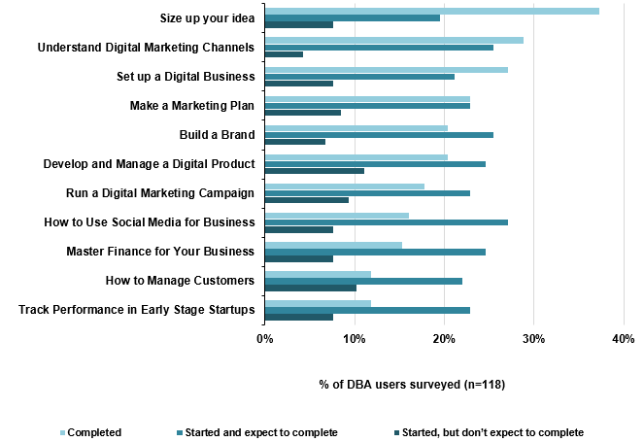
Source: SQW survey
  - Most respondents believed that they could be encouraged to continue using the DBA by measures including receiving periodic email prompts (35%), being assigned a tutor or buddy (34%), greater flexibility in the timing of live events (29%), more rewards (24%), and better rewards (23%). Other suggestions were for the DBA to comprise a free micro master or specialisation degree, practical workshops, and a fluency in digital marketing course.
  - Respondents generally had positive views towards the DBA. It was rated highly on the quality of the course content (84% found this to be “good” or “very good”), its user-friendliness (83% found this to be “good” or “very good”), and the relevance of the course (81% found this to be “good” or “very good”). Notably, 90% were likely to recommend the DBA to others.
  - Survey respondents were asked how DBA could be improved. For each of the possible improvements, the majority of respondents reported that could be at least “somewhat useful” (see Figure 3-2). The three most popular options were: more courses on a wider range of subjects; certifications to be recognised; and to have access to other TCUK programmes and initiatives through the DBA.
Figure 3-2: In your opinion, how useful would the following be to improve the DBA?
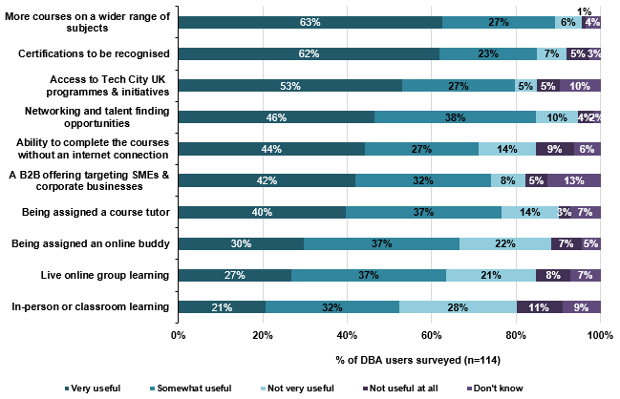
Source: SQW survey
  - To supplement the online survey, we conducted in-depth telephone interviews with 15 DBA users to add further insight and analysis to the survey responses. Four of these interviews are included as case studies in Annex C.
  - Interviewees gave some insight into why they accessed and used the DBA. The main reason was its association with business schools and universities, particularly UCL (eight responses). The second reason was the association with TCUK (four responses), followed by the fact that the DBA is government backed (two responses). Whilst the TCUK association was important for some, several interviewees (six responses) had not heard of TCUK, and so this did not affect their decision to start using the programme. The courses started and completed by the interviewees are summarised in Table 3-9.

Table 3-9: Courses that DBA interviewees have completed, started and expected to complete, and started but don’t expect to complete (of the 10 who gave an answer):
Course | Completed or expected to complete | Started but don’t expect to complete
Size up your idea | 9 | 1
Set up a Digital Business | 9 | 1
Make a Marketing Plan | 8 | 2
Develop and Manage a Digital Product | 7 | 3
Build a Brand | 6 | 4
Understand Digital Marketing Channels | 5 | 5
Run a Digital Marketing Campaign | 4 | 6
Master Finance for Your Business | 4 | 4
How to Manage Customers | 4 | 6
How to Use Social Media for Business | 4 | 6
How to Track Performance in Early Stage Start-ups | 3 | 7
Source: SQW survey
  - In terms of issues affecting completion, the feedback from the telephone interviews aligned with the survey results in that the DBA users often did not have enough time to finish modules (five responses). A small number identified ways in which they may be encouraged to complete courses, e.g. through email prompts (two responses) and more or better rewards (one response). One consultee suggested that the DBA could hold 60-minute educational video sessions once a week, as this would fit easily around most schedules.
  - Overall, the DBA interviewees were positive about their experience of the courses. Several stated that the DBA was useful for them because it was focused on achieving one goal, namely to clearly explain how to start, grow or join a digital business (nine responses). As such, they found the DBA more practical than other available programmes. We return to this point in section 4 when reporting on outcomes achieved. Several found the courses approachable and easy to use (eight responses), high quality (seven responses), and engaging and accessible (six responses). Some others enjoyed the courses because they were free (five responses), included useful videos (four responses), gave rewards (four responses) and could be picked up as and when to fit around any schedule (three responses). In this way, the interviewees and survey respondents both shared positive views towards the DBA.
  - The DBA telephone interviewees echo the survey respondents in terms of what potential improvements to the DBA they would find useful, but several proposed an additional recommendation; that the DBA should be more widely publicised (four responses). They would like the DBA to be promoted in the digital sector and in start-up circles, so that it is recognised by potential employers and business partners.

Tech Nation Visa Scheme
  - The Tech Nation Visa Scheme is a cohort of the Home Office’s Tier 1 Exceptional Talent visa route for those working in the digital and tech based industries. TCUK has acted as the endorsement body for this route since its inception in 2012. This allows up to 200 endorsements per year.
  - Prior to applying for the Tier 1 visa from UK Visas & Immigration, those considering this route must first seek an endorsement from TCUK. This process seeks to determine whether the applicant aligns with the broad aims of the Exceptional Talent and Exceptional Promise routes, namely that they meet one or more of the following criteria:
- be established as a world leader in the field of digital technology
- demonstrate the potential to become a world leader in the field of digital technology
- be an internationally recognised skilled professional in this field
- have the necessary business and technical skills to grow and scale-up technology companies.
  - The criteria are subjective, but the application requires applicants to provide citations and endorsements from colleagues and partners and concrete evidence of market innovations and/or business success which highlights either a proven track record (exceptional talent) or one or two examples of innovation (exceptional promise).
  - Tech Nation’s list of roles and skills required or sought is broad, ranging from specific technical positions such as ‘Senior data scientists’ or ‘Kernel programmers’ to experiences including ‘Scaling a digital product internationally’ or ‘Leading a C suite team in an SME’. This breadth is borne out in the list of endorsed applicants, which includes experts in business analysis and public affairs alongside a host of software engineers and product developers. A full breakdown of roles held by successful applicants is shown in Figure 3-3. This shows that software engineers are by far the largest group of endorsed applicants.
Figure 3-3: Tech Nation Visa applicants and endorsements by job role, 2014-2017
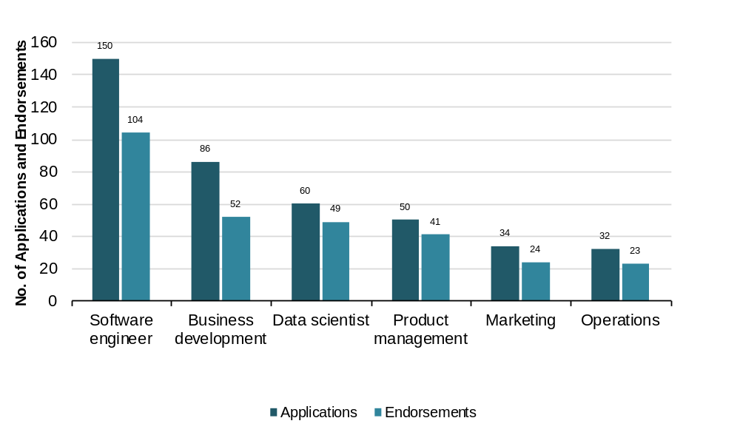
Source: TCUK
  - As well as endorsing applicants, TCUK also undertakes outreach activities to improve knowledge of the Tech Nation Visa Scheme amongst UK companies, including free “visa surgeries” in the Northern cities.
  - TCUK can also recommend changes to the criteria to both DCMS and the Home Office. For example, during 2015/16 they suggested changes to acknowledge the increasing importance of ‘scale up’ experience to the UK digital economy, to support the Northern Powerhouse and allow recruitment of teams from overseas.
  - We interviewed four successful applicants of the Tech Nation Visa Scheme as case studies. These included company owners, digital experts and other individuals using the UK as a base for broad international practice. These individuals have received endorsements from global tech players such as Google, Microsoft and Zoosk and/or have contributed to globally recognised open-source software projects. The cases studies can be found in Annex B.
  - The feedback from the case studies was very positive on the scheme (as was the role of TCUK). The key points from consultees are summarised as follows.
  - There was a mix of motivations amongst applicants for the scheme. For all applicants, their decision was underpinned by a desire to work in the UK, specifically London. In two instances the original motivation was to establish a new business or European satellite of an existing business, whilst another effectively led to this outcome, but was driven by the desire to procure a specific contract. Although not a core motivation, the flexibility of the visa in terms of the ability to move roles, build a portfolio career or work overseas was a secondary benefit – all four applicants interviewed have taken advantage of this benefit in one way or another, and all identified it as a key benefit over other visas, specifically Tier 2.
  - All applicants interviewed had a mixed view of the application process, but for differing reasons. For some it was too slow and bureaucratic, and for others the guidance offered was unclear or lacking detail. Despite this there was recognition that a high standard was required, and that TCUK’s ability to advise and influence the process was bound by their relationship with and responsibility to the Home Office.
  - Applicants would have welcomed a more responsive approach to questions, particularly those regarding endorsements and the depth and detail required on achievements and career to date. The guidance offered is very broad, with little direction on what types or quality of evidence was necessary to give an applicant the best chance of success. One applicant did have a positive experience; TCUK had checked and approved the endorsement letters during the application process in a manner which did not prejudice the forward application with the Home Office.
  - For all applicants, the UK’s decision to leave the European Union has caused issues. It has led to loss of contracts and opportunities, and low confidence in the European and UK business communities to invest in the types of innovation and change which some of them offer. This is especially concerning for a provider of cloud-based procurement services who chose the TCUK visa as a means of establishing a European presence.
  - There is a clear sense of community amongst Tech Nation Visa holders. Even within the small number of individuals interviewed, applicants were aware of others’ backgrounds, with several having met via a networking and alumni group founded by two case study participants (with TCUK’s “blessing”). Beyond this, three out of four applicants interviewed were ‘paying forward’ on the experience by mentoring either UK start-up businesses, or recent Tech Visa arrivals. This may not be unusual practice within the tech community per se, but those who mentioned this tied it back to a positive experience of the UK marketplace and the support offered to them by TCUK.
  - The main issue of the Scheme, beyond a lack of in-depth guidance on the application process, was a lack of pastoral support upon arrival in the UK. Although most of those interviewed had some prior knowledge of the UK either as a destination for study or holiday they would have welcomed stronger ‘business concierge’ support to help them embed themselves in their new living and working environment. This covered everything from educational choices for an applicant’s children, through to registering with a GP, and the fundamentals of UK company, tax and employment law processes. One person interviewed suggested that this ‘may be available’ but it was never clear where, and from whom, which led to several large and potentially avoidable legal bills. This may well not be within TCUK’s remit, but links to other points made by stakeholders on the need for TCUK to be able to tap into the wider support that TCUK-engaged individuals and businesses may benefit from.

Tech Nation Report
  - The Tech Nation report is viewed very positively by stakeholders and companies alike and has been described as a “seminal publication” for the UK digital tech sector. The key purpose of the report is to provide the most comprehensive analysis of the UK’s digital tech industries using date from a range of sources (e.g. surveys, job advertisements, privately-held data such as on investment, and official ONS data). The 2017 Tech Nation survey received more than 2,700 submissions (i.e. organisations and/or individuals providing data), up from 2,000 for the 2016 report. The 2017 report was assembled with the assistance of seven project partners and 220 community partners.
  - Several stakeholders commented that the report has become “better with each edition”, highlighting “the foundation of Tech stats delivered in the report” as of key significance, especially for promoting dialog across the sector and for looking at the comparative strengths of clusters across the UK. Above all, consultations suggested that the report is used and discussed widely - “it does get mentioned quite a lot”, “a lot of people use the numbers”, “it is what gets the most clicks” – and stakeholders are very keen for the report to continue moving apace with the sectors.
  - Some stakeholders regarded the Tech Nation report as “the most important thing it [TCUK] does” and as having “massively served its purpose”. Local stakeholders, in particular, find the report “useful in loads of ways”, as it is not only “very credible” but has put “a spotlight on the performance of tech clusters outside of London”. This was noted to have built the confidence and galvanised the voice of tech communities and policymakers in less prominent cities, and further provided “a turning point in developing relationships in different parts of the UK”. More specifically, regions use the report to promote tech activity locally, as a key positioning tool, for attracting inward investment, and for benchmarking, which has yielded “big savings in time and research” for organisations and investors.
  - According to one regional stakeholder the Tech Nation Report has helped to improve the “confidence of the region” - the material/data contained in the report is frequently used in marketing materials to promote the regions.
  - Finally, a few stakeholders identified the lack of advanced warning for issuing the Tech Nation Survey to their ‘communities’. It was argued that a better response rate could have been achieved if this had been done as it would have allowed to prepare and “warm up” respondents and maintain a better relationship with their community. According to TCUK, 2,700 survey responses were received this year, up from the 2,000 responses received in the previous year. This suggests that the multi-approach to engagement expanded the reach overall.

Marketing
  - TCUK’s marketing activities uses a wide range of ‘tools’ (e.g. social media, roadshows, online and print press, and events) to further amplify and develop the capabilities of the UK’s digital tech sector nationally and internationally. This involves, but is not limited to:
- developing and managing the TCUK brand within the wider ecosystem
- PR and communications for thought leadership content
- active dissemination through digital channels
- influencing policy areas, partnerships and events.
  - Overall, the feedback from companies and stakeholders suggests that the marketing efforts of TCUK and Tech North are thought to be of high quality. The following provide examples:
- profiling and awareness raising of activities such as the Tech Nation Report, events, showcasing activities of Tech North of northern businesses
- the use of the TCUK website with quality content such as video clips on programmes and infographics.
- bringing together firms through the business lifecycle programmes
- leadership, organisation and convening, e.g. FinTech Delivery Panel.
  - However, a specific area where further work could be done relates to the need to develop clearer branding and objectives for TCUK and Tech North and communicate these to intended audiences. As part of this, there is a need to address branding and linkage issues to overcome confusion on the roles and remit of both TCUK and Tech North. In section 6, we discuss this further.

Assessment of outputs
  - The key outputs capturing the performance of TCUK and Tech North are presented in a series of tables below covering: Business Lifecycle Programmes, Digital Skills, and Thought Leadership (including marketing). It is worth noting that these cover many (but not all) of the metrics set out in the TCUK Evaluation Strategy 2014 (which also included targets for 2014/15). The data presented in the tables have been drawn from various sources:
- TCUK DCMS Monitoring Meeting March 2017 Reporting Period & Year-end Review PowerPoint
- TCUK Historic Delivery PowerPoint (supplied June 2017)
- TCUK Events Schedule (April 2017)
- TCUK Dashboard
- TCUK Evaluation Strategy (2014)
- Interim Evaluation of TCUK (2015).
  - It is our understanding from TCUK that in many cases there were no targets for 2015/16 and 2016/17. Where there were no targets, the increase (or decrease) over time have been used to judge performance. Where there were targets, these have been identified and commented upon to show progress (or otherwise).
  - In reviewing the monitoring data, it became clear that there is plethora of different indicators from various sources, which in some cases report slightly different figures. We do not present all of the indicators below but have selected those which were directly related to the activities discussed above, and which relate to the indicators identified in TCUK Evaluation Strategy.

Business Lifecycle Programmes
  - The data in Table 3-10 show that for all the business lifecycle programmes there have been increases between 2015/16 and 2016/17 for the number of companies engaged, completed applications, proportion of companies outside of London in all programmes, event attendance and number of events held. We understand that there are a greater number of smaller events, which are associated with higher levels of engagement and greater targeting of applicants. The significant increase in the proportion of companies from outside London was likely to be influenced to a large degree by the volume of companies engaged through the Founders’ Network in the north of England.
  - The Net Promoter Score (NPS) was also “great” at 56% for 2016/17 (we note from the TCUK KPI Dashboard that the NPS was reported to be even higher, at 64% as at June 2017). According to TCUK, the NPS in 2016/17 for Future Fifty was 28% (target 60%); Upscale first cohort was 58% (target 60%); and Founders’ Network was 74% (target 65%).
Table 3-10: Business Lifecycle Programmes: Future Fifty, Upscale, Northern Stars, Founders’ Network
 | 2015/16 | 2016/17 | % change
Number of companies in all programmes | 151 | 232 | 87%
Total completed applications all programmes | 235 | 391 | 66%
% of total applications that were completed | 38% | 55% | 48%
% of companies outside of London in all programmes | 34% | 78% | 126%
Average Net Promoter Score | N/A | 56% | N/A
Total event attendance | 1,755 | 2,459 | 40%
Number of events | 50 | 93 | 86%
Source: TCUK DCMS Monitoring Meeting March 2017 Reporting Period & Year-end Review PPT
  - Table 3-11 gives the Future Fifty targets for: number of firms supported, number of events held, and number of individuals participating in events. The data indicated that all targets have been exceeded or nearly met. The achieved figures also show some major increases since 2014/15, in particular for the number of individuals from Future Fifty firms participating in events.
Table 3-11: Future Fifty metrics
Metric | 2015/15 - target | 2014/15 –achieved | 2015/16 - target | 2015/16 (as of Q4 2015) - achieved | 2016/17 -target | 2016/17 (as of Q4 2016) - achieved
Number of firms provided with intensive one-to-one support from the Future Fifty team | 50 | 50 | 50 | 50 | 50 | 48*
Number of Future Fifty events delivered | 12 | 19 | 10 | 18 | 10 | 31
Number of individuals from Future Fifty firms participating in events delivered as part of the programme | 100 | 205 | Not available | 348 | Not available | 698
Source: TCUK DCMS Monitoring Meeting- March 2017 Reporting Period & Year-end Review PPT’; TCUK Historic Delivery PPT; Interim Evaluation of TCUK (2015); TCUK Events Schedule (April 2017); * 48 companies because two went into administration
  - In Annex E, Table E-1 identifies the events held between 2014 and 2016, the event type and the number of attendees at each event. The events appear to be well balanced in terms of the number and range of topics covered in each year. Partner-led workshops and peer networking/ roundtable were the most common events. The levels of attendance appears to be relatively consistent throughout all events and over time.
  - Table 3-12 indicates that the target for the number of Upscale firms provided with support has been achieved. The number of events held was notably greater than for the number of Future Fifty events (49 Upscale versus 19 Future Fifty events in 2015/16).
Table 3-12: Upscale metrics
Metric | 2015/16 - target | 2015/16 (as of Q4 2015) - achieved | 2016/17 (as of Q4 2016) – achieved
Number of firms provided with intensive one-to-one support from the Upscale team | 30 | 30 | 33
Number of Upscale events delivered | 22 | 49 | 20
Number of individuals from Upscale firms participating in events delivered as part of the programme | Not available | 1,281 | 526
Source: TCUK DCMS Monitoring Meeting- March 2017 Reporting Period & Year-end Review PPT’; TCUK Historic Delivery PPT
  - The metrics for Northern Stars are presented in Table 3-13. The figures for number of applications completed in 2016/17 show good progress.
Table 3-13: Northern Stars metrics
Metric | 2015/16 – achieved | 2016/17 - target | 2016/17 - achieved
Application started | 223 | Not available | 176
Application completed | 71 | 92 | 80
Pitching events | 4 | 4 | 4
Finalists | 20 | 20 | 20
Winners | 10 | 10 | 10
Source: TCUK DCMS Monitoring Meeting- March 2017 Reporting Period & Year-end Review PPT’; TCUK Historic Delivery PPT
  - The targets for Founders’ Network applications, companies, events held have nearly been met or exceeded as shown in Table 3-14.
Table 3-14: Founders’ Network metrics
Metric | 2016/17 - target | 2016/17 - achieved
Applications | 257 | 232
Companies | 150 | 161
Events | 20 | 19
Attendees | Not available | 328
Source: TCUK DCMS Monitoring Meeting- March 2017 Reporting Period & Year-end Review PPT’; TCUK Historic Delivery PPT’ SQW estimates based on TCUK monitoring data

Digital Skills
  - Table 3-15 presents the metrics for Digital Business Academy and the Tech Nation Visa Scheme. The number of people completing at least one course, the number of courses started, the number of courses completed, and average course completion rate have all risen between 2015/16 and 2016/17. There is significant increase in applications received and endorsed between 2015/16 and 2016/17 – a 350% increase in demand over one year.
Table 3-15: Digital Skills: Digital Business Academy, Tech Nation Visa Scheme (cumulative)
 | 2015/16 | 2016/17 | % change
Digital Business Academy
Number of people started at least one course | 10,290 | 14,852 | 44%
Number of people completed at least one course | 1,128 | 1,769 | 57%
Number of courses started | 16,309 | 22,435 | 37%
Number of courses completed | 2,120 | 3,162 | 49%
Average course completion rate | 13% | 14% | 1%
Net Promotor Score | N/A | 59%
Proportion of people outside of London | N/A | 45%
Tech Nation Visa Scheme
Applications received | 84 | 467 | 455%
Applications endorsed | 65 | 324 | 398%
% approved | 77% | 69% | -8%
Source: TCUK DCMS Monitoring Meeting March 2017 Reporting Period & Year-end Review PPT

Thought leadership (including marketing)
  - TCUK has been very active in the thought leadership space with increased presence online – one-third increase in social media followers (twitter, Facebook etc.) and greater numbers of unique web visits. The substantial increase in publication views of 262% is a major achievement in just one year. Press coverage has risen by 8%, but Advertising Value Equivalency and clippings have declined. According to TCUK this may be in part due to reduced spending in PR, and shift in coverage to more specialist publications.
Table 3-16: Thought leadership – marketing
 | 2015/16 | 2016/17 | % change
Online:
Social media followers | 80,000 | 106,299 | 33%
Unique web visits | 127,500 | 185,000 | 45%
Publication views | 71,777 | 260,000 | 262%
Press:
Clippings | 2,181 | 1,628 | -25%
Advertising Value Equivalency | £6,331,900 | £4,316,322 | -31%
Total circulation | 552,998,662 | 599,334,799 | 8%
Source: TCUK DCMS Monitoring Meeting March 2017 Reporting Period & Year-end Review PPT
  - TCUK have now published three Tech Nation Reports since 2015, which are proving to be a successful “hit” within and outside of the digital tech community. This is evident by the company and stakeholder feedback, wide coverage of the report in the media, and the number of page views for the 2017 report (over 66,000 since launched in March 2017). The dissemination of the report in 2017 was through road shows, events and online. It is also important to highlight that there are various other publications produced by TCUK for example Tech Nation Best Practice – Promoting Enterprise & Regeneration.

Summary
  - The evidence indicates that the activities cover all stages of the entrepreneurship and business journey. Underpinning all the activities is a focus on developing a community and voice for all those who are active in the digital tech sector. In this respect, we reinforce the feedback from stakeholders that the offer from TCUK is about the “package of activities”. Moreover, whilst the activities delivered by TCUK and Tech North can be viewed discretely, there is notable evidence of linkages between them, for example at different points of the ‘customer journey’ for different programmes (as in Upscale companies graduating to Future Fifty), and through the use of alumni to help support other activities. We consider these points in more detail in section 4.
  - The motivations for involvement in the various programmes seem to accord with the rationales stated within the underlying logic models for TCUK as a whole as well as the individual programmes. In particular, accessing knowledge and expertise helps in addressing information failures on the part of companies, the access to government helps to address the information issues in terms of how government and policy understands the needs of the sector, and the networking components align with arguments around clustering externalities.
  - The outputs appear to be directly linked to the activities of TCUK. Overall, TCUK has made impressive progress in achieving many of its intended outputs over time across the Business Lifecycle Programmes, Digital Skills and Thought Leadership. The TCUK and Tech North staff should be commended for their hard work in delivering the outputs given the ‘lean’ operations of the initiatives.

Assessment of outcomes, impacts and value for money
  - This section sets out the evidence on the intended outcomes and impacts of the different programmes, including the extent to which these may not have occurred without TCUK or Tech North. This is followed by an assessment of value for money of TCUK and Tech North. The section ends with an assessment of the wider impacts, including that on the ecosystem.

Outcomes

Future Fifty
  - The Future Fifty companies we interviewed reported that they had achieved or expected to achieve the following key outcomes as a result of participating in the programme (see Table 4-1). It is worth pointing out that the top three outcomes reported align well with the original motivations of the companies for joining the programme.
Table 4-1: Future Fifty outcomes
 | No. of responses
Increased promotion and recognition | 15
Accessed new networks and/or made new connections | 15
Improved peer to peer learning | 14
Gained access to government | 10
Gained access to expertise | 9
Improved understanding of market position of market opportunities | 5
Improved management capabilities | 4
Launched new products or services | 2
Accessed new investment | 2
Developed knowledge and skills specific to their main market | 2
Accessed new markets | 1
Source: SQW interviews
  - One of the most commonly reported outcomes was increased promotion and recognition. In some cases, this had helped to increase exposure and access to potential customers and investors. Several companies identified that this had the added benefit of helping to attract and recruit high calibre employees. This was achieved by using the Future Fifty “badge” as an accolade to signal to potential recruits and graduates that they are good companies to work for and develop careers with.
  - The other two most prominent outcomes were access to new networks and/or making new connections; and improved peer-to-peer learning.
  - The events programme, in particular, was valued not only for the quality of the content and experts on hand, but equally for the extended discussions it facilitated within the peer group of companies. The events provided a “perfect setting” and “relaxed environment” for facilitating networking and providing opportunities for establishing new connections and networks. Several noted that by learning from, and being influenced by, the collective “bank of intelligence” within the peer group they had been able to make better decisions that had shaped the strategic planning of their companies. Looking to the future, several companies suggested that the new relationships and “close-knit community” established over the course of the programme is expected to yield benefits in years to come. More specifically, as the groups of companies scale, mature and confront similar issues, the network may well provide an invaluable resource to tap into, share knowledge and exchange insights – “it has allowed us to develop relationships that we intend to tap into in the future”. Similarly, several of the companies noted that they now engage with TCUK as speakers and mentors on Future Fifty itself, as well as Upscale, serving to expand and deepen the network across cohorts and programmes.
  - Further to the three key outcomes noted above, two other outcomes were reported by around half of the consultees: access to government and access to expertise. Based on the consultations, ‘access’ referred not only to organised events with experts and cabinet ministers (including at Downing Street), but also to ad-hoc support on a range of issues, including visa applications, as illustrated in the case studies (see later in this section). Several companies underscored the calibre of experts enlisted for the events, with some reporting benefits as a direct consequence of support, including one company actively entering a new market via a contact met at an “international expansions” event.
  - In ‘hard’ quantitative terms however, the evidence on performance measures such as employment, sales or valuation was very limited. Several companies suggested that outcomes in these terms were not a direct result of the programme, and so very difficult to estimate. Several did indicate that the programme was likely to have had a modest impact in one or more of these areas, but that this was more indirect and operating through the types of outcomes outlined in Table 4-1. In terms of timing, four companies did suggest that while the programme was unlikely to have resulted in increased employment, sales or valuation, it had allowed them to reach their current position at a faster rate, for example by being able to tap into the knowledge of experts and the peer group to make better decisions more rapidly. Four further companies suggested that the programme had helped to achieve outcomes of higher quality, at a larger scale, or in terms of combinations of greater speed, higher quality and larger scale.
  - It is also worth mentioning that a number of the companies had undergone an IPO or M&A during, or subsequent to, participating in the programme (as noted in Section 3). Of the companies interviewed, five had undergone an IPO or M&A at the time of the interviews, with several either in the process of, or with immediate plans to, reach a similar outcome in the near future.
  - We provide case study summaries of two interviewee companies (Crowdcube and Lumi Technologies) to illustrate how TCUK’s engagement with these companies has led to positive business benefits. Two further case studies (Graze and Loopup) are provided in Annex C.
Crowdcube
Crowdcube is a crowdfunding platform, established in 2011, which enables individuals to invest in, or provide a loan to, small companies in return for equity or an annual return. The company is based in Exeter, Devon, and has an office in London.
The primary motivation for applying to the Future Fifty programme was to generate PR value, particularly by forming part of “a cohort of the best, brightest, and most promising digital tech companies in the UK”. It is worth noting that one of their chief officers simultaneously acted as a mentor on the Upscale programme, and continues to do so.
The biggest benefit to the programme for the company was the “kudos and recognition” associated with becoming a Future Fifty company, and the increased profile achieved through the launch event for the new cohort of companies, in particular. Benefits have already been realised in this respect, with further benefits expected into the future. Specifically, this has helped to raise the profile of the company to potential investors in Crowdcube, as well as interest in their platform among companies as an option for raising finance and among potential investors in these companies. The scale of this impact is very hard to estimate, but it is likely to have had a modest impact on the company’s speed of development – they would be “a little bit further behind” without taking part in Future Fifty. The company largely attributes its growth more broadly to increased awareness of the company on the side of investors in Crowdcube as an investment platform, in crowdfunding as a more viable option for businesses seeking finance, and from greater acknowledgement from financial institutions and venture capitalists in the crowdfunding sector.
The company has also attended a number of high quality events and made some valued connections through the programme. In terms of impact, it is important to note that such events are plentiful in London and linking such activities to outcomes is very hard to do. In terms of suggested improvements on the programme, more could be done to structure and promote the programme content in ways to “grab the attention of CEOs”, as well as to proactively bring the cohort of supported companies together by encouraging networking.

Lumi Technologies
Lumi Technologies, founded in 2008, is a market leader in mobile applications designed to transform meetings, conferences, events, and education and training with technologies that allow for interactive audience engagement – such as real-time polling and Q&A – and the sharing of ideas, suggestions and feedback. The company is based in Hampshire, with offices in the United States, Australia, Netherlands, Belgium, France, Germany, Finland, Hong Kong, Singapore and South Africa.
Following an invitation from Future Fifty, Lumi applied to be part of the first cohort of beneficiary companies. The programme was regarded as not only “very competitive” and rigorous, and therefore “good to be in”, but also attractive in terms of networking opportunities and access to government.
The key benefits for Lumi centred on the opportunity to network with tech firms and to take advantage from, and contribute to, the “bank of intelligence” within a community of firms facing similar challenges. This was further galvanised through the Future Fifty events programme, which was regarded as focussing on the right areas and arranged with the “best experts”. More specifically, the advice and the exchange of insights around R&D tax credits, IP, and talent management were regarded as particularly valuable. In return, senior staff at Lumi – with backgrounds in investment banking and private equity – could share their knowledge and experiences in finance and venture capital to the benefit of the network.
More generally, the kudos associated with the Future Fifty brand has yielded PR value to the company, which may have modestly boosted their valuation. Visits to Downing Street, to discuss issues pertinent to tech companies, access to government ministers and respond to important developments, such as the Future Fifty statement around the EU referendum result, are regarded as morale boosting and highly valuable. There have been, however, instances where the responsiveness to requests from companies by the programme have not met expectations.

  - In addition to the above feedback, Table 4-2 provides comments by eight companies given directly to TCUK on their engagement with the Future Fifty programme. It must be noted that these comments were not requested from the companies as part of this evaluation, but were provided to us by TCUK. Whilst recognising that there may be a degree of positive bias among companies providing feedback directly to TCUK, they do provide useful insight on how the programme is perceived. The views are encouraging of the programme, highlighting for example the benefits of peer-learning, access to Government, and development of the wider ecosystem, all of which align with the evidence collected independently through the interviews conducted as part of this evaluation.
Table 4-2: Views from Future Fifty companies provided directly to TCUK
Quotes
“Sometimes there’s questions that can only be answered by someone who’s done this before… Being able to sit in a room with 49 other CEOs, is absolutely fantastic.” Andrew Patrick White, CEO, FundApps
“The concierge-style service means that there's a team at Tech City UK who are able to give us practical help and advice in tackling the speed bumps we face on our growth journey.” Sarah Wood, CEO, Unruly Media
“It’s a fantastic network of great people and companies. Great support from the Government which is doing a fantastic job in the UK tech industry.” José Neves, CEO, Farfetch
“Being part of Future Fifty not only provides us with direct benefits, such as peer-learning, but ensures that our experiences help shape the wider scale-up ecosystem.” Rhydian Lewis, CEO, RateSetter
“The really important stuff to us is the access Future Fifty gives us to companies of a similar size and the voice into Government, more than just the accolade of having made it.” Alice Newton-Rex, Head of Product, WorldRemit
“I think that Future Fifty can be a great sounding board for meeting like-minded founders” Bernhard Niesner, CEO, Busuu
“I’ve met some of the best tech companies in the UK, some really interesting companies launching in the U.S.” Charles Wells, CMO, Just Giving
“Really appreciate the support from Tech City and Future Fifty over the last few years - made a big difference.” Ben Medlock, co-founder of SwiftKey (sold to Microsoft, February 2016)
Source: TCUK
  - Finally, feedback from stakeholders emphasised the programme’s ability to showcase the “best the UK has got” and highlight the dynamism of tech in the UK, particularly to an international audience. Stakeholders also highlighted the direct benefits experienced by companies through as an example, increased exposure to clients and investors. The role model effects of the group were also highlighted as important, helping to inspire participants in other TCUK programmes – Upscale, in particular – as well as the broader tech community.

Upscale
  - The outcomes achieved by the 15 Upscale companies we interviewed are presented in Table 4-3. The same key outcomes are common for Upscale as they are for Future Fifty: accessed new networks and/or made new connections; increased promotion and recognition; improved peer to peer learning; and gained access to government. However, it is notable that three outcomes are cited more by Upscale companies: improved management capabilities; improved decision-making/judgement; and gained access to expertise. Interestingly, the second, improved decision-making/judgement was not cited by any of the Future Fifty companies interviewed. These differences may reflect that ‘coaching’ is more of a focus for the Upscale programme.
Table 4-3: Upscale outcomes
 | Number of responses
Accessed new networks and/or made new connections | 11
Increased promotion and recognition | 9
Improved peer to peer learning | 9
Improved management capabilities | 7
Improved decision-making/judgement | 7
Gained access to expertise | 7
Gained access to government | 7
Improved understanding of market position of market opportunities | 4
Developed knowledge and skills specific to their main market | 4
Launched new products or services | 2
Considered new business models | 2
Source: SQW interviews
  - It is worth mentioning that two outcomes (‘accessed new markets’ and ‘accessed new investment’) were not reported by Upscale companies. On the latter, it is important to distinguish between greater exposure to investors and actually seeking/receiving investment. Several companies reported on the increased exposure and awareness of investors as result of the programme. For example, one company interviewed “knows 10 times the VCs than before Upscale”, and another company reported that it “could have raised investment, but […] are not in fundraising phase”.
  - The feedback from consultations suggests many of the outcomes are inter-linked and not mutually exclusive. For example, in one case the greatest value for the company was in the networking opportunities available across the company (not just for CEOs), as different events were aimed at different staff members. This meant that many members of the team were able to build their own networks with other businesses. This in turn was considered “good” for developing internal expertise and knowledge, and giving the company “confidence” to progress with their growth plans.
  - We also found evidence of connections being continued beyond the Upscale programme. A few companies reported that they were in contact with each other (and with mentors from the programme) through various channels e.g. email and informal groups. For example, one company interviewee has formed a group (outside of Upscale) of around 10 people that have been on the programme. This group is active and is used for sharing “problems” about being an entrepreneur. This support network is claimed to have been very important for this consultee. For this consultee, the unique feature of the programme was that the consultee found a group of peers/founders who would otherwise would not have come together. Other companies have formed working relationships or maintained close contact with other companies that were on the programme.
  - From the above, it appears the programme is considered important in developing greater connectivity in digital tech networks as well as in raising the profile of companies. Another indication of progression is the transition between TCUK programmes - one company we interviewed had graduated from Upscale and was now part of Future Fifty. In the view of this company, this would have unlikely to have happened if they had not been on the Upscale programme first. A review of the TCUK monitoring information suggests there are other examples of this graduation starting to happen (i.e. four companies have graduated from Upscale to Future Fifty).
  - As with Future Fifty, few companies reported “hard” outcomes on company performance such as turnover, employment or company valuation. There were essentially three categories of companies when reporting on improvement in company performance to the programme:
- First, those that attributed no direct effect of the programme on improving their growth (eight companies).
- Second, those who thought there was some attribution but it was simply very difficult for them to provide quantitative estimates (three companies).
- Third, those that confirmed attribution to the programme and quantified this (two companies reporting from 10-20% of their increase in turnover and employment).
  - From the perspective of stakeholders, Upscale was considered a welcome addition to the Future Fifty programme for a number of reasons including:
- the UK is considered to be good at starting businesses, but not “great” at growing them into “global champions” (partly because of lack of access to investment) the Upscale programme contributes to addressing growth challenges
- Upscale is about networking and coaching, ensuring that there is a degree of mentorship so that companies can learn from one another – enabling them to accelerate their development more quickly than would otherwise be the case
- Upscale companies have graduated to Future Fifty, thus providing linkage between programmes.
  - It was also pointed out that the programme arguably has helped to improve the “density of networks” in London with companies able to learn from others on key challenges that they face, for example talent sourcing, how to negotiate VC rounds, and marketing. In the view one consultee, Upscale and the London Mayor’s programme have similar content and there is perhaps some duplication of effort, with no evidence of coordination between these two programmes.

Northern Stars
  - All eight of the Northern Stars consulted for this study were early stage start-ups when they joined the programme. As a result, most firms identified the potential for raising their firm’s profile and networking opportunities as the main reasons for getting involved with the programme. The benefits the firms actually witnessed aligned with these expectations. All firms stated that their involvement in the programme had led to them accessing new networks and/or making new connections, and had led to increased promotion and recognition. Six reported that it had helped them in accessing new investment. Note here that the outcomes related to making connections with investors for potential future investment, rather than directly leading to investment occurring to date. This reflected the early stage of many of the firms, with the contacts established seen to be more useful in the future than at present.
Table 4-4: Northern Stars outcomes
 | Number of responses
Accessed new networks and/or making new connections | 8
Increased promotion and recognition | 8
Improved peer to peer learning | 6
Gained access to expertise | 6
Improved understanding of market position or market opportunities | 6
Accessed new investment | 6
Improved decision-making/judgment | 5
Gained access to government | 5
Accessed new markets | 5
Improved management capabilities | 4
Considered new business models | 3
Launched new products or services | 2
Developed skills and knowledge specific to their main markets | 2
Other | 1
Source: SQW interviews
  - All firms noted that being involved in the Northern Stars had helped to increase the profile of their business. For example, the Northern Stars competition pitching process provided firms the opportunity to present information about themselves. Similarly, the events that the firms attended, including ‘South by South West’ and ‘Tech Crunch’, provided the opportunity to promote the business to attendees and fellow exhibitors. The raised profile helped firms to attract potential investors, customers and staff. A few companies reported useful outcomes:
“We got increased visibility through the Bloomberg pitch, and a feature length piece on their website, which was great PR for the firm”
“The press coverage is the most valuable result of the programme, as it helps with investment and hiring talent”
“Northern Stars helped the firm in terms of its notoriety, raising the firm’s profile, and helping us to access new opportunities, with people contacting us after seeing us at events”.
  - All firms cited networking benefits resulting from their involvement in the programme. The programme gave Northern Stars the opportunity to network with fellow like-minded tech start-ups across the North that were also on the programme, as well as opportunities to meet prospective customers, investors, other tech entrepreneurs from outside the North, potential recruits, and Tech North itself. These connections have proved useful for firms in learning from their peers, finding new customers, recruiting new staff, and developing relationships with prospective investors. The feedback from companies included the following:
“One of the great things was meeting the other winners, and we are still in touch with them now”
“The other Northern Stars were like-minded, which meant we learnt from each other, including from other’s mistakes and learning best practice; some firms had experience of business development, whilst others had technical know-how”
“We met investors and leaders from other businesses at South by South West… Going to South by South West also helped us to forge close relationships with the other Northern Stars”
“We made connections through firms and individuals we met at events we attended, including potential talent and potential customers”.
  - Interlinked with these, consultees noted other benefits, such as increased credibility as a business, increased learning about running a business, access to expertise and government. In addition, firms noted that the process of having to present their firms at pitches and events meant that they honed their ability to pitch succinctly their business to new contacts. One business secured investment from investors that they met at the Tech Crunch event attended by the winners of Northern Stars. This £1m equity investment was secured in mid-2016, whilst the firm was on the programme, and they reported that whilst they would have secured this investment anyway, it would have taken longer to do so without Northern Stars.
  - Of the eight firms consulted for this study, six have grown in employment terms since starting on Northern Stars, with one remaining the same size, and one shrinking. All seven firms that had achieved sales when they joined the programme continue to trade. Attribution of positive outcomes directly to Northern Stars was mixed, due to the types of benefits that the firms experienced. Raised profile, networking, increased credibility and knowledge were all reported as helpful for the business, but it was difficult for some companies to link this directly to any uplift in business performance. That said, some of the companies interviewed did identify and could quantify a direct link in performance improvement to taking part in Northern Stars. In summary:
- four of the eight firms that we interviewed attributed no direct effect of the programme on improving their growth
- four of the eight firms were able to attribute positive business performance (employment and/or turnover) outcomes to the Northern Stars programme, with the attribution levels ranging, at 5%, 10%, 25% and 60% of growth achieved.

Founders’ Network
  - As highlighted in section 3, the Tech North Founders’ Network (FN) is an educational six-month programme of workshops and events for tech start-up founders in the North of England. It allows them to connect with each other, share experiences and learn from experts.
  - The following discussion on the outcomes and benefits of FN has been informed by a short online survey sent by Tech North to FN beneficiaries. The survey received 11 completed responses out of 208 companies despite sending out several reminders. The low response rate leads us to consider the results below as illustrative rather than conclusive. Full survey results can be found in Annex D.
  - Most respondents agreed that FN has provided them with opportunities to hear from and be inspired by successful founders (eight responses). Several believed that FN has given them opportunities to meet and network with other start-up founders in the North and support each other on similar challenges (seven responses), and others believe it has given them access to learning to equip them with the knowledge they need to scale their business (seven responses). All respondents agreed that these three benefits were either “important” or “very important” to the successful growth of their business.
  - The majority agreed at least “to some extent” that FN has provided them with useful ideas, knowledge and/or skills to grow their business (nine responses), has contributed to developing a cohesive entrepreneur-led tech ecosystem across the North of England (nine responses), and has increased their confidence in their ability to successfully grow their business (nine responses). Other areas where most respondents agree the FN has helped “to some extent” is in enabling them to build relevant professional networks and contacts (eight responses), and inspiring and motivating them to try to continue to grow their business. One respondent commented that FN provides a great opportunity to meet others trying to get a business idea off the ground, and that they enjoy being part of the community fostered by FN.
  - There were five elements of FN which most respondents found “important” or “very important” to allow it to successfully support ambitious digital tech entrepreneurs in the North of England. These elements were:
- providing opportunities for learning about topics of interest for founders (11 responses)
- being local (i.e. focused on connecting start-ups in specific cities / regions of the North - 11 responses)
- bringing high quality speakers from other parts of the UK and the world to the North of England (10 responses)
- being focused on the North (10 responses)
- being free of charge (10 responses).

Digital Business Academy
  - The Digital Business Academy is a free MOOC for users to develop skills to start, grow or join a digital business. It brings together resources from industry experts and educational institutions such as University of Cambridge, University College London, Founder Centric and Valuable Content, as discussed in section 3.
  - This section is primarily informed by the 121 DBA users surveyed between in March and April 2017, with some insight included from the interviews conducted with 15 DBA users between April and May 2017. Full survey results can be found in Annex D.
  - The majority of respondents believed that the DBA has changed their views or understanding of the digital tech sector at least “somewhat” in different ways (see Figure 4-1 below). In addition, nearly half report that they have been able to apply “a lot” of what they have learned from the DBA to their work, and some (8%) have been able to apply “everything”.
  - They have indicated that the most valuable skill or piece of knowledge learned from the DBA for them has been marketing and branding (37%), knowledge and information sharing (29%), and/or business development (21%).
  - If the DBA did not exist, the majority of respondents would have sought to acquire the same or similar skills and knowledge from another resource (95%). The survey results show a clear preference for other free online resources (80%), followed by free offline resources (42%).
Figure 4-1: To what extent has using the DBA changed your views or understanding of digital tech? Has it…
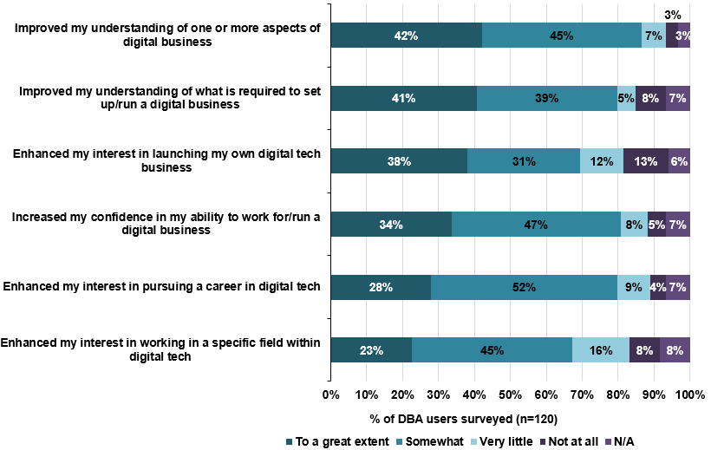
Source: SQW survey
  - A fifth (19%) of respondents have launched their own digital tech business or begun to make concrete plans to do so (Figure 4-2). Another fifth (21%) have taken on a different role/been promoted in either the digital tech sector or a ‘digital job’ in another sector. Over one-third (38%) have experienced no change.
Figure 4-2: Since you began using the DBA, have you…
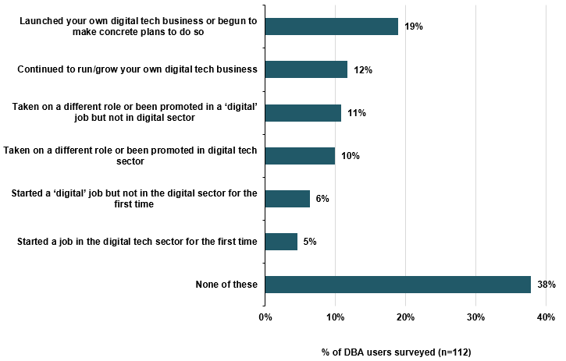
Source: SQW survey
  - We conducted telephone interviews with 15 DBA users to add further insight and analysis to the survey responses. Of the 15 interviewees, 10 had started or developed an early stage business, five are in employment; two have remained in non-digital sector roles, two have found employment after university and full-time childcare respectively, and one has been promoted in the digital sector.
  - Four of these interviews are included as case studies in Annex C. Overall, the case study subjects found the DBA beneficial, stating that it helped avoid some business costs, helped scale up their business, updated their knowledge, helped increase turnover, attract investment and build confidence. Some said it helped contribute to gaining a new job.
  - For those starting and/or developing businesses, there have been a range of ways in which the DBA was thought to have helped:
- for five of those interviewed by telephone, DBA has provided them with a strong framework to organise their initial business ideas
- others believed that it gave them a good understanding of the UK/ London market (four respondents)
- three respondents indicated that engagement in DBA has helped them to increase their turnover, and four respondents indicated that completing further DBA courses is expected have a positive effect on their future turnover
- other ways in which outcomes had been achieved for business owners included the positive effect on confidence and assistance on specific areas, such as developing a strong marketing plan.
  - Of the five that were interviewed by telephone and were in employment, outcomes have been varied. It has had the most impact on the two who have found employment after university and raising children respectively. Both agreed that the DBA has greatly helped them find employment by developing their knowledge and skills. The former believed that the DBA was complementary to his university degree, for which they achieved 1st class honours, and the latter found that the DBA was a great means for women to get back into the workforce after having children.
  - They did not attribute all of their success to the DBA, but saw it as a contributory factor alongside other reasons. The recent student thought that the DBA was important in helping him find employment, but that his degree was more important. Similarly, the mother returning to work found that alongside the DBA, her previous years’ work experience and existing professional network were also important in helping her find employment.
  - It has had less impact on the remaining three DBA users in employment. The two who have remained in non-digital sector roles had used the DBA to pursue a digital sector career, but have not yet realised this goal. The DBA user who had been promoted in the digital sector does not believe the DBA helped him achieve this.

Tech Nation Visa Scheme
  - The Tech Nation Visa Scheme has had some success in deepening the pool of high quality practitioners in the UK digital industries. They have helped bring both technical expertise (including data science, software engineering and innovation using open source techniques) and experience of the digital business cycle (e.g. scaling up, IPOs and MBOs) in key international markets such as the USA and South Korea.
  - The source of successful applicants is diverse. Although the US and South Korea, along with Russia, have the most successfully endorsed applications, they are followed by relatively large numbers from India, Pakistan and Australasia and a small number from Africa, South America and the Middle East. Research has shown that culturally and internationally diverse teams can benefit innovation - the scope of SQW’s research has not directly addressed this issue, but it seems likely that the 50% of endorsed applicants currently working within UK companies will bring learning and innovation benefits to their colleagues.
  - The size of outcomes and impacts is limited by take up. TCUK is permitted to endorse up to 200 applications per year and has seen improved take-up year-on-year. They fulfilled only 60 of these in 2015/16 with 228 applications endorsed in the 2016/17 financial year. This may suggest that TCUK’s attempts to address the problem through improved and increased outreach - notably through ‘visa surgeries’ with stakeholders in the North of England and partnering with leading tech accelerators including Tech Stars and Codebase – are bearing fruit. At the same time, it may also be indication of a broader need for senior and specialist skills across the digital economy, and increased awareness of the visa offer amongst employers and within the international tech labour market.
  - In qualitative terms, the four case studies undertaken by SQW, show real diversity of skills and experience. Experiences since visa grant have been mixed, and contingent on broader business conditions.
  - Two of the four applicants have changed jobs, which highlights the usefulness of the visa’s flexibility. Both have found more suitable roles, which draw on their background (Silicon Valley start-up product design and innovation accelerators respectively) and seem to be benefiting their current employers. A third applicant has broadened her client base from an original contract and is offering international digital usability consultancy to some of the UK, Europe and the USA’s leading media brands. Despite originally applying for the visa as the easiest way to fulfil a commission, she now foresees growing her business and practice from a London base.
  - One applicant has used the visa to establish a UK branch of their cloud procurement business, one has based her international digital media consultancy from the UK and others have undertaken diverse projects but are currently working in traditional, senior roles in UK digital businesses. The chief benefit which they drew attention to is experience of working in the international marketplace – case study applicants felt the UK’s understanding of both Silicon Valley and East Asia was poor, and that a deepening of knowledge on this front would help UK businesses get across new business processes and improve hit rate in terms of securing financing.
  - We provide case study summaries of two beneficiaries of the Tech Nation Visa Scheme (Lisa Gray and Akram Dweikat). Two further case studies are provided in Annex C
Lisa Gray
Lisa Gray has had a successful career in Australia and the USA as a producer of interactive and digital content for TV, online and in the crossover space between moving image and digital worlds. She was initially approached by a UK based company - Elton John’s Rocket Entertainment - regarding some potential conceptual consultation on a new project. The company was a start-up and unable to sponsor Lisa’s application so she instead pursued the idea of a Tier 1 Exceptional Talent visa which would allow her to work for both this and other clients.
Since arrival in the UK, Lisa has run her own creative and digital consultancy, worked for clients in the UK and the USA including the Guardian, BBC Worldwide, CBBC and Vice TV as well as Rocket Entertainment. She has passed up more permanent opportunities in favour of a portfolio based approach to her career.
The flexibility of the Tech Nation visa has allowed Lisa to build this portfolio, and to carve a niche in supporting projects in the moving image industries. This has also allowed her to remain globally active, taking jobs in Europe, the USA and back in Australia and to speak on several high-profile international panels. She sees the UK as the perfect place to build her career and is already looking toward citizenship in the long term.
Lisa’s engagement with TCUK was relatively light touch, but she doesn’t necessarily see this as a shortcoming. She found the paperwork for the initial application relatively intense and complicated, but having applied for funding and permits in Australia felt that she had a ‘head start’ over others.
Her initial application was rejected due to an administrative error – the Home Office permitted her to re-apply without prejudice due to lack of clarity in the guidance, but required her to re-submit the application and repay the fee. Despite this setback, as an applicant for the fast-track process she had the visa in hand quickly in order to take up her initial contract.
Lisa is part of the alumni group, seeking to make connection with other Tech Nation visa holders, but would welcome more opportunities to connect with other members of the TCUK community. This includes other stakeholders who may offer helpful business leads or interesting creative opportunities. She is due to undertake a coding course through one such connection, and wants to find opportunities to diversify her client and skills base.

Akram Dweikat
Akram Dweikat is a Palestinian national with a BSc degree in Computer Engineering and MSc in Innovation, Entrepreneurship and Management. He was central to building the start-up community in the West Bank, working with multinationals including Microsoft and Google, through which he met former US President Barack Obama.
Akram obtained a scholarship to complete a Master’s at Imperial College London, an experience which led him to return to the UK to set up a business alongside some friends. He chose the Tech Nation Visa to expedite the process, and for the range of opportunities it provides him with, from being able to register his own company to consulting or future employment.
He found TCUK’s support very helpful – they provided swift, helpful responses to several emails and went as far as providing the format and guidelines for endorsement letters from Google, Microsoft and other reputable entities.
Having fulfilled his initial intention to establish a business with friends, Akram spent the subsequent period consulting for several UK start-ups and tech SMEs, providing technical and market expertise to companies that could not afford to sponsor the visa for someone of his background. Akram recently accepted the role of CTO at BfB Labs, a post which was open for three months and proved difficult to fill due to a need for a combination of signal processing, hardware and software development experience. Akram's expertise, standing with TCUK, and his involvement in the emerging tech scene of Palestine, were all important factors in him securing the post.
He brings a unique package to the UK tech community, which suggests that TCUK’s internal screening processes are meeting their brief to find the ‘brightest and best’ international talent. Akram speaks Arabic, brings good knowledge of the Middle-Eastern market and on the technical front combines knowledge of both hardware and software. He allies this to skills in Fintech, including helping start-ups with big data and encryption challenges.
Despite a positive experience, Akram would like TCUK to do more outreach and roadshows in the Middle East where he feels there is untapped potential. He is very keen to help facilitate these using both his language skills and his market knowledge. He also feels that TCUK could provide more support to successful applicants by way of a ‘Welcome Pack’. He had to research the intricacies of UK employment law (and later tax rules for the self-employed), and to start up and register his own company including dealing with English and Welsh company law, despite little knowledge of the UK’s legal system.

Thought leadership and advocacy
  - There have been a number of outcomes relating to the thought leadership and advocacy role of TCUK and Tech North – and often with corroborating views from a range of different stakeholder perspectives. Three notable areas relate to the raised profile and promotion of the UK internationally as one of the top places for digital tech companies, which is particularly related to London, the increased awareness and understanding of regional clusters, especially within the UK but also to an extent internationally, and the voice provided to the digital tech sector, especially in policy circles. We discuss each of these in turn.
  - TCUK has developed international recognition, for itself, its programmes and for the brand “Tech City”. This was evidenced through a range of different sources. Stakeholders outside of TCUK that operated in different parts of the world indicated that TCUK is very well-known internationally – with most investment agencies overseas having heard of the brand and ‘Tech City’. Overseas, this is particularly understood as being the digital tech sector in London, which is described as “the Silicon Valley of the UK”. Through this, the UK has been put on the map as a tech savvy nation and an exceptionally competitive option for investors. Corroborating this view, stakeholders with a perspective from, and/or networks in, the investor community reported the increasing interest in the UK. This had been partly facilitated by TCUK’s work, including its promotional activities, but also the way in which high profile people had been attracted to support or talk at business lifecycle programme events. Whilst there are a range of factors that have contributed to investments in the UK, it is believed that TCUK has helped to attract some major companies, in particular to London. It is unusual for single factors to be decisive, and so the view from stakeholders was that TCUK’s role has helped to highlight the existence of a healthy and supportive ecosystem and to provide a perspective in between industry and government.
  - The evidence in terms of venture capital and private equity-backed investment identifies that London is still the largest location for investment in Europe, with £2.2bn of investment in 2016, compared to £1.2bn for Amsterdam and £1.1bn for Paris (drawing on Pitchbook data). Notably, as summarised by one interviewee, “there is now a significant interest in London as a place for investing in tech companies… If Tech City UK means London, then it has done its job.”
  - TCUK is seen as an important ambassador for promoting the UK digital tech sector overseas, through the profile it generates, its programme activities that demonstrate an active, connected and supportive ecosystem, and the practical assistance on international visits.
  - In the rest of the UK, the Tech Nation report has been recognised across regional and local stakeholders as an effective way of communicating that there is a range of digital tech ‘clusters’ outside of the capital. In particular, the Tech Nation report was seen as a turning point in establishing relationships with different parts of the UK, with the local coverage provided in the 2016 and 2017 reports providing a significant boost. Different local consultees illustrated this in the interview feedback:
- For one, the main outcome of the Tech Nation report was the recognition that “we have a significant digital offer here”, which has been very helpful in communicating to local and national partners that “we have to start investing in this sector”. There was also a sense that it has contributed to securing additional investment.
- For a second representative in the East of England, the Tech Nation report has been helpful in raising the awareness of the tech community locally. It has also helped to foster links that have contributed to the establishment of “Tech East”, which, with some public funding, has brought together Cambridge, Ipswich and Norwich.
- A third interviewee noted that it has provided an understanding of the tech clusters outside of London, which has benefitted the North of England in particular. This, along with the presence of Tech North, has started “a movement” of people, and has improved perceptions and aspirations around the digital tech sector.
- Finally, a fourth perspective highlighted that they use the Tech Nation report as an important part of their promotion efforts, and believes that it does contribute to galvanising the voice of the tech community locally. It can help to provide key messages that can be used when talking to potential investors about the region.
  - Regionally, investment outside of London has significantly recovered from 2015 to 2016, which could in part be down to Tech Nation and associated profile-raising of TCUK though is likely to be influenced by other factors. The non-London share of venture capital and private equity backed investment was 74% in 2012, which fell to around 40% between 2013 and 2015, before rising significantly to 68% in 2016. In addition, it is notable that investment in the UK excluding London in 2016 was greater than in France in total. However, there are likely to be other contributors to these trends, such as accelerators and European funding. On the latter in particular, arguably the share of investment outside of London fell in the years when private investment recovered and hit its recent peak, but increased in 2016 as private investors became more cautious and so European funding in the regions played a larger role in overall levels of investment in the UK. This may indicate that the private market is strong in London in particular, albeit subject to cyclical changes, but there remains a job to do in attracting investors outside of London and creating an ecosystem that can support a long-term legacy.
  - In addition to the Tech Nation report, there was positive feedback on the sharing of practice and through the early engagement with Tech North. For one local area in particular, it was noted that they have built their start-up advice and support services around good practice and advice received through the network, which has helped to stimulate private sector investment in early stage companies locally. The key factor here was being able to exploit the experience of other places, because TCUK was “really good at connecting you with experts”. Other stakeholders echoed the view, which was also identified in the interim evaluation of TCUK. Some of this effective sharing of ideas and expertise was particularly associated with the early days of the Cluster Alliance, though this has ceased to exist and was considered by some local stakeholders as a loss. Some local partners were unaware that it had been formally disbanded, and this communication issue ought to be resolved urgently.
  - The third outcome on thought leadership and advocacy relates to the insight and voice that TCUK has provided on behalf of the sector, especially in relation to policy. TCUK has sought to play an effective role in sitting between government and the digital tech sector, able to bring together the evidence and views of the sector and present them to government as well as getting companies to speak directly to government. A number of policy developments are notable in this regard, including inputs on:
- relaxation of rules on exceptional tech-related visas, responding in particular to issues around skills and talent shortages
- tax relief on peer to peer lending
- development of policy, e.g. around funding and inputs to the Digital Strategy
- work that has recently started in developing policy to support emerging areas such as fintech.

Impacts
  - We have estimated the impacts on companies that are attributable to the Future Fifty, Upscale and Northern Stars programmes based on the sample of interviews in terms of:
- Gross Value Added (GVA) impacts to date
- employment impacts to date.
  - The impacts from these three programmes have been aggregated to estimate the total impact to date of TCUK’s business lifecycle programmes delivered over the 2014/15 to 2016/17 period.
  - It is important to note that the estimates of impacts are uncertain for the business lifecycle programmes for several reasons including the following:
- A limited number of companies attributed and quantified impact on their growth performance to the programmes, reflecting the nature of benefits and routes to benefits. This will underestimate the overall effect, because our estimates do not take account of the non-quantifiable and non-attributable benefits.
- The large turnover and employment associated with some companies, especially Future Fifty companies, means that there is a margin of error associated with estimates. For instance, if the attribution to TCUK activities was slightly higher (or lower) for companies with high growth, then this would result in significant increases (or decreases) in the estimate of impact.
  - That said, we have ‘reasonable’ sample sizes on which to base our estimates:
- 21 out of 75 companies interviewed for Future Fifty
- 13 out of 33 companies interviewed for Upscale
- eight of 10 companies interviewed for Northern Stars.

GVA impacts
  - In estimating impacts, we developed an Excel-based economic impact model, which established the route to GVA (and employment) and used data provided from our business interviews to populate the model – in particular drawing on those companies, which attributed some tangible impact to the programmes. The steps involved:
- estimating the increase in turnover of individual companies by reviewing data on turnover before joining the programme and after (using the latest 2016/17 data)
- for Future Fifty, companies joined across three years covering 2014/15-2016/17
- for Upscale and Northern Stars, all companies joined in 2016/17
- adjusting the increase to reflect the additionality (or deadweight i.e. what would have happened anyway, without the programme) of the programme based on the responses from companies; estimates ranged from:
- 2.5% to 5% attribution of growth to Future Fifty (three cases)
- 5% to 20% attribution of growth to Upscale (six cases)
- 5% to 60% attribution of growth to Northern Stars (four cases).
  - After this, we adjusted for the following factors:
- displacement (the extent to which impacts for the beneficiaries are at the expense of their competitors in the UK) – given the enabling nature of TCUK and the firms, traditional displacement is considered less relevant; new products and services replace incumbent ones, and even though this displaces sales, it represents net gains to businesses and consumers
- we, therefore, assumed displacement to be low at 5% for all Future Fifty companies, and the same for most Upscale and Northern Stars companies (unless in a few cases companies provided specific information that indicated higher displacement)
- to convert turnover growth to GVA, we applied GVA/turnover ratios to each company based on data from ONS Annual Business Survey (2015) using the SIC codes that each company classified themselves against in Companies House.
  - Following this, GVA for the sample of companies was extrapolated to the population by grouping the responses we received by small, medium and large firms (in terms of employment) – and grossing up to ensure that we weighted the estimate to reflect any differences between the sample and the population. We gross-up to a ‘valid’ population of 75 companies for Future Fifty (i.e. companies joining in 2014, 2015 and 2016), 30 companies for Upscale; and 10 companies for Northern Stars (i.e. cohorts for 2016/17).
  - The total GVA impacts for the three business lifecycle programmes (drawing on the 2014/15 to 2016/17 cohorts) are presented in Table 4-5. This gives an aggregated TCUK impact of £11.0m for the population (115 companies) up to 2016/17.
Table 4-5: Total GVA impact (£m)
 | Up to 2016/17 -  sample (£m) | Up to 2016/17 - population (£m)
Future Fifty | 1.3 | 8.6
Upscale | 0.9 | 2.0
Northern Stars | 0.4 | 0.5
Total GVA | 2.6 | 11.0
Source: SQW impact model
  - We wish to insert a strong ‘health warning’ on these estimates as they are based on:
- a small number of companies who attributed changes in their performance
- the impacts to date only – these do not take into account potential impacts in the future
- grossing-up the impacts from the sample to the population – this is more significant for Future Fifty compared to Upscale and Northern Stars as it is driven by the larger size of companies
- i.e. the impacts reported in the Future Fifty sample are extrapolated to companies in population which have larger turnover and employment
- highly sensitive to changes in certain variables - company turnover and employment figures and/or the deadweight
- for example, for Future Fifty, if the percentage of turnover growth attributable to the programme is reduced from 5% to 2.5% in two cases, the GVA is £6.4m (£2.2m lower).
  - Notwithstanding the above, the results show that the highest GVA is generated by Future Fifty. This is likely to reflect the much larger size of the firms (in terms of turnover and employment), and so the greater absolute growth of these companies. It is also likely to be due to the fact that some companies joined the programme earlier and have participated for longer compared to the Upscale and Northern Stars.

Employment impacts
  - For the employment impacts, the steps involved:
- estimating the increase in employment of individual companies before joining the programme and after (using the latest 2016/17 data)
- adjusting for additionality and displacement using the same approach as for turnover above
- adjusting for leakage (the extent to which the benefits of the programmes will accrue outside the UK) ranging from 0% to 50%, depending on the proportion of the firm’s employees based outside the UK (e.g. many are global firms and so have employees overseas).
  - As above, we grossed-up to the population on the same basis as we did for estimating GVA.
  - The total employment impacts for the three business lifecycle programmes to date (i.e. 2014/15 to 2016/17) are presented in Table 4-6. This gives an aggregated TCUK employment impact of 115 jobs for the population (115 companies) up to 2016/17.
Table 4-6: Total employment impact (number of jobs)
 | Up to 2016/17-  sample | Up to 2016/17- population
Future Fifty | 10 | 59
Upscale | 13 | 42
Northern Stars | 12 | 14
Total employment | 35 | 115
Source: SQW impact model
  - Again, we wish to emphasise the impacts should be interpreted with caution for similar reasons as mentioned for estimating GVA.

Value for money
  - The impact evaluation needs to consider the economic value for money (VfM) of TCUK (including Tech North) overall. We use cost-benefit analysis (CBA) to assign monetary values on the changes in GVA impacts. This provides an overall justification for investment in TCUK (i.e. do the benefits outweigh the costs?)
  - Following from this, a benefit-cost ratio can be calculated when the net benefits (i.e. GVA) are divided by public costs. In business support programmes, a positive BCR of at least two is considered to be minimum for providing at least reasonable value for money.
  - Dividing the aggregate GVA impact by the total costs associated with each business lifecycle programme gives a BCR of at least 5.8 for the period 2014/15-2016-17 (Table 4-7).
  - The data in the table indicate some variation across the three business lifecycle programmes. We would caution against reading too much into the differences between programmes. In particular, companies benefits from Upscale and Northern Stars only joined the programmes in 2016/17, whereas some of the Future Fifty companies participated in 2014/15, allowing longer for impacts to have occurred. In addition, it is likely that there may be greater potential impacts in the future for companies benefiting from Upscale and Northern Stars, because of the earlier stage that the companies are at.
Table 4-7: Benefit-cost ratios
 | 2014/15-2016/17
Future Fifty | 6.5
Upscale | 7.1
Northern Stars | 1.6
Overall ratio | 5.8
Source: SQW impact model
  - Benchmarking BCRs with other programmes needs to be done with caution, in particular because programmes operate in different contexts and in different ways, and due to the differences in approaches to evaluation. With these caveats in mind, the evidence indicates that the BCR for TCUK’s business lifecycle programmes, at 5.8 overall is in a similar ballpark to other interventions. For instance, Innovate UK has estimated that its programmes generate £7.30 of GVA for every £1 spent (based on evidence on Collaborative R&D, Feasibility Studies, Smart and Knowledge Transfer Partnerships programmes), though this evidence includes forecast effects on business performance. The evidence from Regional Development Agency (RDA) interventions in the field of sector/cluster support indicated a GVA:cost ratio of 7.7. It must be noted that for Innovate UK and RDA programmes, there were often more direct routes from the activities to outcomes, e.g. through grants or specific support, and so businesses may have been able to more readily monetise the value of such support. For TCUK programmes, as discussed above, the evidence has indicated a greater prevalence of indirect routes to effects with networks and knowledge of greater importance. These types of effects are difficult to quantify and monetise.

Sensitivity analysis
  - As already mentioned, the estimates for GVA and employment impacts are highly sensitive to changes in certain variables. Two of these key variables are deadweight and displacement. To illustrate the possible change in the ‘central’ estimates reported above we undertake sensitivity analysis by changing the assumptions on these two variables as follows:
- First, we increase the displacement from 5% to 30% for companies in the sample with quantified impacts across the three business lifecycle programmes. This is based on research for BIS (2009) which provides the mean displacement at the regional level for 'business development and competitiveness’ interventions (based on 252 ‘observations’).
- Second, we increase the additionality by 10 percentage points for each company in the sample with quantified impacts across the three business lifecycle programmes. This value is partly informed by the mean additionality within each of the Programmes (i.e. based on the additionality values provided by the respondent businesses themselves).
  - Table 4-8 provides the resulting BCRs from the sensitivity analysis with only the displacement values changed. The results indicate that the overall BCR would be lower relative to central estimates.
Table 4-8: Benefit-cost ratios – sensitivity analysis with displacement
 | 2014/15-2016/17
Future Fifty | 4.8
Upscale | 5.2
Northern Stars | 1.3
Overall ratio | 4.3
Source: SQW impact model
  - Similarly, Table 4-9 presents the results from the sensitivity analysis with only additionality (or deadweight) values changed. The BCR for the individual business lifecycle programmes would be much greater compared to the central estimates, especially for Future Fifty and Upscale. The overall BCR, therefore, is also higher.
Table 4-9: Benefit-cost ratios – sensitivity analysis with deadweight
 | 2014/15-2016/17
Future Fifty | 25.8
Upscale | 12.1
Northern Stars | 2.3
Overall ratio | 20.1
Source: SQW impact model
  - We wish to re-iterate that the results from sensitivity analysis are for illustrative purposes only and show the high degree of variability from changing two key assumptions in the economic impact model.

DBA
  - In addition to the impacts estimated above, we provide descriptive results for DBA based on the sample of 121 responses to the online survey and 15 interviews to estimate the overall change in salary, turnover and employment because of using DBA. Due to the incompleteness of evidence available, in particular on the low numbers of respondents for which specific values of the benefits and the attribution to DBA were available, we have not converted these to GVA.
  - All users were categorised into business users (self-employed and entrepreneurs) and non-business users (those employed in the digital tech sector; employed in a different sector; students and unemployed). Analysis was only conducted on users residing in the UK.
  - For business users, turnover growth was measured using the responses from users (before DBA and in the last financial year 2016/17). In total, 11 business users attributed some of their turnover growth to DBA but only four businesses provided quantification. We used the median change in turnover of £10k in the sample as a proxy measure for the remaining seven users. In addition, there was a one business-user, which attributed all of their turnover and employee growth to DBA but we consider this an outlier. This outlier was used in our overall estimates but not to calculate the median. To calculate employment growth, we subtracted the reported number of employees before DBA from the number of current employees.
  - For non-business users, the salary growth was estimated using current salary bands and percentage salary growth.
  - Following this, the overall changes in turnover, employment and salaries were adjusted as follows:
- additionality was estimated for each user based on the survey data, and the levels of additionality were then applied to their change in turnover, employment and salary (see below for findings on additionality)
- salary changes were adjusted for substitution, i.e. a negative effect that arises when a firm substitutes a jobless person to replace an existing worker to take advantage of the public sector assistance – this was estimated at 3.5% based on BIS (2009) research on additionality.

DBA additionality
  - Taking in to account the above, we estimated the level of additionality based on the small number of users reporting this (three out of 50 said that they would definitely not have achieved the same outcomes without DBA), which reflect that DBA is complementary to other contributory factors. Levels of full deadweight, whereby individuals would have achieved the same outcomes otherwise, were 18%. Overall, therefore, and applying 50% for partial additionality, the indicative level of additionality for those achieving outcomes is estimated to be 44%. Table 4-10 presents the results from the survey on what would have happened had users not used the DBA (additionality).
Table 4-10: What would have happened had you not used the DBA?
Outcome | Those who had started a ‘digital’ job, or job in the digital sector | Those who had taken on a different role or been promoted in the digital sector or another sector | Those who launched a business or planned to post-DBA | Those who continued to run & grow their own digital tech business | Total
Achieved same outcomes anyway | 2 | 4 | 0 | 3 | 9
Had a business/ job performance of lower effectiveness or quality | 4 | 7 | 3 | 4 | 18
Taken longer to achieve outcomes | 2 | 6 | 1 | 6 | 14
Definitely not achieved same outcomes | 2 | 0 | 0 | 1 | 3
Possibly not achieved same outcomes | 1 | 5 | 0 | 0 | 6
Total | 11 | 22 | 4 | 13 | 50
Source: SQW survey; n=50
  - Bearing in mind the additionality estimates, we set out below information on actual outcomes as reported by DBA users:
- Users starting a ‘digital’ job or a job in the digital sector, and users that had taken on a different role or been promoted in a ‘digital’ job or the digital sector: 35 survey respondents had been promoted or gained employment in a ‘digital’ job, or a job in the digital tech sector. Of this group, 57% earn less than £30k, 27% earn between £30k and £40k, and 13% earn £40k or more.
- Those starting a ‘digital’ job or a job in the digital sector: nine believed that the DBA has helped them find their job, find it more quickly, or has made them more effective in the role. Six said that their new salary was higher by at least 10% compared to their previous salary.
- Those taking on a different role or receiving a promotion in a ‘digital’ job, or the digital sector: 18 believed that the DBA had helped them take on a new role or responsibility, helped them do so more quickly, helped them become more effective in the role, or helped them increase the value of the role/ responsibilities. There were 15 users stating that their salary has increased, and seven said it has risen by at least 10%.
- Users continuing to run their own digital tech business: four believed that their business would not have developed at the same time, scale or quality without the DBA.
- Users launching their own digital tech business or beginning to make concrete plans to do so: of the 13 who had launched their own business, 11 believed that had they not used the DBA, their business would not have developed at the same time, scale, quality, or at all.
- Ten of the DBA telephone interviewees had set up or developed an early-stage business after having used the DBA. Most of these businesses do not employ anyone in addition to the founder, and most would not disclose their annual turnover.
- However, one DBA user said that since starting his business, they have taken on three full time employees and up to 10 freelancers at any one time.
- One DBA user attributed their business turnover from 2016/17 entirely to the DBA. Furthermore, one interviewee stated, “the DBA inspired me to do this”, and “the DBA changed my life”.
  - Following from the above, the estimated effects of DBA for our sample are presented in Table 4-11. This shows modest effects on turnover, employment and salaries for the 121 sampled for the survey.
Table 4-11: DBA results from sample (online survey and interviews)
 | 2016/17
Total increase in turnover (£) | 216,000
Total increase in employment | 8
Total increase in salary (£) | 6,700
Source: SQW analysis
  - We suggest these results are treated as indicative only. The survey data were based on a relatively small number of responses that responded to the survey (under 10% of the number that have completed at least one course) and that quantified turnover, employment and/or salary effects. This number was also reduced when the sample was filtered to include only those who offered some attribution to the DBA and who were resident in the UK.

Wider impacts, including on the ecosystem
  - Overall, the evidence indicates that TCUK has contributed to developing a community that is now less fragmented and is better networked and connected. There are a number of different levels where this effect is evident:
- At an individual company level, it has helped companies to come through in the sector, and these companies have been introduced to key influencers, to investors, and to one another to help them access expertise and so develop and grow.
- In working with cohorts of companies, peer-to-peer relationships have been fostered and this has helped to enhance networking – both in terms of volume and depth of relationships. These relationships have continued beyond the programmes, thereby helping to develop the connectivity and density of networks within the tech cluster.
- In terms of the sectoral profile and voice, there is strong evidence from companies themselves that they perceive that the digital tech sector is listened to more than it ever has been before. The consistent message coming through from the business lifecycle programme beneficiaries was that a key benefit from TCUK was the access provided to government and policy. In addition, the identification of high potential companies, and the promotion of these, has helped to generate profile benefits for the UK digital tech sector to investors – in the UK and overseas.
  - In bringing about these benefits on the ecosystem, there have been some important links between activities, which have meant that the package of support has been of greater value than simply the sum of individual parts. Several examples illustrate this:
- The advocacy and thought leadership has depended on the effective networking and connections of TCUK leadership, but also on its ability to engage effectively with digital tech companies and to get these companies to present their views to government. Therefore, the business lifecycle programmes are an important means of supporting thought leadership and policy influence.
- The business lifecycle programmes have also been used to support wider promotional activities. Future Fifty, for instance, has identified and selected high potential companies that have scope to (and have) attracted investment from international investors – thereby helping to raise the international profile of the UK digital tech sector. Upscale, with its emphasis on earlier stage companies, has done a similar job with UK-based investors. With respect to attracting inward investors to the UK, the presence of the business lifecycle programmes, and the environment that they help to create, give reassurance to these inward investors that the ecosystem is supportive in the UK.
- Within the business lifecycle programmes, there have been some individual points of feedback that the flagship Future Fifty programme acts as an aspiration for programme participants on other programmes (such as Upscale and Northern Stars). There were also some early signs of graduation, for example from Upscale to Future Fifty.
- In addition, alumni of the different programmes have continued to be involved in working with the subsequent cohorts of companies/beneficiaries – thereby building up knowledge and experience within the ecosystem to be passed on.
  - A final point worth mentioning on wider impacts is the potential way in which TCUK’s activities may crowd out activities of the private sector. An assessment of crowding out was not explicitly within the scope of this evaluation. However, we briefly comment on this based on the evidence that has been gathered as part of the evaluation. In doing so, we cannot prove or otherwise the effects of crowding out the private sector. There is private provision which ‘overlaps’ with the support provided by TCUK. For example, topics covered under the business lifecycle programmes such as strategy, finance and recruitment are available for digital tech businesses through private sources; the sector itself does engage in networking and this has grown in recent years (such as with the Meetups); and respondents to the survey on DBA pointed to other provision that they may have been able to access otherwise. These points suggest that there could be an element of crowding out. However, two points are worth highlighting that suggest TCUK is not necessarily crowding out private sector activities:
- TCUK’s offer, both to businesses and individuals, was noted as of high quality. In relation to business lifecycle programmes, for example, a key element that may be unique is the combination of the access provided to government, the networking opportunities with peers of the most ‘promising’ digital tech companies and with a range of other relevant contacts such as investors, and the international profile (e.g. voice in communicating to international investors).
- Related to this, there may be a strong ‘experience good’ aspect to the nature of activities provided by TCUK – i.e. the quality of such services that are offered by the private sector are difficult to know in advance, which limits market take-up of private sector activities. The fact that some of the networks have continued beyond TCUK activities may provide evidence of this, as well as reflecting the position of TCUK in catalysing these activities. This is because the value of the networks is unknown in advance, but then demonstrated leading to their legacy (at least for a period of time).

Summary
  - The evidence suggests TCUK has contributed to important outcomes for companies across the three business lifecycle programmes, in particular: increased promotion and recognition; accessing new networks and/or new connections; peer-to-peer learning; access to Government; and improved management capabilities. It has also positively benefited DBA users in developing their digital skills, and has had some success in deepening the pool of high quality practitioners in the UK digital industries through the Tech Nation Visa Scheme. More widely, stakeholders corroborate that TCUK and Tech North have provided thought leadership and advocacy, which has raised the profile of the UK internationally as one of the top places for digital tech companies. They have also provided a voice to the digital tech sector, especially in policy circles. There is certainly a sense that the digital tech ecosystem has evolved and that TCUK has played a key role, especially in London, with some effects now emerging in the North of England.
  - The outcomes reported above align with the types of rationales that the programme was designed to overcome. To an extent, this provides some justification that the programme was required to address such issues. These included information failures relating to: entrepreneurs’ knowledge and skills; choosing and accessing appropriate support; and policy-makers’ understanding of the digital tech sector. Two further rationales for public intervention relate to: (a) ‘network failures’ - where networks are fragmented and/or broad and where communication and cooperation within networks are sub-optimal; and related to this (b) ‘cluster externalities’ which are considered important in innovation and for firms to raise their competitive advantage and for regional, and national competitiveness. The evidence reported above (and later in section 6) suggests that TCUK has contributed to networking and clustering through the development and growth of the digital tech ecosystem/community. The evidence has suggested that the sector is now less fragmented, and better networked and connected more so in London, but emerging in the North of England.
  - In terms of the economic evaluation, the extent of attribution of monetised benefits to the three business lifecycle programmes has been challenging. The economic evaluation is also very sensitive to relatively small changes in certain assumptions – e.g. with high growth companies, if the value attributed to the programme is lower or higher this can have a significant bearing on the results. With these points in mind, the core estimate of the economic benefits over the 2014/15 to 2016/17 period for the three business lifecycle programmes represents £11m of GVA to the UK economy and BCR of 5.8:1. This indicates value for money, with the BCR in a similar ballpark to innovation support and sector/cluster support schemes of Innovate UK and the former Regional Development Agencies (with the evidence from these organisations pointing to ratios of between 7:1 and 8:1). The slight differences are likely to reflect the greater focus on knowledge and network development in TCUK programmes, and the related challenges in quantifying and monetising such benefits.

Assessment of monitoring and evaluation data
  - This section outlines monitoring and evaluation data limitations and proposes areas to strengthen or amend the data that are collected to improve impact assessment in the future.
  - We understand from TCUK that monitoring involves the work set out below under each of the TCUK’s activities, and so the review below follows this structure.

Current monitoring practices

Business Lifecycle Programmes data
  - Data for business lifecycle programmes are collected by using a mix of different tools and approaches including:
- YouNoodle (connects top start-ups with opportunities for growth) is used to manage the application process when companies apply to join the programme. This information is then imported into the TCUK CRM.
- Eventbrite and Fatsoma are used to manage programme events (connected to mailchimp for campaigns). TCUK imports these data into the CRM to capture individual attendance and attendance by company. All the companies and relevant contacts are within the CRM.
- Net Promotor Scores (NPS) are captured at the end of each session, and further NPS data are captured at the mid and end-point of the programme about the whole programme.
- These data points are presented through the TCUK online dashboard (klipfolio). The information is extracted from the dashboard to put into their monitoring report for DCMS.
- Investment raised by companies is tracked via Beauhurst and Pitchbook – programme managers keep a spreadsheet of data with daily/weekly updates provided from these sources. This is also connected to TCUK’s dashboard to show amount raised since joining the programme.

Digital Skills
  - Similarly, for Digital Skills the following approaches are taken:
- DBA is integrated into TCUK’s dashboard to provide a ‘live’ view of user activity and engagement. This information is extracted to put into TCUK’s monitoring reports. As the dashboard presents a macro picture of DBA, TCUK run Structured Query Language (SQL) queries to analyse specific areas (for example, investigating spikes in take-up after Christmas).
- Data on users are captured at point of registration, and users are tracked to see how they engage with the platform.
- Tech Nation Visa Scheme tracks applications and endorsements via a spreadsheet that is connected to the dashboard that summarises and visualises the data. This is extracted and put into TCUK’s monitoring report. Similar to DBA, TCUK run analysis on the source file to ‘deep dive’ specific trends.

Thought Leadership
  - In relation to Thought Leadership activities, the TCUK team adopts the following processes:
- Real time reach and engagement data on TCUK’s publications is generated and accessed via the web – e.g. on publications such as Tech Nation 2017. This is the same for web traffic and engagement, and social media. These are connected and automated via TCUK’s dashboard, with the information extracted from this or Google Analytics to feed into the monitoring report.
- Media circulation and policy mentions are captured and these are displayed visually in TCUK’s dashboard.
- TCUK provides breakdown analysis of social media and website engagement in the dashboard, where marketing has its own separate section.
  - Taking into account all of the above, on a weekly basis individual TCUK team members update their tasks/projects on Trello. This is then fed into the narrative for the monitoring report.
  - TCUK produces the monitoring report for DCMS each month (and meet with them on a monthly basis to discuss the monitoring report).

Summary
  - Overall, TCUK’s monitoring systems and processes appear to be extensive and adopt the latest industry leading tools to track and report data. Activity is captured for DCMS, with progress against performance measures tracked for reporting purposes (albeit targets are not available against some indicators for recent years).
  - However, current indicators tend to be overly concerned with activities rather than outcomes. We suggest that TCUK would benefit from the regular reporting to DCMS (and for future evaluation purposes) being rationalised to focus on fewer output measures, which are most closely aligned with TCUK’s intended outcomes and impacts.

Areas to strengthen
  - Based on our review of the monitoring data (including our assessment of outputs in Section 3) there are some areas where further consideration could assist future evaluations:
- Ensure consistency of figures and other data over time between different sources. The monitoring data should show targets and achievements on an annual basis since 2014 (rather than a snapshot for one year).
- A large number of indicators are being tracked – all are relevant and useful to demonstrate the work of TCUK but there needs to be a focus on reporting accurately the core indicators (as in the Evaluation Strategy).
- As part of participation in TCUK programmes, companies should continue to take part in monitoring and evaluation activities (e.g. capture feedback and NPS after sessions), but with more focus on outcomes.
- The economic approach to evaluation conveys only part of the TCUK story, as it does not reflect the way in which TCUK brings about impact. Going forward, presuming objectives and activities continue to be similar to previously, it would be reasonable for future evaluation work to focus on non-economic indicators, e.g. relating to profile, networks (including the extent and depth of networks), as much as (if not more than) economic indicators. There is a need to communicate to funders and partners this balance between economic and non-economic indicators of success.

Review of progress against recommendations from interim evaluation
  - In the 2015 interim evaluation of TCUK, a series of recommendations were made. An objective of this final evaluation was to consider how far the recommendations have been taken forward either by TCUK or partners. In Table 6-1, we provide commentary on each of the recommendations.
Table 6-1: How recommendations put forward in the interim evaluation have been taken forward by TCUK
Recommendation | Comment
R1. The Government should continue to invest in TCUK as it appears to be delivering significant benefit to the digital tech sector in the UK – a sector that is a key driver of growth and productivity.  DCMS/BIS/Innovate UK should consider signalling a longer-term commitment to TCUK, given the finding that some stakeholders are uncertain about the longevity of TCUK and this may be a restriction on full engagement among members of the community | Government has continued to invest in TCUK at a similar level since the interim report was published. TCUK’s funding is guaranteed until the end of the current Spending Review period, and the government is considering how TCUK’s remit should be adapted going forward in view of wider government priorities.  This needs to be addressed taking account of the evidence in this report in order to provide certainty in the future.  Assessment: addressed, but again requires revisiting
R2. TCUK should seek to deepen the awareness of, engagement with, and impact of its activities for firms, partner organisations and people based outside London, and establish a firm footing for Tech North to build its own activities and programmes. | In relation to Tech North, the evaluation has focussed on Northern Stars – as well as including stakeholder interviews, so a full assessment has not yet been undertaken. Within this context, however, Tech North has started to build its own programmes and activities – and Northern Stars provides an early example of this. However, more broadly the initiative has taken longer to get going than expected, partly due to significant changes in management and team. Whilst it is settling down now, there is a question as to whether it has enough of its own independence or clarity of strategy (see more below).  With respect to engagement with partner organisations and people based outside of London, the evidence indicates that this has gradually diminished over time – in particular with organisations representing local clusters (see more below). That said, we recognise recent developments e.g. Community Engagement Managers in the North, Tech Nation Roadshows, and Tech North Summer Showcase across different Northern cities.  Assessment: partly addressed; Tech North has started to establish itself but there is more to do; wider engagement has arguably diminished rather than deepened, however recent evidence suggests the latter is being addressed
R3. TCUK should consider broadening and deepening relationships with digital tech sector partners based outside the UK, and use this position to the benefit of programmes - in particular for Future Fifty companies. | There is evidence from the Future Fifty programme in particular of events, speakers and contacts that have been made with partners outside of the UK – e.g. learning from Silicon Valley investors and companies. Several companies have gone on to obtain international investment, which the programme may have contributed towards.  Assessment: addressed
R4. TCUK should review the selection policy for Future Fifty firms to ensure that each firm is at the right stage in development to benefit fully from the programme. | The key criteria for companies joining Future Fifty is generating at least £5m revenue per annum, and demonstrating revenue growth of at least 30% over two years prior to application. This covers a breadth of companies, ranging from just meeting the criteria to those which are ‘multiples’ of this.  A review of the monitoring data show companies have strong growth potential and have reached sufficient development  Assessment: addressed
R5. TCUK should develop a documented plan for the Tech Nation Alliance’s programme of activities, and increase clarity among Tech Nation Alliance members about the role and responsibilities of people representing individual clusters. | The Tech Nation Alliance has ceased to exist, though some partners were unaware of this. The engagement with local partners should be addressed as part of the development of TCUK’s purpose going forward.  Assessment: not addressed
R6. TCUK should explore opportunities for co-branding and joint promotion of the DBA with local partners (especially outside London) to help promote it through local networks. | DBA has been promoting its platform through partners via Tech North, and joining up TCUK’s digital skills efforts across the organisation. We understand that TCUK is currently refreshing their offer, including branding, to increase reach and engagement.  DBA users suggested further promotion through start-up networks and employers as well – and this may assist with recognition from employers in terms of the courses completed and skills developed.  Assessment: addressed; scope for enhancing further
R7. TCUK should consider expanding DBA to also include lower time commitment ‘taster’ options for courses, as a way of drawing people in to the more resource-intensive courses. | We understand that DBA has created a new role, ‘Learning Lead’, who is refreshing the DBA content and working with TCUK to develop their platform to enable easier engagement. This will include users being able to try a course before registering to complete the course.  Assessment: addressed
R8. TCUK should consider the imaginative use of email reminders to prompt people to start and complete DBA courses. | We understand that TCUK is exploring automated systems to contact users to encourage them to complete the course. TCUK is also refreshing rewards to create more incentives for users to complete the course.  Assessment: partly addressed; this recommendation has been considered and some actions are expected to be implemented in the future
R9. TCUK should prepare for future evaluations, by developing more structured mechanisms for capturing basic monitoring data in a single place to ease reporting. Data proposed to be gathered for the monitoring and evaluation of TCUK, as set-out in the SQW evaluation strategy | There appears to be a system in place to track and report activities. This makes use of latest leading online (and offline) software/tools for collecting and interrogating data These are fed into the monthly reporting to DCMS.  For this evaluation monitoring data supplied by TCUK required checking to ensure consistency of figures and other information data over time between different sources. All data tracked are brought to a single place on ‘klipfolio’. It would also be helpful to consolidate data prior to 2016 including KPIs (targets and achieved).  Assessment: addressed; scope for enhancing further
R10. TCUK should be mindful that the future evaluation will need to include beneficiary surveys, and should be careful to avoid its own satisfaction surveys making those evaluation surveys impossible (though survey fatigue). | Whilst we understand that satisfaction surveys have been carried out, the feedback on non-responses does not necessarily indicate that this was down to survey fatigue. Indeed, TCUK has been helpful, where possible, in prompting businesses in particular to take part in the evaluation.  Assessment: not an issue.
Source: SQW

How TCUK complements and works well with other advocacy and industry organisations in the digital economy space
  - TCUK does not deliver its core programmes in a vacuum – its ability to influence the wider ecosystem requires working with other organisations involved in the growth of digital tech businesses. It is evident from TCUK’s core programmes there is extensive engagement with a range of policy and industry organisations, for example with central government, regulators, business advisors, lawyers, accountants, recruitments consultants, investors, local economic development organisations, accelerators, tech industry bodies, and other private sector organisations/players involved in the innovation space. In Section 3, in Table 3-6 and Table 3-8, we identified some partners and advisors directly engaged in the business lifecycle programmes. The ability to secure high profile and quality experts to deliver programmes indicates their willingness to be part of the TCUK’s cause.
  - As mentioned previously, TCUK is also well known internationally and is seen as the ‘gateway’ by overseas investors to the UK digital tech scene/opportunities. Section 4 set out the evidence to support this. Notably, its promotional activities have been acknowledged, and it has been seen to have a good position in the landscape between government and industry that provides a unique voice in communicating to international investors (complementing the roles played by the likes of Department for International Trade (and UK Trade and Investment previously) and London and Partners). In addition, it has effectively drawn on its networks and connections (e.g. connections with individuals working in Silicon Valley).
  - We also note that the Tech Nation Report 2017 refers to over 220 Tech Nation “Community Partners” across the UK including “Community Leads”. This is an impressive number demonstrating the scale and breadth of the TCUK’s engagement. Although it is not possible to comment on the quality and depth of individual partnerships it is clear that they wish to be associated with TCUK which is tantamount to the strong reputation it has built-up. What is not clear from looking at the list of Community Partners is the level of connections with the university base within the UK and internationally, beyond that used to deliver the DBA courses.
  - A few stakeholders commented on the need to do further work in the regions. Related to this was the desire among a few stakeholders for Tech North to back initiatives on a city level, rather than pan-Northern initiatives, though has some potential resource implications associated with this, and this contradicted business feedback relating to the benefits of pan-northern working.
  - Table 6-2 sets out some of the key organisations/ initiatives operating in the digital tech sector and their key roles. This is a selective list of the most relevant organisations, and so it is important to recognise that there are various other ‘actors’ in the broader innovation ecosystem. These include: Higher Education Funding Councils, universities, science parks, accelerators, and support available from public bodies such as Innovate UK (e.g. through its main funding schemes and other specifically focussed competitions), BEIS, the British Business Bank, the Department for International Trade, and the devolved administrations.
  - In considering the respective roles of the organisations, TCUK has a distinctive role that is complementary to the work of others. For example, whilst others also provide a means for developing networks and connections (e.g. KTN and the Digital Catapult), these are in the context of developing links to support innovation and technology development, whereas TCUK does so to help digital technology companies to understand and address barriers to their growth more widely. We understand that TCUK works with most of the organisations listed in the table below e.g. Digital Catapult and techUK. For example, TCUK has held events at the Digital Catapult such as with past applicants and programme partners of the Tech Nation Visa Scheme. Tech City UK and techUK worked as strategic partners for London Technology Week in 2015, and communicate each other’s initiatives through their own marketing channels (e.g. launch of DBA announced on the techUK website).
Table 6-2: Key organisations/initiatives in the digital sector
 | Key role
Tech City UK | The mission of TCUK is to ‘build a pipeline of high-growth tech businesses by supporting talent, publishing insightful research, and championing the UK tech sector nationally and internationally’. The evaluation evidence identifies TCUK’s key role in developing networks and connections; promotional activities for the digital tech sector; linkages between government and industry; communicating to international investors; and supporting fast growing businesses.
Digital Catapult | The Digital Catapult (part of the wider Catapult network) has c. 80 staff and focuses on four ‘technology layers’:  - ‘Data-Driven’: new ways to work with personal data  - ‘Connected’: continuing the development of the Internet of Things, and associated enabling networking technologies (e.g. 5G)  - ‘Intelligent’: Artificial Intelligence and machine learning  - ‘Immersive’: covering virtual reality technologies.  Activities are focused around industry collaboration, strategic leadership & developing capability; promoting market opportunities; identifying and promoting datasets; facilitation of collaboration activity between businesses, universities and other partners; providing legal, regulatory or technological advice; providing funding advice; signposting to other business support services; organising events; and industry engagement and developing the Catapult brand.
The Knowledge Transfer Network (KTN) | With over 100 staff, the KTN has a broad range of activities, and has some 85,000 organisations engaged - from academics and researchers to businesses, entrepreneurs and funders. The organisations engaged stretch well beyond the digital technologies area.  The KTN aims to connect these organisations to accelerate innovation across a range of business sectors, technologies, and markets (including ‘Digital Economy & Creative Industries’; ‘Enabling Technologies; Emerging Technologies’; and Access to Funding). The core objectives are to make connections between those engaged in innovation, improve business performance, and contribute to increase business-led R&D in the UK.
techUK | techUK is the technology trade association of companies in the UK. It aims to increase the growth of the tech sector by helping its 950+ members to develop markets, relationships and networks; and reduce business costs and business risks. techUK’s key activities include hosting events e.g. their flagship Public Services 2030 conference - an event to promote the use of digital technologies in the public sector; providing business services such as legal advice, central London meeting space and industry reports; and delivering a variety of training courses. techUK represents the interests of its members to the UK government through its Central Government Council, Government Group and techUK Public Services Board.
Tech Partnership | The Tech Partnership is a non-profit organisation, its mission is ‘to deliver the skills for a million digital jobs by 2025.’ The partnership is a collaborative network of 800 employers looking to inspire new and diverse talent in digital careers; raise the quality of digital skills training and education; and make basic digital skills accessible. It provides support and training for employers, teachers, lecturers and students through a range of activities including school visits from industry ambassadors; Tech Industry Gold apprenticeships and Tech Future, an online interactive learning platform. A representative of TechUK sits on the Tech Partnership Co-ordinating Board.
Source: See references in table.
  - Following from the above, the key lessons on the way in which has TCUK worked with these other organisations in the digital economy arena seem to be twofold. First, it has had its own focus, complementary to the work of other organisations; and second TCUK has worked with other organisations where this has been mutually reinforcing, e.g. through cross-referrals or joint marketing.
  - There are other lessons on how TCUK has complemented other organisations, including the following:
- The eminent advisors and partners that TCUK (and Tech North) has engaged with in delivering the business lifecycle programmes have ensured the latest market knowledge and practice are shared with participants.
- Engaging leading universities and other providers to develop the DBA courses has helped to signal quality to potential users, resulting in high demand for these courses.
- Developing clear objectives (and communicating these effectively) may assist in further differentiating the offer between TCUK and other organisations.

How the effectiveness of the TCUK initiative could be improved
  - Drawing on the evidence, including the stakeholder interviews, there are three sets of areas where effectiveness of the TCUK initiative may be improved. These relate to strategy and objectives, and practical aspects around communication and consistency.
  - In relation to strategy, there is a need for TCUK and Tech North to be clearer on the objectives and strategic ambitions. This in part reflects the stages of development, with TCUK having evolved over an initial period, reached a degree of maturity in some aspects (such as flagship activities like Future Fifty), but now needing to move into its next stage. There are perceptions and evidence to suggest that TCUK has been effective in developing the ecosystem in London, but that it now needs to have more strategic clarity on what it is trying to do with respect to supporting the development of the tech sector in other parts of the UK. In addition, there is also a need to be clear on its branding, notably given the plethora of brands (e.g. TCUK itself, Tech Nation, Tech North, Future Fifty etc.), and in particular to overcome the risk of confusion in the landscape on the roles and remit of both TCUK and Tech North. With respect to Tech North, it is evident that there is work to do in developing a clear strategy for the team here, and currently it is more reactive rather than being proactive with a strong sense of purpose. As pointed out by several stakeholders, having longer-term funding would also provide the certainty for developing a clearer strategy.
  - Related to this strategic aspect for TCUK and Tech North, in terms of activities outside of London, there is a need to think carefully about the appropriate spatial scale of activities, and what can be realistically delivered and achieved with different degrees of resourcing. This could involve providing some similar activities to the business lifecycle programmes and associated profile raising, which have worked well in London and are starting to work on a modest scale in the north of England. These could be focussed in particular places, and would need to involve local partner organisations. The model may be different outside of London, however, reflecting that London is a closer, denser and better-connected network, but in other parts of the UK, either there is greater dispersion (e.g. in the north of England) or there is less density.
  - As noted in section 4, there has historically been some useful sharing and networking through the cluster alliance. However, despite the initial enthusiasm, this has been disbanded. From the stakeholder interviews, there is clearly appetite for some activity of this nature, as it provided a vehicle to help raise the profile and recognition for areas outside of London and because of the connections made within the alliance and to other experts. Therefore, there should be some consideration of activities in this area, and this could link into the previous point around strategy and the objectives outside of London.
  - In relation to practicalities, there are a number of issues that could be improved upon:
- TCUK has suffered to an extent from staff turnover, and this has affected continuity and consistency of activity. Evidence on conflicting or inconsistent approaches came from a mix of different perspectives, including from business beneficiaries of the lifecycle programmes, and different stakeholders who had engaged with TCUK. It seems that in some quarters, the continuation of activity may depend on the enthusiasm of an individual, rather than this being linked to the strategic imperatives for the initiative. There is a need to ensure a continuity of approach, avoiding the adverse effects of changes in personnel.
- TCUK could also take greater advantage of the existing landscape for business development, by linking businesses in the sector to other existing initiatives such as those relating to export advice or access to finance. One of TCUK’s strengths is its ability to make connections and draw in expertise, and so this could be used to enhance the value that the digital tech companies it engages with (and/or could be engaged with through programmes across the UK) can get from various stakeholders involved in the business support landscape (e.g. Department for International Trade).
- A range of other operational suggestions were made on specific programmes, including the following:
- The need for greater consistency of engagement was highlighted by beneficiaries across all of the business lifecycle programmes – for some, the engagement had declined over time.
- Beneficiaries of Upscale noted the variation in the types of companies engaged, and that there could be more tailoring of activities as a result. For instance, events could be better pitched at the right level to reflect first time versus more experienced entrepreneurs, and could also take account of the different needs of health tech, Fintech etc.
- Future Fifty has a significant international dimension, and it was considered by some that Upscale could also be more internationally focussed.
- For Northern Stars and wider Tech North activities to work effectively, it needs to recognise the pan-northern nature of companies and the sector – this has been built in well, but there was a perception that this had slipped in recent months (e.g. perception that activities have become concentrated in particular cities), and is a risk that needs to be managed going forward. In addition, feedback also suggested that companies engaged in Tech North activities would welcome exposure to wider TCUK activities.

How TCUK's setup/status enables them to do their job and/or if there are other models that might deliver better value for money
  - TCUK was set up as an independent, private sector organisation, and as a result it has functioned at arm’s length from government. The purpose of this arrangement was for TCUK to: be seen as being within the “entrepreneurial eco-system”; provide greater independence and therefore freedom to innovate; provide flexibility over delivery plans and resources; provide greater ability to attract high quality business leaders; provide greater flexibility over TCUK staff contractual and retention issues; and provide the flexibility to pursue alternative commercial models (e.g. spinning-off parts of the business into separate, financially independent entities).
  - As previously described, the evidence has suggested that TCUK has operated within (and contributed to) the eco-system. The evidence has indicated that TCUK has attracted high quality business leaders onto its programmes, such as Future Fifty and Upscale. These have included high quality partners, coaches and sponsors. TCUK has also had flexibility on contracting arrangements with providers of the DBA courses; and in the design and implementation of activities/programmes from one year to the next.
  - In terms of other models that might deliver better value for money, the evidence has found that TCUK has been run in a lean way. There are few clear alternative models that would be more economical, and there are no obvious aspects of the operating model where there might be substantial deadweight spend (i.e. actual activity that would have gone ahead without TCUK’s support) .
  - However, in order to maximise its impact, TCUK should focus on those activities that are likely to deliver the most additionality and/or the highest extent of outcomes. Some care is needed here, because as previously noted many of the outcomes, for businesses in particular, are difficult to quantify. Moreover, one of the successes of TCUK has been in developing a package of activities that supports the development of the ecosystem. However, there may perhaps be merit in shifting the balance of activities slightly, by focussing more on the businesses that are seeking to scale-up rather than those that already have demonstrated this. In addition, TCUK could focus on those aspects that are valued more by businesses, such as providing access to new networks/connections, promotion and profile raising, access to expertise, and providing access to government.

Conclusions and recommendations
  - In this final section, we set out the conclusions and recommendations from the evaluation, aligning with the study objectives.

Evaluation of the delivery
  - The evaluation of delivery has considered a range of activities undertaken by TCUK and Tech North, including the specific programmes that engage with businesses and individuals, the marketing and promotional activities, policy-facing work and local engagement.
  - The evidence from the business lifecycle programmes is very favourable. Consistent across the programmes is the feedback that the programmes are of high quality. This partly reflects that eminent advisors and partners that TCUK and Tech North have been able to attract to help deliver the programmes. These include investors, lawyers, accountants, business advisors, recruitment consultants and global companies. The feedback on quality also reflects the range of appropriate and useful events that are organised to enable companies to make new connections, learn from peers and learn from experts in the field. In addition, the sense of creating a digital tech community has been valued by those participating in the programmes, and the access provided to Downing Street and policy-makers more widely is noted as being important in providing a voice to the digital tech community. Reflecting this feedback, overall satisfaction levels with the business lifecycle programmes evaluated in detail are high.
  - That said, a number of lessons were noted on delivery, which may inform TCUK and Tech North’s delivery in the future:
- There were a number of particular cases across the business lifecycle programmes where responsiveness to requests had not met expectations, and this consistency of engagement needs to be addressed.
- For Northern Stars, a related issue was on staff changes, which had affected momentum towards the end of participation. The genuine pan-northern nature of the scheme was applauded, and so maintaining momentum and the pan-northern approach may be important going forward.
- For Upscale participants specifically, there was feedback that the programme could be more internationally focused, and that greater clarity on the content of sessions in advance would make it easier to assess whether they would be worthwhile attending.
  - The notion of “quality” in delivery was also a feature of the motivations for users of the Digital Business Academy. In particular, the association with reputable business schools and universities was a key reason why users engaged with DBA in the first place. The association with TCUK was also a factor for some, though not all. In terms of the experience of using DBA, positive points were the ease of use and access, engaging style and quality of the content. Again, there were some suggestions for improvements, some of which echo the earlier interim evaluation, and there may still be further scope to improve completion rates. Suggestions included the following:
- more courses on a wider range of subjects
- more and better rewards, which may help improve completion rates
- certifications to be recognised – and related to this greater engagement with employers, which may help to promote the value of the DBA courses
- better links or access to other TCUK programmes and initiatives.
  - Another key aspect of the digital skills work of TCUK is the Tech Nation Visa Scheme. The numbers have grown substantially, and TCUK reached its quota last year. Only a small number of interviews were conducted for this evaluation, but the feedback alongside the data available highlight that the scheme’s delivery is aligned with the aims to attract proven or potential digital tech talent to the UK that can add to the skills base. As well as the desire to work in the UK, and specifically London, a further motivator for use of the Visa Scheme is the flexibility that the visa offers to enable changes in roles. Given the nature of the digital tech labour market and patterns of work, this is an important feature.
  - In addition to the specific programmes of activity mentioned above, the partnership development and marketing roles of TCUK have been key to its work. In these conclusions, we focus on two aspects.
  - On thought leadership (including marketing and promotion), TCUK produces the annual Tech Nation report, which is viewed very positively by stakeholders and companies alike and has been described as a “seminal publication” for the UK digital tech sector. Indeed, some stakeholders regard the Tech Nation report as the most important thing that it does.
  - A couple of other cross-cutting observations were made on delivery where there is scope for improvement:
- There have been certain issues around continuity and consistency of activities. Feedback suggested that this was in part due to relatively high staff turnover. There is a need to ensure a continuity of approach, avoiding the adverse effects of changes in personnel.
- Second, TCUK could take greater advantage of the existing landscape. This could assist with business development, e.g. linking digital tech companies to appropriate existing initiatives relating to exporting or access to finance, and with individuals, e.g. in helping successful Visa Scheme applicants access other advice on settling in the UK.
  - Overall, TCUK’s monitoring systems and processes for monitoring and evaluation data collection (and reporting) appear to be extensive and adopt the latest industry leading tools to track and report data. These are organised against each of the TCUK’s activities: business lifecycle programmes, Digital Skills, and Thought Leadership. Activity is adequately captured for monthly reporting to DCMS, with progress against performance measures tracked for reporting purposes. However, there is a need to ensure consistency and accuracy of data over time between different sources. We also found that current monitoring and evaluation indicators tend to be overly concerned with activities rather than TCUK’s intended outcomes and impacts.

Evaluation of outcomes and impacts

Business lifecycle programmes
  - Across all three of the business lifecycle programmes that were evaluated in greatest detail (i.e. Future Fifty, Upscale and Northern Stars), the evidence was strong in relation to the ‘intermediate’ effects on companies, with the following notable:
- Companies benefiting from all three commonly reported networking and new connections, the increased promotion and recognition of their business, improved peer to peer learning, and gaining access to government to communicate the issues facing the digital tech sector.
- In addition, beneficiaries of Upscale reported the access to expertise and improved management capabilities, and those beneficiaries of Northern Stars commonly reported the improvement in credibility of their business and improved ability to pitch the business. These additional benefits are likely to reflect the increased emphasis on coaching in Upscale and the nature of Northern Stars as a business pitching competition.
  - On average, companies engaged in the three programmes have grown significantly during and since their participation. However, the effect on ‘hard’ performance measures such as employment and sales turnover that could be attributed to the programmes was limited – especially for Future Fifty. Future Fifty companies reported that this was not their expectation as the focus was on the networking and profile-raising. That said, even though effects on performance measures were limited in terms of the number of companies affected, due to the scale of growth of Future Fifty companies and one of the Upscale companies where turnover and employment growth was attributed to the programmes, the overall value was substantive (see the Economic Evaluation section below). Beneficiaries of Northern Stars were most likely (four out of eight) to report benefits to their turnover and employment, which may reflect their earlier development stage.

Digital skills programmes
  - Through both the DBA and the Tech Nation Visa Scheme, there is evidence that the digital skills programmes are helping address key challenges:
- The interest, understanding and confidence on a range of digital tech issues have been improved amongst DBA survey respondents. For just over three-fifths of DBA survey respondents have progressed with a business or business idea, progressed in their digital career or started their digital career – with some of these respondents attributing their or their business’s progress partly to what they have learnt.
- Case study evidence on the Tech Nation Visa Scheme highlights the ways in which this has helped to bring new talent and connections to the UK, thereby addressing shortages or bringing in new ideas.

Thought leadership and advocacy
  - There have been a number of outcomes relating to the thought leadership and advocacy role of TCUK and Tech North. Three notable areas relate to the raised profile and promotion of the UK internationally as one of the top places for digital tech companies, which is particularly related to London, the increased awareness and understanding of regional clusters particularly through the highly regarded Tech Nation reports, especially within the UK but also to an extent internationally, and the voice provided to the digital tech sector, especially in policy circles.

Effects on the ecosystem
  - In bringing about the outcomes, there is evidence that the package of support has been of greater value than simply the sum of individual parts due to inter-linkages and synergies between activities. Through these synergies, and also through the capacity that has been built within the digital tech community, there is evidence that the ecosystem is benefiting. Several examples illustrate this:
- The advocacy and thought leadership has depended on the effective networking and connections of TCUK leadership, and on its ability to engage effectively with digital tech companies and to get these companies to present their views to government.
- The business lifecycle programmes have been used to support promotional activities. Future Fifty, for instance, has attracted high potential companies that reflect the strongest on the UK digital tech scene. The potential of these companies have helped to raise the international profile of the UK digital tech sector.
- Within the business lifecycle programmes, there have been some individual points of feedback that the flagship Future Fifty programme acts as an aspiration for programme participants on other programmes (such as Upscale and Northern Stars). It is early days, though there are some examples starting to occur of Upscale graduates applying for Future Fifty. In addition, alumni of programmes are getting involved with future cohorts so that they pass on their own experiences and knowledge.
- Beyond the activities, the new networks and connections that are being fostered are being taken forward by the individuals under their own steam. There is evidence that peer-to-peer networks are continuing beyond participation in TCUK activities, for instance through entrepreneur networks or through networks of successful visa applicants. Such developments suggest that TCUK is supporting key features of a sustainable cluster, through facilitating greater connectivity, density and diversity in the ecosystem and the way actors interact.

Economic evaluation
  - As noted above, the extent of attribution of monetised benefits to the programmes has been limited to a degree. This has partly reflected the promotional, networking and advocacy focus of certain programmes. This is not to denigrate such activities and benefits – they are likely to be hugely valuable in developing the digital tech ecosystem, indirectly affecting levels of investment attracted, business performance and wider sector growth. However, it is important to note this caveat in presenting the economic evaluation where we focus on the benefits that can be monetised. A second caveat is that the economic evaluation is very sensitive to relatively small changes in certain assumptions – e.g. with high growth companies, if the value attributed to the programme is lower or higher this can have a significant bearing on the results.
  - With these points in mind, the economic evaluation has focussed on the three business lifecycle programmes. The core estimate of the economic benefits associated with cohorts of companies joining programmes between 2014/15 to 2016/17 represents £11m of gross value added (GVA) to the UK economy to date.
  - Dividing the aggregate GVA impact by the total costs associated with these business lifecycle programmes gives a BCR of 5.8:1 for the period 2014/15-2016-17. This evidence indicates that the estimated benefits justify the costs for TCUK, and that the BCR is in a similar ballpark to other innovation support and sector/cluster support schemes.
  - There is a strong ‘health warning’ associated with these estimates. They are based on a small number of companies who were able to attribute changes in their performance, and do not take account of the wider non-quantifiable benefits that the programmes have brought about, such as enhanced networks and connections, and the development of knowledge (as described above). They also only reflect impacts to date, and for some programmes in particular, the current stage of the businesses engaged is likely to mean that there may be some substantial effects in the future.
  - The estimated economic benefits are generated through the three business lifecycle programmes, which account for less than one-quarter of the total costs for the period 2014/15-2016/17. More widely, the evidence indicates there is value through TCUK contributing to the development of a community that is now less fragmented and is better networked and connected.
  - In the context of value for money, it is also worth highlighting the assessment that TCUK was seen by stakeholders as a ‘lean operation’. It was noted by stakeholders that both TCUK and Tech North have modest budgets, with comparisons made to similar initiatives overseas. Reflecting their size and scale of operations, the evaluation has found that they are delivering a range of activities, and TCUK has high profile both in the UK and overseas, with Tech North’s image now developing in the north of England in particular. The evidence suggests that overall the initiative is efficient in its delivery.
  - On balance, we consider TCUK to be a valuable asset (as demonstrated by the outcomes and impacts reported by beneficiaries and stakeholders we have consulted), but that there is scope for some improvement to enhance the effectiveness.

Recommendations

Responding to the interim recommendations…
  - TCUK has sought to address the recommendations put forward in the interim evaluation, with many fully or partially addressed. In particular, TCUK has:
- broadened and deepened relationships with digital tech sector partners based outside the UK
- reviewed the selection policy for Future Fifty firms to ensure that each firm is at the right stage of development to benefit fully
- expanded DBA to include lower time commitment ‘taster’ options for courses
- explored opportunities for co-branding and joint promotion of the DBA with local partners especially outside of London (though there is scope for enhancing this further)
- developed a structured mechanism for capturing monitoring data (with further action to develop this further).
  - However, TCUK has further work to do in establishing Tech North’s presence, and in deepening relationships elsewhere in the UK – although progress has been made in certain places.

… and recommendations going forward
  - Reflecting on the evidence of the evaluation, therefore, a series of recommendations are proposed in Table 7-1.
Table 7-1: Recommendations
Issue | Recommendation
Strategy | TCUK and Tech North need to develop clear objectives relating to their strategic ambitions going forward. As part of this, there is particular need for TCUK to determine its intents and approach to developing the tech sector in other parts of the UK (outside of London).
Branding | TCUK should review its various brands to ensure coherence and prevent any confusion.
Delivery outside of London | There is a need to think carefully about the appropriate spatial scale of activities, and what can be realistically delivered and achieved with different degrees of resourcing – in particular outside of London. This could involve providing some similar activities to the business lifecycle programmes and associated profile raising, which have worked well in London and are starting to work on a modest scale in the north of England. These could be focussed in particular places, involving local partner organisations.
Operations – cross-cutting | There is a need to ensure greater consistency in how businesses, partners and others are engaged by TCUK and Tech North. This should include addressing issues of staff turnover, which may affect continuity.
Operations – business lifecycle | TCUK and Tech North should review the suggestions for improvement made by beneficiaries and summarised in this report.
Operations - DBA | Similarly, TCUK should review the suggestions for improvement with respect to DBA. For instance, this should consider the scope of course subjects, rewards, ideas relating to employer engagement to promote the value of DBA courses, and potential links to other TCUK or Tech North programmes.
Monitoring and evaluation data | Ensure monitoring data are captured consistently over time, including since 2014. This should address any discrepancies between different sources of data.  Ensure that there is a balanced set of measures within the core reporting of performance, capturing a greater focus on intended outcomes (as well as activities), and a balance between economic and non-economic indicators (e.g. relating to profile and networks).
Source: SQW

List of consultees
          - We are very grateful to the following organisations consulted in the course of our study.
Table A-1: Stakeholders
 | Organisation
Tech City UK | TCUK Management  TCUK Board members  Tech North Advisory Board member  TCUK – Future Fifty Programme Lead  TCUK – Upscale Programme Leads  Tech North – Northern Star Programme Lead
Sub-UK/local stakeholders | Scottish Enterprise  Codebase (Scotland)  Sunderland Software City  Tech Britain (Manchester)  EngineShed/SETsquared (Bristol)  Futurelabs (Leeds)  Business Writers (Norwich)  Centre for Digital Innovation (c4di)  Digital City (Middlesbrough)  Baltic Creative (Liverpool)  Campus North (Newcastle)  Invest Bristol & Bath
International associate/partner/other private organisations | Chinwag  Founder Centric  White Star Capital  Google Campus  MassChallange UK
Public/Government | DCMS  DIT  HM Treasury
Source: SQW

Logic models
          - As introduced in section 2 of the main report, this Annex section set out logic models for each of the key programmes assessed as part of this evaluation, covering:
- Future Fifty (see Figure B-1)
- Upscale (see Figure B-2)
- Northern Stars (see Figure B-3)
- Founders’ Network (see Figure B-4)
- Digital Business Academy (see Figure B-5)
- Tech Nation Visa Scheme (see Figure B-6)
- Tech Nation alliance (see Figure B-7)
- Marketing (see Figure B-8).
Figure B-1: Logic model for Future Fifty
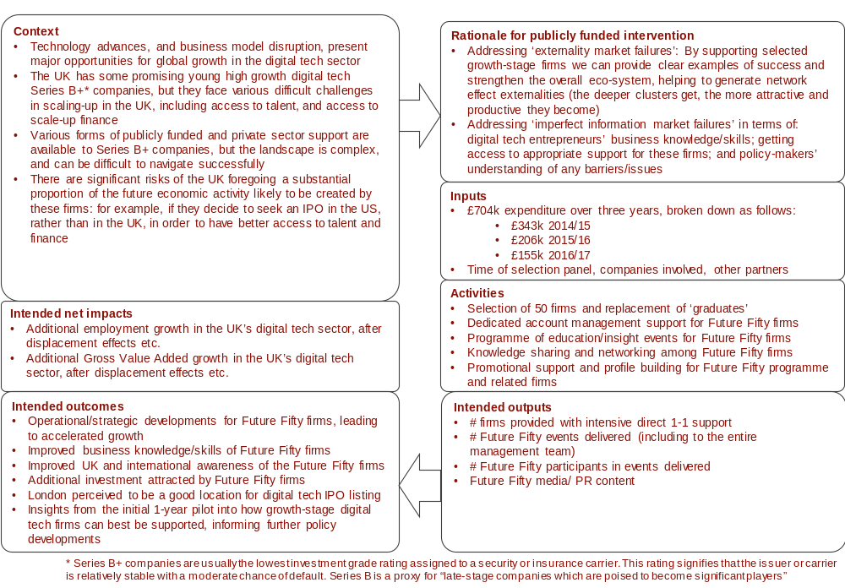

Figure B-2: Logic model for Upscale
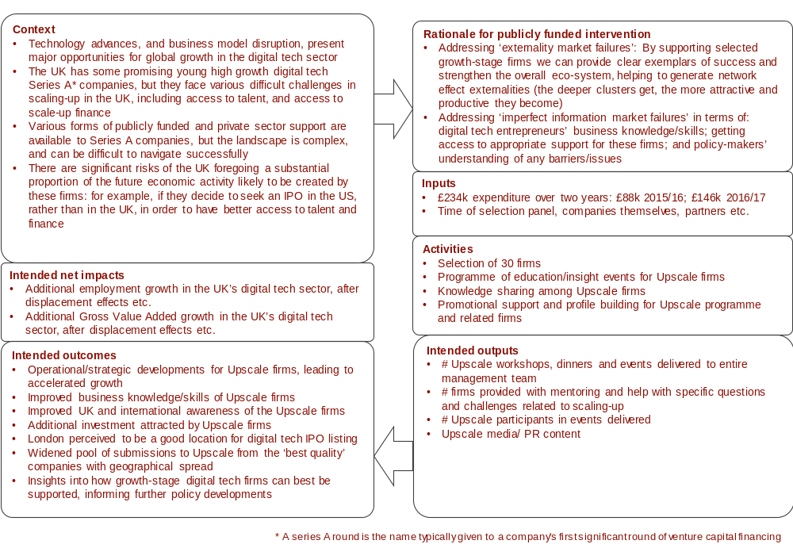

Figure B-3: Logic model for Northern Stars
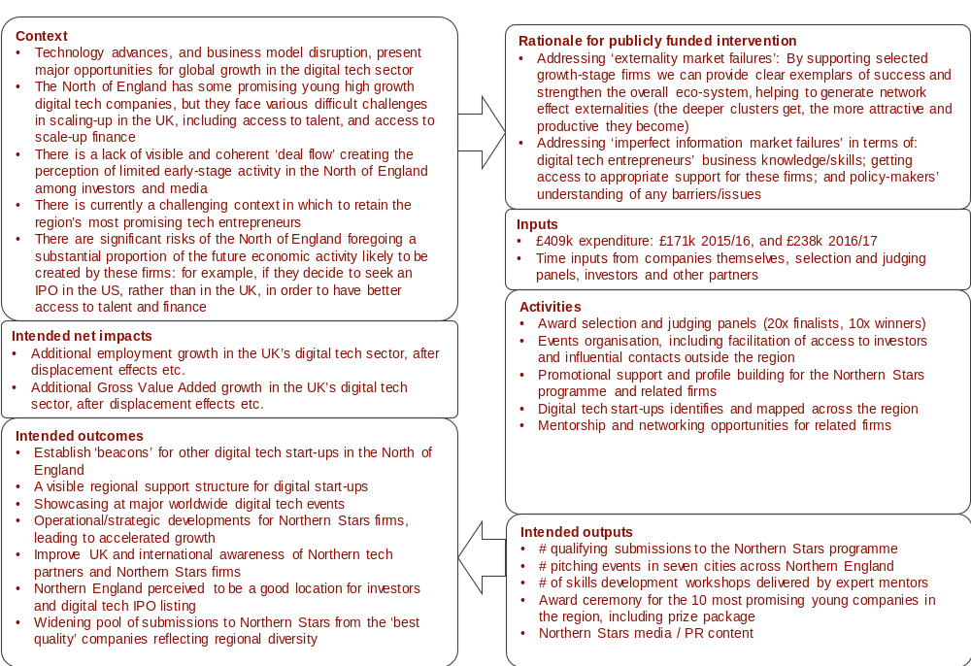

Figure B-4: Logic model for Founders’ Network
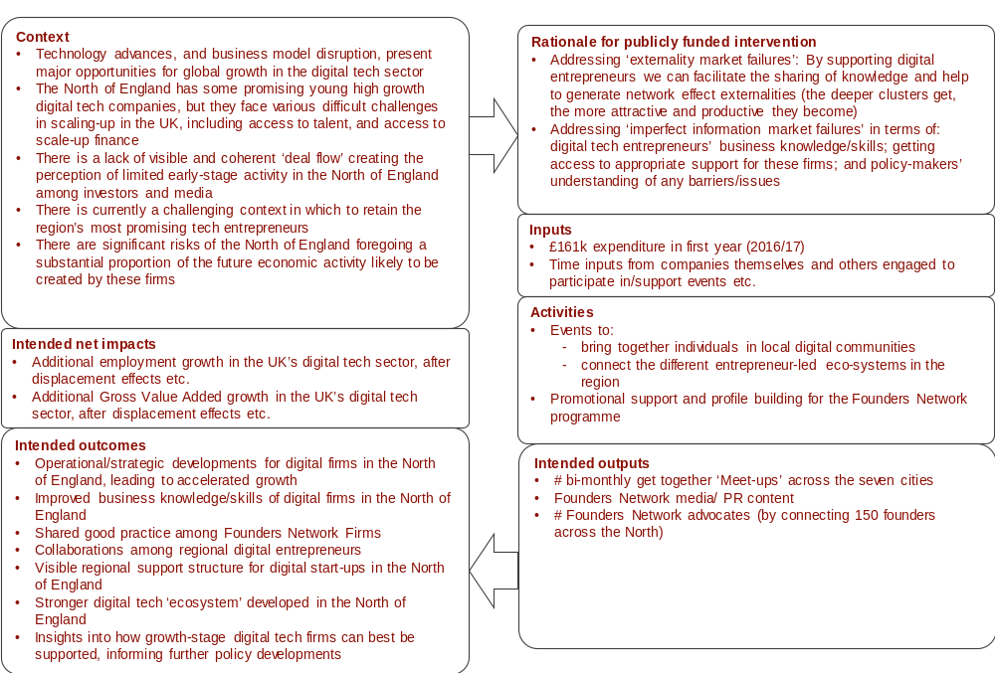

Figure B-5: Logic model for Digital Business Academy
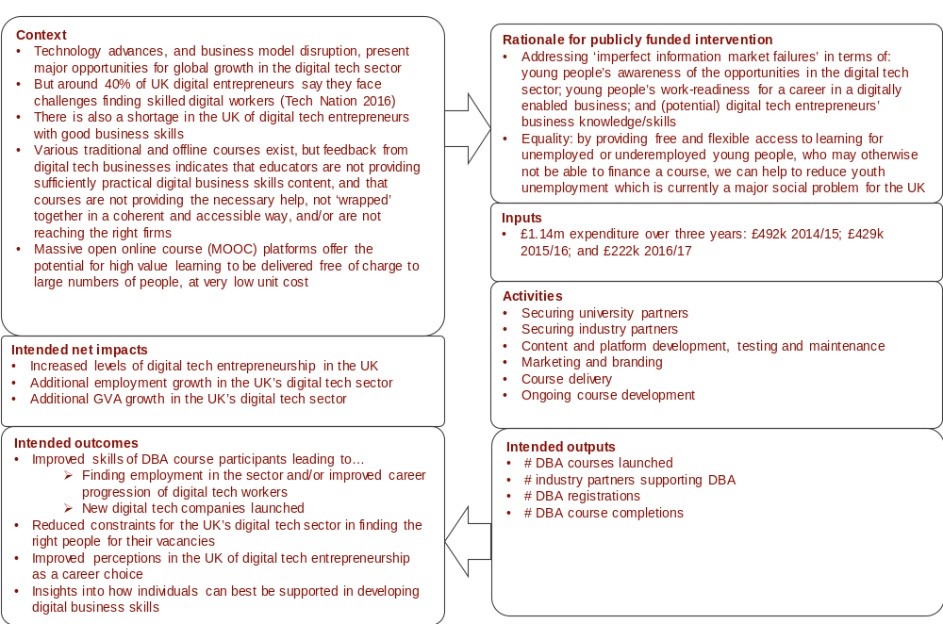

Figure B-6: Logic model for Tech Nation visa scheme
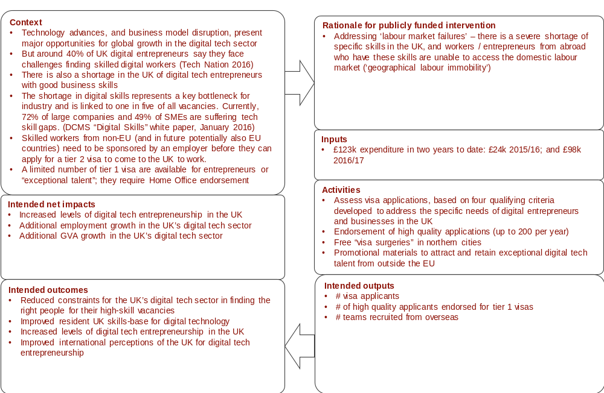

Figure B-7: Logic model for Tech Nation Alliance
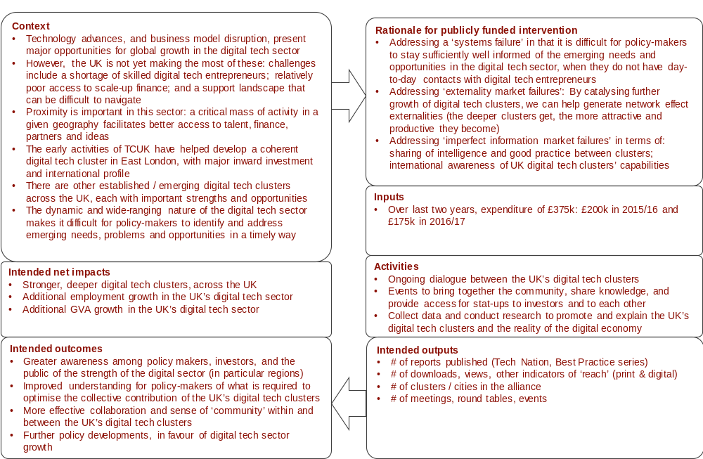

Figure B-8: Logic model for marketing
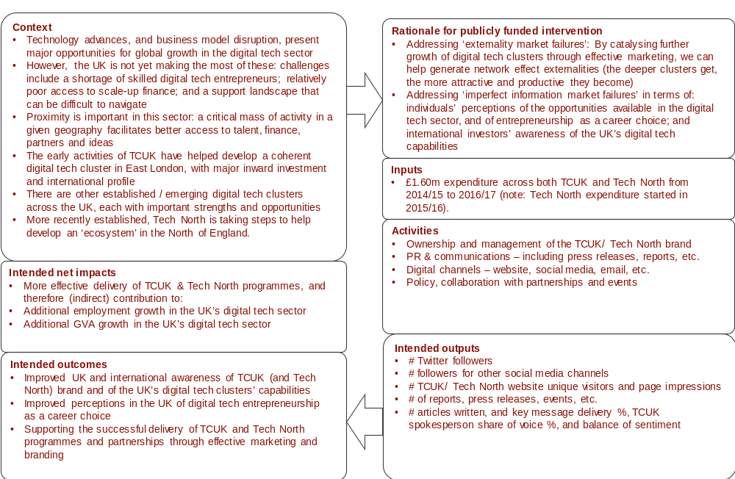

Case studies
          - This annex presents case studies for Future Fifty, Digital Business Academy, and the Tech Nation Visa Scheme. The purpose of these case studies is to illustrate how different aspects of TCUK’s support have led to positive business or career benefits.

Future Fifty

Future Fifty Case Study: Graze
Graze was founded in September 2008 as an online, direct-to-consumer retailer of healthy snacks. The company have since become a multi-channel retailer, and very recently entered the US market. The motivation for applying for the Future Fifty programme was the opportunity to make connections and exchange ideas in a collaborative community of peers.
Linking with the original motivation, the most significant benefit of the programme is the community of peers that have been developed and drawn together. As many of the companies are tackling similar issues - many unique to the scaling-up process most are engaged in – this had led to the invaluable exchange of learning and insights, and contributed to the personal and skills development skills of the firm’s CEO and senior leadership team.
The events programme has also been important for two things: developing knowledge and establishing expert connections. On the former, two events stood out, one on capital markets generally, and another on financial institutions in the US/Silicon Valley. Both events have proved highly valuable as the company recently entered the US market. Furthermore, the combination of the peer group on the programme and the attendance by other “trailblazing” companies at events (including as speakers) has enabled Graze to make new connections and establish new networks. These have further helped them to navigate the myriad challenges associated with scaling-up a company.
Importantly, although many of the elements of the programme could be sourced from elsewhere, “it would take a lot of time to find something of comparable quality”. There are, however, some concerns that issues can sometimes be miscommunicated between Future Fifty staff and that, more recently, the frequency with which events and activities are held has declined. For example, on the first point, while access to government has been a valuable aspect of the programme, an approach from Graze on the issue of the Royal Mail privatisation did not fully meet expectations. While an initial meeting was held to discuss, activities eventually “fizzled out”.

Future Fifty Case Study: LoopUp
LoopUp’s mission is to “make conference calls less painful” through its B2B remote meeting and conference calling solution. The company entered the market in 2006 and is based in Shoreditch, London, with offices in San Francisco, New York, Boston and Hong Kong. They employ around 120 staff across the business.
The company became aware of the programme through their involvement in the London tech-scene, and applied to the programme following interactions with the UK government and the British consulate. Aspects of the programme aligned well with their own strategic objectives: to raise the profile of the company and gain more PR exposure. To this end, the Future Fifty brand was deemed an important selling point. Prior to becoming a Future Fifty company, their growth had been consistent and organic, driven largely by word-of-mouth and targeted outbound reach.
The principal benefits associated with the programme can be summarised in terms of “access [to government], contacts and exposure”. On the last of these, as soon as the company was accepted onto the programme, the PR value and media coverage through TCUK events proved very positive. It was not possible to estimate the specific value gained, but it has likely made contributions to raising awareness among investors and a positive factor in their IPO in August 2016. More broadly, the focus of the programme is viewed as positive, and the TCUK staff involved were described as being high quality and full of enthusiasm.
Although not initially the main draw to the programme, a number of new contacts have been established through the programme, spanning peers on the programme itself, ministers in government, to a range of potential investors and industry experts. An important example was meeting the head of the AIM, which was helpful given their subsequent IPO. Another example is the establishment of new connections through an “international expansions” event that may lead to the company entering new markets in the near future.
In terms of access, meetings and formal dinners with ministers (along with fellow programme beneficiaries) have been important in providing a sense that the tech community is “being listened to” and considered by policy-makers. Finally, recently the company wished to employ two skilled people from the US, and received some very helpful ad hoc support through the programme to navigate the process and minimise the difficulties associated with it.

Digital Business Academy
Digital Business Academy Case Study: Petar Savic
In 2014, Petar Savic moved to London. He decided that he wanted to set up his own business and wanted to learn how to do so in the London market. After searching online for relevant information and courses, he discovered the DBA.
Petar was attracted to the DBA due to its resources on digital marketing, which aligned with his role at UCL as well as his business aspirations. Although Petar was impressed by the DBA’s association with UCL, he was most impressed by the fact that TCUK had produced the programme. He considers TCUK to be an industry pioneer and, as such, believes that the TCUK brand is a stamp of quality. He found the course focused, insightful, easy to navigate, and was motivated by the rewards gained after courses are completed.
Petar was an active user of DBA and completed all but one of the courses. His involvement in DBA led to TCUK recommending him for the role of Marketing and Events Coordinator at UCL, which he successfully secured. In this new role (mainly based at IDEALondon - a ‘post accelerator’ run by CISCO in partnership with UCL), he helped to organise hundreds of successful technology events and provide assistance to start-ups.
He believes that DBA helped him infiltrate the start-up ecosystem and establish himself in the market. He found many networking opportunities and mentors through his use of the DBA. This helped to develop his own start-up ideas. Subsequently, in December 2015, Petar started his own business, Supreme Factory Ltd. This is a virtual accelerator that connects a network of tech-sector employees, students, incubators, accelerators, start-ups, mentors and investors from London, the former Yugoslavia and the Balkans to support and grow early stage businesses.
“The DBA changed my life” – Petar Savic
Petar credits the DBA with the fact that he has set up his business. The programme taught him how to establish a business in the London market, and gave him the confidence to do so. It taught him how to increase turnover, scale up in a smart way, reduce business costs and attract investment, all of which he has applied to the Supreme Factory Ltd. He expects that his use of the skills and knowledge acquired through DBA will result in future improvements to his business in terms of its management and growth (e.g. in sales turnover and valuation).
Petar is convinced that, had he not discovered the DBA, he would have continued working in paid employment and would not have started his own business.

Digital Business Academy Case Study: Bassem Abu Nimeh
Bassem Abu Nimeh worked for a bank in Jordan before he decided to move to the UK, having been awarded the Chevening Scholarship by the Foreign and Commonwealth Office to study MSc Entrepreneurship at the University of Brighton.
He was searching online for business courses he could do to complement his degree and enhance his career prospects when he found the DBA. Bassem was more open to trying the DBA because it was a UK resource; from experience, he believes online courses from the UK tend to focus on teaching the material, as opposed to online courses from the US which tend to be marketing tools for further content. He was impressed by the DBA’s video lessons made by academic institutions, its focus on teaching practical steps towards starting a business, and the rewards gained on finishing courses.
After completing the first six courses (Size up your Idea, Set up a Digital Business, Develop and Manage a Digital Product, Make a Marketing Plan, Build a Brand, Understand Digital Marketing Channels), Bassem graduated with distinction from the University of Brighton and moved to Jordan where he was hired as a Senior Innovation Centre Executive at Aramex. His role involves running business services for start-ups and brokering partnerships.
Bassem believes that the DBA contributed to his knowledge and, as such, helped him gain a distinction in his degree. Furthermore, the DBA has given Bassem the tools and the confidence to pursue a digital sector career, and has contributed to him getting his current role at Aramex.
Bassem would like to move to England in the near future to start a digital business.

Digital Business Academy Case Study: Alina Alexandrescu
Alina Alexandrescu holds a postgraduate qualification and works in the digital sector in the UK, having relocated from overseas. She has always wanted to open her own business, but knew little about how to do so in the UK market. She searched online for free courses and discovered the DBA.
She chose to use the DBA over other available courses because it is clearly focused on teaching users how to start up a business. Other attractions are its affiliation with UCL, clear programme structure, useful videos, lack of deadlines, and the rewards given when courses are completed.
Alina has completed four of the courses (Size up your Idea, Set up a Digital Business, Develop and Manage a Digital Product, and Make a Marketing Plan), which helped her understand the process of starting her own business in the UK, and led her to discover that she would like to run a franchise. She has since bought a franchise of Forever Living Products International Inc, a company that manufactures and sells aloe vera products.
The DBA has had a sizeable impact on her decision to start this kind of enterprise. This has helped her avoid high business costs, as franchises often pose less of a financial risk than other models. Alina expects to complete further DBA courses and believes this will help her increase turnover and take on employees.
Had she not used the DBA, Alina believes she still may have started her own business, but it would not have been this business.

Digital Business Academy Case Study: Judith McLaughlin
Judith McLaughlin first became aware of the Digital Business Academy (DBA) during a 10-year career break to raise her children. She has over a decade of experience in marketing and was looking for a free resource to help update her skillset to suit the demands of the current jobs market and, ultimately, get a job in digital marketing.
DBA appealed to Judith for three reasons: it could fit around her schedule; it was a government approved resource; and it was free. Indeed, she would not have used it if it had required payment.
She found the DBA courses to be of a good standard: they were user-friendly and engaging. The ‘Understanding Digital Marketing’ course was particularly useful for her. It provided her with a good foundational knowledge of digital marketing and an insight into the skills she needed to develop to work in the industry. In particular, this course helped her to understand the steps she needed to take in order to re-enter the job market at a similar level to where she was when she started her career break.
Judith is now a product manager in the marketing department of a global technology group that designs, manufactures and markets electrical equipment. Her extensive marketing experience qualified her for the job but DBA updated her knowledge, gave her job search direction and increased her the confidence to re-enter the world of work. She thinks that DBA is a great means for men and women to get back into the workforce after children.
Although Judith believes that she could have achieved similar benefits from courses elsewhere, she is happy she chose DBA over its competitors. DBA helped to smooth her transition back into employment. She would recommend it to others looking to re-enter the workforce after a career break.

Tech Nation Visa Scheme
Tech Nation Visa Scheme Case Study: Dan Cuellar
Dan Cuellar is Software Engineering Manager for FOODit Inc., a company offering a single app electronic point of sale to restaurants for bookings and takeaway orders. Prior to coming to the UK, Dan created an open source software project for app automation – Appium – which has several hundred thousand users across the world. He regularly leads Meetups and gives training on its uses in the UK. Several job roles in the London Tech cluster now require applicants to be au fait with Appium, and so he is a ‘job creator’ in his own right.
He came to the UK from Silicon Valley on a Tier 2 visa, originally working with another employer (Shazam), before moving to FOODit after one year. He moved onto the Tech Nation visa scheme under own his steam.
He was attracted to the Tech Nation visa scheme due to the potential ‘double jeopardy’ of the Tier 2 scheme, which ties the visa to a single employer – this could possibly leave a visa holder without a job or means to find one in the UK if a business folds, a distinct possibility in the world of start-ups.
The Tech Nation Visa offers Dan more flexibility to move between firms, or start his own enterprise. Since receiving the visa he has taken paid work alongside his day to day job, including training and conference engagements. The further flexibility the visa affords has allowed him to travel and make stronger connections across Europe and further afield. He regularly speaks at conferences and events in the UK and further afield and it was unclear whether this was allowed on Tier 2, even where opportunities were unpaid. The Tier 1 status allows him to take both paid and pro bono opportunities. It also offers a longer tenure and is much cheaper than the equivalent Tier 2 visa.
Dan also brings a wealth of experience from Silicon Valley, including spells with Zoosk and Microsoft. In his opinion, this experience is important, because it brings with it knowledge of business processes, such as agile development, as well as close working with funders, such as angels and VCs. These skills are less well-developed in the UK.
Dan wishes the Tech Nation visa scheme had existed when he first considered moving to the UK as he would have used it in the first place. If he had not been able to move onto it he is sure that he would have moved back to the USA much more quickly – the freedom and flexibility provided is a big plus. The name ‘Exceptional Talent’ is, however, off putting – the tech community are humble and do not like to self-certify as ‘exceptional’; a rebrand removing that word would make the route ‘less discouraging’.

Tech Nation Visa Scheme Case Study: Daniel Tay
Daniel Tay is founder of cloud procurement platform ‘Trinity,’ which trades in the UK as Trinity Digital Technology Limited. He has been running businesses in Hong Kong and China for several years and initially considered setting up a UK arm after taking part in a Hong Kong-UK Trade & Investment delegation in 2014, which was designed to help the development of ‘Silicon Roundabout’.
Daniel also attended a similar event in Paris and ultimately chose to move to London in 2016 in part due to personal ties to the UK (he was schooled and worked here) and the fact that this would provide a better place to educate his children. Paris offered better incentives and business inception support, but London offered more familiar lifestyle and adaptability.
Daniel found the application process for the Tech Nation visa complicated and found guidance difficult to acquire. At that time of his application, there was no contact person to call or enquire information. As a result, he was taking a lot of his efforts ‘on faith’.
TCUK was still evolving as an organisation at the time, and therefore unable to provide a great deal of support. Daniel found their factsheet and guidance helpful to a point, but this only gave broad timelines and nothing much else like information on family relocation or children education options. Supplying the right evidence was relatively straightforward given his background and experience, but completing the paperwork and securing updates on the application were much more difficult.
Brexit was not expected when Daniel submitted his Tech Nation application and the post Brexit market outlook is challenging for Daniel’s business. In addition, the current market is made even more uncertain with the upcoming UK General Elections in June. Much of their commercial activity to date has been spadework and business development.
The small and medium enterprise business environment appears to be in a ‘look and see’ mode – so this is not a great time to be selling new business systems to them– so his intended growth and expansion plans have been delayed.
Daniel is now part of the wider TCUK Tech Nation visa alumni community who are seeking to help future applicants with their applications based on personal experiences. He is also advising two start-ups in the ecosystem and keen to take on more mentoring as and when capacity allows. Although his experience has been mixed, Daniel is still keen to ‘pay forward’ this opportunity afforded to him and his family by the UK.
He feels that both TCUK and the Home Office could be more transparent and helpful to future applicants. His experience here contrasts unfavourably with France, which was much more pro-active in pursuing his business and offering a more enhanced business support service.

Online survey results
          - This Annex presents the results from two separate online surveys of beneficiaries from the Digital Business Academy (DBA), and the Founders’ Network (FN).

DBA
          - The DBA is a set of free Massive Open Online Courses (MOOC) for users to develop skills to start, grow or join a digital business. An online survey was sent to 12,859 users (of which 1,699 had completed at least one of the 11 courses available through DBA) to gather their feedback on DBA. The survey was live for 13 weeks (February to March 2017) and received 121 responses.

Profile
          - Nearly two-thirds of the survey respondents were male and one-third were female.
Table D-1: What is your gender?
 | Number of responses
Male | 73
Female | 41
Source: SQW online survey; n=114
          - The most common age group of respondents was between 20 and 29, followed by 30 to 39.
Figure D-1: In which age bracket do you fall?
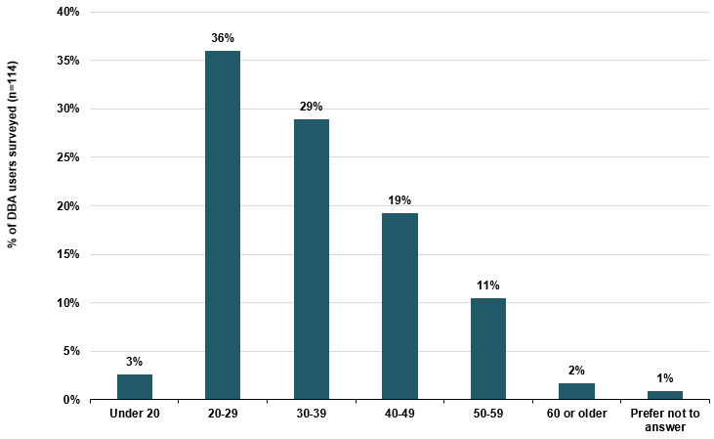
Source: SQW online survey; n=114
          - Around 80% of respondents were educated to degree level.
Figure D-2: What is the highest level of qualification you have obtained?
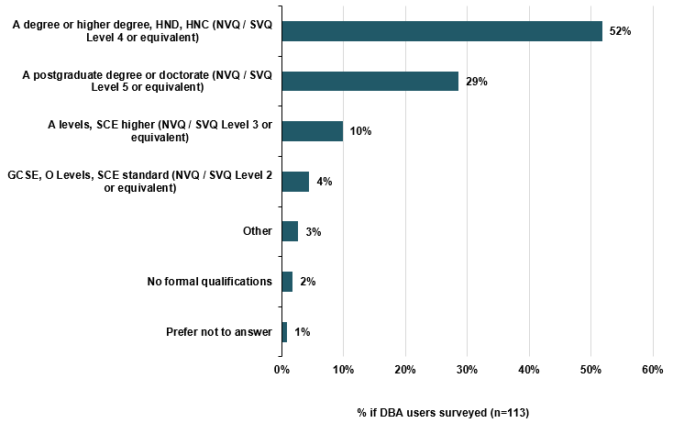
Source: SQW online survey
          - Just over two-thirds of respondents were living in the UK at the time of taking the survey.
Table D-2: Where do you currently reside?
Location | Responses (number) | Responses (%)
In the UK | 78 | 68%
Elsewhere in the world | 22 | 19%
Elsewhere in the EU | 14 | 12%
Source: SQW online survey; n=114
          - Responses came from a fairly even mix of self-employed/ entrepreneurs, those employed in a different sector, students and those employed in the digital tech sector. A small minority were unemployed.
Figure D-3: Which of the following best describes your situation when you first began using the DBA?
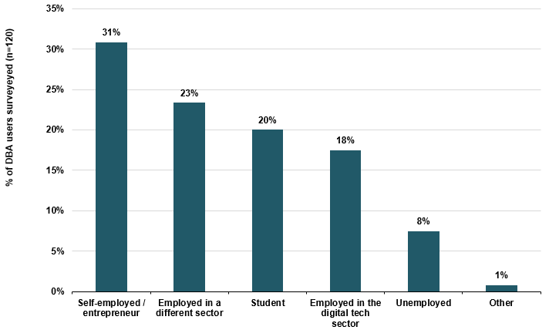
Source: SQW online survey; n=120

Use and views on the DBA, and skills acquired
          - The main reason respondents started using DBA was to launch and/or grow their digital tech business followed by enhancing their chances of finding a job in the digital tech sector; for general interest; and to improve their career progression in the digital sector. A minority cited other reasons including to learn new skills, and to be able to support their students to use the DBA.
Figure D-4: What was the main reason you began using the DBA?
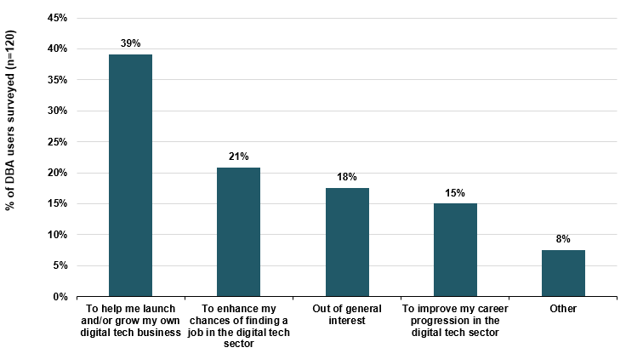
Source: SQW online survey; n=120
          - Two of the most commonly completed courses were ‘Size up your idea’ and ‘Set up a Digital Business’. Marketing related courses were also popular including ‘Digital Marketing Channels’ and ‘Making a Marketing Plan’. Overall, there was a relatively even spread of other courses expected to be completed.
Figure D-5: Which of the following DBA courses have you started / completed?
Source: SQW online survey
          - The main reason why respondents had not completed one or more of the courses they started was due to the length of time it would take to complete the course.
Figure D-6: If relevant, why have you not completed one or more of the courses you started?
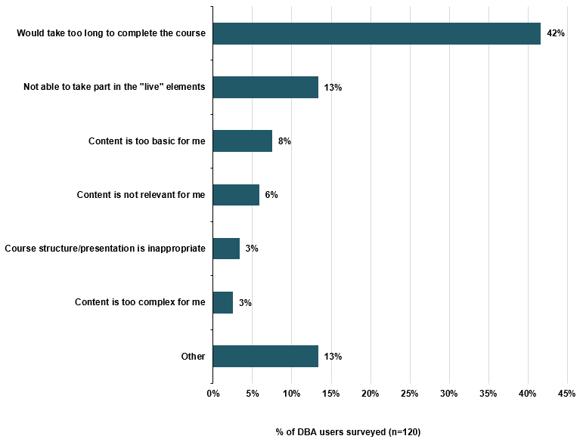
Source: SQW online survey
          - Respondents could be mainly encouraged to complete courses by periodic email prompts, being assigned a tutor or buddy, greater flexibility in the timing of live events, and more and/ or better rewards.
Figure D-7: Would any of the following encourage you to complete the course(s)?
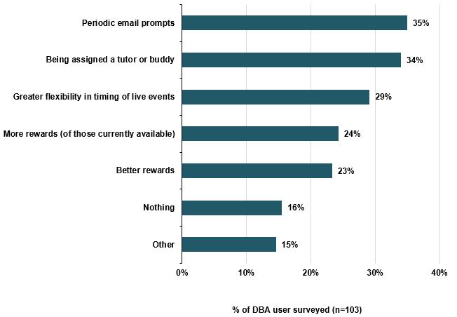
Source: SQW online survey
          - The DBA was generally rated good or very good by respondents, in particular on the quality of the course content, the user-friendliness of the DBA platform, and the relevance of the content to users.
Figure D-8: Overall, how would you rate the DBA in terms of the…
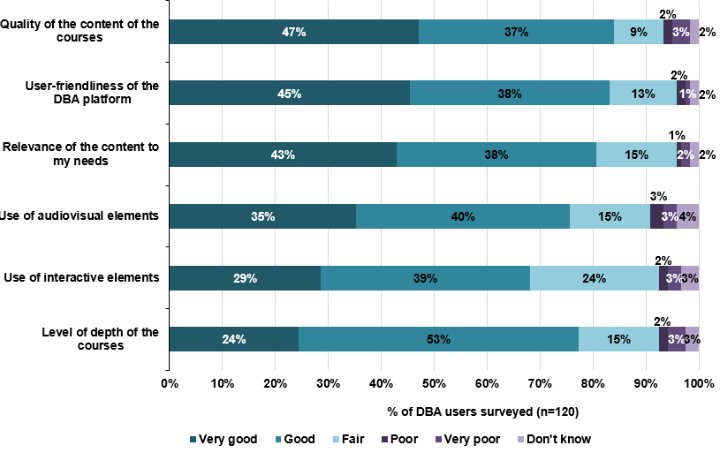
Source: SQW online survey
          - Most respondents found that the DBA had positively improved their understanding, interest, and confidence of digital tech.
Figure D-9: To what extent has using the DBA changed your views or understanding of digital tech?
Source: SQW online survey
          - Most respondents have been able to apply what they learned from the DBA in their work.
Table D-3: How much of what you learned from the DBA have you been able to apply in your work?
 | Number of responses
Everything | 10
A lot | 55
A little | 43
Nothing | 11
Source: SQW online survey; n=119
          - The three most valuable skills or knowledge gained from the DBA include: marketing and branding, knowledge and information sharing, and business development.
Figure D-10: What is the most valuable skill or piece of knowledge you have learned from the DBA?
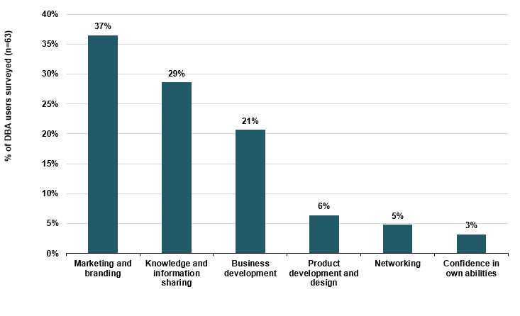
Source: SQW online survey; n=63
          - If the DBA did not exist, the majority of respondents would have used other free online resources to acquire the same or similar skills and knowledge, and many would have used free offline resources. Less popular alternatives would have been paid for online resources and paid for offline resources.
Figure D-11: If the DBA didn’t exist, how would you have sought to acquire the same or similar skills and knowledge?
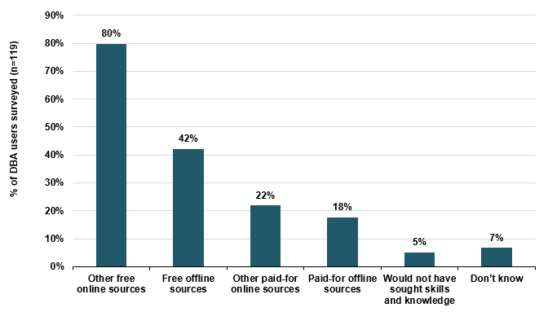
Source: SQW online survey; n=119
          - Most respondents could have acquired the skills and knowledge gained through the DBA via an alternative route.
Figure D-12: To what extent do you think you could have acquired the same or similar skills and knowledge from one or more of the alternatives listed in the previous questions?
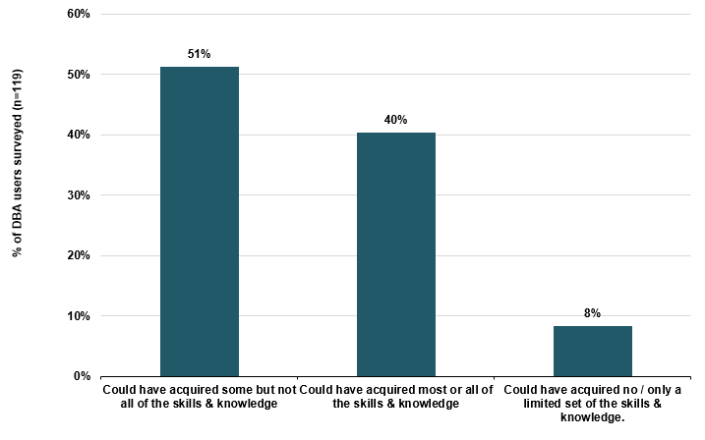
Source: SQW online survey; n=119

Results and Impacts of the DBA
          - A fifth of respondents have launched their own digital tech business or begun to make concrete plans to do so. A further one- fifth have taken on a different role/been promoted in either the digital tech sector or a ‘digital job’ in another sector.
Figure D-13: Since you began using the DBA, have you…
Source: SQW online survey
          - Approximately half of the respondents who had started a job or been promoted in the digital tech sector, or a ‘digital’ job, were working full time, with the remainder working part time.
Table D-4: Is your current employment in the digital tech sector / field:
 | Number of responses
Full time | 18
Part time | 16
Source: SQW online survey; n=34
          - The annual gross salaries for most respondents who had started a job or been promoted in the digital tech sector, or a ‘digital’ job, were below £40,000.
Figure D-14: What is your current annual gross salary in your current employment role in the digital tech sector / field, i.e. before the deduction of tax and national insurance?
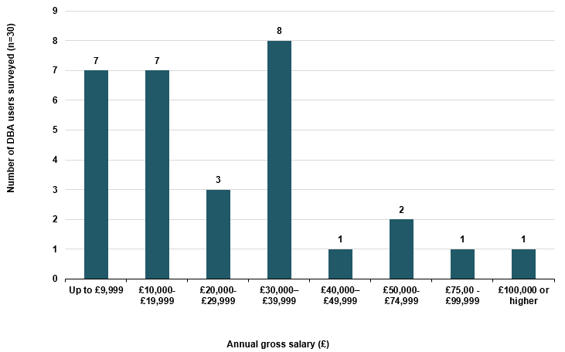
Source: SQW online survey; n=30
          - Only 10 respondents answered how their current salary in the digital tech sector/ field compared with their previous salary in a different sector/ field. Half of these respondents indicated their current salary was higher.

Table D-5: How does your current salary in the digital tech sector / field compare with your previous salary in a different sector / field?
 | Number of respondents
Current salary is much higher (by 20% or more) | 2
Current salary is somewhat higher (by 10-15%) | 3
Current salary is about the same | 1
Current salary is lower | 1
I did not draw a salary | 3
Source: SQW online surveys; n=10
          - Most respondents who have started a job in the digital sector for the first time, or who have started a job but not in the digital sector, affirmed that the DBA has made a positive difference to them personally in a number of ways, as set out in Figure D-15.
Figure D-15: Would you say that using the DBA has made a difference to you personally in any of the following ways? Has it…
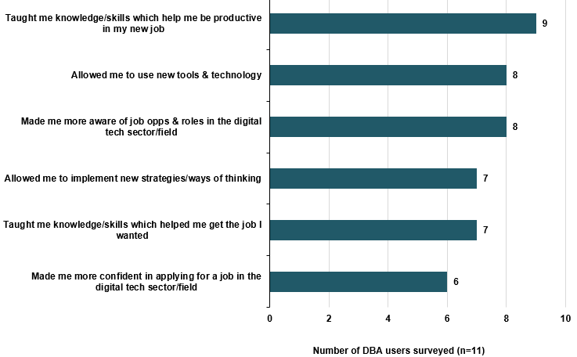
Source: SQW online survey
          - Without the DBA, half of these 11 respondents would have found a job in the technical sector/ field but been less effective in the role, or taken longer to find the job.

Table D-6: Reflecting on your previous responses, overall, which of the following do you think would have happened had you not used the DBA?
 | Number of responses
Would have found a job in the technical sector/ field but been less effective in the role | 4
Would have found a job in the digital sector but at a later date | 2
Would definitely not have found a job in the digital sector/ field at all | 2
Would have found a similar job in the digital sector/ field in the same timescale and same level | 2
Would possible not have found a job in the digital sector/ field at all | 1
Source: SQW online survey; n=11
          - Over two-thirds of the 21 respondents who have taken on a different role or been promoted in a ‘digital’ job or the digital sector, since having used the DBA, have seen increases in their salaries.
Figure D-16: Has your salary changed as a result of your new role, responsibilities and/or skills?
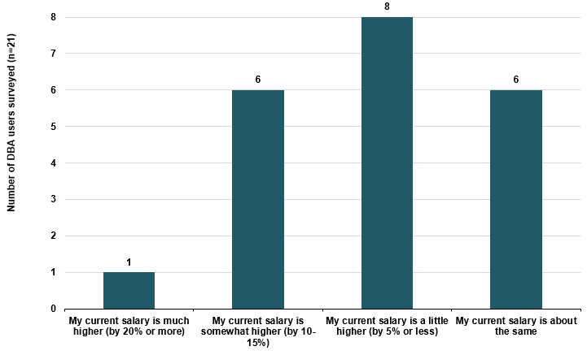
Source: SQW online survey; n-21
          - Of those respondents who have taken on a different role or been promoted in a ‘digital’ job, or the digital sector since having used the DBA, half stated that the DBA has made a positive difference to them personally in a number of ways, as in Figure D-17.
Figure D-17: Would you say that using the DBA has made a difference to you personally in any of the following ways? Has it…
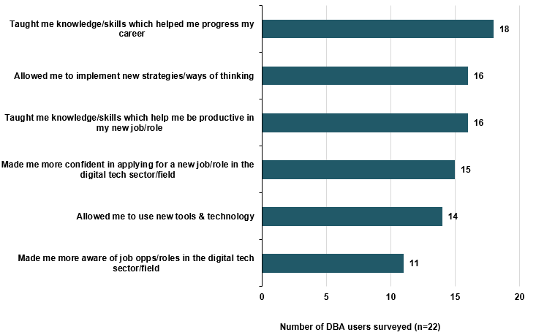
Source: SQW online survey
          - Very few respondents who have taken on a different role or been promoted in a ‘digital’ job, or the digital sector reported that, had they not used the DBA, they would have taken on a new role/ responsibilities in the digital sector/ field in the same timescale and level.
Table D-7: Reflecting on your previous responses, overall, which of the following do you think would have happened had you not used the DBA?
 | Number of responses
Would have taken on a new role/responsibilities in the digital sector / field but at a later date | 6
Would have taken on a new role/responsibilities in the digital sector/field but would have been less effective | 5
Would possibly not have taken on a new role/responsibilities in the digital sector/field at all | 5
Would have taken on a new role/responsibilities in the digital sector/field in the same timescale & level | 4
Would have taken on a new role/responsibilities in the digital sector/field but of lower value | 2
Source: SQW online survey; n=22
          - Of the respondents who have launched their own digital tech business or have begun to make concrete plans to do so, most are in the process of making concrete plans and intend to start trading within 12 months.
Table D-8: What is the current status of your digital tech business?
 | Number of responses
I am in the process of making concrete plans & intend to start trading within 12 months | 13
I am in the process of developing ideas but unsure if/when I might launch the business | 4
I have launched the business & began trading within the last 12 months | 3
I launched the business & began trading more than 12 months ago | 1
Source: SQW online survey; n=21
          - Over half of the 21 respondents who have launched their own digital tech business or have begun to make concrete plans to do so stated that the DBA allowed them to implement new strategies or new ways of thinking; made them more confident in setting up a digital tech business; allowed them to use new tools and technology; made the process of launching the business less difficult; and sped up the process of launching the business.
Figure D-18: Would you say that using the DBA has made a difference to you and/or your new business in any of the following ways? Has it…
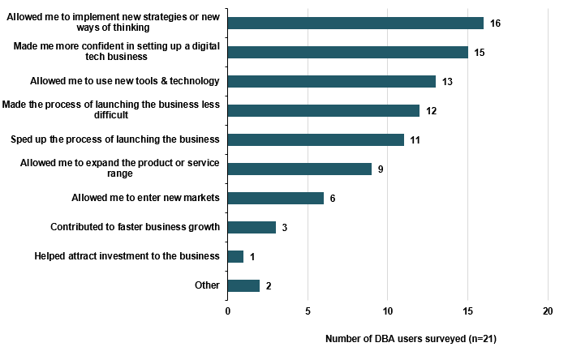
Source: SQW online survey
          - Of the four respondents who had already launched their business, all but one had not employed anyone.
Table D-9: Does your business employ anyone (other than yourself)?
 | Number of responses
Yes | 1
No | 3
Source: SQW online survey; n=4
          - Of the four respondents who had launched a business, three had generated revenue to date.
Table D-10: Has your business generated any revenue to date?
 | Number of responses
Yes | 1
No | 3
Source: SQW online survey; n=4
          - The four respondents identified timing, quality and scale additionality associated with DBA.
Table D-11: Reflecting on your previous responses, overall, which of the following do you think would have happened had you not used the DBA?
 | Number of responses
The business would have started, but would have been of lower quality | 2
The business would have started but at a later date | 1
The business would have started, but on a smaller scale | 1
Source: SQW online survey; n=4
          - Before using the DBA, most of the 13 respondents who had a digital tech business did not employ anyone.
Table D-12: Before you started using the DBA, did your digital tech business already have any employees (other than yourself)?
 | Number of responses
Yes | 3
No | 10
Source: SQW online survey; n=13
          - Of these respondents, there was an almost equal split between those who had sales/ revenue from their business before using the DBA.
Table D-13: Before you started using the DBA, did your digital tech business already have any sales / revenue?
 | Number of responses
Yes | 7
No | 6
Source: SQW online survey; n-13
          - Most of the respondents who continued to run and grow their own digital tech business report that the DBA has allowed them to implement new strategies/ways of thinking, and has allowed them to use new tools and technology.
Table D-14: Would you say that using the DBA has made a difference to you and/or your new business in any of the following ways? Has it…
 | Number of responses
Allowed me to implement new strategies/ways of thinking | 9
Allowed me to use new tools & technology | 9
Contributed to faster business growth | 2
Allowed me to expand the product or service range | 1
Other | 1
Source: SQW online survey; n=13
          - Of the respondents who have continued to run and grow their own digital tech business, most did not employ anyone other than themselves in their digital tech business before using the DBA.
Table D-15: Does your business employ anyone (other than yourself)?
 | Number of responses
Yes | 3
No | 10
Source: SQW online survey; n=13
          - Of the respondents continued to run and grow their own digital tech business, there was an equal split between those that generated revenue in the last year and those that did not.
Table -D-16: Has your business generated any revenue in the last year?
 | Number of responses
Yes | 7
No | 5
Source: SQW online survey; n-12
          - Of the respondents who continued to run and grow their own digital tech business, most indicated quality, time, and scale additionality of DBA.
Table D-17: Reflecting on your previous responses, overall, which of the following do you think would have happened to the development of your business had you not used the DBA?
 | Number of responses
Would have found a job in the digital sector/field but been less effective in the role | 4
Would have found a job in the digital sector/field but at a later date | 3
Would definitely not have found a job in the digital sector/field at all | 3
Would have found the similar job in the digital sector/field in the same timescale & same level | 2
Would possibly not have found a job in the digital sector/field at all | 1
Source: SQW online survey; n=13

Overall satisfaction and suggestions for improvements.
          - The majority of respondents would be likely to recommend the DBA to others.
Figure D-19: On a scale of 1 to 10, how likely is it that you would recommend the DBA to others? (where 10 represents very likely).
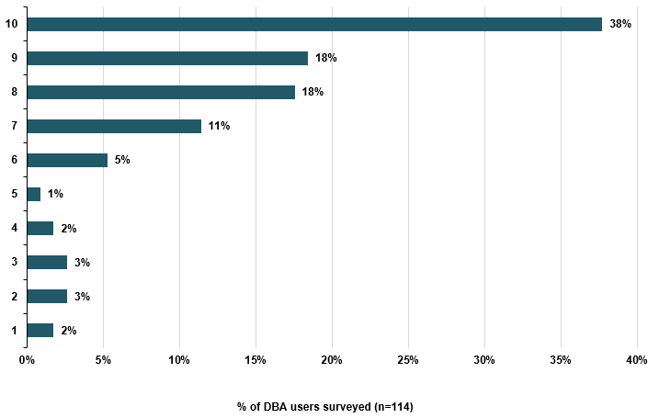
Source: SQW online survey
          - The three options considered most useful to improving the DBA were more courses on a wider range of subjects, certifications to be recognised, and access to other Tech City UK programmes and initiatives through the DBA.
Figure D-20: In your opinion, how useful would the following be to improve the DBA?
Source: SQW online survey

Founders’ Network
          - The Tech North FN is an educational six-month programme of workshops and events for tech start-up founders in the North of England that allows them to connect with each other, share experiences and learn from experts. We developed a short online survey to gather feedback from beneficiaries on their experiences of participating in FN. The survey went live in March 201, and received 11 completed responses out of 208 companies.

Profile
          - The majority of respondents were male.
Table D-18: What is your gender?
 | Number of respondents
Male | 7
Female | 2
Prefer not to answer | 2
Source: SQW online survey; n=11
          - Respondents’ ages ranged from under 20 to 59.
Table D-19: In which age bracket do you fall?
 | Number of responses
Under 20 | 1
20 – 29 | 3
30 – 39 | 2
40 – 49 | 3
50 – 59 | 1
60 or older | 0
Prefer not to answer | 1
Source: SQW online survey; n=11
          - All respondents were based in North West England, North East England and Yorkshire and the Humber.
Table D-20: Where are you based?
 | Number of responses
North West England | 5
North East England | 3
Yorkshire and the Humber | 3
Elsewhere in the UK | 0
Not in the UK | 0
Source: SQW online survey; n=11
          - Eight Tech North Founders had launched a business by the time of taking the survey, while the remaining three were in the process of developing ideas or making concrete plans to start a business.
Table D-21: Which of the following best describes the current status of your digital tech business?
 | Number of responses
I have launched the business and began trading within the last 12 months | 5
I am in the process of making concrete plans for the business, and intend to begin trading within the next 12 months | 2
I launched the business and began trading more than 12 months ago | 3
I am in the process of developing ideas but am still unsure if/ when I might launch the business | 1
Source: SQW online survey; n=11

Motivation and engagement with Founders’ Network
          - Respondents had heard about the Tech North Founders’ Network from a variety of sources: Tech City staff, Tech City UK/ North newsletter, social media, Tech City UK/ North website, and peers, colleagues or friends.
Table D-22: How did you first come across / hear about the Tech North Founders’ Network?
 | Number of respondents
From Tech City UK/ Tech North staff (e.g. at an event) | 3
Tech City UK/ Tech North newsletter | 2
Social media | 2
Tech City UK/ Tech North website | 2
From peers/ colleagues/ friends | 2
Other | 0
Source: SQW online survey; n=11
          - Tech North Founders chose to apply to become members to: meet like-minded digital tech founders in their region and feel part of a community, help with setting up and growing their business generally, and build their professional network with a view to future collaborations.

Table D-23: What was/were the main reason(s) you chose to apply to become a Network member?
 | Number of respondents
To meet like-minded digital tech founders in my region and feel part of a community | 10
To build my professional network with a view to future collaborations | 8
To get help with setting up and growing my business generally | 9
To learn about specific aspects of starting up and scaling a digital tech business | 6
To engage with Tech North and/or Tech City UK | 5
Other | 0
Source: SQW online survey; n=11
          - Most respondents were either satisfied or very satisfied with the application process.
Table D-24: How satisfied were you with the application process?
 | Number of responses
Very satisfied | 5
Satisfied | 4
Neither satisfied nor dissatisfied | 1
Dissatisfied | 1
Very dissatisfied | 0
Source: SQW online survey; n=11
          - Most respondents had participated in workshops or masterclasses on specific topics, and/ or had attended evening networking.
Table D-25: Which of these Founders’ Network activities have you used / participated in?
 | Number of responses
Workshops / masterclasses on specific topics | 10
Evening networking (dinner and drinks) | 7
Slack digital communications platform | 4
Founders’ Network: The Summit (regional event on 2 March 2017) | 4
Source: SQW online survey; n=11
          - Most of the Tech North Network activities were considered useful or very useful by most respondents.
Figure D-21: And for those you have taken part in, how useful have you found them?
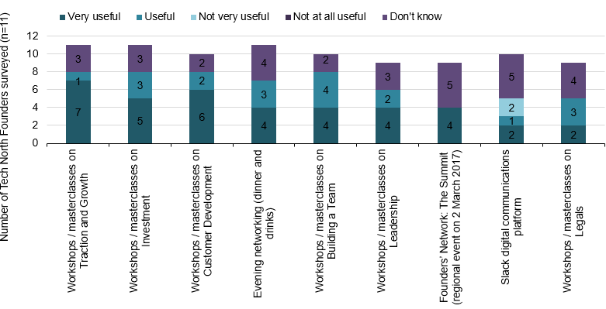
Source: SQW online survey; n=11
          - Over half of the respondents considered most of the aspects of the workshops/ masterclasses they had attended excellent.
Figure D-22: Based on the workshops / masterclasses you have attended, how would you rate the following aspects?
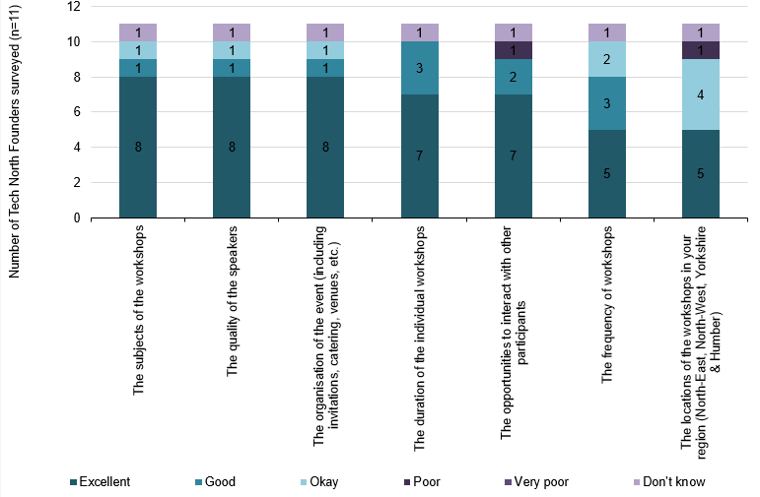
Source: SQW online survey; n=11

Benefits of participation
          - Most of the respondents reported that the Founders’ Network provided them with: opportunities to meet and network in the North of England; opportunities to hear from and be inspired by successful founders; learning to equip them with the knowledge needed to scale their business.
Figure D-23: To what extent has the Founders’ Network provided you with:
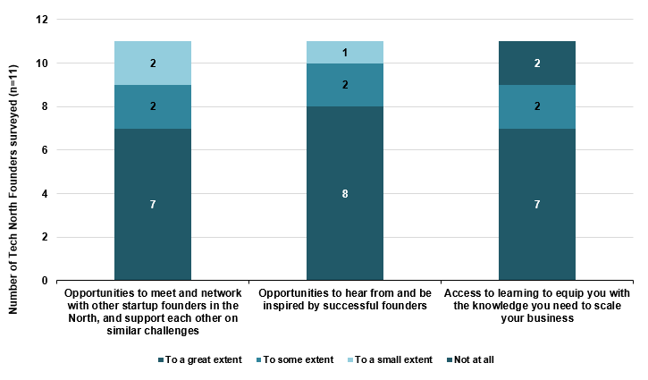
Source: SQW online survey; n=11
          - All respondents believed that opportunities to meet with and support other start-up founders in the north, and opportunities to hear from and be inspired by successful founders are either important or very important.
Figure D-24: How important is each of these to the successful growth of your business?
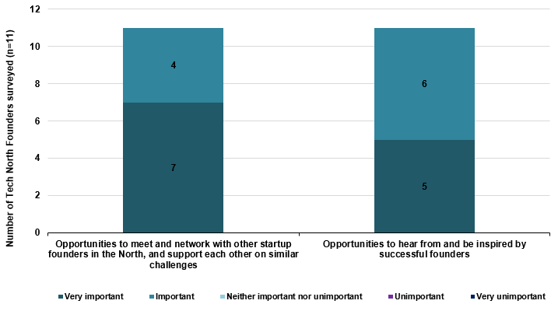
Source: SQW online survey; n=11
          - The majority of respondents believe that the FN is having a positive effect on a number of varied factors, including contributing to a cohesive employer-led tech ecosystem across the North of England, enabling FN members to build relevant professional networks and contacts, and increasing members’ confidence in their ability to successfully grow their own business.
Figure D-25: To what extent would you agree that the Founders’ Network:
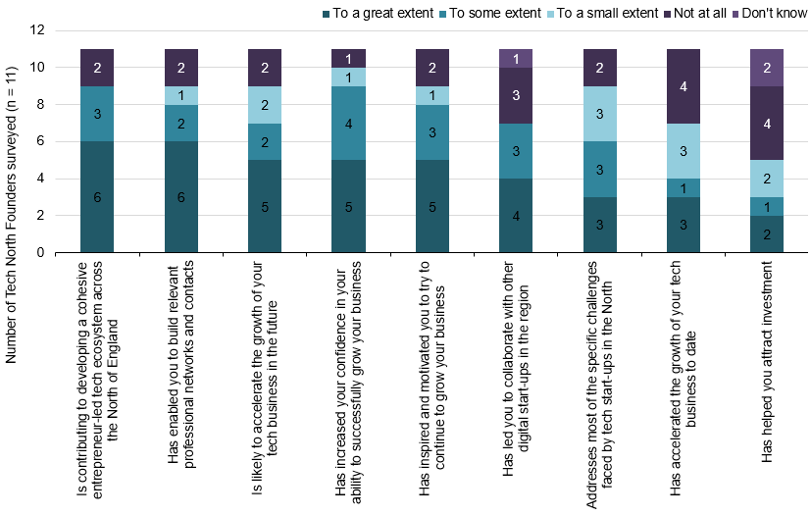
Source: SQW online survey; n=11

Overall assessment and suggestions
          - Most respondents found that all elements of the FN outlined in Figure D-26 were important or very important to successfully supporting ambitious digital tech entrepreneurs in the North of England. These elements included, but were not limited to, providing opportunities for learning about topics of interest for founders, and bringing high quality speakers from other parts of the UK and the world to the North of England.
Figure D-26: In your view, how important is each of the following elements for the Founders’ Network to successfully support ambitious digital tech entrepreneurs in the North of England? The fact that it:
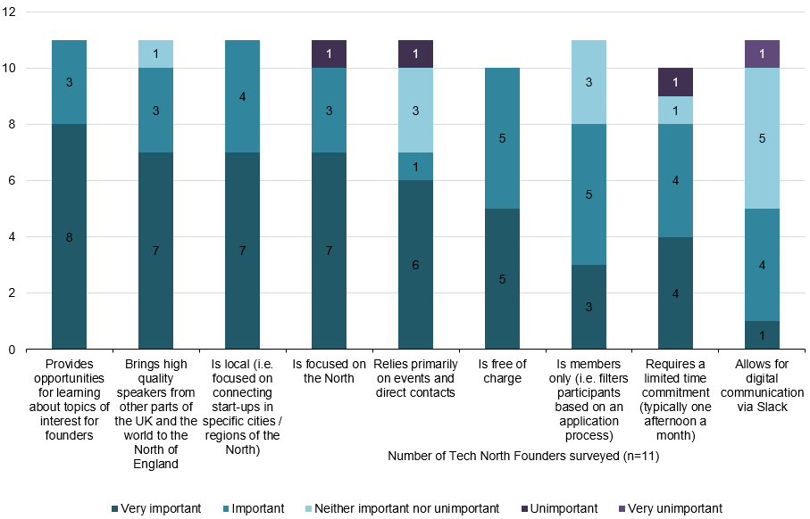
Source: SQW online survey; n=11
          - Respondents were asked how likely they were to recommend the Founders’ Network to others on a scale of one to 10 (where 10 represents very likely). Eight respondents gave a ‘10’, one gave a ‘nine’. Only two respondents gave a score below ‘four’.

Future Fifty events
Table E-1: Future Fifty events and attendance, 2014-2016
 | Name of event | Type of event |  |  |  | Attendance
 |  | Networking/ speaker dinner | Partner led workshop | Peer networking/ roundtable
2014 | Hiring for Hypergrowth |  |  |  | 10
 | Profile building in US |  |  |  | 15
 | Capital Markets |  |  |  | 37
 | Employee incentive schemes |  |  |  | 20
 | Investis Digital Estate |  |  |  | 12
 | Google |  |  |  | 24
 | Analysts Breakfast |  |  |  | 12
 | Workshop of workshops |  |  |  | 9
 | Leadership |  |  |  | 26
 | Capital Markets update |  |  |  | 13
 | HR network |  |  |  | 20
2015 | HR network |  |  |  | 19
 | HR network |  |  |  | 8
 | Finance network |  |  |  | 7
 | No 10 Roundtable |  |  |  | 40
 | Advisory Panel Dinner |  |  |  | 67
 | HR Network - going public |  |  |  | 10
 | Leadership training |  |  |  | 39
 | Incentive schemes |  |  |  | 12
 | Comms workshop |  |  |  | 10
 | CMO Dinner |  |  |  | 29
 | Leadership (Itay) Dinner |  |  |  | 93
 | HR Recruiters event |  |  |  | 18
 | Digital Single Market event |  |  |  | 11
 | HR employee engagement |  |  |  | 14
 | COO 'Holacracy' Dinner |  |  |  | 46
 | Immigration roundtable |  |  |  | 7
 | CFO Dinner |  |  |  | 27
 | Retain Your Superstars |  |  |  | 16
 | Leadership and Motivation |  |  |  | 31
2016 | National Gallery Dinner |  |  |  | 94
 | Future Fifty HR Meetup |  |  |  | 22
 | Delivering Constructive Feedback |  |  |  | 26
 | Exit - The end of the beginning: M&A and IPO |  |  |  | 74
 | Exit - The end of the beginning: M&A and IPO - Dinner |  |  |  | 40
 | Defining Success to Empower your Team |  |  |  | 31
 | CTO Meetup at Space Ape Games |  |  |  | 20
 | CMO Sessions: Lunch with Mat Braddy |  |  |  | 29
 | CTO Sessions: with Azeem Azhar |  |  |  | 34
 | HR Session with Ben Hunt-Davis MBE |  |  |  | 31
 | Going Global Summit |  |  |  | 84
 | Going Global Dinner |  |  |  | 56

First significant round of a firm’s venture capital financing - refers to the class of preferred stock sold to investors in exchange for their investment.
House of Commons Business, Innovation and Skills Committee (2016) The Digital Economy. Second Report of Session 2016-17
Tech City UK (2017) Tech Nation 2017
Ibid 2
HM Government (2017) Building our Industrial Strategy Green Paper, London
DCMS (2017) UK Digital Strategy 2017, London
HM Treasury (2015) Fixing the foundations: Creating a more prosperous nation
First significant round of a firm’s venture capital financing - refers to the class of preferred stock sold to investors in exchange for their investment.
SQW (2015) Interim Evaluation of Tech City UK, Final Report
SQW (2014) Tech City UK Evaluation Strategy, Final Report
HM Treasury (2011) The Magenta Book Guidance for Evaluation, HM Treasury
SQW (2014) Tech City UK Evaluation Strategy, Final Report
OECD Directorate For Science, technology and Innovation Committee on Digital Economy Policy (2016) Stimulating Digital Innovation for Growth and Inclusiveness: The Role of Policies for the Succesful Diffusion of ICT. Available here. And Nesta (2014) The Effects of Cluster Policy on Innovation. Manchester Institute of Innovation Research - Nesta Working Paper No. 12/05. Available here.
Journal of Innovation and Entrepreneurship, A Systems View Across Time and Space (2014) From market failures to market opportunities: managing innovation under asymmetric information. Available here. And BIS (2014) The Case for Public Support of Innovation. At the sector, technology and challenge areas. Available here.
Marshall, A. (1890) Principles of Economics. London, Macmillan.
Porter, M. E. (1990 The Competitive Advantage of Nations. New York: Free Press.
Porter, M. E. (1998) Clusters and the New Economics of Competition. Harvard Business Review. November-December 1998 issue. Available here.
https://www.gov.uk/government/publications/uk-digital-strategy
It is difficult to provide a precise response rate for ‘warm’ contacts though 115 respondents that had/expect to complete a course from 1,700 would be around a 7% response rate.
Originally through the (former) Department for Business, Innovation and Skills and then DCMS. The current DCMS funding is from 2016 to 2020 (c. £4.0m in the first two years, and £2m in the final two years)
According to TCUK, not all the commercial revenue was spent.
See for example, http://www.gouvernement.fr/en/la-french-tech
Based on our review of TCUK’s monitoring data, not all companies remain on the programme for the full two years.
Including Department for International Trade, and UK Visa & Immigration.
http://futurefifty.com/
A new cohort of companies joined the programme in 2017, taking the total number of companies to 103.
Bootstrapping refers to starting a company with little capital - building a company from personal finances or from the operating revenues of the new company.
https://www.sxsw.com/
https://techcrunch.com/2016/12/04/users-guide-to-disrupt-london-2016/
https://technorthhq.com/ecosystem/business-rocks-2016/
Smart Survey. https://www.smartsurvey.co.uk/ (Accessed 16.06.17)
In order to maximise responses the survey went live shortly the FN: The Summit regional event held on 2nd March 2017.
NPS is an index ranging from -100 to 100 that measures the willingness of customers to recommend a company's products or services to others. NPS is calculated by subtracting the percentage of customers who are detractors from the percentage who are promoters. See: https://www.netpromoter.com/know/
An NPS of 30-70 is considered “great”. See: https://www.retently.com/blog/good-net-promoter-score/
We have evidence to attribute performance changes for 21 firms.
These company comments were provided to
Smart Survey. https://www.smartsurvey.co.uk/ (Accessed 16.06.17)
How Does Cultural Diversity in Global Innovation Teams Affect the Innovation Process?,Viviane A. Winkler and Ricarda B. Bouncken, Engineering Management Journal Vol. 23 , Iss. 4,2011
Tech City UK (2017) Tech Nation 2017, using Pitchbook data
Tech City UK (2017) Tech Nation Report 2017 – drawing on Pitchbook data
Annual Business Survey 2015. Office for National Statistics: https://www.ons.gov.uk/
We did check with TCUK if the companies on their business lifecycle programmes had been classified in the SICs used for the digital tech sector as in the Tech Nation Report 2017, but this information was not available.
For example, if ‘medium size’ companies were under-represented in the sample then they would be given greater weight; and conversely if ‘large’ companies were over-represented in the sample, then they would have a lower weight. This was considered fairer than simply multiplying to the total number companies.
BEIS (2017) Sector Analysis - Assessing the value for money of government support to business: an appraisal framework.
The costs are £1.91m, which equates to the value of the business lifecycle programme (and associated cohorts) for which GVA are estimated – i.e. so that the costs and benefits both relate to the same activity. To be clear, the costs cover only a part (and not all) TCUK activity for the period 2014/15 – 2016/17.
Source: Innovate UK (2016) Delivery Plan 2016/17
Source: PricewaterhouseCoopers (2009) Impact of RDA Spending – volume 1
BIS Occasional Paper. No.1. Research to Improve Additionality. October 2009.
The mean displacement value for 'business development and competitiveness’ theme at the regional level is 29.3%.
BIS (2009) Research to improve the assessment of additionality.
This is based on 50% additionality for those where there is quality or speed additionality, 50% for those who possibly would not have achieved outcomes otherwise, and 100% additionality for those who definitely would not have achieved outcomes otherwise, i.e. (0.5 * (18 + 14 + 6) + 1 * (3))/50 = 0.44
Information supplied by TCUK.
https://www.younoodle.com/
https://www.eventbrite.co.uk/
https://www.fatsoma.com/
https://mailchimp.com/
https://www.klipfolio.com/builders-home
http://about.beauhurst.com/
https://pitchbook.com/
https://trello.com/
SQW (2015) Interim Evaluation of Tech City UK, Final Report
https://www.techuk.org/insights/news/item/4456-tech-city-uk-techuk-join-london-technology-week-as-strategic-partners
http://www.techuk.org/insights/news/item/2772-tech-city-uk-launches-digital-business-academy
TCUK impact evaluation ITT.
This cohort, in precise terms, were those who had 'started a job in the digital sector for the first time', 'started a digital job but not in the digital sector', 'taken on a different role or been promoted in digital sector', or had ‘taken on a different role or been promoted in a digital job in another sector’.
Ibid.

