Read Me

Throughout the creation of this website 3 main languages were used. This includes HTML, CSS and JavaScript.

Several different concepts were used to make the website as creative as possible. Firstly, on the index page a fully CSS image slideshow was used to display the different images. I used this as opposed to a JavaScript slideshow as it was an easier and much simpler concept, which brought the same results and therefore saved me time. Moreover, on the Liverpool FC page, I used a table like structure to set the webpage out to give it a distinctive look compared to the other pages. This page is a bright and user-friendly page, which provides all the relevant details to football fans about their team.

Moving on, the Real Madrid page uses several JavaScript functions. The JavaScript function allowed the user to select a player to view the statistics and a simple mouse over image, which changes the image when you hover over it. I did not extensively use JavaScript as I believe the website did not require this for the purpose it was made for. I believe extensive use of JavaScript would have made the website complicated and prevented problems for the user. Lastly, the contact us page contains a form that allows the user to submit any questions that they may have. The JavaScript function used on this form validates the user input ensuring all fields have an input before the enquiry can be submitted.

In order to make the website responsive, I used several media queries to resize a number of elements. Although, I used media queries some elements of the website did not resize accordingly to a mobile perspective. In addition to this, I made a responsive navigation menu which resizes when the website is used on a mobile phone. To test the websites responsiveness, I used Google Chrome to change the mobile device to see how it would look on different devices. This was my first ever time making a responsive website which is why I struggled on certain aspects of this assignment.

Overall, I believe I managed to use several concepts which will aid the users ability to use the website in a good manner. If I was to do this website again, I would ensure almost all elements of the website are resized accordingly. This could possibly be done with the use of media queries, JavaScript function and further research, which will allow the webpage to be resized when the dimensions of the websites are changed. Moreover, I would also ensure that the contact form directs the message to the relevant place using PHP. However, since this website did not go live this was not a serious problem or an issue. This website was written using HTML5, JavaScript and CSS3. Bootstrap was not used in the development of this website.

Resolution on a Macbook Air:

Home Page:

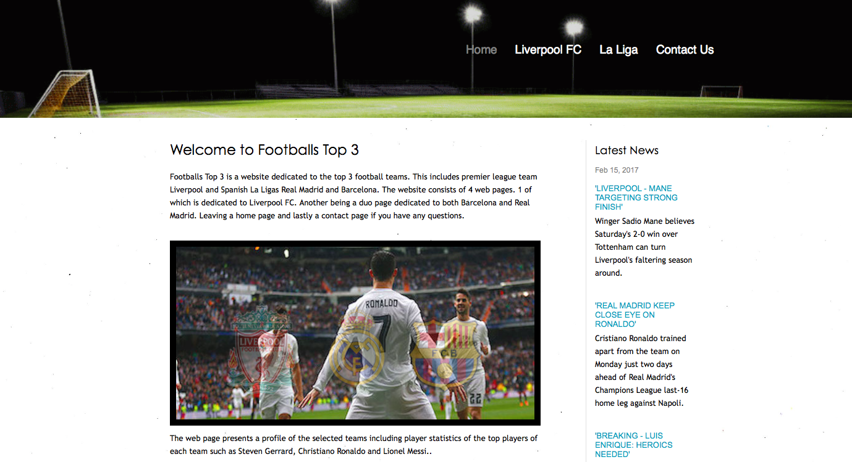

Liverpool FC Page:

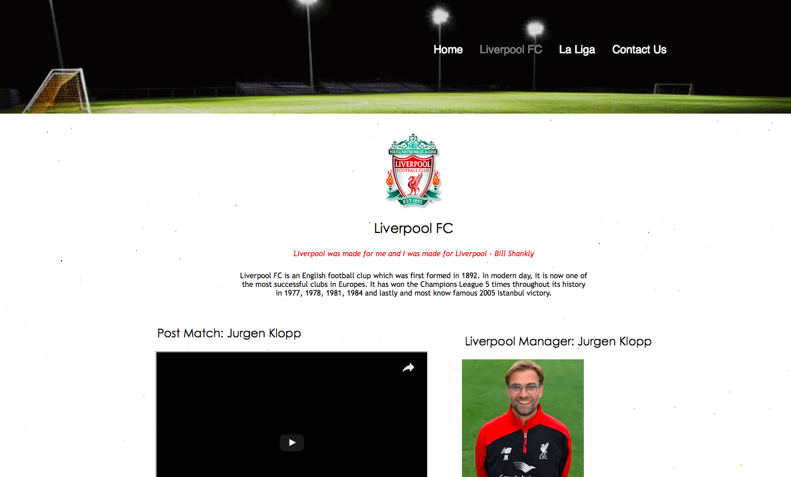

La Liga Page:

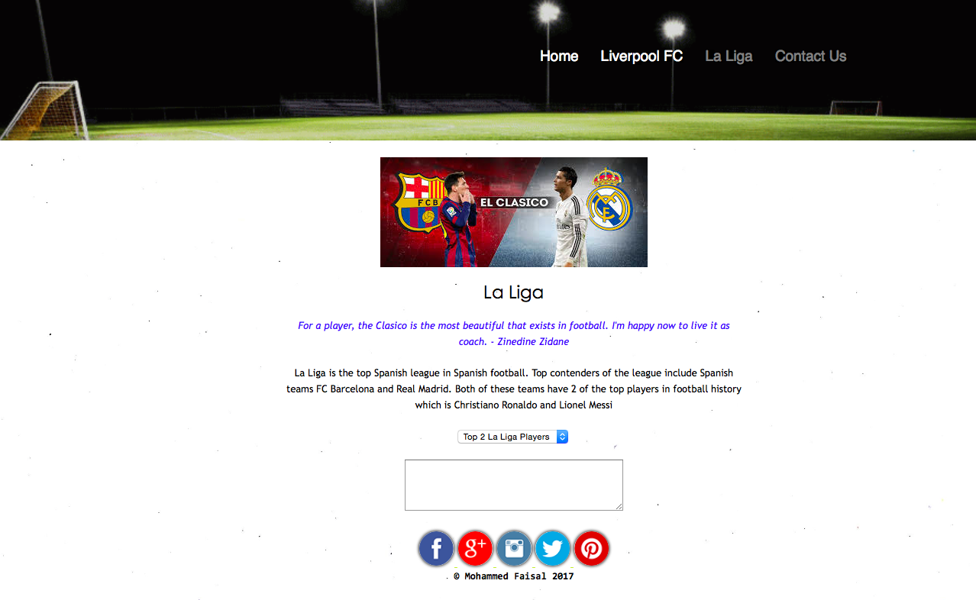

Contact Page:

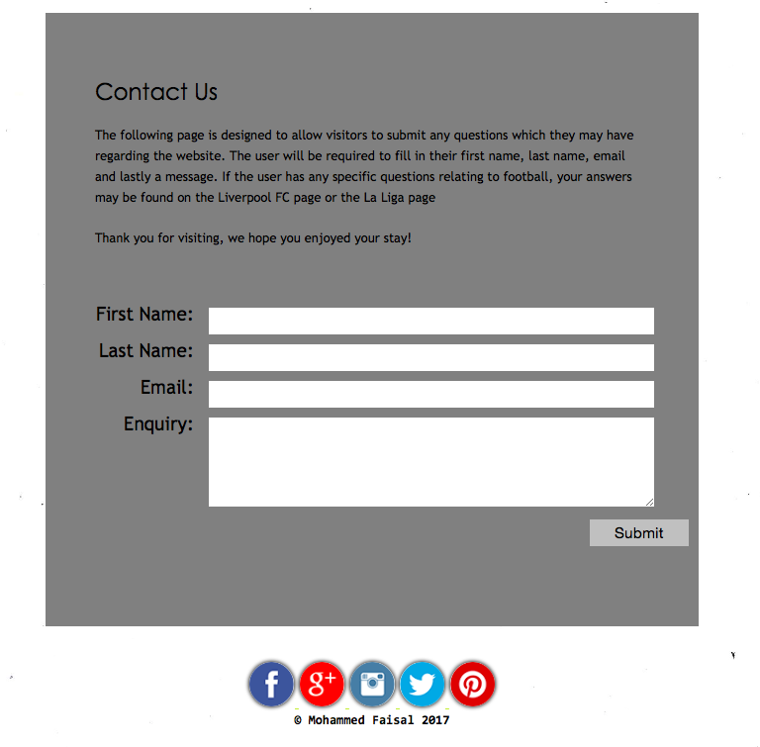

Reference List:

What is responsive design? (2015)

Available at: <https://www.w3schools.com/css/css_rwd_intro.asp> (Last Accessed: 28th February 2017)

CSS navigation menu (2015)

Available at: <https://www.w3schools.com/css/css_navbar.asp> (Last Accessed: 12th February 2017)

How to create a responsive navigation menu (2016)

Available at: <https://www.w3schools.com/html/html_responsive.asp> (Last Accessed: 18th March 2017)

How to create a navigation menu (2016) Available at: <https://www.w3schools.com/howto/howto_js_topnav.asp>

(Last Accessed: 22nd March 2017)