1. Key Literature References
2. Relevant Information
3. Brief Understanding of the Project and Case Study
4. Products
5. MOMENTICA, specialising on fan-artist engagement, alleged to be built on sustainable blockchain technology
6. tradeable NFT minted K-pop artists’ photo-cards and there are future plans to include athlete photo-cards and other metaverse virtual assets (such as webtoon and video-games entities);
7. live platform NFT system, providing not just BTS NFTs, but those of other Hype K-pop labels.
8. Project- Greenfield (Phase 1: NFT minting, NFT trading; Phase 2 ESG enabling NFT services
9. User Stories
10. Functional Requirements
11. **require modifying the smart-contracts of the NFT system’s new NFT issue and trading transactions** to have: Hybe contribute 2% of the NFT transaction settlement amount to the transacting fans’ chosen charities’ projects supported by BTS and other K-pop labels. Fans contribute 2% of the NFT transaction settlement amount and optionally more to their chosen charities’ projects.
12. **Select charity organisation criteria development**: Allowing authorised Hybe staff and K-pop members to add legitimate Korean and international charities and endorsed projects for receiving contributions initiated by NFT. Setup NFT exchange accounts for receiving donations
13. Linking to online project communication websites of charity institutions, **providing project progress information using dashboards, multimedia stories and Weverse social media for fans, charity organisations and occasionally the K-pop idols.**
14. **Linking to a cybersecurity education service for users,** to learn how to detect and report social engineering and malware injection schemes in order to use the ESG enabled NFT system safely.
15. Non-Functional Requirements
    1. UI: dashboard views of their accumulated contribution against each charity’s project’s deliverables and % complete information.
    2. In these charities’ websites, fans can click on their contributions or project deliverables to land on the charity’s project website-page to view more progress information and multimedia stories and engage in Weverse social media communications.
    3. Having icons on projects’ pages to allow fans view their contributions to projects.
    4. Weverse login authentication and other malware detection capabilities. The login authentication also detects each user’s country of residence, to ensure a user’s legal eligibility to transact NFT as not all countries permit cryptocurrency transactions
16. System Interoperability Requirements
    1. All NFT users must have a Weverse account to access the new ESG-NFT application
    2. Charities’ landing pages reside in the Weverse platform
17. 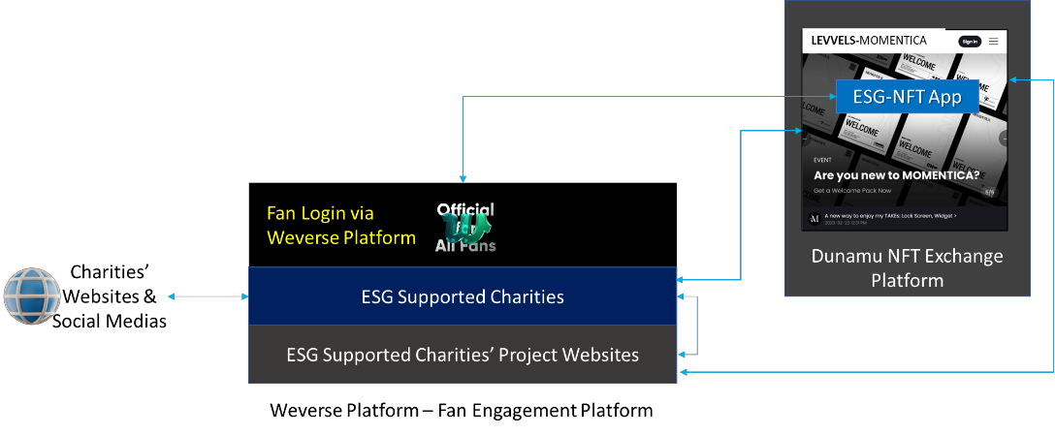
18. Conceptual Architecture Modelling Requirements
19. Assumptions
20. Social Media Engagement increases sales
21. Hybe’s business success to date is still highly hinged on the continuing success of its BTS-label, whose IP-resources and fandom are the core competencies, critical as building blocks, for developing Hybe’s digital service capabilities.
22. NFT trading helps to secure Hybe’s public financial worth
23. BTS fans are also ESG minded
24. environmental sustainability, social responsibility and good governance in both its strategic and operational pursuits already exists.
25. **Phase 1 already completed.** Hybe has decided to delegate the development of its phase 2’s NFT linked ESG services to your group.
26. **Training for new 1-2 months**
27. **Constraints:**
    1. **600K USD**
    2. **End on 1/08/23**
    3. **Start on 1/04/23**
    4. **Approval from EA for project conceptual Model**
28. Strategy
29. Hybe is continuing to invest more in technology to grow and sustain BTS success-sales, geographical reach, ease of IP distribution.
30. **Weverse** platform : connect all its K-pop labels and fans in accessing their artists’ creative IP-resources
31. **NFT Strategy** mint BTS and other K-pop labels’ intellectual property (IP) resources - notably their music tracks, videos, autographs, voice recording, etc - to generate new income streams.
32. Project- Greenfield (Phase 1: NFT minting, NFT trading; Phase 2 ESG enabling NFT services
33. ESG enabling project and increase Hybe’s branding back in Korea and internationally.
34. Hybe has plans to expand its corporate, ICT and project governance frameworks to include new SDG compliant sustainability principles, policies and development guidelines.
35. K-pop idols being ambassadors for partnering charity firms, whose projects subscribed to several SDG goals.
36. Stakeholders
37. Dunamu(PaaS) operator of South Korea’s largest crypto exchange, UpBit) to access an international NFT trading platform (Bread, 2021) provided by Levvels Inc
38. Levvels Inc
39. BTS fans(ARMY) are also ESG minded. The demographic profile of BTS fans is predominately adult, a majority nearing or in their thirties, and inter-generational.
40. senior Enterprise Architects provide functional requiremts
41. charity firms Examples are ChildFund Korea and Black Lives Matter, etc (Cho, 2022).

1. The Founder and CEO are the financial sponsors and they will not get involved in the day to day matters of your project.
2. ESG-product owner, also program manager, is Jimin Park
3. Kirin Martino will lead the **user experience** and contents design of the project communication service
4. Sharon Oy-Lee is a business user assigned to assist in **gathering user requirements**, help bring in more Hybe business users if required, and in charge of **user acceptance testing.**
5. Three of Hybe IT personnel

2) Stakeholder Engagement:

1) Weverse platform: artists’ creative IP-resources (notably their music tracks and music-videos)

2) MOMENTICA, specialising on fan-artist engagement, alleged to be built on sustainable blockchain technology

3) **Linking to a cybersecurity education service for users,** to learn how to detect and report social engineering and malware injection schemes in order to use the ESG enabled NFT system safely.

1. Individual Ideas
2. References