Name: Mohammed Faruq Nalband

MEAN Stack CI/CD Project

Project Overview
This project demonstrates a full MEAN stack application deployed with Docker, Nginx, and automated CI/CD using GitHub Actions. The objective is to ensure a consistent, containerized environment and a fully automated deployment process.
Repository Structure
mean-stack-ci-cd/
├── backend/
│ ├── Dockerfile
│ ├── package.json
│ ├── server.js
│ └── ... (backend source files)
├── frontend/
│ ├── Dockerfile
│ ├── package.json
│ ├── angular.json
│ └── dist/ (Angular build output)
├── nginx/
│ ├── default.conf
│ └── Dockerfile (optional)
├── .github/
│ └── workflows/
│ └── ci-cd.yml
├── docker-compose.yml
├── README.md
└── .gitignore

Dockerfiles
Backend Dockerfile (backend/Dockerfile)
FROM node:18-alpine
WORKDIR /usr/src/app
COPY package*.json ./
RUN npm install
COPY . .
EXPOSE 3000
CMD ["node", "server.js"]

Frontend Dockerfile (frontend/Dockerfile)
# Stage 1: Build Angular app
FROM node:18-alpine as build
WORKDIR /app
COPY package*.json ./
RUN npm install
COPY . .
RUN npm run build --prod
# Stage 2: Serve with Nginx
FROM nginx:alpine
COPY --from=build /app/dist/your-angular-app /usr/share/nginx/html
COPY nginx/default.conf /etc/nginx/conf.d/default.conf
EXPOSE 80
CMD ["nginx", "-g", "daemon off;"]

Docker Compose (docker-compose.yml)
version: "3.9"
services:
backend:
build: ./backend
container_name: backend
ports:
- "3000:3000"
networks:
- mean-network

frontend:
build: ./frontend
container_name: frontend
ports:
- "81:80"
depends_on:
- backend
networks:
- mean-network

networks:
mean-network:
driver: bridge

Nginx Configuration
server {
listen 80;
server_name _;

root /usr/share/nginx/html;
index index.html;

location / {
try_files $uri /index.html;
}

location /api/ {
proxy_pass http://backend:3000/;
proxy_http_version 1.1;
proxy_set_header Upgrade $http_upgrade;
proxy_set_header Connection 'upgrade';
proxy_set_header Host $host;
proxy_cache_bypass $http_upgrade;
}
}

GitHub Actions CI/CD Workflow (.github/workflows/ci-cd.yml)
name: MEAN Stack CI/CD

on:
push:
branches:
- main

jobs:
build-and-deploy:
runs-on: ubuntu-latest

steps:
- name: Checkout code
uses: actions/checkout@v3

- name: Set up Docker Buildx
uses: docker/setup-buildx-action@v2

- name: Log in to Docker Hub
uses: docker/login-action@v2
with:
username: ${{ secrets.DOCKER_USERNAME }}
password: ${{ secrets.DOCKER_PASSWORD }}

- name: Build and push backend image
run: |
docker build -t ${{ secrets.DOCKER_USERNAME }}/mean-backend:latest ./backend
docker push ${{ secrets.DOCKER_USERNAME }}/mean-backend:latest

- name: Build and push frontend image
run: |
docker build -t ${{ secrets.DOCKER_USERNAME }}/mean-frontend:latest ./frontend
docker push ${{ secrets.DOCKER_USERNAME }}/mean-frontend:latest

- name: Deploy with Docker Compose
run: |
ssh -o StrictHostKeyChecking=no ${{ secrets.SERVER_USER }}@${{ secrets.SERVER_IP }} "
cd /home/ubuntu/mean-app &&
docker-compose pull &&
docker-compose up -d --build"

Conclusion
Additional files were created to enable containerization, orchestration, and automated deployment:
- Dockerfiles: Ensure consistent runtime environments for backend and frontend.
- Docker Compose: Orchestrates multi-service deployment with minimal effort.
- Nginx configuration: Efficiently serves Angular SPA and proxies API requests.
- GitHub Actions CI/CD workflow: Automates build, push, and deployment processes, reducing manual intervention and errors.
These additions make the application production-ready, maintainable, and scalable, demonstrating modern DevOps best practices.

Instructions for Reviewer
- Clone the repository:
git clone https://github.com/mohammedfaruq50/mean-devops-task
Navigate to project folder:
cd mean-stack-ci-cd
- Run locally :
docker-compose up --build
- CI/CD automatically deploys on push to main branch.
- Refer to screenshots folder (if included) for workflow and UI verification.

Screenshots:
Frontend
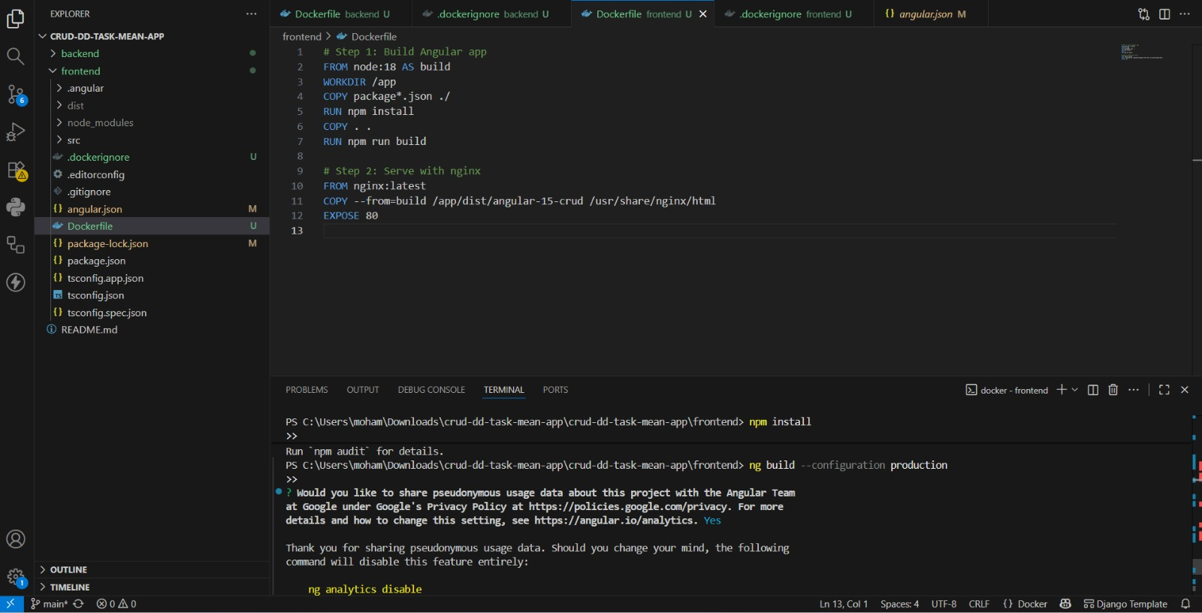
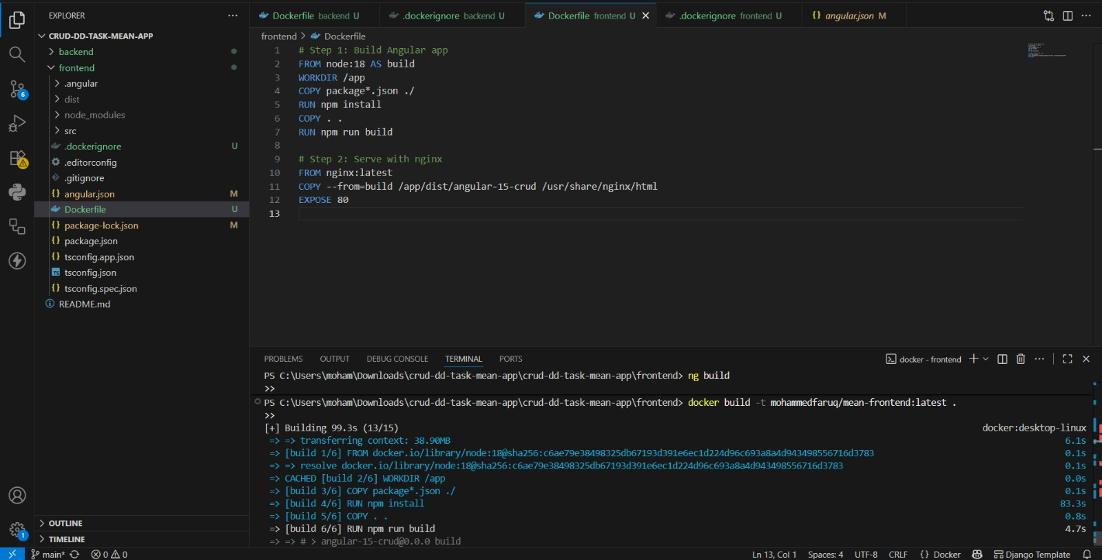
Backend
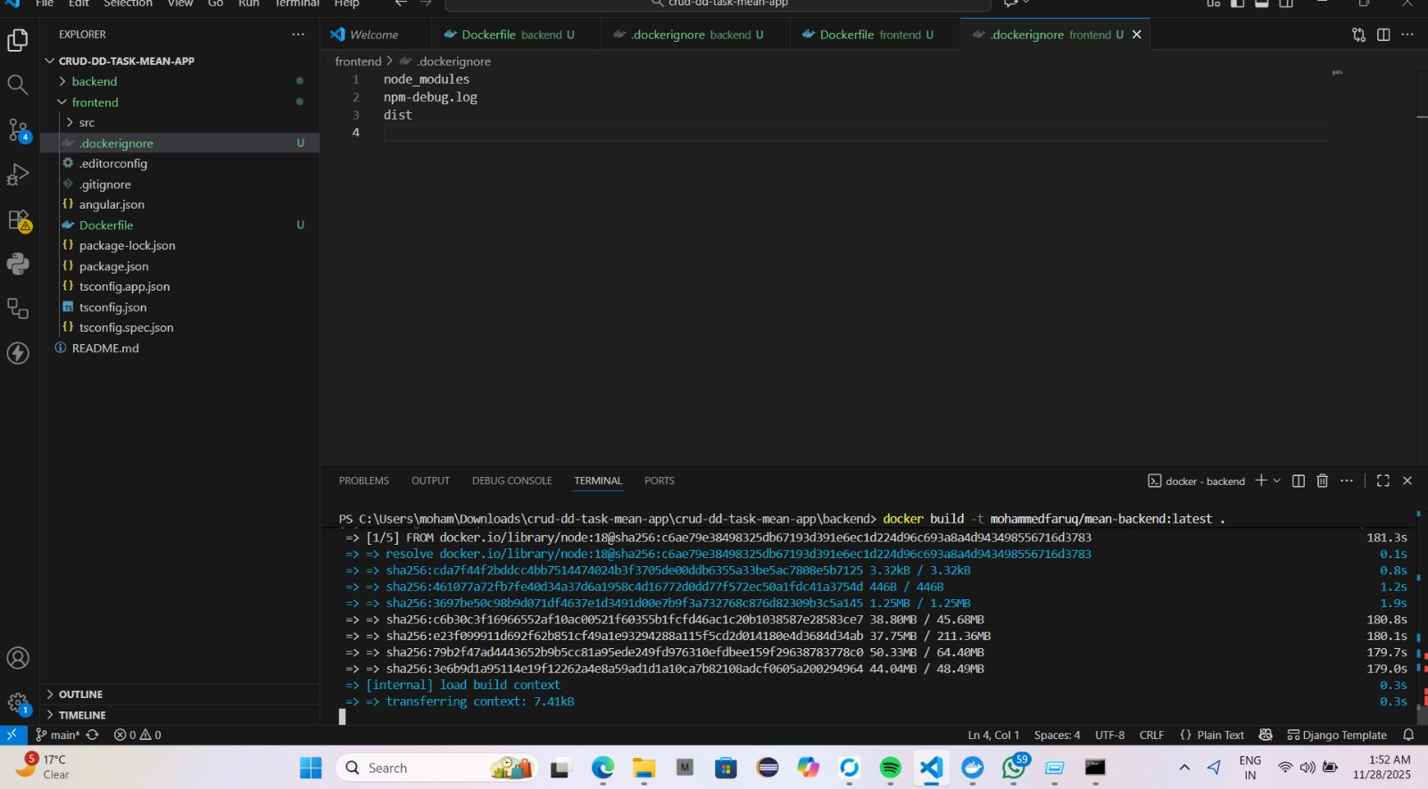
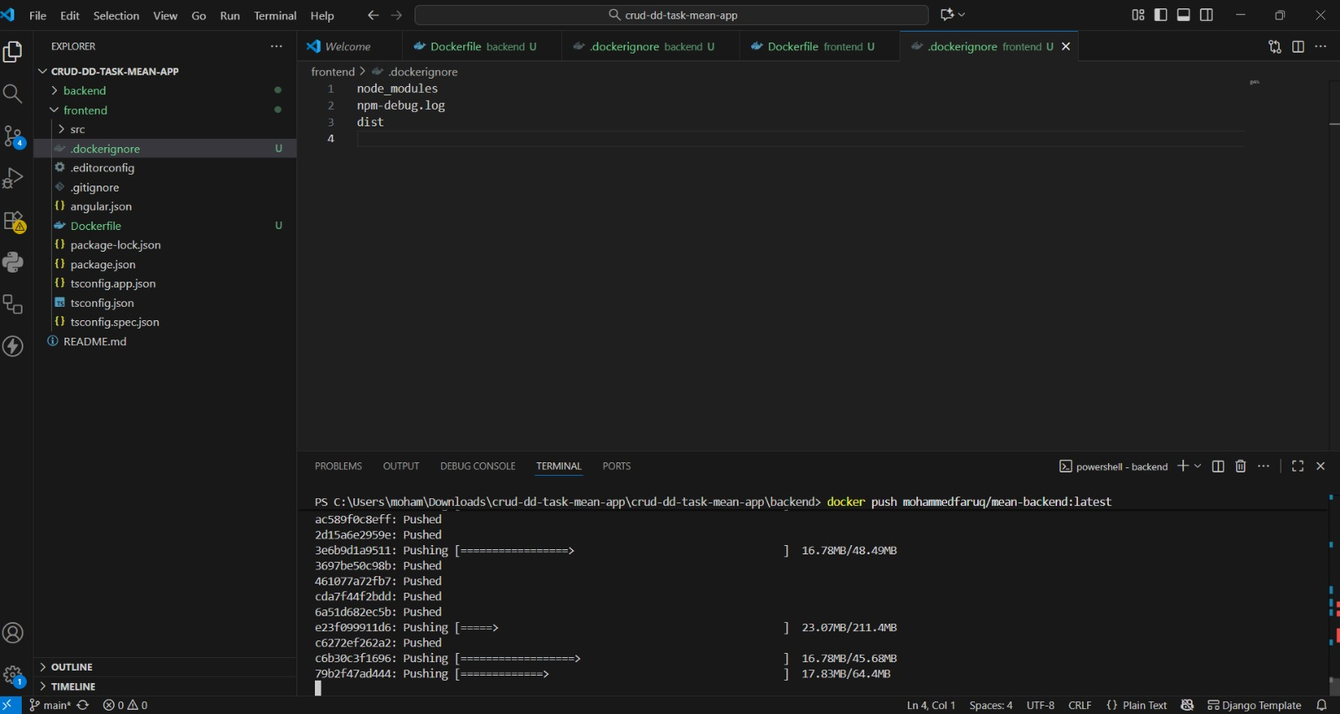

CI/CD
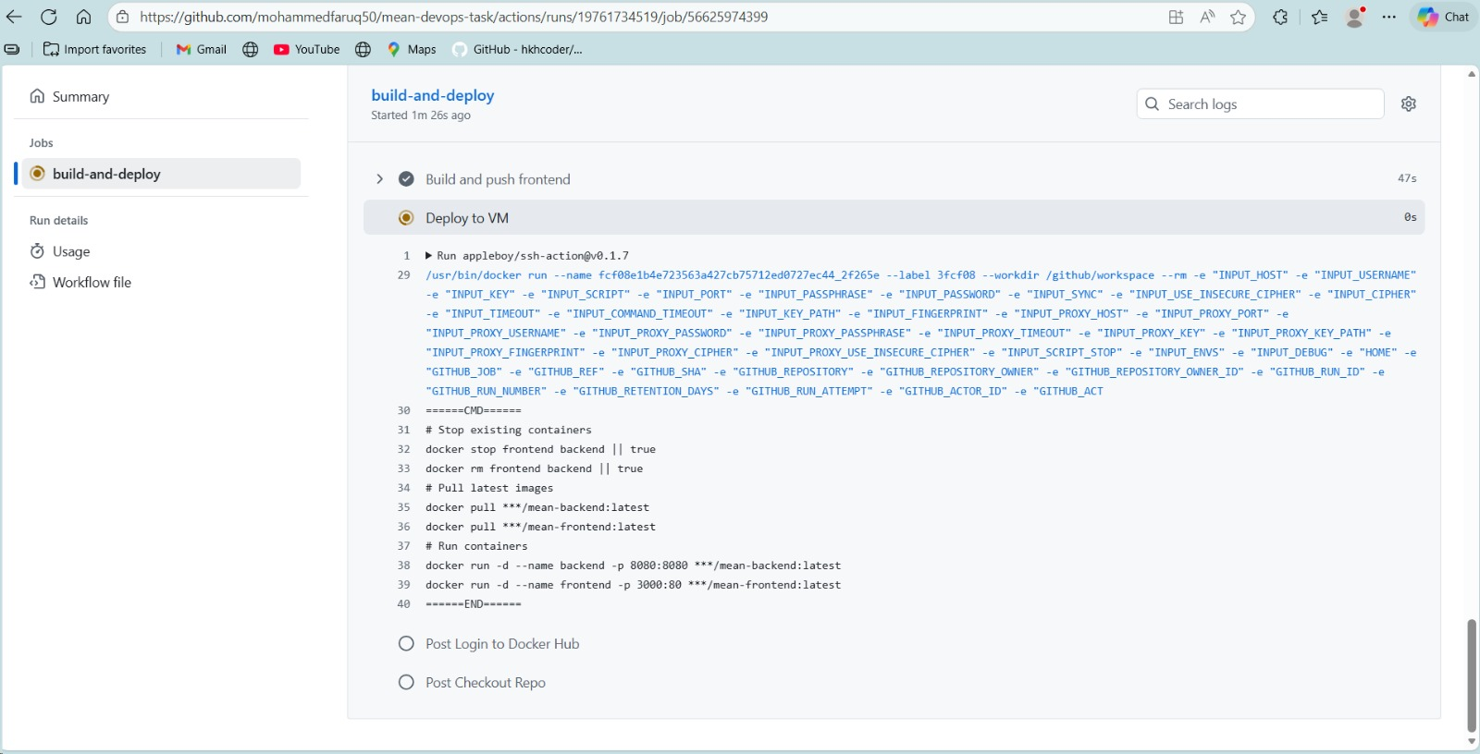

VM
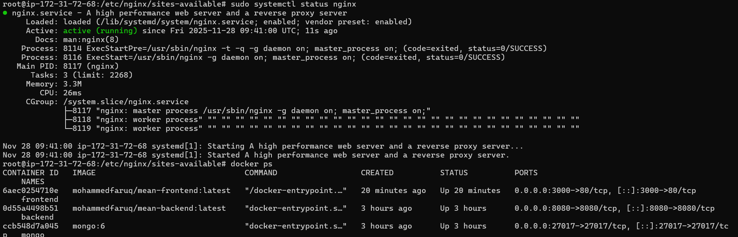ss

