Team Members

**1-Mohamed Jamal El-Deen Mohamed**

**2-Youssef Ibrahim Mammon**

**3-Abdelrahman Ali Mohamed**

Data dictionary

Table customer

Data dictionary for customer id column:

|  |  |  |  |  |
| --- | --- | --- | --- | --- |
| name | definition | Data type | Possible values | Required |
| Customer ID | Id for customer | Integer | 1,14,3,50 | Yes |

Data dictionary for Full Name column :

|  |  |  |  |  |
| --- | --- | --- | --- | --- |
| name | definition | Data type | Possible values | Required |
| Full Name | name the customer | nchar | A,b,e,h | Yes |

Data dictionary for Phone Number column:

|  |  |  |  |  |
| --- | --- | --- | --- | --- |
| name | definition | Data type | Possible values | Required |
| Phone Number | Number phone for customer | nchar | 0,3,56,100 | No |

Data dictionary for nationality column:

|  |  |  |  |  |
| --- | --- | --- | --- | --- |
| name | definition | Data type | Possible values | Required |
| nationality | Nationality for customer | nchar | A,d,r,g,v | No |

Data dictionary for gender column:

|  |  |  |  |  |
| --- | --- | --- | --- | --- |
| name | definition | Data type | Possible values | Required |
| gender | Grander for customer | nchar | Man,wemon | No |

Data dictionary for address column:

|  |  |  |  |  |
| --- | --- | --- | --- | --- |
| name | definition | Data type | Possible values | Required |
| address | Address for customer | nchar | A,d,f,e,z | No |

Data dictionary for chick in column:

|  |  |  |  |  |
| --- | --- | --- | --- | --- |
| name | definition | Data type | Possible values | Required |
| Chick in | Chick in the customer in hotel | nchar | S,I,d,gt | Yes |

Data dictionary for chick out column:

|  |  |  |  |  |
| --- | --- | --- | --- | --- |
| name | definition | Data type | Possible values | Required |
| Chick out | Chick out the customer in hotel | nchar | Fg,h,t,w,v | Yes |

Data dictionary for chick out column:

|  |  |  |  |  |
| --- | --- | --- | --- | --- |
| name | definition | Data type | Possible values | Required |
| Chick out | Chick out the customer in hotel | nchar | Fg,h,t,w,v | Yes |

Data dictionary for price column:

|  |  |  |  |  |
| --- | --- | --- | --- | --- |
| name | definition | Data type | Possible values | Required |
| price | All-inclusive price for the customer | bigint | 12$,13$ | Yes |

Data dictionary for room number column:

|  |  |  |  |  |
| --- | --- | --- | --- | --- |
| name | definition | Data type | Possible values | Required |
| Room number | Number of room | Integer | 1,2,3,5 | Yes |

Data dictionary for room id column:

|  |  |  |  |  |
| --- | --- | --- | --- | --- |
| name | definition | Data type | Possible values | Required |
| Room id | ID of room | Integer | 1,2,3,5 | Yes |

Table Employee

Data dictionary for Employee ID column:

|  |  |  |  |  |
| --- | --- | --- | --- | --- |
| name | definition | Data type | Possible values | Required |
| Employee ID | ID for Employee | integer | 0,3,56,100 | Yes |

Data dictionary for Employee Name column:

|  |  |  |  |  |
| --- | --- | --- | --- | --- |
| name | definition | Data type | Possible values | Required |
| Employee Name | Name phone for Employee | nchar | A,d,f,e,z | Yes |

Data dictionary for E Number column:

|  |  |  |  |  |
| --- | --- | --- | --- | --- |
| name | definition | Data type | Possible values | Required |
| E Number | Number phone for Employee | nchar | 0,3,56,100 | Yes |

Data dictionary for Gender column:

|  |  |  |  |  |
| --- | --- | --- | --- | --- |
| name | definition | Data type | Possible values | Required |
| Gender | Gender for Employee | nchar | A,d,f,e,z | No |

Data dictionary for Employee Email column:

|  |  |  |  |  |
| --- | --- | --- | --- | --- |
| name | definition | Data type | Possible values | Required |
| Employee Email | Employee Email for Employee | nchar | A,d,f,e,z | Yes |

Data dictionary for User Name column:

|  |  |  |  |  |
| --- | --- | --- | --- | --- |
| name | definition | Data type | Possible values | Required |
| User Name | User Name for Employee | nchar | A,d,f,e,z | Yes |

Data dictionary for Password column:

|  |  |  |  |  |
| --- | --- | --- | --- | --- |
| name | definition | Data type | Possible values | Required |
| Password | Password for Employee | nchar | 0,3,56,100 | Yes |

Table Room

Data dictionary for Room ID column:

|  |  |  |  |  |
| --- | --- | --- | --- | --- |
| name | definition | Data type | Possible values | Required |
| Room ID | Id for Room | integer | 0,3,56,100 | Yes |

Data dictionary for Room Number column:

|  |  |  |  |  |
| --- | --- | --- | --- | --- |
| name | definition | Data type | Possible values | Required |
| Room  Number | Number for Room | nchar | 0,3,56,100 | Yes |

Data dictionary for View Room column:

|  |  |  |  |  |
| --- | --- | --- | --- | --- |
| name | definition | Data type | Possible values | Required |
| View Room | View for Room | nchar | A,d,f,e,z | Yes |

Data dictionary for Beds column:

|  |  |  |  |  |
| --- | --- | --- | --- | --- |
| name | definition | Data type | Possible values | Required |
| Beds | Number of beds for Room | nchar | 0,3,56,100 | Yes |

Data dictionary for Price column:

|  |  |  |  |  |
| --- | --- | --- | --- | --- |
| name | definition | Data type | Possible values | Required |
| Price | All room rates | Bigint | 0,3,56,100 | Yes |

Data dictionary for Booked column:

|  |  |  |  |  |
| --- | --- | --- | --- | --- |
| name | definition | Data type | Possible values | Required |
| Booked | Booked for Room | nchar | 0,3,56,100 | Yes |

**Data Dictionary – Data Flow**

Data flow: **(1) Description from**

|  |  |
| --- | --- |
| **Data flow Description from**  **ID:1**  **Name (label): enquiring for room**  **Description: enquire the guest about required room** | |
| **Source: external entity**  **(guest)** | **Destination: process**  **(enquire)** |
| **Type of Data Flow**  File Screen Report Form Internal | |
| **Data structure: Guest data structure** | **Volume/time:**  **3/minute** |
| **Comments: the guest must register on the application** | |

Data flow: **(2) Description from**

|  |  |
| --- | --- |
| **Data flow Description from**  **ID:2**  **Name (label): enquiring from employee**  **Description: enquiring the employee about a room** | |
| **Source: process**  **(enquire)** | **Destination: external entity**  **(employee)** |
| **Type of Data Flow**  File Screen Report Form Internal | |
| **Data structure: employee**  **Data structure** | **Volume/time**  **1-3/minute** |
| **Comments: ask the guest to fil up his information** | |

Data flow: **(2) Description from**

|  |  |
| --- | --- |
| **Data flow Description from**  **ID: 3**  **Name (label): searching for room in system**  **Description: use the system to check for empty room** | |
| **Source: external entity**  **(employee)** | **Destination: process**  **(search)** |
| **Type of Data Flow**  File Screen Report Form Internal | |
| **Data structure:**  **Employee data structure** | **Volume/time:**  **1-3/minute** |
| **Comments: the employee must open up the system** | |

Data flow: **(1) Description from**

|  |  |
| --- | --- |
| **Data flow Description from**  **ID: 4**  **Name (label): search in the files about the required room**  **Description: use data store to check about empty room** | |
| **Source: process**  **(search)** | **Destination: data storage** |
| **Type of Data Flow**  File Screen Report Form Internal | |
| **Data structure:**  **Search data store** | **Volume/time:**  **1-3/minute** |
| **Comments:** | |

Data flow: **(1) Description from**

|  |  |
| --- | --- |
| **Data flow Description from**  **ID: 5**  **Name (label): responding data**  **Description: return the result of the searching process** | |
| **Source: data store** | **Destination: search for the required room** |
| **Type of Data Flow**  File Screen Report Form Internal | |
| **Data structure:**  **room data structure** | **Volume/time:**  **1-3/minute** |
| **Comments:** | |

Data flow: **(1) Description from**

|  |  |
| --- | --- |
| **Data flow Description from**  **ID: 6**  **Name (label): respond the data**  **Description: return the result of the searching process** | |
| **Source: entity**  **employee** | **Destination: process**  **Enquire for empty room** |
| **Type of Data Flow**  File Screen Report Form Internal | |
| **Data structure:**  **Employee data structure** | **Volume/time:**  **1-3/minute** |
| **Comments:** | |

Data flow: **(1) Description from**

|  |  |
| --- | --- |
| **Data flow Description from**  **ID: 7**  **Name (label): responding data**  **Description: return the result of the searching process** | |
| **Source: process**  **(enquire for empty room)** | **Destination: entity**  **(guest)** |
| **Type of Data Flow**  File Screen Report Form Internal | |
| **Data structure:**  **Guest data structure** | **Volume/time:**  **1-3/minute** |
| **Comments:** | |

Data flow: **(1) Description from**

|  |  |
| --- | --- |
| **Data flow Description from**  **ID: 8**  **Name (label): rejecting**  **Description: if the guest can’t find the required room and he need to cancel the process** | |
| **Source: external entity**  **(guest)** | **Destination: process**  **(canceling room)** |
| **Type of Data Flow**  File Screen Report Form Internal | |
| **Data structure:**  **Guest data structure** | **Volume/time:**  **1-3/minute** |
| **Comments:** | |

Data flow: **(1) Description from**

|  |  |
| --- | --- |
| **Data flow Description from**  **ID: 9**  **Name (label): canceling**  **Description: canceling the process and pause it** | |
| **Source: process:**  **(canceling)** | **Destination: external entity**  **(employee)** |
| **Type of Data Flow**  File Screen Report Form Internal | |
| **Data structure:**  **Employee data structure** | **Volume/time:**  **1/minute** |
| **Comments: pause the process confirming** | |

Data flow: **(1) Description from**

|  |  |
| --- | --- |
| **Data flow Description from**  **ID: 10**  **Name (label): reserving room**  **Description: decision to reserve the room by the guest** | |
| **Source: external entity**  **(guest)** | **Destination: process**  **(reserve room)** |
| **Type of Data Flow**  File Screen Report Form Internal | |
| **Data structure: guest data structure** | **Volume/time:**  **5/minute the** |
| **Comments: the guest must be sure that it is the desired room** | |

Data flow: **(1) Description from**

|  |  |
| --- | --- |
| **Data flow Description from**  **ID: 11**  **Name (label): reserving from employee**  **Description: reserve the room by hotel using the system** | |
| **Source: process:**  **Reserve room** | **Destination: external entity**  **(employee)** |
| **Type of Data Flow**  File Screen Report Form Internal | |
| **Data structure:**  **Employee data structure** | **Volume/time:**  **1-3/minute** |
| **Comments: system must be on to complete the process** | |

Data flow: **(1) Description from**

|  |  |
| --- | --- |
| **Data flow Description from**  **ID: 12**  **Name (label): confirming info**  **Description: confirm the info about the guest** | |
| **Source: external entity**  **(Employee)** | **Destination: process**  **(Confirm)** |
| **Type of Data Flow**  File Screen Report Form Internal | |
| **Data structure:**  **Employee data structure** | **Volume/time:**  **1-3/minute** |
| **Comments: these info must be correct** | |

Data flow: **(1) Description from**

|  |  |
| --- | --- |
| **Data flow Description from**  **ID: 13**  **Name (label): confirming and saving the data**  **Description: take the info about the guest and save it** | |
| **Source: process:**  **(confirm the required info)** | **Destination: info data storage** |
| **Type of Data Flow**  File Screen Report Form Internal | |
| **Data structure:**  **info data structure** | **Volume/time:**  **1-3/minute** |
| **Comments: confirming the info in data storage** | |

Data flow: **(1) Description from**

|  |  |
| --- | --- |
| **Data flow Description from**  **ID: 14**  **Name (label): payment**  **Description: pay for the reservation** | |
| **Source: external entity**  **(guest)** | **Destination: process**  **Pay for the process** |
| **Type of Data Flow**  File Screen Report Form Internal | |
| **Data structure:**  **Guest data structure** | **Volume/time:**  **5-10/minute** |
| **Comments: the type of the transaction must be selected** | |

Data flow: **(1) Description from**

|  |  |
| --- | --- |
| **Data flow Description from**  **ID: 15**  **Name (label): paying for the transaction**  **Description: pay the money to reserve the room to room** | |
| **Source: process**  **(pay for the room)** | **Destination: external entity**  **(employee)** |
| **Type of Data Flow**  File Screen Report Form Internal | |
| **Data structure:**  **Employee data structure** | **Volume/time:**  **3/minute** |
| **Comments:** | |

Data flow: **(1) Description from**

|  |  |
| --- | --- |
| **Data flow Description from**  **ID: 16**  **Name (label): storing the transaction**  **Description: store the info and the process of reserving the room** | |
| **Source: entity**  **(employee)** | **Destination: process**  **(store the info)** |
| **Type of Data Flow**  File Screen Report Form Internal | |
| **Data structure:**  **employee data structure** | **Volume/time:**  **5/minute** |
| **Comments:** | |

Data flow: **(1) Description from**

|  |  |
| --- | --- |
| **Data flow Description from**  **ID: 17**  **Name (label): save the transaction in file**  **Description: save the transaction in file in data storage** | |
| **Source: process**  **Store the info transaction** | **Destination: info data storage** |
| **Type of Data Flow**  File Screen Report Form Internal | |
| **Data structure:**  **info data structure** | **Volume/time:**  **3/minute** |
| **Comments:** | |

Data flow: **(1) Description from**

|  |  |
| --- | --- |
| **Data flow Description from**  **ID: 18**  **Name (label): complaining about the problem**  **Description: tell the responsible about the hotel about any problem** | |
| **Source: entity**  **guest** | **Destination: process**  **Complain about the problem** |
| **Type of Data Flow**  File Screen Report Form Internal | |
| **Data structure:**  **Guest data structure** | **Volume/time:**  **24/hour** |
| **Comments: make sure to solve this problem** | |

Data flow: **(1) Description from**

|  |  |
| --- | --- |
| **Data flow Description from**  **ID: 19**  **Name (label): complain and write the problem**  **Description: describe the problem by writing it** | |
| **Source: process**  **(complain about any problem)** | **Destination: temporary data storage** |
| **Type of Data Flow**  File Screen Report Form Internal | |
| **Data structure:**  **temporary data storage** | **Volume/time:**  **24/hour** |
| **Comments: try to describe your problem in details** | |

Data flow: **(1) Description from**

|  |  |
| --- | --- |
| **Data flow Description from**  **ID: 20**  **Name (label): displaying the problems**  **Description: display the completions to the manager** | |
| **Source: temporary data storage** | **Destination: manager** |
| **Type of Data Flow**  File Screen Report Form Internal | |
| **Data structure: manager data structure** | **Volume/time:**  **8/hour** |
| **Comments: the manager must check the problems permanently** | |

Data flow: **(1) Description from**

|  |  |
| --- | --- |
| **Data flow Description from**  **ID: 21**  **Name (label): returning responses**  **Description: return the responses about the problems** | |
| **Source: manager** | **Destination: temporary data storage** |
| **Type of Data Flow**  File Screen Report Form Internal | |
| **Data structure: manager data structure** | **Volume/time:**  **8/hours** |
| **Comments:** | |

Data flow: **(1) Description from**

|  |  |
| --- | --- |
| **Data flow Description from**  **ID: 22**  **Name (label): responding data**  **Description: return the responses about the problems** | |
| **Source: temporary (problems) data storage** | **Destination: complain about the problem** |
| **Type of Data Flow**  File Screen Report Form Internal | |
| **Data structure:**  **problems data structure** | **Volume/time:**  **8/hours** |
| **Comments:** | |

Data flow: **(1) Description from**

|  |  |
| --- | --- |
| **Data flow Description from**  **ID: 23**  **Name (label): responding data**  **Description: return the responses about the problems** | |
| **Source: complain about the problem** | **Destination: entity**  **guest** |
| **Type of Data Flow**  File Screen Report Form Internal | |
| **Data structure: guest**  **Data structure** | **Volume/time:8/hour** |
| **Comments:** | |

Data flow: **(1) Description from**

|  |  |
| --- | --- |
| **Data flow Description from**  **ID: 24**  **Name (label): receiving the problem by the manager**  **Description: it shows the manager the valid problem** | |
| **Source: temporary problems data store** | **Destination: entity**  **(manager)** |
| **Type of Data Flow**  File Screen Report Form Internal | |
| **Data structure:**  **problems data store** | **Volume/time:**  **8/hour** |
| **Comments: the manager should try to solve this problem** | |

Data flow: **(1) Description from**

|  |  |
| --- | --- |
| **Data flow Description from**  **ID: 25**  **Name (label): managing the hotel**  **Description: manage and take the control of the hotel** | |
| **Source: process**  **(manages)** | **Destination: external entity(hotel)** |
| **Type of Data Flow**  File Screen Report Form Internal | |
| **Data structure:**  **Hotel data structure** | **Volume/time:**  **24/hour** |
| **Comments:** | |

Context Level:

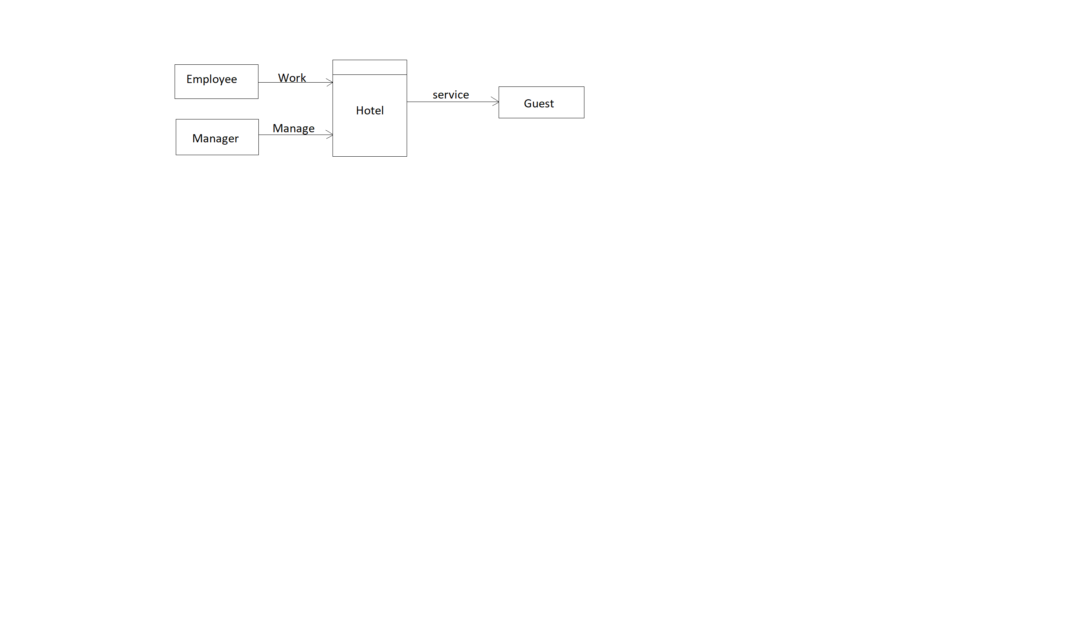

Logical Data flow:

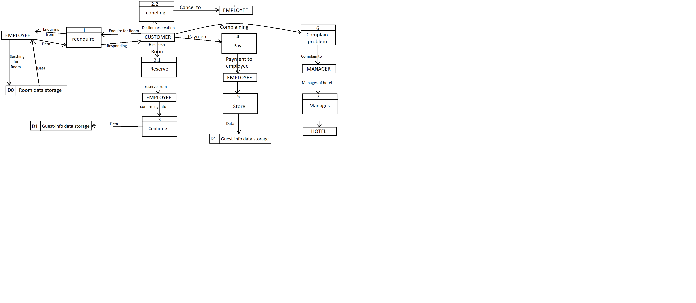

Physical Data flow:

