

[Description](https://docs.google.com/document/d/1gKP6RxykeekNk5bYxXIKjEitKDPdxpRyIaa9t50bLSA/edit#heading=h.sm4ra97uwo11)

[Intended User](https://docs.google.com/document/d/1gKP6RxykeekNk5bYxXIKjEitKDPdxpRyIaa9t50bLSA/edit#heading=h.aws88pzfmqca)

[Features](https://docs.google.com/document/d/1gKP6RxykeekNk5bYxXIKjEitKDPdxpRyIaa9t50bLSA/edit#heading=h.zheq5430xrpq)

[User Interface Mocks](https://docs.google.com/document/d/1gKP6RxykeekNk5bYxXIKjEitKDPdxpRyIaa9t50bLSA/edit#heading=h.giquerrw6g46)

[Screen 1](https://docs.google.com/document/d/1gKP6RxykeekNk5bYxXIKjEitKDPdxpRyIaa9t50bLSA/edit#heading=h.a4jdupabry3k)

[Screen 2](https://docs.google.com/document/d/1gKP6RxykeekNk5bYxXIKjEitKDPdxpRyIaa9t50bLSA/edit#heading=h.dpcbbkx5yry)

[Key Considerations](https://docs.google.com/document/d/1gKP6RxykeekNk5bYxXIKjEitKDPdxpRyIaa9t50bLSA/edit#heading=h.gvcvmae8jn8u)

[How will your app handle data persistence?](https://docs.google.com/document/d/1gKP6RxykeekNk5bYxXIKjEitKDPdxpRyIaa9t50bLSA/edit#heading=h.v8my7nhtvz0m)

[Describe any corner cases in the UX.](https://docs.google.com/document/d/1gKP6RxykeekNk5bYxXIKjEitKDPdxpRyIaa9t50bLSA/edit#heading=h.gw69vjn1ico0)

[Describe any libraries you’ll be using and share your reasoning for including them.](https://docs.google.com/document/d/1gKP6RxykeekNk5bYxXIKjEitKDPdxpRyIaa9t50bLSA/edit#heading=h.6yqqubmw5bs)

[Describe how you will implement Google Play Services.](https://docs.google.com/document/d/1gKP6RxykeekNk5bYxXIKjEitKDPdxpRyIaa9t50bLSA/edit#heading=h.qrxg682nywe6)

[Next Steps: Required Tasks](https://docs.google.com/document/d/1gKP6RxykeekNk5bYxXIKjEitKDPdxpRyIaa9t50bLSA/edit#heading=h.v518bncmggeg)

[Task 1: Project Setup](https://docs.google.com/document/d/1gKP6RxykeekNk5bYxXIKjEitKDPdxpRyIaa9t50bLSA/edit#heading=h.8oe8zpk3qsmp)

[Task 2: Implement UI for Each Activity and Fragment](https://docs.google.com/document/d/1gKP6RxykeekNk5bYxXIKjEitKDPdxpRyIaa9t50bLSA/edit#heading=h.rzllsk6uqztx)

[Task 3: Your Next Task](https://docs.google.com/document/d/1gKP6RxykeekNk5bYxXIKjEitKDPdxpRyIaa9t50bLSA/edit#heading=h.fdmohs7hes)

[Task 4: Your Next Task](https://docs.google.com/document/d/1gKP6RxykeekNk5bYxXIKjEitKDPdxpRyIaa9t50bLSA/edit#heading=h.umfwsvmx7tpn)

[Task 5: Your Next Task](https://docs.google.com/document/d/1gKP6RxykeekNk5bYxXIKjEitKDPdxpRyIaa9t50bLSA/edit#heading=h.kjidlkq4xm3u)

**GitHub Username**: mohammedgmgn

ReadShow

Description

ReadShow allow users to discover and search for the most popular books

Intended User

Anyone who interested in Reading

Features

:

* User can switch between publication type (books-magazines-all )
* User can view a detailed information about the book
* User can Search about specific book
* User can add specific book to his favorite books
* User can Share specific book

User Interface Mocks

These can be created by hand (take a photo of your drawings and insert them in this flow), or using a program like Photoshop or Balsamiq.

**Screen 1**

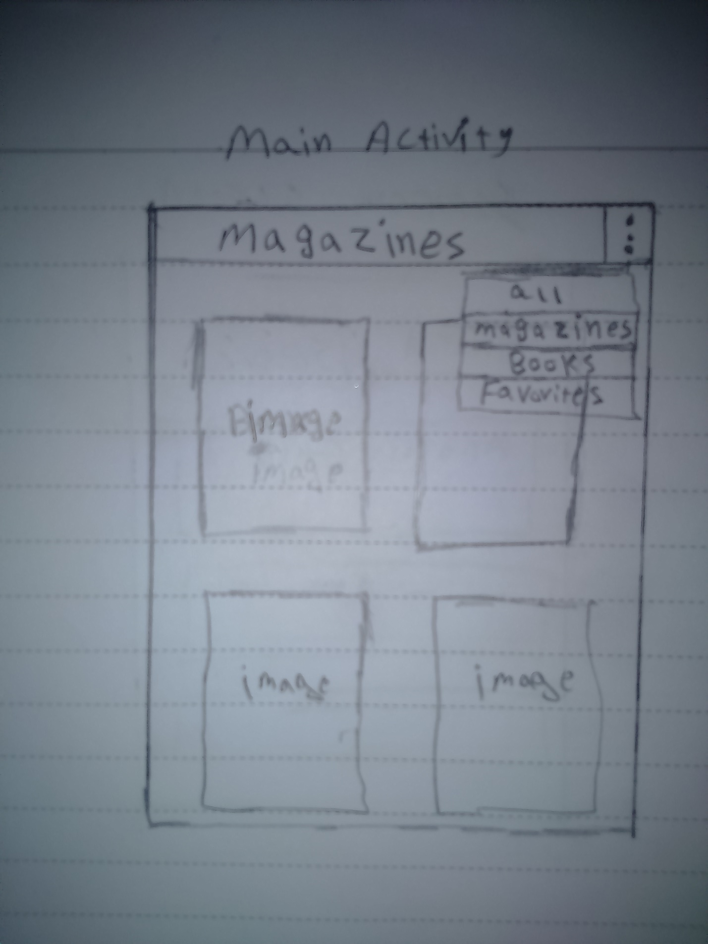

In the Main Screen will showing books or Magazines or both according to user choice

**Screen 2**

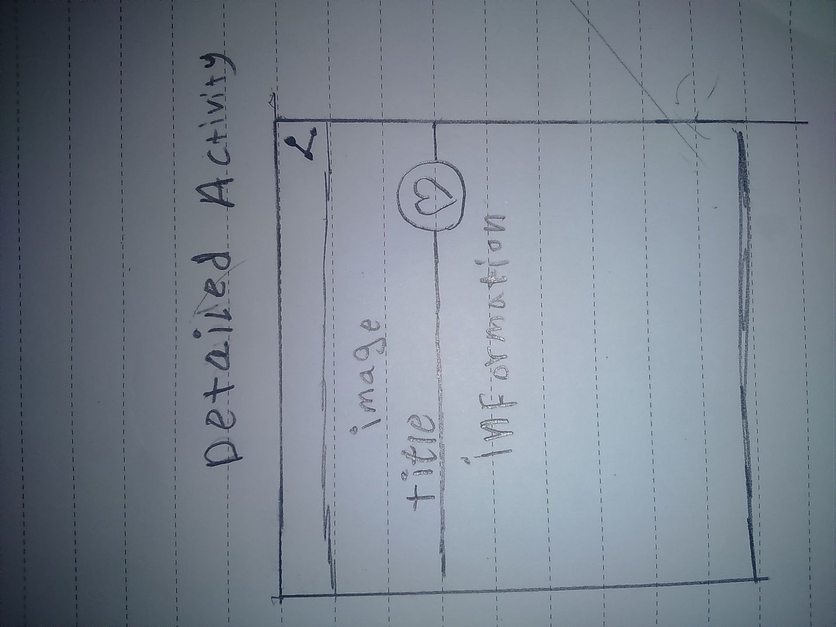

The Detail screen will show information for each book w

**Screen 3**

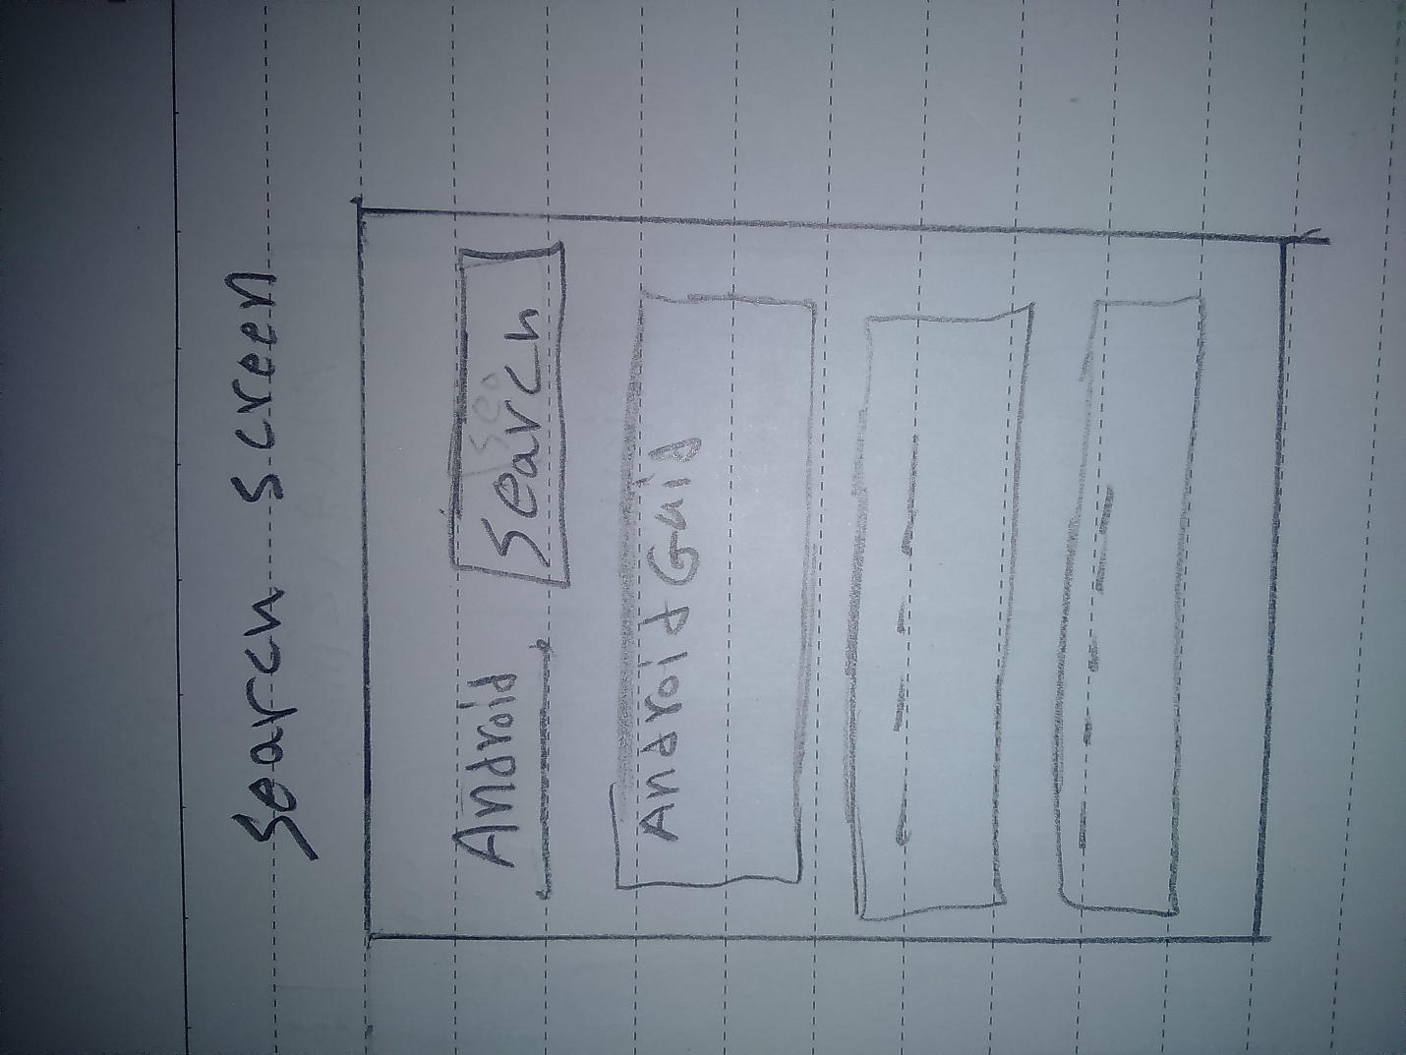

this screen enable user to search for specific book

**Screen 4**

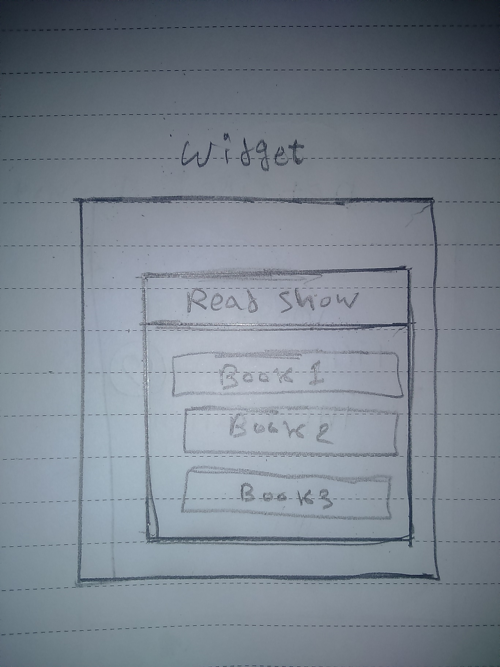

Widget app UI

Key Considerations

**How will your app handle data persistence?**

Maintaining a data store for books and giving ability to user to add his favorite books

The favorite books data will stored using content provider and will be shown in separate activity

By querying using Uri

**Describe any corner cases in the UX.**

Handle cases when there are no books to show

**Describe any libraries you’ll be using and share your reasoning for including them.**

* Glide to handle the loading and caching of images
* ButterKnife for binding android views

**Describe how you will implement Google Play Services.**

Using google books api to get books and magazines

Next Steps: Required Tasks

This is the section where you can take the main features of your app (declared above) and decompose them into tangible technical tasks that you can complete incrementally until you have a finished app.

**Task 1: Project Setup**

* Build UI For Main Activity to Show books
* Creating database for books
* Build UI for Detail activity that allows users to view specific book information

**Task 2: Implement UI for Each Activity and Fragment**

* Configure a data store for add books to favorites and show it.
* Build UI for favorites activity
* Implement search feature

**Task 3:**

* Use google books api to get different print type books using volley
* Implementing content provider
* App integrates with firebase notification to broadcast for updates
* Implement Intent Service class

**Task 4:**

* get favorite books from content provider and show it
* implement loader to move its data to views
* Implement widgets
* Implement google ads