Customer Behavior Analysis – Task 1
Prepared for Alfido Tech | Role: Data Analytics Intern | October 2026

1. Executive Summary
This project analyzes customer transactions and purchasing behavior for Alfido Tech using a dataset of 250,000 transactions across 49,673 unique customers from January 2020 through September 2023. By implementing RFM (Recency, Frequency, Monetary) segmentation, customers were classified into five distinct behavioral segments: Champions, Loyal Customers, Potential / Recent Buyers, At Risk, and Lost / Hibernating.
Key findings indicate that Champions and Loyal Customers constitute 42.5% of the customer base but generate 55.8% ($380.1M) of total revenue ($681.3M). Concurrently, 8,711 At-Risk customers represent $140.7M in historical spend but have been inactive for an average of 411.5 days. Overall customer churn is 20.0%, and recorded return rates average 49.8% across top-selling categories (Books and Clothing). Five concrete recommendations are provided to maximize customer lifetime value and curb attrition.

2. Dataset Overview & Data Cleaning
The raw dataset contains 250,000 rows and 13 columns. The data cleaning process identified 0 duplicate rows. Missing values were concentrated in the Returns column (47,596 missing values, representing transactions without returns), which were imputed with 0.0. Transaction timestamps were converted into datetime objects, and redundant customer age columns were consolidated.
Feature / Step | Issue Identified | Resolution Taken
Duplicate Check | 0 exact duplicate rows | Maintained 250,000 records
Returns Field | 47,596 NaN records | Imputed with 0.0 (no return recorded)
Purchase Date | String format | Converted to datetime for recency analysis
Age Columns | Redundant 'Age' & 'Customer Age' | Dropped duplicate 'Age' column
Aggregation | Transaction granularity | Grouped by Customer ID to build RFM features

3. Customer Segmentation (RFM Methodology)
Customers were segmented using RFM quintile scores (1 to 5). Recency was measured from September 16, 2023 (1 day after the latest purchase date). The resulting five tiers provide clear strategic clarity:
Segment | Customer Count | % Base | Avg Spend | Total Revenue | Avg Recency
Champions | 8,739 | 17.6% | $21,785 | $190.4M (27.9%) | 61.3 days
Loyal Customers | 12,354 | 24.9% | $15,355 | $189.7M (27.8%) | 129.0 days
At Risk | 8,711 | 17.5% | $16,152 | $140.7M (20.7%) | 411.5 days
Lost / Hibernating | 11,115 | 22.4% | $7,579 | $84.2M (12.4%) | 564.3 days
Potential / Recent | 8,754 | 17.6% | $8,719 | $76.3M (11.2%) | 114.2 days

4. Key Findings & Visual Insights
1. Monthly Revenue Stability: Monthly sales remained steady at ~$15.5M per month across 2020 through mid-2023.
2. Repeat Purchase Behavior: Over 96.6% of customers have purchased at least twice, showing strong baseline loyalty.
3. Core Categories: Books ($204.9M) and Clothing ($204.5M) generate 60.0% of total company revenue.
4. High Return Rate: Returns average 49.8% across recorded purchases, demanding immediate product quality and sizing remediation.
5. Revenue Concentration: Champions and Loyal Customers generate $380.1M (55.8% of gross revenue).
Figure 1: Monthly Revenue Trend (2020 - 2023)
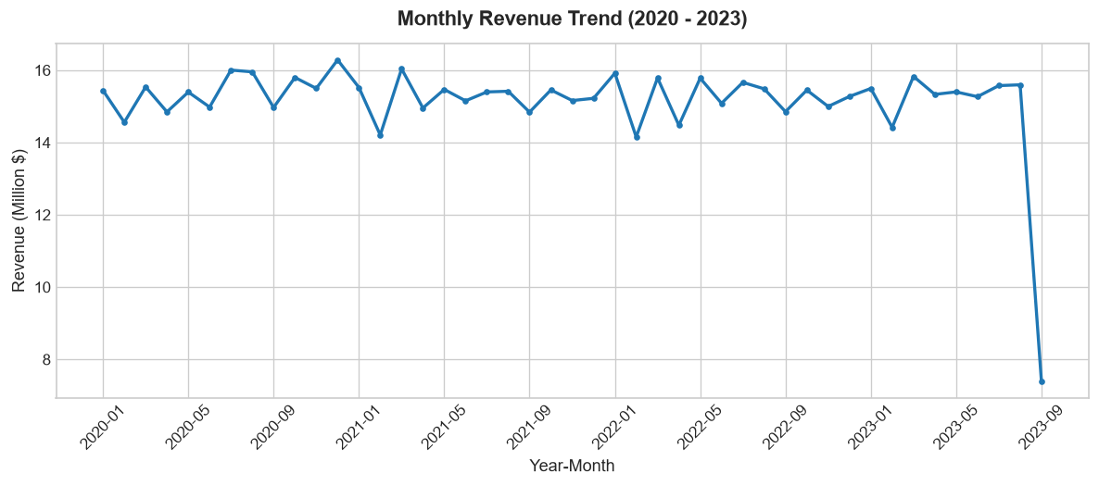
Figure 2: Total Revenue by Product Category
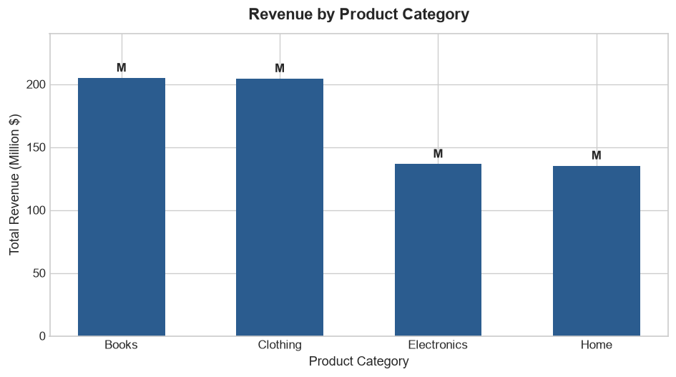
Figure 3: Customer Base vs Revenue Contribution by Segment
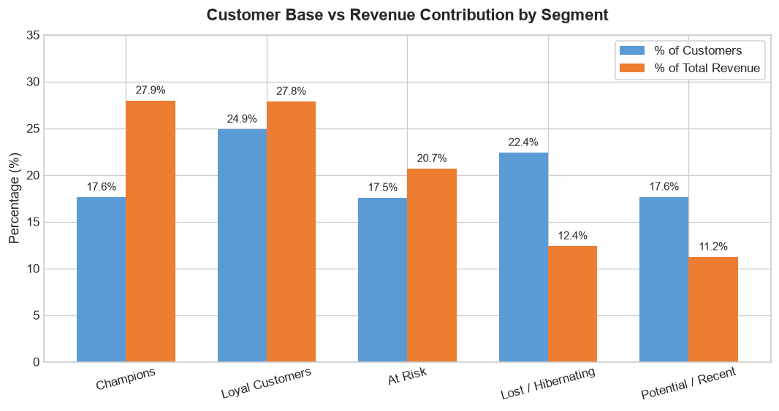
Figure 4: Customer Recency Distribution by Segment
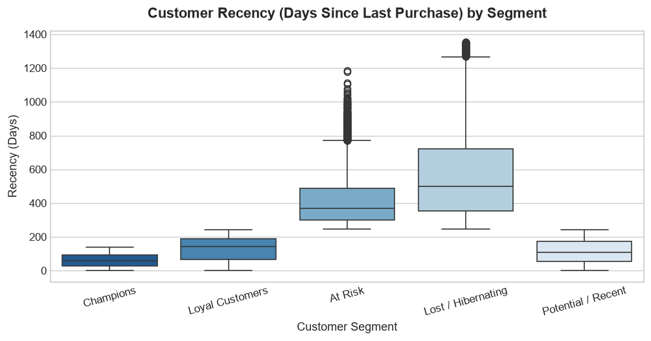

5. Five Actionable Business Recommendations

Recommendation 1 – Targeted Win-Back Campaign for the At-Risk Segment
Finding: The At-Risk segment comprises 8,711 customers (17.54% of base) who previously spent $140.7 million ($16,152 average spend across ~5.9 orders), but have not bought in an average of 411.5 days (over 13 months).
Action: Alfido Tech should launch a personalized, multi-stage re-engagement email sequence offering an exclusive 15% return incentive and highlighting trending items in their preferred categories (Clothing/Books).
Expected Benefit: Reactivating 10% to 15% of these high-frequency buyers recaptures between $14M and $21M in lifetime transaction volume and halts permanent attrition.

Recommendation 2 – VIP Loyalty Program for Champions to Maximize Advocacy
Finding: Champions represent 8,739 customers (17.59% of base) but generate $190.4 million (27.94% of total revenue) with the highest average spend ($21,785) and an average recency of just 61.3 days.
Action: Implement an exclusive tiered VIP program offering early product drops, priority customer support, zero-fee expedited shipping, and referral rewards.
Expected Benefit: Deepens brand loyalty, increases purchase frequency from 7.6 to 8.5+ orders annually, and converts top spenders into organic brand advocates.

Recommendation 3 – Upselling and Nurturing Potential / Recent Buyers
Finding: The Potential / Recent Buyers segment includes 8,754 customers (17.62% of base) who purchased recently (average recency 114.2 days) but have lower lifetime frequency (3.20 orders) and spend ($8,719 avg).
Action: Deliver personalized post-purchase follow-up recommendations, cross-category bundle discounts (e.g. buy Clothing, get 20% off Books), and time-limited next-order vouchers within 30 days of purchase.
Expected Benefit: Migrates high-recency occasional buyers into the Loyal Customers tier, increasing their average order count from 3.2 towards the 5.8 loyal customer benchmark.

Recommendation 4 – Category Bundling and High-Return Rate Remediation
Finding: Books and Clothing drive 60.0% of total revenue ($409.5M combined across 149,964 orders), yet recorded product returns are notably high at ~49.8% across orders with return records.
Action: Alfido Tech should cross-promote Electronics and Home accessories with top-selling Books and Clothing items, while simultaneously improving sizing guides, material specifications, and customer reviews to address the ~50% return rate.
Expected Benefit: Boosts basket sizes across complementary product lines while reducing return logistics costs and customer friction.

Recommendation 5 – Automated Lifecycle Monitoring and Recency-Triggered Alerts
Finding: Across the dataset, 20.0% of customers (9,942 accounts) are flagged as churned, and inactive customers average 564.3 days since last interaction, indicating customer disengagement often goes unaddressed for over a year.
Action: Build an automated CRM dashboard tracking customer recency thresholds, triggering dynamic reminder notifications when a customer exceeds 180 days without a transaction.
Expected Benefit: Intervenes before customers transition from active/loyal status into dormant or lost states, reducing the overall 20% churn rate by an estimated 3–5 percentage points.

6. Conclusion & Limitations
By focusing marketing and retention resources on recovering the 8,711 At-Risk customers, protecting the high-value Champions tier, and resolving high return rates in top categories, Alfido Tech can substantially enhance customer retention and revenue longevity.
Limitations:
• Profit margins and cost of goods sold were not provided in the dataset.
• Return records contained 47,596 missing values which were treated as zero-return transactions.
• Demographic features reflect simulated e-commerce benchmark distributions.

