DISK FAILURE
PREDICTION IN CLOUD
DATA CENTRES
Under Extreme Class Imbalance
Project 7 · AWS + Python · Seven-day SMART early warnings
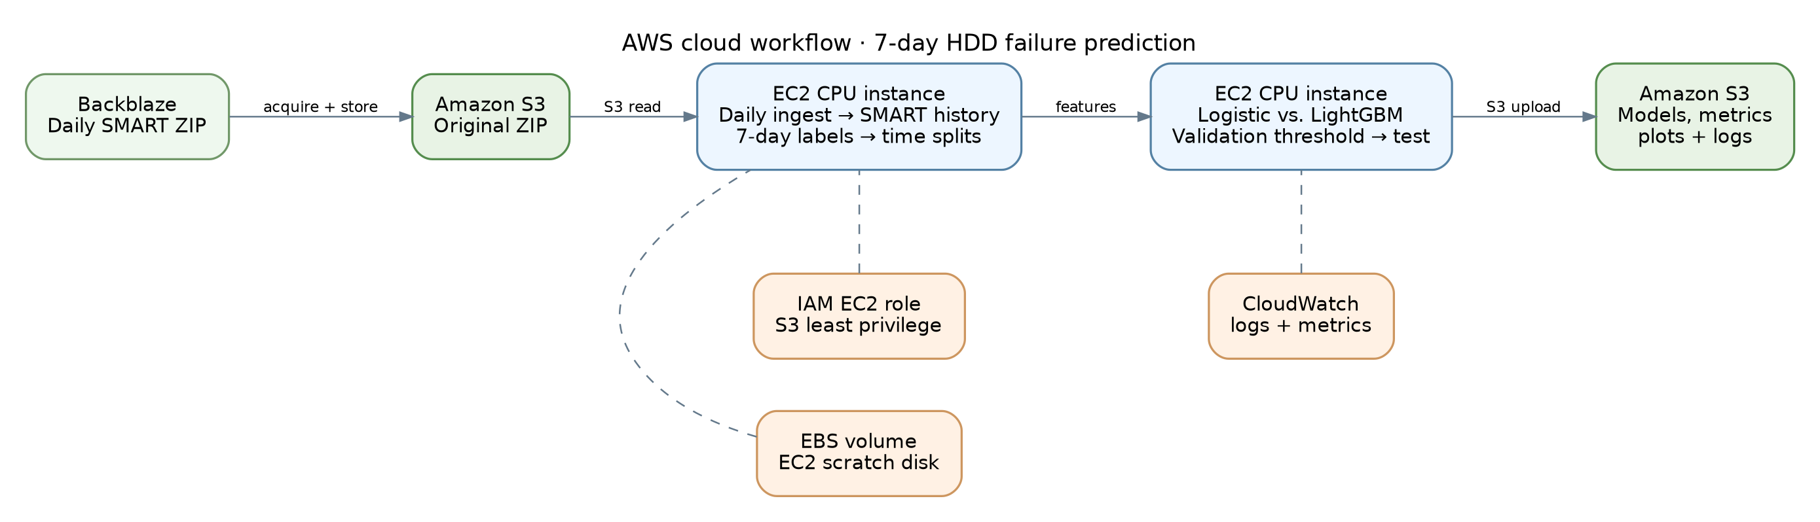
DOCUMENT STATUS: MSA UNIVERSITY REVIEW VERSION (15 OCTOBER 2026). Q1 pilot and Q2 later-period experimental results, the AWS architecture, and CloudWatch CPU monitoring evidence are integrated. Team names and student IDs are filled in. Before submission: confirm instructor/submission date, verify the exact code revision, and upload source files to the provided GitHub repository (currently empty). The study does not claim production-ready alert performance.
Course / institution | Cloud Computing — MSA University
Project team / student IDs | Mohammed Hossam — 247713  Ahmed Tamer — 244749  Ahmed Mohamed — 242679  Hamza Belal — 243387
Course instructor | [Instructor name — to confirm]
Prepared / submission | 15 October 2026 • [Submission date — to confirm]

Executive summary
This project investigates early HDD failure warnings from real Backblaze SMART telemetry using a seven-day prediction horizon. A class-weighted Logistic Regression baseline was compared with static and temporal LightGBM variants on AWS EC2. Q1 pilot training and testing used an outcome-enriched subset of two HDD models to fit a 1 GiB instance; thresholds were fixed from Q1 validation. A later Q2 evaluation used all eligible observations of those models without selecting extra failing drives. Q1 pilot results demonstrate the completed training pipeline but cannot be used as natural-prevalence deployment estimates. Q2 data expose a severe operating trade-off: the lowest tested false-positive rate was 36.35% at 87.09% recall (static weighted LightGBM), with only 0.1355% precision. All results are explicitly labeled as either pilot or out-of-time evaluation.
Verified cloud execution used Backblaze Q1 2023 for pilot training and Q2 2023 for later-period testing on two HDD models. The source ZIPs, processed Parquet data, trained model artifacts and results were uploaded to a private Amazon S3 bucket. Amazon EC2 executed preprocessing, model fitting, and Q2 inference; AWS IAM restricted S3 access and CloudWatch supplied CPUUtilization monitoring evidence. The Q1 test comprised 13,946 enriched drive-days (145 positives, 1.0397% prevalence); the Q2 test comprised 2,327,260 naturally distributed eligible drive-days (1,317 positives, 0.05659% prevalence). Results may change on other drive models or dates.

1. Project title and team members
Title: Disk Failure Prediction in Cloud Data Centres Under Extreme Class Imbalance. Project number: 7. Institution: MSA University. Team: Mohammed Hossam (247713); Ahmed Tamer (244749); Ahmed Mohamed (242679); Hamza Belal (243387). Course: Cloud Computing. Course instructor: to be supplied. GitHub repository destination: https://github.com/mohammedhossam740-oss/cloud-project.git (source publication still pending verification).

2. Problem statement, objectives and motivation
Cloud storage facilities depend on thousands of HDDs, many of which report Self-Monitoring, Analysis and Reporting Technology (SMART) measurements daily. A warning several days before hardware failure can support controlled replacement and data migration. Unfortunately, confirmed failures are uncommon relative to healthy drive-days, so a classifier can be almost always accurate while never identifying a failing drive. Over-sensitive warning systems create excessive manual investigations and premature replacements.
- Predict a confirmed HDD failure on days t+1…t+7, excluding the observation/failure day.
- Quantify the native class imbalance; do not disguise prevalence by resampling the test set.
- Compare a class-balanced Logistic Regression baseline with cost-sensitive LightGBM.
- Study whether three-day changes and rolling averages improve warning performance.
- Select warning thresholds on validation data and report false positives at practical recall.
- Demonstrate real AWS-hosted dataset storage, processing, logging and experiment outputs.

3. Related work and research gap
Recent work supports imbalance-aware losses, sequential signals and explicit false-alarm assessment. The papers below are independently verifiable; findings are those reported by the authors, not results of our implementation.
Study | Main method / reported contribution | Gap for this project
Ahmed & Green, 2022 [2] | Cost-sensitive and sampling-aware ML for severe imbalance. | Benchmark a transparent baseline without misleading accuracy.
Zhang et al., 2023 [3] | Blended ML/neural ensemble for HDD failure and cross-model robustness. | Test drive-model shifts explicitly.
Ahmed & Green, 2024 [4] | LSTM using weighted/focal losses on SMART sequences. | Evaluate lightweight CPU temporal features instead.
Ahmed & Green, 2025 [5] | Cost-aware 1D-CNN and survival analysis. | Measure false alarms under operational threshold constraints.
Li et al., 2025 [6] | Explainable time-series features and false-alarm-aware XGBoost. | Ablate short-window SMART features.
Wei et al., 2025 [7] | Prediction robustness to substantial missing SMART observations. | Acknowledge sparse/missing model-specific sensors.
Research gap addressed: a simple, reproducible CPU pipeline that combines horizon-correct labels, conservative censor handling, chronological embargoed evaluation, explicit cost-sensitive learning, drive-model stratification and deployment evidence on one cloud platform. The work is not proposed as novel neural-network research; its contribution is an auditable implementation and operational comparison.

4. Dataset description and source
Backblaze releases daily drive records named YYYY-MM-DD.csv, containing date, serial number, model, capacity, a failure indicator and raw/normalized SMART attributes [1]. The default data source for this repository is the Q1 2023 archive; Backblaze lists it as approximately 819 MB compressed and 7.53 GB uncompressed. The implementation filters two large Seagate HDD models, ST12000NM0008 and ST14000NM001G, before in-memory aggregation. This is a practical subset, not a claim to cover the entire fleet.
The Q1 pilot used outcome-enriched drive selection to fit within a 1 GiB EC2 instance; it is not suitable for estimating deployed positive predictive value. Q2 evaluation used the complete eligible population of the two selected models without failure-based sampling: 91 source daily snapshots, prediction dates 1 April - 23 June 2023 (84 eligible prediction dates), 2,327,260 eligible drive-days, and 1,317 positive drive-days. There were 208 distinct failing drives with eligible positives. Accordingly, Q2 prevalence was 0.05659% of eligible drive-days. Detailed source evidence: uploaded summary.json and comparison.csv.
Attribute | Meaning / use | Caution
smart_5_raw | Reallocated-sector count | Raw interpretation can vary by model.
smart_9_raw | Power-on hours | Longitudinal age proxy; can be irregular.
smart_187_raw | Uncorrectable errors | Frequently sparse or absent.
smart_188_raw | Command timeouts | Potentially model-specific encoding.
smart_194_raw | Temperature | Check raw vs normalized semantics.
smart_197_raw | Pending sectors | Useful degradation candidate.
smart_198_raw | Offline uncorrectable sectors | May be missing or highly sparse.

5. Methodology and implementation

5.1 Seven-day labels and right censoring
A prediction example is a functioning drive on date t. Its label is 1 only if a recorded failure occurs at a date t+d, with d in {1,…,7}. Its label is 0 only if all seven subsequent daily records are present and no earlier failure was recorded. Other examples—including end-of-quarter right censoring, gaps and unknown future status—are removed. Failure-day and post-failure records are excluded from prediction examples. Drive disappearance alone does not imply failure.

5.2 Predictors, baseline and proposed model
The original SMART attributes are transformed into 3-day deltas and 3-observation rolling means only where the dates are consecutive. Historical features are constructed on the raw chronological data BEFORE filtering rows by labels, so the feature values never encode future label availability. Categorical model identity is one-hot encoded and numerical inputs are median-imputed and MaxAbs-scaled. The Logistic Regression baseline uses balanced class weights; improved LightGBM uses short-window temporal features and weighted positive cases. The pipeline also trains static-feature and unweighted temporal LightGBM ablations.

5.3 Training/test separation and decision rule
Train, validation and test examples are ordered by prediction date. Each preceding split ends at least seven calendar days before the next split begins, preventing forecast labels from crossing boundaries. Data imputation, scaling and model fitting are learned from training rows only. After training, the highest validation threshold achieving the requested 80% recall is selected. A threshold tuned on the test set would be leakage and is prohibited. The actual test recall can fall below 80%.
Q1 pilot preparation retained the histories of drives associated with confirmed failures and sampled 5% of other drives. Its training split was capped at 60,000 rows (523 positive, 59,477 negative), validation comprised 17,035 rows (112 positive), and Q1 pilot test comprised 13,946 rows (145 positive). Training ran on 1 Jan - 13 Feb 2023; validation used 21 Feb - 3 Mar; and Q1 pilot testing used 11 - 22 Mar. The chronological gaps help prevent seven-day outcome overlap across splits. Validation-selected thresholds were reused unchanged on the natural-prevalence Q2 population. Physical drives can occur in both quarters, so Q2 is time-disjoint, not serial-number-disjoint. Q2 temporal history resets at the quarter boundary.

6. Cloud platform and complete service inventory
AWS is selected for its straightforward S3 + EC2 architecture. The implementation is designed for a private account, and paid resources are not created without account-owner authorization. Services/resources required for the described execution are:
Cloud service / resource | Purpose / setup
Amazon S3 | Private project bucket: original ZIP, curated Parquet, models, figures, logs and comparison tables.
Amazon EC2 | Amazon Linux 2023 t3.micro instance runs Backblaze archive scanning, low-memory data preparation, training and Q2 evaluation.
Amazon EBS | 20 GiB EBS gp3 root volume provides persistent OS, Python environment and working files.
AWS IAM | Instance role with S3 access limited to project prefix; no embedded long-lived API keys.
Amazon CloudWatch | Standard EC2 per-instance CPUUtilization graph (Figure 2). No memory or disk monitoring agent was verified.
Amazon VPC | Network boundary and security group restricting SSH to trusted operator IP.
Actual cloud execution: Amazon Linux 2023 on one t3.micro EC2 instance (2 vCPUs, approximately 1 GiB RAM), with a 20 GiB EBS gp3 volume, in Europe (Stockholm), eu-north-1. The private S3 bucket disk-failure-ml-project-2026 stores Backblaze Q1 and Q2 2023 archives, experiment models, and results. The EC2 instance uses the DiskFailureEC2Role IAM instance profile. This low-memory setup was used for memory-conscious training and streamed Q2 evaluation; actual charges or credits depend on the AWS account.

6.1 CloudWatch monitoring evidence
The AWS CloudWatch Classic Metrics console was used to display the EC2 per-instance CPUUtilization metric for DiskFailure-ML-Server (instance i-0e98ccdb3bf7a794f) in Stockholm (eu-north-1). The one-day graph shows periods of elevated CPU activity. It confirms CloudWatch monitoring was accessible for this instance, but does not by itself identify individual Python jobs or prove their execution times.
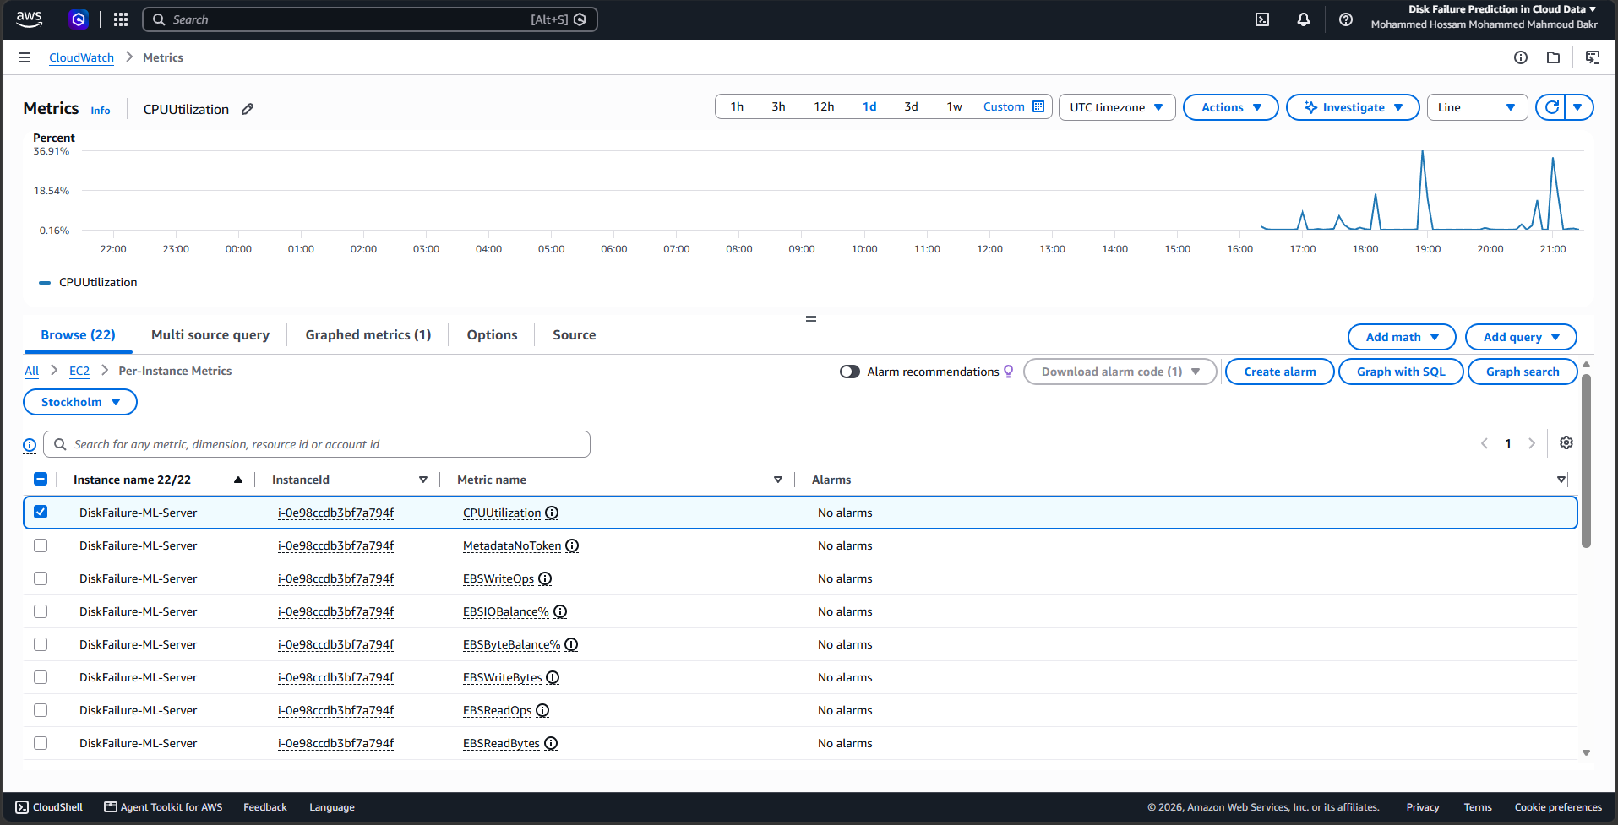
Figure 2. Actual AWS CloudWatch monitoring screenshot, showing CPUUtilization for the selected EC2 instance over the one-day view (provided by the project operator, 15 October 2026). The screenshot is operational evidence; specific training jobs cannot be uniquely assigned to individual peaks.

7. Cloud architecture diagram
Figure 1. AWS processing architecture. For the verified execution, source Backblaze ZIP files and ML artifacts were stored in S3; feature preparation, model fitting and independent Q2 evaluation ran on an EC2 instance with S3 access supplied by an IAM role. CloudWatch provided standard EC2 CPU utilization monitoring. This diagram describes the implemented data flow; the CloudWatch screenshot provides separate operational evidence.

8. Experimental setup, evaluation metrics and results

8.1 Implemented experiment matrix
Model / experiment | Changed factor | Status
Weighted Logistic Regression | Linear baseline on static SMART variables | Executed on AWS: Q1 pilot training; Q2 2023 temporal holdout evaluation
Weighted LightGBM (static) | Nonlinear model with no temporal engineered features | Executed on AWS: Q1 pilot training; Q2 2023 temporal holdout evaluation
Unweighted LightGBM (temporal) | Effect of class weight | Executed on AWS: Q1 pilot training; Q2 2023 temporal holdout evaluation
Weighted LightGBM (temporal) | Proposed method | Executed on AWS: Q1 pilot training; Q2 2023 temporal holdout evaluation
Holdout drive model | Train on one model, test on other (if positive cases exist) | Not independently verified (model-disjoint experiment pending)

8.2 Measures and calculations
True positives (TP) are failure-window warnings; false positives (FP) are warnings on known negative drive-days. True negatives (TN) and false negatives (FN) complete the confusion matrix. Precision = TP/(TP+FP); recall = TP/(TP+FN); F1 = 2PR/(P+R); false-positive rate = FP/(FP+TN). False warnings per 1,000 evaluated drive-days = 1,000×FP/N, where N is the total number of eligible test drive-days. Average precision summarizes the precision-recall ranking curve; ROC-AUC summarizes threshold ranking. Distinct failing drives detected and drive-event recall are also reported, because seven positive drive-days from one failing drive are correlated observations.

8.3 Measured Q1 2023 outcome-enriched pilot test
The direct Q1 CSV export confirms a 13,946-row pilot test (145 seven-day positive drive-days; 1.0397% positive prevalence) after training on a capped 60,000 observations. The pilot selected all known failing drives plus 5% of remaining drives, so precision and alert counts below are NOT estimates for the natural drive fleet. All models used thresholds selected on Q1 validation, not on test data. The training set contained 523 positive labels among 60,000 records; validation contained 112 among 17,035. Exact chronological date windows are recorded in run_metadata.json.
Pilot Q1 measure | Logistic | Static weighted  LGBM | Temporal  LGBM | Temporal weighted  LGBM
Drive-days / positives | 13,946 / 145 | 13,946 / 145 | 13,946 / 145 | 13,946 / 145
Precision (%) | 1.7795 | 2.5033 | 3.3402 | 1.7612
Recall (%) | 91.72 | 91.72 | 89.66 | 90.34
F1-score (%) | 3.491 | 4.874 | 6.440 | 3.455
Average precision (%) | 28.34 | 24.46 | 29.12 | 23.93
False-positive rate (%) | 53.19 | 37.53 | 27.26 | 52.95
ROC-AUC | 0.9004 | 0.8770 | 0.8968 | 0.8877
False alarms / 1k drive-days | 526.4 | 371.4 | 269.8 | 523.9
TP / FP | 133 / 7,341 | 133 / 5,180 | 130 / 3,762 | 131 / 7,307
Drive-event recall (%) | 90.91 | 93.94 | 93.94 | 96.97
Table 8.1. Q1 outcome-enriched pilot holdout: actual metrics from uploaded Q1 comparison CSV. Pilot alert precision is not population precision.
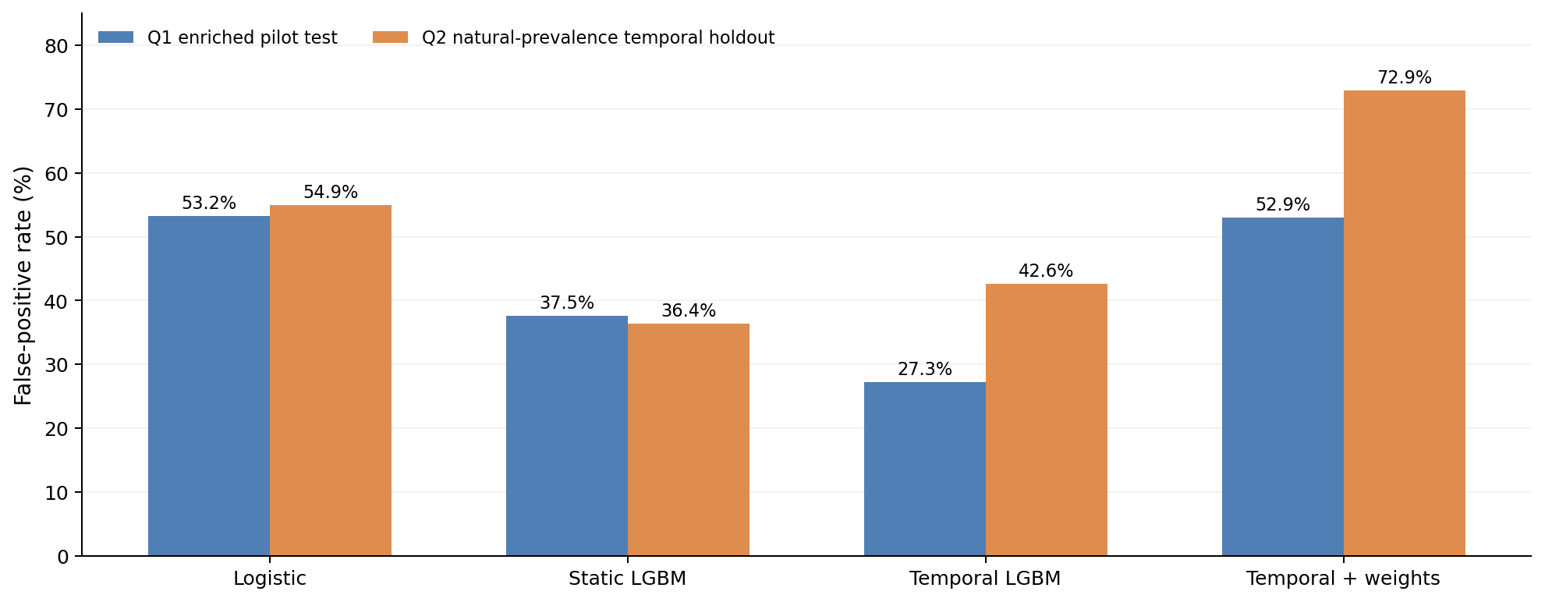
Figure 3. False-positive rates at Q1-validation-selected thresholds. The cohorts differ substantially in prevalence; compare model variants within each cohort, not absolute cross-cohort precision.
Within the Q1 pilot, unweighted temporal LightGBM attained the lowest FPR (27.26%) and highest F1-score (6.44%); the cost-sensitive temporal variant was not the strongest. On Q2, static weighted LightGBM attained the lowest FPR, underscoring that Q1 pilot ranking does not transfer reliably. All Q2 thresholds were held fixed from Q1 validation.

8.4 Measured Backblaze Q2 2023 out-of-time evaluation
The uploaded, matching comparison.csv and summary.json record the completed independent Q2 evaluation. Four previously fitted Q1 models generated predictions for 2,327,260 eligible drive-days (1,317 positives, 0.05659% label prevalence) on model ST12000NM0008 and ST14000NM001G. All decision thresholds were fixed using Q1 validation, with no Q2 threshold tuning or failure-based sampling. The tables below report Q2 figures, not pilot-test estimates. Q1 pilot metrics are documented separately and await direct source CSV integration.
Q2 test measure | Logistic | Static weighted  LGBM | Temporal  LGBM | Temporal weighted  LGBM
Drive-days / positives | 2,327,260 / 1,317 | 2,327,260 / 1,317 | 2,327,260 / 1,317 | 2,327,260 / 1,317
Precision (%) | 0.0876 | 0.1355 | 0.1214 | 0.0744
Recall (%) | 85.04 | 87.09 | 91.50 | 95.82
F1-score (%) | 0.1750 | 0.2705 | 0.2424 | 0.1486
Average precision (%) | 4.330 | 2.815 | 5.884 | 4.356
ROC-AUC | 0.8361 | 0.8617 | 0.8964 | 0.8599
False-positive rate (%) | 54.94 | 36.35 | 42.64 | 72.92
False alarms / 1k drive-days | 549.1 | 363.3 | 426.2 | 728.8
TP / FP | 1,120 / 1,277,868 | 1,147 / 845,541 | 1,205 / 991,786 | 1,262 / 1,696,064
TN / FN | 1,048,075 / 197 | 1,480,402 / 170 | 1,334,157 / 112 | 629,879 / 55
Detected failing drives / 208 | 185 / 208 | 195 / 208 | 197 / 208 | 203 / 208
Drive-event recall (%) | 88.94 | 93.75 | 94.71 | 97.60
Table 8.2. Real Q2 holdout metrics from user-supplied comparison.csv and summary.json. LGBM = LightGBM; Q1 threshold reused unchanged.
Data provenance: Q1 pilot measurements and split counts were imported directly from user-supplied comparison (1).csv and run_metadata.json; Q2 results from user-supplied comparison.csv and summary.json (exports from S3 disk-failure/q2_independent/). Thresholds were picked from Q1 validation and reused on Q2. The CloudWatch screenshot is infrastructure monitoring evidence, not a time-aligned training-job trace. For fully reproducible submission, preserve the exact code revision, installed library versions, and a repository link.

8.5 Drive-model-specific performance and generalization
The two model populations behave differently despite sharing the same prediction pipeline. Table 8.2 illustrates the results of the lower-false-alarm weighted static LightGBM model: its false-positive rate is 54.01% for ST12000NM0008, compared with 5.06% for ST14000NM001G. This suggests a substantial model-specific calibration or distribution-shift problem, not a general guarantee of cross-model portability. A fully held-out drive-model experiment was not performed.
Drive model | Recall (%) | Precision (%) | FPR (%) | TP / FP
ST12000NM0008 | 87.09 | 0.105 | 54.01 | 843 / 803,097
ST14000NM001G | 87.11 | 0.711 | 5.06 | 304 / 42,444
Table 8.3. Q2 performance of static weighted LightGBM by HDD model; all results use Q1-fixed threshold.

9. Comparison with the baseline
Both experiments reject an unqualified claim that temporal weighting always improves results. On the enriched Q1 pilot test, temporal unweighted LightGBM had the lowest false-positive rate (27.26%) and highest F1 (6.44%), versus 53.19% FPR and 3.49% F1 for Logistic Regression; its recall was 89.66% versus 91.72% for the baseline. On the natural-prevalence Q2 holdout, static weighted LightGBM had the lowest false-positive rate (36.35%) versus 54.94% for Logistic Regression, a 33.83% relative reduction, and a higher recall of 87.09% versus 85.04%. Nevertheless, that model emitted 845,541 false-positive drive-day predictions over 2,327,260 eligible drive-days (about 363 false alerts per 1,000 drive-days) and achieved just 0.1355% precision. Temporal unweighted LightGBM achieved Q2 average precision 5.884% and ROC-AUC 0.8964 with 91.50% recall and 42.64% FPR; temporal weighted LightGBM reached 95.82% recall but incurred 72.92% FPR. These thresholds are not suitable for automatic drive replacement. Neither Q1 pilot precision nor Q1 pilot prevalence should be presented as production-like.

10. Discussion, limitations and future work
- The Q1 test is deliberately positive-enriched (1.0397% labels) whereas Q2 preserves eligible-drive prevalence (0.05659%). These test sets support different claims; Q1 pilot precision and alarm counts cannot be generalized to the HDD population. The Q2 holdout is later in calendar time but not drive-disjoint, and temporal features reset at the quarter boundary.
- A single quarter may yield few unique failing drives per split; extend to multiple quarters if sensitivity estimates are unstable.
- Backblaze monitoring has missing or manufacturer-specific SMART semantics; cross-manufacturer deployment needs dedicated validation.
- Seven daily positive snapshots of one failed drive are correlated and inflate row-wise effective sample size; event-level recall helps but does not replace clustered uncertainty intervals.
- Filtering unknown outcomes makes the evaluation conservative but can exclude informative incomplete traces and alter the population.
- Downsampling training negatives for memory efficiency changes training prevalence; probability calibration should use naturally distributed held-out data if risks are displayed as probabilities.
- Threshold selected to achieve 80% validation recall may not achieve that recall during an unseen test period.
- Future work: multi-quarter drift analysis, bootstrapped by-drive confidence intervals, calibrated risk, cost-of-action curves, expanded HDD cohorts and automated retraining.

11. References
[1] Backblaze, “Hard Drive Reliability & Test Data,” official Drive Stats archive, https://www.backblaze.com/cloud-storage/resources/hard-drive-test-data (accessed Oct. 2026).
[2] J. Ahmed and R. C. Green II, “Predicting severely imbalanced data disk drive failures with machine learning models,” Machine Learning with Applications, vol. 9, 100361, 2022. DOI: 10.1016/j.mlwa.2022.100361.
[3] M. Zhang, W. Ge, R. Tang, and P. Liu, “Hard Disk Failure Prediction Based on Blending Ensemble Learning,” Applied Sciences, vol. 13, no. 5, 3288, 2023. DOI: 10.3390/app13053288.
[4] J. Ahmed and R. C. Green II, “Cost aware LSTM model for predicting hard disk drive failures based on extremely imbalanced S.M.A.R.T. sensors data,” Engineering Applications of Artificial Intelligence, vol. 127, 107339, 2024. DOI: 10.1016/j.engappai.2023.107339.
[5] J. Ahmed and R. C. Green II, “Leveraging survival analysis in cost-aware deepnet for efficient hard drive failure prediction,” Neural Computing and Applications, vol. 37, pp. 1089–1104, 2025. DOI: 10.1007/s00521-024-10479-6.
[6] W. Li, H. Zhou, S. Radhakrishnan, and S. Kamarthi, “Explainable time series features for hard disk drive failure prediction,” Engineering Applications of Artificial Intelligence, vol. 152, 110674, 2025. DOI: 10.1016/j.engappai.2025.110674.
[7] S. Wei et al., “DFPoLD: A Hard Disk Failure Prediction on Low-Quality Datasets,” Informatics, vol. 12, no. 3, 73, 2025. DOI: 10.3390/informatics12030073.
[8] Amazon Web Services, “Amazon EC2 User Guide,” https://docs.aws.amazon.com/AWSEC2/latest/UserGuide/concepts.html.
[9] Amazon Web Services, “Amazon S3 User Guide,” https://docs.aws.amazon.com/AmazonS3/latest/userguide/Welcome.html.
[10] Amazon Web Services, “Installing the CloudWatch agent,” https://docs.aws.amazon.com/AmazonCloudWatch/latest/monitoring/Install-CloudWatch-Agent.html.

12. Repository, code and reproducibility
Repository destination provided by the team: https://github.com/mohammedhossam740-oss/cloud-project.git. At the time of preparation (15 October 2026), the public repository page is accessible but shows no committed files; do not treat this URL as evidence of code publication until source is uploaded. The supplied project code archive and supporting scripts contain the Q1 training/evaluation pipeline, low-memory pilot creation, Q2 evaluation, configuration, tests and AWS-related documentation. The real experiment outputs were stored privately in Amazon S3: Q1 trained models, results and figures under disk-failure/pilot/ and Q2 comparison.csv, summary.json and predictions under disk-failure/q2_independent/. The GitHub repository should contain source/configs/README/tests and small evaluation summaries, not raw Backblaze ZIPs, .pem keys, credentials, or private system data.
To reproduce: on an Amazon Linux 2023 EC2 instance using Python 3.11, create an isolated environment and install requirements; download official Backblaze Q1 and Q2 2023 archives to private S3 storage; obtain the files on EC2 using an instance IAM role; run the low-memory Q1 pilot preparation script, pilot seven-day labeling and chronological Q1 model training (report the outcome-enriched design); apply the previously frozen Q1 validation thresholds to the entire eligible Q2 selected-model population without retraining; upload resulting CSV/JSON/plots/models to S3; and record CloudWatch per-instance CPUUtilization. Preserve code version, package versions and archive integrity. The two-quarter study does not establish calibration or a true model-disjoint generalization estimate. Stop EC2 when unused to reduce compute charges. Repository upload and exact commit hash are pending and must be verified before final submission.

Submission verification notes
- Repository destination: https://github.com/mohammedhossam740-oss/cloud-project.git (verify files have been pushed, and record the resulting commit hash).
- Course instructor and official submission date must be confirmed by the team.
- Public source should include the modified macOS-metadata filtering loader, the Q1 pilot preparation script, Q2 independent evaluation script, requirements and reproducible configurations. Do not publish secret keys or entire Backblaze data archives.
- Report Q1 pilot metrics explicitly as outcome-enriched; use Q2 natural-prevalence results for independent temporal evaluation. Observed false-positive rates remain too high for operational rollout.

