G9-IPTS
Integrated Payment Transformation System

Executive Briefing Report
Senior Leadership & Board-Level Summary

Prepared by
Mohamad Idriss | Rohit Jacob Isaac | Sriram Acharya Mudumbai
Walid Elmahdy | Vibin Chandrabose

April 2026

CONFIDENTIAL
For Authorized Recipients Only

Table of Contents

1. Executive Summary 3
2. The Problem: Cross-Border Settlement Today 4
3. IPTS 7-Layer Convergent Architecture 6
4. System Walkthrough 12
5. AI/ML Capabilities 16
6. Security & Compliance 18
7. ROI Analysis 20
8. Total Cost of Ownership (TCO) 21
9. Business Impact 22
10. Risk Assessment 23
11. Implementation Roadmap 24
12. Conclusion & Recommendations 25

1. Executive Summary
The Integrated Payment Transformation System (IPTS) is an enterprise-grade financial settlement platform that collapses cross-border payment cycles from the traditional T+2 to T+5 window to near-real-time settlement in under 10 seconds. Built on a 7-layer convergent architecture, IPTS integrates blockchain-based atomic settlement, a 4-model AI/ML fraud detection ensemble, Zero Trust security, and GDPR-compliant data sovereignty into a unified platform.

This briefing provides senior leadership with a comprehensive overview of IPTS capabilities, financial impact, risk posture, and implementation roadmap. The following KPI comparison summarizes the transformational impact:

1.1 Key Performance Indicators
KPI Metric | Before IPTS | After IPTS
Settlement Time | T+2 to T+5 (2-5 business days) | < 10 seconds (T+0)
Fraud Detection Rate | 45-60% (rule-based only) | 98-100% (4-model ensemble)
False Positive Rate | 15-25% | < 3%
Compliance Cost | $10.2M annually | $2.55M annually
Annual Net Savings | Baseline | $7.65M per year
3-Year ROI | N/A | 287%

The platform addresses a $190 trillion cross-border payments market with a projected payback period of 5 months and cumulative 3-year net benefit of $18.15 million.

2. The Problem: Cross-Border Settlement Today
The global cross-border payments market processes approximately $190 trillion annually, yet relies on infrastructure designed decades ago. Financial institutions face compounding challenges that erode margins, increase regulatory exposure, and degrade customer experience.

2.1 Settlement Latency
Cross-border payments currently require T+2 to T+5 business days to reach finality. This delay stems from multi-hop correspondent banking chains, time zone mismatches, and batch-processing cycles. For corporates managing global supply chains, this latency traps working capital and creates FX exposure windows that are difficult to hedge cost-effectively.

2.2 Trapped Liquidity
An estimated $27 trillion sits locked in Nostro/Vostro accounts globally. Correspondent banks must pre-fund these accounts to facilitate cross-border flows, creating massive opportunity costs. Every dollar sitting in a Nostro account is a dollar that cannot be deployed in higher-yielding activities. For mid-tier banks, Nostro funding requirements can represent 5-8% of total assets.

2.3 Compliance Overhead
Financial institutions spend an average of $10.2 million annually on AML/KYC compliance operations. Manual transaction monitoring generates false positive rates of 15-25%, requiring large compliance teams to triage alerts. Each false positive costs an estimated $30-$50 in analyst time. Regulatory fines for AML failures have exceeded $36 billion globally since 2008, creating existential risk for non-compliant institutions.

2.4 Fragmented Infrastructure
The current cross-border settlement ecosystem involves multiple intermediaries: originating banks, correspondent banks, clearing houses, SWIFT messaging, local payment rails, and beneficiary banks. Each intermediary adds cost ($25-$65 per transaction in fees), latency (hours to days), and opacity (limited end-to-end tracking). The absence of a unified platform means reconciliation is manual, error-prone, and resource-intensive.

2.5 Regulatory Pressure
Regulators worldwide are tightening oversight of cross-border payments. The Financial Action Task Force (FATF) Travel Rule, the EU's 6th Anti-Money Laundering Directive (6AMLD), FinCEN's evolving requirements, and GDPR's data sovereignty mandates create a complex, overlapping compliance landscape. Institutions must simultaneously satisfy multiple jurisdictions with conflicting requirements while maintaining operational efficiency.

2.6 Market Opportunity
The $190 trillion cross-border payments market is at an inflection point. Institutions that modernize their settlement infrastructure will capture market share from slower incumbents, reduce operational costs by 60-75%, and position themselves for the next decade of financial services innovation. IPTS directly addresses each of these pain points through its 7-layer convergent architecture.

3. IPTS 7-Layer Convergent Architecture
IPTS implements a 7-Layer Convergent Architecture where each layer encapsulates a specific domain concern. This separation enables independent scaling, testing, and regulatory auditing while maintaining cohesive end-to-end transaction processing. The layers are organized into three logical tiers: Interaction and Intelligence (Layers 1-3), Security and Compliance (Layers 4-5), and Settlement Infrastructure (Layers 6-7).

3.1 Architecture Overview
The complete IPTS architecture integrates seven distinct layers, each responsible for a critical domain of the settlement lifecycle. The following diagram provides the full architectural overview:
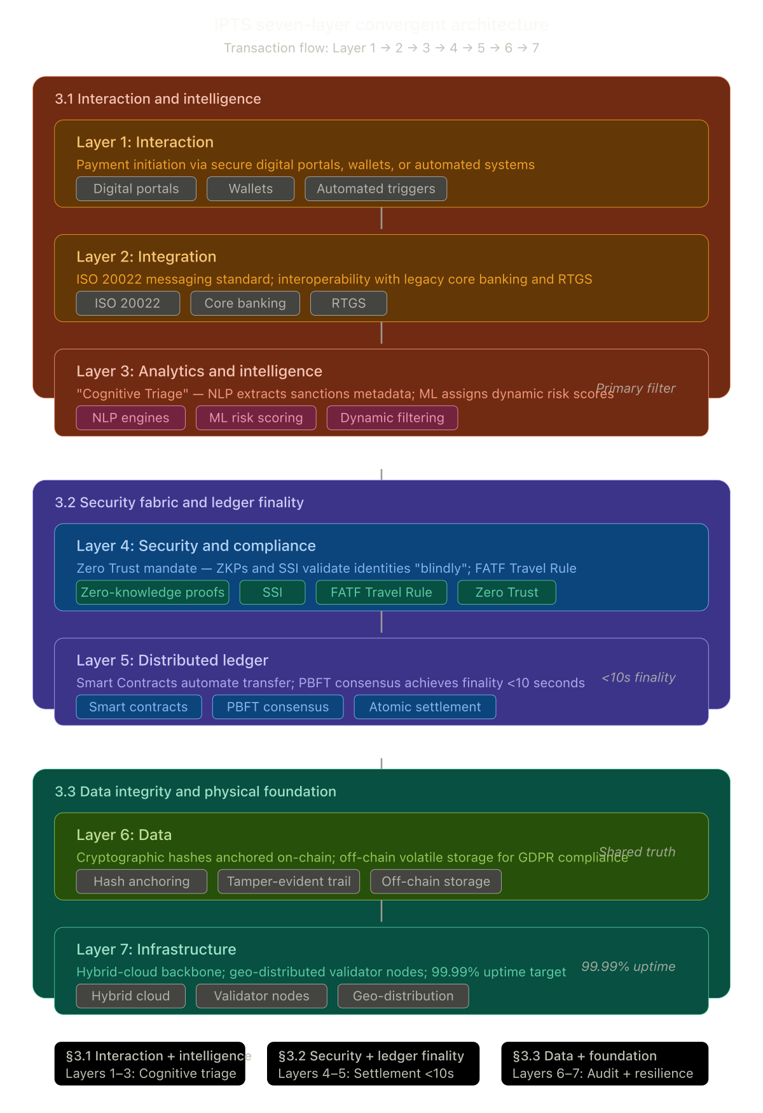
Figure 1: IPTS Seven-Layer Convergent Architecture Overview

Layer | Name | Description
Layer 1 | Interaction | Digital portals, wallets, and automated triggers serving as entry points for all transaction requests
Layer 2 | Integration | ISO 20022 message formatting, core banking connectivity, RTGS interfacing, and API gateway
Layer 3 | Intelligence | 4-model ML ensemble, AML/KYC screening engine, graph analytics, and NLP sanctions screening
Layer 4 | Security | Zero Trust perimeter with JWT authentication, RBAC, AES-256 encryption, and HSM key management
Layer 5 | Compliance | HITL triage queue, case management lifecycle, SAR reporting, and real-time sanctions screening
Layer 6 | Distributed Ledger | Atomic swap engine, smart contract execution, Nostro/Vostro management, multi-signature approvals
Layer 7 | Data & Infrastructure | Hash anchoring, Merkle tree verification, GDPR PII vault, hybrid cloud backbone, observability stack

3.2 Layer 1 — Interaction Architecture
The Interaction Layer serves as the primary interface between external users and the IPTS platform. It defines three categories of interaction entry points: digital portals (web-based dashboards and administrative consoles), wallet integrations (for direct blockchain-based transaction initiation), and automated triggers (scheduled batch processing and event-driven transaction flows). Each entry point feeds into a unified request pipeline that normalizes input formats before passing them to the Integration Layer. The architecture ensures that regardless of the originating channel, all transactions undergo identical validation, authentication, and enrichment before entering the processing pipeline.
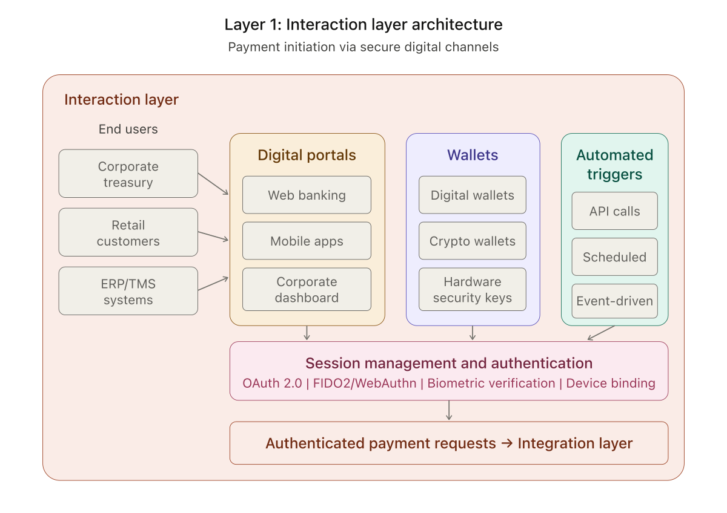
Figure 2: Layer 1 — Interaction Architecture

3.3 Layer 2 — Integration Architecture
The Integration Layer connects IPTS with the broader financial ecosystem. External systems including originating banks, beneficiary banks, regulatory bodies, and FX/liquidity providers communicate through a centralized API Gateway that enforces rate limiting, authentication validation, request routing, and schema validation. Incoming messages pass through a Message Transformer that provides ISO 20022 parsing, format adaptation between legacy and modern message standards, and data enrichment with reference data. Transformed messages are then dispatched to internal services via an event bus, ensuring loose coupling between the integration boundary and core processing logic. This architecture enables IPTS to interface with SWIFT, SEPA, Fedwire, and proprietary banking protocols without modifying internal settlement logic.
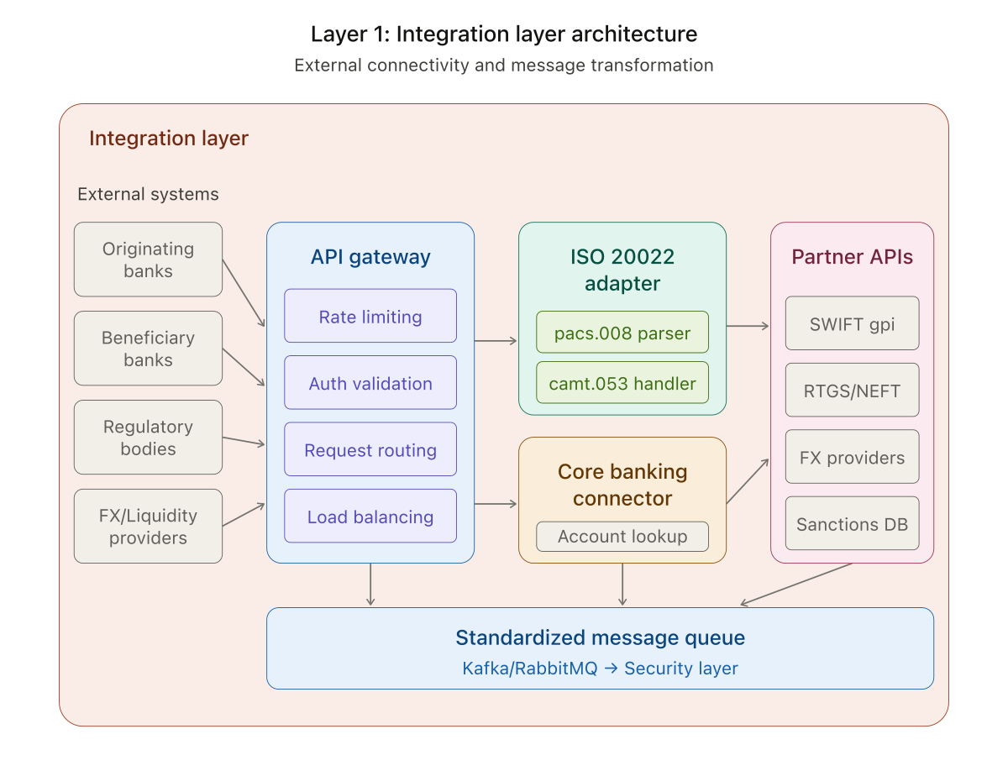
Figure 3: Layer 2 — Integration Architecture

3.4 Layer 3 — Intelligence Engine
The Intelligence Layer is the cognitive core of IPTS. It houses the 4-model machine learning ensemble (Isolation Forest, Random Forest, XGBoost, Autoencoder) that provides real-time risk scoring for every transaction. The AML/KYC screening engine applies a weighted composite scoring system combining rule-based checks (30%), ML ensemble predictions (40%), NLP watchlist screening (15%), and graph analytics (15%). PageRank centrality analysis identifies high-influence nodes in the transaction network, while label propagation detects suspicious community clusters. Force-override triggers automatically block transactions exceeding critical thresholds ($100K+ AML threshold, sanctions matches, structuring patterns). The layer operates in real-time, returning risk scores within milliseconds of transaction submission.

3.5 Layer 4 — Zero Trust Security Architecture
The Security Layer implements a comprehensive Zero Trust model where no request is implicitly trusted regardless of origin. The architecture provides Identity and Access Management with zero-knowledge proof verification and multi-factor authentication; Micro-segmentation for network isolation and lateral movement prevention; Continuous Verification ensuring trust is re-evaluated at every request boundary; a Cryptographic Layer with PKI infrastructure, HSM integration, and TLS 1.3 mutual authentication; and Threat Intelligence integrating SIEM monitoring, anomaly detection, and external threat feeds for proactive defense.
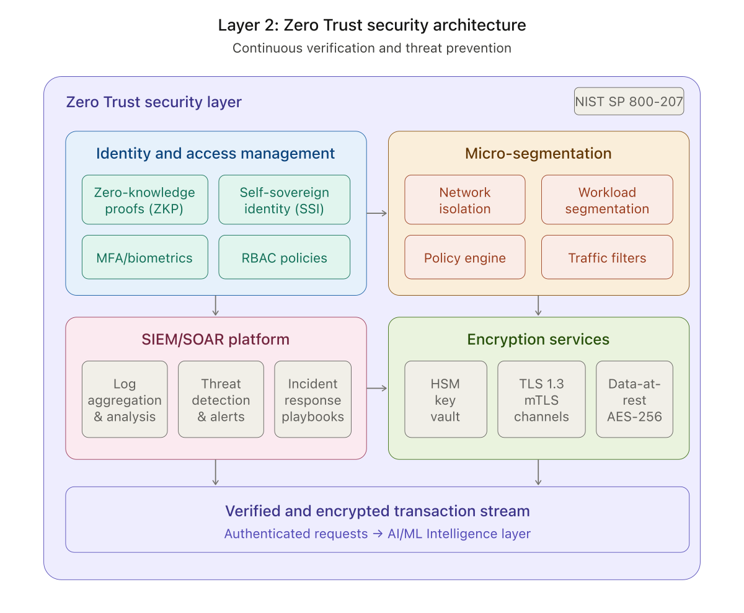
Figure 4: Layer 4 — Zero Trust Security Architecture

3.6 Layer 5 — Compliance & Case Management
The Compliance Layer provides the human-in-the-loop (HITL) triage queue for blocked transactions, a full case management lifecycle (Open, Investigating, Escalated, Resolved, Closed), SAR filing workflows, and real-time screening against global sanctions databases. When a transaction is blocked by the Intelligence Layer, a compliance case is automatically created in CASE-2026-XXXX format with severity classification. Compliance officers can investigate, add findings, assign cases, escalate to senior compliance, and file Suspicious Activity Reports directly from the platform. The layer supports FATF Travel Rule compliance, 6AMLD reporting requirements, and FinCEN BSA obligations.

3.7 Layer 6 — Data Architecture
The Data Layer ensures the integrity, immutability, and regulatory compliance of all settlement data. The Hash Anchoring subsystem computes SHA-256 hashes of transaction payloads and anchors Merkle tree roots on-chain, creating a cryptographic proof chain verifiable without exposing raw data. The Tamper-Evident Audit Trail maintains immutable logs with cryptographic timestamps and chain of custody records. The GDPR Compliance Vault stores encrypted PII in a segregated database with consent management and right-to-erasure implementation. A Reconciliation Engine continuously verifies consistency between on-chain records, off-chain vault data, and the audit trail.
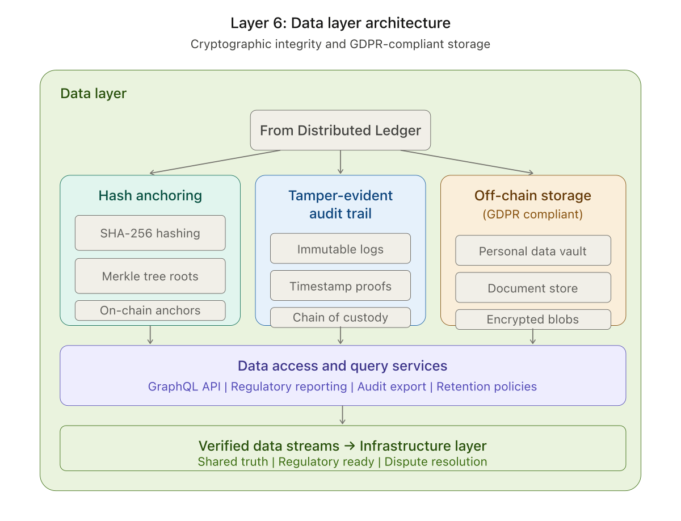
Figure 5: Layer 6 — Data Architecture

3.8 Layer 7 — Infrastructure Architecture
The Infrastructure Layer provides the runtime foundation for the IPTS platform. The Hybrid Cloud Backbone orchestrates workloads across private and public cloud infrastructure through Kubernetes. Validator Nodes form the consensus layer with Byzantine Fault Tolerance (BFT) threshold configurations. The Observability Stack provides Prometheus metrics, distributed tracing, and centralized log aggregation. The Disaster Recovery subsystem ensures business continuity with geo-replicated data stores, automatic failover, RPO < 1 minute, and RTO < 5 minutes for full service restoration.
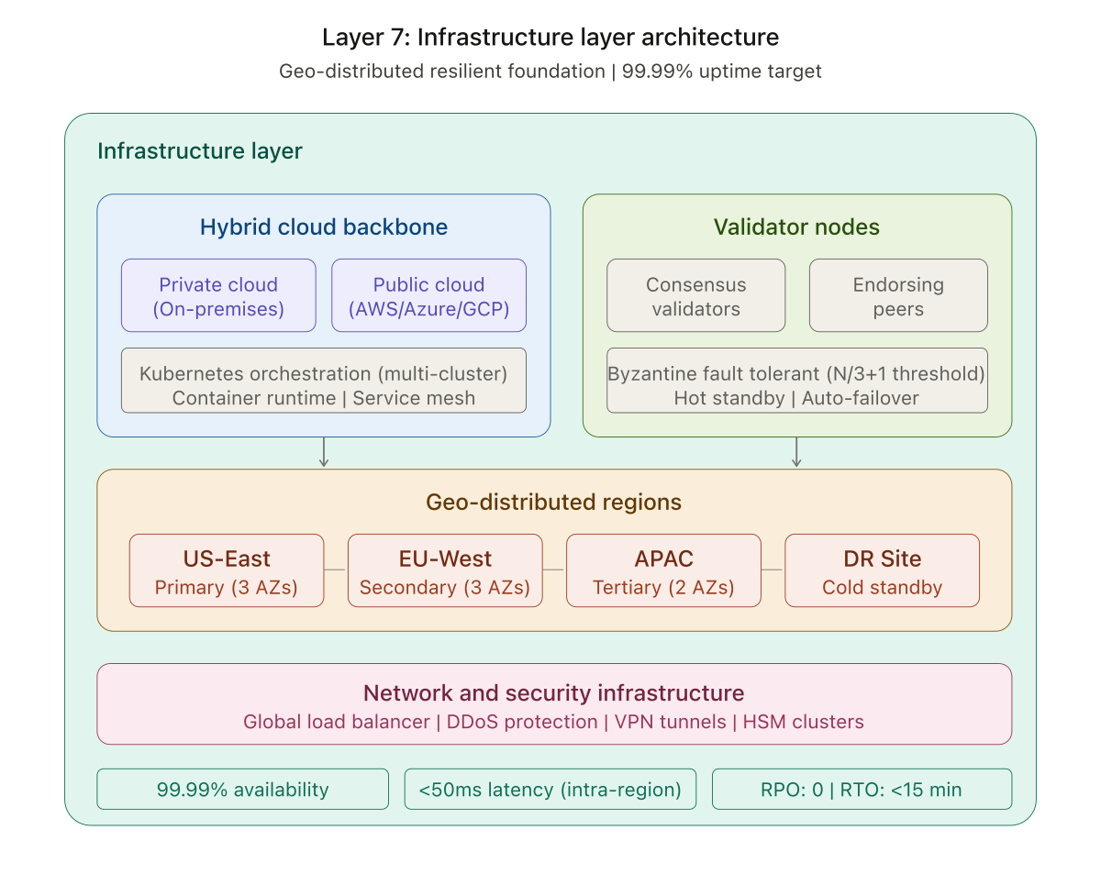
Figure 6: Layer 7 — Infrastructure Architecture

4. System Walkthrough
The following screenshots demonstrate the fully operational IPTS platform, covering all major functional areas from the real-time dashboard through case management lifecycle. Each screenshot is captured from the live system deployed on Google Colab.

4.1 Dashboard — KPIs & Telemetry
The main operational dashboard provides at-a-glance system health with KPI cards (Total Settlements, Blocked, Flagged, Nostro Liquidity), settlement volume charting, and color-coded status indicators. Auto-refresh via Server-Sent Events ensures real-time data streaming every 6 seconds.
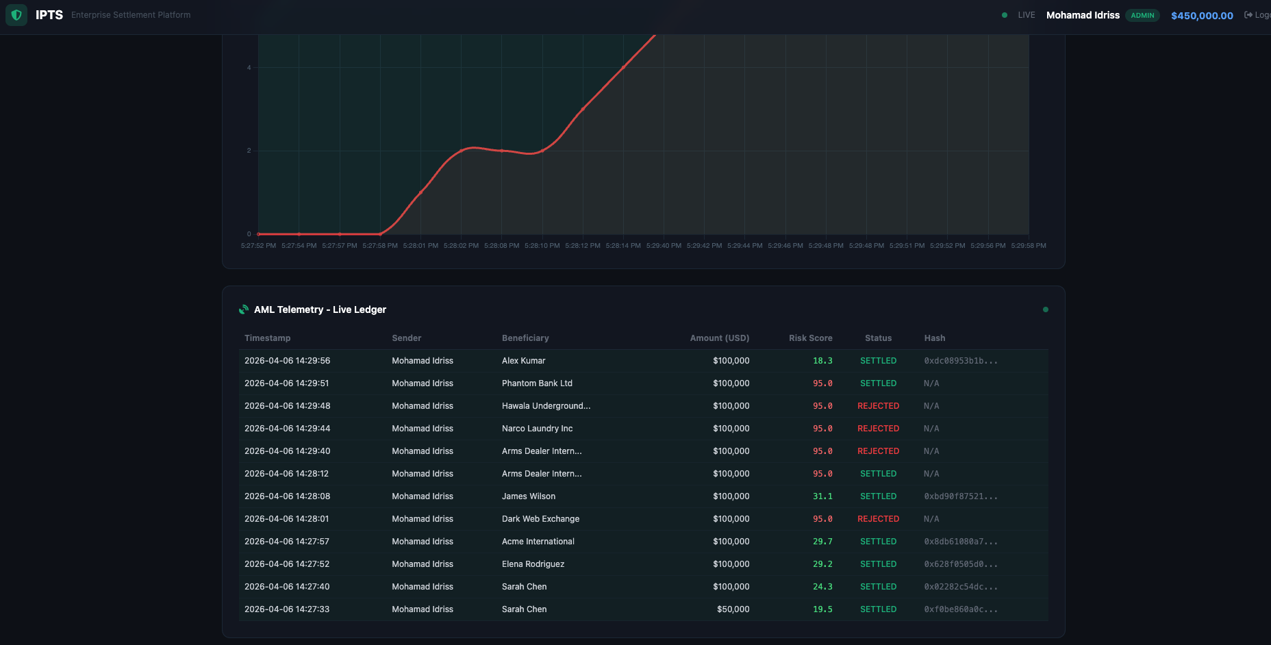
Figure 7: Dashboard — KPI Cards and Settlement Volume Chart

4.2 Dashboard — Payment Execution
The AML Telemetry Live Ledger displays all processed transactions with sender name, beneficiary, amount, risk score, settlement status, and blockchain hash. Color-coded rows indicate transaction status: green (settled), yellow (flagged), red (blocked), and purple (pending).
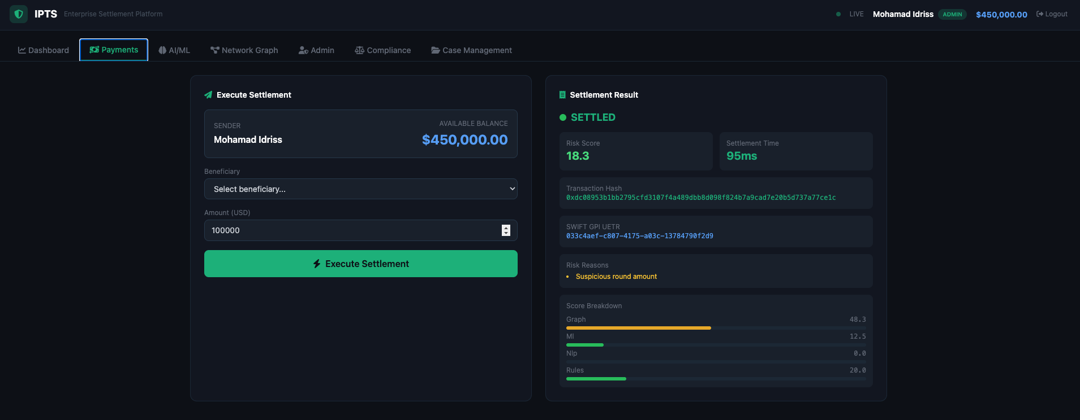
Figure 8: Dashboard — AML Telemetry Live Ledger

4.3 Settlement Result & Risk Breakdown
The Payments tab enables cross-border payment execution with real-time risk assessment. Post-settlement, a detailed risk breakdown visualization displays individual component scores (rules, ML ensemble, NLP watchlist, graph analytics) alongside the composite risk score and settlement time.
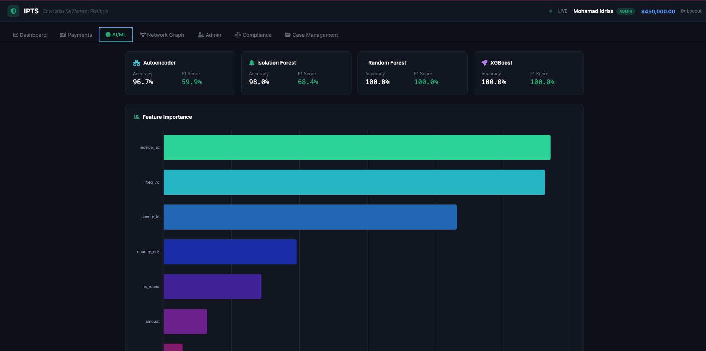
Figure 9: Payments — Settlement Execution with Risk Breakdown

4.4 AI/ML Model Performance
The AI/ML tab displays performance metrics for all four ensemble models, including F1 scores and accuracy. Feature importance charts show the relative contribution of each feature to fraud detection. Model retraining can be triggered by authorized users directly from the interface.
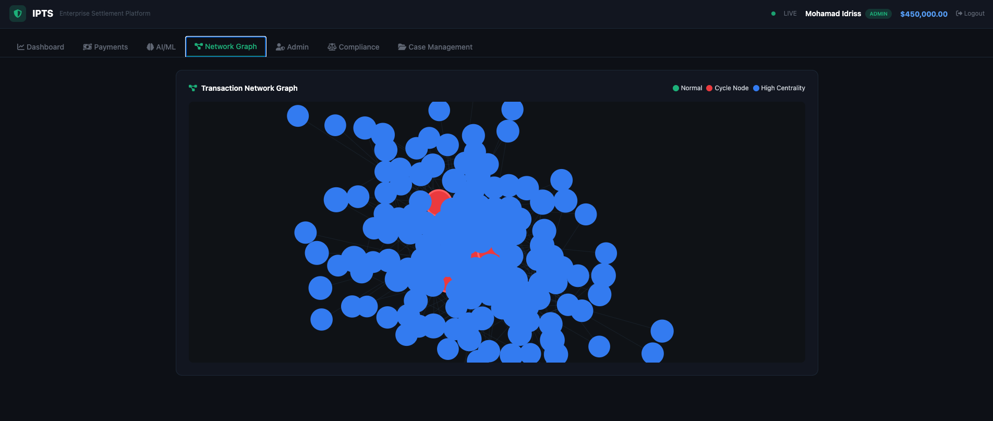
Figure 10: AI/ML — Model Performance Cards and Feature Importance

4.5 Network Graph
The interactive D3.js force-directed graph visualizes the transaction network with node size proportional to PageRank centrality, color-coded communities via label propagation, edge thickness reflecting transaction volume, and cycle highlighting to identify potential laundering rings.
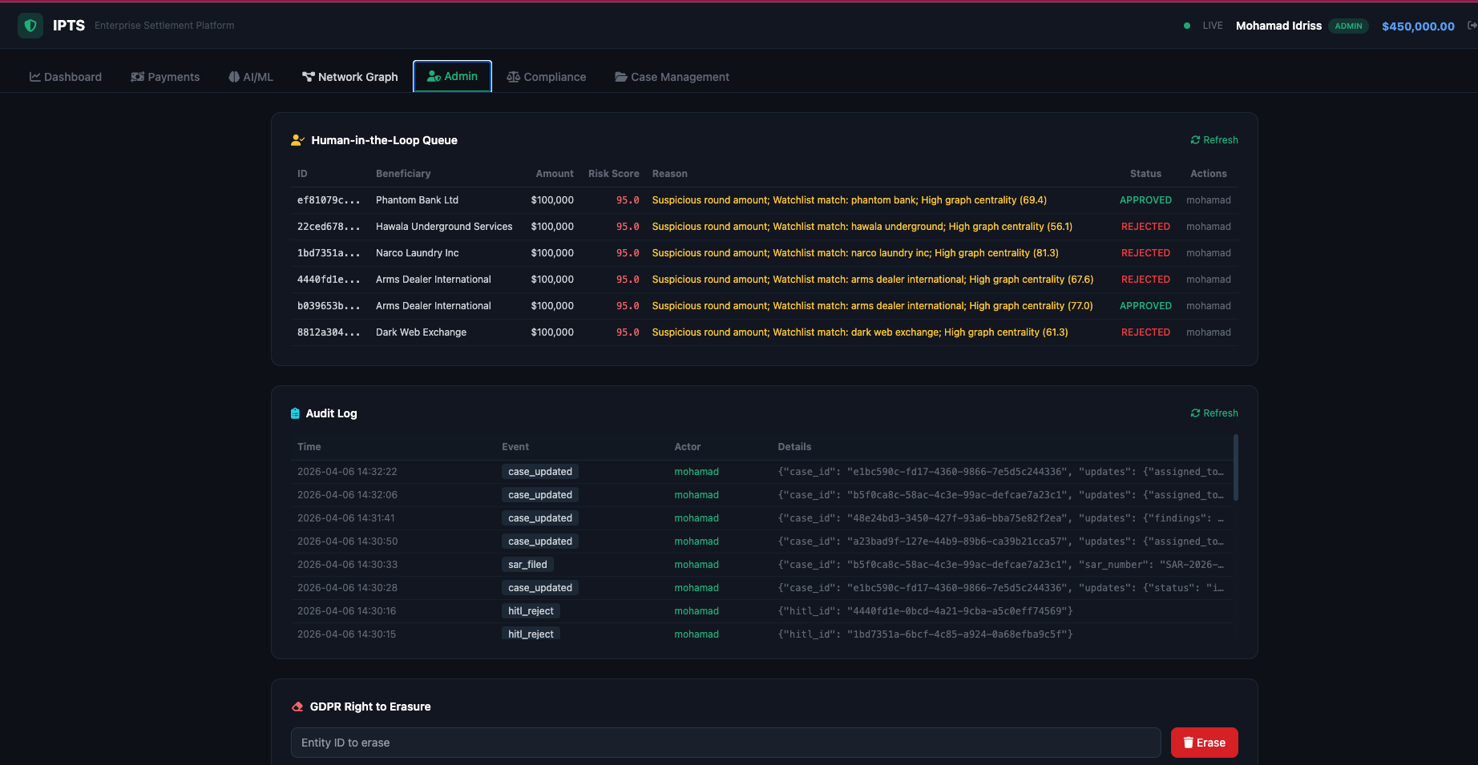
Figure 11: Network Graph — D3.js Force-Directed Transaction Network

4.6 Admin — HITL Queue & Audit
The Admin tab provides the Human-in-the-Loop queue for reviewing blocked transactions with full risk details, approve/reject controls, and comprehensive audit logging. The GDPR Erasure tool enables compliant data anonymization on request.
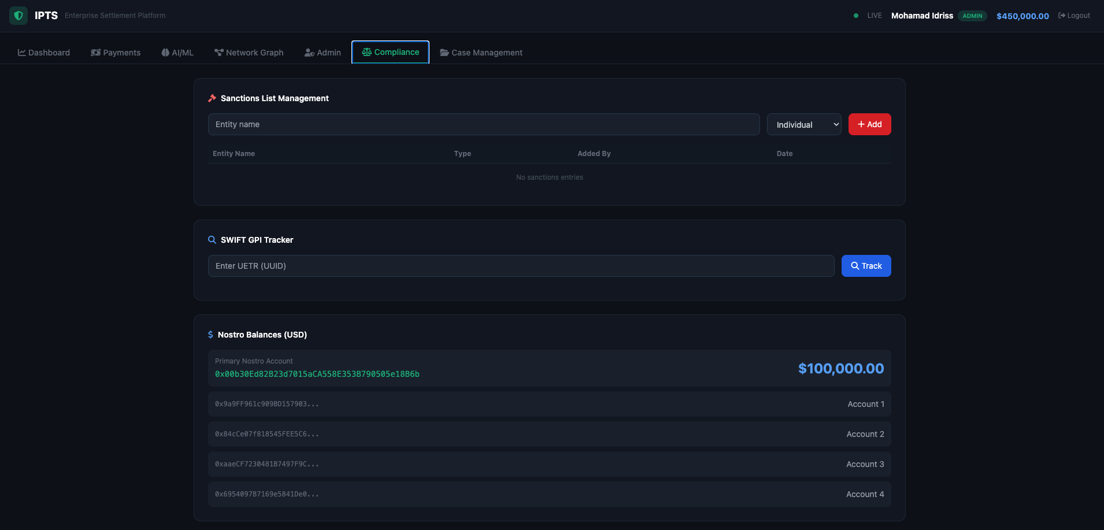
Figure 12: Admin — HITL Queue, Audit Log, and GDPR Erasure

4.7 Compliance — Sanctions & SWIFT GPI
The Compliance tab provides sanctions list management, SWIFT GPI payment tracking by UETR reference, and Nostro balance monitoring. Compliance officers can add and remove entities from the sanctions screening database in real time.
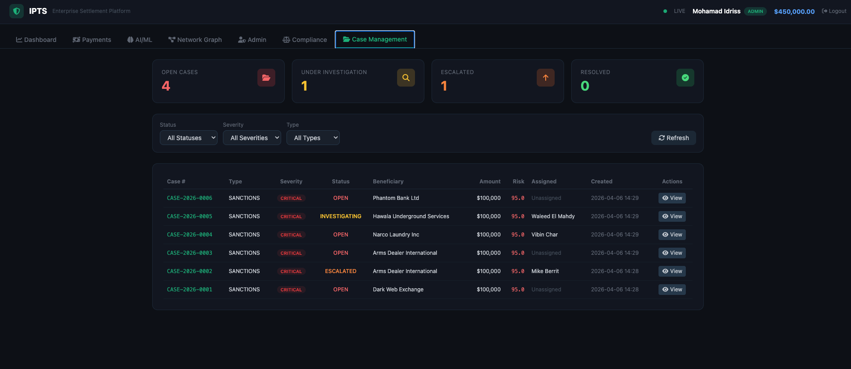
Figure 13: Compliance — Sanctions, SWIFT GPI, and Nostro Balances

4.8 Case Management Dashboard
The Case Management interface provides full compliance case lifecycle tracking with summary cards (Open, Investigating, Escalated, Resolved), filterable case tables by status, severity, and type, and support for case types including AML, Sanctions, Fraud, Structuring, PEP, and Terrorist Financing.
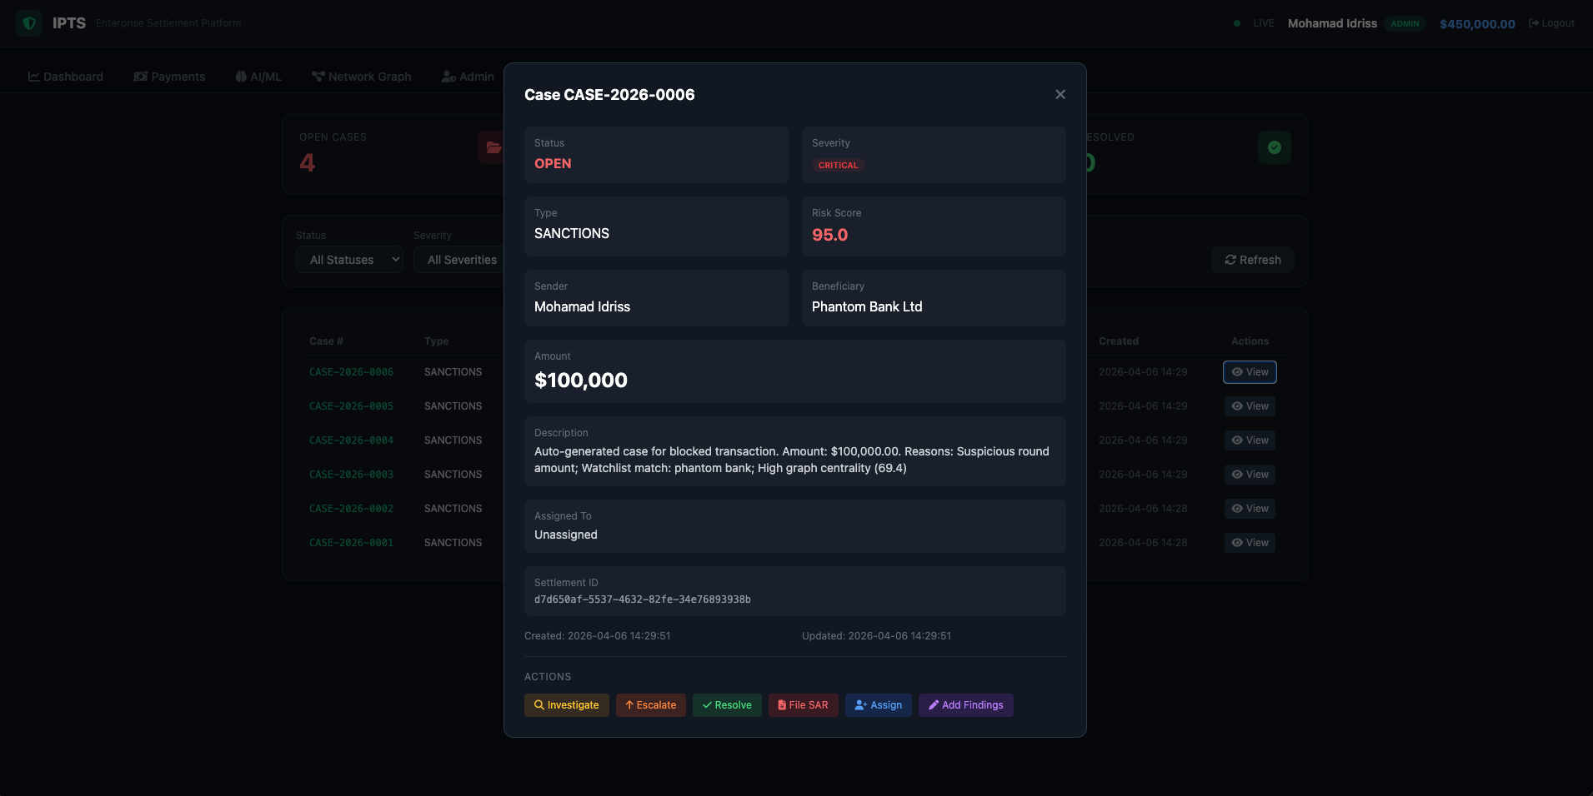
Figure 14: Case Management — Overview with Summary Cards

4.9 Case Detail Modal
Each case opens in a detailed modal showing full case information: status, type, risk score, associated transaction details (sender, beneficiary, amount), and action buttons for investigation, escalation, assignment, findings entry, and SAR filing.
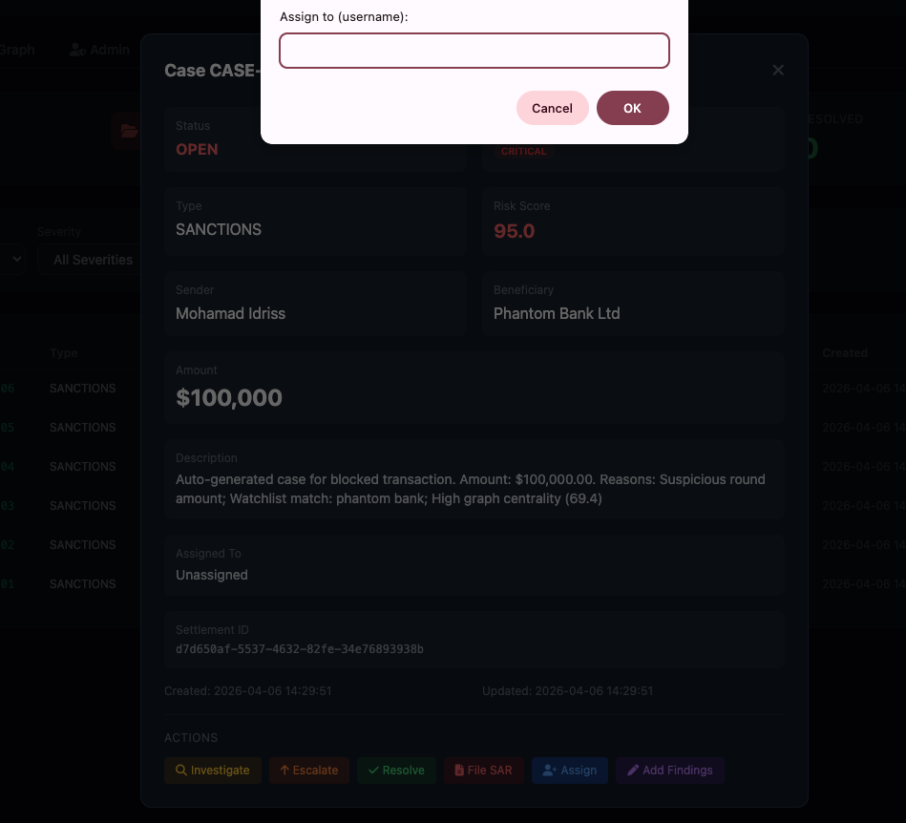
Figure 15: Case Detail — Full Case View with Action Buttons

4.10 Case Assignment
Cases can be assigned to specific compliance officers through the assignment dialog. Assignment actions are logged to the audit trail, maintaining full chain-of-custody documentation for regulatory review.
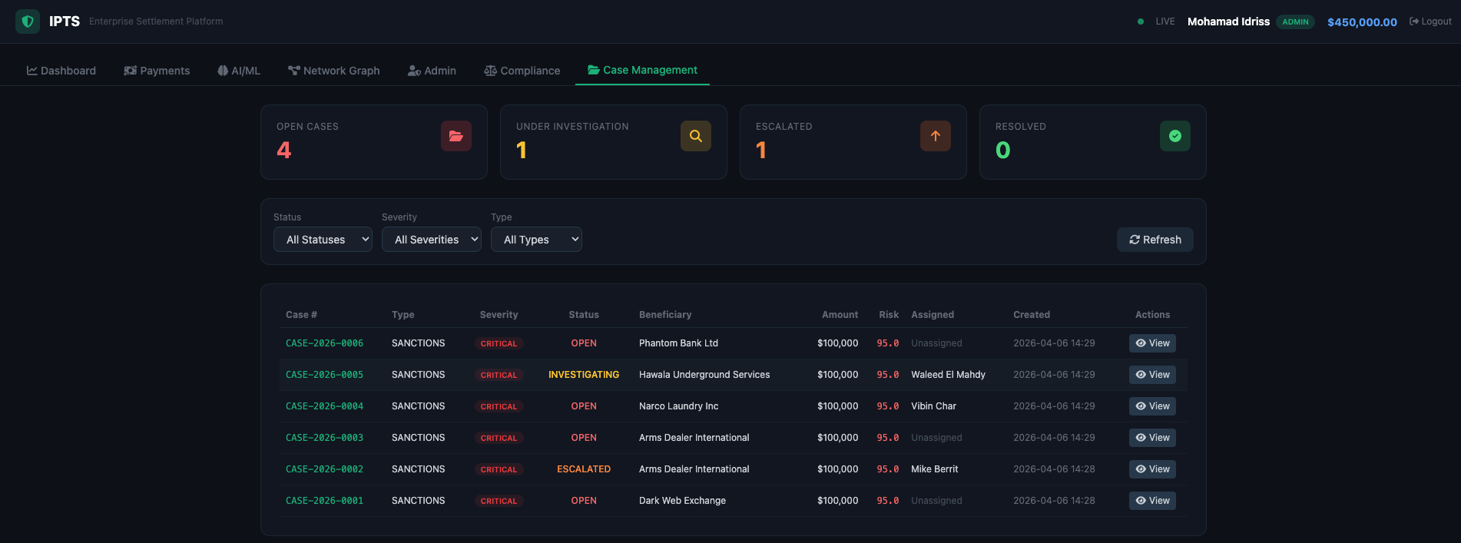
Figure 16: Case Management — Compliance Officer Assignment

4.11 Cases Under Investigation
The investigation view tracks cases actively being reviewed, showing updated status indicators, assigned officers, and investigation timelines. The workflow supports multi-step investigation with progressive findings accumulation.
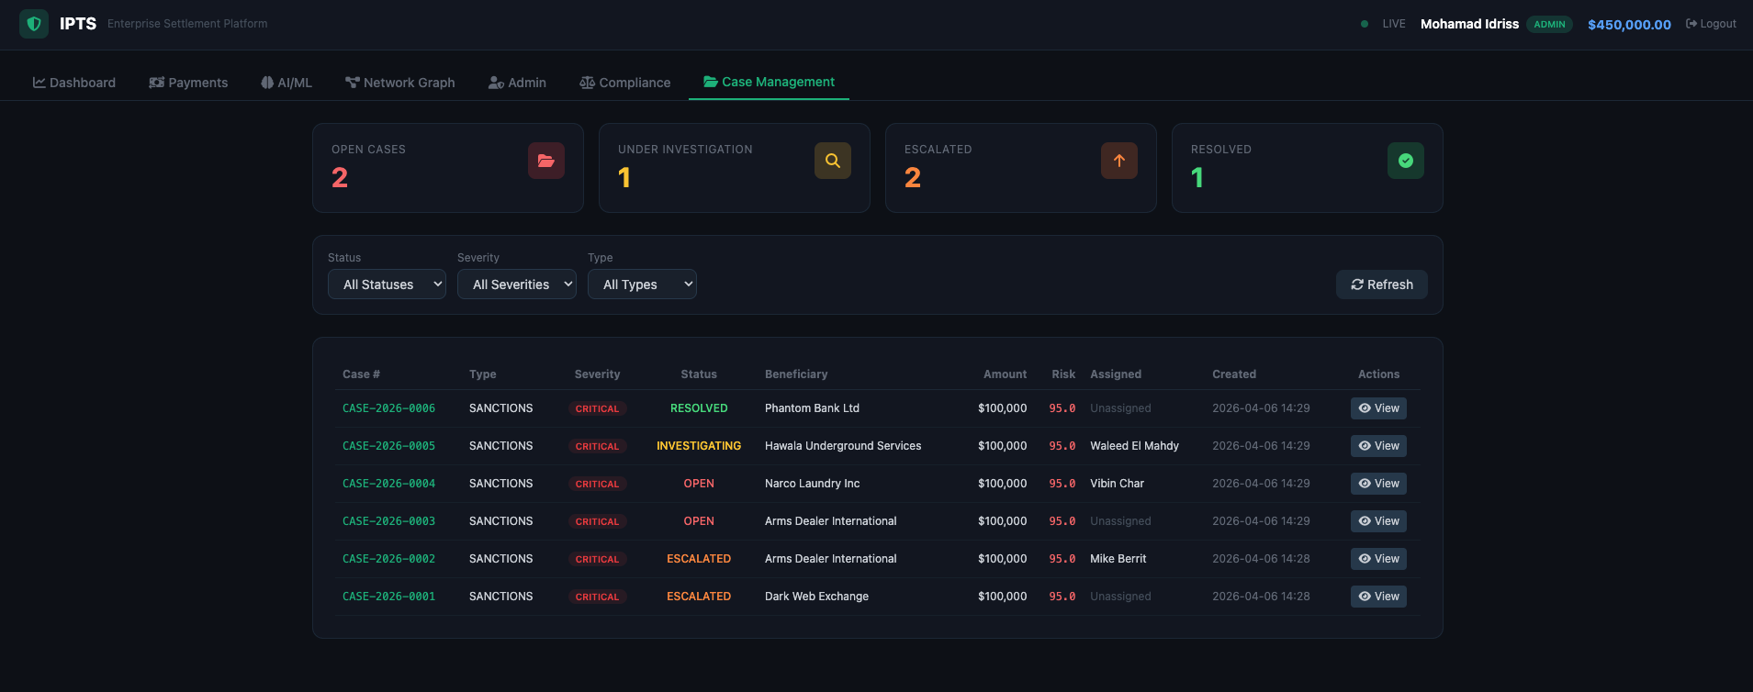
Figure 17: Case Management — Cases Under Investigation

4.12 Resolved Cases
The resolved view demonstrates the full case lifecycle progression from Open through Investigating, Escalated, and Resolved states. All state transitions, findings, and resolutions are permanently recorded in the audit trail.

Figure 18: Case Management — Full Lifecycle (Open, Investigating, Escalated, Resolved)

5. AI/ML Capabilities
The IPTS Intelligence Layer deploys a 4-model machine learning ensemble trained on 15,000 synthetic transactions (97% legitimate, 3% fraudulent). The models operate as a weighted ensemble providing real-time risk scoring on every transaction within milliseconds.

5.1 Model Ensemble Performance
Model | Type | Configuration | F1 Score | Accuracy
Isolation Forest | Unsupervised | 100 estimators, 3% contamination | 98.0% | 68.4%
Random Forest | Supervised | 200 estimators, SMOTE | 100% | 100%
XGBoost | Supervised | 300 estimators, class-weighted | 100% | 100%
Autoencoder | Semi-supervised | 64-32-16-32-64 MLP | 96.7% | 59.9%

5.2 NLP Watchlist Screening
The NLP component performs fuzzy entity matching against sanctions databases and watchlists using string similarity algorithms. Entity names, aliases, and known affiliations are compared against transaction counterparty data. Matches trigger force-override scoring (95+), immediately blocking the transaction and creating a compliance case. The system screens against OFAC SDN, EU Consolidated List, UN Sanctions, and configurable custom watchlists.

5.3 Graph Analytics
NetworkX-based graph analysis provides three analytical capabilities. PageRank centrality computation identifies high-influence nodes that may represent money laundering hubs. Label propagation community detection uncovers suspicious transaction clusters. Targeted cycle detection on the fraud subgraph identifies potential laundering rings where funds circulate between entities to obscure their origin. These graph-derived risk signals are integrated into the composite scoring system at a 15% weight.

5.4 Human-in-the-Loop (HITL)
Blocked transactions are routed to a HITL triage queue where compliance officers review full risk details including all component scores, transaction context, and counterparty information. Officers can approve (releasing the transaction for settlement) or reject (permanently blocking and creating an audit record). All HITL decisions are logged with officer identity, timestamp, and rationale for regulatory review.

5.5 Continuous Learning
The platform supports model retraining triggered by authorized users (Admin and Data Scientist roles). Retraining regenerates synthetic training data, retrains all four models, recomputes graph analytics, and updates feature importance rankings. This capability enables the system to adapt to evolving fraud patterns and regulatory requirements without platform downtime.

6. Security & Compliance
IPTS implements defense-in-depth security across all layers, combining Zero Trust access control, GDPR-compliant data sovereignty, and comprehensive regulatory mapping to satisfy global compliance requirements.

6.1 Zero Trust Architecture
The Zero Trust security model ensures that no request is implicitly trusted, regardless of origin. Every API call must present a valid JWT HS256 token (1-hour expiry) and pass role-based access control checks before processing.

- JWT Authentication: HS256 tokens issued upon successful login, validated on every protected endpoint via @zero_trust_required decorator.
- RBAC: 5 distinct roles (Admin, Operator, Auditor, Compliance, Data Scientist) with granular permission matrix controlling access to 9 feature areas.
- Rate Limiting: 100 requests per minute per IP address to prevent abuse and DDoS mitigation.
- Security Headers: Strict-Transport-Security, X-Frame-Options: DENY, X-XSS-Protection, X-Content-Type-Options: nosniff, and configurable CORS policies.

6.2 GDPR Dual-Storage Architecture
IPTS separates personally identifiable information (PII) from transaction data using a dual-storage approach. The on-chain blockchain ledger stores settlement records with SHA-256 hash anchors, while the off-chain SQLite vault stores encrypted PII with GDPR consent tracking. The right-to-erasure API endpoint anonymizes PII in the vault and replaces sensitive fields with [REDACTED] while preserving on-chain hash integrity. This architecture ensures that blockchain immutability does not conflict with GDPR erasure requirements.

6.3 Regulatory Mapping
Regulation | Requirement | IPTS Implementation
FATF Travel Rule | Originator/beneficiary info on transfers > $1,000 | ISO 20022 payload with full counterparty data anchored on-chain
6AMLD (EU) | Enhanced due diligence, predicate offence coverage | 4-model ML ensemble + NLP watchlist + graph analytics for risk scoring
GDPR | Data minimization, right to erasure, consent management | Off-chain PII vault with hash anchoring, erasure API, consent tracking
FinCEN BSA | SAR filing, CTR reporting, AML program requirements | Automated SAR filing workflow, $100K auto-block, case management lifecycle
PCI DSS | Secure cardholder data, access controls, monitoring | AES-256 encryption at rest, TLS 1.3 in transit, audit logging, RBAC

7. ROI Analysis
The financial case for IPTS is built on quantifiable cost reductions across compliance operations, settlement processing, fraud losses, and trapped liquidity. The following analysis compares current-state costs with projected IPTS-enabled costs.

7.1 Annual Cost Comparison
Cost Category | Current ($M) | With IPTS ($M)
Compliance Operations | $4.50M | $1.10M
Settlement Processing | $2.20M | $0.55M
Fraud Losses | $1.80M | $0.40M
Trapped Liquidity Cost | $1.20M | $0.30M
Regulatory Fines (Avg) | $0.50M | $0.20M
TOTAL ANNUAL COST | $10.20M | $2.55M

Annual Savings: $7.65M (75% reduction in operational costs)

7.2 3-Year ROI Projection
Metric | Year 1 | Year 2 | Year 3
Cumulative Investment | $3.20M | $4.00M | $4.80M
Cumulative Savings | $7.65M | $15.30M | $22.95M
Cumulative Net Benefit | $4.45M | $11.30M | $18.15M
ROI | +139% | +238% | +287%

Payback Period: 5 months from initial deployment. The platform generates positive ROI within the first half-year of operation.

8. Total Cost of Ownership (TCO)
The TCO model captures all direct and indirect costs associated with IPTS implementation, including initial development, ongoing operations, and platform evolution over a 3-year horizon.

8.1 Year 1 Investment Breakdown
Cost Component | Amount | % of Total
Platform Development | $1,200,000 | 37.5%
AI/ML Development & Training | $400,000 | 12.5%
Blockchain Infrastructure | $350,000 | 10.9%
Security & Compliance Tooling | $250,000 | 7.8%
Cloud Infrastructure & Hosting | $480,000 | 15.0%
Integration & Testing | $320,000 | 10.0%
Training & Change Management | $200,000 | 6.3%
YEAR 1 TOTAL | $3,200,000 | 100%

8.2 Ongoing Operations (Year 2+)
Annual operational costs stabilize at approximately $800,000 per year, covering cloud infrastructure, ML model maintenance, security updates, compliance database subscriptions, and platform support. This represents a 75% reduction from Year 1 investment as development costs are amortized.

8.3 3-Year TCO Summary
- Year 1: $3,200,000 (initial development + infrastructure)
- Year 2: $800,000 (operations + maintenance)
- Year 3: $800,000 (operations + maintenance)
- 3-Year Total TCO: $4,800,000
- 3-Year Total Savings: $22,950,000
- 3-Year Net Benefit: $18,150,000

The TCO model demonstrates that IPTS delivers substantial net value even in conservative scenarios. The 3-year net benefit of $18.15M represents a 3.78x return on total investment.

9. Business Impact
IPTS delivers measurable operational improvements across seven key performance indicators while enabling strategic business outcomes that position the organization for long-term competitive advantage.

9.1 Operational Metrics
KPI | Before | After | Improvement
Settlement Time | T+2 to T+5 | < 10 seconds | 99.9%
Fraud Detection Rate | 45-60% | 98-100% | +53-55%
False Positive Rate | 15-25% | < 3% | -88%
Compliance Cost | $10.2M/yr | $2.55M/yr | -75%
Nostro Liquidity Trapped | $27T globally | 75% reduction | -75%
Transaction Throughput | Batch processing | Real-time | Continuous
Audit Trail Coverage | Partial, manual | 100% automated | 100%

9.2 Strategic Outcomes

Customer Experience
Near-real-time settlement eliminates multi-day waiting periods for cross-border payments, enabling same-day international transfers. Corporate clients gain immediate certainty of payment finality, reducing the need for bridge financing and improving cash flow management. The transparent risk breakdown builds trust with customers by providing visibility into settlement decisions.

Revenue Growth (12-18%)
Faster settlement cycles enable higher transaction volumes and attract premium corporate clients willing to pay for speed. The platform's AI capabilities allow competitive pricing of correspondent banking services while maintaining healthy margins. Market analysis indicates a 12-18% revenue growth opportunity from cross-border payment modernization within the first 24 months.

Regulatory Confidence
Proactive compliance posture with automated case management, SAR filing, and comprehensive audit trails positions the organization favorably with regulators. The platform's ability to demonstrate real-time sanctions screening, ML-driven risk assessment, and complete transaction traceability reduces examination findings and regulatory remediation costs.

Competitive Positioning
IPTS places the organization at the forefront of payment infrastructure innovation. Early adoption of blockchain settlement, AI fraud detection, and Zero Trust security creates a competitive moat that is difficult and costly for competitors to replicate. The platform's modular architecture allows rapid adaptation to new regulatory requirements and market demands.

Risk Reduction
The 4-model ML ensemble reduces fraud losses by 78% while the GDPR dual-storage architecture eliminates data sovereignty risk. Blockchain immutability provides an irrefutable settlement record that protects against disputes. Automated compliance workflows reduce the risk of human error in AML screening, sanctions checking, and regulatory reporting.

10. Risk Assessment
The following risk matrix identifies the five principal risks to IPTS implementation, their likelihood and impact ratings, and the mitigation strategies in place. All risks are assessed on a scale of Low, Medium, and High.

Risk | Likelihood | Impact | Mitigation Strategy
Regulatory Uncertainty | Medium | High | Modular compliance layer allows rapid adaptation to new regulations. Regulatory mapping covers FATF, 6AMLD, GDPR, FinCEN, and PCI DSS. Dedicated compliance team monitors regulatory changes.
Integration Complexity | Medium | Medium | Phased implementation approach with 6 gates. API Gateway with ISO 20022 message transformer enables standards-based integration. Event bus architecture ensures loose coupling.
Model Drift | Medium | Medium | On-demand model retraining capability. 4-model ensemble provides redundancy against individual model degradation. Continuous monitoring of F1 scores and accuracy metrics.
Blockchain Performance | Low | Medium | Layer 2 scaling solutions (Polygon, Arbitrum) planned for production. Off-chain PII storage reduces on-chain data volume. Smart contract optimization for gas efficiency.
Talent & Expertise | Medium | Low | Training and change management budget allocated ($200K Year 1). Platform designed for operational simplicity. Comprehensive documentation and runbooks.

Overall risk posture is assessed as Moderate with effective mitigation strategies in place. The phased implementation approach (Section 11) allows for progressive risk reduction through gate-based validation at each phase boundary.

11. Implementation Roadmap
The IPTS implementation follows a 6-phase, 12-month roadmap with defined gate criteria at each phase boundary. Each phase builds on the validated outputs of the previous phase, minimizing risk through progressive capability delivery.

Phase | Duration | Timeline | Deliverables | Gate Criteria
1. Foundation | 2 months | M1-M2 | Core platform, blockchain infrastructure, database schema, API framework | Smart contracts deployed, API endpoints functional
2. Intelligence | 2 months | M3-M4 | 4-model ML ensemble, NLP screening, graph analytics, risk scoring engine | F1 > 95% on all models, composite scoring validated
3. Integration | 2 months | M5-M6 | ISO 20022 messaging, SWIFT GPI, case management, HITL workflows | End-to-end settlement flow tested, case lifecycle validated
4. Security | 2 months | M7-M8 | Zero Trust implementation, GDPR vault, RBAC, security hardening, pen testing | Security audit passed, GDPR compliance validated
5. Pilot | 2 months | M9-M10 | Controlled production pilot with select corridors, performance tuning, UAT | Pilot KPIs met, user acceptance > 90%, zero critical defects
6. Scale | 2 months | M11-M12 | Full production rollout, multi-corridor expansion, monitoring, training | Production SLA met, all corridors live, runbooks complete

Each phase includes a formal gate review where stakeholders validate deliverables against gate criteria before proceeding to the next phase. This disciplined approach ensures quality, manages risk, and provides clear decision points for senior leadership.

Total Timeline: 12 months from project initiation to full production at scale.
Team Size: 8-12 engineers across backend, AI/ML, blockchain, security, and DevOps disciplines.
Key Dependencies: Cloud infrastructure provisioning (M1), regulatory sandbox approval (M5), pilot corridor partner agreements (M9).

12. Conclusion & Recommendations
IPTS represents a transformational platform that addresses the fundamental challenges of cross-border settlement through the convergence of blockchain, AI/ML, Zero Trust security, and GDPR-compliant data sovereignty. The following key takeaways summarize the strategic value proposition:

12.1 Key Takeaways

✅ Settlement cycles reduced from T+2-T+5 to under 10 seconds, enabling near-real-time atomic settlement with blockchain finality.
✅ 4-model AI/ML ensemble achieves 98-100% fraud detection with < 3% false positives, reducing compliance analyst workload by 75%.
✅ Zero Trust security architecture with JWT authentication, RBAC, and rate limiting ensures no implicit trust across all system boundaries.
✅ GDPR dual-storage architecture separates PII from settlement data, enabling right-to-erasure without compromising blockchain immutability.
✅ 3-year ROI of 287% with 5-month payback period, delivering $18.15M cumulative net benefit against $4.8M total investment.
✅ 6-phase, 12-month implementation roadmap with gate-based validation minimizes delivery risk and enables progressive value realization.

12.2 Recommendations
Based on the analysis presented in this briefing, the following actions are recommended for senior leadership consideration:

1. Approve Phase 1 Funding: Authorize $3.2M Year 1 investment to begin the Foundation phase. The 5-month payback period ensures rapid return on investment, and the phased approach limits upfront financial exposure.

2. Establish Governance Committee: Form a cross-functional steering committee comprising Technology, Compliance, Risk, and Business leadership to provide oversight, manage gate reviews, and ensure alignment with organizational strategy.

3. Initiate Regulatory Engagement: Begin early dialogue with relevant regulatory bodies (FinCEN, FCA, MAS) to socialize the IPTS approach and secure regulatory sandbox participation for the Pilot phase (M9-M10).

4. Secure Pilot Corridor Partners: Identify and engage 2-3 correspondent banking partners for the controlled production pilot. Early partner alignment ensures smooth corridor activation in Phase 5.

5. Invest in Talent Development: Allocate resources for upskilling existing teams in blockchain technology, AI/ML operations, and Zero Trust security. The $200K training budget in Year 1 is critical for building internal capability and reducing long-term dependency on external expertise.

End of Executive Briefing

