IPTS
Integrated Payment Transformation System

Technical Architecture & Capability Report

Version 3.0
April 2026
Author: Mohamad Idriss

CONFIDENTIAL
Enterprise-Grade Financial Settlement Platform

Table of Contents

1. Executive Summary
The Integrated Payment Transformation System (IPTS) is an enterprise-grade financial settlement platform built on a 7-layer convergent architecture. Its primary mission is to collapse cross-border settlement cycles from the traditional T+5 (five business days) to under 10 seconds, achieving near-real-time atomic settlement.

IPTS integrates four foundational technology pillars into a unified platform:
- Blockchain Settlement: Ethereum smart contracts (Solidity ^0.8.0) deployed on a local Ganache blockchain provide immutable, atomic T+0 settlement with cryptographic audit trails.
- AI/ML Fraud Detection: A 4-model ensemble (Isolation Forest, Random Forest, XGBoost, Autoencoder) trained on 15,000 synthetic transactions provides real-time risk scoring on every transaction.
- Zero Trust Security: JWT-based authentication, role-based access control (RBAC) with 5 distinct roles, rate limiting, and comprehensive security headers enforce a zero-implicit-trust perimeter.
- GDPR-Compliant Data Sovereignty: Off-chain PII vaulting with on-chain hash anchoring ensures regulatory compliance while maintaining blockchain immutability.

The entire system is packaged as a single Python deployment script (~2,500 lines) designed to run in Google Colab. Within 90-120 seconds, it orchestrates dependency installation, ML model training, smart contract compilation and deployment, Flask API server startup, and public URL exposure via Localtunnel.

Key capabilities include automated AML screening with configurable blocking thresholds ($100K+ auto-block), human-in-the-loop (HITL) triage for blocked transactions, compliance case management with SAR filing workflows, SWIFT GPI payment tracking, and a professional real-time dashboard with 7 functional tabs.

2. System Architecture
IPTS implements a 7-Layer Convergent Architecture where each layer encapsulates a specific domain concern. This separation enables independent scaling, testing, and regulatory auditing of each layer while maintaining cohesive end-to-end transaction processing.

2.1 Architecture Overview

Layer | Name | Description
Layer 1 | Presentation | Single-page application with Tailwind CSS, Chart.js, D3.js, and Server-Sent Events (SSE) for real-time dashboard updates
Layer 2 | Security | Zero Trust perimeter with JWT HS256 auth, rate limiting (100 req/min), RBAC with 5 roles, HSTS, XSS, and CORS headers
Layer 3 | AI/ML Intelligence | 4-model ensemble (Isolation Forest, Random Forest, XGBoost, Autoencoder), NLP watchlist screening, PageRank graph analysis
Layer 4 | Compliance | AML/KYC screening, HITL triage, case management lifecycle, SAR filing, sanctions database, SWIFT GPI tracking
Layer 5 | Blockchain | Ethereum smart contracts (Solidity ^0.8.0), atomic swaps, Nostro/Vostro liquidity, multi-sig approval, compliance oracle
Layer 6 | Data Sovereignty | SQLite off-chain vault, GDPR right to erasure, PII encryption, SHA-256 hash anchoring, ISO 20022 payload separation
Layer 7 | Infrastructure | Ganache local blockchain, Flask API server, Localtunnel public exposure, automated ML training pipeline, process orchestration

2.2 Seven-Layer Convergent Architecture
The following diagram presents the complete IPTS seven-layer convergent architecture. The layers are organized into three logical sections: Interaction and Intelligence (Layers 1-3), Security and Compliance (Layers 4-5), and Settlement Infrastructure (Layers 6-7). Layer 1 (Interaction) encompasses digital portals, wallets, and automated triggers that serve as the entry points for all transaction requests. Layer 2 (Integration) handles ISO 20022 message formatting, core banking system connectivity, and RTGS interfacing. Layer 3 (Intelligence) is the cognitive core, housing the AML/KYC screening engine, the four-model ML ensemble, graph analytics for network-based risk detection, and NLP-based sanctions screening.
Layers 4 and 5 form the security and compliance boundary. Layer 4 (Security) implements Zero Trust principles including JWT authentication, RBAC enforcement, AES-256 encryption at rest and in transit, and HSM-backed key management. Layer 5 (Compliance) provides the human-in-the-loop triage queue, full case management lifecycle, SAR reporting workflows, and real-time sanctions screening against global watchlists.
The settlement infrastructure comprises Layers 6 and 7. Layer 6 (Distributed Ledger) contains the atomic swap engine, smart contract execution environment, Nostro/Vostro balance management, and multi-signature approval workflows for high-value transactions. Layer 7 (Data) ensures tamper-evident audit trails through SHA-256 hash anchoring, Merkle tree root verification, GDPR-compliant PII vaulting with consent management, and ISO 20022 payload separation between on-chain and off-chain storage.
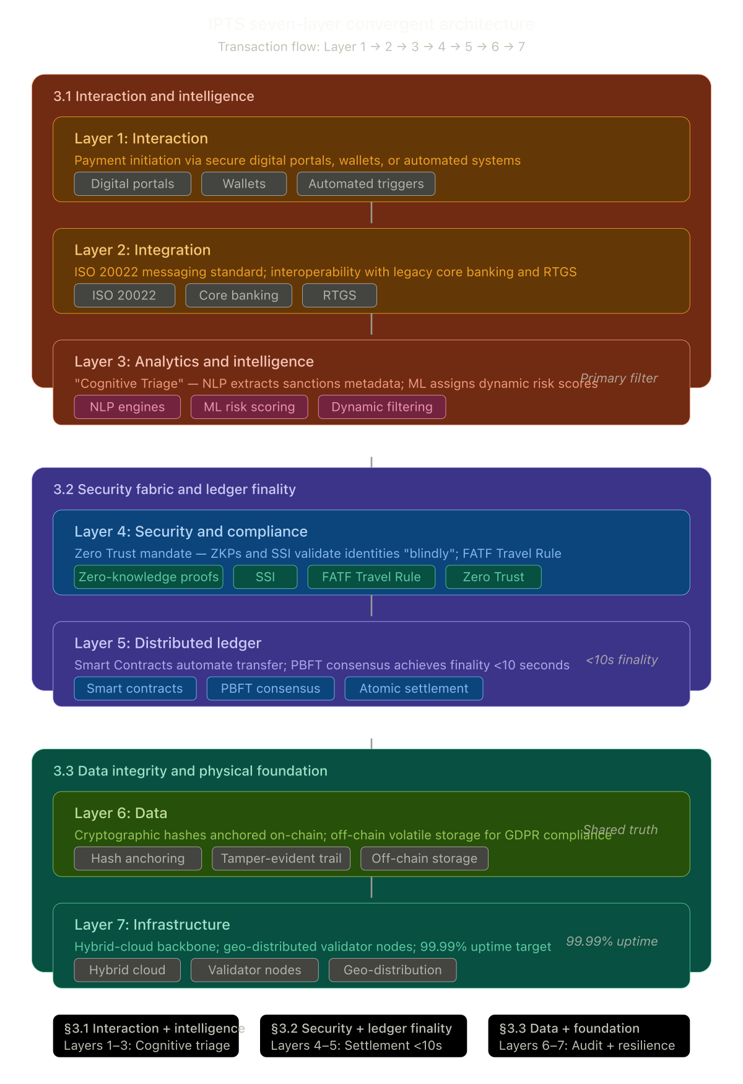
Figure 1: IPTS Seven-Layer Convergent Architecture Overview

2.3 Layer 1 — Interaction Architecture
The Interaction Layer serves as the primary interface between external users and the IPTS platform. It defines three categories of interaction entry points: digital portals (web-based dashboards and administrative consoles), wallet integrations (for direct blockchain-based transaction initiation), and automated triggers (scheduled batch processing and event-driven transaction flows). Each entry point feeds into a unified request pipeline that normalizes input formats before passing them to the Integration Layer. The architecture ensures that regardless of the originating channel, all transactions undergo identical validation, authentication, and enrichment before entering the processing pipeline.
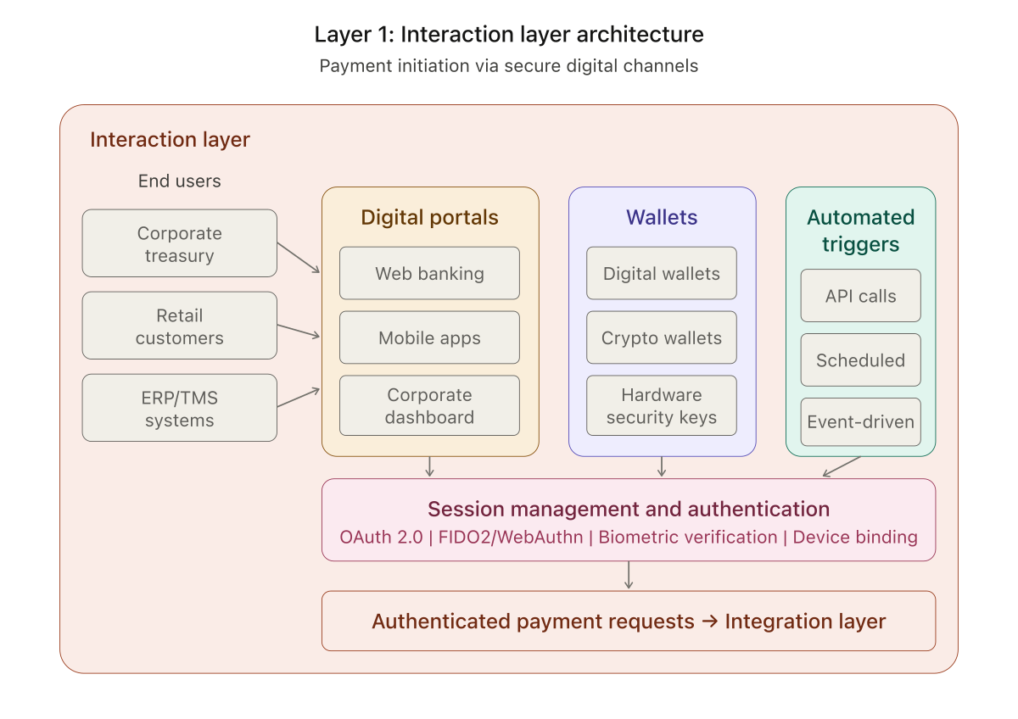
Figure 2: Layer 1 — Interaction Architecture

2.4 Layer 1 — Integration Architecture
The Integration Layer connects IPTS with the broader financial ecosystem. External systems including originating banks, beneficiary banks, regulatory bodies, and FX/liquidity providers communicate through a centralized API Gateway that enforces rate limiting, authentication validation, request routing, and schema validation. Incoming messages pass through a Message Transformer that provides ISO 20022 parsing, format adaptation between legacy and modern message standards, and data enrichment with reference data. Transformed messages are then dispatched to internal services via an event bus, ensuring loose coupling between the integration boundary and core processing logic. This architecture allows IPTS to interface with SWIFT, SEPA, Fedwire, and proprietary banking protocols without modifying internal settlement logic.
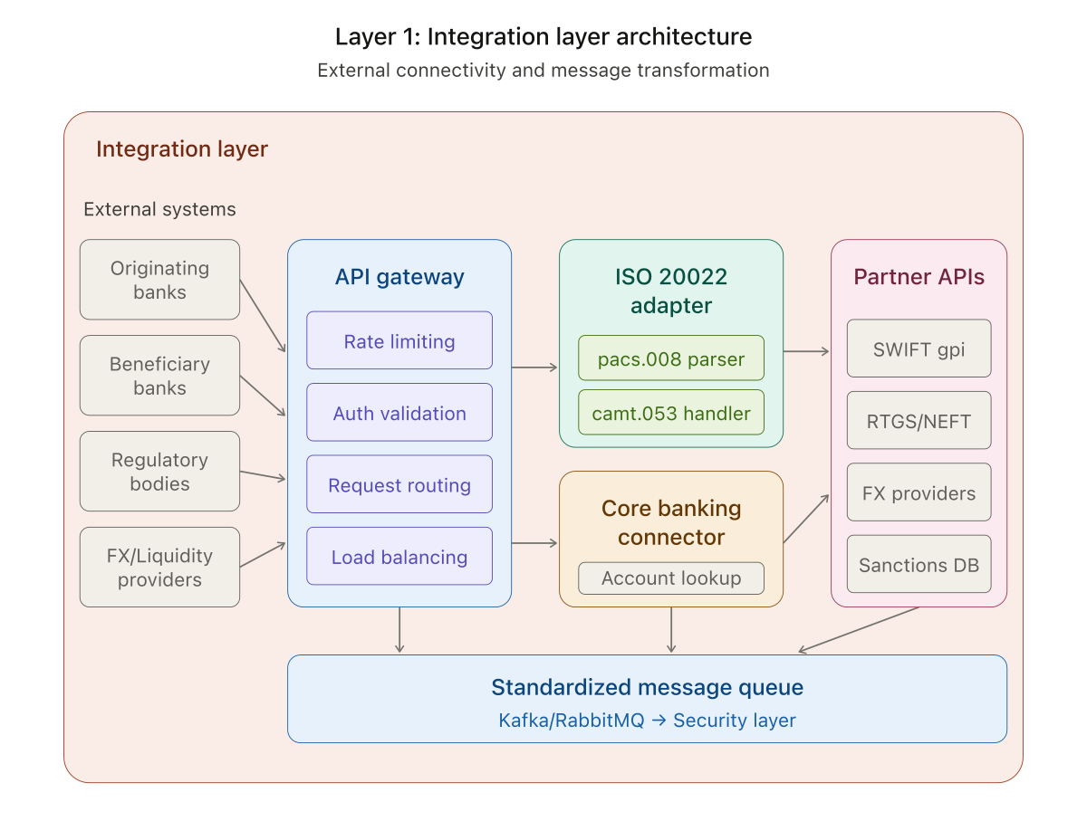
Figure 3: Layer 1 — Integration Architecture

2.5 Layer 2 — Zero Trust Security Architecture
The Security Layer implements a comprehensive Zero Trust model where no request is implicitly trusted regardless of origin. The architecture is organized into four security domains. Identity and Access Management provides zero-knowledge proof verification, self-sovereign identity (SSI) support, multi-factor authentication with biometric options, and fine-grained role-based access control. Micro-segmentation enforces network isolation between service components, workload segmentation to prevent lateral movement, data classification policies, and lateral movement prevention through service mesh controls.
All interactions undergo Continuous Verification, ensuring that trust is re-evaluated at every request boundary rather than being established once at session creation. The Cryptographic Layer provides PKI infrastructure for certificate management, HSM integration for hardware-backed key storage, TLS 1.3 mutual authentication for all inter-service communication, and automated key rotation on configurable schedules. The Threat Intelligence domain integrates with SIEM systems for centralized security event monitoring, employs anomaly detection algorithms for identifying unusual access patterns, consumes external threat feeds for proactive defense, and maintains incident response playbooks for automated remediation.
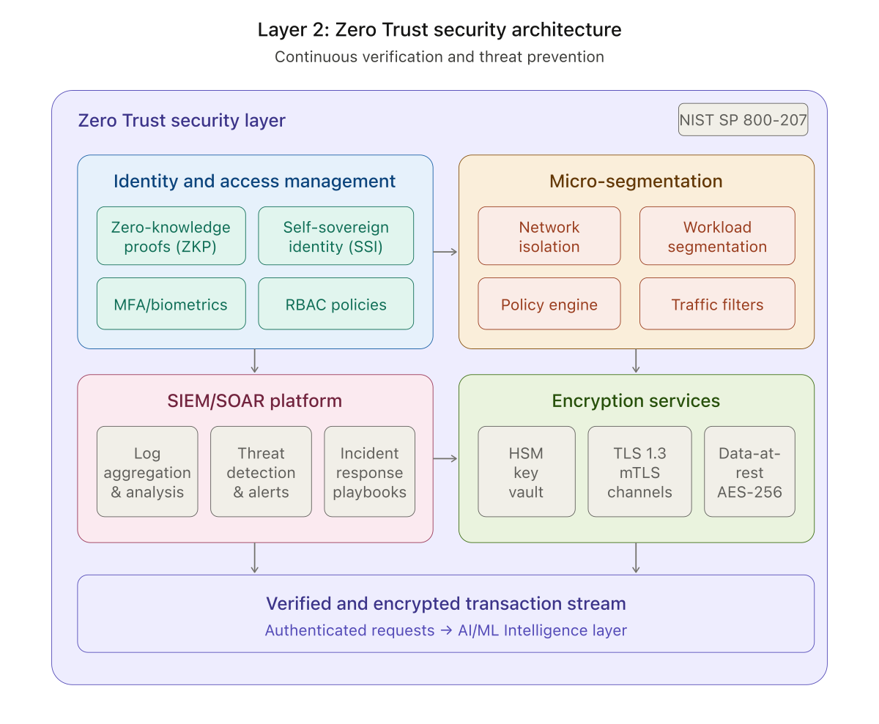
Figure 4: Layer 2 — Zero Trust Security Architecture

2.6 Layer 6 — Data Architecture
The Data Layer ensures the integrity, immutability, and regulatory compliance of all settlement data. Data flows from the Distributed Ledger into three specialized subsystems. The Hash Anchoring subsystem computes SHA-256 hashes of transaction payloads and anchors Merkle tree roots on-chain, creating a cryptographic proof chain that can verify the integrity of any historical transaction without exposing raw data. The Tamper-Evident Audit Trail maintains immutable logs with cryptographic timestamp proofs and full chain of custody records, ensuring that every action taken on the platform is permanently recorded and verifiable.
The GDPR Compliance Vault addresses data sovereignty requirements by storing encrypted PII in a segregated database with full consent management, right-to-erasure implementation, and data minimization policies. When a GDPR erasure request is processed, the vault anonymizes PII fields while preserving the on-chain hash anchors, maintaining audit integrity without retaining personal data. A Reconciliation Engine continuously verifies consistency between on-chain records, off-chain vault data, and the audit trail, automatically flagging any discrepancies for investigation.
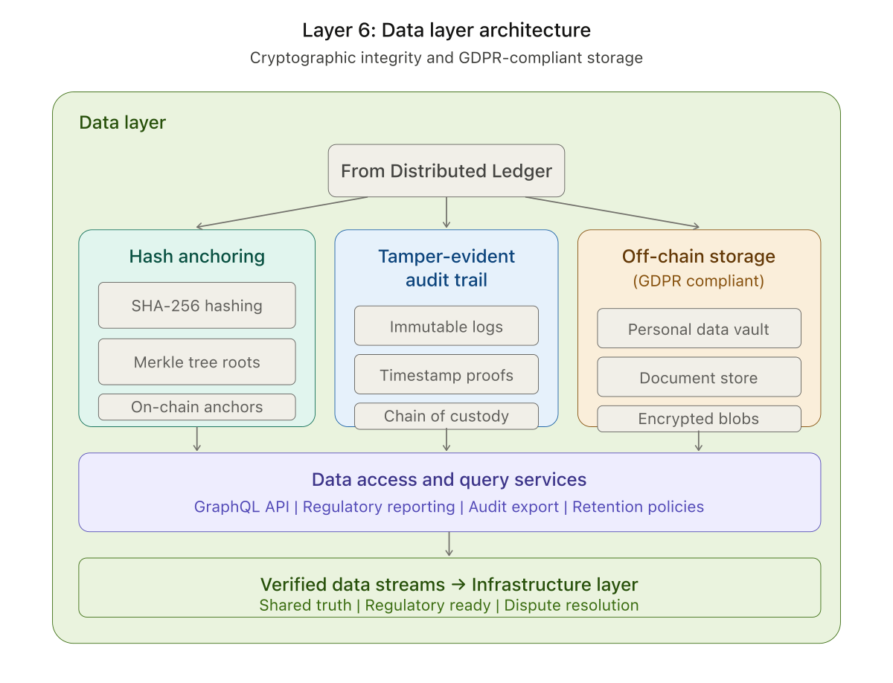
Figure 5: Layer 6 — Data Architecture

2.7 Layer 7 — Infrastructure Architecture
The Infrastructure Layer provides the runtime foundation for the entire IPTS platform. The Hybrid Cloud Backbone orchestrates workloads across private cloud infrastructure (for sensitive financial data processing) and public cloud resources (for scalable compute), unified through Kubernetes orchestration that manages container deployment, scaling, and service discovery. Validator Nodes form the consensus layer, with consensus validators, endorsing peers, and Byzantine Fault Tolerance (BFT) threshold configurations ensuring that settlement finality is achieved even in the presence of malicious or faulty nodes.
The Observability Stack provides comprehensive operational visibility through Prometheus metrics collection for real-time performance monitoring, distributed tracing for end-to-end transaction flow analysis across microservices, and centralized log aggregation for troubleshooting and compliance auditing. The Disaster Recovery subsystem ensures business continuity with geo-replicated data stores, automatic failover mechanisms, a Recovery Point Objective (RPO) of less than 1 minute ensuring minimal data loss, and a Recovery Time Objective (RTO) of less than 5 minutes for full service restoration.
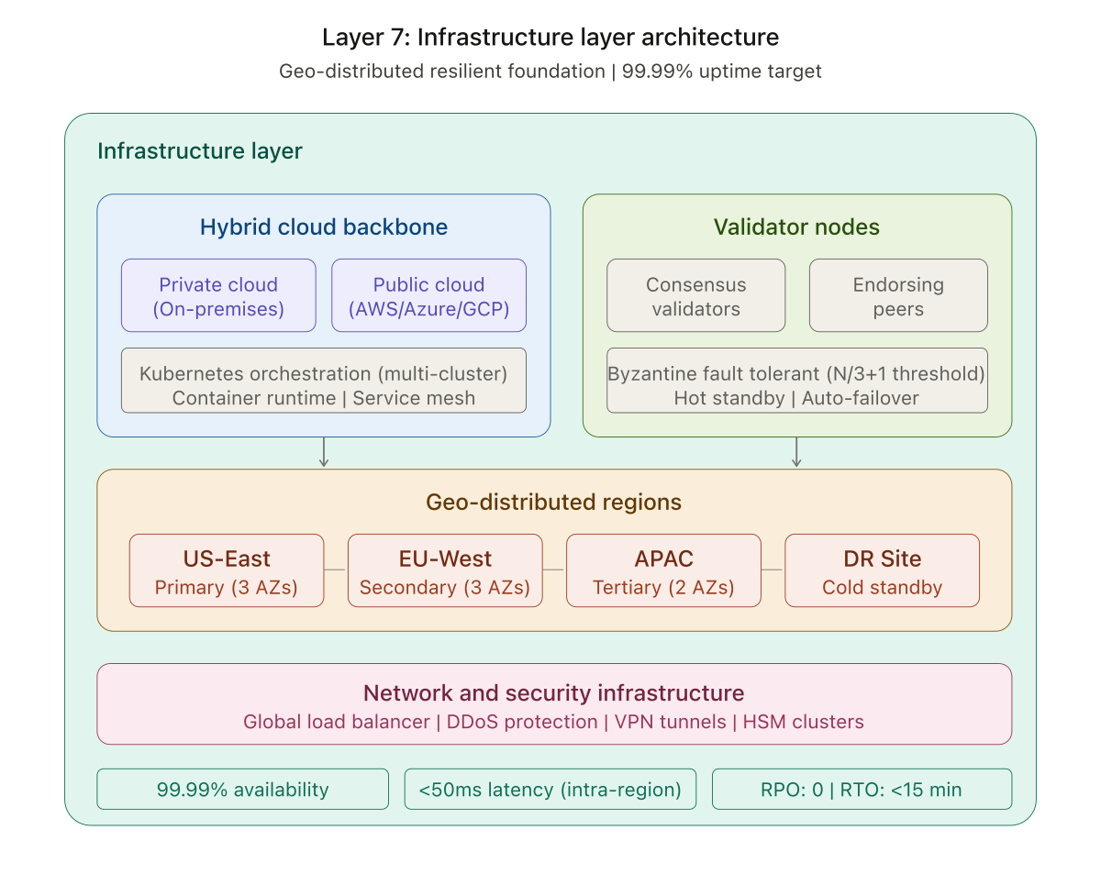
Figure 6: Layer 7 — Infrastructure Architecture

3. Technical Components

3.1 Blockchain Infrastructure
The blockchain layer provides the immutable settlement backbone. Five Solidity smart contracts are compiled using py-solc-x and deployed to a local Ganache instance with 10 pre-funded accounts (1,000 ETH each).

Smart Contracts
Contract | Purpose
IPTS_Enterprise_Settlement | Primary settlement contract: injectLiquidity, executeAtomicSwap, getNostroBalance, getSettlement
ComplianceOracle | On-chain risk score storage and compliance verification checks
MultiSigApproval | Multi-signature approval workflow for high-value settlements
AuditTrail | Immutable on-chain audit event logging with timestamps
NostroVostro | Nostro/Vostro account balance management and reconciliation

The atomic swap mechanism in IPTS_Enterprise_Settlement verifies sender balances, executes the fund transfer, and anchors an immutable bytes32 ISO 20022 hash to the ledger in a single transaction. All settlement amounts are denominated in USD and converted to ETH at a fixed rate of $3,500/ETH for blockchain recording.

3.2 AI/ML Fraud Detection Engine
The cognitive intelligence layer trains four complementary machine learning models on a synthetic dataset of 15,000 transactions (97% legitimate, 3% fraudulent). The models operate as a weighted ensemble for real-time risk scoring.

Model Architecture
Model | Type | Configuration | Purpose
Isolation Forest | Unsupervised | 100 estimators, 3% contamination | Anomaly detection on feature space
Random Forest | Supervised | 200 estimators, SMOTE-resampled | Binary fraud classification
XGBoost | Supervised | 300 estimators, class-weighted | Gradient-boosted classification
Autoencoder | Semi-supervised | 64-32-16-32-64 MLP, 97th pctl | Reconstruction error anomaly detection

Feature Set
Each transaction is characterized by 8 features:
- amount: Transaction value in USD
- hour: Hour of day (0-23) when transaction was initiated
- day_of_week: Day of week (0-6)
- freq_7d: Number of transactions by the same sender in the past 7 days
- is_round: Binary flag indicating if amount is a round number
- country_risk: Risk score of recipient jurisdiction (0.0-1.0)
- sender_id: Numeric identifier of the sending entity
- receiver_id: Numeric identifier of the receiving entity

Graph Analysis
NetworkX is used for graph-based risk assessment, including PageRank centrality computation to identify high-influence nodes, label propagation community detection to uncover suspicious clusters, and targeted cycle detection on the fraud subgraph (nodes 0-49) to identify potential laundering rings.

3.3 AML Risk Scoring Engine
The AML Risk Engine combines all intelligence sources into a composite risk score using a 4-component weighted system with force-override triggers for critical scenarios.

Scoring Components
Component | Weight | Method
Rule-Based | 30% | Deterministic threshold checks (amount, structuring, jurisdiction, frequency)
ML Ensemble | 40% | Weighted average of 4 model predictions (ISO 20%, RF 35%, XGB 35%, AE 10%)
NLP Watchlist | 15% | Fuzzy entity matching against watchlist + sanctions database
Graph Risk | 15% | PageRank centrality analysis of sender/receiver in transaction network

Force-Override Triggers
The following conditions bypass the weighted scoring system and force specific outcomes:
Condition | Forced Score | Result
Transaction amount > $500,000 | 95+ | BLOCKED
Transaction amount > $100,000 (AML threshold) | 85+ | BLOCKED
Watchlist or sanctions database match | 95+ | BLOCKED
Structuring ($9K-$9.9K) + high frequency (>10 txns/7d) | 85+ | BLOCKED
High value (>$100K) + high-risk country (>0.7) | 85+ | BLOCKED
Any single scoring component >= 90 | min 80 | BLOCKED

Decision Thresholds
Composite Score | Decision | Action Taken
>= 80 | BLOCKED | Transaction halted. Added to HITL queue. Compliance case auto-created.
>= 60 | FLAGGED | Transaction settled on blockchain but logged for compliance review.
< 60 | APPROVED | Transaction settled normally. Balance deducted from sender, credited to receiver.

3.4 Zero Trust Security
The security layer implements a Zero Trust architecture where no request is implicitly trusted, regardless of origin.
- JWT HS256 tokens with 1-hour expiry issued upon successful authentication
- @zero_trust_required decorator enforces authentication on all protected API endpoints
- Rate limiting: 100 requests per minute per IP address to prevent abuse
- Security headers: Strict-Transport-Security, X-Frame-Options: DENY, X-XSS-Protection, X-Content-Type-Options: nosniff
- CORS policy with configurable allowed origins for cross-origin requests
- All passwords are compared server-side; no client-side credential storage

3.5 Database & Data Sovereignty
The data sovereignty layer uses SQLite (ipts_vault.db) as the off-chain secure vault, maintaining a strict separation between on-chain settlement records and off-chain personally identifiable information (PII).

Database Schema
Table | Purpose
pii_vault | Encrypted PII storage with GDPR consent tracking and data hashes
settlements | All transaction records with status, risk scores, blockchain tx hashes, and timing
hitl_queue | Human-in-the-loop review queue for blocked transactions
audit_log | Immutable audit trail of all system actions, actors, and IP addresses
sanctions_list | Sanctions screening database with entity names, types, and reasons
swift_gpi_tracker | SWIFT gpi payment tracking with UETR references
user_accounts | User balances, wallet addresses, and account metadata
compliance_cases | Full compliance case lifecycle tracking with severity, findings, and SAR numbers

GDPR compliance is enforced through a dedicated right-to-erasure API endpoint that anonymizes PII in the vault and replaces sensitive fields in settlements with [REDACTED]. The SHA-256 hash of ISO 20022 payloads remains on-chain as an immutable anchor, while the raw payload data resides exclusively in the off-chain vault.

4. User Interface
The IPTS frontend is a professional single-page application served via Flask and styled with Tailwind CSS CDN. It features a dark fintech-grade theme with 7 functional tabs, real-time data streaming via Server-Sent Events (SSE), and responsive design.

4.1 Login Screen
- Zero Trust authentication requiring username and password credentials
- 5 pre-configured test accounts with different roles and starting balances displayed below the login form
- JWT token issued on successful authentication and stored in localStorage
- Failed login attempts are logged to the audit trail with IP address

4.2 Dashboard Tab
The main operational dashboard provides at-a-glance system health and transaction monitoring:
- KPI Cards: Total Settlements, Blocked (red), Flagged (yellow), Nostro Liquidity (USD)
- Settlement Volume Chart: Real-time Chart.js visualization of settlement activity by status
- AML Telemetry Table: Live ledger showing sender name, beneficiary, amount (USD), risk score, status, and blockchain hash
- Color-coded status indicators: green (settled), yellow (flagged), red (blocked), purple (pending)
- Auto-refresh every 6 seconds via SSE stream

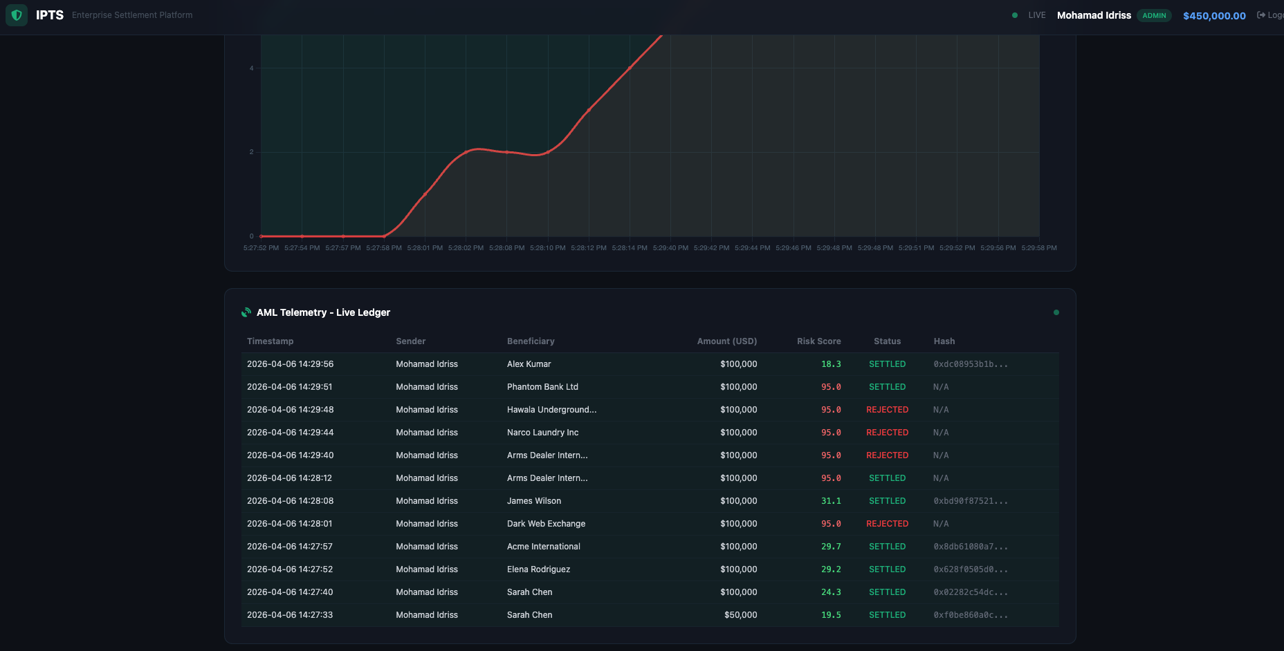
Figure 7: Dashboard — KPI Cards and Settlement Volume Chart

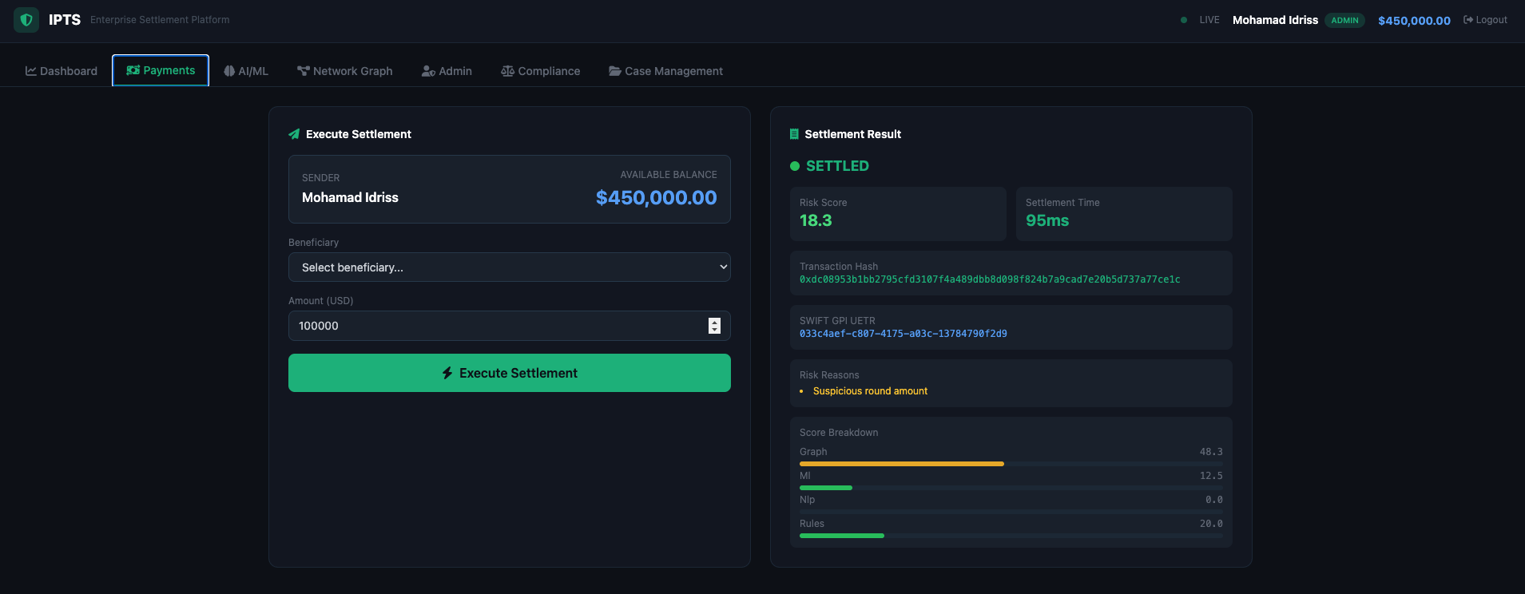
Figure 8: Dashboard — AML Telemetry Live Ledger

4.3 Payments Tab
The settlement execution interface allows authorized users to initiate cross-border payments:
- Sender identity displayed as read-only field showing the logged-in user's full name
- Available balance prominently displayed in large blue text
- Beneficiary dropdown populated from API, including both legitimate and suspicious test entities
- Risk indicators on suspicious beneficiaries: [HIGH RISK] and [CRITICAL RISK] labels
- Amount input in USD with real-time validation
- Post-settlement risk breakdown visualization showing rules, ML, NLP, and graph component scores
- Insufficient funds error displayed inline when balance is too low
- Balance updates immediately after successful settlement

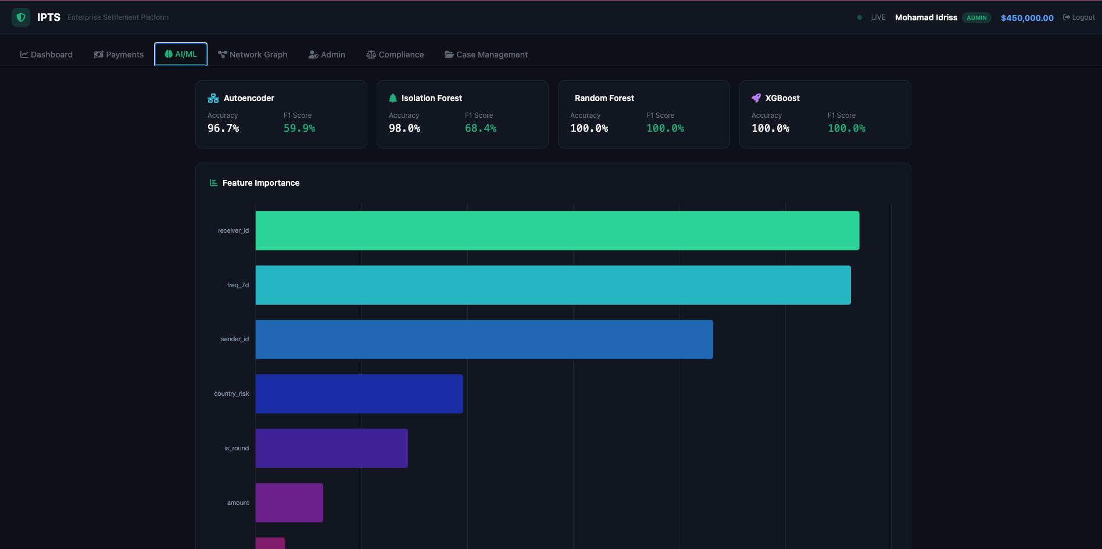
Figure 9: Payments — Settlement Execution with Risk Breakdown

4.4 AI/ML Tab
- Model performance cards for all 4 models displaying F1 score and accuracy metrics
- Feature importance chart showing relative contribution of each feature
- Ensemble weight configuration display (Rules 30%, ML 40%, NLP 15%, Graph 15%)
- Model Retraining button visible only to Admin and Data Scientist roles
- Retraining triggers background thread that regenerates synthetic data and retrains all 4 models

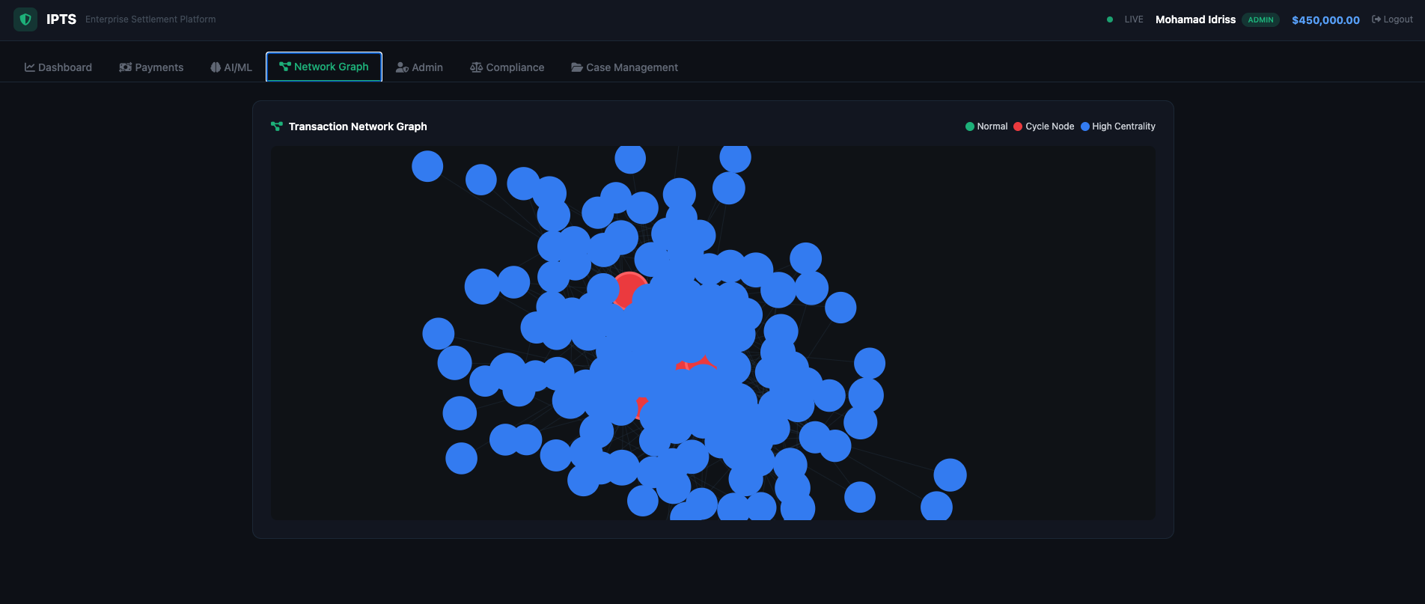
Figure 10: AI/ML — Model Performance Cards and Feature Importance

4.5 Network Graph Tab
- Interactive D3.js force-directed graph visualization of the transaction network
- Node size proportional to PageRank centrality (larger = more influential)
- Color-coded communities detected via label propagation algorithm
- Edge thickness proportional to transaction weight between entities
- Cycle highlighting to identify potential money laundering rings

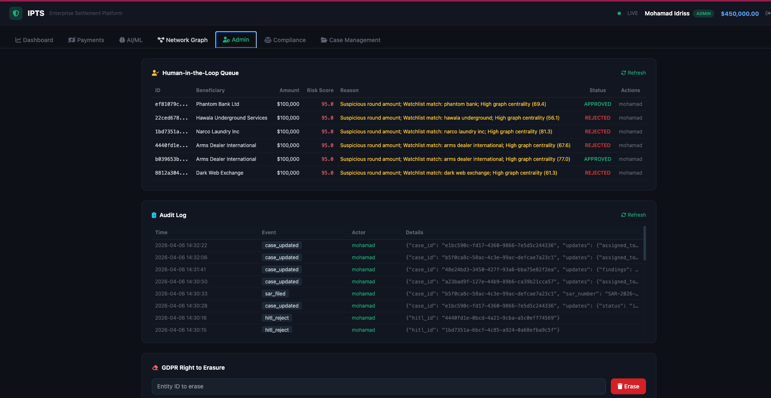
Figure 11: Network Graph — D3.js Force-Directed Transaction Network

4.6 Admin Tab
- HITL Queue: Review blocked transactions with full risk details, approve or reject with audit logging
- Audit Log: Complete trail of all system actions including logins, settlements, approvals, and GDPR erasures
- GDPR Erasure: Compliance tool to anonymize/delete PII data on request

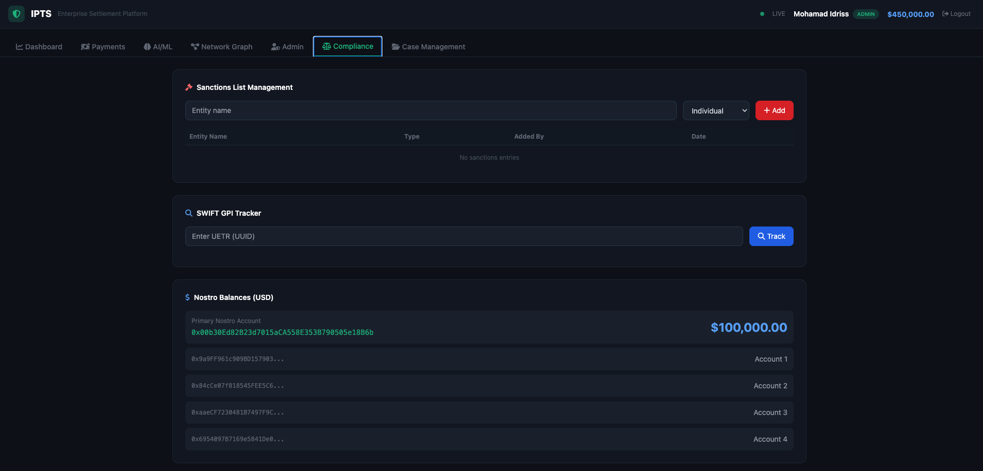
Figure 12: Admin — HITL Queue, Audit Log, and GDPR Erasure

4.7 Compliance Tab
- Sanctions Management: Add and remove entities from the sanctions screening database
- SWIFT GPI Tracking: Search and track payments by UETR (Unique End-to-End Transaction Reference)
- Nostro Position: View current liquidity positions in USD

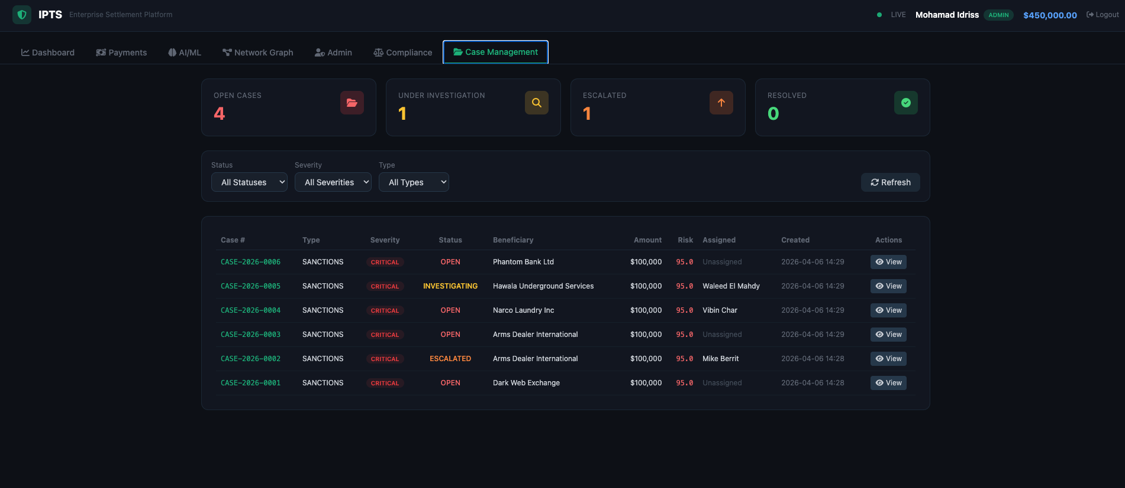
Figure 13: Compliance — Sanctions, SWIFT GPI, and Nostro Balances

4.8 Case Management Tab
The dedicated case management interface provides full compliance case lifecycle tracking:
- Summary Cards: Open cases, Under Investigation, Escalated, and Resolved (current month) counts
- Filterable Case Table: Filter by status (open/investigating/escalated/resolved/closed), severity (critical/high/medium/low), and case type
- Case Types: AML, Sanctions, Fraud, Structuring, PEP, Terrorist Financing
- Severity Levels: Critical (red), High (orange), Medium (yellow), Low (green)
- Case Actions: Investigate, Escalate, Resolve, Assign, Add Findings, File SAR
- Auto-Creation: Compliance cases are automatically created when transactions are blocked, with case numbers in CASE-2026-XXXX format

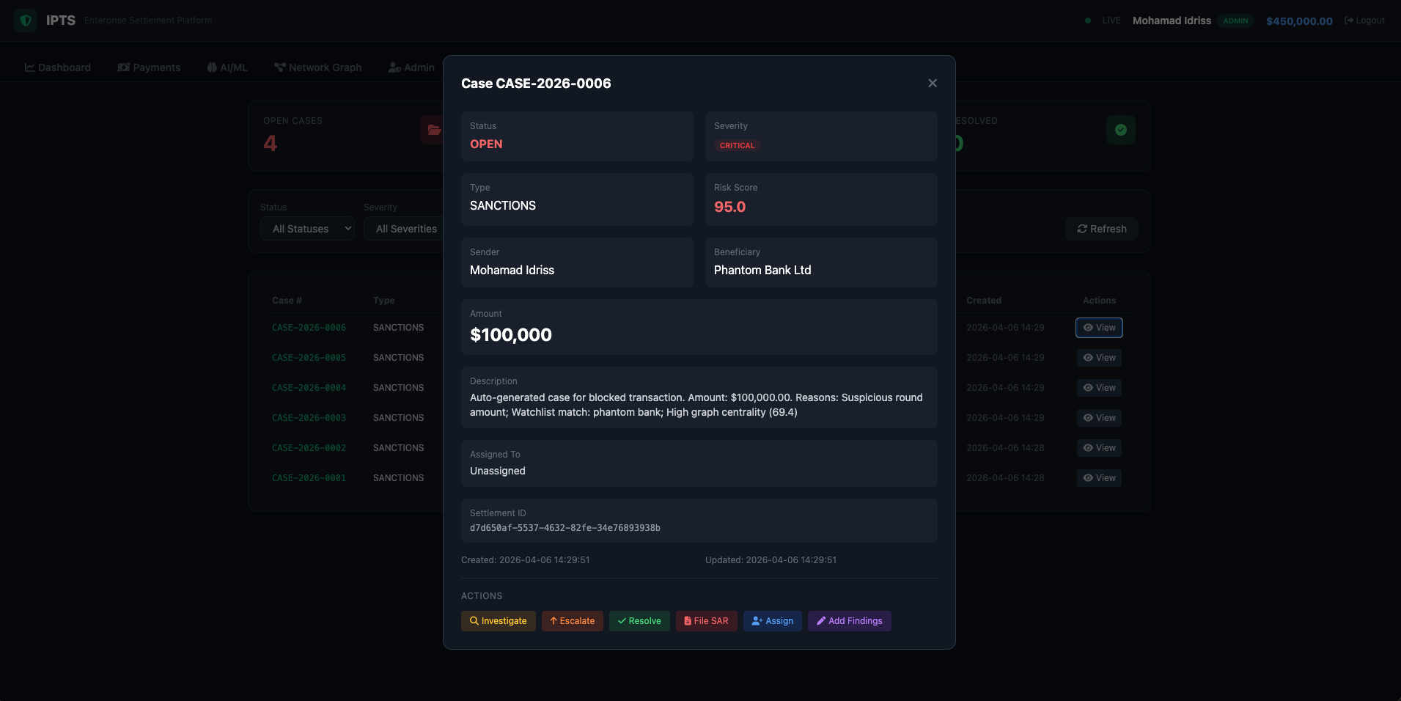
Figure 14: Case Management — Overview with Summary Cards and Case Table

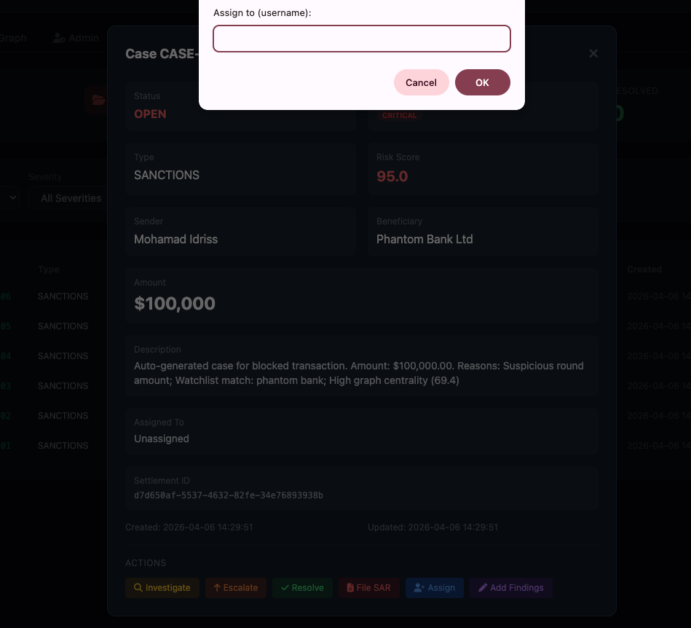
Figure 15: Case Detail — Full Case View with Action Buttons

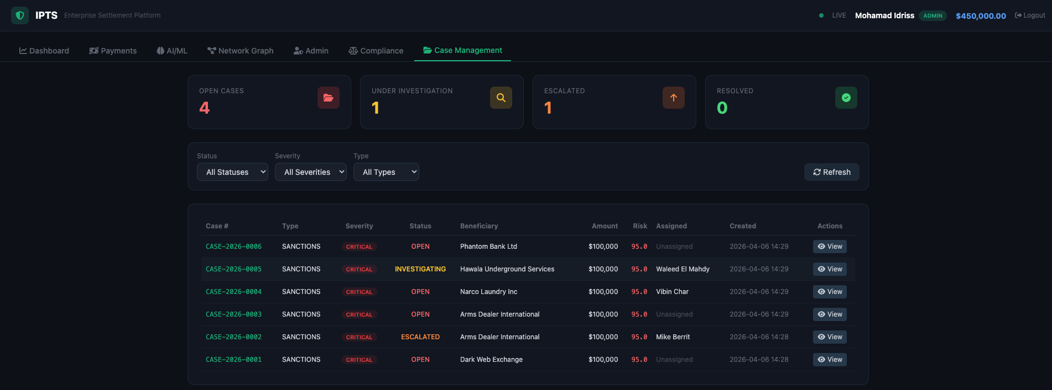
Figure 16: Case Management — Compliance Officer Assignment

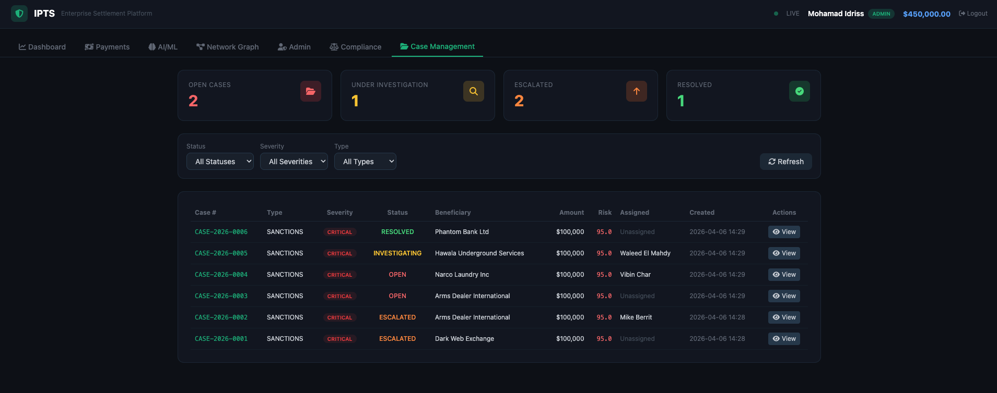
Figure 17: Case Management — Cases Under Investigation


Figure 18: Case Management — Full Lifecycle (Open, Investigating, Escalated, Resolved)

5. User Accounts & Role-Based Access Control
IPTS implements a comprehensive RBAC system with 5 user accounts, each mapped to a specific role with distinct permissions and starting balances.

5.1 User Accounts
Username | Password | Full Name | Role | Balance (USD)
mohamad | Mohamad@2026! | Mohamad Idriss | Admin | $1,000,000
rohit | Rohit@2026! | Rohit Jacob Isaac | Operator | $750,000
sriram | Sriram@2026! | Sriram Acharya Mudumbai | Auditor | $500,000
walid | Walid@2026! | Walid Elmahdy | Compliance | $350,000
vibin | Vibin@2026! | Vibin Chandrabose | Data Scientist | $150,000

5.2 Permission Matrix
Feature | Admin | Operator | Auditor | Compliance | Data Sci.
Dashboard | Y | Y | Y | Y | Y
Execute Payments | Y | Y | - | - | -
View Transactions | Y | Y | Y | Y | Y
HITL Approve/Reject | Y | - | - | Y | -
Case Management | Y | - | Y | Y | -
Retrain Models | Y | - | - | - | Y
GDPR Erasure | Y | - | - | Y | -
Sanctions Mgmt. | Y | - | - | Y | -
Audit Logs | Y | - | Y | Y | -

6. API Reference
All API endpoints (except /api/login) require JWT authentication via the Authorization: Bearer <token> header. The API follows RESTful conventions with JSON request/response bodies.

6.1 Authentication
Method | Endpoint | Description
POST | /api/login | Authenticate user and receive JWT token

6.2 Account Management
Method | Endpoint | Description
GET | /api/accounts/me | Current user account info and balance
GET | /api/accounts/beneficiaries | List available beneficiaries for payment

6.3 Settlements
Method | Endpoint | Description
POST | /api/settlement | Execute a new cross-border settlement
GET | /api/transactions | List transactions (paginated: ?page=1&per_page=20)
GET | /api/dashboard | Real-time dashboard metrics and KPIs

6.4 HITL Review
Method | Endpoint | Description
GET | /api/hitl/queue | List all HITL review items
POST | /api/hitl/approve/<id> | Approve a blocked transaction
POST | /api/hitl/reject/<id> | Reject a blocked transaction

6.5 Compliance & Case Management
Method | Endpoint | Description
GET | /api/compliance/cases | List compliance cases (filterable by status, severity, type)
GET | /api/compliance/cases/<id> | Get detailed case information
POST | /api/compliance/cases | Create new compliance case manually
PUT | /api/compliance/cases/<id> | Update case (status, findings, assignment)
POST | /api/compliance/cases/<id>/escalate | Escalate case to senior compliance
POST | /api/compliance/cases/<id>/file-sar | File Suspicious Activity Report
GET | /api/compliance/sanctions | List sanctions database entries
POST | /api/compliance/sanctions | Add entity to sanctions list
GET | /api/compliance/swift-gpi/<uetr> | Track SWIFT payment by UETR

6.6 AI/ML & System
Method | Endpoint | Description
GET | /api/models/metrics | ML model performance metrics and feature importance
POST | /api/models/retrain | Trigger model retraining (admin/datascientist only)
GET | /api/network/graph | Transaction network graph data for D3.js visualization
GET | /api/audit/log | Audit trail entries (limited to last N events)
POST | /api/gdpr/erasure | GDPR right to erasure (admin/compliance only)
GET | /api/stream | Server-Sent Events (SSE) real-time event stream

7. Deployment Guide

7.1 Google Colab Deployment
IPTS is designed for one-click deployment on Google Colab. Follow these steps:

Step 1: Open Google Colab at colab.research.google.com and create a new notebook.
Step 2: Upload both project files (ipts_colab_deploy.py and ipts_frontend.html) using the file upload cell.
Step 3: Install Node.js 18+ by running the NodeSource setup script.
Step 4: Execute the main deployment script: python ipts_colab_deploy.py
Step 5: Access the system via the Localtunnel URL printed in the output.

7.2 Deployment Phases
The deployment script executes 8 sequential phases:
Phase | Description | Duration | Details
Phase 0 | Environment Cleanup | ~1s | Kill stale processes on ports 8545/5000
Phase 1 | Dependency Installation | ~30-60s | Install Python packages, Node.js packages (ganache, localtunnel)
Phase 2 | Directory Structure | ~1s | Create /content/ipts/ with subdirectories
Phase 3 | ML Model Training | ~10-20s | Generate 15K synthetic transactions, train 4 models, graph analysis
Phase 4 | Contract Compilation | ~10-15s | Compile 5 Solidity contracts using py-solc-x (solc 0.8.21)
Phase 5 | Frontend Deployment | ~1s | Copy ipts_frontend.html to templates/ directory
Phase 6 | Backend Generation | ~1s | Write the Flask app.py (1,200+ lines) with all API endpoints
Phase 7 | Service Launch | ~15-20s | Start Ganache, deploy contracts, start Flask, open Localtunnel

Total boot time: approximately 90-120 seconds from execution to a live, publicly accessible system.

7.3 Troubleshooting
Issue | Solution
Ganache not reachable | Re-run the deployment script. Ganache may need more time to initialize on Colab.
Localtunnel URL not showing | Run npx localtunnel --port 5000 in a separate Colab cell.
Colab disconnects after 30 min | Keep the browser tab active. Consider upgrading to Colab Pro for longer sessions.
Port already in use | Kill existing processes: kill -9 $(lsof -ti:8545) and kill -9 $(lsof -ti:5000)
Import errors | Manually install: pip install web3 py-solc-x flask pyjwt scikit-learn xgboost imbalanced-learn networkx
Graph analysis hangs | Update to the latest version of ipts_colab_deploy.py which uses optimized graph algorithms.

8. Testing Scenarios
The following test scenarios validate the core functionality of the IPTS platform. Each scenario is designed to test a specific AML rule, security boundary, or functional requirement.

# | Scenario | Input | Expected | Validates
1 | Normal Payment | $50,000 to Rohit Jacob Isaac | APPROVED | Basic settlement flow, balance deduction
2 | AML Threshold | $150,000 to any beneficiary | BLOCKED | $100K auto-block rule, case creation
3 | Watchlist Match | Any amount to Dark Web Exchange | BLOCKED | NLP watchlist screening, score 95+
4 | Structuring | $9,500 repeated with high freq | BLOCKED | Smurfing detection pattern
5 | Insufficient Funds | Amount exceeding balance | ERROR | Balance validation, error handling
6 | Sanctions Hit | Any amount to Tehran Petroleum | BLOCKED | Sanctions DB matching, case creation
7 | Low Risk Transfer | $5,000 to a known individual | APPROVED | Clean transaction processing
8 | HITL Approve | Approve a blocked transaction | SETTLED | HITL workflow, status update
9 | Model Retrain | Trigger via admin account | SUCCESS | ML pipeline, role permissions
10 | GDPR Erasure | Erase entity PII data | REDACTED | GDPR compliance, data anonymization

9. Future Roadmap
The following enhancements are planned for future versions of the IPTS platform:

9.1 Production Hardening
- Replace SQLite with PostgreSQL for production-grade concurrent access
- Add Redis for session caching, rate limiting, and pub/sub messaging
- Containerize with Docker and Docker Compose for consistent deployment
- Implement Kubernetes orchestration for horizontal scaling
- Add comprehensive unit, integration, and end-to-end test suites

9.2 Blockchain Enhancement
- Deploy to Ethereum mainnet or Layer 2 solutions (Polygon, Arbitrum, Optimism)
- Implement ERC-20 token support for stablecoin settlements (USDC, USDT)
- Add cross-chain bridge functionality for multi-blockchain settlement
- Integrate with Chainlink oracles for real-time FX rates

9.3 AI/ML Evolution
- Implement federated learning for privacy-preserving model training across institutions
- Add graph neural networks (GNN) for more sophisticated network analysis
- Integrate real transaction data feeds for continuous model improvement
- Implement explainable AI (XAI) for regulatory-compliant model decisions
- Add real-time model monitoring and drift detection

9.4 Compliance & Integration
- Full SWIFT ISO 20022 message parsing and generation
- KYC integration with providers like Onfido and Jumio
- Automated regulatory reporting (FinCEN, FCA, MAS)
- Multi-tenancy support for multiple financial institutions
- Integration with SWIFT gpi real-time tracking network

10. Conclusion
The Integrated Payment Transformation System (IPTS) demonstrates that the convergence of blockchain technology, artificial intelligence, and Zero Trust security can fundamentally transform cross-border financial settlement. By reducing settlement times from 5 days to under 10 seconds while simultaneously strengthening compliance and security, IPTS represents a viable blueprint for next-generation financial infrastructure.

The 7-layer convergent architecture ensures clean separation of concerns while enabling seamless end-to-end transaction processing. The AI/ML risk engine, with its 4-model ensemble and force-override mechanism, provides robust fraud detection that can be tuned to meet varying regulatory requirements across jurisdictions.

The platform's deployment model, a single script that boots the entire enterprise stack in under 2 minutes, demonstrates that complex financial systems can be made accessible for rapid prototyping, testing, and demonstration purposes without sacrificing architectural integrity.

As the financial industry continues its digital transformation journey, platforms like IPTS will play an increasingly critical role in bridging the gap between legacy settlement infrastructure and the real-time, transparent, and secure financial systems that the global economy demands.

End of Report

