**Report on Regression**

Mohammed Jasam

**Summary:**

In this assignment we were given multiple images of a ring shaped structured each rotated at a specific angle in the incremental order. My task was to train different regression models using the training data and infer the angle of rotation of the testing images.

The different models I had to implement were:

1. Linear Regression.
2. Perform Feature Selection.
3. Bayesian Regression using a Regularized term using the selected features.
4. Non-Linear Regression on the selected features.
5. Dual Non-Linear Regression without the feature selection.

For each of the above task I had to infer the results and find out the sum of the difference between the inferred angle and the ground truth angle of the testing images.

**Algorithmic Approach:**

Extract the features/pixels into the matrix along with w from training and GT from testing data which will later be used in evaluation.

***Task 1: Linear Regression***

In this method, we calculate the *phi* value by calculating the inverse of the train data and multiplying it with the w (the angle of rotation). This *phi* is used to infer the rotation on the testing data. Once, the inference on each image is generated the mean of the absolute difference between the inference and the ground truth is performed and the error is determined.

***Result:***

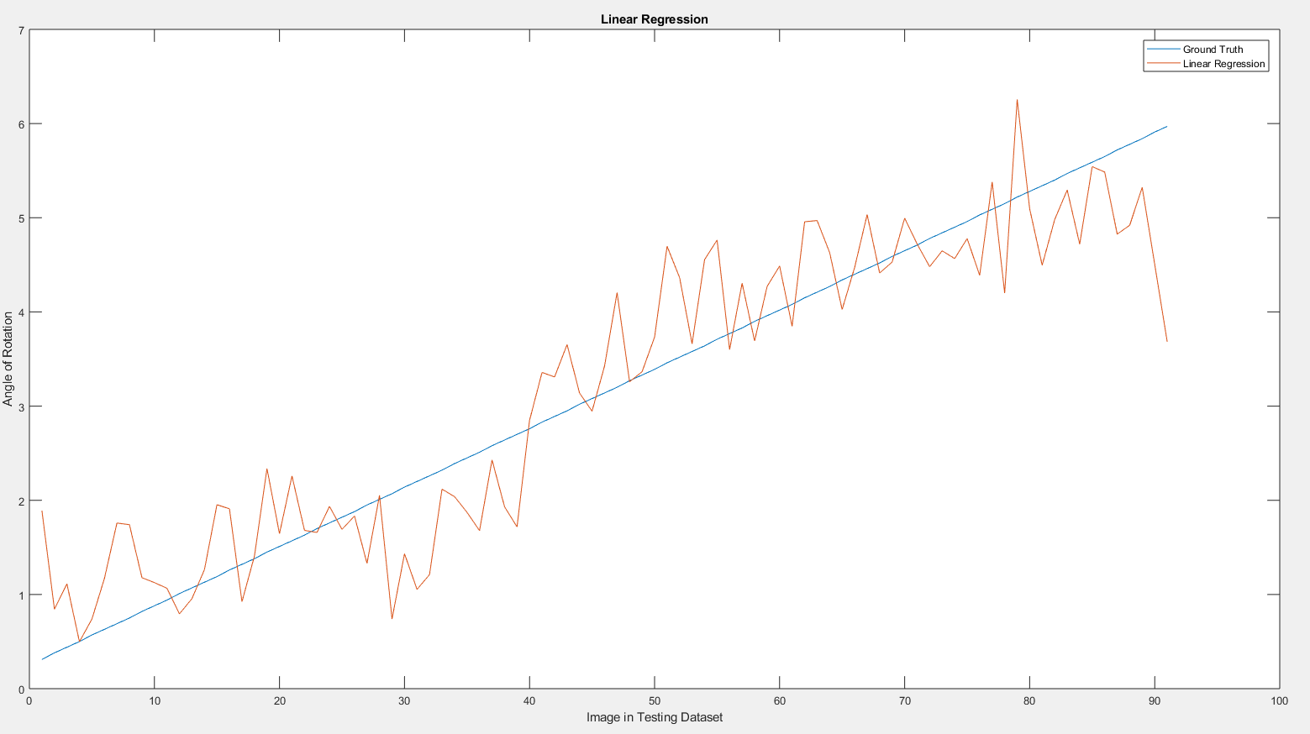

Figure 1: Linear Regression Inference

***Observation:***This model was the simplest among all, the inference was pretty straight forward. I have observed that the model does a mediocre prediction of angle on testing data.

***Task 2: Feature Selection***

This task was pretty straightforward as well. I had to reduce the number of features as when we observe the images, most of the portion in the image remains constant and only a part of the image (The ring/ donut) changes its pixel values. Therefore, to improve execution time, I selected the features which had a variance more than a specified threshold value.

***Observation:***

This process has improved the execution time significantly but the trade-off is the accuracy in the model prediction/inference on the angle of rotation on the testing data.

***Task 3: Bayesian Linear Regression using the selected features and regularized term***

This model was implemented on the matrix with selected features. Here, I calculated the mean and variance of the train data and then found out the optimal(least) variance value which will improve the accuracy of the inference. This was utilized in calculating the A matrix, then its inverse is calculated which is used to find out the inference on the testing images. The evaluation technique is the same, I had to calculate the mean of the absolute difference between the inference angle and the ground truth angle on the testing dataset.

***Results:***

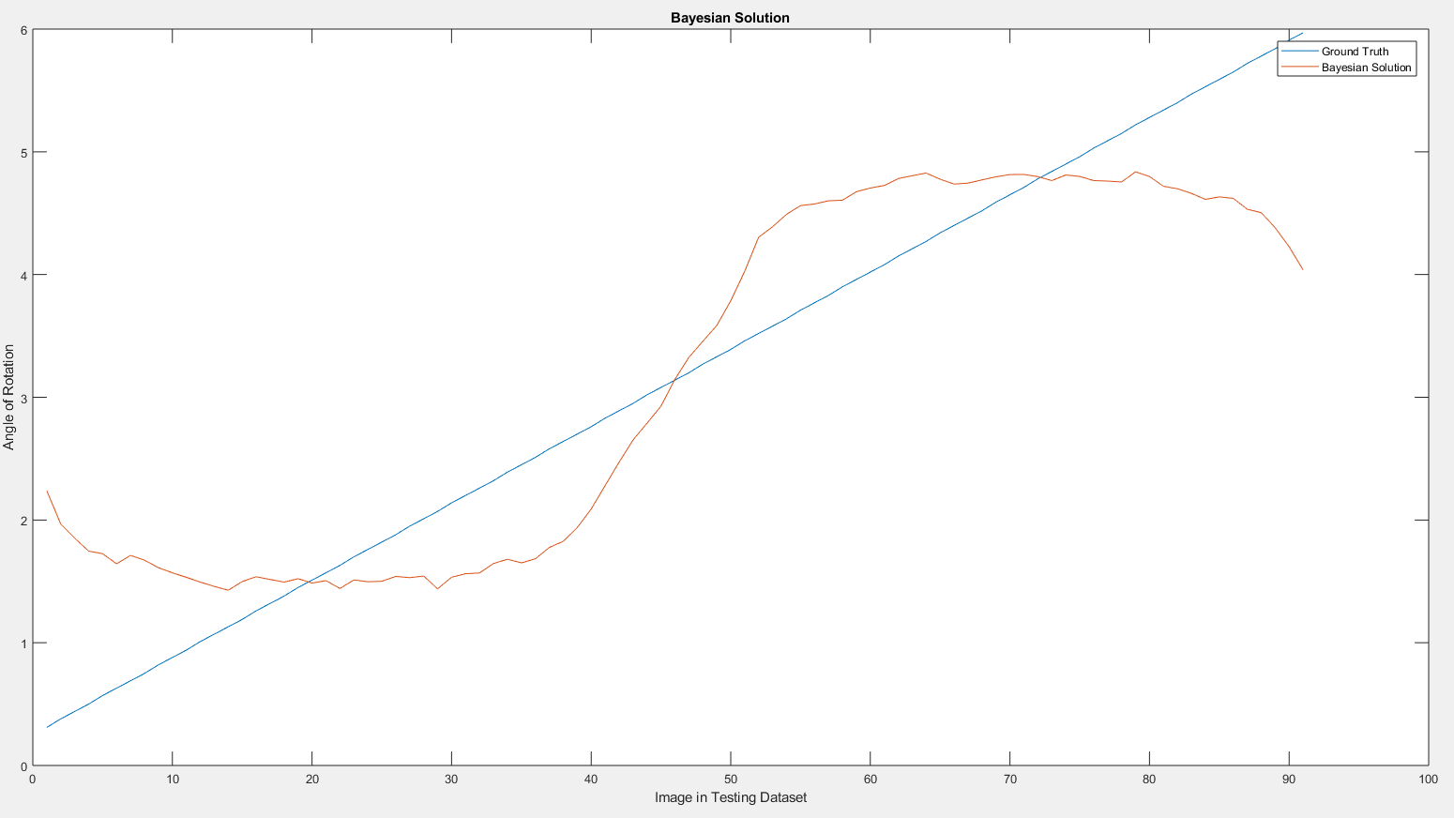

Figure 2: Bayesian Solution using selected features

***Observation:***

This model has huge errors in predictions, especially for the starting and ending images in the testing dataset. The evaluation error came out to be worse than the Linear Regression model.

***Task 4: Non-Linear Regression using Feature Selection***

A non-linear analysis is performed in this method to produce better results. The method involves the creation of *Z* matrix which is the stacking up of image in vertical order where each column is an image and the image is columnized and stack on each other where the first is the original image, the second is where the pixel values are multiplied by power 2 and so on. This value is mentioned earlier. Once those are done the *ZTrain* and *ZTest* matrices are generated which are used to obtain the *phi* which in-turn is used to obtain the inference on the testing data.

***Results:***

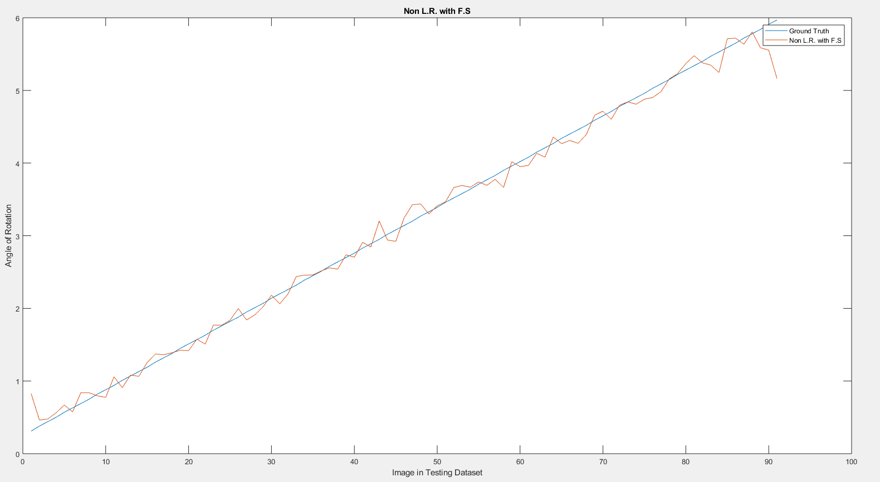

Figure 3: Non- Linear Regression using Feature Selection

***Observation:***

This model has the least error 0.09 compared to all other models in this project. The model predicts the values accurately with very small deviation from the ground truth.

***Task 5: Dual Non-Linear Regression without the feature selection process***

In this model we again utilize all the features offered by the datasets. To reduce the complexity X’ * X is performed to reduce the dataset to 90 x 90 rather than a huge matrix. Here, we first calculate *psi* using the *A*_*inverse* matrix which is later used to obtain *phi.* The evaluation metric is the same as the earlier methods. We first calculate the absolute difference between inferred angle and ground truth on each image in testing dataset. Next, we find out the mean of all to get the error in the inference made by the model.

***Experimentation:***

I have tried to implement the model using Quadratic Kernel which gave me a better result than the earlier method in Dual Non-Linear Regression.

***Results:***

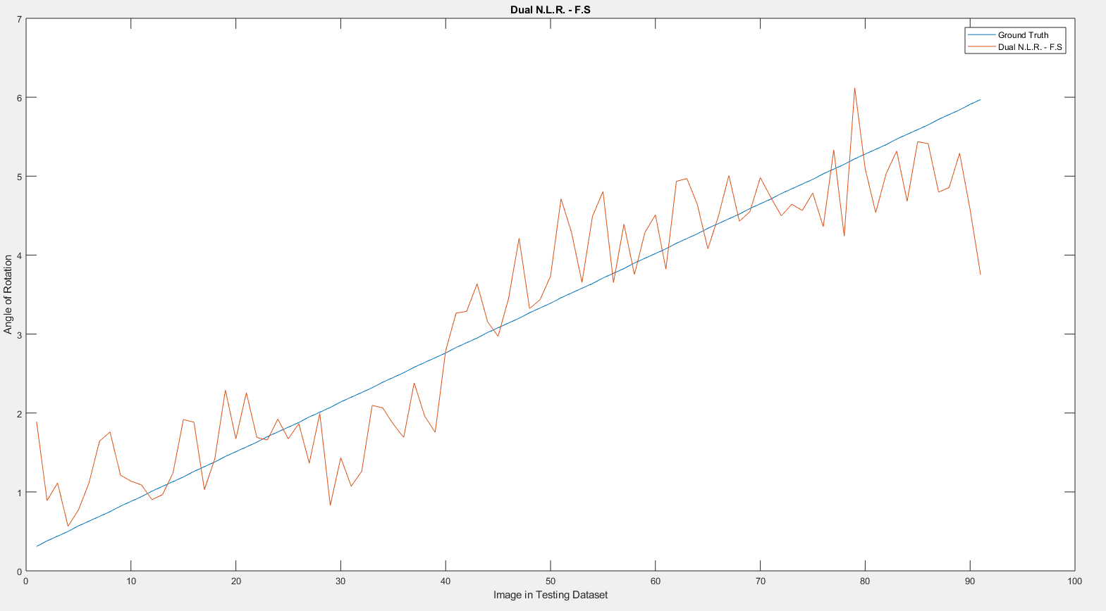

Figure 4: Dual Non- Linear Regression without feature selection

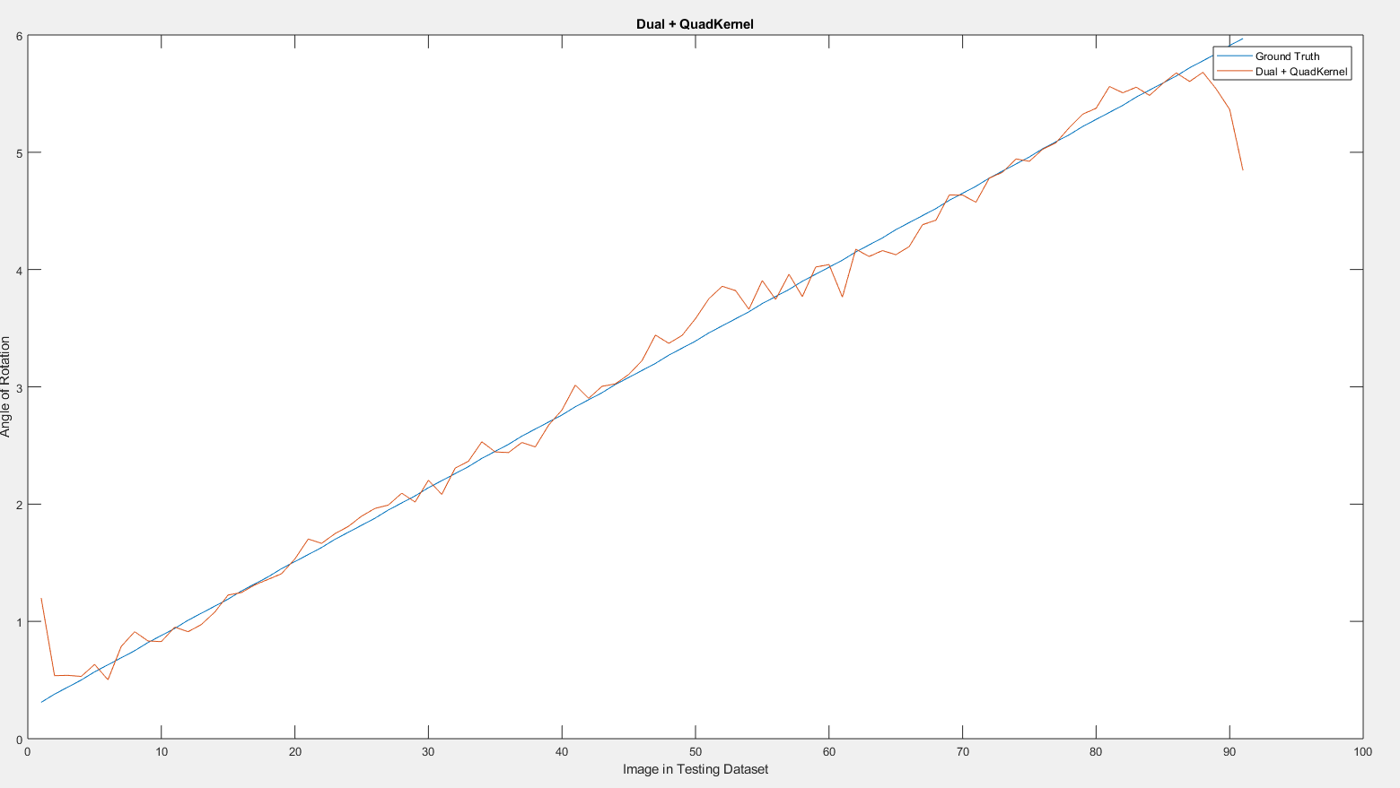

Figure 5: Dual N.L.R. using Quadratic Kernel

***Observation:***

The first method in this model is implemented by calculating psi and phi, it gives rather skewed results, the kernel method gives better accuracy and less prediction error. The kernel method is the second best in the list standing behind the Non-Linear Regression

***Final Results:***

