# **ASSIGNMENT 7: REGRESSION**

## **Pooja Kancherla**

## [**pknq6@mst.edu**](mailto:pknq6@mst.edu)

1. **Brief Summary of the Project:**

In this project, we have to use Regression analysis to infer the rotation of a given ring image. There are different regression models that we have to train on a dataset of images and then use these models to infer knowledge from the test images. Regression analysis is statistical process of estimating relationships among variables. It also allows us to compare the effects of variables measured on different scales. We have to use the following regression models to learn the parameters from the training dataset and infer the rotation of test images:

* Linear Regression
* Feature Selection
* Bayesian Regularization
* Non-Linear Regression
* Dual Non-Linear Regression

1. **Outline of the algorithmic approach:**

The set of images is split in to two parts comprising of training and testing sets. Training is used to learn a model and subsequently test the model’s performance on test images.

**Task 1:** The first method implemented is Linear Regression in which a simple linear model is involved in the calculation of ‘phi’ and this ‘phi’ is used to infer the rotation of ring in test images. Later, the mean absolute difference between inference and ground truth is calculated. The deviation is produced on a chart.

**Task 2:** In the next model, I performed feature selection on the training data set. I then calculated the variance of pixels of each image in order to find the pixels which does not provide much new or useful information. For this, I selected a cut-off level and eliminated all the pixels whose variance is lower than this level. Thereby, I generated a new dataset and also used this feature selection in the next model.

**Task 3:** Using the new dataset generated by feature selection and by also adding the regularization term ‘lambda’, I found the Bayesian solution. Lambda is, in principle, ratio of variance of w distribution and prior covariance. In order to perform inference on the testing data I had to calculate the inverse of A. After obtaining the inference I calculated the mean abs diff between inference and ground truth and produced results and charts

**Task 4:** We know that the distribution can’t always be linear, so we used non linear regression approach to accurately infer the angle of rotation on the testing data. Here, I had to perform a Z transformation of the training data. Here I used lambda value during the calculation of phi which will later be used to infer the results.

**Task 5:** The last part of the project is touse the dual regression model. In this task we had to again utilize all the features of the training and testing images. To reduce complexity rather than multiplying X * X’ which would potentially lead to 10000 features, I performed X’ * X leading to 90 * 90 matrix. After that inverse operation was performed and psi and phi were calculated which will later be utilized for inference.

**RESULTS:**

1. **Linear Regression:**

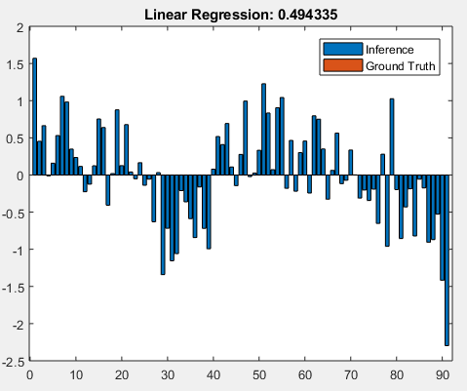

Fig 1: Deviation chart between inference and ground truth

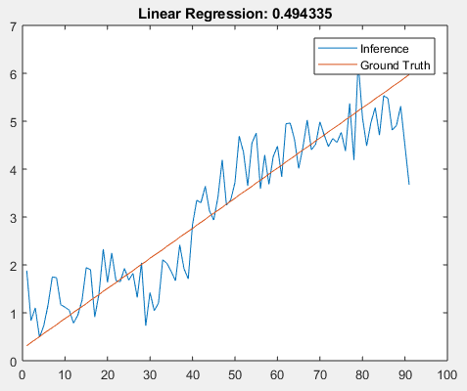

Fig 2: Inference vs Ground Truth

**Observations:**

This is a very basic model, we can see that when the whole set of features are supplied it performs normally showing max deviation during the starting and ending images in the dataset.

1. **Feature Selection**

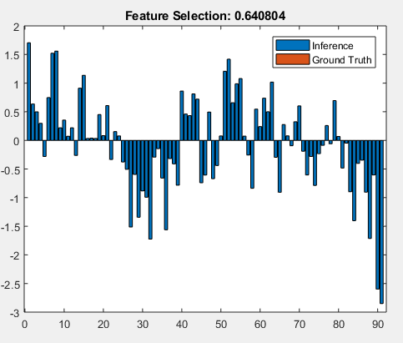

Fig 3: Deviation Chart

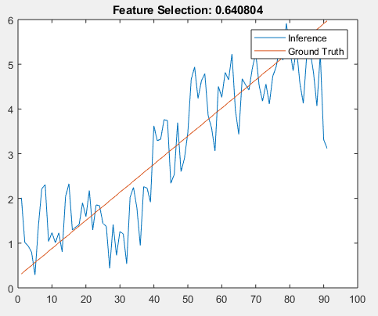

Fig 4: Inference vs Ground Truth

**Observations:**

Linear Regression was performed using selected features. There is a higher deviation than the previous model, mainly due to the reduction in the number of features but that in fact is necessary to improve the runtime of the algorithm. It has a higher Mean absolute error than the previous model.

1. **Bayesian Regularization:**

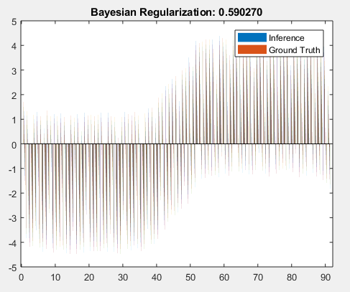

Fig 5: Deviation Chart

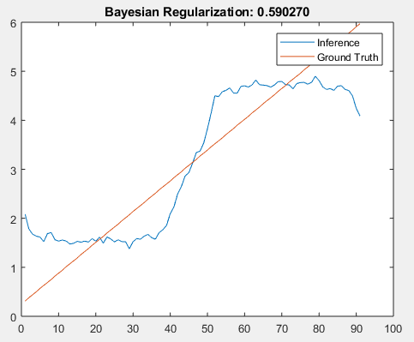

Fig 6: Inference vs Ground Truth

**Observations:**

Using the Bayesian regression I have observed that the deviation is huge, approximately at the highest it was 1400 % than the ground truth of that particular image. The model tries to fit across the dataset, but with error, the mean abs error is less than that of the previous model but higher than the original all feature linear regression.

1. **Non-Linear Regression:**

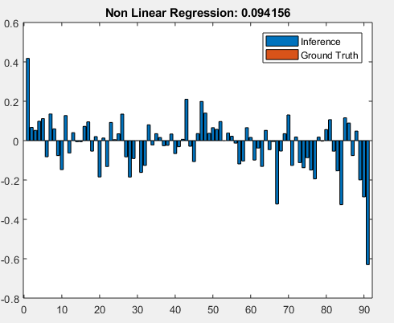

Fig 7: Deviation Chart

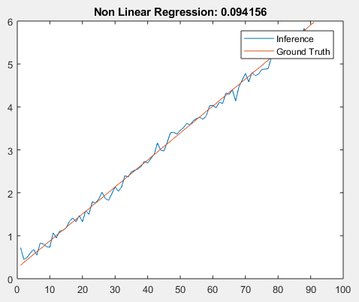

Fig 8: Inference vs Ground Truth

**Observations:**

This model had the best inference values. The mean abs error was the least among other models. Here I used pow = 2, which created a z matrix with X and X.^2. I have tried out with other higher powers but the time complexity increases due to the increase in the z matrix.

1. **Dual Non-Linear Regression:**

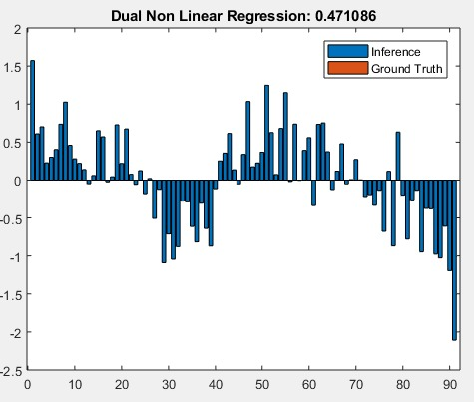

Fig 9: Deviation chart

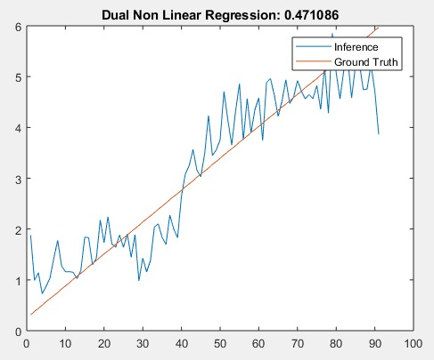

Fig 10: Inference vs. Ground Truth

**Observations:**

This model was again performed on the whole set of features so the time complexity inceased when compared to the previous models. The mean abs error is relatively low compared to the bayesian regularization model. I have observed that the values have a higher deviation near the start and end of the datasets.

**Combined Results:**

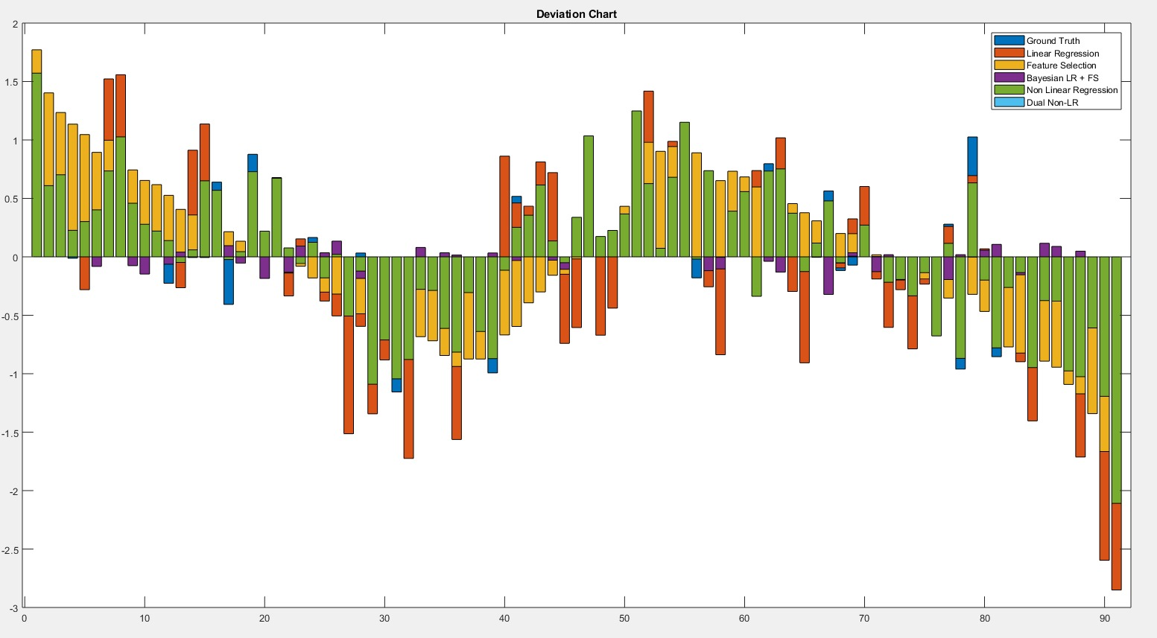

Fig 11: Deviation chart comparison

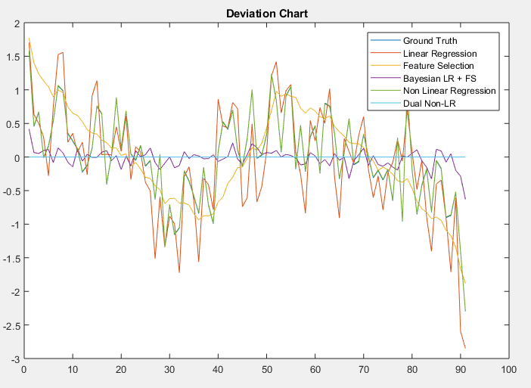

Fig 11: Deviation chart comparison

**Manipulations:**

During the calculation of phi, I was facing problems of running into NaN values. So, I added a small value 0.001 to the diagonal of the X * X’ matrix in order to perform the inverse. This operation was cost and time consuming, which is the main reason why the execution of Linear_Regression.m takes lots of time (Calculation of inv matrix takes that time.)

**Output:**

The following output shows the evaluation results of the performance for each of the variants of the regression models used in the project:

