REPORT for HW#5 By Bharath Ballamudi

1. The project is about using different techniques from the family of Linear Regression modelling to training models and using these models to infer knowledge from test images.
2. A dataset comprising of images of a varying degree of gradient is split into two sets: training and testing. Training is used to learn a model and subsequently test the model’s performance on test images. The first part of the assignment concerns training a simple linear model involving computation of phi and using this phi to infer the rotation of ring in test images. This model is further evaluated on its performance in inferring close to the ground truth.

This model is followed by performing feature selection on the input train data. Here, the variance is computed for pixels at particular locations across the training data. If the variance is lower than the threshold then there is no information served by these pixels and are virtually useless and redundant. Consequently, a new dataset is generated by dropping the entries corresponding to these pixel locations. This data set is used further in the following model considerations to avail better performance.

The above generated new train data is used in concert with regularization by introducing the parameter lambda. Lambda is, in principle, ratio of variance of w distribution and prior covariance. Different values are to be tried and the best possible value for lambda is to chosen for better performance. Lambda is added to the inverse component in the expression for computing phi.

The new data set is used with non-linear transformation linear regression. Here the input matrix is transported to higher dimension by incrementally raising the input columns to powers of predetermined collection of values. Here, in this assignment the value is chosen to be d=2.

The last part of the assignment deals with the dual linear regression. Here, the problem is formulated as if computing (X’*X) instead of computationally more expensive (X*X’). Otherwise, the end result should be same as that of regularized linear regression problem.

1. Below is the table holding the performance evaluation results obtained for each of the variants of the linear regression employed in the assignment.

|  |  |
| --- | --- |
| Model variant | Mean absolute error |
| Linear Regression (LR) | 0.494 |
| Regularized linear Regression (lambda=0.1) | 0.619 |
| Non-linear Regularized LR (d=2) | 0.094 |
| Dual regularized LR (Kernel = Quadratic) | 0.1143 |

The below graph captures the differences in the inferring powers for the four variants of Linear Regression considered. The graph agrees with the performance evaluation table presented before.

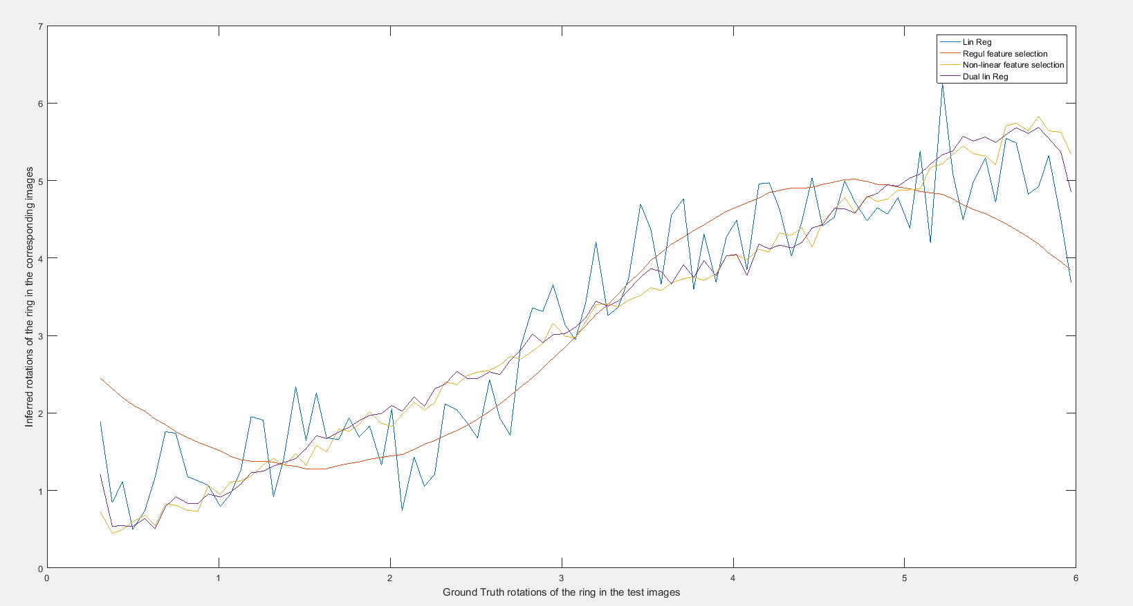

Even for different lambda values the distribution of the errors for the models found to be pretty much consistent with each other.