**Brief summary of what you think the project was about**

Regression is important tools for modelling and analyzing data. It is statistical process of estimating relationships among variables. Regression analysis also allows us to compare the effects of variables measured on different scales. There are various regression models.

1. Linear Regression model

The goal of linear regression is to predict the posterior distribution. It is the simplest form of regression. It is used to determine the extent to which there is a linear relationship between variables.

1. Bayesian Linear Regression model
2. Non Linear Regression model
3. Dual Linear Regression model

We used these different models for analyzing the variable relationship and estimated their evaluation values.

**Brief outline of the algorithmic approach**

1. For linear regression, I calculated the value of phi (ie. Mean value) of all the images by using the formula. Then infer testing images and also evaluation value is calculated here.
2. 2. For feature selection, Variance of o X images is calculated. There is 100*100 matrix which increases complexity. Hence after checking threshold limit (say 50) we eliminate the rows with less than threshold value and we get new reduced X matrix.
3. For Bayesian , we used A_inverse function to the mean value. We calculate variance of X as well as variance of mean (prior). By dividing both variance and multiplying by I (identity matrix) we get A_inv value. We can also use lambda value within the given range like 100,1000,0.1…. instead of division of variances.
4. For Non linear regression, we calculate the value of Z matix. The Z matrix consists of X^i values where I=1,2,…N. We then calculate mean and sigma values of Z.
5. For Dual regression, we calculate psi value and the multiply psi value to X to get mean value. We the calculate mean and sigma values. This is double linear regression.

**Pictures of intermediate or final results that convince us that the program does what you think it does.**

File:RegressionToInferTheOrientation_V1 (Linear Regression)

Value of evaluation: 0.4941

Output:

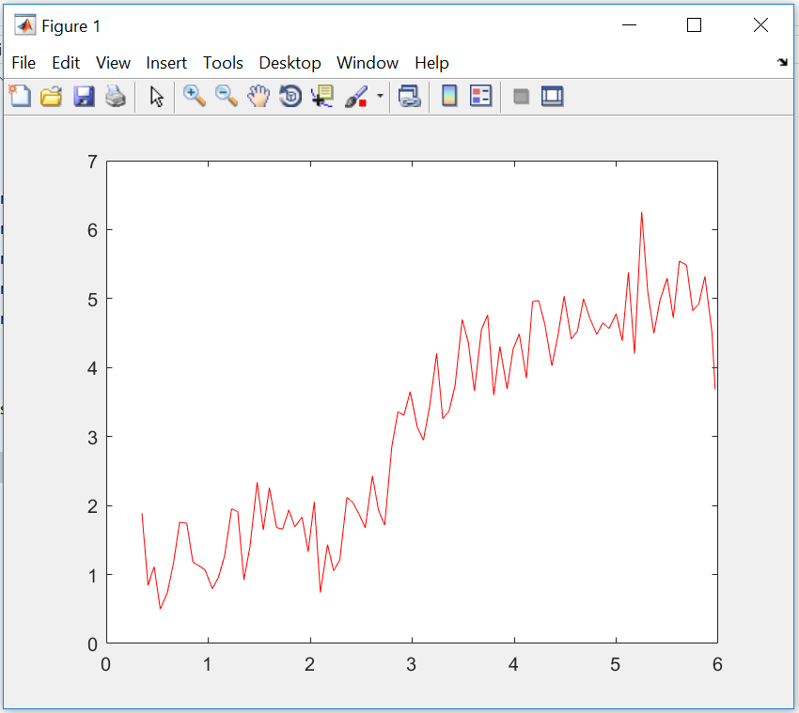

------------------------------------------------------------------------------------------------------------------------------------------

File:RegressionToInferTheOrientation_V2 (Feature Selection)

Value of evaluation: 2.8158

Output:

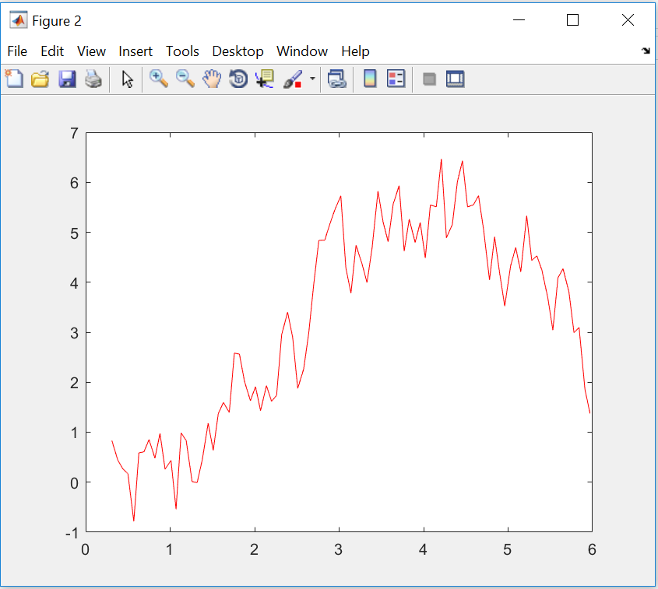

------------------------------------------------------------------------------------------------------------------------------------------

File:RegressionToInferTheOrientation_V3 (Bayesian Linear regression)

Value of evaluation: 8.6665

Output

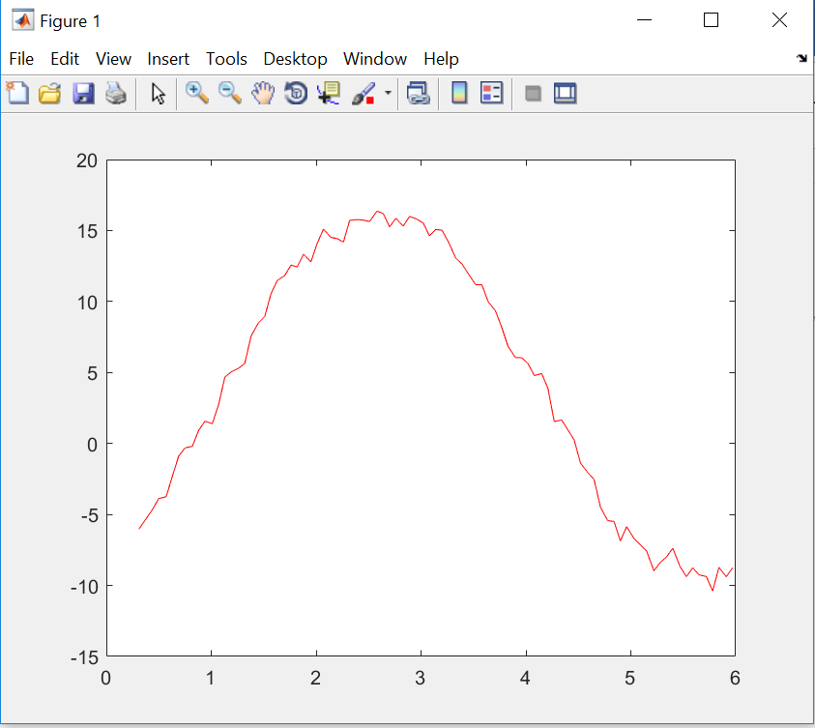

------------------------------------------------------------------------------------------------------------------------------------------

File:RegressionToInferTheOrientation_V4 (Non Linear Regression)

Value of evaluation 0.5598

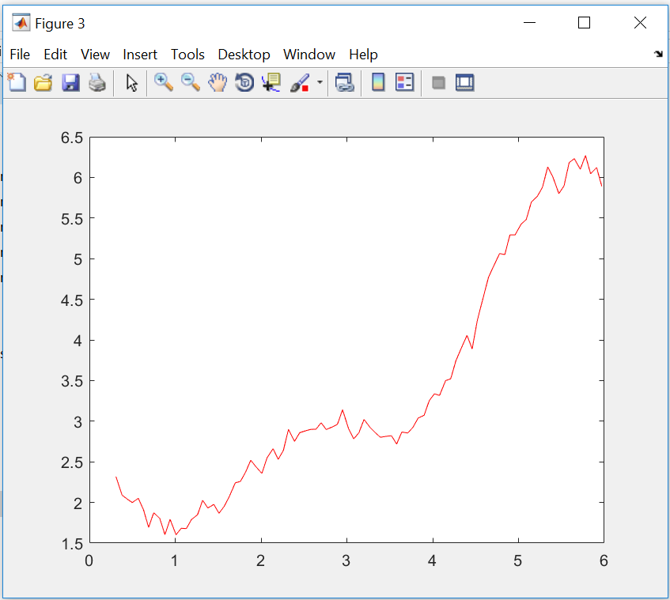

------------------------------------------------------------------------------------------------------------------------------------------

File:RegressionToInferTheOrientation_V5 (Dual Linear Regression)

Value of evaluation: 0.4944

Output



