**Report**

1. **Brief summary of what you think the project was about**

Regression is important tools for modelling and analyzing data. It is statistical process of estimating relationships among variables. Regression analysis also allows us to compare the effects of variables measured on different scales. There are various regression models.

1. Logistic Regression method

Logistic regression is a statistical method for analyzing a dataset in which there are one or more independent variables that determine an outcome. The outcome is measured with a dichotomous variable (in which there are only two possible outcomes).

1. Bayesian Logistic Regression method

Bayesian inference is the process of analyzing statistical models with the incorporation of prior knowledge about the model or model parameters

(3) Dual Logistic Regression method

(4) Dual Bayesian Logistic Regression method

(5) Kernel Logistic Regression method

(6) Relevance Vector Logistic Regression method

**b) Brief outline of the algorithmic approach,**

In logistic regression, I have changed the initialization values to zeros in fit_logr_cost.m.

In other regression model, in fit_blogr_cost.m file, for L value I have added epsilon to log so that we can avoid infinite values. Another way on doing it is changing the mvnpdf fuction. But I have used epsilon.

Approach that I have followed is:

1. Take training face and background images in X matrix.
2. W matrix contains 1s for total number of face images and 0s for total number of background images.
3. We take any value of initial phi/psi
4. We either take random value for prior variance or calculate variance of X and take sum of all the values as prior variance.
5. Similarly for lambda random values are taken.
6. Take testing face and background images in X_test matrix.
7. Call the fit functions
8. We then calculate inference. If prediction value is less than threshold (say 0.5) it is rounded to 0 else it is rounded to 1.
9. We calculate Miss detection for face images
10. False alarm is calculated for background images
11. And we plot results for Predictions, false alarm and miss detection
12. **Pictures of intermediate or final results that convince us that the program does what you think it does.**

All the output images are in Output folder as well as test results are in Result text document in same folder. I have included details in ReadMe file

1. Logistic Regression

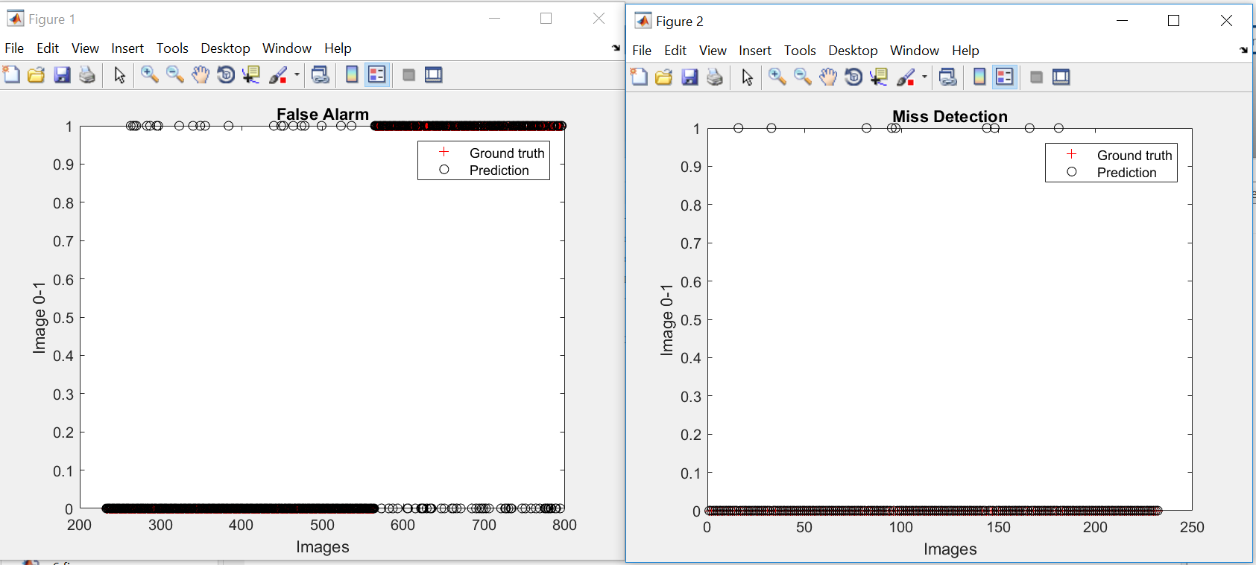

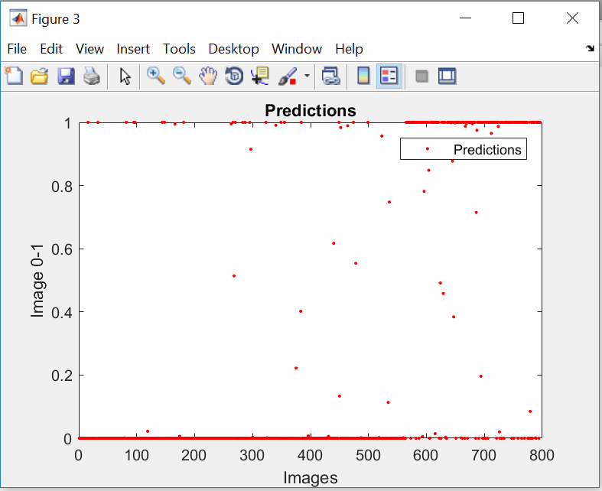

--------------------------------------------------------------------------------------------------------------------------

1. Bayesian Logistic Regression

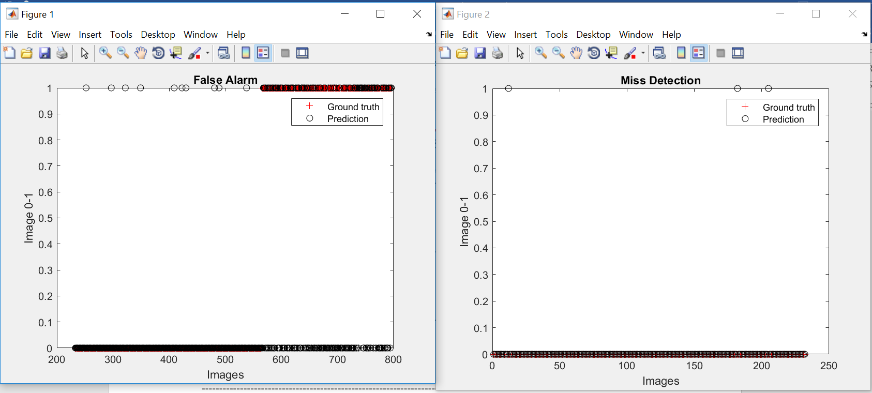 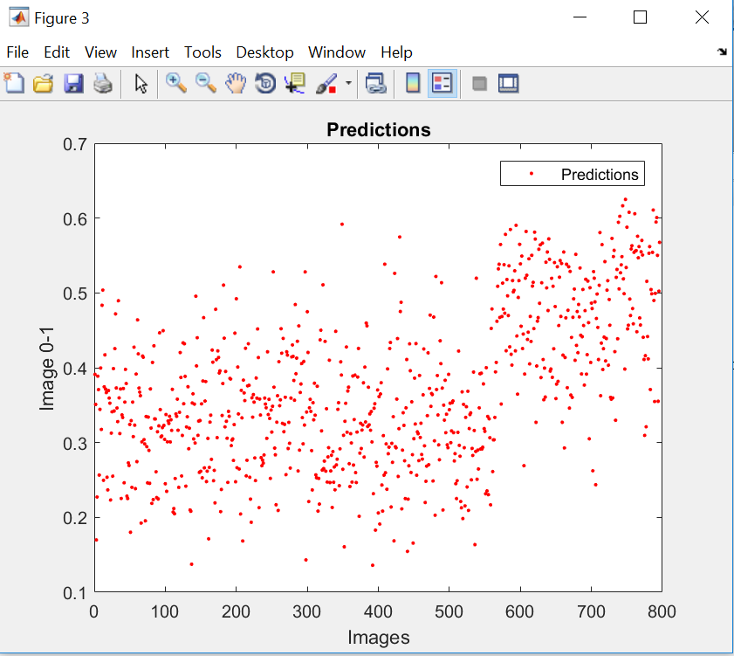

--------------------------------------------------------------------------------------------------------------------------

1. Dual Logistic Regression

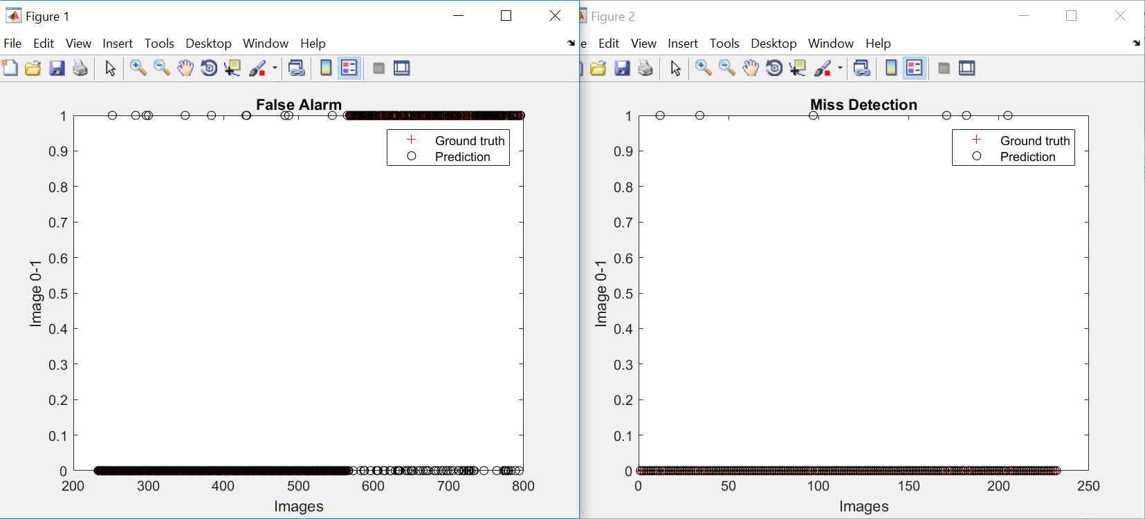

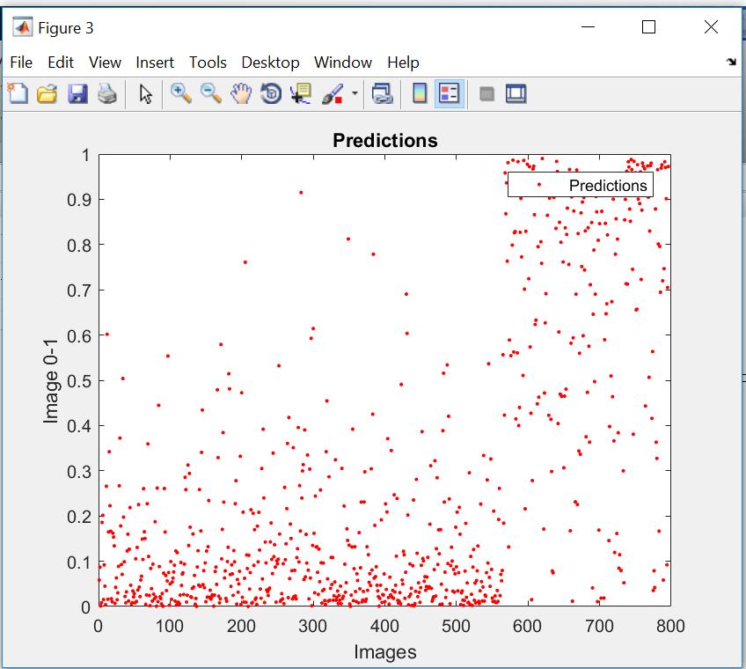

--------------------------------------------------------------------------------------------------------------------------

1. Dual Bayesian Logistic Regression

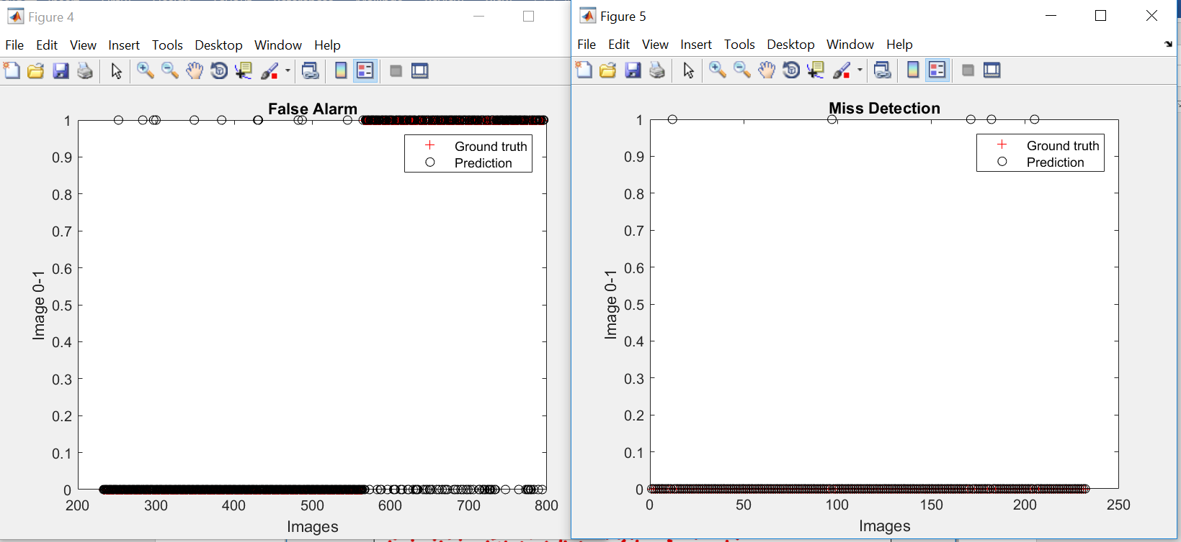

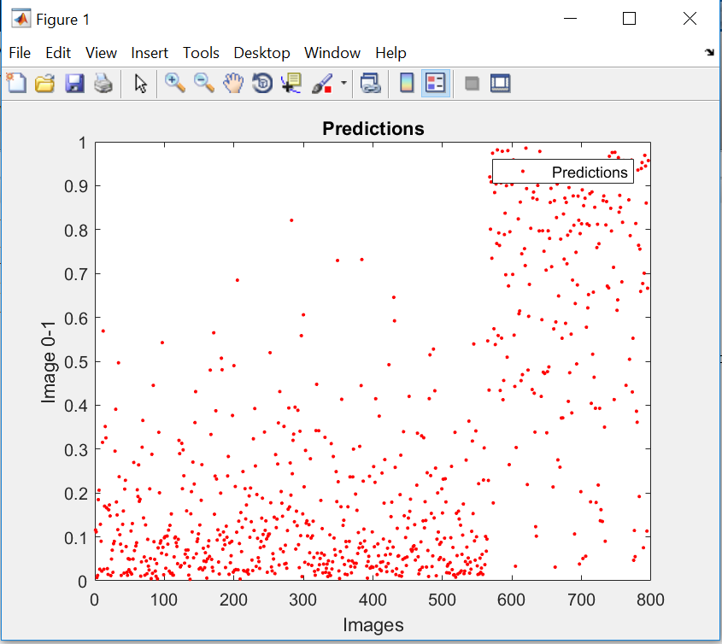

--------------------------------------------------------------------------------------------------------------------------

1. Kernel Logistic Regression

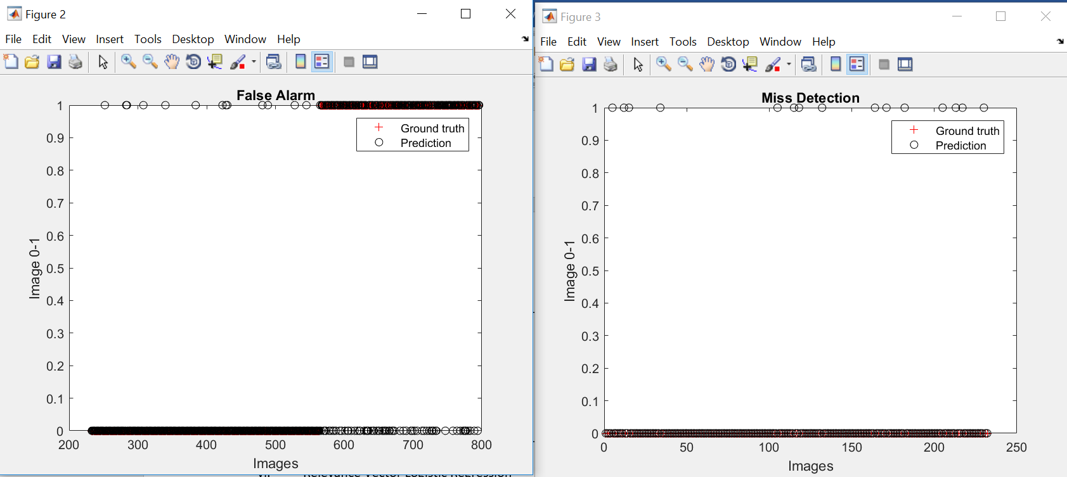

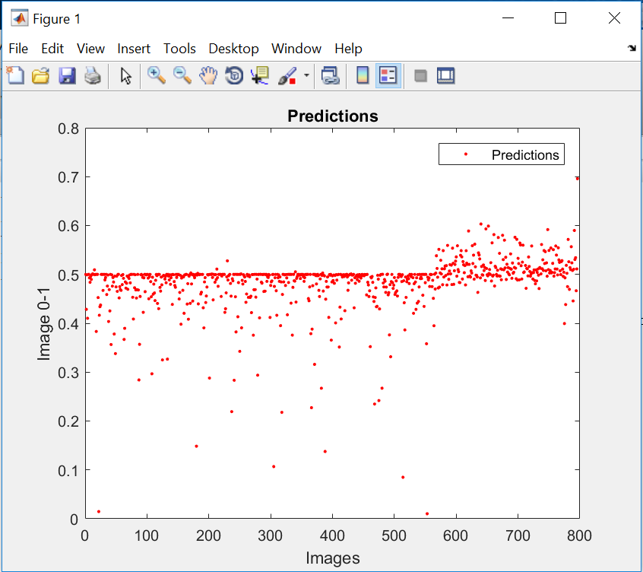

--------------------------------------------------------------------------------------------------------------------------

1. Relevance Vector Logistic Regression



