Hybrid Automated EDA Report
Generated on: 27 January 2026, 02:38 PM
Source: cancer_data_denmark.csv
Rows: 230484 Columns: 22
Missing values (top 30):
Customer_ID 0
Customer_Name 0
Disbursed_Amount 0
Loan_Repayment_Status 0
Interest_Rate 0
Account_Balance 0
Bank_Branch 0
Mobile_Number 0
Loan_Approval_Date 0
Loan_Term 0
EMI_Amount 0
Credit_Score 0
Loan_Status 0
Loan_Amount 0
Loan_Type 0
State 0
City 0
Annual_Income 0
Occupation 0
Gender 0
Age 0
Branch_Manager 0

2. Univariate Analysis — Numeric

Loan_Amount
count=230484 mean=1097855.98 median=741555.00 std=1079367.92 IQR=829648.75 min=50010 max=4999960
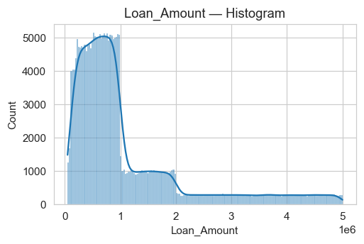
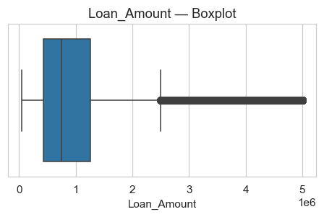

Disbursed_Amount
count=230484 mean=1097855.98 median=741555.00 std=1079367.92 IQR=829648.75 min=50010 max=4999960
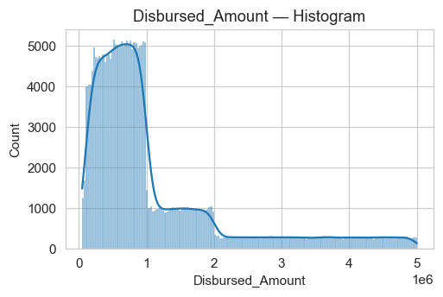
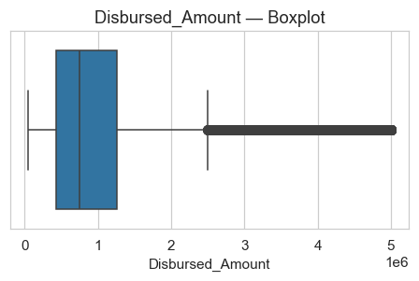

Annual_Income
count=230484 mean=1348861.08 median=1346870.50 std=664284.38 IQR=1151314.00 min=200004 max=2499999
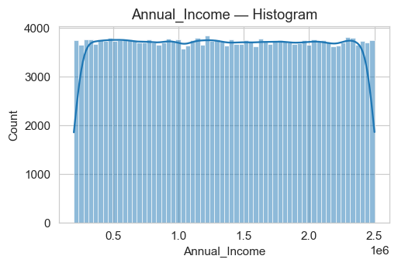
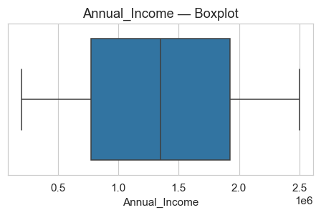

Account_Balance
count=230484 mean=252676.15 median=252734.50 std=143048.51 IQR=248313.50 min=5002 max=499995
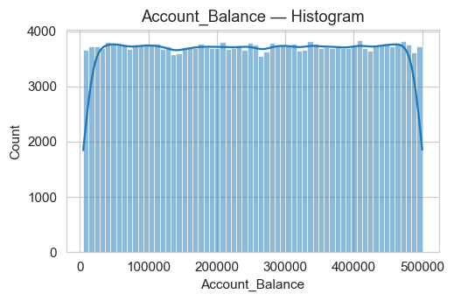
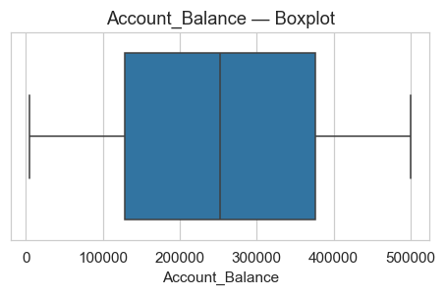

EMI_Amount
count=230484 mean=25211.53 median=20564.58 std=17742.12 IQR=23335.83 min=1233.5 max=90215.92
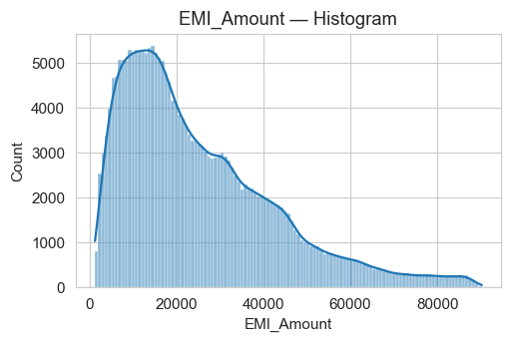
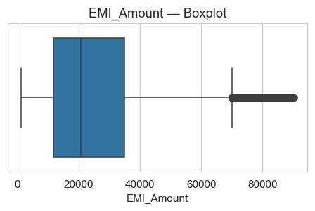

Credit_Score
count=230484 mean=575.14 median=575.00 std=158.92 IQR=275.00 min=300 max=850
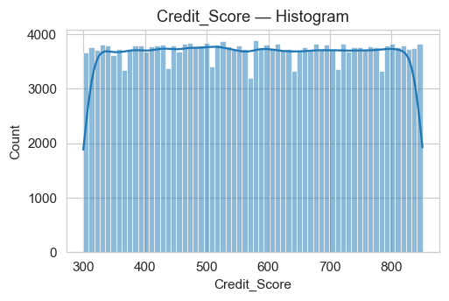
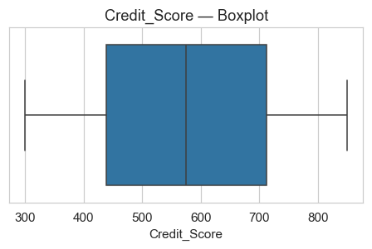

Loan_Term
count=230484 mean=84.28 median=60.00 std=89.29 IQR=48.00 min=12 max=360
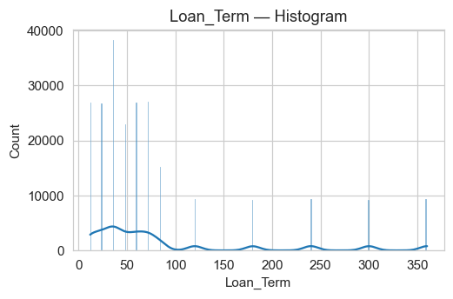
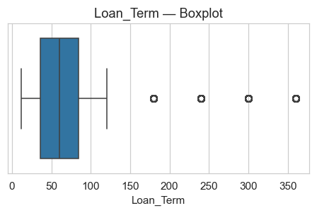

Age
count=230484 mean=44.01 median=44.00 std=15.29 IQR=26.00 min=18 max=70
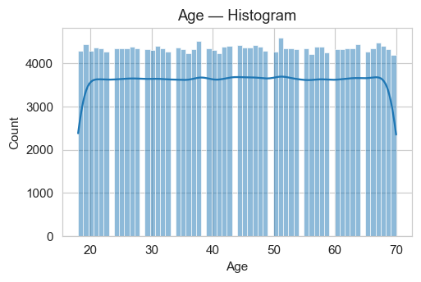
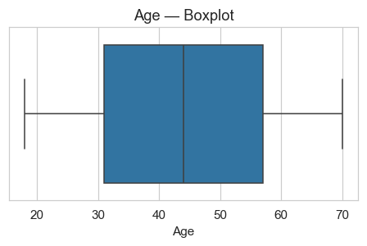

Interest_Rate
count=230484 mean=11.49 median=11.49 std=2.02 IQR=3.49 min=8.000015486 max=14.99996487
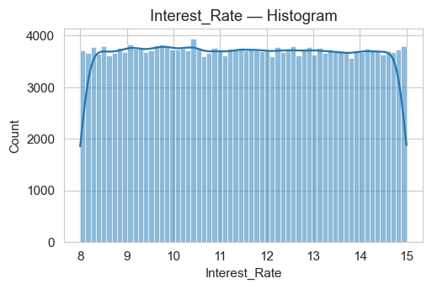
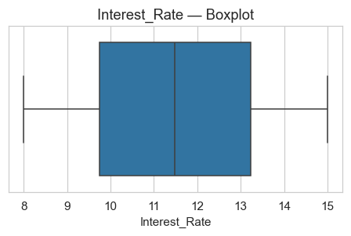

3. Univariate Analysis — Categorical

Gender
Top categories (count):
Gender
Male 77146
Female 76744
Other 76594
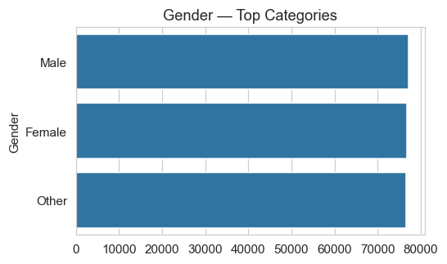

Loan_Status
Top categories (count):
Loan_Status
Closed 76949
Active 76832
Default 76703
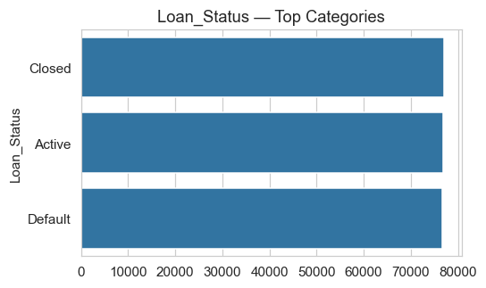

Loan_Repayment_Status
Top categories (count):
Loan_Repayment_Status
Completed 77227
Pending 76641
Deferred 76616
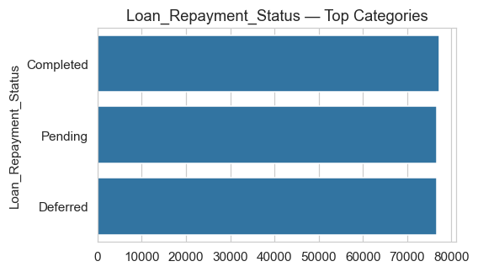

4. Numeric vs Numeric — Top Correlations

Loan_Amount vs Loan_Term (Correlation = 0.68)
This section examines the linear relationship between 'Loan_Amount' and 'Loan_Term'.
Correlation measures strength and direction:
- Positive values → direct relationship
- Negative values → inverse relationship
- Values near 0 → weak or no relationship
Scatterplot:
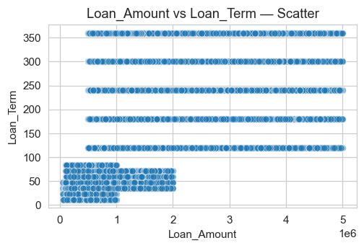
Regression Line Fit:
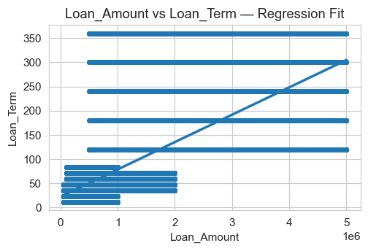
Insight:
- The correlation coefficient is 0.68.
- Higher absolute correlation indicates stronger linear association.
- Regression line helps visualize the trend direction.

Loan_Amount vs EMI_Amount (Correlation = 0.51)
This section examines the linear relationship between 'Loan_Amount' and 'EMI_Amount'.
Correlation measures strength and direction:
- Positive values → direct relationship
- Negative values → inverse relationship
- Values near 0 → weak or no relationship
Scatterplot:
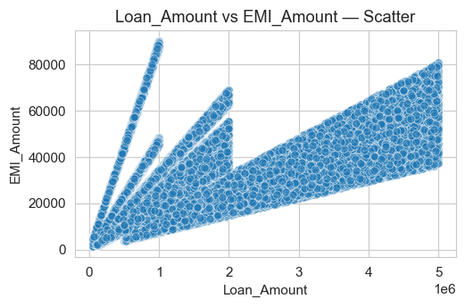
Regression Line Fit:
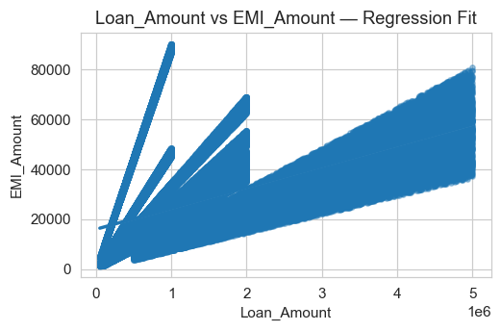
Insight:
- The correlation coefficient is 0.51.
- Higher absolute correlation indicates stronger linear association.
- Regression line helps visualize the trend direction.

EMI_Amount vs Interest_Rate (Correlation = 0.07)
This section examines the linear relationship between 'EMI_Amount' and 'Interest_Rate'.
Correlation measures strength and direction:
- Positive values → direct relationship
- Negative values → inverse relationship
- Values near 0 → weak or no relationship
Scatterplot:
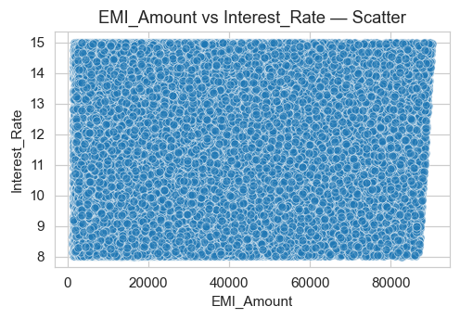
Regression Line Fit:
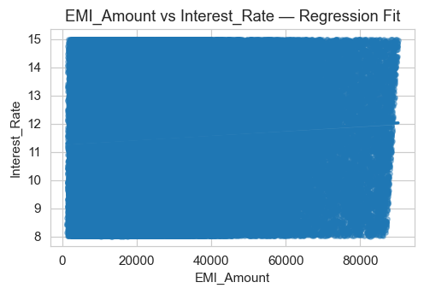
Insight:
- The correlation coefficient is 0.07.
- Higher absolute correlation indicates stronger linear association.
- Regression line helps visualize the trend direction.

Account_Balance vs Credit_Score (Correlation = 0.00)
This section examines the linear relationship between 'Account_Balance' and 'Credit_Score'.
Correlation measures strength and direction:
- Positive values → direct relationship
- Negative values → inverse relationship
- Values near 0 → weak or no relationship
Scatterplot:
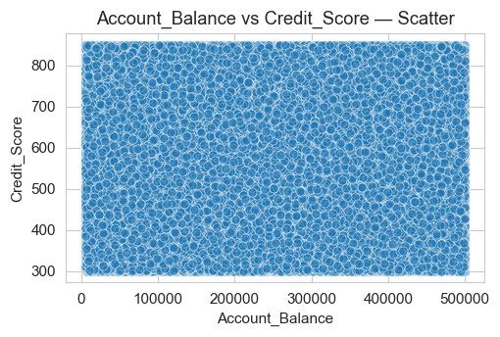
Regression Line Fit:
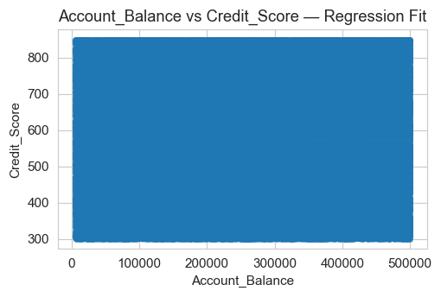
Insight:
- The correlation coefficient is 0.00.
- Higher absolute correlation indicates stronger linear association.
- Regression line helps visualize the trend direction.

Loan_Term vs Age (Correlation = 0.00)
This section examines the linear relationship between 'Loan_Term' and 'Age'.
Correlation measures strength and direction:
- Positive values → direct relationship
- Negative values → inverse relationship
- Values near 0 → weak or no relationship
Scatterplot:
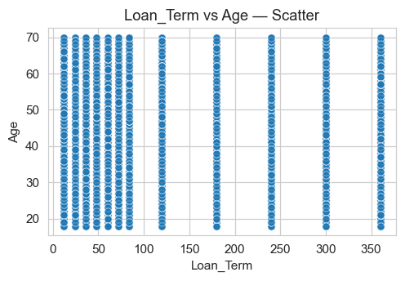
Regression Line Fit:
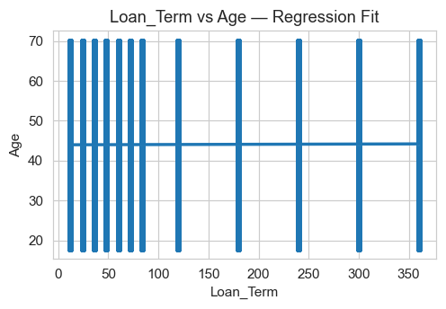
Insight:
- The correlation coefficient is 0.00.
- Higher absolute correlation indicates stronger linear association.
- Regression line helps visualize the trend direction.

Account_Balance vs EMI_Amount (Correlation = 0.00)
This section examines the linear relationship between 'Account_Balance' and 'EMI_Amount'.
Correlation measures strength and direction:
- Positive values → direct relationship
- Negative values → inverse relationship
- Values near 0 → weak or no relationship
Scatterplot:
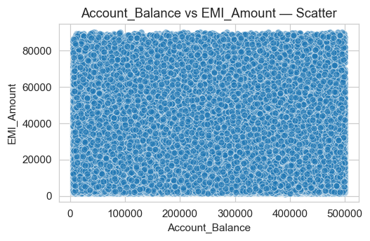
Regression Line Fit:
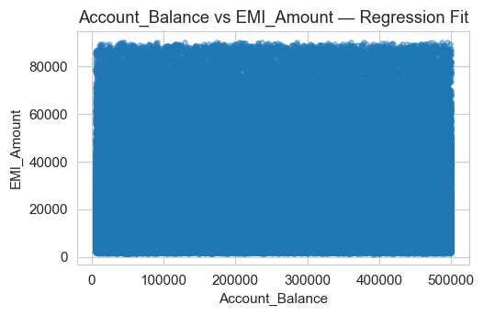
Insight:
- The correlation coefficient is 0.00.
- Higher absolute correlation indicates stronger linear association.
- Regression line helps visualize the trend direction.

EMI_Amount vs Loan_Term (Correlation = 0.00)
This section examines the linear relationship between 'EMI_Amount' and 'Loan_Term'.
Correlation measures strength and direction:
- Positive values → direct relationship
- Negative values → inverse relationship
- Values near 0 → weak or no relationship
Scatterplot:
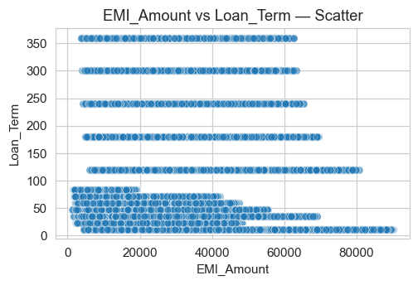
Regression Line Fit:
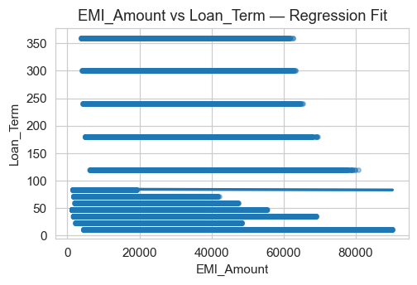
Insight:
- The correlation coefficient is 0.00.
- Higher absolute correlation indicates stronger linear association.
- Regression line helps visualize the trend direction.

Loan_Amount vs Age (Correlation = 0.00)
This section examines the linear relationship between 'Loan_Amount' and 'Age'.
Correlation measures strength and direction:
- Positive values → direct relationship
- Negative values → inverse relationship
- Values near 0 → weak or no relationship
Scatterplot:
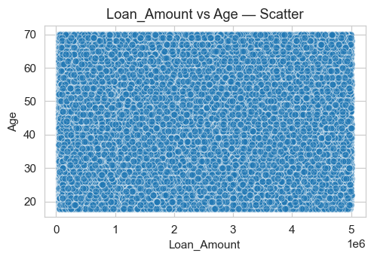
Regression Line Fit:
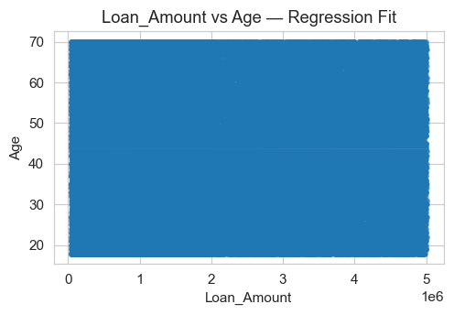
Insight:
- The correlation coefficient is 0.00.
- Higher absolute correlation indicates stronger linear association.
- Regression line helps visualize the trend direction.

Credit_Score vs Interest_Rate (Correlation = 0.00)
This section examines the linear relationship between 'Credit_Score' and 'Interest_Rate'.
Correlation measures strength and direction:
- Positive values → direct relationship
- Negative values → inverse relationship
- Values near 0 → weak or no relationship
Scatterplot:
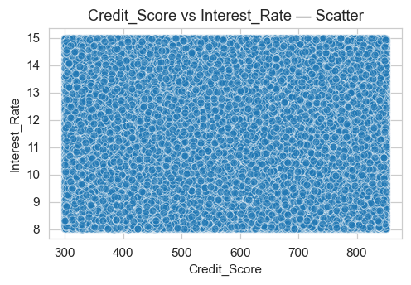
Regression Line Fit:
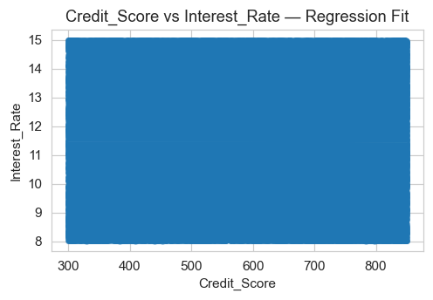
Insight:
- The correlation coefficient is 0.00.
- Higher absolute correlation indicates stronger linear association.
- Regression line helps visualize the trend direction.

Annual_Income vs Loan_Term (Correlation = 0.00)
This section examines the linear relationship between 'Annual_Income' and 'Loan_Term'.
Correlation measures strength and direction:
- Positive values → direct relationship
- Negative values → inverse relationship
- Values near 0 → weak or no relationship
Scatterplot:
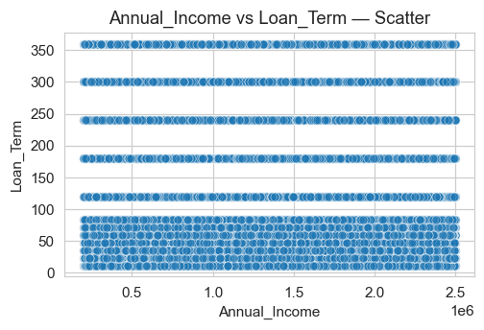
Regression Line Fit:
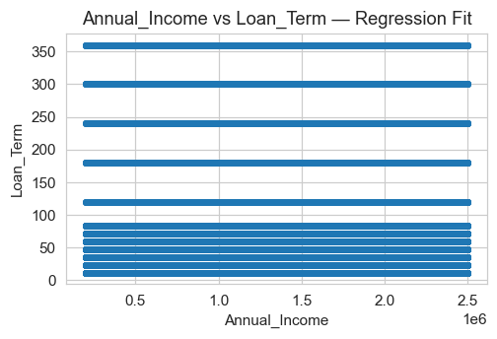
Insight:
- The correlation coefficient is 0.00.
- Higher absolute correlation indicates stronger linear association.
- Regression line helps visualize the trend direction.

5. Numeric vs Categorical — Most Influential

Loan_Amount by Loan_Status (Eta² = 0.000)
This section compares the numeric variable 'Loan_Amount' across the categories of 'Loan_Status'.
A higher Eta² value indicates that the categorical variable 'Loan_Status' explains more variation in 'Loan_Amount'.
Group Statistics:
count mean median std
Loan_Status
Active 76832 1102192.30 743819.0 1083710.46
Closed 76949 1091235.17 740314.0 1072362.18
Default 76703 1100154.42 740856.0 1081994.05
Plot:
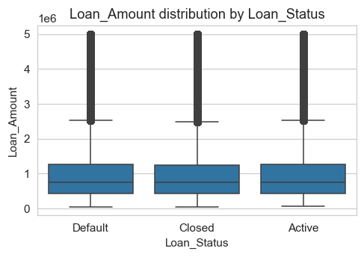
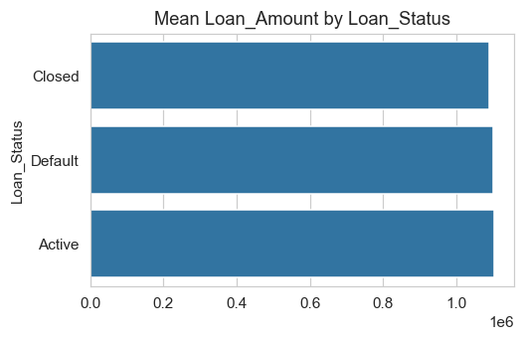
Interpretation:
- The variable 'Loan_Amount' shows differences across levels of 'Loan_Status'.
- Categories with higher means indicate stronger association.
- Eta² = 0.000 (0 = no effect, 1 = strong effect).

Disbursed_Amount by Loan_Status (Eta² = 0.000)
This section compares the numeric variable 'Disbursed_Amount' across the categories of 'Loan_Status'.
A higher Eta² value indicates that the categorical variable 'Loan_Status' explains more variation in 'Disbursed_Amount'.
Group Statistics:
count mean median std
Loan_Status
Active 76832 1102192.30 743819.0 1083710.46
Closed 76949 1091235.17 740314.0 1072362.18
Default 76703 1100154.42 740856.0 1081994.05
Plot:
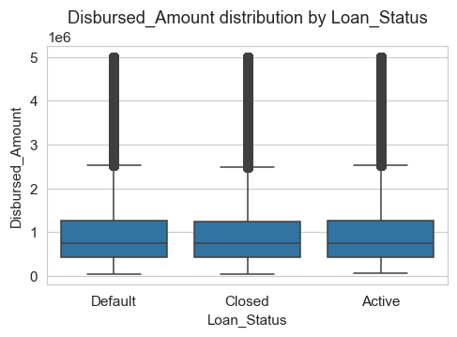
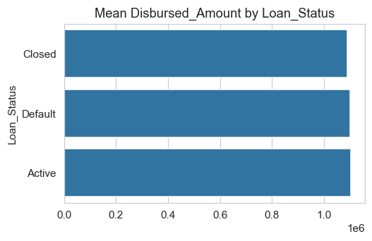
Interpretation:
- The variable 'Disbursed_Amount' shows differences across levels of 'Loan_Status'.
- Categories with higher means indicate stronger association.
- Eta² = 0.000 (0 = no effect, 1 = strong effect).

Annual_Income by Loan_Repayment_Status (Eta² = 0.000)
This section compares the numeric variable 'Annual_Income' across the categories of 'Loan_Repayment_Status'.
A higher Eta² value indicates that the categorical variable 'Loan_Repayment_Status' explains more variation in 'Annual_Income'.
Group Statistics:
count mean median std
Loan_Repayment_Status
Completed 77227 1350264.49 1351336.0 663790.85
Deferred 76616 1351418.43 1349510.5 664576.26
Pending 76641 1344890.44 1340116.0 664479.99
Plot:
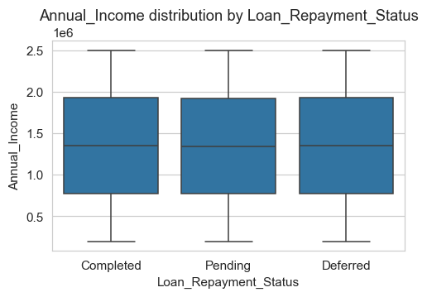
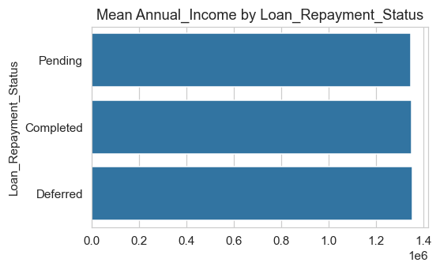
Interpretation:
- The variable 'Annual_Income' shows differences across levels of 'Loan_Repayment_Status'.
- Categories with higher means indicate stronger association.
- Eta² = 0.000 (0 = no effect, 1 = strong effect).

Age by Loan_Repayment_Status (Eta² = 0.000)
This section compares the numeric variable 'Age' across the categories of 'Loan_Repayment_Status'.
A higher Eta² value indicates that the categorical variable 'Loan_Repayment_Status' explains more variation in 'Age'.
Group Statistics:
count mean median std
Loan_Repayment_Status
Completed 77227 44.10 44.0 15.30
Deferred 76616 43.94 44.0 15.28
Pending 76641 43.99 44.0 15.29
Plot:
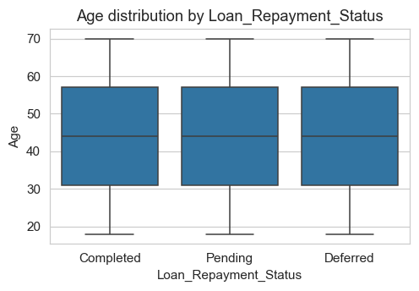
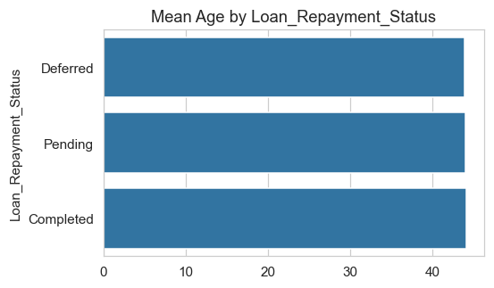
Interpretation:
- The variable 'Age' shows differences across levels of 'Loan_Repayment_Status'.
- Categories with higher means indicate stronger association.
- Eta² = 0.000 (0 = no effect, 1 = strong effect).

Annual_Income by Gender (Eta² = 0.000)
This section compares the numeric variable 'Annual_Income' across the categories of 'Gender'.
A higher Eta² value indicates that the categorical variable 'Gender' explains more variation in 'Annual_Income'.
Group Statistics:
count mean median std
Gender
Female 76744 1352774.36 1356744.5 662678.65
Male 77146 1346595.21 1341211.5 664456.08
Other 76594 1347222.35 1342353.0 665708.02
Plot:
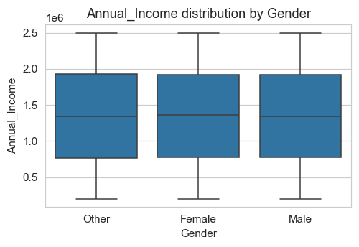
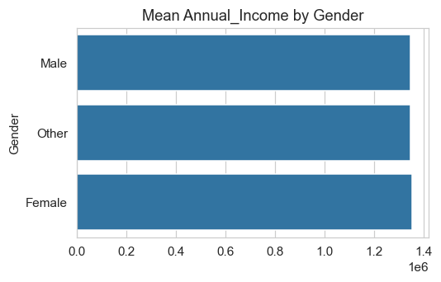
Interpretation:
- The variable 'Annual_Income' shows differences across levels of 'Gender'.
- Categories with higher means indicate stronger association.
- Eta² = 0.000 (0 = no effect, 1 = strong effect).

Credit_Score by Loan_Status (Eta² = 0.000)
This section compares the numeric variable 'Credit_Score' across the categories of 'Loan_Status'.
A higher Eta² value indicates that the categorical variable 'Loan_Status' explains more variation in 'Credit_Score'.
Group Statistics:
count mean median std
Loan_Status
Active 76832 575.58 576.0 158.57
Closed 76949 575.63 576.0 159.41
Default 76703 574.21 574.0 158.78
Plot:
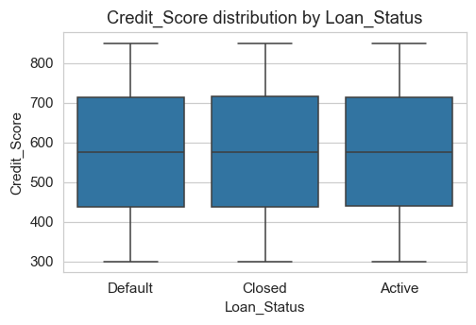
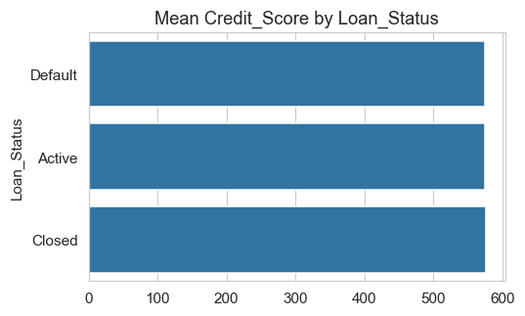
Interpretation:
- The variable 'Credit_Score' shows differences across levels of 'Loan_Status'.
- Categories with higher means indicate stronger association.
- Eta² = 0.000 (0 = no effect, 1 = strong effect).

Interest_Rate by Loan_Repayment_Status (Eta² = 0.000)
This section compares the numeric variable 'Interest_Rate' across the categories of 'Loan_Repayment_Status'.
A higher Eta² value indicates that the categorical variable 'Loan_Repayment_Status' explains more variation in 'Interest_Rate'.
Group Statistics:
count mean median std
Loan_Repayment_Status
Completed 77227 11.49 11.48 2.02
Deferred 76616 11.50 11.51 2.02
Pending 76641 11.49 11.48 2.02
Plot:
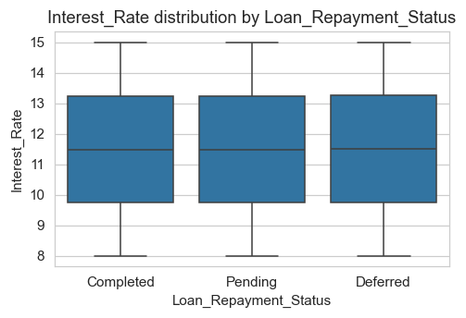
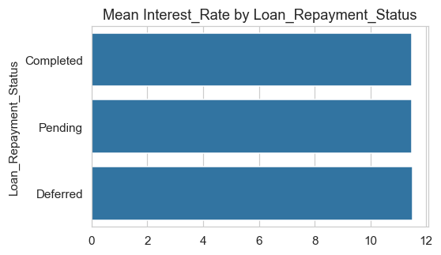
Interpretation:
- The variable 'Interest_Rate' shows differences across levels of 'Loan_Repayment_Status'.
- Categories with higher means indicate stronger association.
- Eta² = 0.000 (0 = no effect, 1 = strong effect).

Loan_Term by Loan_Status (Eta² = 0.000)
This section compares the numeric variable 'Loan_Term' across the categories of 'Loan_Status'.
A higher Eta² value indicates that the categorical variable 'Loan_Status' explains more variation in 'Loan_Term'.
Group Statistics:
count mean median std
Loan_Status
Active 76832 84.69 60.0 89.98
Closed 76949 83.95 48.0 89.13
Default 76703 84.20 60.0 88.77
Plot:
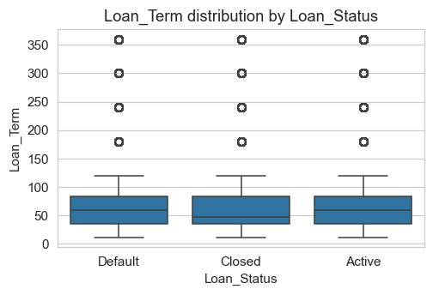
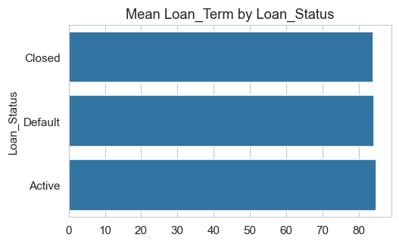
Interpretation:
- The variable 'Loan_Term' shows differences across levels of 'Loan_Status'.
- Categories with higher means indicate stronger association.
- Eta² = 0.000 (0 = no effect, 1 = strong effect).

Annual_Income by Loan_Status (Eta² = 0.000)
This section compares the numeric variable 'Annual_Income' across the categories of 'Loan_Status'.
A higher Eta² value indicates that the categorical variable 'Loan_Status' explains more variation in 'Annual_Income'.
Group Statistics:
count mean median std
Loan_Status
Active 76832 1351081.75 1355815.5 664783.68
Closed 76949 1345703.68 1339023.0 664004.05
Default 76703 1349804.21 1347200.0 664061.92
Plot:
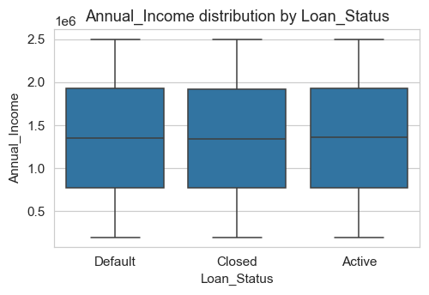
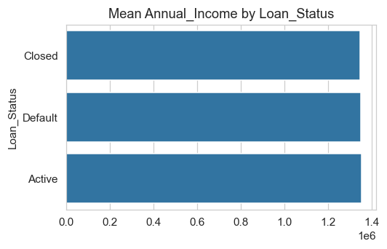
Interpretation:
- The variable 'Annual_Income' shows differences across levels of 'Loan_Status'.
- Categories with higher means indicate stronger association.
- Eta² = 0.000 (0 = no effect, 1 = strong effect).

Account_Balance by Gender (Eta² = 0.000)
This section compares the numeric variable 'Account_Balance' across the categories of 'Gender'.
A higher Eta² value indicates that the categorical variable 'Gender' explains more variation in 'Account_Balance'.
Group Statistics:
count mean median std
Gender
Female 76744 253276.65 253613.0 143019.33
Male 77146 252634.00 252475.5 142883.93
Other 76594 252116.92 252221.5 143242.79
Plot:
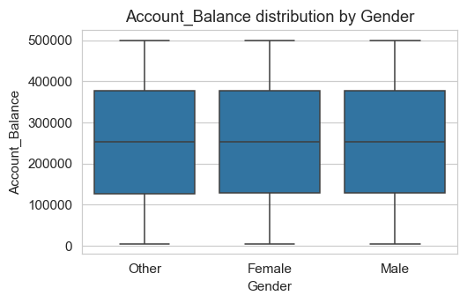
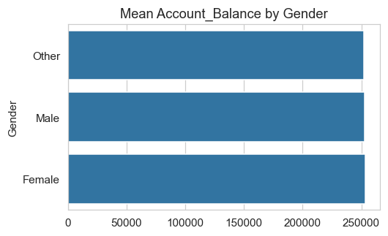
Interpretation:
- The variable 'Account_Balance' shows differences across levels of 'Gender'.
- Categories with higher means indicate stronger association.
- Eta² = 0.000 (0 = no effect, 1 = strong effect).

6. Categorical vs Categorical — Top Associations

Loan_Status vs Loan_Repayment_Status (Cramer's V = 0.003)
This section evaluates the association between two categorical variables:
- Cramer's V ranges from 0 to 1
- 0 = No association
- 1 = Perfect association
A higher value indicates stronger interaction between 'Loan_Status' and 'Loan_Repayment_Status'.
Crosstab Summary:
Loan_Repayment_Status Completed Deferred Pending
Loan_Status
Active 25582 25480 25770
Closed 25729 25593 25627
Default 25916 25543 25244
Heatmap:
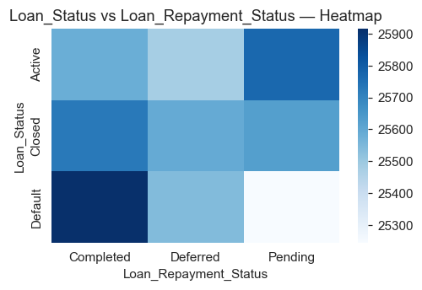
Stacked Bar Chart:

Insight:
- Cramer's V = 0.003 indicates the strength of association.
- The heatmap helps identify concentration patterns.
- Stacked bars show proportional distribution of categories.

Gender vs Loan_Status (Cramer's V = 0.002)
This section evaluates the association between two categorical variables:
- Cramer's V ranges from 0 to 1
- 0 = No association
- 1 = Perfect association
A higher value indicates stronger interaction between 'Gender' and 'Loan_Status'.
Crosstab Summary:
Loan_Status Active Closed Default
Gender
Female 25378 25668 25698
Male 25695 25816 25635
Other 25759 25465 25370
Heatmap:
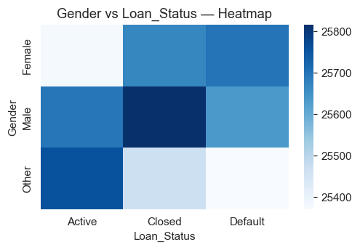
Stacked Bar Chart:

Insight:
- Cramer's V = 0.002 indicates the strength of association.
- The heatmap helps identify concentration patterns.
- Stacked bars show proportional distribution of categories.

Gender vs Loan_Repayment_Status (Cramer's V = 0.000)
This section evaluates the association between two categorical variables:
- Cramer's V ranges from 0 to 1
- 0 = No association
- 1 = Perfect association
A higher value indicates stronger interaction between 'Gender' and 'Loan_Repayment_Status'.
Crosstab Summary:
Loan_Repayment_Status Completed Deferred Pending
Gender
Female 25640 25608 25496
Male 25943 25564 25639
Other 25644 25444 25506
Heatmap:
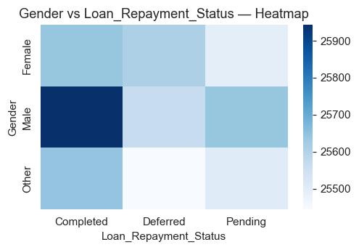
Stacked Bar Chart:

Insight:
- Cramer's V = 0.000 indicates the strength of association.
- The heatmap helps identify concentration patterns.
- Stacked bars show proportional distribution of categories.

7. Insights & Conclusion
This hybrid report highlights the most impactful relationships while remaining compact (50–60 pages).
Use this report as a foundation for deeper modeling or domain-level interpretation.

