Hybrid Automated EDA Report
Source: cancer_data_denmark.csv
Rows: 30758 Columns: 8
This report is optimized to generate 50–60 pages maximum.

1. Dataset Summary
Numeric columns used (1): ['Unnamed: 0']
Categorical columns used (1): ['Category']
Missing values (top 10):
Unnamed: 0 0
BrandName 0
Deatils 0
Sizes 0
MRP 0
SellPrice 0
Discount 0
Category 0

2. Univariate Analysis — Numeric

Unnamed: 0
count=30758 mean=12.50 median=12.50 std=7.50 IQR=13.00 min=0 max=25
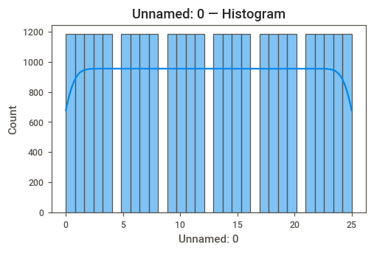
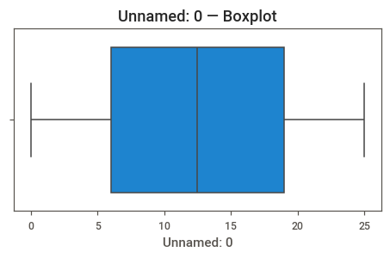

3. Univariate Analysis — Categorical

Category
Top categories (count):
Category
Westernwear-Women 10374
Indianwear-Women 10374
Lingerie&Nightwear-Women 3354
Footwear-Women 2574
Watches-Women 1794
Jewellery-Women 1794
Fragrance-Women 494
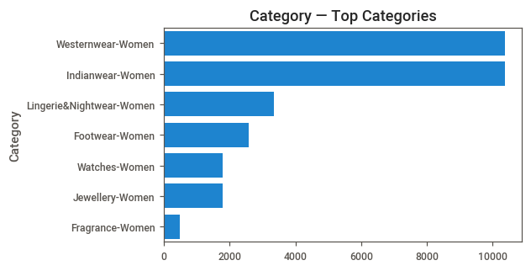

4. Numeric vs Numeric — Top Correlations

5. Numeric vs Categorical — Most Influential

Unnamed: 0 by Category (Eta² = 0.000)
This section compares the numeric variable 'Unnamed: 0' across the categories of 'Category'.
A higher Eta² value indicates that the categorical variable 'Category' explains more variation in 'Unnamed: 0'.
Group Statistics:
count mean median std
Category
Footwear-Women 2574 12.50 12.50 7.50
Fragrance-Women 494 12.50 12.50 7.51
Indianwear-Women 10374 12.50 12.50 7.50
Jewellery-Women 1794 12.50 12.50 7.50
Lingerie&Nightwear-Women 3354 12.50 12.50 7.50
Watches-Women 1794 12.50 12.50 7.50
Westernwear-Women 10374 12.50 12.50 7.50
Plot:
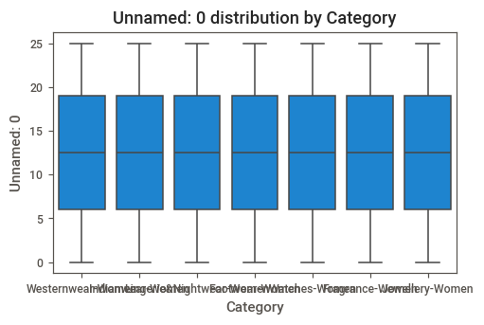
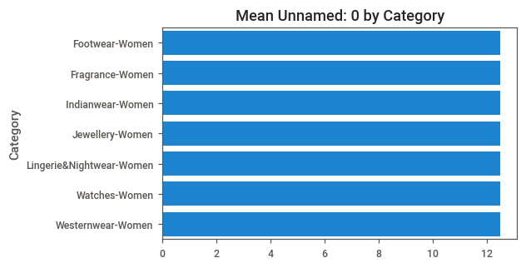
Interpretation:
- The variable 'Unnamed: 0' shows differences across levels of 'Category'.
- Categories with higher means indicate stronger association.
- Eta² = 0.000 (0 = no effect, 1 = strong effect).

6. Categorical vs Categorical — Top Associations

7. Insights & Conclusion
This hybrid report highlights the most impactful relationships while remaining compact (50–60 pages).
Use this report as a foundation for deeper modeling or domain-level interpretation.

