Hybrid Automated EDA Report
Source: cancer_data_denmark.csv
Rows: 3000 Columns: 25
This report is optimized to generate 50–60 pages maximum.

1. Dataset Summary
Numeric columns used (7): ['Patient_ID', 'Survival_Months', 'Age', 'Lymph_Nodes_Examined', 'BMI', 'Lymph_Nodes_Positive', 'Tumor_Size_cm']
Categorical columns used (14): ['Gender', 'Metastasis', 'Alcohol_Consumption', 'Family_History', 'Relapse', 'Genetic_Mutation', 'Smoking_Status', 'Income_Level', 'Stage', 'Comorbidities', 'Region', 'Treatment_Type', 'Occupation', 'Cancer_Type']
Missing values (top 30):
Alcohol_Consumption 998
Genetic_Mutation 789
Comorbidities 606
Patient_ID 0
Metastasis 0
Income_Level 0
Occupation 0
Relapse 0
Survival_Months 0
Family_History 0
BMI 0
Smoking_Status 0
Lymph_Nodes_Positive 0
Age 0
Lymph_Nodes_Examined 0
Tumor_Size_cm 0
Treatment_End_Date 0
Treatment_Start_Date 0
Treatment_Type 0
Diagnosis_Date 0
Stage 0
Cancer_Type 0
Region 0
Gender 0
Followup_Date 0

2. Univariate Analysis — Numeric

Patient_ID
count=3000 mean=1500.50 median=1500.50 std=866.17 IQR=1499.50 min=1 max=3000
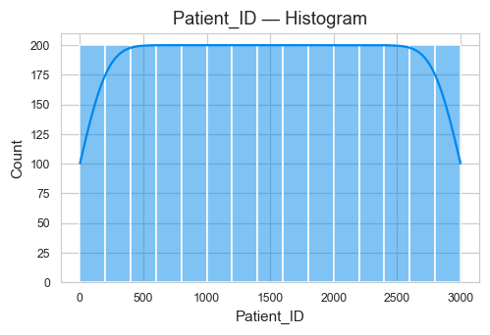
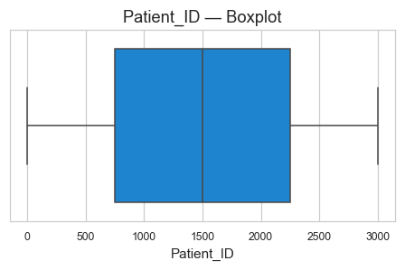

Survival_Months
count=3000 mean=59.48 median=59.00 std=33.99 IQR=58.00 min=1 max=119
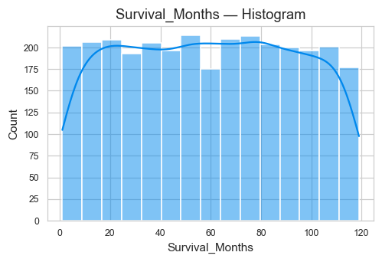
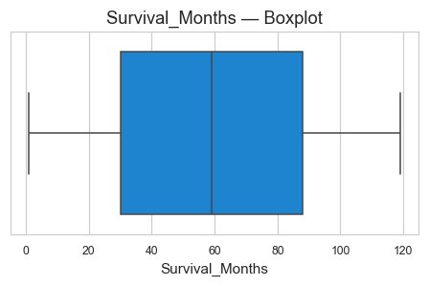

Age
count=3000 mean=53.70 median=54.00 std=20.87 IQR=37.00 min=18 max=89
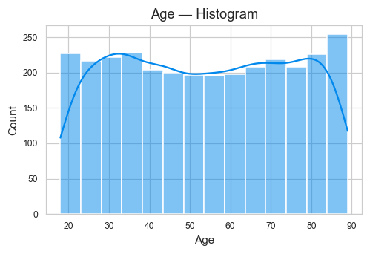
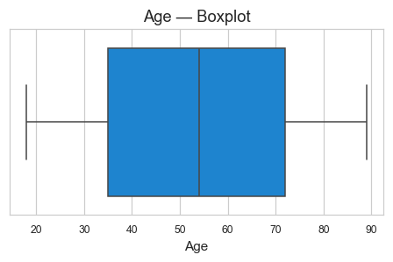

Lymph_Nodes_Examined
count=3000 mean=9.58 median=10.00 std=5.77 IQR=10.00 min=0 max=19
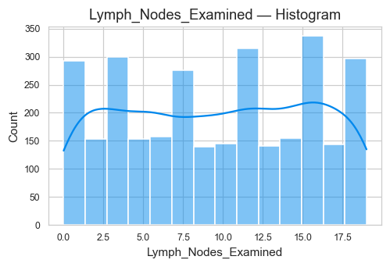
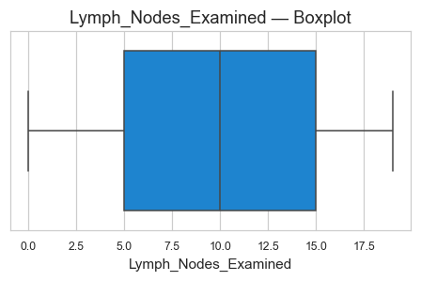

BMI
count=3000 mean=25.05 median=25.10 std=5.07 IQR=7.10 min=9.8 max=44.3
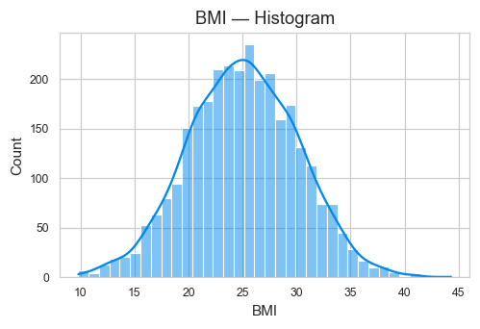
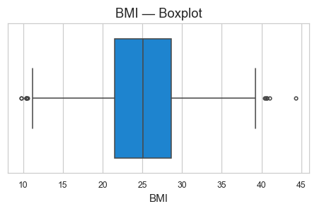

Lymph_Nodes_Positive
count=3000 mean=4.82 median=3.00 std=4.57 IQR=7.00 min=0 max=19
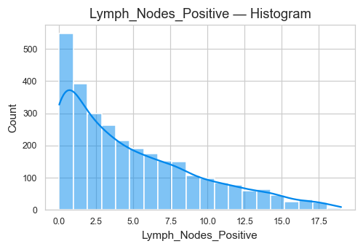
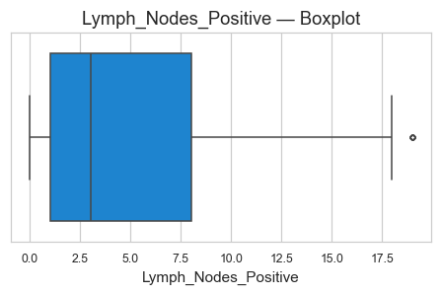

Tumor_Size_cm
count=3000 mean=5.22 median=5.23 std=2.72 IQR=4.57 min=0.5 max=10.0
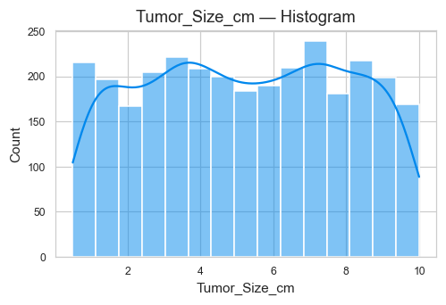
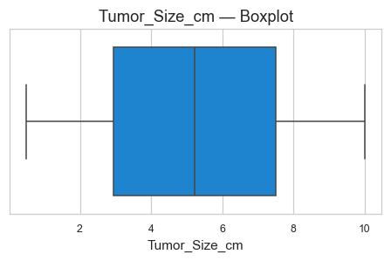

3. Univariate Analysis — Categorical

Gender
Top categories (count):
Gender
Male 1548
Female 1452
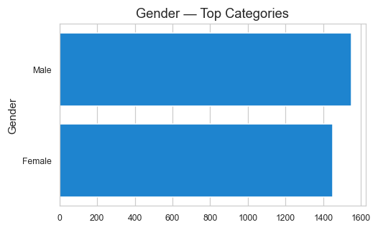

Metastasis
Top categories (count):
Metastasis
Yes 1506
No 1494
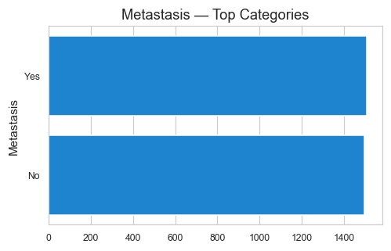

Alcohol_Consumption
Top categories (count):
Alcohol_Consumption
Moderate 1003
Heavy 999
nan 998
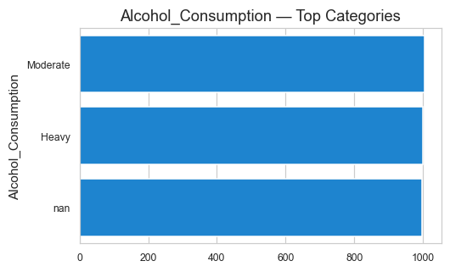

Family_History
Top categories (count):
Family_History
Yes 1516
No 1484
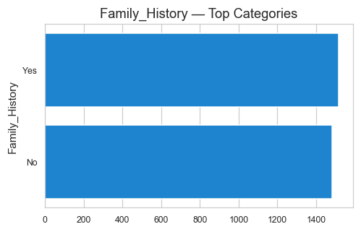

Relapse
Top categories (count):
Relapse
Yes 1501
No 1499
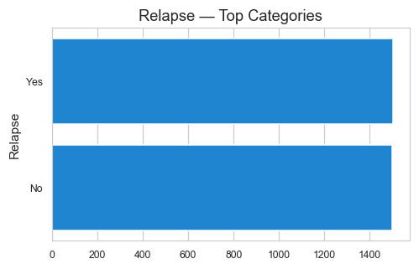

Genetic_Mutation
Top categories (count):
Genetic_Mutation
nan 789
BRCA2 754
TP53 743
BRCA1 714
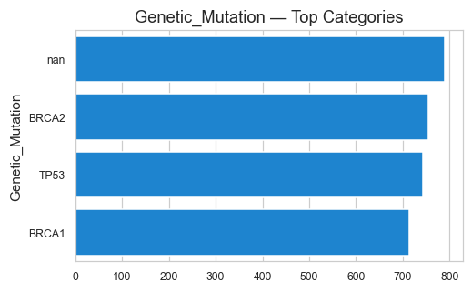

Smoking_Status
Top categories (count):
Smoking_Status
Never 1032
Former 991
Current 977
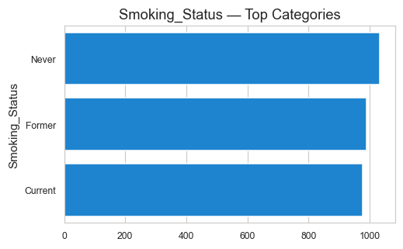

Income_Level
Top categories (count):
Income_Level
Medium 1021
High 1001
Low 978
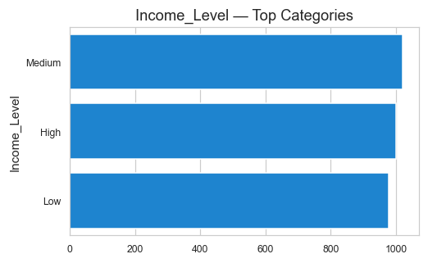

Stage
Top categories (count):
Stage
III 769
I 755
IV 753
II 723
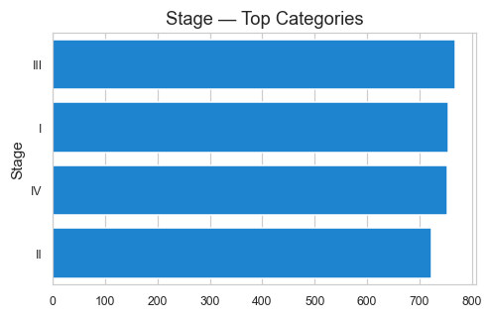

Comorbidities
Top categories (count):
Comorbidities
Cardiovascular 627
Hypertension 617
nan 606
Multiple 584
Diabetes 566
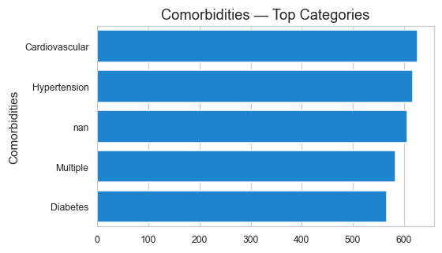

Region
Top categories (count):
Region
Midtjylland 624
Nordjylland 621
Sjælland 604
Hovedstaden 581
Syddanmark 570
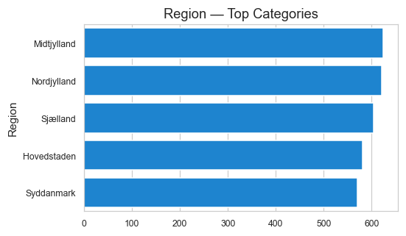

Treatment_Type
Top categories (count):
Treatment_Type
Immunotherapy 612
Chemotherapy 611
Surgery 597
Radiation 594
Hormone Therapy 586
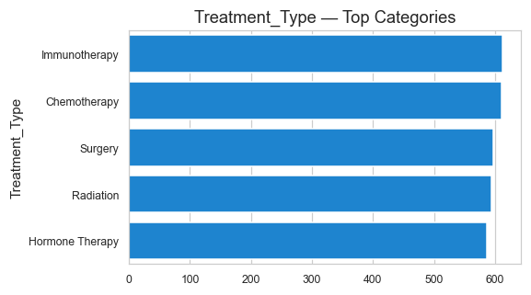

Occupation
Top categories (count):
Occupation
Unemployed 621
Healthcare 610
Office Worker 603
Manual Labor 584
Retired 582
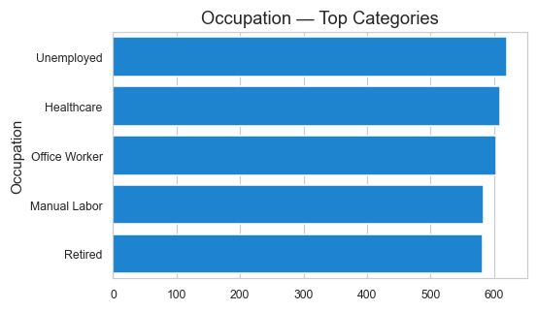

Cancer_Type
Top categories (count):
Cancer_Type
Lung 514
Leukemia 510
Breast 507
Colon 506
Prostate 488
Skin 475
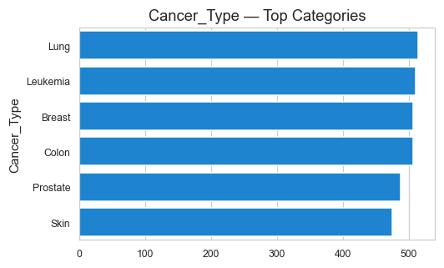

4. Numeric vs Numeric — Top Correlations

Lymph_Nodes_Examined vs Lymph_Nodes_Positive (Correlation = 0.65)
This section examines the linear relationship between 'Lymph_Nodes_Examined' and 'Lymph_Nodes_Positive'.
Correlation measures strength and direction:
- Positive values → direct relationship
- Negative values → inverse relationship
- Values near 0 → weak or no relationship
Scatterplot:
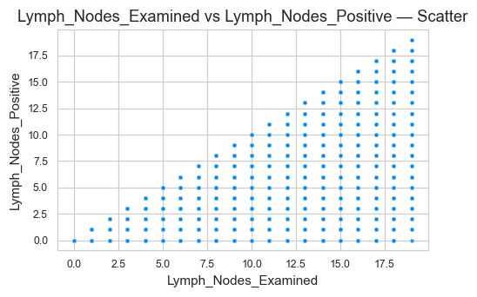
Regression Line Fit:
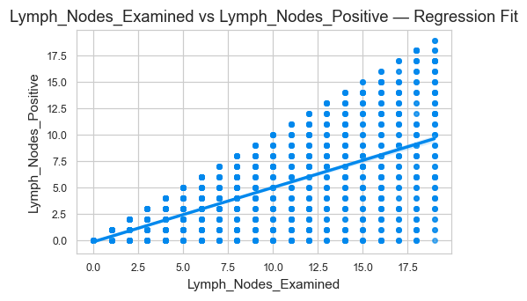
Insight:
- The correlation coefficient is 0.65.
- Higher absolute correlation indicates stronger linear association.
- Regression line helps visualize the trend direction.

Patient_ID vs Survival_Months (Correlation = 0.04)
This section examines the linear relationship between 'Patient_ID' and 'Survival_Months'.
Correlation measures strength and direction:
- Positive values → direct relationship
- Negative values → inverse relationship
- Values near 0 → weak or no relationship
Scatterplot:
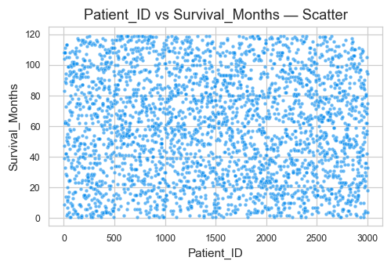
Regression Line Fit:
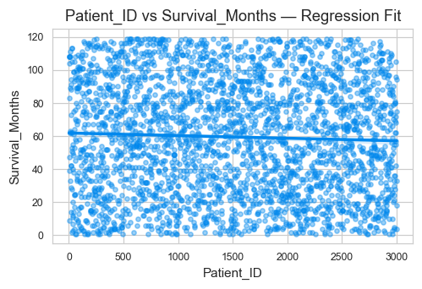
Insight:
- The correlation coefficient is 0.04.
- Higher absolute correlation indicates stronger linear association.
- Regression line helps visualize the trend direction.

Patient_ID vs Age (Correlation = 0.04)
This section examines the linear relationship between 'Patient_ID' and 'Age'.
Correlation measures strength and direction:
- Positive values → direct relationship
- Negative values → inverse relationship
- Values near 0 → weak or no relationship
Scatterplot:
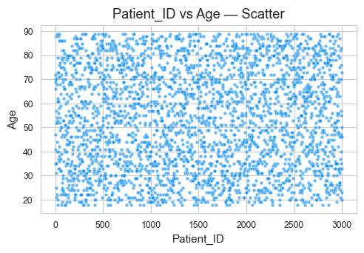
Regression Line Fit:
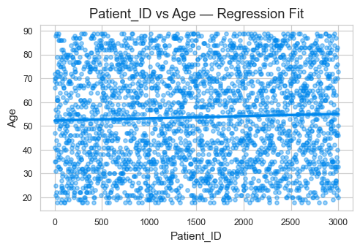
Insight:
- The correlation coefficient is 0.04.
- Higher absolute correlation indicates stronger linear association.
- Regression line helps visualize the trend direction.

Age vs Tumor_Size_cm (Correlation = 0.03)
This section examines the linear relationship between 'Age' and 'Tumor_Size_cm'.
Correlation measures strength and direction:
- Positive values → direct relationship
- Negative values → inverse relationship
- Values near 0 → weak or no relationship
Scatterplot:
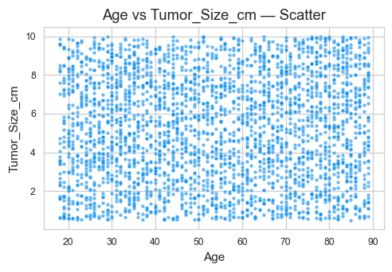
Regression Line Fit:
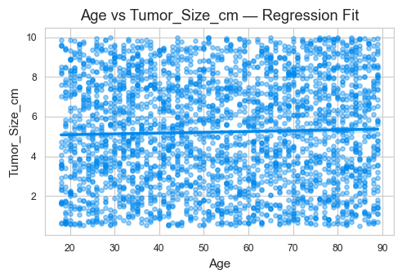
Insight:
- The correlation coefficient is 0.03.
- Higher absolute correlation indicates stronger linear association.
- Regression line helps visualize the trend direction.

Lymph_Nodes_Examined vs Tumor_Size_cm (Correlation = 0.03)
This section examines the linear relationship between 'Lymph_Nodes_Examined' and 'Tumor_Size_cm'.
Correlation measures strength and direction:
- Positive values → direct relationship
- Negative values → inverse relationship
- Values near 0 → weak or no relationship
Scatterplot:
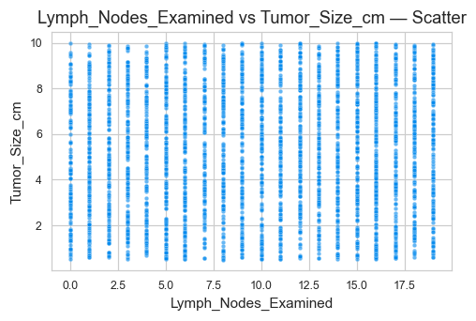
Regression Line Fit:
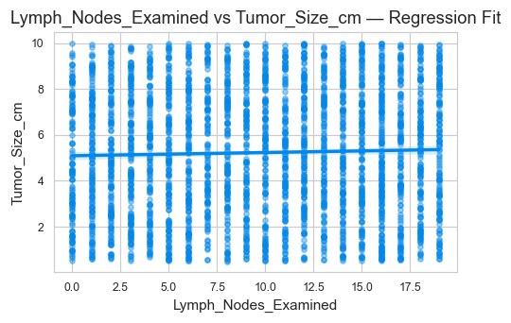
Insight:
- The correlation coefficient is 0.03.
- Higher absolute correlation indicates stronger linear association.
- Regression line helps visualize the trend direction.

Lymph_Nodes_Examined vs BMI (Correlation = 0.03)
This section examines the linear relationship between 'Lymph_Nodes_Examined' and 'BMI'.
Correlation measures strength and direction:
- Positive values → direct relationship
- Negative values → inverse relationship
- Values near 0 → weak or no relationship
Scatterplot:
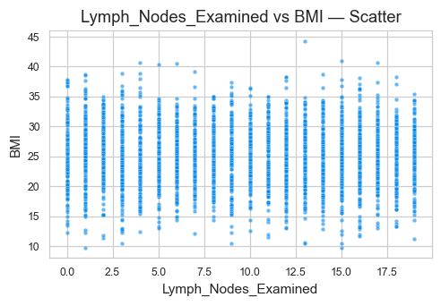
Regression Line Fit:
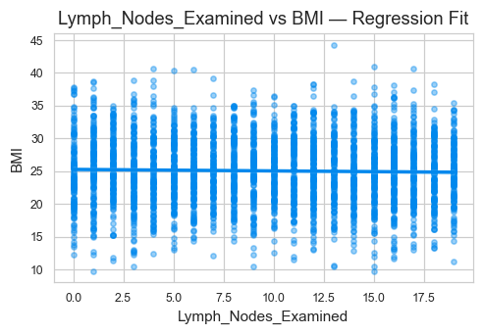
Insight:
- The correlation coefficient is 0.03.
- Higher absolute correlation indicates stronger linear association.
- Regression line helps visualize the trend direction.

Survival_Months vs Tumor_Size_cm (Correlation = 0.02)
This section examines the linear relationship between 'Survival_Months' and 'Tumor_Size_cm'.
Correlation measures strength and direction:
- Positive values → direct relationship
- Negative values → inverse relationship
- Values near 0 → weak or no relationship
Scatterplot:
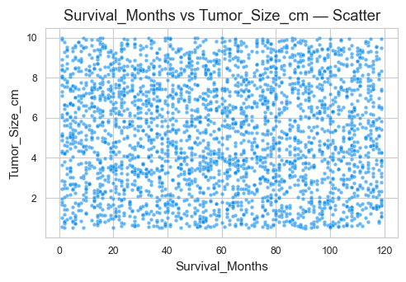
Regression Line Fit:
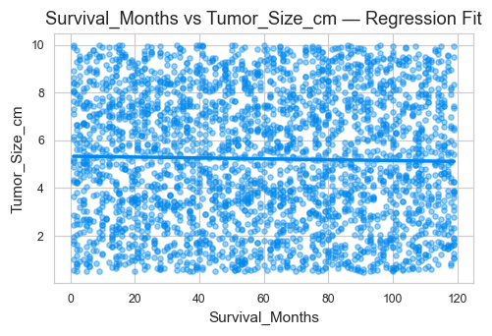
Insight:
- The correlation coefficient is 0.02.
- Higher absolute correlation indicates stronger linear association.
- Regression line helps visualize the trend direction.

Survival_Months vs Lymph_Nodes_Examined (Correlation = 0.02)
This section examines the linear relationship between 'Survival_Months' and 'Lymph_Nodes_Examined'.
Correlation measures strength and direction:
- Positive values → direct relationship
- Negative values → inverse relationship
- Values near 0 → weak or no relationship
Scatterplot:
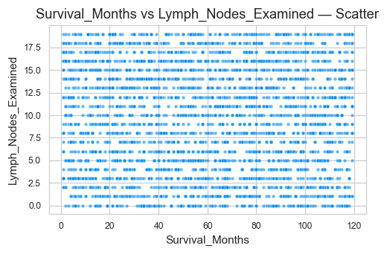
Regression Line Fit:
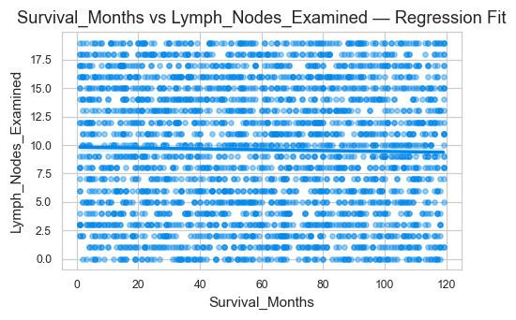
Insight:
- The correlation coefficient is 0.02.
- Higher absolute correlation indicates stronger linear association.
- Regression line helps visualize the trend direction.

Patient_ID vs BMI (Correlation = 0.02)
This section examines the linear relationship between 'Patient_ID' and 'BMI'.
Correlation measures strength and direction:
- Positive values → direct relationship
- Negative values → inverse relationship
- Values near 0 → weak or no relationship
Scatterplot:
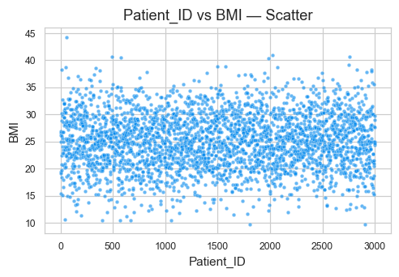
Regression Line Fit:
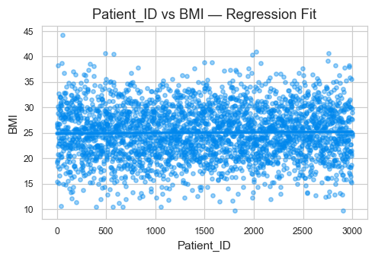
Insight:
- The correlation coefficient is 0.02.
- Higher absolute correlation indicates stronger linear association.
- Regression line helps visualize the trend direction.

Patient_ID vs Lymph_Nodes_Examined (Correlation = 0.02)
This section examines the linear relationship between 'Patient_ID' and 'Lymph_Nodes_Examined'.
Correlation measures strength and direction:
- Positive values → direct relationship
- Negative values → inverse relationship
- Values near 0 → weak or no relationship
Scatterplot:
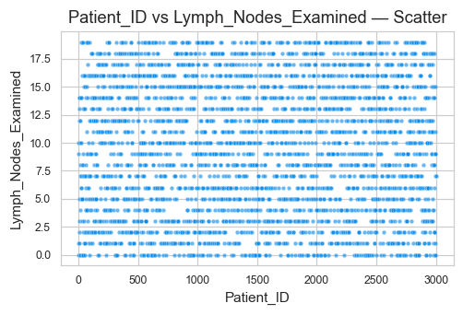
Regression Line Fit:
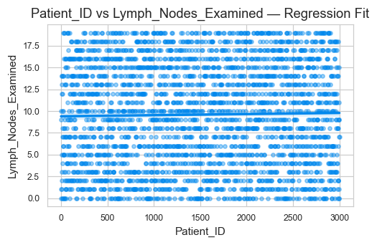
Insight:
- The correlation coefficient is 0.02.
- Higher absolute correlation indicates stronger linear association.
- Regression line helps visualize the trend direction.

5. Numeric vs Categorical — Most Influential

Lymph_Nodes_Positive by Cancer_Type (Eta² = 0.003)
This section compares the numeric variable 'Lymph_Nodes_Positive' across the categories of 'Cancer_Type'.
A higher Eta² value indicates that the categorical variable 'Cancer_Type' explains more variation in 'Lymph_Nodes_Positive'.
Group Statistics:
count mean median std
Cancer_Type
Breast 507 5.11 4.00 4.68
Colon 506 4.85 3.00 4.80
Leukemia 510 5.13 4.00 4.67
Lung 514 4.55 3.00 4.35
Prostate 488 4.82 3.00 4.53
Skin 475 4.41 3.00 4.33
Plot:
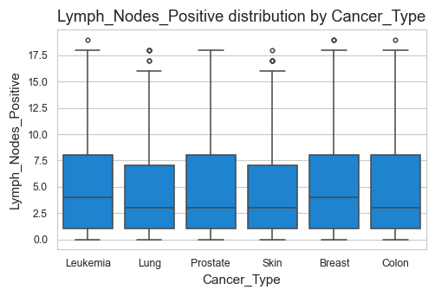
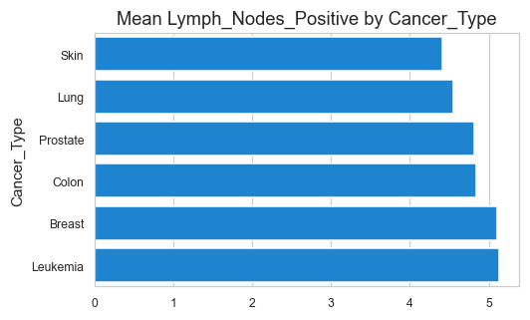
Interpretation:
- The variable 'Lymph_Nodes_Positive' shows differences across levels of 'Cancer_Type'.
- Categories with higher means indicate stronger association.
- Eta² = 0.003 (0 = no effect, 1 = strong effect).

Survival_Months by Cancer_Type (Eta² = 0.003)
This section compares the numeric variable 'Survival_Months' across the categories of 'Cancer_Type'.
A higher Eta² value indicates that the categorical variable 'Cancer_Type' explains more variation in 'Survival_Months'.
Group Statistics:
count mean median std
Cancer_Type
Breast 507 60.78 63.00 33.99
Colon 506 59.24 60.00 33.74
Leukemia 510 60.41 60.00 34.22
Lung 514 61.73 63.00 33.77
Prostate 488 58.87 59.00 33.87
Skin 475 55.53 51.00 34.18
Plot:
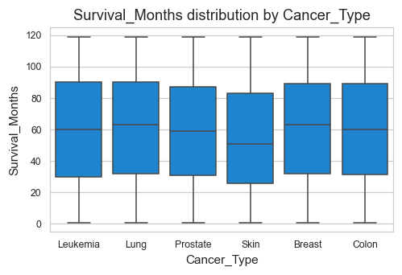
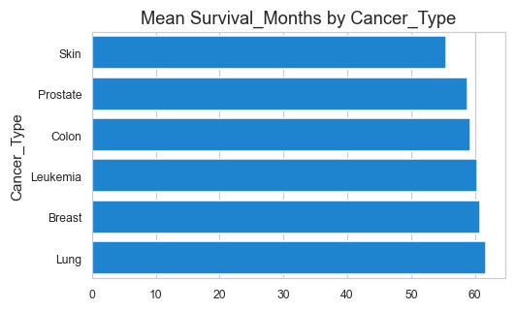
Interpretation:
- The variable 'Survival_Months' shows differences across levels of 'Cancer_Type'.
- Categories with higher means indicate stronger association.
- Eta² = 0.003 (0 = no effect, 1 = strong effect).

Tumor_Size_cm by Cancer_Type (Eta² = 0.003)
This section compares the numeric variable 'Tumor_Size_cm' across the categories of 'Cancer_Type'.
A higher Eta² value indicates that the categorical variable 'Cancer_Type' explains more variation in 'Tumor_Size_cm'.
Group Statistics:
count mean median std
Cancer_Type
Breast 507 5.33 5.32 2.67
Colon 506 5.17 5.10 2.75
Leukemia 510 5.49 5.62 2.70
Lung 514 5.02 4.78 2.68
Prostate 488 5.23 5.15 2.73
Skin 475 5.11 5.23 2.76
Plot:
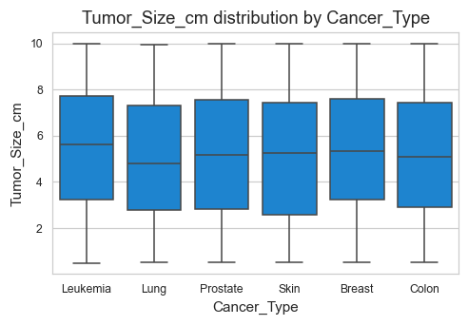
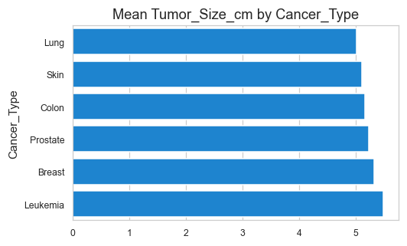
Interpretation:
- The variable 'Tumor_Size_cm' shows differences across levels of 'Cancer_Type'.
- Categories with higher means indicate stronger association.
- Eta² = 0.003 (0 = no effect, 1 = strong effect).

Lymph_Nodes_Examined by Genetic_Mutation (Eta² = 0.003)
This section compares the numeric variable 'Lymph_Nodes_Examined' across the categories of 'Genetic_Mutation'.
A higher Eta² value indicates that the categorical variable 'Genetic_Mutation' explains more variation in 'Lymph_Nodes_Examined'.
Group Statistics:
count mean median std
Genetic_Mutation
BRCA1 714 9.60 10.00 5.73
BRCA2 754 9.95 10.00 5.72
TP53 743 9.70 10.00 5.75
Plot:
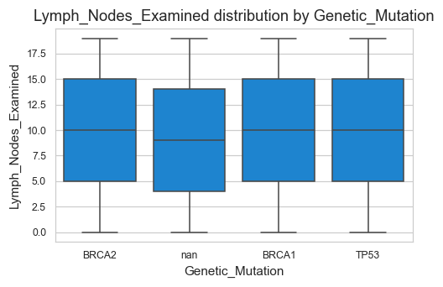
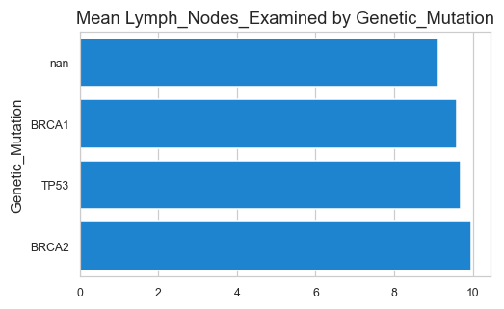
Interpretation:
- The variable 'Lymph_Nodes_Examined' shows differences across levels of 'Genetic_Mutation'.
- Categories with higher means indicate stronger association.
- Eta² = 0.003 (0 = no effect, 1 = strong effect).

Age by Genetic_Mutation (Eta² = 0.003)
This section compares the numeric variable 'Age' across the categories of 'Genetic_Mutation'.
A higher Eta² value indicates that the categorical variable 'Genetic_Mutation' explains more variation in 'Age'.
Group Statistics:
count mean median std
Genetic_Mutation
BRCA1 714 53.32 53.50 21.05
BRCA2 754 53.30 53.00 20.42
TP53 743 55.56 56.00 20.90
Plot:
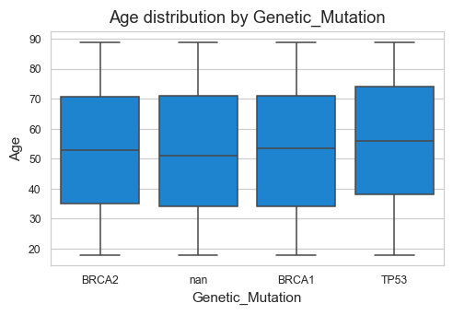
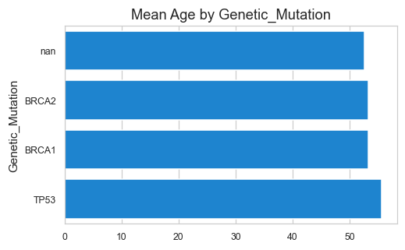
Interpretation:
- The variable 'Age' shows differences across levels of 'Genetic_Mutation'.
- Categories with higher means indicate stronger association.
- Eta² = 0.003 (0 = no effect, 1 = strong effect).

Age by Income_Level (Eta² = 0.003)
This section compares the numeric variable 'Age' across the categories of 'Income_Level'.
A higher Eta² value indicates that the categorical variable 'Income_Level' explains more variation in 'Age'.
Group Statistics:
count mean median std
Income_Level
High 1001 54.46 54.00 20.89
Low 978 54.44 55.00 20.81
Medium 1021 52.24 52.00 20.86
Plot:
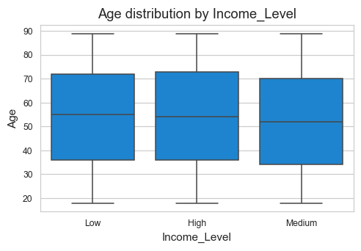
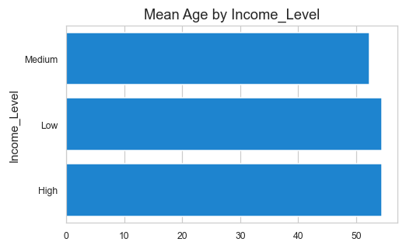
Interpretation:
- The variable 'Age' shows differences across levels of 'Income_Level'.
- Categories with higher means indicate stronger association.
- Eta² = 0.003 (0 = no effect, 1 = strong effect).

Tumor_Size_cm by Region (Eta² = 0.002)
This section compares the numeric variable 'Tumor_Size_cm' across the categories of 'Region'.
A higher Eta² value indicates that the categorical variable 'Region' explains more variation in 'Tumor_Size_cm'.
Group Statistics:
count mean median std
Region
Hovedstaden 581 5.39 5.47 2.65
Midtjylland 624 5.36 5.38 2.69
Nordjylland 621 5.04 4.81 2.74
Sjælland 604 5.20 5.28 2.66
Syddanmark 570 5.14 5.02 2.83
Plot:
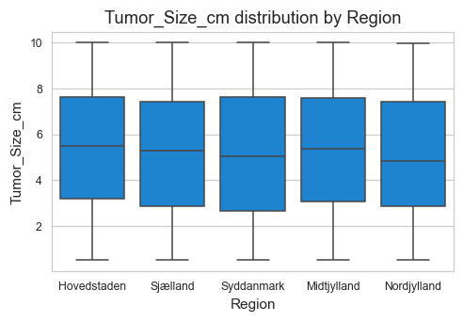
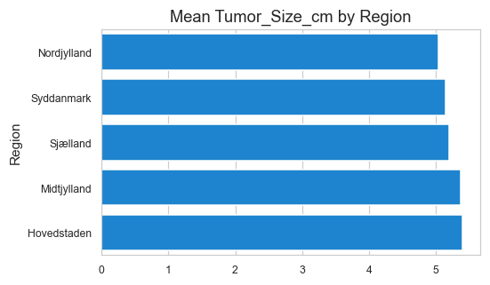
Interpretation:
- The variable 'Tumor_Size_cm' shows differences across levels of 'Region'.
- Categories with higher means indicate stronger association.
- Eta² = 0.002 (0 = no effect, 1 = strong effect).

BMI by Stage (Eta² = 0.002)
This section compares the numeric variable 'BMI' across the categories of 'Stage'.
A higher Eta² value indicates that the categorical variable 'Stage' explains more variation in 'BMI'.
Group Statistics:
count mean median std
Stage
I 755 24.89 24.90 5.08
II 723 24.90 24.90 5.16
III 769 24.93 25.20 5.03
IV 753 25.48 25.40 5.01
Plot:
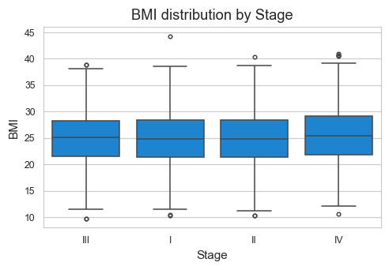
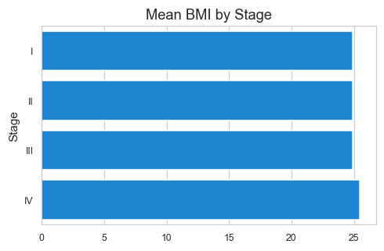
Interpretation:
- The variable 'BMI' shows differences across levels of 'Stage'.
- Categories with higher means indicate stronger association.
- Eta² = 0.002 (0 = no effect, 1 = strong effect).

Patient_ID by Metastasis (Eta² = 0.002)
This section compares the numeric variable 'Patient_ID' across the categories of 'Metastasis'.
A higher Eta² value indicates that the categorical variable 'Metastasis' explains more variation in 'Patient_ID'.
Group Statistics:
count mean median std
Metastasis
No 1494 1,542.99 1,568.50 867.47
Yes 1506 1,458.34 1,436.50 863.10
Plot:
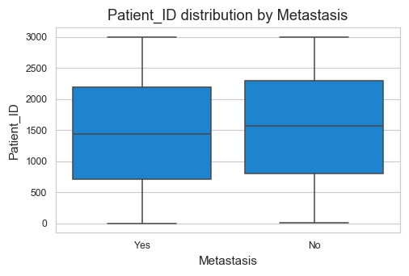
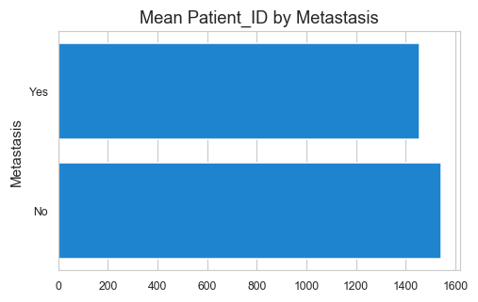
Interpretation:
- The variable 'Patient_ID' shows differences across levels of 'Metastasis'.
- Categories with higher means indicate stronger association.
- Eta² = 0.002 (0 = no effect, 1 = strong effect).

Survival_Months by Comorbidities (Eta² = 0.002)
This section compares the numeric variable 'Survival_Months' across the categories of 'Comorbidities'.
A higher Eta² value indicates that the categorical variable 'Comorbidities' explains more variation in 'Survival_Months'.
Group Statistics:
count mean median std
Comorbidities
Cardiovascular 627 61.31 62.00 33.24
Diabetes 566 58.02 57.50 34.56
Hypertension 617 61.07 62.00 33.69
Multiple 584 57.37 56.00 33.69
Plot:
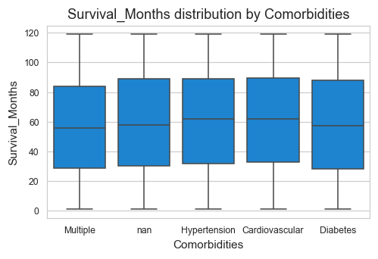
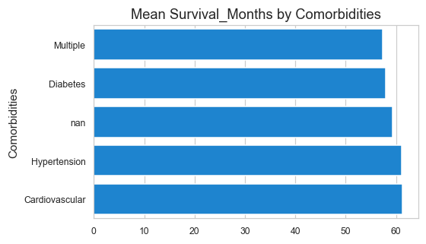
Interpretation:
- The variable 'Survival_Months' shows differences across levels of 'Comorbidities'.
- Categories with higher means indicate stronger association.
- Eta² = 0.002 (0 = no effect, 1 = strong effect).

6. Categorical vs Categorical — Top Associations

Metastasis vs Genetic_Mutation (Cramer's V = 0.051)
This section evaluates the association between two categorical variables:
- Cramer's V ranges from 0 to 1
- 0 = No association
- 1 = Perfect association
A higher value indicates stronger interaction between 'Metastasis' and 'Genetic_Mutation'.
Crosstab Summary:
Genetic_Mutation BRCA1 BRCA2 TP53 nan
Metastasis
No 388 369 341 396
Yes 326 385 402 393
Heatmap:
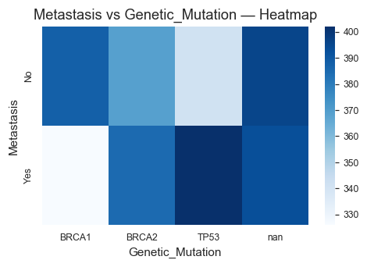
Stacked Bar Chart:

Insight:
- Cramer's V = 0.051 indicates the strength of association.
- The heatmap helps identify concentration patterns.
- Stacked bars show proportional distribution of categories.

Gender vs Alcohol_Consumption (Cramer's V = 0.050)
This section evaluates the association between two categorical variables:
- Cramer's V ranges from 0 to 1
- 0 = No association
- 1 = Perfect association
A higher value indicates stronger interaction between 'Gender' and 'Alcohol_Consumption'.
Crosstab Summary:
Alcohol_Consumption Heavy Moderate nan
Gender
Female 446 515 491
Male 553 488 507
Heatmap:
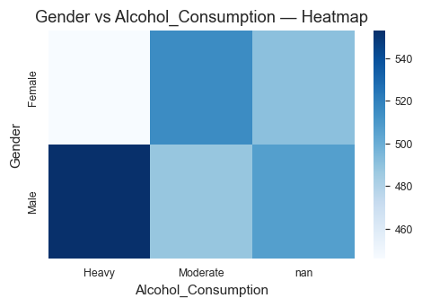
Stacked Bar Chart:

Insight:
- Cramer's V = 0.050 indicates the strength of association.
- The heatmap helps identify concentration patterns.
- Stacked bars show proportional distribution of categories.

Relapse vs Occupation (Cramer's V = 0.047)
This section evaluates the association between two categorical variables:
- Cramer's V ranges from 0 to 1
- 0 = No association
- 1 = Perfect association
A higher value indicates stronger interaction between 'Relapse' and 'Occupation'.
Crosstab Summary:
Occupation Healthcare Manual Labor Office Worker Retired Unemployed
Relapse
No 278 283 303 318 317
Yes 332 301 300 264 304
Heatmap:
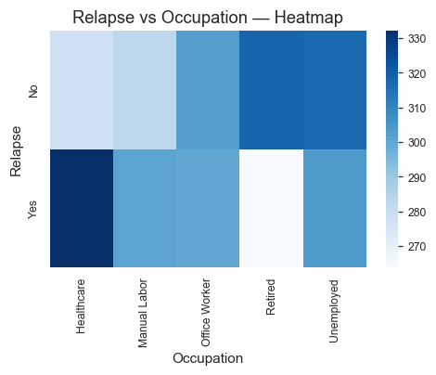
Stacked Bar Chart:

Insight:
- Cramer's V = 0.047 indicates the strength of association.
- The heatmap helps identify concentration patterns.
- Stacked bars show proportional distribution of categories.

Alcohol_Consumption vs Cancer_Type (Cramer's V = 0.046)
This section evaluates the association between two categorical variables:
- Cramer's V ranges from 0 to 1
- 0 = No association
- 1 = Perfect association
A higher value indicates stronger interaction between 'Alcohol_Consumption' and 'Cancer_Type'.
Crosstab Summary:
Cancer_Type Breast Colon Leukemia Lung Prostate Skin
Alcohol_Consumption
Heavy 159 169 163 199 150 159
Moderate 155 158 192 175 169 154
nan 193 179 155 140 169 162
Heatmap:
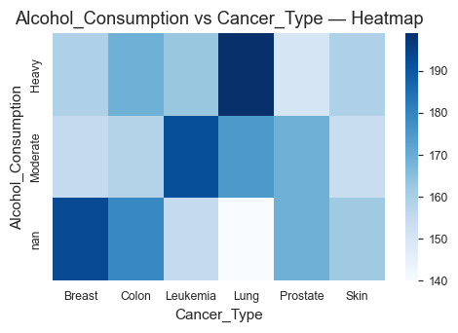
Stacked Bar Chart:

Insight:
- Cramer's V = 0.046 indicates the strength of association.
- The heatmap helps identify concentration patterns.
- Stacked bars show proportional distribution of categories.

Metastasis vs Treatment_Type (Cramer's V = 0.044)
This section evaluates the association between two categorical variables:
- Cramer's V ranges from 0 to 1
- 0 = No association
- 1 = Perfect association
A higher value indicates stronger interaction between 'Metastasis' and 'Treatment_Type'.
Crosstab Summary:
Treatment_Type Chemotherapy Hormone Therapy Immunotherapy Radiation \
Metastasis
No 275 292 313 293
Yes 336 294 299 301
Treatment_Type Surgery
Metastasis
No 321
Yes 276
Heatmap:
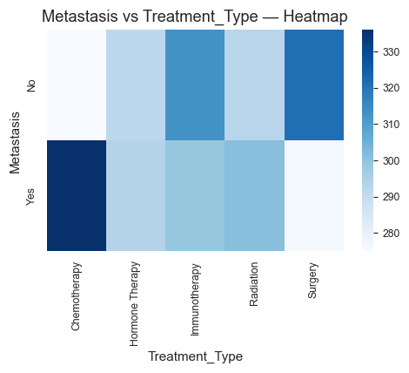
Stacked Bar Chart:

Insight:
- Cramer's V = 0.044 indicates the strength of association.
- The heatmap helps identify concentration patterns.
- Stacked bars show proportional distribution of categories.

Relapse vs Comorbidities (Cramer's V = 0.043)
This section evaluates the association between two categorical variables:
- Cramer's V ranges from 0 to 1
- 0 = No association
- 1 = Perfect association
A higher value indicates stronger interaction between 'Relapse' and 'Comorbidities'.
Crosstab Summary:
Comorbidities Cardiovascular Diabetes Hypertension Multiple nan
Relapse
No 316 300 289 272 322
Yes 311 266 328 312 284
Heatmap:
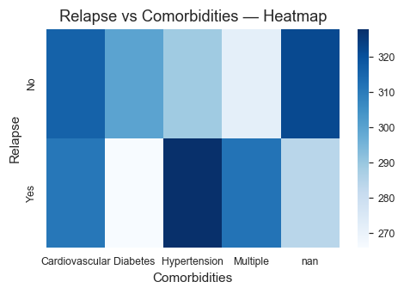
Stacked Bar Chart:

Insight:
- Cramer's V = 0.043 indicates the strength of association.
- The heatmap helps identify concentration patterns.
- Stacked bars show proportional distribution of categories.

Gender vs Income_Level (Cramer's V = 0.042)
This section evaluates the association between two categorical variables:
- Cramer's V ranges from 0 to 1
- 0 = No association
- 1 = Perfect association
A higher value indicates stronger interaction between 'Gender' and 'Income_Level'.
Crosstab Summary:
Income_Level High Low Medium
Gender
Female 483 444 525
Male 518 534 496
Heatmap:
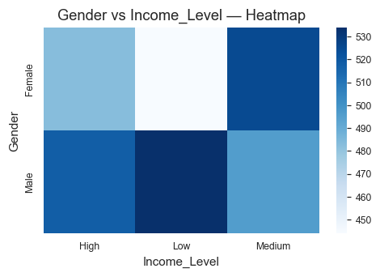
Stacked Bar Chart:

Insight:
- Cramer's V = 0.042 indicates the strength of association.
- The heatmap helps identify concentration patterns.
- Stacked bars show proportional distribution of categories.

Genetic_Mutation vs Income_Level (Cramer's V = 0.041)
This section evaluates the association between two categorical variables:
- Cramer's V ranges from 0 to 1
- 0 = No association
- 1 = Perfect association
A higher value indicates stronger interaction between 'Genetic_Mutation' and 'Income_Level'.
Crosstab Summary:
Income_Level High Low Medium
Genetic_Mutation
BRCA1 222 237 255
BRCA2 248 232 274
TP53 276 257 210
nan 255 252 282
Heatmap:
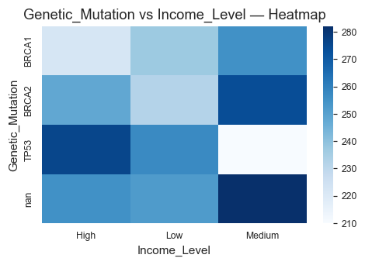
Stacked Bar Chart:

Insight:
- Cramer's V = 0.041 indicates the strength of association.
- The heatmap helps identify concentration patterns.
- Stacked bars show proportional distribution of categories.

7. Insights & Conclusion
This hybrid report highlights the most impactful relationships while remaining compact (50–60 pages).
Use this report as a foundation for deeper modeling or domain-level interpretation.

