Lab02: Identifying and Preventing Phishing Attacks
Student: Mohammed Moiz Uddin Id: 35260388
Environment: Kali Linux (VirtualBox), Social-Engineering Toolkit (SET), Firefox ESR

1. Objective
Simulate a credential-harvesting phishing attack using SET's Site Cloner against a local test login form (login.html), capture submitted credentials, and analyze the indicators that would let a victim identify the page as fraudulent.

2. Methodology
- Created a minimal login.html test form (username/password fields, POST method) and served it locally via python3 -m http.server 8080, since SET's Site Cloner performs an HTTP fetch and cannot ingest a file:// path directly — the assignment's suggested file:///home/youruser/login.html input fails with “Error. Unable to clone this specific site” in current SET builds.
- Launched setoolkit → Social-Engineering Attacks → Website Attack Vectors → Credential Harvester Attack Method → Site Cloner.
- Supplied the local network IP (192.168.56.101) as the POST-back address, and http://127.0.0.1:8080/login.html as the clone source.
- SET cloned the page successfully and began listening on port 80.
- Visited http://192.168.56.101/ in Firefox (simulating the victim), entered test credentials, and submitted the form.
- SET captured the submitted fields and the browser was redirected back to the original clone source (127.0.0.1:8080) — mirroring how real phishing kits forward victims to a legitimate-looking destination after harvesting.
- Repeated the capture to confirm consistent results, then terminated the harvester with Ctrl+C to generate SET's session report.

3. Evidence

3.1 Screenshot — Fake Login Page
The page is reachable at http://192.168.56.101/ — a bare IP address with no HTTPS, served by SET's cloned harvester rather than the legitimate source.
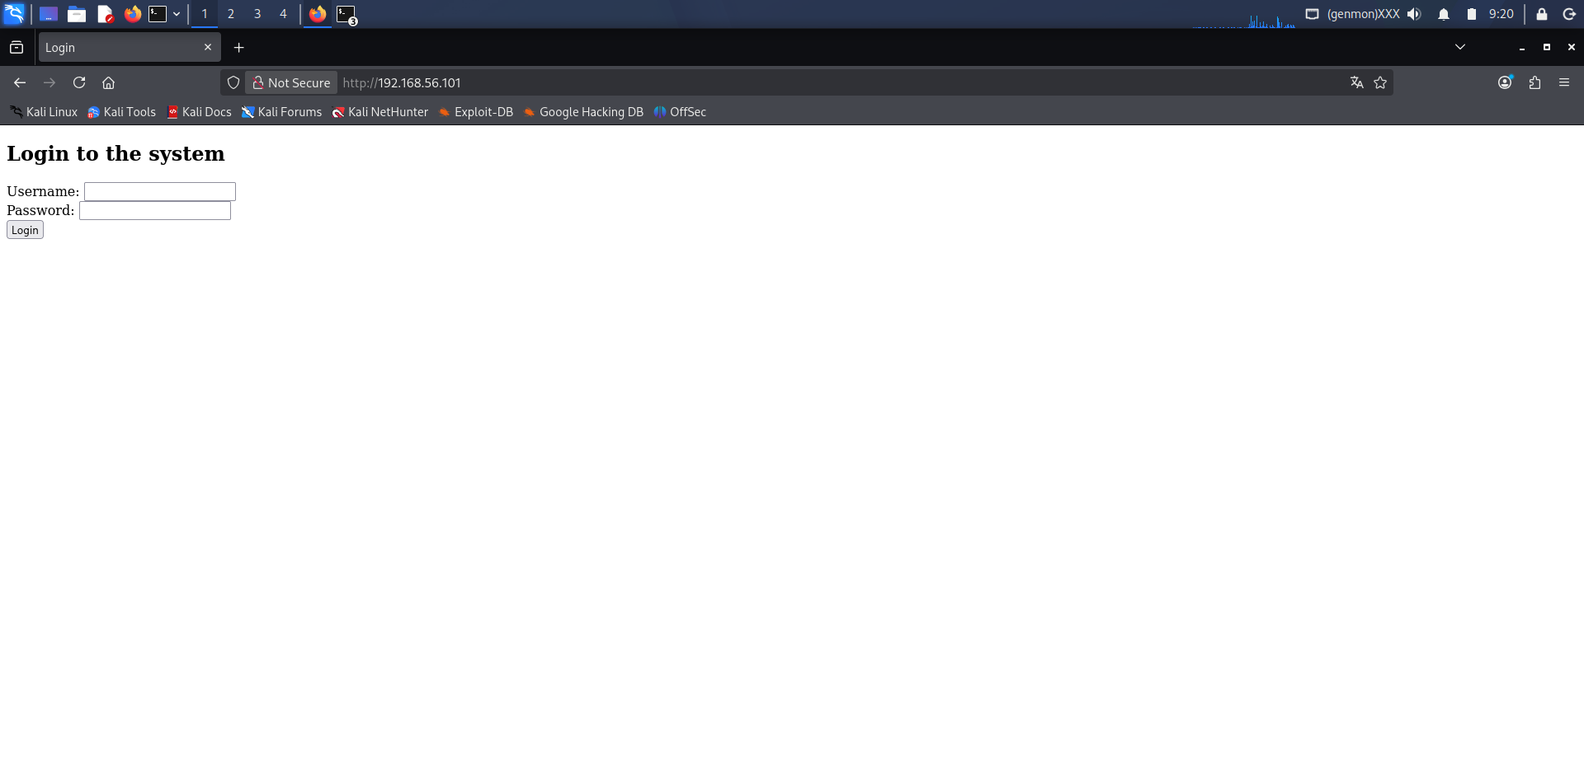
Figure 1. Fake login page served by SET's Credential Harvester at http://192.168.56.101/

3.2 Screenshot — Terminal with Captured Data
SET's output confirms the harvested fields:
[*] WE GOT A HIT! Printing the output:
POSSIBLE USERNAME FIELD FOUND: username=test
POSSIBLE PASSWORD FIELD FOUND: password=password123
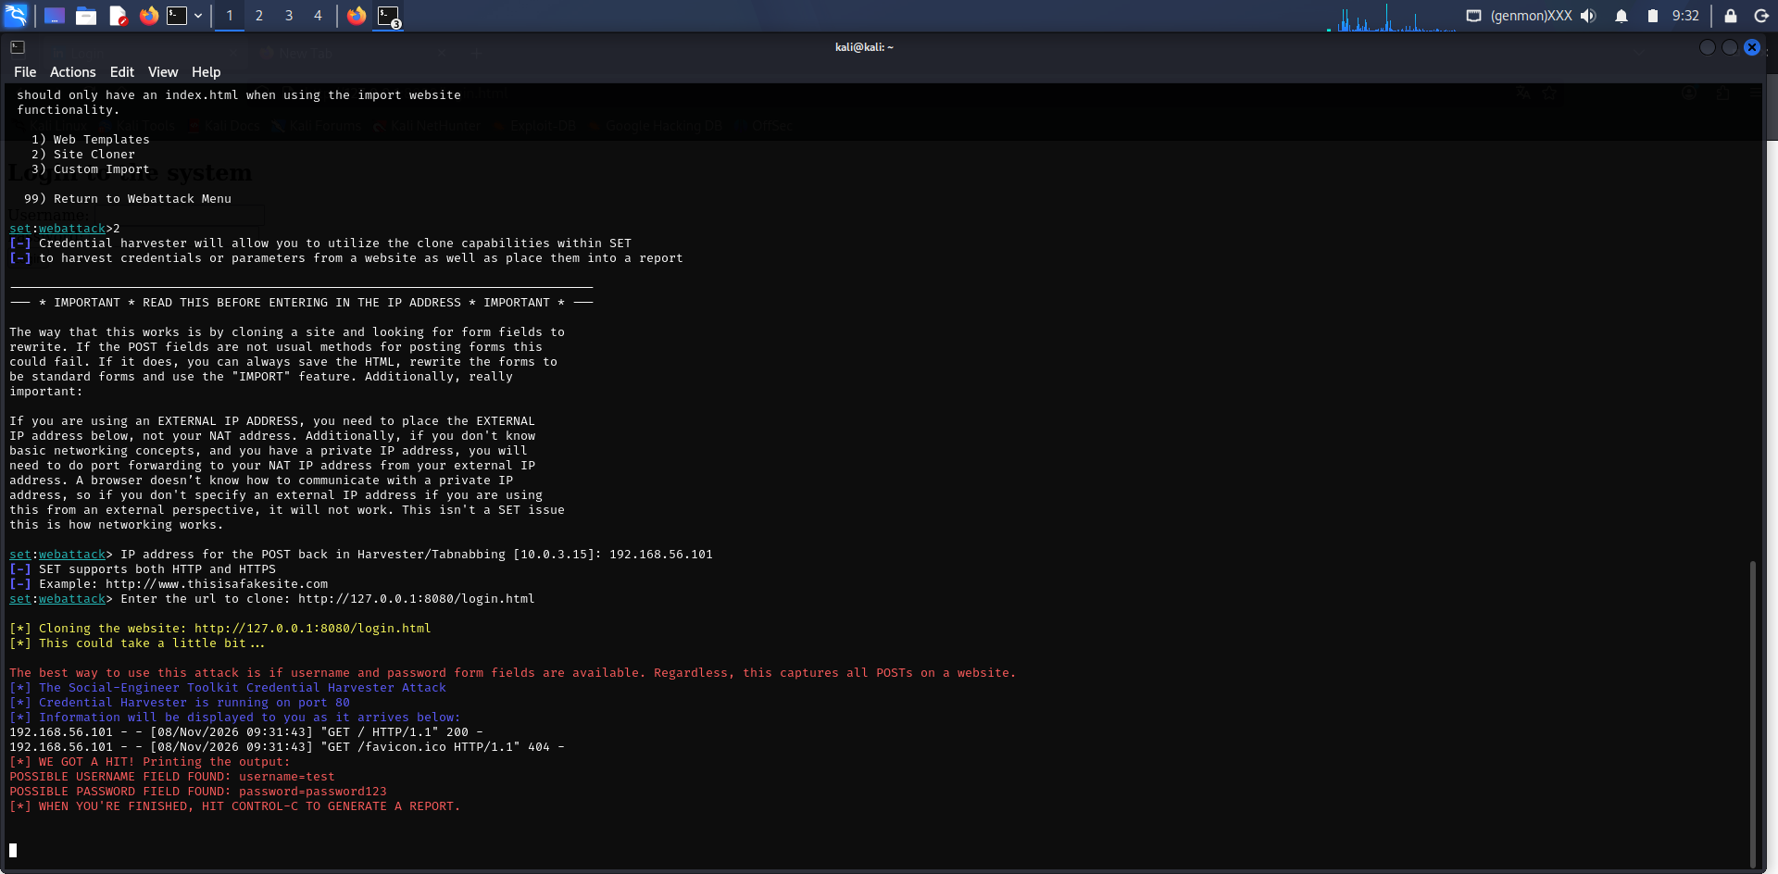
Figure 2. SET terminal showing captured credentials from the harvester.

4. How the Victim Would Recognize That It is a Phishing Page
- No real domain name — the address bar shows a bare IP address (192.168.56.101) instead of a recognizable company domain such as login.mybank.com.
- “Not Secure” warning — Firefox explicitly flags the connection, since the page is served over plain HTTP with no TLS certificate.
- No branding or styling — the form is unstyled, generic HTML with no logos, colors, or layout matching a real organization's site.
- Unexpected post-submit redirect — after logging in, the victim is silently bounced to a different address (127.0.0.1:8080) rather than landing on an expected dashboard.
- No certificate to inspect — clicking the padlock/shield icon shows no organization or certificate authority information.

5. Reflection and Analysis

5.1 What are the characteristics of phishing pages?
- Mismatched, misspelled, or unusually formatted URLs (e.g., paypa1.com, IP addresses instead of domains, excessive subdomains, lookalike characters).
- Missing or invalid HTTPS/TLS certificates, or certificates issued for a different domain than the one displayed.
- Generic, outdated, or slightly-off branding compared to the real site.
- Urgent or alarming language pressuring the user to act immediately (“your account will be suspended”).
- Requests for information a legitimate login page wouldn't normally need up front.
- Poor grammar, spelling errors, or inconsistent formatting.
- Links that don't match their displayed text when hovered over.
- No way to navigate the rest of the “site” — phishing clones are often a single isolated page.

5.2 How would you protect yourself from such an attack?
- Check the URL and domain carefully before entering credentials — type known addresses directly or use saved bookmarks rather than clicking email/SMS links.
- Confirm HTTPS is present and that the certificate matches the expected organization.
- Use a password manager — it will not auto-fill credentials on a domain it doesn't recognize.
- Enable multi-factor authentication (MFA) so a stolen password alone isn't sufficient to compromise the account.
- Be skeptical of urgent or unsolicited login prompts, especially from email or SMS links.
- Keep browser phishing/malware protection enabled (e.g., Google Safe Browsing, Microsoft SmartScreen).
- Report suspicious pages so they can be blocklisted for other users.

5.3 Why do modern sites make such attacks more difficult?
- Enforced HTTPS and HSTS, which make unencrypted clones immediately visible as insecure.
- Browser-integrated phishing blocklists (Safe Browsing, SmartScreen) that flag or block known malicious domains.
- Multi-factor authentication, which reduces the value of a harvested password alone.
- FIDO2/WebAuthn and passkeys, cryptographically bound to the legitimate origin — they simply won't work on a cloned domain.
- Email authentication standards (SPF, DKIM, DMARC) that make phishing emails harder to spoof convincingly.
- Certificate Transparency logs and automated takedown services that help identify and shut down phishing domains faster.
- Consistent, well-established branding and domain history, which makes a hastily cloned page easier for a cautious user to spot as “off.”

6. Conclusion
This laboratory exercise demonstrated how phishing pages can imitate legitimate login interfaces and how submitted information may be exposed through insecure web forms. The experiment highlighted the importance of verifying URLs, identifying suspicious login pages, and using modern authentication mechanisms such as MFA and passkeys. The practical demonstration was performed in a controlled local environment using dummy credentials for educational purposes.

