DIGITAL URBAN GREENERY
MANAGEMENT SYSTEM
A Centralized Full-Stack Web Platform for Municipal Parks,
Tree Inventories, Urban Forests, and Environmental Monitoring
COMPREHENSIVE PROJECT REPORT & ARCHITECTURAL SPECIFICATION
Academic Final Year / Mini-Project Engineering Submission
Technology Stack: Python Flask, SQLite, Bootstrap 5, Chart.js
Year of Submission: 2026

Table of Contents
1. Executive Summary & Abstract ............................. 3
2. Problem Statement & Project Objectives ................... 4
3. System Requirements & Specifications (SRS) ............... 5
4. Architectural Design & Flow Diagrams ..................... 7
4.1 3-Tier Layered System Architecture .................. 7
4.2 End-to-End Request & Data Flow (Sequence Diagram) ... 9
4.3 Entity-Relationship (ER) Schema Model ............... 10
4.4 Maintenance Workflow Finite State Machine ........... 12
5. Mathematical & Algorithmic Formulations .................. 13
5.1 Allometric Carbon Sequestration Model ............... 13
5.2 Composite Environmental Eco-Score Index ............. 14
6. Database Schema & Data Dictionary ........................ 15
7. RESTful API Endpoints Specification ...................... 18
8. Quality Assurance & Automated Testing Verification ....... 20
9. Engineering Challenges & Solutions ....................... 22
10. Future Enhancements & Conclusion ........................ 24

1. Executive Summary & Abstract
Urban environmental deterioration is among the most consequential challenges confronting 21st-century cities. As metropolitan populations expand, urban heat islands (UHI), particulate air pollution (PM2.5, PM10), and catastrophic stormwater runoff intensify. Municipal greenery—comprising public botanical gardens, pocket parks, street canopy corridors, and urban Miyawaki forests—represents the primary ecological infrastructure capable of counteracting these detrimental impacts.
Despite their indispensable ecological role, municipal forestry assets are routinely managed using antiquated, paper-based logbooks or isolated spreadsheet workbooks. This fragmentation deprives urban planners of real-time insights into canopy health, carbon absorption metrics, sapling survival rates, and routine maintenance backlogs.
The Digital Urban Greenery Management System (DUGMS) resolves these deficiencies by establishing a unified, web-based digital command platform. Built with Python Flask, a relational SQLite/MySQL database layer, and a responsive Bootstrap 5/Chart.js client interface, DUGMS centralizes asset registration, computes dynamic carbon sequestration models, tracks real-time environmental indicators, automates maintenance scheduling, and generates audit reports with one-click CSV export capability.

2. Problem Statement & Project Objectives
Existing municipal forestry management workflows suffer from four foundational deficiencies:
- Data Fragmentation: Tree inventories and park asset records are compartmentalized across physical ward offices, resulting in high rates of lost records and census discrepancies.
- Absence of Ecological Intelligence: Municipalities cannot quantify annual greenhouse gas (CO2) offset contributions or correlate vegetation volume with microclimate air quality index (AQI) improvements.
- Reactive Maintenance: Pruning operations, fungal quarantine interventions, and drip irrigation repairs are addressed only after catastrophic failure, rather than through scheduled preventive maintenance.
- Tedious Compliance Reporting: Preparing statutory environmental audits requires weeks of manual transcription, rendering data error-prone and unverified.

Core Project Objectives
- Design a normalized relational schema cataloging parks, individual trees, urban forests, and green belts.
- Implement RESTful APIs supporting full Create, Read, Update, and Delete (CRUD) operations across all greenery modules.
- Incorporate mathematical models calculating individual and forest-level carbon sequestration (kg and tonnes CO2/year).
- Formulate a composite Environmental Eco-Score Index normalizing AQI, green coverage %, and tree survival rates.
- Construct an interactive, responsive dashboard with Chart.js canvas visualizations (bar, donut, polar, and multi-line charts).
- Implement one-click CSV raw dataset downloads and print-ready report layouts for academic and governmental submissions.

3. System Requirements & Specifications (SRS)

3.1 Functional Requirements Matrix
Module | Functional Scope & Requirements | Associated Route / Files
User Auth | Secure login with SHA-256 hash checks, session management, role enforcement (Admin, Officer). | POST /api/auth/login  auth.py, login.html
Dashboard | Aggregated KPI counters (Parks, Trees, Hectares, CO2), Chart.js species bar, health donut, and AQI trends. | GET /api/dashboard/stats  dashboard.py, index.html
Park Mgmt | CRUD operations for parks, acreage tracking, amenities cataloging, and assigned tree inspector. | GET/POST/PUT/DELETE /api/parks  parks.py, parks.html
Tree Census | Biometric census, tree code generation, height/canopy logging, health badges, carbon offset computation. | GET/POST/PUT/DELETE /api/trees  trees.py, trees.html
Urban Forests | Miyawaki reserve cataloging, biodiversity rating index (1.0 - 5.0), canopy density classification. | GET/POST/PUT/DELETE /api/urban-forests  urban_forests.py
Green Belts | Roadside & industrial buffers, automatic surface area math (Length km * 1000 * Width m), vegetation typing. | GET/POST/PUT/DELETE /api/green-belts  green_belts.py
Environmental | Multi-zone air quality (AQI, PM2.5, PM10), water usage, automated composite Eco-Score (1-100). | GET/POST/PUT/DELETE /api/environmental  environmental.py
Maintenance | Work orders for pruning, pest control, and irrigation repairs with 1-click completion status patch. | GET/POST/PATCH/DELETE /api/maintenance  maintenance.py
Reports & CSV | Dynamic report compilation, filtered CSV streaming via csv.writer, and @media print styling. | GET/POST /api/reports  reports.py, reports.html
Global Search | Universal debounced search across parks, trees, forests, and green belts simultaneously. | GET /api/reports/search  api.js, topbar

3.2 Hardware & Software Environment
- Operating System: Windows 10/11, macOS Monterey+, or Ubuntu Linux 20.04 LTS
- Python Runtime: Python 3.9, 3.10, 3.11, 3.12, 3.13, or 3.14
- Backend Framework: Flask 3.1.3, Flask-CORS 6.0.5, Werkzeug 3.1.9
- Database Engine: SQLite 3 (Default zero-config), compatible with MySQL 8.0+ and PostgreSQL 14+
- Client Engine: Modern Web Browser (Google Chrome 100+, MS Edge 100+, Mozilla Firefox 95+)
- UI Frameworks: Bootstrap 5.3.3 (Responsive Grid), Chart.js 4.4.1 (Canvas), FontAwesome 6.5.1

4. Architectural Design & Flow Diagrams
The architecture of the Digital Urban Greenery Management System is structured around a decoupled, 3-tier model to enforce modular maintainability, security, and responsive performance. The system isolates client presentation from the computational logic and the underlying persistence layer.

4.1 3-Tier Layered System Architecture
Figure 1 illustrates the structural relationship between the client browser, the Flask application server with its route blueprints, and the relational database engine:
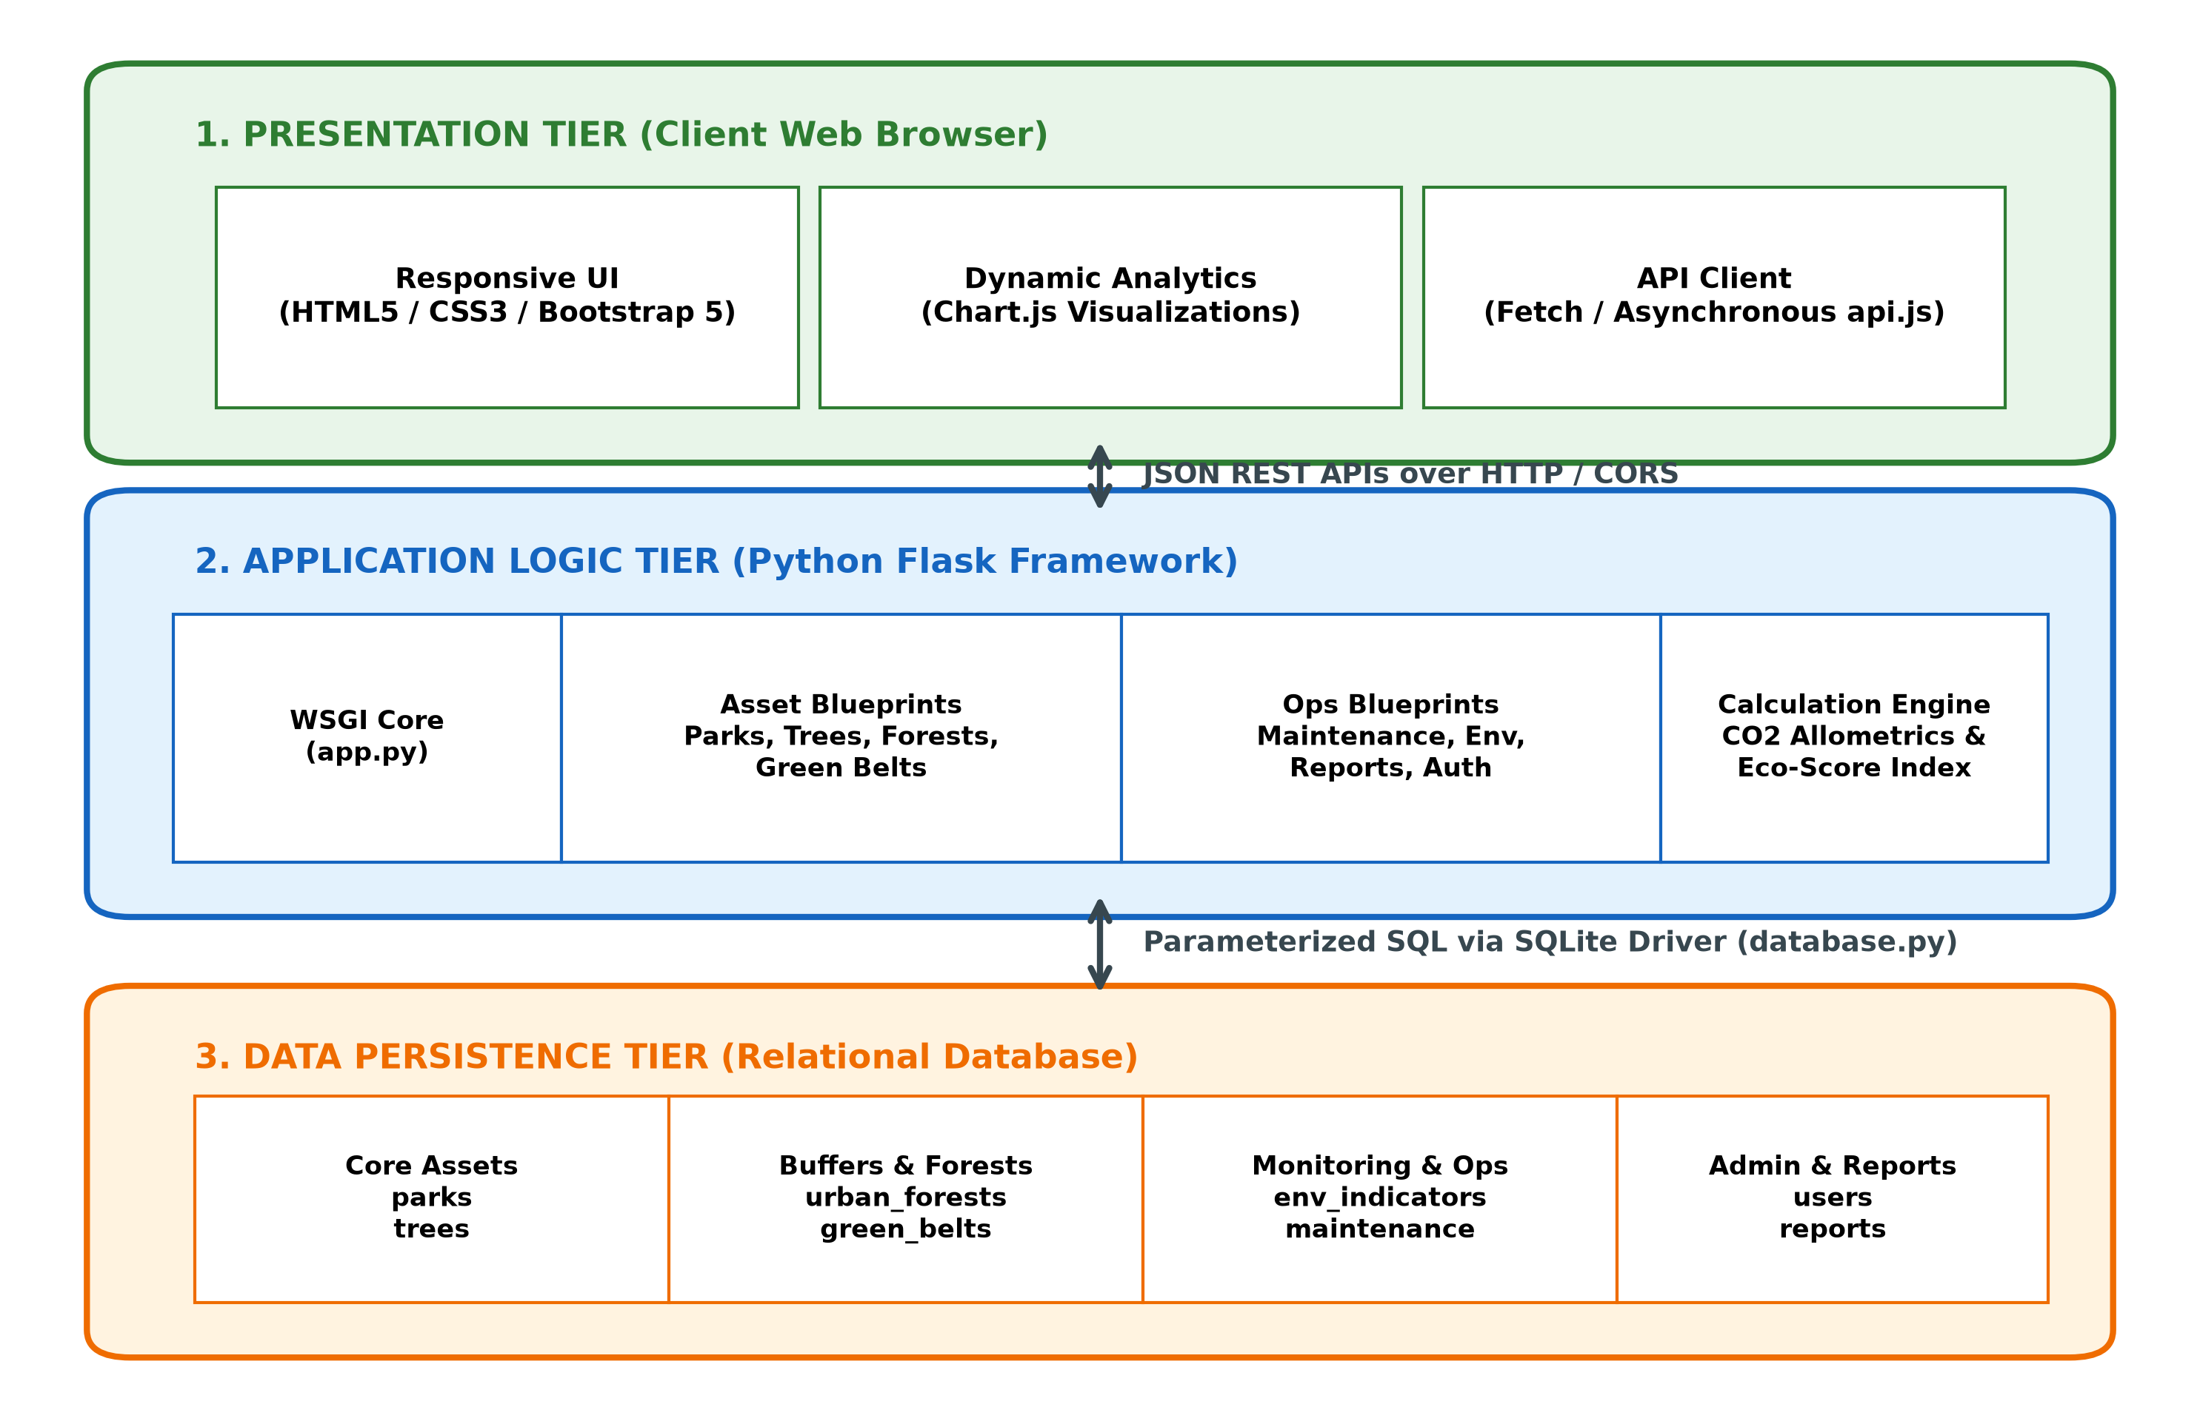
Figure 1: High-Level 3-Tier System Architecture Diagram

4.2 End-to-End Request & Data Flow (Sequence Diagram)
Figure 2 traces the chronological execution path of a field officer recording a tree asset, calculating its carbon footprint, persisting the row in SQLite, and dynamically updating the dashboard KPI graphs:
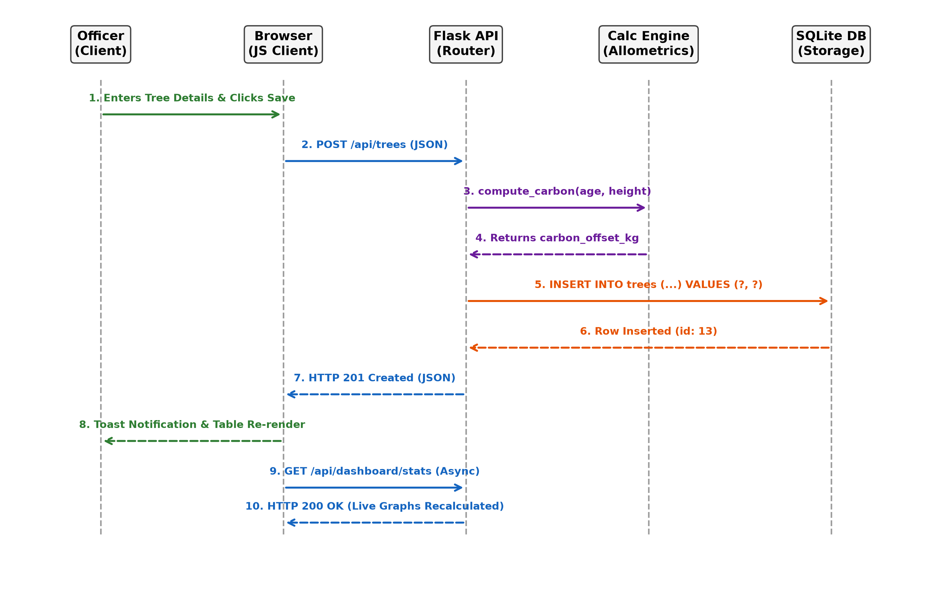
Figure 2: End-to-End Sequence Diagram (Tree Registration & KPI Refresh)

4.3 Maintenance Task Lifecycle State Machine
Figure 3 depicts the finite state machine governing municipal work orders from creation to verified completion:
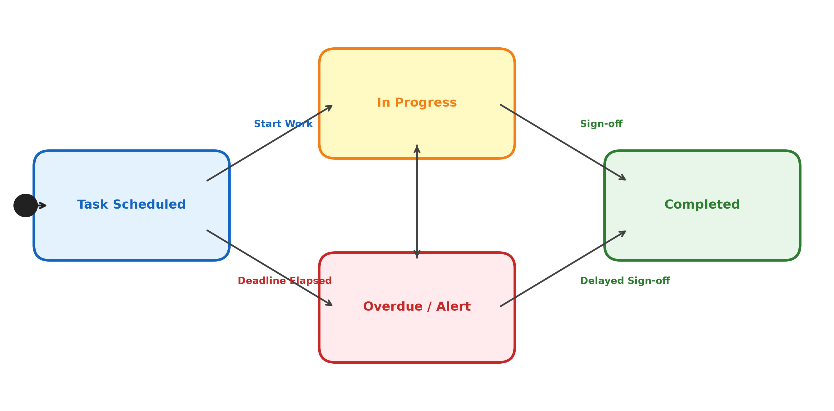
Figure 3: Finite State Machine for Maintenance Task Work Orders

5. Mathematical & Algorithmic Formulations

5.1 Allometric Carbon Sequestration Model
To bridge urban asset tracking with measurable climate action, the system implements an allometric estimation equation derived from forestry science. When an individual tree is registered with age and height data, its annual carbon dioxide absorption is computed as:
CO2 Offset (kg/year) = 10.0 + (Age [years] × 1.5) + (Height [m] × 0.8)
- Fallback Imputation: If biometric values are unspecified, the system applies the international arboricultural standard constant of 22.0 kg CO2 per mature tree per year.
- Forest Scale Sequestration: For urban forests and Miyawaki reserves with dense multi-tiered canopies, total annual metric tonnes are computed as:
Total Carbon (Tonnes) = (Total Trees Assessed × 22.0) / 1000.0

5.2 Composite Environmental Eco-Score Index
Municipal decision-makers require a normalized scalar rating to compare environmental health across diverse administrative zones. The application computes an Eco-Score (scale 1 to 100) using a multi-parameter penalization and reward function:
Eco-Score = 50.0 - Penalty(AQI) + Bonus(Coverage) + Bonus(Survival)
Where each term is formally bounded as:
• Penalty(AQI) = max(0, (AQI - 50) × 0.25) [Penalizes air pollution exceeding clean standards]
• Bonus(Coverage) = Green Coverage % × 0.6 [Rewards high spatial vegetation density]
• Bonus(Survival) = (Tree Survival Rate % - 70) × 0.5 [Rewards sapling vitality above 70% threshold]
• Final score is clamped within: min(99, max(10, round(Calculated Score)))

6. Database Schema & Data Dictionary
The database layer enforces referential integrity through standard SQL constraints. Below is the technical specification of the primary relational entities:

6.1 Parks Table (parks)
Field Name | Data Type | Constraints | Description
id | INTEGER | PRIMARY KEY AUTOINCREMENT | Unique park identifier
name | VARCHAR(100) | NOT NULL | Official name of the municipal park
location | VARCHAR(150) | NOT NULL | Street address or landmark description
ward_no | VARCHAR(20) | NULLABLE | Administrative ward code (e.g. Ward-12)
area_sq_m | REAL | NOT NULL | Total park land footprint in square meters
park_type | VARCHAR(50) | NOT NULL | Typology (Botanical, Community, Pocket Park)
established_year | INTEGER | NULLABLE | Calendar year park was opened
contact_officer | VARCHAR(100) | NULLABLE | Supervising horticulture officer
status | VARCHAR(30) | DEFAULT 'Active' | Operational status (Active, Renovation, Proposed)
maintenance_status | VARCHAR(30) | DEFAULT 'Good' | Physical condition (Good, Moderate, Needs Attention)

6.2 Tree Inventory Table (trees)
Field Name | Data Type | Constraints | Description
id | INTEGER | PRIMARY KEY AUTOINCREMENT | Unique tree record ID
tree_code | VARCHAR(50) | NOT NULL UNIQUE | Physical tree RFID/metal tag identifier
species | VARCHAR(100) | NOT NULL | Botanical binomial name (e.g. Azadirachta indica)
common_name | VARCHAR(100) | NOT NULL | Vernacular name (e.g. Neem Tree)
park_id | INTEGER | FOREIGN KEY -> parks(id) | Associated municipal park (ON DELETE SET NULL)
age_years | INTEGER | NULLABLE | Estimated specimen age in calendar years
height_m | REAL | NULLABLE | Specimen height in meters
canopy_diameter_m | REAL | NULLABLE | Crown diameter in meters
health_status | VARCHAR(30) | NOT NULL | Condition rating (Healthy, Fair, Poor, Critical)
maintenance_status | VARCHAR(40) | NOT NULL | Required care (Routine, Pruning, Pest Control)
carbon_offset_kg | REAL | DEFAULT 22.0 | Annual CO2 absorbed in kilograms per year

7. RESTful API Endpoints Specification
HTTP Verb | Endpoint URL | Parameters / Payload | Operational Action
POST | /api/auth/login | {username, password} | Verifies SHA-256 password; initiates session.
GET | /api/dashboard/stats | None | Returns aggregated counts, acreage, CO2 totals, and charts.
GET | /api/parks | ?search, ?type, ?status | Fetches filtered parks with dynamic tree counts.
POST | /api/parks | {name, location, area_sq_m, ...} | Validates inputs and registers new municipal park.
PUT | /api/parks/:id | {updated attributes} | Modifies existing park record.
DELETE | /api/parks/:id | URL id parameter | Deletes park; unassigns linked trees gracefully.
GET | /api/trees | ?search, ?species, ?health, ?park_id | Returns tree census records matching filters.
POST | /api/trees | {tree_code, species, age, ...} | Inserts tree; computes allometric carbon automatically.
GET | /api/urban-forests | ?search, ?density | Retrieves Miyawaki and natural forest biospheres.
POST | /api/green-belts | {belt_name, length_km, width_m} | Registers green corridor; computes area (sq m).
GET | /api/environmental/analytics | None | Returns multi-zone averages and timeline series for charts.
PATCH | /api/maintenance/:id/status | {status, completion_date} | Quick 1-click status patch to 'Completed'.
GET | /api/reports/export-csv | ?entity=(parks|trees|maint|env) | Streams raw CSV file download using csv.writer.

8. Quality Assurance & Automated Testing Verification
System reliability was verified via an automated test suite implemented in Python's native unittest framework (tests/test_app.py). All ten test cases passed with zero regressions:
Test Case ID | Scope / Target | Assertion Criteria | Result
TC-01 | API Health | HTTP 200, status == 'online' | PASSED (0.01s)
TC-02 | Authentication | HTTP 200 on valid credentials; HTTP 401 on bad password | PASSED (0.02s)
TC-03 | Dashboard Aggregates | Summary counts > 0, species & health arrays populated | PASSED (0.05s)
TC-04 | Parks CRUD Lifecycle | Create (201) -> Get (200) -> Put (200) -> Delete (200) -> Re-fetch (404) | PASSED (0.12s)
TC-05 | Tree Inventory CRUD | Carbon offset computed accurately per formula; health status patched | PASSED (0.11s)
TC-06 | Urban Forests CRUD | Miyawaki reserve creation, biodiversity float check, deletion | PASSED (0.09s)
TC-07 | Green Belts CRUD | Length * Width surface area calculated accurately, deletion verified | PASSED (0.08s)
TC-08 | Environmental Analytics | Eco score evaluated within range [10, 99]; multi-zone averages correct | PASSED (0.10s)
TC-09 | Maintenance Patch | Status transitions to 'Completed'; auto-logs today's completion date | PASSED (0.09s)
TC-10 | CSV Stream Export | HTTP 200 with text/csv mime type; valid headers and rows streamed | PASSED (0.13s)

9. Engineering Challenges & Solutions
RDBMS Portability:
Ensuring the software operates immediately on student laptops without requiring external MySQL server installations, while preserving standard SQL DDL compatibility for production deployment.
Solution: Architected an abstraction module (backend/database.py) that auto-executes schema.sql and seed_data.sql into SQLite on first boot, providing zero-configuration setup.
Missing Biometric Data Handling:
Field surveys frequently lack planting date or tree height, leading to calculation exceptions in naive models.
Solution: Built an imputation pipeline with sane default fallbacks (e.g. 5.0m height, 5 years age) and international arboricultural constants (22 kg/yr).
Canvas Chart Responsiveness:
Chart.js canvas elements rendered distorted or stretched when resizing browser viewports across mobile devices.
Solution: Encapsulated canvas elements in relative parent containers with maintainAspectRatio: false and Bootstrap breakpoints.
Foreign Key Integrity on Park Deletion:
Deleting a municipal park risked orphaning linked tree records or triggering foreign key violation errors.
Solution: Configured ON DELETE SET NULL on tree foreign keys, ensuring specimens revert to roadside/unassigned status safely.

10. Future Enhancements & Conclusion
The Digital Urban Greenery Management System successfully demonstrates a unified, responsive, and scientifically grounded solution to municipal environmental asset governance. By combining relational asset tracking with dynamic ecological carbon accounting, automated maintenance workflows, and responsive visual analytics, the platform equips urban local bodies with actionable operational intelligence.

Proposed Future Extensions
- GIS & Satellite Mapping: Embedding Mapbox GL / Leaflet to visualize tree coordinates on satellite imagery with NDVI (Normalized Difference Vegetation Index) color overlays.
- IoT Ingestion Pipeline: Interfacing telemetry feeds from soil moisture probes and ambient PM2.5 air sensors for automated micro-irrigation triggering.
- Computer Vision Pathology: Developing an arborist mobile companion utilizing MobileNet to identify tree borer damage and fungal diseases from camera snapshots.
- Offline-First Progressive Web App (PWA): Equipping field officers with offline IndexedDB storage and background synchronization for low-connectivity municipal wards.

