


[Aire]

Airlines Data Model
[Aire]
D,m,m n,[Aire]

Prepared by:
- Ahmed Ehsan.
- Omar Zaid.
- Mohammed Nabil.
- Aya Medhat.

Prepared For:
Eng/ Nada Fath_Allah

Table Of Contents:

- Business Processes.
- Model Design
- Logical Model.
3.1 Grain.
3.2 Dimension Tables.
3.3 Fact Tables.
- Physical Model. (Attached With Project)
- Bussines Analysis By SQL Queries.
- Indexing Report. (Attached)

1-Business process

- Improving the current business process as we need to focus on the flight activity.
- Improving the company profit through the booking process.
- Improving customer care service through tracking clients feedback.
- Model Design

We chose Kimbull Approach to build our model. We needed to get up and running to deliver results ASAP. Our intention was to have the capability to increment our model step by step in the future while having a user friendly interface for quick reporting and self-service reporting.

We used galaxy schema to answer several business questions.
- Logical Model.

3.1 Grain:
- per flight reservation

3.2 Dimension Tables.
Passenger dimension :represents personal data about each passenger
Frequent Flyer Dimension: represents the passengers who subscribed to the loyalty program which is correlated with miles earned.
Aircraft dimension :represents data about aircrafts model and capacity
Flight dimension: focus on each flight distance and airports.
Date dimension: represent date, date of week, date of month, date of year, month number, quarter, year.
Time dimension:general timing of general day
Fare base dimension: represent the actual value of the ticket considering the flight and the class type.
Reservation channel dimension: represents the different channels a passenger can making a reservation from like
OTA → online travel agency ( 8%)
directly from the airline (0% share rate)
Directly from the airport ( 3% share rate)
Class type dimension: represent whether the passenger sat in economy, business, business economy or first class.
Also track the upgrade or downgrade of the reserved class .

Hotel dimension: represent information about the hotel that the passenger spends a number of nights in.
Interaction type dimension: represent the time of feedback , complaint,inquiries before/after/within the flight.

3.3 Fact Tables

Flight activity fact:

- Represent information about Reservation (ticket number and date of reservation)
- Fair base revenue
- Airport tax (2-14%)
- Baggage charges
- Upgrade fees ( in case of upgrade + , downgrade -)
- Earned miles

Overnight stay fact:
- represent the details of the date of arrival, departure and reservation about passengers who spend a number of nights in a hotel.
- Also display the room charges.

Customer care fact:
- Table to calculate the average rate from passengers about our different services .
Frequent Promotion Factless table:
- To represent number of frequent flyers who do not respond to the promotion events .
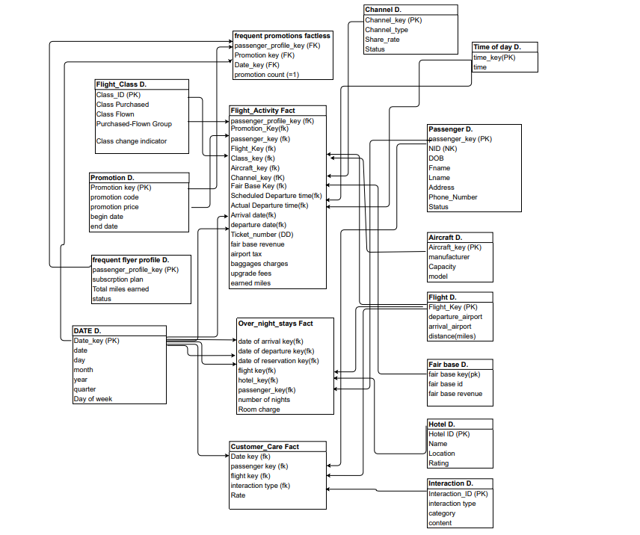

5-Bussines Analysis By SQL Queries.

Q1)how many miles passengers earn

SELECT PASSENGER_key,SUM(earned_miles) AS EARN
FROM FLIGHT_ACTIVITies
GROUP BY PASSENGER_key;
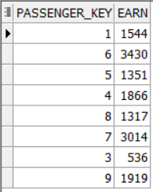

Q2) What are the top frequent destinations ?
Select f.arrival_airport, count(*)
From flight_activities fa join flight f on
fa.flight_key=f.flight_key
Group by f.arrival_airport
Order by count(*) desc ;

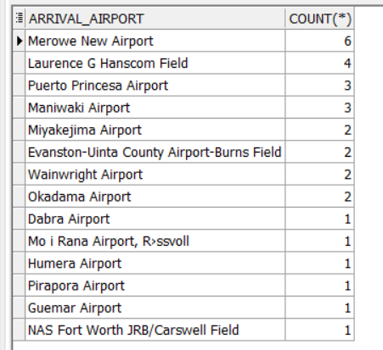

Q3) what is the most frequent channel used by passengers ?

Select c.channel_type, count(*)
From flight_activities fa join channel c on
fa.channel_key=c.channel_key
Group by c.channel_type
Order by count(*) desc ;

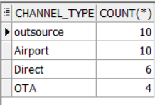

Q4) what is the average rate for the negative comments?

Select avg(cc.rate)
From customer_care cc join interaction i
On cc.interaction_id=i.interaction_id
Where i.Type='Negative';

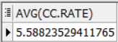

Q5) what is the average number of overnights for frequent users ?

Select avg(Number_of_nights)
From Over_Night_Stay_New;
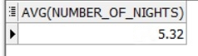

Q6) What is the average room charge the company pays for overnight ?
Select avg(room_charge)
From Over_Night_Stay_New ;

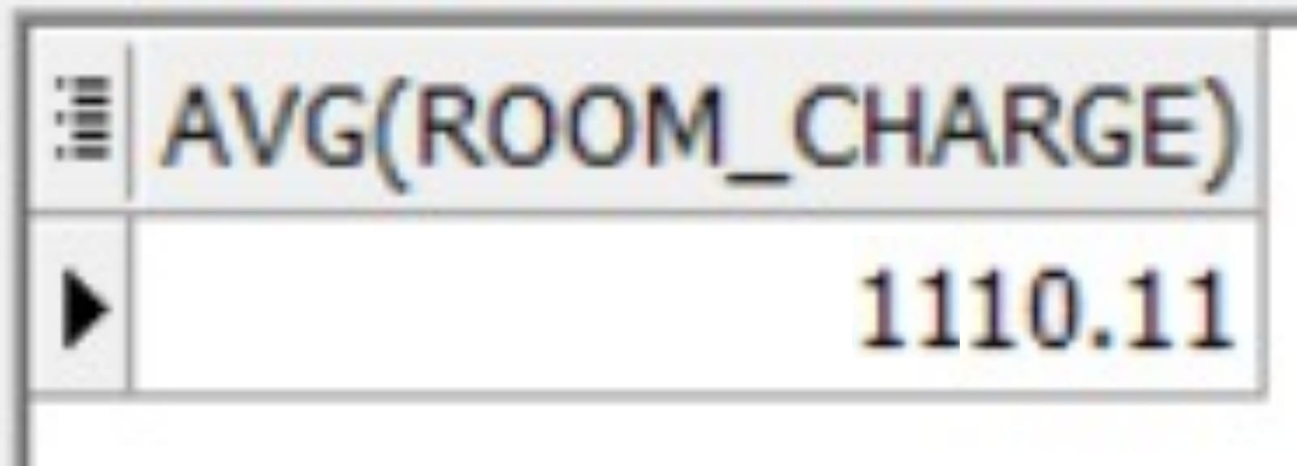

Q7) How many frequent flyers do not respond to the promotions events ?
Select count(*) from frequent_promotions ;

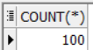

Q8) what are top destinations do most passengers tend to spend overnights in ?

Select f.arrival_airport , count(o.Number_of_nights) as counter
From over_night_stay_new o join flight f
On o.flight_key=f.flight_key
Group by f.arrival_airport
Order by counter desc;
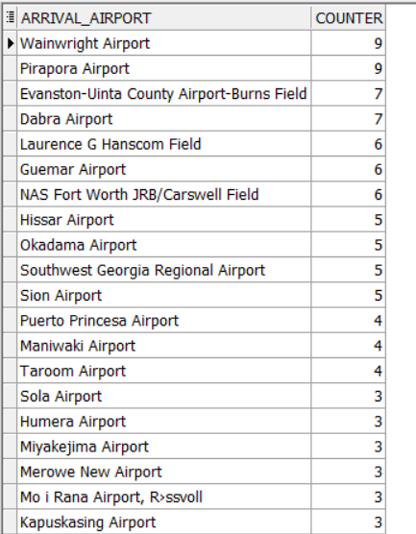

Q9)what is the profit per quarter for every year ?
SELECT YEAR_,QUARTER,SUM(fair_base_revenue)
AS PROFIT
FROM flight_activities f,Date_Dimension d
WHERE f.DATE_key=d.date_KEY
GROUP BY d.YEAR_,d.QUARTER
ORDER BY d.YEAR_,d.QUARTER DESC

