
VIT BHOPAL UNIVERSITY
School of Computing Science and Engineering
Bhopal-Indore Highway, Kothrikalan, Sehore
Madhya Pradesh – 466114
CSA1021 INTRODUCTION TO PROBLEM SOLVING AND PROGRAMMING

REG.NO: 26BHI10069
NAME: MOHAMMED NIFAL V
BRANCH: HEALTH INFORMATICS
REPOSITORY LINK: https://github.com/mohammednifal26bhi10069/VITyarthi-project

Detailed Project Report Python Console- Based Application
Project Type | Menu-driven hospital management application
Implementation | Python 3
Data Storage | In-memory lists and dictionaries
Interface | Console / command-line
Report Sections | 12 required submission sections
Prepared from the supplied Hospital Patient Management System source program.

Introduction
The Hospital Patient Management System (HPMS) is a menu-driven Python application developed to manage common hospital administration tasks from a command-line interface. The program organizes patient information, medical records, doctor details, appointments, laboratory tests, medicines, billing information, and patient discharge within a single script.
The application uses Python lists to hold collections of patients, doctors, appointments, laboratory tests, and medicines. Individual records are represented with dictionaries containing the fields needed by each feature. A continuous main-menu loop connects the individual functions and allows the user to perform multiple operations during one program session.
The system is intentionally lightweight: it does not depend on external libraries, a database, a web server, or a graphical user interface. This makes it suitable as an academic project demonstrating modular programming, data structures, input validation, record searching, appointment handling, and calculation of hospital charges.

Problem Statement
Manual handling of hospital information can make it difficult to keep patient details, medical information, appointments, laboratory records, medicine charges, and bills organized. A basic computerized system is therefore needed to provide a structured way to enter, search, display, update, and calculate this information.
The project addresses this need by providing a single console application with separate functions for the major hospital-management activities. The system also validates several numeric inputs, prevents duplicate patient and doctor identifiers/names, blocks selected operations for discharged patients, and automatically recalculates bill components when laboratory tests or medicines are added.

Functional Requirements

ID | Requirement | Description
FR-01 | Patient registration | The system shall accept and store patient ID, name, gender, phone, address, age, disease, and doctor name
FR-02 | Patient display/search | The system shall display patient records and search patients by ID or name.
FR-03 | Medical records | The system shall store diagnosis, symptoms, prescription, test results, and treatment details and allow those
FR-04 | Doctor management | The system shall add doctor information, department, and consultation fee and display  doctor details.
FR-05 | Appointments | The system shall book, view, and cancel appointments for registered patients and avail  able doctors.
FR-06 | Laboratory tests | The system shall add and display laboratory test name, fee, and result for a patient.
FR-07 | Medicine records | The system shall add and display medicine name, quantity, price, and calculated total  charge.
FR-08 | Billing | The system shall calculate and display doctor, laboratory, pharmacy/medicine, administrative, other, and total
FR-09 | Discharge | The system shall display final bill information and change a patient's status to  discharged.
FR-10 | Menu control | The system shall provide a numbered menu and an exit option.

4.Non-functional Requirements
Quality | Requirement
Usability | The numbered console menu should be straightforward to operate and each operation provides  prompts and success
Input validation | Numeric values such as fees, quantities, and prices are converted and checked using exception  handling in the relevant
Reliability | The program checks for missing patients/doctors/appointments in several operations and  handles duplicate patient IDs
Maintainability | Hospital operations are separated into functions such as add_patient(), book_appointment(),  generate_bill(), add_lab_bill()
Portability | The program uses standard Python functionality and does not require external packages.
Performance | For the small in-memory datasets expected by this academic project, linear searches through Python  lists are sufficient
Data persistence | Persistent storage is not a requirement of the current implementation; data exists only for the duration  of the programs
Security | Authentication, authorization, encryption, and database-level access control are not implemented in the supplied program

5.System Architecture
The application follows a simple single-process, function-oriented architecture. The main menu receives user commands and dispatches them to specialized functions. Those functions read from or update five in-memory collections: patients, doctors, appointments, lab_tests, and medicines.
Console / Main Menu
Patient
■
Functions
Doctor &
■
Appointment
Lab &
■
Medicine
Billing &
■
Discharge
In-Memory Data Layer: patients | doctors | appointments | lab_tests | medicines
Single Python script; functions operate directly on lists of dictionaries.
Figure 1. High-level component architecture.
There is no separate database or service layer. The program starts with empty lists, modifies them during execution, and exits through the main menu. Consequently, all records are lost when the program terminates.

6.Design Diagrams

6.1Use Case Diagram
Hospital Patient Management System
Hospital Staff
Manage Patients
Manage Medical Records
Manage Doctors
Manage Appointments
Manage Lab Tests
Manage Medicines
Generate Bills
Discharge Patient
Figure 2. Use cases supported by the hospital staff/user actor.

6.2Workflow Diagram
Start / Main Menu
Select Operation
Validate Input
Find/Create Record
Perform Operation
Update In-Memory Data
Display Result
Return to Menu / Exit
Figure 3. General workflow for menu-driven operations.

6.3Sequence Diagram
User
Main Menu
Function
Data Lists
Select option
Call function
Read / update
Return data
Format result
Display
Figure 4. Generic sequence for a user-selected operation.
The exact function called depends on the selected menu option. For example, selecting Generate Bill invokes generate_bill(), while adding a laboratory test invokes add_lab_test(). The function accesses the relevant list(s), updates records, and prints the result before control returns to the menu loop.

6.4Class / Component Diagram
The supplied program does not define Python classes. It is function-oriented and uses dictionaries for records. Therefore, a component diagram is more accurate than a traditional UML class diagram for the current implementation.
Console / Main Menu
Patient
■
Functions
Doctor &
■
Appointment
Lab &
■
Medicine
Billing &
■
Discharge
In-Memory Data Layer: patients | doctors | appointments | lab_tests | medicines
Single Python script; functions operate directly on lists of dictionaries.
Figure 5. Component view of the function-oriented implementation.

6.5ER Diagram / Logical Data Model
Although the project does not use a persistent database, it does use structured in-memory data collections. The following ER-style logical model documents the relationships represented by the dictionaries and their identifiers.
PATIENT
■
id, name, gender,
■
e, status
phone
, diseas
DOCT
OR
■
me, information,
na
■
nt, fee
partme
de
ENT
APPOINTM
■
, patient_id,
id
■
doctor_name, date, time
LAB TEST
■
patient_id, test_name,
■
fee, result
MEDICINE
■
patient_id, name,
■
quantity, price, total
assigned doctor
booking
tests
charges
charges
Logical in-memory data model; no persistent database is implemented.
Figure 6. Logical in-memory data model (ER-style representation)

7.Design Decisions & Rationale

Decision | Rationale
Lists and dictionaries instead of a  database | The project is an academic console application and the supplied implementation keeps records in lists of dictionaries
Function-oriented structure | Each major operation is implemented as a separate function. This makes the  program easier to follow
Single main menu | continuous while-loop provides one entry point for all operations and makes the application easy to navigate
ID/name search | Patient records and medical records can be located by patient ID or name, providing two practical lookup
Automatic bill recalculation | Laboratory and medicine entries update the patient's bill through recalculate_patient_bill(), reducing manual
Input validation with try/except | Fees, prices, and quantities are converted to numeric types and invalid values are rejected with a user-face
Status-based discharge control | Patients are initialized as admitted and changed to discharged after the discharge operation.

8.Implementation Details

8.1Data Structures
- patients: list of patient dictionaries containing personal details, medical-record fields, billing fields, and status.
- doctors: list of dictionaries containing doctor name, information, department, and consultation fee.
- appointments: list of dictionaries containing appointment ID, patient details, doctor name, date, time, and status.
- lab_tests: list of dictionaries containing patient ID/name, test name, fee, and result.
- medicines: list of dictionaries containing patient ID/name, medicine name, quantity, price, and total.

8.2Main Functional Modules
Module | Functions
Patient | add_patient(), display_patients(), search_patient(), show_patient()
Medical Record | add_medical_records(), search_medical_record(), display_medical_record()
Doctor | add_doctor_details(), display_doctors()
Appointment | book_appointment(), view_appointments(), cancel_appointment()
Laboratory | add_lab_test(), view_lab_tests()
Medicine | add_medicine(), view_medicines()
Billing | recalculate_patient_bill(), generate_bill()
Discharge | discharge_patient()

8.3Billing Logic
The bill is recalculated by summing the patient's doctor fee, all laboratory test fees for that patient, all medicine totals for that patient, administrative fee, and other charges. The resulting value is stored in the patient's bill field. Pharmacy bill and medicine charges are both derived from the medicine totals.
total = doctor_fee + lab_bill + pharmacy_bill total = total + administrative_fee + other_charges patient["bill"] = total

8.4Main Menu Mapping
Option | Operation
1 | ADD PATIENT
2 | DISPLAY PATIENT
3 | ADD MEDICAL RECORDS
4 | SEARCH MEDICAL RECORD
5 | SEARCH PATIENT
6 | GENERATE BILL
7 | ADD DOCTOR DETAILS
8 | DISPLAY DOCTOR DETAILS
9 | BOOK AN APPOINTMENT
10 | VIEW APPOINTMENTS
11 | CANCEL APPOINTMENT
12 | ADD LAB TEST
13 | VIEW LAB TESTS
14 | ADD MEDICINE
15 | VIEW MEDICINES
16 | DISCHARGE PATIENT
17 | EXIT

9.Screenshots / Results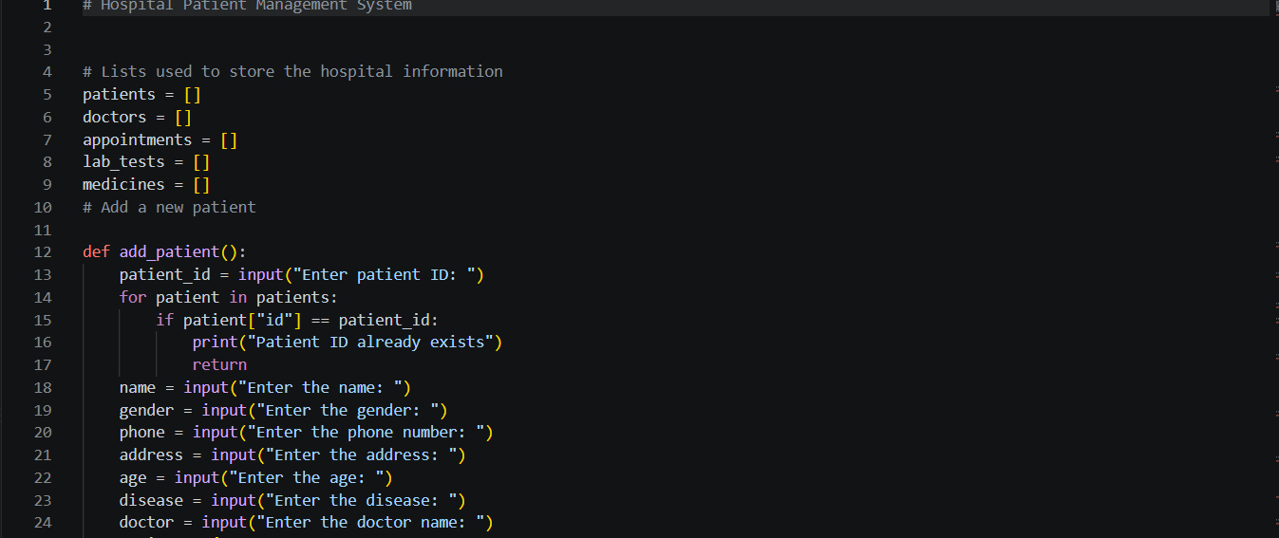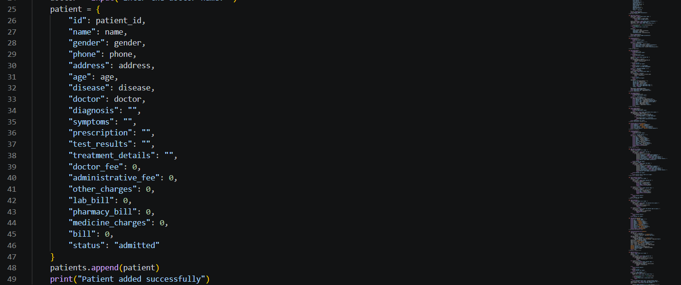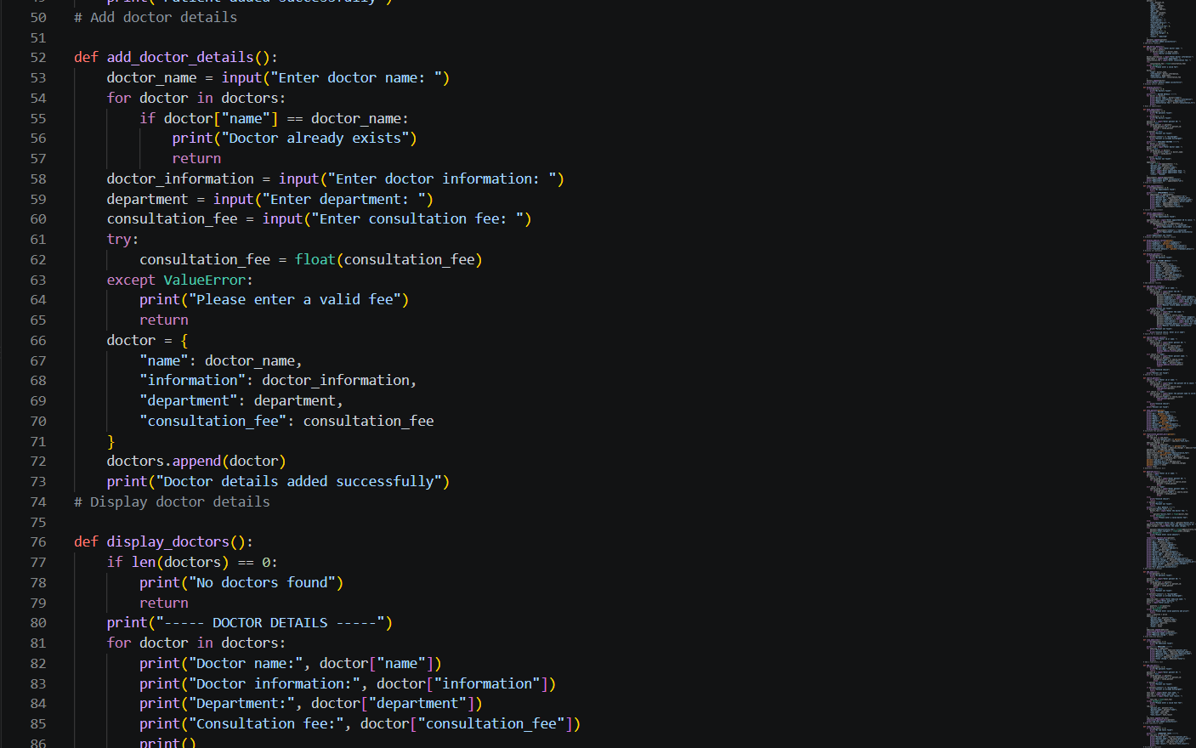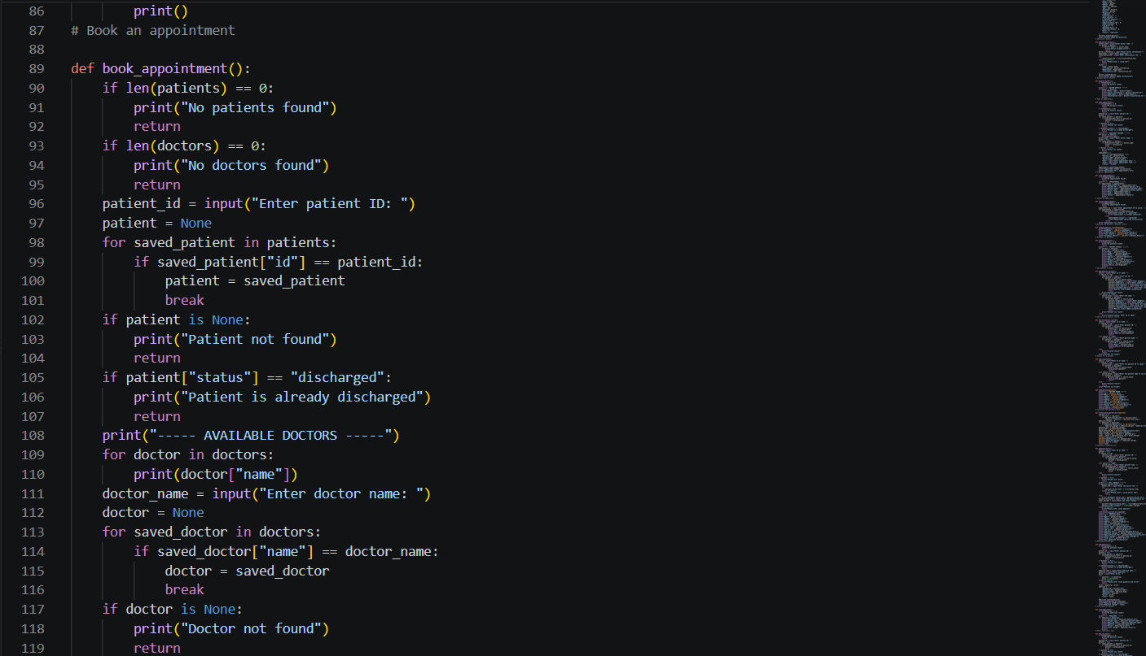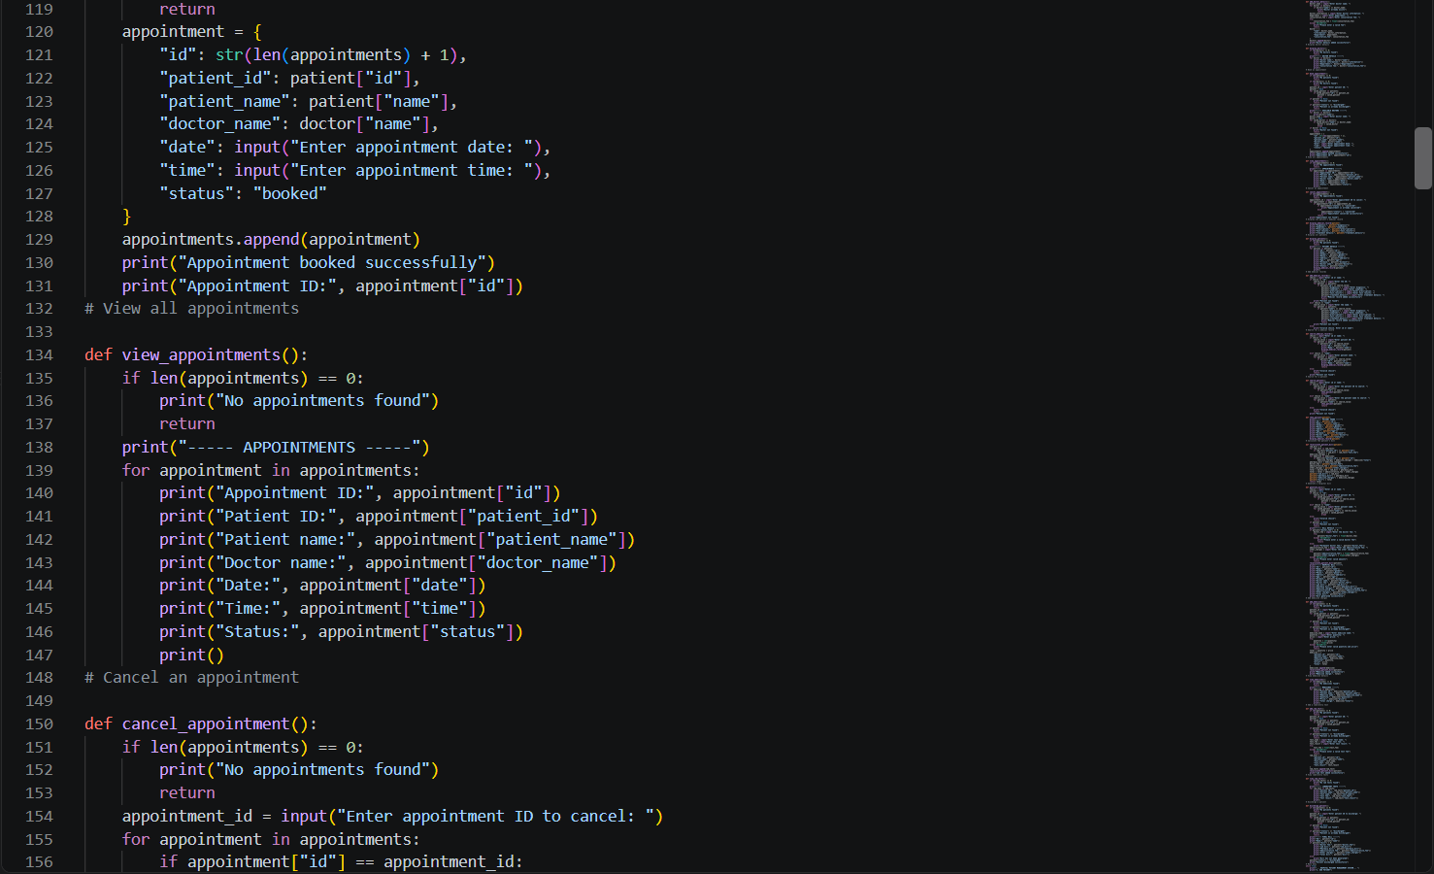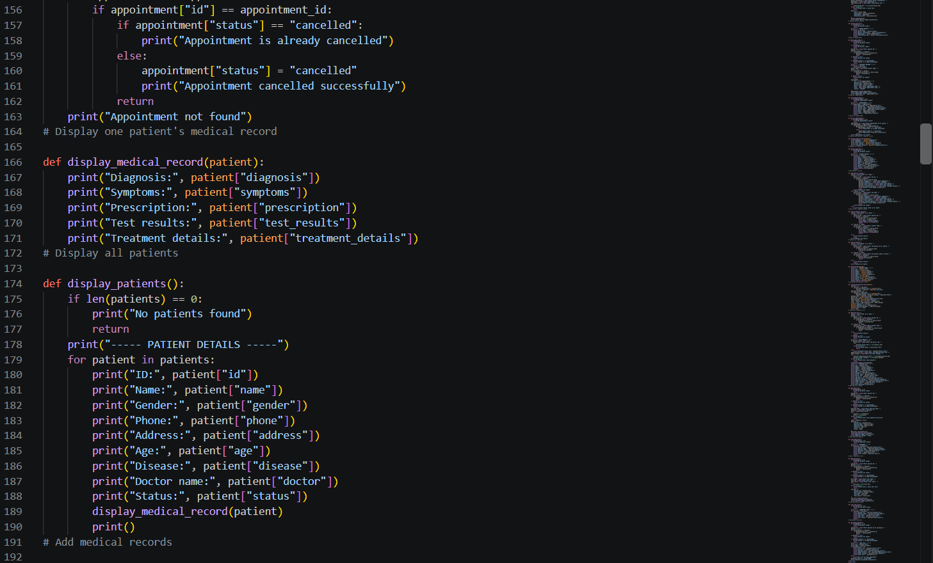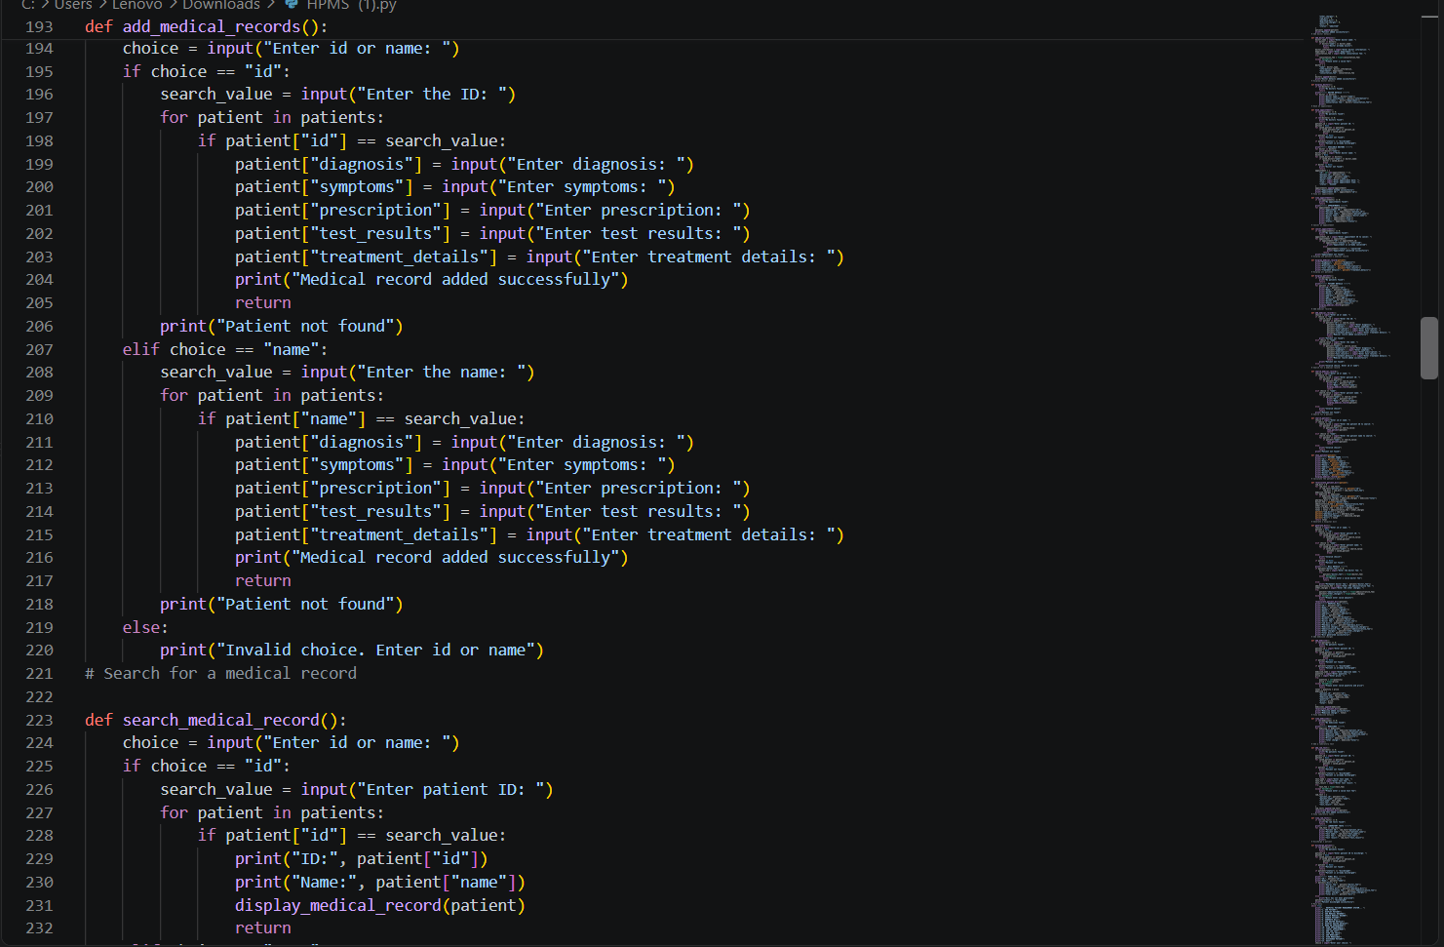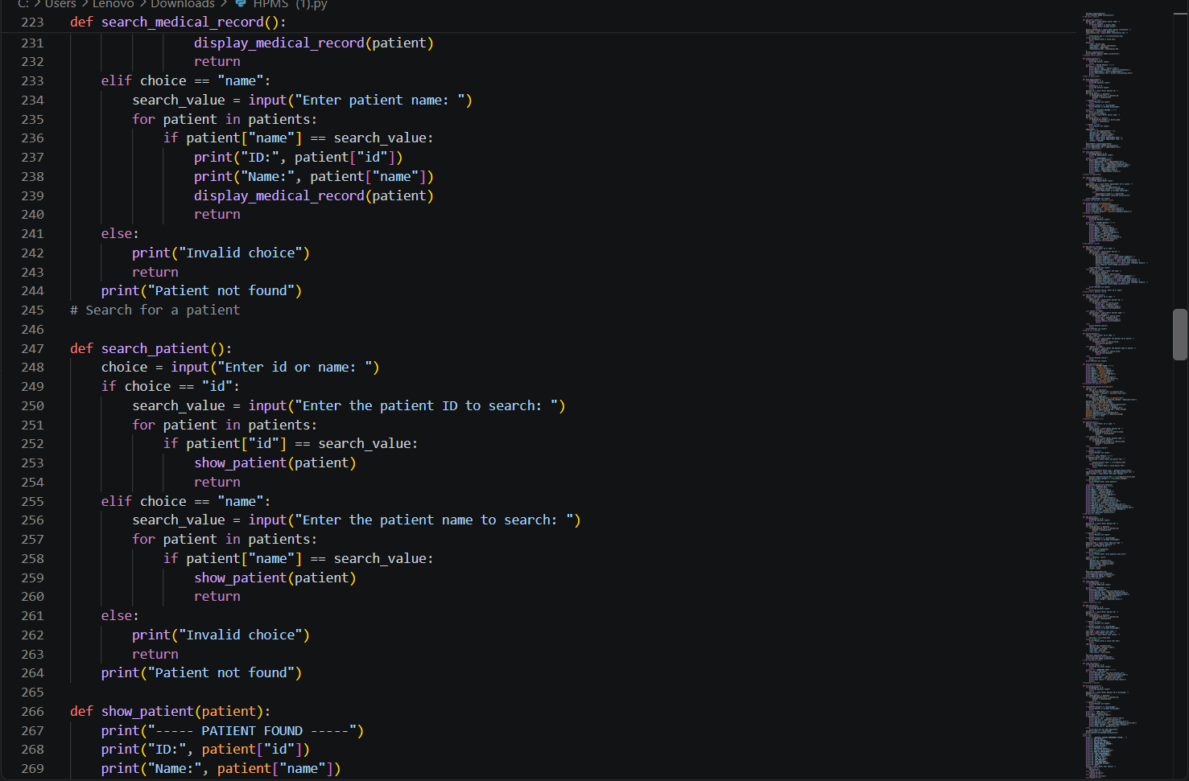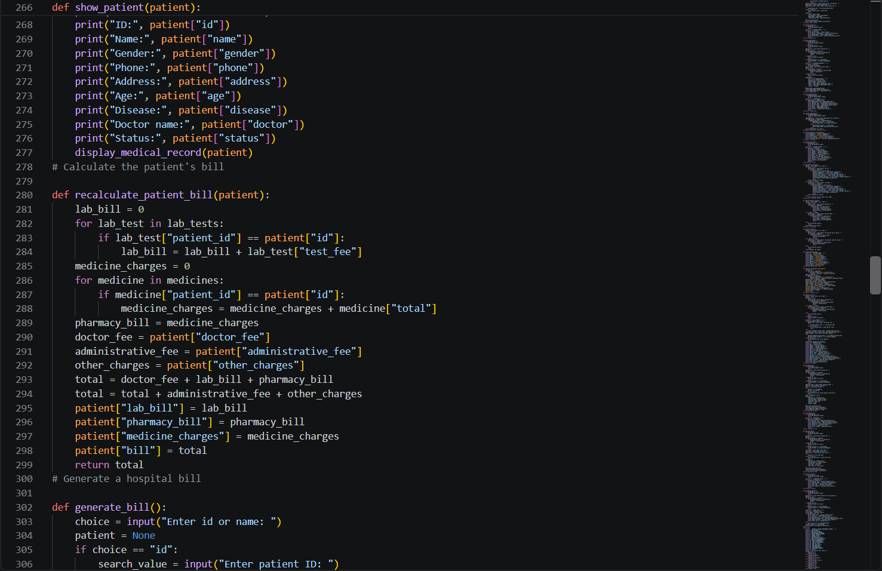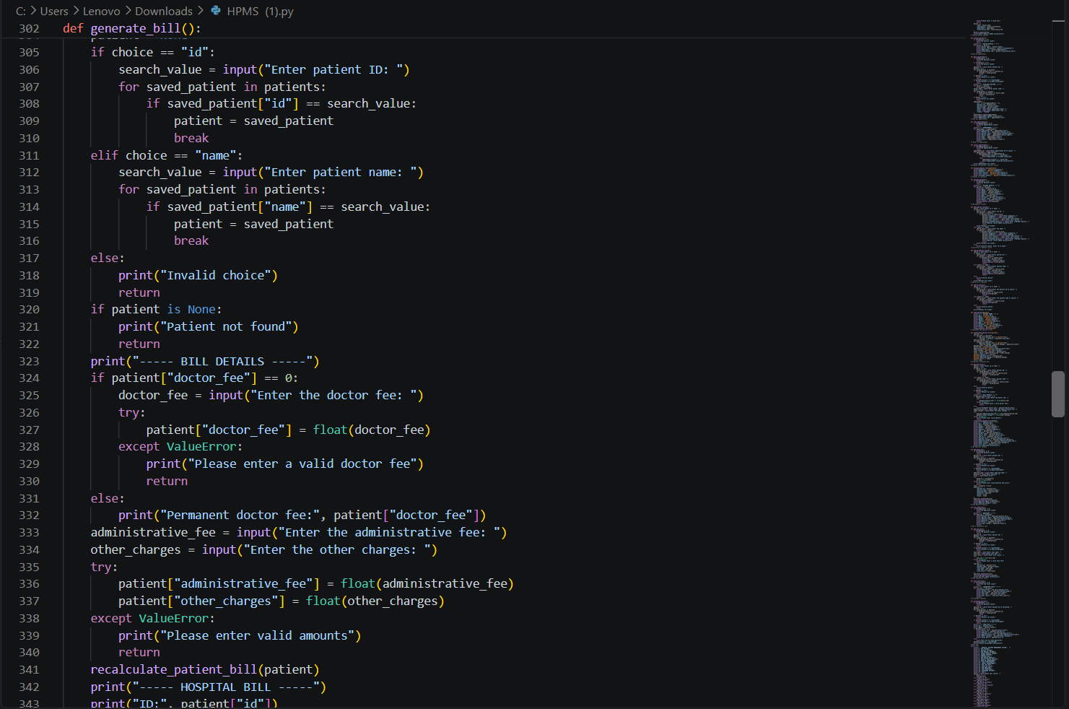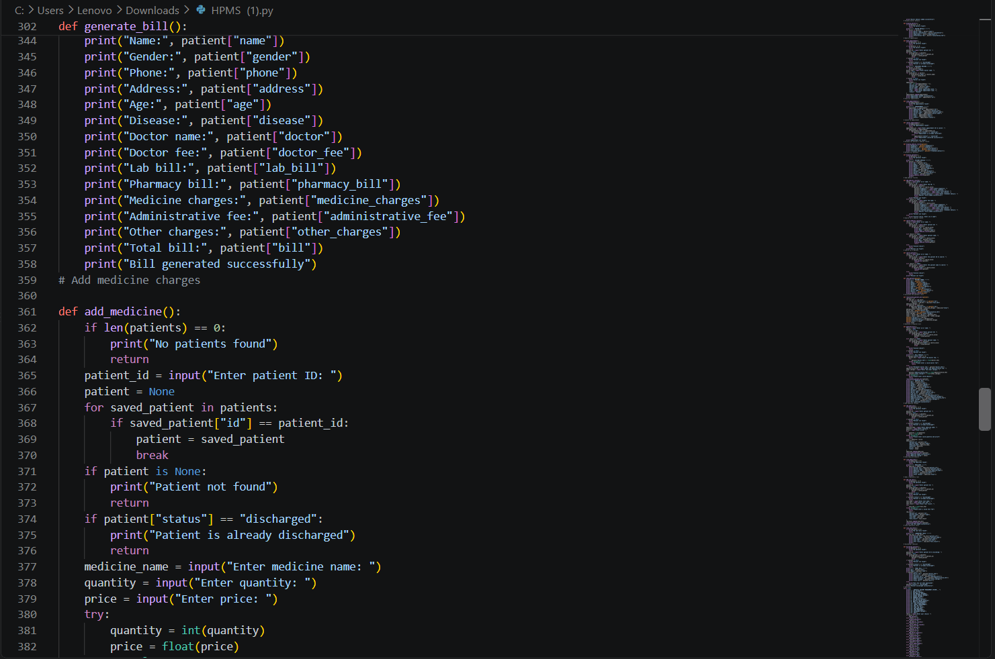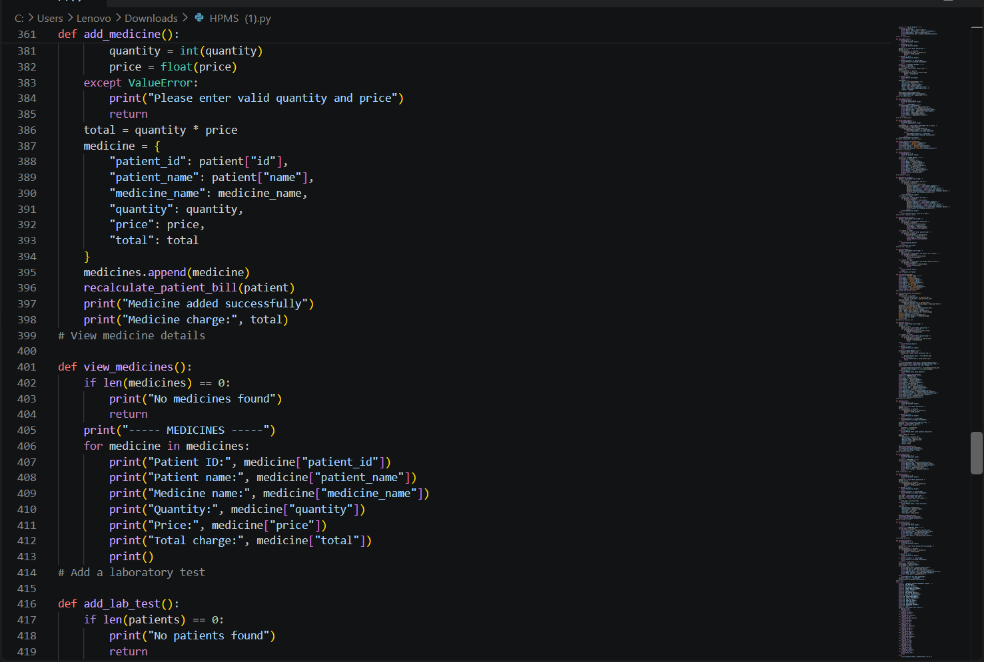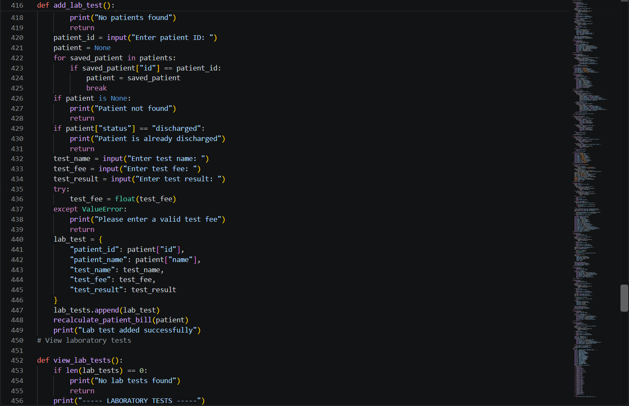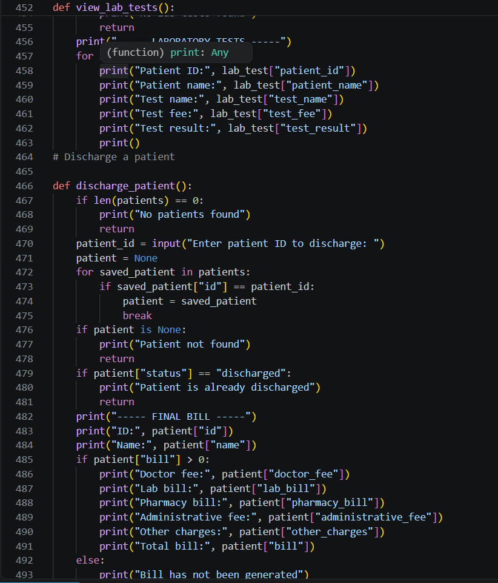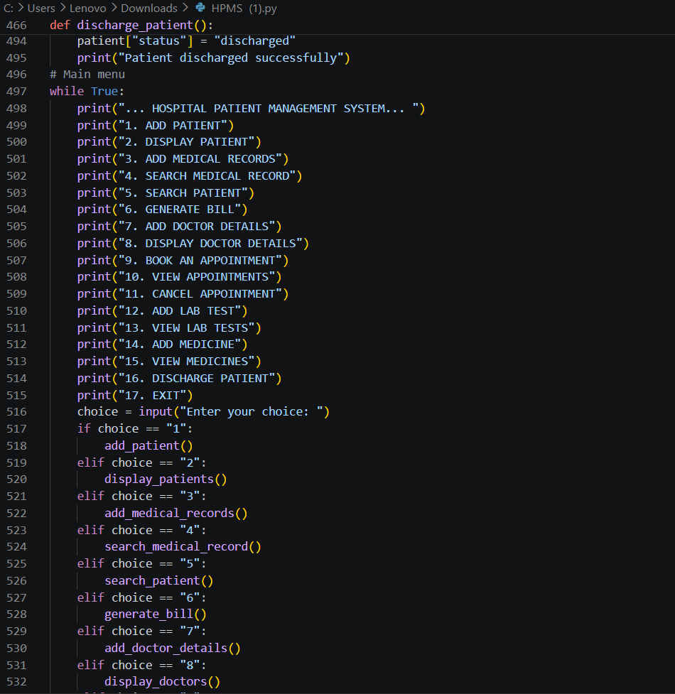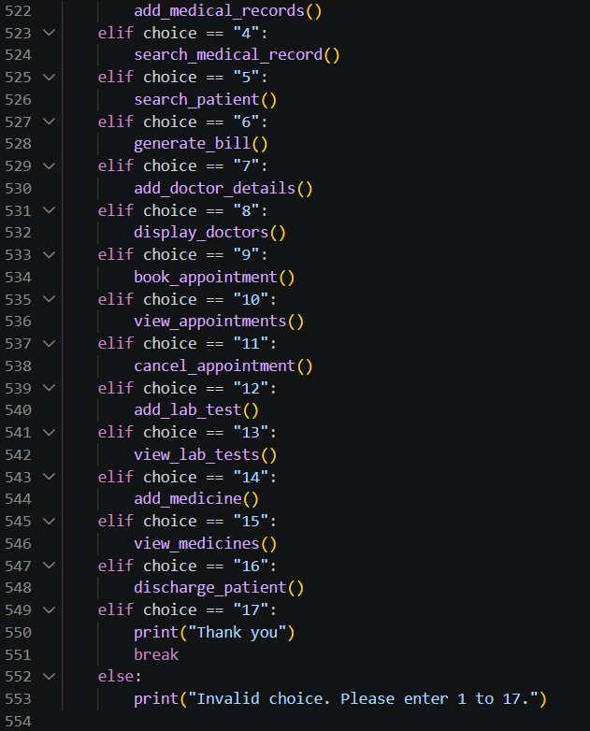

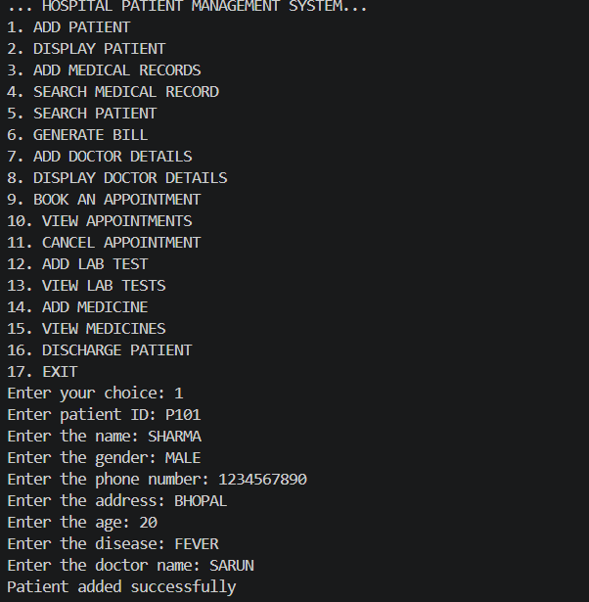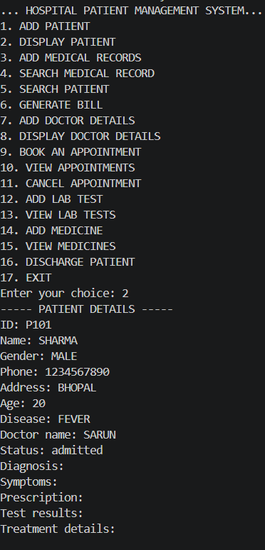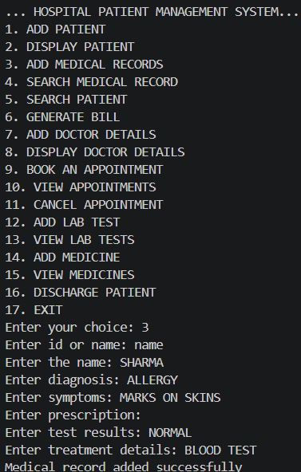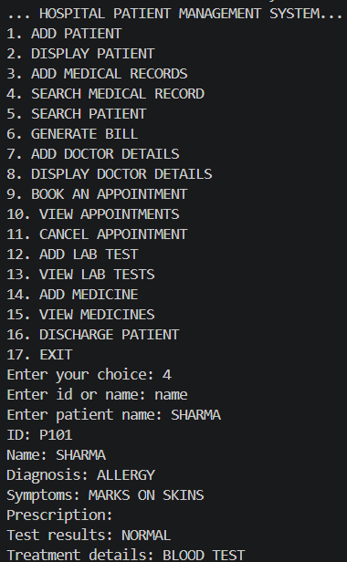

9.1Patient, Lab, Medicine and Billing Result

Patient added successfully
Doctor details added successfully
Lab test added successfully
Medicine added successfully
Medicine charge: 100.0
----- HOSPITAL BILL -----
ID: P001
Name: Aarav Sharma
Doctor fee: 200.0
Lab bill: 300.0
Pharmacy bill: 100.0
Medicine charges: 100.0
Administrative fee: 100.0
Other charges: 50.0
Total bill: 750.0
Bill generated successfully

9.2Discharge Result
----- FINAL BILL -----
ID: P001
Name: Aarav Sharma
Doctor fee: 200.0
Lab bill: 300.0
Pharmacy bill: 100.0
Administrative fee: 100.0
Other charges: 50.0
Total bill: 750.0
Patient discharged successfully
Thank you
The execution also verified that the Python file compiles successfully and that the tested workflow can move from patient creation through billing and discharge. The sample data above is test data only and is not intended to represent real patient information.

10.Testing Approach
Testing was approached using feature-based functional tests through the console menu. Each major operation was exercised with valid input, and selected invalid-input and state conditions were considered from the program's implemented checks.
ID | Feature | Input | Expected Result | Observed
T01 | Add patient | Unique ID and valid details | Patient added successfully | Pass
T02 | Duplicate patient | Existing patient ID | Duplicate ID rejected | Pass
T03 | Add doctor | Valid doctor and fee | Doctor added successfully | Pass
T04 | Medical record | Existing patient ID | Medical record stored | Pass
T05 | Book appointment | Existing patient + doctor | Appointment created with ID | Pass
T06 | Add lab test | Existing patient + numeric fee | Lab test stored | Pass
T07 | Add medicine | Existing patient + numeric quantity/price | Medicine charge calculated | Pass
T08 | Generate bill | Fees and charges entered | Total bill displayed | Pass
T09 | Discharge patient | Existing admitted patient | Status changed to discharged | Pass
T10 | Exit | Option 17 | Program exits with thank-you message | Pass
Additional negative/state checks supported by the code include invalid numeric fee/quantity handling, missing patient/doctor handling, duplicate doctor detection, already-cancelled appointments, and attempts to perform selected operations on discharged patients.

11.Challenges Faced

Managing related records without a database
Patient, doctor, appointment, laboratory, and medicine information must be linked through IDs and names while remaining in separate Python lists. This requires careful searching before updates.

Keeping billing totals consistent
The bill depends on multiple sources of charges. A dedicated recalculate_patient_bill() function centralizes the calculation after laboratory and medicine updates.

Handling user input
The application relies on console input, so numeric values need conversion and validation. try/except blocks are used for several fee, price, and quantity fields.

Maintaining patient state
The program must distinguish admitted and discharged patients. Several operations check the patient's status before continuing.

Testing an interactive program
Because the application runs through a continuous menu loop, end-to-end testing requires a sequence of menu choices and inputs rather than isolated function calls.

12.Project Summary and Current Limitations
The Hospital Patient Management System demonstrates a complete basic workflow for hospital information management in a console environment. It covers patient registration, medical records, doctors, appointments, laboratory tests, medicines, billing, and discharge through a single Python application.
The current implementation has clear boundaries: records are stored only in memory, there is no authentication, there is no persistent database, and there is no graphical or web interface. These limitations are consistent with the supplied implementation and also identify natural areas for future development if the project is extended.

Potential future extensions
- Persistent database storage for patients, doctors, appointments, medicines, and laboratory tests.
- A graphical or web-based user interface.
- Authentication and role-based access for different hospital staff.
- Date/time validation and richer appointment scheduling.
- Printable/exportable bills and reports.
- Improved input validation and structured error handling.End of Report

