**Graphene Devices for Beyond-CMOS Heterogeneous Integration**

Submitted in partial fulfillment of the requirements for

the degree of

Doctor of Philosophy

in

Electrical and Computer Engineering

Mohamed Darwish

B.S., Electronics and Communications Engineering, Ain Shams University

M.S., Electronics and Communications Engineering, Ain Shams University

Carnegie Mellon University

Pittsburgh, PA

September 2017

© Mohamed Darwish, 2017

All rights reserved

Acknowledgements

Abstract

Semiconductor manufacturing is the workhorse for a wide range of industries. It lies at the heart of consumer electronics, telecommunication equipment and medical devices. Most semiconductor electronics are made from Silicon, and are fabricated using CMOS technology. The versatility of semiconductor electronics stems from the ever-reducing cost of integrating more computing and memory functions on chip. The small cost for adding extra functions has been maintained in the past 50 years through transistor scaling. Transistor scaling focuses on shrinking the size of transistors integrated on chip. This reduction in transistor size, while keeping the overall cost of the chip fixed allowed us to reduce the cost per function with scaling, and is what is celebrated as Moore’s law. Scaling has been working gracefully up to the last decade, where the exponential rise in manufacturing cost and diminishing gains of scaling on device performance reduce its economic benefit. To revive the cost reduction trend, different techniques were proposed such as augmenting CMOS manufacturing with new materials (Beyond CMOS), 3D integration, and integrating more non-transistor elements on-chip (More than Moore).

In this work, we focus on the efficient implementation of several circuit functions using an allotropy of carbon known as graphene. Graphene, a single layer of carbon atoms arranged in a hexagonal lattice, has unique electronic properties that has been taken the solid-state electronics community by a storm since its first experimental conception in 2004. Despite its promising electronic properties, namely the very high charge-carrier mobility and reduced scattering by impurities, graphene circuits has been held back by a plethora of nonidealities and technological roadblocks that hamper its use in traditional transistor-based circuits. In this work, we attempt to leverage the unique physical properties of graphene to implement non von-Neumann neuromorphic computing architectures, low-loss diodes and evaluate the behavior of diffusive-transport graphene couplers. We focus on the the design, fabrication and characterization of graphene devices in the presence of the current performance-limiting technological nonidealities in heterogeneous graphene-CMOS systems. We present the design, fabrication and characterization of all-graphene resistive data converters devices and diodes, discussing their performance and application as building elements of all-graphene brain-inspired computing architectures. We evaluate the performance of graphene couplers operating in the diffusive transport regime, which serve as a method to analyze the cross-coupling between adjacent graphene interconnects. We also discuss the current technological limitations hampering the performance of graphene devices, and the roles of different processing non-idealities on the characteristics of graphene devices.

Table of Contents

List of Tables

List of Figures

# Introduction

The Semiconductor Industry has evolved over the d

## Economics of Scaling and Moore’s Law

## Beyond-CMOS Materials and Devices

## Graphene as a Beyond-CMOS Material

## Overview of Document

# The Electronic Properties of Graphene

## Electronic Band Structure of Graphene

## Klein-Tunneling and the Absence of Backscattering

## The Role of the Substrate

## Charge Transport in CVD Graphene

## Contact-Induced Doping

## Characterization of Graphene

### Raman Analysis

### Constant Mobility Model

Transport in CVD graphene at room temperature is diffusive that gives bias and back-gate independent number for each device. The model gives a single number for the mobility (), Dirac point shift (), charged-impurity concentration (), and contact resistance (). Although it is not the most accurate model, but it help when evaluating statistical data because it reports a single number per device, making statistical analysis and data reporting more consistent.

# All-Graphene Neuromorphic Computing Architectures

## Cellular Neural Networks (CNNs)

## All-Resistance CNNs

## Graphene Neurons and Synapses

## Measurement Results

## Conclusion

# Graphene Low-Loss Diodes

Graphene’s unique electronic properties, make it attractive in designing devices that utilize the photon-like behavior of charge carriers. The photon-like behavior of charge carriers in graphene allows us to build zero turn-on voltage diodes, where the carrier trajectories can be controlled in an anisotropic manner. In this chapter, we propose an implementation of low-loss graphene diodes using asymmetric transmission of charge carriers across an oblique barrier. We present measurement results from prototype devices showing how our proposed diodes outperform other implementations and discuss the performance limitations of our proposed structure.

In comparing the performance of different low-loss diodes we use the current conduction asymmetry (), defined at the ratio of the forward to reverse current ratio at the same voltage magnitude:

|  |  |  |
| --- | --- | --- |
|  |  | (‎4.1) |

Where and represent the same voltage magnitude but applied in the forward and reverse directions, respectively[1]. The asymmetry of a perfect linear resistor is unity, and the asymmetry of an ideal diode approaches infinity as it indicates perfect blocking of reverse current.

## Geometric Graphene Diodes

Geometric diodes use the asymmetric transmission of charge carrier across an aperture to achieve asymmetric conduction[1]–[6]. The principle of operation of such diodes can be explained using the toy model shown in Figure ‎4.1.

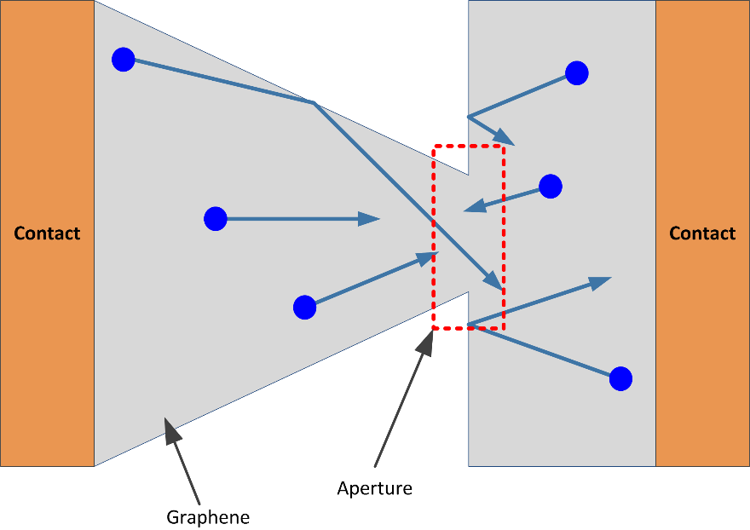

Figure ‎4.1 Toy model representing the asymmetric transmission across an aperture. Charge carriers (blue circles) get collimated into the aperture when traveling from left to right, causing large transmission. On the other hand, charge carriers travelling from right to left do not get collimated and transmit only through a small area.

Charge carriers incident from the left to right get collimated by the geometry of the channel leading to the aperture, allowing most of them to pass through. On the other hand, charge carriers traveling from the left to right do not get collimated and only a small portion passes through the aperture. A formal analysis of geometric diodes can be found in[2].

The maximum asymmetry reported for geometric diodes was ~1.35 for exfoliated graphene and 1.15 for CVD graphene[1]. The reduction in asymmetry obtained in CVD graphene can be attributed to the increase in scattering, increasing the resistance of the forward path and allowing carriers to pass in the reverse direction[7]–[19]. This is a strong indicator of the impact of scattering on the performance any diode utilizing the photon-like behavior of charge carriers in graphene.

## Oblique Incidence Diodes

Oblique incidence diodes depend on the concept of total-internal reflection of charge carriers from an oblique junction to cause asymmetric conduction. Klein tunneling in graphene causes normal incident carriers to always pass through, but obliquely incident carriers can be reflected. Asymmetric conductance across graphene oblique PN junction has been predicted theoretically and measured experimentally[20]–[32].

The angular condition on reflection can be obtained by matching the boundary conditions at the barrier, which yields a Snell’s law-like relation[22], [24], [33], [34]s:

|  |  |  |
| --- | --- | --- |
|  |  | (‎4.2) |

The critical angle beyond which reflections of charge carrier occur can be obtained by setting to 90 degrees:

|  |  |  |
| --- | --- | --- |
|  |  | (‎4.2) |

Where is the energy of the charge carrier, and is the energy of the Dirac point in the incidence medium (subscript 1) and the transmission medium (subscript 2) respectively, and is the critical angle of incidence in the first medium. This is depicted in Figure ‎4.2 for a case when , causing transmission away from the normal.

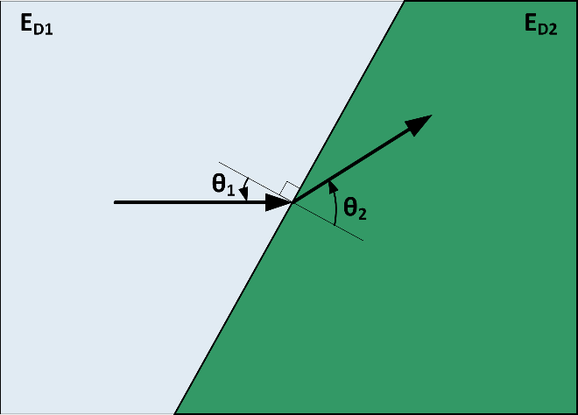

Figure ‎4.2 Schematic presentation of charge carrier motion across an oblique carrier when , causing transmission away from the normal. Further increase in will cause to increase till it reaches 90 degrees. Further increase in causes total internal reflection of charge carriers.

The structure of an oblique incidence diode is shown in Figure ‎4.3. The oblique gate sets the angle of the potential barrier (θ) and the voltages on the top and back gate set the potential barrier height.

|  |
| --- |
| (a) |
| (b) |

Figure ‎4.3 (a) Cross-section, and (b) Top view of oblique incidence diode. The whole device lies on a back gate that is not shown for clarity. The top gate is oblique relative to the channel. The potential barrier can be set by controlling the voltage of the top and back gates.

The transmission coefficient across an abrupt junction vs the energy of charge carrier and angle of incidence when tunneling in different directions across regions with eV and eV is shown in Figure ‎4.4. Transmission asymmetry occurs except when .

|  |  |
| --- | --- |
| (a) | (b) |

Figure ‎4.4 Transmission coefficient when crossing abrupt barrier of between eV and eV. (a) from region 1 to region 2, and (b) from region 2 to region 1.

## Performance Limitations

### Lead Resistance

The transmission coefficient across the interface is used for calculating the interface resistance using the Landauer-Büttiker formalisms[35]–[37]. However, the asymmetry is controlled by the total resistance of the device in the forward and reverse direction. The lead resistance adds up to the resistance of the device in both directions and reduces the total resistance difference, and asymmetry of the device.

For example, Figure ‎4.4 shows that maximum asymmetry occurs when the Fermi level of the device causes one of the sides to be intrinsic. However, this causes the lead resistance of that section to be maximum, which can impact the overall asymmetry of the device. In summary, the lead resistance is an important factor that can limit the overall performance of the device.

### Thermal broadening of energy distribution

The transmission coefficient is a strong function of both the angle of incidence and energy of charge carriers. The thermal broadening of the Fermi-Dirac distribution at non-zero temperature means that a region of energies around the Fermi level take part in conduction[35]–[37]. As such, the total asymmetry depends on the energy thermal broadening. For example, if the device is biased to make one of the sides intrinsic, as the temperature increases, more charge carriers with non-zero transmission ratio take place in conduction, reducing the asymmetry of the interface resistance.

### Momentum Distribution Smearing by Scattering

Charge carriers in graphene are subject to many mechanisms of scattering[7]–[9], [11]–[14], [16]–[19], [22], [38]–[77]. Scattering smears the angular distribution of charge carriers[78]–[82]. The angular distribution smearing should be included used in the Landauer-Büttiker to include the effect of such smearing. Accordingly, the Landauer-Büttiker equation for the interface conductance be written as:

|  |  |  |
| --- | --- | --- |
|  |  | (‎4.4) |

Where is the transmission probability, is the number of conducion modes, is the Fermi-Dirac distribution, and is the momentum smearing angular distribution function of the carriers.

This smearing function will cause more angles to take part in the conduction at the interface, which will noticeably increase the conduction of the interface in the reverse direction, reducing the asymmetry of the device.

Unfortunately, there are no analytical expressions for the momentum angular distribution, but it can be obtained using Monte Carlo simulation[78]–[82]. Equation (‎4.4) highlights the profound effect scattering has on the performance devices relying on the photon-like properties of graphene charge carriers to achieve conduction asymmetry.

## Measurement Results

We fabricated 20 diode devices using CVD graphene on SiO2, following the same procedure given in ‎Appendix B. The devices were fabricated with 4 oblique angles: 20°, 30°, 45° and 60°, with 5 devices fabricated at each angle. The measurements were performed using a setup similar to that shown in ‎Appendix C. Figure ‎4.5 shows a false color SEM image of one of the fabricated devices with an oblique angle of 45°.

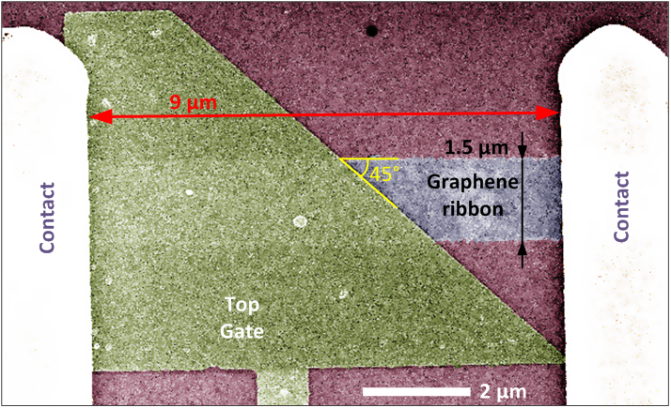

Figure ‎4.5 False color SEM image of one of the fabricated diode devices with a 45° oblique top gate.

The measurements shown in Figure ‎4.6 shows that the highest asymmetry corresponds to an oblique angle of 45°. The mean asymmetry at 45° is 1.65, and the smallest asymmetry was 1.47 at an angle of 30°; this asymmetry is 28% -43% higher than that obtained using CVD geometrical diodes, and 9%-22% higher than that obtained using exfoliated geometrical diodes. Interestingly, the mean asymmetry is a weak function of the gate angle.

The weak dependence of the asymmetry on the gate angle can be attributed to the smearing of the angular distribution of the carriers, distributing the incidence angles of the carriers over a broad range of angles. This angular broadening seems to be wide enough to smear the differences in angle over the range of the fabricated devices to the point of smearing out any trend.

In addition, the proposed diode outperforms the asymmetry of geometric diodes fabricated with either CVD or exfoliated graphene. This can be attributed to the effectiveness of oblique barriers in creating conduction asymmetry compared to apertures. The higher asymmetry however comes at the expense of adding an extra gate, which is not required in geometric diodes. The added gate control terminal is not necessarily a problem, and paves the road for oblique diodes to implement graphene PN junction multiplexers and logic[21], [25], [26], [28], [29], [83].

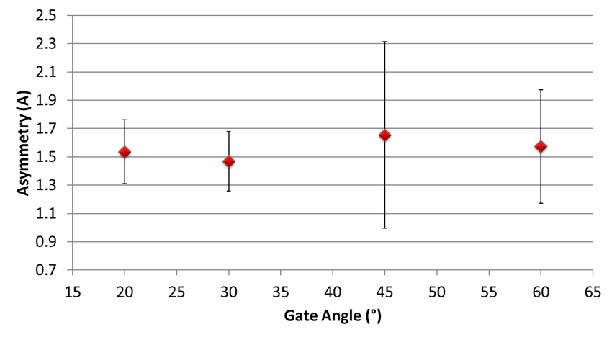

Figure ‎4.6 Extracted asymmetry for each oblique gate angle. The error bars represent the standard deviation of the data and the red diamonds represents the mean.

## Conclusion

Oblique incidence diodes outperform geometrical diodes in terms of the asymmetry. The added asymmetry comes at the expense of adding an extra terminal, making the oblique incidence diodes a 3-terminal device. The added terminal adds to the functionality of the device, allowing it to be used to implement graphene PN junction multiplexers and logic. The largest asymmetry was obtained for a gate angle of 45°.

Quantitatively, the asymmetry numbers are very low and need to be improved for the devices to be application worthy. The major culprit in limiting the asymmetry is the scattering, which smears the angular distribution of the carriers incident on the gate to the point of smearing the differences in angles from 20° to 60°. Higher performance might be achievable using better channel and dielectrics. For example, using exfoliated graphene encapsulated by hBN would reduce the scattering, achieve ballistic transport over a larger mean free path[64], [84]–[87], which could yield higher asymmetry.

# Diffusive-Transport Graphene Couplers

The similarity between the dispersion relation of photons and charge carriers in graphene appeals to designing optics-inspired electronic devices. An interesting optics-inspired analog is the electronic directional coupler. Optics directional couplers allow coupling light between two branches, where the coupling coefficient varies periodically with the coupling distance[88]. The electronic wave modes in graphene ribbons and the resistive coupling between graphene ribbons in close proximity has been analyzed for ballistic transport [54], [65], [89]. The problem of analyzing resistive coupling in diffusive graphene ribbons is different from that in ballistic graphene ribbons. The successive scattering events randomize the wavefunction phase information [35]–[37] prohibiting the direct application of the coupled-mode theory. A direct consequence of this phase randomization is losing the spatial periodicity of the coupling coefficient predicted in ballistic devices.

Modeling of resistive coupling is also crucial for deeply scaled interconnects, in which transport will inadvertently be diffusive due to line-edge roughness[16], [18], [90]. Graphene interconnects in close proximity has been studied previously to evaluate their cross-talk performance[91]–[97]. Prior work focused on analyzing the delay and energy metrics of a single graphene interconnect, accounting only for the capacitive coupling among interconnects.

In this chapter, we study the coupling between graphene ribbons operating in the diffusive transport regime. We start by developing an analytical model for the coupling resistance between two graphene ribbons separated by a dielectric, highlighting the impact of different fabrication non-idealities on the coupling. We then evaluate the spatial dependence of such coupling coefficient, showing its monotonic saturating behavior, and assess the impact of such coupling on the performance of deeply scaled interconnects.

## Modeling Diffusive-Transport Current Coupling

An electronic current coupler consists of two graphene ribbons in close proximity as shown in Figure ‎5.1. The phase incoherence associated with diffusive transport devices prohibits the direct application of coupled mode theory to evaluate the coupling between two coupled graphene ribbons. A more direct approach would be to model the coupling using the tunneling resistance between the two branches of the coupler; this emphasizes the diffusive nature of the transport and the lack of phase coherency in the associated wave functions.

The modeling of the tunneling resistance between the two graphene ribbons must take into account the difference in energy dispersion relations across the tunneling barrier. The energy dispersion relation of charge carriers changes from a linear dispersion relation in graphene, to a parabolic dispersion relation with an energy gap in the oxide regions, as shown in Figure ‎5.2. The lack of states in the dielectric energy gap translates to decaying wavefunctions from the graphene ribbons on either side of the dielectric. In other words, despite the linear energy dispersion relation of graphene, the lack of states in energy gap region of the parabolic dielectric gives rise to a decaying wavefunction, reminiscent of tunneling in parabolic systems.

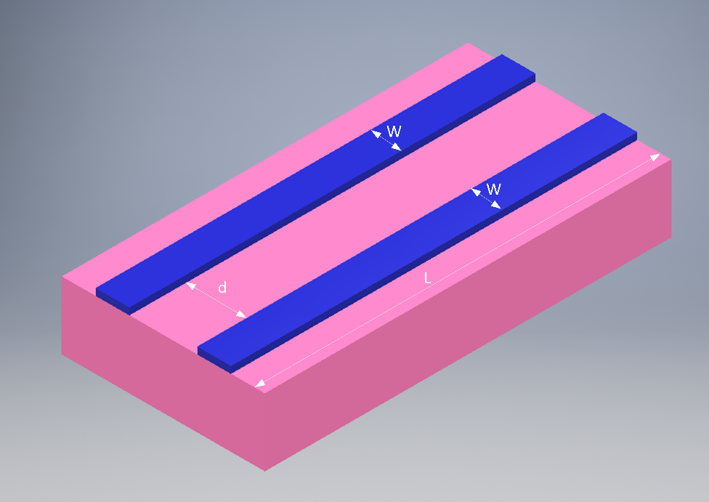

Figure ‎5.1 Schematic representation of an electronic graphene coupler. The ribbons are spaced by a distance d apart, over a length of L, while each ribbon has a width of W. The graphene is shown in blue while the surrounding oxide is shown in pink. The oxide is only shown below the graphene ribbon for clarity.

The calculation of the tunneling resistance is based on the analysis of Graphene-Insulator-Graphene (GIG) junctions[98], [99]. The major difference between the prior work on GIG junctions and the current problem is that in this device tunneling occurs between the edges of the graphene ribbons rather than normal to them. The edge tunneling nature modifies the results presented in [98], [99] slightly, but follows its essence otherwise. We defer the estimation of the tunneling resistance to Section ‎5.3, but stress on the fact that it is a tunneling resistance whose value is very large compared to the ribbons’ resistance; its value is limited by how close the two ribbons can be spaced apart, and for all practical purposes, this tunneling resistance value is significantly larger than the resistance of the graphene ribbons. This observation will proof useful when analyzing the electrical model of the device.

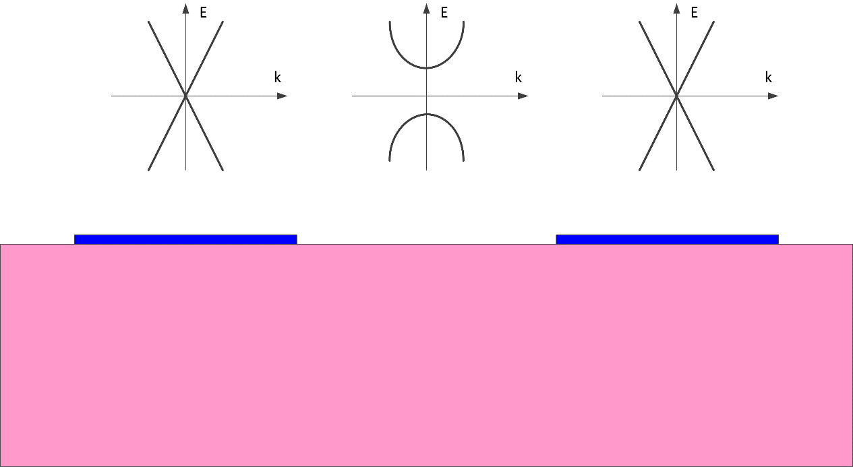

Figure ‎5.2 Cross Section of the graphene coupler with the bottom oxide only shown for clarity. The electronic energy dispersion relation for each region is shown above it; it is linear in each graphene region and parabolic with a band gap in the dielectric surrounding them. The energy gap in the parabolic region is significantly larger than the energy of charge carriers in each graphene ribbon.

The electrical model of the device is composed of three distributed resistors: a distributed resistor for each of the graphene ribbons with a distributed tunneling conductance connecting them together, as shown in Figure ‎5.3. We label one of the ribbons as the input ribbon, and the other as the output ribbon. For this analysis, we apply a current stimulus at the input ribbon and calculate the current at other end (output) of each ribbon.

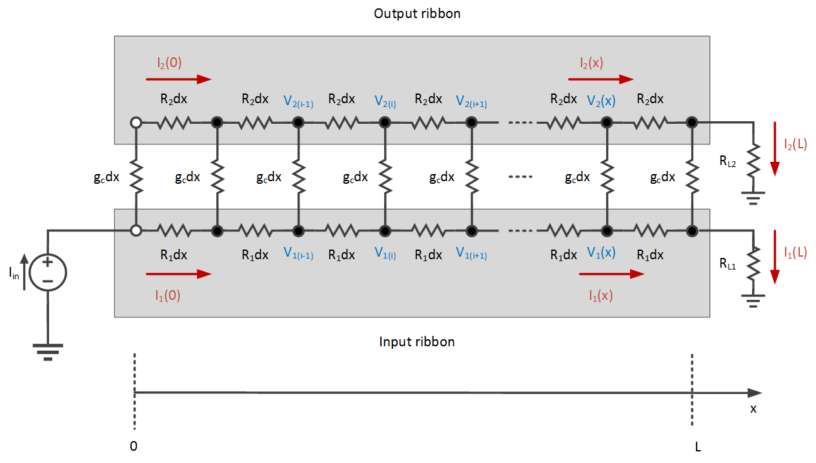

Figure ‎5.3 Electrical model of graphene coupler. The graphene ribbons are modelled using two distributed resistors with a resistance per unit length of R1 and R2, and the tunneling resistance coupling them is modelled using a distributed conductance with conductance per unit length gc.

The coupling coefficient between the current in the two ribbons is defined as the ratio between the output ribbon and input ribbon branch currents as:

|  |  |  |
| --- | --- | --- |
|  |  | (‎5.1) |

A detailed analysis of the electrical model and a derivation of the coupling coefficient is provided in ‎Appendix E. The current distribution and coupling are a strong function of the load at the output of each branch. This is expected due to the passive nature of the device that does not provide any buffering. Throughout this chapter, we assume that the ratio of the two loads matches the ratio of the ribbons’ resistance per unit length, that is . A more general analysis can be found in ‎Appendix E.

Under the matching load condition, we can approximate the current distribution in each branch of the coupler is:

|  |  |  |
| --- | --- | --- |
|  |  | (‎5.2) |

Where .

## Dependence Current Coupling Coefficient on Coupling Distance

Under the condition of matching load ratios, , the current coupling coefficient is:

|  |  |  |
| --- | --- | --- |
|  |  | (‎5.3) |

In the limiting case when , Equation (‎5.3) reduces to:

|  |  |  |
| --- | --- | --- |
|  |  | (‎5.4) |

Equations (‎5.2), (‎5.3) and (‎5.4) provides a very intuitive way of explaining the behavior of the diffusive-transport coupler: given enough length, the coupler will divide the current by the ratio of the resistances of the two branches, just as if they shorted only at the input end. Unlike the ballistic-transport coupler or the optical directional coupler, the coupling coefficient does not show any periodicity on the coupling coefficient. The lack of coupling coefficient periodicity is due to the loss of the phase information due to successive scattering associated with diffusive transport. The diffusive-transport coupler rather acts as a current divider that divides the current with according to the ratio of the two branch resistances. However, rather than being an ideal current divider, the current division takes places over a special distance dictated by the characteristic length, which is a function of the ratio between the coupling and branches conductance.

An example of the spatial variation of the current coupling coefficient and the voltage across the branches of a balanced coupler if shown in Figure ‎5.6 as obtained using SPICE simulations.

|  |  |
| --- | --- |
| (a) | (b) |

Figure ‎5.4 (a) Spatial variation of the current and (b) Spatial variation of the voltage across a balanced coupler. The simulations were performed using SPICE over a discretized model comprised of 1000 sections.

## Estimation of the tunneling resistance

The tunneling resistance can be estimated using the Bardeen Hamiltonian approach as in other Graphene-Insulator-Graphene junctions [98], [99]. The tunneling current evaluated using the Bardeen Transfer Hamiltonian [98], [99] is given as:

|  |  |  |
| --- | --- | --- |
|  |  | (‎5.5) |

Where is the valley degeneracy factor (2 in graphene), is the spin degeneracy factor (), is the tunneling matrix element, and are all the states in the electrodes in between which tunneling occurs, and is the Fermi Dirac distribution in the input and output electrodes respectively, and is the energy of the state. The matrix element is given as:

|  |  |  |
| --- | --- | --- |
|  |  | (‎5.6) |

Where is the reduced Planck constant, is the free-electron mass, is the wavefunction of state , is the direction of tunneling current flow and the integral is performed on a plane midway between the two tunneling electrodes. The matrix element in the case of graphene electrodes is given in [98], [99] as:

|  |  |  |
| --- | --- | --- |
|  |  | (‎5.7) |

Where is the wavevector of the decaying exponential function inside the parabolic region barrier (also known as the extinction coefficient), is the two tunneling electrodes separation, is the wavefunction normalization constant, is a scaling factor in the order of unity that accounts for the wave vector misalignment between the overlapping tunneling wavefunctions, is the misalignment vector with an angle similar to the in accounting for rotational misalignment between the tunneling bands, and and is the wavevector between the input and output electrodes. For low field transport in graphene, the wavevector of the charge carriers taking part in tunneling is quite close to the Dirac points ( and ).

The lateral tunneling and the use of lithography to form the junction requires some modifications to tunneling matrix element that significantly simplify its analysis:

1) Lithography creates rough edges. An example of the edge roughness of metal lines obtained when creating metal lines using PMMA photoresist is shown in Figure ‎5.5. The edge roughness standard deviation is 3 nm and there is no correlation between the edges. As such, the tunneling distance and corresponding tunneling resistance is a random variable, and the differential equations used to describe the transport in the electrical model should replace a constant with a random variable, converting Equation (‎E.1) into a set of coupled stochastic differential equation. This level of detail is only required when the edge roughness represents a considerable portion of the ribbon width or ribbon spacing, but should be kept into consideration when developing statistical models for the coupler. When the roughness of the edge is small relative to the ribbons separation or the width of each ribbon, using the average separation distance to derive a single constant value for tunneling conductance is enough.

|  |  |
| --- | --- |
| (a) | (b) |

Figure ‎5.5 SEM images of 25 nm metal lines created using PMMA photoresist. The images shows an edge roughness standard deviation of 3 nm and the lack of correlation between edges in close proximity; (a) single metal wire, and (b) two metal wires with a separation of 25 nm.

2) In this device, tunneling is from a 1D edge to the opposite 1D edge across a 2D barrier, not from a 2D surface of a graphene sheet to another across a 3D barrier. The tunneling probability across a 2D barrier falls exponentially away from the normal connecting the two closest points across the barrier. As such, a 1D model is suitable to describe the tunneling probability between the edges. In the 1D model the tunneling probability is:

|  |  |  |
| --- | --- | --- |
|  |  | (‎5.8) |

Where is a point midway the 2D barrier assumed to be in the x direction.

3) The two branches of the coupler are fabricated from a single CVD graphene sheet over SiO2 with a single common back gate. Since the devices are in close proximity, their Fermi level should be closely aligned. However, the surface roughness of the substrate will cause the formation of charge puddles, which causes random shifts in the Fermi level, and the barrier height, across the graphene ribbons. Our first order estimate will neglect these charge puddles and assumes Fermi level alignment, but a more elaborate analysis should account for charge puddles and roughness.

4) The region between the two branches of the coupler is typically composed of an oxide. The effective mass of the oxide should be taken into account when calculating the tunneling matrix element, not the free-electron mass.

5) The tunneling resistance is a function of the Fermi level separation between the two ribbons, which is a function of the potential different between them. The voltage drop between the two ribbons is small, thus the variation of tunneling resistance due to the spatial variation of the Fermi level difference can be neglected. This is further justified by the fact that we are interested in the low-field transport phenomena occurring across lithographically defined barriers (roughly nm apart), a condition under which electrode charging occurs.

Taking the above points into consideration we can rewrite the tunneling current in the low-field transport regime at T=0 K as:

|  |  |  |
| --- | --- | --- |
|  |  | (‎5.9) |

Where is a constant in the order of unity that captures the effects of misalignment and normalization constants (it has the units of m-1), and V is the applied voltage. The extinction coefficient in this case is given as:

|  |  |  |
| --- | --- | --- |
|  |  | (‎5.10) |

Where is graphene’s work function, is the ribbon’s Fermi level, and is the electron affinity of SiO2. Equation (‎5.4) yields the tunneling current per unit length of the ribbons in the low field transport regime. The conductance per unit length of the ribbon is thus given as:

|  |  |  |
| --- | --- | --- |
|  |  | (‎5.11) |

Evaluating Equation (‎5.11) without the constant to estimate the order of and the extinction factor , we find it is a strong function of the separation distance and weak function of the ribbon’s Fermi level as shown in Figure ‎5.6.

|  |  |
| --- | --- |
| (a) | (b) |

Figure ‎5.6 (a) Logarithm of tunneling coupling conductance (), and (b) Extinction coefficient () while varying the Fermi level from 0 to 0.3 eV and the separation distance from 1 to 25 nm.

The numbers obtained show that the coupling is extremely weak. This is due to the use of a non-resonant tunneling device [98], [99]. In addition, with the separation distances achievable in the order of 10 nm, the extinction of the coupling wave function is very weak to yield appreciable coupling ( nS/m). This translates to a very large, impractical, coupling characteristic length, which means that the device operates essentially as two independent ribbons.

## Impact of Current Coupling on Deeply Scaled Interconnects

Resistive coupling between neighboring interconnects is a hazard to signal integrity. Deeply scaled graphene interconnects will not suffer because of current coupling before the spacing between them falls well below 5 nm laterally. However, care should be taken when discussing the limits on stacking graphene interconnects [91], [93]–[97], [100], [101]. Resonant-tunneling [98], [99], can play a significant role in the engineering of graphene interconnects.

Resonant tunneling between neighboring interconnects would increase the coupling conductance and cause resistive leakage of current among neighboring interconnects. and should be prevented if the interconnects do not belong to the same route.

Similarly, resonant tunneling can be used to reduce the overall interconnect resistance. It can be used to reduce the overall resistance of a stacked, multi-layer graphene interconnect, where the layers belong to the same route and carry the same signal. The large coupling distributed conductance will help shunt the resistance of each layer and reduce the overall resistance.

Proper design of stacked graphene interconnects, or different graphene-metallization layers in multi-layer graphene chips should take into account the resonant stacking constraints. If two ribbons are routed normal to each other on successive graphene-metallization layer (Manhattan Routing), the spacing between the layers should be carefully chosen to prevent resonant tunneling as long as they carry independent signals.

## Conclusion

A graphene-insulator-graphene electronic coupler operating in the diffusive-transport regime does not show a spatially periodic dependence on the coupler length. Diffusive-transport coupler show an asymptotic, monotonic dependence of the coupling coefficient on the coupling length due to the loss of wavefunction phase information by successive scattering events.

Diffusive-transport graphene couplers are not practically viable without creating a resonant tunneling structure. Otherwise, the tunneling-based coupling conductance between the graphene ribbons will be too small to yield any practically significant effect.

The analysis of the graphene coupler shows that graphene interconnects are highly scalable laterally, where resistive coupling will not be effective even when the inter-ribbon spacing falls below 5 nm. However, care should be taken when stacking graphene interconnects to prevent resonant tunneling between independent routes when using multi-layer graphene interconnects. Similarly, resonant tunneling can be used in multi-layer graphene interconnects to reduce the overall interconnect resistance..

# Current Technological Limitations on Graphene Devices and Circuits

The performance of graphene FETs and devices is hampered by numerous technological limitations. In this chapter, we discuss the technological limitations limiting the electrical performance of graphene FETs. We focus on electrical and thermal interface contact resistance, the evolution of stress in dual-gated graphene FETs, and the impact of photoresist chemistry, specifically metal-ion content, on the performance of graphene FETs.

## Contact Engineering

Graphene FET architectures typically utilize top contacts to graphene sheets as shown in Figure ‎6.1. Although not as good as edge contacts[87], they are simpler to fabricate. Contacts play an important role in the device’s performance. In this section, we discuss the current limitations in terms of electrical contact resistance and thermal interface resistance of metal-graphene contacts, and how they affect the performance of a graphene FET.

|  |  |
| --- | --- |
| (a) | (b) |

Figure ‎6.1 (a) False Color SEM image, and (b) Cross-Section of a typical graphene FET. The top gate oxide is used to passivate the device against environmental effects when used or measured in air.

### Electrical Resistance

Electrical contact resistance between metal and graphene has been studied extensively. Different contact models differ in the complexity and accuracy[102]–[116]. Experimental measurements of contact resistance to graphene are marred by many non-idealities, such as low adhesion of the contact metal to graphene, and a perceived negative contact resistance due to the metal contact doping the graphene region around it[117]. The use of circular TLM structure helps in mitigating adhesion issues due to the large surface contact area[118], [119]. The metal doping graphene around the contacts due to the finite density of states of graphene has been predicted theoretically[105], [106], [108], [114], [120]–[125], measured experimentally[61], [63], [109], [113], [123], [126]–[128], and its impact on the interpretation of experimental data evaluated[117].

The proper choice of a metal contact to graphene is compromise between finding a metal that adheres well to graphene, but does not damage its electrical through excessive interaction[104]–[106], [108], [109], [111], [112], [115], [116], [120]–[123], [129]–[131]. Palladium and nickel has been identified as the metals with lowest contact resistance with graphene[104], [106], [108], [110], [111], [119], [123], [129], [130], [132], [133], with Pd giving lower contact resistance results. The low adhesion of Pd to graphene necessitates the use of an adhesion layer. Titanium and chromium has been both proposed and used as adhesion layer candidates[115], [134].

To compare Ti/Pd vs Cr/Pd stacks, we fabricated 25 devices of each and fitted it to the constant mobility model[43], which provides a single value for the contact resistance. The fabrication procedure is similar to that outlined in ‎Appendix B, without the top-gate metal deposition. The devices are similar to those shown in Figure ‎6.1, and where fabricated using CVD graphene on SiO2. We found that titanium consistently gives lower contact resistance, with less spread in statistical data; a box plot of the fitted data is shown in Figure ‎6.2.

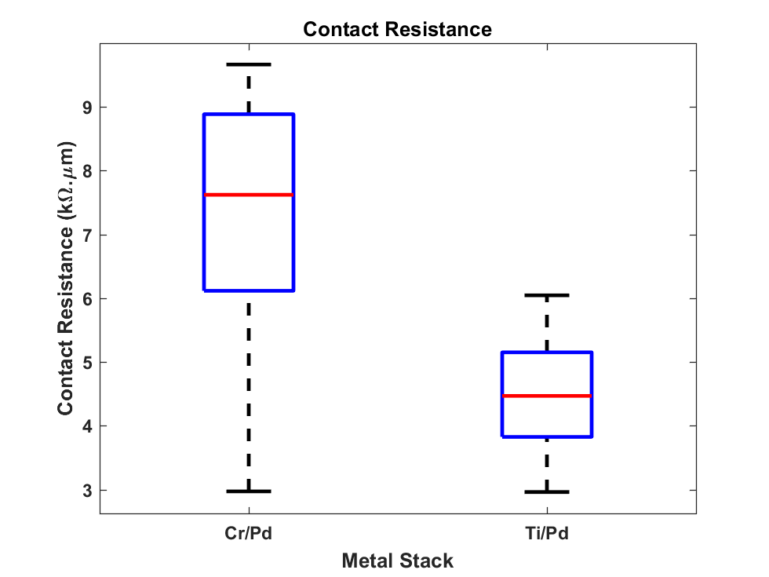

Figure ‎6.2 Box plot of extracted contact resistance value for Cr/Pd and Ti/Pd metal stacks. The layer thickness was 1.5/40 nm for each stack. The data analysis was performed using measurements from 25 devices for each metal stack. The box plot whisker edges correspond to the extreme data points, the blue box limits correspond to the 75% and 25% percentile points and the red horizontal line is the median of the data. The results show the the Ti/Pd stack shows less spread and lower contact resistance compared to Cr/Pd.

The spread in Ti/Pd and Cr/Pd can be attributed to the formation of metal oxides at the adhesion layer/graphene interface[119]. The lower spread and median in Ti/Pd points towards less oxidation of Ti in our process relative to Cr. The spread of the data and the dependence of the stack contact resistance on the metal deposition conditions elucidates the importance of fully reporting the deposition conditions. When reporting contact resistance measurement data, deposition system-dependent characteristics (deposition rate, deposition pressure, purity of the metal source) can have a profound effect on the reported data, which can be contradictory if not information is given on the deposition conditions[104], [108], [113], [119], [123], [128], [130], [131], [135], [136].

### Thermal Interface Resistance

The thermal interface conductance affects how much Joule heating created by the electrical contact resistance flows through the channel, raising its temperature. Figure ‎6.3 shows a simplified contact thermal circuit depicting how Joule heating affects the temperature of the channel. Figure ‎6.3 is valid when a doped graphene FET is operating in low-field transport regime, causing a negligible amount of Joule heating inside the channel. This model is different from the high-field transport models, where the Fermi level spatial variation can cause the formation of a hot spot inside the channel at the position of the charge neutrality point[137]–[140].

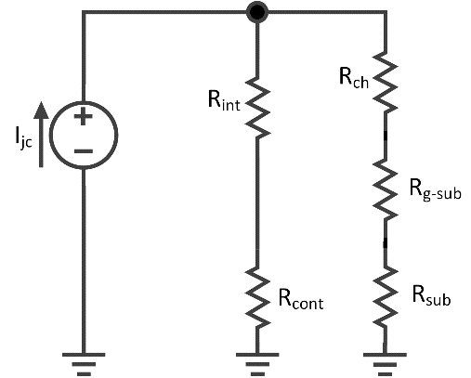

Figure ‎6.3 A simplified thermal circuit showing how heat flux generated by Joule heating distributes into the channel and the contact. The thermal current is the heat current generated due to Joule heating at the metal-graphene interface (), where is the electrical current flowing through the contact and is the electrical contact resistance. , , , and are the thermal resistances of the metal-graphene interface, metal contact, graphene channel, the graphene-substrate interface and substrate, respectively. All the grounds shown are thermal grounds, representing the temperature of the surrounding.

The amount of heat flux flowing through is given as:

|  |  |  |
| --- | --- | --- |
|  |  | (‎6.1) |

The temperature difference between the channel and the surrounding is that given as:

|  |  |  |
| --- | --- | --- |
|  |  | (‎6.2) |

The thermal resistance of the metal contact is typically low due to the high thermal conductivity of metals. We can thus approximate Equation (‎6.2) as:

|  |  |  |
| --- | --- | --- |
|  |  | (‎6.3) |

Equation (‎6.3) shows the thermal interface resistance plays a crucial role in determining how much heat flux flows into the channel, causing its temperature to increase. If the thermal interface resistance between the graphene and metal contact is low, most of the generated heat flux will flow out though the contact instead of through the channel. The metal-graphene thermal interface resistance is also important in the high-field transport regime, as it a low thermal interface resistance reduces the amount of temperature rise inside the channel[141].

Thermal interface resistance is a strong function of the interface and bonding between the metal and graphene. The interaction between the metal and the graphene plays a crucial role. Gold, palladium and nickel span the interaction spectrum from no interaction in the case of gold, weak interaction in the case of palladium, and strong interaction forming a carbide in the case of nickel. The corresponding thermal interface conductance varies from 20 MW/m2K for Au, 25 MW/m2K for Pd, and 45 MW/m2K for Ni.

Equation (‎6.3) highlights the importance of co-optimization of the electrical and thermal-interface contact resistances. The optimization of thermal contact resistance typically involves a proper choice of the metal contact material[142]–[144], and co-optimization should focus on the reduction of the electrical and thermal interface resistance product[144].

## Stress in dual-gated Graphene FETs during Processing

Stress in thin films is inversely proportional to the thickness of the film, and graphene being single layer, represents the lower limit of thickness. Graphene channels are typically sandwiched between two oxides; the fabrication of graphene FETs usually entails the deposition of a top-gate oxide, whether for use as a top-gate dielectric or for passivation. Even when fabricated over a single oxide layer, graphene being the lowest thickness element in the sack is the most prone to stress, and stress affects the electronic properties graphene[62], [145], [146].

To study the evolution of stress in graphene during fabrication, we used Raman analysis. We used the 2D peak position as a metric to evaluate the evolution of strain in the graphene channel after each process of fabrication outlined in ‎Appendix B [70], [145]–[152]. We evaluated the stress in the graphene channel before processing, after contacting, after ALD seed evaporation and after ALD of the top-gate oxide. We performed the experiment using 3 different photoresist and developer pairs and the results were consistent across all 3 pairs. The Raman analysis was performed on the photolithography defined graphene channel simislar to that shown in Figure ‎6.4. The Raman analysis was performed on data obtained from area scans over the exposed channels.

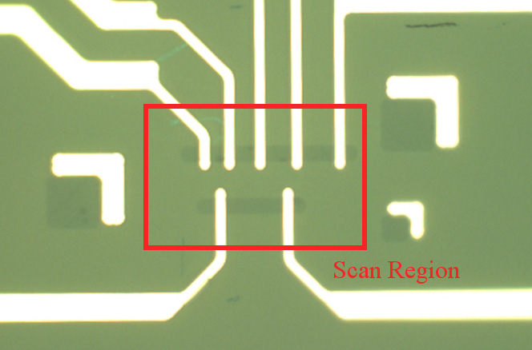

Figure ‎6.4 Optical microscope image of graphene FET device used to evaluate the stress evolution during fabrication. The graphene channels inside the red box was analyzed using Raman analysis to evaluate the stress during fabrication.

The 2D peak position was used as a metric for the strain in the channel. The 2D red shifts under tensile strain. The exact value of the strain was not calculated from the 2D peak shift due to the different values of the reported shift rates[70], [146], [147], [150], [151], [153].

The Raman spectrum from a single point and an aggregate of the 2D peak position after each fabrication step is shown in Figure ‎6.5. The single point spectrum shown in Figure ‎6.5(a) shows that the 2D peak red shift slightly after contacting indicating a slight tensile strain of the channel, followed by a distinctive shift in after the Al2O3 seed layer deposition followed by a return to its original position after the completion of the top gate oxide ALD.

|  |  |
| --- | --- |
| (a) | (b) |

Figure ‎6.5 (a) Raman spectrum around the 2D peak, (b) 2D peak data aggregate across the graphene channel after different fabrication steps. The arrows in (a) show clarify the evolution of the 2D peak position. The 2D peak position initially redshifts, indicating tensile strain, after contacting. The red shift is maximum after the Al2O3 seed layer deposition, indicating that this is the process inducing the maximum strain in the graphene channel. The 2D peak position almost moves back to position prior to the seed deposition after ALD. The 2D peak FWHM is not included in the analysis, as it is a weak function of the strain and due to its high sensitivity to impurities and substrate roughness.

The aggregate of 2D peak positions from the scan of the graphene channel shown in Figure ‎6.5(b) confirms the behavior shown in Figure ‎6.5(a). Initially, the 2D peak positions are scattered over a range of peak positions due to the roughness of the substrate[154]. Once the channel is contacted the spread of the points reduces significantly. This reduction of 2D peak position can be attributed to the contacts anchoring the graphene ribbon of the substrate with a given tension, because the contacts typically spread beyond the graphene, effectively pinning it to the substrate. After the depositions of the Al2O3 seed layer (1.5 nm of aluminum left to natively oxidize in air) the 2D peak positions redshift significantly. This can be attributed to the high tension in the graphene between the high-stress thin top oxide and the substrate. Graphene has a negative thermal expansion coefficient unlike Al2O3 and SiO2 [148], exposing it to a high tensile stress by the thin top oxide seed layer. After the completion of the ALD, which takes about 1 hour at 150 °C, the peak position almost move back to their original position, blue shifting by a small amount (~ 3 cm-1). This can be attributed to the thickness increase of the top gate oxide and the thermal processing causing a reduction in the overall stress in the top gate oxide, and the graphene channel subsequently. We cannot ascertain whether the long time anneal or the thickness increase is the cause of stress reduction, but experimenting with different growth times and temperatures could allow the evaluation of the effect of each parameter more accurately.

## Impact of Metal-Ion Containing Developers on the Performance of Graphene FETs

Photoresist developer chemistries can be divided into metal-ion free and metal-ion containing. The choice of a developer chemistry depends on its compatibility and if it has desirable properties with respect to the fabrication process.

We studied the impact of metal-ion free (MIF) developer and metal-ion containing (MIC) developers on the performance of graphene FET transistors. We used CD26 (TMAH-based developer) as the MIF developer, for use with Shipley S1805 photoresist with LOR3A lift-off layer, and used AZ Developer (Na-based developer) and AZ400K (K-based developer) as MIC developers, for use with AZ4110 photoresist. We fabricated 25 devices using each photoresist using commercial CVD graphene and evaluated the performance of the devices by fitting their characteristics to the constant mobility model[43]. Electrical measurements included a hysteresis sweep of the gate to extract the resulting hysteresis in Dirac point voltage occurring because of interface trapped charges between the graphene and SiO2 substrate[155]–[168]. The devices were fabricated using the same steps outlined in ‎Appendix B, but without the top gate metal deposition. The devices were measured using the setup outlined in ‎Appendix C. Each box corresponds to measurements from 25 devices. In all box plot figures in this section, the box plot whisker edges correspond to the extreme data points, the blue box limits correspond to the 75% and 25% percentile points and the red horizontal line is the median of the data.

Figure ‎6.6 shows the Dirac point voltage obtained using the different developers. The data shows that the MIF CD26 developer yields the lower Dirac point voltage. This is expected as the lack of metal ions in the MIF developer causes less doping compared to the MIC developers, which dope the graphene significantly due to the metal ion content.

The hysteresis of Dirac point voltage shown in Figure ‎6.7 shows that the MIC developers have the lowest magnitude of hysteresis. This can be attributed to the screening of graphene-dielectric interface charges by the metal-ion dopants, reducing their effect in causing hysteresis.

The extracted charged-ion concentration is shown in Figure ‎6.8. It confirms that the charged-impurity concentration of MIF developers is considerably less than that obtained using MIC developers. This results is expected, as the more metal ions are essentially charged impurities.

The extracted mobility is shown in Figure ‎6.9. We note that MIF developers yield significantly higher charge carrier mobility compared to MIC developers. This result can be attributed to the reduction in charged-impurity scattering when using MIF developers as they cause less charged-impurity concentration.

The extracted contact resistance normalized per device width is shown in Figure ‎6.10. Although the median values are close, the spread is significantly lower when using MIF developers. This indicates a more consistent metal-graphene interface as the contact resistance is a strong function of the state of the metal-graphene interface.

The results conclusively indicate the MIF developers are superior when processing graphene compared with MIC developers, unless the graphene channel is to be doped intentionally.

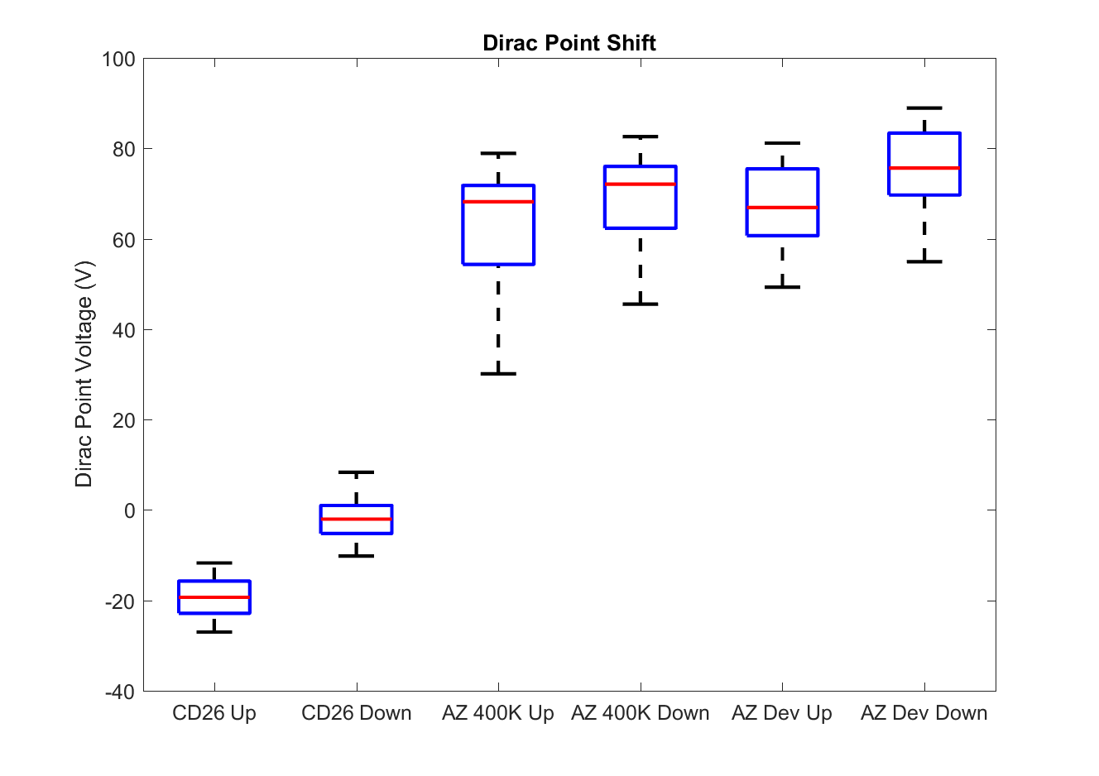

Figure ‎6.6 Dirac point voltage measured for the devices fabricated using different photoresist. Labels "Up" and "Down" correspond to sweeping the back-gate voltage up and down.

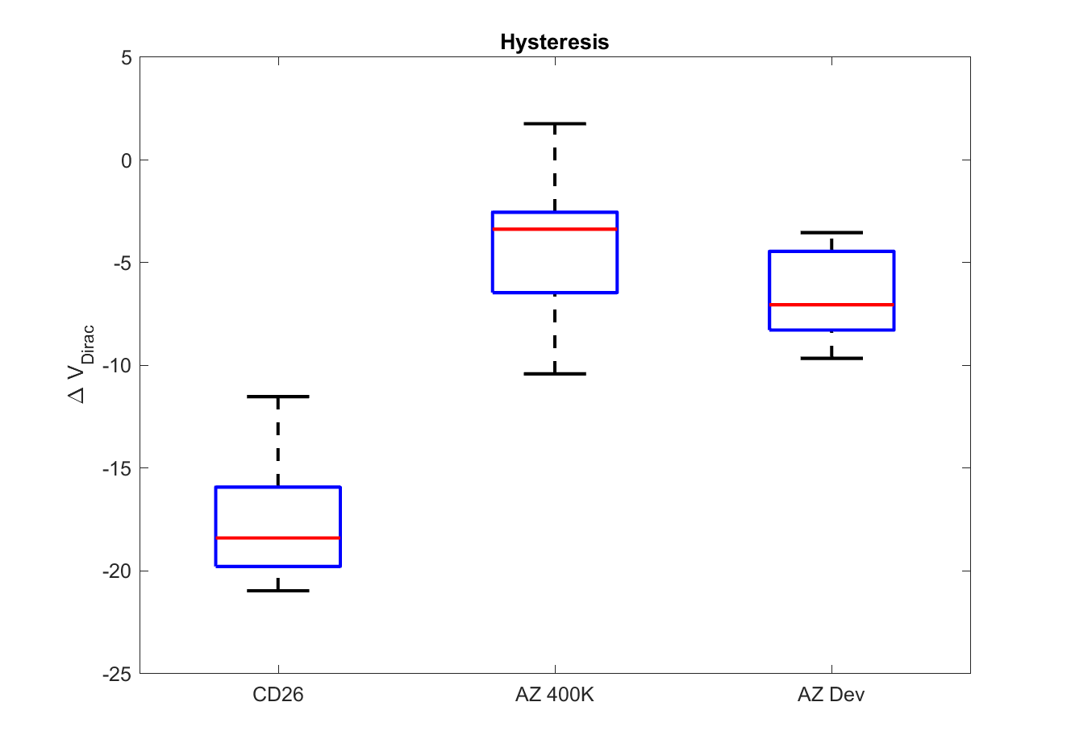

Figure ‎6.7 Hysteresis in Dirac point voltage, defined as the difference between the up and down voltage sweep Dirac point voltages. The MIC developers show small hysteresis, which can be attributed to the large density of metal-ion doping, screening the interface charges and reducing the hysteresis caused by them.

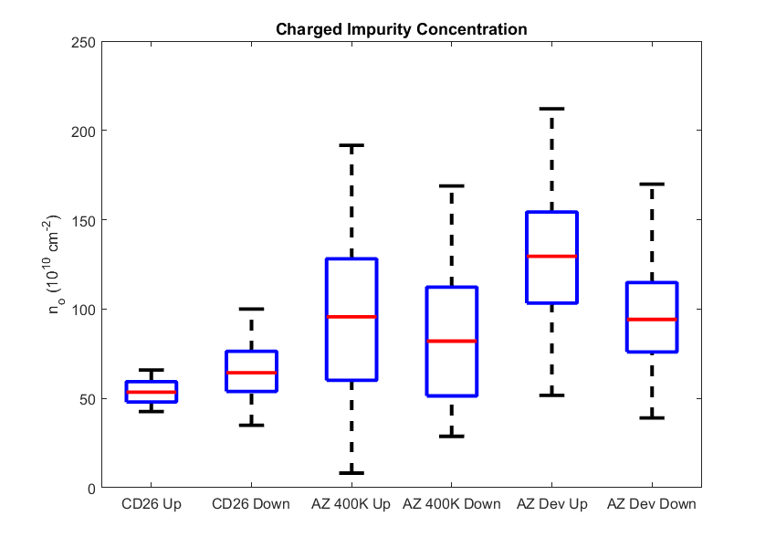

Figure ‎6.8 Extracted charged-impurity concentration using different developers. As expected, the MIF developers cause the least density of charged-impurities.

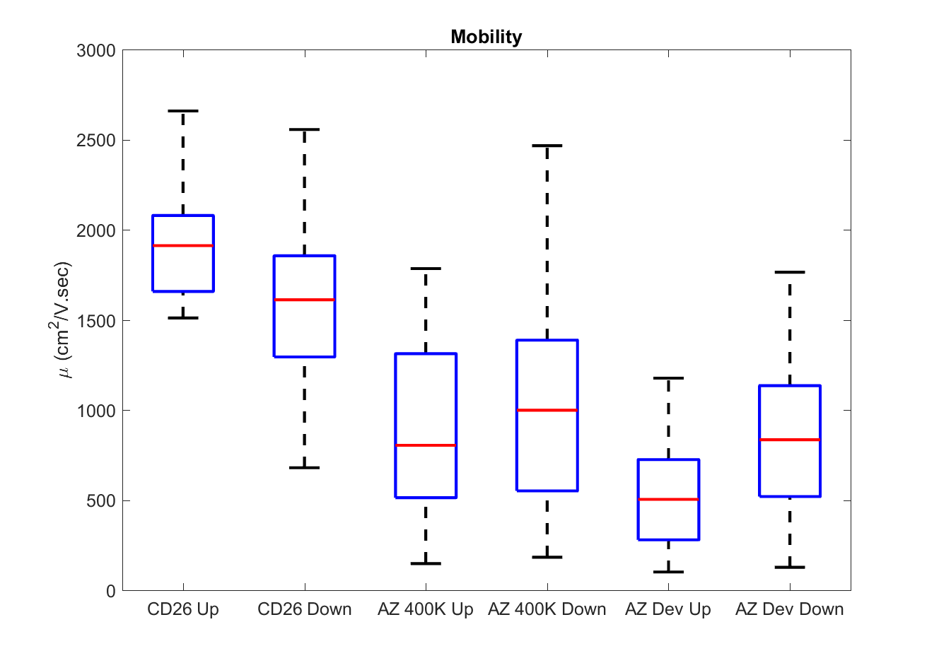

Figure ‎6.9 Extracted charge carrier mobility using different developers. MIF developers show higher mobility, which can be attributed to the less charged-impurity scattering as they yield lower charged-impurity concentration.

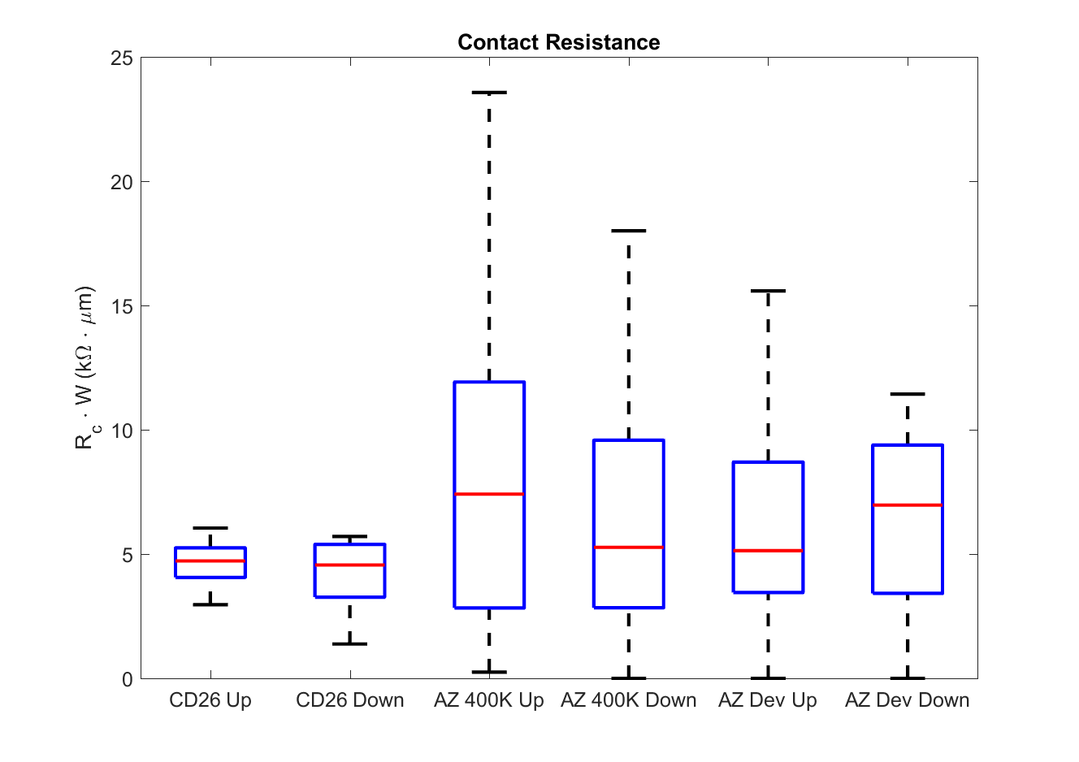

Figure ‎6.10 Extracted contact resistance. The median values are not far apart considerably, but MIF developers show the lowest spread, indicating the most consistent metal-graphene interface.

### Relation Between Charge Carrier Mobility and Charged-Impurity Concentration

Charge carrier mobility () and charged-impurity concentration () are inversely proportional[14]. It was shown theoretically that the charge carrier m [43]. The study of impact of MIF and MIC developers on graphene FET performance allowed us to experimentally evaluate the relation between charge carrier mobility and charged-impurity concentration.

The extracted charge carrier mobility and the inverse of charged-impurity concentration is shown in Figure ‎6.11. The data shows a clear inverse relationship between and . To evaluate the proportionality constant between the inverse relationship, the data was fit to using the equation . The best fit shows , which is significantly different from the theoretically predicted data. This result suggests that the charged-impurity scattering is stronger than what has been predicted theoretically.

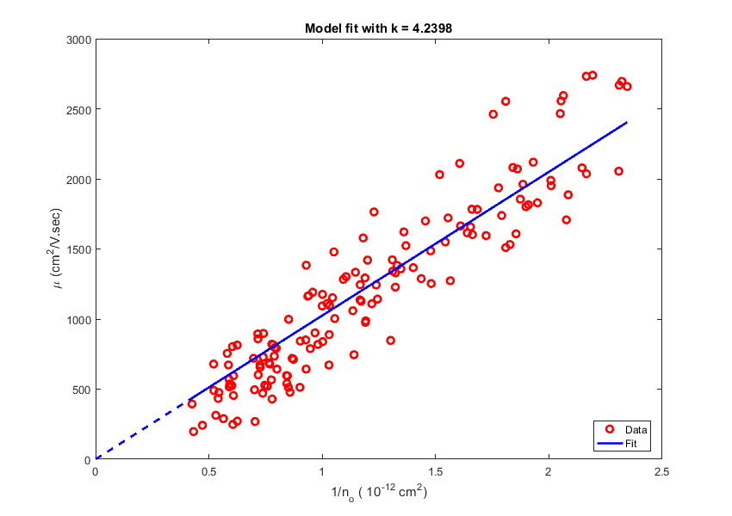

Figure ‎6.11 Extracted charge carrier mobility vs inverse of charged-impurity concentration. the results show a clear inverse relation between the charge carrier mobility and charged-impurity concentration. The best fit equation is . The dashed line shows the extension of the fit to the origin.

## Photoresist Residuals on Graphene Channels

Photoresists are organic, which makes them adhere well to graphene. However, this high adhesion to graphene causes resist residuals to stay on the graphene surface, increasing the contact resistance and acting as a dielectric barrier between the graphene and top gate oxide. The use of oxygen plasma, or milder ozone, to remove the organic contaminants on the graphene and enhance the contact resistance has been reported in the literature[169]–[172].

We studied the residual left over graphene channels after the channel definition step to evaluate how much residual is left by different residues. We used AFM analysis to evaluate the step height over the graphene channel right after removing the sacrificial photoresist layer used as an etch mask, as outlined in ‎Appendix B. The step heights using the different photoresists and developers used in Section ‎6.3 are shown in Figure ‎6.12.

The CD26 developer with S1805 resist shows the smallest step height, 1.19 ± 0.16 nm, which is quite close to the idea AFM step height of graphene, indicating a very small residue[158], [173], [174].

|  |  |
| --- | --- |
| (a) | (b) |
| (c) | (d) |

Figure ‎6.12 (a) False color SEM image showing the graphene FET with the scan area shown as a yellow line. (b)-(d) AFM scan results for when using CD 26, AZ Developer and AZ400 developer, respectively.

On the contrary, the step height channels defined using AZ Developer and AZ400K with AZ4110 photoresist shows a step height in the excess of 10 nm. These results point towards high adhesion between the photoresist and graphene. The large step height also mean that the interface of graphene is covered with a relatively thick residue, which will certainly affect the transport and interface properties. This might be one of the reasons behind the large spread in extracted model values in Section ‎6.3 for the devices fabricated using AZ Developer and AZ400K.

# Conclusion and Future Work

## Alloyed Contacts for Optimized Thermal and Electrical Contact Resistance

## Oblique incidence diodes using exfoliated graphene encapsulated by hBN

## CVD Graphene over CVD hBN

## Mixing 2D Materials for Optimized Contacts

References

# Graphene Processing

## Preprocessing Anneal

CVD graphene transfer typically requires spinning a PMMA support layer over the graphene to hold it when etching away the growth substrate (typically copper)[175]. PMMA residue affect the transport properties of graphene and increase the contact resistance. To remove the PMMA residue, graphene post transfer is annealed in a forming gas at around 300 °C to remove the PMMA residuals[116], [170], [175]–[179].

Throughout this work, the preprocessing anneal was performed at a temperature of 270-300 °C, for at least 4 hours, 5% H2 in Ar by volume (25 sccm H2 in 475 sccm of Ar). The process was performed in a 2” quartz tube at atmospheric pressure.

## Photoresist spin coat

The spin coating parameters depended on the photoresist used. The following parameters summarizes the photoresist spin coating parameters used throughout this work:

* S1805 Photoresist:
  1. Spin coat LOR3A lift-off layer at 4000 RPM for 45 seconds.
  2. Post spin bake at 190 °C for 5 minutes.
  3. Spin coat S1805 resist at 4000 RPM for 45 seconds.
  4. Post spin bake at 115 °C bake for 5 minutes.
* AZ4110 Photoresist:
  1. Spin coat AZ4110 photoresist at 5000 RPM for 90 seconds
  2. Post spin bake at 5 minute bake at 95 °C

## Photolithography

The lithography was performed using Karl Süss MA6 contact aligner in contact mode. The light source was an i-line, 320 nm source calibrated to an intensity of 5 mW/cm2. The photolithography masks used were 4”x4”x0.090” Quartz AR with a chrome mask layer, procured from Photronics Inc.

The photolithography parameters depended on the photoresist used. The following parameters summarize the photolithography exposure and development procedure used throughout this work. Note that prior to the exposure of the sample, a dummy sample was first exposed to ensure proper source calibration:

* S1805 Photoresist:
  + Exposure Time: 18 seconds
  + Development parameters: 1 minute in CD26 with gentle agitation followed by a 30 second rinse in gently running water.
* AZ4110 Photoresist with AZ400K developer:
  + Exposure Time: 45 seconds
  + Development parameters: 1 minute in 1:4 AZ400K:DI (by volume) with gentle agitation followed by a 30 second rinse in gently running water.
* AZ4110 Photoresist with AZ developer:
  + Exposure Time: 35 seconds
  + Development parameters: 1.7 minutes in 1:1 AZ400K:DI (by volume) with gentle agitation followed by a 30 second rinse in gently running water.

Lift-off was performed in Microposit 1165 remover kept in a closed beaker on a hot plate set to 70 °C.

## Electron-Beam Lithography

PMMA A7 was used as an e-beam resist throughout this work. The following steps were used during e-beam lithography:

1. Spin coat PMMA A7 at 5000 RPM for 90 seconds.
2. Post spin bake at 180 °C or 190 °C for 90 seconds.
3. Exposure parameters:
   1. Working distance: 6.5-7.5 mm.
   2. Acceleration voltage: 30 kV.
   3. Spot Size: 3.
   4. Beam current: ~136 pA.
   5. Magnification: Depends on pattern size. Typically 1500x.
   6. Point-to-Point Spacing: 5 nm.
   7. Line-to-Line Spacing: 30 nm.
   8. Line dose: 1.6 nC/cm.
   9. Area dose: 450-600 µC/cm2.
4. Development parameters:
   1. Developer: 1:3 MIBK:IPA (by volume)
   2. Development time: 55 seconds with gentle agitation followed by 15 seconds in IPA with gentle agitation

## Electron-Beam Evaporation

Samples were loaded over a 3” carrier wafer using 90 °C heat release tape. The samples were left to pump out in vacuum for at least 3 hours, typically overnight reaching a base pressure in the low 10-7 Torr, in the Ultek E-Beam evaporator. The current then was increased slightly till the pressure started going down (this only occurs for the first layer after the pump down when the evaporated metal reacts with the water vapor and radicals sticking to the evaporation chamber walls), while ensuring the e-beam is properly focused and centered on the source crucible. The shutter was opened once the chamber pressure started going up.

The rate for all deposition over graphene was kept between 0.1 – 0.3 Å/sec to enhance the adhesion between the metal and the graphene. This was kept for the first 3-5 nm then the rate was increased to the values typically used with that metal in the evaporation chamber.

The typical evaporation currents were as follows:

* Cr: 20 mA
* Ti: 30-40 mA
* Pd: 40-50 mA
* Al: 40 mA
* Au: 50 mA

After the evaporation run was complete the chamber was let to cool down for 15 minutes before venting.

## Top Gate Oxide/Passivation Deposition

The top gate oxide used throughout this work was Al2O3 due to its high reported mobility[43]. To facilitate the ALD of oxide on graphene we used a seed layer of evaporated aluminum left to oxidize in air[43]. The top gate oxide deposition parameters throughout this work was as follows:

1. Evaporate 1.5 nm of aluminum then leave it in air for at least 30 minutes.
2. Load the sample into ALD machine with the growth chamber temperature set and stable at 150 °C.
3. Grow 8.5 nm of Al2O3 using a TMAH based precursor with H2O as an oxygen source (thermal growth NOT plasma assisted growth). The growth rate was about 1 Å/cycle. The 8.5 nm deposition took around an hour.

The sample was removed from the chamber once the run was done.

## Graphene etching

Graphene etching was done using O2 plasma in a Reactive-Ion Etching machine (Plasma-Therm 790 RIE). We used this machine because initial experimentation with the IPC Barrel Etcher showed excessive lateral etching underneath the etch mask sacrificial layer. On the other hand, the RIE machine yielded cleaner etches with less lateral etching. The etch parameters in the Plasma-Therm 790 RIE are as follows:

* Recipe name: mdgphn1m
* Chuck used: Aluminum
* Etch time: 1 minute
* Power: 20 W
* Gases: 14:6 O2:Ar
* Pressure: 1 mT
* DC Voltage: ~ 180V (automatically controlled)

## Backside oxide etch

Commercially available graphene and thermally-grown SiO2 over silicon substrates come with an oxide on the on both the top-side and back-side of the substrate, that is, the oxide is on both sides of the silicon carrier wafer. The top-side oxide is grown over the finished silicon face and acts as the back-gate oxide. The top-side oxide is the back-gate oxide that carrier the transferred graphene. The back-side oxide is a byproduct of the thermal growth process. The back-side oxide prevents electrical contact to the silicon substrate and should be removed prior to any measurements. This can be confirmed by optically inspecting the back side of the carrier wafer: if the backside is any color other than grey then it is covered with an oxide. Pictures depicting the back side of the sample (graphene facing down) are shown in Figure ‎A.1, showing the back side before and after the removal of the back-side oxide.

|  |  |
| --- | --- |
|  |  |

Figure ‎B.1(a) Before, and (b) after the removal of the back-side oxide from the silicon sample. The back-gate oxide is deposited on the top-side of the sample, while the back-side oxide growth is a byproduct of the thermal oxide growth process.

Before doing any processing on the back side, the top-side oxide and graphene should be covered by spin coating PMMA or photoresist over it to prevent scratching the graphene during the etch of the back-side oxide. The back-side oxide can be removed using RIE or by floating it over BHF. We prefer the use of RIE etching because it is more safe and less prone to accidental damage to the graphene features if the sample falls into the BHF. When using an RIE oxide etch recipe, the etch time and recipe should be carefully set up to prevent, and remove, any polymer formation on the silicon surface as it would increase the contact resistance to the back gate (the silicon).

# Fabrication of a Dual-Gated Graphene FET

We go through the details of fabricating a dual-gated graphene FET. This procedure is identical for neurons, synapses and diodes, except for the e-beam mask used to shape the top gate. The processing parameters follow the values outlines in ‎Appendix A. The steps are numbered according to their order.

## Preprocessing Anneal

The preprocessing anneal is crucial to remove any PMMA residual from the graphene transfer step and is typically performed for at least 4 hours before any fabrication.

## Contact Photolithography

1. Spin coating the photoresist and contact layer lithography as shown in Figure ‎C.1

|  |  |
| --- | --- |
| (a) | (b) |

Figure ‎C.1 Sample cross-section after (a) Spin coating, and (b) photolithography and development of contact layer.

1. Contact metal stack evaporation and lift-off as shown in Figure ‎C.2.

|  |  |
| --- | --- |
| (a) | (b) |

Figure ‎C.2 Sample cross-section after (a) contact stack evaporation, and (b) contacts lift-off.

Figure ‎C.3 shows an optical microscope image of the sample after steps (1) and (2).

|  |  |
| --- | --- |
| (a) | (b) |

Figure ‎C.3 Optical microscope image after (a) contact photolithography, and (b) contacts lift-off.

## Channel Definition

1. Spin coating the photoresist and the channel etch mask as shown Figure ‎C.4.

|  |  |
| --- | --- |
| (a) | (b) |

Figure ‎C.4 Sample cross-section after (a) Spin coating, and (b) photolithography and development of channel etch mask.

1. O2 plasma etching of the exposed graphene using the RIE and removal of the etch mask as shown in Figure ‎C.5.

|  |  |
| --- | --- |
| (a) | (b) |

Figure ‎C.5 Sample cross-section (a) during channel definition, and (b) after etch mask removal. The red arrows signifiy the O2 plasma etching the exposed graphene.

Figure ‎C.6 shows an optical microscope image of the sample after steps (1) and (2). Figure ‎C.6(a) shows the tears in the graphene channel prior to the etch. After the etch no graphene is visible outside the etch mask as seen in Figure ‎C.6(b).

|  |  |
| --- | --- |
| (a) | (b) |

Figure ‎C.6 Optical microscope image after (a) contact photolithography, and (b) contacts lift-off.

## Top Gate Oxide/Passivation Deposition

ALD seed layer is evaporated then the ALD is performed over the seed as shown in Figure ‎C.7. The top gate oxide also acts as a passivation to protect the channel from the environment. In our experiments, 10 nm of Al2O3 was enough to protect the graphene from environmental dopants.

|  |  |
| --- | --- |
| (a) | (b) |

Figure ‎C.7 Sample cross-section after (a) seed layer evaporation, and (b) top oxide ALD.

## Top Gate Lithography

This step is only required if a top gate is needed. The step is used for the fabrication of the neurons, synapses or diode oblique gates. The only difference is the e-beam mask used to pattern the top gate.

1. Spin coating the e-beam resist and the e-beam lithography of top gate as shown in Figure ‎C.8.

|  |  |
| --- | --- |
| (a) | (b) |

Figure ‎C.8 Sample cross-section after (a) Spin coating, and (b) e-beam lithography and development of top gate deposition mask.

1. Evaporation of the top gate metal stack and lift-off as shown in Figure ‎C.9.

|  |  |
| --- | --- |
| (a) | (b) |

Figure ‎C.9 Sample cross-section after (a) top gate metal stack evaporation, and (b) top gate lift-off.

Figure ‎C.10 shows an optical microscope image and a false color SEM image of a graphene synapse after step (2).

|  |  |
| --- | --- |
| (a) | (b) |

Figure ‎C.10 (a) Optical microscope image of graphene synapse, and (b) False color SEM image of the same device.

## Back-side oxide etch

1. Spin coating the top side of the sample (devices side) with photoresist or PMMA and bake it.
2. Use the RIE to etch the back side oxide, while putting protected device-side down, or put the sample gently over BHF, while keeping the protected device-side up, making sure to put it down softly so as it floats over the BHF. The BHF will etch only the back side oxide. Sometimes, the BHF vapor seeps under the protection layer damaging some of the oxide and devices near the edges and corners of the sample.

## Contact window opening

This step is optional and only required if the top gate oxide it too thick or too hard for the probes to punch through it, or if the devices are to be wire bonded.

1. Spin coating the photoresist and the photolithography of contact openings as shown in Figure ‎C.11.

|  |  |
| --- | --- |
| (a) | (b) |

Figure ‎C.11 Sample cross-section after (a) Spin coating, and (b) photolithography and development of oxide etch mask.

1. Ion milling or RIE etching of the exposed oxide and removal of the etch mask as shown in Figure ‎C.12. It is recommended to use O2 plasma etching to remove any the top most crust of the photoresist prior to dissolving the etch mask as the crust is typically hardened by ion milling and removing it enhances dissolving of the etch mask.

|  |  |
| --- | --- |
| (a) | (b) |

Figure ‎C.12 Sample cross-section (a) during oxide etching, and (b) after etch mask removal. The blue arrows signifiy the accelerated ions used for ion millng or the reactive species if RIE is used for etching the exposed oxide.

# Measurement Setup for Dual-Gated Graphene FETs

# Derivation of the Current Coupling Coefficient in a Diffusive-Transport Graphene Coupler



Figure ‎E.1 Electrical model of graphene coupler. The graphene ribbons are modelled using two distributed resistors with a resistance per unit length of R1 and R2, and the tunneling resistance coupling them is modelled using a distributed conductance with conductance per unit length gc.

The electrical model of the device is composed of three distributed resistors: a distributed resistor for each of the graphene ribbons with a distributed tunneling conductance connecting them together, as shown in Figure ‎5.3. We label one of the ribbons as the input ribbon, and the other as the output ribbon. For this analysis, we apply a current stimulus at the input ribbon and calculate the current at other end (output) of each ribbon.

We start by solving the voltage differential equation for the distributed system then relating it to the current.

Applying KCL at any node the node (i), we get:

This can be rewritten as:

Taking the limit as , we get:

|  |  |  |
| --- | --- | --- |
|  |  | (‎E.1) |

Substituting from the two equations together to decouple the equations we get:

Accordingly, the differential equation for each branch after substitution:

The resulting decoupled equations are:

|  |  |  |
| --- | --- | --- |
|  |  | (‎E.2) |

|  |  |  |
| --- | --- | --- |
|  |  | (‎E.3) |

The two differential equations are the same. The general solution is written as:

|  |  |  |
| --- | --- | --- |
|  |  | (‎E.4) |

The above equation can be rewritten by setting to be:

|  |  |  |
| --- | --- | --- |
|  |  | (‎E.5) |

Current conservation dictates the boundary conditions on the current as:

|  |  |  |
| --- | --- | --- |
|  |  | (‎E.6) |

Ohm’s law relates the current and voltage at any given position as:

|  |  |  |
| --- | --- | --- |
|  |  | (‎E.7) |

In addition, Ohm’s law as relates the voltage and current at the output end of each ribbon:

|  |  |  |
| --- | --- | --- |
|  |  | (‎E.8) |

The coupling coefficient between the current in the two ribbons is defined as the ratio between the output ribbon and input ribbon branch currents as:

|  |  |  |
| --- | --- | --- |
|  |  | (‎E.9) |

Equations (‎E.1) and (‎E.4) can be solved for the relation between the constant to give:

|  |  |  |
| --- | --- | --- |
|  |  | (‎E.10) |

Before proceeding to solve the equation, we note that the voltage and current equation present a system of two coupled second order linear equations, reducible to two fourth order decoupled ordinary differential equations. Ohm’s law relates the voltage gradient to the current and hence, the current continuity equation poses a condition on the first derivative of the voltage, while Equation (‎E.8) serves as a Robin boundary condition relative the voltage to its derivative at the boundary. Accordingly, the current system cannot be completely solved analytically; we will not be able to obtain the values of the four constants needed to fully determine a unique solution, but it can be solved numerically. In this discussion, we provide an incomplete solution that does not determine all the unknown constants, but reveals the functional form of the solution.

By letting , we can write the current in each branch using the left side of Equation (‎E.7) as:

|  |  |  |
| --- | --- | --- |
|  |  | (‎E.11) |

From the current conservation equation (‎E.6) we obtain the requirement on the constant , allowing us to rewrite Equation (‎E.11) as:

|  |  |  |
| --- | --- | --- |
|  |  | (‎E.12) |

The voltage across each ribbon is this given as:

|  |  |  |
| --- | --- | --- |
|  |  | (‎E.13) |

Although it is quite tempting to null the increasing exponential constant , its presence is important in maintaining the consistency of the equations. This is can be seen through applying the boundary condition given by Equation (‎E.8):

|  |  |  |
| --- | --- | --- |
|  |  | (‎E.14) |

If the constant, is set to zero the while , Equation (‎E.14) reduces to:

|  |  |  |
| --- | --- | --- |
|  |  | (‎E.15) |

Equation (‎E.15) can only be satisfied if D is also nulled. This result is erroneous as it means that the current will not change regardless of the values of if the output of the device is shorted. In line with Equation (‎E.14), we can extract the value of as:

|  |  |
| --- | --- |
|  | (‎E.16) |

Equation (‎E.16) shows that the coefficient of the exponential increasing term decays exponentially with the length of the device and will not cause an unphysical increase in the voltage or current across the device length.

To sum up, we can write the functional form of the voltage and current across the coupler as:

|  |  |  |
| --- | --- | --- |
|  |  | (‎E.17) |

|  |  |  |
| --- | --- | --- |
|  |  | (‎E.18) |

The solution reveals the functional form of the current to distribute between the two lines in an asymptotic fashion. The current asymptote is roughly given by the current division ratio had the two branches been connected only at the input end. The asymptotic behavior roughly follows an exponentially decaying function with a characteristic length.

To demonstrate the functional behavior, we study the case when the coupler branches have matched impedance with their loads, i.e. when. In such a case, Equation (‎E.16) reduces to:

|  |  |  |
| --- | --- | --- |
|  |  | (‎E.19) |

For all practical purposes, the value of and thus the contribution of the exponentially increasing term in Equation (‎E.17) and Equation (‎E.18) can be neglected to give:

|  |  |  |
| --- | --- | --- |
|  |  | (‎E.20) |

|  |  |  |
| --- | --- | --- |
|  |  | (‎E.21) |

A useful approximation that simplifies the analysis considerably is to assume . This assumption is valid especially when. This assumption is especially valid in our analysis, as is a tunneling conductance that is considerably small relative to the conductance of the either branches of the coupler. Under this assumption, and thus we can rewrite Equation (‎E.21) as:

|  |  |  |
| --- | --- | --- |
|  |  | (‎E.22) |

Equation (‎E.22) demonstrates the behavior of the coupler under the matching approximation, while neglecting . The current in each branch asymptotically approaches its value had the two ribbons been connected only at the input side, with an asymptotic behavior following an exponential function with a characteristic length of . In this case the current coupling coefficient is given as:

|  |  |  |
| --- | --- | --- |
|  |  | (‎E.23) |

In the limit when , the current coupling coefficient at the output end of the coupler is given as :

|  |  |  |
| --- | --- | --- |
|  |  | (‎E.24) |